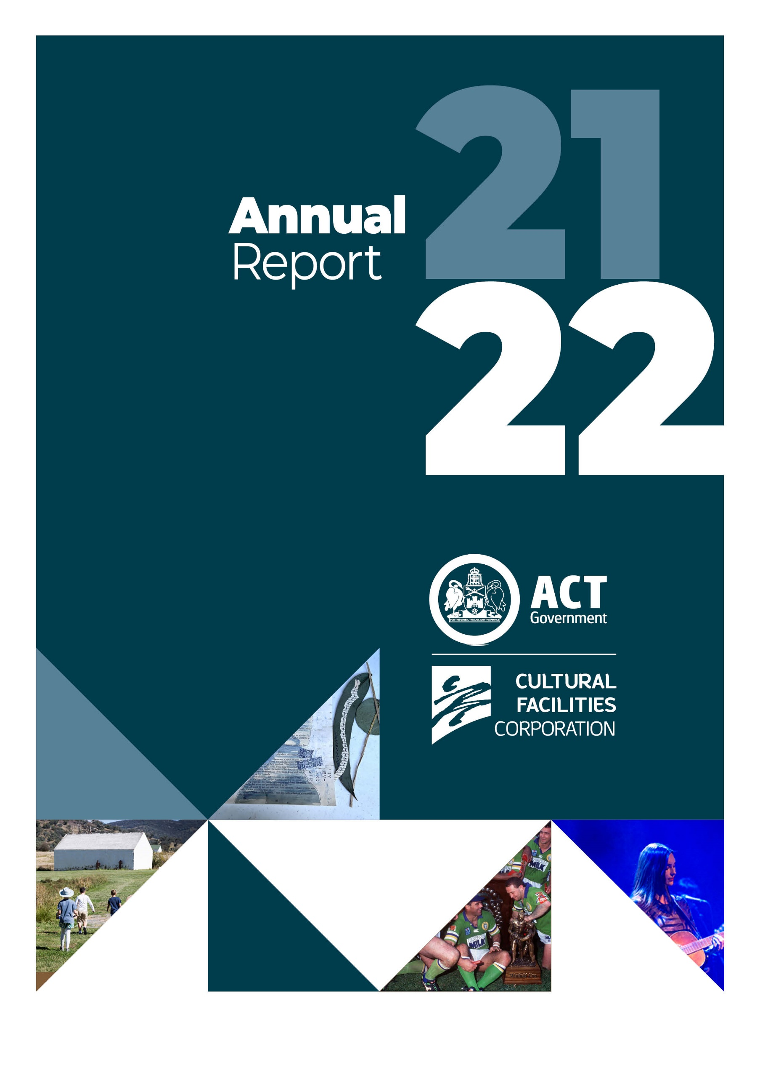

The Cultural Facilities Corporation acknowledges the traditional custodians of the Canberra region. The Cultural Facilities Corporation wishes to acknowledge and respect their continuing culture and the contribution they make to the life of this city and this region.
CULTURAL FACILITIES CORPORATION
PO Box 939
CIVIC SQUARE ACT 2608
ABN : 88187240846
Published by the Cultural Facilities Corporation, Canberra.
Contact for this report
General enquiries about this report should be directed to:
Telephone : (02) 6207 3962
Email : cfccorporatefinance@act.gov.au
For more information on the activities of the Cultural Facilities Corporation please visit the following websites: www.culturalfacilities.act.gov.au; www.canberratheatrecentre.com.au; www.cmag.com.au; and www.historicplaces.com.au
Freedom of Information
Freedom of information requests can be made by emailing: cfccorporatefinance@act.gov.au
Accessibility
The ACT Government is committed to making its information, services, events and venues accessible to as many people as possible. If you are deaf, or have a hearing or speech impairment, and need the telephone typewriter (TTY) service, please phone 13 36 77 and ask for 13 34 27. For speak and listen users, please phone 1300 555 727 and ask for 13 34 27. For more information on these services, contact us through the National Relay Service: www.relayservice.gov.au
If English is not your first language and you require a translating and interpreting service, please telephone Access Canberra on 13 22 81.
ISBN: 978 0 642 60744 7
© Australian Capital Territory 2022

This work, the Cultural Facilities Corporation 2021–22 Annual Report, is licensed under a Creative Commons Attribution 4.0 licence. You are free to re-use the work under that licence, on the condition that you credit the Australian Capital Territory Government as author, indicate if changes were made and comply with the other licence terms. The licence does not apply to the ACT Government logo, Cultural Facilities Corporation logo, branding, images or photographs.
The report is available electronically at www.culturalfacilities.act.gov.au and via the Open Access website www.act.gov.au/open-access. Hard copies of the report are available by contacting
(02) 6207 3962 or emailing cfccorporatefinance@act.gov.au.

Front cover images: Students walking to the convict barn, Lanyon Homestead (Photo Jane Duong); Nature’s Notes – Pianola Rolls Mixed Media Art Calthorpes’ House workshop program; The Canberra Raiders celebrate beating the Canterbury Bulldogs, 36–12 in the NSWRL Grand Final, Photo credit: Courtesy of the Canberra Raiders; and Lisa Mitchell performed in The Playhouse, Photo credit: Dom Northcott.

Contents
A. Transmittal Certificate 5
B. Organisation Overview and Performance 11
B.1 Organisational Overview 12
B.2 Performance Analysis 29
B.3 Scrutiny 39
B.4 Risk Management 64
B.5 Internal Audit 64
B.6 Fraud Prevention 65
B.7 Freedom of Information 65
B.8 Community Engagement and Support 66
B.9 Aboriginal and Torres Strait Islander Reporting 66
B.10 Work Health and Safety 68
B.11 Human Resources Management 69
B.12 Ecologically Sustainable Development 72
C. Financial Management Reporting 75
C.1 Financial Management Analysis 76
C.2 Financial Statements 76
C.3 Capital Works 77
C.4 Asset Management 79
C.5 Government Contracting 80
C.6 Statement of Performance 81
Appendices 83
Appendix 1 – Members and Remuneration of the CFC Board during 2021–22 84
Appendix 2 – Senior Managers of the CFC 87
Appendix 3 – Advisory Committees 89
Appendix 4 – Facilities and business/activities under management 95
Appendix 5 – Canberra Museum and Gallery and ACT Historic Places venues –
Schedule of exhibitions, programs and events 97
Appendix 6 – Canberra Museum and Gallery –
Acquisitions (Purchases and Donations) 100
Appendix 7 – Major funding, sponsorship and support 102
Attachment 1 – Financial and Performance Statements and Management
Discussion and Analysis 103
Abbreviations and Acronyms 165
Compliance Statement 167
Index 168

Part A
Transmittal Certificate
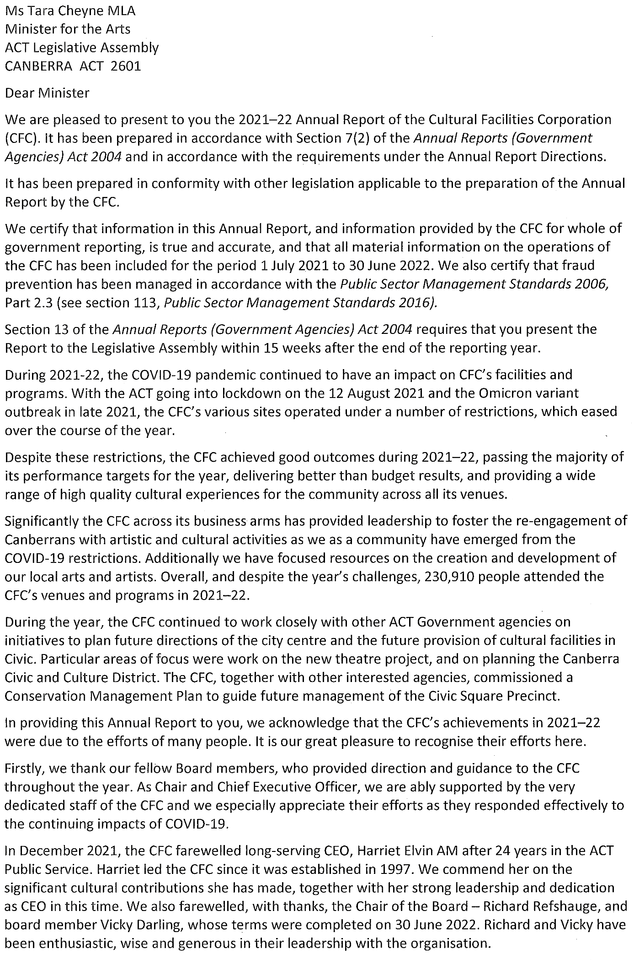

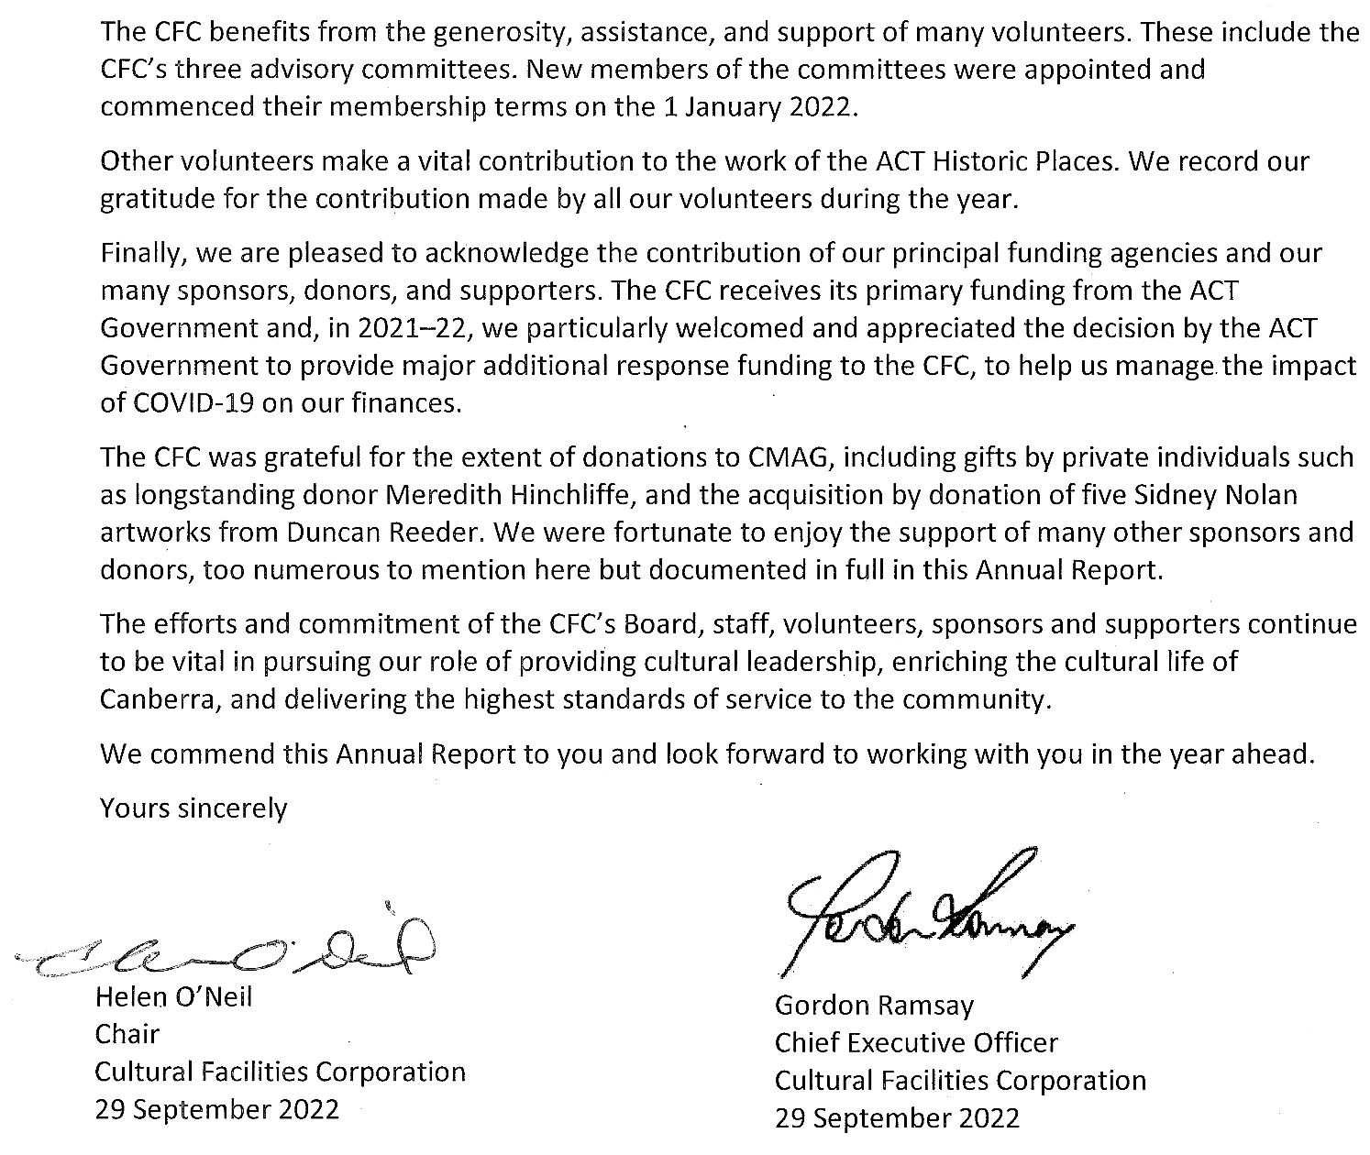

Year at a Glance
JULY 2021  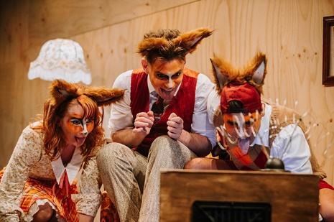  Fantastic Mr Fox performed in The Playhouse | - Children’s production Fantastic Mr Fox performed in The Playhouse (opposite picture).  - World premiere season of Hannah Gadsby Body of Work performed in the Canberra Theatre.  - The Nolan Gallery program Every Picture Tells a Story was attended by over 240 participants in July and August 2021.  - CMAG exhibition Ruth Lane-Poole: A Woman of Influence opened in conjunction with the Australiana Fund.  - Bangarra Dance Theatre’s Sandsong performed in the Canberra Theatre.  - The CFC commenced its involvement in the 2021 Audrey Fagan Board Mentorship Program, providing mentorship for two people from July to December 2021.
AUGUST 2021  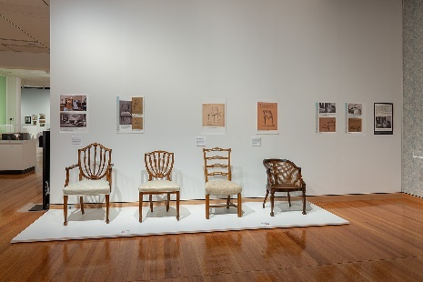  Chairs deigned by Ruth Lane-Poole, c. 1920s. Ruth Lane-Poole: A Woman of Influence exhibition. Photographed by RLDI for Canberra Museum and Gallery | - The ACT went into lockdown on the 12 August 2021 due to COVID-19 pandemic and all CFC venues closed.  - Community programs associated with CMAG exhibition Ruth Lane-Poole: A Woman of Influence included CMAG on Saturday: Pattern Play, a workshop for families with children.  - Governor-General David Hurley and Mrs Linda Hurley visited the CMAG exhibition Ruth Lane-Poole: a Woman of Influence (opposite picture). In 1926, Ruth Lane-Poole was appointed as the interior ‘furnisher’ for Government House and The Lodge in preparation for Federal Parliament moving to Canberra in 1927.  - Threads of Policing and Spowers and Syme opened however, neither exhibition was open to the public before COVID-19 lockdown. Both exhibitions were extended and available for public viewing in October 2022.
SEPTEMBER 2021  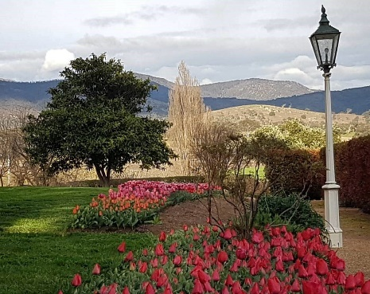  Tulips in bloom at Lanyon | - All CFC venues remained closed due to the COVID-19 lockdown and the CFC COVID-19 Crisis Management Group met regularly.  - Beautiful displays of tulips were in bloom at Lanyon (opposite picture).  - Lanyon’s Floriade related program Spring into the South day of activities were cancelled; however, displays were shared through social media.  - During the CMAG closure, approximately 1,000 items from the Canberra Press Photography Collection were catalogued.  - The CFC’s 2021–24 Strategic Plan was launched.
OCTOBER 2021  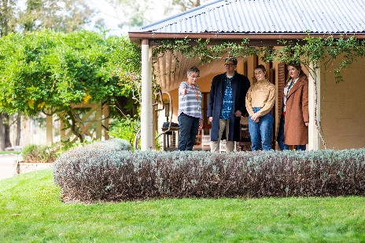  Lanyon Homestead Tour (Tourism Australia) | - Following the end of the COVID-19 lockdown, Lanyon Homestead reopened on 28 October 2021, followed by Calthorpes’ House on 30 October 2021.  - CMAG reopened to the public on 29 October 2021 with new exhibitions, Mandy Martin From Queanbeyan to New York : 1978–1984 / Art & Life and Brenda L. Croft: ‘hand/made/held/ground’.  - CMAG launched the digital version of exhibition Ruth Lane Poole: A Woman of Influence, including professional footage filmed in the gallery space.  - Major glass work Timshel by Brian Corr was installed in the CMAG foyer.  - Tim the Yowie Man featured Lanyon in the Panorama magazine of The Canberra Times.  - ACT Historic Places was selected to be part of the National Tourism Content Initiative, to be delivered by VisitCanberra and Tourism Australia, as part of the COVID-19 recovery (opposite picture).
NOVEMBER 2021  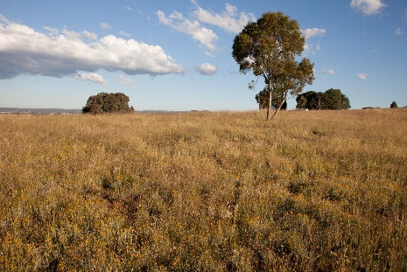  A paddock of native and exotic grasses at Mugga-Mugga (Photo Caroline Young) | - Mugga-Mugga reopened on 6 November 2021 and hosted the first post-lockdown program Walk: Wildflowers & Grasslands at Mugga-Mugga Cottage with Sarah Sharp (opposite picture).  - Christmas at Home displays in November and December 2021, to display Christmas collections at Mugga-Mugga and Calthorpes’ House, and interpret Victorian Christmas traditions at Lanyon.  - CMAG exhibition Finding the dry heart: Sidney Nolan’s early travels in Central Australia opened.  - The Canberra Theatre Centre Box Office recommenced on site operations and returned to 100% operational capacity.  - The Wharf Revue: Can of Worms, the first post-lockdown show and national premiere, performed in the Canberra Theatre.
DECEMBER 2021  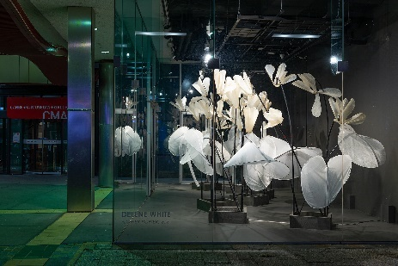  CMAG exhibition Delene White: Flower Power opened in Gallery 4 | - The 2021 Don Aitkin Awards were held and recognised four staff members for their contribution and achievements: Karen Furner; Krystle Lollback; Cath Moran; and Nicky State.  - Board members, Shad Sears and Genevieve Jacobs were reappointed to the Board for the period 1 January 2022 to 31 December 2023.  - Harriet Elvin AM concluded her role as Chief Executive Officer on the 10 December 2021 and Gordon Ramsay commenced his role as the new Chief Executive Officer on 13 December 2021.  - CMAG exhibition Delene White: Flower Power opened (opposite picture).  - CMAG presented Curator Talk: Virginia Rigney in conjunction with exhibition Mandy Martin From Queanbeyan to New York : 1978– 1984 / Art & Life.  - Lanyon hosted a Wedding Open Day.
JANUARY 2022  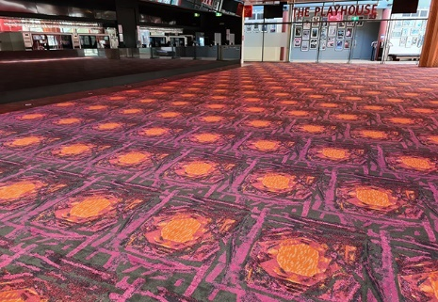  New carpet at the Canberra Theatre Centre | - New carpet was installed at the Canberra Theatre Centre. The design of the carpet replicates Frances Burke’s design for the Canberra Theatre’s original house curtain (opposite picture).  - Bohemian Symphony – The Music of QUEEN Orchestrated, Sooshi Mango and Children’s production Magic Beach performed in the Canberra Theatre.  - New opening hours for Mugga-Mugga and Calthorpes’ House were implemented.
FEBRUARY 2022  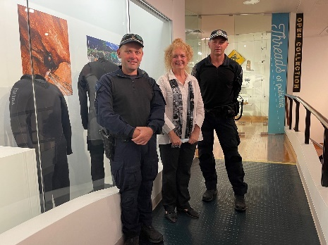  CMAG hosted In Conversation: The Thai Cave Rescue and the Australian Federal Police | - CMAG exhibition Canberra Raiders: 40 Years in the Limelight opened in partnership with the Canberra Raiders.  - Judith Lucy & Denise Scott – Still Here performed in The Playhouse.  - Beneath the Tiger Moon: A Lunar New Year Celebration performed in the Courtyard Studio.  - CMAG hosted In Conversation – The Thai Cave Rescue and the Australian Federal Police in conjunction with CMAG exhibition Threads of Policing (opposite picture).  - CMAG presented a Printmaking Workshop with artist Sally Mumford, for the Winnunga Women’s Group in conjunction with National Gallery of Australia’s touring exhibition Spowers and Syme.  - CMAG acquired five Sidney Nolan works, including three photographs and two enamel paintings on glass, by donation.  - Reel Classics: The Reel McCoy Film Society presented American Gigolo (1980) and Monsoon Wedding (2001) at CMAG.
MARCH 2022  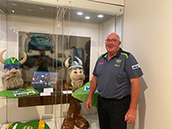  Tony Wood aka ‘Victor the Viking’ giving a free public floor talk as part of the CMAG exhibition Canberra Raiders: 40 Years in the Limelight | - The Canberra Theatre Centre hosted over 20 events as part of the Canberra Comedy Festival.  - Dead Puppets Society’s The Wider Earth performed in The Playhouse.  - The Whitlams performed in the Canberra Theatre.  - CMAG presented CMAG on Saturday: Imaginationscape a workshop for children 6-10 years of age in conjunction with Sidney Nolan.  - CMAG hosted Floor talk: Victor the Viking in conjunction with CMAG exhibition Canberra Raiders: 40 Years in the Limelight (opposite picture).  - Calthorpes’ House hosted Wellbeing Workshop: Nature’s Notes – Pianola Rolls Mixed Media Art and Mugga-Mugga hosted Wellbeing Workshop: Ink Stick Drawing with Naomi Zouwer.  - CMAG hosted CMAG after Dark @ Enlighten Festival to coincide with Enlighten Canberra.
APRIL 2022  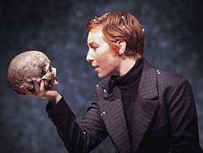  Hamlet – Harriet Gordon-Anderson | - Minister Cheyne opened CMAG exhibition Sidney Nolan: Inferno, which included a VIP event featuring a dance and theatre performance.  - A flu vaccination program was available to all CFC staff.  - Bell Shakespeare performed Hamlet in The Playhouse (opposite picture).  - Lanyon hosted program Stories at Sunset with Tim the Yowie Man; and Kids Week Art: Dreamtime by the River with First Nations host Duncan Smith OAM from Wiradjuri Echoes.  - Mugga-Mugga hosted Wellbeing Workshop: Cyanotypes at Mugga-Mugga Grassland.
MAY 2022  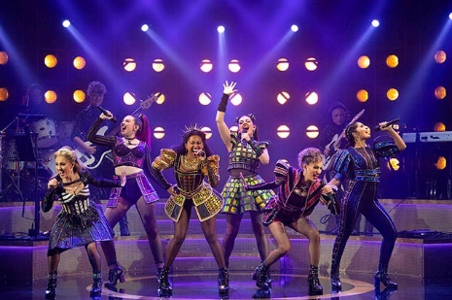  SIX Australian 2021 Cast-Loren Hunter, Chelsea Dawson, Phoenix Jackson Mendoza, Kala Gare, Kiana Daniele, Vidya Makan. Photographer: JAMES D MORGAN-GETTY IMAGES | - Reconciliation Day Eve Concert was held in the Canberra Theatre.  - Canberra Theatre Centre - WEX programme – the Creative Immersion Program. Five-day program for 10 students (Yr. 9-12) exploring theatre arts.  - The Broadway and West End hit Six the Musical performed in the Canberra Theatre attracting large crowds in April and May 2022 (opposite picture).  - Urzila Carlson and Jimeoin: Turn It Up! performed in the Canberra Theatre.  - Back to Back Theatre made their national capital premiere with The Shadow Whose Prey The Hunter Becomes and performed in The Playhouse.  - Reel Classics: The Reel McCoy Film Society presented Coup de Torchon and Mad About Music and It started with Eve.  - CMAG held numerous programs Every Picture Tells a Story in conjunction with The Nolan Gallery.  - Lanyon hosted program Mother’s Day High Tea and Wedding Open Day.
JUNE 2022  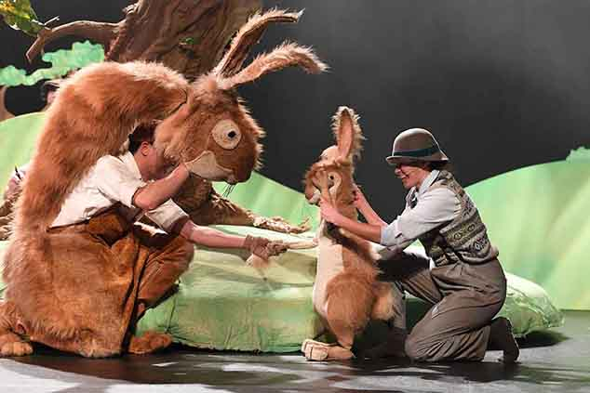  Drew Wilson and Catherine McNamara in Guess How Much I Love You  Photo: James D Morgan | - Guess How Much I Love You performed in the Canberra Theatre (opposite picture).  - CMAG hosted a dance performance by Canberra Dance Theatre’s GOLD dancers Gathering Threads in conjunction with exhibition Connection Point: Contemporary established fibre textile artists of ACT and NSW.  - A new CFC Intranet was launched as a central repository of key information, templates, policies and other documents for staff.  - Australian Dance Collective’s Three performed in The Playhouse, and Canberra Youth Theatre presented the world premiere of The Initiation by Cathy Petocz in the Courtyard Studio.  - Calthorpes’ House held numerous education programs Dawn’s Surprise.

Part B
Organisation Overview and Performance

B.1 Organisational Overview

B.1.1 Vision, mission and values
The CFC’s 2021–24 Strategic Plan provides the overarching framework for the organisation’s planning activities over a five-year period, including for the development of its annual corporate plans.
The Strategic Plan identifies the CFC’s role, vision, key values and principles, and key priorities. It also identifies the mission, purpose, vision and key strategies both for the organisation as a whole and for its three business arms:
- the Canberra Theatre Centre (CTC);
- the Canberra Museum and Gallery (CMAG), including The Nolan Collection; and
the ACT Historic Places: Lanyon, Calthorpes’ House and Mugga-Mugga.

Overarching vision for the CFC
Our vision is for Canberra to be a creative capital that values the arts for their intrinsic qualities, their contribution to building a more inclusive and resilient society, their support for making the city an exciting place to live and an attractive destination for business and tourism, and their important role in the economy of the ACT and region.
We see the CFC as a leader in this creative city, providing high quality cultural experiences based on the arts and heritage resources that we hold in trust for the people of Canberra, and playing a significant role in the region’s cultural and economic life.

Mission
Mission/purpose statements (What we are/What we do) are identified in the Strategic Plan for the CFC as a whole and for each business arm. These are supported by vision statements for each area and statements as to what the CFC is seeking to achieve in a number of areas, as set out below.
CFC
What we are | An enterprise of the ACT Government that manages a number of Canberra’s major cultural facilities
What we do | We connect people with rich and diverse cultural experiences through activities at our venues
Our vision | To provide cultural leadership in the Canberra region and beyond
What we want to achieve | Leadership: A cultural leader in the ACT region and beyond  Strategy: A clear direction for our future  Governance: An accountable and dynamic organization  People: An employer of choice  Finances: Long-term financial sustainability  Assets: Support for delivering high quality cultural experiences
Canberra Theatre Centre
What we are | The Canberra region’s main theatre centre, incorporating the Canberra Theatre, The Playhouse and the Courtyard Studio
What we do | We connect people with theatre experiences of national and international quality
Our vision | To be a leading theatre centre in Australasia and Asia
What we want to achieve | Customers: Audiences that are growing, diverse, engaged and entertained  Programming: A diverse, high quality, entertaining and distinctive program  Business: Venues, systems and people that support high quality live performances  Leadership: An integral part of the cultural life of the Canberra region and beyond
CMAG
What we are | A museum and gallery dedicated to the visual arts and social history of the Canberra region
What we do | We connect people with the Canberra region’s rich and diverse stories, sense of place, and contemporary identity
Our vision | To be a leading regional cultural venue in Australia and beyond
What we want to achieve | Customers: Audiences that are growing, diverse and engaged  Programming: Exhibitions and programs that reflect Canberra’s unique identity  Stewardship: Venues and collections that allow us to tell the many stories of Canberra  Leadership: An integral part of the cultural life of the Canberra region and beyond
ACT Historic Places
What we are | Three historic places that reflect different aspects of Canberra’s history: Lanyon, Calthorpes’ House and Mugga-Mugga
What we do | We connect people with Canberra’s rich and diverse stories and heritage
Our vision | To be leading historic places in Australia and beyond
What we want to achieve | Customers: Audiences that are growing, diverse and engaged  Programming: Programs that explore Canberra’s history by interpreting each place Stewardship: Buildings, grounds and collections that are conserved and researched Leadership: An integral part of the cultural life of the Canberra region and beyond

Key Values and Principles
Leadership
We are committed to providing cultural leadership, excellence and innovation, including leadership in using digital applications to enhance our systems and programs.
Engagement
We actively seek to engage our communities in a greater understanding of the value of the arts, and of our cultural heritage, through our programs and activities, placing customer service as our primary goal and recognising the diverse needs and expectations of our customers.
Collaboration
We value cooperative and strategic partnerships across all areas of our activities.
Professionalism
We place major importance on maintaining professional standards in the management of our facilities and in the design and delivery of our programs.
In observing these values, we are committed to implementing the ACT Government Service Values: respect, integrity, collaboration and innovation. The CFC committed to its role in fulfilling the Statement of Ambition for the Arts 2021 – for Canberra to be recognised as Australia’s arts capital, through the strategies of:
- Create amazing art and culture;
- Develop arts, cultural and creative industry, practice and facilities; and
Promote our arts and culture.

B.1.2 Role, functions and services
The CFC was established under the Cultural Facilities Corporation Act 1997 (the CFC Act), which came into operation as from 1 November 1997.
The functions of the CFC, as set out in the CFC Act (Section 6) are:
- to manage, develop, present, coordinate and promote cultural activities at designated locations and other places in the ACT;
- to establish and research collections;
- to conserve and exhibit collections in the possession or under the control of the CFC;
- to undertake activities, in cooperation with other people if appropriate, to exercise its other functions; and
to exercise other functions given to the CFC under this Act or another Territory Law.
The CFC Act (Section 7) requires that the CFC, in exercising its functions, must consider:
- any cultural policies or priorities of the Executive known to the CFC; and
other cultural activities in the ACT.
The CFC is responsible for:
- the Canberra Theatre Centre (CTC);
- CMAG, including The Nolan Collection; and
the ACT Historic Places: Lanyon, Calthorpes’ House and Mugga-Mugga.
The CFC’s functions therefore include the performing arts, the visual arts, social history and cultural heritage management. The organisation delivers a range of cultural services to the community by providing activities such as theatre presentations, exhibitions, and education and community programs, and through conserving and presenting significant aspects of the ACT’s cultural heritage.
Additional information about the CFC can be found at the following websites:
- www.culturalfacilities.act.gov.au covering whole of CFC matters;
- www.canberratheatrecentre.com.au covering the CTC;
- www.cmag.com.au covering CMAG and The Nolan Collection; and
www.historicplaces.com.au covering the ACT Historic Places.

Clients and stakeholders
During 2021–22, the CFC initially reported to the Minister for the Arts. The Chief Minister, Treasury and Economic Development Directorate (CMTEDD) is the “parent” directorate for the CFC. The CFC’s other clients and stakeholders include:
- the community of the ACT and region;
- visitors to the ACT;
- the arts, cultural, heritage, education, business and tourism sectors, including other cultural organisations;
- national producers of performing arts, including commercial and funded companies;
- the diplomatic community; and
- the media, especially the Canberra media.

B.1.3 Organisational structure, environment and planning framework

Organisational structure
The CFC is organised into three business arms: the Canberra Theatre Centre, CMAG, and the ACT Historic Places, together with a central finance/corporate section. The CFC’s top level organisational chart as at 30 June 2022 is provided below.
Figure B.1.3a CFC Organisational Chart

Organisational environment
During 2021–22, the CFC had close working relationships with a number of ACT Government agencies and entities including CMTEDD, City Renewal Authority, artsACT, Minister’s Creative Council, Major Projects Canberra, Events ACT, ACT Health, Environment, Planning and Sustainable Development Directorate, ACT Government Solicitor, ACT Heritage Council, Access Canberra, ACT Property Group, Territory Records Office, Public Sector Workforce Health, Safety and Wellbeing, Transport Canberra and City Services, ACT Treasury and ACT Audit Office.

Planning Framework
As noted in Section B.1.1, the CFC has adopted a five-year Strategic Plan that provides the overarching framework for the organisation’s planning activities, including for the development of its annual business plans.
The CFC’s 2021–22 Business Plan, based on its 2016–21 Strategic Plan, identified the actions the CFC intended to take during the year to work towards the Strategic Plan. Results relating to these actions are reported in summary in this section and in detail in Section B.2, page 29.
The CFC’s accountability indicators and targets for 2021–22 were identified in the CFC’s 2021–22 Statement of Intent, which was included in the 2021–22 ACT Budget statements. The Statement of Intent also identified the CFC’s strategic objectives and indicators. Results relating to the CFC’s accountability and strategic indicators are reported in summary in this section. Further details about the CFC’s accountability indicators are provided in the 2021–22 Statement of Performance at Attachment 1, page 159 to this report. Further details about the CFC’s strategic indicators are provided in Section B.2, page 29.

B.1.4 Summary of performance in achieving objectives and targets
Performance outcomes for the CFC in 2021–22 were generally higher than expected in the second half of the year, particularly in the months of March, April and May 2022 which saw increased activity in all of CFC’s venues, after emerging from the 2021 lockdowns.
This resulted in the CFC meeting the majority of its accountability indicator targets for 2021–22. For example, during the year the CFC:
- welcomed an estimated 230,910 visitors and patrons to its facilities and programs, a figure 25% above target; and
recorded 474 days in total of venue usage at the Canberra Theatre Centre’s (CTC) venues, a result 18% above target.
The CFC did not achieve its target for the number of exhibitions, with the total of 20 being 26% below target. This was due to CMAG extending the duration of certain exhibitions and deferring others, as a result of the COVID-19 situation.
Detailed performance results and variance explanations are included in the 2021–22 Statement of Performance at Attachment 1, page 159 to this report.

Performance outcomes – Financial Management
The CFC’s overall financial result for 2021–22 was an operating deficit of $1.384m, which was 46.7% lower than the budgeted deficit of $2.592m. It should be noted that, due to its large asset holdings and consequent significant depreciation expenses, the CFC always expects to have an operating deficit as it is not funded for depreciation, but receives capital injections through the capital works program. The lower than estimated deficit was primarily due to supplies and services expenses being below expectations, especially production costs and royalties, as a result of restrictions resulting from the COVID-19 pandemic reducing the volume of the CFC’s theatre activities.
The CFC achieved an own-sourced revenue figure of 36.5% as a proportion of total revenue for
2021–22, against a target of 36.8%. The CFC recorded a result for Cost to Government per estimated visitor/patron of $55.44 against a target of $69.20, the better than target result reflecting the above-target number of visitors and patrons in the second half of the year.
The CFC completed the majority of its 2021–22 capital works and capital upgrade projects by year-end, although certain expenditure on, and funding for, capital projects for ACT Historic Places, CMAG and CTC, was deferred from 2021–22 into 2022–23. This was due to: revised project schedules; delays in obtaining necessary approvals; and COVID-19 related restrictions on interstate contractors and supplies.
A full analysis of the CFC’s financial results and financial position is set out in the Management Discussion and Analysis at Attachment 1, page 149 to this report.

Performance outcomes – Strategic Objectives/Indicators
Strategic Objective 1: The CFC provides cultural leadership in the Canberra region and beyond.
Strategic Indicator 1: The extent to which the CFC connects people with rich and diverse cultural experiences through activities at its venues, in the following areas.
- A smooth recovery from the COVID-19 pandemic
- Throughout the year, the CFC pursued its goal of providing leadership in cultural planning, administration and management, focusing on COVID-19 management.
- The planning and implementation of the CFC’s COVID-19 response was managed through meetings of the CFC COVID-19 Crisis Management Group. The first meeting of year was on the 12 August 2021 in response to the ACT going into lockdown. The response included adapting to COVID-19 restrictions and their impact on capacity limits for activities and events, supporting staff wellbeing during varying levels of COVID-19 restrictions and ensuring COVIDSafe plans were implemented throughout CFC facilities, to keep staff and the community safe.
The CFC continued to report on COVID-19 matters through meetings of the CFC COVID-19 Crisis Management Group and providing updates to the Minister, Board, staff and stakeholders.
- Leadership: A cultural leader in the ACT region and beyond
- A new Chief Executive was recruited in the CFC. Harriet Elvin AM concluded her role as Chief Executive Officer on 10 December 2021 and Gordon Ramsay was appointed as the new Chief Executive Officer commencing on 13 December 2021.
- Throughout the year, as noted in further detail below, the CFC pursued its goal of providing leadership in cultural planning, administration and management, focusing on COVID-19 management and recovery.
- The CFC worked with Major Projects Canberra (MPC) to reduce adverse impacts on the CFC’s city-based facilities from the construction phase of Light Rail Stage 2. The CFC has requested updates from the Light Rail Project Team to include information regarding traffic management, impacts on parking, pedestrian access and noise issues.
- The CFC has led coordination and collaborative work across National Cultural Institutions and local arts organisations, providing a more solid foundation for future joint work in communications, engagement, promotions and potentially programming.
Across each of its business arts, the CFC has focused resources into fostering the creativity of local arts practitioners and organisations. In particular, through the New Works program and active partnerships with local arts organisations, the CTC has supported Canberran creatives in a most difficult period.
- Strategy: A clear direction for the future
- During the year, the CFC’s 2021–22 Business Plan, based on the CFC 2021–24 Strategic Plan, guided the work of the Board, advisory committees, staff and volunteers.
- The 2021–22 Business Plan incorporated priorities to guide the CFC’s operations, with a particular focus on managing the impact of the continuing COVID-19 pandemic.
- Information compiled during the year has been used as the basis for reporting against the 2021–22 Business Plan in this 2021–22 Annual Report.
The CFC 2021-24 Strategic Plan will be reviewed in and will reflect CFC’s involvement in implementation of the Minister’s Statement of Ambition for the Arts, Canberra: Australia’s Arts Capital.
- Governance: An accountable and dynamic organisation
- The CFC maintained robust governance systems to provide a high standard of accountability throughout the year.
- CFC Chair Acting Justice Richard Refshauge and Board member Vicky Darling concluded their roles on 30 June 2021. Deputy Chair, Helen O’Neil was appointed to Chair commencing 1 July 2022. Two new members were appointed: Dr Rachael Coghlan was appointed as Deputy Chair and Michael Sollis as Board member commencing 1 July 2022. Two current Board members, Shad Sears and Genevieve Jacobs, were reappointed to the Board on 16 December 2021 for the period 1 January 2022 to 31 December 2023.
- The renewal process for membership of CFC’s three advisory committees was completed in 2021 in accordance with the procedures set out in the CFC’s Advisory Committees Charter, for the period 1 January 2022 to 31 December 2024.
- The CFC Fraud and Corruption Prevention Plan was approved by the Board at its December 2021 meeting.
The CFC participated in the 2021 Audrey Fagan Board Mentorship Program, providing mentorship for two people from July to December 2021.
- People: An employer of choice
- The CFC focused on attracting, developing and retaining highly skilled staff and volunteers, and on ensuring its sites are safe and rewarding places to work.
- COVIDSafe plans were developed and implemented for all CFC venues. Procedures and precautions were put in place to ensure activities operated safely to protect staff, patrons and visitors. COVIDSafe plans were updated throughout the year to meet specific business requirements and changing COVID-19 restrictions.
- CFC staff were provided with Mental Health and Wellbeing resources throughout the year. The ACT Government Healthy Minds – Thriving Workplace Strategy 2019–22 continued to be implemented throughout the year to assist staff with mental health and wellbeing during the COVID-19 pandemic. Staff had to rapidly adapt to changes in the workplace, such as working from home, returning to work, and adapting work arrangements as CFC reopened venues and sites. Staff had access to the ACT Government Work health and safety during COVID-19 SharePoint site and provision of resources around managing lockdown fatigue, physical health and wellbeing to support working from home such as a virtual physiotherapy service, and coping with anxiety about restrictions easing.
- CFC was represented in whole-of-government enterprise bargaining by the Chief of Staff, with agency-specific claims ideas being canvassed within CFC by a consultative committee of staff representing all areas of the CFC. The CFC also participated in whole-of-government Secure Work Conversion Round 2 with the result of one temporary and two casual staff members being found eligible for conversion to permanent roles.
The CFC implemented a number of measures to improve communication, collaboration, and consultation with and between staff including creating a CFC intranet site, encouraging more effective work area meetings, holding all-staff townhall meetings, and measured use of all staff emails.
- Finances: Long-term financial sustainability
- In 2021–22 the CFC maintained high standards of financial management and reporting, with a focus throughout the year on oversight of the impact of the COVID-19 pandemic on the organisation’s finances.
- The audit of the CFC’s 2021–22 Financial Statements by the ACT Auditor-General resulted in an unmodified audit.
- The Government provided additional COVID-19 Response funding of $2.517 million to the CFC in 2021-22 to enable it to continue its operations and to keep employing its staff during the COVID-19 pandemic.
The CFC developed high-quality bids for the 2022–23 ACT Budget leading to major funding for the Canberra Theatre Centre expansion and redevelopment plus new works funding for Lanyon Upgrades.
- Assets: Support for delivering high quality cultural experiences
- High quality asset management continued to be a key priority for the CFC during 2021–22, in view of its responsibility for major cultural sites.
- The CFC is currently reviewing a systematic approach to provide the necessary skills and training to all staff through the whole-of-government e-learning platform and by other means. E-learning will be available to most staff in 2022–23 to undertake core training.
The CFC’s Resource Management Plan continued to provide the framework for the CFC’s sustainability and energy efficiency practices.
Further details regarding outcomes against Strategic Objective 1 and Strategic Indicator 1 are provided under Section B.2, page 29.
Strategic Objective 2: The Canberra Theatre Centre is a leading theatre centre in Australasia and Asia.
Strategic Indicator 2: The extent to which the Canberra Theatre Centre connects people with theatre experiences of national and international quality, in the following areas.
- A smooth recovery from the COVID-19 pandemic
The Canberra Theatre Centre (CTC) continued meetings with ACT Health during its emergence from lockdown and the reopening of theatres. Conversations with ACT Health also ensured support of visiting companies and ongoing COVIDSafe operations.
During lockdown, the CTC continued to send a weekly e-newsletter, focusing on at-home content showcasing artists and performers associated with the CTC. With a range of engaging content, we maintained our newsletter’s average open rate.
During the recovery period, the CTC’s newly created New Works program supported local artists. New works including David Atfield’s Chiaroscuro and Jake Silvestro’s December premiered at the CTC, showcasing local excellence to Canberra audiences.
- The CTC committed extensive marketing support to presenters from outside of the region. This helped to achieve ticket sale objectives, utilising our large database and engaged social media following.
- Customers – Audiences that are growing, diverse, engaged and entertained
- The CTC continued to act in accordance with ACT Health Guidelines and utilised a range of communicate methods to do this successfully. The CTC sends all patrons attending the Theatre an “info email” that outlines COVID-19 safety, and traffic/construction information ahead of their arrival.
- The CTC continued work on the procurement of a Ticketing and customer relationship management system, a Probity Advisor was engaged, and the procurement went to market with a Request for Proposals in the final quarter of the year. The successful tenderer is expected to be confirmed in the first part of 2022–23.
- The programming team initiated work around its strategy during this financial year, and a key focus remains on the provision of public programs that support and enhance the overall patron experience. Work has commenced in reviving these opportunities that were paused during the pandemic due to capacity limits, and COVIDSafe operations.
- The CTC held a “2022 launch event” for frequent attendees, where they were introduced to more than 29 productions, including 12 brand new productions, five company debuts, 10 premiere seasons, and two major musical productions.
- Programming – A diverse, high quality, entertaining and distinctive program
- The CTC continued its commitment to support and nurture youth arts programs in the ACT through investing in presentations from local Youth Arts Organisations such as QL2’s major work Terra Firma, and a number of performances from Canberra Youth Theatre including: The Initiation; Two Twenty Somethings Decide Never To Get Stressed About Anything Ever Again. Ever; and Dags.
- The CTC invested in and showcased the works of local artists including: Jake Silvestro’s December; Fred Smith’s Charity Concert to Welcome Afghanistan Refugees to Canberra; and Mikelangelo and the Black Sea Gentlemen’s David Branson Memorial Show.
- The CTC presented major touring productions including:
- Bangarra Dance Theatre’s Sandsong;
- Opera Australia’s Carmen;
- Bell Shakespeare’s Hamlet;
- Sydney Theatre Company’s White Pearl; and
- Louise Withers and Associates’ Six the Musical.
- The CTC co-presented with Soft Tread Enterprises, the world premiere season of The Wharf Revue: Can of Worms, and attracted the world premiere season of Hannah Gadsby’s Body of Work with three sold out performances.
- The CTC continued its commitment to First Nation’s programming. Presentations included sold out performances of Bangarra Dance Theatre’s Sandsong, Joel Bray’s I Liked It...But I Didn’t Know What the F#!k It Was About, and the return of the highly celebrated Reconciliation Day Eve Concert that featured the music of First Nations artists including Christine Anu, BRIGGS, and Electric Fields.
A Strategic review of the CTC’s programming strategy was undertaken in November 2021. The strategy is complementary to the ACT Arts Minister’s Statement of Ambition, and identifies the three key priorities of Aspiration, Connection and Collaboration to be the drivers in our programming decisions.
- Business – Venues, systems and people that support high quality live performances
- The CTC undertook the first year of a three-year program of upgrades, to enhance the safety of patrons, ensure a high level of WHS standards for staff, enhance security infrastructure, and implement other essential works. Works completed in year one includes the installation of new carpet, stair nosing and tactile indicators. Further studies were undertaken regarding access improvements for the Canberra Theatre auditorium and additional wheelchair seating locations, and WiFi hearing augmentation projects were initiated.
- Better Infrastructure Funding was utilised for the replacement of a forklift and to support the foyer carpet project.
- The marketing of Canberra Ticketing will be further expanded following the outcome of the ticketing system procurement.
- Leadership – An integral part of the cultural life of the Canberra region and beyond
- The CTC continued to attend and participate in New Theatre Project Steering committee meetings. The CTC contributed to studies with the CRA that formed the CRA’s Vision for the Canberra Civic and Culture District document. The CTC worked collaboratively with MPC on the development of the business case for progressing detailed designs for the new Theatre project.
Further details regarding outcomes against Strategic Objective 2 and Strategic Indicator 2 are provided under Section B.2, page 29.
Strategic Objective 3: CMAG is a leading regional cultural venue in Australia and beyond.
Strategic Indicator 3: The extent to which CMAG connects people with the Canberra region’s rich and diverse stories, sense of place, and contemporary identity, in the following areas.
- A smooth recovery from the COVID-19 pandemic
- Following the COVID-19 lockdown on 12 August 2021, CMAG reopened to the public on 29 October 2021. The reopening was supported by a COVIDSafe Plan which continued to be reviewed and updated throughout the year.
- CMAG reopened with new exhibitions, Mandy Martin From Queanbeyan to New York: 1978-1984 / Art & Life and Brenda L. Croft: ‘hand/made/held/ground’.
The MakerSpace and ReaderSpace activities for families with children were reintroduced in the CMAG foyer with modified offerings to align with Public Health Directions.
- Customers: Audiences that are growing, diverse and engaged
- CMAG’s reopening, framed by the COVIDSafe Plan ensured that visitors understood the additional cleaning, contact tracing and physical distancing measures implemented providing a safe and welcoming environment.
- CMAG continually seeks to improve customer satisfaction with their visit to, and experience of, CMAG, with surveys available to complete online and onsite. Surveys were sent via scheduled email to invite feedback from participants after an event.
- Funding was secured in the 2021–22 Budget to enhance CMAG’s accessibility for people living with disabilities and to undertake a range of physical improvements such as:
- the Open Collection access ramp upgrade works completed in April 2022; and
- audio descriptions developed for key works in the Ruth Lane-Poole: A Woman of Influence and Mandy Martin From Queanbeyan to New York: 1978-1984 / Art & Life exhibitions.
- Programming: Exhibitions and programs that reflect Canberra’s unique identity
- CMAG presented a high quality exhibition program in 2021–22 that reflected the diverse interests of the Canberra community. New exhibitions presented during the year included: Ruth Lane-Poole: A Woman of Influence; Mandy Martin From Queanbeyan to New York: 1978–1984 / Art & Life; Brenda L. Croft: ‘hand/made/held/ground’; Canberra Raiders: 40 Years in the Limelight; and Back to the Boombox.
- CMAG presented several exhibitions of The Nolan Collection throughout the year, including Finding the dry heart: Sidney Nolan’s early travels in Central Australia and Sidney Nolan: Inferno.
Community and learning programs were held in association with exhibitions such as Connection Point: Contemporary established fibre textile artists of ACT and NSW included a CMAG After Dark event, a textile workshop for adults led by artist Sharon Peoples, a workshop for children CMAG on Saturday: Plastic Painting, a creative dementia workshop, a curator talk with Virginia Rigney, a children’s program CMAG on Saturday: Stitch Stories and a dance performance by Canberra Dance Theatre’s GOLD dancers.
- Stewardship: Venues and collections that allow us to tell the many stories of Canberra
- During 2021–22, CMAG undertook works to improve Work, Health and Safety standards and accessibility such as the Open Collection access ramp upgrade works were completed. These upgrade works included a change in material and texture to better support visitors affected by dementia or with accessibility requirements.
- Research was undertaken by CMAG’s Visual Arts and Social History curatorial staff, and essays written for the forthcoming publication about CMAG’s permanent collection.
- During the year, CMAG continued to conserve, research, interpret and manage the Nolan Collection under the Nolan Management Agreement with the Commonwealth.
The Nolan Gallery at CMAG was refreshed and rehung, with five works removed from display to prepare for travel on loan to the Heide Museum of Modern Art. Condition reports were prepared for the loaned works.
- Leadership: An integral part of the cultural life of the Canberra region and beyond
- In support of CMAG’s initiative to enhance CMAG’s presence and profile on London Circuit and Civic Square, new street level signage advertising CMAG was installed on the glazing of the former restaurant tenancy.
- Repainting of the Civic Square CMAG external courtyard was completed.
- Architecture and design firms have been engaged to begin work on fit out requirements for two currently empty North Building ground floor tenancies to create a new digital gallery and new retail and collaboration spaces.
- The ongoing relationship with Heide Museum of Modern Art continued. Works from the Nolan Foundation Collection were loaned for the exhibition Sidney Nolan: Search for Paradise.
Further details regarding outcomes against Strategic Objective 3 and Strategic Indicator 3 are provided under Section B.2, page 29.
Strategic Objective 4: The ACT Historic Places are leading historic places in Australia and beyond.
Strategic Indicator 4: The extent to which ACT Historic Places connects people with the Canberra rich and diverse stories and heritage, in the following areas.
- A smooth recovery from the COVID-19 pandemic
- Following the end of the COVID-19 lockdown on 12 August 2021, ACT Historic Places (ACTHP) managed the reopening of its sites to the public with Lanyon reopening on 28 October 2021, Calthorpes’ House on 30 October 2021 and Mugga-Mugga on 6 November 2021.
- Revised COVID-19 restrictions allowed properties to open, allowing internal tours, with limited group sizes and COVIDSafe requirements in place.
- Learning programs recommenced in May 2022. Learning programs were initially modified to meet COVID-19 requirements; however, as restrictions relaxed, modifications to programs and group rotations saw an ability for extended group sizes.
- Public programs recommenced in November 2021, with events held regularly from March 2022 onwards. First public program held after the COVID-19 lockdown was Wildflowers & Grasslands at Mugga-Mugga Cottage.
Strong digital marketing and use of social media during lockdown aimed to create public engagement in the COVID-19 lockdown period. This included series of stories and posts about the history, collection, landscape and people at each property.
- Customers: Audiences that are growing, diverse and engaged
- Throughout the year, ACTHP focused on providing high-quality experiences for its customers, resulting in an 95% approval rate.
- In 2021–22, ACTHP welcomed 40,068 visitors to Lanyon, Calthorpes’ House and Mugga-Mugga. This included 1,958 attending 133 learning programs; 2,567 visitors participating in 671 museum tours; attendees at 17 public programs, and guests at venue hire events.
16 volunteers provided 705 volunteer hours across all three properties in 2021–22.
- Programming: Programs that explore Canberra’s history by interpreting each place
- ACTHP provided a broad range of activities that increased people’s understanding and enjoyment of Lanyon, Calthorpes’ House and Mugga-Mugga, their collections, and landscape settings.
- ACTHP developed and trialled a pilot virtual excursion for Kindergarten to Year 2 primary students that focused on grasslands and landscape of Mugga-Mugga; and trialled an online Artefact Chat learning program. Discussions have commenced on secondary school engagement and a range of subject themes including geography and visual arts have been considered.
As part of Canberra and Region Heritage Festival, Kids Week Workshops, Making Clay Seed Pods with Fran Romano at Lanyon; and Dreamtime by the River with Duncan Smith from Wiradjuri Echoes at Lanyon were held.
- Stewardship: Buildings, grounds and collections that are conserved and researched
A range of activities was undertaken throughout the year to conserve, research and interpret the Historic Places.
The restoration of the Lanyon Cemetery was completed including replacement of the existing fence, significant landscape works and conservation cleaning and repainting of lettering on the gravestones.
- Development of tree management strategies has commenced for each property. A budget bid was submitted to Treasury and collation of previous work and data on trees was collated, with a strategic project plan under development.
- Over 3,700 documents and images have been scanned including the Cunningham photographs associated with Lanyon and several historic documents for Mugga-Mugga.
Implementation of the monitoring program as required by the Grasslands Management Plan for Mugga-Mugga by Sarah Sharp is supporting regrowth of listed native grasslands on the site.
Leadership: An integral part of the cultural life of the Canberra region and beyond
- ACTHP was part of the National Experience Content Initiative with Tourism Australia/Visit Canberra. This included creating photographic and video marketing collateral for Lanyon, Calthorpes’ House and Mugga-Mugga for Tourism Australia and the CFC.
- Lanyon remained a popular venue for functions and weddings—seven weddings were held in 2021-22 and Lanyon was the finalist in the 2021 Brides Choice awards for historic venues.
- ACTHP maintained and developed partnerships with other relevant education, government and non-government organisation and institutions. These included:
- erosion Management with ACT Parks and Conservation in the river corridor;
- collaboration with EventsACT regarding public programs including as a Floriade community partner;
- discussions with CraftACT and Contour 556 about participation in Design Canberra Festival and Contour 556 expanded program; and
- developing a project with University of Canberra to co-design research-based museum programs that use heritage sites and museum collections to support people and families affected by dementia.
Further details regarding outcomes against Strategic Objective 4 and Strategic Indicator 4 are provided under Section B.2, page 29.

B.1.5 Outlook

Current and future priorities
During the year, the CFC’s 2021–24 Strategic Plan, guided the work of the Board, advisory committees, staff and volunteers and identifies the following six key priorities for this period.
- Progress the development of a major new theatre for the nation’s capital
- Work with other agencies to refine planning for a fit-for-purpose, audience-focused venue.
- Build towards this new venue through programming large scale productions and through creative partnerships at local, regional, national and international levels.
- Expand and enhance CMAG
- Extend CMAG’s facilities and programs within North Building.
- Enhance CMAG’s presence and profile on Civic Square and London Circuit.
3. Position the Canberra Civic and Culture District as a premier cultural location
- Grow the District as the vibrant creative heart of Canberra.
- Place the new theatre as its centrepiece and an enhanced CMAG as a key aspect.
4. Celebrate the multi-layered heritage values and cultural relevance of ACT Historic Places
- Highlight their contemporary relevance and their role in enhancing community wellbeing.
- Develop innovative programming and increased business and tourism opportunities.
5. Promote Indigenous engagement and reconciliation
- Create partnerships with First Nations peoples.
- Reflect the CFC’s commitment to Indigenous engagement and reconciliation through Reconciliation Action Planning.
6. Deliver cultural leadership for the ACT region, including in COVID-19 recovery
- Position the CFC as a leader in the region’s creative recovery from COVID-19.
- Advocate for the value of arts and heritage to community wellbeing and the economy.
In addition to implementing actions towards the six key priorities identified above, other specific issues to be pursued by the CFC in 2022–23 include the following, to the extent that these can be progressed within restrictions arising from the COVID-19 situation.
- Encourage visitation to, access to, and patronage of, the CFC’s facilities, programs and collections.
- Present exhibitions, learning and community programs, including outreach activities and partnership programming.
- Present a varied program of performing arts productions, including by attracting major theatre presentation to Canberra.
- Undertake the second year of a three-year program of upgrades for the Canberra Theatre Centre (CTC), in order to enhance accessibility and safety for patrons, ensure a high level of Work Health and Safety standards for staff, enhance security infrastructure, and implement other essential works.
- Develop design and undertake extensive stakeholder and community consultation for the CTC expansion and redevelopment of a new theatre.
- Undertake the last year of a two-year package of works at CMAG to improve Work Health Safety standards and accessibility, together with the last year of a further two-year package of works and initiatives to enhance CMAG’s presence and profile on London Circuit and Civic Square, to develop the Canberra Civic and Culture District as a premier cultural precinct.
- Continue to implement a program of infrastructure upgrades at Lanyon, Calthorpes’ and Mugga-Mugga, to facilitate effective business operations and achieve high standards of Work Health and Safety, undertaking building stabilisation measures, and upgrading security infrastructure and ICT connectivity.
- Undertake ongoing programs of other infrastructure upgrades and capital projects, in order to ensure the CFC’s cultural facilities remain fit for purpose and support the delivery of high-quality cultural experiences.
- Lead a collaborative approach to audience development, visitor attraction, and cooperative programming with other arts organisations across the ACT including the National Cultural Institutions.
Work with the City Renewal Authority (CRA) and other Civic Square stakeholders on enlivening the square through joint events and arts activation.
Apart from the areas identified above, the main ongoing priority of the CFC is to provide cultural leadership by promoting the value of a vibrant cultural life for community wellbeing, for economic development, and for the ACT’s recovery from the COVID-19 pandemic, and by creating opportunities for all Canberrans to engage with the arts.

Current and future challenges
2021–22 was a challenging year for the CFC as a result of the impacts on its operations of restrictions from the COVID-19 pandemic. Major aspects are summarised below, with further details provided in Section B.2, page 29. Managing impacts for the CFC of the COVID-19 pandemic will remain a key challenge for the organisation in 2022–23.
Venues
Following the closure of all CFC venues on the 12 August 2021 and the easing COVID-19 restrictions in late October 2021, the CFC undertook a phased reopening. Lanyon and CMAG opened on 29 October 2021, Calthorpes’ House opened 30 October 2021, CTC Box Office recommenced on site operations 1 November 2021 and Mugga-Mugga opened 6 November 2021. All venues remained open for the rest of 2021–22 subject to occupancy levels, program and activities.
Programs and activities
During the year, activities at all sites were guided by health-related restrictions, with COVIDSafe plans reviewed and updated to address the changing requirements.
- CTC
CTC hosted a series of events and activities that gradually increased in size over the course of the year. From 12 November 2021, the CTC was able to accommodate audiences at 100% capacity.
- CMAG
CMAG hosted a series of activities that gradually increased in size over the course of the year. In the second part of the year, CMAG had increased audience sizes in its venues, and welcomed school students back to learning programs.
- ACT Historic Places (ACTHP)
ACTHP hosted a series of activities that gradually increased in size over the course of the year. In the second part of the year, ACTHP had increased audience sizes at its sites and welcomed school students back to learning programs.
Staffing
The health and wellbeing of the CFC’s staff and volunteers were a priority during the year, with the reopening of venues and the rebuilding of activities.
CFC staff were provided with Mental Health and Wellbeing resources throughout the year. The ACT Government Healthy Minds – Thriving Workplace Strategy 2019–22 continued to be implemented throughout the year to assist staff with mental health and wellbeing during the COVID-19 pandemic. Staff had to rapidly adapt to changes in the workplace, such as working from home, returning to work, and adapting work arrangements as CFC reopened venues and sites. Staff had access to the ACT Government Work health and safety during COVID-19 SharePoint site and provision of resources around managing lockdown fatigue, physical health and wellbeing to support working from home such as a virtual physiotherapy service, and coping with anxiety about restrictions easing.
Management of, and reporting on, COVID-19 impacts on the CFC
The CFC’s senior management team met as the CFC’s COVID-19 Crisis Management Group on 12 August 2021 in response to the ACT going into lockdown. The response included adapting to COVID-19 restrictions and their impact on capacity limits for activities and events, supporting staff wellbeing during varying levels of COVID-19 restrictions, and ensuring COVIDSafe plans were implemented throughout CFC facilities to keep staff and the community safe.
Throughout the year, regular reporting was provided to the CFC Board on COVID-19 matters, including on financial impacts of the situation.
Economic impact
The main continuing challenge for the CFC remains the variability and unpredictability of the performing arts business, which impacts directly on the CFC's main non-government income source, its theatre-related revenues.
In addition to addressing impacts arising from the COVID-19 situation, there are a range of challenges relating to business operations.
Potential disruption to CFC’s city-based facilities from the construction phase of Light Rail Stage 2
CFC coordinates with Major Projects to seek to minimise the impact of the construction phase of Light Rail Stage 2 on the CFC’s city-based facilities. The CFC receives periodic updates from the Light Rail Project Team to include information regarding traffic management, impacts on parking and pedestrian access, and noise issues.
New Theatre Project and Civic Square
CFC is excited to be embarking on the next, significant stage of the redevelopment of the CTC. Our focus will include ensuring engagement and future engagement of CFC’s patrons and visitors whilst the redevelopment is designed, planned and executed.
The CFC continued its collaborative preparatory work on the New Theatre Project with the Major Projects Canberra (MPC) and the CRA. Works included:
- participation in Canberra Theatre Steering Committee meetings, with MPC, CRA, and ArtsACT;
- consultation with the CRA on planning for the Canberra Civic and Culture District; and
planning with MPC for detailed design and consultation stages of the project, including a contemporisation review.
CFC will, in conjunction with its partners and stakeholders, work to progress this project alongside and in harmony with ongoing enhancement of Civic Square, seeking to build public engagement in the space flanked by two of the designated locations under the CFC Act.
Capital works projects
The constraints on the construction industry in and beyond the ACT place pressure on CFC in the delivery of its broad capital works program. CFC is drawing on specific skills and the whole of organisation focus to mitigate the challenges in this area.

B.1.6 Internal Accountability

Leadership Team of the CFC
During 2021–22, the leadership team of the CFC comprised the following positions:
- Chief Executive Officer;
- Chief Finance Officer;
- Chief of Staff;
- Director, Canberra Theatre Centre;
- Director, CMAG; and
Director, ACT Historic Places.
The names and information about the occupants of these positions are provided at Appendix 1, page 84 (for the Chief Executive Officer, as a CFC Board member) and Appendix 2, page 87 (for the other five leadership team positions).
The responsibilities of each leadership team position are reflected in the organisational chart at page 15. Further information relating to the structure of the organisation is provided at Section B.1.3, page 15.
The team members meet as a Senior Leadership Team every fortnight to discuss strategic, operational, financial and collaboration matters. Other significant committees of the CFC include the WHS Committee (refer to Section B.10, page 68), the Agency Consultative Committee (refer to page 70), and the Security Executive Group (refer to page 27). The CFC established in March 2020 a CFC COVID-19 Crisis Management Group, comprising the CEO and senior managers, which continued to meet as needed in 2021–22.
Board of the CFC
- Composition
Section 10 of the CFC Act provides for the CFC Board to have seven members.
The Chair, Deputy Chair, and four Members of the CFC Board are appointed by the Minister in accordance with the provisions of the Financial Management Act 1996 (the FM Act), Sections 78–79. The CFC’s Chief Executive Officer is also a Member of the CFC Board in accordance with Section 80 of the FM Act.
The functions of the Chair, Deputy Chair, Chief Executive Officer, and associated provisions relating to Board Members, are set out in the FM Act (Division 9.3).
Details of the CFC Board’s membership and remuneration during 2021–22 are provided at Appendix 1, page 84.
- Meetings
The CFC’s Board meetings are convened and conducted in accordance with the provisions of the FM Act (Division 9.4).
A schedule of the CFC’s Board meetings held during 2021–22, and information about attendances at these meetings, are at Appendix 1, page 84.
Board Charter
The Board has adopted a Board Charter to guide its operations and performance. This is available at http://www.culturalfacilities.act.gov.au.
Audit Committee of the Board
The CFC has established the Audit Committee as a sub-committee of the Board, with a formal charter setting out its role and functions in relation to oversight of financial, audit, and compliance matters, including risk management and internal controls.
The Audit Committee Charter is provided as Part G of the CFC Board Charter, available at http://www.culturalfacilities.act.gov.au. Membership details and a schedule of meetings held during 2021–22 are provided at Section B.5, page 64.
Advisory Committees
The CFC has established three Advisory Committees, in accordance with Section 8 (i)(a) of the CFC Act, to provide expert strategic advice in relation to their respective specialist areas.
The committees include:
Name of Committees | Role of Committees
CMAG Advisory Committee | To provide the CFC Board with expert strategic advice, within the context of the CFC’s Strategic Plan for 2016–21 and its annual Corporate Plans.  The committees provide expert advice and assistance on a voluntary basis. This support is valuable in contributing to the CFC’s policy development, business planning and community participation activities.
Historic Places
Advisory Committee
Canberra Theatre Centre Advisory Committee

The CFC commenced the process for a full renewal of the membership of the committees in 2021. This resulted in new appointments being made to the committees in the first half of 2021–22, for a full three-year term from 1 January 2022 to 31 December 2024.
Individual advisory committee meetings were then held during 2022.
In 2021–22, members of the three advisory committees attended for approximately 24 hours of time in total.
The operation of the advisory committees is governed by an Advisory Committees Charter, which is available at http://www.culturalfacilities.act.gov.au.
Details about Advisory Committee memberships, together with information about advisory committee meetings held during 2021–22, are provided at Appendix 3, page 89.
Further information about the operation of the advisory committees is provided under Section B.2, page 29.

B.2 Performance Analysis
The CFC’s 2021–22 Statement of Intent was prepared in accordance with Section 61 of the Financial Management ACT 1996 and published in the 2021–22 ACT Budget statements. The Statement of Intent identified the CFC’s strategic objectives and indicators. Performance against these is summarised under Section B.1.4, page 16.
The 2021–22 Statement of Intent also identified targets for the CFC’s accountability indicators, which represent the CFC’s key performance indicators. A detailed analysis of outcomes against these targets is presented in the CFC’s 2021–22 Statement of Performance at Attachment 1, page 159, with a summary provided under Section B.1.4, page 16.
To allow an understanding of trends relating to these key performance indicators, charts are presented below of results for the indicators from 2018–2022.
Figure B.2a: Estimated number of visitors/patrons to CFC facilities/programs
2021–22 continued to see impacts on visitor/patron numbers due to the COVID-19 pandemic. The outcome for 2021–22 was, however, higher than expected due to an improvement in visitor/patron numbers in the second part of the year, particularly in the months of March, April and May 2022 with just under 106,000 visitor/patron numbers in this period. The result for the year was 25% above target.
Figure B.2b: Number of exhibitions at facilities managed by the CFC
The outcome of 20 exhibitions for 2021–22 was lower than the target of 27. The below-target outcome in 2021–22 was due to CMAG extending the duration of certain exhibitions and deferring others as a result of the COVID-19 pandemic. Exhibitions such as Spowers and Syme, Canberra Raiders: 40 years in the limelight and Back to the Boombox were extended.
Figure B.2c: Numbers of education and community programs provided by the CFC
2021–22 continued to see an impact on program provision due to COVID-19 restrictions on activities. Demand for education and community programs was, however, strong in the second part of the year when the easing of COVID-19 restrictions allowed the resumption of programs. This led to the outcome of 231 programs being 5% above target.
Figure B.2d: Number of days venue usage at the Canberra Theatre Centre’s venues
Above target usage rates were achieved for the venues of the Canberra Theatre Centre in 2021–22 particularly in the second part of the year. There were 470 days of venue usage, 18% above target.
Figure B.2e: Customer satisfaction with quality of services provided by the CFC, as measured by annual survey
Customer satisfaction levels over the past four years have been above target, reflecting attempts by each venue to achieve as high a standard as possible. The level for 2021–22 was 94%, 4% above target.
Figure B.2f: Cost to Government per estimated visitor/patron to CFC facilities/programs
A rise in the cost to Government figure experienced in 2020–21 continued and increased in 2021–22, due to lower visitor/patron numbers resulting from the COVID-19 pandemic and the provision of special COVID-19 funding. The outcome for the year of $55.44 was, however, better than the target of $69.20. This was due to higher than expected visitor/patron numbers in the second half of the year, allowing greater capacity at venues.
Figure B.2g: Own Sourced Revenue as a Proportion of Total Revenue for the Corporation
The major impact of the COVID-19 pandemic on own sourced revenue , which commenced in 2019–20, was still evident in 2021–22. The result for the year was 36.5%, against a target of 36.8%.

CORPORATE/FINANCE/HR
AT A GLANCE
FULL TIME EQUIVALENT  STAFF  90   | QUALITY OF SERVICE  94%  of visitors satisfied with quality of the CFC’s services | FINANCE  8,776 transactions processed for payments totalling more than $9.79 million    GENDER COMPOSITION OF CFC WORKFORCE  Female 61%  Male 39%  CFC WORK HEALTH AND SAFETY COMMITTEE MEETINGS    22 staff participated throughout the year
ADVISORY COMMITTEES  17 members attended for  24 hours in 2022    OWN SOURCED REVENUE  36.5% | PAYROLL  5,658  individual pays  CASUAL STAFF  70 casuals employed throughout the year

The following section analyses in detail the organisation’s performance against the CFC, Canberra Theatre Centre (CTC), CMAG and ACT Historic Places (ACTHP) mission/purpose statements as set out in the CFC’s 2021–22 Business Plan, which in turn is based on the CFC’s 2021–24 Strategic Plan.
In each case, the start of the section (What we are, What we do and Our vision) and the shaded areas (Strategies to achieve this) set out the long-term strategies identified in the 2021–24 Strategic Plan.
The next area contains the key outcomes achieved against these strategies during the course of 2021–22. Some of the key outcomes were not fully achieved in 2021–22 due to restrictions relating to COVID-19 impacting on the CFC’s operations.
For 2021–22, each section also includes a summary of COVID-19 management and recovery actions.

B.2.1 Cultural Facilities Corporation (CFC)
What we are: an enterprise of the ACT Government that manages a number of Canberra’s major cultural facilities
What we do: we connect people with rich and diverse cultural experiences through activities at our venues
Our vision: to provide cultural leadership in the Canberra region and beyond
A smooth recovery from the COVID-19 pandemic
Strategies to achieve this:
- Manage through, and recover from, the COVID-19 pandemic, ensuring that, to the extent possible:
- negative impacts of COVID-19 on the CFC’s venues and operations are minimised;
- positive impacts are retained and built upon;
- the CFC’s financial sustainability is maintained; and
- the CFC provides cultural leadership in the recovery from COVID-19.
Key outcomes in 2021–22 against the above strategies
- Throughout the year, the CFC pursued its goal of providing leadership in cultural planning, administration and management, focusing on COVID-19 management.
- The planning and implementation of the CFC’s COVID-19 response was managed through meetings of the CFC COVID-19 Crisis Management Group. The first meeting of year was on 12 August 2021 in response to the ACT going into lockdown. The response included adapting to COVID-19 restrictions and their impact on capacity limits for activities and events, supporting staff wellbeing during varying levels of COVID-19 restrictions, and ensuring COVIDSafe plans were implemented throughout CFC facilities to keep staff and the community safe.
- The CFC continued to report on COVID-19 matters through meetings of the CFC COVID-19 Crisis Management Group and providing updates to the Minister, Board, staff and stakeholders.
Further specific outcomes relating to COVID-19 are identified below.

Leadership – A cultural leader in the ACT region and beyond
Strategies to achieve this:
- Provide cultural leadership in the ACT region’s creative recovery from COVID-19.
- Play a leading role in developing the Canberra Civic and Culture District, in partnership with the City Renewal Authority (CRA) and other agencies.
- Work with Major Projects Canberra (MPC) to reduce negative impacts, and promote positive outcomes, for the CFC’s city-based operations from Light Rail Stage 2.
Provide leadership in cultural planning and management, including through creative partnerships; through a commitment to Indigenous engagement and reconciliation; and by demonstrating the importance of arts and heritage to individual and community wellbeing.
Key outcomes in 2021–22 against the above strategies
- A new Chief Executive Officer (CEO) was recruited in the CFC. Harriet Elvin AM concluded her role as Chief Executive Officer on 10 December 2021 and Gordon Ramsay was appointed as the new Chief Executive Officer commencing his role on 13 December 2021.
- Throughout the year, the CFC pursued its goal of providing leadership in cultural planning, administration and management, focusing on COVID-19 management and recovery.
- The CFC continued to work closely with the CRA, MPC and other ACT Government agencies in developing the Canberra Civic and Culture District as a premier cultural precinct.
- During the year, the CFC liaised with the CRA on:
- the Conservation Management Plan (CMP) for the Civic Square Precinct which was finalised and submitted for Heritage Council approval;
- activation of North building ground floor spaces;
- the economic and social analyses of the Canberra Civic and Culture District, to inform broader planning and funding options for this future project;
- focussing on the draft Vision for the Canberra Civic and Culture District; and
the new theatre project including master planning consultancy and early design work.
- The CFC Board Executive met regularly with the CRA Board throughout the year.
- The CFC worked with MPC to reduce adverse impacts on the CFC’s city-based facilities from the construction phase of Light Rail Stage 2. The CFC has requested updates from the Light Rail Project Team to include information regarding traffic management, impacts on parking, pedestrian access and noise issues.
- Partnerships were maintained with the Minister’s Creative Council and the Childers Group through participation of the CFC Board Member and Council Chair, Genevieve Jacobs. Her tenure as the Chair of the Minister’s Creative Council ended in June 2022.
- Throughout the year, CFC staff participated in a range of activities with peak cultural and tourism bodies, including conferences and meetings of the Canberra Region Tourism Advisory Forum, the Australian Museums and Galleries Association and the Art Association of Australia and New Zealand.
For details regarding initiatives to support the inclusion of Aboriginal and Torres Strait Islander people in CFC governance and staffing, please refer to section B.9, Aboriginal and Torres Strait Islander reporting, page 66.

Strategy – A clear direction for our future
Strategies to achieve this:
- Ensure our Strategic Plan remains relevant and current as the framework for the CFC’s strategic directions.
- Use our Strategic Plan to guide the work of the Board, advisory committees, staff and volunteers, and to guide how we communicate with our stakeholders.
Use our Strategic Plan as the basis for annual business plans, and for regular reporting.
Key outcomes in 2021–22 against the above strategies
- During the year, the CFC’s 2021–22 Business Plan, based on the CFC 2021–24 Strategic Plan, guided the work of the Board, advisory committees, staff and volunteers.
- The 2021–22 Business Plan incorporated priorities to guide the CFC’s operations, with a particular focus on managing the impact of the continuing COVID-19 pandemic.
- Information compiled during the year has been used as the basis for reporting against the
2021–22 Business Plan in this 2021–22 Annual Report.
- The CFC 2021-24 Strategic Plan will be reviewed in 2022–23 and will reflect CFC’s involvement in implementation of the Minister’s Statement of Ambition for the Arts, Canberra: Australia’s Arts Capital.
- Subject to the updating of the CFC 2021–24 Strategic Plan, the 2022–23 Business Plan will be approved in 2022–23.
The CFC’s web portal was updated, and key strategic and corporate documents were uploaded during the year. In complying with the Freedom of Information Act 2016, documents that are of public interest are accessible via the Open Access Information Scheme website and the Cultural Facilities Corporation website. In response to Freedom of Information requests, the CFC’s online disclosure log includes access applications, decision notices and released documents.
Governance – An accountable and dynamic organisation
Strategies to achieve this:
- Ensure our governance systems provide a high standard of accountability.
- Maintain our Board at full strength, with members who are highly skilled, diverse, and committed to continuous improvement.
Maintain our three advisory committees as important sources of advice to the organisation, and of engagement with the communities we serve.
Key outcomes in 2021–22 against the above strategies
- The CFC maintained robust governance systems to provide a high standard of accountability throughout the year.
- CFC Chair Acting Justice Richard Refshauge and Board member Vicky Darling concluded their roles on 30 June 2021. Deputy Chair, Helen O’Neil was appointed to Chair commencing on 1 July 2022. Two new members were appointed—Dr Rachael Coghlan was appointed as Deputy Chair and Michael Sollis as Board member commencing 1 July 2022. Two current Board members, Shad Sears and Genevieve Jacobs were reappointed to the Board on 16 December 2021 for the period 1 January 2022 to 31 December 2023.
- The renewal process for membership of CFC’s three advisory committees was completed in 2021 in accordance with the procedures set out in the CFC’s Advisory Committees Charter, for the period 1 January 2022 to 31 December 2024. New members were inducted and an annual work program for each committee was developed.
- Representatives of the ACT Audit Office were invited to all meetings of the CFC’s Audit Committee during 2021–22. An ACT Audit Office representative provided a briefing to the September 2021 Audit Committee meeting and to the October 2021 Board meeting on the audit of the CFC’s 2020–21 Financial Statements and 2020–21 Statement of Performance.
- The main focus of the internal audit program was the completion of the superannuation underpayment review.
- The CFC’s quality assurance program for the year focused on asset stocktakes at ACTHP and of visual art, vendor banking details, and monthly superannuation calculations.
- A new Risk Management Framework and Policy and Risk Management Plan were approved by the Board at its December 2021 meeting. The Risk Management Framework and Policy provides the foundation and organisational arrangement for how risk is managed across the CFC and the Risk Management Plan establishes the processes for risk management in the CFC.
- The CFC Fraud and Corruption Prevention Plan was approved by the Board at its December 2021 meeting.
- The CFC’s Security Executive Group met throughout the year to discuss security matters.
- The Senior Leadership Team fortnightly coordination meeting was established in February 2022, comprising the CEO, CFO, Chief of Staff and the Directors of CTC, CMAG and ACTHP.
- A key documents register (KDR) continued to be used by the CFC during the year, in order to centralise policies, develop consistent formatting, ensure alignment to the Strategic Plan and identify timeframes for review, updating and approval.
- An audit of the KDR was completed resulting in an increasing shift toward consistency with and utilisation of whole-of-government documents and a more streamlined approach in the processing and approval of CFC documents, including notably in the areas of recruitment and human resources
- Key policies, plans, and strategies received Board approval throughout the year.
The CFC participated in the 2021 Audrey Fagan Board Mentorship Program, providing mentorship for two people from July to December 2021.
People – An employer of choice
Strategies to achieve this:
- Attract, develop and retain staff and volunteers who are highly skilled, diverse and passionate about their work.
Ensure our workplace is safe, respectful and rewarding for staff and volunteers.
Key outcomes in 2021–22 against the above strategies
- COVIDSafe plans were developed and implemented for all CFC venues. Procedures and precautions were put in place to ensure activities operated safely to protect staff, patrons and visitors. COVIDSafe plans were updated throughout the year to meet specific business requirements and changing COVID-19 restrictions.
- In response to COVID-19 restrictions, working-from-home arrangements were successfully implemented for many work groups. The CFC utilised electronic meeting platforms such as Microsoft Teams and Webex, and Corporate Finance practices were revised to reflect remote working arrangements. Hybrid working arrangements continued throughout the year.
- The CFC focused on attracting, developing and retaining highly skilled staff and volunteers, and on ensuring its sites are safe and rewarding places to work.
- The CFC Induction session is aimed at supporting and settling new employees within the CFC. The session is focused on providing all relevant information to the new staff member regarding the business of the organisation, including the Enterprise Agreement, staff entitlements, Employee Assistance Program, Work Health and Safety/RiskMan, Performance management and First Aid. Employees are provided with an Induction Pack which includes all supporting documents relating to the session.
- With the ACT going into lockdown and the ACT Government COVID-19 response there were issues with bargaining time frames for a new Enterprise Agreement which expired 31 October 2021. An interim CFC Enterprise Agreement 2021–22 was approved on 21 December 2021 and operated from 28 December 2021, expiring on 31 October 2022.
- CFC was represented in whole-of-government enterprise bargaining by the Chief of Staff, with agency-specific claims ideas being canvassed within CFC by a consultative committee of staff representing all areas of the CFC. The CFC also participated in whole-of-government Secure Work Conversion Round 2 with the result of one temporary and two casual staff members being found eligible for conversion to permanent roles.
- The CFC continued to implement the Respect, Equity and Diversity (RED) Framework. RED training occurs in July 2022.
- CFC staff were provided with Mental Health and Wellbeing resources throughout the year. The ACT Government Healthy Minds – Thriving Workplace Strategy 2019–22 continued to be implemented throughout the year and staff had access to the ACT Government Work health and safety during COVID-19 SharePoint site.
- The CFC implemented a number of measures to improve communication, collaboration, and consultation with and between staff including creating a CFC intranet site, encouraging more effective work area meetings, holding all-staff townhall meetings, and measured use of all staff emails.
- The CFC Work Health and Safety (WHS) Committee met in August and November 2021 and in February and May 2022 to discuss WHS issues across the organisation. Representatives from the Community and Public Sector Union and Media, Entertainment and Arts Alliance (both unions with coverage in the CFC) were invited to these meetings. CFC Work Unit Health and Safety meetings for the CTC and CMAG/ACTHP were held throughout the year.
- WHS and injury management improvement strategies continued to be implemented throughout the year, and a report on workplace safety was provided to all Board meetings. In addition to these regular reports, a further report was provided to the Board every six months on key safety risks identified for CFC workplaces, and how these risks were being managed.
- The CFC’s three advisory committees operated throughout 2022. All committee members provide their time on a voluntary basis. Individual committee meetings were held in 2022.
- Volunteers at Lanyon and Calthorpes’ House contributed a total of 705 hours in 2021–22. ACTHP invited volunteers to all social events and occasions, and celebrated their contributions at an event at Lanyon in May 2022 during National Volunteer Week.
- A flu vaccination program was available to all CFC staff in April 2022.  - The 2021 Don Aitkin Awards were held on 16 December 2021 and recognised four staff members for their contribution and achievements: Karen Furner (Corporate staff member); Krystle Lollback (CTC staff member); and Nicky State (ACTHP staff member); and Cath Moran (CMAG staff member). | 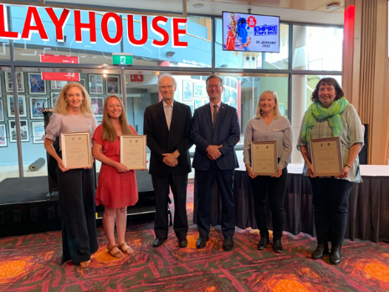  2021 Don Aitkin award recipients and ceremony

Finances – Long-term financial sustainability
Strategies to achieve this:
- Maintain high standards of financial management and reporting.
Maximise both government and own-sourced income, to ensure financial sustainability and support future growth.
Key outcomes in 2021–22 against the above strategies
- In 2021–22 the CFC maintained high standards of financial management and reporting.
- The audit of the CFC’s 2021–22 Financial Statements by the ACT Auditor-General resulted in an unmodified audit.
- For 2021–22, the CFC achieved own-sourced revenue of 36.5% comparable with a target of 36.8%.
- The CFC achieved a cost to government per visitor outcome of $55.44 compared with a target of $69.20. The better than target figure relates primarily to higher than expected visitors/patrons in the second half of the year and easing of COVID-19 restrictions.
- The CFC’s 2021–22 internal budget included strategies to address COVID-19 and long-term financial sustainability.
- The Government provided additional COVID-19 Response funding of $2.517 million to the CFC in 2021-22 to enable it to continue its operations and to keep employing its staff during the COVID-19 pandemic.
- Additionally, $438,000 COVID-19 economic support initiative funding was reprofiled from the previous year to continue support in responding to the loss of revenue from the COVID-19 pandemic.
- The Corporate Finance area continued to meet deadlines for payroll, theatre show acquittals, accounts payments and the collection of receivables.
- The CFC developed high-quality bids for the 2022–23 ACT Budget leading to major funding for the CTC expansion and redevelopment plus new works funding for Lanyon Upgrades.
The Corporate Finance area developed policies and procedures for FBT, GST, payroll, revenue recognition and processing, and for the Micropay payroll system to be migrated to the cloud.

Assets – Support for delivering high quality cultural experiences
Strategies to achieve this:
- Maintain high standards of asset management.
- Achieve high standards of disability access.
- Ensure ICT resources, business systems and records support our work and deliver high quality outcomes.
Key outcomes in 2021–22 against the above strategies
- High quality asset management continued to be a key priority for the CFC during 2021–22, in view of its responsibility for major cultural sites.
- The CFC is currently reviewing a systematic approach to provide the necessary skills and training to all staff through the whole-of-government e-learning platform and by other means. The e-learn platform will be available to most staff in 2022–23 to undertake core training.
- A SharePoint CFC Intranet was launched in June 2022 to ensure staff key information is shared and located in a central location, enabling greater communication and collaboration across the CFC.
- The CFC contracted RiskLogic to finalise a new Business Continuity Plan in 2021–22 that ensures appropriate levels of preparedness in the event of a disruption, and high-level response and recovery capabilities in relation to major crises including bushfires, smoke haze and COVID-19.
- The CFC continues to use the Whole of Government Electronic Document Records Management System (EDRMS) HPE Content Manager/TRIM (with WIRE interface) for its record management.
- A records improvement plan was implemented prioritising the digitisation of records.
- A staff member represents the CFC in the Records and Information Management Community of Practice meetings facilitated by the Territory Records Office and the Digital Records Capability Working Group meetings facilitated by Records Services.
The CFC’s Resource Management Plan continued to provide the framework for the CFC’s sustainability and energy efficiency practices. Staff members participate in the ACT Public Service led presentations Sustainability Network Speaker Services.

CANBERRA THEATRE CENTRE
AT A GLANCE

B.2.2 Canberra Theatre Centre
What we are: the Canberra region’s main theatre centre, incorporating the Canberra Theatre, The Playhouse and the Courtyard Studio
What we do: we connect people with theatre experiences of national and international quality
Our vision: to be a leading theatre centre in Australasia and Asia
A smooth recovery from the COVID-19 pandemic
Strategies to achieve this:
- Manage through, and recover from, the COVID-19 pandemic, ensuring that, to the extent possible:
- negative impacts of COVID-19 on the CTC’s venues and operations are minimised;
- positive impacts are retained and built upon.
- the CTC’s financial sustainability is maintained; and
- the CTC provides cultural leadership in the recovery from COVID-19.
Key outcomes in 2021–22 against the above strategies
- The Canberra Theatre Centre (CTC) continued meetings with ACT Health during its emergence from lockdown and the reopening of theatres. Conversations with ACT Health also ensured support of visiting companies and ongoing COVIDSafe operations.
- The CTC utilised the lockdown and recovery period to undertake a major upgrade of carpeted areas of the public foyer spaces. This project was completed in March 2022.
- During lockdown, the CTC continued to send a weekly e-newsletter, focusing on at-home content showcasing artists and performers associated with the CTC. With a range of engaging content, we maintained our newsletter’s average open rate, and were recommended by ABC Radio Canberra, 2CC, and The Canberra Times.
- During the recovery period, the CTC’s newly created New Works program supported local artists. New works including David Atfield’s Chiaroscuro and Jake Silvestro’s December premiered at the CTC, showcasing local excellence to Canberra audiences.
- The CTC committed extensive marketing support to presenters from outside of the region. This helped to achieve ticket sale objectives, utilising our large database and engaged social media following.
Further specific outcomes relating to COVID-19 are identified below.
Customers – Audiences that are growing, diverse, engaged and entertained
Strategies to achieve this:
- Ensure that customers remain at the centre of all that we do.
- Increase our audience and diversify it in terms of age, geography, and cultural background.
Develop a suite of marketing and ticketing technology that enhances the customer experience and builds the CTC brand.
Key outcomes in 2021–22 against the above strategies
- The CTC continued to act in accordance with ACT Health Guidelines and utilised a range of communicate methods to do this successfully. The CTC sends all patrons attending the Theatre an “info email” that outlines COVID-19 safety, and traffic/construction information ahead of their arrival.
- The CTC continued work on the procurement of a Ticketing and customer relationship management system, a Probity Advisor was engaged and the procurement went to market with a Request for Proposals in the final quarter of the year. The successful tenderer is expected to be confirmed in the first part of 2022–23.
- The programming team initiated work around its strategy during this financial year, and a key focus remains on the provision of public programs that support and enhance the overall patron experience. Work has commenced in reviving these opportunities that were paused during the pandemic due to capacity limits, and COVIDSafe operations.
- The Access Action Plan continued to inform the CTC’s decisions regarding accessibility improvements to the CTC. During the year, the CTC made improvements to Wheelchair accessibility in the Canberra Theatre, including the construction of a ramp enabling greater access to the front rows of the theatre’s seating. As part of the foyer carpet upgrade, tactile indicators across all foyers were replaced and upgraded.
- The CTC held a “2022 launch event” for frequent attendees, where they were introduced to more than 29 productions, including 12 brand new productions, five company debuts, 10 premiere seasons, and two major musical productions.
The CTC reviewed its options for audience engagement and value adding including member programs, and incorporated its ambitions in the Statement of requirements for the ticketing system procurement.
Programming – A diverse, high quality, entertaining and distinctive program
Strategies to achieve this:
- Deliver a program of performances of the highest quality possible.
- Develop strategic partnerships with producers and presenters.
- Contribute to, and nurture, the deepening of creativity in the ACT.
Increase the number of Indigenous performances presented by the CTC.
Key outcomes in 2021–22 against the above strategies
- The CTC continued its commitment to the development and elevation of arts practice in the ACT through the New Works Program, producing the world premiere of David Atfield’s Chiaroscuro in November 2021.
- The CTC continued its commitment to support and nurture youth arts programs in the ACT through investing in presentations from local Youth Arts Organisations such as QL2’s major work Terra Firma, and a number of performances from Canberra Youth Theatre including: The Initiation; Two Twenty Somethings Decide Never To Get Stressed About Anything Ever Again. Ever; and Dags.
- The CTC invested in and showcased the works of local artists including: Jake Silvestro’s December; Fred Smith’s Charity Concert to Welcome Afghanistan Refugees to Canberra; and Mikelangelo and the Black Sea Gentlemen’s David Branson Memorial Show.  - The CTC presented major touring productions including:  - Bangarra Dance Theatre’s Sandsong;  - Opera Australia’s Carmen;  - Bell Shakespeare’s Hamlet;  - Sydney Theatre Company’s White Pearl; and  Louise Withers and Associates’ Six the Musical. | 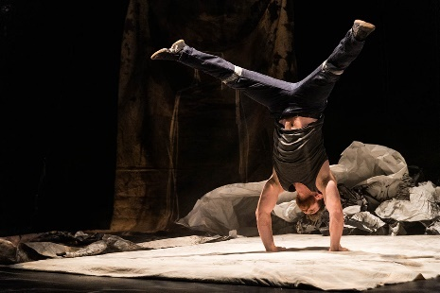  December Jake Silvestro, credit Mark Turner
- The CTC co-presented with Soft Tread Enterprises, the world premiere season of The Wharf Revue: Can of Worms, and attracted the world premiere season of Hannah Gadsby’s Body of Work with three sold out performances.
- Comedy remains popular with our audience and the CTC attracted the presentation of many high-quality comedians, including hosting over 20 events of the Canberra Comedy Festival 2022 including:
- HARD QUIZ LIVE hosted by Tom Gleeson;
- Judith Lucy & Denise Scott – Still Here;
- Lano & Woodley;
- Urzila Carlson; and
Ross Noble: 2021 Comeback Special.
- Other notable events, included hosting two live national broadcasts of ABC Q&A program, two sold out performances of The Resilience Project, multiple funding performances of Music at Midday, and the ABC’s The Party Room LIVE Federal Election special.
- The CTC attracted high quality contemporary music events throughout the year including:
- APIA Good Times Tour 2021;
- Xavier Rudd;
- Julia Jacklin;
- The Whitlams;
- Jessica Mauboy: The Boss Lady Tour; and
John Butler.
- Family programming included:
- shake & stir theatre co’s Fantastic Mr Fox;
- Slingsby Theatre Company’s Emil & The Detective;
- CDP Theatre Producers’ Magic Beach;
- The Wiggles Fruit Salad TV Big Show;
- Teeny Tiny Stevies - A Thoughtful Tour;
- Dead Puppet Society’s The Wider Earth; and
Guess How Much I Love You.
- The ACT UP! Program ran between February and June 2022 and engaged 12 ACT schools; one regional school (Bateman’s Bay) and 16 teachers.
- Approximately 50% of teachers engaged for the first time in 2022.
- Engaged six local artists as mentors/industry professionals.
- Engaged 243 ACT students; 17 regional students (Bateman’s Bay).
Preparation for the 2023 ACT UP! Program is underway.
- The Theatre Reserve was not accessed in 2021–22, however it remains an important fund that supports the risk-appetite for programming major theatre productions in at the CTC.
- The New Works program of activity and productions was successfully developed and presented by the CTC’s programming team. Activity included information sessions, a New Idea’s lab and incubator program, creative development and performances.
- The CTC continued its commitment to First Nation’s programming. Presentations included sold out performances of Bangarra Dance Theatre’s Sandsong, Joel Bray’s I Liked It...But I Didn’t Know What the F#!k It Was About, and the return of the highly celebrated Reconciliation Day Eve Concert that featured the music of First Nations artists including Christine Anu, BRIGGS, and Electric Fields.
- A Strategic review of the CTC’s programming strategy was undertaken in November 2021. The strategy is complementary to the ACT Arts Minister’s Statement of Ambition, and identifies the three key priorities of Aspiration, Connection and Collaboration to be the drivers in our programming decisions.

Contracts by Genre

Nights Usage by Genre

Contracts by Locality

Nights Usage by Locality

Business – Venues, systems and people that support high quality live performances
Strategies to achieve this:
- Grow the CTC business as it transitions to a 5,000 seat facility.
- Develop Canberra Ticketing into the ACT’s leading ticketing agency.
Build strength and resilience in the CTC’s budget, to ensure high quality delivery and maintenance of facilities.
Key outcomes in 2021–22 against the above strategies
- The CTC undertook the first year of a three-year program of upgrades, to enhance the safety of patrons, ensure a high level of WHS standards for staff, enhance security infrastructure, and implement other essential works. Works completed in year one includes the installation of new carpet, stair nosing and tactile indicators. Further studies were undertaken regarding access improvements for the Canberra Theatre auditorium and additional wheelchair seating locations, and WiFi hearing augmentation projects were initiated.
- Better Infrastructure Funding was utilised for the replacement of a forklift and to support the foyer carpet project.
- The marketing of Canberra Ticketing will be further expanded following the outcome of the ticketing system procurement.
A review of food and beverage options to enhance the customer experience and generate increased revenues has been re-cast as a potential collaborative project across the CFC. It was not able to be progressed during COVID-19 restricted times.

Leadership – An integral part of the cultural life of the Canberra region and beyond
Strategies to achieve this:
- Plan for the transformation of the CTC into a leading Australian performing arts centre, through the major new theatre project.
- Provide leadership in theatre education from primary through to tertiary and vocational education.
Grow the CTC’s contribution to the creative sector and economy of the Territory.
Key outcomes in 2021–22 against the above strategies
- The CTC continued to attend and participate in New Theatre Project Steering committee meetings. The CTC contributed to studies with the CRA that formed the CRA’s Vision for the Canberra Civic and Culture District document. The CTC worked collaboratively with Major Projects Canberra on the development of the business case for progressing detailed designs for the new Theatre project.
- The CTC worked closely with producing teams of international musicals Come From Away and Six the Musical to position these high quality and broad appeal productions to the widest possible market. Both productions were successful in their applications for regional marketing funding from Visit Canberra, bringing further reach to their campaigns.
- The CTC created videos with Joel Bray on tour through Canberra’s landmarks, secured funding with Winter Event Fund, and created key marketing assets for Joel Bray’s I Liked It...But I Didn’t Know What the F#!k It Was About.
- The CTC facilitated production photography during the world premiere season of The Wharf Revue: Can of Worms, that enabled the production’s campaigns in other markets.
- The CTC connected with local artists, teachers, students and undergraduates through training in design and stagecraft planning. The CTC’s highly regarded Work Experience program was conducted twice during the year. Each program ran for five days, and hosts up to ten Y9-12 students, and provides a creative immersion program including guest speakers, creative projects, viewing a performance and several technical drills/exercises.
- The CTC continues to provide Vocational Education and Training in theatre technical skills (Cert III) through its established relationship with CIT. The course materials underwent considerable revision during the year, where micro credentialing was also explored. The program provides local artists, teachers, students and undergraduates with explicit training in design, stagecraft and technical skills (LX–Lighting, AX–Audio, AV–Audio Visual, MX–Stage Mechanist). It also develops and extends trained theatre specialists in the region.
Future course options have been investigated.

CMAG at a glance

QUALITY OF SERVICE    Over 90%  approval rating  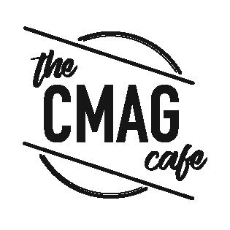  442 soups supped  1,631 toasties pressed  2,063 cappuccinos dusted  3,062 flat whites flung  1,209 lattes arted  COMMUNITY AND EDUCATION PROGRAMS  74   |   1,009  OBJECTS digitised  15  EXHIBITIONS  LEARNNG AND COMMUNITY PROGRAMS  157    Over 1,000 items from the  Canberra Press Photography Collection were catalogued   | 60%  of the visitors to the Canberra Raiders: 40 Years in the Limelight exhibition were first time visitors to CMAG  VISITORS  28,286  VENUE HIRE    960  people attended private events at CMAG

B.2.3 Canberra Museum and Gallery
What we are : a state/territory level museum and gallery dedicated to the visual arts and social history of the Canberra region
What we do : we connect people with the Canberra region’s rich and diverse stories, sense of place, and contemporary identity
Our vision : to be a leading regional cultural venue in Australia and beyond
A smooth recovery from the COVID-19 pandemic
Strategies to achieve this:
- Manage through, and recover from, the COVID-19 pandemic, ensuring that, to the extent possible:
- negative impacts of COVID-19 on the CMAG’s venues and operations are minimised;
- positive impacts are retained and built upon.
- CMAG’s financial sustainability is maintained; and
- CMAG provides cultural leadership in the recovery from COVID-19.
Key outcomes in 2021–22 against the above strategies
- Following the COVID-19 lockdown on 12 August 2021, CMAG reopened to the public on 29 October 2021. The reopening was supported by a COVIDSafe Plan which continued to be reviewed and updated throughout the year.
- CMAG reopened with new exhibitions, Mandy Martin From Queanbeyan to New York: 1978-1984 / Art & Life and Brenda L. Croft: ‘hand/made/held/ground’.
- The reopening of activities was phased to ensure CMAG was meeting the requirements of the Public Health Directions.
- The MakerSpace and ReaderSpace activities for families with children were reintroduced in the CMAG foyer with modified offerings to align with Public Health Directions.
- During the COVID-19 lockdown period CMAG:
- catalogued over 1,000 items from the Canberra Press Photography; and
- completed audio description training to allow for audio descriptions to be developed for key works in forthcoming exhibitions for blind and vision-impaired patrons.
Further specific outcomes relating to COVID-19 are identified below.
Customers – Audiences that are growing, diverse and engaged
Strategies to achieve this:
- Ensure that customers remain at the centre of all that we do.
- Design programs and marketing to reach those audiences that do not currently access our services.
Conduct market research to enable greater focus on target audiences in services and programming.
Key outcomes in 2021–22 against the above strategies
- CMAG’s reopening, framed by the COVIDSafe Plan ensured that visitors understood the additional cleaning, contact tracing and physical distancing measures implemented providing a safe and welcoming environment.
- CMAG followed Government advice on easing of COVID-19 restrictions throughout the year, including the removal of density limits and mask mandates for the public.
- CMAG Staff met with representatives from the Light Rail Project Team in September 2021 to gain an understanding of the impacts from the construction work.
- CMAG Patrons were advised of impacts to parking due to early works held in November 2021 via the CMAG website.
- CMAG continually seeks to improve customer satisfaction with their visit to, and experience of, CMAG, with surveys available to complete online and onsite. Surveys were sent via scheduled email to invite feedback from participants after an event.
- A specific exhibition survey was included in the exhibition Canberra Raiders: 40 Years in the Limelight to assess the impact of the exhibition with new visitors to CMAG. 60% of the visitors were first time visitors to CMAG.
- Funding was secured in the 2021–22 Budget to enhance CMAG’s accessibility for people living with disabilities and to undertake a range of physical improvements such as:
- the Open Collection access ramp upgrade works completed in April 2022; and
- audio descriptions developed for key works in the Ruth Lane-Poole: A Woman of Influence and Mandy Martin From Queanbeyan to New York: 1978-1984 / Art & Life exhibitions.
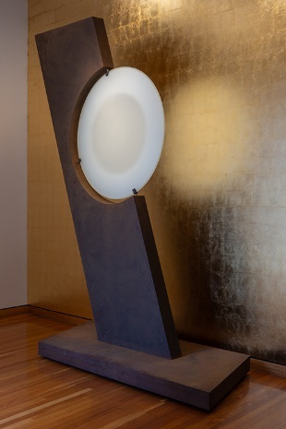  A major donation to the CMAG collection, Brian Corr, Timshel, 2012 kiln formed, waterjet cut, cold worked constructed glass with corten steel. Gift of Lesley Kehoe, 2021 currently on display in the CMAG foyer. | - CMAG’s online presence and social media increased as follows:  - CMAG website attracted 6.6% more users than in 2020–21;  - Instagram profile visits were up 4% from 2020–21; and  Facebook page likes increased by 7% from 2020–21.  - The total value of donations to the CMAG Collection was around $200,000.

Programming – Exhibitions and programs that reflect Canberra’s unique identity
Strategies to achieve this:
- Program excellent, innovative exhibitions, with a well-balanced mix of exhibitions that respond to a breadth of themes and societal issues.
- Develop a range of community and learning programs and events that complement the exhibition program and contribute to activation of the precinct.
- Ensure exhibitions feature cultural and gender diversity and Indigenous content, with a commitment to exhibitions of Indigenous content being Indigenous led, such as through Indigenous guest curators.
Key outcomes in 2021–22 against the above strategies
- CMAG presented a high quality exhibition program in 2021–22 that reflected the diverse interests of the Canberra community. New exhibitions presented during the year included:
- Ruth Lane-Poole: A Woman of Influence, guest curated by Margaret Betteridge exploring the life of Ruth Lane-Poole and her design work including her work furnishing Canberra’s two official residences – Government House and The Lodge. The content of the exhibition was converted to an exhibition website including an exhibition walkthrough video and object audio descriptions.
- Mandy Martin From Queanbeyan to New York: 1978–1984 / Art & Life, celebrating the life and work of artist Mandy Martin– charts the shifts in Martin’s practice over six years after she moved from Adelaide to Queanbeyan.
- Brenda L. Croft: ‘hand/made/held/ground’, focussed on the work of Indigenous artist Brenda Croft, curated by the artist– a mixed media installation which metaphysically maps Croft’s patrilineal relationship to Country reimagining customary objects jimpila (spearhead) and kurrwa (stone axe) originally created on Gurindji homelands.
- Spowers and Syme, an National Gallery of Australia exhibition celebrating the artistic friendship of Ethel Spowers and Eveline Syme.
- Threads of Policing, curated by the Australian Federal Police Museum featuring objects from Museum’s collection inspired by the 40th Anniversary Quilts project.
- Canberra Raiders: 40 Years in the Limelight, celebrating 40 years since the establishment of the Canberra Raiders rugby league team.
- Connection Point: Contemporary established fibre textile artists of the ACT and NSW.
- Back to the Boombox was held in the Open Collections Gallery and featured a local collector’s boombox collection.
- Jan Brown: A life with Art, featuring the late Jan Brown’s works from the CMAG Collection installed in display cases in the CMAG Foyer.
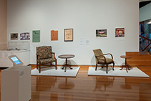  Upholstered chairs and tripod tables designed by Ruth Lane-Poole, c.1920s. Ruth Lane-Poole: A Woman of Influence exhibition. Photographed by RLDI for Canberra Museum and Gallery. | 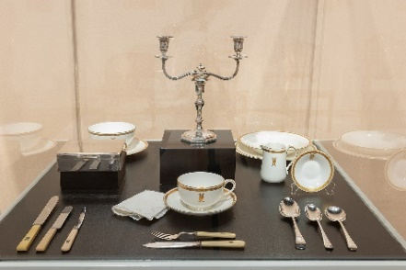  A selection of crockery and cutlery from ‘The Lodge’, Canberra. Ruth Lane-Poole: A Woman of Influence exhibition. Photographed by RLDI for Canberra Museum and Gallery. | 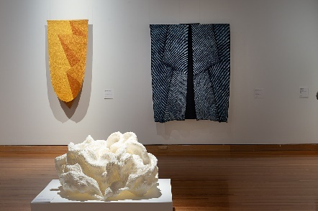  CMAG exhibition Connection Point:  Contemporary established fibre textile artists  of ACT and NSW installation view Foreground, Lucy Irvine, Envelopment 2009, nylon cord, cable  ties, steel, paint, courtesy the artist.  Background, Keiko Amenomori Schmeisser,  Rising Gold 2018, shibori, indigo dye and  paint on linen; Nightfall 2018, shibori, indigo  dye on linen, courtesy the artist.
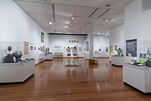  CMAG exhibition Canberra Raiders: 40 Years in the Limelight | 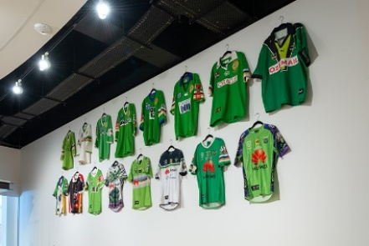  Jerseys on display at CMAG exhibition Canberra Raiders: 40 Years in the Limelight | 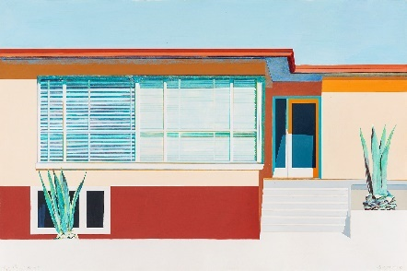  Image Queanbeyan Study No. 5 1998 from  CMAG exhibition Mandy Martin From  Queanbeyan to New York: 1978–1984 /  Art & Life
- A full list of CMAG exhibitions presented in 2021–22 is provided in Appendix 5, page 97.
- During the year, CMAG presented a comprehensive range of public and education programs and other activities, often in association with specific exhibitions or special events.
- COVIDSafe activities for families with children connecting the CMAG collection to artmaking and children’s literature resumed after the lockdown in the MakerSpace and ReaderSpace areas within the CMAG foyer with refreshed signage and digital features.
- Community programs were held in association with the following exhibitions.
- Ruth Lane-Poole: A Woman of Influence included CMAG on Saturday: Pattern Play, a workshop for families with children.
- Mandy Martin From Queanbeyan to New York: 1978–1984 / Art & Life included a Curator Talk with Virginia Rigney and a MakerSpace activity in the CMAG foyer for families with children to create a Concertina Collage inspired by Mandy Martin’s paintings.
- Brenda L. Croft: ‘hand/made/held/ground’ included a Conversation between Dr Brenda L. Croft and Jodie Cunningham, CEO Craft ACT.
- Spowers and Syme included a Curator talk with Sarina Noordhuis-Fairfax and a Printmaking Workshop with artist Sally Mumford, for the Winnunga Women’s Group.
- Connection Point: Contemporary established fibre textile artists of ACT and NSW included a CMAG After Dark event, a textile workshop for adults led by artist Sharon Peoples, a workshop for children CMAG on Saturday: Plastic Painting, a creative dementia workshop, a curator talk with Virginia Rigney, a children’s program CMAG on Saturday: Stitch Stories and a dance performance by Canberra Dance Theatre’s GOLD dancers.
- Back to the Boombox included a School holiday workshop for children and a collector talk with Kinloch Kilby.

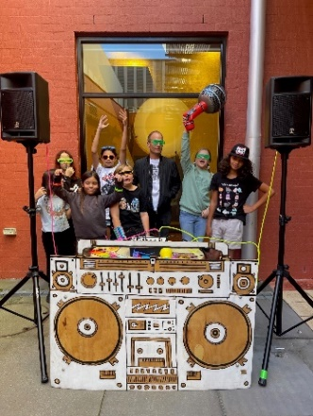  School holiday workshop: Boombox Block Party at CMAG in conjunction  with Back to the Boombox exhibition | 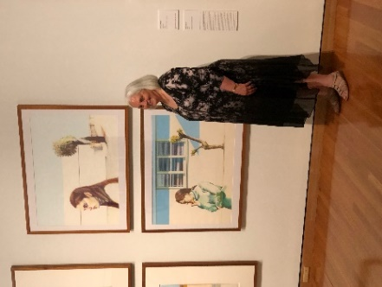  Peppina Sorbara at CMAG exhibition  Mandy Martin From Queanbeyan to  New York : 1978– 1984 / Art & Life |  | 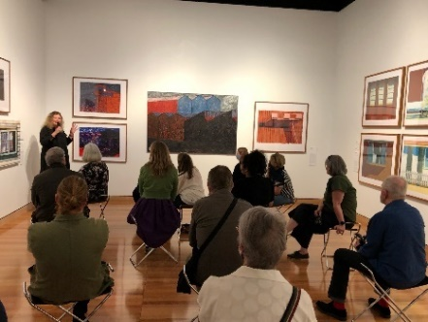  CMAG presented Curator Talk: Virginia Rigney in conjunction with exhibition Mandy Martin From Queanbeyan to New York : 1978– 1984 / Art & Life
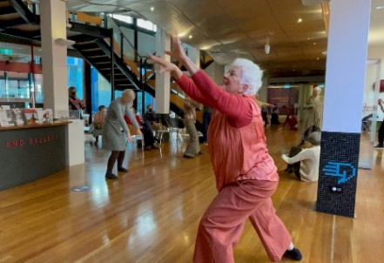  Dance performance by Canberra Dance Theatre’s GOLD dancers Gathering Threads was presented in response to CMAG exhibition Connection Point: Contemporary established fibre textile artists of ACT and NSW |  | 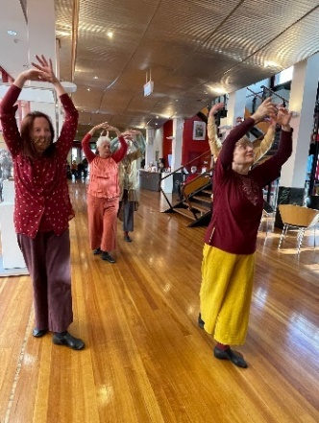  Canberra Dance Theatre’s GOLD  dancers | 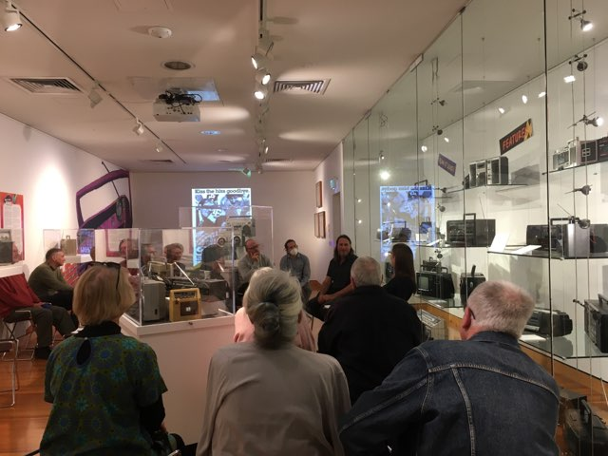  CMAG hosted Collector Talk: Kinloch Kilby in conjunction with Back to the Boombox exhibition
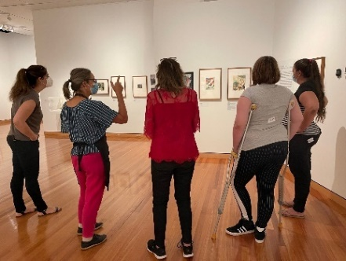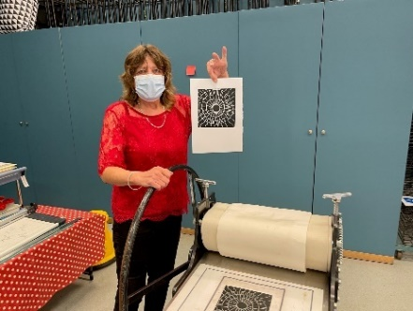  CMAG presented Printmaking Workshop with artist Sally Mumford, for the Winnunga Women’s Group in conjunction with National Gallery of Australia’s touring exhibition Spowers and Syme |  |  |  | 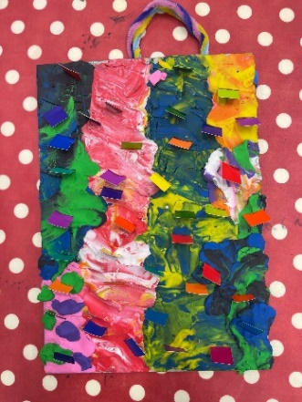  Artwork created in children’s program CMAG on Saturday:  Plastic Painting
- Threads of Policing included a Curator talk with Chris Cranston and a conversation between AFP divers Ben Cox and Chris Markcrow.
- Canberra Raiders: 40 years in the limelight included a talk featuring Tony Wood OAM aka Victor the Viking and a MakerSpace activity for families with children to create a Raiders jersey.
Brian Corr, Timshel included a children’s program CMAG on Saturday: Shimmer and shine in response to a sculpture from the CMAG collection.
- Reel McCoy film group recommenced their bi-weekly film screenings at CMAG in March 2022.
- The Nolan Foundation collection was displayed in the dedicated Nolan Gallery until the COVID-19 lockdown on 12 August 2021. It remained closed until November 2021 while works took place in the gallery space.
- The temporary display wall featured works from 2020–21 CMAG exhibition Sidney Nolan: Remembrances of my youth until 12 August 2021, including a selection of Sidney Nolan’s large spray-painted works.
- The CMAG exhibition Sidney Nolan: Inferno opened in April 2021 and featured a major work on loan from the Estate of Lady Nolan, that explores themes from ancient mythology and classical literature, while reflecting on the horrors of war.
- The Nolan Gallery focused outreach resource, Stop.Motion Nolan, was borrowed by Majura Primary in Term 3.
- 470 students participated in the onsite Nolan focused learning program, Every Picture Tells a Story during Term 3, 2021 before the COVID-19 lockdown and when programs recommenced in Term 2, 2022.
- A children’s program exploring the Nolan collection, CMAG on Saturday: Imaginationscape was held.
- The newly developed Nolan Secondary Learning Resource was developed for students in Years 7–10 during the COVID-19 lockdown period.
- Several programs were delivered to coincide with the Enlighten Canberra festival including:
- CMAG After Dark @ Enlighten Festival;
- Canberra Day Print Workshops @ Enlighten Festival; and
Canberra Day Fibre Workshops @ Enlighten Festival.
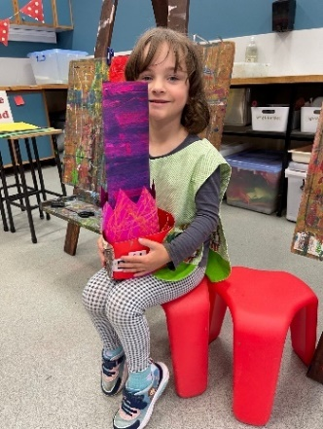 | 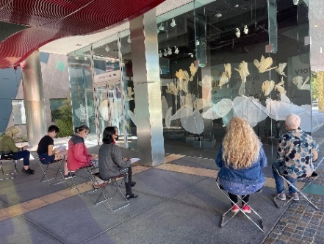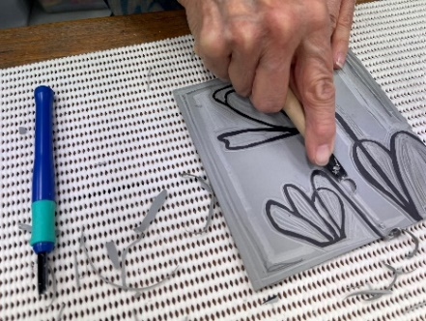  Canberra Day Print Workshop @ Enlighten Festival inspired by CMAG exhibition  Delene White: Flower Power
Artwork from children’s program CMAG on Saturday: Imaginationscape

Stewardship – Venues and collections that give us a distinct place in Canberra’s cultural landscape
Strategies to achieve this:
- Maintain CMAG’s venues and facilities to accepted international museum standards.
- Develop, conserve, research and interpret CMAG’s visual arts and social history collection, and the Commonwealth-owned Nolan Collection.
- Market the collections, so that these important resources are leveraged to the benefit of CFC, the ACT Government, and the community.
Key outcomes in 2021–22 against the above strategies
- During 2021-22, CMAG undertook works to improve Work, Health and Safety standards and accessibility such as the Open Collection access ramp upgrade works were completed. These upgrade works included a change in material and texture to better support visitors affected by dementia or with accessibility requirements.
- Research was undertaken by CMAG’s Visual Arts and Social History curatorial staff, and essays written for the forthcoming publication about CMAG’s permanent collection. Essays on the collection from guest authors were also received.
- CMAG’s significant collection of works by Mandy Martin from the Mandy Martin From Queanbeyan to New York: 1978–1984 / Art & Life exhibition was researched, photographed and documentation improved in preparation for display in the exhibition.
- Cultural Gifts were submitted to the Australian Government for the acquisition of works by Hamilton Darroch, Mandy Martin, and Sidney Nolan.
- The project to audit collection conservation needs commenced with project scoping, resulting in the development of a process and indicative timeline for completion. Conservation priorities were identified for the collection.
- During the COVID-19 lockdown closure the CMAG Exhibitions and Collections team worked with the Front of House team to catalogue over 1000 items from the Canberra Photography Collection.
- 1,009 items from the CMAG collection were digitised.
- Upgrades to the CMAG website including the online collection are in the planning stages.
- During the year, CMAG continued to conserve, research, interpret and manage the Nolan Collection under the Nolan Management Agreement with the Commonwealth.
- The Nolan Gallery at CMAG was refreshed and rehung, with five works removed from display to prepare for travel on loan to the Heide Museum of Modern Art. Condition reports were prepared for the loaned works.
- A new exhibition on the temporary wall in The Nolan Gallery was curated. Finding the dry heart: Sidney Nolan’s early travels in Central Australia, focusses on Nolan’s works depicting Central and Northern Australia and including works donated to CMAG by Duncan Reeder under the Australian Government’s Cultural Gifts program.
- A new exhibition in The Nolan Gallery Sidney Nolan: Inferno opened and featured a major work on loan from the Estate of Lady Nolan.
- CMAG collaborated with relevant agencies to bring works from the Nolan Collection to a wider audience as follows:
- CMAG loaned works to Heide Museum of Modern Art travelling exhibition, Sidney Nolan: Search for Paradise.
Permission to reproduce Sidney Nolan’s work Under the pier was given to Flinders Community Association for inclusion in a student education resource.
Leadership – An integral part of the cultural life of the Canberra region and beyond
Strategies to achieve this:
- Enhance CMAG’s role as a state/territory level museum, especially by developing a greater footprint in the North Building and enhancing CMAG’s visibility on London Circuit and Civic Square, in order to support activation of the Canberra Civic and Culture District and promotion of CMAG as a major visitor attraction in the city centre of Canberra.
- Identify and implement opportunities that demonstrate CMAG’s initiative and entrepreneurship, and create a mix of income streams.
- Ensure that CMAG’s cultural leadership, and people management and leadership are core to its values and work priorities.
Key outcomes in 2021–22 against the above strategies
- In support of CMAG’s initiative to enhance CMAG’s presence and profile on London Circuit and Civic Square, new street level signage advertising CMAG was installed on the glazing of the former restaurant tenancy.
- Repainting of the Civic Square CMAG external courtyard was completed.
- Architecture and design firms have been engaged to begin work on fit out requirements for two currently empty North Building ground floor tenancies to create a new digital gallery and new retail and collaboration spaces.
- Catalogue essays focusing on the depth and quality of the CMAG Collection from guest authors and internal staff were completed and will be published in 2023.
- Several CMAG senior staff participated in conferences and museum sector initiatives as follows:
- Visual Arts Senior Curator, Virginia Rigney wrote an article for publication in the summer edition of Art Monthly on the Mandy Martin From Queanbeyan to New York: 1978–1984 / Art & Life exhibition; is on the board of Photo Access, ACT Health and the Commonwealth Club; and attended the Australian Museums and Galleries Association (AMaGA) ACT branch networking event; and
Social History Senior Curator, Dr Hannah Paddon attended AMaGA events and a Australian Federal Police (AFP) Museum briefing.
- The ongoing relationship with Heide Museum of Modern Art continued. Works from the Nolan Foundation Collection were loaned for the exhibition Sidney Nolan: Search for Paradise.
- Brutal Transformations Paste up Project by Lymesmith was installed on North Building walls in partnership with CraftACT’s Nurture program and the City Renewal Authority, to be part of Design Canberra 2022.
- CMAG continued to develop new partnerships with other relevant organisations, institutions and agencies a follows.
- Spowers and Syme, a touring exhibition from the National Gallery of Australia.
- Threads of Policing exhibition was presented in conjunction with the Australian Federal Police Museum.
- Canberra Raiders: 40 Years in the Limelight in partnership with the Canberra Raiders.
- Connection Point: Contemporary established textile artists of the ACT and NSW in partnership with Untethered Fibre artists Inc.
A performance, Gathering Threads was presented in response to CMAG exhibition Connection Point: Contemporary established fibre textile artists of ACT and NSW in partnership with Canberra Dance Theatre’s GOLD Company.

ACT HISTORIC PLACES AT A GLANCE
VISITORS  40,068  WEDDINGS AND EVENTS  7 weddings  1 baptism  1 memorial service  Numerous other celebrations  BUILDINGS  32 separate roof faces on the Lanyon Homestead including gables, awnings, verandahs and dormer windows.  JUST FOR FUN  1 lost dog found at Lanyon and reunited with its owner | GARDENS AND GROUNDS    Over 360hrs of mowing of over 1,332,900m2 of grass  Over 600km of road grading on the Lanyon gravel driveway  Over 278km walked while raking the gravel paths and courtyards at Lanyon  CONSERVATION AND CONSERVATION    Historic floors, furniture surfaces and hundreds of collection items were cleaned over 250 times  Calthorpes’ House accessioning over 600 items accessioned across Calthorpes House and as part of newly acquired research collections  Over 3,746 pages of historic documents and images were scanned  LEARNING AND COMMUNITY PROGRAMS  157 | VOLUNTEERS  705 hours of assistance from our committed volunteers  ACCOLADES  Lanyon  Ranked #8 of 58 sites in Canberra on Trip Advisor  Brides Choice Awards finalist for 2021  DID YOU KNOW?  The Southern Cross Windmill at Lanyon is one of the largest in the southern hemisphere.  There are over 800 trees which are managed across our historic places.

B.2.4 ACT Historic Places
What we are: three historic places that reflect different aspects of Canberra’s history - Lanyon Homestead, Calthorpes’ House and Mugga-Mugga
What we do: we connect people with Canberra’s rich and diverse stories and heritage
Our vision: to be leading historic places in Australia and beyond
A smooth recovery from the COVID-19 pandemic
Strategies to achieve this:
- Manage through, and recover from, the COVID-19 pandemic, ensuring that, to the extent possible:
- negative impacts of COVID-19 on ACTHP’s venues and operations are minimised;
- positive impacts are retained and built upon.
- ACTHPs financial sustainability is maintained; and
- ACTHP provides cultural leadership in the recovery from COVID-19.
Key outcomes in 2021–22 against the above strategies
- Following the end of the COVID-19 lockdown on 12 August 2021, ACT Historic Places (ACTHP) managed the reopening of its sites to the public with Lanyon reopening on 28 October 2021, Calthorpes’ House on 30 October 2021 and Mugga-Mugga on 6 November 2021.
- Revised COVID-19 restrictions allowed properties to open, allowing internal tours, with limited group sizes and COVIDSafe requirements in place.
- Modifications to learning programs saw groups experience the Lanyon Homestead as a ‘Dollhouse’ peeking through open doors, accommodating larger groups sizes.
- On-site learning programs were impacted with the lockdown period, which saw programs cease in August 2021. Learning programs recommenced in May 2022. Learning programs were initially modified to meet COVID-19 requirements; however, as restrictions relaxed, modifications to programs and group rotations saw an ability for extended group sizes.
- Off-site (outreach) learning program boxes – Dawn’s Suitcase and Artefact Chat remained in use.
- Public programs were cancelled due to the COVID-19 lockdown such as Floriade related program Spring into the South at Lanyon. Public programs recommenced in November 2021, with events held regularly from March 2022 onwards.
- First public program held after the COVID-19 lockdown was Wildflowers & Grasslands at Mugga-Mugga Cottage, which was sold out.
- The Wellbeing Workshop Series in March and April 2022 saw over 150 participants across programs in photography, bush tucker, clay, pianola roll art, ink drawing, and cyanotype photography.
- Strong digital marketing and use of social media during lockdown aimed to create public engagement in the COVID-19 lockdown period. This included series of stories and posts about the history, collection, landscape and people at each property.
- Interaction with social media posts demonstrated a growing audience beyond ACTHP’s own channels.
- Publication of online blog about Musical Reimagining at Lanyon Homestead was released during the COVID-19 lockdown period.
- The new look ACTHP website was launched in the COVID-19 lockdown period in October 2021, providing a more contemporary and cleaner looking website aesthetic.
Further specific outcomes relating to COVID-19 are identified below.

Customers – Audiences that are growing, diverse and engaged
Strategies to achieve this:
- Ensure that customers remain at the centre of all that we do.
- Develop initiatives to foster special interests and experiences, and increased opportunities for visitor engagement.
Improve public recognition of ACTHP’s brand and profile.
Key outcomes in 2021–22 against the above strategies
- Throughout the year, ACTHP focused on providing high-quality experiences for its customers resulting in an 95% approval rate.
- In 2021–22, ACTHP welcomed 40,068 visitors to Lanyon, Calthorpes’ House and Mugga-Mugga. This included 1,958 attending 133 learning programs; 2,567 visitors participating in 671 museum tours; attendees at 17 public programs, and guests at venue hire events.
- ACTHP’s branding and marketing was developed to encourage new audiences and promote the relevance and value of each place as follows.
- Entry signage was replaced at the Lanyon, Calthorpes’ House and Mugga-Mugga with new branding and updated layout information.
- ACTHP Website was refreshed utilising new branding, colours schemes and layouts.
- Social media presence increased with enhanced branding.
- Tourism Australia took a series of images and videos at the three ACTHP properties for promotion purposes nationally, as well as providing these resources for internal use.
Ongoing use of Lanyon’s Step into the Story tag line was used for promotional material.

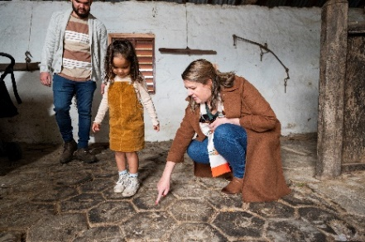 | 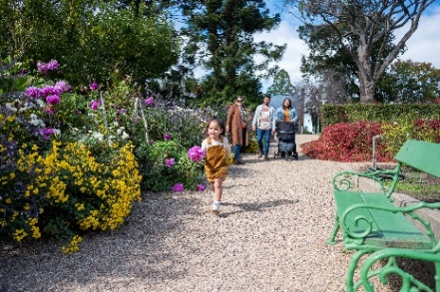 | 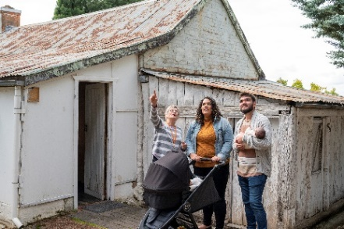
The wood block floor in the stables at Lanyon (Tourism Australia) | Families enjoying the beautiful gardens at Lanyon (Tourism Australia) | Mugga-Mugga Cottage guided Tour  (Tourism Australia)
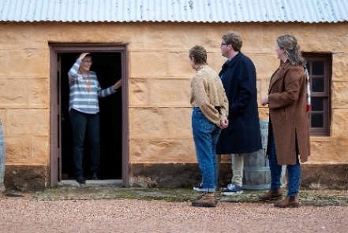 | 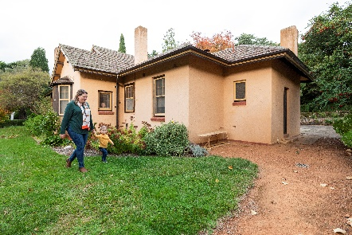 | 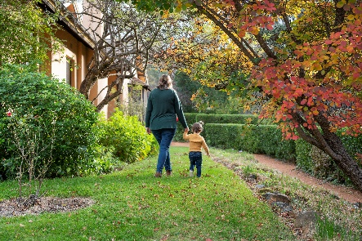
Lanyon guided tours (Tourism Australia) | Calthorpes’ House (Tourism Australia) | Calthorpes’ House gardens  (Tourism Australia)
- Customer feedback to inform and improve facilities and services was used in 2021-22.
- The 2021–22 Visitor and Public Program Survey was launched in July 2021, including QR code link to make it easier for visitors to access survey.
- The QR code link to TripAdvisor, continues to encourage visitors to provide public feedback for our sites and to help raise awareness of our properties.
- Lanyon Homestead also ranked the 8th best site/landmark in Canberra on TripAdvisor out of 58 sites in 2021.
- New opening hours for Mugga-Mugga and Calthorpes’ House were implemented from January 2022 to provide increased access to Mugga-Mugga. Mugga-Mugga was previously open only one day per month, and these new hours provided an additional 18 days of access to the public.
- ACTHP continued to engage with First Nations communities to strengthen and improve ACTHP’s approach to interpretation and management of Indigenous stories and values as follows:
- Developed new public programs with First Nations educator and plant consultant Adam Shipp to provide bush tucker and native plant programs at Mugga-Mugga and Lanyon.
- Engaged Adam Shipp to implement bush tucker plantings at Mugga-Mugga to increase public program opportunities.
- Children’s program Kids Week Art: Dreamtime by the River was held over two days with First Nations host Duncan Smith from Wiradjuri Echoes.
- Strong digital marketing and use of social media during the COVID-19 lockdown period was used to increase public engagement, including a series of stories and posts about the history, collection, living collection (gardens and grounds) and people at each property. This resulted in an increase of 429% reach and 4% increase of followers through Facebook during the lockdown period.
- General engagement also continued to grow though social media, with an overall 65% growth in Facebook page likes and follows, a 91% growth in Facebook page visits and 83% growth in the reach of our Facebook posts. Despite limited growth in followers on Instagram, there was a 481% growth in the reach of Instagram posts.
ACTHP had 16 volunteers in Visitor Services, who provided 705 volunteer hours across all three properties in 2021–22.
Programming – Programs that explore Canberra’s history by interpreting each place
Strategies to achieve this:
- Deliver a diverse and contemporary program of exhibitions and of community, learning and on-line programs, which enhances an understanding of each site’s history, natural and cultural values and contemporary relevance.
- Develop and deliver programs based on the principles of lifelong and immersive learning to reach broader audience groups.
Develop programs that support Indigenous reconciliation, cultural values and story-telling.
Key outcomes in 2021–22 against the above strategies
- The programs offered by ACTHP during 2021–22 provided a broad range of activities that increased people’s understanding and enjoyment of Lanyon, Calthorpes’ House and Mugga-Mugga, their collections, and landscape settings. Activities and programs conducted included:
- Walk: Wildflowers & Grasslands at Mugga-Mugga Cottage with ecologist Sarah Sharp.
- Special Tour with a Ladies Dementia Group at Lanyon. This visit prompted development of new and specific dementia friendly programs.
- Christmas at Home displays in November and December 2021. Christmas collections at Mugga-Mugga and Calthorpes’ House, and to interpret Victorian Christmas traditions at Lanyon.
- Two Wedding Open Days at Lanyon.
- Wellbeing Talk: Bush Tucker Talk with Adam Shipp at Mugga-Mugga.
- Wellbeing Workshop Series included:
- Clay Thought Vessels with Fran Romano at Lanyon.
- Cyanotypes at Mugga-Mugga Grasslands with PhotoAccess.
- Ink Stick Drawing with Naomi Zouwer at Mugga-Mugga.
- Nature’s Notes – Pianola Rolls Mixed Media Art Calthorpes’ House.
- Nature Photography with Ben Kopilow Lanyon Homestead.
- ‘Beyond The Farm Gate’ Walking tour.
- ‘Stories at Sunset’ with Tim the Yowie Man at Lanyon.
- As part of Canberra and Region Heritage Festival Kids Week Workshops, Making Clay Seed Pods with Fran Romano at Lanyon; and Dreamtime by the River with Duncan Smith from Wiradjuri Echoes at Lanyon.
- Mother’s Day High Tea at Lanyon was sold out, attracting over 70 guests.
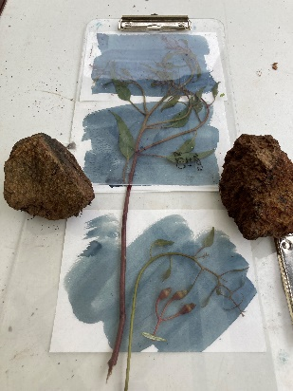 | 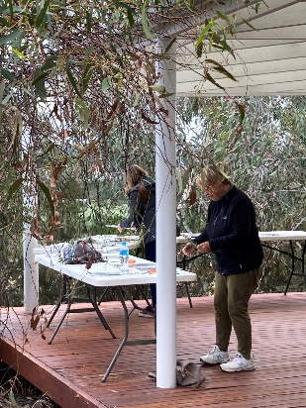 |  | 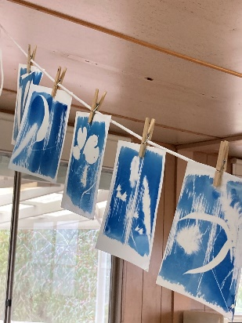
Images from the community program Cyanotypes at Mugga-Mugga Grasslands
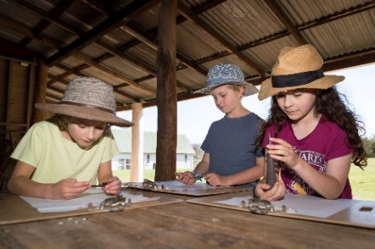  Examining artifacts in Who Were the Convicts learning program, Lanyon Homestead  (Photo Jane Duong) |  | 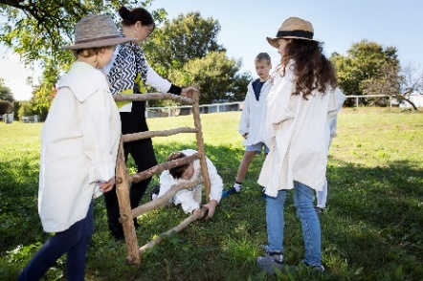  Assembling hurdles in the Convicts learning  program, Lanyon Homestead  (Photo Jane Duong)
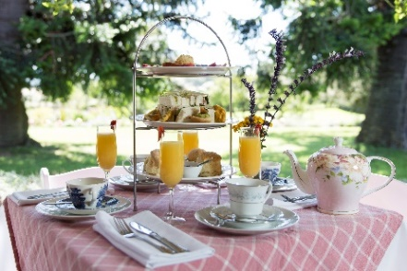 |  | 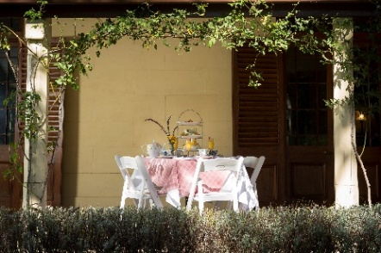
Mother’s Day High Tea on the verandah of Lanyon Homestead (Photo’s Jane Duong)
- Harvest Day Out 2022 @ Lanyon Homestead with over 10 individual workshops and performances planned was cancelled due to severe weather warning. Parts of this program will be reprised for Floriade 2022.
- Recruitment is underway for a Curator to lead research projects at the properties and develop related programs, exhibitions and publications.
- During the year ACTHP developed and trialled a pilot virtual excursion for Kindergarten to Year 2 primary students that focused on grasslands and landscape of Mugga-Mugga; and trialled an online Artefact Chat learning program. Discussions have commenced on secondary school engagement and a range of subject themes including geography and visual arts have been considered.
- Project proposal, stakeholder discussions and terms and conditions have been developed for a non-acquisitive Art Prize program which will commence in 2022–23.
In 2021–22, a renewable energy pilot project was implemented. A Cobber engine is now operational at Mugga-Mugga and learning programming is in development.
Stewardship – Buildings, grounds and collections that are conserved and researched
Strategies to achieve this:
- Provide leadership in cultural heritage management, including in documentation, research, conservation, interpretation and visitor engagement.
- Recognise, conserve and promote the multi-layered heritage values and cultural relevance of each ACTHP site, in the areas of ecological heritage, Indigenous heritage and stories, Canberra’s convict and colonial history, and Canberra’s social history as the Federal Capital.
Realise the potential of each site collection to provide further access and understanding for on-line visitors.
Key outcomes in 2021–22 against the above strategies
- A range of activities was undertaken throughout the year to conserve, research and interpret the Historic Places.
- The restoration of the Lanyon Cemetery was completed including replacement of existing fencing with an innovative wombat-proof fence, significant landscape works, and conservation, cleaning, and repainting of lettering on the gravestones.
- The scoping and costing stages of the conservation works program for Lanyon, Mugga-Mugga and Calthorpes’ House is complete, with procurement in its final stages.
- Accessioning of the Calthorpes’ House collection has continued with almost 400 more items included in the database.
- A new ACTHP Collections Policy was developed and endorsed by the CFC Board.
- Asset management planning has been implemented in preliminary development of maintenance programs for the three ACTHP sites.
- As part of the ongoing Security Upgrade Project for ACTHP, security assessments of each site were completed, scoping and costing completed, with implementation of upgrades planned for 2022 in consultation with ACT Government, Shared Services.
- The Water Supply Infrastructure Upgrade Project has continued. The first test bore failed to locate water. A second test bore was drilled, located a small amount of water, but not sufficient for a bore. A third bore site has been located and verified by two hydrologists, approvals for this testing are underway.
- Development of tree management strategies has commenced for each property and Budget funding was secured for this key project to conserve or remove and replace trees approaching end-of-life.
- ICT connectivity continues to be an issue for Lanyon Homestead. An internal fibre network at Lanyon and for connectivity to the Lanyon Heritage Centre and Workshop has been proposed.
- ACTHP commenced scoping the update of the Conservation Management Plans (CMP) for each site. Conservation works will be completed in 2022–23 and the CMP’s will reflect the most up-to-date site conditions.
- Acquisition and accessioning of Dawn Waterhouse’s Shirley Temple, Calthorpes’ House Recipe Research Collection and Royal Collection was completed, with over 220 items included. Dawn Waterhouse has also donated additional objects originally part of Calthorpes’ House with accessioning and exhibition proposals under development.
- Over 3,700 documents and images have been digitised including the Cunningham photographs associated with Lanyon and several historic documents for Mugga-Mugga.
- Implementation of the monitoring program as required by the Grasslands Management Plan for Mugga-Mugga by Sarah Sharp is supporting regrowth of listed native grasslands on the site.
- A training session was provided for staff by Sarah Sharp for grasslands monitoring. Monitoring has commenced and stakeholder consultation is ongoing.
- The first stage of a rabbit control program at Mugga-Mugga is underway in collaboration with ACT Parks and Conservation.
- Weed management planning is also underway and proposals for cultural burns at Mugga-Mugga are in development.
- Annual bushfire and emergency training for all staff was held at Lanyon in December 2021.
- CMAG and ACTHP Work Unit Health and Safety Committee was refreshed with new membership and an inspection schedule for 2022.

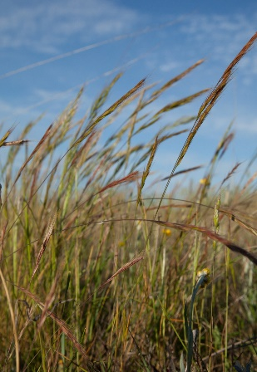 | 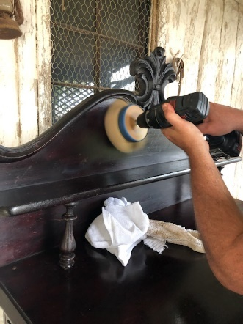 | 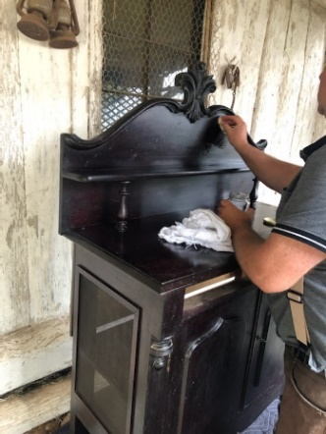
Speargrass, Mugga-Mugga grasslands  (Photo Caroline Young) | Conservation work being carried out on the chiffonier located at  Mugga-Mugga Cottage in the Dining room

Leadership – An integral part of the cultural life of the Canberra region and beyond
Strategies to achieve this:
- Position ACTHP and its sites as cultural places that grow the education and tourism sector in Canberra.
- Provide leadership in heritage place activation in order to showcase the cultural, social, education and economic benefits of engaging with cultural heritage.
- Provide leadership in cultural planning and management, including through creative partnerships and by demonstrating the importance of arts and heritage to individual and community wellbeing.
Key outcomes in 2021–22 against the above strategies
- ACTHP was part of the National Experience Content Initiative with Tourism Australia/Visit Canberra. This included creating photographic and video marketing collateral for Lanyon, Calthorpes’ House and Mugga-Mugga for Tourism Australia and Cultural Facilities Corporation.
- Lanyon was featured in a marketing campaign for Southpoint Shopping Centre in Tuggeranong.
- The Director, ACTHP presented at:
- the ACT Region Heritage Symposium in August 2021, about the Role of Heritage and Community Wellbeing;
- the University of Canberra, Heritage and Tourism lecture;
- keynote speaker at the Royal Australian Historical Society Annual Conference, about the Beard Watson Collection at Calthorpes’ House; and
- Australia Museum and Galleries Association Conference – the role of the arts and heritage in supporting community wellbeing.
- Lanyon Heritage Centre has continued as a teaching space for education programs, and dedicated storage for museum collections.
- Lanyon remained a popular venue for functions and weddings. 14 functions were held including seven weddings, a Baptism party, Christmas parties and a memorial service.
- Lanyon was a finalist in the 2021 Brides Choice awards for historic venues.
- ACT HP maintained and developed partnerships with other relevant education, government and non-government organisation and institutions. These included:
- wombat mange treatment and survey at Lanyon with ACT Wildlife continued throughout the year.
- erosion Management with ACT Parks and Conservation in the river corridor.
- collaboration with ACT Heritage regarding participation in the Canberra and Region Heritage Festival.
- collaboration with EventsACT regarding public programs including as a Floriade community partner.
- ACTHP is part of the Joint Course Advisory Committee – University of Canberra for the Bachelor of Arts (Culture and Heritage) and Graduate Certificate in Heritage Materials Conservation.
- ACTHP staff provided a tour and lecture at Mugga-Mugga and on campus regarding the work of ACTHP and the key role the organisation plays in the community to students from the Australian National University in the Introduction to Heritage Management course.
Developing a project with University of Canberra to co-design research-based museum programs that use heritage sites and museum collections to support people and families affected by dementia.

B.3 Scrutiny
There were no Auditor-General, ACT Ombudsman or Legislative Assembly Committee reports that related specifically to the CFC in 2021–22.
For further information contact: CFO, CFC Corporation Finance (02) 6205 2195

B.4 Risk Management
The CFC finalised a new Risk Management Framework and Policy and Risk Management Plan in December 2021. These documents guide and inform risk management activities across the CFC including for the CFC’s Strategic Risks, Fraud Corruption and Control, and Work Health and Safety.
The CFC already has in place a comprehensive Strategic Risk Management Register, which is implemented, monitored and updated on an ongoing basis. This register provides the framework for supporting strategies and plans relating to more specific areas of risk, such as disaster preparedness and business continuity plans.
A revised Strategic Risk Management Register was approved by the Board in December 2021.

B.5 Internal Audit
The CFC Audit Committee, a subcommittee of the CFC Board, met on six occasions during 2021–22. Meetings were held on 14 July 2021, 30 September 2021, 25 November 2021, 28 January 2022, 24 March 2022 and 26 May 2022. The number of meetings attended by Committee members was as follows:
Name of Member | Position | Meetings attended
Shad Sears | Chair | Six
Gordon Ramsay | Member | Three
Harriet Elvin | Member | Three
Helen O’Neil | Member | Six

The CFO and Financial Controller are invited to each meeting as an observers and an open invitation is also extended to the ACT Audit Office to send an observer to each meeting.
The Part G of the CFC Board Charter sets out the operations for the Audit Committee and incorporates specific roles for risk management and audit matters. It is available at http://www.culturalfacilities.act.gov.au.
Internal Audit
The Audit Committee reviews and approves an internal audit/quality assurance plan for each financial year. A Chief Executive Financial Instruction has been issued dealing with audit committee and internal audit matters.
The main focus of the internal audit program was the completion of the superannuation underpayment review.

B.6 Fraud Prevention
The CFC has a comprehensive Fraud and Corruption Prevention Plan and Policy (FCPPP) which is implemented and monitored on an ongoing basis. Oversight of this plan is undertaken by the Audit Committee, as one of the roles under its Charter – refer to http://www.culturalfacilities.act.gov.au.
A revised FCPPP was approved by the Board in December 2021.

B.7 Freedom Of Information
Open Access Information - Section 96 (3) (a) (i), (ii) and (iii)
Number of decisions to publish Open Access information. 7
Number of decisions not to publish Open Access information. 0
Number of decisions not to publish a description of Open Access information withheld. 0
FOI Applications received and decision type - Section 96 (3) (a) (iv), (vii), (viii) and (ix)
Number of access applications received. 0
Number of applications where access to all information requested was given. 0
Number of applications where access to only some of the information requested was given (partial release). 0
Number of applications where access to the information was refused. 0
FOI processing timeframe - Section 96 (3) (v) and (vi); Section 96 (3) (d)
Total applications decided within the time to decide under section 40. 0
Applications not decided within the time to decide under section 40. 0
Number of days taken to decide over the time to decide in section 40 for each application. 5 days. This was with the approval of the respondent under section 41 within 20 working days of the application. 0
Amendment to personal information - Section 96 (a) (x) and Section 96 (3) (e)
Number of requests made to amend personal information, and the decisions made (e.g. amended, refused, notation added to record, other). 0
Reviews – Section 96 (3) (b); Section 96 (3) (c)
Number of applications made to Ombudsman under section 74 and the results of the application (e.g. affirmed, varied, set aside and substituted, withdrawn, other). 0
Number of applications made to ACT Civic and Administrative Tribunal under section 84 and the results of the application (e.g. affirmed, varied, set aside and substituted, withdrawn, other). 0
Fees - Section 96 (3) (f)
total charges and application fees collected from access applications. 0
FOI requests can be made by contacting the Cultural Facilities Corporation FOI Information Officer, PO Box 939 CIVIC SQUARE ACT 2608 or emailing CFCcorporatefinance@act.gov.au.
Further information can be found at http://www.culturalfacilities.act.gov.au.

B.8 Community Engagement and Support
The CFC actively seeks to engage its communities in a greater understanding of the value of the arts, and of cultural heritage, through its programs and activities, placing customer service as its primary goal and recognising the diverse needs and expectations of customers. A summary of actions taken by the CFC during 2021–22 in terms of community engagement and support is provided below, with detailed information presented about each of these actions under Section B.2, page 29.
During the year, CMAG and ACT Historic Places (ACTHP) presented a diverse range of high quality exhibitions, learning and community programs and other activities, including on site, off site (through outreach programs) and online. Productive partnerships were developed with other cultural organisations, the tourism sector and the wider community in developing and delivering programs and events. The Canberra Theatre Centre (CTC) connected the community with the performing arts, including through initiatives that addressed special needs in the community. The CTC provided a wide range of activities for the education system and wider community.
The CFC’s digital strategies provided new community engagement opportunities through the use of social media and digital programming. Digital engagement activities were particularly important for maintaining contact with the communities the CFC serves during the period of site closures from August to October 2021 and the recovery period, due to COVID-19 restrictions. New digital initiatives were introduced, such as museum online learning programs and online catalogues extending the access to exhibitions, collections and programs. ACTHP’s interaction with social media posts demonstrated a growing audience which included a series of stories and posts about the history, collection, green collection and people at each property. The content of the Ruth Lane-Poole CMAG exhibition was converted to an exhibition website including an exhibition walk through video and object audio description.
Once restrictions eased, COVID-19 safe activities for the community resumed; for example, the MakerSpace and ReaderSpace areas within the CMAG foyer were reintroduced with modified offerings to align with Public Health Directions. Audio descriptions were developed for key works in the CMAG exhibitions Ruth Lane-Poole: a Woman of Influence and Mandy Martin From Queanbeyan to New York: 1978– 1984 / Art & Life.
Implementation of COVIDSafe Plans ensured that CFC visitors understood the additional cleaning, contact tracing and physical distancing measures implemented to keep staff and visitors safe.
The CFC continually seeks to improve customers’ satisfaction with their visit to, and experience of its venues. Customer satisfaction surveys were conducted throughout the year and reported as part of the CFC’s 2021–22 Statement of Performance. Information gained from the surveys was used in future planning to improve facilities and services.
A major community engagement activity for the CFC is the operation of its three CFC advisory committees. In 2022, the CFC’s advisory committees provided advice on a range of specialised matters relating to the operation of the CFC’s three program areas: CMAG; ACTHP; and the CTC.
Engagement tools included individual sessions of each committee with approximately 17 advisory committee members participating, providing expert strategic advice on a voluntary basis, and providing important links between the CFC and the wider community.

B.9 Aboriginal and Torres Strait Islander Reporting
The CFC ensures cultural diversity is an essential feature of its regular programming, including exhibitions, theatre presentations and programs featuring Indigenous cultures. Examples of activities in each area of the CFC in 2021–22 are provided below.

Canberra Theatre Centre
Canberra Theatre Centre (CTC) continued its commitment to showcasing and promoting the work of First Nations artists and strengthening the diversity and cultural connection of its program through the presentation of the following events:
Bangarra Dance Theatre’s Sandsong, stories from the Great Sandy Desert created in consultation with Wangkatjungka/Walmajarri Elders from the Kimberley translated into dance.
I Liked… It But I didn’t Know What the F#!k it Was About, an immersive and participatory examination of contemporary art from Wiradjuri artist Joel Bray.
The CTC’s annual Reconciliation Day Eve Concert featuring performances from Christine Anu, BRIGGS, and Electric Fields.
CMAG
CMAG’s Indigenous engagement during the year included the following.
- Ensure exhibitions feature cultural and Indigenous content, with a commitment to exhibitions of Indigenous content being Indigenous led, such as through Indigenous guest curators. CMAG presented major exhibition Brenda L. Croft: ‘hand/made/held/ground’. Brenda Croft is an indigenous artist who curated the exhibition. The installation maps Croft’s patrilineal relationship to Country, reimagining customary objects such as jimpila (spearhead) and kurrwa (stone axe) originally created on Gurindji homelands. The contemporary representations reflect ancestral journeys - those undertaken on traditional homelands, and those returning home.
- CMAG presented exhibition Connection Point: Contemporary established fibre textile artists of ACT and NSW. Artworks by Jennifer Kenmare Martinello AO and Dr Matilda House were presented in this exhibition and the placement of their works in the entry area was designed to acknowledge their significance and to act as a welcome onto the country of the exhibition represented.
- CMAG hosted a CareerTrackers intern in Exhibitions and Collections, Access and Learning and Front of House. This program supports Indigenous students.
- The following learning programs were delivered at CMAG in 2021–22, each featuring Indigenous content in response to the key cross curriculum priority of Aboriginal and Torres Strait Islander Histories and Cultures in the Australian Curriculum.
- Every Picture Tells a Story – onsite and online learning program for Preschool to Year 2 students. During this program, students are introduced to Indigenous place names and Ngunnawal language, which is woven through the stories found in Sidney Nolan’s paintings.
- What Do Artists Make – onsite learning program for Preschool to Year 2 students. During this program students engage with works by Aboriginal artists Paul House and Tom Rowney.
- The Art Box – outreach learning program for Kindergarten to Year 3 students. This resource features the work by Matilda House, Murrumbeja Dooligah, 1996, lithograph.
- The following community programs were delivered at CMAG in 2021–22, each featuring Indigenous artists.
- CMAG After Dark @ Enlighten Festival – in association with the Enlighten Festival Australian Dance Party artists performed between Civic Square and the CMAG exhibition Connection Point: Contemporary established fibre textile artists of ACT and NSW.
- Conversation: Dr Brenda L. Croft and Jodie Cunningham, CEO Craft ACT discussing CMAG exhibition Brenda L. Croft: ‘hand/made/held/ground’.
A staff member attended the Bundian Way Arts Exchange —ANU School of Art and Design program.
ACT Historic Places
In 2021–22, ACT Historic Places engaged with Indigenous communities to strengthen and improve its approach to interpretation and management of Indigenous stories and values through specific activities, including the following.
- ACTHP engaged Indigenous educator and plant consultant Adam Shipp to provide bush tucker and native plant programs at Mugga-Mugga Cottage and Lanyon Homestead. Mugga-Mugga hosted Wellbeing Talk: Bush Tucker with Adam Shipp, sharing his passion for traditional Aboriginal plant use and their uses, including foods, fibres and medicines. Unfortunately, the Lanyon Homestead talk was cancelled due to extreme weather.
- Lanyon Homestead hosted the program Kids Week Art: Dreamtime by the River with First Nations host Duncan Smith OAM from Wiradjuri Echoes.

B.10 Work Health and Safety
The CFC is committed to maintaining the health, safety and welfare of its employees. Workplace Health and Safety (WHS) is managed in accordance with the statutory provisions of the Work Health and Safety Act 2011.
CFC venues and activities operated under a range of COVID-19 related restrictions during the year. The CFC committed to prioritising the health and safety of its employees, volunteers and visitors/patrons by ensuring compliance with COVID-19 guidelines and restrictions.
The CFC has:
- a CFC WHS Policy Statement, which has been advised to all staff;
- nominated six Health and Safety Officers;
- established a CFC WHS Committee (WHSC) and Work Unit Health and Safety Committees (WUHSC); and
ensured that WHS issues are discussed at each fortnightly meeting of the CFC Senior Leadership Team – refer to B.1.6, page 27.
The CFC is served by two WUHSC, reporting to CFC WHSC. During 2021–22, 22 staff participated in these Committees.
The WUHSC conducted a number of site inspections where risks are reviewed and improvements recommended as appropriate.
The highest rated risks for CFC include:
- Electrocution;
- Fire Emergency Management; and
Working at heights.
The CFC is treating these risks by a number of measures, including: ensuring regular test and tag of electrical equipment, Fire Warden training, testing of emergency systems, evacuation practice and ongoing training for working at heights and manual handling.
The CFC’s WHS arrangements operate as part of the ACT WHS and Injury Management Improvement Strategy, which commits ACT Government employers and employees to high standards of workplace health and safety. The CFC’s WHS arrangements also acknowledge the targets set by the ACT Government for improving WHS performance, injury management and prevention.
The CFC Board receives a WHS report at each meeting. These reports include information about: accidents or incidents; outcomes and corrective action from previous accidents or incidents; risk assessments undertaken; meetings of the WHSC and WUHSCs, together with key issues discussed at these meetings; training provided on WHS; progress on development of the Safety Management System; and other WHS matters, such as security management.
In addition, every six months, a further report is provided to the Board on key WHS risks in the CFC, together with risk controls and risk treatment strategies.
Work Health and Safety Act 2011
In 2021–22, the CFC received Improvement notices N-0000004464, 4465, 4466, and 4467 under Part 10 of the Work Health and Safety Act 2011. The notices were issued on 20 June 2022, and received on 24 June 2022. The notices related to improvements required of the Canberra Theatre Centre (CTC) in relation to EWIS, Emergency, First Aid & Fire Panel training. The CTC fully complied with all Improvement Notices, and all notices were confirmed by WorkSafe as closed on 7 July.
In 2021–22, the CFC did not receive notices of improvement, or non-disturbance under Part 10 of the Work Health and Safety Act 2011.
In 2021–22, the CFC did not receive notices of enforceable undertakings under Part 11 of the Work Health and Safety Act 2011.
In 2021–22, the CFC did not receive notices of failure to comply with a safety duty under Part 2, Division 2.2, 2.3 or 2.4 of the Work Health and Safety Act 2011.
In 2021–22, CFC staff members were trained in WHS through participation in a number of courses, including:
- First Aid training;
- Mental Health and Crisis Support training;
- Emergency Control Organisation training and video training;
- QPR training (Question, Persuade, Refer) Suicide prevention training;
- In-House COVID-19 Safe training;
- Manual Handling; and
CTC Tech rigging training;
There were no serious injury, illness or dangerous incidents reported to WorkSafe ACT in accordance with Part 3 Section 38 of the Work Health and Safety Act 2011 in 2021–22.

B.11 Human Resources Management

B.11.1 Human Resources Management
The CFC’s approach to Human Resources (HR) management and workforce planning is through the ongoing implementation and review of its HR Plan. Further information about HR management is provided in Section B.2.1, page 32.

B.11.2 Learning and Development
The CFC places high importance on staff training and development. During 2021–22, staff attended many formal training courses, a range of conferences and seminars, and other professional development opportunities. These ranged from training courses on specific topics, such as Mental Health and Crisis Support training through to attendances at meetings and conferences for the arts and museum sector, such as the annual national conference of The Australian Museums and Galleries Association.
Other examples of professional development opportunities attended by staff in 2021–22 included Canberra Region Tourism Advisory Forum meetings; Art Association of Australia and New Zealand Conference Webinar; ACT Region Heritage Symposium; Royal Australian Historical Society Annual Conference; Arts and Health Advisory Committee meetings; Visible Thinking in the Museum, (The Powerhouse); Understanding Audiences in a Pandemic (ArtsHub); Audio Description training; Bundian Way Arts Exchange course; National Capital Art Prize judging panel; Australian Tax Office E-invoicing for intermediaries; Confidentiality and Conflicts - Tax Practitioners Board Webinar; Australian Registrars Committee Conference; and Best Practice Recruitment and Staff Selection. The CFC also undertakes performance management/skills development assessment programs. Further information is provided under Section B.2.1, page 32.
Expenditure on staff training and professional development during 2021–22 amounted to $47,983. This amount includes membership fees for professional development programs, staff training and conference fees. Associated travel and accommodation costs are not included in this amount but were very limited in 2021–22 due to COVID-19 restrictions on travel.
During the year, four staff members participated in courses provided by ACTPS Training Calendar at a total cost of $1,344.
The CFC convenes meetings of its Agency Consultative Committee (ACC) consisting of staff, management and union representatives. The ACC met on 12 May and 20 June 2022.

B.11.3 Staffing Profile
The CFC’s Staffing Profile as at 23 June 2022 (the last pay date for the 2021–22 financial year) was as follows.
FTE and headcount by division/branch
Division/branch | FTE | Headcount
Cultural Facilities Corporation | 90 | 144
FTE and headcount by gender
 | Female | Male | Total
Full Time Equivalent | 55 | 35 | 90
Headcount | 88 | 56 | 144
Percentage of workforce | 61% | 39% | 100%

Headcount by classification and gender
Classification groups | Female | Male | Total
ASO2 | 15 | 3 | 18
ASO3 | 4 | 0 | 4
ASO4 | 9 | 2 | 11
ASO5 | 9 | 5 | 14
ASO6 | 5 | 5 | 10
GSO4 | 0 | 2 | 2
GSO6 | 0 | 2 | 2
GSO7 | 0 | 1 | 1
GSO9 | 0 | 1 | 1
PO1 | 5 | 0 | 5
PO2 | 3 | 0 | 3
SOGA | 2 | 1 | 3
SOGC | 5 | 2 | 7
SPOA | 1 | 0 | 1
SPOC | 1 | 0 | 1
Executive Contract | 1 | 2 | 3
Box Office | 7 | 5 | 12
Senior Wardrobe | 1 | 0 | 1
Patron Services | 15 | 11 | 26
First Year Apprentice | 1 | 0 | 1
Tech. Level 1 | 3 | 9 | 12
Tech. Level 2 | 1 | 2 | 3
Tech. Level 4 | 0 | 3 | 3
Total | 88 | 56 | 144
Headcount by employment category and gender
 | Female | Male | Total
Casual | 41 | 29 | 70
Permanent Full-time | 25 | 18 | 43
Permanent Part-time | 11 | 3 | 14
Temporary Full-time | 6 | 4 | 10
Temporary Part-time | 5 | 2 | 7
Total | 88 | 56 | 144
Headcount by diversity group
Division/branch | Headcount | Percentage of agency workforce
Aboriginal and Torres Strait Islander Peoples | 1 | -1%
Culturally and Linguistically diverse | 8 | 5%
People with Disability | 2 | 2%
Prospective employees of the CFC are asked to identify their ethnicity or disability. However, declaring this information is not mandatory.
Headcount by age group, gender and average length of service
Age Group | Female | Average length of service | Male | Average length of service
Under 25 | 9 | 1 | 10 | 6
25-34 | 20 | 3 | 9 | 2
35-44 | 14 | 5 | 15 | 6
45-54 | 21 | 4 | 10 | 7
55 and over | 24 | 10 | 12 | 11
Recruitment and separation rates for the agency
 | Recruitment rate | Separation rate
CFC | 18% | 32%
Attraction and Retention Initiatives (ARins)
 |  | Total
Number of ARINS as at 30 June 2022 |  | 6

The statistics exclude Board members and people on leave without pay.

B.12 Ecologically Sustainable Development
Climate Change and Greenhouse Gas Reduction policies and programs
The Water Supply Infrastructure Upgrade project for Lanyon saw the completion of its concept design, Cultural Heritage Survey, test bore and final design and documentation. The first test bore failed to locate water. A second test bore was drilled in 2021–22 and located a small amount of water, but not sufficient for a bore. A third bore site has been located and verified by two hydrologists, approvals for this testing are underway.

A renewable energy pilot project at Mugga-Mugga was completed, with a Cobber engine operational, converting green waste to electricity.

Sustainable development performance 2021–22 and 2020–21
Indicator as at 30 June | Unit | 2021–22 |  | 2020–21 |  | Percentage  change
Stationary energy usage
Electricity use | Kilowatt hours |  | 1,608,187 |  | 1,579,161 |  | 2%
Natural gas use (non-transport) | Megajoules |  | 5,806,970¹ |  | 4,123,039¹ |  | 41%
Diesel (non-transport) | Kilolitres |  | - |  | - |  | -
Transport fuel usage
Electric vehicles | Number |  | - |  | - |  | -
Hybrid vehicles | Number |  | 1 |  | 1 |  | -
Hydrogen vehicles | Number |  | - |  | - |  | -
Total number of vehicles | Number |  | 5 |  | 5 |  | -
Fuel use – Petrol | Kilolitres |  | .5² |  | .7² |  | (29%)
Fuel use – Diesel | Kilolitres |  | 1.5 |  | 1.7 |  | (12%)
Fuel use – Liquid Petroleum Gas (LPG) | Kilolitres |  | - |  | - |  | -
Fuel use – Compressed Natural Gas (CNG) | Gigajoules |  | - |  | - |  | -
Water usage
Water use | Kilolitres |  | 5,554³ |  | 4,514³ |  | 23%
Resource efficiency and waste
Reams of paper purchased | Reams |  | 199⁴ |  | 431⁴ |  | (54%)
Recycled content of paper purchased | Percentage |  | 79% |  | 73% |  | 8%
Waste to landfill | Litres⁵ |  | 45,760 |  | 47,740 |  | (4%)
 | Tonnes⁵ |  | 26.1 |  | 29.4 |  | (11%)
Co-mingled material recycled | Litres⁵ |  | 22,880 |  | 22,880 |  | -
 | Tonnes⁵ |  | 11.3 |  | 11.4 |  | (1%)
Paper & Cardboard recycled (incl. secure paper) | Litres |  | 22,880 |  | 22,880 |  | -
 | Tonnes |  | 1.9⁶ |  | 1.4⁶ |  | 36%
Organic material recycled | Litres |  | Note⁷ |  | Note⁷
Greenhouse gas emissions
Emissions from natural gas use (non-transport) | Tonnes CO₂-e |  | 299⁸ |  | 212⁸ |  | 41%
Emissions diesel use (non-transport) | Tonnes CO₂-e |  | - |  | - |  | -
Emissions from transport fuel use | Tonnes CO₂-e |  | 5 |  | 6 |  | (17%)
Emissions from refrigerants fuel use | Tonnes CO₂-e |  | .1 |  | - |  | -
Total emissions | Tonnes CO₂-e |  | 304 |  | 218 |  | 39%

The information used for calculations in the above table was provided by ActewAGL, Weston Energy, ICON Water, ACT Property Group, WINC, Veolia, Iron Mountain, Cleanaway, Elgas, AAAWater and SG Fleet Australia Pty Ltd., with assistance from: the Environment, Planning and Sustainable Development Directorate (EPSDD); Climate Change and Energy—Zero Emissions Government, Schools and Community; and the Enterprise Sustainability Platform.
- The increase in natural gas use is due to differing patterns of operations in the CFC during the COVID-19 pandemic over the years. For example, gas usage in 2017–18 was comparable at 5,979,681 Megajoules.
- The decrease in fuel-use – petrol is due to less travelling required as there was a reduction in operations and activities due to COVID-19 restrictions.
- The increase in water use is due to venues increasing operations following the ACT COVID-19 lockdown. In particular the Canberra Theatre Centre saw increased water usage in the second part of the year.
- The decrease in reams of paper purchased is due to the CFC’s commitment to reduce paper usage and transitioning to a more digitised environment.
- Not all service providers of waste collection from CFC facilities report the amounts of waste collected in litres. Some provide the amounts in tonnes. It is not possible to convert tonnes to litres, therefore both figures are provided.
- The increase in Paper & Cardboard recycled is due to CFC’s commitment to recycle and reduce waste to landfill.
- Large amounts of garden waste are collected, composted and re-used to replenish the gardens at the ACT Historic Places. However, it is not possible to quantify the amount of organic material recycled.
- The increase in emissions from natural gas use is due to point 1. above.

The following statements have been provided by the EPSDD; Climate Change and Energy for inclusion in this report.
Emissions reported for stationary energy and transport fuels include Scope 1 and Scope 2 emissions only. Scope 1 are direct emissions from sources owned and operated by the government including: emissions from transport fuel and natural gas use. Scope 2 are indirect emissions from mains electricity.
Emission factors used to calculate natural gas and fleet fuel are based on the latest National Greenhouse Accounts factors.
The ACT met it’s 100% renewable electricity target in 2019-20. As a result, the ACT Government reports zero greenhouse gas emissions from electricity use. The ACT Government is committed to maintaining 100% renewable electricity supply beyond 2020.
Treatment of plug-in hybrids
A plug-in hybrid electric vehicle (also known as a range-extended vehicle) is fuelled by electricity as well as having either a petrol or diesel tank to extend the range of the vehicle for long trips. PHEVs are considered zero emissions vehicles (ZEVs) under the ACT Government Fleet Procurement and Management Policy and are counted as ZEVs in reporting.

Part C
Financial Management Reporting

C.1 Financial Management Analysis
A full analysis of the CFC’s 2021–22 financial results and financial position is set out in the Management Discussion and Analysis at Attachment 1, page 149 to this report.

C.2 Financial Statements
The CFC’s 2021–22 Financial Statements are set out in Attachment 1, page 103 to this report.

C.3 Capital Works
2021–22 CAPITAL WORKS TABLE
Project | Original estimated completion date | Revised completion date | Original project value  $0,000 | Revised project value  $0,000 | Prior year expenditure  $0,000 | Current year expenditure  $0,000 | Total expenditure to date  $0,000
New Capital Works
Improvements to the Canberra Theatre Centre | June 24 | - | 1,442 | 1,421 | - | 460 | 460
Improvements to the Canberra Museum and Gallery and the North Building | June 23 | - | 600 | 590 | - | 106 | 106
Works in Progress
Upgrading Lanyon Homestead | June 23 | June 24 | 3,097 | 3,035 | 488 | 323 | 811
Completed Works
Upgrading the Canberra Theatre Centre | June 22 | - | 1,480 | 1,480 | 1,370 | 110 | 1,480
Better Infrastructure Fund
Cultural Facilities Corporation | June 22 | - | 439 | 439 | - | 439 | 439
Total Capital Works Program |  |  | 7,058 | 6,965 | 1,858 | 1,438 | 3,296

2021–22 CAPITAL WORKS RECONCILIATION
 |  | 2021–22 Approved  Financing  $0,000 |  | 2021–22 Drawdown  Amount  $0,000 |  | 2021–22 Actual Expenditure  $0,000
New Capital Works
Improvements to the Canberra Theatre Centre | 900 |  | 350 |  | 460
Improvements to the Canberra Museum and Gallery and the North Building | 350 |  | 70 |  | 106
Works in Progress
Upgrading Lanyon Homestead | 988 |  | 323 |  | 323
Upgrading the Canberra Theatre Centre | 110 |  | 110 |  | 110
Better Infrastructure Fund
Cultural Facilities Corporation | 439 |  | 439 |  | 439
Total Capital Works Program | 2,787 |  | 1,292 |  | 1,438
Works Funded From Other Sources
Adjusted for Capital funded through Own Sourced Revenue | - |  | - |  | 99
Balances per Capital Works Management | 2,787 |  | 1,292 |  | 1,537
Balances per cash flow statements | 2,787 |  | 1,292 |  | 1,537
For further information contact: CFO, CFC Corporate Finance (02) 6205 219

C.4 Asset Management

C.4.1 Assets Managed
The CFC managed assets with a total value of $66,496,000 as at 30 June 2022. The CFC’s major assets and approximate values are:
Description | $0,000
Canberra Theatre Centre, and extensions at fair value | 31,551
Land at fair value | 17,580
Historic Places buildings at fair value | 5,963
Plant and Equipment at fair value | 5,172
Art and Social History Collection | 5,398
Capital Works in Progress | 813
Intangible Assets | 19
During 2021–22 the following major assets were added to the CFC’s asset register:
Description | $0,000
Property, plant and equipment acquisitions | 585
Building upgrades | 570
Art and Social History objects (including donated art) | 151
There were no significant assets removed from the CFC’s asset register during 2021–22.

C.4.2 Assets Maintenance and Upgrade
The CFC maintains its assets in accordance with the CFC’s Strategic Asset Management Plan.
Major asset upgrades (including works funded and reported through the capital works program) completed during 2021–22 were:
Description | $0,000
Improving facilities at the Canberra Theatre Centre | 570
Upgrading Lanyon Homestead | 323
Improving facilities at the Canberra Museum and Gallery | 70
For building assets, the expenditure on repairs and maintenance was $510,000, which represented 1.4% of the assets written down value. For Plant and Equipment assets, the expenditure on repairs and maintenance was $342,000, which represented 6.7% of the assets written down value.
A three year rolling independent valuation of the CFC’s assets has been implemented to ensure all items are reflected at fair value in the CFC’s asset register and any impairment is identified.

C.4.3 Office Accommodation
CFC staff members occupy or use premises at the Canberra Theatre Centre, CMAG, Lanyon, Calthorpes’ House, Mugga-Mugga and North Building administration area locations.
In view of the wide range of workplaces in which CFC staff work (including historic places, theatre and gallery environments, where areas used by staff as offices may be combined with other uses such as ticketing, patron servicing etc.), it is difficult to provide a precise figure of the average area occupied by each employee. An estimate of the total office area occupied as of 30 June 2022 is 1,147 square metres and an estimate of the average area occupied by each FTE employee as of 30 June 2022 is 13 square metres.

C.5 Government Contracting

C.5.1 Procurement Principles and Processes
The CFC engaged external sources of goods, services and works during 2021–22 and these goods, services and works were procured with the support and assistance of Procurement ACT as required.
The CFC believes that its procurement selection and management processes comply with the Government Procurement Act 2001 and Government Procurement Regulation 2007. It liaises regularly with Procurement ACT on procurement matters including through the involvement of officers of Procurement ACT in the more complex or higher value procurement processes.

C.5.2 External Sources of Goods, Services and Works
The online ACT Government Contracts Register records contracts with suppliers of goods, services and works, with a value of $25,000 or more.
A full search of Cultural Facilities Corporation contracts notified with an execution date from 1 July 2021 to 30 June 2022 can be made at https://www.tenders.act.gov.au/contract/search.
Secure Local Jobs Code
There have been no exemptions provided to the CFC from secure local jobs code requirements under Section 22G of the Government Procurement Act 2001.
Aboriginal and Torres Strait Islander Procurement Policy (ATSIPP) Performance Measures
No. | ATSIPP Performance Measure | Result
1. | The number of unique Aboriginal and Torres Strait Islander Enterprises that respond to Territory tender and quotation opportunities issued from the Approved Systems. | 4
2. | The number of unique Aboriginal and Torres Strait Islander Enterprises attributed a value of Addressable Spend in the financial year. | 6
3. | Percentage of the financial year’s Addressable Spend that is spent with Aboriginal and Torres Strait Islander Enterprises – target 1%. | less than 1%
Creative Services Panel
The Creative Services Panel is a whole of government arrangement for the purchase of creative services*, including:
From 1 July 2021 to 30 September 2021
- advertising
- marketing
- communications and engagement
- digital
- graphic design
- photography and video
media buying.
From 1 October 2021 to 30 June 2022
- Communications and engagement
During 2021–22, Cultural Facilities Corporation spent at total of $153,808.93 through suppliers of the panel. This includes marketing, advertising and graphic design creative work for various performances at the Canberra Theatre Centre and for exhibitions and programs at CMAG and ACT Historic Places. Major purchases through this panel are published online on the ACT Government Contracts Register.
*The services available through the panel changed on 1 October 2022.

C.6 Statement of Performance
The CFC’s 2021–22 Statement of Performance is set out in Attachment 1 to this report, page 159.

Appendix 1 –
Members and Remuneration of the CFC Board during 2021–22
Appendices
ACTING JUSTICE RICHARD REFSHAUGE
(Chair appointment – 1 January 2019 to 30 June 2022)
Richard Refshauge BA (Hons) LLB graduated from the ANU and commenced private legal practice in 1976 with local firm, Macphillamy Cummins & Gibson. He became a partner in 1981 and senior partner in 1992. The firm merged with Sly & Weigall in 1994 and he became Chairman of the Canberra partners. The firm changed its name in 1995 to Deacons Graham & James. In 1998, he was appointed the third ACT Director of Public Prosecutions and in 2008 a Judge of the ACT Supreme Court, a position from which he retired in May 2017. He has since been appointed an Acting Judge in the ACT Supreme Court to preside over the Drug and Alcohol Sentencing List. He has presented guest lectures at the ANU College of Law, where he has been, since 2001, an Distinguished Honorary Professor. He is also an Adjunct Professor of the School of Law at the University of Canberra. Richard has had a long involvement with the arts in Canberra. He was President of the Arts Council of Australia (ACT Division) and Director of the Arts Council of Australia. He was a member of the Canberra Theatre Trust. He was Chair of the Board of Fortune Theatre Company, of Reid House Theatre Workshop, of Canberra Youth Theatre and of the Australian Choreographic Centre. He was a member and then the second Chair of the ACT Cultural Council. In 2014–15 he was a member of the Board of the Cultural Facilities Corporation. He is currently Chair of the Board of QL2 and Deputy Chair of the Board of the National Institute of Dramatic Art. He has also been involved in many welfare organisations in Canberra and is currently Chair of Directions Health Services, member of the Board of the Greater Good Foundation and is Chancellor of the Anglican Diocese of Canberra and Goulburn. Appointed as Acting Judge of the Supreme Court.
HELEN O’NEIL
(Deputy Chair appointment – 27 November 2018 to 30 June 2022)
Helen is the Chair of Performing Arts Connections, representing arts centres, touring companies and service organisations in Australian live performance, and Chair of South East Arts. She is a former Board member of Craft ACT, Currency House Inc and the Australian Film Finance Corporation. Her executive experience includes roles as Country Director of the British Council in Australia leading cultural relations in the arts, science and higher education; Executive Director of the Australian Major Performing Arts Group and the Council for the Humanities, Arts and Social Sciences; and with Opera Australia. In public policy she was Senior Adviser to the Minister for the Arts, The Hon Simon Crean and also worked with the Minister for Communications, The Hon Kim Beazley. Helen has worked in screen and digital areas with News Ltd, and as a journalist with the ABC and The Age. She has degrees from the University of Melbourne (BA) and from Harvard University's Kennedy School (MPA).
HARRIET ELVIN AM
(Ex officio as Chief Executive Officer to 10 December 2021)
Harriet holds degrees at undergraduate and graduate level from Cambridge University, and the Australian National University (ANU), in classics, law, international law, business administration, art history and curatorship. She was formerly the General Manager of the ACT Bureau of Arts and Heritage and the recipient of the inaugural ACT Government - ANU MBA Scholarship (1997).
Her membership include the External Advisory Board of the ANU College of Business and Economics; the Canberra Region Tourism Advisory Forum; and the Australiana Fund National Council and Canberra Committee. She is also Chair of the Cambridge Society, ACT Branch; a Fellow of the Institute of Managers and Leaders, Australia and New Zealand; and Fellow of the Australian Institute of Company Directors. Harriet was the 2001 ACT Telstra Business Woman of the Year and was awarded a Centenary Medal for service to Australian society in business leadership. She received the award of Member of the Order of Australia (AM) in the 2021 Queen’s Birthday honours for significant service to arts administration in the ACT and to the community.
GORDON RAMSAY
(Ex officio as Chief Executive Officer from 13 December 2021)
Gordon is a former member of the ACT Executive (2016–20) during which time he held six portfolios, including Attorney-General and Minister for the Arts and was a member of various national ministerial councils, contributing to key reforms in areas in multiple areas of ACT life and orchestrating key support mechanisms for artists during the pandemic.
Gordon has a Bachelor of Arts and an Honours Degree in Law from Sydney University and a Bachelor of Theology from the Sydney College of Divinity. After practising both commercial and intellectual property law, he and his family moved to Canberra where he led Kippax Uniting Church and its large community service arm, UnitingCare Kippax. Under his leadership, UnitingCare Kippax achieved a five-fold increase in income generation in support of 1500 people per week experiencing disadvantage.
Gordon also chaired Uniting, one of Australia’s largest not-for-profit providers of aged care, with an annual budget of $700 million and a balance sheet of over $1.6 billion in property assets, over 8000 staff and 3000 volunteers, and providing services to 48,000 people per year. During his time he also led governance and organisational restructure of the organisation.
He also has 20 years of advocacy work in areas of social equality, inclusion, and poverty, leading the ACT Targeted Assistance Strategy and as a member of the ACT Community Inclusion Board between 2006–08. He has provided consultancy support on policy and organisational governance, strategy, and structure locally and nationally for much of the past two decades.
He has been an ACT Community Inclusion Advocate, member of the ACT Better Services Taskforce, Community Champion for the “Time to talk: Canberra 2030” and led ACT Anti-Poverty work. He is currently a member of the Board of The Neighbourhood Centre Canberra. He was recognised in the Australian of the Year awards as an ACT Local Hero finalist in 2015.
SHAD SEARS
(Member appointment – 27 November 2018 to 31 December 2023)
Shad is a Partner within the PwC Assurance practice in Canberra. Shad has over 21 years’ experience providing professional services and advice to government and private sector clients. Shad holds Master degrees in both Cyber Security and Information Technology, a Bachelor of Commerce and is also a Fellow of the Institute of Chartered Secretaries and Administrators.
GENEVIEVE JACOBS AM
(Member appointment – 27 November 2018 to 31 December 2023)
Genevieve Jacobs has been a journalist for 30 years, working in print and radio. She was a longtime ABC Canberra presenter and is now the Group Editor for Region Media and a graduate of the Australian Institute of Company Directors. Genevieve is a director of the Cultural Facilities Corporation, the Conflict Resolution Service and the Australian Centre for Christianity and Culture. She chaired the ACT Arts Minister's advisory council and Canberra International Music Festival and has an enduring interest in building and strengthening community engagement.

VICKY DARLING
(Member appointment – 1 January 2019 to 30 June 2022)
Vicky Darling is a management consultant and contractor, providing expertise to government and not-for-profits on governance, strategy and volunteering programs. She served as the Chief Executive Officer of Volunteering and Contact ACT, the peak body for volunteering and community information services in the Canberra region from 2017 until 2020. Following completion of a Bachelor of Arts in Recreation Administration, Vicky worked in the travel and recruitment industries before pursuing a career in public policy and community engagement. She has held executive leadership positions in the private sector, government, peak bodies, and charities and served in the Queensland Parliament.
JULIAN WIDDUP
(Member appointment – 1 February 2020 to 31 December 2022)
Julian Widdup is an experienced director having served on the boards of major Australian and international companies including airports, power utilities, port corporations, financial services, hospitals and public sector enterprises. Julian has a strong background in finance and risk management, having held executive leadership roles with Palisade Investment Partners, Access Capital Advisers and previously worked with the Australian Government. Julian is a fully qualified actuary and a Fellow of the Australian Institute of Company Directors. He completed the Senior Executive Leadership Program with Harvard Business School, holds a Bachelor of Economics and a Master of Business Administration from the Australian National University, and received the ANU University Medal. Julian has a strong interest in the arts. He is currently a director of Screen Canberra, the ASX-listed Rural Funds Group and Australian Catholic Superannuation and Retirement Fund.
Remuneration
The FM Act (Division 9.2, Clause 78(6)) provides that the remuneration of the CFC’s Chair, Deputy Chair, and appointed Members shall be determined by the ACT Remuneration Tribunal.
The current annual remuneration rates, set by the Tribunal’s Determination No. 13 of 2021 are:
Chair $28,685
Deputy Chair $14,355
Member $10,060
The Chief Executive Officer’s remuneration is determined by the ACT Remuneration Tribunal under normal senior executive remuneration arrangements.
2021–22 Meetings of the CFC Board
- 25 August 2021
- 20 October 2021
- 8 December 2021
- 23 February 2022
- 28 April 2022
16 June 2022
The convening of these meetings, and their procedures, complied with the requirements of Division 9.4 of the FM Act.
A quorum was achieved at all meetings (refer to Division 9.4, Section 95 of the FM Act).

Appendix 2 –
Senior Managers of the CFC
IAN TIDY – CHIEF FINANCE OFFICER
Ian is a member of Chartered Accountants Australia and New Zealand and has held previous financial roles in retail with Discount Variety Group and in the audit team at BDO Kendalls in Brisbane. He has been employed with the CFC since December 2005, most recently as the Financial Controller before taking up this position in 2010. He has an undergraduate degree in Business with QUT and has experience in the not-for-profit sector, previously serving on the Board of ArtSound FM.
DR BROOKE THOMAS – CHIEF OF STAFF
Brooke has nearly 20 years’ experience in a range of public service, tertiary sector, community arts, and political advisory roles including at both the Territory and Federal levels and for Ministers of both major parties. She has expertise in social policy development and implementation, complex program management, stakeholder engagement, organisational change management including multi-million dollar transformation projects in the APS, and international relations including negotiating complex bilateral MOUs and chairing a sub-committee of APEC. Most recently she worked for Austrade in the area of visitor economy recovery, leading extensive nation-wide consultations for, and delivery of, THRIVE 2030, the national ten-year strategy for visitor economy recovery.
She has a PhD in Literature with several publications, and a considerable contribution in ACT community arts sector leadership including as a former Chair of Canberra Dance Theatre and of The Stellar Dance Company, and as a dance teacher, performer, volunteer, and fundraiser.
The CFC Chief of Staff role provides strategic leadership on human resources and corporate matters, coordinates communications and stakeholder engagement, drives organisational capacity building through a range of projects, and leads on collaboration, business development and audience diversification with the goal of boosting the CFC’s contribution to the ACT visitor economy.
ALEX BUDD – DIRECTOR, CANBERRA THEATRE CENTRE
Alex Budd commenced his arts career in the lighting department at the Canberra Theatre Centre. He was a founding member of the Canberra based Chamber Opera Company, Stopera. He later worked as Head Electrician and Touring Lighting Designer for Sydney Dance Company, realising lighting designs for Graeme Murphy's ballets across Australia, Europe and the Americas. Alex joined Opera Australia as Tour Manager, Oz Opera in 2000, and has held several roles in Oz Opera and the wider company. After a year at Royal Opera House Covent Garden project managing the Paul Hamlyn Performances, Alex returned to Opera Australia as Manager, Oz Opera, before setting up the Company's Enterprises division. In 2004 Alex was appointed to the Federal Government's Playing Australia Committee, and sat on the Committee for seven years. In 2008 he became General Manager, Melbourne and Enterprises, and in 2016 Executive Producer, Touring and Commercial, the Melbourne-based member of the Company's Executive, with oversight of the music theatre, regional and schools touring and commercial projects of the Opera Australia business. Alex produced 16 New Year's Eve Galas at the Sydney Opera House, as well as the musical tours of South Pacific, The King & I, Anything Goes, My Fair Lady, Evita, and West Side Story. Alex was appointed Director, Canberra Theatre Centre in late 2019, returning to Canberra to lead the organisation where his career began.

DR SARAH SCHMIDT – DIRECTOR, CMAG
Sarah is an art historian and curator who has specialised in public gallery directorship, from leading two Commonwealth collections, to Deputy Directorship of the Art Gallery of Ballarat - one of the top five collections of Australian art. Canberra Museum and Gallery is her fourth Directorship. Her leadership roles are supported by an extensive background in scholarship and curating, as well as in business and in arts marketing.
She has curated major solo exhibitions of noted Australian artists including Rick Amor, Cressida Campbell, Mirka Mora, Patricia Piccinini, John Wolseley, and Ah Xian; and several exhibitions in the areas of 20th century Australian painting, and Australian and European decorative arts. Sarah has also worked as a Unit Lecturer in Arts Management for The University of Melbourne and in an arts and cultural management role for the Australian Embassy, Beijing, China. She holds four postgraduate degrees from The University of Melbourne including a PhD in Art History.
DR ANNA WONG – DIRECTOR, ACT HISTORIC PLACES
Anna has worked in the heritage management and museum industry across a broad range of historic, cultural and natural places in Australia, including precinct-based activation of cultural sites. She previously held archaeology, heritage, and museum-related positions at the NSW Department of Public Works, NSW National Trust, NSW National Parks and Wildlife Service and the National Capital Authority. She was previously a Lecturer in Heritage Studies at the University of Sydney. Her doctoral research examined the Australian heritage conservation movement through the house museum genre and how this shaped our national identity and cultural representation of Australia’s past and present. In 2005, Anna was awarded research fellowships at the International Centre for Jefferson Studies at Monticello and the Winterthur Museum.
Anna has a deep interest in social history and the integration of contemporary programs, stories and site activation at historic places to ensure that heritage continues to be relevant to current communities and audiences.

Appendix 3 –
Advisory Committees
The CFC has established three Advisory Committees, in accordance with Section 8 (i)(a) of the CFC Act, to provide expert strategic advice in relation to their respective specialist areas. The committees include the Canberra Museum and Gallery Advisory Committee; Historic Places Advisory Committee; and Canberra Theatre Centre Advisory Committee.
CANBERRA MUSEUM AND GALLERY ADVISORY COMMITTEE
MEMBERSHIP DURING 2021–22
PROFESSOR NICHOLAS BROWN (CONVENOR)
Nicholas Brown is a professor in the School of History, College of Arts and Social Sciences, Australian National University. He has recently served as the Visiting Cabinet Historian with the National Archives of Australia, and is currently a member of the ACT Heritage Council and the Commonwealth and ACT Working Party of the Australian Dictionary of Biography. He is the author and co-author of a number of books, edited collections, and journal articles, most recently A History of Canberra (2016) with Cambridge University Press.
DR ROSLYN RUSSELL (DEPUTY CONVENOR)
Roslyn Russell is an historian, author, editor and museum consultant who has lived and worked in Canberra since 1982. Her published works include One Destiny! The Federation Story: How Australia Became a Nation (with Philip Chubb), and a selection of Manning Clark’s correspondence, published in 2008 as Ever, Manning: Selected Letters of Manning Clark 1938–1991. Other books include The Business of Nature: John Gould and Australia, and High Seas & High Teas: Voyaging to Australia, both published by the National Library of Australia; and Not Without a Fight: the story of the Friends of the National Museum of Australia (with Louise Douglas). Roslyn is Chair of the UNESCO Australian Memory of the World Committee, and Editor-in-Chief of the International Journal of Intangible Heritage.
DR GUY HANSEN
Dr Guy Hansen is Director of Exhibitions as the National Library of Australia. He has worked in museums for over twenty years. An historian by training, Guy holds degrees from Sydney University and the University of Technology, Sydney. He has worked as the lead curator on numerous exhibition projects including Nation: Symbols of Australia (2001), Captivating and Curious (2005), League of Legends (2008) and Keepsakes: Australians and the Great War (2015). Guy has also been head of the National Museum of Australia’s Collection Development Unit and the Australian Society and History Program. Guy’s research interests include the history of sport in Australia, the history of the car and political cartooning.
PROFESSOR DENISE FERRIS
Denise Ferris is an Emeritus Professor at the Australian National University, in the School of Art & Design where she was Head of School until December 2020. She is an Executive Board Member of the Australian Council of University Art and Design Schools (ACUADS) and Deans and Directors of Creative Arts (DDCA), peak bodies for the tertiary art and design sector. Denise holds degrees from Sydney University and University of Technology Sydney.
An art practitioner, Ferris’ photographs are held in Australian public collections, including the National Gallery, National Library, Australian War Memorial, ACT Legislative Assembly Art Collection and Canberra Museum and Gallery as well as international collections including the District Six Museum, Cape Town and Nara City, Japan.

SQUADRON LEADER GARY OAKLEY OAM
Currently serving in the Royal Australian Air Force in the History and Heritage section as the Indigenous Historian/Curator. Also holds the position as the National President of the Aboriginal and Torres Strait Islander Veterans and Services Association.
Started his career as a 15 year old Junior Recruit in the Royal Australian Navy (RAN) and served for 22 years mostly in submarines. Also a Vietnam War veteran for service in HMAS Sydney.
Left the RAN to take up a position as an Assistant Curator in the Military and Heraldry Section of the Australian War Memorial and after several years moved to the then Gallery Development later Exhibitions section as the Exhibitions Curator in which time he curated most of the galleries currently in the Memorial. He also spent time researching and as a curator at the Bavarian Army Museum in Ingolstadt Germany. He was the first Indigenous Liaison Officer appointed by the Memorial. Whilst a curator at the Memorial he stayed in the RAN Reserve doing programs with the Navy History Section and Australian Defence Force Indigenous Affairs. Offered a position in Air Force in their newly set up Equity and Diversity branch he retired from the Public Service to take up a commission in the Air Force.
DR CHARLOTTE CRAW
Charlotte Craw is an arts, culture and heritage professional with experience working in cultural institutions, public policy, community arts and tertiary education in Australia, Cambodia and New Zealand. Since 2015, she has worked in collection development at the Australian Institute of Aboriginal and Torres Strait Islander Studies. She is the co-author of the Ningaloo Coast and Sambor Prei Kuk World Heritage nominations, and her other publications include academic articles, art criticism, poetry and short fiction.
SARA KELLY
Sara Kelly has been a museum consultant for the last three and a half years, also undertaking research for cultural institutions on a voluntary basis. Since early 1982 Sara has worked in Art Galleries and Museums at a National, State, University and Local level, as a Director, Curator, and a Loans and Collections Manager. In addition to a Fine Art degree from the ANU, she has a Diploma in Law and Collection Management, which facilitated extensive work on state and international transport logistics, compliance across a number of areas including Indemnity and Sanctions, and their reporting for the movement of cultural material.
AMELIA ZARAFTIS
Amelia Zaraftis is an executive leader, fundraiser, educator, artist, and reconciliation advocate, living on Ngunnawal Ngambri Country. As the Director of Advancement at Burgmann College, a not-for-profit residential college on the ANU campus, Amelia leads the College’s alumni relations, communications, and fundraising program, and champions the College’s Reconciliation program. At the ANU School of Art & Design, Amelia also co-leads the Arts ACT-funded Sharing Stories Arts Exchange project which facilitates artists’ engagement with First Nations communities in Canberra and surrounds. Early her career, Amelia was the Education and Community Programs Officer at CMAG. In 2018, Amelia was a co-recipient of the ANU Vice Chancellor’s Award for Reconciliation. Amelia holds a Bachelor of Visual Arts (First Class Honours) from the ANU and a Bachelor of Education from the University of Canberra.
The Advisory Committee met on 22 March 2022.

HISTORIC PLACES ADVISORY COMMITTEE
MEMBERSHIP DURING 2021–22
BARBARA REEVE, FIIC, M.ICOMOS (CONVENOR)
Barbara served as the Australian War Memorial's Head, Collection Services, 1998 – 2014, responsible for the Conservation, Registration, and Collection Management System teams, then stepped into the role of Manager, Heritage Preservation Projects, until her retirement in 2017. Prior to moving to Canberra she was the inaugural Head of Conservation, Australian National Maritime Museum, 1993-98. Professional training includes: BA (Archaeology) Bryn Mawr College; BSc (Conservation) University of London; Museum Leadership Program, 2001, 2003, 2005; Visiting Scholar, Wolfson College, Cambridge, 2010; Advance Professional Development course, Best Practice in Managing Heritage Places, ANU, 2014; Certified Passivhaus Designer / Consultant, Passivhaus Institut, 2020. A Fellow and Ordinary Member of Council for the International Institute for Conservation, and former Director, AusHeritage, her international experience includes establishing conservation training at Hong Kong University, and work for museums, collectors, and archaeological excavations in Europe, the Asia-Pacific, and the Middle East. Her professional interests and publications include conservation education and practice, bushfire recovery, and sustainability / eco-effectiveness in the building and heritage sectors.
DR DIANNE FIRTH OAM (DEPUTY CONVENOR)
Dr Dianne Firth is Adjunct Associate Professor in the Faculty of Arts and Design at the University of Canberra and is a registered landscape architect and Fellow of the Australian Institute of Landscape Architects. She holds a PhD, B Land Arch, BSc, and Dip Ed.
She was Head of the Landscape Architecture program at the University of Canberra until 2012 and was Deputy Chair of the ACT Heritage Council until March 2018. In 2017 Dianne was awarded an OAM for her service to landscape architecture and education. Her PhD, Behind the Landscape of Lake Burley Griffin: landscape, water, politics, and the National Capital 1899-1964, was completed in 2000. The current focus of her research, publication and lecturing is Canberra’s landscape: its design, legacy, and heritage.
She has served as chair for the review of the National Capital Open Space System for the National Capital Authority, as a member of the Design Review Panel for the ACT Government, and as a landscape expert on the ACT Government's Tree Renewal Strategic Plan.
ALISTAIR GRINBERGS
Alistair is a research scholar with the Centre for Creative and Cultural Research at the University of Canberra. His research is focused on the potential benefits of centering First Nations culture, experience and values in heritage management practice and seeking to understand how that might determine what forms of engagement and investigation are required and what questions about the past then become relevant.
1993 to 1997: NSW National Parks & Wildlife Service – responsible for advice on Indigenous and historic heritage places and values, assessment of environmental impact assessments, and negotiation with NSW and Commonwealth Government agencies on the management of legacy assets within Kosciuszko National Park following corporatisation of the Snowy Mountains Scheme. 1997 to 2000: Australian Heritage Commission - responsibility for coordinating complex advice to the Government on National Estate listed places and related policy matters including amendments to the Environment Protection and Biodiversity Conservation Act. 2000: Australian National Antarctic Research Expedition to Heard & McDonald Islands - completed a heritage assessment of the former Australian base at Atlas Cove. 2001-2003: Environment Australia - managing a review of the Ozone Protection Act and associated amendments to the legislation to include synthetic greenhouse gasses used as alternatives to ozone depleting substances. 2003 to 2008: Independent consulting practice - completed a range of projects including organisational restructures of Booderee and Kakadu National Parks, a national review of heritage tourism in protected areas and the assessment of National Heritage List values of the Australian Alps National Parks. 2008 – 2016: Ironbark Heritage & Environment – Director of a consulting practice that focused on First Nations heritage assessments in the rapidly expanding WA iron ore mining sector. 2017 to 2020: EcoLogical Australia and later Lantern Heritage.
JOANNE LISINSKI
Joanne is a Conservator and specialises in modern materials and materials analysis, and has experience in archaeological and built heritage preservation and management. She is currently a Senior Conservator at the Australian War Memorial. Prior to this, she worked in the Middle East for 15 years in Conservation and Technical Art History. She completed Master degrees in Conservation Science (University College London), Middle Eastern and Central Asian Studies (Australian National University), and Undergraduate studies in Fine Arts (RMIT). She has particular interest in experimental and contemporary art practice. She is a Board Member at You Are Here (YAH) and Secretary of the Australian Museums and Galleries Association Art, Craft and Design National Network (AMaGA ACD NN). In 2020, Joanne was selected to attend the Audrey Fagan Board Traineeship Program and completed a one year mentorship program with CFC’s then CEO. Her professional interests and publications include conservation science, collection hazard and risk management, and work place health and safety.
AMANDA MARSHALL
Amanda Marshall is the Visual Ars Coordinator at St Francis Xavier College Canberra, leading the Visual Arts Department and teaching Visual Arts, Photography and Media to Years 7–12. With a Master of Studies (Visual Arts/Science ANU), Bachelor of Science (ANU) and Diploma of Education (QUT), she has taught Science, Mathematics and Visual Arts at primary and secondary schools, across public and private sectors in NSW, QLD and ACT. Amanda’s focus on wellbeing and visual arts led to her appointment as lecturer in positive psychology in education, and primary Visual Arts teaching at the Australian Catholic University (ACU, 2017–2019) and presenting at the International Positive Psychology Conference and the National Visual Arts Education Conference (2019). She also lectured in the Clemente tertiary program offered by the ACU and St Vincent de Paul for those impacted by trauma. Additionally, her passion for Visual Thinking Strategies (involving group observation, analysis and discussion) enables the development of critical thinking, literacy and social competency skills in group settings.
DR SHANNYN PALMER
Shannyn is a community-engaged practitioner, researcher and writer. She currently works as a consultant, helping organisations and institutions to achieve best practice in community engagement and create meaningful collaborations. She has over a decade of experience working in community engagement, facilitation and research with First Nations peoples and communities and government and non-government organisations in the arts, cultural and cultural heritage sectors. She has a PhD in History from the Australian National University and recently published her first book with Melbourne University Press, Unmaking Angas Downs: Myth and History on a Central Australian Pastoral Station, which traces a history of colonisation in Central Australia from the perspective of Anangu who lived there. She is committed to the development of community-engaged practice and meaningful intercultural conversations and collaborations.
The Advisory Committee met on 9 May 2022.

CANBERRA THEATRE CENTRE ADVISORY COMMITTEE
MEMBERSHIP DURING 2021–22
MEG WILLIAMS (CONVENOR)
Meg Williams joined ANA as Chief of Staff in 2021. Previously Meg was the Director of Inertia Music Label Group, one of Australia's leading Independent music companies and a part of the global [PIAS] group of companies, overseeing the strategic release of emerging and established artists here and around the world. With a background in communications and management, Meg has been the Executive Director of the Association of Artist Managers (AAM) and currently sits on the board of FBi Radio.
CLAUDIA SANTANGELO (DEPUTY CONVENOR)
Claudia is a fundraiser with the Australian National University. She drives philanthropic growth in support of Aboriginal and Torres Strait Islander led projects, and health and climate initiatives with national impact.
Claudia has a strong background in the arts industry. She has produced her own shows for Sydney Fringe, Co-Directed a multi-day arts and music festival, and spent three years as Manager of Sydney Film Festival’s Travelling Film Festival, among other production and events management gigs. Prior to this she managed the IBM Cape York Program, working with Indigenous Enterprise Partnerships to coordinate staff secondments supporting community driven projects.
Through 2013-2015 Claudia worked in Timor-Leste, first as an Australian Youth Ambassador with the Association of Community Radio, supporting this local collective to build their profile, funding and reach. She then worked with the Timor-Leste‘s President’s office, successfully establishing a national nutrition awards program.
Claudia’s move to Canberra in 2015 introduced her to the philanthropy world, where her community-building experience and creativity remain key to her success as a fundraising professional.
KELS BAGUST
Kels is a passionate and established arts producer, festival manager, curator of events and general manager. Most recently Kels has worked as the Contemporary Music Producer for Sydney Opera House, curating and collaborating on their year-round contemporary music program for the newly reopened Concert Hall. From 2017 to 2022, Kels was the Live Music Manager for the University of Canberra’s live music arm, UC Live; producing and managing events at UC Refectory, UC Hub and Stonefest Music Festival. Kels is a member of MusicACT, and has also worked in event management, operations and curatorial roles for a number of Canberra based arts organisations, including Ainslie and Gorman Arts Centres and Dionysus.
SOËLILY CONSEN-LYNCH
Soëlily Consen-Lynch is a Dutch trained legal professional in employment law and industrial relations, working in ACT Government.
Prior to moving to Canberra with her family in 2013, she worked in corporate law and legal aid in the Netherlands.
Advocacy has been her passion from early on and as she felt a void "helping people" in Australia, she commenced volunteering in various community organisations as she always tries to look for ways to support and empower people and improve people's quality of life where possible.
In 2019 she joined the Multicultural advisory council of the ACT Minister of Multicultural Affairs, a position she recently vacated in April 2022, to give other community members a chance to join the council.
In 2020-2021 she was the vice chair of the ACT Chapter of the Mental Health Foundation Australia Multicultural Ambassadors.
In 2021, she was the chair of the ACT chapter of the Mental Health Foundation Australia Multicultural Ambassadors and she was also a Volunteer Coordinator for UN Women IWD Committee Canberra.
This year she joined the MHFA Attache- team.
Soëlily is also a member of the Celebrate Gungahlin Reference Group to assist the annual Celebrate Gungahlin event.
FREDELIZA PIPER
Fredeliza Campos is an archaeologist and an ethnomusicologist. In the Philippines, she has held various music related positions, such as A&R for BMG Records, Music Specialist for the National Philharmonic Orchestra and as an Archivist for the music instrument collection of the University of the Philippines, Center for Ethnomusicology. She completed her postgraduate studies at the University of the Philippines (Master of Science in Archaeology) and the University of Hong Kong (Master of Philosophy in Ethnomusicology). As an academic, Fredeliza has received fellowships to conduct in-depth analyses of zoological specimens and musical instruments from institutional collections, such as the Field Museum of Natural History in Chicago, Naturalis Biodiversity Center in Leiden, and museums in the Philippines. She is currently affiliated with the Australian National University as part of the secretariat for the Indo-Pacific Prehistory Association, a large organization of archaeologists, anthropologists and other specialists in similar fields working in the Indo-Pacific region. She has ongoing research on cultural and religious festivals, specifically looking at the performance of traditional musical instruments and their early forms. Fredeliza is also a member of Rondanihan, a rondalla musical group based in Canberra, and plays an active role in various cultural activities as part of the Philippine-Australian diaspora.
DAVID HOBBES
David is an Architect and Heritage Consultant at Philip Leeson Architects.
The Advisory Committee met on 16 March 2022.

Appendix 4 –
Facilities and Business/Activities under Management
CFC – MAIN UNDERTAKINGS
Asset | Business/Activity | General Description of Business Activity
Canberra Theatre Centre, comprising –  - Canberra Theatre  (1,239 seats).  - The Playhouse Theatre  (614 seats).  - The Courtyard Studio  (90 seats).  - Other venues and spaces including: Link/Foyer; Technical Workshop; and the CTC Forecourt. | - Presentation of live performances.  - Technical services support to presenters.  - Marketing/sales support to presenters.  - Front of house support to presenters.  - Front of house services to patrons.  - Box Office services.  - Building maintenance services, asset management etc.  - Discovery and Learning. | - Presentation of live performances.  - Providing excellent patron experiences.  - Foster performing arts skills through creative learning and vocational education and training.
- Canberra Museum and Gallery (including The Nolan Collection), comprising –  - Gallery spaces, art studio, theatrette, meeting rooms, foyer, and collection storage area. | - Visual arts/social history (exhibitions, museological activities, etc) programs – either curated by the facility or in partnership with community groups, private organisations or other institutions.  - Front of house services to visitors.  - Technical services support for exhibition installation.  - Research, learning and community programs.  - Venue Hires/usage by commercial/community users.  - CMAG Café. | - Development and presentation of visual arts and social history programs.  - Development, conservation and research of an integrated social history and visual arts collection.
Lanyon, Homestead/Historical Precinct | - House museum and grounds, with associated tours, activities etc.  - Conservation management  - Commercial/community venue hire (weddings etc).  - Research, learning and community programs.  - Technical/caretaking/gardening services.  - Catering/concessions. | - Conservation, interpretation and presentation of cultural heritage resource with associated supporting services and facilities.  - Presentation of exhibitions and outdoor performances and events especially in association with festivals.
Calthorpes’ House,  Red Hill | - House museum and gardens with associated tours, activities etc.  - Conservation management  - Research, learning and community programs.  - Technical/gardening/security support services. | - Conservation, interpretation and presentation of cultural heritage resource associated with support services.
Mugga-Mugga,  Symonston | - House museum and grounds with associated tours, activities etc.  - Conservation and management  - Education Centre and associated programs.  - Commercial/community hires/usages.  - Technical/gardening/security support services. | - Conservation, interpretation and presentation of cultural heritage resource associated with support services.  - Presentation of events especially in association with festivals.  - Environmental education activities.
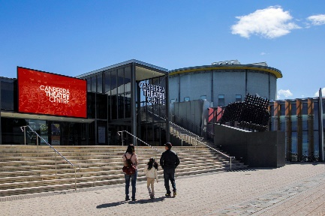Canberra Theatre Centre | 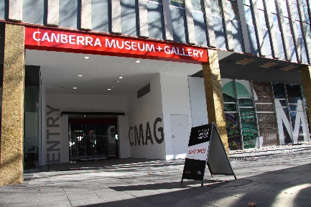CMAG | 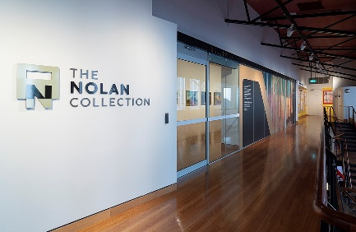The Nolan Collection
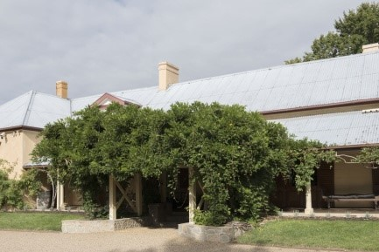Lanyon Homestead | 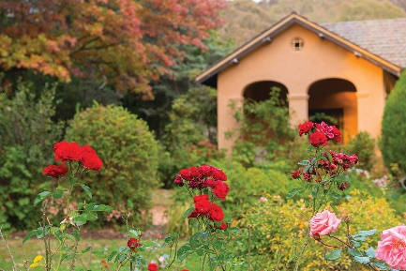Calthorpes’ House | 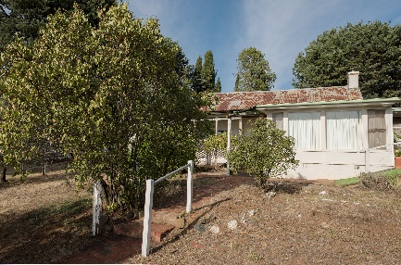Mugga-Mugga

Appendix 5 –
Canberra Museum and Gallery and ACT Historic Places Venues – Schedule of Exhibitions, Programs and Events
The following is a list of exhibitions, community and education programs and events at CMAG and the ACT Historic Place venues in 2021–22.
Canberra Museum and Gallery
Exhibitions
* Exhibitions recorded in 2020–21 Annual Report.
** Exhibitions installed and scheduled to open in August 2021 however, were not available for public viewing as the ACT went into lockdown on the 12 August 2021.
* Seeing Canberra | 7 March 2020–24 July 2021
* Crafting Canberra | 7 March 2020–24 July 2021
* Don’t forget the Milk: Celebrating 50 Years of Canberra Milk | 3 April–31 July 2021
* The Piano Creatures: A Ragged Shore | 22 May–4 September 2021
* Natalie Rosin: Brutalism | 21 June–7 August 2021
* Sidney Nolan: Remembrances of my youth | 20 March–16 October 2021
The Nolan Collection | Permanent Exhibition
Ruth Lane-Poole: A Woman of Influence | 10 July to 2 October 2021
** Spowers and Syme | 29 October 2021–12 February 2022
** Threads of Policing | 29 October– 8 February 2022
Mandy Martin From Queanbeyan to New York: 1978–1984 / Art & Life | 29 October 2021–12 February 2022
Brenda L. Croft: hand/made/held/ground’ | 29 October 2021–22 January 2022
Finding the dry heart: Sidney Nolan’s early travels in Central Australia | 27 November 2021–2 April 2022
Sidney Nolan: Inferno | 9 April–17 September 2022
Back to the Boombox | 11 April–16 July 2022
Brian Corr, Timshel | 29 October 2021–30 June 2022
Canberra Raiders: 40 years in the limelight | 26 February–27 August 2022
Connection Point: Contemporary established fibre textile artists of ACT and NSW | 5 March–18 June 2022
Delene White: Flower Power | 4 December–3 September 2022
Glass Alphabet | 7 May–1 August 2022
Jan Brown: A life with Art | 17 June 2022–30 March 2023

Learning and Community Programs
Floor Talks: Conducted by artists and CMAG staff for the following exhibitions: Spowers and Syme; Threads of Policing; Mandy Martin From Queanbeyan to New York: 1978– 1984 / Art & Life; Back to the Boombox; and Canberra Raiders: 40 years in the limelight.
Reel Classics: The Reel McCoy Film Society presented classic cinema film screenings throughout the year.
Other programs included:
- Community programs resumed after the COVID-19 lockdown period in November 2021 with two programs presented in association with exhibition Spowers and Syme.
- The MakerSpace and ReaderSpace activities for families with children were reintroduced in the CMAG foyer with modified offerings to align with Public Health Directions.
- Curator Talk with Virginia Rigney and a MakerSpace activity for families with children to create a Concertina Collage inspired by Mandy Martin’s paintings in the exhibition Mandy Martin From Queanbeyan to New York: 1978–1984 / Art & Life.
- Curator talk with Chris Cranston and a conversation between AFP divers Ben Cox and Chris Markcrow in conjunction with exhibition Threads of Policing.
- Printmaking Workshop with artist Sally Mumford, for the Winnunga Women’s Group in conjunction with the National Gallery of Australia’s touring exhibition Spowers and Syme.
- Canberra Day workshops coinciding with the Enlighten Canberra festival.
- Various children’s programs CMAG on Saturday: Shimmer and Shine; Stitch Stories and Plastic Painting.
- Gathering Threads presented a performance in response to CMAG exhibition Connection Point: Contemporary established fibre textile artists of ACT and NSW in partnership with Canberra Dance Theatre’s GOLD Company.
Outreach Programs:
- Exhibition in a Suitcase was loaned to Radford Early Learning Centre, Hackett PreSchool and North Ainslie Primary School.
- Old MacDonald’s Farm was loaned to Tharwa Preschool.
Programs conducted in association with The Nolan Collection
- Every Picture Tells a Story: A learning program exploring the paintings of Sidney Nolan, attended by various Preschools.
- An opening event featuring dance and theatre performances in conjunction with CMAG exhibition Sidney Nolan: Inferno.
Outreach Programs
- Stop Motion Nolan suitcase was loaned to Majura Primary School.
Venue Hire: Venues within CMAG were hired by 30 different organisations during 2021–22, with a number of these organisations hiring venues on multiple occasions such as the AMaGA, Canberra Critics Circle, Australian Federal Police Protective Services and ACT Office for Disability (Community Services Directorate). The organisations ranged from Federal and ACT agencies to not-for-profit organisations, community groups, and private sector organisations.
ACT Historic Places
Exhibitions
Lanyon
Within Living Memory | Permanent exhibition
The Cunningham Family Album | Permanent exhibition
The Convict Years | Permanent exhibition
Calthorpes’ House
Calthorpes’ House Orientation Exhibition | Permanent exhibition
Mugga-Mugga
Getting It Together | Permanent exhibition
Learning and Community Programs
Lanyon
Convicts and Who were the Convicts?: Learning programs discussing the profiles of convicts assigned to Lanyon, attended by various schools.
James’ Diary: Learning programs providing a tour of the homestead in the footsteps of James Cunningham, attended by various schools.
Child’s Play: Learning programs exploring the world of old-fashioned games and Victorian paper dolls, attended by various schools.
Other Programs included: Wellbeing Talk: Bush Tucker Talk; Canberra Grammar School-Visual Art Program; Clay Thought Vessels with Fran Romano; Grasslands walk; Cyanotypes at Mugga-Mugga Grasslands; Ink Stick Drawing with Naomi Zouwer; Nature’s Notes – Pianola Rolls Mixed Media Art Calthorpes’ House; Nature Photography with Ben Kopilow Lanyon Homestead; ‘Stories at Sunset’ with Tim the Yowie Man; Kids Week Workshop: Making Clay Seed Pods and Dreamtime by the River; Wildflowers & Grasslands at Mugga-Mugga Cottage; and Mother’s Day Music and Mimosa High Tea.
Calthorpes’ House
Dawn’s Surprise: Program taking children on a journey around the house, attended by various primary schools.
Mugga-Mugga
At the Garden Gate: Program that focuses on the landscape and environment of Mugga-Mugga, attended by various primary schools and early learning centres.
Outreach Programs:
- Artefact Chat Boxes and Dawn's Suitcase were loaned to various primary schools.
Venue Hire/Function Usage: Spaces within Lanyon and Mugga-Mugga were used by 13 different organisations and groups during 2021–22.
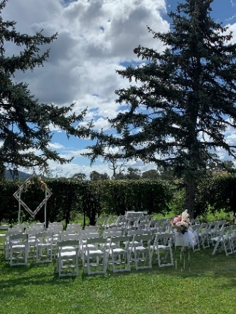 | 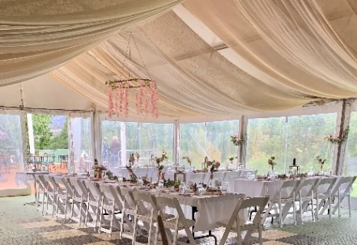  The grounds of Lanyon and the Barracks Café  are popular wedding ceremony venues.

Appendix 6 –
Canberra Museum and Gallery –
Acquisitions (Purchases and Donations)
PURCHASES
Visual Arts
- Sammy Hawker, Nguagara Lake George 2, 2020 photography
- Johannes Kuhnen, Vessel 2009, anodised aluminium, titanium, stainless steel

DONATIONS
Social History
- Margaret Dean, Compendium of 7 x postcards depicting several different Canberra landmarks
- Ian Rose, Manoeuvre Area Federal Territory for operations 3rd Light Horse Brigade 1913
- Sharon Prendergast, 14 x wax drinking straws with “GOVERNMENT FREE MILK” printed on them
Felicity Grant, 1 x fire screen embroidered with a lyrebird by Eirene Mort and constructed by Nora Weston
Visual Arts
- Mandy Martin, Red break 1984, oil on canvas
- Mandy Martin, Early sign 1982, acrylic and oil on canvas
- Mandy Martin, Letterbox, 1978 gouache on cold pressed board
- Mandy Martin, Arranged marriage: Pepina, 1978 gouache on cold pressed board
- Mandy Martin, Tree 1, 1978 gouache on cold pressed board
- Mandy Martin, Phone box, 1978 gouache on cold pressed board
- Mandy Martin, Imported Bride, 1978 five colour screen print numbered 9/15
- Mandy Martin, Queanbeyan garden 1, 1979 gouache, watercolour, coloured pencil on Fabrino
- Mandy Martin, Untitled (two pine tree and fence), 1980 pastel on paper
- Mandy Martin, Fence 2, 1979 pastel on paper
- Mandy Martin, Untitled (women and 44 gallon drum), 1979 gouache on fashion board
- Mandy Martin, Wrapped Trees, 1980 gouache and watercolour on paper
- Mandy Martin, Queanbeyan study : garden IV, 1980 gouache, watercolour, coloured pencil on paper
- Mandy Martin, Picket Fence, 1980 screen print, numbered 8/20
- Mandy Martin, Burnt Fibro, 1980 screen print, numbered 1/20
- Mandy Martin, Pink House, 1981 screen print, numbered 3/25
- Mandy Martin, Steps, 1981 screen print, numbered 4/25
- Mandy Martin, Untitled, 1982 gouache and pastel on paper
- Mandy Martin, Pink Drape, 1981 acrylic on canvas
- Mandy Martin, Mirror, 1980 oil pastel and paint stick on lavis
- Mandy Martin, Green windows, 1980 acrylic, oil paint stick on arches
- Mandy Martin, Fire Escape, 1981 paint stick on Dessin
- Mandy Martin, Fire Escape 2, 1981 paint stick on Dessin
- Mandy Martin, Drought 1, 1982 pastel on johanot paper
- Mandy Martin, Drought and redundancy, 1982 pastel on johanot paper
- Mandy Martin, Drought 8, 1982 pastel on johanot paper
- Mark Denton, Untitled [‘Shaving’ – version 2 pink and red], screen print on paper 1984 60 x 42
- Unknown artist Alison Alder (as printer), Bitumen River Gallery Birthday Party 1984 screen print on paper screen print, printed in colour inks, from five stencils
- Neil Roberts & Acme Ink. Performism [version 2], 1984 screen print on paper 76 x 50.8”
- Sidney Nolan, Untitled (Outback hotel, rider and horse), enamel, ink glass, wood
- Sidney Nolan, Untitled (Triumphal statue), enamel, ink, glass, wood
- Sidney Nolan, Untitled (Brian the stockman at Wave hill mounting a dead horse), inkjet print on paper
- Sidney Nolan, Untitled (Sheds and old car in landscape), inkjet print on paper
- Sidney Nolan, Untitled (Abandoned cottage and buggies, Queensland), inkjet print on paper
- Melita Dahl, Action Unit (lip stretcher), Pigment ink print archival paper
- Melita Dahl, Happy (0/96), Pigment ink print archival paper
Note : in some cases the acquisition process was being finalised as at 30 June 2022.

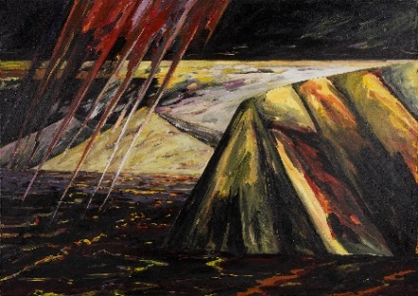
Mandy Martin ( B.1952 D. 2021 )
Red Break 1984
Oil on canvas, 173 x 244
Canberra Museum and Gallery Collection
Donated through the Australian Government's Cultural Gifts Program by Mandy Martin 2021

Appendix 7 –
Major Funding, Sponsorship and Support
The CFC enjoyed the continuing support of Government agencies and of several major sponsors, as well as the assistance of many donors and supporters during 2021–22. Without their generous support many of the CFC’s performances, exhibitions, programs and events would not be possible.
CFC GOVERNMENT FUNDING  ACT Government  CANBERRA MUSEUM AND GALLERY  Government Funding  Commonwealth Department of Infrastructure, Transport, Regional Development and Communications  Major Non-Government Support ($10,000 and over)  Meredith Hinchliffe  John Hindmarsh AM  Supporters (up to the value of $10,000 and major in-kind support)  Mrs Barbara Refshauge  Phillip Keir  John Hindmarsh AM and Rosana Hindmarsh  Ms Harriet Elvin (former CEO)  Contributions to the Canberra Region Treasures Fund 2014–2022  John Hindmarsh AM (former CFC Chair)  Louise Douglas (former CFC Chair)  Virginia Haussegger AM (former CFC Board Member)  Ms Harriet Elvin (former CEO)  Dawn Waterhouse  Laura Cree  Maureen Fisher  John Mulvaney AO  Kerry-Anne Cousins  Koula Notaras  John Olsen OBE AO  Jody Turner  Frank Bergersen  John and Dianne Firth  Dr Howard Galloway  Dr Charlotte Galloway  Rosanna Burston  Phoebe Bischoff OAM  Robyn A Duncan  Lady L D Yeend  Jacqueline Pinkava | Contributions to the Canberra Region Treasures Fund 2014–2022 (continued)  Estelle Barnes  Bill and Beverley Wood  Dorothy Cameron  Marian Hill  Judith Bibo  Gabrielle Watt  Karina Harris and Neil Hobbs  Dr Roslyn V Russell  Kristine Reithmiller  Joan Adler  Paul G White PSM  Dr Mark Lax  Lynette Henderson  Richard Rolfe  ACT HISTORIC PLACES  ACT Government Funding  Environment, Planning and Sustainable Development Directorate  CANBERRA THEATRE CENTRE  Supporters (up to the value of $10,000 and major in-kind support)  Justice Richard Refshauge (CFC Chair)  Ms Helen O’Neil (CFC Deputy Chair)  Mr Gordon Ramsay (CFC CEO)  Isher Sekhon  Dr Pauline Bryant  Dr Sue Packer  Mrs Louise John  Ms Claire Boland  Ms Jayne Macphillamy  Pam Nicolson  Denise M Skea  Douglas Sturkey  Dr Mark Westacott  Mr Gary James  Ms Abbey Turrell  Ms Katherine Sanders  Shirley Wells  Ms Shelley Blakley  Ms Jane Smyth

Attachment 1
Financial and Performance Statements and
Management Discussion and Analysis
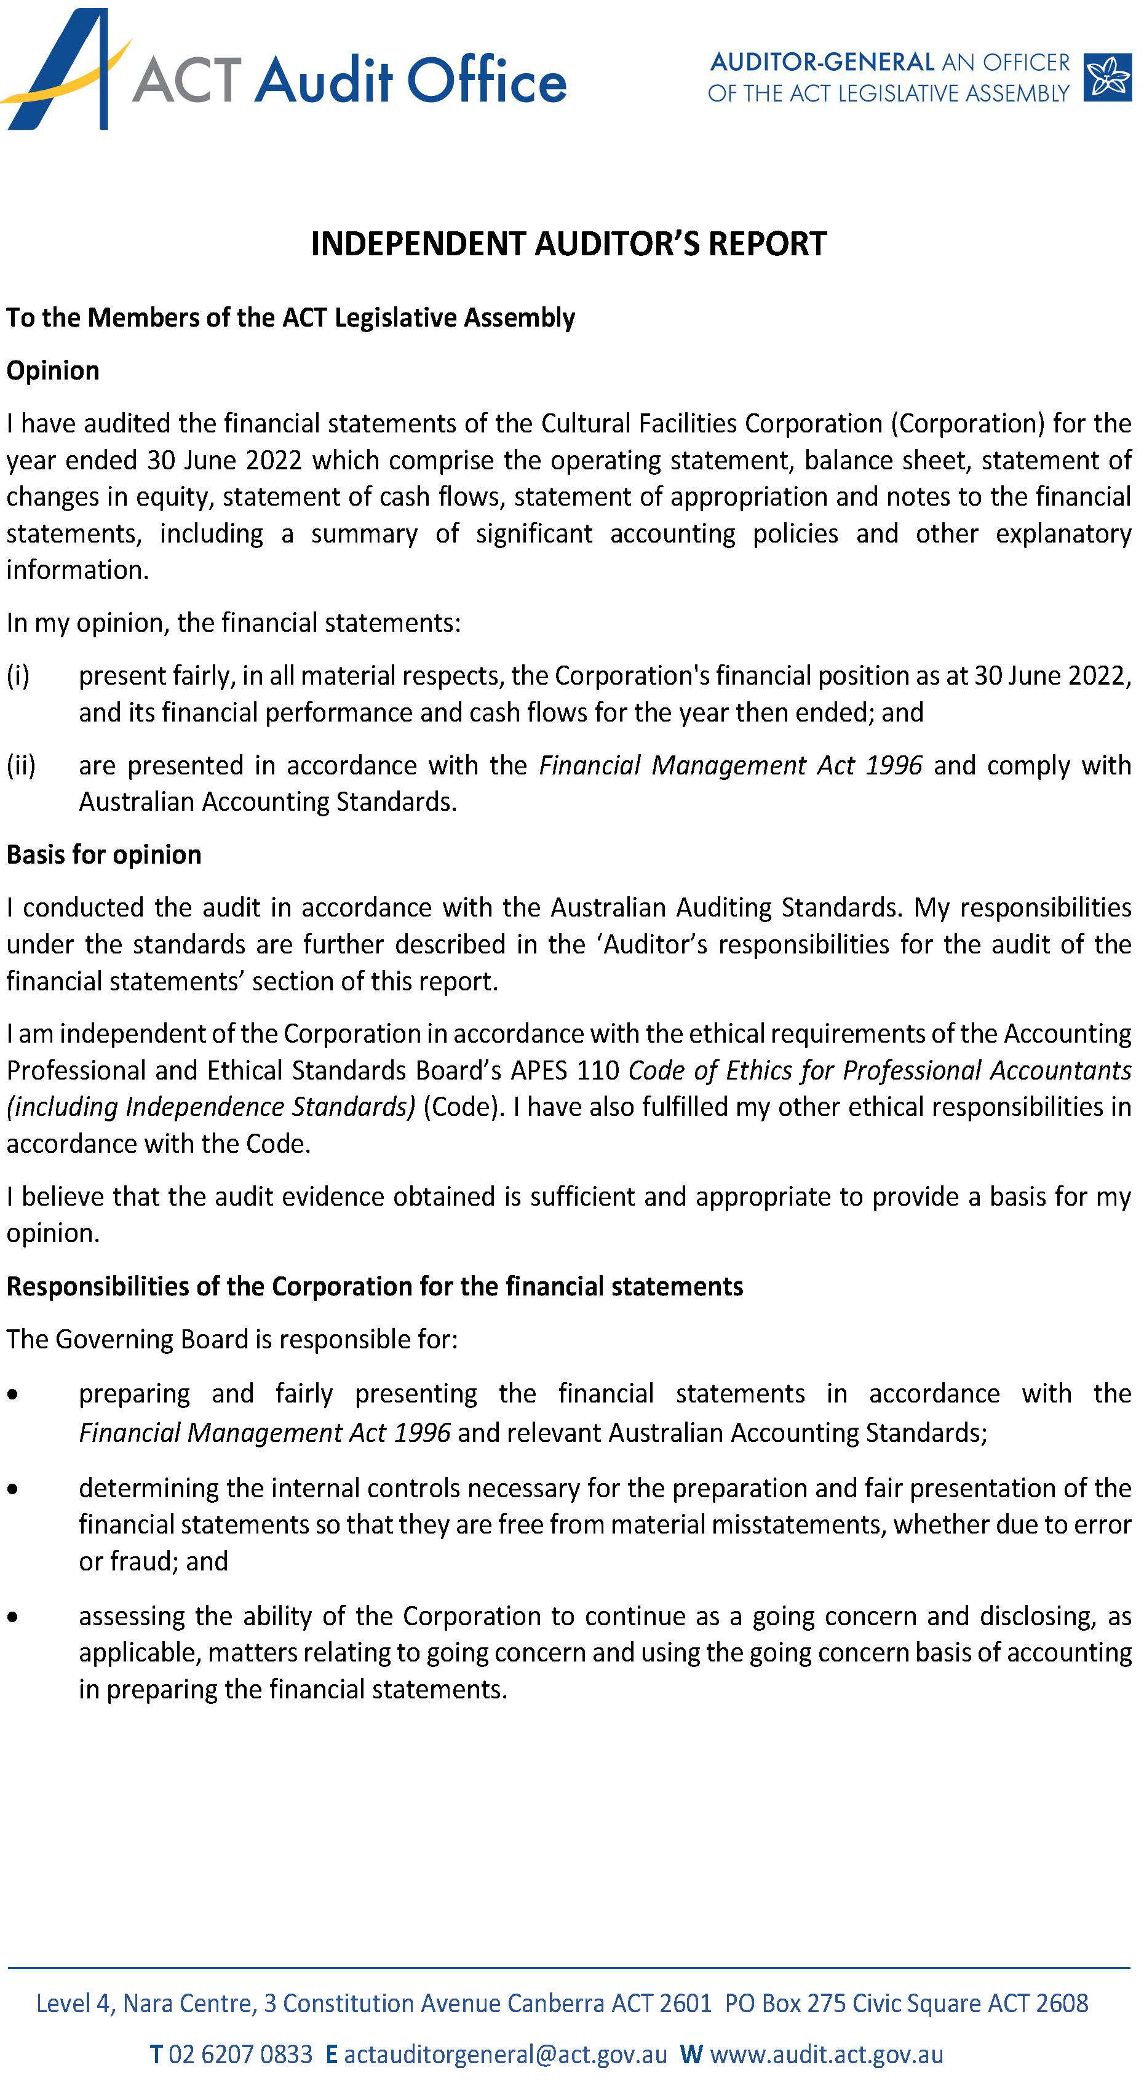
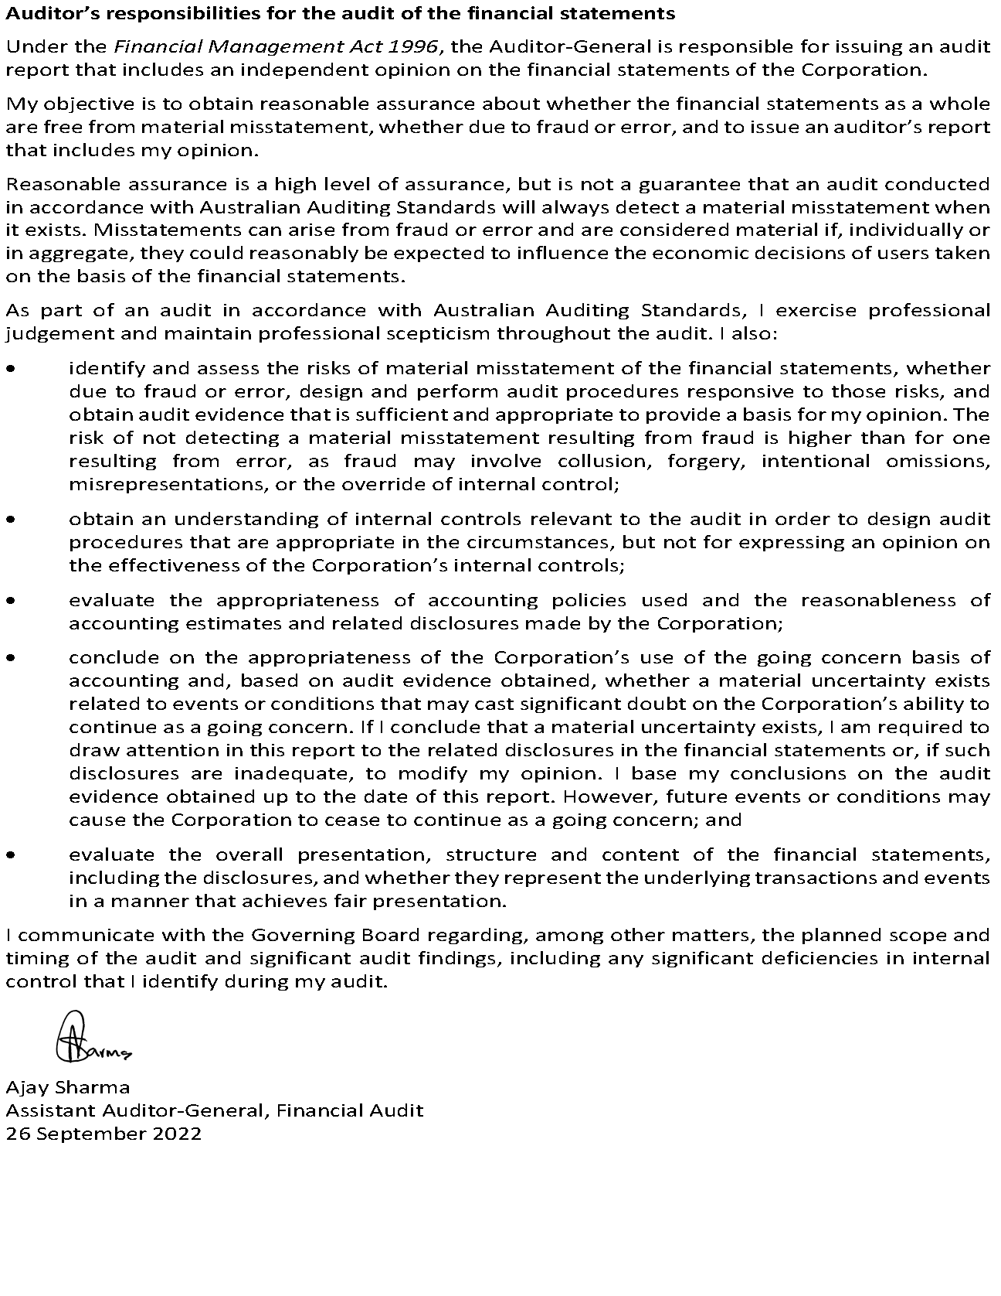
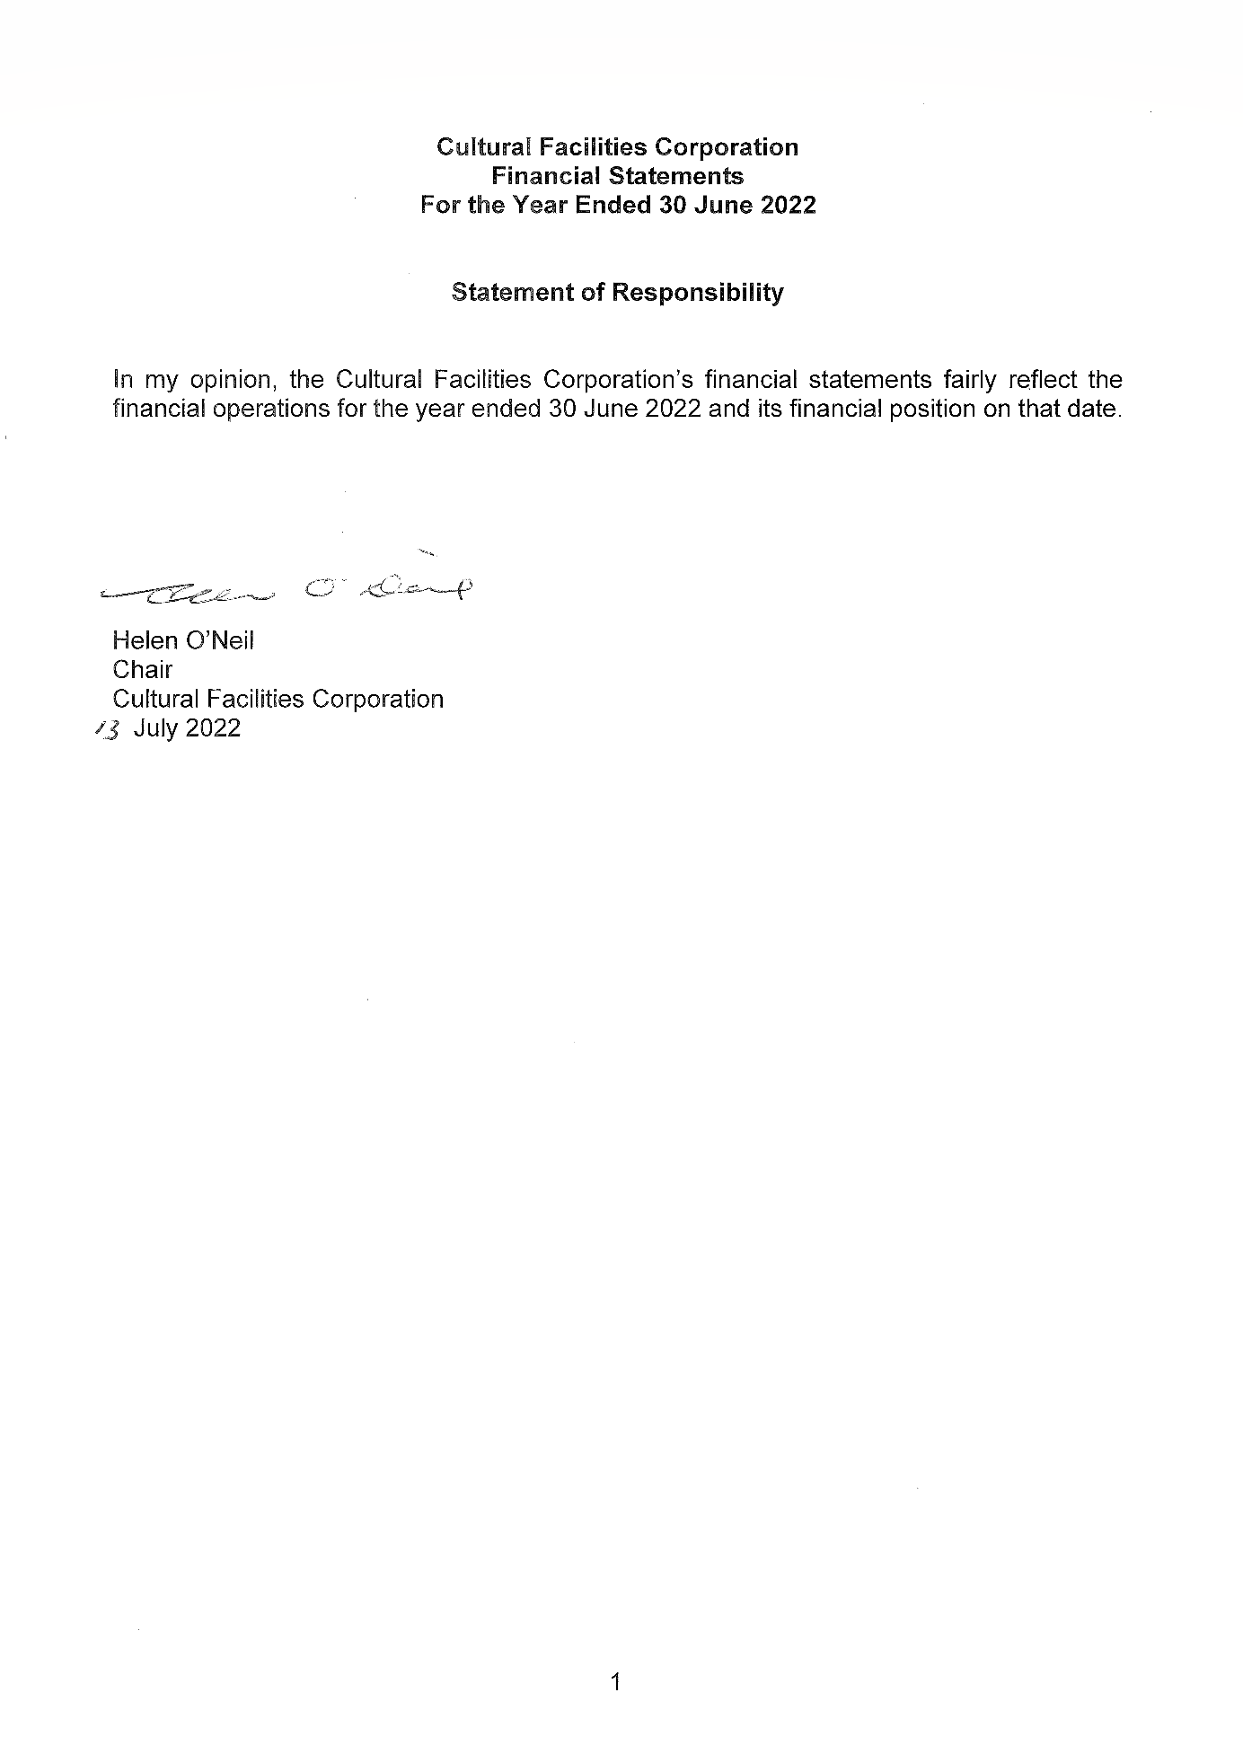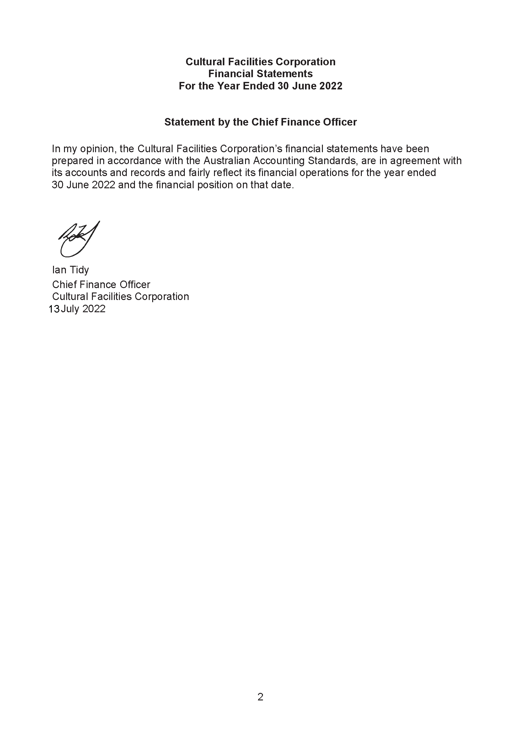

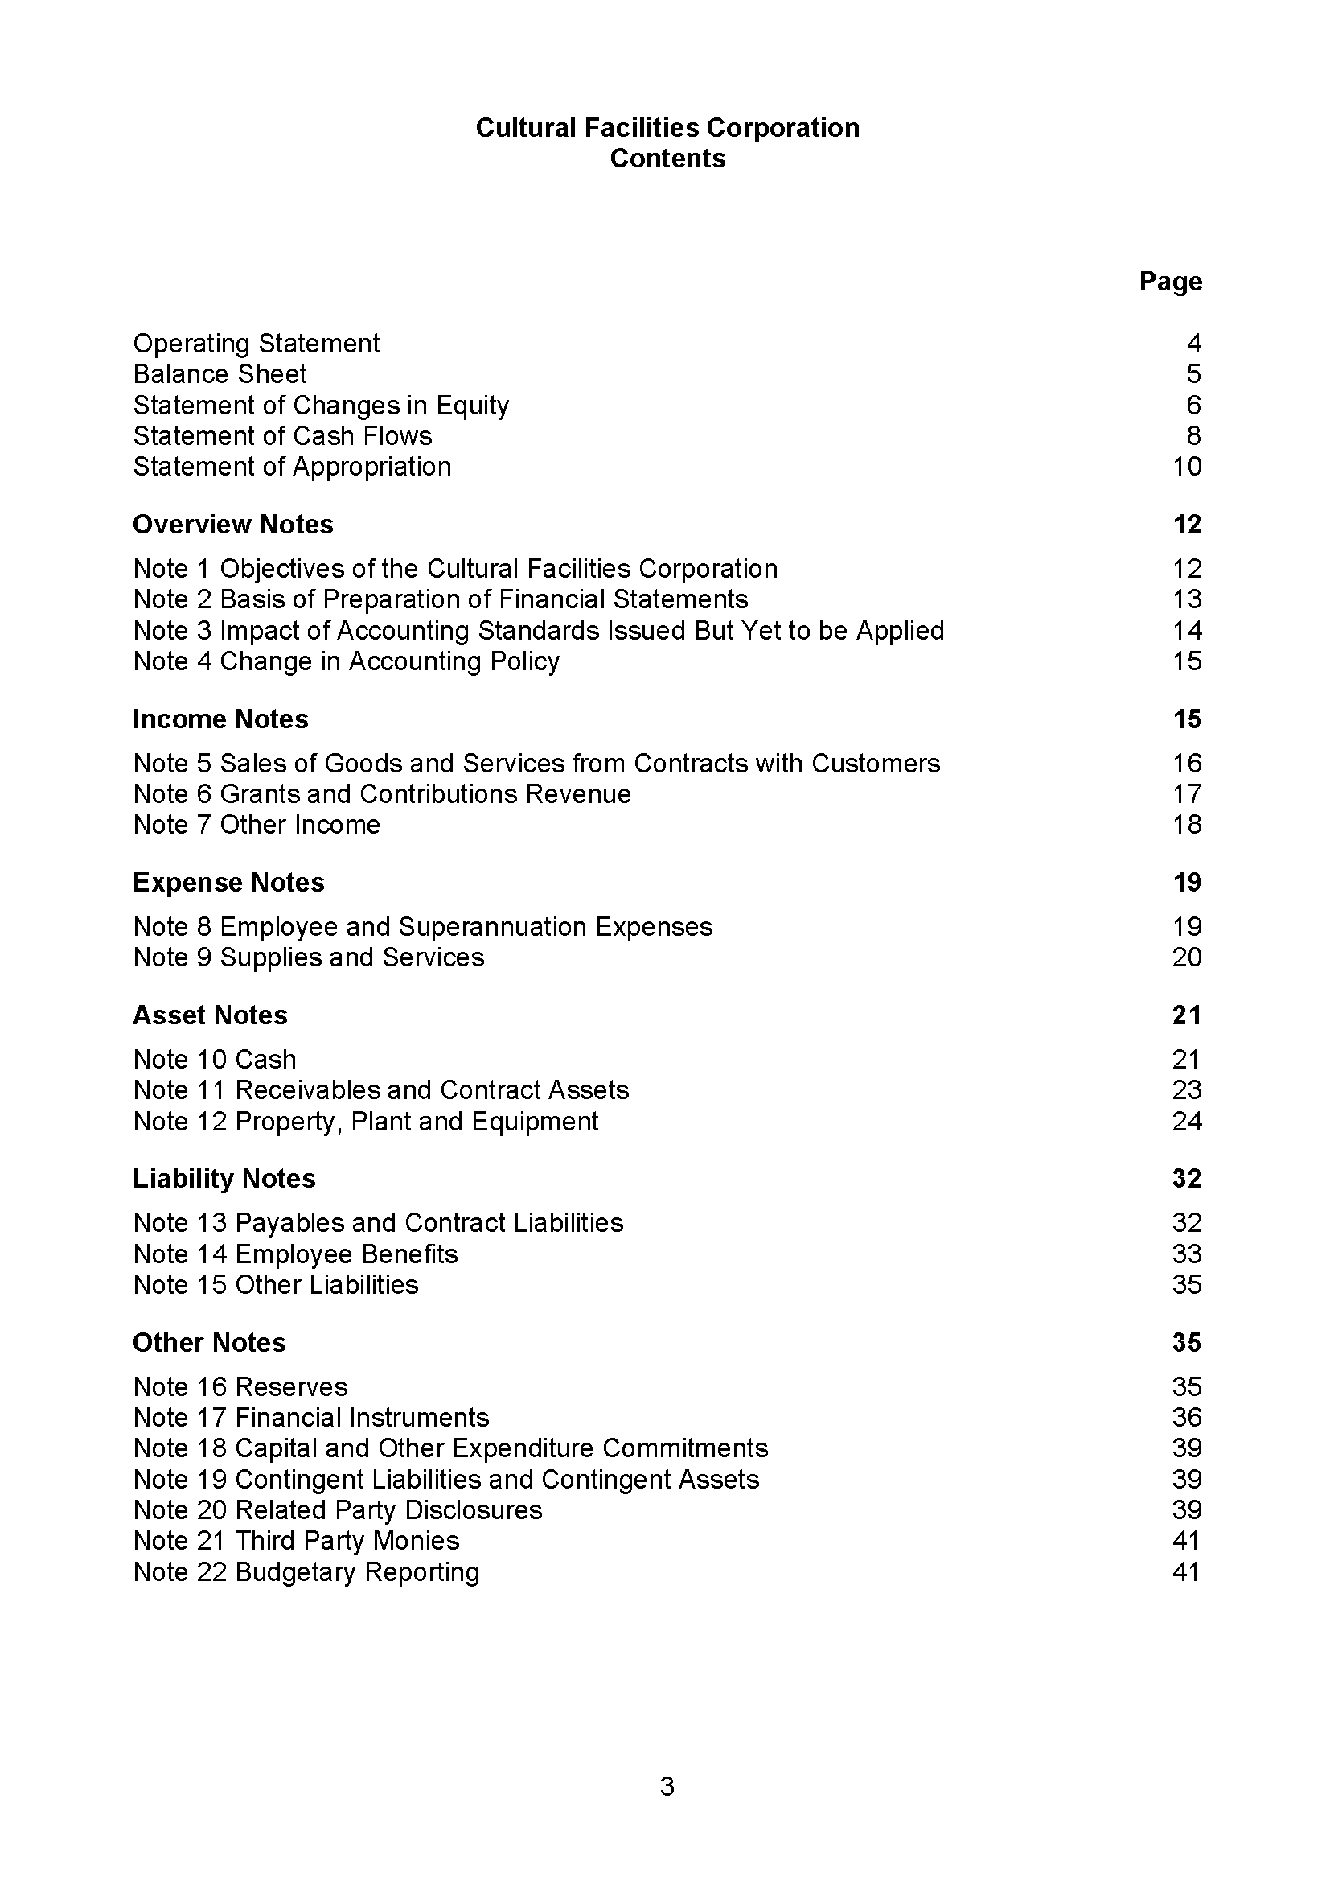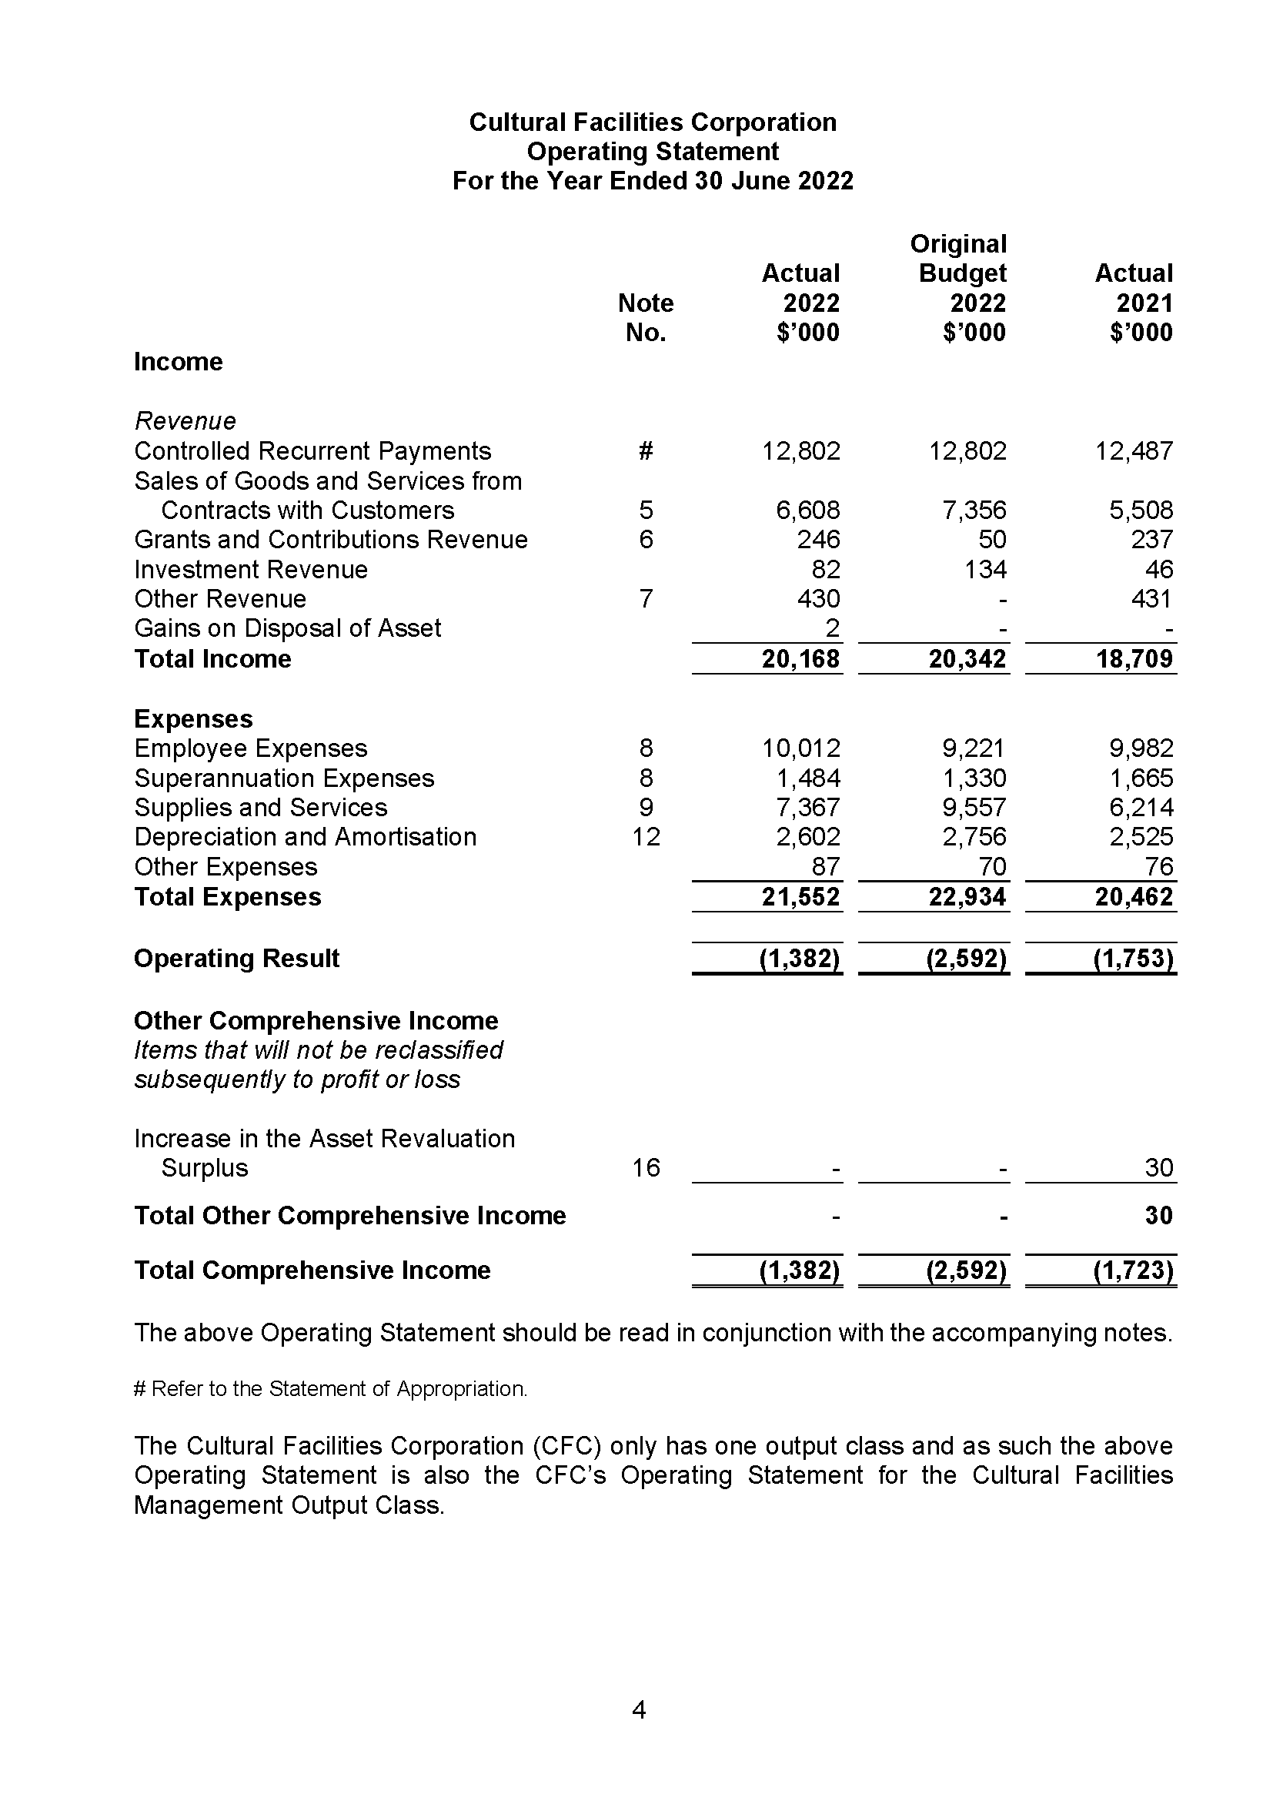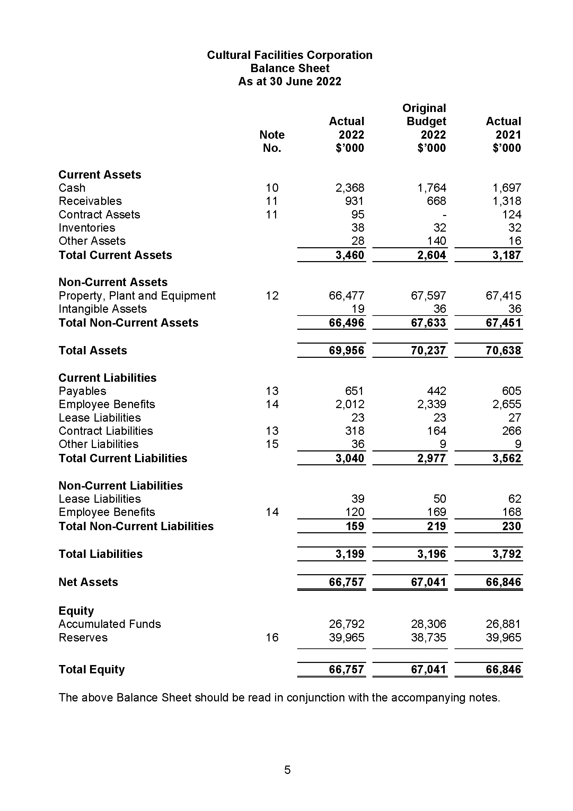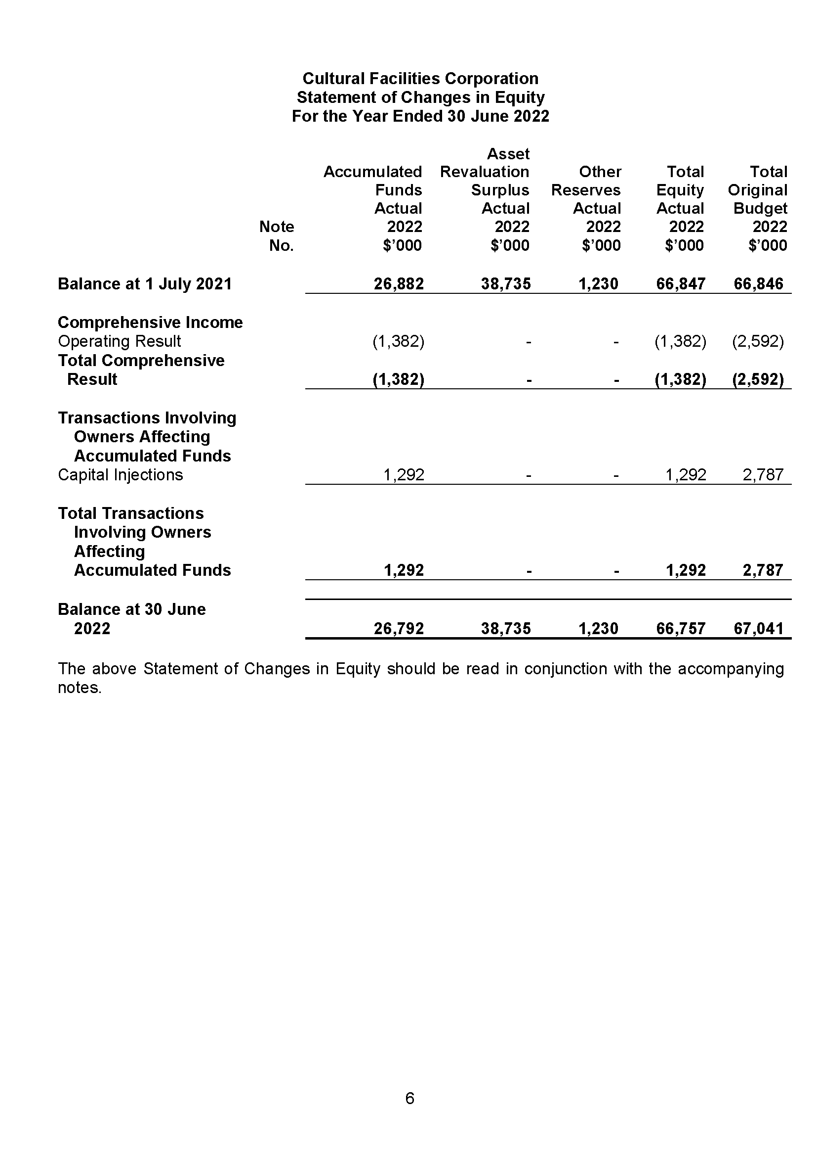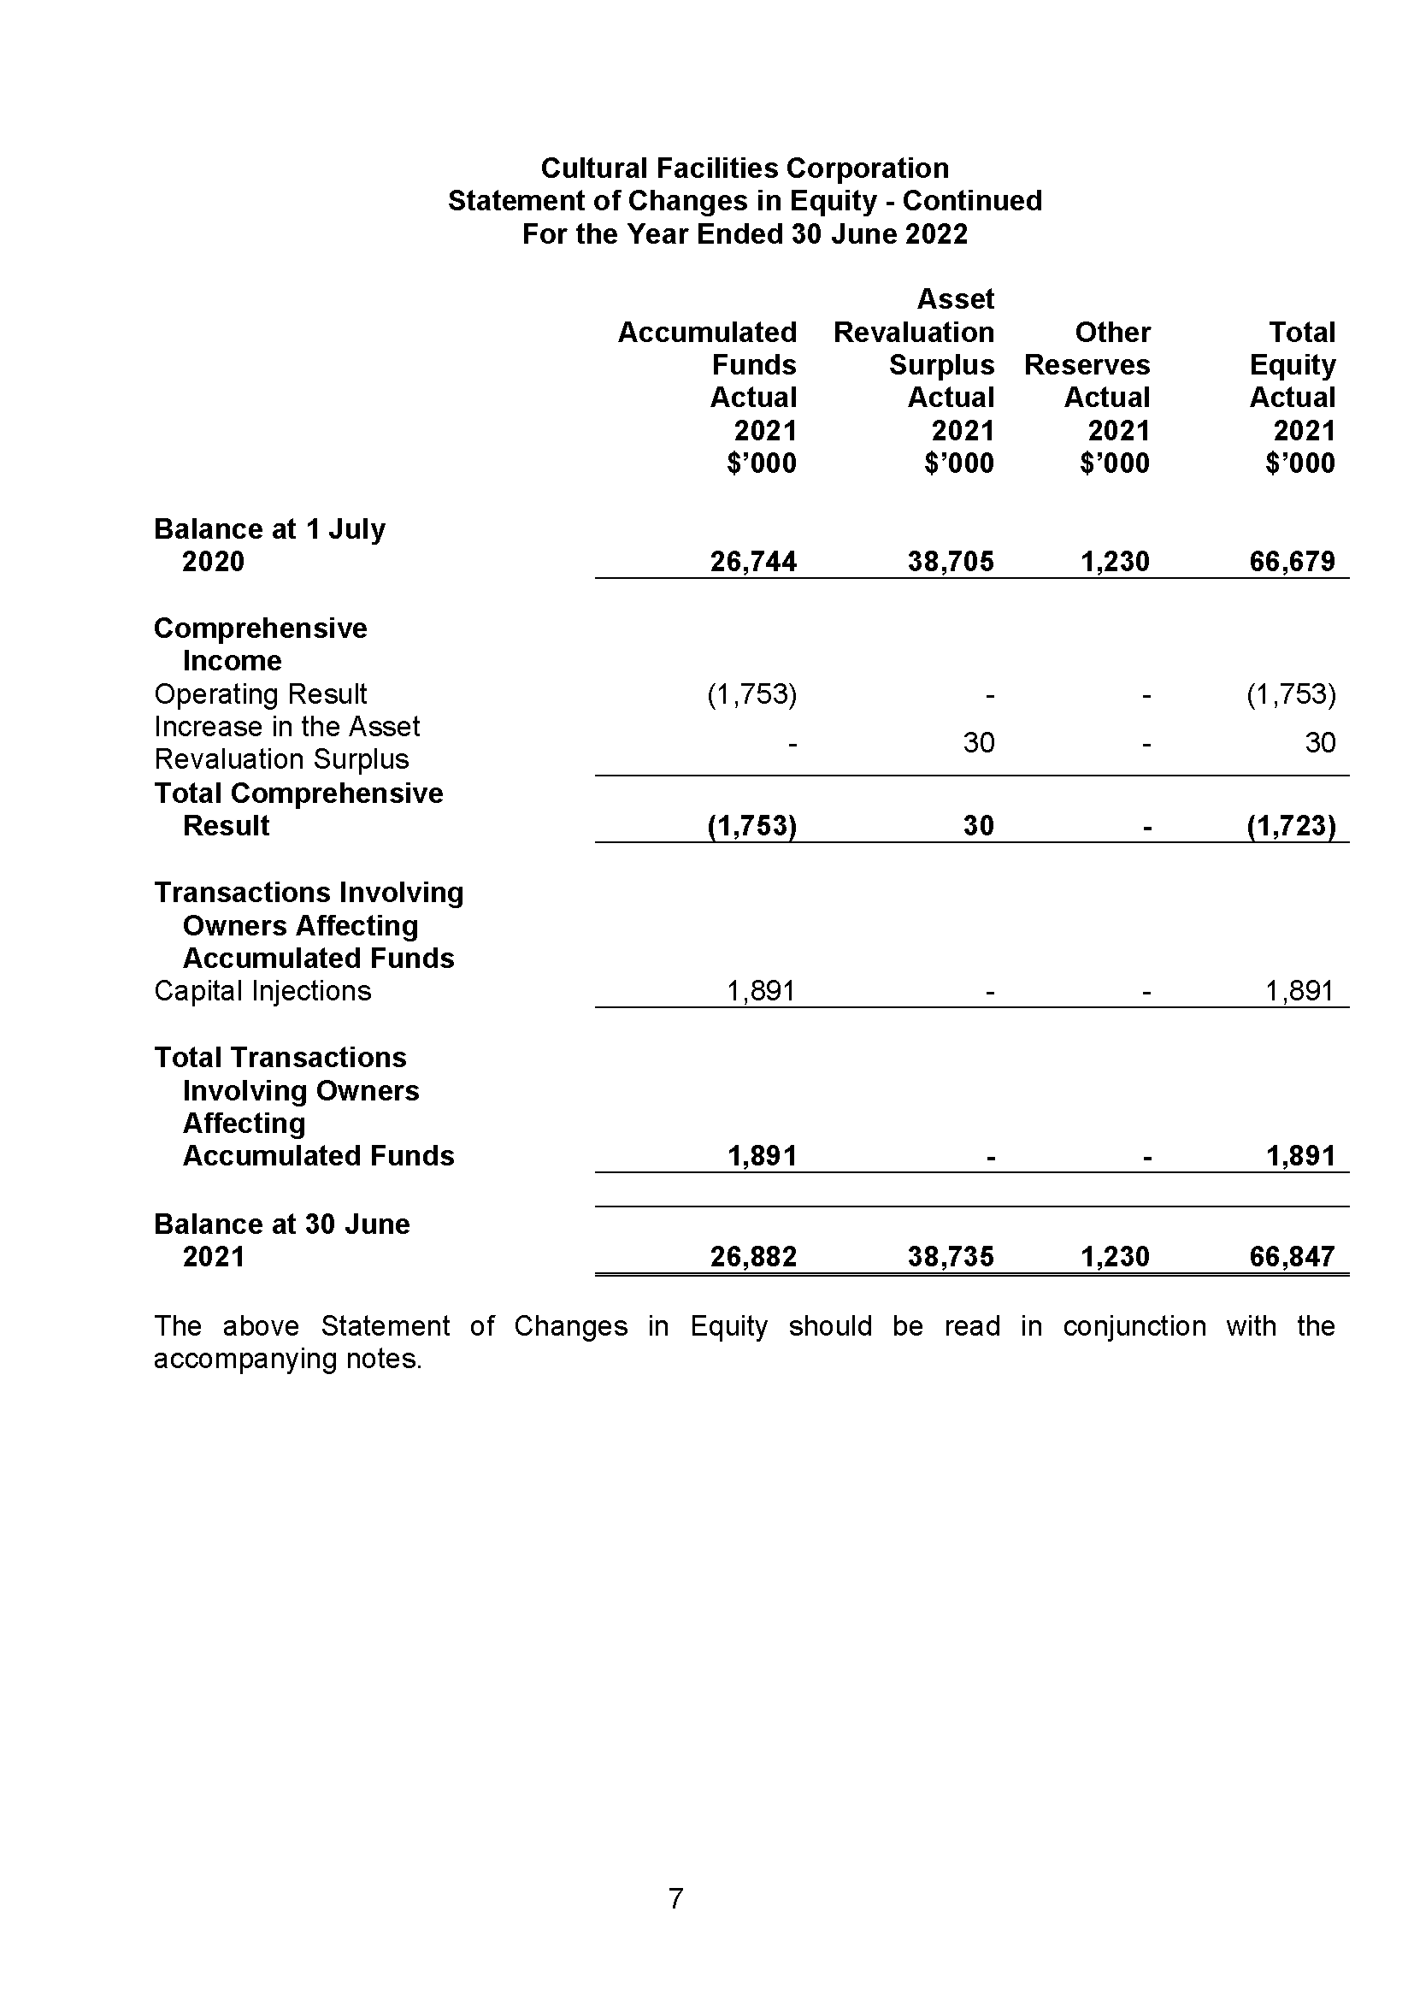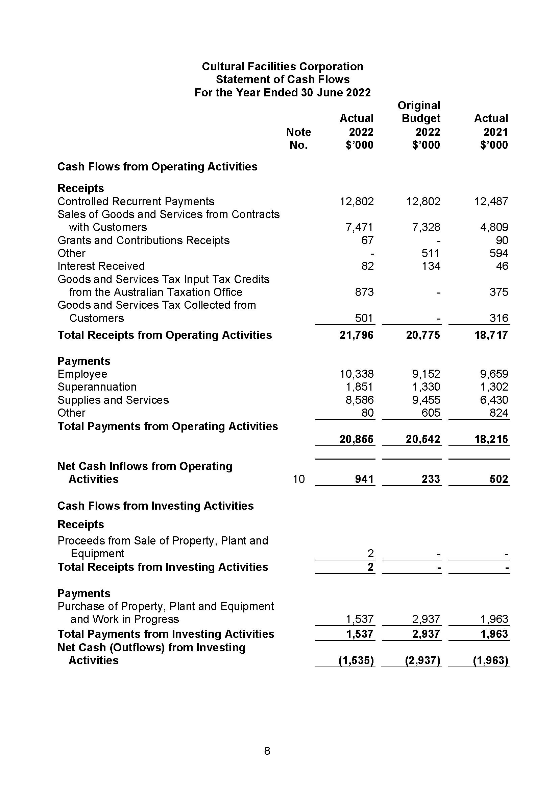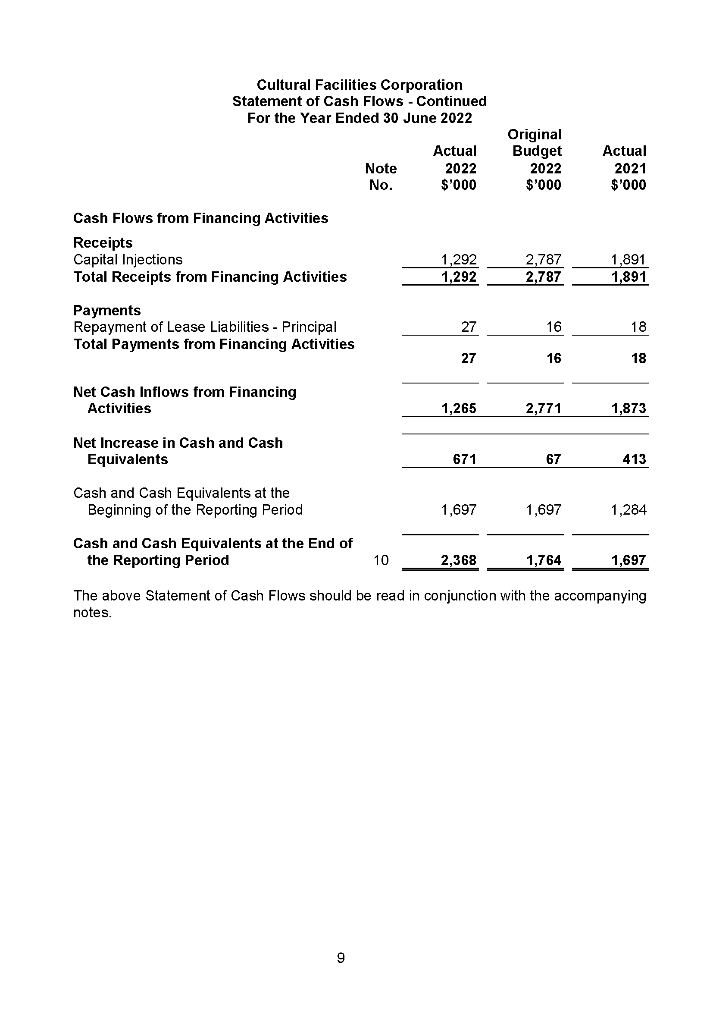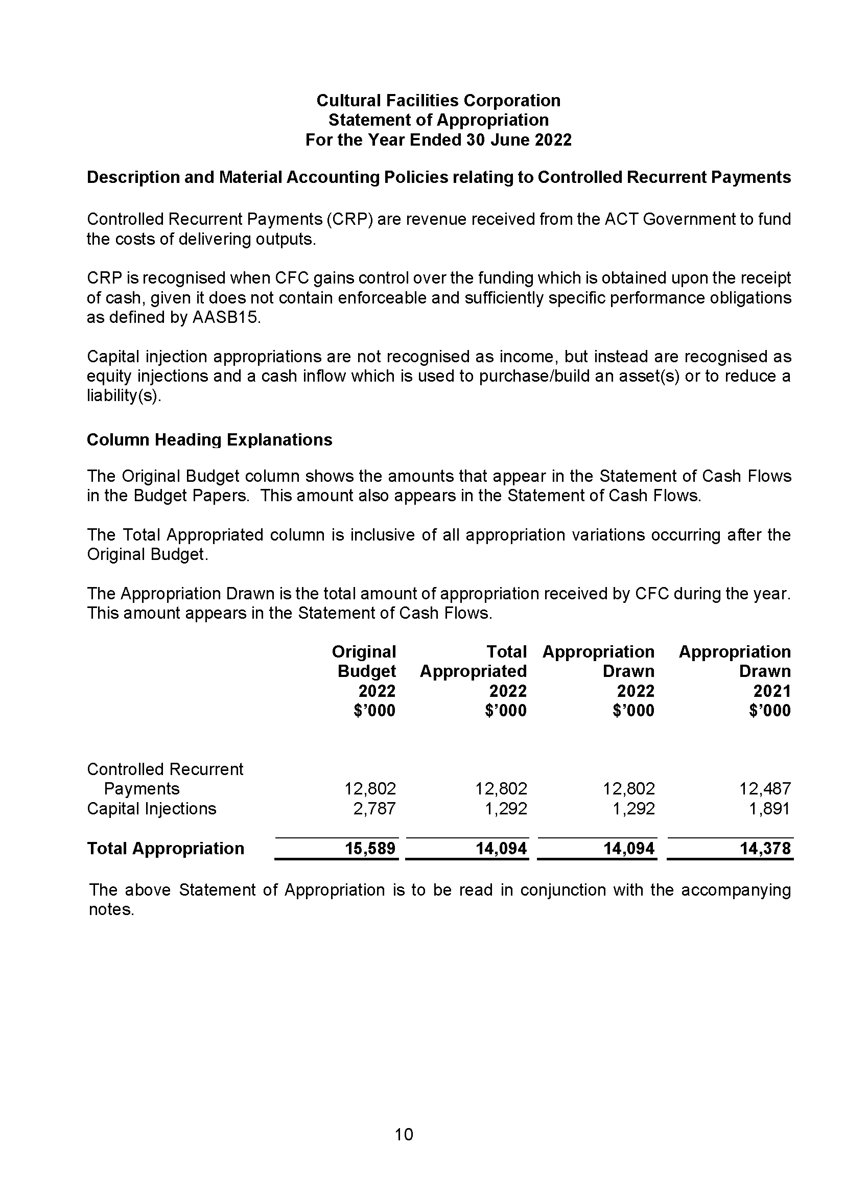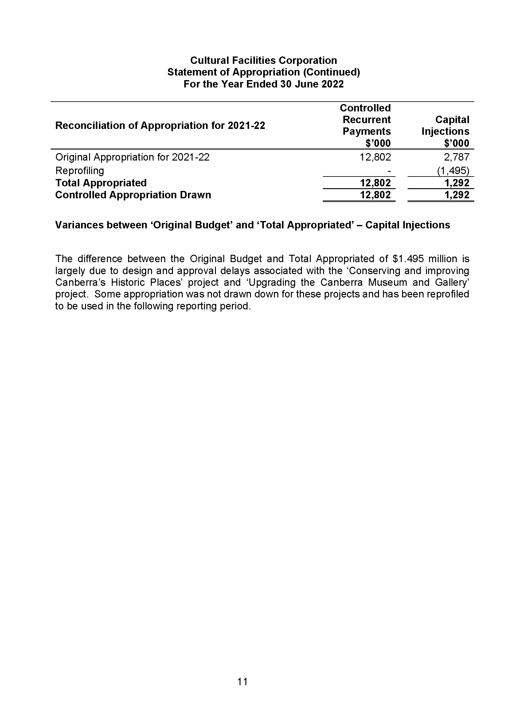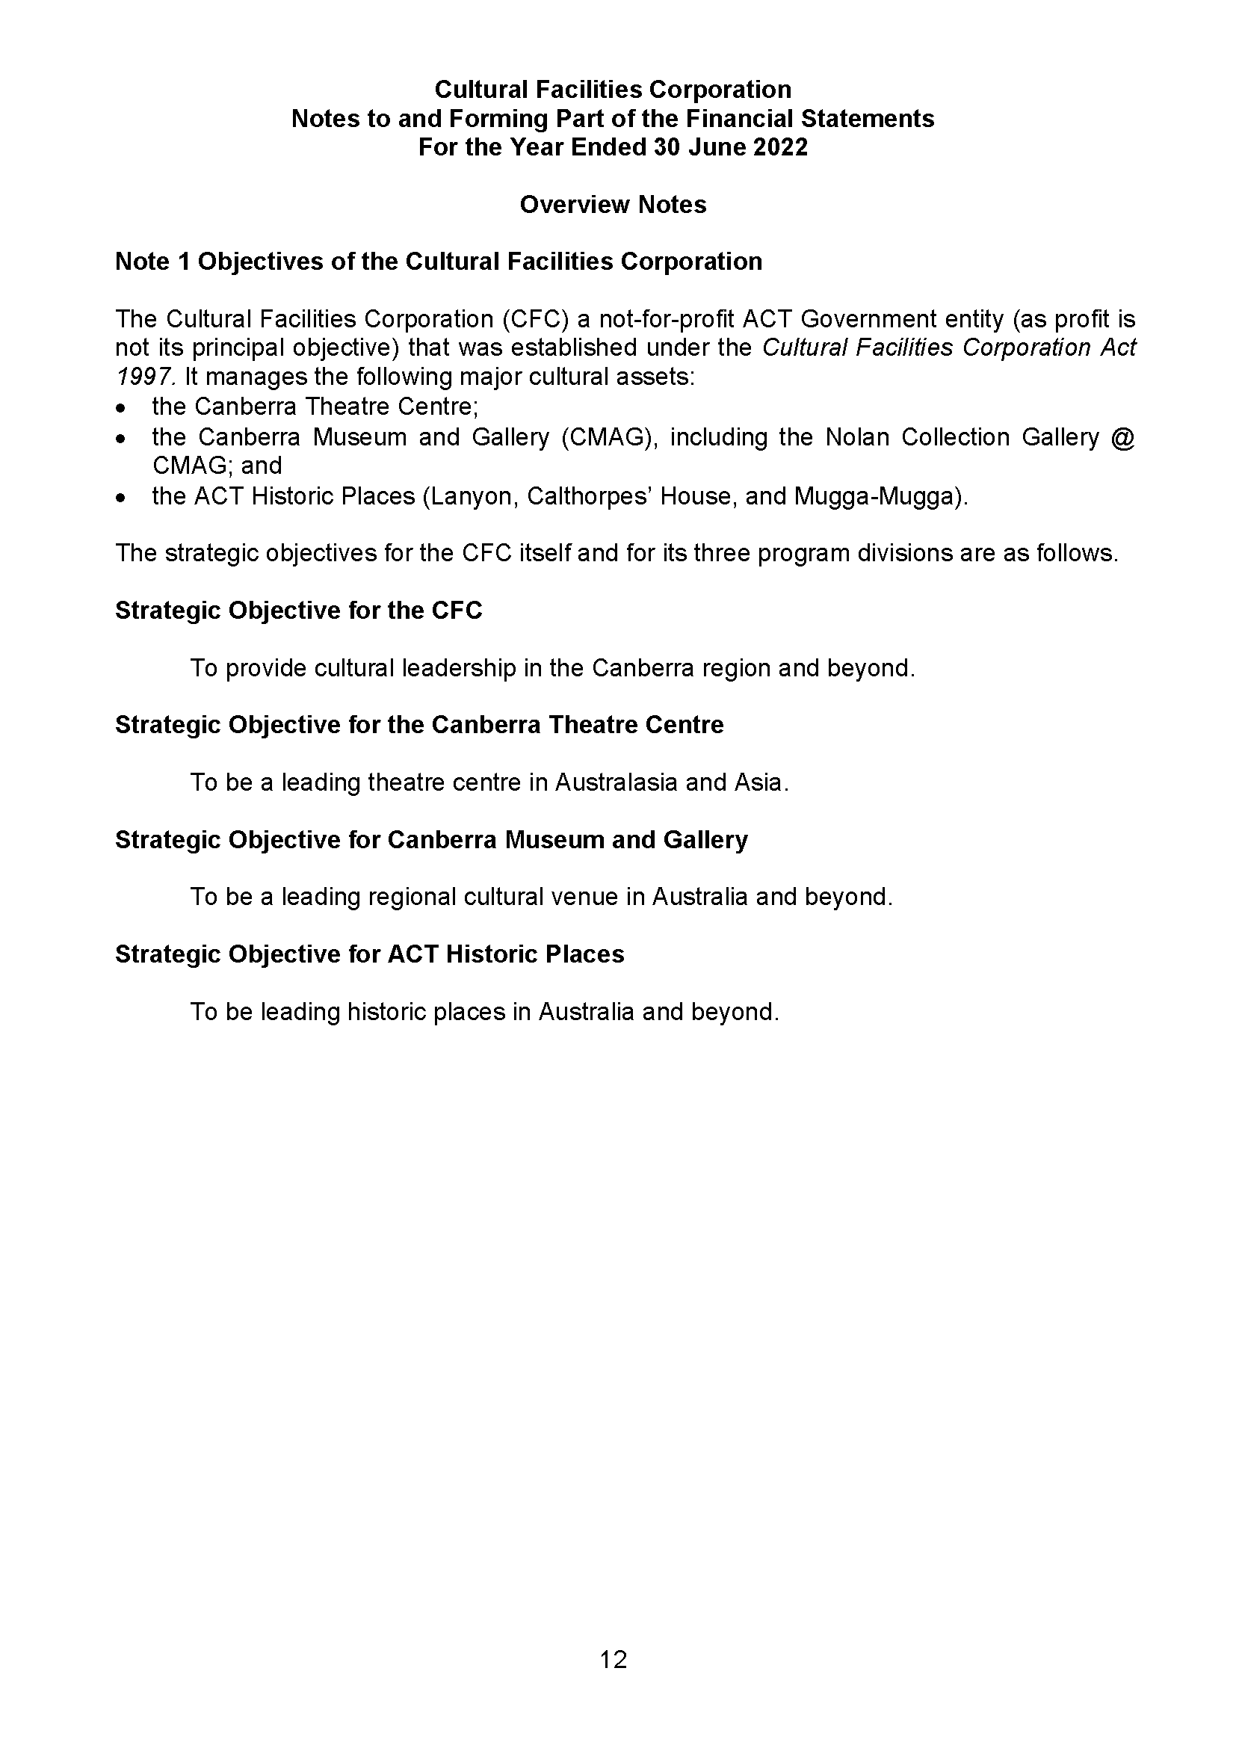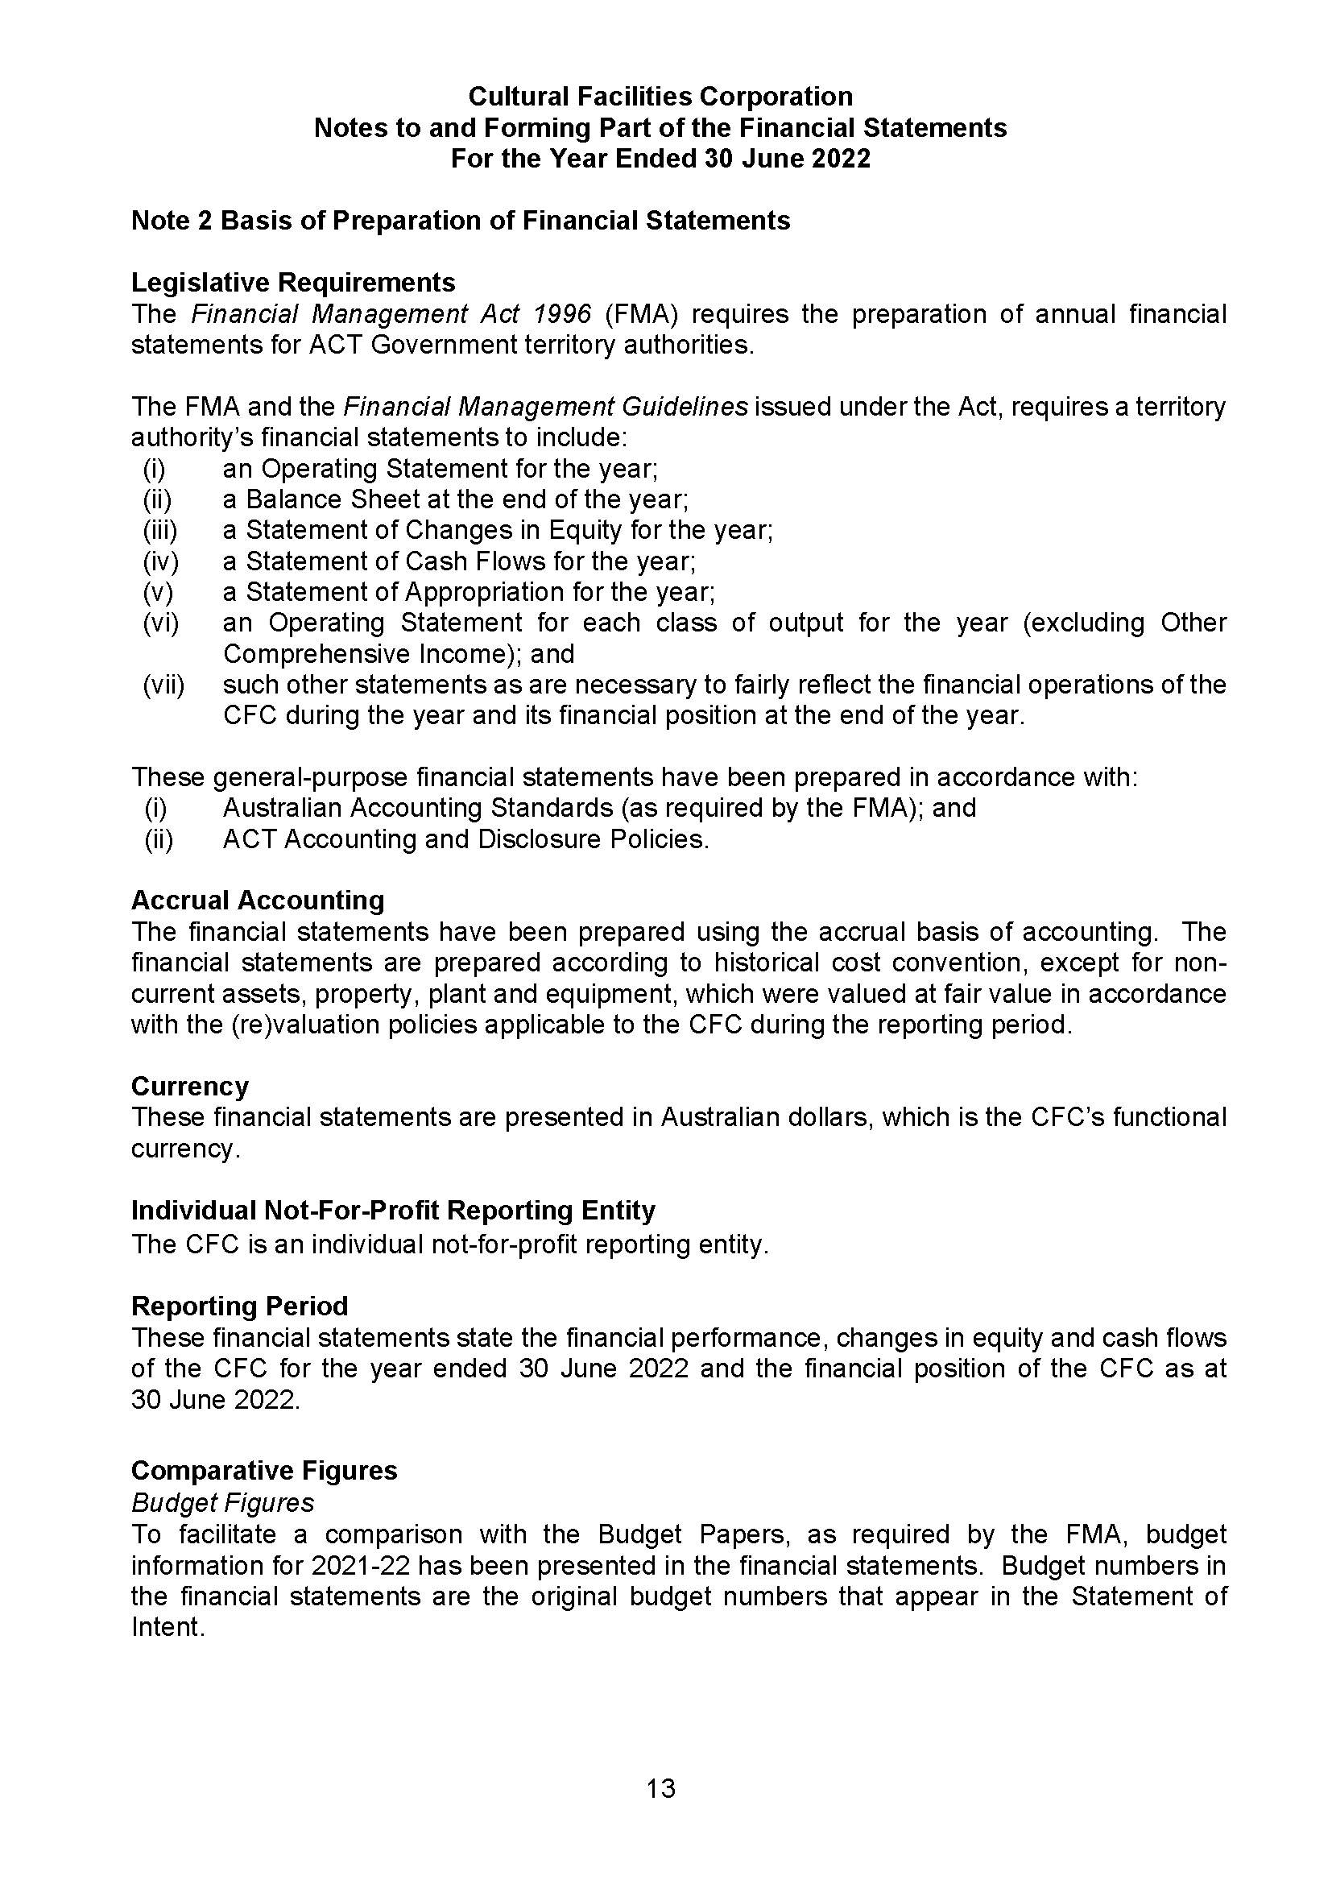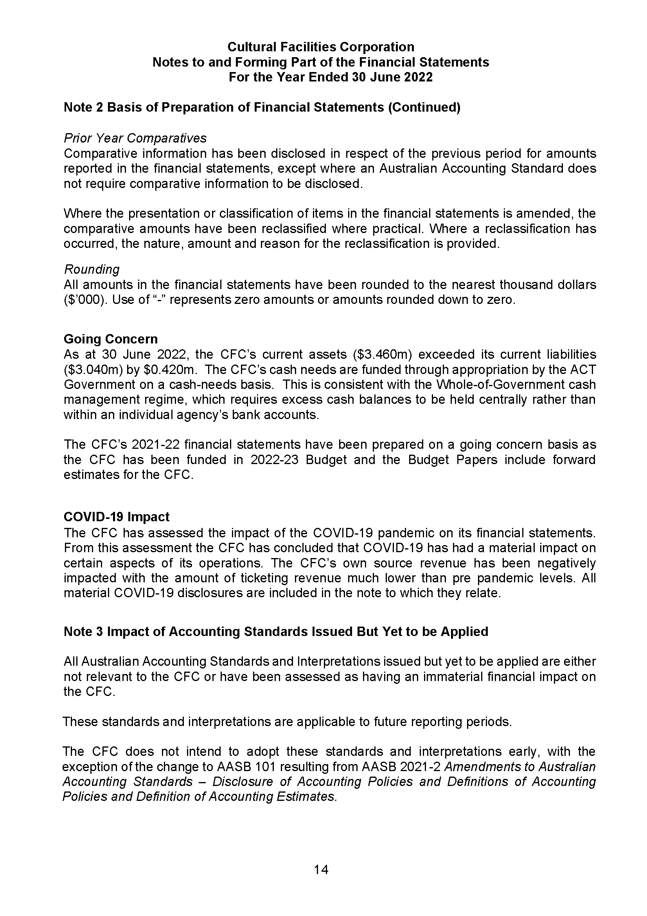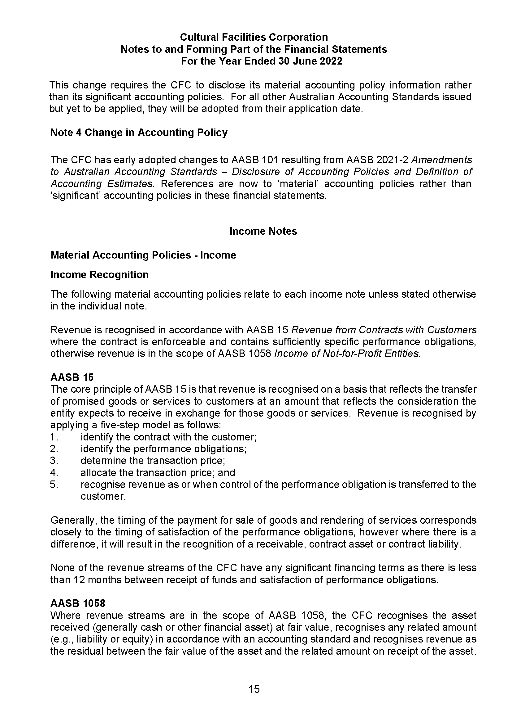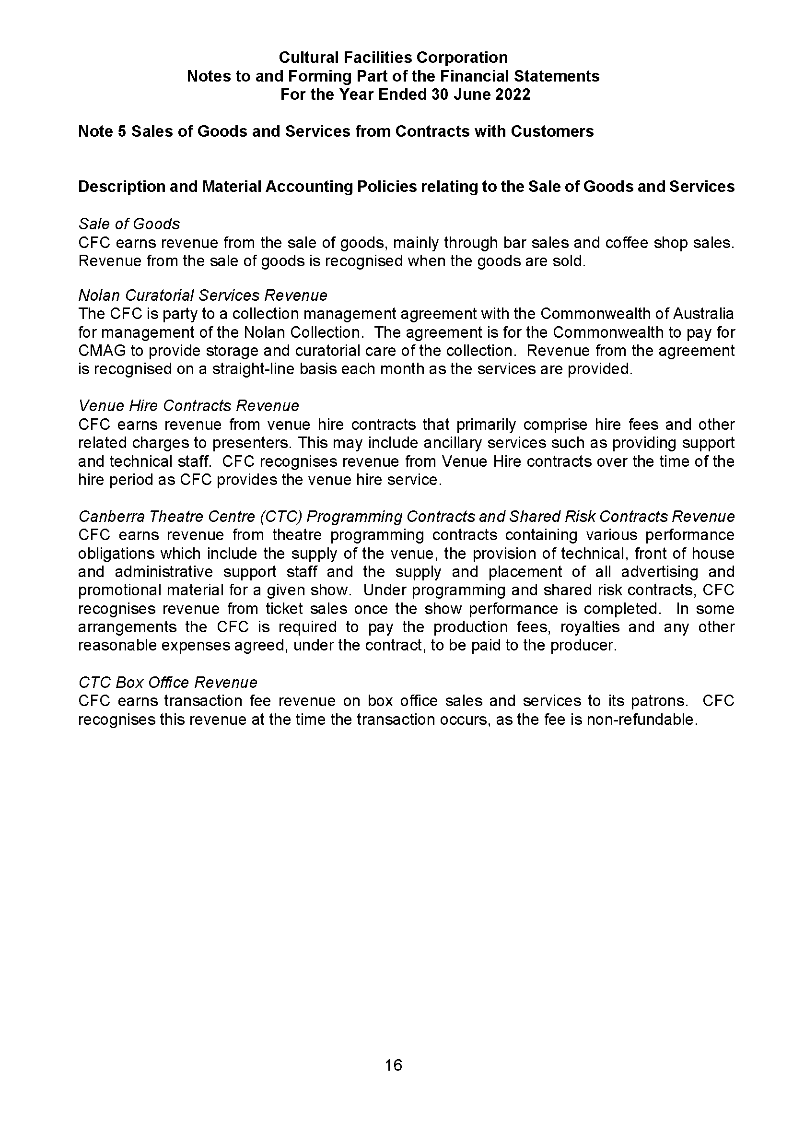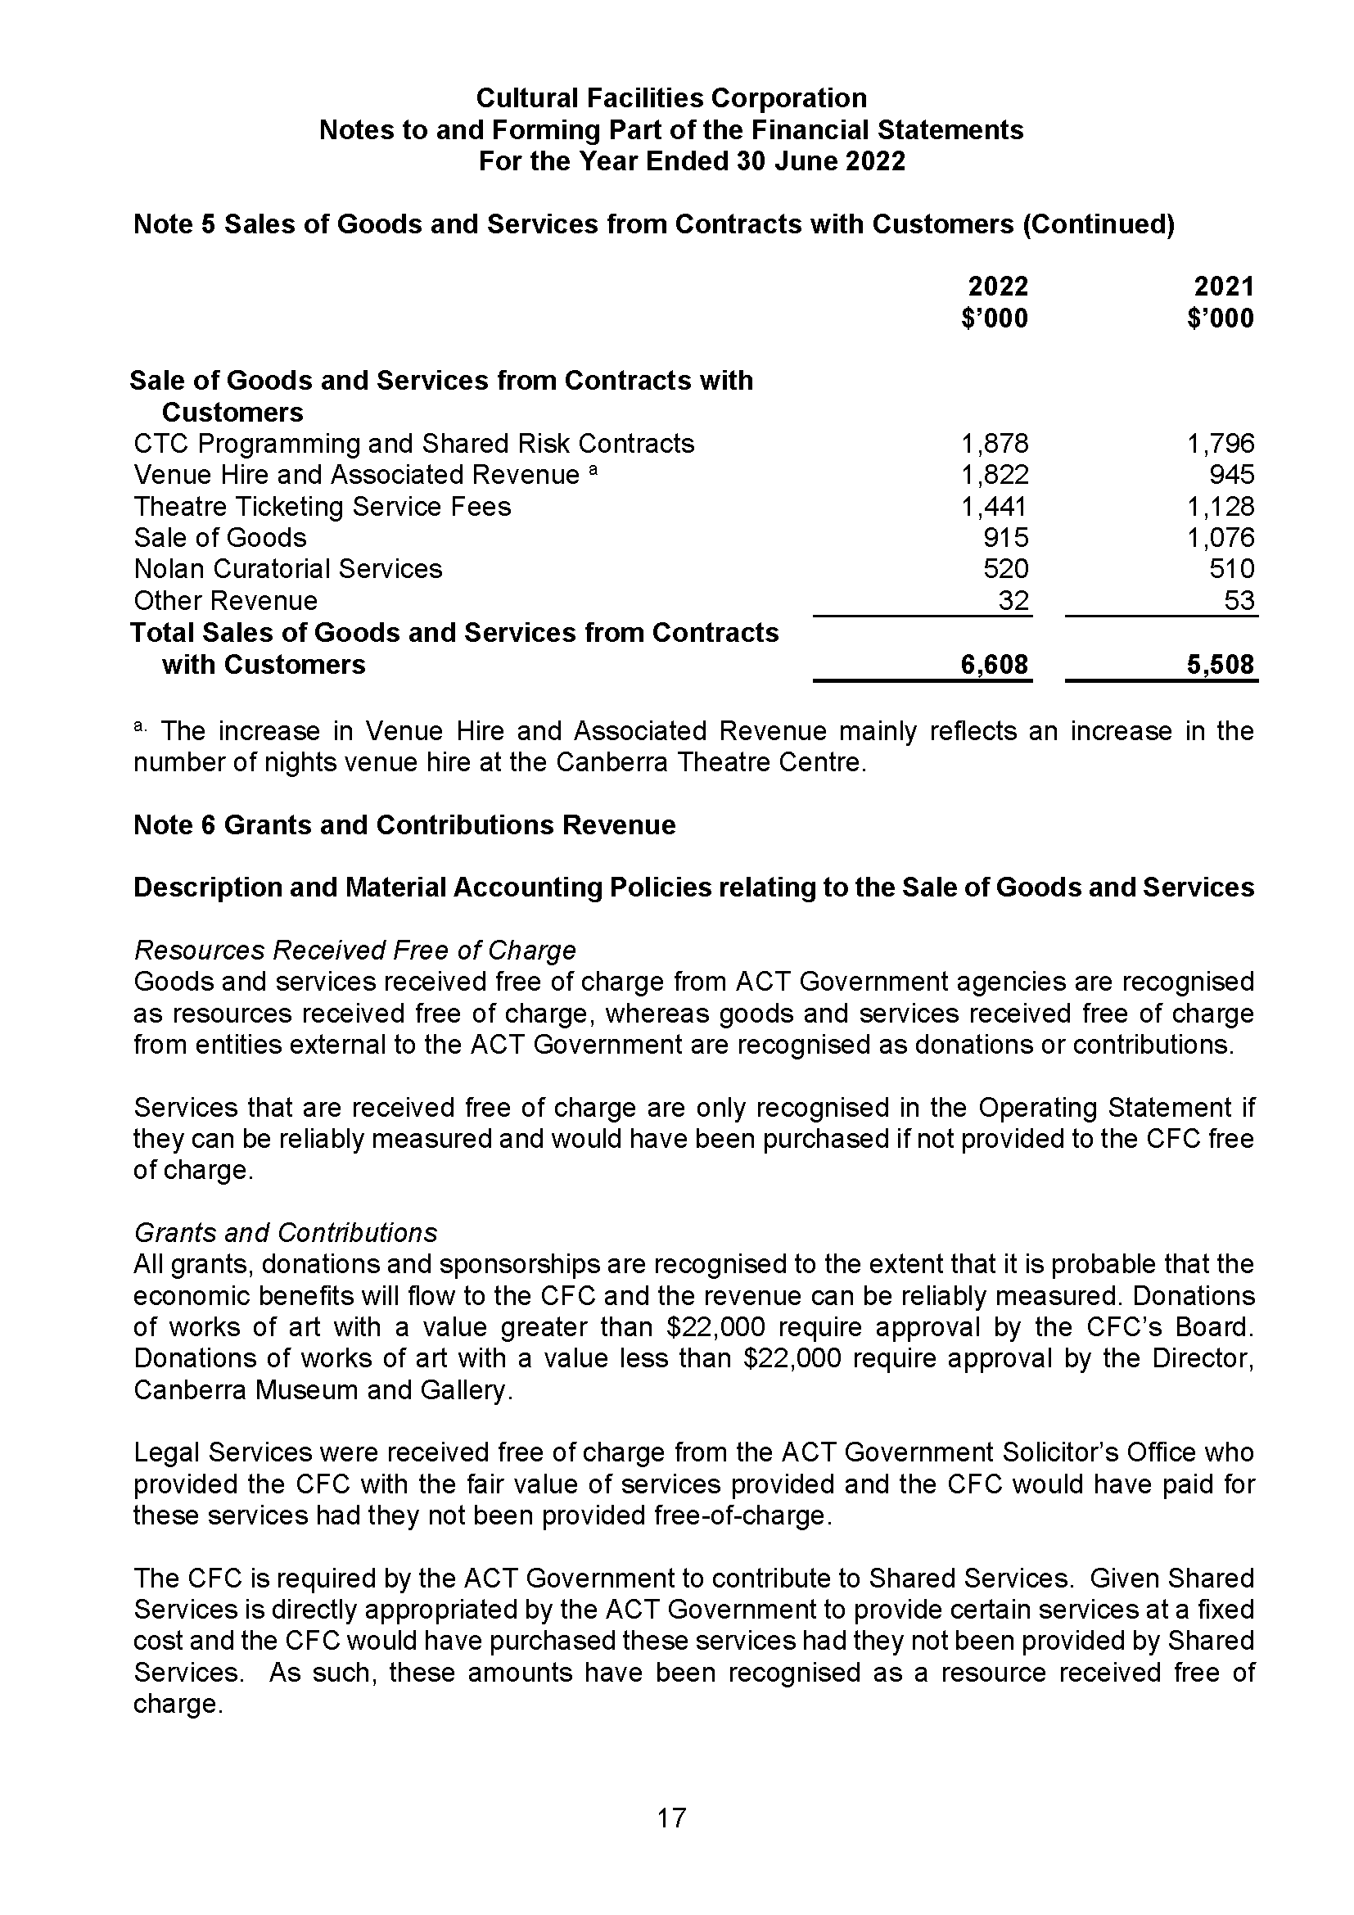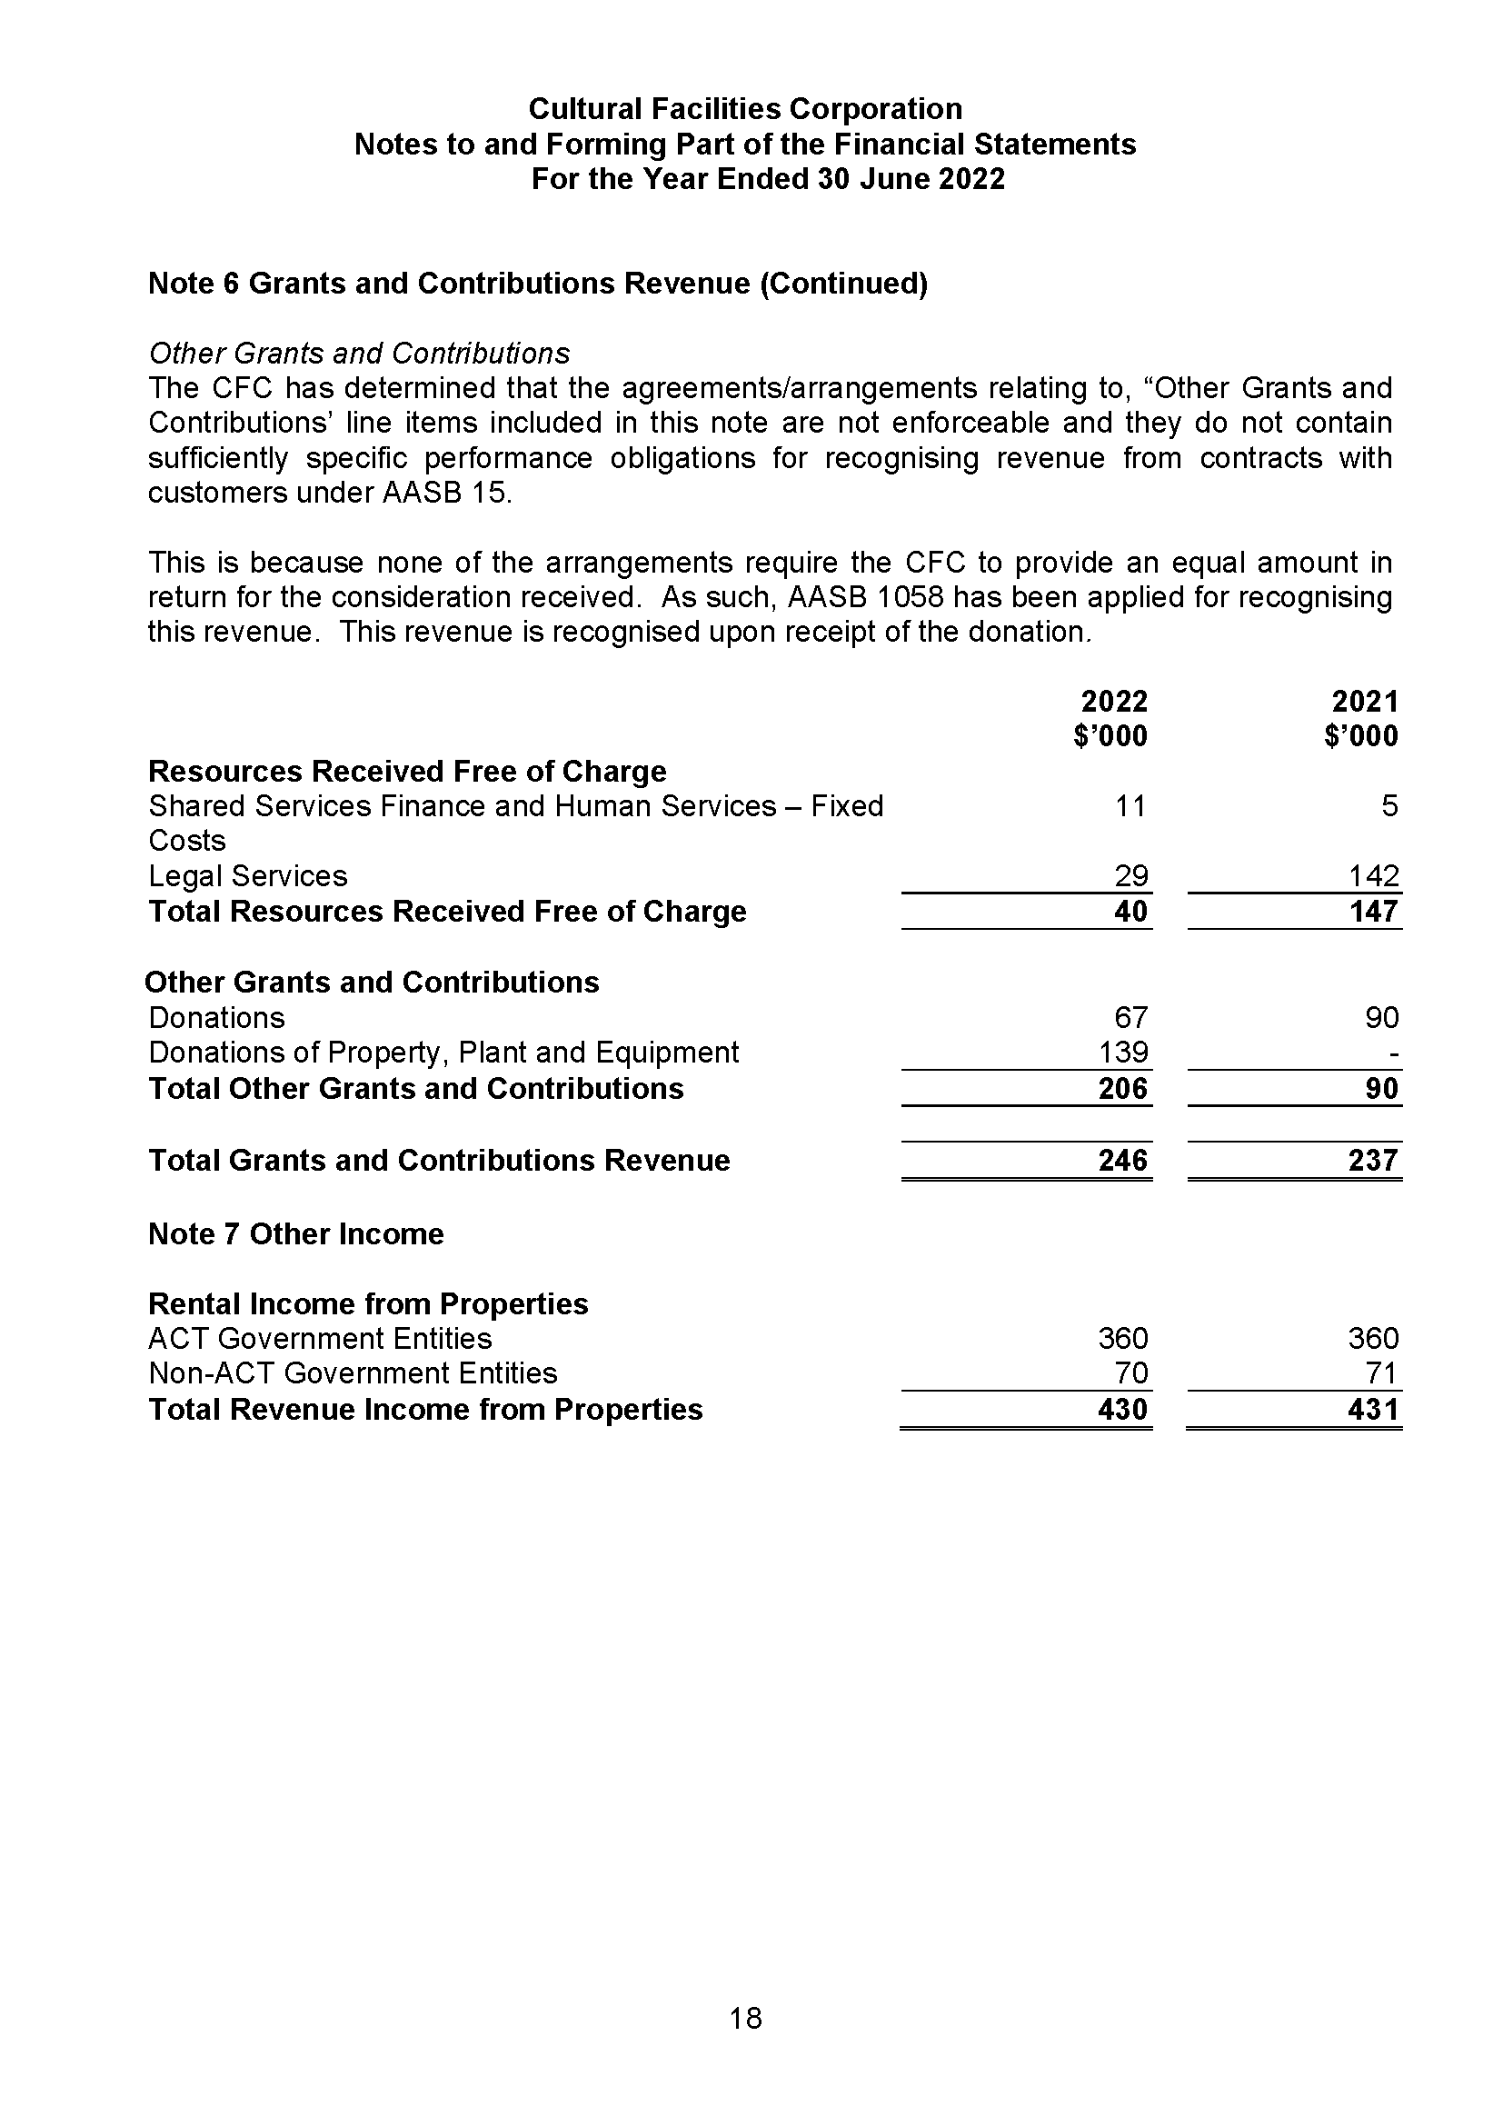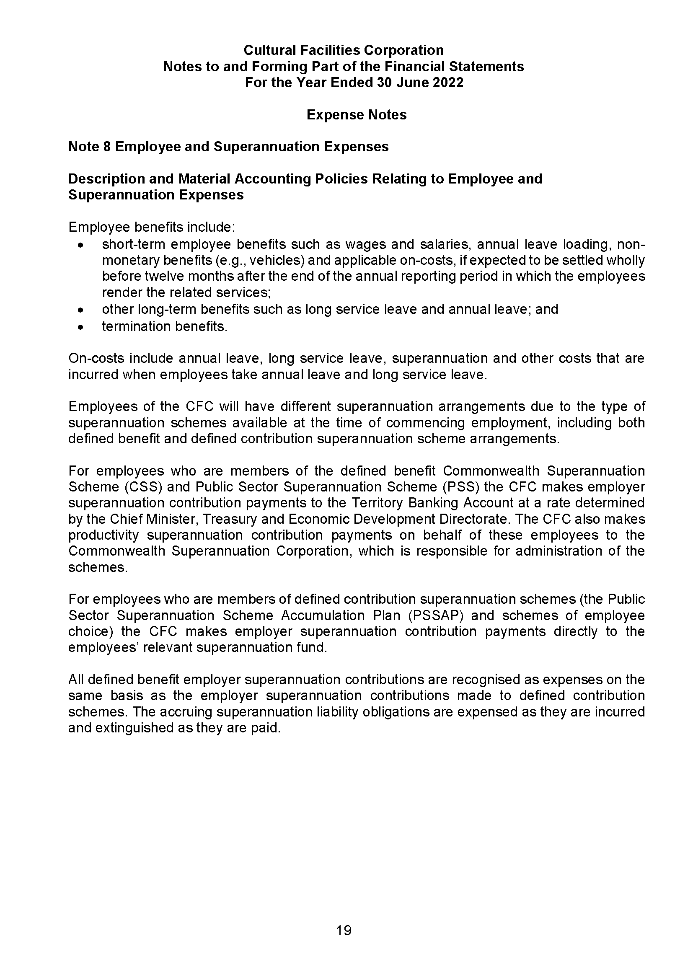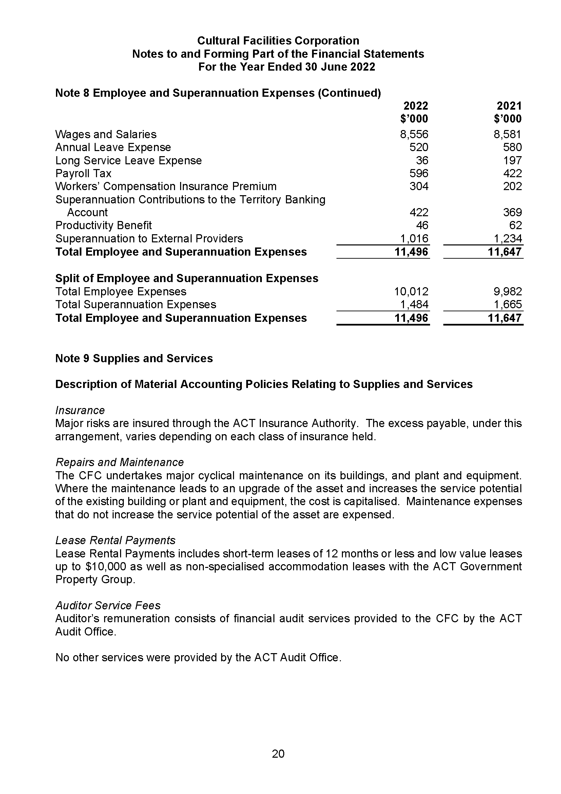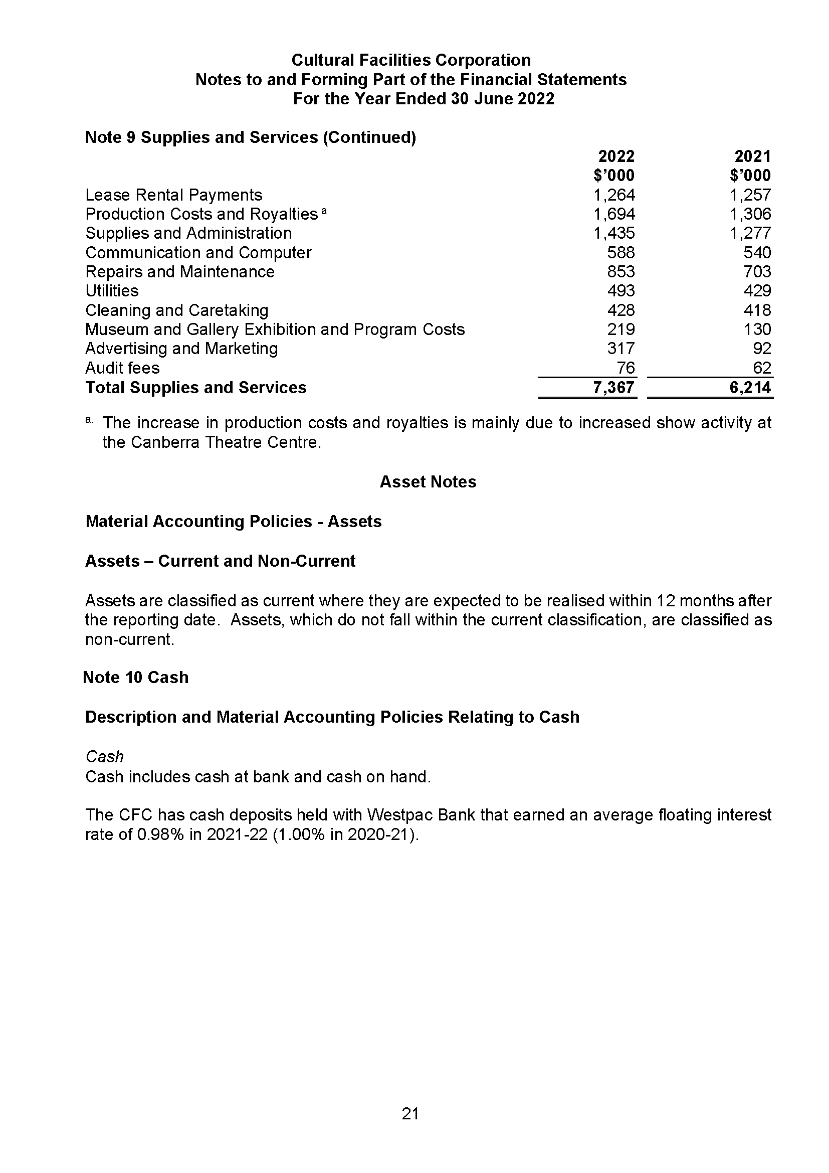
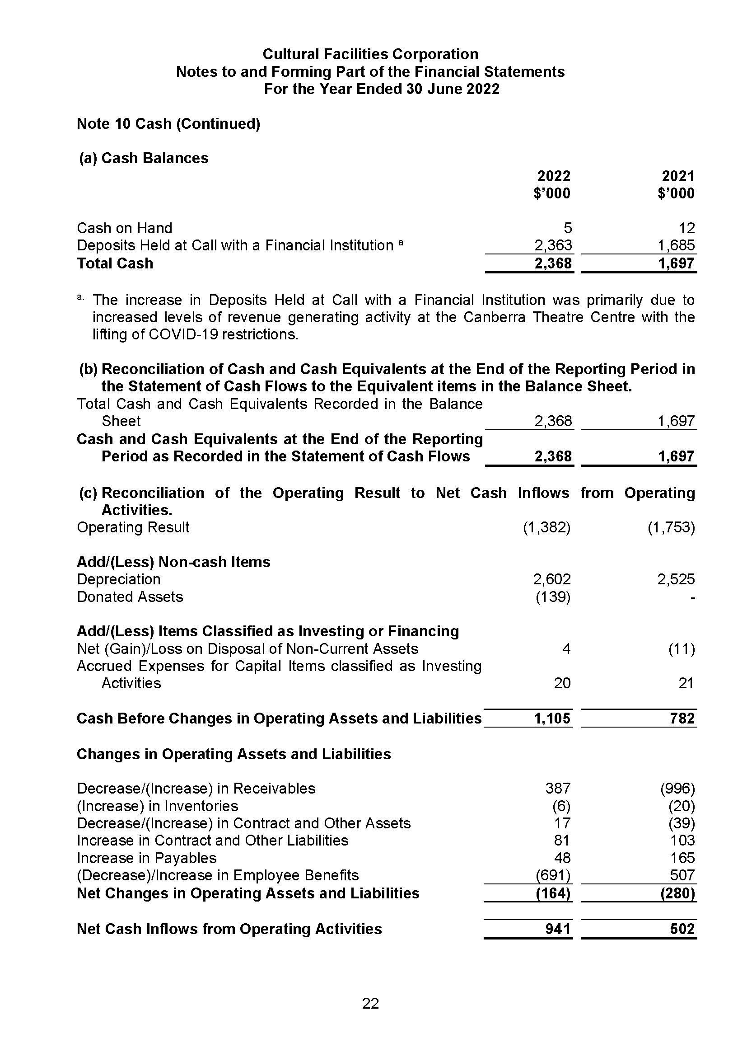
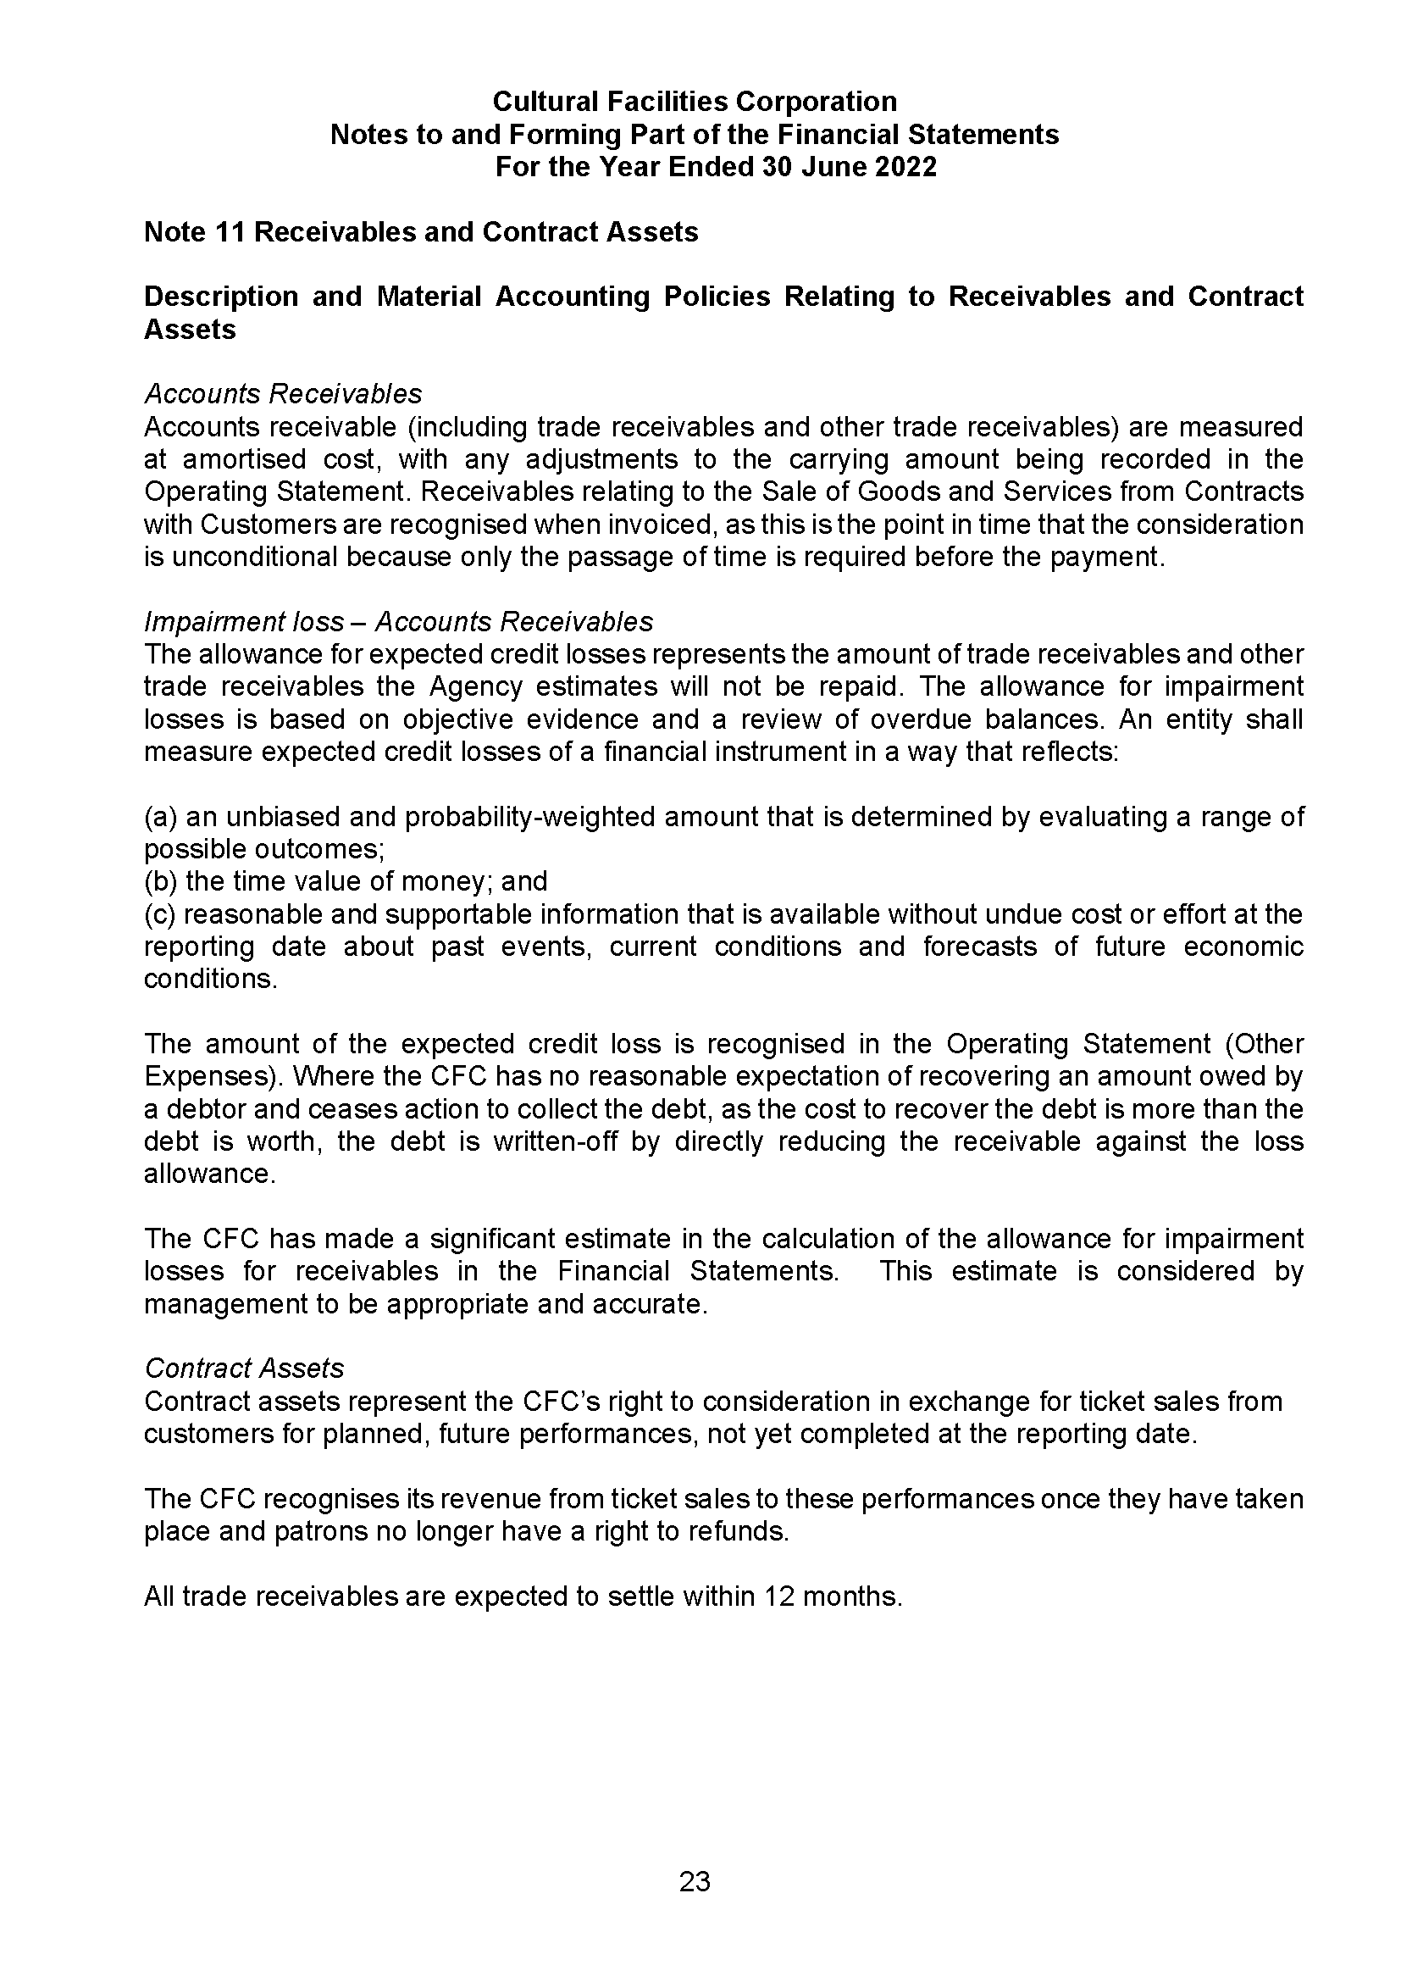
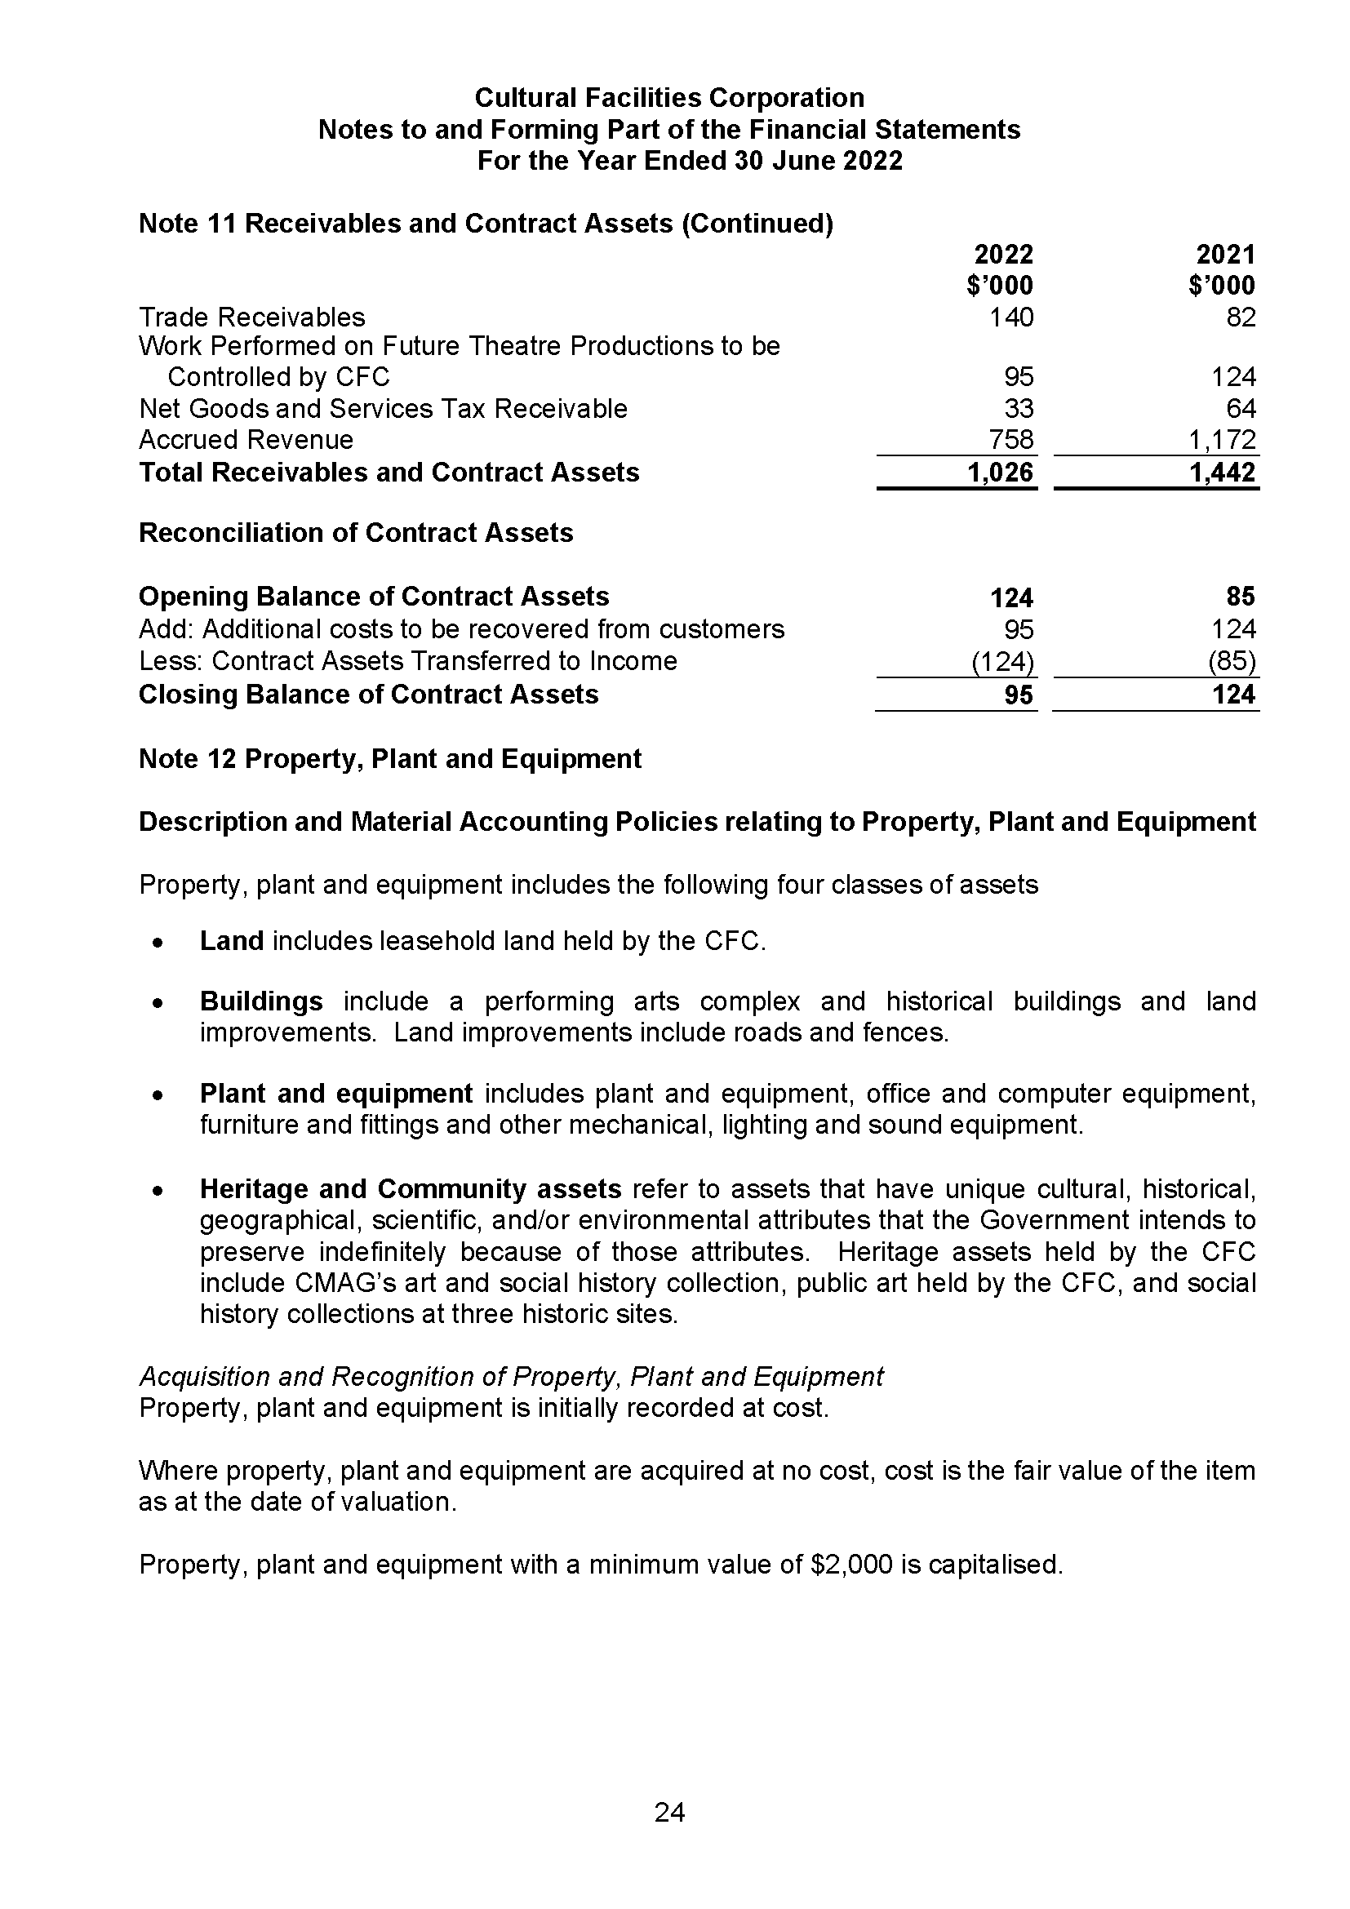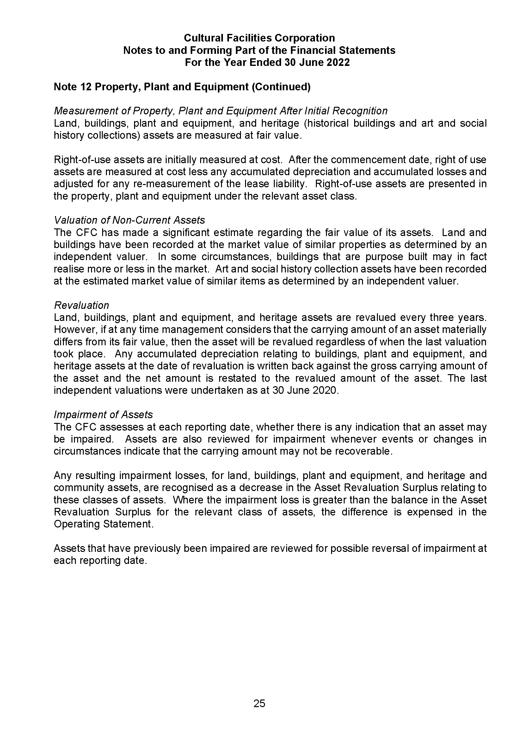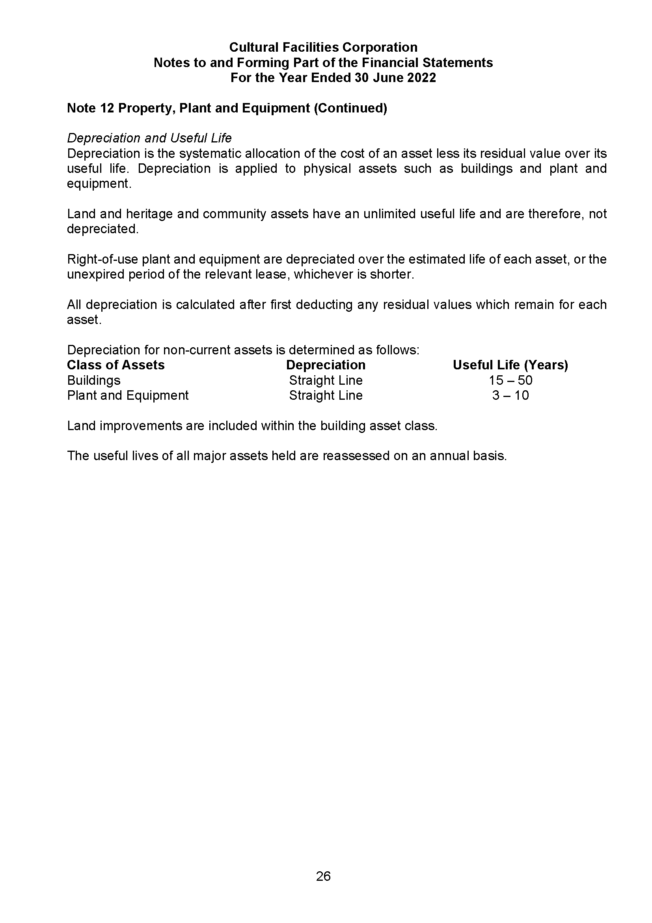

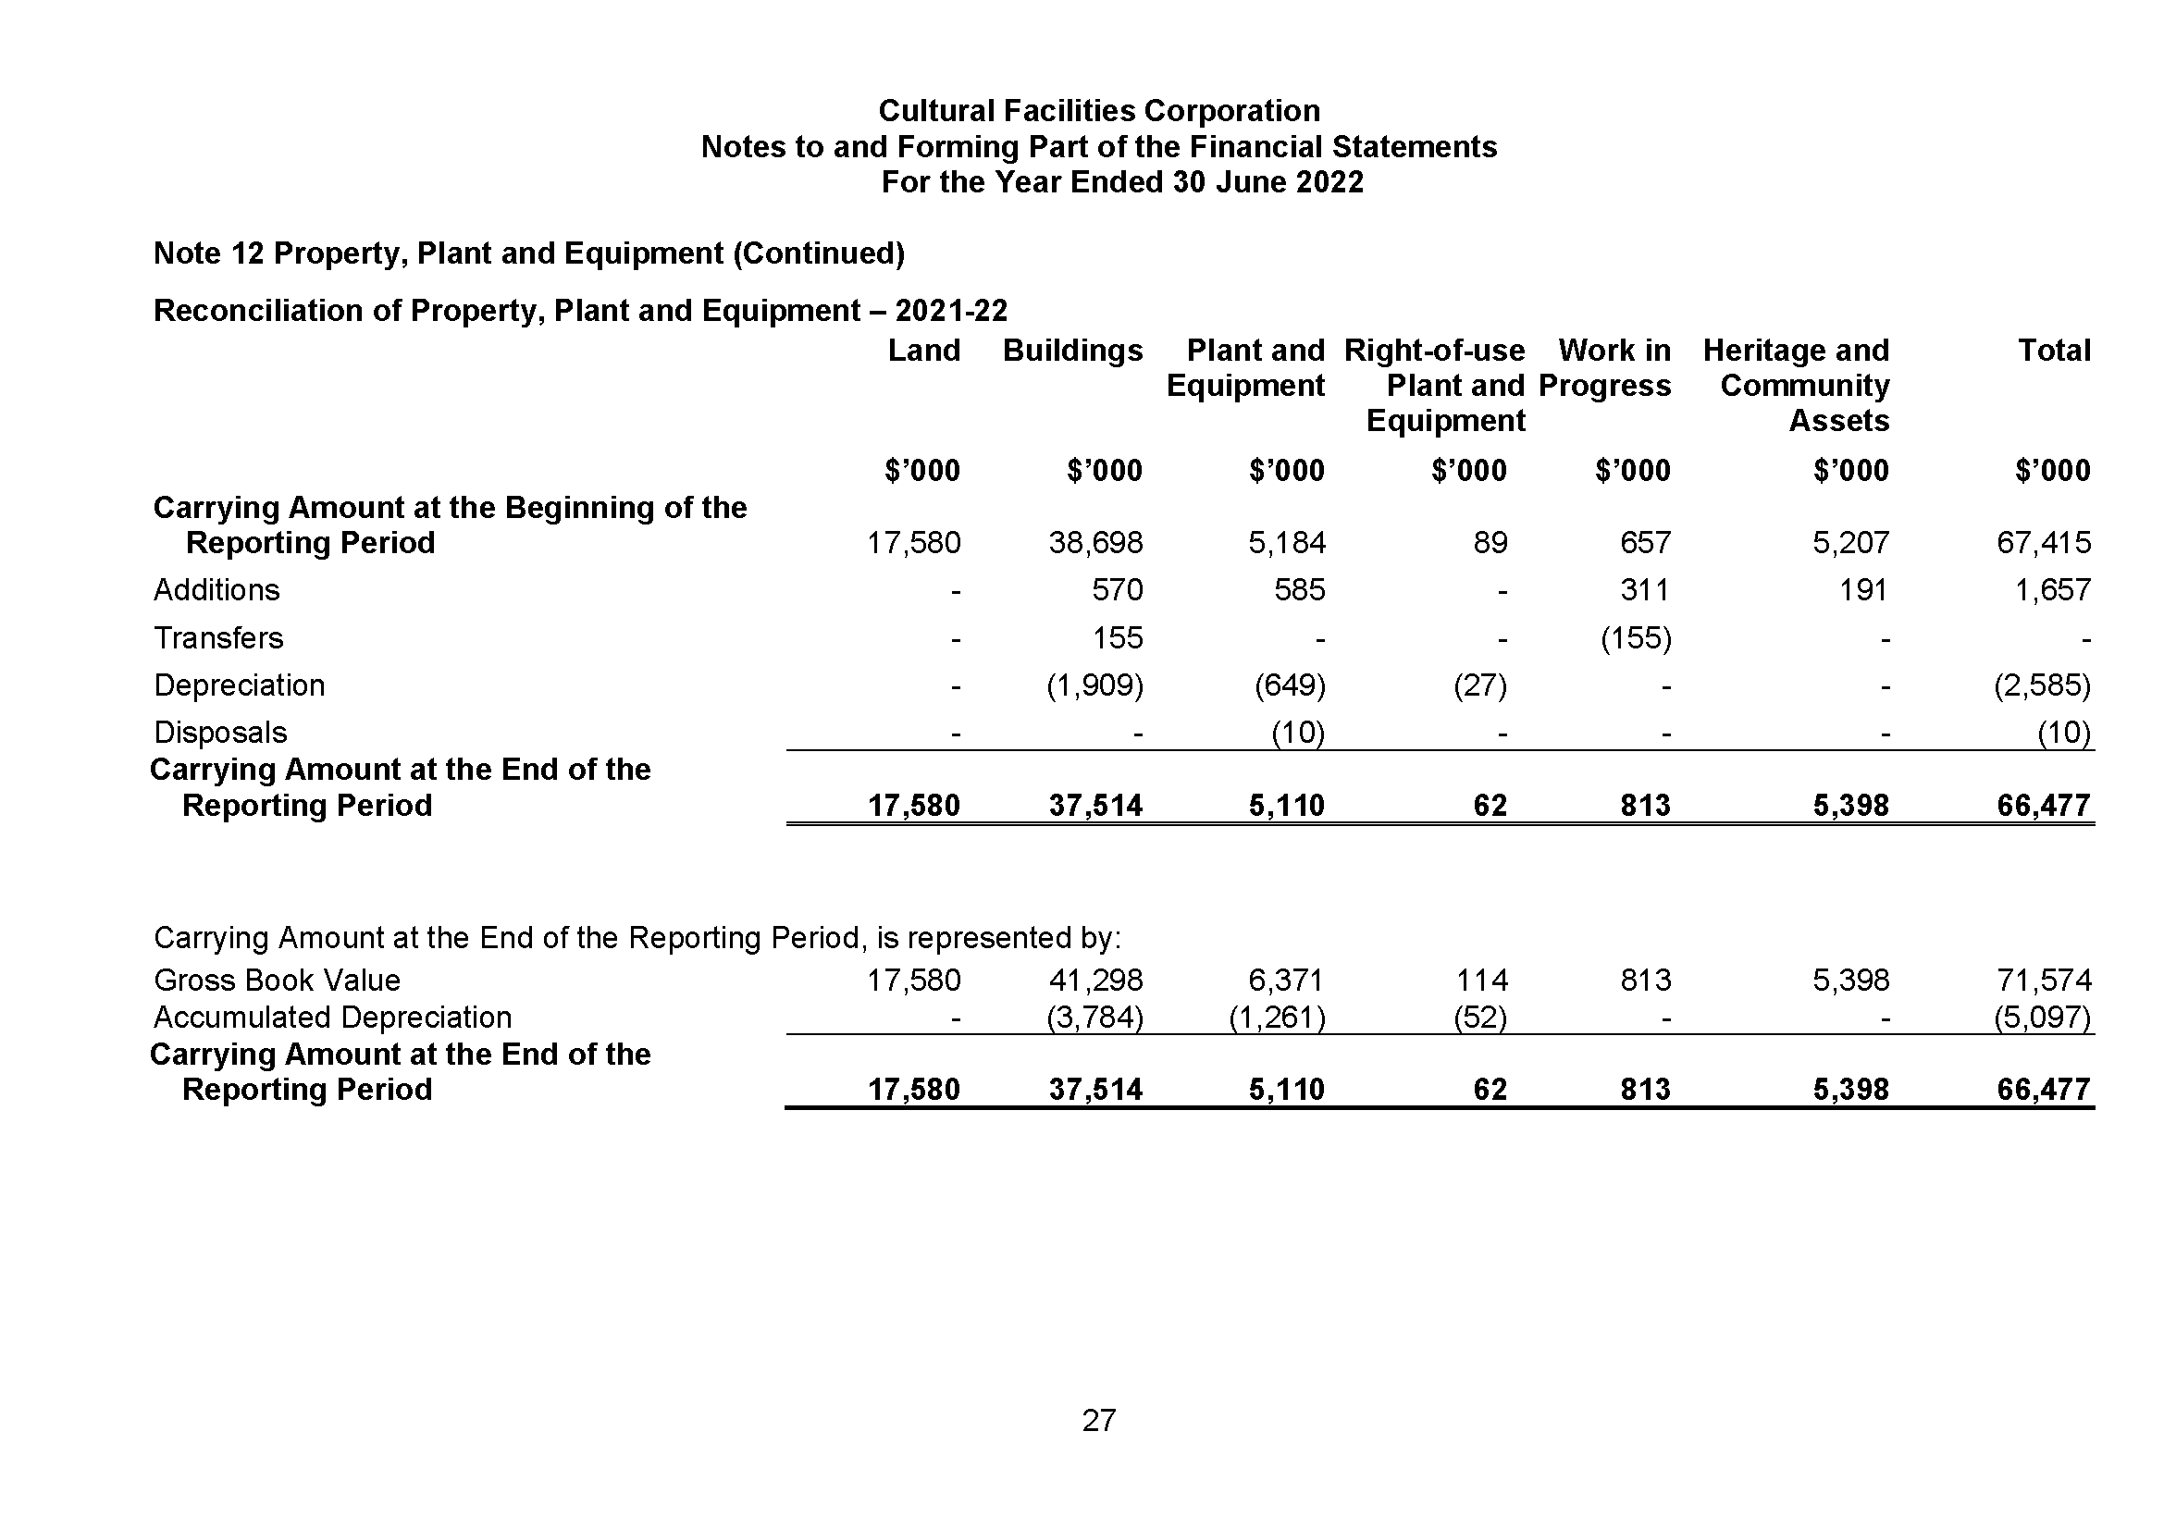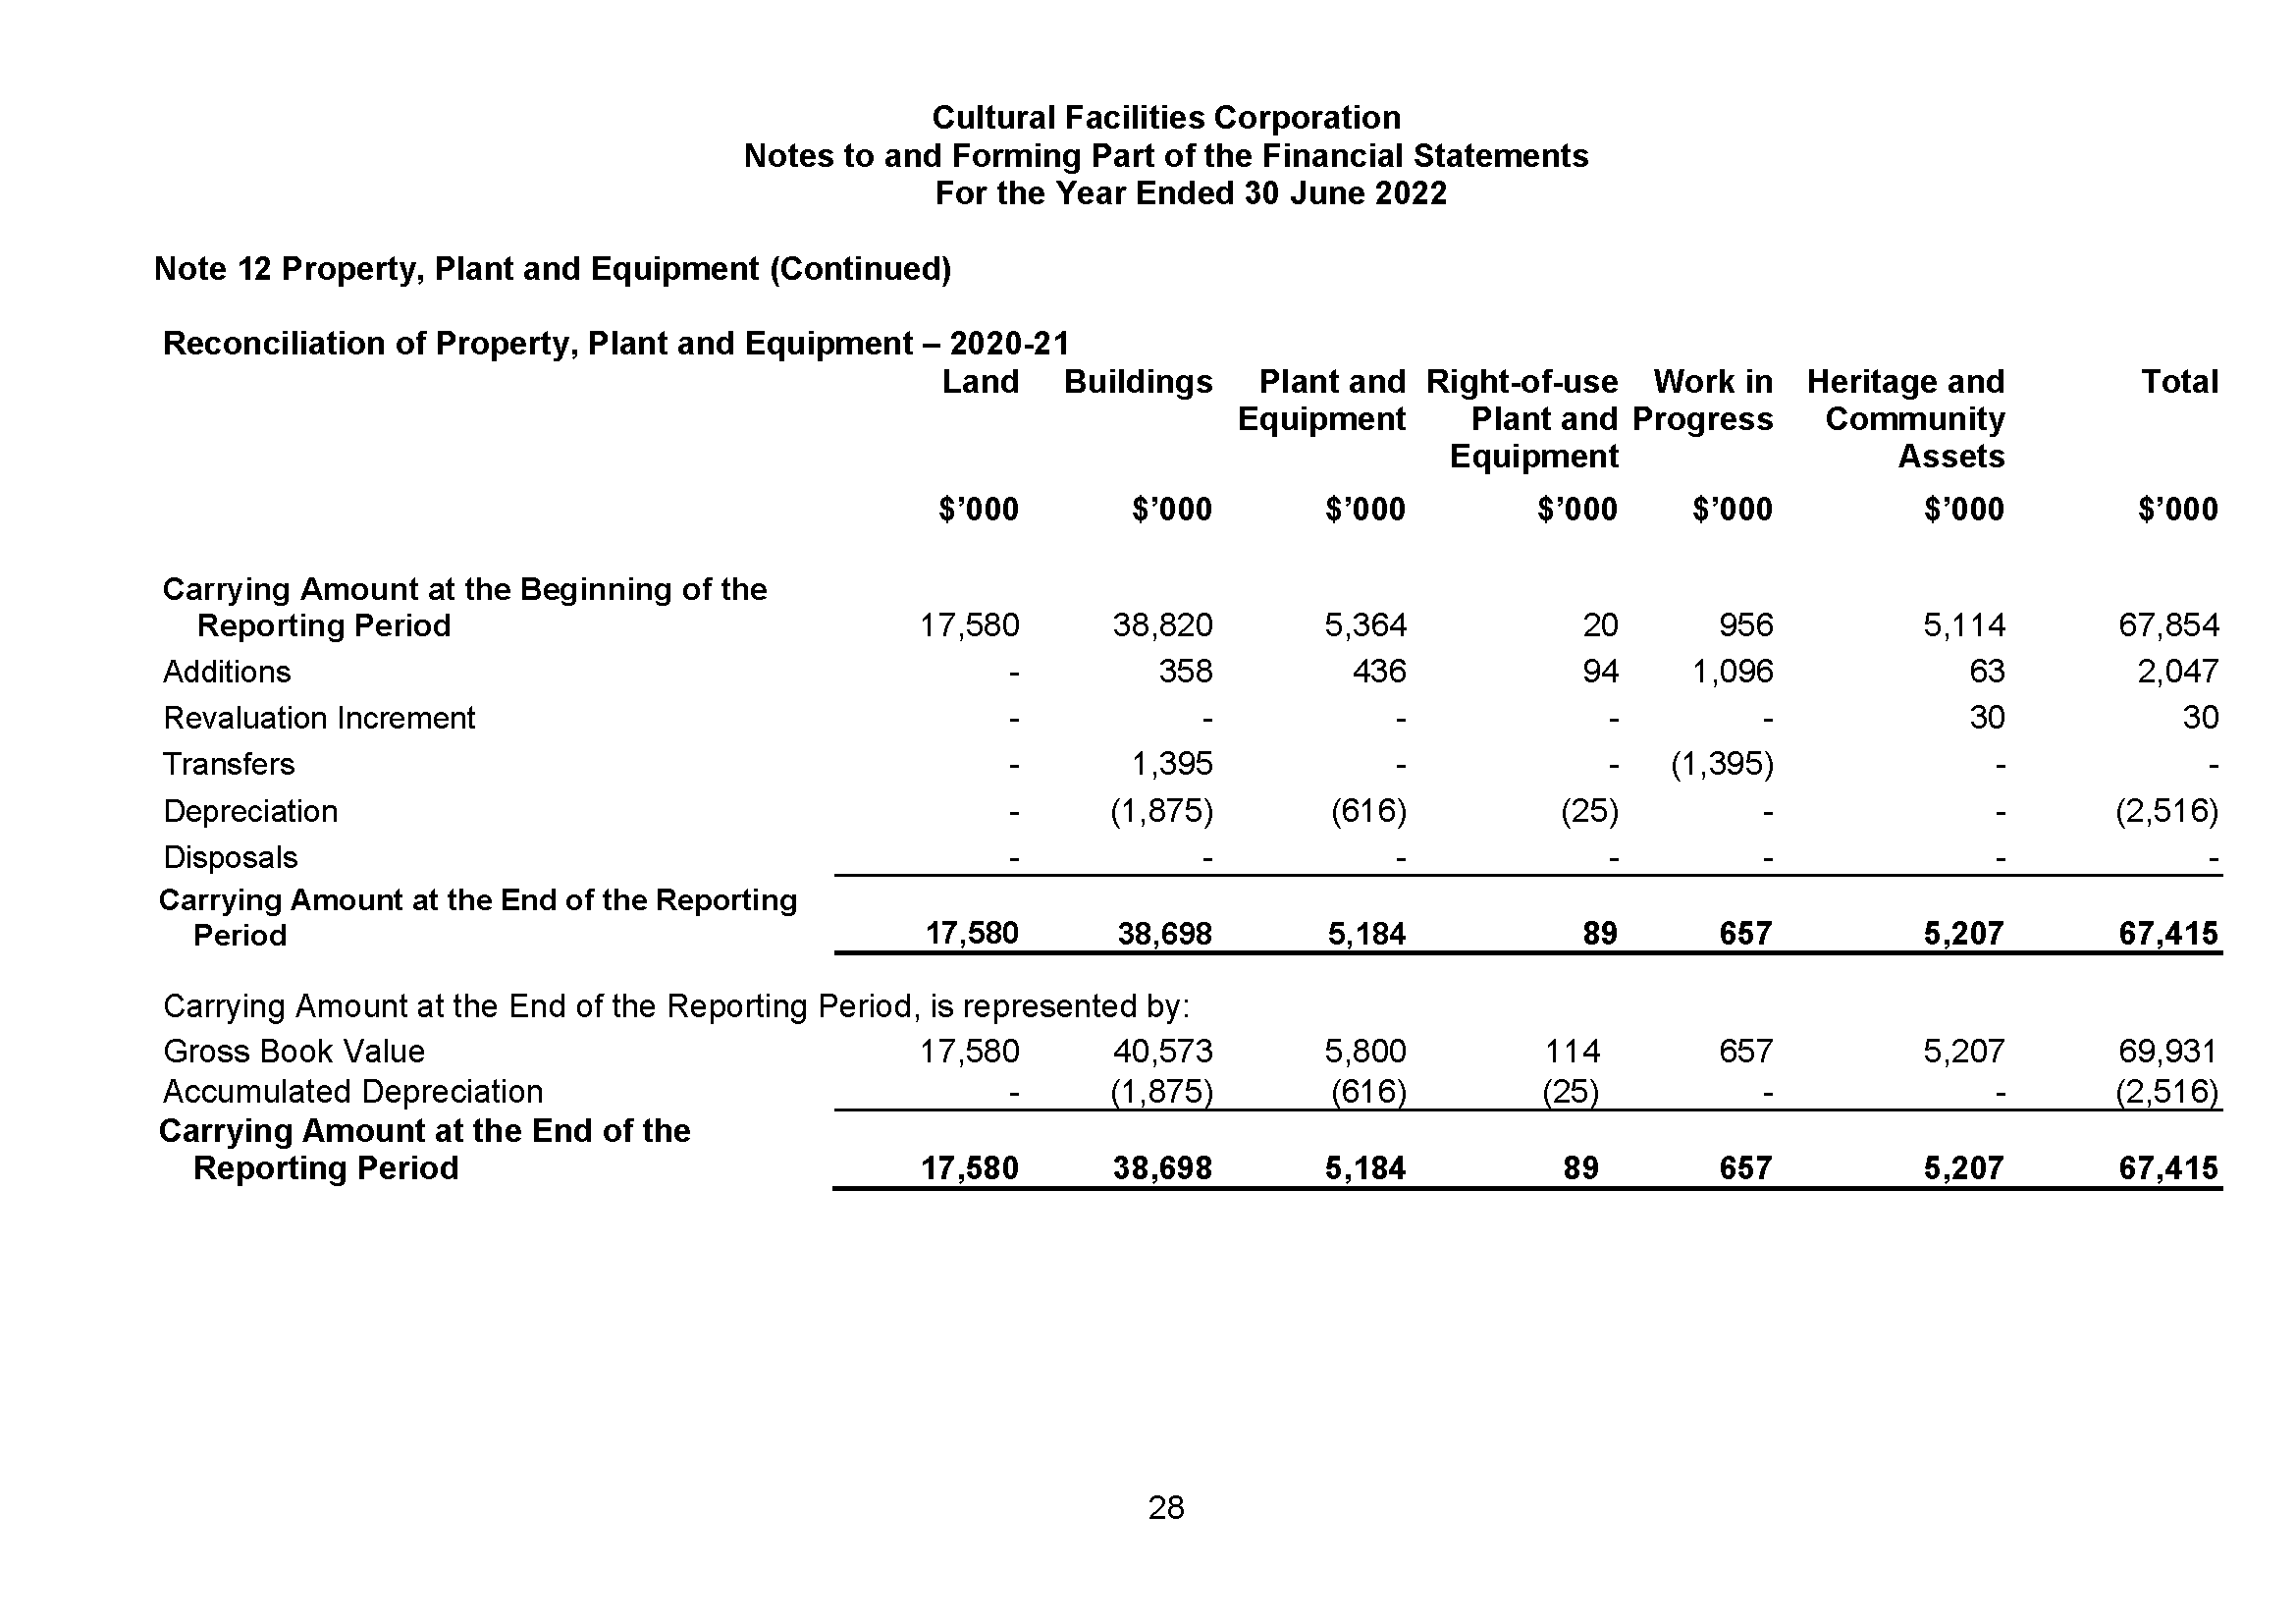
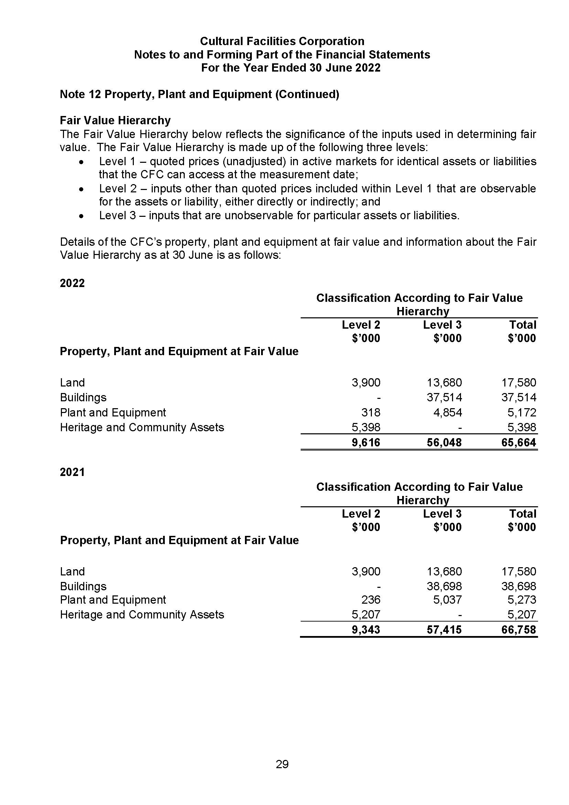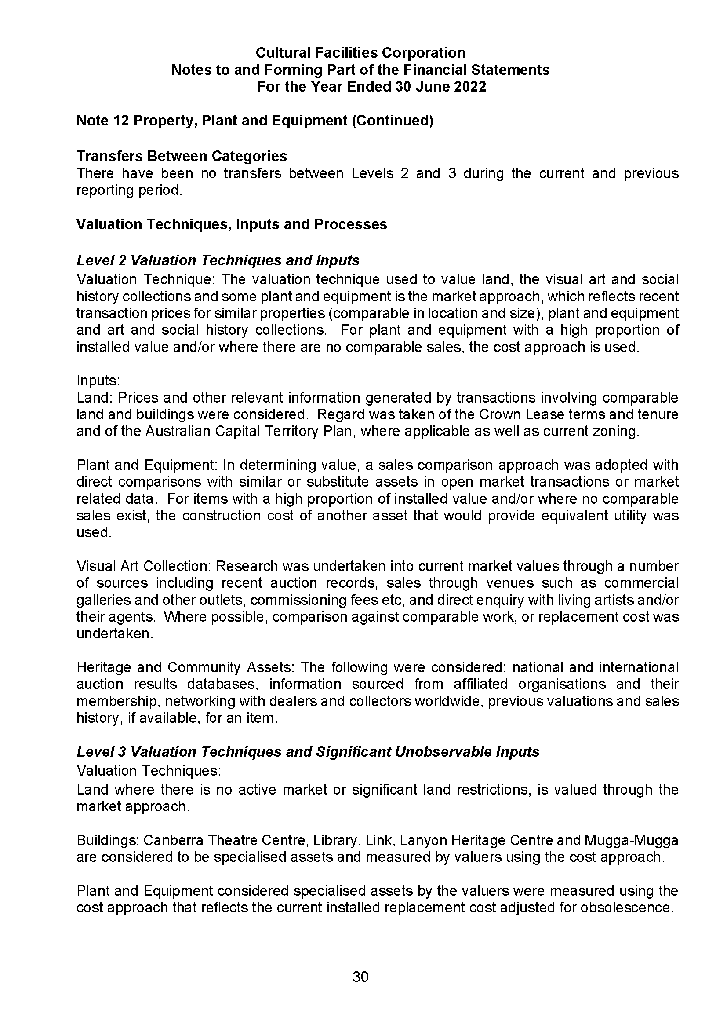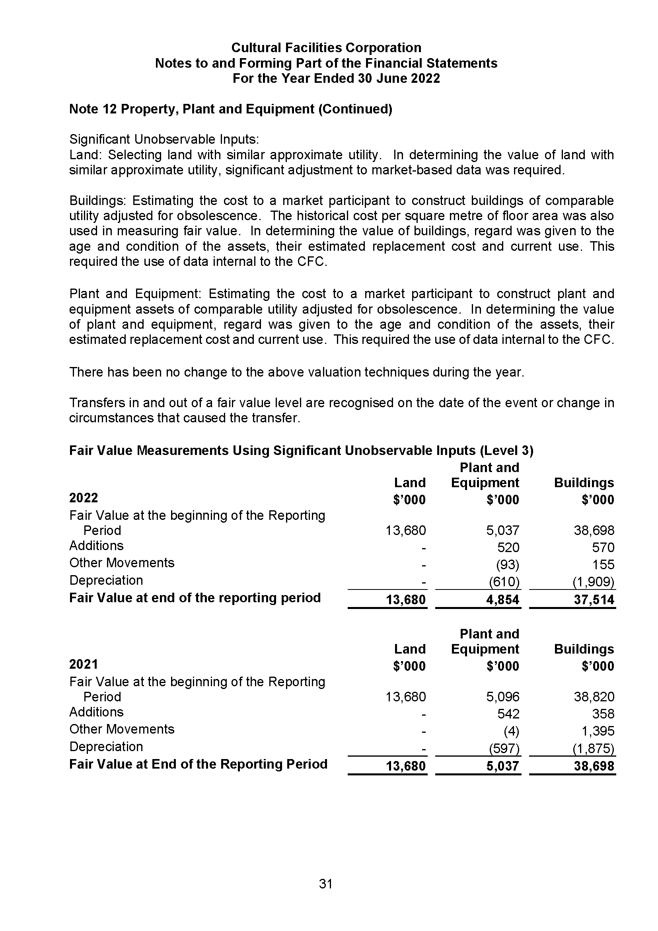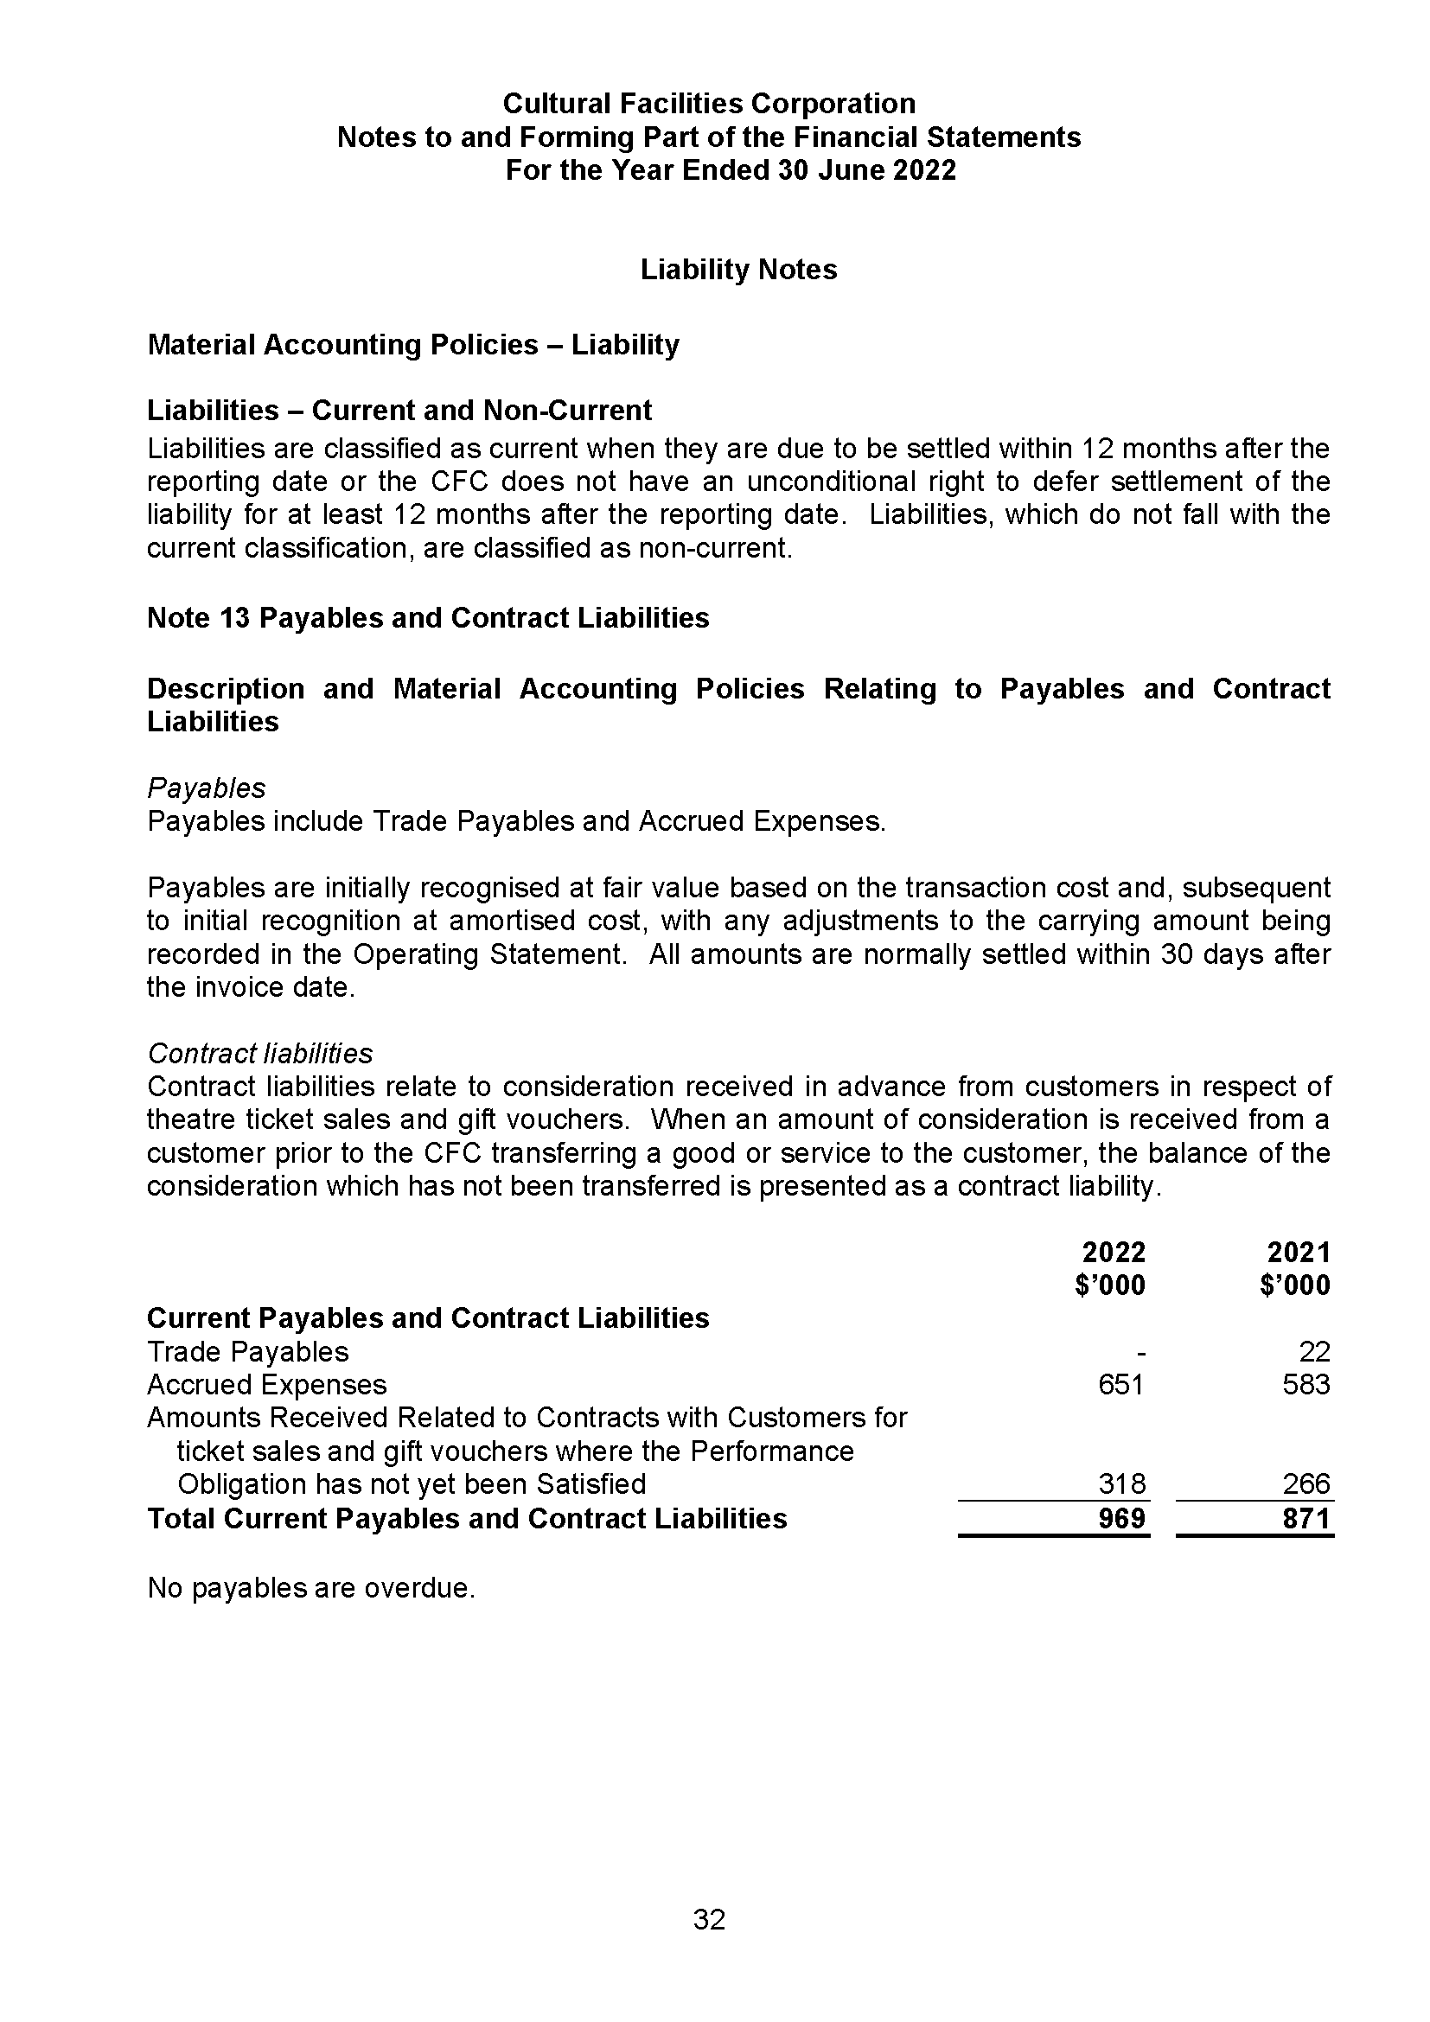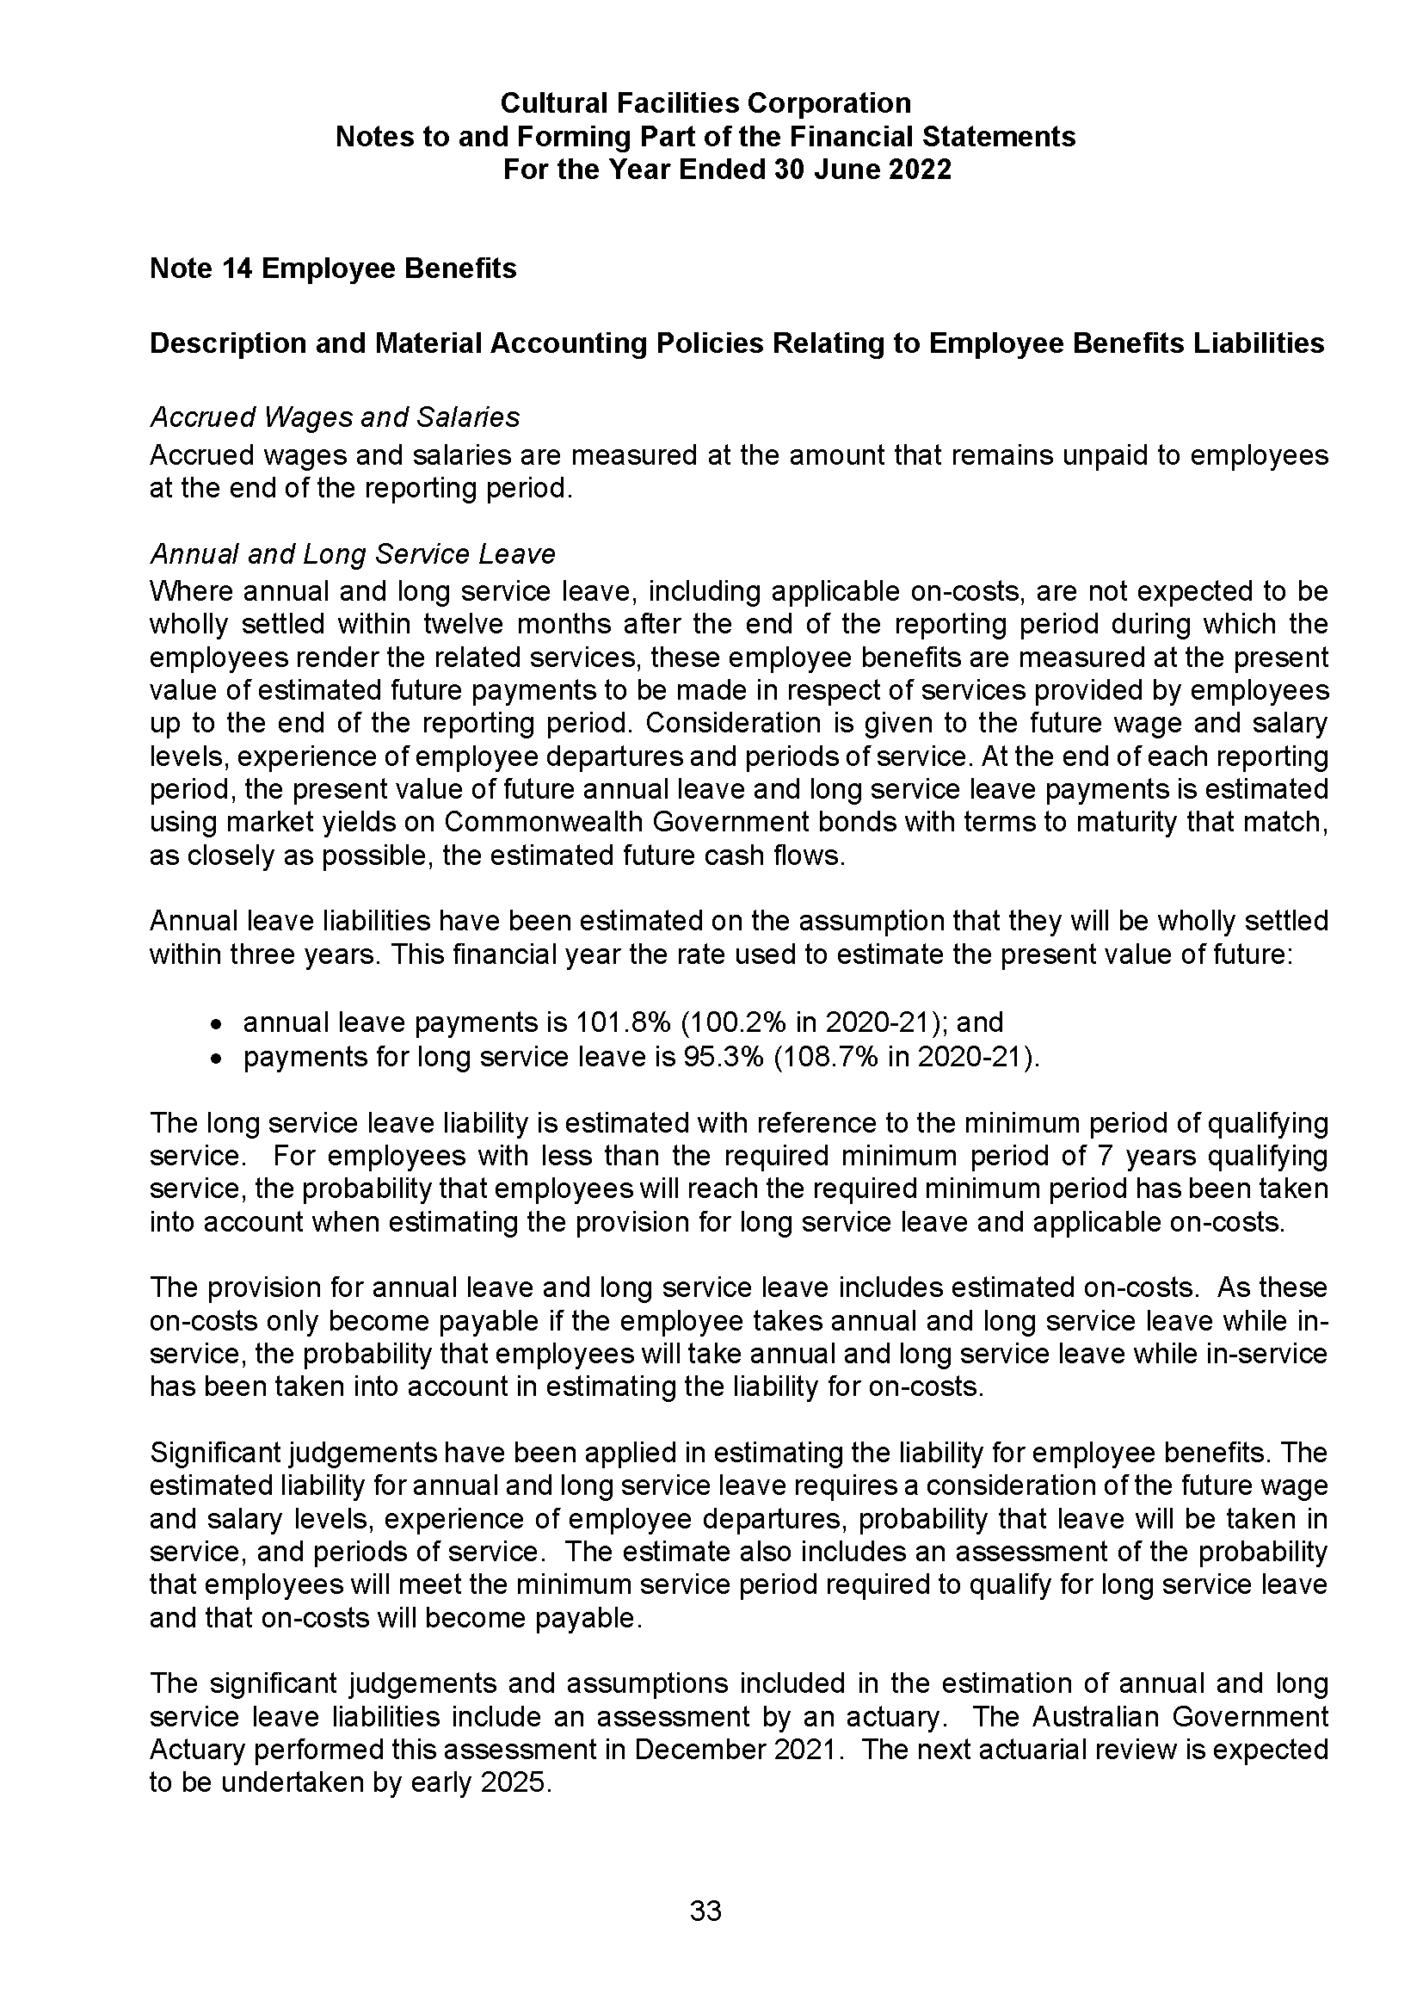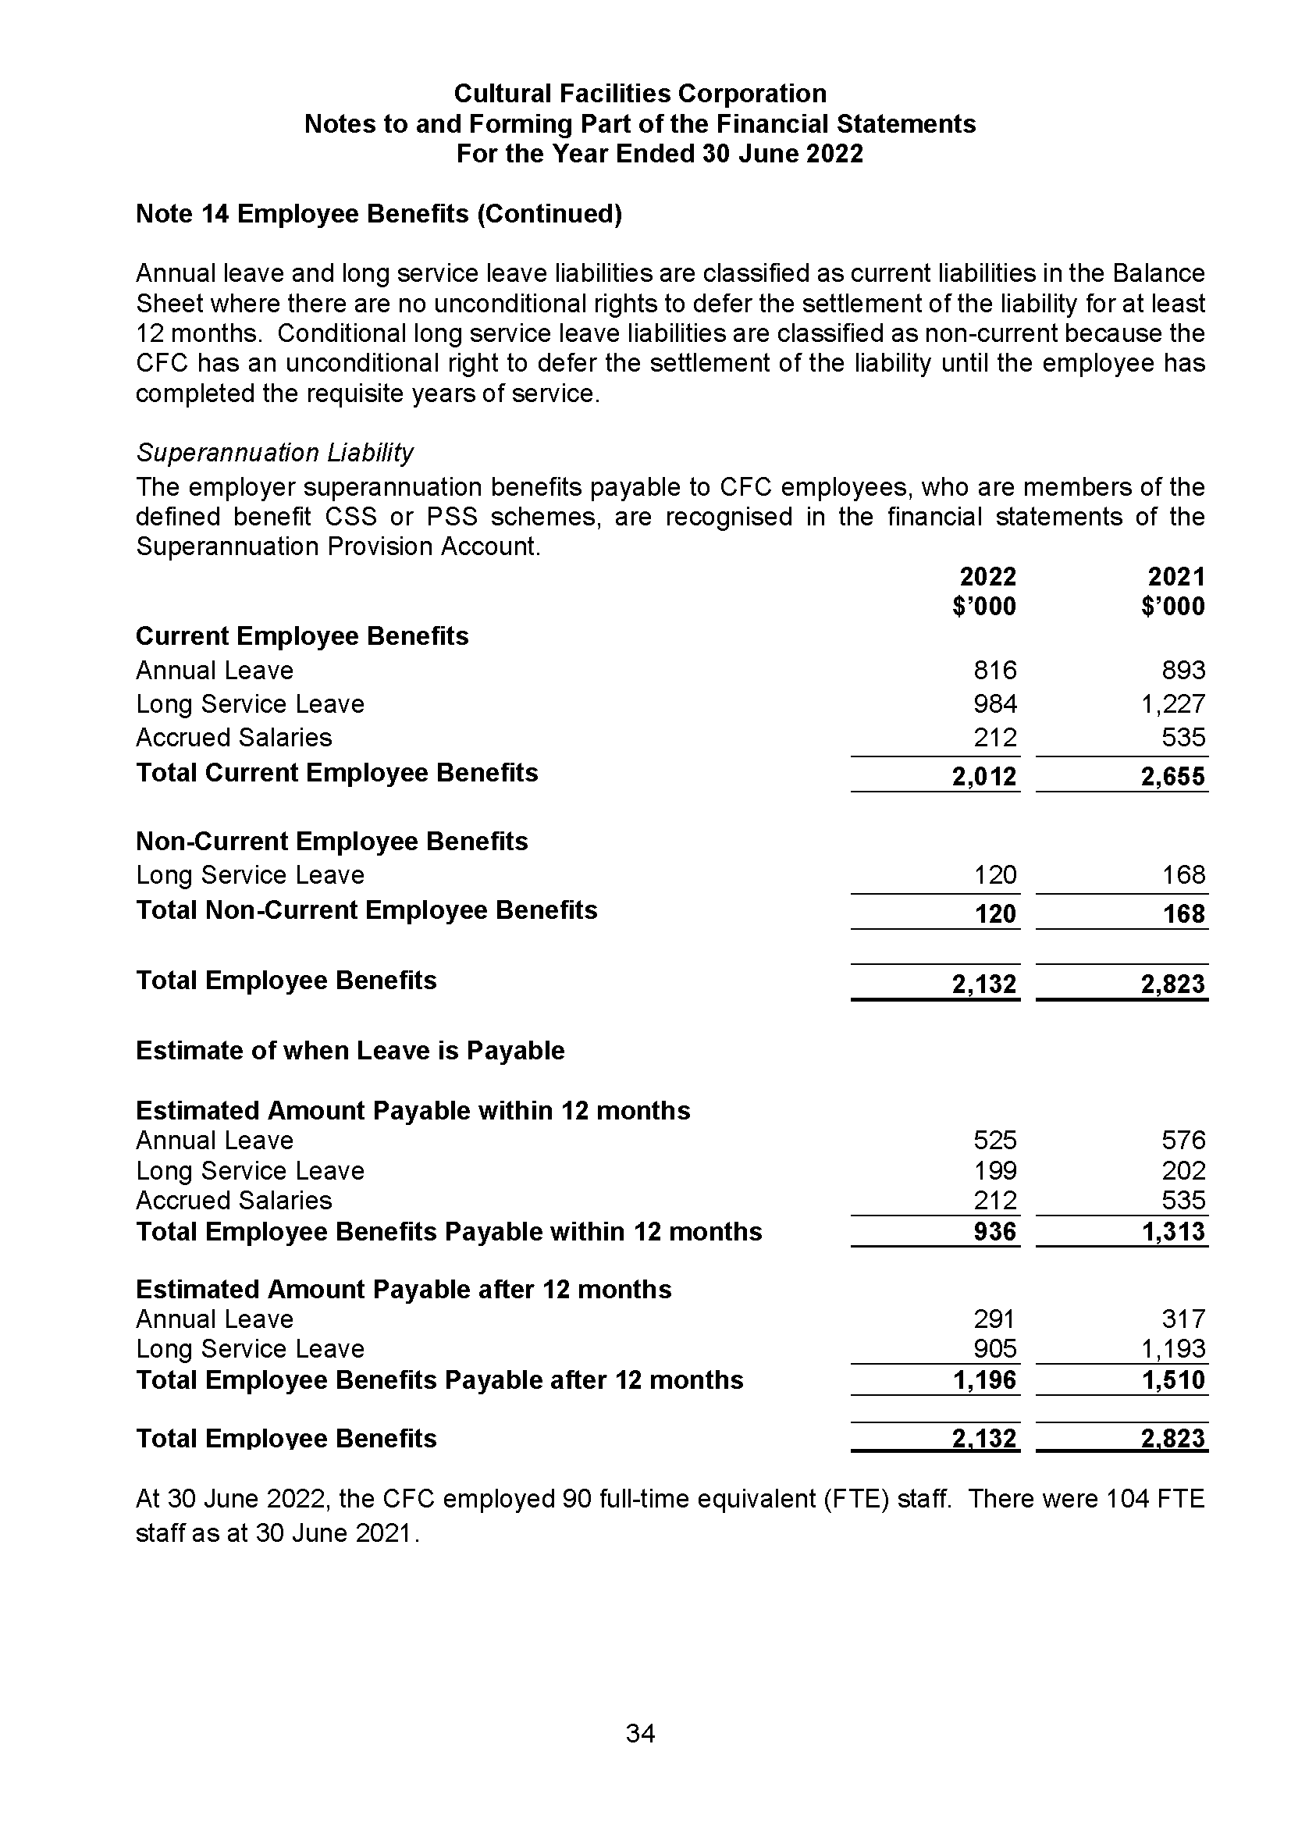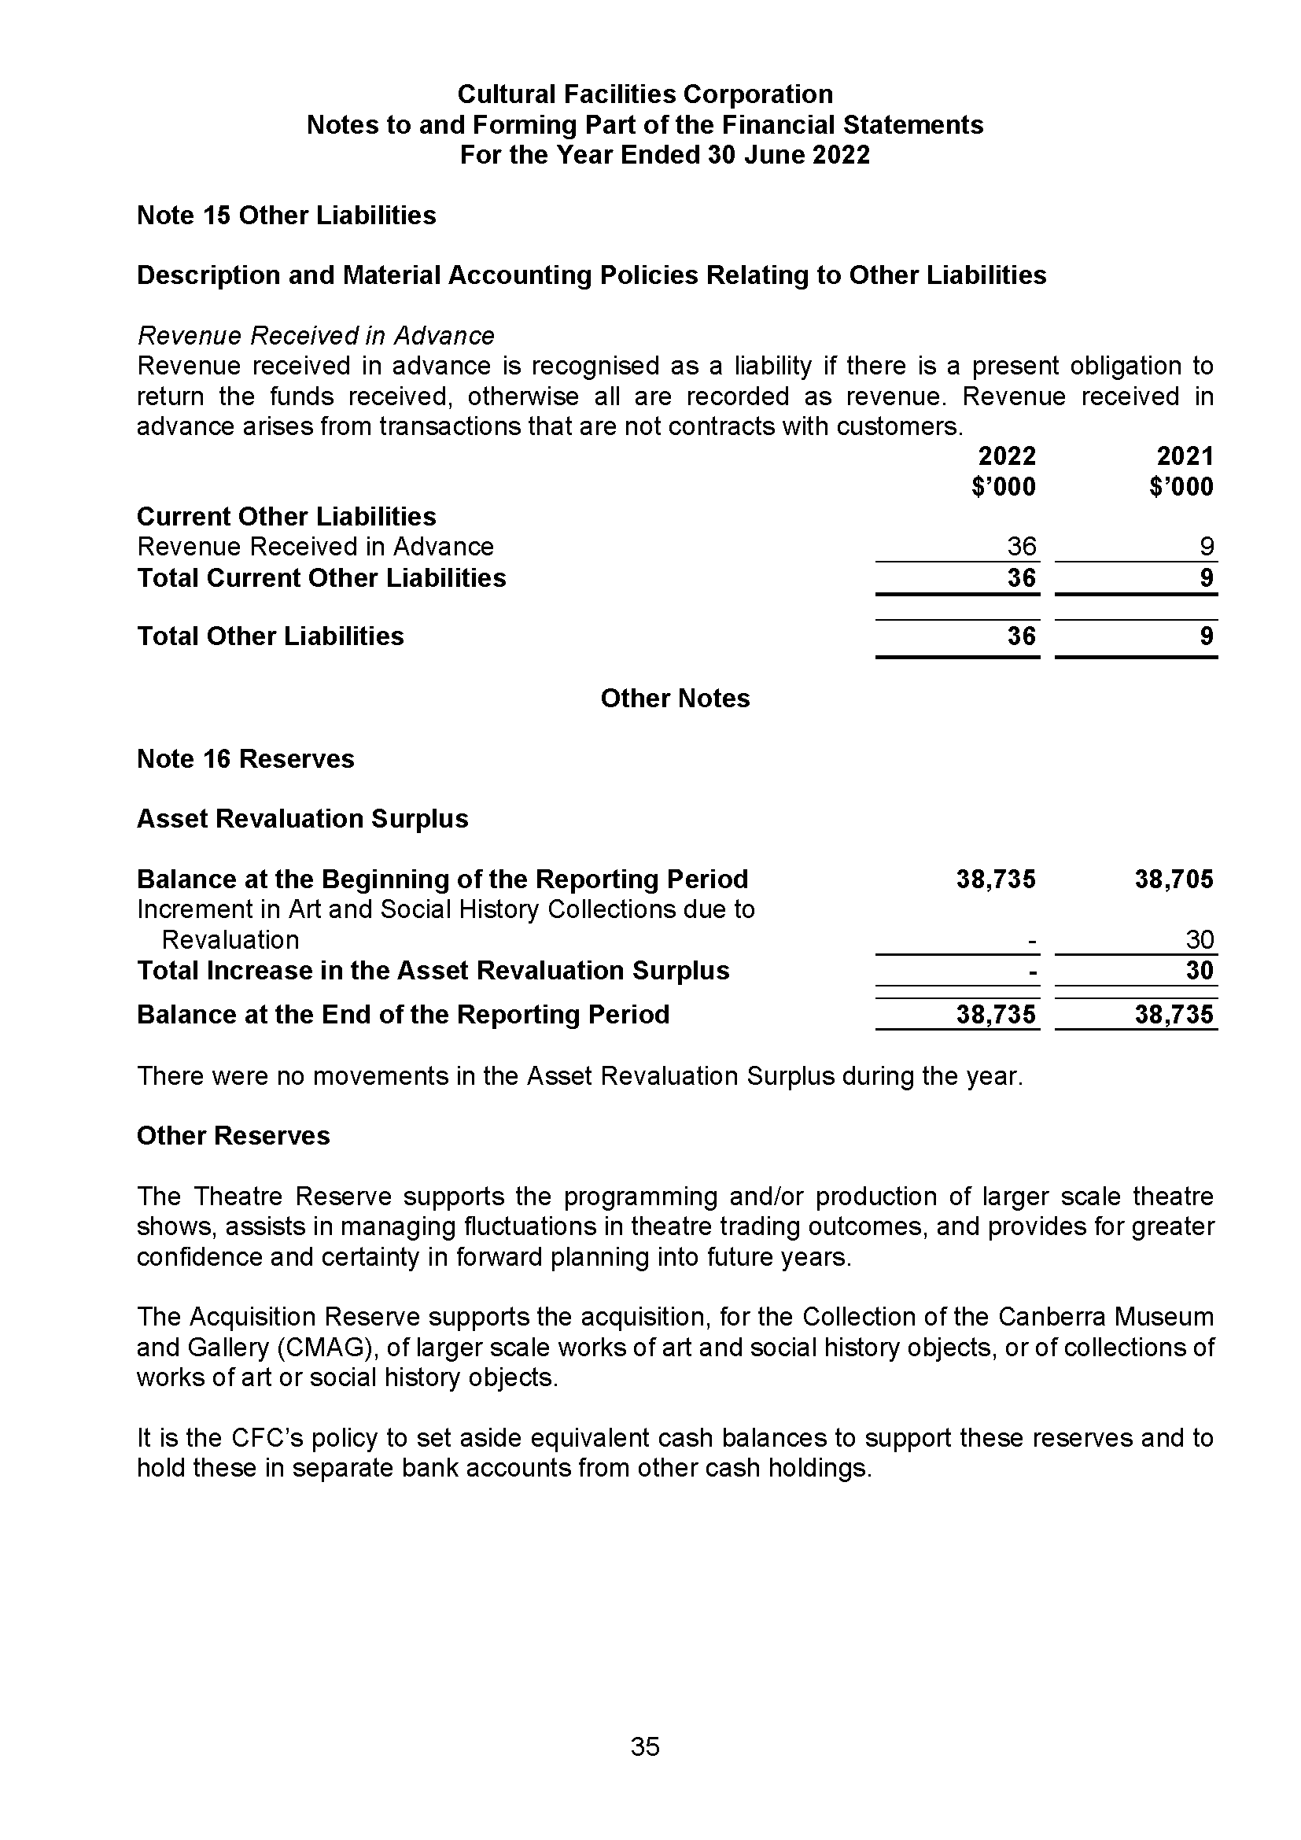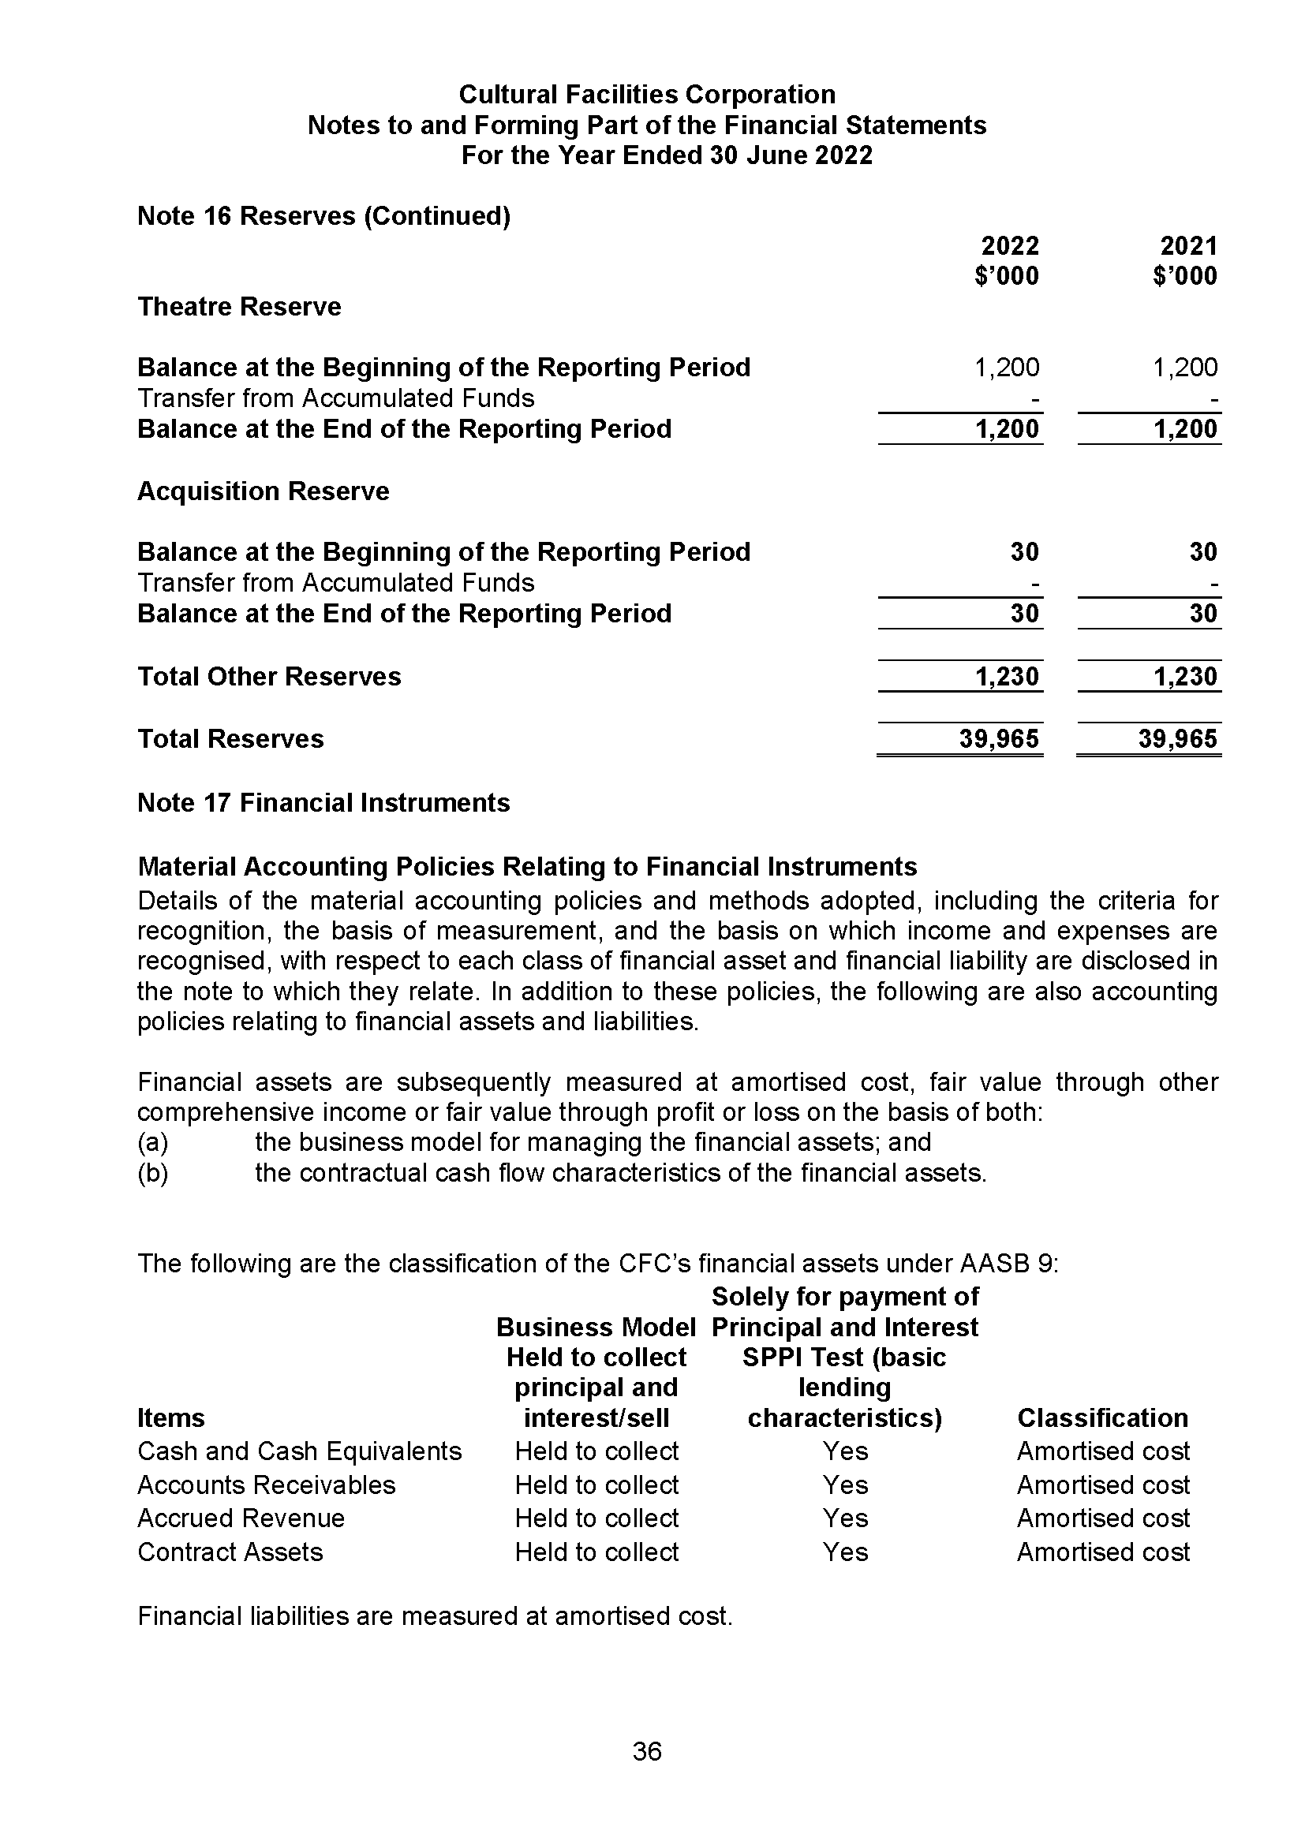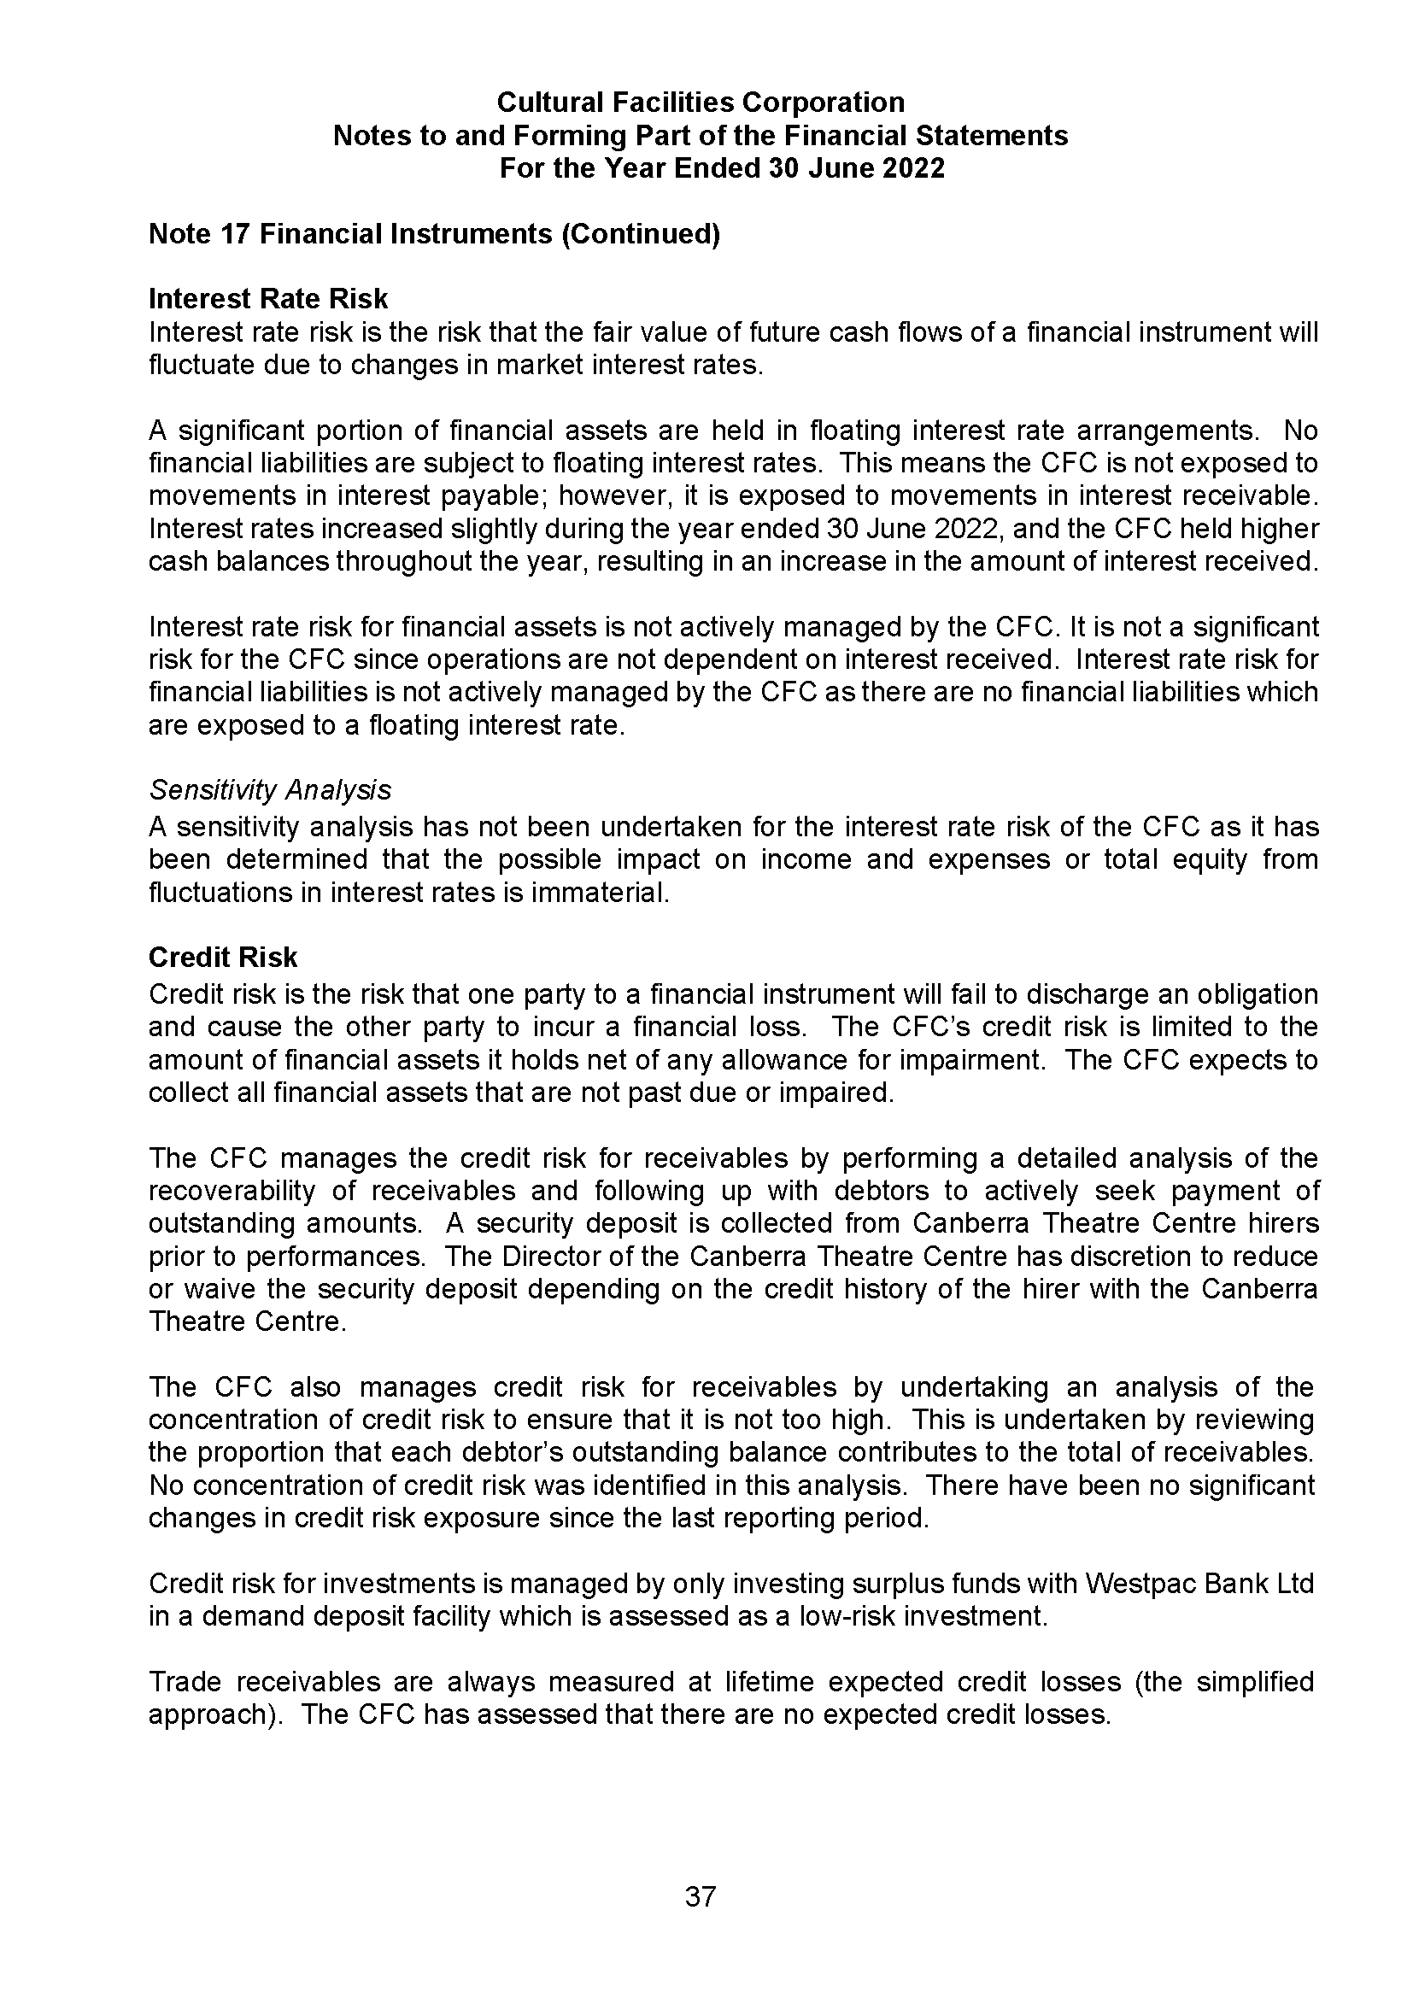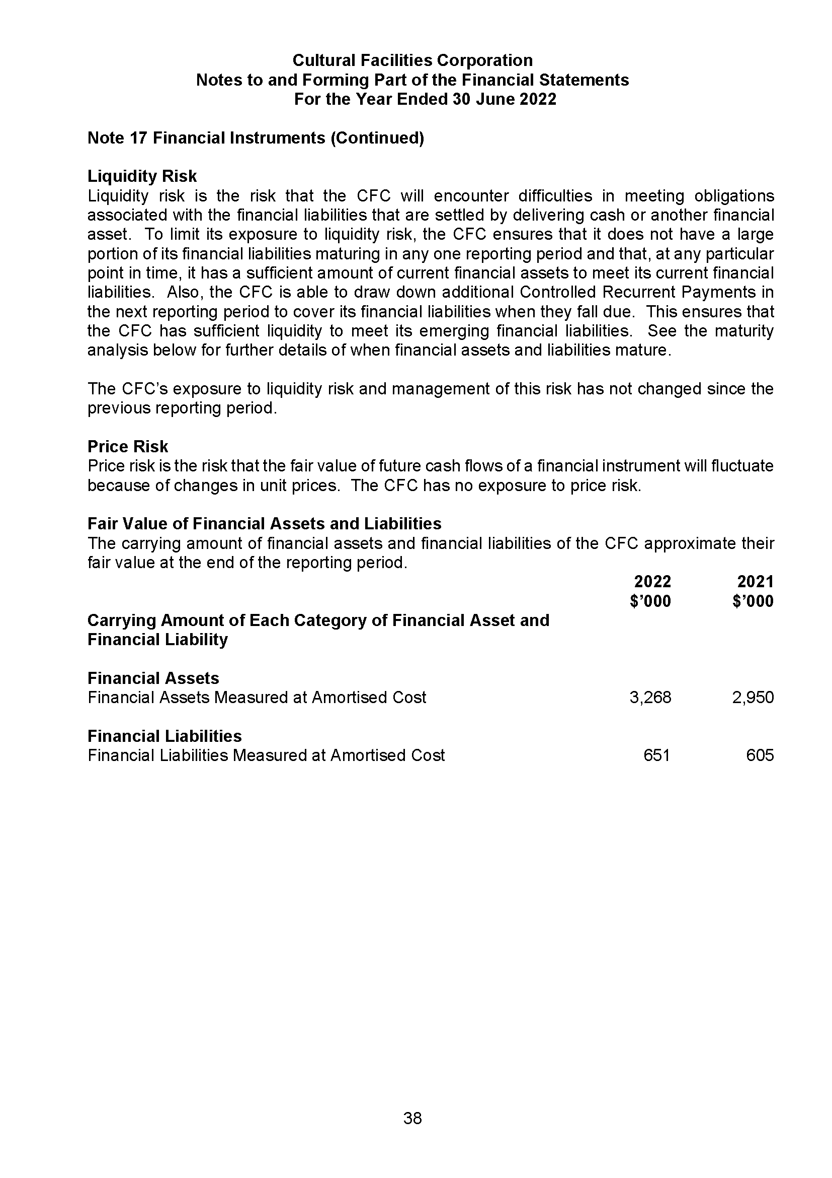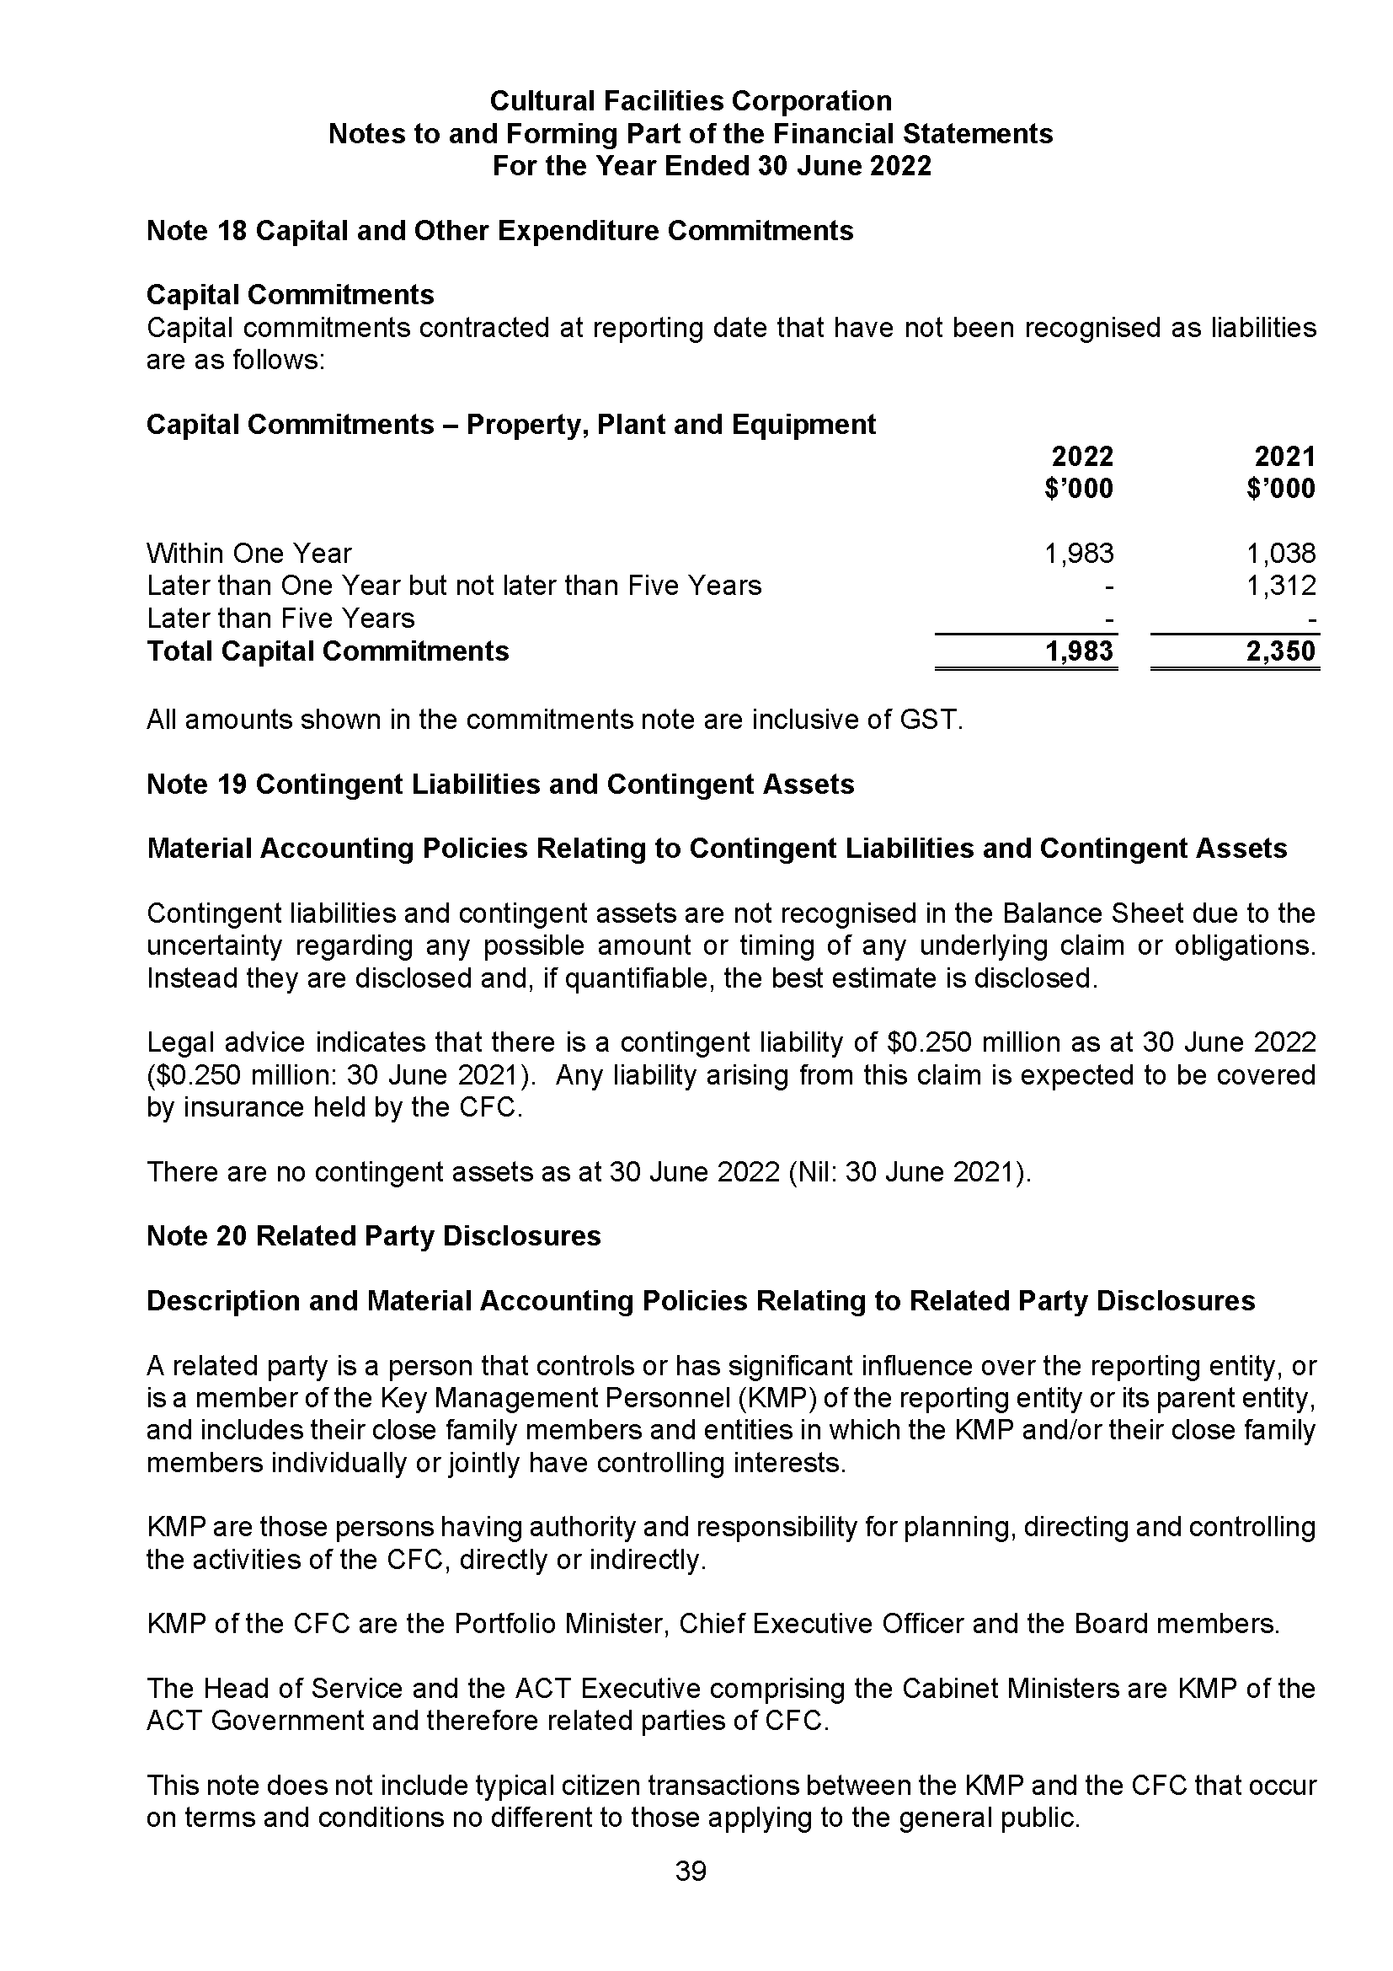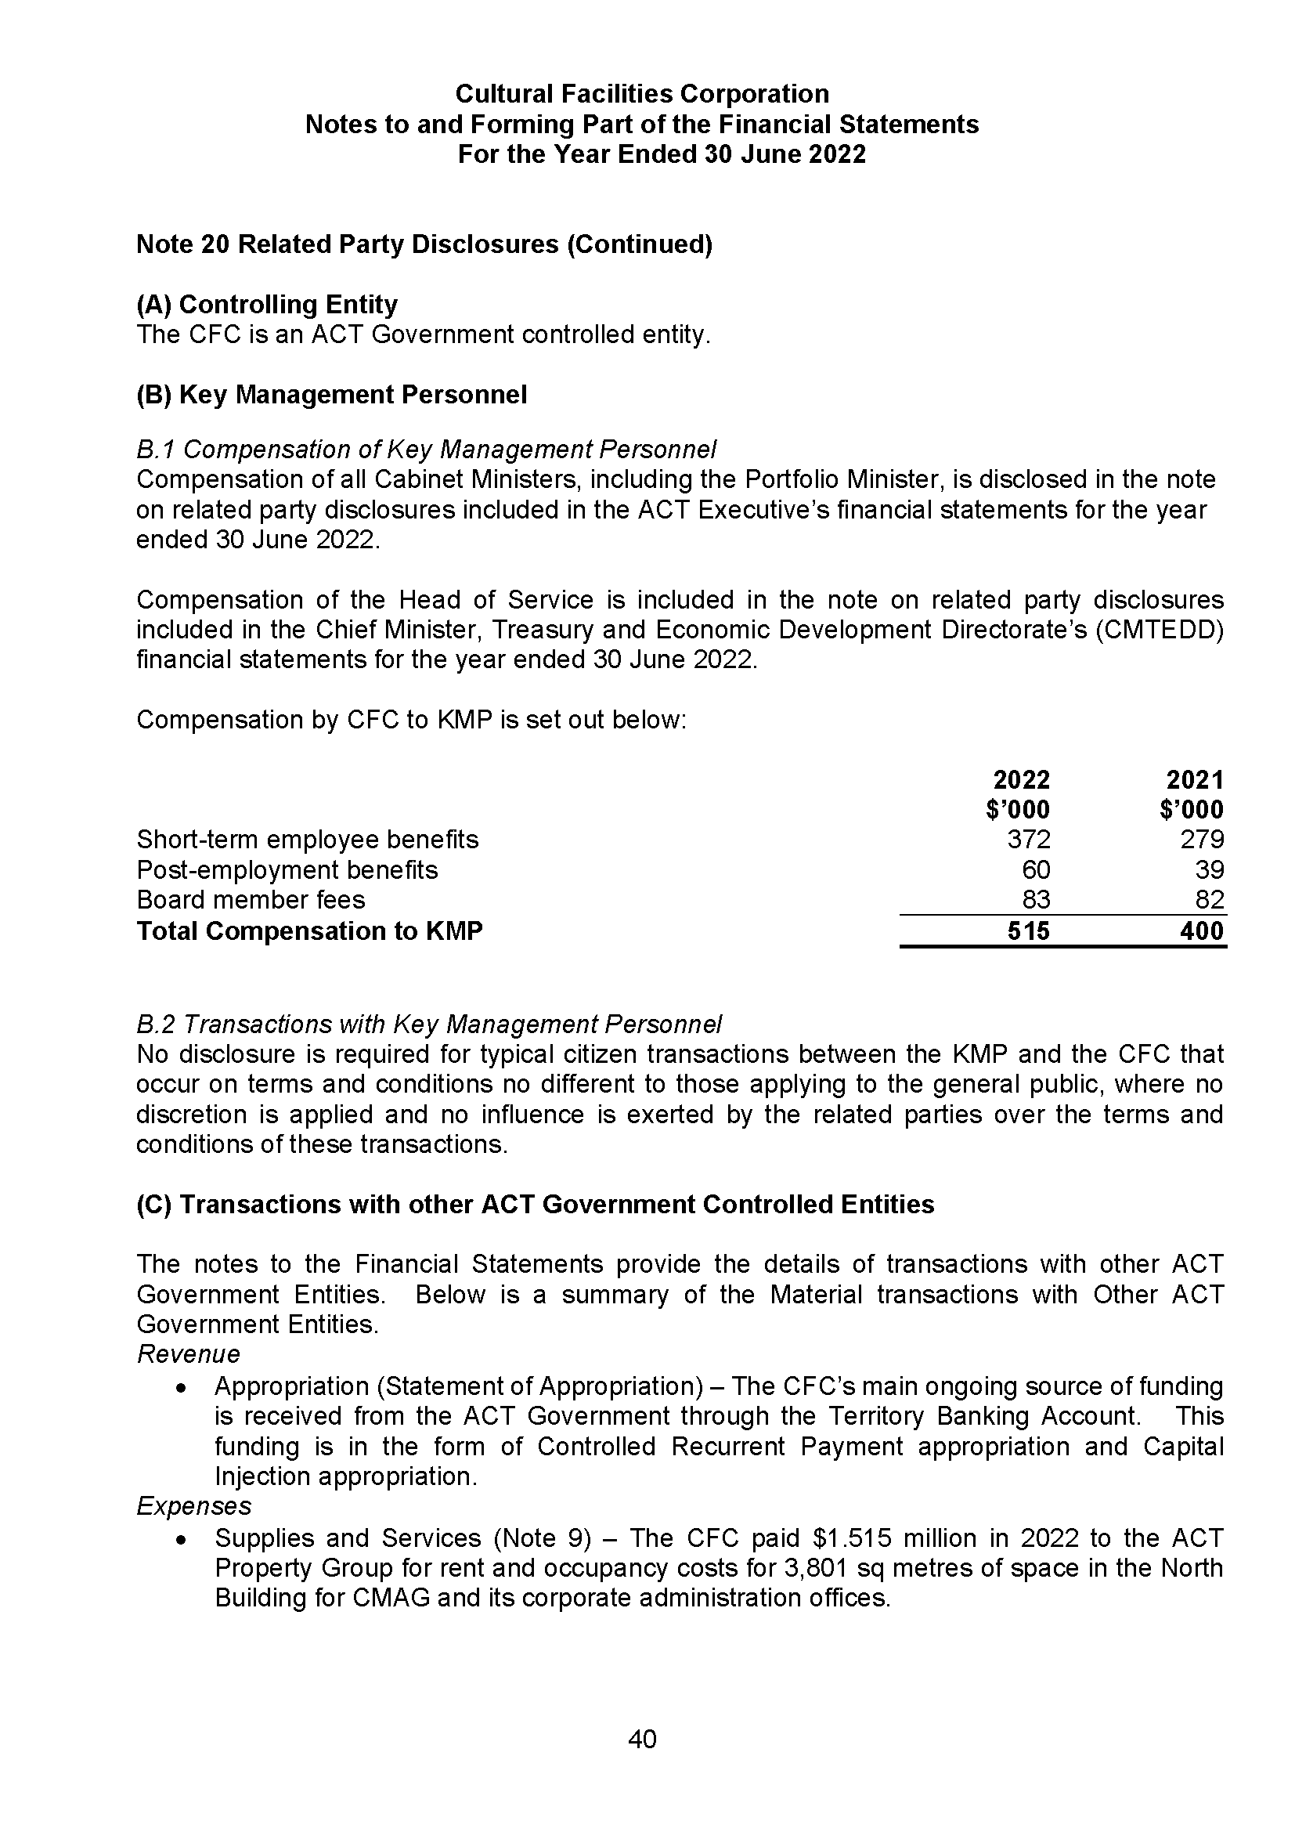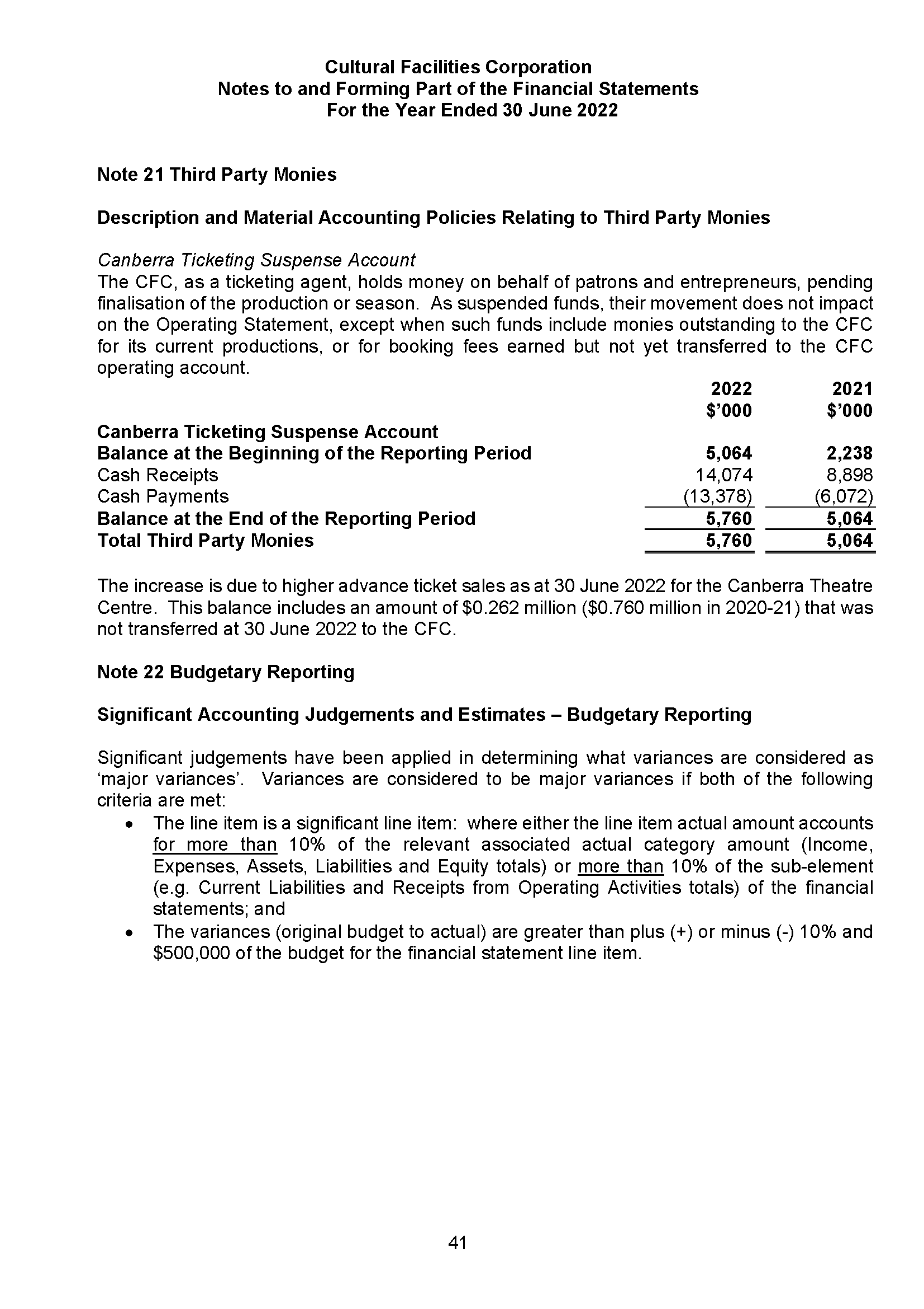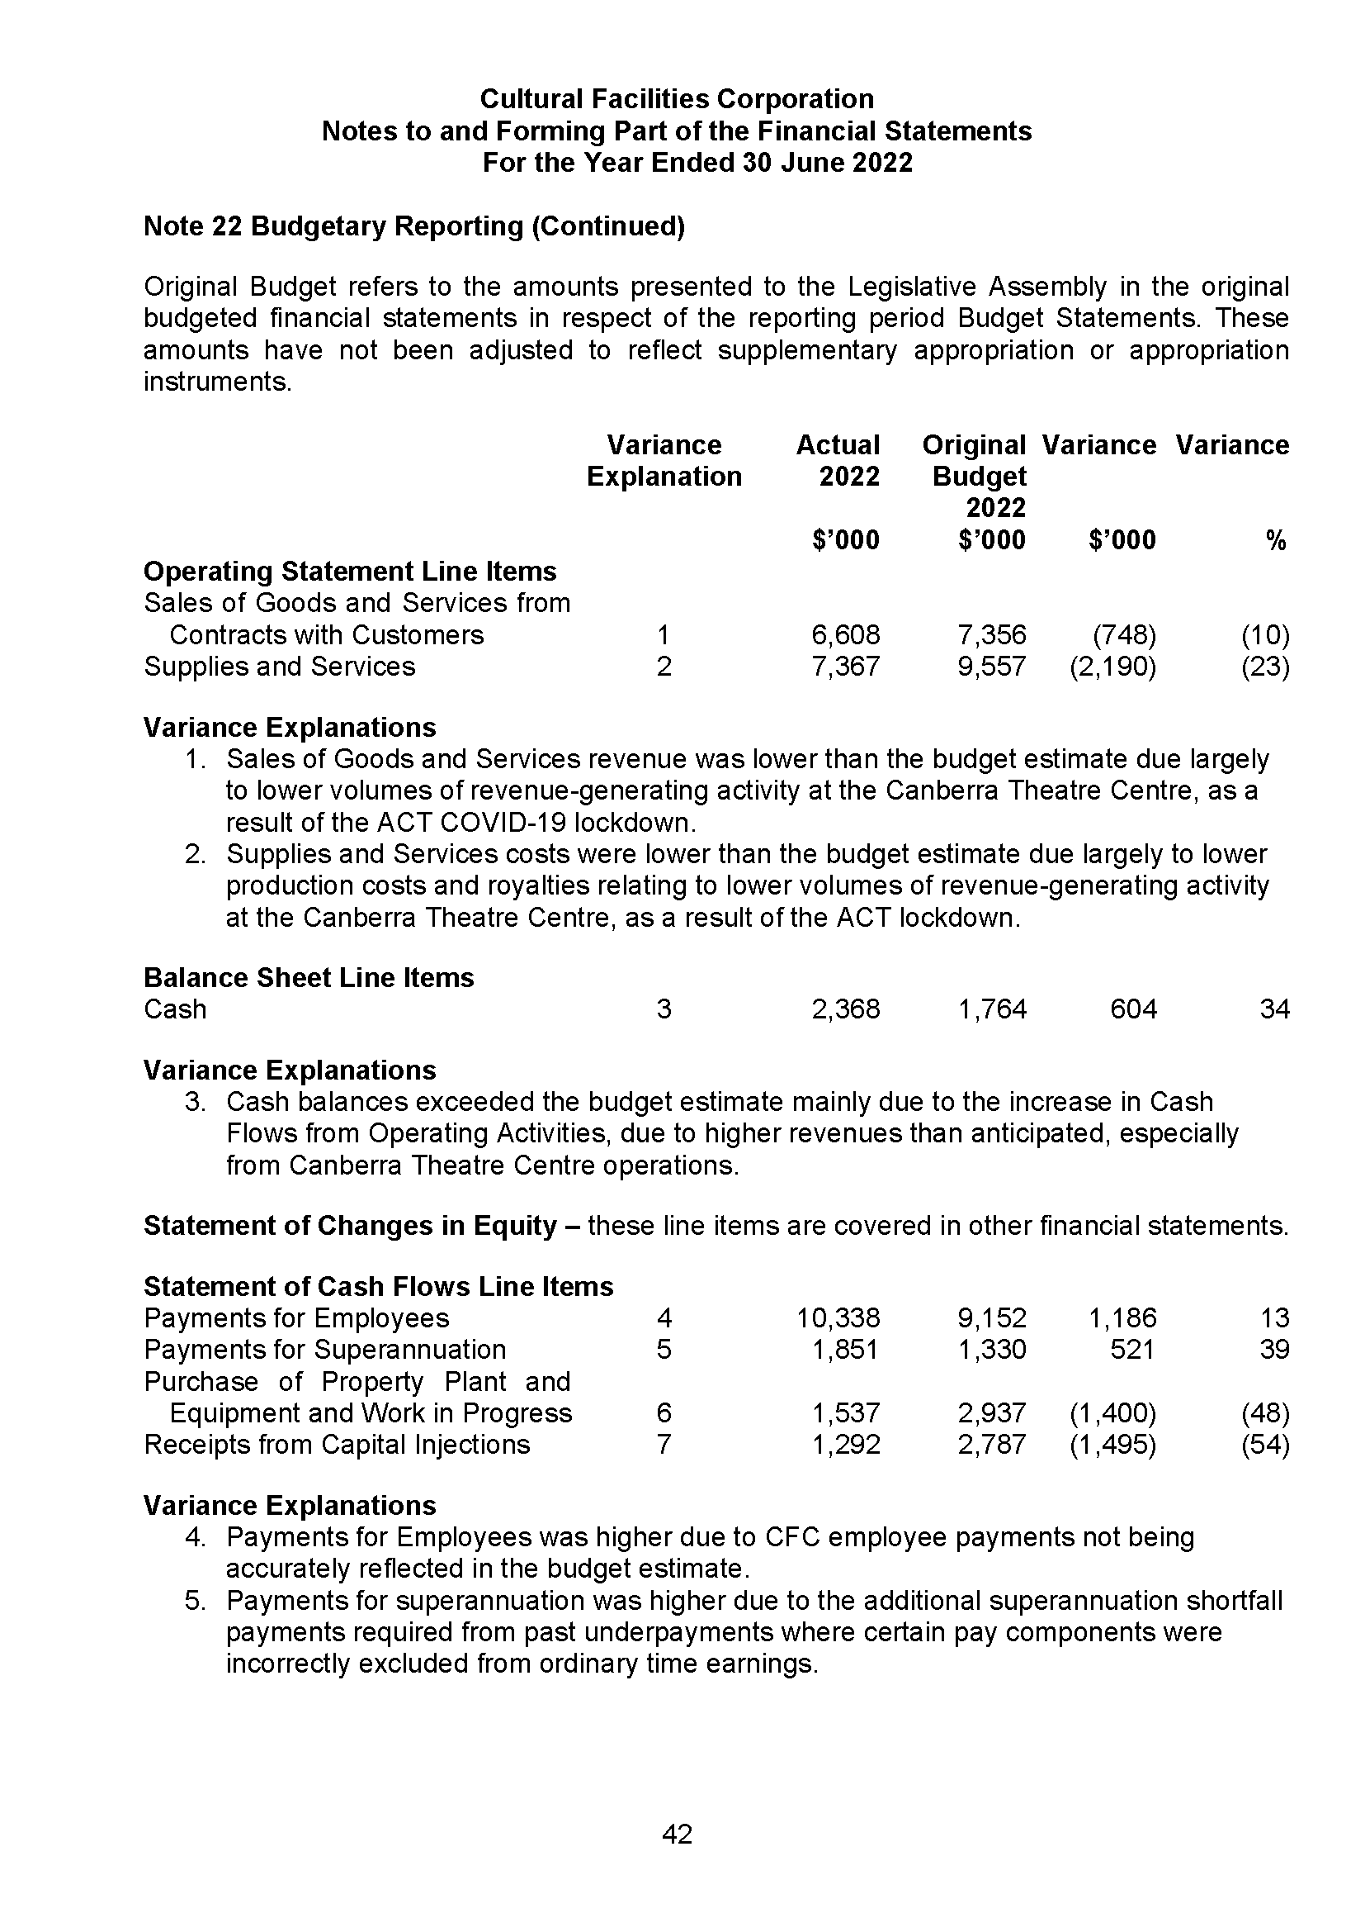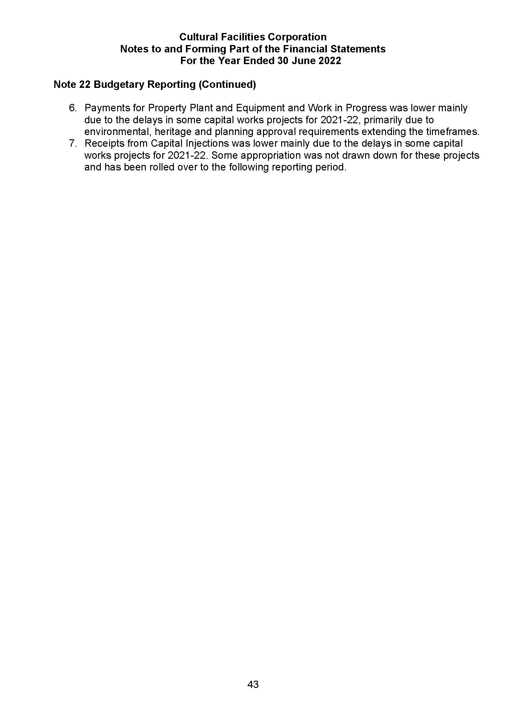
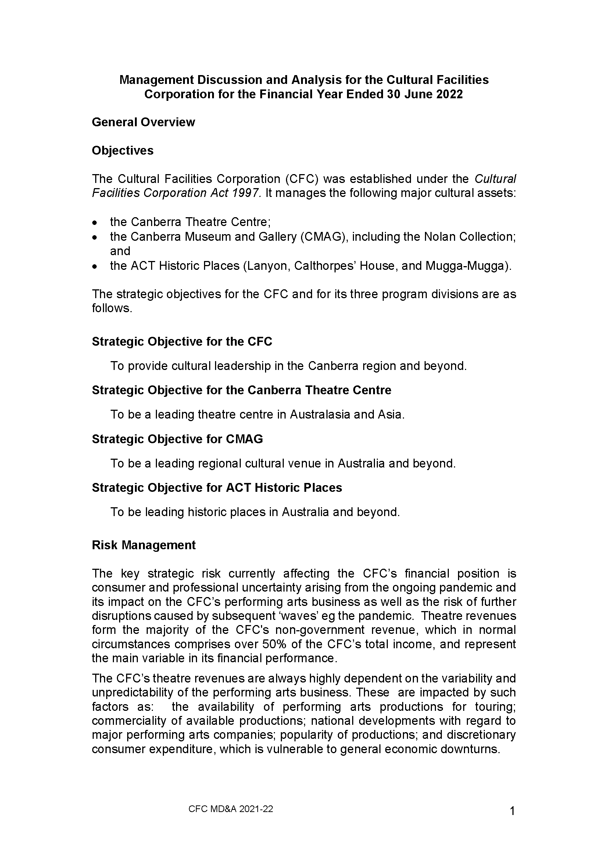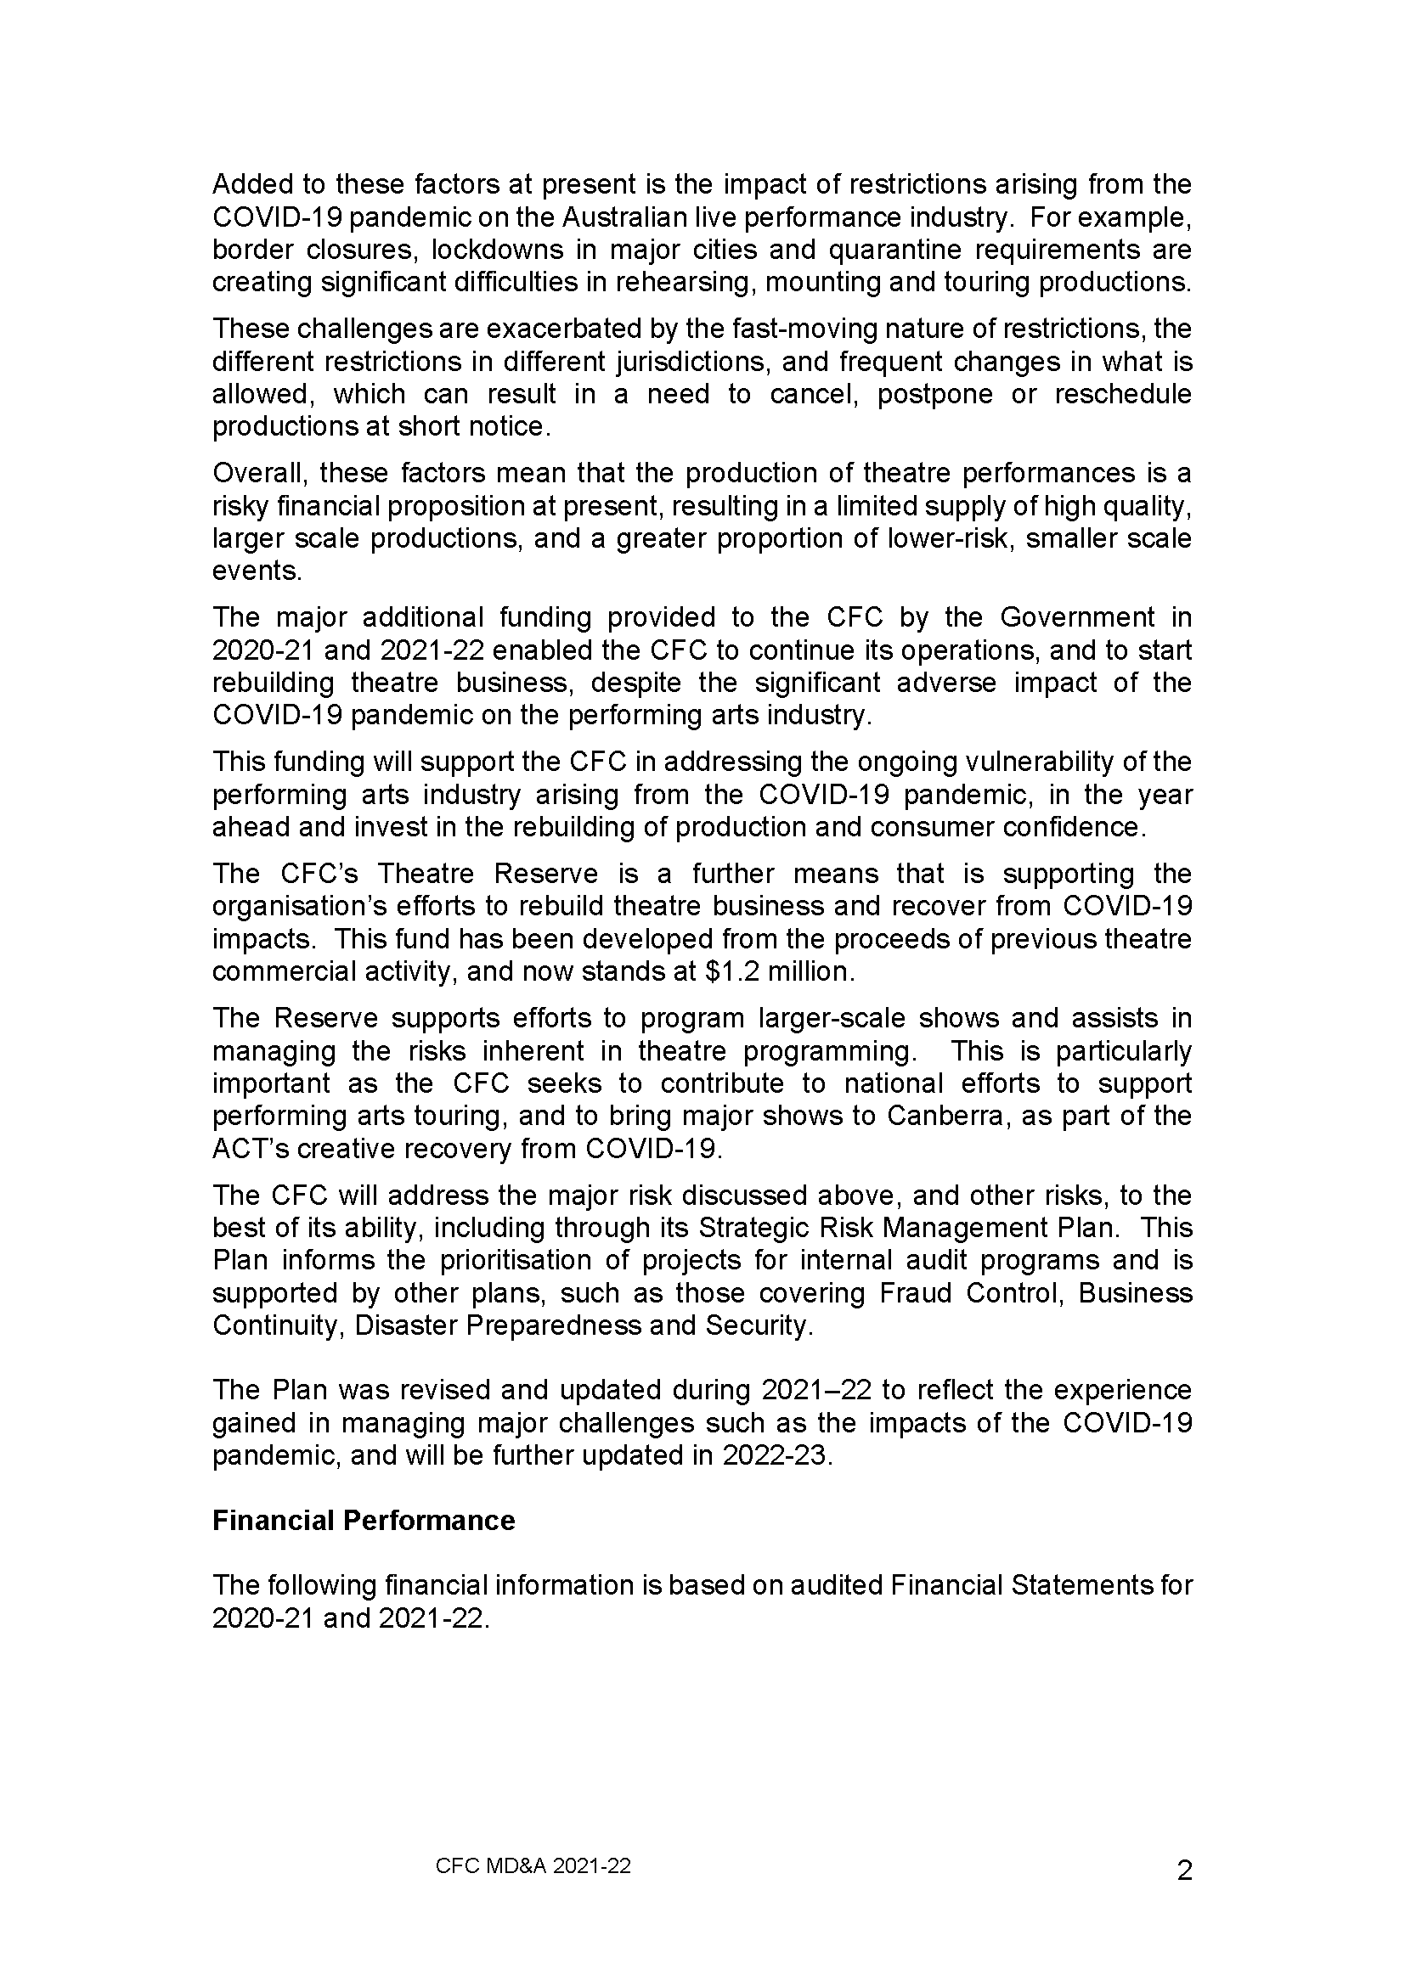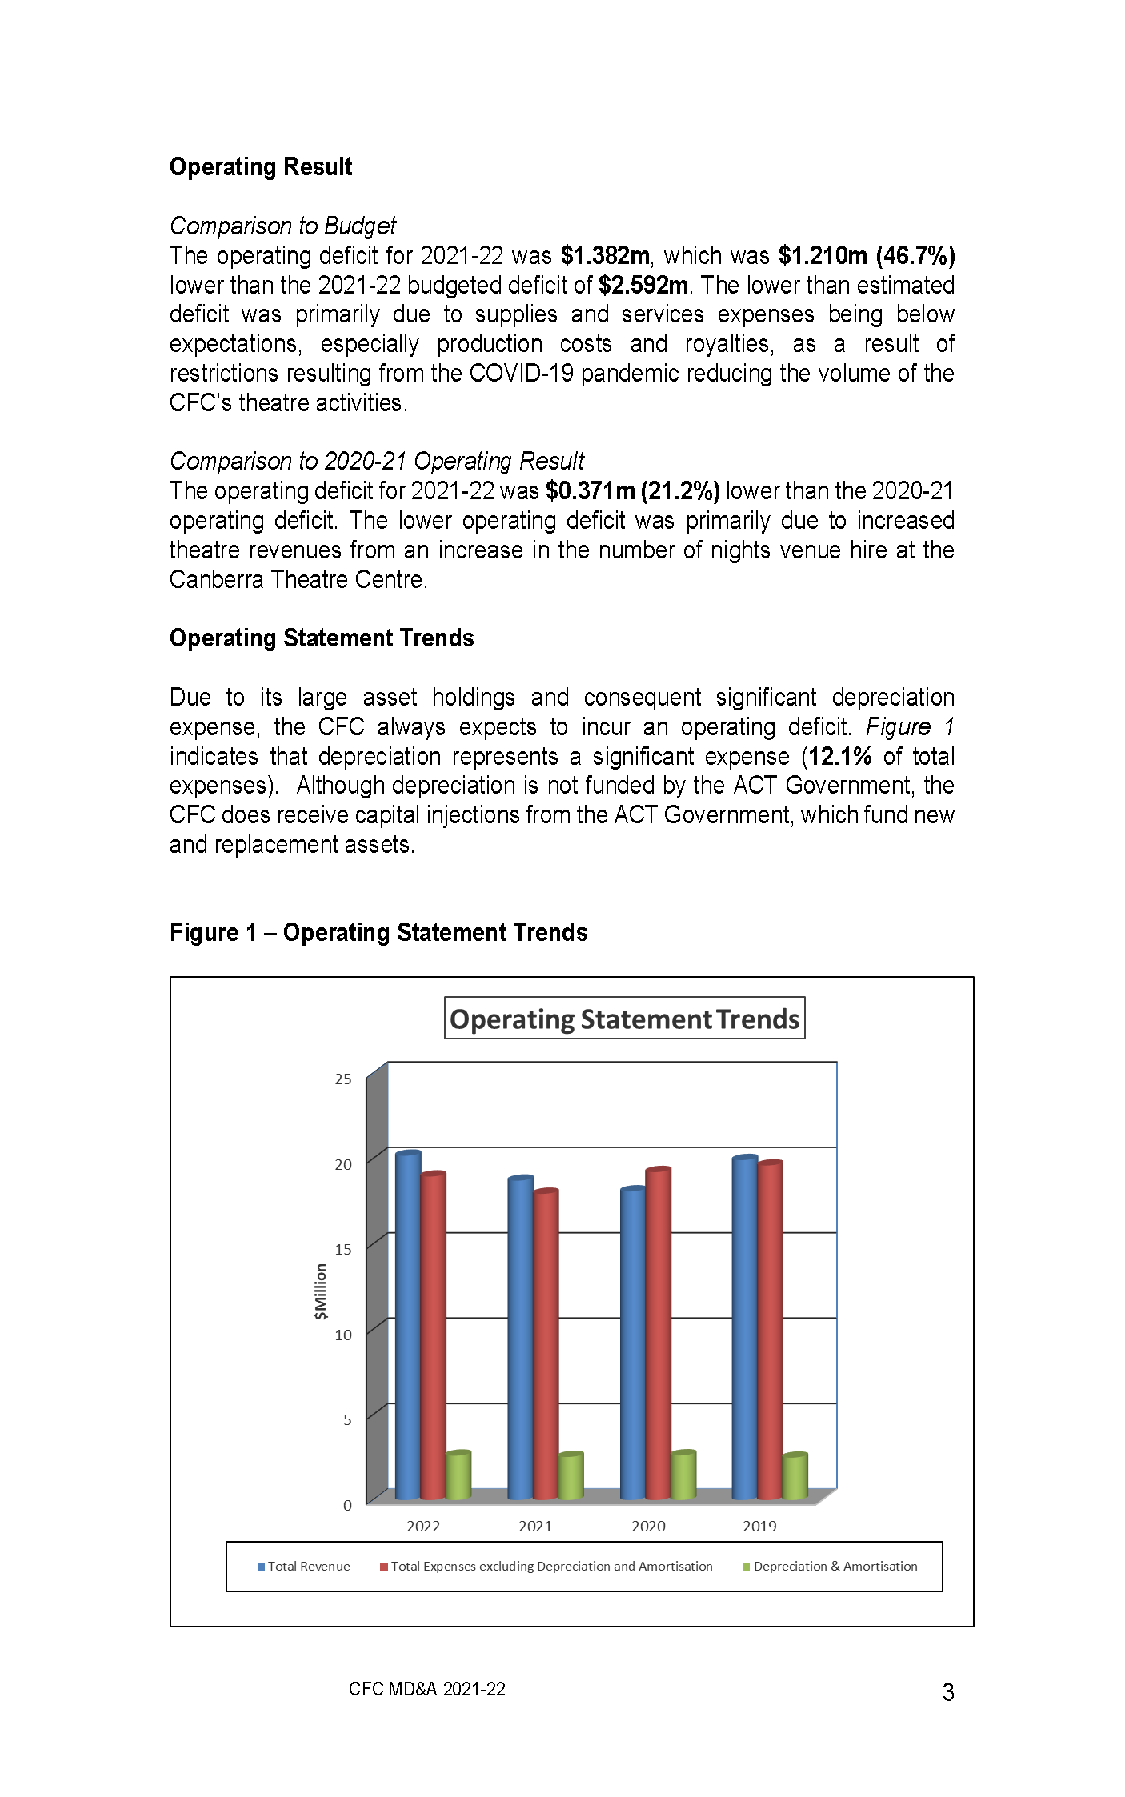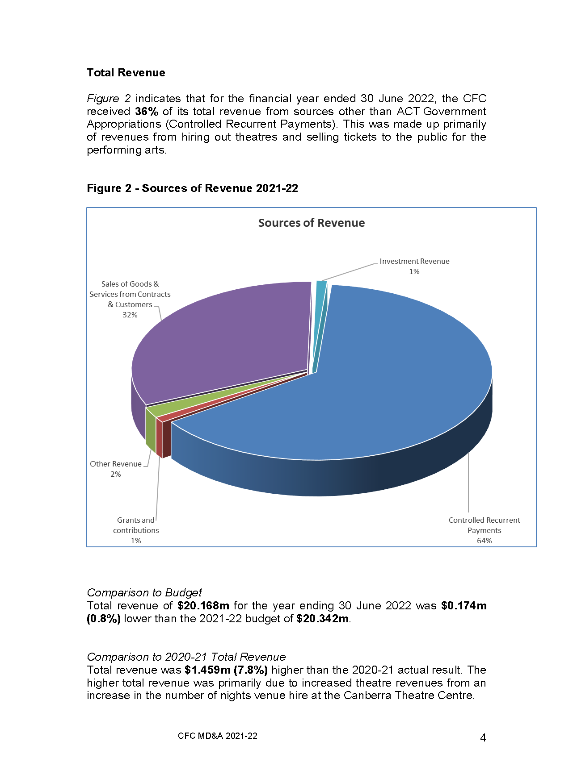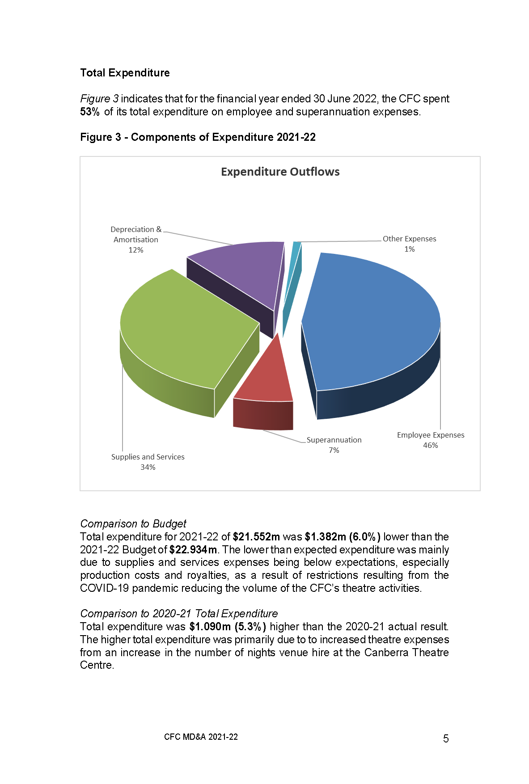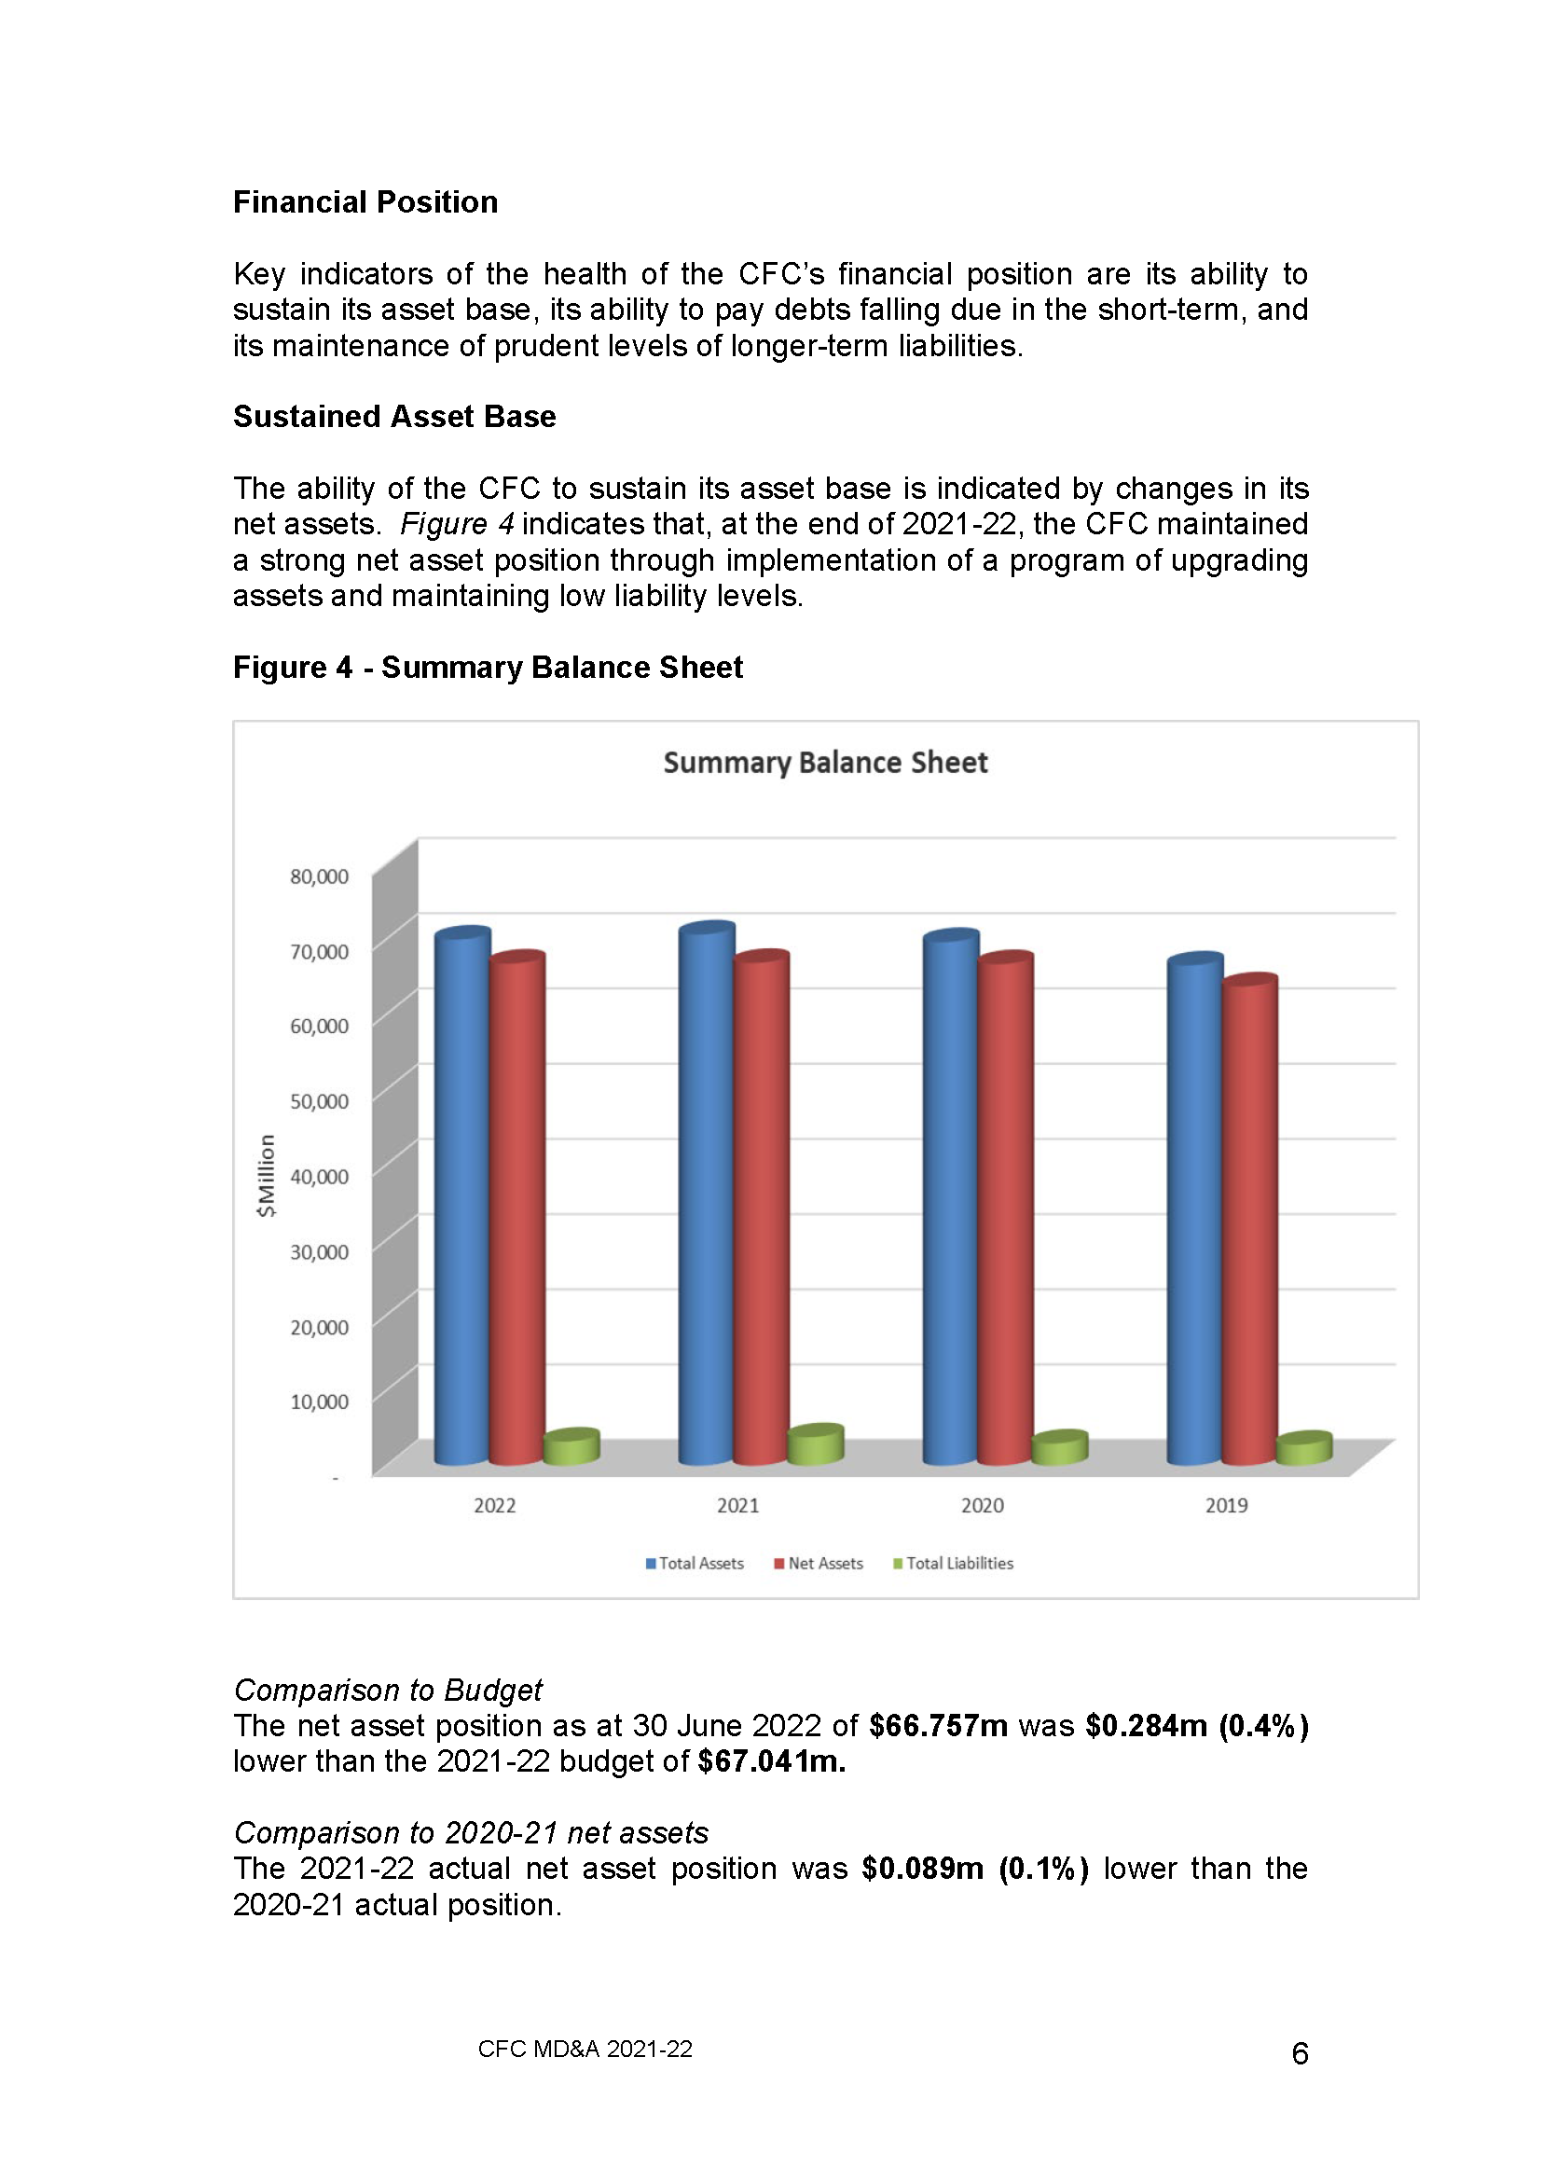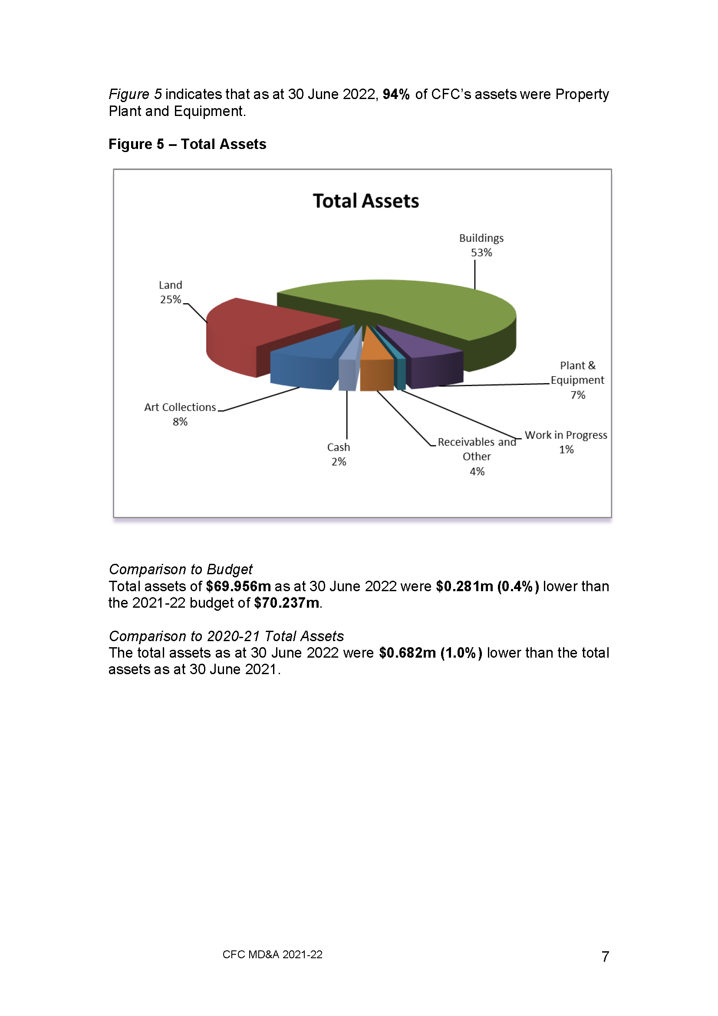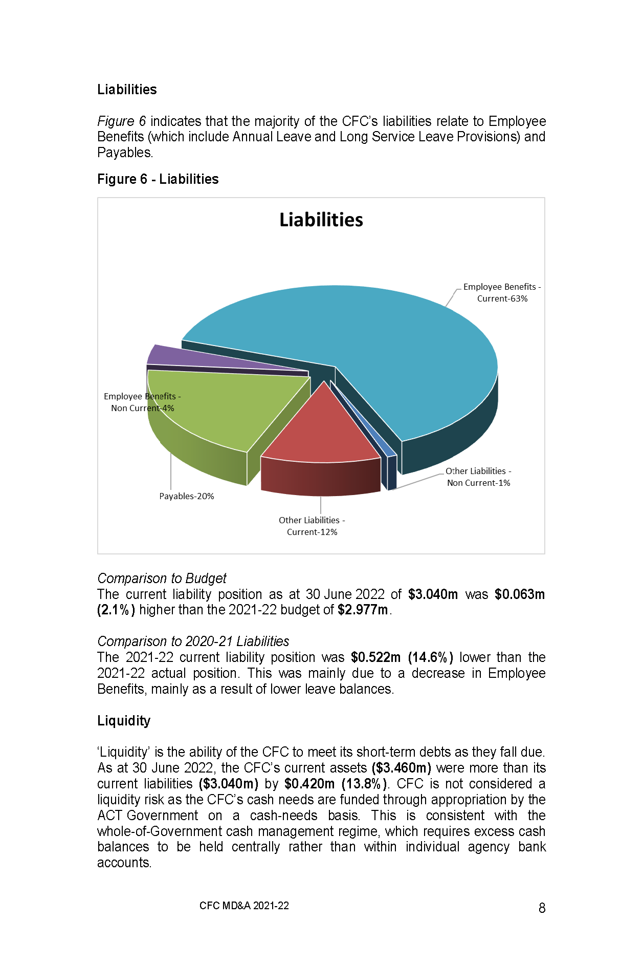

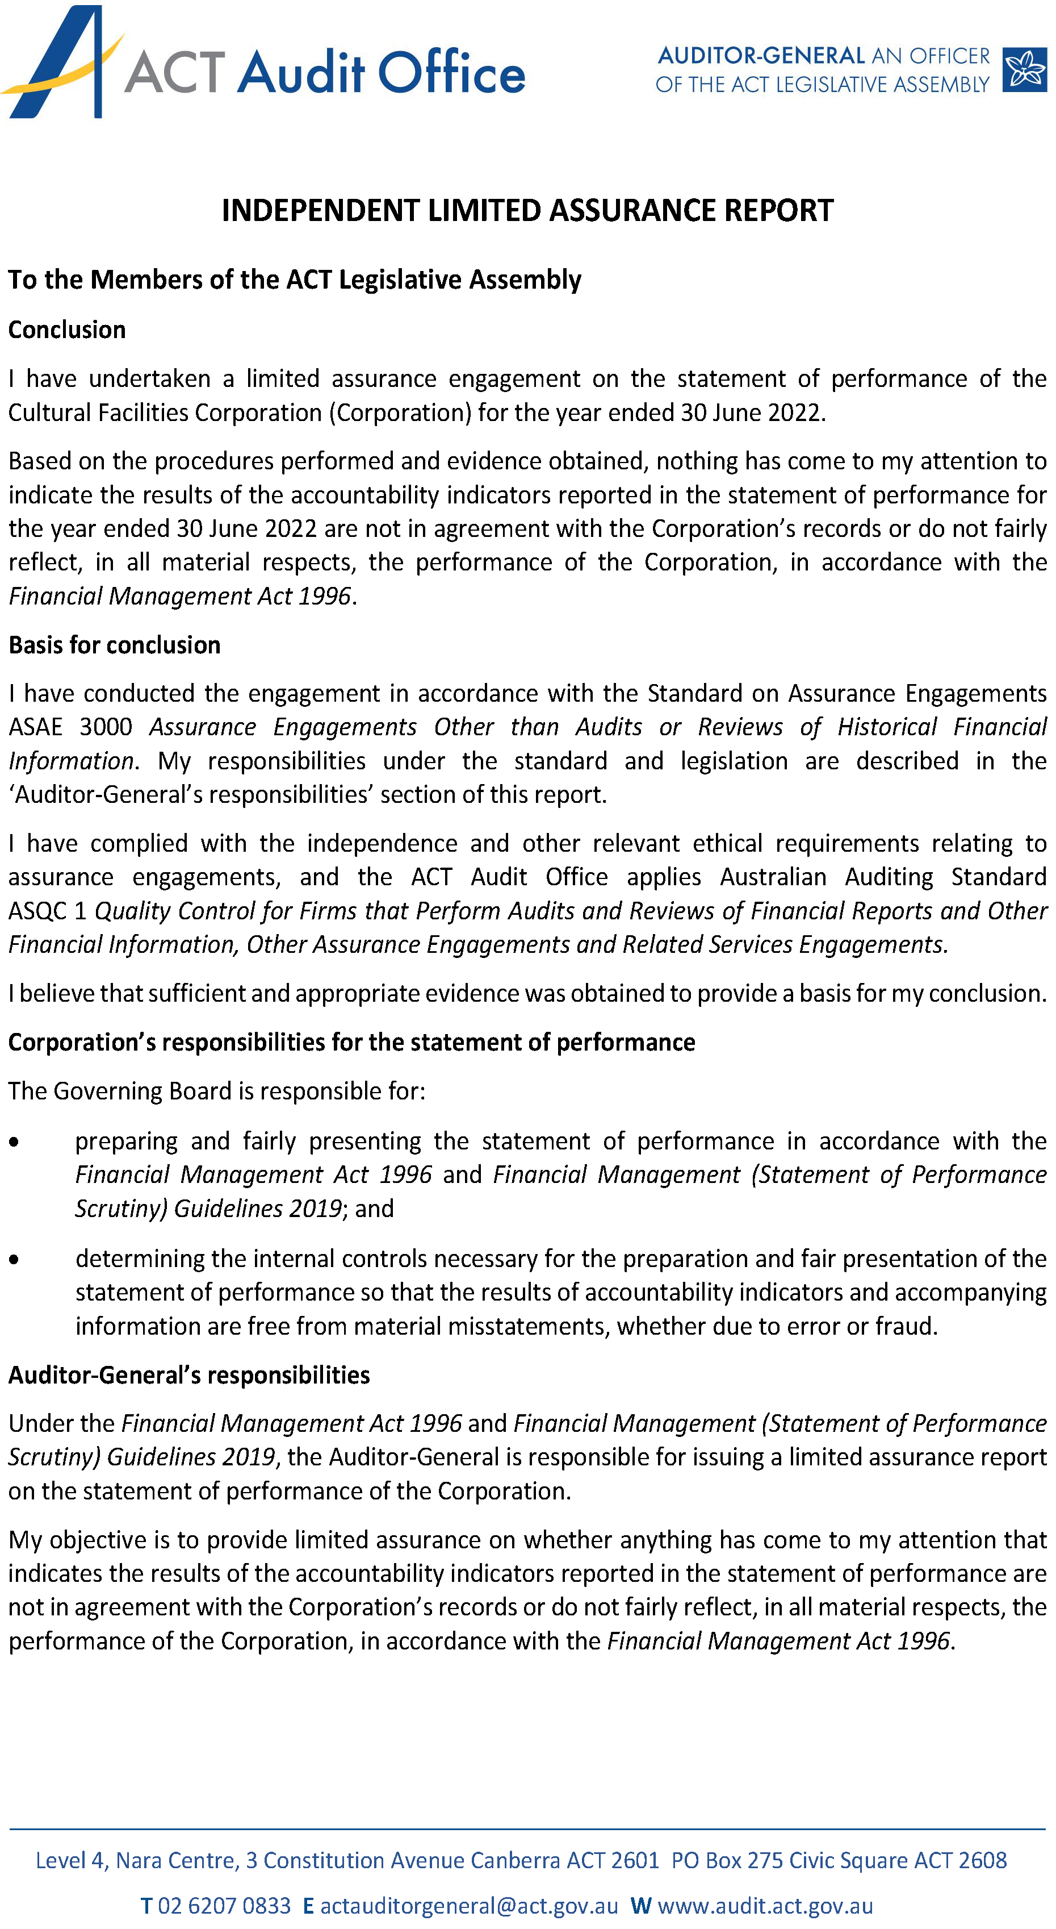
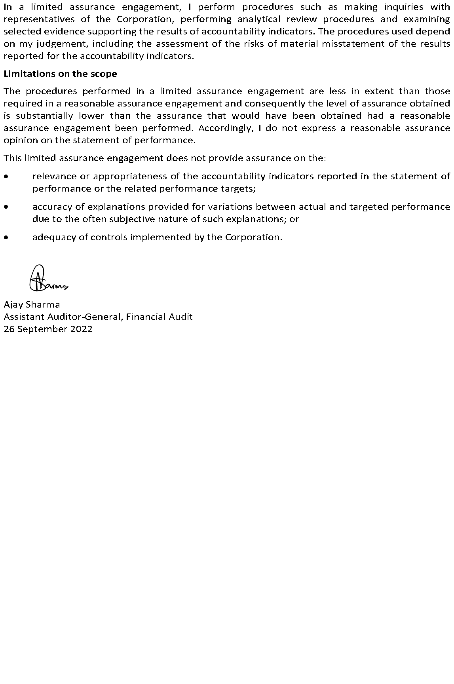

STATEMENT OF PERFORMANCE

FOR THE YEAR ENDED

30 JUNE 2022

CULTURAL FACILITIES CORPORATION

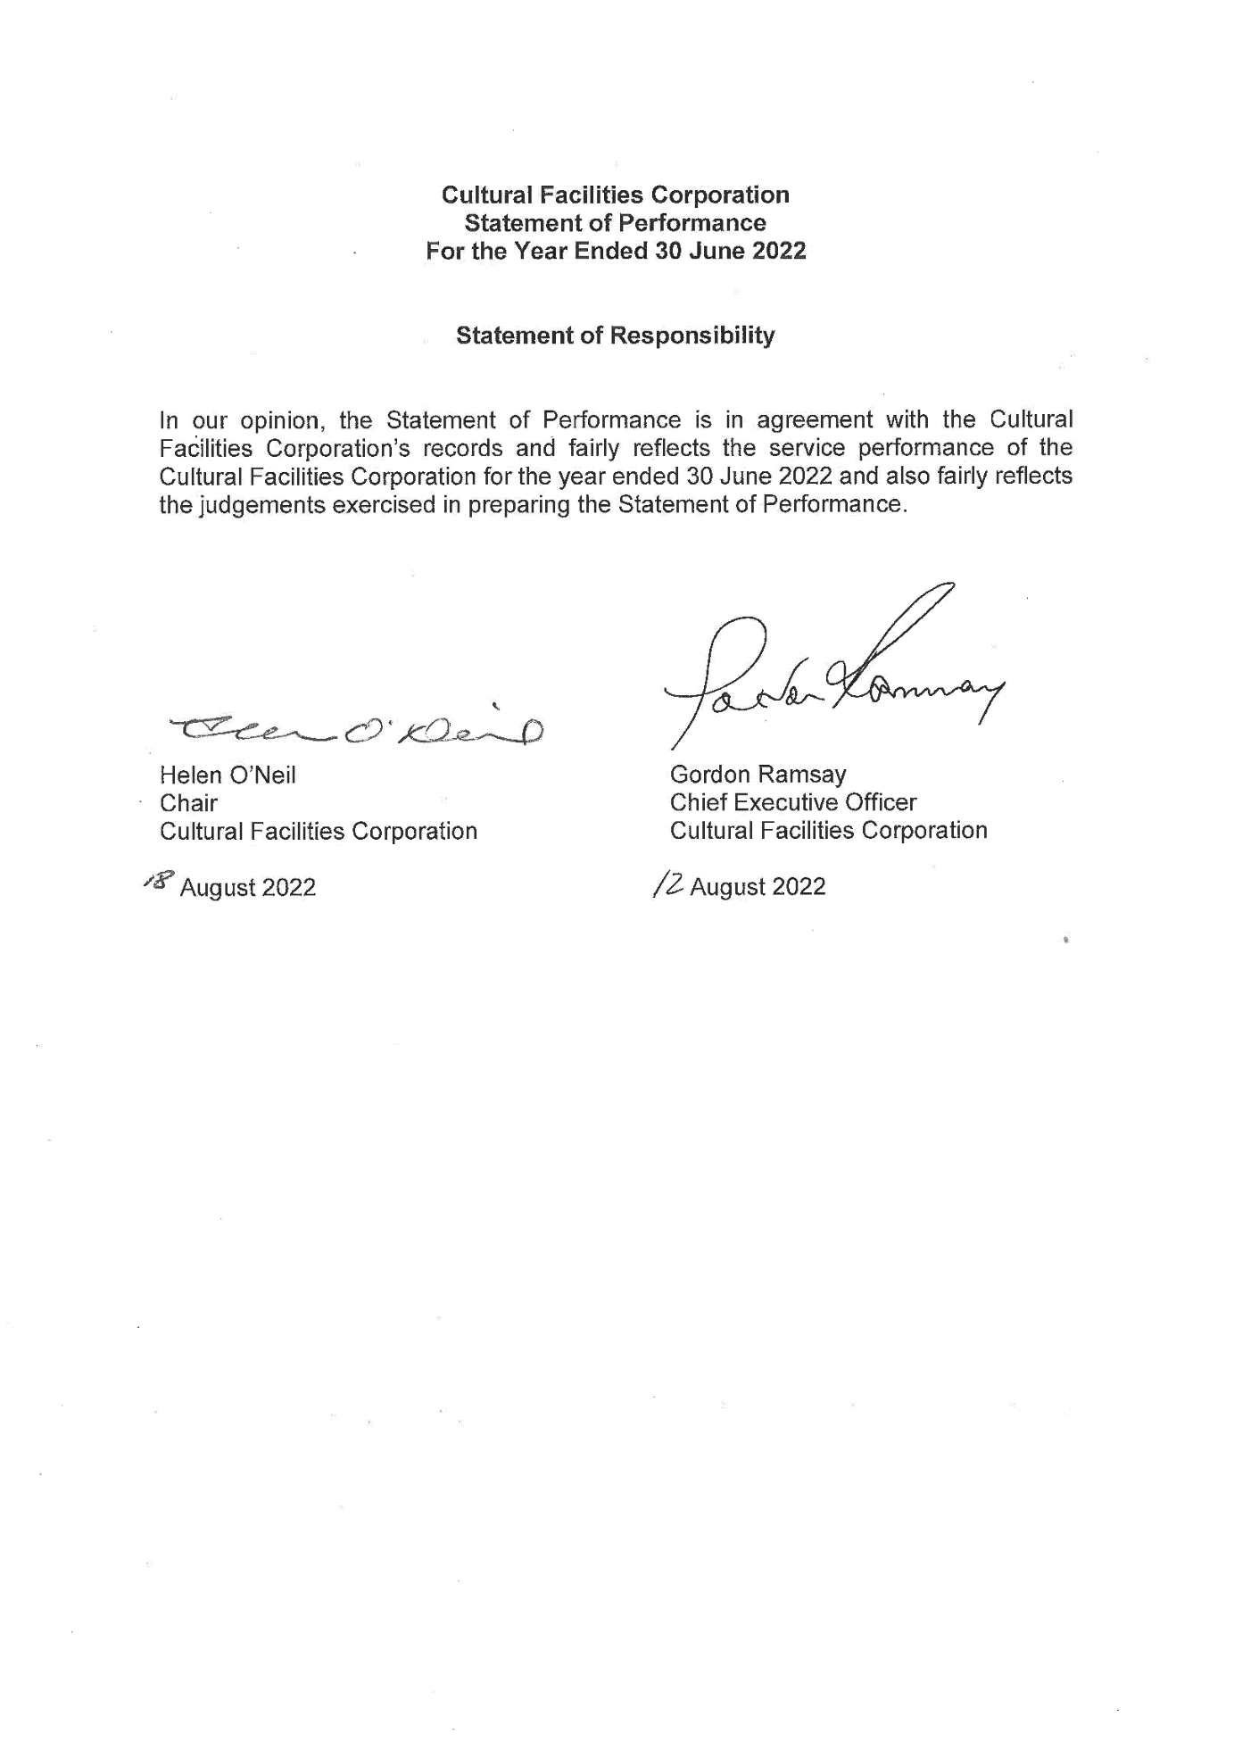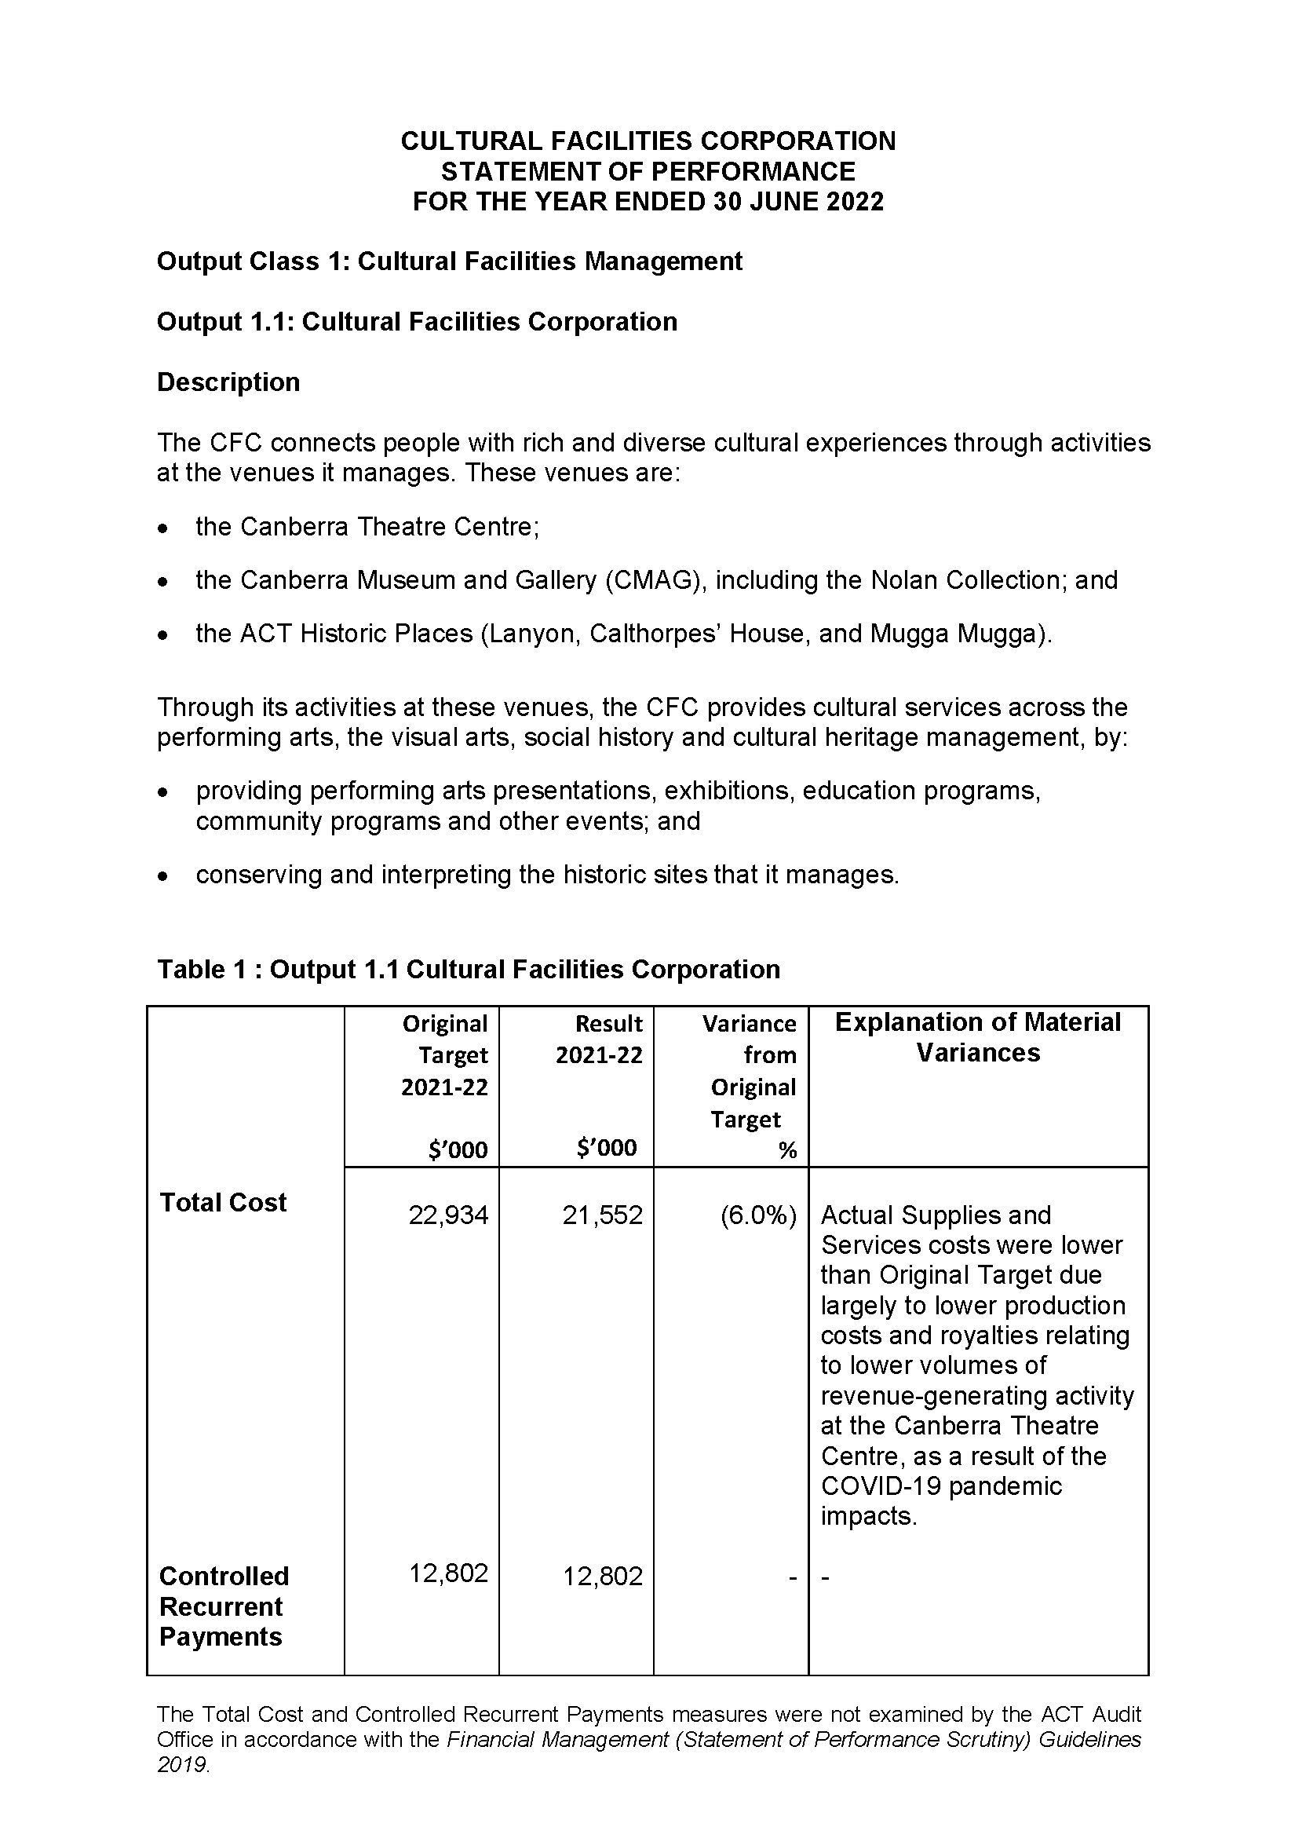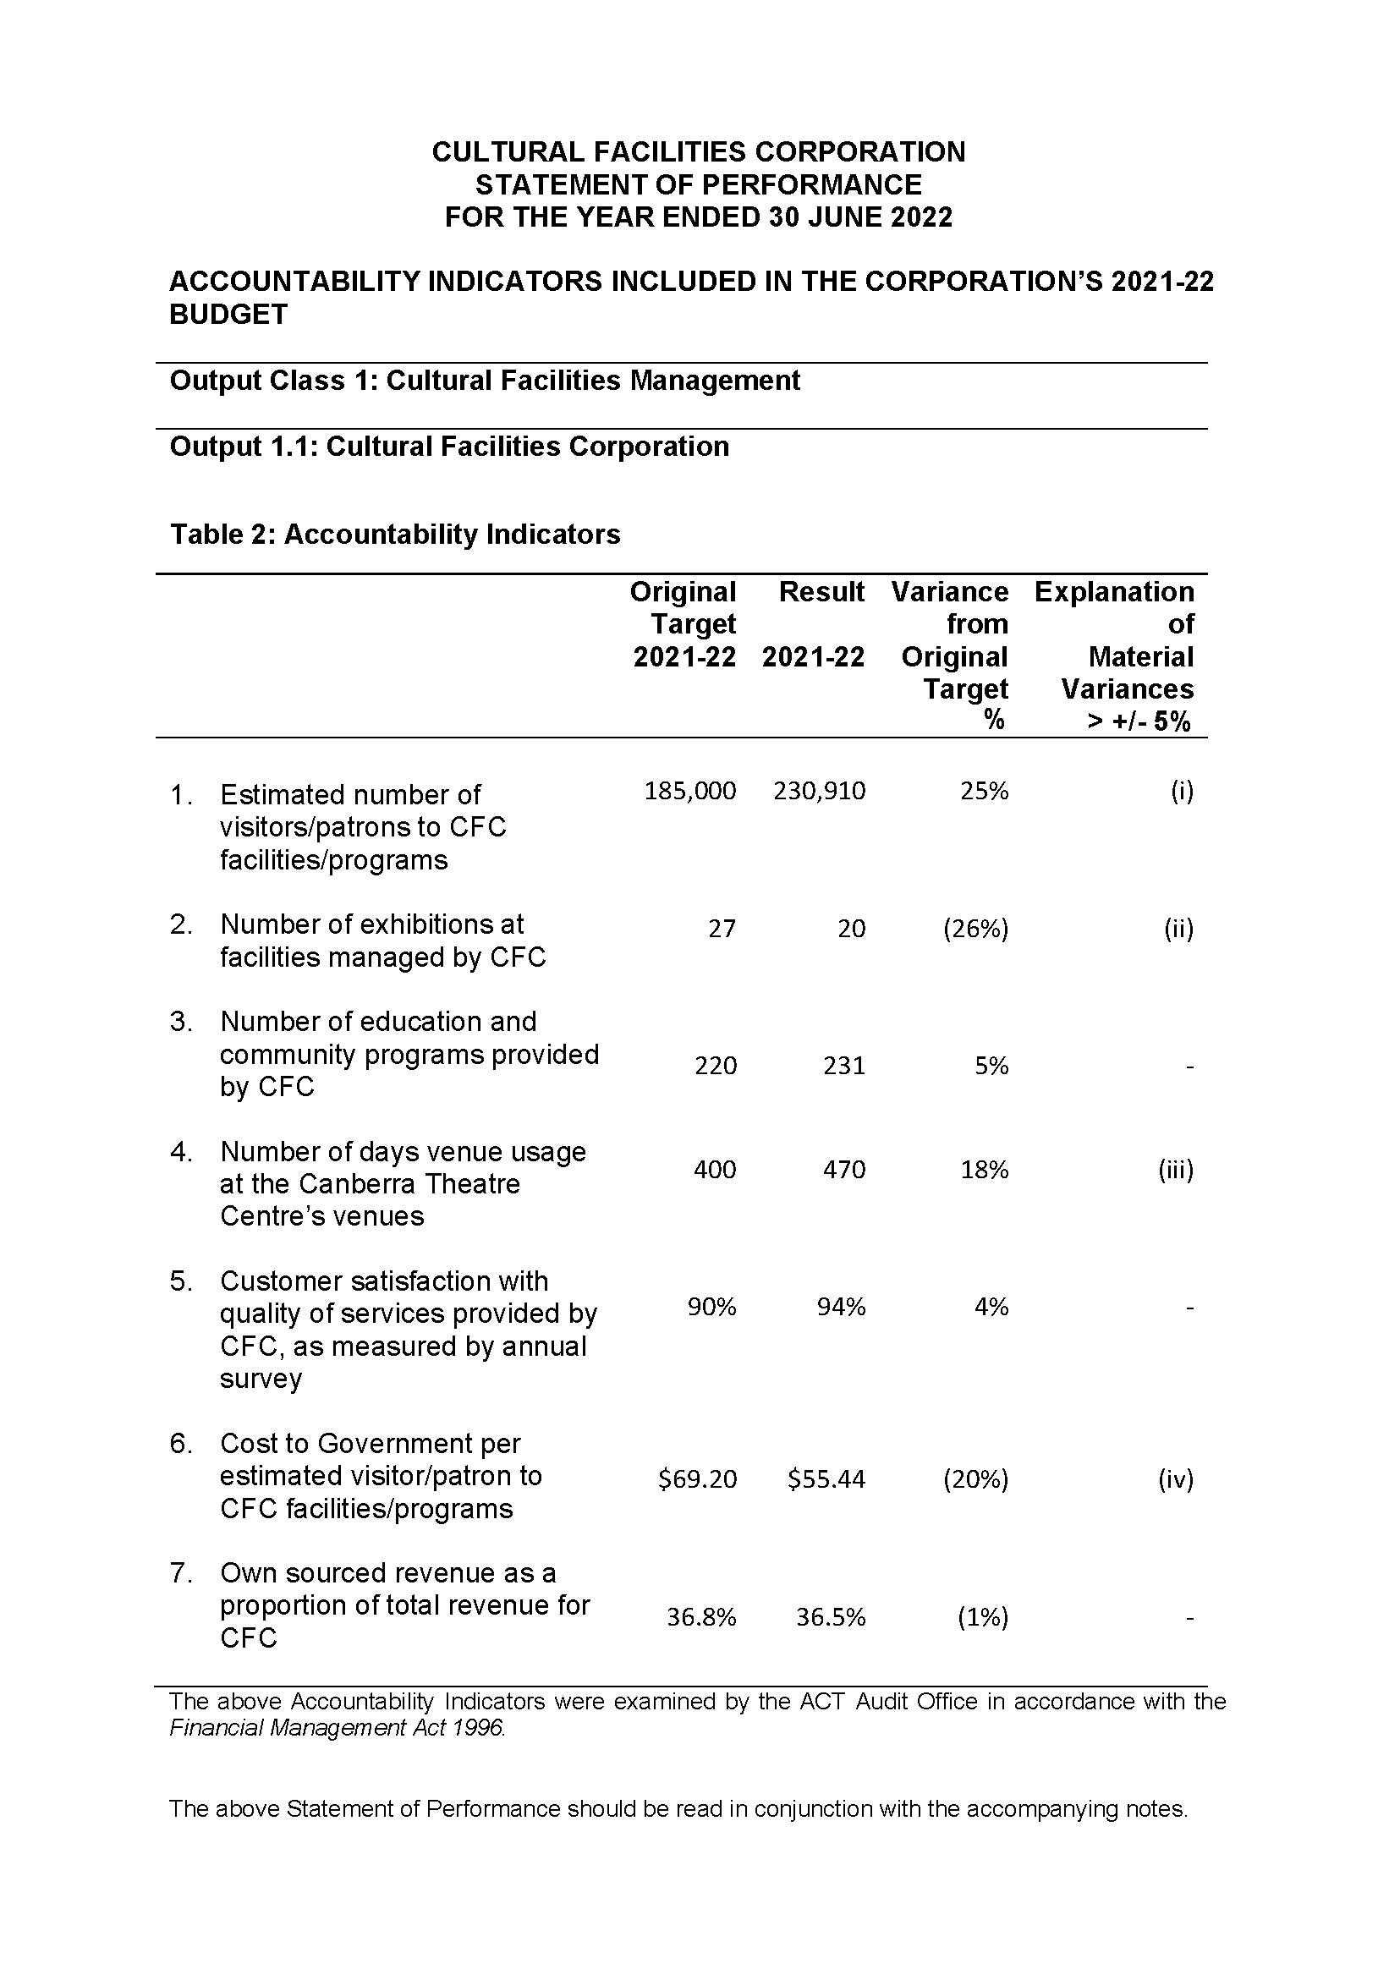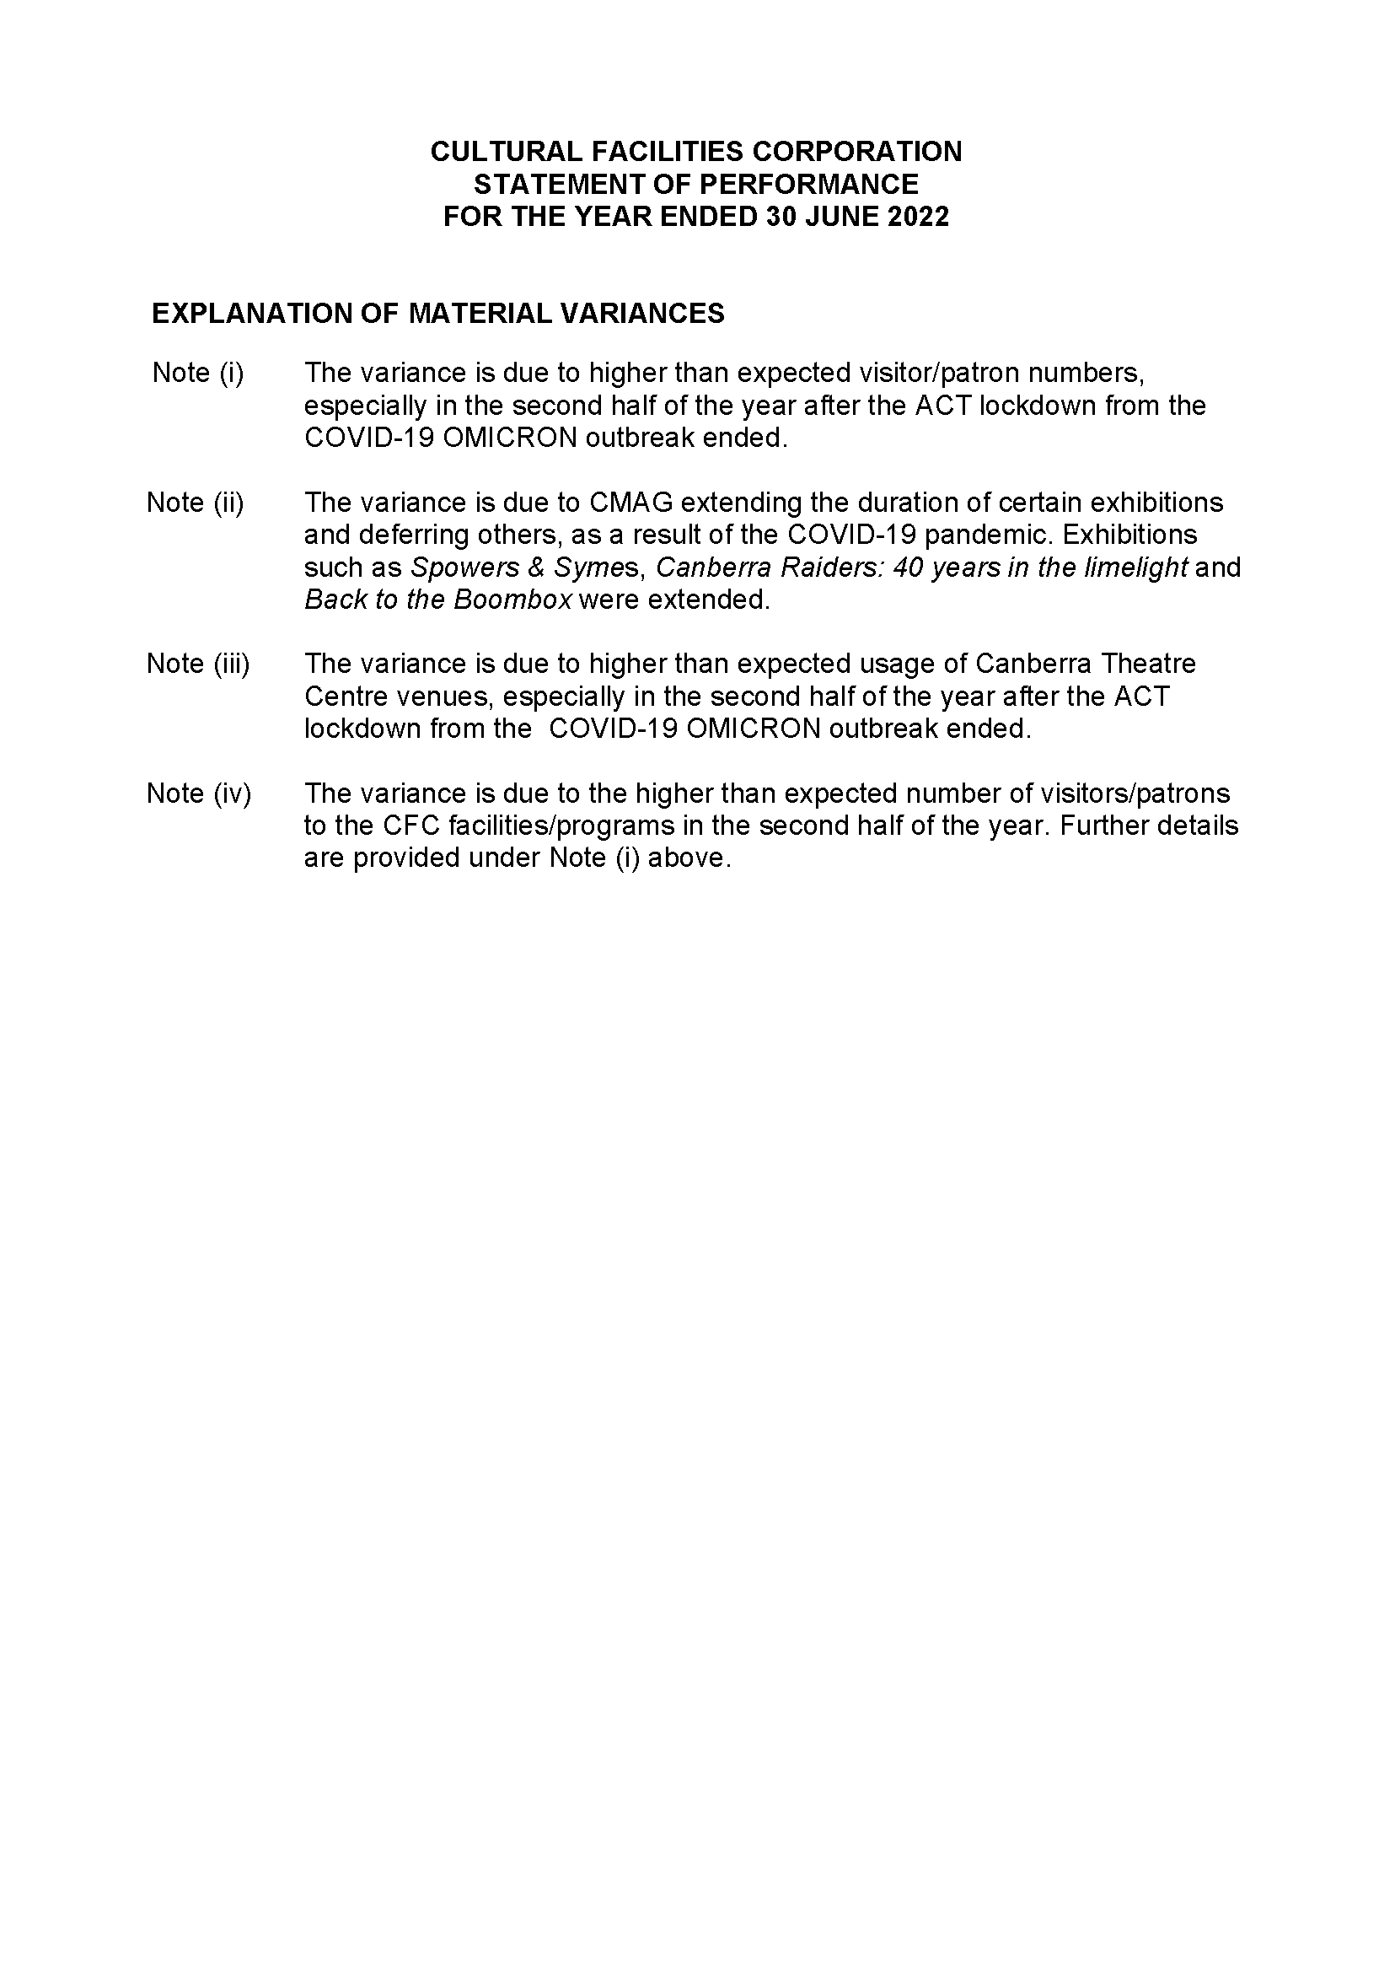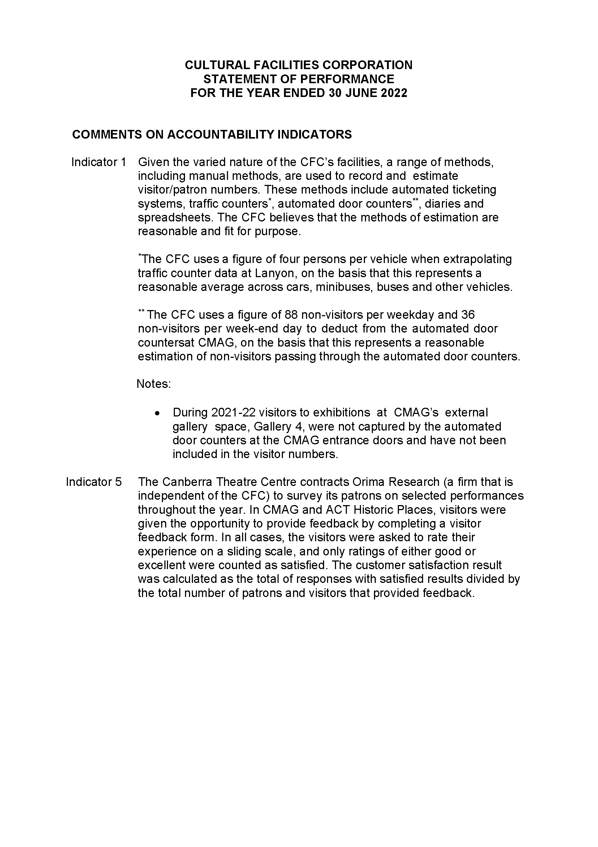

Abbreviations and Acronyms

ABC | Australian Broadcasting Corporation
ACC | Agency Consultative Committee
ACT  ACTHP | Australian Capital Territory  ACT Historic Places
ActewAGL | ACT Electricity and Gas
ACTPS | ACT Public Service
AM  AMaGA | Member of the Order of Australia  Australian Museums and Galleries Association
ANU | Australian National University
AO  ASO | Officer of the Order of Australia  Administrative Services Officer
ASOC  ATSIPP | Artist Society of Canberra  Aboriginal and Torres Strait Islander Procurement Policy
BA  BCP | Bachelor of Arts  Business Continuity Plan
BSc  CTC | Bachelor of Science  Canberra Theatre Centre
CEO | Chief Executive Officer
CFC | Cultural Facilities Corporation
CFO | Chief Financial Officer
CMAG | Canberra Museum and Gallery
CMTEDD | Chief Minister, Treasury and Economic Development Directorate
CNG  CMP  COVID-19 | Compressed Natural Gas  Conservation Management Plan  Coronavirus disease 2019
CPI | Consumer Price Index
CRA  CRM  DA  ESA | City Renewal Authority  Client Relationship Management  Development Application  Emergency Services Agency
EPSDD | Environment, Planning and Sustainable Development Directorate
ESD | Ecologically Sustainable Development
ESP | Enterprise Sustainability Platform
FBT | Fringe Benefits Tax
FCP | Fraud Control Plan
FM | Financial Management
FM Act | Financial Management Act 1996
FM | Frequency Modulation
FTE | Full Time Equivalent
GHG | Green House Gas
GSO | General Services Officer
GST | Goods and Services Tax
HR | Human Resources
ICOMOS | International Council on Monuments and Sites
IT | Information Technology
Kg | Kilogram
kWh | kilowatt hour
LED | Light-emitting diode
LPA | Live Performance Australia
LPG | Liquid Petroleum Gas
MBA | Master of Business Administration
MD&A | Management Discussion and Analysis
MEAA | Media Entertainment and Arts Alliance
MLA  MWh | Member of the Legislative Assembly  megawatt hour
NAIDOC | National Aboriginal and Torres Strait Islander Peoples Day Observance Committee
NSW | New South Wales
PD | Professional Development
PhD  PHEV | Doctor of Philosophy  Plug-in Hybrid Electric Vehicle
PO | Professional Officer
RED | Respect, Equity and Diversity
S | Section
SES | Senior Executive Service
SOG | Senior Officer Grade
SPO  SRMP | Senior Professional Officer  Strategic Risk Management Plan
t | Tonne
VET | Vocational Education and Training
WHS  ZEVs | Work Health and Safety  Zero Emissions Vehicles

Compliance Statement
The Cultural Facilities Corporation’s (CFC) Annual Report must comply with the Annual Report Directions (the Directions) made under section 8 of the Annual Reports (Government Agencies) Act 2004. The Directions are found at the ACT Legislation Register: http://www.legislation.act.gov.au.
The Compliance Statement indicates the subsections, under Parts 1 to 5 of the Directions, that are applicable to the CFC and the location of information that satisfies these requirements.
Part 1 Directions Overview
The requirements under Part 1 of the Directions relate to the purpose, timing and distribution, and records keeping of annual reports. The CFC’s Annual Report complies with all subsections of Part 1 under the Directions.
In compliance with section 15 Feedback, Part 1 of the Directions, contact details for the CFC are provided within the CFC’s Annual Report to provide readers with the opportunity to provide feedback.
Part 2 Reporting entity Annual Report Requirements
The requirements within Part 2 of the Directions are mandatory for all reporting entities and the CFC complies with all subsections. The information that satisfies the requirements of Part 2 is found in the CFC’s Annual Report as follows:
- A. Transmittal Certificate, see page 5;
- B. Organisational Overview and Performance, inclusive of all subsections,
see pages 11–74; and
C. Financial Management Reporting, inclusive of all subsections, see pages 75–81.
Part 3 Reporting by Exception
The CFC has nil information to report by exception under Part 3 of the Directions for the 2021–22 reporting year.
Part 4 Reporting entity Specific Annual Report Requirements
The following subsection of Part 4 of the 2021 Directions is applicable to the CFC.
Ministerial and Director‐General Directions
The CFC has nil information to report for the 2021–22 reporting period.
Part 5 Whole of Government Annual Reporting
All subsections of Part 5 of the Directions apply to the CFC. Consistent with the Directions, the information satisfying these requirements is reported in the one place for all ACT Public Service directorates, as follows :
- Bushfire Risk Management, see the annual report of the Justice and Community Safety Directorate;
- Human Rights, see the annual report of the Justice and Community Safety Directorate;
- Legal Services Directions, see the annual report of the Justice and Community Safety Directorate; and
Territory Records, see the annual report of Chief Minister, Treasury and Economic, Development Directorate.
Part 6 State of the Service report
- Public Sector Standards and Workforce Profile, see the annual State of the Service Report.
- ACT Public Service Directorate annual reports are found at the following web address : http://www.cmd.act.gov.au/open_government/report/annual_reports

Index

Aboriginal and Torres Strait Islander Reporting, 66
Acquisitions, 100
ACT Audit Office, 15, 35, 64
ACT Government, 15
ACT Heritage, 15
ACT Historic Places, 12, 13, 14, 22, 32, 47, 49, 74, 79, 102
Advisory Committees, 89
Asset Management, 79
Assets, 19
Audit Committee, 64, 65
Box Office, 71
Calthorpes’ House, 12, 13, 14, 57, 79, 96, 99
Canberra Museum and Gallery, 14, 79, 95
Canberra Region Treasures Fund, 102
Canberra Theatre, 12, 14, 16, 19, 25, 30, 32, 40, 66, 79, 81, 84, 87, 95, 96, 102, 165
Canberra Theatre Centre, 12, 14, 77, 78, 79, 95, 102
Capital Works, 77, 78, 79
CFC Board, 84
City Renewal Authority, 15, 165
Climate Change, 72
CMAG, 12, 13, 14, 21, 32, 47, 88, 96, 97, 98
Community and education programs, 97
Community Engagement and Support, 66
Compliance Statement, 167
conservation, 95
Conservation, 62, 95, 96
Conservation And Housekeeping, 56
Corporate Plan, 32
Courtyard Studio, 12, 95
COVID-19 pandemic, 25, 26
COVIDSafe, 35
Cultural Facilities Corporation, 32, 40
Cultural Facilities Corporation Act 1997, 14
Current and future challenges, 25, 28
Current and future priorities, 24
Customers, 21, 23
donations, 100
Ecologically Sustainable Development, 72
Education Centre, 96
exhibitions, 14, 95, 97, 102
Exhibitions, 97
Facilities and Business/Activities under Management, 95
Finances, 19
Financial Management, 76
Financial Statements, 76
Fraud Prevention, 65
Freedom of Information, 65
Governance, 18
Government Contracting, 80
Human Resources, 69
Internal Audit, 64
interpretation, 95, 96
Lanyon, 12, 14, 79, 95, 98, 99
Leadership, 17, 22, 23
Learning and Development, 69
Management Discuss and Analysis, 76, 159
Mission, 12
Mugga-Mugga, 12, 14, 57, 79, 96, 99
Nolan Collection, 14, 95, 96, 98
Nolan Gallery, 79
Office Accommodation, 79
Organisational environment, 15
Organisational Overiew, 12
Organisational structure, 15
Outlook, 24
People, 18
Performance Analysis, 29
Performance outcomes – Financial Management, 16
Performance outcomes – Strategic Objectives/Indicators, 17
Planning Framework, 16
Programming, 21, 23
Recovery from the COVID-19 pandemic, 17, 19, 21, 22, 25
Research, 95, 96
Risk Management, 64
Role, functions and services, 14
Scrutiny, 64
Senior Management of the CFC, 27
Senior management team, 26, 87
Sponsorship and support, 102
Staffing Profile, 70
Statement of Intent, 16
Statement of Performance, 16, 81, 159
Stewardship, 22, 23
Strategic Asset Management Plan, 79
Strategic Plan, 12, 16, 32
Strategy, 17
Summary of performance in achieving objectives and targets, 16
The Playhouse, 12, 95
Transmittal Certificate, 5
Vision, mission and values, 12
Work Health and Safety, 36, 68
Year at a Glance, 8

