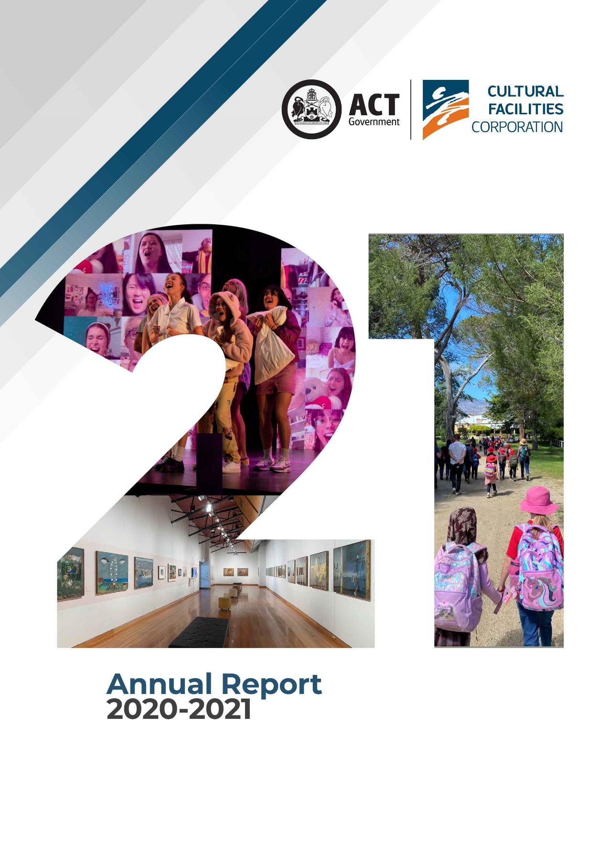

CULTURAL FACILITIES CORPORATION
ANNUAL REPORT
2020–21

The Cultural Facilities Corporation acknowledges the Traditional Custodians of the ACT, the Ngunnawal people. We acknowledge and respect their continuing culture and the contribution they make to the life of this city and this region.
CULTURAL FACILITIES CORPORATION
PO Box 939
CIVIC SQUARE ACT 2608

ABN : 88187240846
Published by the Cultural Facilities Corporation, Canberra.

© Australian Capital Territory 2021

This work, the Cultural Facilities Corporation 2020–21 Annual Report, is licensed under a Creative Commons Attribution 4.0 licence. You are free to re-use the work under that licence, on the condition that you credit the Australian Capital Territory Government as author, indicate if changes were made and comply with the other licence terms. The licence does not apply to the ACT Government logo, Cultural Facilities Corporation logo, branding, images or photographs.
The report is available electronically at http://www.culturalfacilities.act.gov.au and via the Open Access website – http://www.act.gov.au/open-access. Hard copies of the report are available by contacting
(02) 6207 3962 or emailing cfccorporatefinance@act.gov.au.

The ACT Government is committed to making its information, services, events and venues accessible to as many people as possible. If you have difficulty reading a standard printed document and would like to receive this publication in an alternative format – such as large print and audio – please call the Canberra Blind Society on (02) 6247 4580. If English is not your first language and you require the translating and interpreting service, please call the Telephone Interpreter Service on 131 450. If you are deaf or hearing impaired and require assistance, please call the National Relay Service on 133 677.

Enquiries about this publication should be directed to :
Telephone : (02) 6207 3962
Email : cfccorporatefinance@act.gov.au

For more information on the activities of the Cultural Facilities Corporation please visit the following websites :
- www.culturalfacilities.act.gov.au
- www.canberratheatrecentre.com.au
- www.cmag.com.au
- www.historicplaces.com.au

Front cover images : FANGIRLS performed in The Playhouse, credit Brigette Honeyman; students participating in the James’ Diary learning program at Lanyon, credit Jodie Cunningham; and CMAG exhibition Sidney Nolan and St Kilda : Memory and Modernism, credit RLDI.
Back cover images : Exterior of Calthorpes’ House; Exterior of CMAG (Civic Square); Exterior of the Canberra Theatre Centre; and Exterior of Mugga-Mugga Cottage.
Printed on recycled paper

Table of Contents
A. TRANSMITTAL CERTIFICATE 5
B. ORGANISATION OVERVIEW AND PERFORMANCE 11
B.1 Organisational Overview 12
B.2 Performance Analysis 30
B.3 Scrutiny 62
B.4 Risk Management 62
B.5 Internal Audit 62
B.6 Fraud Prevention 63
B.7 Freedom of Information 63
B.8 Community Engagement and Support 64
B.9 Aboriginal and Torres Strait Islander Reporting 65
B.10 Work Health and Safety 66
B.11 Human Resources Management 68
B.12 Ecologically Sustainable Development 70
C. FINANCIAL MANAGEMENT REPORTING 73
C.1 Financial Management Analysis 74
C.2 Financial Statements 74
C.3 Capital Works 75
C.4 Asset Management 77
C.5 Government Contracting 78
C.6 Statement of Performance 78
APPENDICES 79
Appendix 1 – Members and Remuneration of the CFC Board during 2020–21 80
Appendix 2 – Senior Managers of the CFC 83
Appendix 3 – Advisory Committees 85
Appendix 4 – Facilities and business/activities under management 91
Appendix 5 – Canberra Museum and Gallery and ACT Historic Places venues –
schedule of exhibitions, programs and events 93
Appendix 6 – Canberra Museum and Gallery –
Acquisitions (purchases and donations) 96
Appendix 7 – Major funding, sponsorship and support 98

Attachment 1 – Financial and Performance Statements and
Management Discussion and Analysis 101
Abbreviations and Acronyms 168
Compliance Statement 170
Index 171


Ms Tara Cheyne MLA
Minister for the Arts
ACT Legislative Assembly
CANBERRA ACT 2601
Dear Minister
We are pleased to present to you the 2020–21 Annual Report of the Cultural Facilities Corporation (CFC). It has been prepared in accordance with Section 7(2) of the Annual Reports (Government Agencies) Act 2004, other applicable legislation, and the Annual Report Directions.
We certify that information in this Annual Report, and information provided by the CFC for whole of government reporting, are honest and accurate, and that all material information on the operations of the CFC has been included for the period 1 July 2020 to 30 June 2021. We also certify that fraud prevention has been managed in accordance with the Public Sector Management Standards 2006, Part 2.3 (see section 113, Public Sector Management Standards 2016).
Section 13 of the Annual Reports (Government Agencies) Act 2004 normally requires that you present the Report to the Legislative Assembly within 15 weeks after the end of the reporting year. However, under section 14, the Chief Minister has granted an extension of the time for when the report must be presented by you to the Legislative Assembly. The Chief Minister has granted the extension to the Legislative Assembly sitting day on 2 December 2021, in view of the impact of the COVID-19 pandemic on agency operations, especially the ACT lockdown that took place from 12 August 2021 to 14 October 2021.
During 2020–21, the COVID-19 situation again had a significant impact on the CFC’s activities. The CFC’s various sites operated under a number of restrictions, which eased over the course of the year. COVIDSafe plans and procedures were maintained and updated as necessary, allowing the CFC’s operations to address changing restrictions, and ensuring the safety of staff, volunteers and visitors. Staff were provided with measures to support their health, fitness and wellbeing, including through mental health resources. Management of the situation was overseen by the CFC COVID-19 Crisis Management Group, while regular reporting was provided through CEO COVID-19 updates to staff, and detailed reports to the CFC Board.
Despite the many difficulties and restrictions arising from the COVID-19 station, the CFC achieved good outcomes during 2020–21, surpassing the majority of its performance targets for the year, delivering better than budget results, and providing a wide range of high quality cultural experiences for the community, across all its venues.
These outcomes included very successful seasons of The Wharf Revue: Good Night and Good Luck and of children’s productions Room on the Broom: Live on Stage! and Bluey’s Big Play: The Stage Show at the Canberra Theatre Centre. The Centre secured the rehearsals and premiere performances for Bluey’s Big Play: The Stage Show when rehearsals scheduled to take place in Adelaide were relocated to Canberra due to a COVID-19 outbreak in South Australia. Major exhibitions at the Canberra Museum and Gallery (CMAG) during the year included Sign of the Times and HABITAT : Ways of living, which included the venue’s first opening event following the COVID-19 closure period. Activities at the ACT Historic Places included Lanyon being the main southside site for Floriade : Reimagined 2020, while Lanyon was also the venue for a day of harvest-themed activities for Harvest Day Out. Overall, and despite the year’s challenges, over 225,000 people attended the CFC’s venues and programs in 2020–21.
During the year, the CFC continued to work closely with other ACT Government agencies on initiatives to plan future directions of the city centre and the future provision of cultural facilities in Civic. Particular areas of focus were : work on the new theatre project, and on planning the Canberra Civic and Culture District; and the CFC’s involvement in the heritage listing of the Civic Square Precinct, which was finalised in September 2020. The CFC, together with other interested agencies, commissioned a Conservation Management Plan to guide future management of the Precinct, with the Plan expected to be completed during 2021–22.
In providing this Annual Report to you, we acknowledge that the CFC’s achievements in 2020–21 were due to the efforts of many people. It is our great pleasure to recognise their efforts here.
Firstly, we thank our fellow Board members, who provided direction and guidance to the CFC throughout the year. As Chair and Chief Executive Officer, we are ably supported by the very dedicated staff of the CFC. This year, we especially appreciated the efforts of staff as they responded to the rapidly changing COVID-19 situation with patience, resilience and skill.
In terms of senior staff appointments, Dr Sarah Schmidt commenced in October 2020 as the new Director of CMAG. Sarah brings to this role an extensive and distinguished background in the galleries, museums and wider cultural sector, taking over from Sophie Chessell, who provided excellent leadership to CMAG as acting Director.
The CFC benefits from the generosity, assistance and support of many volunteers. These include the CFC’s three advisory committees. Members of the committees all concluded their membership terms on 30 June 2021, and we take this opportunity to thank them for the valuable support they have provided, over the past five years, to the work of the CFC.
Other volunteers make a vital contribution to the work of the ACT Historic Places, including the National Trust volunteers at Lanyon. We record our gratitude for the contribution made by all our volunteers during the year.
Finally, we are pleased to acknowledge the contribution of our principal funding agencies and our many sponsors, donors and supporters. The CFC receives its primary funding from the ACT Government and, in 2020–21, we particularly welcomed and appreciated the decision by the ACT Government to provide major additional funding to the CFC, to help us manage the impact of
COVID-19 on our finances.
The CFC was grateful for the extent of donations to CMAG, including gifts by private individuals such as longstanding donor Meredith Hinchliffe, and funds generously donated to support the acquisition of a painting by William Dargie, ANZAC Day Canberra 1970, including donations by former CFC Chair, John Hindmarsh and local businessman Richard Rolfe. We were fortunate to enjoy the support of many other sponsors and donors, too numerous to mention here but documented in full in this Annual Report.
The efforts and commitment of the CFC’s Board, staff, volunteers, sponsors and supporters continue to be vital as we seek to take a major role in the ACT’s creative recovery from COVID-19, as well as continuing our role of providing cultural leadership, enriching the cultural life of Canberra, and delivering the highest standards of service to the community.
We commend this Annual Report to you and look forward to the CFC continuing to work closely with you in the year ahead.
Yours sincerely
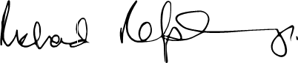  Acting Justice Richard Refshauge  Chair  Cultural Facilities Corporation  26 November 2021 |   Harriet Elvin AM  Chief Executive Officer  Cultural Facilities Corporation  26 November 2021

YEAR AT A GLANCE
JULY 2020  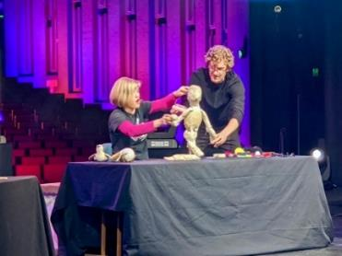  CTC@Home program Marianne Mettes from PuppetOOdle |  | - The reopening of Mugga-Mugga on 4 July 2020 completed the resumption of activities at CMAG, the ACT Historic Places, and the Canberra Theatre Centre Box Office, following the COVID-19 closure period in the final quarter of 2019–20.  - In each case, venues operated according to certain restrictions; for example, initially Lanyon, Calthorpes' House and Mugga-Mugga provided tours to the gardens, grounds and outbuildings only, due to the interiors of the properties being too small to allow social distancing of tour groups.  - Before the resumption of live theatre, the livestreaming program CTC@Home continued its program of local professional artists performing on stage in the Canberra Theatre (opposite picture).  - The Where You Are festival launched in the Canberra Theatre.
AUGUST 2020  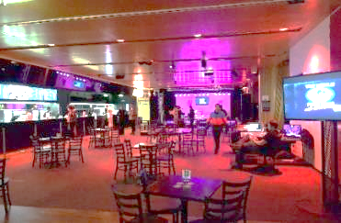The Link was transformed into a cabaret venue to accommodate the Link Bar series. |  | 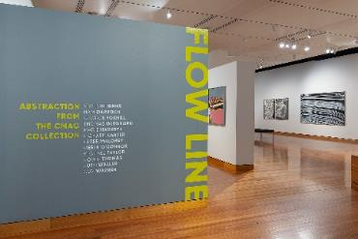Flow Line : Abstraction from the CMAG Collection, credit RLDI |  |  |  |  | - CMAG hosted its first children’s community program of the year, CMAG on Saturday – ShapeShifter, exploring the work of Sidney Nolan.  - CMAG exhibition Flow Line opened (opposite picture).
- CMAG exhibition Sidney Nolan and St Kilda : Memory and Modernism opened.
- The Canberra Theatre Centre (the Centre) hosted a number of events for the 2020 Canberra Writers’ Festival – its first event following the closure period.
- Various bands such as Pod People, Brass Knuckle and Chris Endrey & Friends performed live in the Link Bar as part of the Link Bar series (above picture).
- CMAG purchased Adrian Feint’s Canberra Landscape 1944.
- Lanyon was confirmed as the main southside venue for Floriade : Reimagined.
SEPTEMBER 2020  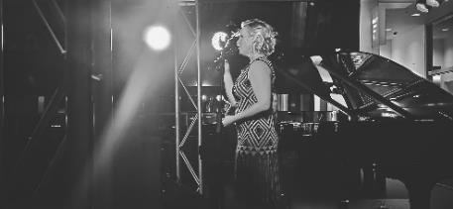  Emma Pask live in the Link Bar, credit Jem Natividad  - The Centre hosted the Canberra 2060 Futures with a Capital F project with the assistance of RISE Canberra (ACT Government’s COVID-19 support and funding provided for the arts and events sector).  - Emma Pask performed in the Link Bar (above picture).  - CMAG hosted Panel Conversation : After the fires – seeing Canberra in a new light in conjunction with the Seeing Canberra exhibition. |  |  |  | 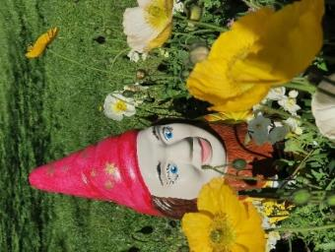Gnome painting program at Lanyon  - Lanyon presented a range of activities including photography workshops, tours and gnome painting sessions in conjunction with Floriade : Reimagined. |  |  |  |  | - Lanyon presented the school program Lanyon’s Landscape : First Nations Peoples, settlers and convicts and children’s program KIDS@ACTHP : Rattle your Tin Dog!  - CMAG hosted Collector Talk : The Art of the Fan with collector Wendy Whitham in conjunction with The Art of the Fan exhibition.  - CMAG’s Gallery 1 was used as a polling station for the 2020 ACT Election.
OCTOBER 2020  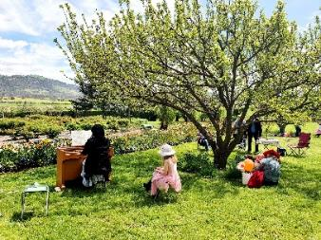  A Waltz through the Tulips program - Grace Chan performed on an 1850s harmonium at Lanyon  - With COVID-19 restrictions easing, the Centre moved to 50% seating capacity.  - Canberra Youth Theatre’s production of NORMAL performed in The Playhouse, and the Centre’s vocational education and training students participated in stage management. | 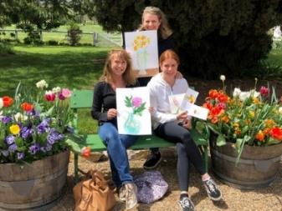 Art Makers at Lanyon - Still life, Watercolour and Gouache workshop as part of Floriade : Reimagined  - The online Nolan Collection program CovidSafe Nolan Children’s Trail (via CMAG’s Instagram stories) was launched.  - CMAG exhibition The Art of the Fan opened.  - Room on the Broom : Live on Stage! performed in the Canberra Theatre. |  |  |  |  |  |  | - Lanyon continued to be busy with Floriade : Reimagined, attracting nearly 8,500 visitors. As part of the music program A Waltz through the Tulips, Grace Chan performed on an 1850s harmonium in the garden (opposite pictures).  - Lanyon hosted the program Children’s Drawing Trail.  - The CFC’s Social Club sunrise breakfast was held in the Lanyon gardens.
NOVEMBER 2020  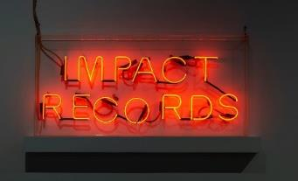  Sign of the Times, credit RLDI  - CMAG exhibitions Sign of the Times and The Blade : Australia’s love affair with lawn opened.  - CMAG exhibition Tom Campbell : r.a.m.p. opened as part of the ANU School of Art and Design, Emerging Arts Support Scheme. |  |  | 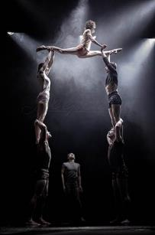  Circa’s Peepshow,  credit Brigette Honeyman |  |  | - Circa’s Peepshow performed in the Canberra Theatre (opposite picture).  - Wolfgang’s Magical Musical Circus performed in The Playhouse.  - Two CMAG floor talks, Flow Line with Guy Warren and Ham Darroch and Building a Life : The Jennings Germans story with Klaus and Rosa Scharrer were filmed for online viewing.  - CMAG Art Prize for digital photography and exhibition opened to Year 7–12 students.
DECEMBER 2020  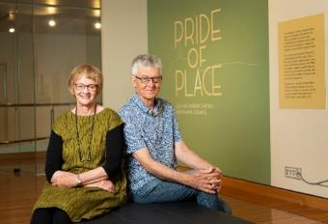  Julie and Andrew Carter – Pride of Place : Australiana  Ceramics, credit RLDI |  |  | - With further COVID-19 easing of restrictions, indoor performance venues were allowed greater seating capacity for events. The Canberra season of The Wharf Revue: Good Night and Good Luck at The Playhouse was a major success, attracting large audience numbers.  - CMAG hosted a floor talk The History and restoration of the Canberra pie cart, in collaboration with the Council of ACT Motor Clubs.  - CMAG exhibition Pride of Place opened (opposite picture).  - The 2020 Don Aitkin Awards were held and recognised staff members Carole Arulantu, Sophie Chessell and Neil Walsh for their outstanding contribution and achievements.
JANUARY 2021  - Bluey’s Big Play: The Stage Show performed in the Canberra Theatre.  - The online art exhibition Creating Lanyon was launched.  - CMAG exhibition Anna Madeleine Raupach : Unequal hours opened (opposite picture).  FEBRUARY 2021  - Music at Midday performed in the Canberra Theatre.  - The Umbilical Brothers performed in the Courtyard Studio.  - CMAG hosted a floor talk The Gents - vintage signs from the city to the outback in conjunction with the exhibition Sign of the Times.  - CMAG presented a teacher professional development workshop in conjunction with the Teacher Quality Institute accredited Arts Up Front Conference. |  |  |  |  | 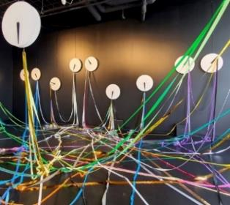  CMAG exhibition Anna Madeline Raupach :  Unequal hours

MARCH 2021  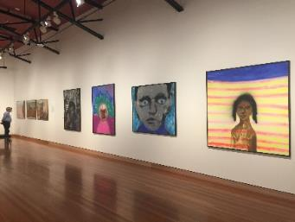  Sidney Nolan : Remembrances of my youth,  credit RLDI  - CMAG exhibition Sidney Nolan : Remembrances of my youth opened  (above picture).  - Minister Cheyne opened CMAG exhibition HABITAT : Ways of living, CMAG’s first post-closure opening event for the year. |  | 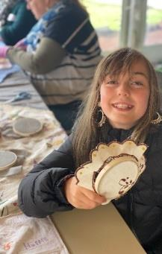  Stitching for Wellbeing Program at Lanyon  - Lanyon hosted Sunday Wellbeing Workshops Watercolour Patterns for Mindfulness and Stitching for Wellbeing (above picture). | - The Gruffalo’s Child performed in the Canberra Theatre and FANGIRLS performed in The Playhouse.  - Minister Cheyne visited Mugga-Mugga for a tour, and was briefed on the renewable energy demonstration program in development there.  - CFC staff attended a morning tea and quiz activity in the Link Foyer to celebrate International Women’s Day.
APRIL 2021  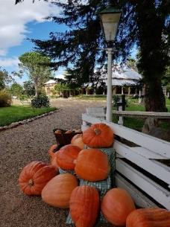  Pumpkins on display at Lanyon, credit Neil Walsh | - With COVID-19 restrictions further easing, the Centre was allowed to host audiences at 100% capacity.  - David Finnigan’s You’re Safe ‘til 2024: Deep History gave its world premiere in the Courtyard Studio with a sold out season.  - ANU School of Art lecture with Anna Madeleine Raupach discussed her CMAG exhibition Anna Madeleine Raupach : Unequal hours.  - CMAG exhibition Don’t forget the Milk : Celebrating 50 Years of Canberra Milk opened.  - CMAG acquired a painting by William Dargie, ANZAC Day Canberra 1970, with the support of generous donations.  - Seven CMAG Art Prize winners were announced.  - Lanyon hosted its first Harvest Day Out event. 750 visitors enjoyed a wide range of talks, tours and workshops with giant pumpkins on display (opposite picture).  - A flu vaccination program was made available to all CFC staff.
MAY 2021  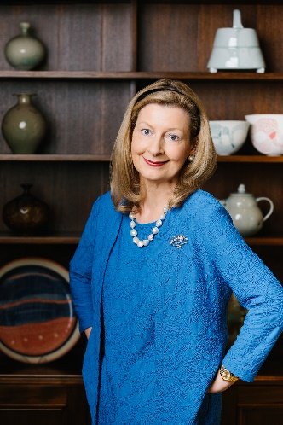  Harriet Elvin AM, Chief Executive Officer | - Harriet Elvin AM, Chief Executive Officer who has led the CFC since it was established in 1997, announced her resignation. Ms Elvin agreed to continue in the role until her successor is appointed (opposite picture).  - Over 80 programs were conducted on site at Lanyon and CMAG, such as school programs James’ Diary and Child’s Play at Lanyon and What do Artists Make at CMAG.  - CMAG exhibition The Piano Creatures : A Ragged Shore opened.  - A German Life and Animal Farm performed in The Playhouse.  - CMAG presented a floor talk Liveability, urban renewal and public space with Ann Cleary in conjunction with the exhibition HABITAT : Ways of living.  - Reel Classics : The Reel McCoy Film Society presented Little Dieter Needs to Fly and Lessons of Darkness at CMAG.
JUNE 2021  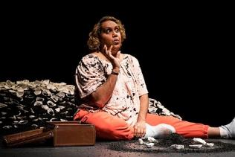Elaine Crombie in The 7 Stages of Grieving,  credit Brigette Honeyman | - The 7 Stages of Grieving performed in The Playhouse (opposite picture).  - The Appleton Ladies’ Potato Race performed in The Playhouse.  - CMAG hosted Studio workshop : Street Art with Byrd in conjunction with the Sidney Nolan : Remembrances of my youth exhibition.  - Lanyon hosted public program Legends of Lanyon with Tim the Yowie Man.  - With the spread of the Delta strain of COVID-19 introducing new restrictions, American Psycho: The Musical performed in The Playhouse from 30 June to 3 July 2021, by exemption granted by the ACT Chief Health Officer.

Organisation Overview and

B.1 Organisational Overview

B.1.1 Vision, mission and values
The CFC’s 2016–21 Strategic Plan provides the overarching framework for the organisation’s planning activities over a five-year period, including for the development of its annual corporate plans.
The Strategic Plan identifies the CFC’s role, vision, key values and principles, and key priorities. It also identifies the mission, purpose, vision and key strategies both for the organisation as a whole and for its three program delivery divisions :
- the Canberra Theatre Centre;
- the Canberra Museum and Gallery (CMAG), including The Nolan Collection; and
- the ACT Historic Places : Lanyon, Calthorpes’ House and Mugga-Mugga.
Overarching vision for the CFC
Our vision is for Canberra to be a creative capital that values the arts for their intrinsic qualities, their contribution to building a more inclusive and resilient society, their support for making the city an exciting place to live and an attractive destination for business and tourism, and their important role in the economy of the ACT and region.
We see the CFC as a leader in this creative city, providing high quality cultural experiences based on the arts and heritage resources that we hold in trust for the people of Canberra, and playing a significant role in the region’s cultural and economic life.
Mission
Mission/purpose statements (What we are/What we do) are identified in the Strategic Plan for the CFC as a whole and for each division. These are supported by vision statements for each area and statements as to what the CFC is seeking to achieve in a number of areas, as set out below.
CFC
What we are | An enterprise of the ACT Government that manages a number of Canberra’s major cultural facilities
What we do | We connect people with rich and diverse cultural experiences through activities at our venues
Our vision | To provide cultural leadership in the Canberra region and beyond
What we want to achieve | Leadership : A cultural leader in the ACT region and beyond  Strategy : A clear direction for our future  Governance : An accountable and dynamic organization  People : An employer of choice  Finances : Long-term financial sustainability  Assets : Support for delivering high quality cultural experiences

Canberra Theatre Centre
What we are | The Canberra region’s main theatre centre, incorporating the Canberra Theatre, The Playhouse and the Courtyard Studio
What we do | We connect people with theatre experiences of national and international quality
Our vision | To be a leading theatre centre in Australasia and Asia
What we want to achieve | Customers : Audiences that are growing, diverse, engaged and entertained  Programming : A diverse, high quality, entertaining and distinctive program  Business : Venues, systems and people that support high quality live performances  Leadership : An integral part of the cultural life of the Canberra region and beyond

CMAG
What we are | A museum and gallery dedicated to the visual arts and social history of the Canberra region
What we do | We connect people with the Canberra region’s rich and diverse stories, sense of place, and contemporary identity
Our vision | To be a leading regional cultural venue in Australia and beyond
What we want to achieve | Customers : Audiences that are growing, diverse and engaged  Programming : Exhibitions and programs that reflect Canberra’s unique identity  Stewardship : Venues and collections that allow us to tell the many stories of Canberra  Leadership : An integral part of the cultural life of the Canberra region and beyond

ACT Historic Places
What we are | Three historic places that reflect different aspects of Canberra’s history : Lanyon, Calthorpes’ House and Mugga-Mugga
What we do | We connect people with Canberra’s rich and diverse stories and heritage
Our vision | To be leading historic places in Australia and beyond
What we want to achieve | Customers : Audiences that are growing, diverse and engaged  Programming : Programs that explore Canberra’s history by interpreting each place Stewardship : Buildings, grounds and collections that are conserved and researched Leadership : An integral part of the cultural life of the Canberra region and beyond
Key Values and Principles
Leadership
- We are committed to providing cultural leadership, excellence and innovation, including leadership in using digital applications to enhance our systems and programs.
Engagement
- We actively seek to engage our communities in a greater understanding of the value of the arts, and of our cultural heritage, through our programs and activities, placing customer service as our primary goal and recognising the diverse needs and expectations of our customers.
Collaboration
- We value cooperative and strategic partnerships across all areas of our activities.
Professionalism
- We place major importance on maintaining professional standards in the management of our facilities and in the design and delivery of our programs.
In observing these values, we are committed to implementing the :
- ACT Government Service Values : respect, integrity, collaboration and innovation;
- Principles of the 2015 ACT Arts Policy : participation and access to the arts; great arts and great artists; vitality of the Canberra region arts ecology; and engagement with Aboriginal and Torres Strait Islander arts and cultures; and
- The ACT Government’s Strategic Priorities.

B.1.2 Role, functions and services
The CFC was established under the Cultural Facilities Corporation Act 1997 (the CFC Act), which came into operation as from 1 November 1997.
The functions of the CFC, as set out in the CFC Act (Section 6) are :
- to manage, develop, present, coordinate and promote cultural activities at designated locations and other places in the ACT;
- to establish and research collections;
- to conserve and exhibit collections in the possession or under the control of the CFC;
- to undertake activities, in cooperation with other people if appropriate, to exercise its other functions; and
- to exercise other functions given to the CFC under this Act or another Territory Law.
The CFC Act (Section 7) requires that the CFC, in exercising its functions, must consider :
- any cultural policies or priorities of the Executive known to the CFC; and
- other cultural activities in the ACT.
The CFC is responsible for :
- the Canberra Theatre Centre;
- CMAG, including The Nolan Collection; and
- the ACT Historic Places : Lanyon, Calthorpes’ House and Mugga-Mugga.
The CFC’s functions therefore include the performing arts, the visual arts, social history and cultural heritage management. The organisation delivers a range of cultural services to the community by providing activities such as theatre presentations, exhibitions, and education and community programs, and through conserving and presenting significant aspects of the ACT’s cultural heritage.
Additional information about the CFC can be found at the following websites :
- www.culturalfacilities.act.gov.au covering whole of CFC matters;
- www.canberratheatrecentre.com.au covering the Canberra Theatre Centre;
- www.cmag.com.au covering CMAG and The Nolan Collection; and
- www.historicplaces.com.au covering the ACT Historic Places.
Clients and stakeholders
During 2020–21, the CFC initially reported to the Minister for the Arts, Creative Industries and Cultural Events and, following the ACT Election in October 2020, to the Minister for the Arts. The Chief Minister, Treasury and Economic Development Directorate (CMTEDD) is the “parent” directorate for the CFC. The CFC’s other clients and stakeholders include :
- the community of the ACT and region;
- visitors to the ACT;
- the arts, cultural, heritage, education, business and tourism sectors, including other cultural organisations;
- national producers of performing arts, including commercial and funded companies;
- the diplomatic community; and
- the media, especially the Canberra media.

B.1.3 Organisational structure, environment and planning framework
Organisational structure
The CFC is organised into three program delivery divisions: the Canberra Theatre Centre, CMAG, and the ACT Historic Places, together with a central finance/corporate section. The CFC’s top level organisational chart as at 30 June 2021 is provided below.
Figure B.1.3a CFC Organisational Chart

Organisational environment
During 2020–21, the CFC had close working relationships with a number of ACT Government agencies and entities including CMTEDD, City Renewal Authority, artsACT, Minister’s Creative Council, Major Projects Canberra, Events ACT, Environment, Planning and Sustainable Development Directorate, ACT Heritage Council, Access Canberra, ACT Property Group, Territory Records Office, Public Sector Workforce Health, Safety and Wellbeing, ACT Treasury and ACT Audit Office.
Planning Framework
As noted in Section B.1.1, the CFC has adopted a five-year Strategic Plan that provides the overarching framework for the organisation’s planning activities, including for the development of its annual corporate plans.
The CFC’s 2020–21 Corporate Plan, based on its 2016–21 Strategic Plan, identified the actions the CFC intended to take during the year to work towards the Strategic Plan. Results relating to these actions are reported in summary in this section and in detail in Section B.2, page 30.
The CFC’s accountability indicators and targets for 2020–21 were identified in the CFC’s 2020-–21 Statement of Intent, which was included in the 2020–21 ACT Budget statements. The Statement of Intent also identified the CFC’s strategic objectives and indicators. Results relating to the CFC’s accountability and strategic indicators are reported in summary in this section. Further details about the CFC’s accountability indicators are provided in the 2020–21 Statement of Performance at Attachment 1, page 160 to this report. Further details about the CFC’s strategic indicators are provided in Section B.2, page 30.

B.1.4 Summary of performance in achieving objectives and targets
Performance outcomes for the CFC in 2020–21 were generally higher than expected, mainly due to the easing of COVID-19 restrictions in the second half of the year, which supported the resumption of more normal operations. For example, the return to 100% capacity audiences at the Canberra Theatre Centre from April 2021 led to a busy period of theatre activity in the final quarter of the year. These factors resulted in the CFC meeting most of its accountability indicator targets for 2020–21. For example, during the year the CFC :
- welcomed an estimated 225,568 visitors and patrons to its facilities and programs, a figure 22% above target;
- provided 322 education and community programs, a figure 66% above target; and
- recorded 424 days in total of venue usage at the Canberra Theatre Centre’s venues, a result 12% above target.

The CFC did not achieve its target for the number of exhibitions, with the total of 21 being 22% below target. This was due to CMAG extending the duration of certain exhibitions, as a result of the COVID-19 situation.
Detailed performance results and variance explanations are included in the 2020–21 Statement of Performance at Attachment 1, page 160 to this report.
Performance outcomes – Financial Management
The CFC’s overall financial result for 2020–21 was an operating deficit of $1.753m, which was 30.1% lower than the budgeted deficit of $2.511m. It should be noted that, due to its large asset holdings and consequent significant depreciation expenses, the CFC always expects to have an operating deficit as it is not funded for depreciation, but receives capital injections through the capital works program. The lower than estimated deficit was primarily due to supplies and services expenses being below expectations, especially production costs and royalties, as a result of restrictions resulting from the COVID-19 pandemic reducing the volume of the CFC’s theatre activities.
The CFC achieved an own-sourced revenue figure of 32.5% as a proportion of total revenue for
2020–21, against a target of 35.4%. The below-target result was due primarily to the lower than expected volumes of revenue-generating activity at the Canberra Theatre Centre, due to the COVID-19 pandemic. The CFC recorded a result for Cost to Government per estimated visitor/patron of $55.36 against a target of $70.15, the better than target result reflecting the-above target number of visitors and patrons in the second half of the year, when COVID-19 pandemic restrictions eased.
The CFC completed the majority of its 2020–21 capital works and capital upgrade projects by year-end, although certain expenditure on, and funding for, capital projects for ACT Historic Places and Canberra Theatre Centre, was deferred from 2020–21 into 2021–22. This was due to : revised project schedules; delays in obtaining necessary approvals; COVID-19 related restrictions on interstate contractors and supplies; and the need to obtain further specialist advice on theatre accessibility improvements.
A full analysis of the CFC’s financial results and financial position is set out in the Management Discussion and Analysis at Attachment 1, page 151 to this report.

Performance outcomes – Strategic Objectives/Indicators
Strategic Objective 1 – The CFC provides cultural leadership in the Canberra region and beyond.
Strategic Indicator 1 : The extent to which the CFC connects people with rich and diverse cultural experiences through activities at its venues, in the following areas.
- A smooth recovery from the COVID-19 pandemic
- The COVID-19 pandemic presented many new challenges for the CFC throughout 2020–21. The CFC COVID-19 response included : adapting to changing COVID-19 restrictions throughout the year and their impact on audience capacity limits for activities and events; supporting staff wellbeing during varying levels of COVID-19 restrictions; and ensuring COVIDSafe plans were implemented and updated at all CFC facilities, to keep staff and the community safe.
- The CFC continued to manage COVID-19 matters through special meetings of the CFC COVID-19 Crisis Management Group and through regular senior management meetings. Regular reports on COVID-19 management were provided to the Minister, Board and staff.
- Leadership : A cultural leader in the ACT region and beyond
- Throughout the year, the CFC pursued its goal of providing leadership in cultural planning, administration and management, focusing on COVID-19 management and recovery.
- The CFC engaged actively with the City Renewal Authority on the revitalisation of Civic and on cultural planning for the city, including through progressing new theatre studies, and through continued work on planning the Canberra Civic and Culture District. The CFC Board and senior staff participated in a number of workshops and consultations aimed at developing the vision for the District.
- In the first half of the year, the CFC worked closely with the developers and managers of the Constitution Place project as the project reached completion. The completed Constitution Place development provides a high-quality precinct adjacent to the Canberra Theatre Centre with food and beverage, accommodation and car parking facilities, which can all be accessed by theatre patrons and visiting companies.
- The CFC worked with the ACT Heritage Council and other ACT agencies during the final stage of the heritage listing of the Civic Square precinct. The precinct was formally entered onto the ACT Heritage Register on 19 September 2020. In accordance with best practice for the management of heritage-listed sites, the CFC and a number of other interested agencies collaborated in commissioning a detailed Conservation Management Plan for the precinct.
- Strategy : A clear direction for the future
- During the year, the CFC’s 2020–21 Corporate Plan, based on the Strategic Plan, guided the work of the Board, advisory committees, staff and volunteers.
- The 2020–21 Corporate Plan incorporated four key priorities to guide the CFC’s operations, with a particular focus on managing the impact of, and recovery from, the COVID-19 pandemic. A report on progress towards these key priorities was provided to each Board meeting during 2020–21.
- A new Strategic Plan was developed through a consultative process involving the Board, staff and Advisory Committees. This new Strategic Plan covers a three-year period from July 2021 to June 2024, in order to better align strategic planning with annual business planning for each financial year. It will be reviewed and refreshed each year to ensure its continuing relevance and currency.
- Governance : An accountable and dynamic organisation
- During the year, the CFC maintained robust governance systems to provide a high standard of accountability. The Board was maintained at full strength throughout the year.
- The CFC Board Charter was updated, to provide more detail about the role and responsibilities of the Board Executive.
- Both the CFC’s Fraud Control Plan and Strategic Risk Management Plan were updated, and were approved by the Board in 2020. In each case, the updates reflected lessons learned from the COVID-19 situation.
- The CFC participated in the 2020 Audrey Fagan Board Mentorship Program, providing mentorship for two young women : Joanne Lisinski and Ashley Alderton. A graduation ceremony was held for the participants at a function following the December 2020 Board meeting.
- People : An employer of choice
- The CFC again focused on attracting, developing and retaining highly skilled staff and volunteers, and on ensuring its sites are safe and rewarding places to work. Senior appointments during the year included a new CMAG Director, Dr Sarah Schmidt, and a new Financial Controller, Jennifer Kilgariff.
- The ACT Government Healthy Minds – Thriving Workplace Strategy 2019–22 continued to be implemented throughout the year, including initiatives to assist staff with their mental health, fitness and wellbeing during the COVID-19 situation.
- The 2020 Don Aitkin Awards were held on 17 December 2020 and recognised three staff members for their contribution and achievements : Carole Arulantu (Canberra Theatre Centre staff member); Sophie Chessell (CMAG staff member); and Neil Walsh (ACT Historic Places staff member).
- The CFC’s three advisory committees operated throughout the year and attended a range of meetings and workshops. All members contributed their time on a voluntary basis. A full renewal process was implemented for committee membership in 2021, in view of the completion of the terms of all members on 30 June 2021. The new memberships will be finalised in the first half of 2021–22.
- Finances : Long-term financial sustainability
- In 2020–21 the CFC maintained high standards of financial management and reporting, with a major focus throughout the year on oversight of the impact of the COVID-19 pandemic on the organisation’s finances.
- The audit of the CFC’s 2020–21 Financial Statements by the ACT Auditor-General resulted in an unmodified audit.
- The Government provided additional COVID-19 support funding of $3.5 million to the CFC to enable it to continue its operations during the COVID-19 pandemic, although a temporary improvement in trading conditions in the final quarter of the year enabled $0.438 million of this funding to be rolled over into 2021–22.
- The CFC developed high-quality bids for the 2021–22 ACT Budget, resulting in a number of new initiatives being funded in that Budget, together with the provision of further additional COVID-19 support funding to the CFC.
- Assets : Support for delivering high quality cultural experiences
- High quality asset management continued to be a key priority for the CFC during 2020–21, in view of its responsibility for managing major cultural sites.
- The CFC contracted RiskLogic to further develop a new Business Continuity Plan (BCP) to ensure appropriate levels of preparedness in the event of a disruption, and high-level response and recovery capabilities. The BCP will be finalised in 2021–22.
- The CFC’s 2019–22 Resource Management Plan continued to provide the framework for the CFC’s sustainability and energy efficiency practices.
Further details regarding outcomes against Strategic Objective 1 and Strategic Indicator 1 are provided under Section B.2, page 30.

Strategic Objective 2 – The Canberra Theatre Centre is a leading theatre centre in Australasia and Asia.
Strategic Indicator 2 : The extent to which the Canberra Theatre Centre connects people with theatre experiences of national and international quality, in the following areas.
- A smooth recovery from the COVID-19 pandemic
- The Canberra Theatre Centre (the Centre) worked closely with the Office of the ACT Chief Health Officer, other ACT agencies and the national performing arts industry to ensure the Centre managed its recovery from the pandemic in as safe and expedient manner as feasible.
- Through this work, the Centre was able to reopen the Canberra Theatre to events and performances at a capacity of 100 people (8% capacity) in August 2020, gradually building to a return to 100% capacity in the Centre’s venues by April 2021.
- As the COVID-19 restrictions eased, the Centre worked closely with other ACT agencies, especially ACT Health, to manage the safe return of audiences, staff and touring personnel to venues. This required a range of COVIDSafe procedures, including limiting audience capacity, varying production structures, requiring all visitors to register and check-in, and offering additional performances to meet demand while maintaining audience limits.
- Some new opportunities arose from the fast-moving changes, including the opportunity for the Bluey’s Big Play: The Stage Show Company to move its rehearsals and premiere season to the Centre from Adelaide, between December 2020 and January 2021, as a result of COVID-19 restrictions applying at that time in South Australia.
- Customers : Audiences that are growing, diverse, engaged and entertained
- To ensure the comfort and safety of patrons following the reopening of the Centre, detailed planning and communication strategies were developed to ensure ticketholders were informed about production cancellations and reschedules. Website updates and information emails were sent to patrons 48 hours before their attendance to communicate COVID-19 safety procedures.
- The Centre’s booking system was updated to include the ability to add contact tracing details for all ticketholders. After the Check In CBR app became widely used, the Centre moved to align with the ACT Government’s QR code check-in system.
- Attendees and subscribers were surveyed during the reopening period, to gauge their attitudes about returning to the venue. The Centre’s marketing team also sent a survey to subscribers in late 2020 to better understand who they are, and what the Centre can do to retain and engage them in the future.
- The Centre continued to work collaboratively with the builders and owners of the new Constitution Place development, to maximise benefits for customers and visiting companies. This work included developing relationships with the new A by Adina hotel, and inviting selected patrons to try the new multistorey car park free of charge.
- Programming : A diverse, high quality, entertaining and distinctive program
- The COVID-19 situation and subsequent restrictions presented the Centre with specific challenges in relation to presenting shows and performances. The Centre responded by initially providing a range of online and live-streamed content, and later presenting live performances in a COVIDSafe manner to ensure the safety of staff, patrons and performers.
- The CTC@Home program provided live-streamed performances to patrons over the course of the COVID-19 restricted period. Following its launch in June 2020, the program in 2020–21 : featured 43 streams and 41 different artists; provided more than 25 hours of streamable content; attracted more than 110,000 views; and was watched over more than 2,000 hours.
- As COVID-19 restrictions eased, limited-capacity shows became available to small audiences. These included shows in the Courtyard Studio such as the Umbilical Brothers, and small-scale events (limited to 100 people) in the Link Bar foyer.
- The first event held at the Canberra Theatre under the Centre’s COVIDSafe Plan was the Canberra Writers Festival.
- With the further easing of COVID-19 restrictions, larger shows were presented, including successful seasons of The Wharf Revue: Good Night and Good Luck; Room on the Broom: Live on Stage!; and Circa’s Peepshow.
- Business : Venues, systems and people that support high quality live performances
- In 2020–21, the Centre saw the completion of the majority of the three-year Stage 5 upgrade program, including completing the final-year upgrades to the Centre’s public toilet facilities. A small portion of the funding for the program was rolled over into 2021–22 to enable the completion of a consultancy into accessibility improvements in the Canberra Theatre.
- The second, and final, year of the Centre’s Stage 6 upgrades was undertaken in 2020–21, covering a Phase 1 security system upgrade and an Electronic Access Control System connected to the ACT Government network.
- The Centre was able to access additional funds provided by the ACT Government to support local industry in recovering from the COVID-19 closure period. These additional funds enabled a second phase of the security system to be implemented, to cover the entire Centre, together with additional bathroom upgrades in the Canberra Theatre.
- The Centre’s allocation of Better Infrastructure Funding for 2020–21 was used to investigate, licence and purchase bespoke designed carpet for the Canberra Theatre, Link Bar and The Playhouse foyer areas. The new carpet, which will be installed in 2021–22, features a design taken from the Canberra Theatre’s original house curtain.
- Leadership : An integral part of the cultural life of the Canberra region and beyond
- The Centre continued to support venue hirers by providing marketing and publicity for events in the Theatre; for example, with podcast interviews, and increased support of hirers such as Canberra Youth Theatre. The major musical Come From Away launched its Canberra season with an event at the High Commission of Canada.
- A special event for subscribers in March 2021 featured a wide range of productions coming to the Centre, including venue hirers and shows presented by the Centre itself. The offerings to subscribers included a three-play package of Sydney Theatre Company productions.
- In partnership with Canberra Institute of Technology, the Centre continued to deliver the vocational education and training (VET) training course Certificate III in Live Production and Services in Canberra.
- The Discovery and Learning program continued its close relationship with educators and students in the region and assisted them in curriculum delivery, especially by presenting ACT UP! as an online festival of student theatre, and producing the Come Alive Festival.
- Throughout 2020–21, the Centre continued to play a key role in the planning of a new major theatre for Canberra, including through its membership of the steering committee for the new theatre project. A digital survey of the Centre’s existing infrastructure commenced.
Further details regarding outcomes against Strategic Objective 2 and Strategic Indicator 2 are provided under Section B.2, page 30.
Strategic Objective 3 – CMAG is a leading regional cultural venue in Australia and beyond.
Strategic Indicator 3 : The extent to which CMAG connects people with the Canberra region’s rich and diverse stories, sense of place, and contemporary identity, in the following areas.
- A smooth recovery from the COVID-19 pandemic
- Following the COVID-19 closure period in 2019–20, CMAG undertook a phased reopening, supported by a COVIDSafe Plan. This was reviewed and updated throughout the year, to ensure that CMAG met all current ACT Public Health Directions and that visitors understood the additional cleaning, contact tracing and physical distancing measures implemented.
- CMAG’s use as a polling station for the 2020 ACT Election combined the CMAG COVIDSafe Plan with the Elections ACT COVIDSafe Plan, to ensure the safety of visitors during the voting period.
- Community programs resumed at CMAG on 1 August 2020 with the launch of CMAG on Saturday. CMAG’s first onsite learning program, modified in accordance with COVID-19 requirements, was delivered on 8 September 2020.
- The first CMAG exhibition opening event following the closure period was held on 5 March 2021 for the major new exhibition, HABITAT : Ways of living, which was opened by Minister Cheyne.
- Customers : Audiences that are growing, diverse and engaged
- During 2020–21 CMAG continued its efforts to provide excellent customer service, despite the challenges of the COVID-19 situation. Customer surveying in 2020–21 resulted in CMAG receiving 100% approval ratings, and CMAG was proactive in responding to customer feedback and suggestions.
- Throughout 2020–21, planning continued towards securing improvements to CMAG’s facilities, including facilities to improve accessibility for customers, with funding received for this purpose in the 2021–22 ACT Budget.
- The inaugural CMAG Art Prize for secondary students was established and marketed to art specialists in secondary schools via the Arts Up Front network, and prize winners were announced.
- A renewed commitment to marketing CMAG exhibitions was demonstrated by regular full-page advertisements in The Canberra Times – for example, for Sign of the Times and HABITAT : Ways of living – as well as regular Panorama advertising and increased social media posts.
- Programming : Exhibitions and programs that reflect Canberra’s unique identity
- CMAG presented an exhibition program in 2020–21 that reflected the diverse interests of the Canberran community. Major new exhibitions presented during the year included : Flow Line, presenting abstract paintings from the CMAG Collection; Sign of the Times, a CMAG collection-based exhibition, featuring diverse stories connected with signage; touring exhibition The Blade : Australia’s love affair with Lawn; and HABITAT : Ways of living , focusing on works by contemporary artists from Canberra and around Australia that reveal ways of living in a variety of environments.
- CMAG presented several exhibitions of The Nolan Collection throughout the year, including Sidney Nolan and St Kilda : Memory and Modernism, and Sidney Nolan : Remembrances of my youth.
- A range of community and education programs was presented, often in association with specific exhibitions or special events. For example, Access and Learning staff partnered with Thunderstone Aboriginal Cultural Services to create the Ngunawal Story Time project, launched during NAIDOC week, while HABITAT : Ways of living artist Tina Havelock Stevens and fellow performer Liberty Kerr gave a Friday night drumming/cello performance celebrating the eve of World Environment Day.
- Stewardship : Venues and collections that allow us to tell the many stories of Canberra
- During the year, CMAG undertook capital upgrades with its allocation of Better Infrastructure Funding. These upgrades included the removal of a wall in gallery 2/3, to improve the exhibition space and facilitate the display of larger exhibitions.
- 137 objects were added to the CMAG Collection during the year, and 80 works of art were added to the CMAG collection page online.
- A successful grant application was submitted to The Gordon Darling Foundation for a new permanent collection publication for CMAG : a 500-page hardcover book. A range of external writers were confirmed for the project, which devotes a chapter specifically to The Nolan Collection.

- Leadership : An integral part of the cultural life of the Canberra region and beyond
- During the year, CMAG continued work on revitalising its street frontage, and began refreshing its exterior, including new signage above the front door at the Civic Square entry and repainting the front doors. Planning also continued on further improvements to CMAG’s facilities, including the CMAG foyer.
- As part of the foyer revitalisation, the donation of a major Canberra-related glass work by Brian Corr, Timshel (2012) was secured, which will highlight the Canberra community of glass artists. In addition to this gift of a major public artwork, in 2020–21 CMAG succeeded in attracting a range of monetary donations for artworks, and also sponsorship for exhibitions.
- During 2020–21, CMAG welcomed its new Director, Dr Sarah Schmidt, who began work in October 2020. The new CMAG Director contributed extensively to ‘arrival’ media and events : in local print and radio via interviews, and to the arts community via several public speaking engagements and written pieces, such as for Craft ACT and the Canberra Critics Circle.
Further details regarding outcomes against Strategic Objective 3 and Strategic Indicator 3 are provided under Section B.2, page 30.
Strategic Objective 4 – The ACT Historic Places are leading historic places in Australia and beyond.
Strategic Indicator 4 : The extent to which ACT Historic Places connects people with the Canberra region’s rich and diverse stories and heritage, in the following areas.
- A smooth recovery from the COVID-19 pandemic
- Following the COVID-19 closure period in 2019–20, ACT Historic Places (ACTHP) managed the phased reopening of its sites and resumption of events and programs. Lanyon and Calthorpes’ House had already reopened prior to the 2020–21 year commencing, with Mugga-Mugga reopening shortly afterwards, on 4 July 2020.
- Each historic property initially reopened with outdoor tours only, interpreting the property’s gardens and outbuildings for visitors. Indoor museum tours were suspended until February 2021, to comply with physical distancing recommendations.
- Public programs recommenced on site in September 2020 and included events for Floriade : Reimagined, and displays at Lanyon Homestead.
- Learning programs for schools also recommenced on site in September 2020, initially modified to comply with COVID-19 limits on group sizes and program duration. This included developing new two-hour programs : Lanyon’s Landscape : First Nations, Peoples, Settlers and Convicts; and James’ Diary.
- Customers : Audiences that are growing, diverse and engaged
- Throughout 2020–21, ACTHP continued its commitment to providing excellent visitor experiences, with visitors continuing to show enthusiastic approval of ACTHP experiences. Visitor satisfaction survey results confirmed high ratings : 94% of visitors rated their experience of guided tours 8 out of 10 or higher, with 63% rating their tour experience 10 out of 10.
- In response to COVID-19 restrictions, ACTHP developed new outdoor tours at each historic property, and learning programs at Lanyon, to enable a safe reopening for visitors while interior spaces were still closed.
- ACTHP volunteers provided 564 volunteer hours across all three properties in a range of visitor services in 2020–21. These hardworking volunteers were celebrated at Volunteer Appreciation Events held on 31 August 2020 and 17 May 2021.
- Programming : Programs that explore Canberra’s history by interpreting each place
- During the year, ACTHP provided a diverse range of workshops, tours and public events that offered the community many opportunities to learn about, celebrate and enjoy the region’s heritage.
- In a major highlight for the year, ACTHP collaborated with EventsACT to establish Lanyon as the primary Floriade : Reimagined location for south Canberra, following the cancellation of Floriade at Commonwealth Park in 2020. In addition to the Floriade : Reimagined floral displays, Lanyon offered a month of public programs covering heritage, music, art and Aboriginal culture and history.
- The Wellbeing Workshop series, launched in March 2021, supported community wellbeing through art, craft and heritage. This included three workshops at Lanyon: Stitching for Wellbeing; Make a Pinch Pot Tea Bowl; and Watercolour Patterns for Mindfulness.
- April 2021 saw the launch of the Harvest Day Out, a day of tours, workshops and children’s programs and a celebration of the gardens and autumn harvest at Lanyon. This event was held during the ACT Heritage Festival and included talks and workshops on historic sustainability and gardening; an Autumn Jig music performance in the tradition of harvest celebration; and Ngunnawal elder Wally Bell’s Canoe Tree and local Ngunnawal Stories Walk.
- Stewardship : Buildings, grounds and collections that are conserved and researched
- 2020–21 saw the continued implementation of projects to upgrade and improve ACTHP properties, together with a continued commitment to the conservation and restoration of the collections, properties and grounds.
- The Aboriginal Cultural Heritage Survey of Mugga-Mugga was finalised in 2020–21 in consultation with local Aboriginal groups. The survey will help conserve and interpret Aboriginal sites on ACTHP properties in keeping with Aboriginal cultural values and heritage.
- The Grasslands Management Plan for Mugga-Mugga, prepared by Sarah Sharp, continued to be implemented in 2020–21, including through an ecological survey of the site’s grasslands.
- Major capital works at Lanyon progressed throughout 2020–21. Scoping of conservation works, as part of the Lanyon Homestead Conservation Project, was completed, with the implementation of these works to commence in 2021–22. The new Lanyon Homestead workshop was completed in 2021, providing much-improved facilities for grounds staff who care for the site, and for storage of equipment and supplies used in this care.
- Leadership : An integral part of the cultural life of the Canberra region and beyond
- Joint programs and marketing during ACT festivals throughout the year provided good opportunities for new public programs and attractions, as part of Floriade : Reimagined in 2020, and Enlighten and the ACT Heritage Festival in 2021.
- The Lanyon Heritage Centre continued to provide a valuable teaching space for education programs, and dedicated storage for museum collections.
- Lanyon remained a popular venue for functions and weddings. Despite COVID-19 restrictions on gatherings, 21 functions were held in 2020–21, including nine weddings – one a First Nations wedding with a smoking ceremony.
- Continuing efforts to develop Lanyon as a heritage tourism hub and a ‘must see’ attraction for visitors resulted in Lanyon receiving a Tripadvisor Travellers’ Choice Award for 2021, with the site rising to the rank of #7 among 56 attractions in Canberra, moving from #25 in the previous year.
Further details regarding outcomes against Strategic Objective 4 and Strategic Indicator 4 are provided under Section B.2, page 30.

B.1.5 Outlook
Current and future priorities
During 2020–21, the CFC developed a new Strategic Plan through a consultative process that included planning workshop sessions for the Board, senior management team, staff, and the CFC’s three advisory committees. The new Plan covers the three-year period from 2021-24 and identifies the following six key priorities for this period.
- Progress the development of a major new theatre for the nation’s capital
- Work with other agencies to refine planning for a fit-for-purpose, audience-focused venue.
- Build towards this new venue through programming large scale productions and through creative partnerships at local, regional, national and international levels.

- Expand and enhance CMAG
- Extend CMAG’s facilities and programs within North Building.
- Enhance CMAG’s presence and profile on Civic Square and London Circuit.

3. Position the Canberra Civic and Culture District as a premier cultural location
- Grow the District as the vibrant creative heart of Canberra.
- Place the new theatre as its centrepiece and an enhanced CMAG as a key aspect.

4. Celebrate the multi-layered heritage values and cultural relevance of ACT Historic Places
- Highlight their contemporary relevance and their role in enhancing community wellbeing.
- Develop innovative programming and increased business and tourism opportunities.

5. Promote Indigenous engagement and reconciliation
- Create partnerships with First Nations peoples.
- Reflect the CFC’s commitment to Indigenous engagement and reconciliation through Reconciliation Action Planning.

6. Deliver cultural leadership for the ACT region, including in COVID-19 recovery
- Position the CFC as a leader in the region’s creative recovery from COVID-19.
- Advocate for the value of arts and heritage to community wellbeing and the economy.
The new Strategic Plan will be reviewed and refreshed each year, rather than just at the end of its three-year life, to ensure its continued relevance and currency. For 2021–22, this review and refresh will allow an opportunity to reflect, in the updated Strategic Plan, appropriate references to the Minister’s Statement of Ambition for the Arts, Canberra : Australia’s Arts Capital, which was released in October 2021.
In addition to implementing actions towards the six key priorities identified above, other specific issues to be pursued by the CFC in 2021–22 include the following, to the extent that these can be progressed within restrictions arising from the COVID-19 situation.
- Encourage visitation to, access to, and patronage of, the CFC’s facilities, programs and collections.
- Present exhibitions, learning and community programs, including outreach activities and partnership programming.
- Present a varied program of performing arts productions.
- Provide Vocational Education and Training in theatre technical skills at the Canberra Theatre Centre.
- Undertake the first year of a three-year program of upgrades for the Canberra Theatre Centre, in order to enhance the safety of patrons, ensure a high level of Work Health Safety standards for staff, enhance security infrastructure, and implement other essential works.
- Undertake the first year of a two-year package of works at CMAG to improve Work Health Safety standards and accessibility, together with the first year of a further two-year package of works and initiatives to enhance CMAG’s presence and profile on London Circuit and Civic Square, to support activation of the precinct.
- Continue to implement a program of infrastructure upgrades at Lanyon, to facilitate effective business operations and achieve high standards of Work Health Safety, especially by progressing a new water infrastructure project, undertaking building stabilisation measures, and upgrading security infrastructure.
- Undertake ongoing programs of other infrastructure upgrades and capital projects, in order to ensure the CFC’s cultural facilities remain fit for purpose and support the delivery of high-quality cultural experiences.
Apart from the areas identified above, the main ongoing priority of the CFC is to provide cultural leadership through a high standard of service to the community. In keeping with this priority, the CFC will continue to promote the value of a vibrant cultural life for community wellbeing, for economic development, and for the ACT’s recovery from the COVID-19 pandemic.
Current and future challenges
2020–21 was again a very challenging year for the CFC as a result of the impacts on its operations of restrictions from the COVID-19 pandemic. Major aspects are summarised below, with further details provided in Section B.2, page 30. Managing impacts for the CFC of the COVID-19 pandemic will remain a key challenge for the organisation in 2021–22.
Venues
- Following the closure of all the CFC’s venues for most of the final quarter of 2019–20, the easing of government restrictions allowed the CFC to undertake a phased reopening of its sites from early June 2020.
- This phased reopening concluded with the reopening of Mugga-Mugga on 4 July 2020 and the resumption of performances and events at the Canberra Theatre Centre on 15 August 2020.
- All sites then remained open for the rest of 2020–21, although subject to a range of restrictions on occupancy levels, program and activities.
Programs and activities
- During the year, activities at all sites were guided by health-related restrictions, with COVIDSafe plans reviewed and updated to address the changing requirements, and the introduction of the Check In Canberra app at all sites.
Canberra Theatre Centre
- The Canberra Theatre Centre hosted a series of events and activities that gradually increased in size over the course of the year.
- Initially the focus was on small scale events, including some held in the Link foyer. The main theatres were then brought back into action, at first with audiences spaced out in the auditoria to ensure social distancing and then with increasing audience sizes and densities.
- Apart from restrictions on audience size, the Centre’s operations were affected by the availability of touring productions, which were severely impacted by border closures, lockdowns and quarantine requirements elsewhere. One production impacted in this way was the planned Canberra season of Shrek The Musical, which was cancelled following a lockdown in Brisbane.
- The Centre was at times, however, able to benefit from restrictions elsewhere; for example, when the production Bluey’s Big Play: The Stage Show moved its rehearsals and premiere season from Adelaide to Canberra in December 2020 and January 2021, as a result of a COVID-19 outbreak in South Australia.
- From 15 April 2021, the Centre was able to accommodate audiences at 100% capacity and, for the remainder of the year, hosted a very well-attended series of productions.
CMAG
- CMAG hosted a series of activities that gradually increased in size over the course of the year.
- At the start of the year, it provided small-scale functions and programs, and accommodated some venue hire, with restrictions on the number of participants. Learning programs at CMAG were significantly affected by the small size of the CMAG studio, creating challenges for social distancing.
- CMAG’s use as a polling station for the October 2020 ACT Election involved close collaboration with Elections ACT to implement COVIDSafe plans, especially for managing queueing of voters.
- CMAG held its first exhibition opening event after the COVID-19 closures when Minister Cheyne opened HABITAT : Ways of living, on 5 March 2021. This first event was restricted to 60 attendees for social distancing considerations.
- By year-end, CMAG had increased audience sizes in its venues, and welcomed school students back to learning programs.
ACT Historic Places
- Following the reopening of the ACT Historic Places sites to the public, visits and tours were initially restricted to the gardens, grounds and outbuildings of the sites, due to the confined spaces of the house interiors, which presented challenges for social distancing.
- Lanyon’s participation in the 2020 Floriade : Reimagined festival involved detailed COVIDSafe planning for the many activities provided, such as tours, workshops and performances.
- Indoor tours, initially as “household bubbles”, were reintroduced from late February 2021, and were included in Lanyon’s Harvest Day Out program of activities in April 2021.
- Learning programs, initially limited to a two-hour duration, recommenced in September 2020 at Lanyon, using the extensive outdoor areas, which facilitated social distancing.
Staffing
- The health and wellbeing of the CFC’s staff and volunteers were a priority during the year, with the reopening of venues and the rebuilding of activities.
- Resources such as the Mental Health Guru were provided to assist staff in looking after their own wellbeing, and special measures were put in place to support the CFC’s more vulnerable staff members, including those older staff members and volunteers at the ACT Historic Places.
- Regular casual staff continued to be engaged during the reopening period, including the large regular casual team at the Canberra Theatre Centre. Some staff were provided with work placements in other parts of the CFC or in ACT agencies that needed additional resources, such as Access Canberra and ACT Health.
Management of, and reporting on, COVID-19 impacts on the CFC
- The CFC’s senior management team continued to meet regularly as a CFC COVID-19 Crisis Management Group from July to November 2020. At that time, with the general easing of the COVID-19 situation, the Group discontinued meeting separately and instead COVID-19 matters were covered in the fortnightly senior managers’ meeting, as a standing agenda item. In total during the year, the Group met 15 times.
- The CEO continued to provide CEO COVID-19 Updates to staff, to keep them informed about the main COVID-19 related issues for the organisation. At the start of the year these were generally provided on a weekly basis, with the frequency reducing as the situation stabilised and more normal operations resumed.
- Throughout the year, regular reporting was provided to the CFC Board on COVID-19 matters, both by providing copies of the CEO COVID-19 Updates, and by detailed reports to each Board meeting, including on financial impacts of the situation.
In addition to addressing impacts arising from the COVID-19 situation, in 2020–21 the CFC also dealt with a range of other challenges relating to its business operations. These are summarised below.
Construction of the Constitution Place development adjacent to the Canberra Theatre Centre : as this project reached completion during the year, the CFC continued to liaise closely with the project developers and managers to ensure easy access and wayfinding around the construction site. The CFC again appreciated the close working relationships achieved, at both a strategic and operational level, and the care taken by the project managers to minimise disruption to theatre activities. With the completion of the project, the CFC continues to liaise with the Constitution Place owners on matters such as facilitating use of the development’s underground car parks by theatre patrons.
Capital works projects undertaken by the CFC during the year : these presented challenges in terms of the lead time required to implement certain projects, delays in obtaining the necessary approvals, and the need to ensure operational continuity, as far as possible, during the works programs. COVID-19 related restrictions on interstate contractors and supplies resulted in further delays to a number of projects. As a result, certain expenditure was reprofiled from 2020–21 to 2021–22, especially for the major capital works project at Lanyon.
Changes in the CFC’s senior staff : a series of major changes in the staffing of positions that report directly to the CEO commenced in 2018–19, presenting the challenge of maintaining continuity at this level of the organisation. This challenge was addressed by appointing suitably qualified and experienced staff to act in the various roles prior to their substantive filling. In October 2020, the changes at this level concluded with the commencement of Dr Sarah Schmidt as the new Director of CMAG. Dr Schmidt brings to the role an extensive and distinguished background in the galleries, museums and wider cultural sector. Sophie Chessell continued acting in the Director role until Dr Schmidt’s arrival, providing much-needed leadership and stability to CMAG at a time of major external challenges.
Recruitment of new CEO : while the changes in direct reports to the CEO are now complete, a priority for the CFC in the year ahead is to recruit a new CEO, following the resignation in May 2021 of longstanding CEO Harriet Elvin, who has led the organisation since its inception. The new CEO is expected to commence in the first half of 2021–22, with Ms Elvin continuing in the role until that time.
Apart from the specific risks and challenges experienced in 2020–21 and discussed above, the main continuing challenge for the CFC remains the variability and unpredictability of the performing arts business, which impacts directly on the CFC's main non-government income source: its theatre-related revenues.
The creation of a Theatre Reserve is a key strategy that the CFC has put in place in seeking to manage the unpredictability of its income levels. The Reserve has been increased where good theatre trading results have allowed this, and now stands at $1.2 million. It assists in managing the risks inherent in theatre programming, as well as supporting efforts to bring larger-scale shows to Canberra. This will be particularly important as the CFC seeks to rebuild theatre business and contribute to national efforts to support performing arts touring, following COVID-19 lockdowns and border closures.
The CFC will continue to address all the risks identified above, and other risks, to the best of its ability, including through its Strategic Risk Management Plan. The Plan informs the prioritisation of projects for internal audit programs and is supported by other plans, such as those covering Fraud Control, Business Continuity, Disaster Preparedness and Security. The Strategic Risk Management Plan was revised and updated in 2020–21 to reflect the experience gained in managing the major challenges experienced in the previous year. It will be further updated during 2021–22, as part of the introduction of a new Risk Management Framework and Policy for the organisation.

B.1.6 Internal Accountability
Senior Management of the CFC
During 2020–21, the senior management team of the CFC comprised the following positions :
- the Chief Executive Officer;
- the Chief Finance Officer;
- the Director, Canberra Theatre Centre;
- the Director, CMAG; and
- the Director, ACT Historic Places.
The names and information about the occupants of these positions are provided at Appendix 1, page 80 (for the Chief Executive Officer, as a CFC Board member) and Appendix 2, page 83 (for the other four senior management positions).
The responsibilities of each senior management position are reflected in the organisational chart at page 15. Further information relating to the structure of the organisation is provided at Section B.1.3, page 14.
The senior managers meet as a Senior Management committee every fortnight to discuss matters of CFC-wide interest. Other significant committees of the CFC include the WHS Committee (refer to Section B.10, page 66), the Agency Consultative Committee (refer to page 68), and the Security Executive Group (refer to page 35). In addition, in response to the COVID-19 crisis, the CFC established in March 2020 a CFC COVID-19 Crisis Management Group, comprising the CEO and senior managers, which continued to meet as needed in 2020–21.
Board of the CFC
- Composition
Section 10 of the CFC Act provides for the CFC Board to have seven members.
The Chair, Deputy Chair, and four Members of the CFC Board are appointed by the Minister in accordance with the provisions of the Financial Management Act 1996 (the FM Act), Sections 78–79. The CFC’s Chief Executive Officer is also a Member of the CFC Board in accordance with Section 80 of the FM Act.
The functions of the Chair, Deputy Chair, Chief Executive Officer, and associated provisions relating to Board Members, are set out in the FM Act (Division 9.3).
Details of the CFC Board’s membership and remuneration during 2020–21 are provided at Appendix 1, page 80.
- Meetings
The CFC’s Board meetings are convened and conducted in accordance with the provisions of the FM Act (Division 9.4).
A schedule of the CFC’s Board meetings held during 2020–21, and information about attendances at these meetings, are at Appendix 1, page 80.
- Board Charter
The Board has adopted a Board Charter to guide its operations and performance. This is available at http://www.culturalfacilities.act.gov.au.

Audit Committee of the Board
The CFC has established the Audit Committee as a sub-committee of the Board, with a formal charter setting out its role and functions in relation to oversight of financial, audit, and compliance matters, including risk management and internal controls.
The Audit Committee Charter is provided as Part G of the CFC Board Charter, available at http://www.culturalfacilities.act.gov.au. Membership details and a schedule of meetings held during 2020–21 are provided at Section B.5, page 62.
Advisory Committees
The CFC has established three Advisory Committees, in accordance with Section 8 (i)(a) of the CFC Act, to provide expert strategic advice in relation to their respective specialist areas.
The committees include :
Name of Committees | Role of Committees
CMAG Advisory Committee |  | To provide the CFC Board with expert strategic advice, within the context of the CFC’s Strategic Plan for 2016–21 and its annual Corporate Plans.  The committees provide expert advice and assistance on a voluntary basis. This support is valuable in contributing to the CFC’s policy development, business planning and community participation activities.
Historic Places Advisory Committee
Canberra Theatre Centre Advisory Committee
The committees were appointed for a three year term to 30 June 2019, which was then extended for a 12-month period, to 30 June 2020. Due to the COVID-19 situation, it was difficult to arrange a full renewal process for the committees in 2019–20 and so committee members were invited, and agreed, to continue for a further 12-month period, which concluded on 30 June 2021. The CFC commenced the process for a full renewal of the membership of the committees in 2021. This will result in new appointments being made to the committees in the first half of 2021–22, for a full three-year term.
The committees’ first meeting of the 2020–21 year was held as a plenary strategic workshop, which included a presentation by the CFC’s CEO, together with breakout sessions to allow the committees to meet individually. Individual advisory committee meetings were then held during the year and the final meeting of 2020–21 for the committees comprised a plenary workshop, focused on providing input into the CFC’s new Strategic Plan for 2021–24.
In 2020–21, members of the three advisory committees attended for approximately 65 hours of time in total.
The operation of the advisory committees is governed by an Advisory Committees Charter, which is available at http://www.culturalfacilities.act.gov.au.
Details about Advisory Committee memberships, together with information about advisory committee meetings held during 2020–21, are provided at Appendix 3, page 85.
Further information about the operation of the advisory committees is provided under Section B.2, page 30.

B.2 PERFORMANCE ANALYSIS
The CFC’s 2020–21 Statement of Intent was prepared in accordance with Section 61 of the FM Act and published in the 2020–21 ACT Budget statements. The Statement of Intent identified the CFC’s strategic objectives and indicators. Performance against these is summarised under Section B.1.4, page 16.
The 2020–21 Statement of Intent also identified targets for the CFC’s accountability indicators, which represent the CFC’s key performance indicators. A detailed analysis of outcomes against these targets is presented in the CFC’s 2020–21 Statement of Performance at Attachment 1, page 160, with a summary provided under Section B.1.4, page 16.
To allow an understanding of trends relating to these key performance indicators, charts are presented below of results for the indicators from 2017–2021.
Figure B.2a : Estimated number of visitors/patrons to CFC facilities/programs
2020–21 continued to see a major impact on visitor/patron numbers due to the COVID-19 pandemic. The outcome for 2020–21 was, however, higher than expected due to an improvement in visitor/patron numbers in the second part of the year, when easing of restrictions saw a gradual return to more normal and operations. The result for the year was 22% above target.
Figure B.2b : Number of exhibitions at facilities managed by the CFC
The outcome of 21 exhibitions for 2020–21 was lower than the target of 27, although similar to outcomes in 2017–18 and 2018–19. The below-target outcome in 2020–21 was due to CMAG extending the duration of certain exhibitions as a result of the COVID-19 slow-down in audiences.
Figure B.2c : Numbers of education and community programs provided by the CFC
2020–21 continued to see a major impact on program provision due to COVID-19 restrictions on activities. Demand for education and community programs was, however, very strong in the second part of the year when the easing of COVID-19 restrictions allowed the resumption of programs. This led to the outcome of 322 programs being 66% above target.
Figure B.2d : Number of days venue usage at the Canberra Theatre Centre’s venues
Venue usage rates in 2020–21 were much lower than in pre-COVID-19 years. In the final quarter of the year, however, the return to 100% capacity audiences resulted in a busy period at the Canberra Theatre Centre, resulting in a better than expected outcome for the year, of 424 days of venue usage, 12% above target.
Figure B.2e : Customer satisfaction with quality of services provided by the CFC, as measured by annual survey
Customer satisfaction levels over the past four years have been above target, reflecting attempts by each venue to achieve as high a standard as possible. The level for 2020–21 was 99%, 10% above target. The results relate to surveying undertaken at CMAG and the ACT Historic Places only, since COVID-19 restrictions led to customer satisfaction surveying not been undertaken at the Canberra Theatre Centre during the year.
Figure B.2f : Cost to Government per estimated visitor/patron to CFC facilities/programs
A rise in the cost to Government figure experienced in 2019–20 continued and increased in 2020–21, due to lower visitor/patron numbers resulting from the COVID-19 pandemic and the provision of special COVID-19 funding. The outcome for the year of $55.36 was, however, better than the target of $70.15. This was due to higher than expected visitor/patron numbers in the second half of the year due to the easing of COVID-19 restrictions, allowing greater capacity at venues.
Figure B.2g : Own Sourced Revenue as a Proportion of Total Revenue for the Corporation
The major impact of the COVID-19 pandemic on own sourced revenue , which commenced in 2019–20, was very evident in 2020–21. The result for the year was 32.5%, against a target of 35.4%, the negative variance being due to lower levels of theatre-related revenues as a result of COVID-19 restrictions.

CORPORATE/FINANCE/HR
AT A GLANCE
FULL TIME EQUIVALENT  STAFF  104   | QUALITY OF SERVICE  99%  of visitors satisfied with quality of the CFC’s services | FINANCE  8,858 transactions processed for payments totalling more than $8.66 million    GENDER COMPOSITION OF CFC WORKFORCE  Female 61%  Male 39%  WELLBEING    5 health, fitness and wellbeing activities held for staff
ADVISORY COMMITTEES  16 members attended for  65 hours    OWN SOURCED REVENUE  32.5% | PAYROLL  6,093  individual pays  CASUAL STAFF  84 casuals employed throughout the year

The following section analyses in detail the organisation’s performance against the CFC, Canberra Theatre Centre, CMAG and ACT Historic Places mission/purpose statements as set out in the CFC’s 2020–21 Corporate Plan, which in turn is based on the CFC’s 2016–21 Strategic Plan.
In each case, the start of the section (What we are, What we do and Our vision) and the shaded areas (Strategies to achieve this) set out the long-term strategies identified in the 2016–21 Strategic Plan.
The next area contains the key outcomes achieved against these strategies during the course of 2020–21. Some of the key outcomes were not fully achieved in 2020–21 due to restrictions relating to COVID-19 impacting on the CFC’s operations.
For 2020-21, each section also includes a summary of COVID-19 management and recovery actions.
B.2.1 CULTURAL FACILITIES CORPORATION (CFC)
What we are : an enterprise of the ACT Government that manages a number of Canberra’s major cultural facilities
What we do : we connect people with rich and diverse cultural experiences through activities at our venues
Our vision : to provide cultural leadership in the Canberra region and beyond
A smooth recovery from the COVID-19 pandemic :
Key outcomes in 2020–21
- The COVID-19 pandemic presented many new challenges through 2020–21. The CFC COVID-19 response included : adapting to changing COVID-19 restrictions throughout the year and their impact on audience capacity limits for activities and events; supporting staff wellbeing during varying levels of COVID-19 restrictions; and ensuring COVIDSafe plans were implemented and updated at all CFC facilities, to keep staff and the community safe.
- The CFC continued to manage COVID-19 matters through special meetings of the CFC COVID-19 Crisis Management Group and through regular senior management meetings. Regular reports on COVID-19 management were provided to the Minister, Board and staff.
Further specific outcomes relating to COVID-19 are identified in the following sections.
Leadership – A cultural leader in the ACT region and beyond
Strategies to achieve this :
- Play a key role in planning the Civic Square/City Hill cultural precinct, and the wider city centre, emphasising the importance of car parking for visitors to our city-based facilities.
- Provide leadership in cultural planning, administration and management.
- Contribute to major policies, reviews and studies that are relevant to our cultural leadership role, highlighting the importance of the arts to economic and social wellbeing.
Key outcomes in 2020–21 against the above strategies
- Throughout the year, the CFC pursued its goal of providing leadership in cultural planning, administration and management, focusing on COVID-19 management and recovery.
- The CFC continued to work closely with other ACT Government agencies on initiatives to plan future directions of the city centre and the future provision of cultural facilities in Civic, including new theatre facilities. Further information about progress towards the new theatre project is provided under section B.2.2, page 40.
- The CFC engaged actively with the City Renewal Authority on the revitalisation of Civic and on cultural planning for the city, including through continued work on planning the Canberra Civic and Culture District. The CFC Board and senior staff participated in a number of workshops and consultations aimed at developing the vision for the District.
- In the first half of the year, the CFC worked closely with the developers and managers of the Constitution Place project as the project reached completion. The CFC aimed to:
- minimise impacts of the project on the CFC’s city-based facilities during the construction phase, in terms of pedestrian and vehicle access, construction noise and vibration, and car parking availability; and
- maximise benefits of the completed project for the CFC, in terms of car parking availability and services for visitors, patrons and visiting theatre companies, including pre- and post-theatre dining and hotel accommodation.
- Good communication was maintained between the Constitution Place project team and the Canberra Theatre Centre on operational matters such as site access and storage of materials, and a site tour of the development was provided for CFC Board members in July 2020.
- The completed Constitution Place development provides a high-quality precinct adjacent to the Canberra Theatre Centre with food and beverage, accommodation and car parking facilities, which can all be accessed by theatre patrons and visiting companies.
- The CFC worked with the ACT Heritage Council and other ACT agencies during the final stage of the heritage listing of the Civic Square precinct. The precinct was formally entered onto the ACT Heritage Register on 19 September 2020.
- In accordance with best practice for the management of heritage-listed sites, the CFC and a number of other interested agencies collaborated in commissioning a detailed Conservation Management Plan (CMP) for the precinct.
- Following a select tender process, Philip Leeson Architects was engaged to develop the CMP and commenced work on this, including consultation with stakeholders. The CMP is expected to be finalised and submitted for Heritage Council approval in the first half of 2021–22.
- Throughout the year, CFC staff participated in a range of activities with peak cultural and tourism bodies, including meetings of the Canberra Region Tourism Forum, which was valuable in networking and information-sharing about the impacts of COVID-19 on the tourism and hospitality industries. Other relevant meetings and conferences attended included those of the Australian Museums and Galleries Association, and The Australiana Fund.
- Close contact was maintained with the Minister’s Creative Council through the participation of the CFC Board Member and Council Chair Genevieve Jacobs, and by inviting Council members to a CFC Board end-of-year function.
- Contact was also maintained with the Childers Group, including through discussions about hosting a further forum for the regional arts sector, which is scheduled to take place in 2021–22.
- For details regarding the CFC’s initiatives to support the inclusion of Aboriginal and Torres Strait Islander people in CFC governance and staffing, please refer to section B.9, Aboriginal and Torres Strait Islander reporting, page 65.
Strategy – A clear direction for our future
Strategies to achieve this :
- Use the Strategic Plan as the basis for our annual corporate plans.
- Use the Strategic Plan to guide the work of the Board, advisory committees, staff and volunteers.
- Monitor and report on progress towards the Strategic Plan on a regular basis.
- Use the Strategic Plan to guide how we communicate with our stakeholders.
Key outcomes in 2020–21 against the above strategies
- During the year, the CFC’s 2020–21 Corporate Plan, based on the Strategic Plan, guided the work of the Board, advisory committees, staff and volunteers.
- The 2020–21 Corporate Plan incorporated four key priorities to guide the CFC’s operations, with a particular focus on managing the impact of, and recovery from, the COVID-19 pandemic. A report on progress towards these key priorities was provided to each Board meeting during 2020–21.
- Information compiled during the year has been used as the basis for reporting against the 2020–21 Corporate Plan in this 2020–21 Annual Report.
- During the year, a new Strategic Plan was developed through a consultative process involving the Board, staff and Advisory Committees. This new Strategic Plan covers a three-year period from July 2021 to June 2024, in order to better align strategic planning with annual business planning for each financial year. It will be reviewed and refreshed each year to ensure its continuing relevance and currency.
- The CFC’s web portal was updated, and key documents were uploaded during the year. In complying with the Freedom of Information Act 2016, documents that are of public interest are accessible via the Open Access Information Scheme website and the CFC website. In response to Freedom of Information requests, the CFC’s online disclosure log includes access applications, decision notices and any released documents.
- A register of key documents continued to be used by the CFC during the year, in order to centralise policies, develop consistent formatting, ensure alignment to the Strategic Plan and identify timeframes for review, updating and approval.
Governance – An accountable and dynamic organisation
Strategies to achieve this :
- Ensure that our governance systems provide a high standard of accountability.
- Maintain the Board at full strength, with members who are skilled, diverse, well informed and committed to continuous improvement.
- Focus on performance as well as conformance at Board level.
Key outcomes in 2020–21 against the above strategies
- During the year, the CFC maintained robust governance systems to provide a high standard of accountability. The Board was maintained at full strength throughout the year.
- The CFC Board Charter was updated, to provide more detail about the role and responsibilities of the Board Executive, and this updated version was approved at the April 2021 Board meeting.
- The Audit Committee of the Board commenced a review of Section G – Audit Committee of the Board Charter, in the light of new guidelines for Audit Committees introduced by the Chief Minister, Treasury and Economic Development Directorate.
- Representatives of the ACT Audit Office were invited to all meetings of the CFC’s Audit Committee during 2020–21. A representative of the ACT Audit Office briefed the Audit Committee at the Committee’s September 2020 meeting on the audit of the CFC’s 2019–20 Financial Statements and 2019–20 Statement of Performance. An ACT Audit Office representative also provided a written briefing on these to the February 2021 Board meeting.
- The CFC’s quality assurance program for the year focused on key risks identified through its Strategic Risk Management Plan, Fraud Control Plan and Audit Committee meeting discussions.
- Both the CFC’s Fraud Control Plan and Strategic Risk Management Plan were updated, and were approved by the Board in 2020. In each case, the updates reflected lessons learned from the COVID-19 situation.
- The CFC’s Security Executive Group met on a number of occasions during 2020–21 to discuss security matters. One particular matter discussed during the year was security issues relating to some rough sleepers in the Civic Square vicinity. The CFC arranged a number of meetings with stakeholder agencies, the Australian Federal Police, and St Vinnie’s Street to Home Service to discuss the best way to address this matter.
- The CFC participated in the 2020 Audrey Fagan Board Mentorship Program, providing mentorship for two young women : Joanne Lisinski and Ashley Alderton. A graduation ceremony was held for the participants at a function following the December 2020 Board meeting.

People – An employer of choice
Strategies to achieve this :
- Attract, develop and retain staff and volunteers who are highly skilled and passionate about their work.
- Ensure our workplace is safe and rewarding for staff and volunteers.
Key outcomes in 2020–21 against the above strategies
- The CFC again focused on attracting, developing and retaining highly skilled staff and volunteers, and on ensuring its sites are safe and rewarding places to work.
- The CFC regularly attracted a good field of applicants for advertised vacancies, with senior appointments during the year including a new CMAG Director, Dr Sarah Schmidt, and a new Financial Controller, Jennifer Kilgariff.
- The CFC continued to employ its regular casual workers during the recovery period from the COVID-19 closure, ensuring continuity in their income and also in the availability of skilled staff resources to the organisation.
- The ACT Government Healthy Minds – Thriving Workplace Strategy 2019–22 continued to be implemented throughout the year, including various initiatives to assist staff with their mental health, fitness and wellbeing during the COVID-19 situation. These support mechanisms recognised the challenges for staff in adapting to a series of changes in the way they undertook their work, to address changing COVID-19 restrictions.
- The CFC continued to implement the Respect, Equity and Diversity (RED) Framework. RED training was conducted in March and April 2021.
- A flu vaccination program was available to all CFC staff in April 2021.
- The 2020 Don Aitkin Awards were held on 17 December 2020 and recognised three staff members for their contribution and achievements : Carole Arulantu (Canberra Theatre Centre staff member); Sophie Chessell (CMAG staff member); and Neil Walsh (ACT Historic Places staff member).
- Workplace Health and Safety and injury management improvement strategies continued to be implemented throughout the year, and a report on workplace safety was provided to all Board meetings. In addition to these regular reports, a further report was provided to the Board every six months on key safety risks identified for CFC workplaces, and how these risks were being managed.
- COVIDSafe plans were developed and implemented for all CFC venues. Procedures and precautions were put in place to ensure activities operated safely to protect staff, patrons and visitors. COVIDSafe plans were updated throughout the year to meet specific business requirements and changing restrictions.
- The CFC Work Health and Safety (WHS) Committee met in August and November 2020 and in February and May 2021 to discuss WHS issues across the organisation. Representatives from the Community and Public Sector Union and Media, Entertainment and Arts Alliance (both unions with coverage in the CFC) were invited to these meetings. CFC Work Unit Health and Safety meetings were also held throughout the year.
- Volunteers at Lanyon Homestead, Calthorpes’ House and Mugga-Mugga contributed a total of 564 hours in 2020–21. The CFC provided volunteers with two volunteer appreciation week events, a COVIDSafe briefing and tour training, a thank you morning tea, and an International Women’s Day morning tea.
- The CFC’s three advisory committees operated throughout the year and attended a range of meetings and workshops. All committee members provide their time on a voluntary basis. The first advisory committee meeting of 2020–21 was held as a plenary strategic planning workshop for all three committees on 9 November 2020 and included a presentation by the CEO.
- Individual committee meetings were then held in early 2021, and the committees reconvened for a plenary session on 16 June 2021 to focus on strategic planning.
- The CFC implemented a full renewal process for Advisory Committee membership in 2021, in view of the completion of the terms of all members on 30 June 2021. This renewal process involved: reviewing and updating the Advisory Committees Charter; inviting existing members to indicate if they wished to serve a further term; and seeking expressions of interest more broadly, including through targeted approaches to increase the diversity of the committees. The new memberships will be finalised in the first half of 2021–22.
Finances – Long-term financial sustainability
Strategies to achieve this :
- Maintain high standards of financial management and reporting.
- Maximise both government and own-sourced income, to ensure financial sustainability and support future growth.
- Ensure all our customers – both internal and external – are paid accurately and promptly.
Key outcomes in 2020–21 against the above strategies
- In 2020–21 the CFC maintained high standards of financial management and reporting, with a major focus throughout the year on oversight of the impact of the COVID-19 pandemic on the organisation’s finances.
- The audit of the CFC’s 2020–21 Financial Statements by the ACT Auditor-General resulted in an unmodified audit.
- For 2020–21, the CFC achieved own-sourced revenue of 32.5% compared with a target of 35.4%, the slightly lower than target figure relating to lower than anticipated theatre revenues as a result of the COVID-19 situation.
- The CFC achieved a cost to government per visitor outcome of $55.36 compared with a target of $70.15. The better than target figure relates to the higher than expected number of visitors/patrons due to the easing of COVID-19 restrictions in the second half of the year, allowing greater capacity at venues.
- The Government provided additional COVID-19 support funding of $3.5 million to the CFC to enable it to continue its operations and to keep employing its staff during the COVID-19 pandemic, in recognition of the major downturn in the CFC’s income through the loss of theatre revenues. $2.5 million was provided through the August 2020 Economic and Fiscal Update, and a further $1 million was provided through the 2020–21 ACT Budget, although a temporary improvement in trading conditions in the final quarter of the year enabled $0.438 million of this further amount to be rolled over into 2021–22.
- The CFC’s 2020–21 internal budget included strategies to address COVID-19 and long-term financial sustainability.
- The Canberra Theatre Centre explored opportunities to invest in the programming of shows to supplement venue hire activity and to recover from the impacts of the COVID-19 pandemic, which saw a general decrease in touring shows and a resulting loss of venue income.
- The Corporate Finance area continued to meet deadlines for payroll, theatre show acquittals, accounts payments and the collection of receivables.
- The CFC developed high-quality bids for the 2021–22 ACT Budget, resulting in a number of new initiatives being funded in that Budget, together with the provision of further additional COVID-19 support funding to the CFC.

Assets – Support for delivering high-quality cultural experiences
Strategies to achieve this :
- Maintain high standards of asset management.
- Achieve high standards of disability access.
- Ensure IT systems deliver business outcomes.
- Review and improve administrative, financial and customer service systems.
Key outcomes in 2020–21 against the above strategies
- High quality asset management continued to be a key priority for the CFC during 2020–21, in view of its responsibility for managing major cultural sites.
- Details of asset upgrades in each program area are provided under those areas. Cyclical maintenance needs were addressed in assessing priorities for the 2020–21 capital upgrade program across the CFC, funded with Better Infrastructure Funding.
- During the year, IT assets continued to be monitored for best cost effectiveness use.
- The CFC contracted RiskLogic to further develop a new Business Continuity Plan (BCP) to ensure appropriate levels of preparedness in the event of a disruption, and high-level response and recovery capabilities. The BCP will be finalised in 2021–22.
- The CFC continued the rollout of digital records management using the HPE Content Manager/WIRE interface. For example, a specific record type was created for ACT Historic Places to assist in building consistent title fields, thereby simplifying its records management.
- A staff member represents the CFC in the Records and Information Management Community of Practice meetings facilitated by the Territory Records Office and the Digital Records Capability Working Group meetings facilitated by Records Services.
- The CFC’s 2019–22 Resource Management Plan continued to provide the framework for the CFC’s sustainability and energy efficiency practices.

CANBERRA THEATRE CENTRE
AT A GLANCE
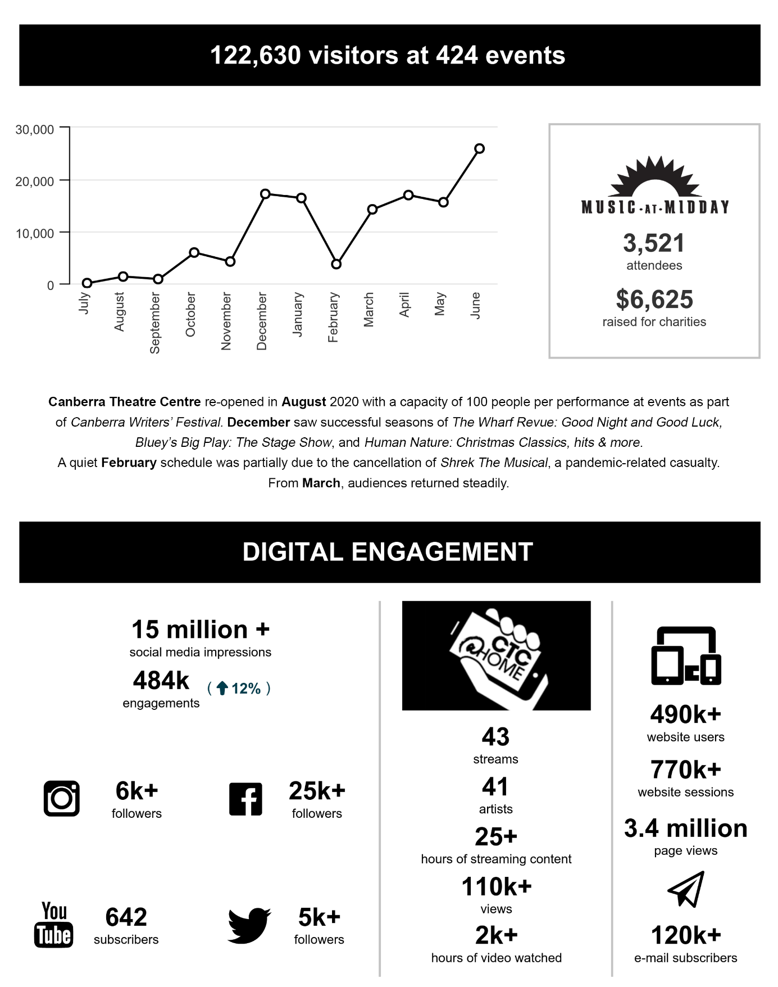

B.2.2 CANBERRA THEATRE CENTRE
What we are : the Canberra region’s main theatre centre, incorporating the Canberra Theatre, The Playhouse and the Courtyard Studio
What we do : we connect people with theatre experiences of national and international quality
Our vision : to be a leading theatre centre in Australasia and Asia
A smooth recovery from the COVID-19 pandemic :
Key outcomes in 2020–21
- The Canberra Theatre Centre (the Centre) worked closely with the Office of the ACT Chief Health Officer, other ACT agencies and the national performing arts industry to ensure the Centre managed its recovery from the pandemic in as safe and expedient manner as feasible. The Chief Health Officer and her team attended the Centre for a variety of meetings, site tours and events in order to understand operations so they could work with the Centre on its COVIDSafe procedures.
- Through this work, the Centre was able to reopen the Canberra Theatre to events and performances at a capacity of 100 people (8% capacity) in August 2020. Capacity limits and accompanying seat gap requirements moved through the following stage.
Date | Capacity Limit | Seat Gap
15 August 2020 | 100 pax | 1.5 m gap (3 seats and 1 row)
01 October 2020 | 50% | 2-seat gap
17 November 2020 | 67% | 1-seat gap
01 December 2020 | 75% by exemption | 1-seat gap
15 December 2020 | 75% | n/a
15 April 2021 | 100% | n/a
- One of the Centre’s primary adaptations following the COVID-19 closure period in 2019–20 was the shift to online streamed performances. The Centre launched its CTC@Home live streaming initiative in June 2020, and continued this streaming program of artists through the early return of live audiences in 2020–21. The entire CTC@Home season delivered 57 individual performances and received more than 140,000 views. The Centre offered other live-streamed events which are detailed below in the Programming section.
- As the COVID-19 restrictions eased, the Centre worked closely with other ACT agencies, especially ACT Health, to manage the safe return of audiences, staff and touring personnel to venues. Ensuring the safety of staff, audiences and performers required a range of COVIDSafe procedures, including limiting audience capacity, varying show structures, requiring all visitors to register and check-in, and offering additional shows to meet demand while maintaining audience limits.
- COVIDSafe measures were tailored to suit the specifics of each event. These included additional front-house and security staff, additional back-of-house procedures for dance school performances, and changes to productions with audience interaction.
- The first events to be held in the Canberra Theatre under the COVIDSafe Plan following reopening were events for the Canberra Writers Festival, where household groups were seated three seats and one row apart, with a maximum of 100 people in the 1,239-seat venue.
- The Centre used the smaller-capacity limits to showcase predominantly local music and comedy acts to limited-capacity audiences (no more than 100 people) in the Link Bar foyer area.
- Certain 2020 ACT Election events were also hosted, including the Elections ACT Announcement and Declarations.
- As restrictions further eased, the Centre continued presenting new productions, within the applicable COVIDSafe guidelines.
- Numerous events were cancelled or rescheduled, often multiple times throughout the year, due to ongoing changes to local restrictions and the effects of border closures, lockdowns and restrictions in other jurisdictions.
- Some opportunities did, however, arise from the fast-moving changes, including the opportunity for the Canberra Youth Theatre to present its production of NORMAL in The Playhouse in October 2020, and, with just 48 hours’ notice, the arrival of the Bluey’s Big Play: The Stage Show company to rehearse and premiere its production at the Canberra Theatre between December 2020 and January 2021. The rehearsals and premiere season were moved from Adelaide to Canberra as a result of COVID-19 restrictions applying at that time in South Australia.
- The COVID-19 pandemic necessitated a different approach to the traditional subscription season model, due to the lack of clarity around touring circuit production availability and safe venue capacity and operations. As a result, the traditional October launch did not proceed. Instead, in March 2021, as restrictions eased, former subscribers were invited to an event at the Centre, where 18 productions scheduled for 2021 were outlined, including three Sydney Theatre Company productions.
- Major productions of two musicals were secured, but not announced. The COVID-19 pandemic led to these productions being postponed. They are now expected to be performed in 2021–22.
Further specific outcomes relating to COVID-19 are identified in the following sections.
Customers – Audiences that are growing, diverse, engaged and entertained
Strategies to achieve this :
- Ensure our customers are the focus of all our activities.
- Provide public programs to enhance the onstage experience.
- Target initiatives to address special needs in the community.
- Develop young patrons, to ensure a future audience.
- Increase audiences, including from the region.
- To ensure the comfort and safety of patrons following the reopening of the Centre, complex planning and communication strategies were developed to ensure ticketholders were informed about production cancellations and reschedules. Website updates and information emails were sent to patrons 48 hours before their attendance to communicate COVID-19 safety procedures.
- The Centre’s booking system was updated to include the ability to add contact tracing details for all ticketholders. After the Check In CBR app became widely used, the Centre moved to align with the ACT Government’s QR code check-in system.
- The Centre continued to work collaboratively with the builders and owners of the new Constitution Place development, to maximise benefits for customers and visiting companies. This work included developing relationships with the new A by Adina hotel, and inviting selected patrons to try the new multistorey car park free of charge.
- Following a review of the ticketing and client relationship management (CRM) system, the Centre developed a Statement of Requirements for a modern ticketing platform and associated CRM system with the goal of enhancing customer service capacity.
- Orima surveys are normally sent to patrons of the Centre throughout the year, to gather information about the venue’s financial impact and a range of other issues. While Orima surveys were paused during the COVID-19 pandemic, attendees and subscribers were surveyed during the reopening period, to gauge their attitudes about returning to the venue. The Centre’s marketing team also sent a survey to subscribers in late 2020 to better understand who they are, and what the Centre can do to retain and engage them in the future.
- ACT Public Health Directions relating to gatherings and physical distancing limited the Centre’s opportunities to provide value-adding experiences and public programs during the pandemic.
- The Access Action Plan continued to inform the Centre’s decisions regarding accessibility improvements to the Centre. During the year, the Centre committed to replacing the carpet in all public foyer areas. As well as removing the trip hazards and uneven surfaces of the old carpet, the foyer improvements will include updating the hearing augmentation technology in the foyer, for foyer announcements and standardising tactile indicators across all foyers.
- Certain performances included access initiatives. For example, the performance by comedian Adam Hills on 5 May 2021 included an Auslan interpreter, who was integrated into Hills’ routine to great comedic effect.
- The Centre continued to work closely with VisitCanberra on initiatives to attract visitors to Canberra, including through alignment of forthcoming events with VisitCanberra’s Major Event vision, and through accessing VisitCanberra’s Major Event Fund.
- The Centre also continued to work closely with the City Renewal Authority (CRA), including on an initiative to incorporate the CRA’s audience segmentation research into visitation analysis and further segmentation work.
Programming – A diverse, high-quality, entertaining and distinctive program
Strategies to achieve this :
- Program high-quality, innovative shows that engage and entertain, and which include international companies and performers, digital programs, and connections to the Asian market.
- Ensure the range of genres presented at the Centre is appropriate for the venues, the marketplace and the supply of product.
- Provide culturally diverse shows as a part of regular programming, including shows featuring Indigenous cultures.
- Program to complement existing festivals and foster new festivals.
- Develop and extend programming for new audiences, with a particular focus on young people.
- Support local performing artists.
- Support producers that take the financial risk at the Centre.
- Attract large-scale shows to Canberra on a regular basis, including opportunities for exclusive Canberra seasons.
Key outcomes in 2020–21 against the above strategies
- The COVID-19 situation and subsequent restrictions presented the Centre with specific challenges in relation to presenting shows and performances. The Centre responded by initially providing a range of online and live-streamed content, and later presenting live performances in a COVIDSafe manner to ensure the safety of staff, patrons and performers.
- The CTC@Home program provided live-streamed performances to patrons over the course of the COVID-19 restricted period. Following its launch in June 2020, the program in 2020–21 featured 43 streams and 41 different artists, provided more than 25 hours of streamable content, attracted more than 110,000 views and was watched over more than 2,000 hours.
- The CTC@Home program included the online weekly series The World from Here with Chris Endrey. In response to the growing demand of audiences for a return to live performance, Chris Endrey’s final World from Here was presented as a combination of a streamed and live-audience event.
- The Centre also offered other live-streamed events, such as the film Tripping with Nils Frahm, Regurgitator Unit 20… at the movies! and a number of the popular Music at Midday performances.
- As COVID-19 restrictions eased, limited-capacity shows became available to small audiences. These included shows in the Courtyard Studio such as the Umbilical Brothers, and small-scale events (limited to 100 people) in the Link Bar foyer. In addition to comedy shows That’s What She Said and The Gig Economy, the Link Bar foyer hosted bands and musicians as part of the Link Bar series including :
- Emma Pask;  - Pork Knuckle Brass Band;  - Lucifungus;  - Chris Endrey & Friends;  - Pod People;  - Witchskull; and  - Michael Simic. | 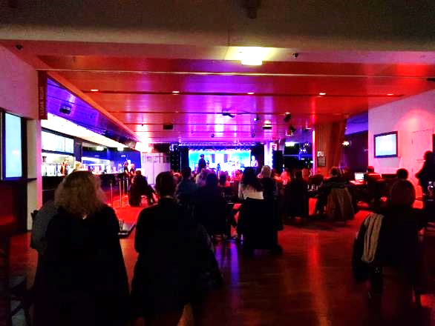  Live in the Link Bar
- The first event held at the Canberra Theatre under the Centre’s COVIDSafe Plan was the Canberra Writers Festival.
- The Centre hosted the interactive game-style show Canberra 2060: Futures with a Capital F as part of the Where You Are festival.
- The Wharf Revue: Good Night and Good Luck was presented with restricted capacity. As a production that would usually sell out, an extra week of performances was added to accommodate demand.
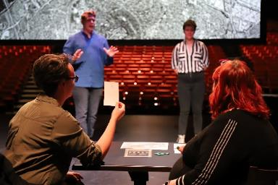  Canberra 2060: Futures with a Capital F,  credit Brigette Honeyman | 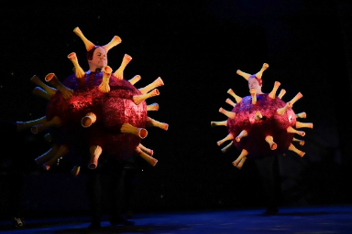  The Wharf Revue: Good Night and Good Luck,  credit Brigette Honeyman
- As restrictions eased, the Centre continued presenting productions, such as :
- Room on the Broom: Live on Stage!;
- Human Nature: Christmas Classics, hits & more;
- Circa’s Peepshow and Wolfgang’s Magical Musical Circus; and
- Hooked on Classics, conducted by George Ellis.
- The Theatre Reserve was used to support programming of a Canberra season of Shrek The Musical in early 2021. Unfortunately, however, the production did not proceed in Canberra due to the impact of COVID-19 restrictions interstate. While the Theatre Reserve was not therefore accessed in 2020–21, its use in securing this production demonstrated the importance of this fund to support the programming of major theatre productions for Canberra.

Business – Venues, systems and people that support high-quality live performances
Strategies to achieve this :
- Maintain the Centre’s venues and facilities to industry standards through the Asset Management Plan.
- Ensure all business areas are resourced, including staffing, for current and future levels of activity.
- Ensure marketing operations maximise ticket sales and support brand identity.
- Ensure Canberra Ticketing maximises ticket sales and seeks entrepreneurial ticketing opportunities.
- Ensure front-of-house operations create a high-quality customer experience and maximise financial returns.
- Ensure technical operations support high-quality theatre experiences.
- Increase Theatre Reserve through the Centre’s commercial activities.
- Use business metrics as a basis for future growth.
Key outcomes in 2020–21 against the above strategies
- In 2020–21, the Centre saw the completion of the majority of the three-year Stage 5 upgrade program, including completing the final-year upgrades to the Centre’s public toilet facilities. A small portion of the funding for the program was rolled over into 2021–22 to enable the completion of a consultancy into accessibility improvements in the Canberra Theatre.
- The second, and final, year of the Centre’s Stage 6 upgrades was undertaken in 2020–21, covering Phase 1 of a security system upgrade and an Electronic Access Control System connected to the ACT Government network.
- The Centre was able to access additional funds provided by the ACT Government to support local industry in recovering from the COVID-19 closure period. These additional funds enabled a second phase of the security system to be implemented, to cover the entire Centre, together with additional bathroom upgrades in the Canberra Theatre.
- The Centre’s allocation of Better Infrastructure Funding for 2020–21 was used to investigate, licence and purchase bespoke designed carpet for the Canberra Theatre, Link Bar and The Playhouse foyer areas. The new carpet, which will be installed in 2021–22, features a design taken from the Canberra Theatre’s original house curtain.
- In January 2020, the Centre migrated to Campaign Monitor, a modern email marketing system with the capacity for automation and integration. The click-to-open rate of the weekly e-newsletter has increased from an average of 1.98% to 5.91% : a threefold increase of customers engaging with the Centre’s email each week. The Centre sent more than 4.5 million emails in 2020–21.
- Due to the uncertainty and unpredictability of performances during 2020–21, the Centre did not conduct its regular patron surveys or collect information to track economic impact.
Leadership – An integral part of the cultural life of the Canberra region and beyond
Strategies to achieve this :
- Maintain a distinctive, clear and consistent brand for the Centre.
- Provide leadership in theatre education, including programs that link to the Australian curriculum, and vocational education and training (VET) programs in technical skills.
- Research and promote the importance of the Centre as a key driver of business activity in the city centre and a key contributor to the economy of the Canberra region.
- Develop a major new theatre appropriate for the nation’s capital.
- The Centre continued to support venue hirers by providing marketing and publicity for events in the Theatre; for example, with podcast interviews, and increased support of hirers such as Canberra Youth Theatre.
- The Centre’s marketing team exceeded ticket sales objectives, with sold-out productions of Room on the Broom: Live on Stage!, FANGIRLS and Bangarra Dance Theatre’s Sandsong. The team created assets for certain shows; for example, for Little Girls Alone in the Woods, which sold out and extended its season.
- The major musical Come From Away launched its Canberra season with an event at the High Commission of Canada.
- A special event for subscribers in March 2021 featured a wide range of productions coming to the Centre, including venue hirers and shows presented by the Centre itself. The offerings to subscribers included a three-play package of Sydney Theatre Company productions.
- In partnership with Canberra Institute of Technology, the Centre continued to deliver the VET training course Certificate III in Live Production and Services in Canberra.
- The VET Certificate III in Live Production and Services supports the creative and live performance industry in Canberra and the surrounding region by producing more technicians who are trained to professional industry standards. This leads to increased capacity in the arts, tourism and events sectors to deliver high-quality live performance and experiences, and encourages more investment in these sectors.
- In 2020, the Centre interviewed 22 applicants for the course, with 13 invited to formally enrol, and seven graduating. While venue restrictions were in force due to the COVID-19 situation, the Certificate III in Live Production and Services moved to online teaching, before returning to the theatre for face-to-face teaching as restrictions eased.
- In 2021, 22 applicants were interviewed and 14 enrolled, with 10 on the way to completing their certificate by year-end.
- The Discovery and Learning team continued its close relationship with educators and students in the region and assisted them in curriculum delivery, especially by presenting ACT UP! as an online festival of student theatre, and producing the Come Alive Festival. During 2020–21, the Centre sold 5,000 tickets for 10 productions to 70 schools and childcare centres.
- The Centre’s Discovery and Learning program also delivered a new Work Experience Program and offered this week-long program twice throughout the year.  - Groups of 10 students were invited to participate in a hands-on, informal tutorial-style introduction to the live performance industry. Students worked on a group project which was presented at the end of the week to a panel, as well as observing productions bumping in, and performing. | 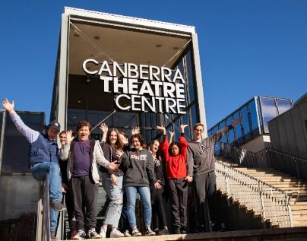  Work Experience students – July 2021, credit Brigette Honeyman

- The Centre continued to explore opportunities with surrounding accommodation and hospitality partners, including the new A by Adina hotel in nearby Constitution Place. Newly opened opportunities for pre-show and post-show dining include those found in the new Verity Lane Market and the food and beverage tenants of Lyric Lane in Constitution Place.
- Throughout 2020–21, the Centre continued to play a key role in the planning of a new major theatre for Canberra, including through its membership of the steering committee for the new theatre project. In conjunction with ACT Treasury, a digital survey of the Centre’s existing infrastructure commenced.
- The Centre participated in an interagency working group overseeing the development of a Conservation Management Plan for the Civic Square precinct, where the main focus for the Centre was on the heritage listing of the exterior of the Canberra Theatre.
- The Centre also worked closely with consultants engaged by the CRA in planning towards the Canberra Civic and Culture District.

CMAG at a glance
QUALITY OF SERVICE  100%  approval rating |  |   2,128  OBJECTS ON DISPLAY | PROGRAMS  114  programs delivered for CMAG and  The Nolan Collection  21 EXHIBITIONS  VISITORS  45,345*    VENUE HIRE  1,178 people attended private events at CMAG
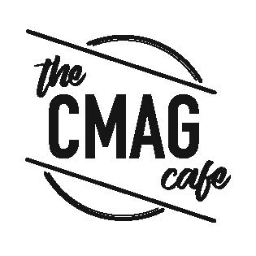  2,104 toasties and 415 soups served | 137 OBJECTS  added to  the CMAG Collection
25 SCHOOLS 
accessed 40 programs
1 wall removed to improve our exhibition space

*includes visitors for 2020 ACT Election voting

B.2.3 CANBERRA MUSEUM AND GALLERY
What we are : a museum and gallery dedicated to the visual arts and social history of the Canberra region
What we do : we connect people with the Canberra region’s rich and diverse stories, sense of place, and contemporary identity
Our vision : To be a leading regional cultural venue in Australia and beyond
A smooth recovery from the COVID-19 pandemic :
Key outcomes in 2020–21
- Following the COVID-19 closure period in 2019–20, the Canberra Museum and Gallery (CMAG) undertook a phased reopening, supported by a COVIDSafe Plan. This was reviewed and updated throughout the year, to ensure that CMAG met all current ACT Public Health Directions and that visitors understood the additional cleaning, contact tracing and physical distancing measures implemented.
- CMAG’s use as a polling station for the 2020 ACT Election combined the CMAG COVIDSafe Plan with the Elections ACT COVIDSafe Plan, to ensure the safety of visitors during the voting period.
- CMAG operated its programs, including openings, tours, workshops and education groups, within COVIDSafe policies, continuing to provide valued offerings and keeping the audience engaged.
- Community programs resumed at CMAG on 1 August 2020 with the launch of CMAG on Saturday. The first onsite learning program, modified in accordance with COVID-19 requirements, was delivered on 8 September 2020.
- The first CMAG exhibition opening event following the closure period was held on 5 March 2021 for the major new exhibition, HABITAT : Ways of living, which was opened by the Minister.
- As a result of changed work arrangements resulting from COVID-19 restrictions, CMAG staff increased skills and confidence in ICT tools to support collaborative work across interfaces such as Microsoft Teams.
- CMAG staff also developed a number of digital programs and continued to extend the access to exhibitions, collections and programs via the development of online resources. Following the cataloguing of nearly 3,000 items from the Canberra Photography Collection during CMAG’s closure period in 2019–20, these were subsequently uploaded onto CMAG’s Digital Asset Management and Collection Management Systems.
Further specific outcomes relating to COVID-19 are identified below.
Customers – Audiences that are growing, diverse and engaged
Strategies to achieve this :
- Ensure our customers are the focus of all our activities.
- Target initiatives to address special needs and interests in the community, extend the demographic of our customers, and reach out to those who do not currently access our services.
- Review visitor surveys and data to enable greater responsiveness in services and programming.
Key outcomes in 2020–21 against the above strategies
- Customer surveying 2020–21 resulted in CMAG receiving 100% approval ratings. CMAG managers and staff were proactive in responding to customer feedback and suggestions. For example, in response to comments received, CMAG introduced a PartyArt ticket option for Saturday workshops, which offers a discount for group bookings.
- Throughout 2020–21, planning continued towards securing improvements to CMAG’s facilities, including facilities to improve accessibility for customers, with funding received for this purpose in the 2021–22 ACT Budget.
- The inaugural CMAG Art Prize for secondary students was established and marketed to art specialists in secondary schools via the Arts Up Front network, and prize winners were announced.
- Throughout the year, CMAG continued to distribute a newsletter featuring secondary, primary and early childhood programs and resources for the education sector each school term.
- A renewed commitment to marketing CMAG exhibitions was demonstrated by regular full-page advertisements in The Canberra Times – for example, for Sign of the Times and HABITAT : Ways of living – as well as regular Panorama advertising and increased social media posts.
- CMAG curators and the Director engaged in regular print media and radio interviews throughout 2020–21, broadening CMAG’s marketing reach.
- The Front of House team participated in a staff workshop in October 2020 covering customer service skills, including sharing upcoming exhibition information to ensure staff are confident in engaging with visitor enquiries.
- Whole-of-CMAG staff meetings were introduced during 2020–21, bringing together Front of House staff and the broader CMAG team every four months.
- In 2020–21 CMAG began opening on public holidays to enhance its tourism/audience profile.

Programming – Exhibitions and programs that reflect Canberra’s unique identity
Strategies to achieve this :
- Program high quality, innovative exhibitions, education and community programs and other activities, using digital applications to enhance programs and systems.
- Ensure cultural diversity is part of regular programming, including exhibitions and programs featuring Indigenous cultures.
- Develop and extend programming for young audiences.
- Provide programs that complement, but make a point of difference with, the national cultural institutions, highlighting CMAG’s unique focus on the Canberra region including by featuring regional artists.
Key outcomes in 2020–21 against the above strategies
- CMAG presented an exhibition program in 2020–21 that reflected the diverse interests of the Canberran community. New exhibitions presented during the year included the following.
- Richard Lewer : I Can’t Just Run Away All My Life Sometimes I Just Have to Stand and Fight was presented in partnership with the Contour 556 Public Art Biennial. The associated symposium, Making Art in Canberra’s Public Domain : Legacies and Futures, hosted at the Canberra Theatre Centre, was presented by Contour 556 and CMAG.
- Flow Line featured abstract paintings from the CMAG Collection.
- Sign of the Times, a CMAG collection-based exhibition, featured diverse stories including Canberra’s first LGBTQI nightclub and stories of businesses established by post-war migrants – this exhibition attracted significant interest and attendance including through word-of-mouth promotion, and activated many individual and community memories.
- The Blade : Australia’s love affair with Lawn, a touring exhibition, featured stories of Indigenous land care and management and those that relate to the traditional owners of the local region. This exhibition was presented in partnership with the Canberra branch of the Australian Garden History Society.
- HABITAT : Ways of living featured works by contemporary artists from Canberra and around Australia revealing ways of living in a variety of environments, from apartments, to suburbia, to locations enduring the collapse of their communities.

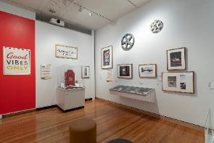 | 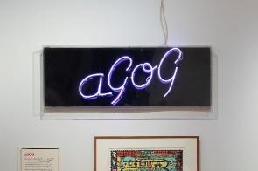 | 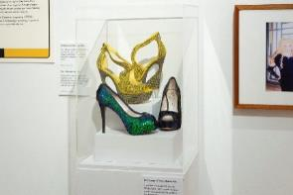
CMAG exhibition Sign of the Times, credit RLDI

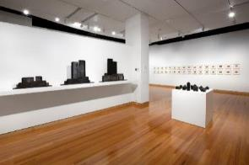 | 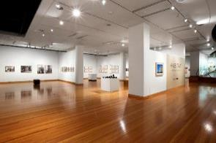 | 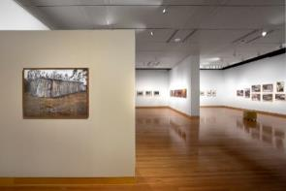
CMAG exhibition HABITAT : Ways of living, credit Andrew Sikorski Art Atelier

- A full list of CMAG exhibitions presented in 2020–21 is provided in Appendix 5, page 93.
- An online catalogue template, which was developed for the exhibition Building a Life : The Jennings Germans story during the COVID-19 closure period in 2019–20, was used in 2020–21 for the exhibition The Art of the Fan.
- Online learning resources developed by CMAG during the year included Access and Learning Officer-led tours, which were made available for preschool students in association with Seeing Canberra and The Nolan Collection.
- During 2020–21, CMAG worked in partnership with the Australiana Fund to develop the major social history exhibition Ruth Lane-Poole : A Woman of Influence, for presentation in 2021–22.
- Access and Learning staff partnered with Thunderstone Aboriginal Cultural Services to create the Ngunawal Story Time project, launched during NAIDOC week.
- CMAG hosted a CareerTrackers intern, participating in the nationwide program to support the development of early-career Indigenous Australians.
- CMAG staff continued to build relationships with Aboriginal and Torres Strait Islander artists, curators and academics in the development of relevant exhibitions of Indigenous Australian Art. CMAG also implemented the practice of employing Indigenous Australian curators to lead the curation of exhibitions of Indigenous content.
- CMAG presented several exhibitions of The Nolan Collection throughout the year, including Sidney Nolan and St Kilda : Memory and Modernism, from August 2020 to March 2021. The exhibition included loans from Heide Museum of Modern Art and examined Sidney Nolan’s early works associated with St Kilda. A second exhibition, Sidney Nolan : Remembrances of my youth, commenced in April 2021.
- Two floor talks in association with exhibitions Flow Line and Building a Life : The Jennings Germans story were filmed with the support of Canberra Theatre Centre.
- HABITAT : Ways of living artist Tina Havelock Stevens and fellow performer Liberty Kerr gave a Friday night drumming/cello performance celebrating the eve of World Environment Day.
- COVIDSafe activities for families with children, connected the CMAG collection to artmaking and children’s literature, in the MakerSpace and ReaderSpace areas within the CMAG foyer. A Children’s Trail on Instagram was launched, while other programs for younger visitors included the Nolan school holiday workshop, Merry Go Round, in association with Sidney Nolan and St Kilda : Memory and Modernism.

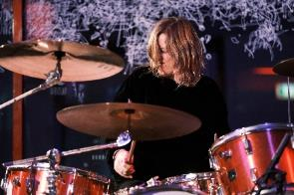 | 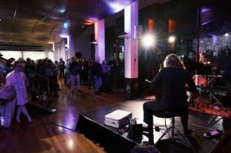 | 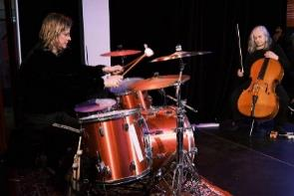
Performance : HABITAT : Ways of living, credit Andrew Sikorski Art Atelier

Stewardship – Venues and collections that allow us to tell the many stories of Canberra
Strategies to achieve this :
- Maintain CMAG’s venues and facilities to industry standards.
- Develop, conserve and research CMAG’s integrated visual arts and social history collection.
- Digitise CMAG’s collection.
- Care for the Nolan Collection and enhance its presentation.
Key outcomes in 2020–21 against the above strategies
- During 2020–21, CMAG undertook capital upgrades with its allocation of Better Infrastructure Funding. These upgrades included the removal of a wall in gallery 2/3, to improve the exhibition space and facilitate the display of larger exhibitions.
- 137 objects were added to the CMAG Collection during the year, and 80 works of art were added to the CMAG collection page online.
- A review of the CMAG Collection Policy was finalised and the Nolan Management Agreement with the Australian Government was also renegotiated and finalised.
- A successful grant application was submitted to The Gordon Darling Foundation for a new permanent collection publication for CMAG : a 500-page hardcover book. A number of external writers were confirmed for the project, which devotes a chapter specifically to The Nolan Collection.
Leadership – An integral part of the cultural life of the Canberra region and beyond
Strategies to achieve this :
- Enhance and extend CMAG’s presence and profile in North Building, to provide greater visibility on Civic Square and London Circuit; more spaces to deliver a greater range of exhibitions and activities; a dedicated family and children’s space; a retail space; a larger café facility; improved venue hire areas, including a large foyer space.
- Promote the role of CMAG as a major visitor attraction in the city centre of Canberra.
- Pursue productive partnerships with other cultural organisations, Canberra region artists, and the wider community in developing and delivering our programs.
Key outcomes in 2020–21 against the above strategies
- CMAG continued its work on revitalising its street frontage. Plans were finalised for revitalised signage on London Circuit, to ensure CMAG is more visible from the street. CMAG also began refreshing its exterior, including new signage above the front door at the Civic Square entry and repainting the front doors.
- Planning also continued on further improvements to CMAG’s facilities, including the CMAG foyer. As part of the foyer revitalisation, the donation of a major Canberra-related glass work by Brian Corr, Timshel (2012) was secured, which will highlight the Canberra community of glass artists.
- In addition to this gift of a major public artwork, in 2020–21 CMAG succeeded in attracting a range of monetary donations for artworks, and also sponsorship for exhibitions.
- Several CMAG staff presented at the Australian Museums and Galleries Association Conference in June 2021 and assisted in the planning, coordination or delivery of a number of panel sessions.
- During 2020–21, CMAG welcomed its new Director, Dr Sarah Schmidt, who began work on 26 October 2020. The new CMAG Director contributed extensively to ‘arrival’ media and events : in local print and radio via interviews, and to the arts community via several public speaking engagements and written pieces, such as for Craft ACT and the Canberra Critics Circle.
- CMAG liaised with curator Margaret Betteridge, the Australiana Fund, the office of the Governor-General of Australia and major institutional lenders such as the National Library, in developing the exhibition Ruth Lane-Poole : A Woman of Influence, for presentation in 2021–22.
- CMAG participated in an interagency working group overseeing the development of a Conservation Management Plan for the Civic Square precinct, where the main focus for CMAG was on the heritage listing of North Building, in which it is located.
- CMAG also worked closely with consultants engaged by the City Renewal Authority, in planning towards the Canberra Civic and Culture District.

ACT HISTORIC PLACES AT A GLANCE
VISITORS  57,593  WEDDINGS AND EVENTS  9  weddings celebrated at Lanyon  including 1 First Nations wedding with smoking ceremony  BUILDINGS  A total of 20 fireplaces maintained across Lanyon, Calthorpes’ House and Mugga-Mugga  Number cubby houses  = 1 at Calthorpes’ House  Number of hospital doors  = 1 at Mugga-Mugga Cottage (upcycled from the Canberra Hospital) | GARDENS AND GROUNDS    16,700 bulb and annuals planted at Lanyon  16 different native shrub varieties with a total of 178 plants propagated at Lanyon  52 native flora species recorded  at Mugga-Mugga  Over 400 trees pruned and dead wooded to prepare Lanyon for the bushfire season | VOLUNTEERS    Volunteers attended for 564  hours    Lanyon Homestead  Tripadvisor Travellers’ Choice Award winner  for 2021
 | CONSERVATION AND HOUSEKEEPING    Over 620 collection items catalogued and entered onto database  Historic floors, furniture surfaces and hundreds of collection items were cleaned over 250 times | PUBLIC PROGRAMS  208 learning and community programs  

B.2.4 ACT HISTORIC PLACES
What we are : three historic places that reflect different aspects of Canberra’s history: Lanyon Homestead, Calthorpes’ House and Mugga-Mugga
What we do : we connect people with Canberra’s rich and diverse stories and heritage
Our vision : to be leading historic places in Australia and beyond
A smooth recovery from the COVID-19 pandemic :
Key outcomes in 2020–21
- Following the COVID-19 closure period in 2019–20, ACT Historic Places (ACTHP) managed the phased reopening of its sites and resumption of events and programs. Lanyon and Calthorpes’ House had already opened prior to the 2020–21 year commencing, with Mugga-Mugga reopening shortly afterwards, on 4 July 2020.
- Each historic property initially reopened with outdoor tours only, interpreting the property’s gardens and outbuildings for visitors. Indoor museum tours were suspended until February 2021, to comply with physical distancing recommendations.
- Once they recommenced, indoor tours were modified to comply with COVID-19 restrictions, including caps on attendance numbers and the introduction of online bookings to manage group numbers and tour times. This resulted in higher participation rates compared with pre-COVID-19 levels.
- The COVID-19 situation continued to present new challenges throughout 2020–21 and ACTHP responded by adapting and innovating.
- For example, the planned Artist-in-Residence onsite exhibition was replaced with an online exhibition, Creating Lanyon, co-curated with Artist Society of Canberra (ASOC) artists from works produced during their Lanyon Homestead residency.
- Cancelled public programs were replaced by blogs, including Our Convict Women, A Bungalow-Style Garden, and by the newly launched Object Stories series, in which ACTHP staff interpret the history behind selected objects from ACTHP collections and sites.
- Public programs recommenced on site in September 2020 and included events for Floriade : Reimagined, and displays at Lanyon Homestead.
- Learning programs for schools also recommenced on site in September 2020, initially modified to comply with COVID-19 limits on group sizes and program duration. This included developing new two-hour programs : Lanyon’s Landscape : First Nations, Peoples, Settlers and Convicts; and James’ Diary.
- In 2021, normal learning programs resumed, including additional rotations at Calthorpes’ House and Mugga-Mugga to comply with COVID-19 capacity requirements.
Further specific outcomes relating to COVID-19 are identified in the following sections.
Customers – Audiences that are growing, diverse and engaged
Strategies to achieve this :
- Ensure our customers are the focus of all our activities.
- Target initiatives to address special needs and interests in the community, extend the demographic of our customers, and reach out to those who do not currently access our services.
- Review visitor surveys and data to enable greater responsiveness in services and programming.
Key outcomes in 2020–21 against the above strategies
- Throughout 2020–21, ACTHP continued its commitment to providing excellent visitor experiences.
- Visitors continue to show enthusiastic approval of ACTHP experiences. Visitor satisfaction survey results from 2020–21 confirmed high ratings : 94% of visitors rated their experience of guided tours 8 out of 10 or higher, with 63% rating their tour experience 10 out of 10. 96% of participants rated public programs 4 out of 5 or higher, with 77% rating their experience 5 out of 5. 80% of teachers rated learning programs 4 out of 5 or higher, with 47% of teachers rating the programs 5 out of 5.
- The new visitor survey for ACTHP, launched in July 2020, was adapted in response to COVID-19 recommendations : it now uses a QR code, which links visitors directly to the survey and removes the need to use an iPad (thus removing a shared surface and the associated COVID-19 risks). ACTHP also provides a QR code that links to Trip Advisor, to encourage visitors to provide public feedback and help raise awareness of ACTHP properties.
- In 2020–21, ACTHP welcomed 57,593 visitors to Lanyon, Calthorpes’ House and Mugga-Mugga (compared to 40,402 in 2019–20). This included 2,163 students attending 182 learning programs; 2,285 visitors participating in 599 museum tours, and the attendees at 26 public programs.
- In response to COVID-19 restrictions, ACTHP developed new outdoor tours at each historic property, and learning programs at Lanyon, to enable a safe reopening for visitors while interior spaces were still closed.
- ACTHP’s digital strategy continued to grow, with a greater focus on digital marketing resulting in a noticeable increase in digital engagement with visitors. Website traffic increased by 43% and pageviews increased by 40% compared to 2019–20. This was also a 37% increase over 2018–19, the most recent year not impacted by COVID-19. The transition to digital marketing for public programs and museum tours also increased participation rates and bookings.
- Social media continued to provide a valuable outreach channel; for example 36,900 people accessed the ACTHP Facebook page, a 2% increase from 2019–20.
- The ACTHP logo, launched in 2019–20, and the tagline Step into the Stories were used throughout 2020–21 on the website, promotional material and digital marketing.
- ACTHP volunteers provided 564 volunteer hours across all three properties in a range of visitor services in 2020–21. These hardworking volunteers were celebrated at Volunteer Appreciation Events held on 31 August 2020 and 17 May 2021.
Programming – Programs that explore Canberra’s history by interpreting each place
Strategies to achieve this :
- Program high-quality, innovative education and community programs and other activities, using digital applications to enhance programs and systems.
- Ensure cultural diversity is part of regular programming, including exhibitions and programs featuring Indigenous cultures.
- Develop and extend programming for young audiences.
- Provide visitors with additional insights into the historic sites through permanent and temporary exhibitions.
Key outcomes in 2020–21 against the above strategies
- During the year, ACTHP provided a diverse range of workshops, tours and public events that offered the community many opportunities to learn about, celebrate and enjoy the region’s heritage.
- In a major highlight for the year, ACTHP collaborated with EventsACT to establish Lanyon as the primary Floriade : Reimagined location for south Canberra, following the cancellation of Floriade at Commonwealth Park in 2020. In addition to the Floriade : Reimagined floral displays, Lanyon offered a month of public programs covering heritage, music, art and Aboriginal culture and history. These included :
- Lanyon Heritage Precinct Tours, complemented by Outdoor Heritage Tours conducted in partnership with Cuppacumbalong Homestead to interpret the related histories of both homesteads and the region;
- Children’s workshops, such as KIDS@ACTHP : Rattle your Tin Dog! and KIDS@ACTHP : Children’s Drawing Trail;
- A Waltz through the Tulips, a music program in partnership with the University of Sydney;
- Art workshops : Art Makers at Lanyon : Drawing Interiors and Art Makers at Lanyon–Still Life, Watercolour and Gouache, with local artist Naomi Zouwer;
- Canoe Tree Walk, a cultural walk exploring Aboriginal history with Ngunnawal elder Wally Bell; and
- The Floriade Family Day Out, hosted by EventsACT.

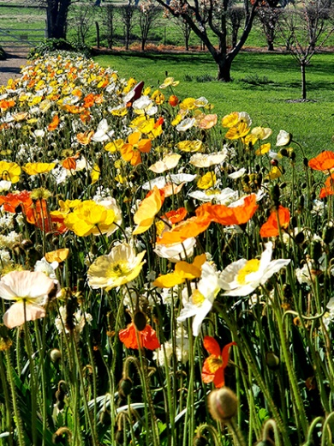  Flowers on display at Lanyon |  | 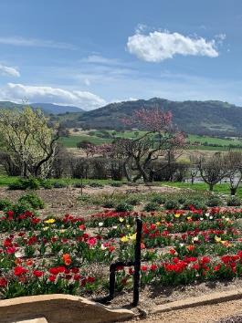  Flowers on display at Lanyon |  | 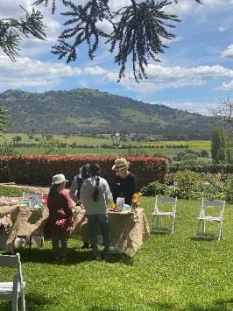Children’s Drawing Trail program at Lanyon
 | 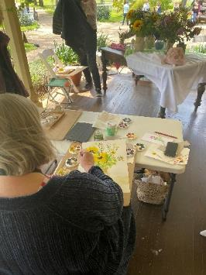 |  | 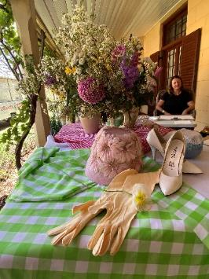
Local artist Naomi Zouwer at Lanyon | Art Makers at Lanyon - Still Life, Watercolour and Gouache workshop and props, with local artist Naomi Zouwer at Lanyon

- The Floriade-linked programming resulted in a 28% increase in visits compared to the previous period in 2019 – a very pleasing result, especially since these were the first public programs delivered after the COVID–19 closure period and were carried out within COVID–19 restrictions regarding numbers, capacity and social distancing.
- The Wellbeing Workshop series launched in March 2021, supported community wellbeing through art, craft and heritage. This included three workshops at Lanyon: Stitching for Wellbeing; Make a Pinch Pot Tea Bowl; and Watercolour Patterns for Mindfulness.
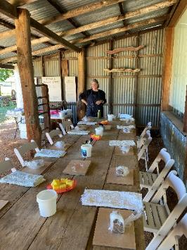 | 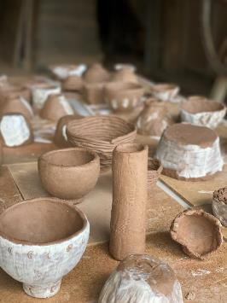 |  | 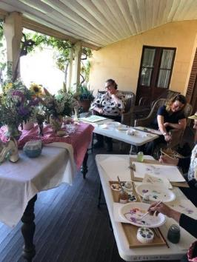
Make a Pinch Pot Tea Bowl program preparation and creations at Lanyon,  credit Jodie Cunningham |  | Watercolour Patterns for Mindfulness  program at Lanyon

- April 2021 saw the launch of the Harvest Day Out – a day of tours, workshops and children’s programs and a celebration of the gardens and autumn harvest at Lanyon. This event was held during the ACT Heritage Festival and included talks and workshops on historic sustainability and gardening, such as the Preserve your Harvest Talk, My Mini Succulent Garden Family Workshop and Permaculture and Millpost Farm Talk. Tours offered included the Lanyon Garden History Walk and Lanyon House Tours, and the day included An Autumn Jig music performance in the tradition of harvest celebrations.

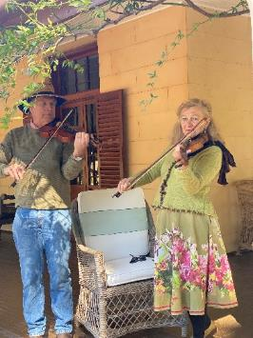 | 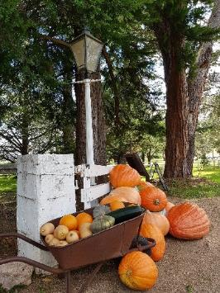 | 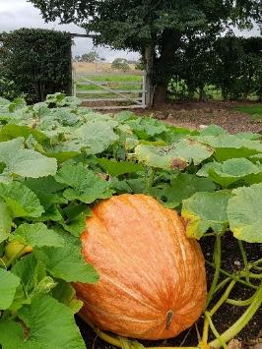
An Autumn Jig program - Jenny Gall and David Game performed at Lanyon, credit Jodie Cunningham | Giant pumkins and produce on display at Lanyon, credit Neil Walsh

- The Harvest Day Out also included Ngunnawal elder Wally Bell’s Canoe Tree and local Ngunnawal Stories Walk, one of ACTHP’s collaborative public programs with Aboriginal presenters/facilitators dedicated to increasing understanding and appreciation of Aboriginal values, history and stories of Historic Places sites and the Canberra region. This commitment was continued in Wiradjuri Echoes by the Rive, a program with Duncan Smith OAM, held during April 2021 as part of ACTHP’s School Holidays Program.
- The display building for the renewable energy ‘Cobber’ engine at Mugga-Mugga was completed in 2020–21. This initiative by a private provider is being implemented in close collaboration with ACTHP. Building and testing the engine was delayed due to the impact of COVID-19 on international freight and imports, with installation of the engine now expected in 2021–22.
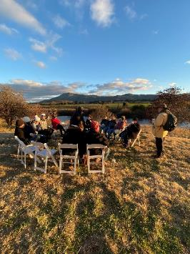  Legends of Lanyon with Tim the Yowie Man program at Lanyon, credit Jodie Cunningham | - New outdoor tours were established, highlighting the gardens and precincts of ACTHP sites while indoor tours were suspended due to COVID-19 restrictions. The new Beyond the Farm Gate tour was opened to the public on 26 March 2021. This two-hour tour, conducted monthly through autumn, winter and spring, provides access to, and interpretation of, areas surrounding the Lanyon precinct not usually available to visitors.  - ACTHP launched the pilot public program Legends of Lanyon with Tim the Yowie Man in June 2021. The event was sold out and will be repeated in 2021–22.

Stewardship – Buildings, grounds and collections that are conserved and researched
Strategies to achieve this :
- Maintain, conserve and research the buildings, grounds and collections of the Historic Places, within the framework of the Conservation Management Plan for each site.
- Develop Lanyon’s collection of decorative and fine arts.
- Digitise the Historic Places collections.
- Position the heritage-listed gardens of the Historic Places as ‘green collections.’
Key outcomes in 2020–21 against the above strategies
- 2020–21 saw the continued implementation of projects to upgrade and improve ACTHP properties, together with a continued commitment to the conservation and restoration of the collections, properties and grounds.
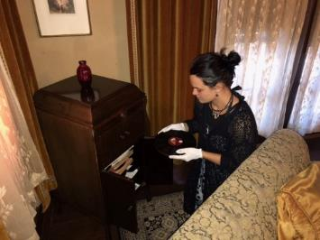 | 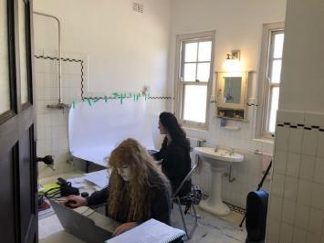
ACTHP Collection Accession officers working on cataloguing the collection at Calthorpes’ House
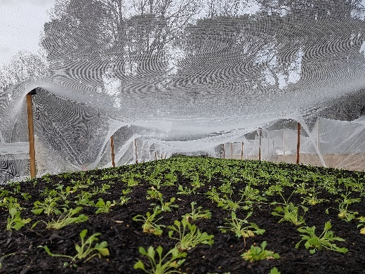  Plants for 2021 display at Lanyon, credit Neil Walsh | 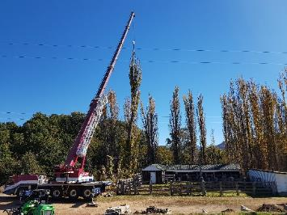  Poplar tree removal at Lanyon, credit Neil Walsh

- The Aboriginal Cultural Heritage Survey of Mugga-Mugga was finalised in 2020–21 in consultation with local Aboriginal groups. The survey will help conserve and interpret Aboriginal sites on ACTHP properties in keeping with Aboriginal cultural values and heritage.
- The Grasslands Management Plan for Mugga-Mugga, prepared by Sarah Sharp, continued to be implemented in 2020–21, including through an ecological survey of the site’s grasslands. The Plan provides the management framework for supporting regrowth of listed native grasslands on the site through monitoring and rotational grazing.
- In support of rehabilitating the grasslands, the Fencing Project at Mugga-Mugga was completed in June 2021 : the Fencing Project will allow rotational grazing, an essential step in regenerating the native grasslands.
 | 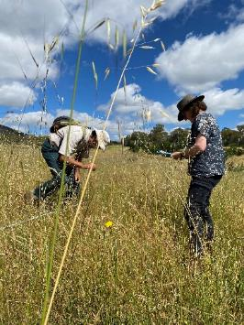 | 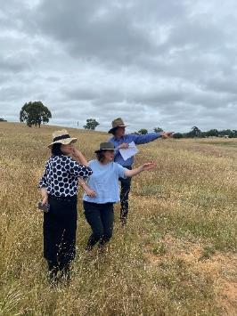
Yellow buttons grassland monitoring at Mugga-Mugga, credit Jodie Cunningham |  | Land management at Mugga-Mugga, credit Jodie Cunningham
- Major capital works at Lanyon progressed throughout 2020–21. Scoping of conservation works, as part of the Lanyon Homestead Conservation Project, was completed and the implementation of these works will begin in 2021–22. The new Lanyon Homestead workshop was completed in 2021, providing much-improved facilities for grounds staff who care for the site, and for storage of equipment and supplies used in this care.
- The Water Supply Infrastructure Upgrade project at Lanyon saw the completion of its concept design, Cultural Heritage Survey, test bore and final design and documentation. As the first test bore failed to locate water, a second test bore will be drilled in 2021–22.
- As part of the ongoing Security Upgrade Project for ACTHP, security assessments of each site were completed, with upgrades in response to these assessments planned for 2021–22. The new communications tower installed on Mt Tennant will provide a more direct wi-fi connection at Lanyon, supporting the site’s security as well as its operations more generally.
- The ACT Historic Places Bushfire Operation Plan for Lanyon was reviewed, updated and submitted to the Emergency Services Agency (ESA) Commissioner, as required under the ESA Fire Management Strategy for ACT. Annual bushfire and emergency training for all staff was held at Lanyon in December 2020.
- ACTHP continued to monitor the progress of a proposed subdivision Development Application (DA) of the block adjacent to Mugga-Mugga Cottage, after making a submission outlining heritage, environmental and planning concerns during the DA public notification period in January 2020. Advice was received in May 2021 that the proposal had not been approved.
- ACTHP worked with ACT Wildlife to continue its care and protection of the many wombats at Lanyon. Care included treating for mange and ongoing monitoring of the wombat population.

Leadership – An integral part of the cultural life of the Canberra region and beyond
Strategies to achieve this :
- Develop Lanyon as a heritage tourism hub and a ‘must see’ attraction for visitors wanting to experience Australia’s settlement history.
- Use the Lanyon Heritage Centre to welcome visitors to the Lanyon site and to research and promote Lanyon’s significance.
- Open up more spaces in Lanyon Homestead for historical interpretation.
- Present Calthorpes’ House as Australia’s best example of a domestic museum of the 1920s.
- Present Mugga-Mugga as an authentic setting to experience life on the Limestone Plains before Canberra was established.
- Ensure the Historic Places are used as examples of best practice in cultural heritage management, including for tertiary education.
- Extend the portfolio of Historic Places, to include sites that allow Canberra’s more recent history to be explored.
Key outcomes in 2020–21 against the above strategies
- ACTHP’s relationships with many other cultural, government and heritage bodies continued to grow during the year, supporting its ability to develop and expand programming and conservation projects.
- Joint programs and marketing during ACT festivals throughout the year provided good opportunities for new public programs and attractions, as part of Floriade : Reimagined in 2020, and Enlighten and the ACT Heritage Festival in 2021.
- ACTHP collaborated on digital marketing with EventsACT, VisitCanberra and ACT Heritage to increase market reach and audience, and reached broader marketing opportunities by programming major ACTHP events in conjunction with these major ACT events.
- In addition to the many public programs offered at Lanyon in its role as the main south Canberra venue for Floriade : Reimagined, Lanyon hosted the Floriade photography workshops and Sunday Program normally held at Commonwealth Park.
- The Lanyon Heritage Centre continued to provide a valuable teaching space for education programs, and dedicated storage for museum collections.
- Lanyon remained a popular venue for functions and weddings. Despite COVID-19 restrictions on gatherings, 21 functions were held in 2020–21, including nine weddings – one a First Nations wedding with a smoking ceremony.
- ACTHP undertook a review of the function and wedding hire packages it provides, with a view to providing simpler and customer-focused packages, which will support its continuing efforts to promote Lanyon as an attractive venue for a range of events and celebrations.
- Continuing efforts to develop Lanyon as a heritage tourism hub and a ‘must see’ attraction for visitors resulted in Lanyon rising to the rank of #7 among 56 attractions in Canberra, moving from #25 in the previous year, and receiving a TripAdvisor Travellers’ Choice Award for 2021.

B.3 Scrutiny
Auditor-General Report No. 2/2018 – ACT GOVERNMENT STRATEGIC AND ACCOUNTABILITY INDICATORS
Recommendation No. 2 summary | Action | Status
CFC’s strategic indicators should be improved so they meet the Quantifiable measurement criterion. If the strategic indicators cannot meet the criterion of Quantifiable through supporting quantitative data, CFC should use qualitative data that can be assessed and explained through commentary. | Once CMTEDD update the Performance and Accountability Framework, CFC will use the revised criteria as the basis for assessing the suitability of its Strategic and Accountability indicators. | Completed. CFC’s 2021–22 Statement of Intent, which includes its strategic indicators, was prepared after reviewing the updated CMTEDD Performance and Accountability Framework.
There were no Auditor-General reports that related specifically to the CFC in 2020–21.
There were no Legislative Assembly Committee reports that related specifically to the CFC in
2020–21.
For further information contact : CFO, CFC Corporation Finance (02) 6205 2195

B.4 Risk Management
The CFC commenced work on a new Risk Management Framework and Policy in 2020–21, which is expected to be finalised in 2021–22, together with a new CFC Risk Management Plan. These new documents will guide and inform risk management activities across the CFC including for the CFC’s Strategic Risks, Fraud Corruption and Control, and Work Health and Safety.
The CFC already has in place a comprehensive Strategic Risk Management Plan (SRMP), which is implemented, monitored and updated on an ongoing basis. This document provides the framework for supporting strategies and plans relating to more specific areas of risk, such as disaster preparedness and business continuity plans.
A revised SRMP was approved by the Board in December 2020.

B.5 Internal Audit
The CFC Audit Committee, a subcommittee of the CFC Board, met on six occasions during 2020–21. Meetings were held on 23 July 2020, 24 September 2020, 26 November 2020, 28 January 2021, 25 March 2021 and 27 May 2021. The number of meetings attended by Committee members was as follows :
Name of Member | Position | Meetings attended
Shad Sears | Chair | Six
Harriet Elvin | Member | Five
Helen O’Neil | Member | Five
The CFO is invited to each meeting as an observer and an invitation is also extended to the ACT Audit Office to send an observer to each meeting.
The Part G of the CFC Board Charter sets out the operations for the Audit Committee and incorporates specific roles for risk management and audit matters. It is available at http://www.culturalfacilities.act.gov.au.
INTERNAL AUDIT
The Audit Committee reviews and approves an internal audit/quality assurance plan for each financial year. A Chief Executive Financial Instruction has been issued dealing with audit committee and internal audit matters.
During the year an internal audit of the Canberra Theatre Centre Ticketing and Revenue process was completed, which reviewed controls and financial practices for the processing and recording of ticketing revenues. The audit found that, overall, controls and practices had been implemented soundly while suggesting certain opportunities for improvements.

B.6 Fraud Prevention
The CFC has a comprehensive Fraud Control Plan (FCP) which is implemented and monitored on an ongoing basis. Oversight of this plan is undertaken by the Audit Committee, as one of the roles under its Charter – refer to http://www.culturalfacilities.act.gov.au.
A revised FCP was approved by the Board in October 2020.
The CEO’s “start the year” email for 2021 reminded staff of their responsibilities with regard to fraud control and prevention.

b.7 FREEDOM OF INFORMATION
Open Access Information - Section 96 (3) (a) (i), (ii) and (iii)
- Number of decisions to publish Open Access information. 16
- Number of decisions not to publish Open Access information. 0
- Number of decisions not to publish a description of Open Access information withheld. 0
FOI Applications received and decision type - Section 96 (3) (a) (iv), (vii), (viii) and (ix)
- Number of access applications received. 12
- Number of applications where access to all information requested was given. 11
- Number of applications where access to only some of the information requested was given (partial release). 0
- Number of applications where access to the information was refused. 1
FOI processing timeframe - Section 96 (3) (v) and (vi); Section 96 (3) (d)
- Total applications decided within the time to decide under section 40. 11
- Applications not decided within the time to decide under section 40. 1
- Number of days taken to decide over the time to decide in section 40 for each application. 5 days. This was with the approval of the respondent under section 41 within 20 working days of the application.
Amendment to personal information - Section 96 (a) (x) and Section 96 (3) (e)
- Number of requests made to amend personal information, and the decisions made (e.g. amended, refused, notation added to record, other). 0
Reviews – Section 96 (3) (b); Section 96 (3) (c)
- Number of applications made to Ombudsman under section 74 and the results of the application (e.g. affirmed, varied, set aside and substituted, withdrawn, other). 0
- Number of applications made to ACT Civic and Administrative Tribunal under section 84 and the results of the application (e.g. affirmed, varied, set aside and substituted, withdrawn, other). 0
Fees - Section 96 (3) (f)
- total charges and application fees collected from access applications. 0
FOI requests can be made by contacting the Cultural Facilities Corporation FOI Information Officer, PO Box 939 CIVIC SQUARE ACT 2608 or emailing CFCcorporatefinance@act.gov.au.
Further information can be found at http://www.culturalfacilities.act.gov.au.

b.8 COMMUNITY ENGAGEMENT AND SUPPORT
The CFC actively seeks to engage its communities in a greater understanding of the value of the arts, and of cultural heritage, through its programs and activities, placing customer service as its primary goal and recognising the diverse needs and expectations of customers. A summary of actions taken by the CFC during 2020–21 in terms of community engagement and support is provided below, with detailed information presented about each of these actions under Section B.2, page 30.
During the year, CMAG and ACT Historic Places presented a diverse range of high quality exhibitions, learning and community programs and other activities, including on site and online. Productive partnerships were developed with other cultural organisations, the tourism sector and the wider community in developing and delivering programs and events. The Canberra Theatre Centre connected the community with the performing arts, including through initiatives that addressed special needs in the community. The Centre provided a wide range of activities for the education system and wider community.
The CFC’s digital strategies provided new community engagement opportunities through the use of social media and digital programming. Digital engagement activities were particularly important for maintaining contact with the communities the CFC serves during the recovery period from site closures due to COVID-19 restrictions, and a number of new digital initiatives were introduced, such as museum online learning programs extending the access to exhibitions, collections and programs. ACT Historic Places collaborated with EventsACT, VisitCanberra and ACT Heritage via digital marketing to broaden community engagement and increase audiences for major events such as Floriade : Reimagined, 2021 Heritage Festival and the Enlighten Festival.
Once restrictions eased, COVID-19 safe activities for the community resumed; for example, the MakerSpace and ReaderSpace areas within CMAG were used for artmaking by families, and children’s literature.
The CFC continually seeks to improve customers’ satisfaction with their visit to, and experience of its venues. Customer satisfaction surveys were conducted throughout the year and reported as part of the CFC’s 2020–21 Statement of Performance. Information gained from the surveys was used in future planning to improve facilities and services.
A major community engagement activity for the CFC is the operation of its three CFC advisory committees. In 2020–21, the CFC’s advisory committees provided advice on a range of specialised matters relating to the operation of the CFC’s three program areas : CMAG; ACT Historic Places; and the Canberra Theatre Centre.
Engagement tools included a plenary workshop of all committee members in November 2020 and individual sessions of each committee throughout the year. The final plenary workshop of the year was held in June 2021 and provided input into development of the CFC’s new Strategic Plan for 2021–24. 16 advisory committee members participated in these engagement activities, providing expert strategic advice to the CFC throughout the year, on a voluntary basis, and providing important links between the CFC and the wider community.

B.9 ABORIGINAL AND TORRES STRAIT ISLANDER REPORTING
The CFC ensures cultural diversity is an essential feature of its regular programming, including exhibitions, theatre presentations and programs featuring Indigenous cultures. Examples of activities in each area of the CFC in 2020–21 are provided below.
Canberra Theatre Centre
- The Centre presented a program of digital events during CTC@Home featuring performances and live reads by local Aboriginal and Torres Strait Islander peoples including Dan Bourcher, Dylan Vandeberg, and Ritchie Allen.
- Students participating in ACT UP! from Bateman’s Bay School featured a large number of Indigenous students and included the personal story written and performed by one of the Indigenous students.
- The Sydney Theatre Company and Bangarra Dance Theatre received a private company welcome to Country from Violet Sheridan, and Selena Walker gave the welcome for the Subscriber VIP Event in March 2021.
- The Centre presented a season of Sydney Theatre Company’s Indigenous-themed The 7 Stages of Grieving including a school matinee and post-show question and answer session.
- The Centre continued to maintain relationships with a range of members of the Aboriginal and Torres Strait Islander community including Richie Allen from Burrunju Aboriginal Corporation, Ngambri-Ngunnawal Elder Matilda House, and Ngunnawal Elder Violet Sheridan.
CMAG
CMAG’s Indigenous engagement during the year included the following.
- CMAG introduced a new policy of employing Indigenous Australian curators to lead the curation of exhibitions of Indigenous content.
- To celebrate NAIDOC 2020 week, CMAG partnered with Thunderstone Aboriginal Cultural Services to create the Ngunawal Story Time project. Ngunawal stories told by the late Ngunawal Elder Don Bell are read by his grandson Jai and are bought to life in a stop motion animation. The Ngunawal Story Time project was displayed in the ReaderSpace for CMAG families with children and was also listed on the NAIDOC 2020 website reaching a nation-wide audience.
- CMAG hosted a CareerTrackers intern from 30 November 2020 to 5 February 2021. This program supports Indigenous students.
- The following learning programs were delivered at CMAG in 2020–21, each featuring Indigenous content in response to the key cross curriculum priority of Aboriginal and Torres Strait Islander Histories and Cultures in the Australian Curriculum.
- Every Picture Tells a Story – onsite and online learning program for Preschool to Year 2 students. During this program, students are introduced to Indigenous place names and Ngunnawal language, which is woven through the stories found in Sidney Nolan’s paintings.
- What Do Artists Make – online learning program for Preschool to Year 2 students. This program was developed and offered to schools in the Canberra region in response to the temporary closure of CMAG due to COVID-19. During this program students engage with works by Aboriginal artists Dean Cross and Kevin Gilbert.
- The Art Box – outreach learning program for Kindergarten to Year 3 students. This resource features the work by Matilda House, Murrumbeja Dooligah, 1996, lithograph.
- CMAG staff continue to build relationships with Aboriginal and Torres Strait Islander artists, curators and academics in the development of relevant exhibitions of Indigenous Australian Art. Of particular note was a new partnership CMAG initiated this year with Paris Norton who spoke to the CMAG team, and who is contributing to its exhibition program in future years.
- The following CMAG exhibitions featured Indigenous cultures.
- The Blade : Australia’s love affair with lawn, a touring exhibition from 21 November 2020 to 20 February 2021, featured stories of Indigenous land care and management and that relate to the traditional owners of the local region.
- HABITAT : Ways of living included Unresettling (2016), a work by James Tylor (Possum), a simulacrum of the stone foundations for an Aboriginal domestic shelter, and an artwork by Miriam Charlie, a Yanyuwa/Garrwa woman living in Borroloola, a community in the Northern Territory. Her photographic series within this exhibition, No country, no home (2015), documented the living conditions of her friends and relatives there.
- Seeing Canberra, drawn from the CMAG Collection, explored different ways of viewing Canberra and included works by Aboriginal artists and an Indigenous themed self-guided tour.
Staff attended the following activities and training :
- Burrunju Art Exhibition opening and workshops as part of NAIDOC 2020;
- Teachers Professional Learning online webinar – how to address the Aboriginal and Torres Strait Islander cross-curriculum perspectives into museum learning programs, conducted by the National Museum of Australia;
- Bundian Way Arts Exchange —ANU School of Art and Design; and
- Indigenous Roadmap : Implementation for Australian Museums and Galleries online webinar.
ACT Historic Places
In 2020–21, ACT Historic Places engaged with Indigenous communities to strengthen and improve its approach to interpretation and management of Indigenous stories and values through specific activities, including the following.
- Lanyon hosted the program Canoe Tree Walk during the Floriade : Imagined and Harvest Day Out at Lanyon. Ngunnawal custodian Wally Bell led a walk where people learnt about the Aboriginal connection to the area and the Murrumbidgee River, and discovered more about the significance of the canoe tree to the Ngunnawal people.
- This commitment was continued with Lanyon program Wiradjuri Echoes by the River with Duncan Smith OAM, held during April 2021 as part of ACTHP’s School Holidays Program.
- The Aboriginal Cultural Heritage Survey of Mugga-Mugga (Fencing and Rotational Grazing Project) and Lanyon (Water Infrastructure Upgrade Project) were undertaken in 2020–21 in consultation with local Aboriginal groups.

B.10 Work Health and Safety
The CFC is committed to maintaining the health, safety and welfare of its employees. Workplace Health and Safety (WHS) is managed in accordance with the statutory provisions of the Work Health and Safety Act 2011.
CFC venues and activities operated under a range of COVID-19 related restrictions during the year. The CFC committed to prioritising the health and safety of its employees, volunteers and visitors/patrons by ensuring compliance with COVID-19 guidelines and restrictions.
The CFC has :
- adopted a CFC WHS Policy Statement, which has been advised to all staff;
- nominated eight Health and Safety Officers;
- established a CFC WHS Committee (WHSC) and work unit Health and Safety Committees (WUHSC); and
- ensured that WHS issues are discussed at each fortnightly meeting of the CFC senior management committee – refer to B.1.6, page 28.

The CFC is served by two WUHSC, reporting to CFC WHSC. During 2020–21, 21 staff participated in these Committees.
The WUHSC conducted a number of site inspections where risks are reviewed and improvements recommended as appropriate.
The highest rated risks for CFC include :
- Working at heights;
- Electrocution; and
- Slips/trips/falls.

The CFC is treating these risks by a number of measures, including : ensuring regular test and tag of electrical equipment, good housekeeping measures to remove tripping hazards, use of hazard warning tape and signage, ongoing training for working at heights and manual handling.
The CFC’s WHS arrangements operate as part of the ACT WHS and Injury Management Improvement Strategy, which commits ACT Government employers and employees to high standards of workplace health and safety. The CFC’s WHS arrangements also acknowledge the targets set by the ACT Government for improving WHS performance, injury management and prevention.
The CFC Board receives a WHS report at each meeting. These reports include information about : accidents or incidents; outcomes and corrective action from previous accidents or incidents; risk assessments undertaken; meetings of the WHSC and WUHSCs, together with key issues discussed at these meetings; training provided on WHS; progress on development of the Safety Management System; and other WHS matters, such as security management.
In addition, every six months, a further report is provided to the Board on key WHS risks in the CFC, together with risk controls and risk treatment strategies.
Work Health and Safety Act 2011
In 2020–21, the CFC did not receive notices of improvement, prohibition, or non-disturbance under Part 10 of the Work Health and Safety Act 2011.
In 2020–21, the CFC did not receive notices of enforceable undertakings under Part 11 of the Work Health and Safety Act 2011.
In 2020–21, the CFC did not receive notices of failure to comply with a safety duty under Part 2, Division 2.2, 2.3 or 2.4 of the Work Health and Safety Act 2011.
In 2020–21, CFC staff members were trained in WHS through participation in a number of courses, including :
- Respect, Equity and Diversity training;  - Mental Health Guru Anxiety and Depression modules (online);  - Mental Health First Aid;  - First Aid training;  - Fire Warden training;  - Emergency Procedures Training;  - Fire Extinguisher training;  - Asbestos Awareness training; | - COVID-19 Infection Control training;  - In-House COVID-19 Safe training;  - Work at Heights and Height safety supervisor training;  - Manual Handling;  - Chainsaw training  - Safe Handling of Sharps and Infectious Waste training; and  - Emergency Control Organisation video training package.
There were no serious injury, illness or dangerous incidents reported to WorkSafe ACT in accordance with Part 3 Section 38 of the Work Health and Safety Act 2011 in 2020–21.

B.11 Human Resources Management

B.11.1 Human Resources Management
The CFC’s approach to Human Resources (HR) management and workforce planning is through the ongoing implementation and review of its HR Plan. Further information about HR management is provided in Section B.2.1, page 33.

B.11.2 Learning and Development
The CFC places high importance on staff training and development. During 2020–21, staff attended many formal training courses, a range of conferences and seminars, and other professional development opportunities. These ranged from training courses on specific topics, such as Respect, Equity and Diversity through to attendances at meetings and conferences for the arts and museum sector, such as the annual national conference of The Australian Museums and Galleries Association.
Other examples of professional development opportunities attended by staff in 2020–21 included Canberra Region Tourism Advisory Forum; Tourism Reboot–A growth and development program for Canberra Region; Live Performance Australia industry discussion about the return to live performances; Teacher Professional Learning; Council of Australian Art Museum Directors virtual forum; Bundian Way Arts Exchange–Indigenous Knowledges of place course; Rethinking inclusive practices - Creative Connections Arts Australia webinar; Infection Control Training; Introduction to Risk in the ACT Government; 2020 Executive Assistant Annual Conference; 2021 Public Sector FBT webinar; Best Practice Recruitment and Staff Selection Training; and Internal Audit Information Series–Behavioural Assurance. The CFC also undertakes performance management/skills development assessment programs. Further information is provided under Section B.2.1, page 33.
Expenditure on staff training and professional development during 2020–21 amounted to $58,207. This amount includes membership fees for professional development programs, staff training and conference fees. Associated travel and accommodation costs are not included in this amount but were very limited in 2020–21 due to COVID-19 restrictions on travel.
During the year, one staff member participated in the ACTPS study assistance program or in courses provided by ACTPS training panel providers, at a total cost of $225.
The CFC convenes meetings of its Agency Consultative Committee (ACC) consisting of staff, management and union representatives, as needed.

B.11.3 Staffing Profile
The CFC’s Staffing Profile as at 21 June 2021 (the last pay date for the 2020–21 financial year) was as follows.
FTE and headcount by division/branch
Division/branch | FTE | Headcount
Cultural Facilities Corporation | 104 | 163
FTE and headcount by gender
 | Female | Male | Total
Full Time Equivalent | 61 | 43 | 104
Headcount | 100 | 63 | 163
Percentage of workforce | 61% | 39% | 100%

Headcount by classification and gender
Classification groups | Female | Male | Total
ASO2 | 19 | 5 | 24
ASO3 | 5 | 0 | 5
ASO4 | 10 | 6 | 16
ASO5 | 5 | 5 | 10
ASO6 | 7 | 5 | 12
GSO2 | 2 | 0 | 2
GSO4 | 0 | 1 | 1
GSO5 | 0 | 1 | 1
GSO7 | 0 | 1 | 1
GSO9 | 0 | 1 | 1
PO1 | 7 | 1 | 8
PO2 | 3 | 0 | 3
SOGA | 2 | 1 | 3
SOGB | 0 | 0 | 0
SOGC | 9 | 2 | 11
Executive Contract | 1 | 1 | 2
Box Office | 8 | 2 | 10
Patron Services | 20 | 12 | 32
Stage Door | 0 | 1 | 1
Tech. Level 1 | 1 | 13 | 14
Tech. Level 2 | 1 | 2 | 3
Tech. Level 4 | 0 | 3 | 3
Total | 100 | 63 | 163
Headcount by employment category and gender
 | Female | Male | Total
Casual | 51 | 33 | 84
Permanent Full-time | 25 | 20 | 45
Permanent Part-time | 14 | 2 | 16
Temporary Full-time | 6 | 7 | 13
Temporary Part-time | 4 | 1 | 5
Total | 100 | 63 | 163
Headcount by diversity group
Division/branch | Headcount | Percentage of agency workforce
Aboriginal and Torres Strait Islander Peoples | 1 | 1%
Culturally and Linguistically diverse | 16 | 10%
People with Disability | 3 | 2%
Prospective employees of the CFC are asked to identify their ethnicity or disability. However, declaring this information is not mandatory.

Headcount by age group, gender and average length of service
Age Group | Female | Average length of service | Male | Average length of service
Under 25 | 17 | 1 | 9 | 1
25-34 | 18 | 2 | 9 | 2
35-44 | 21 | 6 | 19 | 4
45-54 | 19 | 7 | 14 | 6
55 and over | 25 | 12 | 12 | 11
Recruitment and separation rates for the agency
Classification | Recruitment rate | Classification | Separation rate
GSO5 | - | GSO5 | 1%
ASO2 | - | ASO2 | 1%
ASO4 | 3% | ASO4 | -
ASO5 | - | ASO5 | 1%
ASO6 | 2% | ASO6 | -
TECH 2 | 2% | TECH2 | -
TECH4 | 3% | TECH4 | -
SOG C | 2% | SOGC | 1%
SOGA | 1% | SOGA | -
PO1 | 1% | PO1 | -
The statistics exclude Board members and people on leave without pay.

B.12 Ecologically Sustainable Development

Climate Change and Greenhouse Gas Reduction policies and programs
- The Water Supply Infrastructure Upgrade project for Lanyon saw the completion of its concept design, Cultural Heritage Survey, test bore and final design and documentation. As the first test bore failed to locate water, a second test bore will be drilled in 2021–22.

Sustainable development performance 2020–21 and 2019–20
Indicator as at 30 June | Unit | 2020–21 |  | 2019–20 |  | Percentage  change
Stationary energy usage
Electricity use | Kilowatt hours |  | 1,579,161¹ |  | 1,771,865¹ |  | (11%)
Natural gas use (non-transport) | Megajoules |  | 4,123,039 |  | 3,916,736 |  | 5%
Diesel (non-transport) | Kilolitres |  | - |  | - |  | -
Transport fuel usage
Electric vehicles | Number |  | - |  | - |  | -
Hybrid vehicles | Number |  | 1 |  | - |  | -
Hydrogen vehicles | Number |  | - |  | - |  | -
Total number of vehicles | Number |  | 5 |  | 5 |  | -
Fuel use – Petrol | Kilolitres |  | .7² |  | 1.4² |  | (52%)
Fuel use – Diesel | Kilolitres |  | 1.7 |  | 1.7 |  | -
Fuel use – Liquid Petroleum Gas (LPG) | Kilolitres |  | - |  | - |  | -
Fuel use – Compressed Natural Gas (CNG) | Gigajoules |  | - |  | - |  | -
Water usage
Water use | Kilolitres |  | 4,514³ |  | 8,640³ |  | (48%)
Resource efficiency and waste
Reams of paper purchased | Reams |  | 431⁴ |  | 333⁴ |  | 29%
Recycled content of paper purchased | Percentage |  | 73%⁵ |  | 50%⁵ |  | 46%
Waste to landfill | Litres⁶ |  | 47,740 |  | 45,760 |  | 4%
 | Tonnes⁶ |  | 29.4⁷ |  | 23.6⁷ |  | 24%
Co-mingled material recycled | Litres⁶ |  | 22,880 |  | 22,880 |  | -
 | Tonnes⁶ |  | 11.4⁸ |  | 18.6⁸ |  | (39%)
Paper & Cardboard recycled (incl. secure paper) | Litres |  | 22,880 |  | 22,880 |  | -
 | Tonnes |  | 1.4 |  | 1.4 |  | -
Organic material recycled | Litres |  | Note⁹ |  | Note⁹
Greenhouse gas emissions
Emissions from natural gas use (non-transport) | Tonnes CO₂-e |  | 212 |  | 202 |  | 5%
Emissions from diesel use (non-transport) | Tonnes CO₂-e |  | - |  | - |  | -
Emissions from transport fuel use | Tonnes CO₂-e |  | 6 |  | 8 |  | (23%)
Total emissions | Tonnes CO₂-e |  | 218 |  | 210 |  | 4%

The information used for calculations in the above table was provided by ActewAGL, ICON Water, ACT Property Group, WINC, Toms Trash Paks, Suez, Recall/Iron Mountain, Cleanaway, Elgas, AAAWater and SG Fleet Australia Pty Ltd., with assistance from : the Environment, Planning and Sustainable Development Directorate (EPSDD); Climate Change and Energy—Zero Emissions Government, Schools and Community; and the Enterprise Sustainability Platform.
- The decrease in electricity use is due to venues having limited operations due to COVID-19 restrictions, particularly in the first part of the year.
- The decrease in fuel-use – petrol is due to less travelling required as there were limited operations and activities due to COVID-19 restrictions. CFC also purchased a hybrid car in
2020–21 contributing to less fuel usage.
- The decrease in water use is due to venues having limited operations due to COVID-19 restrictions. In particular the Canberra Theatre Centre and Calthorpes’ House used one third of water compared to 2019–20 and Lanyon also saw reduced water usage in 2020–21.
- The increase in reams of paper is due to the timing of bulk purchased paper.
- The increase in recycled content of paper purchased is due to the CFC’s commitment to order paper with greater % recycled content. 370 reams of paper purchased in 2020–21 had greater than 50% recycled content.
- Not all service providers of waste collection from CFC facilities report the amounts of waste collected in litres. Some provide the amounts in tonnes. It is not possible to convert tonnes to litres, therefore both figures are provided.
- The increase in waste to landfill (tonnes) is due to additional waste collections at Lanyon relating to a clean-up following the build of a new workshop and office move.
- The decrease in co-mingled material recycled (tonnes) is due to the Canberra Theatre Centre having limited operations due to COVID-19 restrictions, and therefore reduced co-mingled material recycled waste.
- Large amounts of garden waste are collected, composted and re-used to replenish the gardens at the ACT Historic Places. However, it is not possible to quantify the amount of organic material recycled.

The following statements have been provided by the EPSDD; Climate Change and Energy for inclusion in this report.
Please note that some data reported for FY 2019–20 in the table above may differ slightly from figures reported in the 2019–20 Annual Report. These are due to updates to agency occupancy and historical consumption data. Where actual data is not available, the Enterprise Sustainability Platform provides estimations using an accrual function. Accruals are calculated from the average annual daily consumption of the most current 12-month period applied for the number of days of missing data.
Emissions reported for stationary energy and transport fuels include Scope 1 and Scope 2 emissions only. Scope 1 are direct emissions from sources owned and operated by the government including: emissions from transport fuel and natural gas use. Scope 2 are indirect emissions from mains electricity.
Emission factors used to calculate natural gas and fleet fuel are based on the latest National Greenhouse Accounts factors.
The ACT met its 100% renewable electricity target in 2019–20. As a result, the ACT Government reports zero greenhouse gas emissions from electricity use. The ACT Government is committed to maintaining 100% renewable electricity supply beyond 2020.
Treatment of plug-in hybrids
A plug-in hybrid electric vehicle (PHEV) (also known as a range-extended vehicle) is fuelled by electricity as well as having either a petrol or diesel tank to extend the range of the vehicle for long trips. PHEVs are considered zero emissions vehicles (ZEVs) under the ACT Government Fleet Procurement and Management Policy and are counted as ZEVs in reporting.


. FINANCIAL MANAGEMENT REPORTING

C.1 FINANCIAL MANAGEMENT ANALYSIS
A full analysis of the CFC’s 2020–21 financial results and financial position is set out in the Management Discussion and Analysis at Attachment 1, page 151 to this report.

C.2 Financial Statements
The CFC’s 2020–21 Financial Statements are set out in Attachment 1, page 101 to this report.

C.3 CAPITAL WORKS

2020–21 CAPITAL WORKS TABLE
Project | Original estimated completion date | Revised completion date | Original project value  $0,000 | Revised project value  $0,000 | Prior year expenditure  $0,000 | Current year expenditure  $0,000 | Total expenditure to date  $0,000
Works in progress
Upgrading Lanyon Homestead | June 23 | - | 3,097 | 3,097 | 150 | 338 | 488
Upgrading the Canberra Theatre Centre | June 21 | June 22 | 1,480 | 1,480 | 1,105 | 265 | 1,370
Project | Original estimated completion date | Actual completion date | Original project value  $0,000 | Revised project value  $0,000 | Prior year expenditure  $0,000 | Current year expenditure  $0,000 | Total expenditure to date  $0,000
Completed work
Conserving and improving ACT Historic Places | June 20 | June 21 | 680 | 680 | 240 | 440 | 680
Improving facilities at the Canberra Theatre | June 21 | June 21 | 995 | 995 | 698 | 297 | 995
Better Infrastructure Fund | June 21 | June 21 | 428 | 428 | - | 428 | 428
Total Capital Works Program |  |  | 6,680 | 6,680 | 2,193 | 1,768 | 3,961

2020–21 CAPITAL WORKS RECONCILIATION
 | 2020–21 Approved  Financing  $0,000 | 2020–21 Drawdown  Amount  $0,000 | 2020–21 Actual Expenditure  $0,000
Works in progress
Upgrading Lanyon Homestead | 1,376 | 338 | 338
Improving facilities at the Canberra Theatre | 297 | 297 | 297
Upgrading the Canberra Theatre Centre | 375 | 265 | 265
Conserving and improving ACT Historical Places | 440 | 440 | 440
Better Infrastructure Fund
Cultural Facilities Corporation | 428 | 428 | 428
Total Capital Works Program | 2,916 | 1,768 | 1,768
Works Funded From Other Sources
Adjusted for Capital funded through Own Sourced Revenue | - | - | 72
Fast-Tracked Infrastructure and Maintenance Stimulus | 123 | 123 | 123
Balances per Capital Works Management | 3,039 | 1,891 | 1,963
Balances per cash flow statements | 3,039 | 1,891 | 1,963
For further information contact : CFO, CFC Corporate Finance (02) 6205 2195

C.4 ASSET MANAGEMENT

C.4.1 Assets Managed
The CFC managed assets with a total value of $67,451,000 as at 30 June 2021. The CFC’s major assets and approximate values are :
Description | $0,000
Canberra Theatre Centre, and extensions at fair value | 32,555
Land at fair value | 17,580
Historic Places buildings at fair value | 6,143
Plant and Equipment at fair value | 5,273
Art and Social History Collection | 5,206
Capital Works in Progress | 658
Intangible Assets | 36
During 2020–21 the following major assets were added to the CFC’s asset register:
Description | $0,000
Property, plant and equipment acquisitions | 524
Building upgrades | 936
Art and Social History objects (including donated art) | 92
There were no significant assets removed from the CFC’s asset register during 2020–21.

C.4.2 Assets Maintenance and Upgrade
The CFC maintains its assets in accordance with the CFC’s Strategic Asset Management Plan.
Major asset upgrades (including works funded and reported through the capital works program) completed during 2020–21 were:
Description | $0,000
Works in Progress improving facilities at the Canberra Theatre Centre | 562
Conserving and improving Canberra’s Historic Places | 440
Upgrading Lanyon Homestead | 338
ACT Historic Places cottages upgrade | 98
For building assets, the expenditure on repairs and maintenance was $439,000, which represented 1% of the assets written down value. For Plant and Equipment assets, the expenditure on repairs and maintenance was $195,000, which represented 4% of the assets written down value.
A three year rolling independent valuation of the CFC’s assets has been implemented to ensure all items are reflected at fair value in the CFC’s asset register and any impairment is identified.

C.4.3 Office Accommodation
CFC staff members occupy or use premises at the Canberra Theatre Centre, CMAG, Lanyon, Calthorpes’ House, Mugga-Mugga and North Building administration area locations.
In view of the wide range of workplaces in which CFC staff work (including historic places, theatre and gallery environments, where areas used by staff as offices may be combined with other uses such as ticketing, patron servicing etc.), it is difficult to provide a precise figure of the average area occupied by each employee. An estimate of the total office area occupied as of 30 June 2021 is 1,147 square metres and an estimate of the average area occupied by each FTE employee as of 30 June 2021 is 11 square metres.

C.5 GOVERNMENT CONTRACTING

C.5.1 Procurement Principles and Processes
The CFC engaged external sources of goods, services and works during 2020–21 and these goods, services and works were procured with the support and assistance of Procurement ACT as required.
The CFC believes that its procurement selection and management processes comply with the Government Procurement Act 2001 and Government Procurement Regulation 2007. It liaises regularly with Procurement ACT on procurement matters including through the involvement of officers of Procurement ACT in the more complex or higher value procurement processes.

C.5.2 External Sources of Goods, Services and Works
The online ACT Government Contracts Register records contracts with suppliers of goods, services and works, with a value of $25,000 or more.
A full search of Cultural Facilities Corporation contracts notified with an execution date from 1 July 2020 to 30 June 2021 can be made at https://www.tenders.act.gov.au/contract/search.
Secure Local Jobs Code
There have been no exemptions provided to the CFC from secure local jobs code requirements under Section 22G of the Government Procurement Act 2001.
Aboriginal and Torres Strait Islander Procurement Policy (ATSIPP) Performance Measures
No. | ATSIPP Performance Measure | Result
1. | The number of unique Aboriginal and Torres Strait Islander Enterprises that respond to Territory tender and quotation opportunities issued from the Approved Systems. | 10
2. | The number of unique Aboriginal and Torres Strait Islander Enterprises attributed a value of Addressable Spend in the financial year. | 9
3. | Percentage of the financial year’s Addressable Spend that is spent with Aboriginal and Torres Strait Islander Enterprises – target 1%. | less than 1%
Creative Services Panel
The Creative Services Panel is a whole of government arrangement for the purchase of creative services, including :
- advertising
- marketing
- communications and engagement
- digital
- graphic design
- photography and video
- media buying.

During 2020–21, Cultural Facilities Corporation spent $13,794 value through the panel. This includes marketing, advertising and graphic design creative work for various performances at the Canberra Theatre Centre and for exhibitions and programs at CMAG and ACT Historic Places.

C.6 STATEMENT OF PERFORMANCE
The CFC’s 2020–21 Statement of Performance is set out in Attachment 1 to this report, page 160.

APPENDICES

appendix 1 –
MEMBERS AND REMUNERATION OF THE CFC BOARD DURING 2020–21
ACTING JUSTICE RICHARD REFSHAUGE
(Chair appointment – 1 January 2019 to 30 June 2022)
Richard Refshauge BA (Hons) LLB graduated from the ANU and commenced private legal practice in 1976 with local firm, Macphillamy Cummins & Gibson. He became a partner in 1981 and senior partner in 1992. The firm merged with Sly & Weigall in 1994 and he became Chairman of the Canberra partners. The firm changed its name in 1995 to Deacons Graham & James. In 1998, he was appointed the third ACT Director of Public Prosecutions and in 2008 a Judge of the ACT Supreme Court, a position from which he retired in May 2017. He has since been appointed an Acting Judge in the ACT Supreme Court to preside over the Drug and Alcohol Sentencing List. He has presented guest lectures at the ANU College of Law, where he has been, since 2001, an Distinguished Honorary Professor. He is also an Adjunct Professor of the School of Law at the University of Canberra. Richard has had a long involvement with the arts in Canberra. He was President of the Arts Council of Australia (ACT Division) and Director of the Arts Council of Australia. He was a member of the Canberra Theatre Trust. He was Chair of the Board of Fortune Theatre Company, of Reid House Theatre Workshop, of Canberra Youth Theatre and of the Australian Choreographic Centre. He was a member and then the second Chair of the ACT Cultural Council. In 2014–15 he was a member of the Board of the Cultural Facilities Corporation. He is currently Chair of the Board of QL2 and Deputy Chair of the Board of the National Institute of Dramatic Art. He has also been involved in many welfare organisations in Canberra and is currently a member of the Board of the Greater Good Foundation and is Chancellor of the Anglican Diocese of Canberra and Goulburn. Appointed as Acting Judge of the Supreme Court.
HELEN O’NEIL
(Deputy Chair appointment – 27 November 2018 to 31 December 2022)
Chair of Performing Arts Connections, representing arts centres, touring companies and service organisations in Australian live performance, and Chair of South East Arts. Former Board member of Craft ACT, Currency House Inc and the Australian Film Finance Corporation. Executive experience includes roles as Country Director of the British Council in Australia leading cultural relations in the arts, science and higher education; as Executive Director of the Australian Major Performing Arts Group and the Council for the Humanities, Arts and Social Sciences; and with Opera Australia. In public policy she was Senior Adviser to the Minister for the Arts, The Hon Simon Crean and also worked with the Minister for Communications, The Hon Kim Beazley. Worked in screen and digital areas with News Ltd, and as a journalist with the ABC and The Age. She has degrees from the University of Melbourne (BA) and from Harvard University's Kennedy School (MPA).
HARRIET ELVIN AM
(Ex officio as Chief Executive Officer)
Holds degrees at undergraduate and graduate level from Cambridge University, and the Australian National University (ANU), in classics, law, international law, business administration, art history and curatorship. Former General Manager, ACT Bureau of Arts and Heritage. Recipient of inaugural ACT Government – ANU MBA Scholarship (1997). Member of : the External Advisory Board of the ANU College of Business and Economics; the Canberra Region Tourism Advisory Forum; and the Australiana Fund National Council and Canberra Committee. Chair of the Cambridge Society, ACT Branch. Fellow of the Institute of Managers and Leaders, Australia and New Zealand. Fellow of the Australian Institute of Company Directors. 2001 ACT Telstra Business Woman of the Year. Awarded Centenary Medal for service to Australian society in business leadership. Received the award of Member of the Order of Australia (AM) in the 2021 Queen’s Birthday honours for significant service to arts administration in the ACT and to the community.
SHAD SEARS
(Member appointment – 27 November 2018 to 31 December 2021)
Shad is a Partner within the PwC Assurance practice in Canberra. Shad has over 21 years’ experience providing professional services and advice to government and private sector clients. Shad holds Master degrees in both Cyber Security and Information Technology, a Bachelor of Commerce and is also a Fellow of the Institute of Chartered Secretaries and Administrators.
GENEVIEVE JACOBS AM
(Member appointment – 27 November 2018 to 31 December 2021)
Genevieve Jacobs has been a journalist for 30 years, working in print and radio. She spent over a decade as a broadcaster for ABC Canberra, and is now the Group Editor for Region Media and a graduate of the Australian Institute of Company Directors. Genevieve co-chairs the ACT Reconciliation Council and chairs the Minister's Creative Council. She sits on the boards of the National Folk Festival and Canberra International Music Festival, and is a director of the Conflict Resolution Service and the Australian Centre for Christianity and Culture. Genevieve has an enduring interest in building and strengthening community engagement.
VICKY DARLING
(Member appointment – 1 January 2019 to 30 June 2022)
Vicky Darling is a management consultant and contractor, providing expertise to government and not-for-profits on governance, strategy and volunteering programs. She served as the Chief Executive Officer of Volunteering and Contact ACT, the peak body for volunteering and community information services in the Canberra region from 2017 until 2020. Following completion of a Bachelor of Arts in Recreation Administration, Vicky worked in the travel and recruitment industries before pursuing a career in public policy and community engagement. She has held executive leadership positions in the private sector, government, peak bodies, and charities and served in the Queensland Parliament.
JULIAN WIDDUP
(Member appointment – 1 February 2020 to 31 December 2022)
Julian Widdup is an experienced director having served on the boards of major Australian and international companies including airports, power utilities, port corporations, financial services, hospitals and public sector enterprises. Julian has a strong background in finance and risk management, having held executive leadership roles with Palisade Investment Partners, Access Capital Advisers and previously worked with the Australian Government. Julian is a fully qualified actuary and a Fellow of the Australian Institute of Company Directors. He completed the Senior Executive Leadership Program with Harvard Business School, holds a Bachelor of Economics and a Master of Business Administration from the Australian National University, and received the ANU University Medal. Julian has a strong interest in the arts. He is currently a director of Screen Canberra, the ASX-listed Rural Funds Group and Australian Catholic Superannuation and Retirement Fund.

Remuneration
The FM Act (Division 9.2, Clause 78(6)) provides that the remuneration of the CFC’s Chair, Deputy Chair, and appointed Members shall be determined by the ACT Remuneration Tribunal.
The current annual remuneration rates, set by the Tribunal’s Determination No. 13 of 2020 are :
Chair | $28,120
Deputy Chair | $14,070
Member | $9,860
The Chief Executive Officer’s remuneration is determined by the ACT Remuneration Tribunal under normal senior executive remuneration arrangements.
2020–21 Meetings of the CFC Board
- 27 August 2020
- 22 October 2020
- 9 December 2020
- 24 February 2021
- 28 April 2021
- 23 June 2021
The convening of these meetings, and their procedures, complied with the requirements of Division 9.4 of the FM Act.
A quorum was achieved at all meetings (refer to Division 9.4, Section 95 of the FM Act).

Appendix 2 –
Senior Managers of the CFC
IAN TIDY – CHIEF FINANCE OFFICER
Ian is a member of Chartered Accountants Australia and New Zealand and has held previous financial roles in retail with Discount Variety Group and in the audit team at BDO Kendalls in Brisbane. He has been employed with the CFC since December 2005, most recently as the Financial Controller before taking up this position in 2010. He has an undergraduate degree in Business with QUT and has experience in the not-for-profit sector, previously serving on the Board of ArtSound FM.
ALEX BUDD – DIRECTOR, CANBERRA THEATRE CENTRE
Alex Budd commenced his arts career in the lighting department at the Canberra Theatre Centre. He was a founding member of the Canberra based Chamber Opera Company Stopera. He later worked as Head Electrician and Touring Lighting Designer for Sydney Dance Company , realising lighting designs for Graeme Murphy's ballets across Australia, Europe and the Americas. Alex joined Opera Australia as Tour Manager, Oz Opera in 2000, and has held several roles in Oz Opera and the wider company. After a year at Royal Opera House Covent Garden project managing the Paul Hamlyn Performances, Alex returned to Opera Australia as Manager, Oz Opera , before setting up the Company's Enterprises division. In 2004 Alex was appointed to the Federal Government's Playing Australia Committee, and sat on the Committee for seven years. In 2008 he became General Manager, Melbourne and Enterprises, and in 2016 Executive Producer, Touring and Commercial: the Melbourne based member of the Company's Executive, with oversight of the music theatre, regional and schools touring and commercial projects of the Opera Australia business. Alex produced 16 New Year's Eve Galas at the Sydney Opera House, as well as the musical tours of South Pacific, The King & I, Anything Goes, My Fair Lady, Evita and West Side Story. Alex was appointed Director, Canberra Theatre Centre in late 2019, and in early 2020 returned to head the organisation where his career began.
SOPHIE CHESSELL – A/G DIRECTOR, CMAG AND DIRECTOR, CORPORATE STRATEGY CFC
(1 April 2019 to 23 October 2020)
Sophie has worked at institutions including the National Archives of Australia and also in historic houses and an archaeological research centre in the United States. She manages the Access and Learning section’s programs at Canberra Museum and Gallery (CMAG). She is a passionate about connecting the Canberra community with their visual arts and social history. Sophie started work for the organisation in 2008 and has been working in her current position of Assistant Director: Access and Learning since 2011.
DR SARAH SCHMIDT – DIRECTOR, CMAG
(commenced 26 October 2020)
Sarah is an art historian and curator who has specialised in public gallery directorship, from leading two Commonwealth collections, to Deputy Directorship of the Art Gallery of Ballarat - one of the top five collections of Australian art. Canberra Museum and Gallery is her fourth Directorship. Her leadership roles are supported by an extensive background in scholarship and curating, as well as in business and in arts marketing.
She has curated major solo exhibitions of noted Australian artists including Rick Amor, Cressida Campbell, Mirka Mora, Patricia Piccinini, John Wolseley, and Ah Xian; and several exhibitions in the areas of 20th century Australian painting, and Australian and European decorative arts.
Sarah has also worked as a Unit Lecturer in Arts Management for The University of Melbourne and in an arts and cultural management role for the Australian Embassy, Beijing, China. She holds four postgraduate degrees from The University of Melbourne including a PhD in Art History.
DR ANNA WONG – DIRECTOR, ACT HISTORIC PLACES
Anna has worked in the heritage management and museum industry across a broad range of historic, cultural and natural places in Australia and the USA. Her doctoral research examined the Australian heritage conservation movement through the house museum genre and how this shaped our national identity and cultural representation of Australia’s past and present.
Anna has a deep interest in social history and the integration of contemporary programs and stories at historic places to ensure that heritage continues to be relevant to current communities and audiences.

Appendix 3 –
Advisory Committees
The CFC has established three Advisory Committees, in accordance with Section 8 (i)(a) of the CFC Act, to provide expert strategic advice in relation to their respective specialist areas. The committees include the Canberra Museum and Gallery Advisory Committee; Historic Places Advisory Committee; and Canberra Theatre Centre Advisory Committee.

CANBERRA MUSEUM AND GALLERY ADVISORY COMMITTEE
MEMBERSHIP DURING 2020–21
PROFESSOR NICHOLAS BROWN (CONVENOR)
Nicholas Brown is a professor in the School of History, College of Arts and Social Sciences, Australian National University. He has recently served as the Visiting Cabinet Historian with the National Archives of Australia, and is currently a member of the ACT Heritage Council and the Commonwealth and ACT Working Party of the Australian Dictionary of Biography. He is the author and co-author of a number of books, edited collections, and journal articles, most recently A History of Canberra (2016) with Cambridge University Press.
DR ROSLYN RUSSELL (DEPUTY CONVENOR)
Roslyn Russell is an historian, author, editor and museum consultant who has lived and worked in Canberra since 1982. Her published works include One Destiny! The Federation Story : How Australia Became a Nation (with Philip Chubb), and a selection of Manning Clark’s correspondence, published in 2008 as Ever, Manning : Selected Letters of Manning Clark 1938–1991. Other books include The Business of Nature: John Gould and Australia, and High Seas & High Teas: Voyaging to Australia, both published by the National Library of Australia; and Not Without a Fight: the story of the Friends of the National Museum of Australia ​(with Louise Douglas). Roslyn is Chair of the UNESCO Australian Memory of the World Committee, and Editor-in-Chief of the International Journal of Intangible Heritage.
DR GUY HANSEN
Dr Guy Hansen is Director of Exhibitions as the National Library of Australia. He has worked in museums for over twenty years. An historian by training, Guy holds degrees from Sydney University and the University of Technology, Sydney. He has worked as the lead curator on numerous exhibition projects including Nation : Symbols of Australia (2001), Captivating and Curious (2005), League of Legends (2008) and Keepsakes: Australians and the Great War (2015). Guy has also been head of the National Museum of Australia’s Collection Development Unit and the Australian Society and History Program. Guy’s research interests include the history of sport in Australia, the history of the car and political cartooning.
PROFESSOR DENISE FERRIS
Denise Ferris is an Emeritus Professor at the Australian National University, in the School of Art & Design where she was Head of School until December 2020. She is an Executive Board Member of the Australian Council of University Art and Design Schools (ACUADS) and Deans and Directors of Creative Arts (DDCA), peak bodies for the tertiary art and design sector. Denise holds degrees from Sydney University and University of Technology Sydney.
An art practitioner, Ferris’ photographs are held in Australian public collections, including the National Gallery, National Library, Australian War Memorial, ACT Legislative Assembly Art Collection and Canberra Museum and Gallery as well as international collections including the District Six Museum, Cape Town and Nara City, Japan.

SQUADRON LEADER GARY OAKLEY OAM
Currently serving in the Royal Australian Air Force in the History and Heritage section as the Indigenous Historian/Curator. Also holds the position as the National President of the Aboriginal and Torres Strait Islander Veterans and Services Association.
Started his career as a 15 year old Junior Recruit in the Royal Australian Navy (RAN) and served for 22 years mostly in submarines. Also a Vietnam War veteran for service in HMAS Sydney.
Left the RAN to take up a position as an Assistant Curator in the Military and Heraldry Section of the Australian War Memorial and after several years moved to the then Gallery Development later Exhibitions section as the Exhibitions Curator in which time he curated most of the galleries currently in the Memorial. He also spent time researching and as a curator at the Bavarian Army Museum in Ingolstadt Germany. He was the first Indigenous Liaison Officer appointed by the Memorial. Whilst a curator at the Memorial he stayed in the RAN Reserve doing programs with the Navy History Section and Australian Defence Force Indigenous Affairs. Offered a position in Air Force in their newly set up Equity and Diversity branch he retired from the Public Service to take up a commission in the Air Force.
YOLANDE NORRIS
Yolande Norris is a writer and creative producer based in Braidwood, NSW. A graduate from the ANU School of Art, she has worked with a range of visual arts organisations including the National Gallery of Australia, Canberra Contemporary Art Space and Ainslie and Gorman Arts Centres. Her work extends into arts festivals, including roles as co-director of Critical Animals, a creative research symposium taking place annually in Newcastle as a part of This Is Not Art, and as a founder of You Are Here, an annual experimental and cross-arts festival in Canberra, which she produced from 2010 to 2013 and again in 2018. As a producer and coordinator for community arts projects Yolande has worked with Big hART - Australia’s leading arts and social change company, and for Girls Rock! Canberra - a music education and mentorship program for girls, trans and non-binary youth. Yolande currently works in art programs for artsACT, the ACT Government’s arts agency. She has written memoir, poetry and essays on art, culture, social history and motherhood for a range of publications and platforms, including Meanjin, Art Monthly, Overland and The Griffith Review.
Meetings during 2020–21
The Advisory Committee met on these dates :
- the first meeting of the three committees was held as a plenary workshop on 9 November 2020;
- the Canberra Museum and Gallery Advisory Committee meeting was held on 3 February 2021; and
- the CFC Strategic Planning Workshop for Advisory Committees was held on 16 June 2021.

HISTORIC PLACES ADVISORY COMMITTEE
MEMBERSHIP DURING 2020–21
BARBARA REEVE, FIIC, M.ICOMOS (CONVENOR)
Barbara served as the Australian War Memorial's Head, Collection Services, 1998 – 2014, responsible for the Conservation, Registration, and Collection Management System teams, then stepped into the role of Manager, Heritage Preservation Projects, until her retirement in 2017. Prior to moving to Canberra she was the inaugural Head of Conservation, Australian National Maritime Museum, 1993-98. Professional training includes: BA (Archaeology) Bryn Mawr College; BSc (Conservation) University of London; Museum Leadership Program, 2001, 2003, 2005; Visiting Scholar, Wolfson College, Cambridge, 2010; Advance Professional Development course, Best Practice in Managing Heritage Places, ANU, 2014; Certified Passivhaus Designer / Consultant, Passivhaus Institut, 2020. A Fellow and Ordinary Member of Council for the International Institute for Conservation, and former Director, AusHeritage, her international experience includes establishing conservation training at Hong Kong University, and work for museums, collectors, and archaeological excavations in Europe, the Asia-Pacific, and the Middle East. Her professional interests and publications include conservation education and practice, bushfire recovery, and sustainability / eco-effectiveness in the building and heritage sectors.
DR DIANNE FIRTH OAM (DEPUTY CONVENOR)
Dr Dianne Firth is Adjunct Associate Professor in the Faculty of Arts and Design at the University of Canberra and is a registered landscape architect and Fellow of the Australian Institute of Landscape Architects. She was Head of the Landscape Architecture program at the University of Canberra until 2012 and was Deputy Chair of the ACT Heritage Council until March 2018. In 2017 Dianne was awarded an OAM for her service to landscape architecture and education. Her PhD, Behind the Landscape of Lake Burley Griffin: landscape, water, politics and the national capital 1899-1964’ was completed in 2000. The current focus of her research, publication and lecturing is Canberra’s landscape: its design, legacy and heritage.
MEGAN LOVELL
Ms Lovell is head of the English and Humanities faculty at the University of Canberra High School Kaleen. She worked on the development of the History component of the Australian Curriculum, and is a strong advocate for students engaging in history through experiences at the many museums, galleries and sites in the ACT, interstate and overseas. Before qualifying as a teacher, Megan worked as a broadcaster and journalist.
GREG PETERS
Chief Conservator & Director, Patinations Furniture Conservation Services Pty Ltd. Furniture conservator/restorer working with materials that relate to furniture and architectural timbers. Associated with Historic Places ACT and working professionally across their properties for 20 years. Awarded an Institute of Specialised Skills Fellowship in 2005 to work with conservators and scientists at the Smithsonian Centre for Materials Research and Education, The Winterthur Collection, University of Delaware and the Victoria and Albert Museum. Also a recipient of a Churchill Fellowship in 2000, providing an opportunity to work alongside many of the world’s leading furniture conservators throughout Europe and the UK. Professional Member of the Australian Institute of Conservators of Cultural Material.
PIP GIOVANELLI
Pip is a Canberra based heritage and conservation consultant with over 20 years of experience in the profession. He has a background in building and a degree in Architecture and has worked in private practice, the Australian Heritage Commission, the ACT Heritage Unit and for local government in NSW. He has provided sessional lectures on the management of heritage buildings for the University of Canberra and the ANU and is currently a heritage advisor to several councils in regional NSW. He has a particular interest in vernacular buildings.
Meetings during 2020–21
The Advisory Committee met on these dates :
- the first meeting of the three committees was held as a plenary workshop on 9 November 2020;
- the Historic Places Advisory Committee meeting was held on 18 March 2021 and;
- the CFC Strategic Planning Workshop for Advisory Committees was held on 16 June 2021.

CANBERRA THEATRE CENTRE ADVISORY COMMITTEE
MEMBERSHIP DURING 2020–21
LYNN PETERSEN (CONVENOR)
Lynn is an educator and arts practitioner.
Lynn has a passion for education and working to build the greatest capacity in our young people. Lynn has had the privilege of taking on roles as a Principal and Deputy Principal in a number of ACT schools. She has a strong focus on arts education and the use of drama or theatre to enhance and deepen the delivery of a range of different curriculum areas. She has worked as a clinical teaching specialist at the University of Canberra, fostering the development of our future teachers and continues this association on a sessional basis.
Lynn loves the arts, and the theatre in particular. Lynn's involvement in theatre includes directing, acting (with a love of improvisation) and as an audience member. Two of her strong interests are exploring how theatre interweaves with other art forms within productions; and how the theatre experience directly connects with and engages or challenges an audience. Lynn is an active participant in Canberra's Short and Sweet Festival.
There are many opportunities for the Canberra Theatre Centre to further develop innovative creative learning programs. By working with the advisory committee, Lynn endeavours to support staff in realising the potential for these programs to connect with Canberra's young people and enhance the value of the arts within the Canberra community.
JOANNE GARRISSON
Joanne has studied, lived and worked in Canberra for over 40 years. She considers Canberra is a great place to live and raise children, both her own and now her four grandchildren; and she has enjoyed seeing our city and region grow into the exciting place it has become. Joanne has a passion for all aspects of the arts and is a regular audience member and exhibition attender and appreciative of the excellent and diverse opportunities that Canberra provides for her, her family and friends.
Joanne is committed to ensuring the best possible opportunities are available to young people as they grow and develop into contributing members of our community. She has led and influenced significant education reforms and filled nearly every educator role within the ACT Education Department. Currently Joanne works for the ACT Association of Independent Schools as a senior manager Strategic Programs.
DIANNA NIXON
Dianna has built a unique practice over 40 years, combining her skills as pianist, singer, actor, director and producer, to work on projects for major festivals, for state opera and theatre companies, in community cultural development as well as concert, cabaret, TV, film, and touring music theatre prior to arriving in the ACT in 2004. Awarded a Churchill Fellowship for her work with the developing voice, Dianna runs Wild Voices Music Theatre voice and piano studio out of a purpose-built studio in Dickson, ACT. Voice and accent coaching includes The Street Theatre’s Breaking The Castle, Venus in Fur, Cold Light, The Faithful Servant, and The Chain Bridge. Dianna has directed over 60 works, including Les Misérables at the Canberra Theatre. Dianna prepared the children’s choir for Opera Australia’s Marriage of Figaro, and Melbourne Opera’s Carmen (both performed at Canberra Theatre). Dianna directed The Sonnets Out Loud, at The Street (also creating the soundtrack), and created a promenade-style event, Wild Shakespeare, for the Enlighten Festival. Dianna directed three concerts for Canberra Choral Society, has performed in recital at Wesley Music Centre for their Art Song series, and acted in The Street Theatre's Boys Will Be Boys. With funding from the City Renewal Authority, she created the popup event, One Sunday in the City. Dianna presented a drop-in choir activity at the National Gallery of Australia throughout winter 2018, and in winter 2019 coordinated the choir who actualized In Harmonia Progressio, a vocal work conceived by Indonesian artist, Duto Hardono, for NGA Contemporary Worlds. Dianna founded Music Theatre Projects Ltd in 2019, a not-for-profit production company to creatively develop and produce professional works of theatre, music theatre, TV, film, online content and concert events. Its first event was earlier in 2021, presenting the one act plays of Millicent Armstrong, a largely forgotten playwright from our region. Dianna has a deep involvement in arts activism, with a passion for building sustainability, capacity and community, and a long track record of memberships on boards and committees of both small scale and large arts organisations in Victoria, Queensland, the ACT and NSW.
RUTH PIELOOR
Ruth is a theatre-trained Actor (Nepean UWS), improv artist, puppeteer, creative producer, and playwright, with 30 years in the industry. Professional theatre credits include: Metamorphosis, Under Sedation, Homefront and The Very Sad Fish Lady. Improvised works: Crescendo, Displaced, Imperson8, X-Voice Idol, Out of the Box, Bridesquad, Liar, Proppets, North Vs South and Mighty Little Puppet Show (Melbourne Fringe 2016) and numerous ‘Improvention International festival’ performances. Playwright works include: Under My Bed (published with AustralianPlays.org Under My Bed australianplays.org), Poi-a-tree (Canberra Youth Theatre), Baby Blues, Toddler Slap (Menslink & Alley Cat Productions), Vanity Insanity, Meanwhile, In My Head, and new play Demented, which is being developed in 2021 supported by ArtsACT and Ainslie and Gorman Arts Centre. As a Drama tutor for almost 30 years (Bachelor Teaching UWS), Ruth has devised, directed and scripted countless performances and school productions. Ruth was a resident writer with The Street Theatre’s Hive program 2016–2018 and creative producer participant in The Street Theatre’s Expand program. A latecomer to film and TV in 2018, she has emerged herself in various screen courses and performed in several short films including a new IGTV comedy web series to be released in 2021. Ruth has facilitated and performed in various local business corporate training events and videos, is a passionate freelance Drama tutor, director, proud MEAA Ambassador, resident Clown Doctor with The Humour Foundation at The Canberra Hospital, role-play actor with ANU Medical School, and a Playback and Forum Theatre ensemble member with company Rebus Theatre’s Actorvate.
SARAH STEWART
Sarah Stewart (MBA, MA) is a midwife by trade and currently the Senior Director at the Nursing and Midwifery Office, ACT Health. Sarah's theatrical experience comes from being a stand-up comic. Since moving to Canberra a few years ago, she has become an enthusiastic advocate of Canberra having been a 101 Human and guest reviewer/blogger for the Canberra International Film Festival, as well as a Board Director of the Canberra YWCA. Sarah is a member of the Canberra Theatre Centre Advisory Committee as a result of her passion for Canberra, the Canberra Theatre Centre, and her experience of being a member of the theatre-going public.
Meetings during 2020–21
The Advisory Committee met on these dates :
- the first meeting of the three committees was held as a plenary workshop on 9 November 2020; and
- the CFC Strategic Planning Workshop for Advisory Committees was held on 16 June 2021.

APPENDIX 4 –
facilities and business/activities under management

CFC – MAIN UNDERTAKINGS
Asset | Business/Activity | General Description of Business Activity
Canberra Theatre Centre, comprising –  Canberra Theatre  (1,239 seats).  The Playhouse Theatre  (614 seats).  The Courtyard Studio  (90 seats).  Other venues and spaces including : Link/Foyer; Technical Workshop; and the Centre Forecourt. | Presentation of live performances.  Technical services support to presenters.  Marketing/sales support to presenters.  Front of house support to presenters.  Front of house services to patrons.  Box Office services.  Building maintenance services, asset management etc.  Discovery and Learning. | Presentation of live performances.  Providing excellent patron experiences.  Foster performing arts skills through creative learning and vocational education and training.
Canberra Museum and Gallery (including The Nolan Collection), comprising –  Gallery spaces, art studio, theatrette, meeting rooms, foyer, and collection storage area. | Visual arts/social history (exhibitions, museological activities, etc) programs – either curated by the facility or in partnership with community groups, private organisations or other institutions.  Front of house services to visitors.  Technical services support for exhibition installation.  Research, learning and community programs.  Venue Hires/usage by commercial/community users.  CMAG Café. | Development and presentation of visual arts and social history programs.  Development, conservation and research of an integrated social history and visual arts collection.
Lanyon, Homestead/Historical Precinct | House museum and grounds, with associated tours, activities etc.  Conservation management  Commercial/community venue hire (weddings etc).  Research, learning and community programs.  Technical/caretaking/gardening services.  Catering/concessions. | Conservation, interpretation and presentation of cultural heritage resource with associated supporting services and facilities.  Presentation of exhibitions and outdoor performances and events especially in association with festivals.
Calthorpes’ House,  Red Hill | House museum and gardens with associated tours, activities etc.  Conservation management  Research, learning and community programs.  Technical/gardening/security support services. | Conservation, interpretation and presentation of cultural heritage resource associated with support services.
Mugga-Mugga,  Symonston | House museum and grounds with associated tours, activities etc.  Conservation and management  Education Centre and associated programs.  Commercial/community hires/usages.  Technical/gardening/security support services. | Conservation, interpretation and presentation of cultural heritage resource associated with support services.  Presentation of events especially in association with festivals.  Environmental education activities.
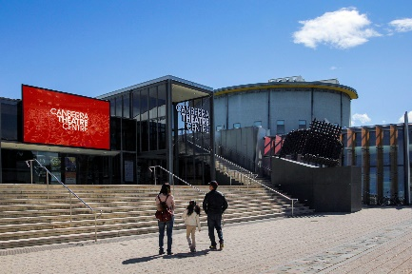Canberra Theatre Centre | 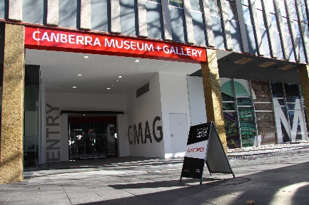CMAG | 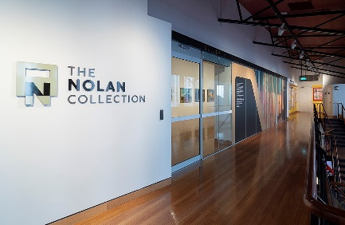The Nolan Collection
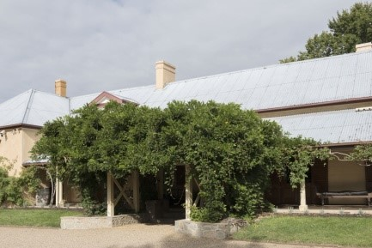Lanyon Homestead | 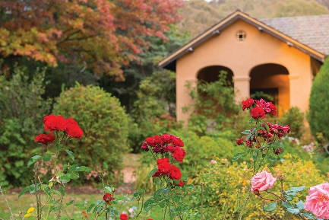Calthorpes’ House | 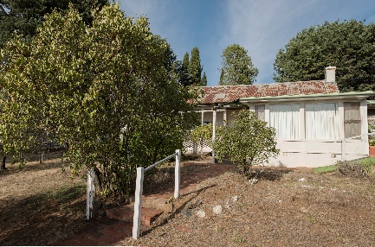Mugga-Mugga

APPENDIX 5 –
canberra museum and gallery and act historic places venues – schedule of exhibitions, programs and events
The following is a list of exhibitions, community and education programs and events at CMAG and the ACT Historic Place venues in 2020–21.
CANBERRA MUSEUM AND GALLERY
Exhibitions
* Exhibitions recorded in 2019–20 Annual Report
* Gosia Wlodarczak : frost drawing | 8 May 2016–30 June 2021
* Building a Life : The Jennings Germans story | 15 February–7 November 2020
* VOID | 15 February–1 August 2020
* Seeing Canberra | 7 March 2020–24 July 2021
* Crafting Canberra | 7 March 2020–24 July 2021
* Place : A travelling Exhibition of artists’ books | 21 March–31 October 2020
* Martyn Jolly’s Phantasmagoria | 10 June–5 September 2020
* Ngaio Fitzpatrick - Dissonance | 13 June–3 October 2020
The Nolan Collection | Permanent Exhibition
Sidney Nolan : Remembrances of my youth | 20 March–16 October 2021
Sidney Nolan and St Kilda : Memory and Modernism | 22 August 2020–13 March 2021
Flowline : Abstraction from the CMAG collection | 15 August–7 November 2020
The Art of the Fan | 19 September–28 November 2020
National Parks Association ACT Environmental Photography Competition | 9–30 October 2020
Richard Lewer : I can’t run away all my life sometimes I just have to stand and fight | 10 October 2020–16 January 2021
Pride of Place : Julie & Andrew Carter’s Australiana Ceramics Collection | 12 December 2020–20 March 2021
Sign of the Times | 21 November 2020–20 February 2021
The Blade : Australia’s love affair with lawn | 21 November 2020–20 February 2021
Tom Campbell r.a.m.p. | 14 November 2020–13 February 2021
Anna Madeleine Raupach : Unequal hours | 23 January–15 May 2021
HABITAT: Ways of living | 6 March–19 June 2021
Don’t forget the Milk : Celebrating 50 Years of Canberra Milk | 3 April–31 July 2021
The Piano Creatures : A Ragged Shore | 22 May–4 September 2021
Natalie Rosin : Brutalism | 21 June–7 August 2021
Learning and Community Programs
Floor Talks : Conducted by artists and CMAG staff for the following exhibitions : Building a Life : The Jennings Germans story; Sign of the Times; The Blade : Australia’s love affair with lawn; and HABITAT : Ways of living.
Reel Classics : The Reel McCoy Film Society presented classic cinema film screenings throughout the year.

Other programs included :
- Community programs resumed after the COVID-19 closure in 2019–20 on 1 August 2020 with the launch of CMAG on Saturday children sessions as follows : ShapeShifter; Artists’ books; Roller landscapes; Backyard fun; Time after time; A Big Canberra sky; and Creature feature.
- COVIDSafe activities for families with children connecting the CMAG collection to artmaking and children’s literature resumed in the MakerSpace and ReaderSpace areas.
- CMAG partnered with Thunderstone Aboriginal Cultural Services to create the Ngunawal Story Time project, launched during NAIDOC week.
- HABITAT : Ways of living artist Tina Havelock Stevens and fellow performer Liberty Kerr, provided a drumming/cello performance celebrating the eve of World Environment Day.
- Over 20 What Do Artists Make children programs conducted.
- Autumn school holiday workshops My House conducted.
Outreach Programs
Exhibition in a Suitcase was loaned to Hackett, North Ainslie, Ainslie School-Reid and Baker Gardens Preschools. Old MacDonald’s Farm was loaned to Ainslie School-Reid and Baker Gardens Preschools.
Programs conducted in association with The Nolan Collection
Floor Talks : Sidney Nolan’s encounters with popular culture / Dr Chris McAuliffe and Nolan & St Kilda with Virginia Rigney.
Every Picture Tells a Story : A learning program exploring the paintings of Sidney Nolan, attended by various Preschools.
Other programs included :
- Nolan school holiday workshop Merry Go Round.
- Studio workshop : Street Art with Byrd - discovering Sidney Nolan’s spray-painted works from the Sidney Nolan : Remembrances of my youth exhibition.
- The online Nolan Collection program CovidSafe Nolan Children’s Trail (via CMAG’s Instagram stories) launched on 27 October 2020 and ran through to 13 March 2021.
- Australian Museum and Galleries Association (AMaGA) Nolan Hack tour.
Outreach Programs
The Art Box : Animals + Plants was loaned to Forrest Primary School; Every Picture Tells a Story loaned to Theodore Preschool; and Stop Motion Nolan suitcases were loaned to Kaleen Primary School.
Venue Hire : Venues within CMAG were hired by 38 different organisations during 2020–21, with a number of these organisations hiring venues on multiple occasions such as the Office of Aboriginal and Torres Strait Islander Affairs, AMaGA, City Renewal Authority, Department of Industry, Science, Energy and Resources and Elections ACT. The organisations ranged from Federal and ACT agencies to not-for-profit organisations, community groups, and private sector organisations.
ACT HISTORIC PLACES
Exhibitions
Lanyon
Within Living Memory | Permanent exhibition
The Cunningham Family Album | Permanent exhibition
The Convict Years | Permanent exhibition
Calthorpes’ House
Calthorpes’ House Orientation Exhibition | Permanent exhibition
Mugga-Mugga
Getting It Together | Permanent exhibition

Learning and Community Programs
Lanyon
Convicts and Who were the Convicts? : Learning programs discussing the profiles of convicts assigned to Lanyon, attended by various schools.
James’ Diary : Learning programs providing a tour of the homestead in the footsteps of James Cunningham, attended by various schools.
Child’s Play : Learning programs exploring the world of old-fashioned games and Victorian paper dolls, attended by various schools.
Other Programs included : Lanyon’s Landscape : First Nations Peoples, settlers and convicts; Children’ Art Trail; Beyond the Farm Gate walk; Sustainable Flowers photography workshop in conjunction with Floriade : Reimagined; Art Makers at Lanyon workshops including Still life, Watercolour and Gouache and Drawing Interiors with local artist Naomi Zouwer; Wally Bell Canoe Tree Walk; Visual Art excursion at Lanyon; Sunday Drive Wellbeing Workshops : Stitching for Wellbeing and Watercolour Patterns for Mindfulness with Naomi Zouwer; School Holiday Program Wiradjuri Echoes by the River; Harvest Day Out : Family Workshop My Mini Succulent Garden, Preserve your Harvest talk and Permaculture at Millpost Farm talk; Legends of Lanyon with Tim the Yowie Man.
Group tours : Frequent Flyer Australia Group; National Trust NSW; and Capital Region Community Services.
Calthorpes’ House
Dawn’s Surprise : Program taking children on a journey around the house, attended by various primary schools.
Mugga-Mugga
At the Garden Gate : Program that focuses on the landscape and environment of Mugga-Mugga, attended by various primary schools and early learning centres.
Historic Places Outreach Programs
Artefact Chat Boxes and Dawn's Suitcase were loaned to various primary schools.
Venue Hire/Function Usage : Spaces within Lanyon and Mugga-Mugga were used by 21 different organisations and groups during 2020–21. Lanyon hosted nine weddings and four memorial services and Mugga-Mugga hosted two meetings.
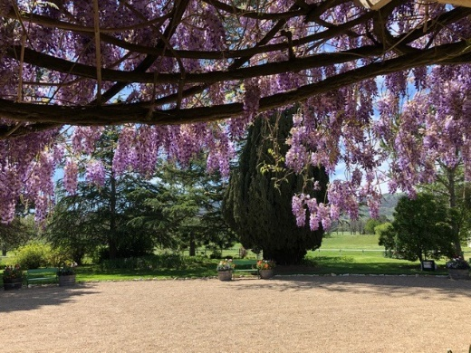
Lanyon Homestead veranda view with wisteria. Area prepared for events.

APPENDIX 6 –
canberra museum and gallery – acquisitions (purchases and donations)

PURCHASES
Social History
- Capital Executive Apartments Canberra, Cuddles n’ Bubbles Sign, c.1990, plastic
- Heide Smith, Portrait of Sylvia Parsons, 1994, black and white print on fine art heavyweight matte paper
- Trevor Dickinson, Starlight Night, 2020, archival print

Visual Arts
- Adrian Feint, Canberra Landscape, 1944, oil on board
- Brigid Cole-Adams, Boulderwood Street, Turner, 1996 – 2000, watercolour
- Brigid Cole-Adams, Cnr Sprent Street and Casey Crescent, Narrabundah, 1996 – 2000, watercolour
- Brigid Cole-Adams, Hodgson Crescent, Pearce, 1996 – 2000, watercolour
- Brigid Cole-Adams, Officer Place, Ainslie, 1996 – 2000, watercolour
- Brigid Cole-Adams, Rafferty Street, Chapman, 1996 – 2000, watercolour
- Brigid Cole-Adams, Untitled, 1996 – 2000, watercolour
- Deej Fabyc, Canberra Youth Theatre Co. presents 'Public Images' by Pamela Van Amstel and 'That elusive thrill' by Sharen Dart, 1985, three colour screen print on paper
- Deej Fabyc, 'Rock for Land Rights' poster, 1985, screen print on paper
- Hamilton Darroch, Mantis 2, 2019, acrylic on canvas
- Janet Dawson, Manuka Evening, c.1986, oil on canvas
- Jeff Mincham, A Little Hazy Now & Then, 2020, multi-glazed, mid-fired ceramic
- Sally Robinson, ‘Art from Artbank’ poster, 1983, screen print on paper
- Waratah Lahy, Smoke, 2020, watercolour, ink, watercolour on paper
- William Dargie, Anzac Day Canberra, 1970, oil on board
- Ximena Briceño, Canberra-Queanbeyan Express bracelet and necklace set, 2018, glass, thermal paper, nylon

DONATIONS

Social History
- Akiba collection, objects relating to home delivery during the COVID-19 lockdown, 2020, various materials
- Aladino Solar collection, objects relating to migration from Chile, c.1970s, various material
- Atkow Family collection, Ampro portable Reel-to-Reel player and related objects, 1950s, various materials
- Australian Underground Spirits, Bottles of hand sanitiser, 2020, plastic, paper, ink
- Belconnen Arts Centre collection, Postcards from Gungahlin series, 2020, card, ink
- Dorothy Outram collection, Canberra Youth Orchestra uniform and related material, 1990, various materials
- Geoff Pryor collection, FCT 7 vehicle number plate, 1927, metal
- Heritage ACT collection, Concrete street pillar, Northbourne Avenue and Alinga Street, c.1930s, concrete
- Llois Cutts collection, material relating to Miss ACT, 1958, various materials
- Richard Allen collection, Meridian Club sign, 1991, metal, wood, paint
- Scott-Finlay collection, nurse’s uniform, 1970s, wool

Visual Arts
- Brian Corr, Timshel, 2012, kiln formed, waterjet cut, cold worked constructed glass with corten steel
- David Pope, three prints from the South Coast is Calling series, 2020, paper and ink
- Douglas Dundas, Canberra Cow Pastures, 1941, oil on canvas
- Guy Warren, Prisoner II, 1962, oil on board
- Hamilton Darroch, Bellow Block I, 2017, gouache on paper
- Hamilton Darroch, Bellow Block II, 2017, gouache on paper
- Hamilton Darroch, Mantis Study I, 2012, gouache on paper
- Hamilton Darroch, Mantis Study II, 2012, gouache on paper
- Harold Cazneaux, Between showers, c.1927, silver gelatin photograph
- Trevor Dickinson, 41 prints from the Canberra Bus Shelters series, c.2018, paper and ink
- Wesley Stacey, Creek in Mumbulla Range, 1978, silver gelatin photograph
- Wesley Stacey, Guboo Ted Thomas, Mumbulla – spiritual – contact, [40] pages: chiefly illustrations
- Wesley Stacey, Space station Canberra, 1992, silver gelatin photograph
Note : in some cases the acquisition process was being finalised as at 30 June 2021.


Adrian Feint, Canberra Landscape, 1944, oil on board

APPENDIX 7 –
major funding, sponsorship and support
The CFC enjoyed the continuing support of Government agencies and of several major sponsors, as well as the assistance of many donors and supporters during 2020–21. Without their generous support many of the CFC’s performances, exhibitions, programs and events would not be possible.

CFC GOVERNMENT FUNDING
ACT Government

CANBERRA MUSEUM AND GALLERY
Government Funding
Commonwealth Department of Infrastructure, Transport, Regional Development and Communications

Major Non-Government Support ($10,000 and over)
Meredith Hinchliffe
Supporters (up to the value of $10,000 and major in-kind support)
Harriet Elvin AM (CFC CEO)
Acting Justice Richard Refshauge (CFC Chair)
Helen O’Neil (CFC Deputy Chair)
Emmanuel H Notaras
Phillip Keir
D W Williams
John Hindmarsh AM (former CFC Chair)
Richard Rolfe AM (via the Canberra Region Treasures Fund)

Contributions to the Canberra Region Treasures Fund 2014–2021
John Hindmarsh AM (former CFC Chair)
Louise Douglas (former CFC Chair)
Virginia Haussegger AM (former CFC Board Member)
Harriet Elvin AM (CFC CEO)
Dawn Waterhouse
Laura Cree
Maureen Fisher
John Mulvaney AO
Kerry-Anne Cousins
Koula Notaras
John Olsen OBE AO
Jody Turner
Frank Bergersen
John and Dianne Firth
Dr Howard Galloway
Dr Charlotte Galloway
Rosanna Burston
Phoebe Bischoff OAM
Robyn A Duncan
Lady L D Yeend
Jacqueline Pinkava
Estelle Barnes
Bill and Beverley Wood
Dorothy Cameron
Marian Hill
Judith Bibo
Gabrielle Watt
Karina Harris and Neil Hobbs
Dr Roslyn V Russell
Kristine Reithmiller
John Olsen
Joan Adler
Paul G White PSM
Dr Mark Lax
Lynette Henderson
Richard Rolfe AM

ACT HISTORIC PLACES
ACT Government Funding
Environment, Planning and Sustainable Development Directorate
Supporters (up to the value of $10,000 and major in-kind support)
Barbara Refshauge

CANBERRA THEATRE CENTRE
Major Non-Government Support ($10,000 and over)
Acting Justice Richard Refshauge (CFC Chair)
Phillip Keir


Financial and Performance Statements and MD&A



INDEPENDENT AUDITOR’S REPORT

To the Members of the ACT Legislative Assembly

Opinion
I have audited the financial statements of the Cultural Facilities Corporation (Corporation) for the year ended 30 June 2021 which comprise the operating statement, balance sheet, statement of changes in equity, statement of cash flows, statement of appropriation and notes to the financial statements, including a summary of significant accounting policies and other explanatory information.

In my opinion, the financial statements:
- present fairly, in all material respects, the Corporation's financial position as at 30 June 2021, and its financial performance and cash flows for the year then ended; and
- are presented in accordance with the Financial Management Act 1996 and comply with Australian Accounting Standards.

Basis for opinion

I conducted the audit in accordance with the Australian Auditing Standards. My responsibilities under the standards are further described in the ‘Auditor’s responsibilities for the audit of the financial statements’ section of this report.

I am independent of the Corporation in accordance with the ethical requirements of the Accounting Professional and Ethical Standards Board’s APES 110 Code of Ethics for Professional Accountants (including Independence Standards) (Code). I have also fulfilled my other ethical responsibilities in accordance with the Code.

I believe that the audit evidence obtained is sufficient and appropriate to provide a basis for my opinion.

Responsibilities of the Corporation for the financial statements
The Governing Board is responsible for:
- preparing and fairly presenting the financial statements in accordance with the Financial Management Act 1996 and relevant Australian Accounting Standards;
- determining the internal controls necessary for the preparation and fair presentation of the financial statements so that they are free from material misstatements, whether due to error or fraud; and
- assessing the ability of the Corporation to continue as a going concern and disclosing, as applicable, matters relating to going concern and using the going concern basis of accounting in preparing the financial statements.

Auditor’s responsibilities for the audit of the financial statements

Under the Financial Management Act 1996, the Auditor-General is responsible for issuing an audit report that includes an independent opinion on the financial statements of the Corporation.

My objective is to obtain reasonable assurance about whether the financial statements as a whole are free from material misstatement, whether due to fraud or error, and to issue an auditor’s report that includes my opinion.

Reasonable assurance is a high level of assurance, but is not a guarantee that an audit conducted in accordance with Australian Auditing Standards will always detect a material misstatement when it exists. Misstatements can arise from fraud or error and are considered material if, individually or in aggregate, they could reasonably be expected to influence the economic decisions of users taken on the basis of the financial statements.

As part of an audit in accordance with Australian Auditing Standards, I exercise professional judgement and maintain professional scepticism throughout the audit. I also:
- identify and assess the risks of material misstatement of the financial statements, whether due to fraud or error, design and perform audit procedures responsive to those risks, and obtain audit evidence that is sufficient and appropriate to provide a basis for my opinion. The risk of not detecting a material misstatement resulting from fraud is higher than for one resulting from error, as fraud may involve collusion, forgery, intentional omissions, misrepresentations, or the override of internal control;
- obtain an understanding of internal controls relevant to the audit in order to design audit procedures that are appropriate in the circumstances, but not for expressing an opinion on the effectiveness of the Corporation’s internal controls;
- evaluate the appropriateness of accounting policies used and the reasonableness of accounting estimates and related disclosures made by the Corporation;
- conclude on the appropriateness of the Corporation’s use of the going concern basis of accounting and, based on audit evidence obtained, whether a material uncertainty exists related to events or conditions that may cast significant doubt on the Corporation’s ability to continue as a going concern. If I conclude that a material uncertainty exists, I am required to draw attention in this report to the related disclosures in the financial statements or, if such disclosures are inadequate, to modify my opinion. I base my conclusions on the audit evidence obtained up to the date of this report. However, future events or conditions may cause the Corporation to cease to continue as a going concern; and
- evaluate the overall presentation, structure and content of the financial statements, including the disclosures, and whether they represent the underlying transactions and events in a manner that achieves fair presentation.

I communicate with the Governing Board regarding, among other matters, the planned scope and timing of the audit and significant audit findings, including any significant deficiencies in internal control that I identify during my audit.


Ajay Sharma
Assistant Auditor-General, Financial Audit
22 September 2021
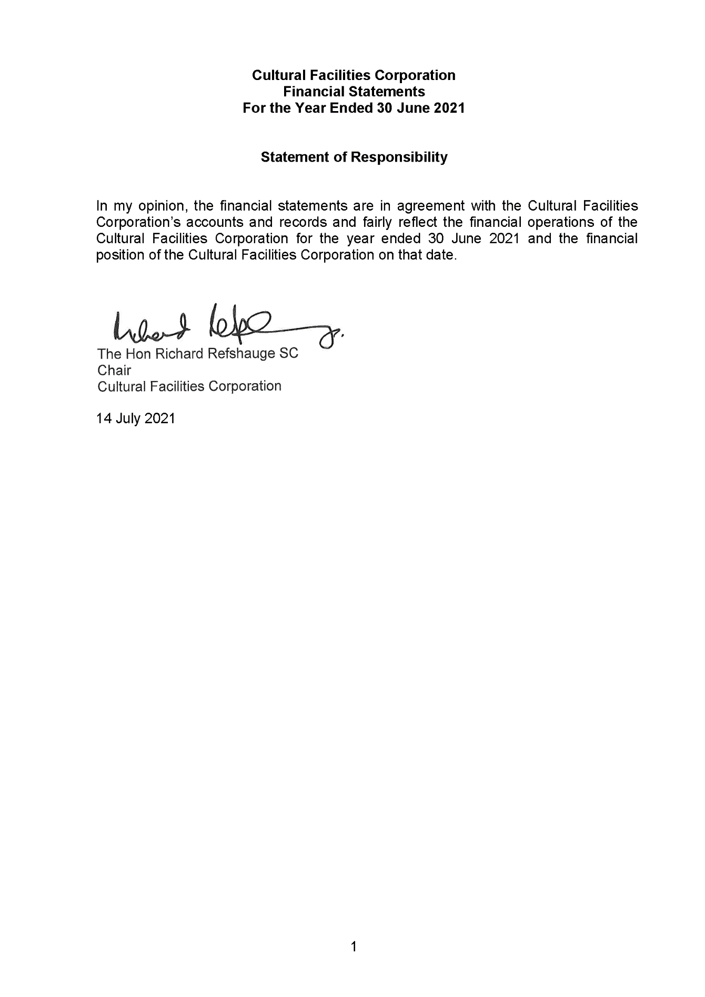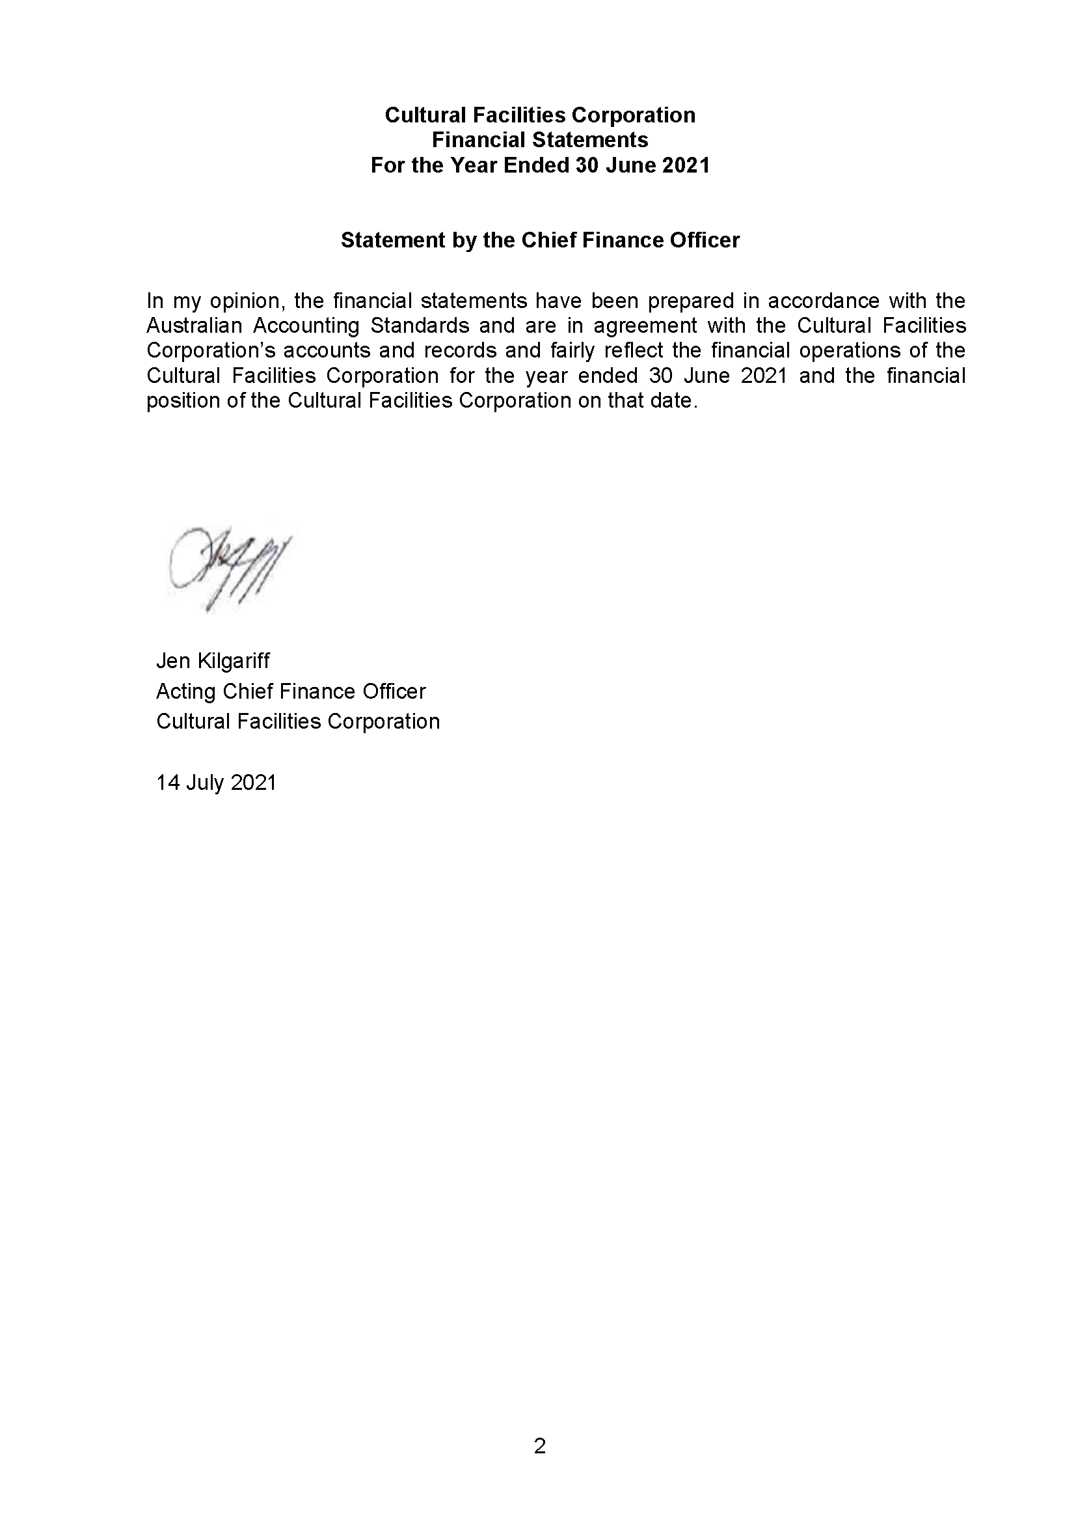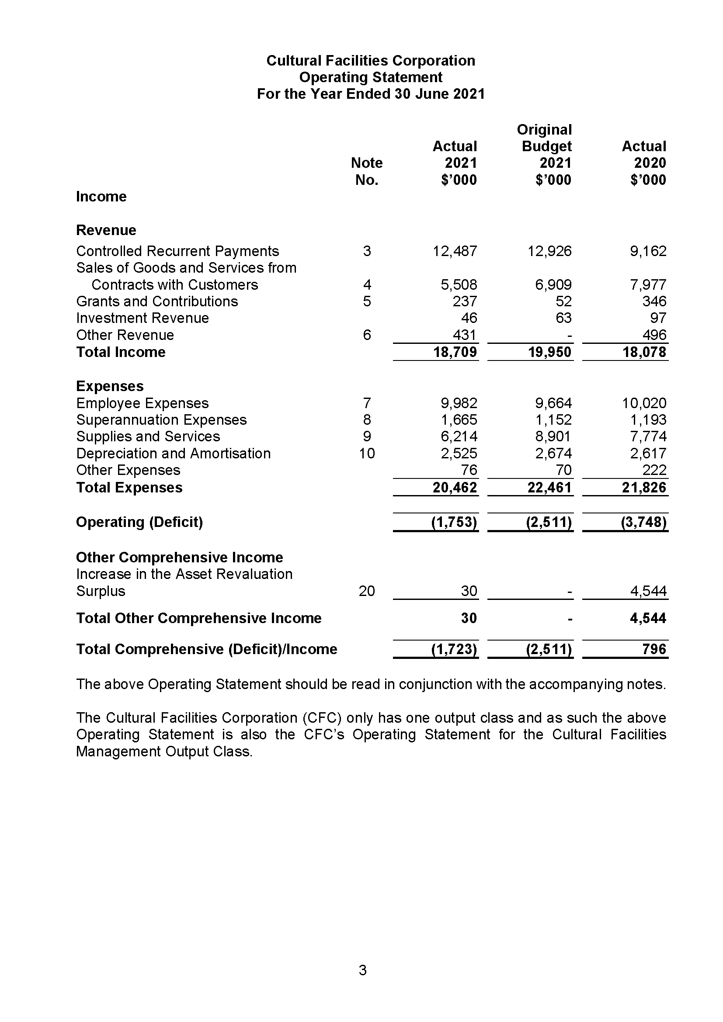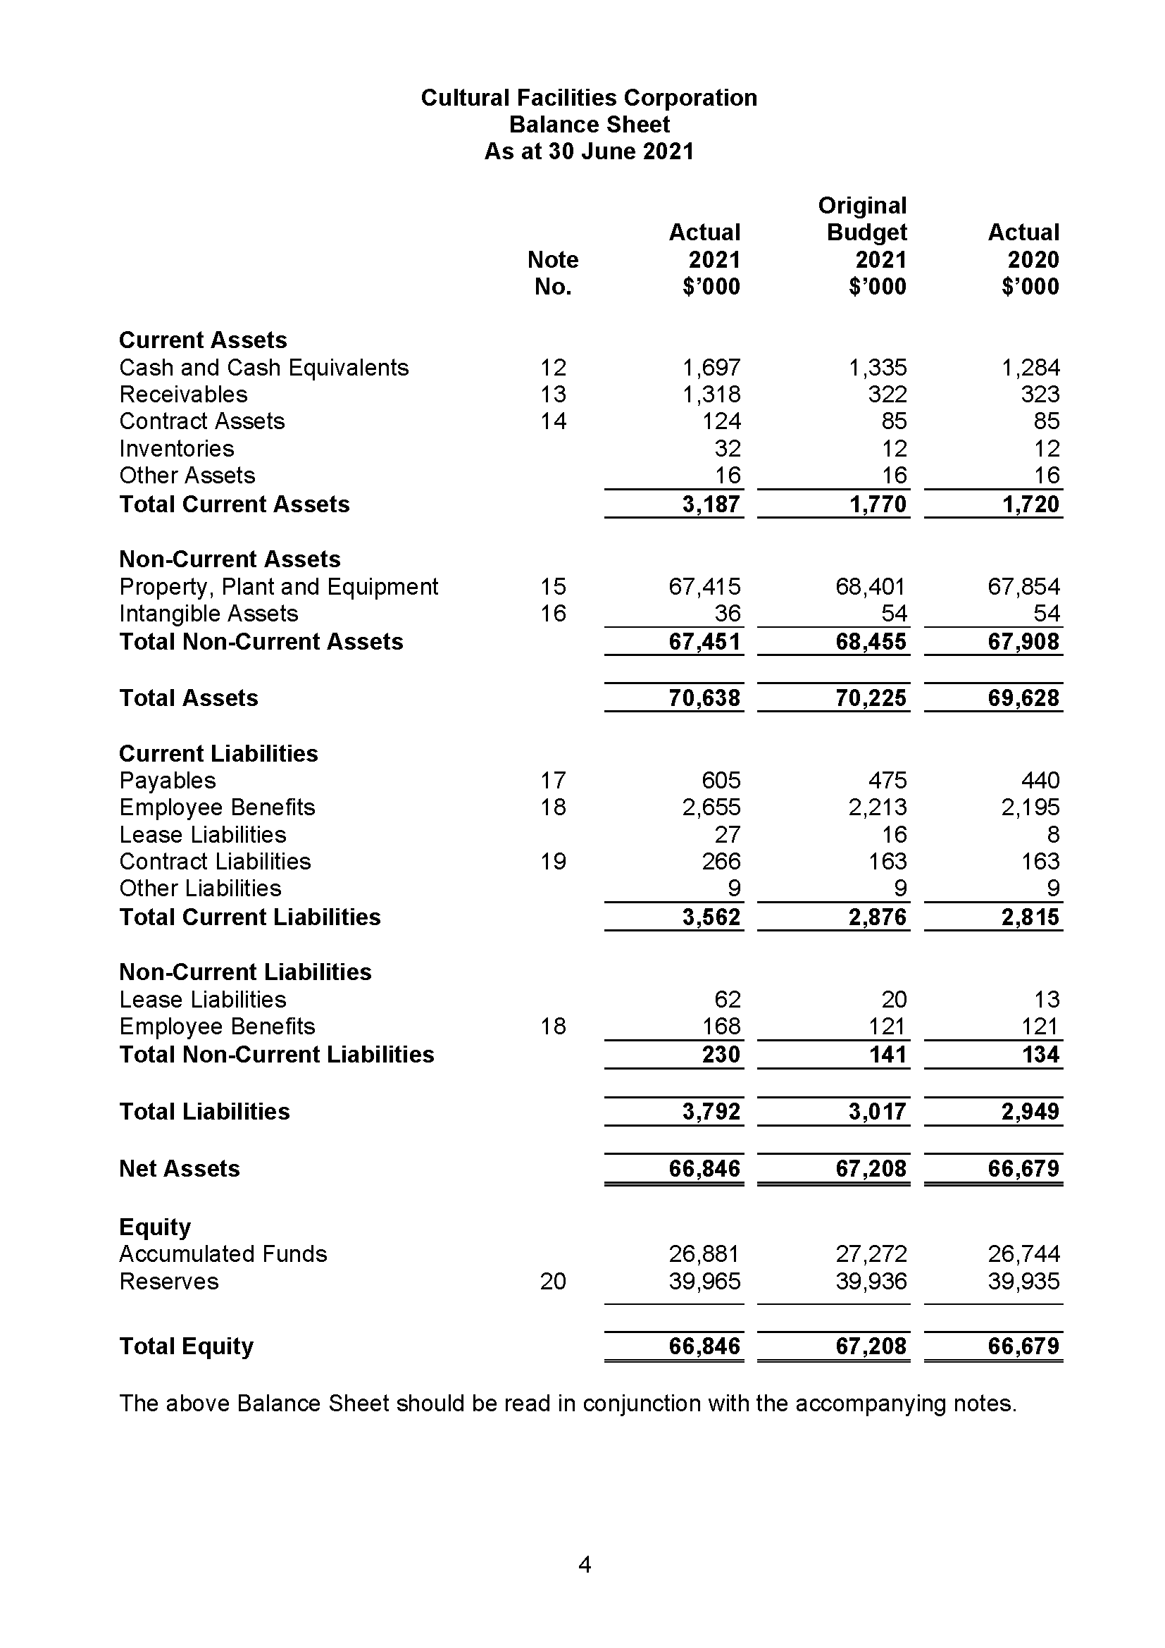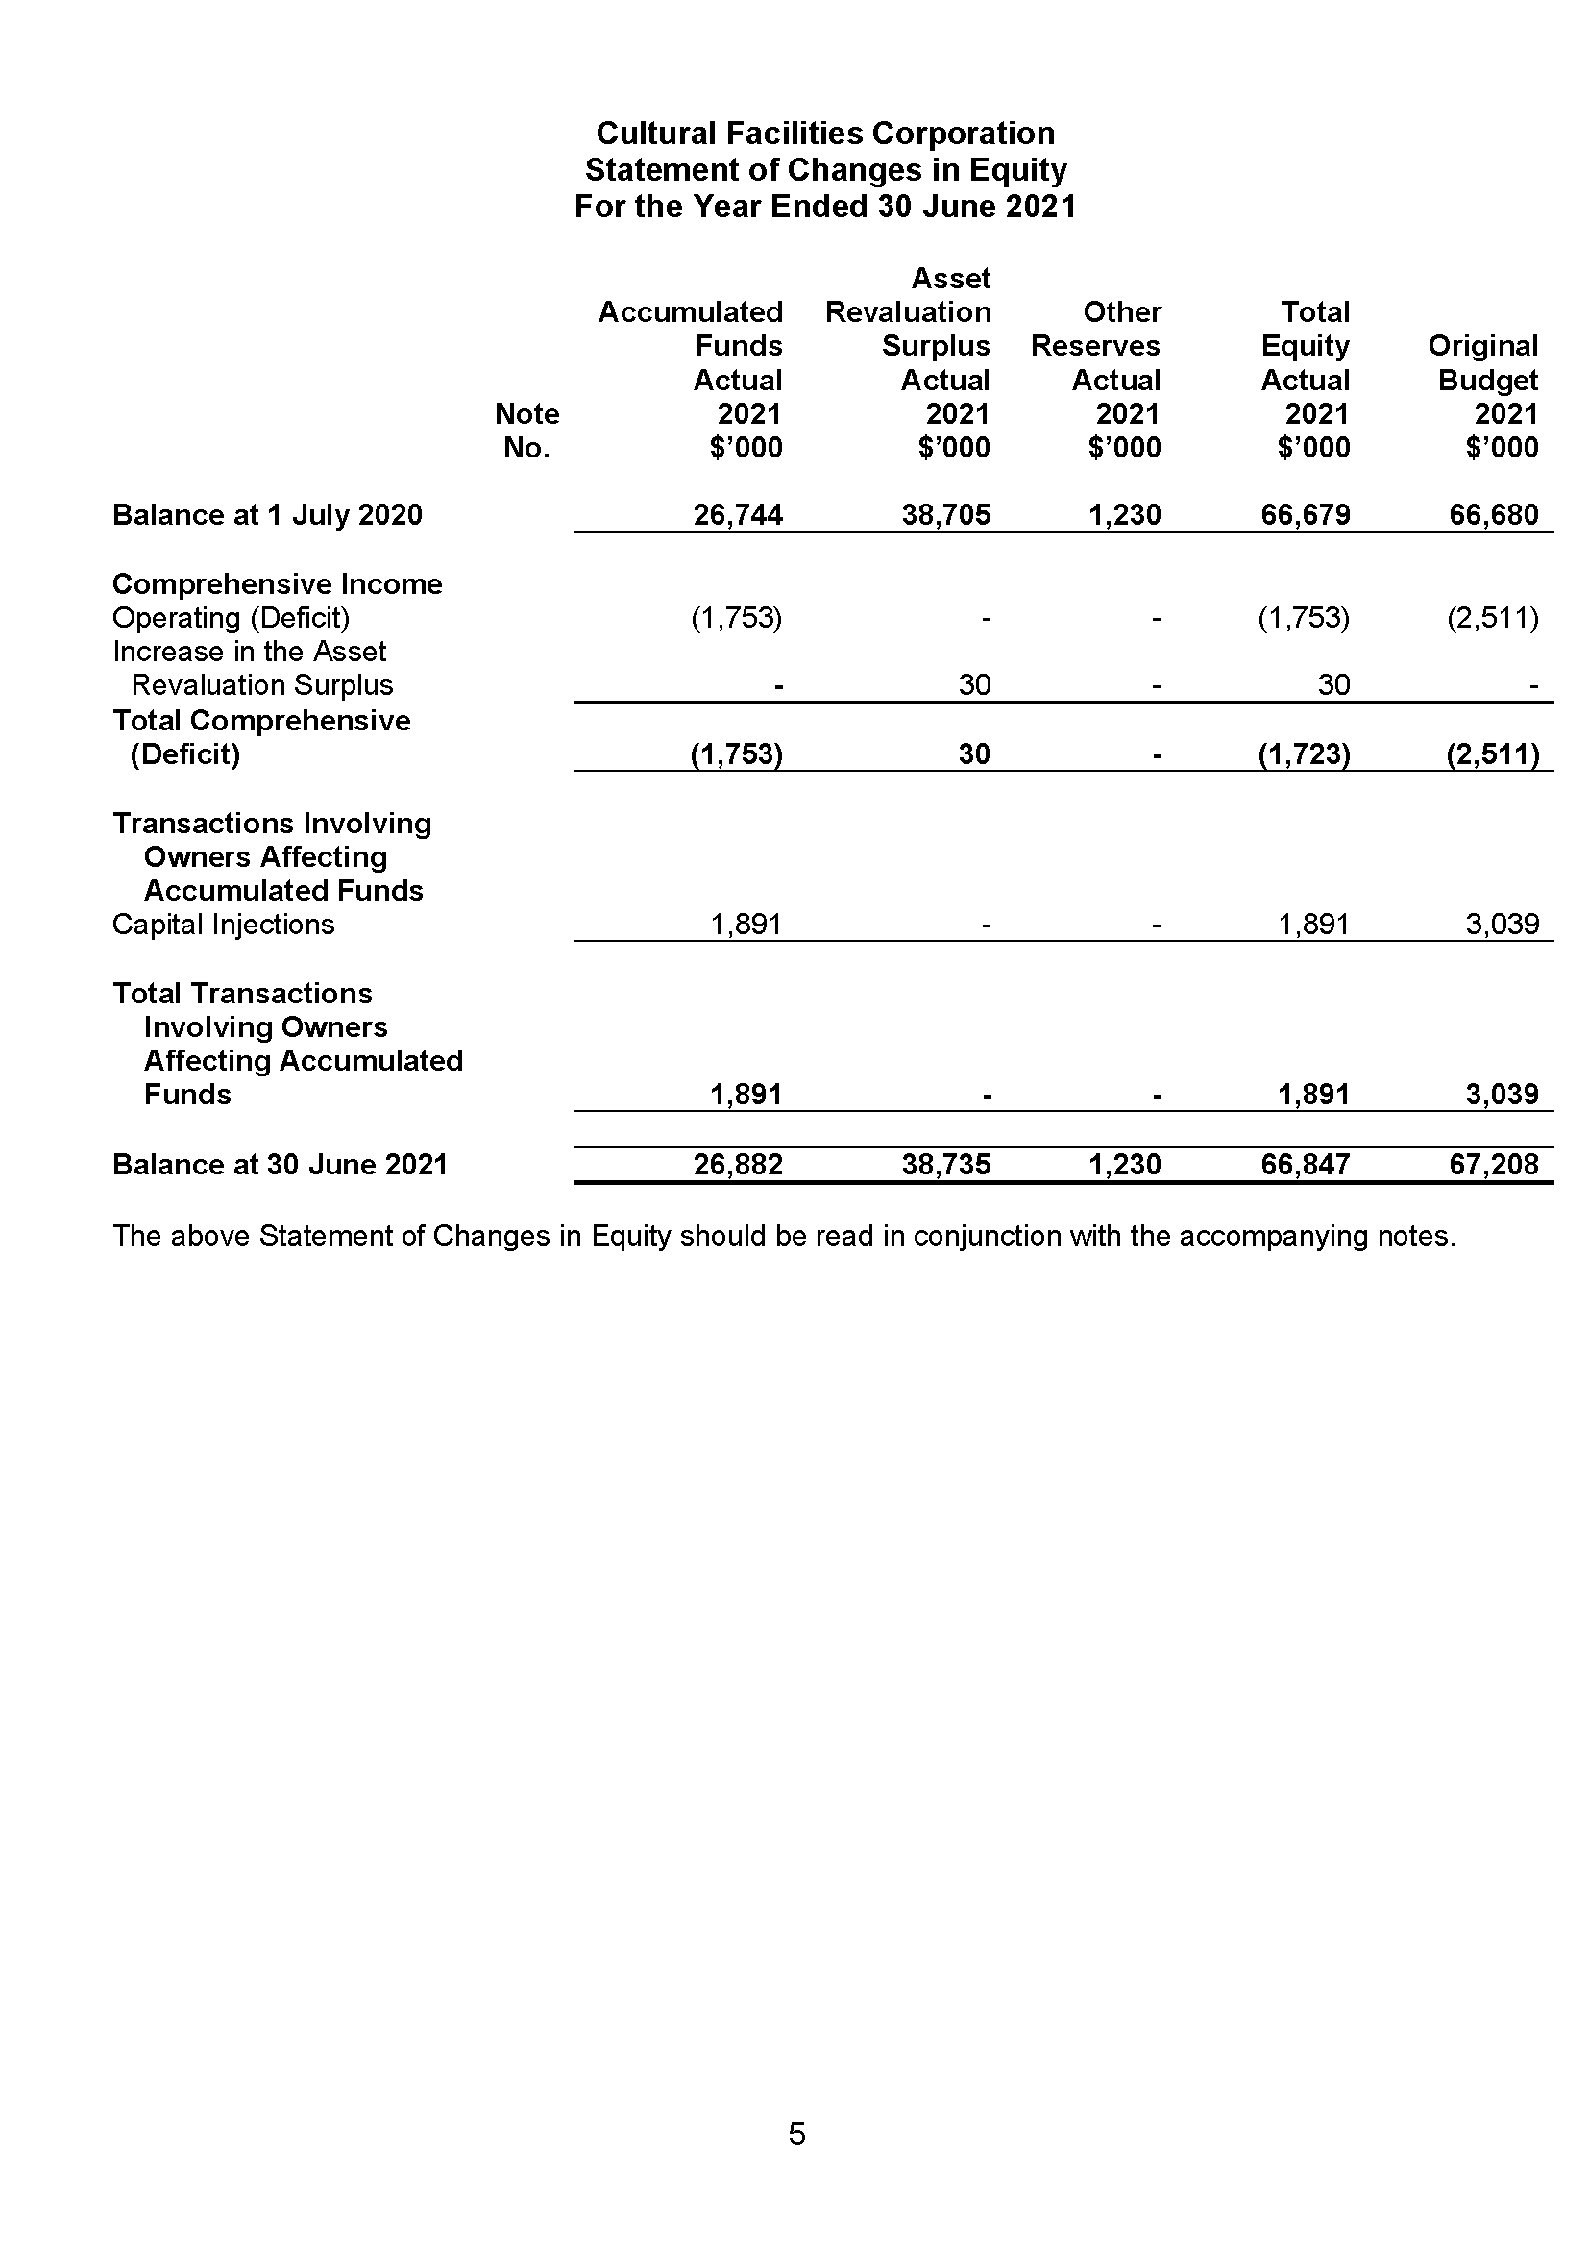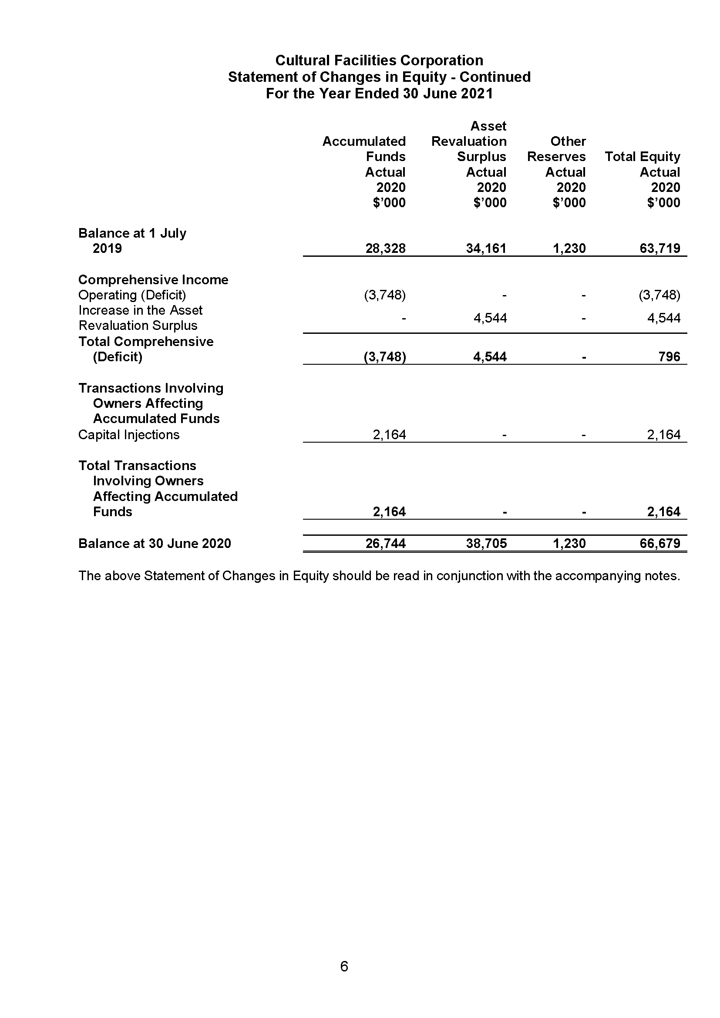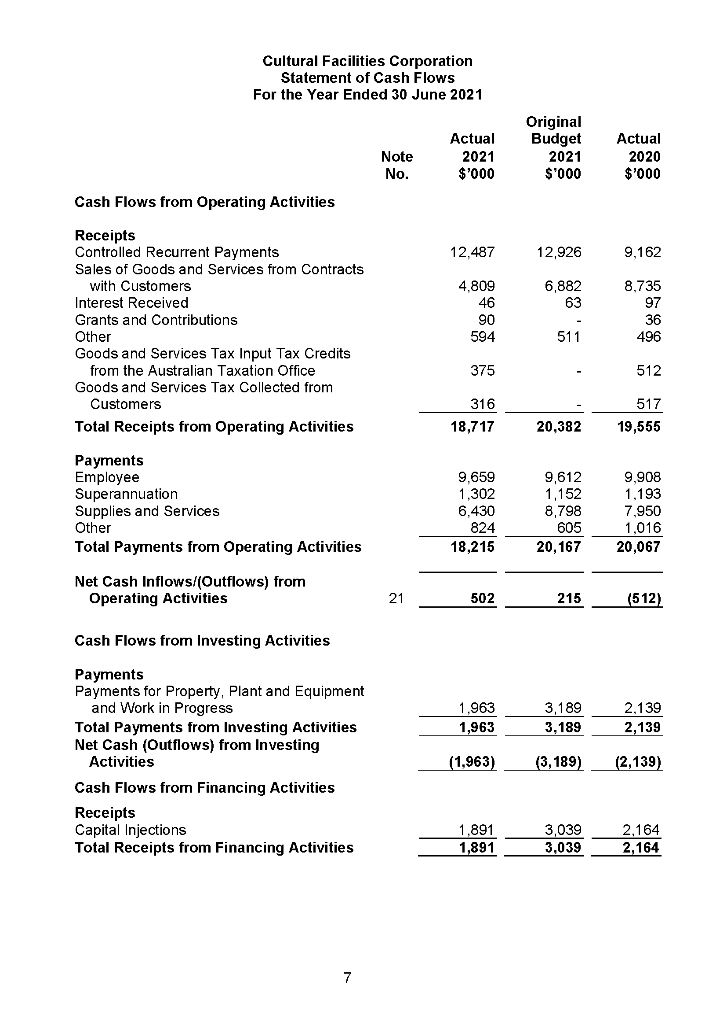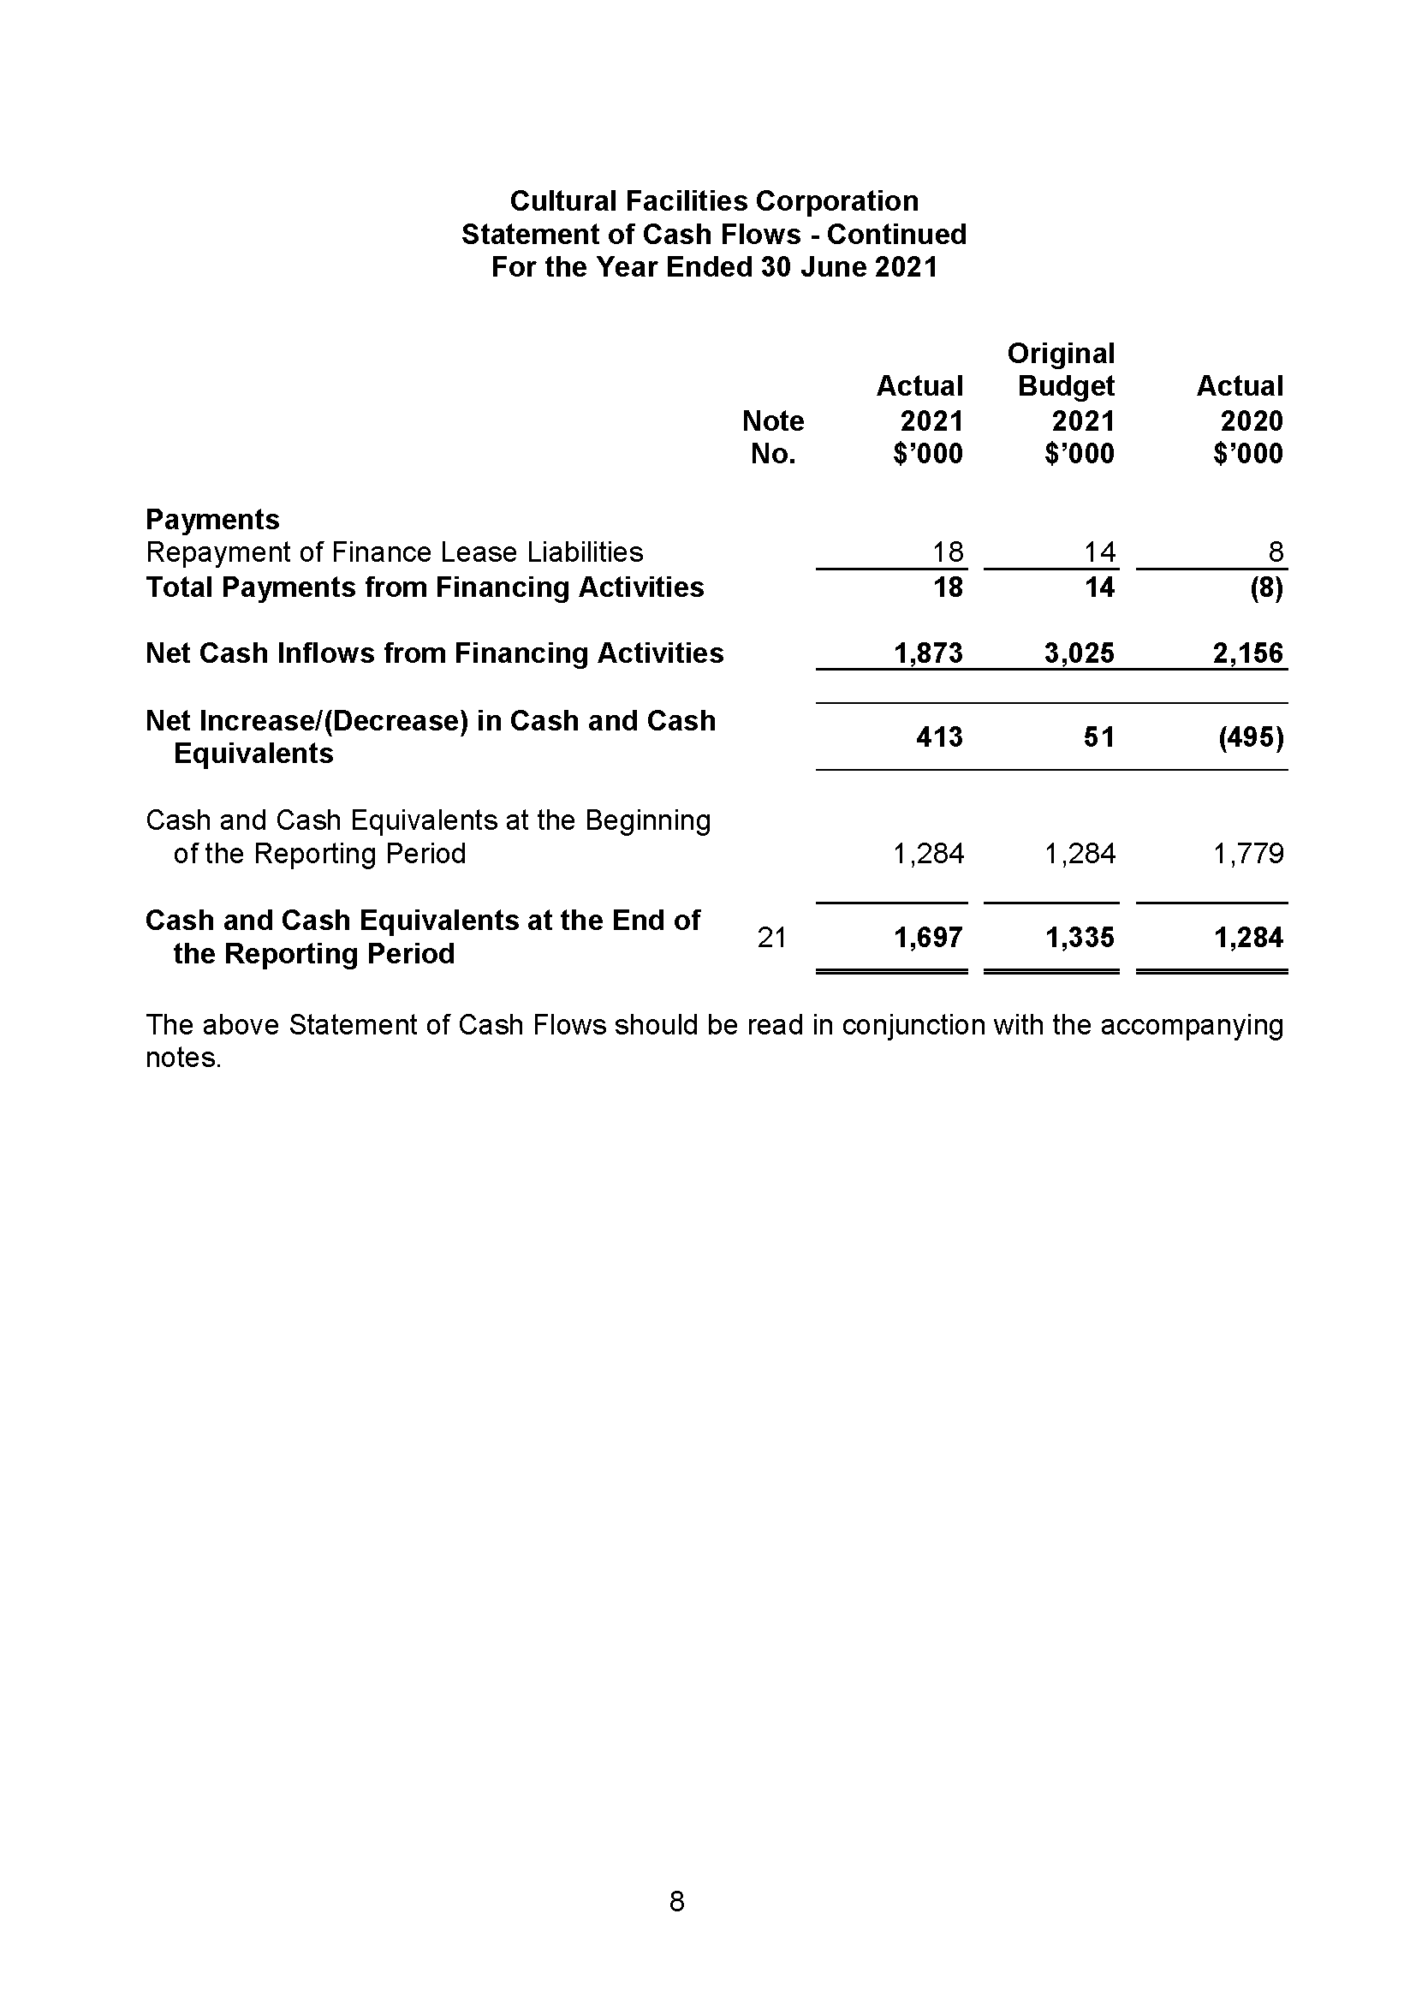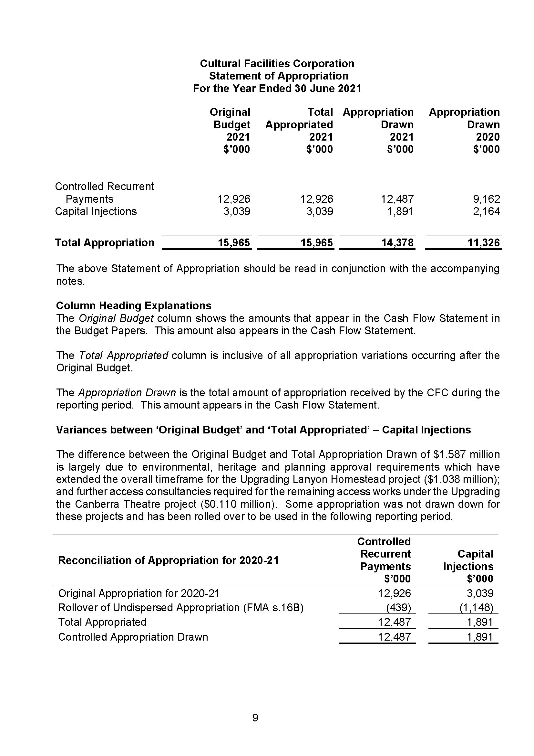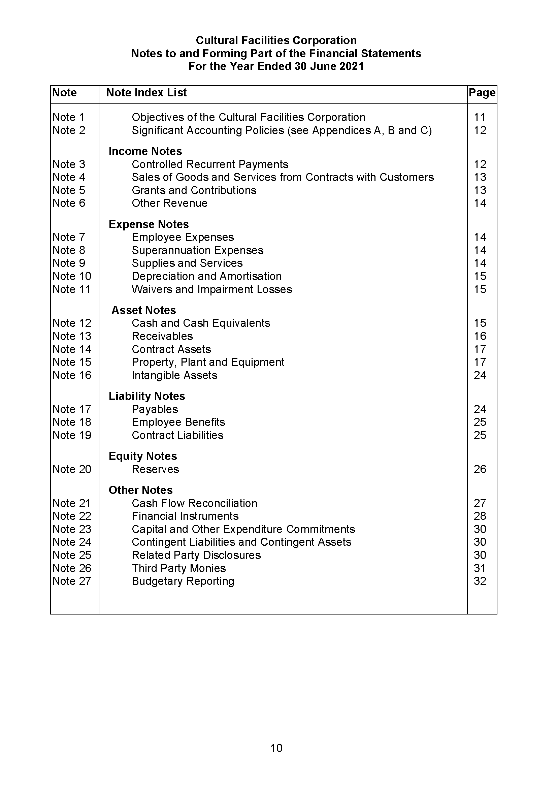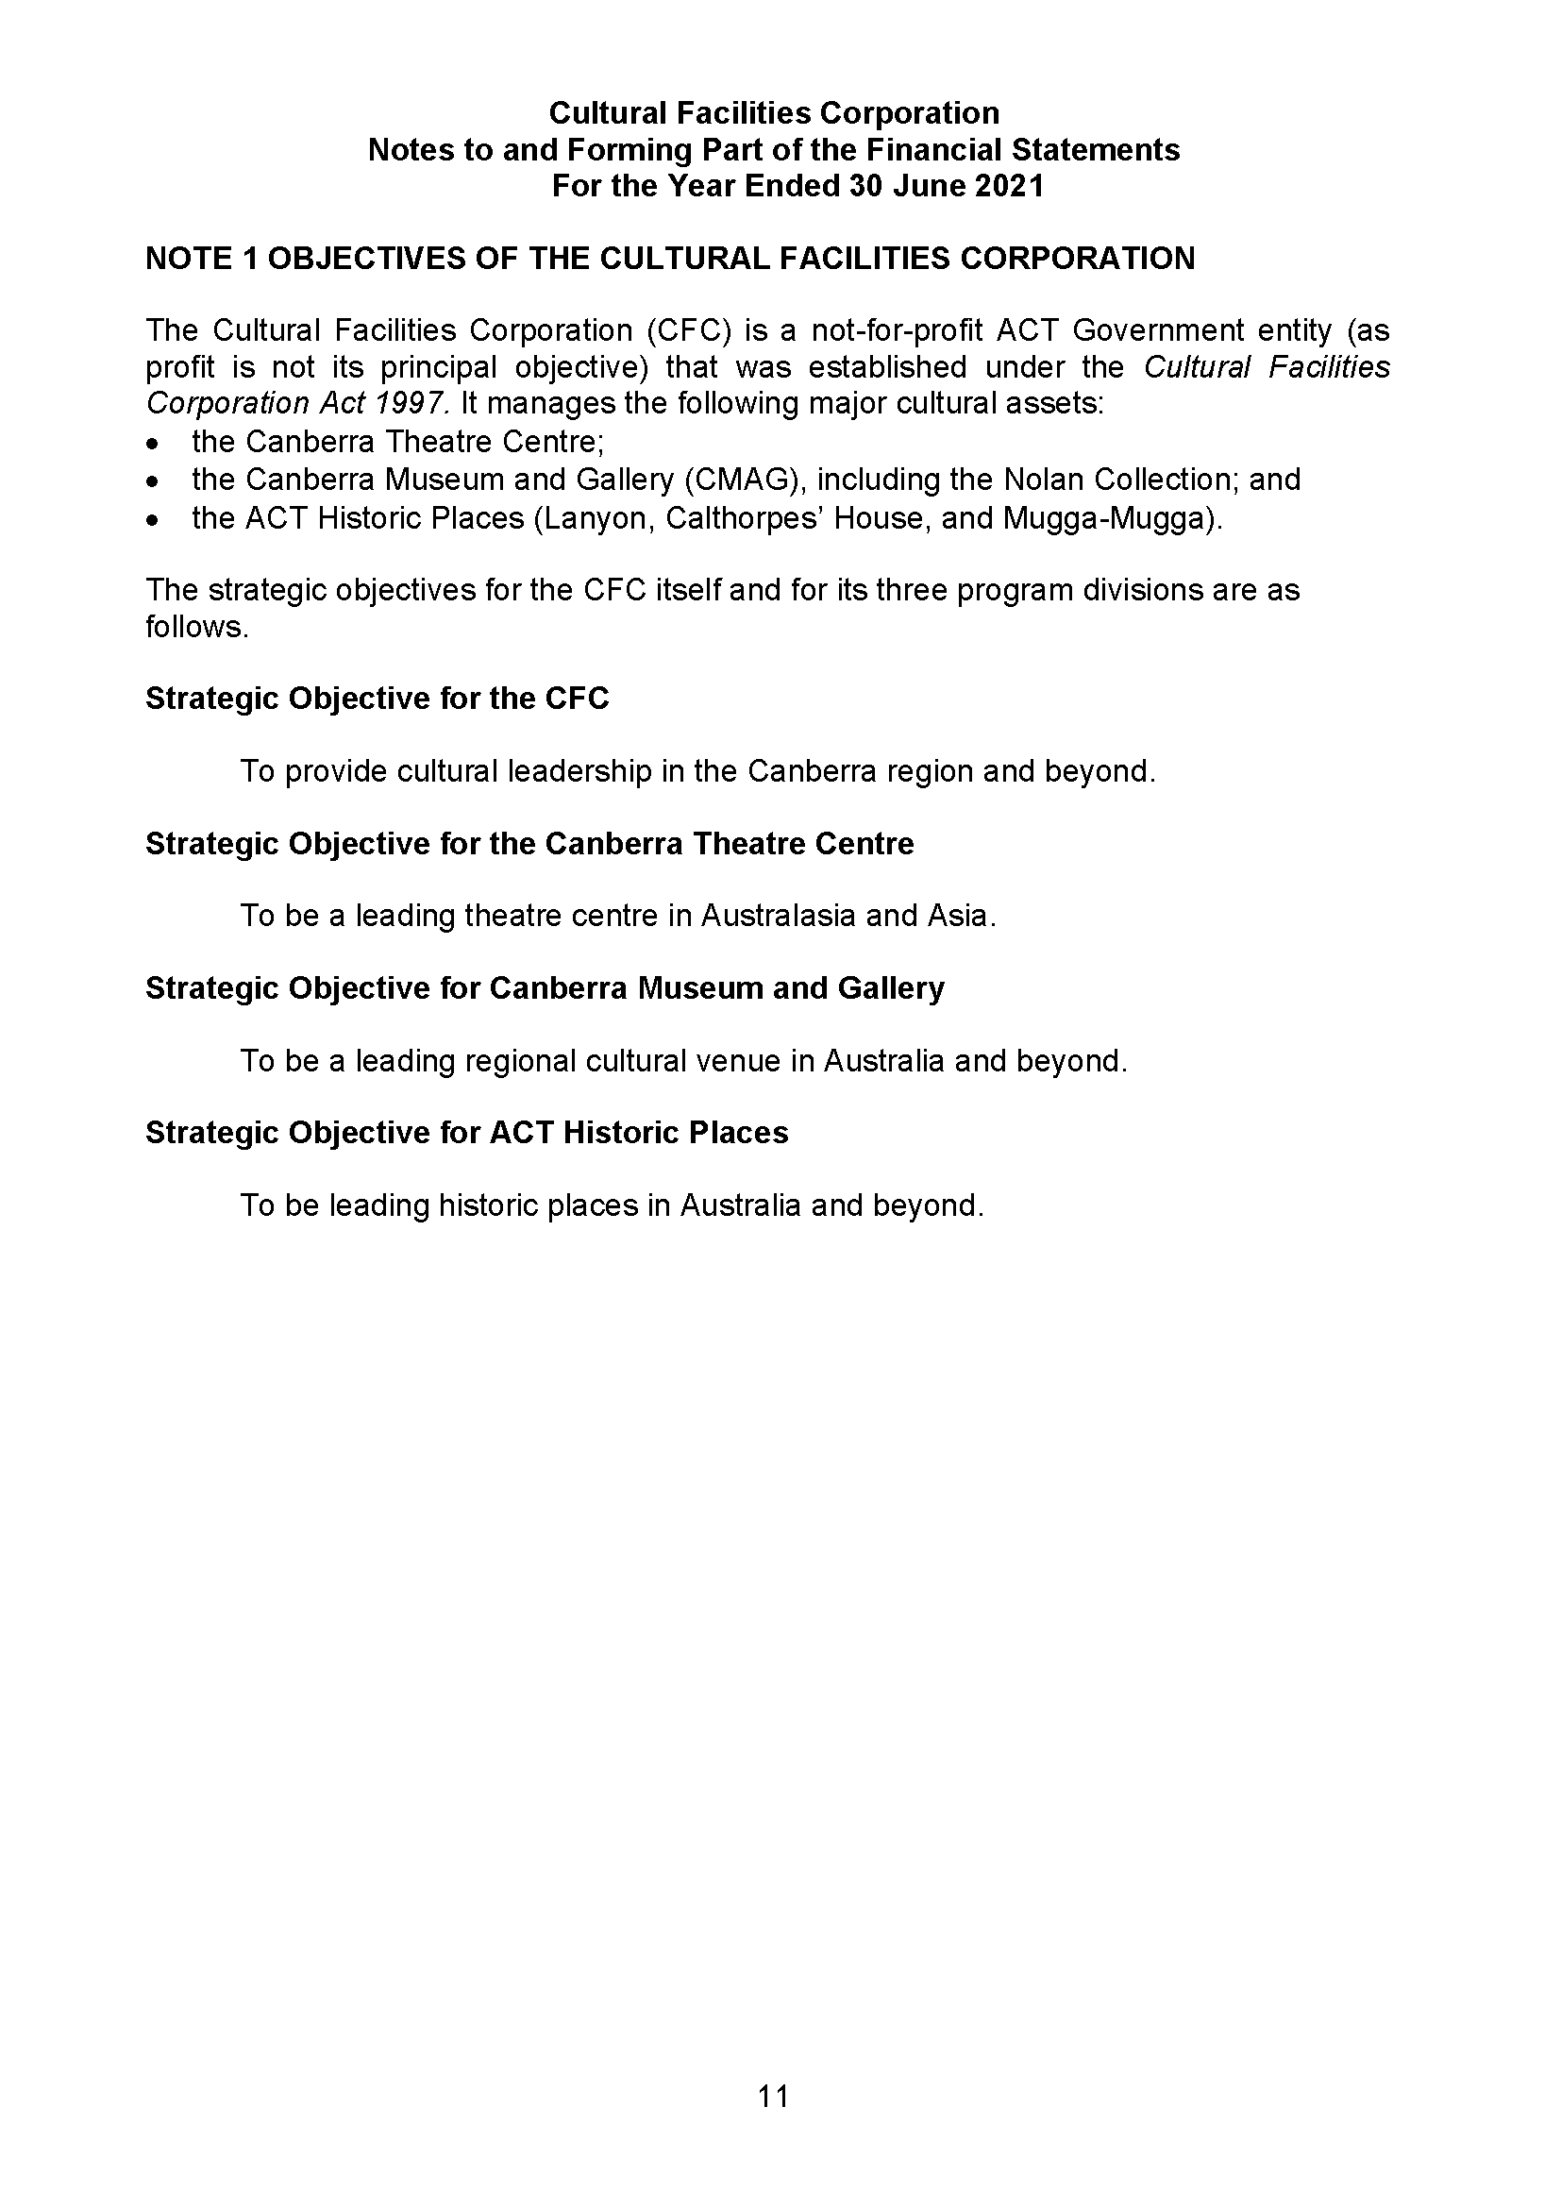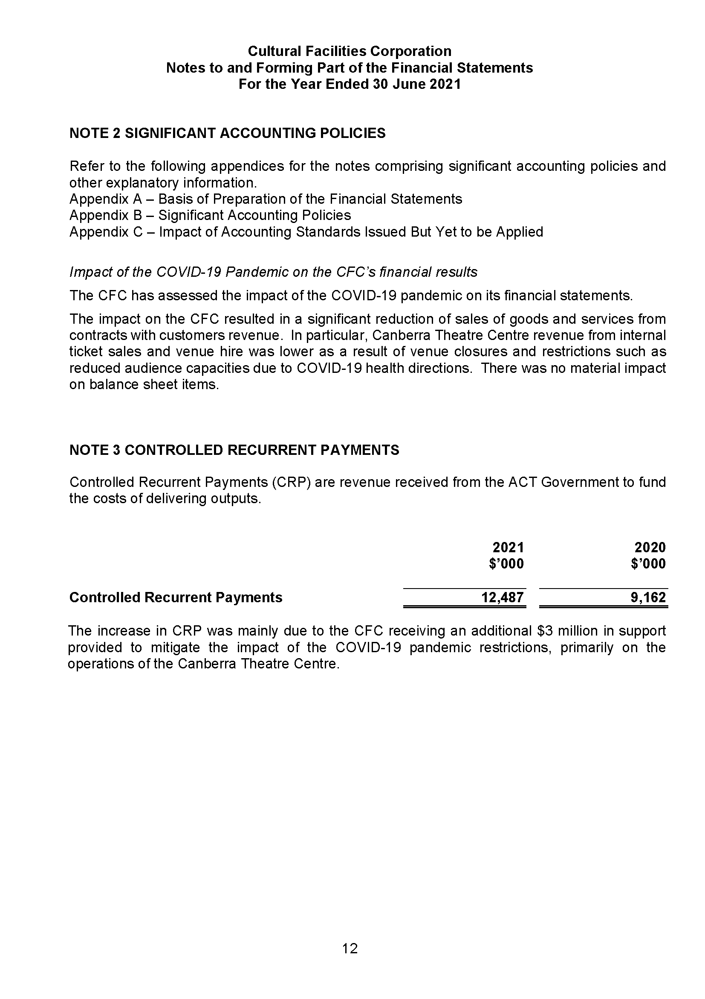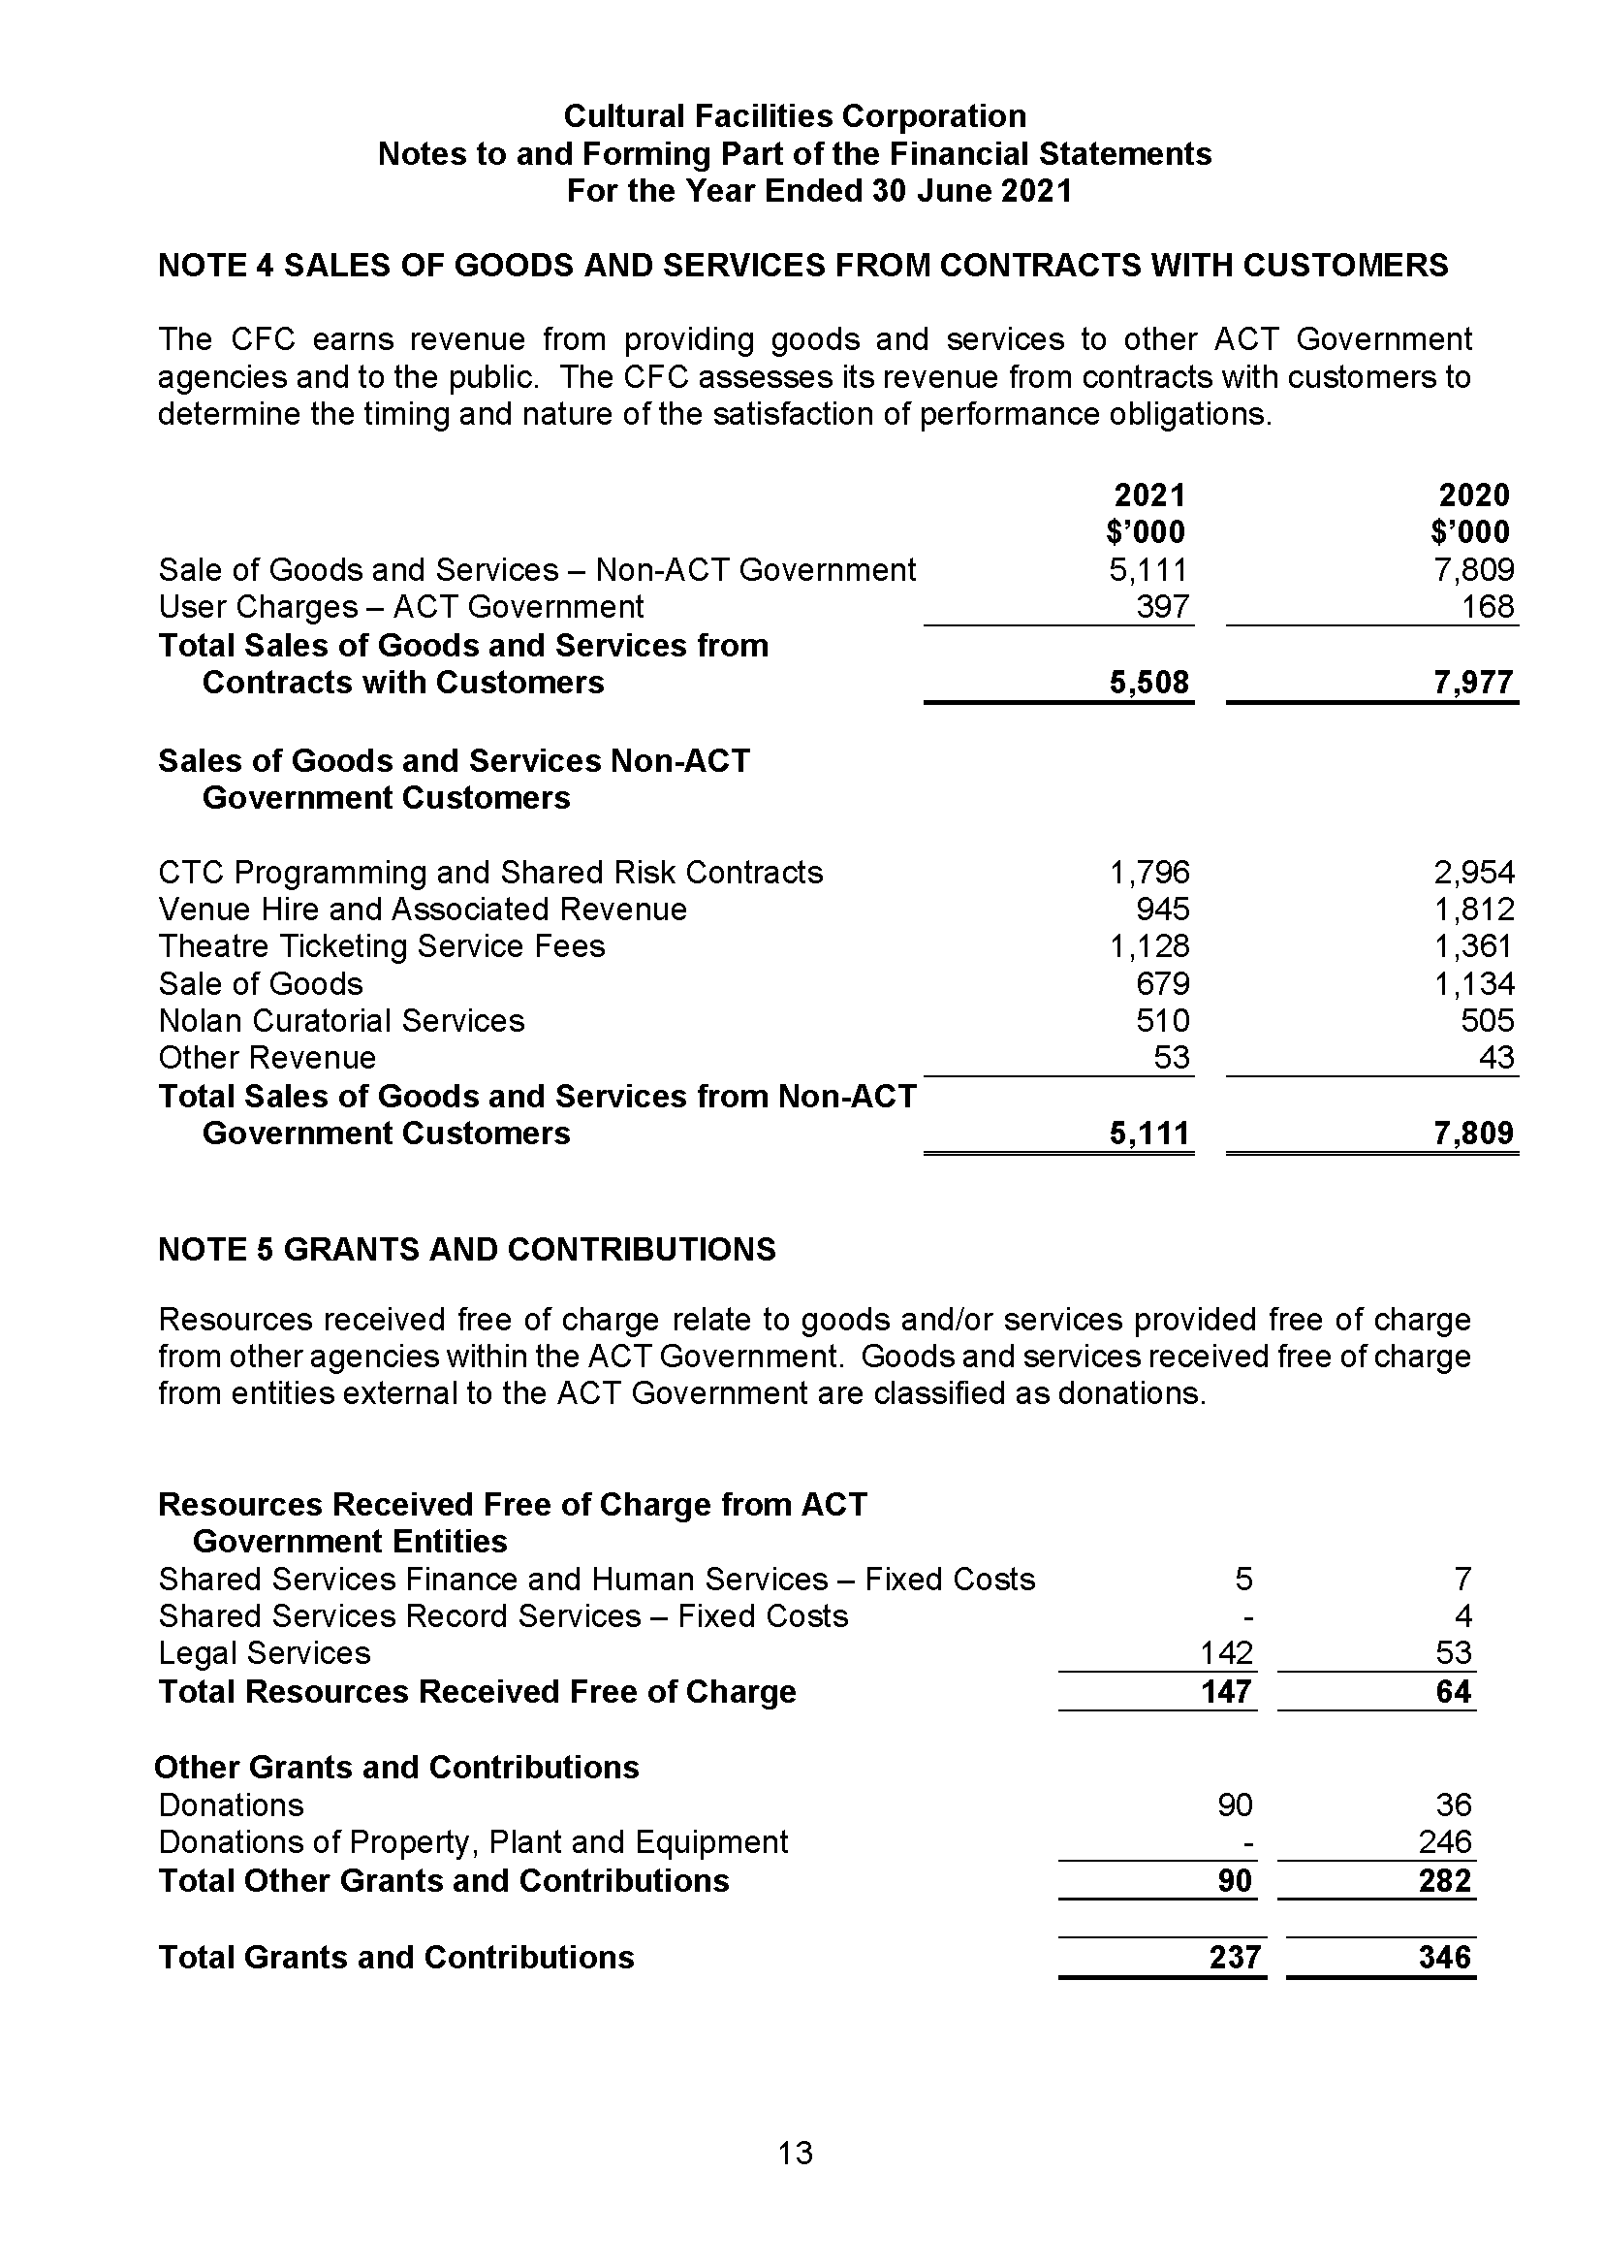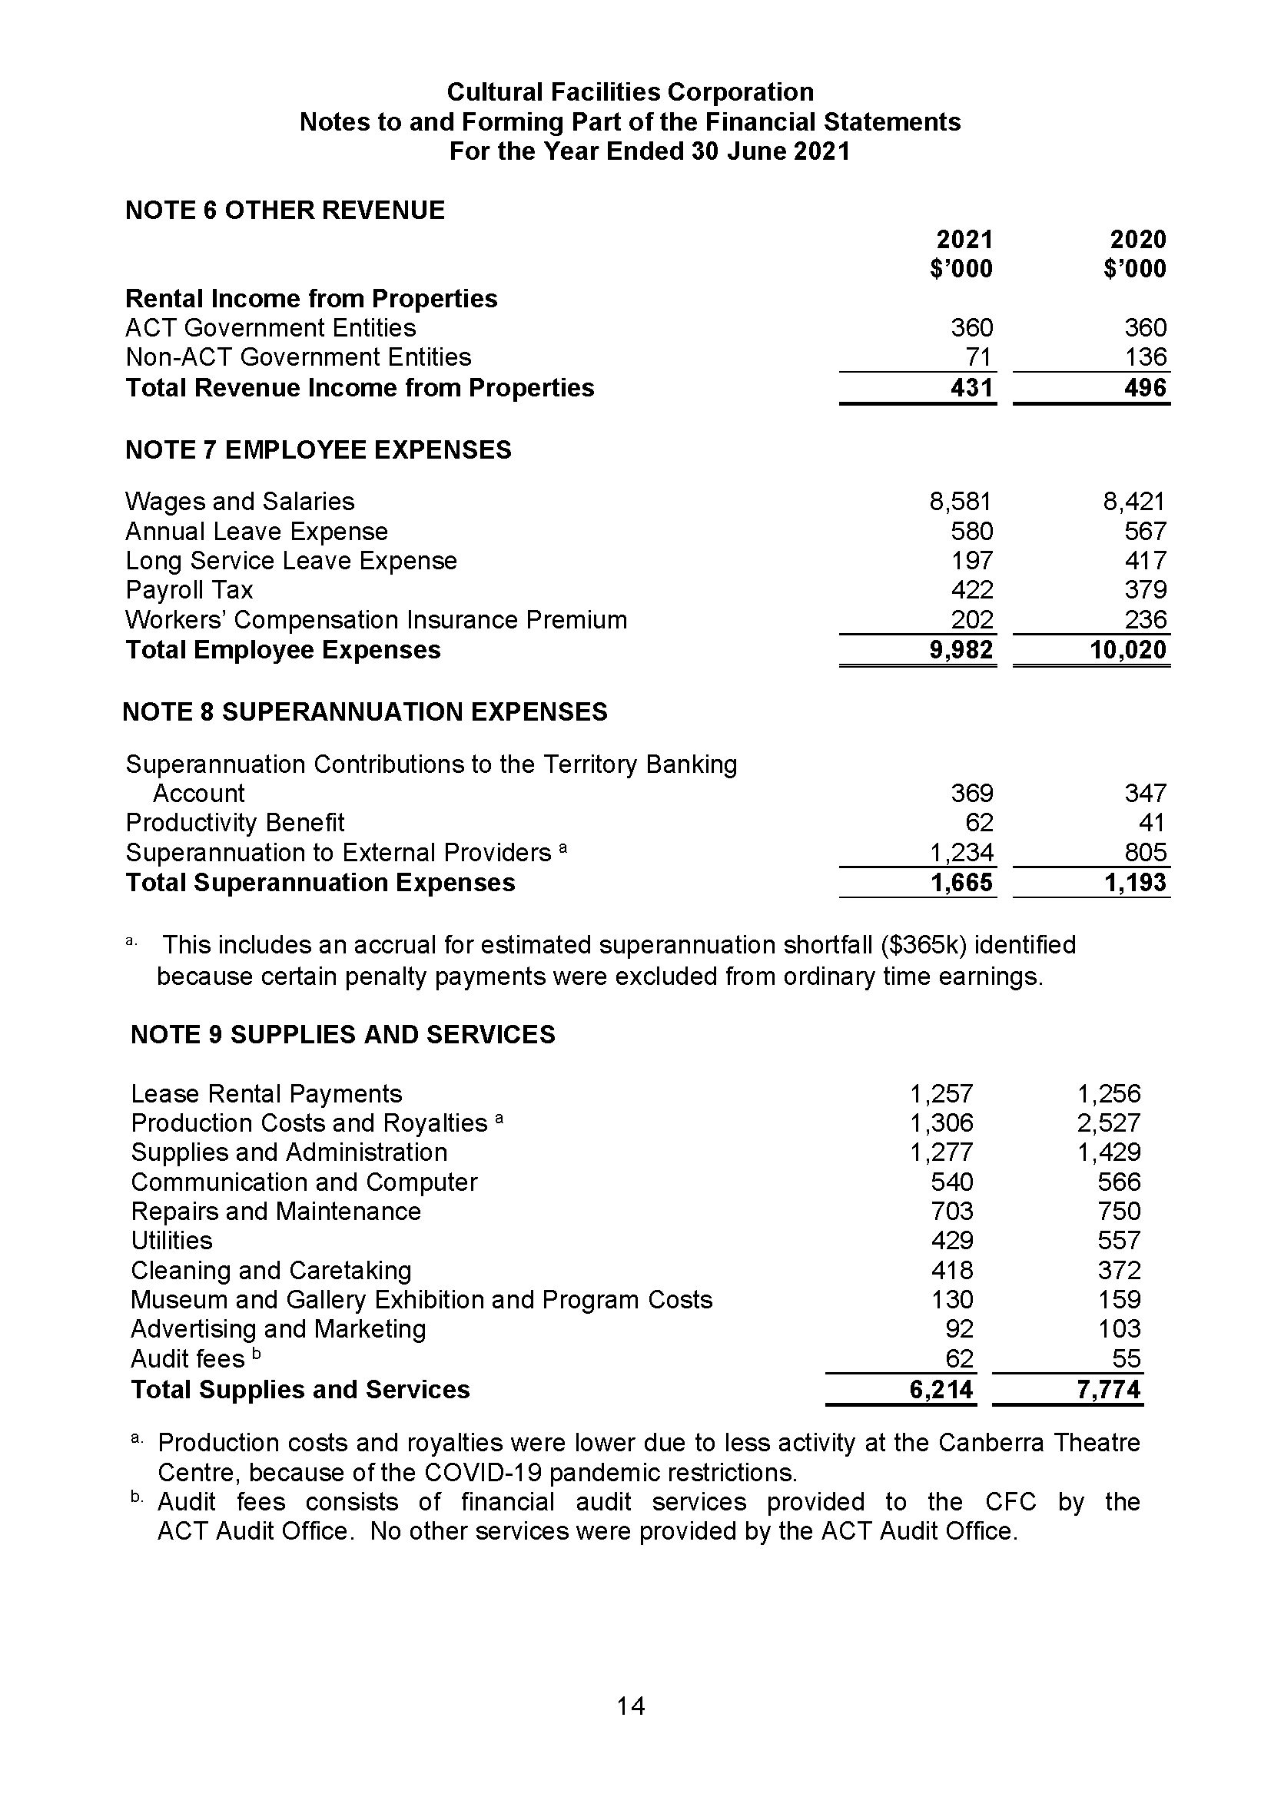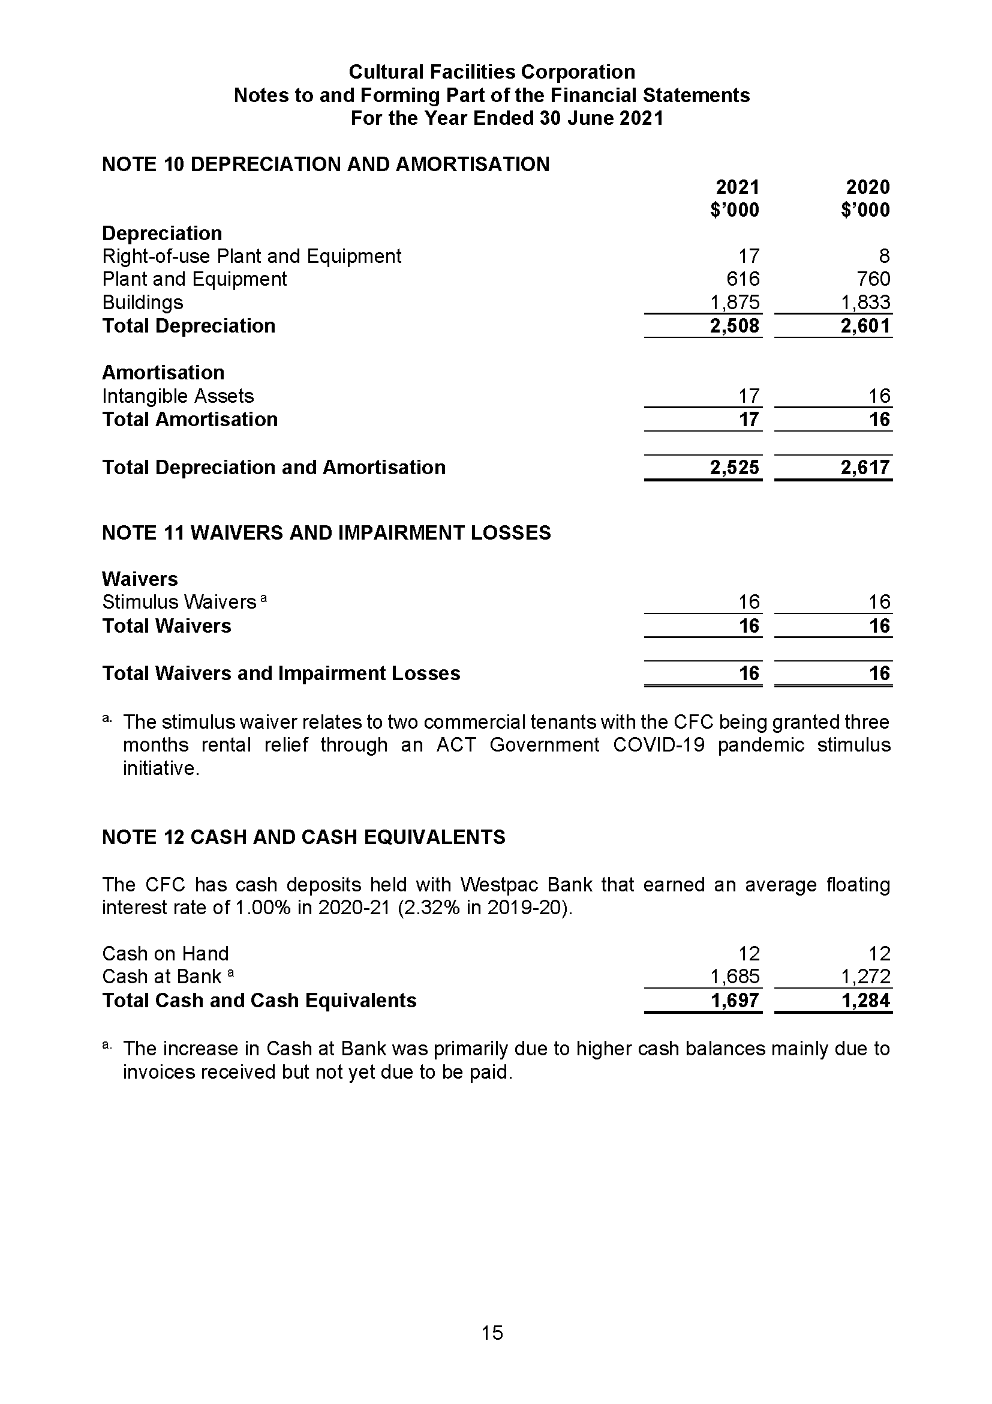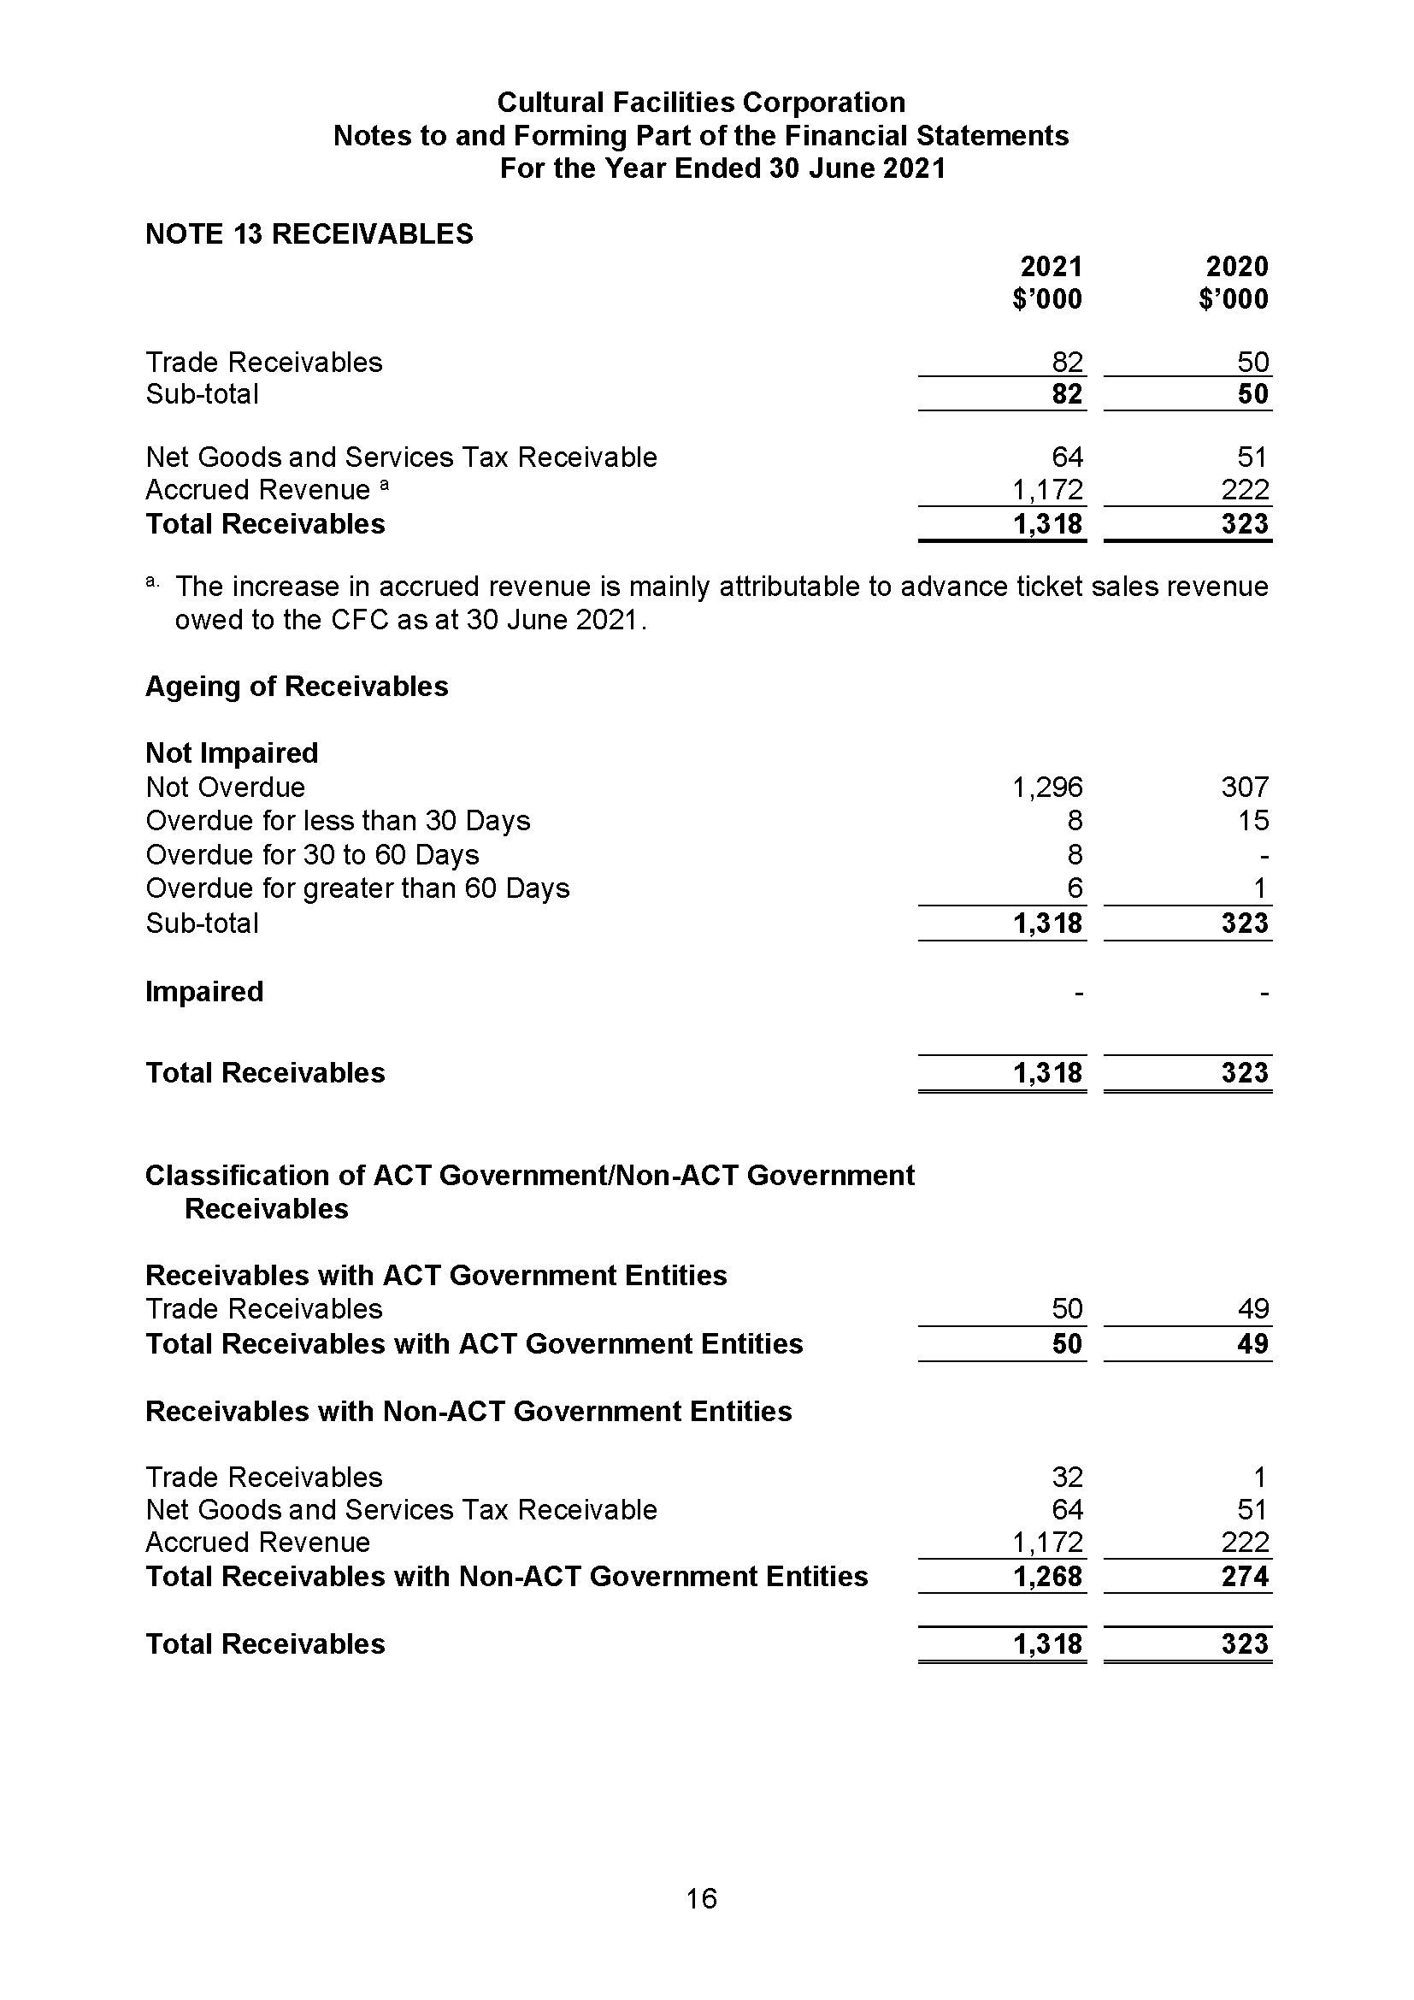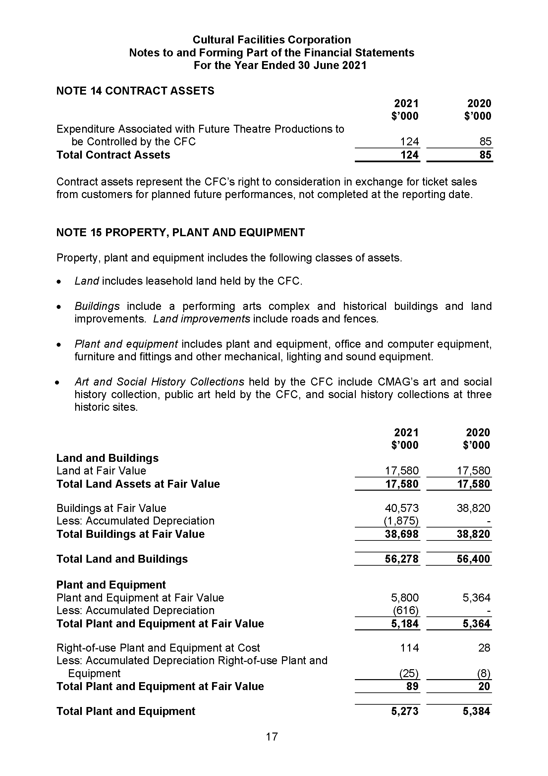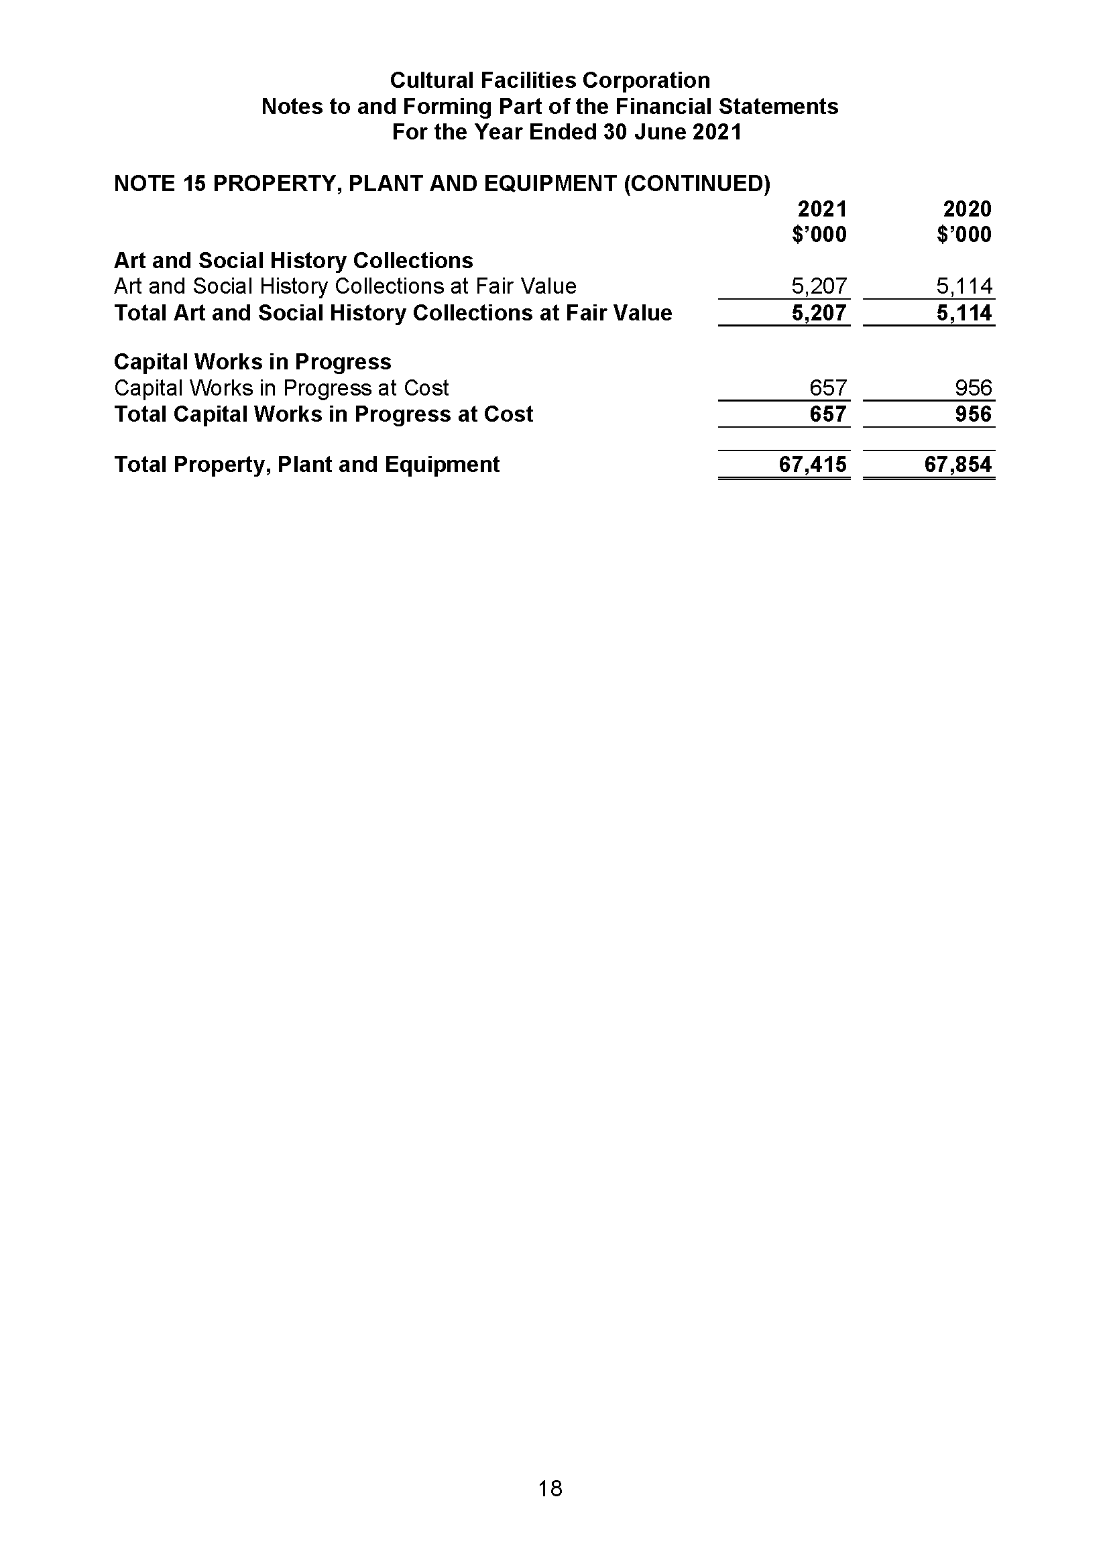
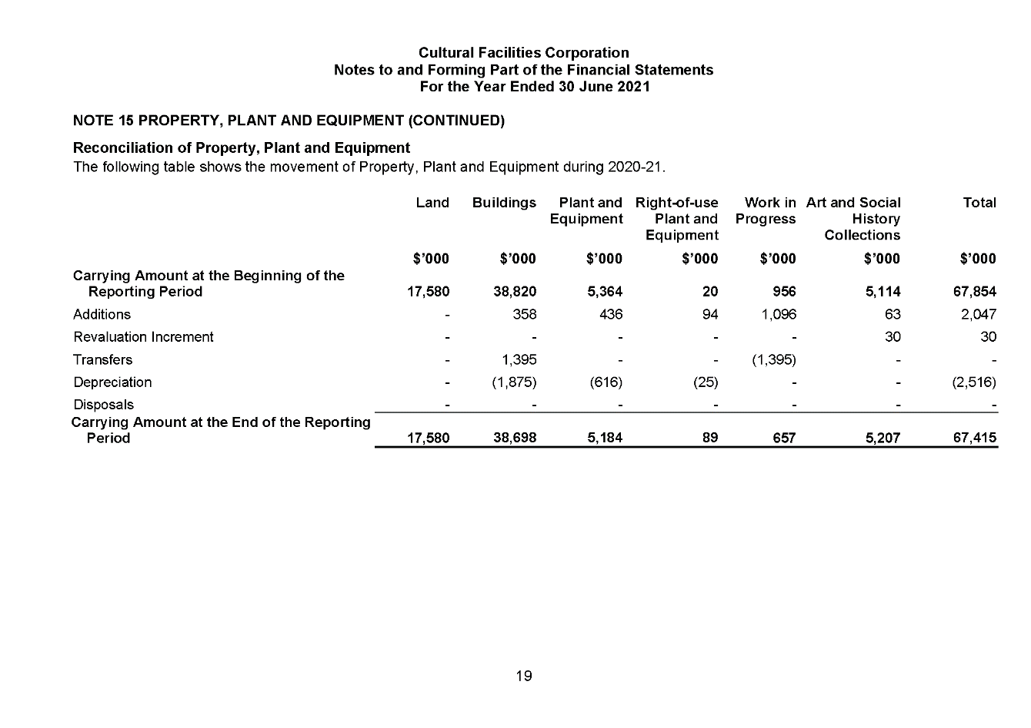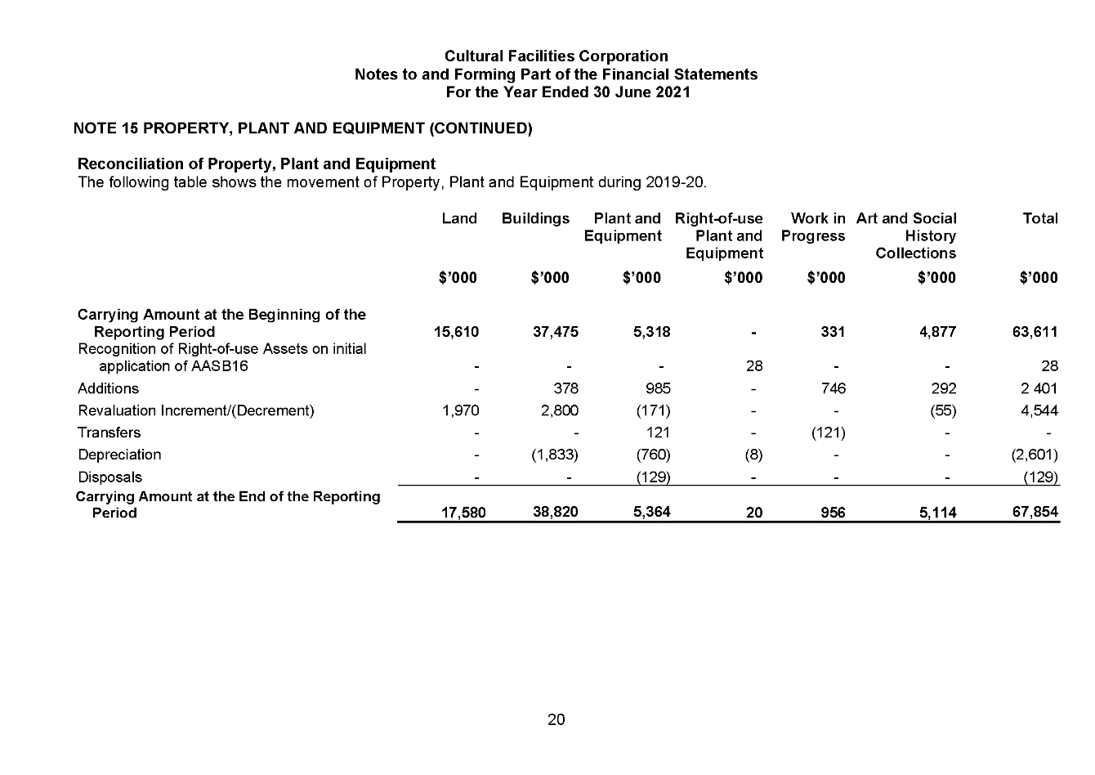
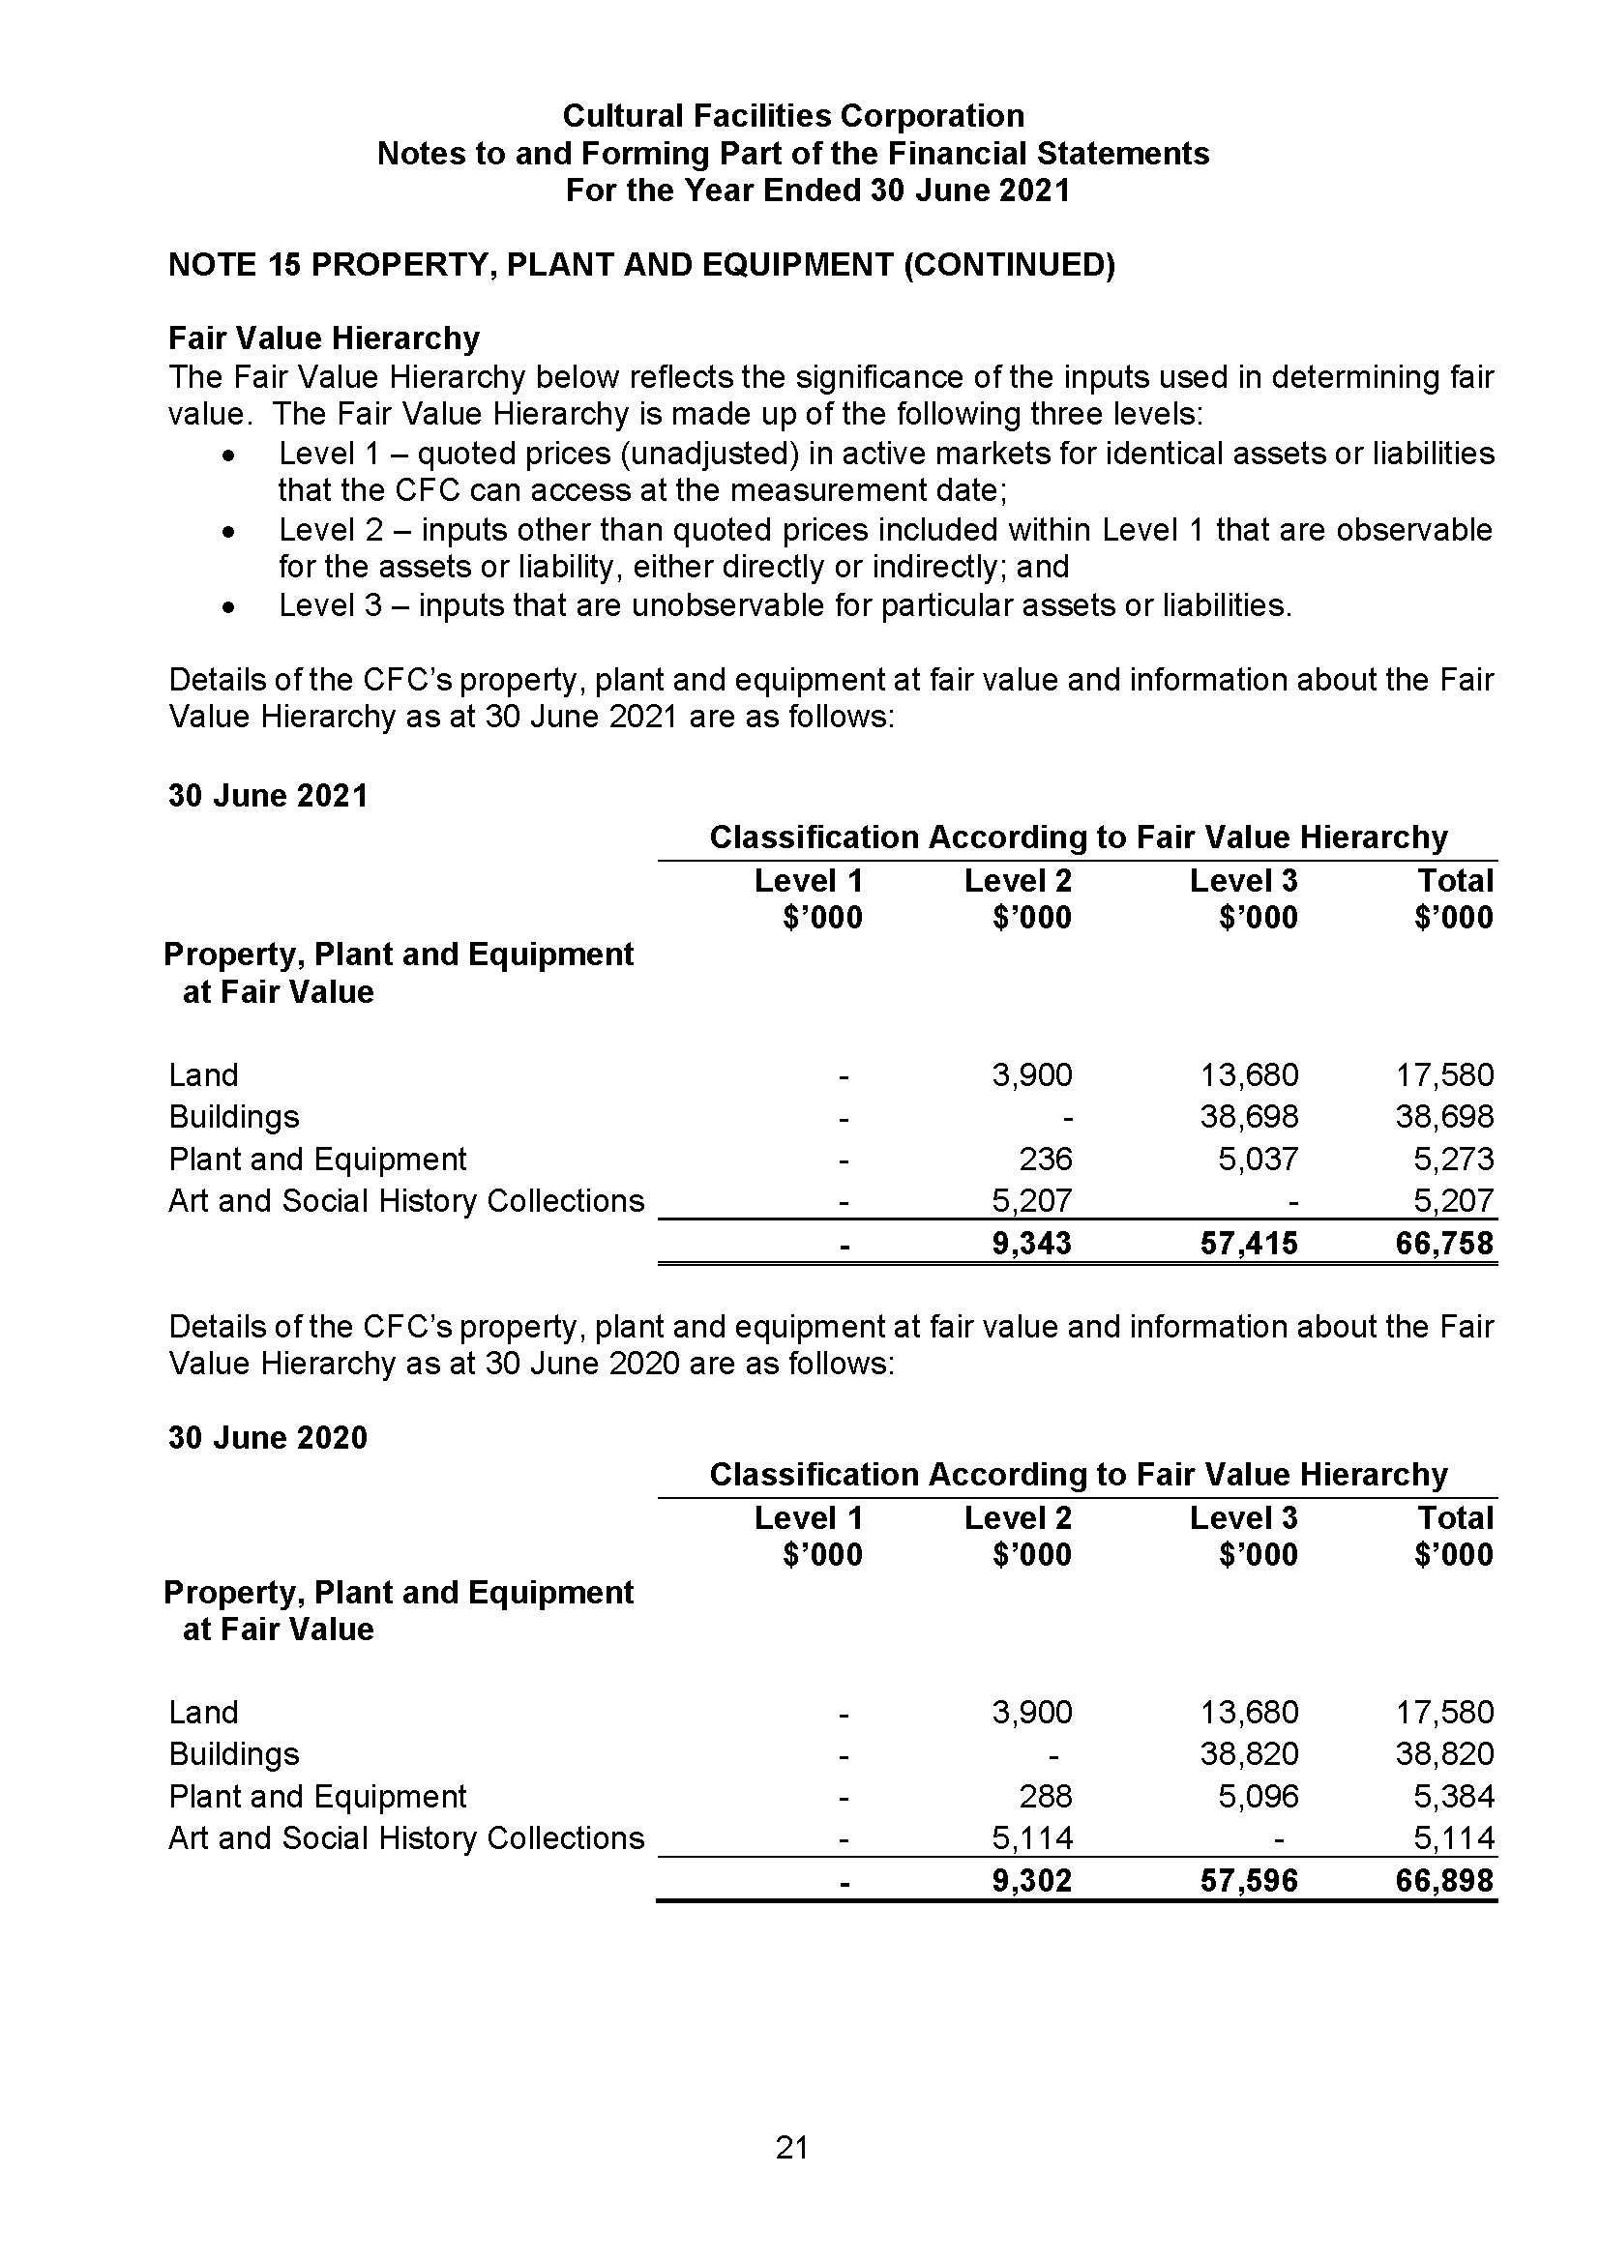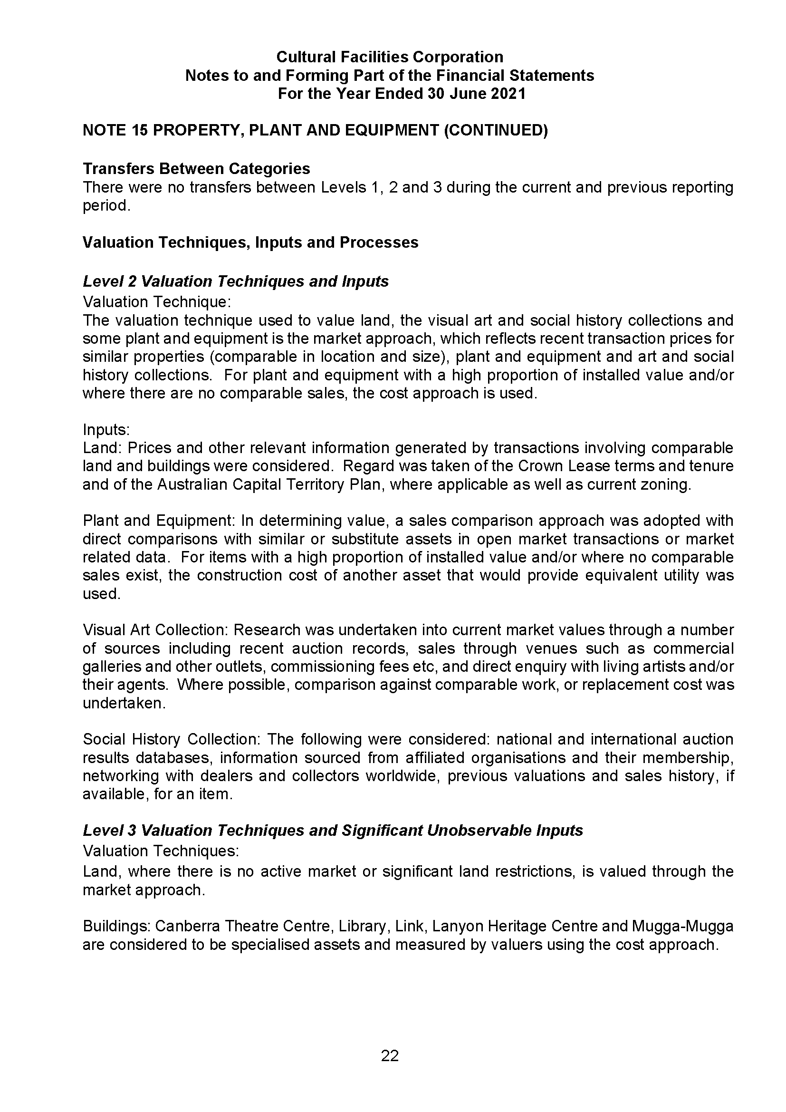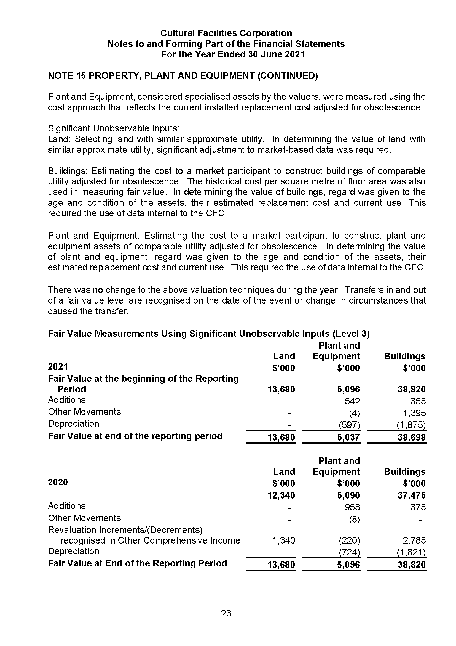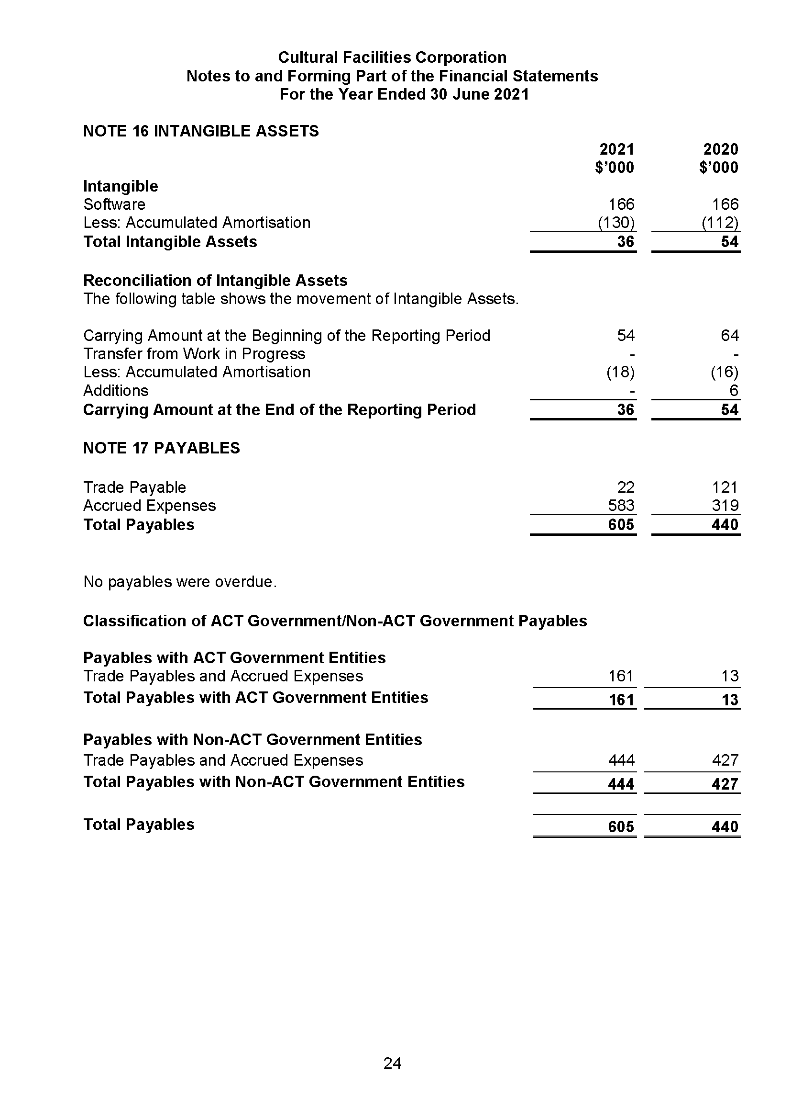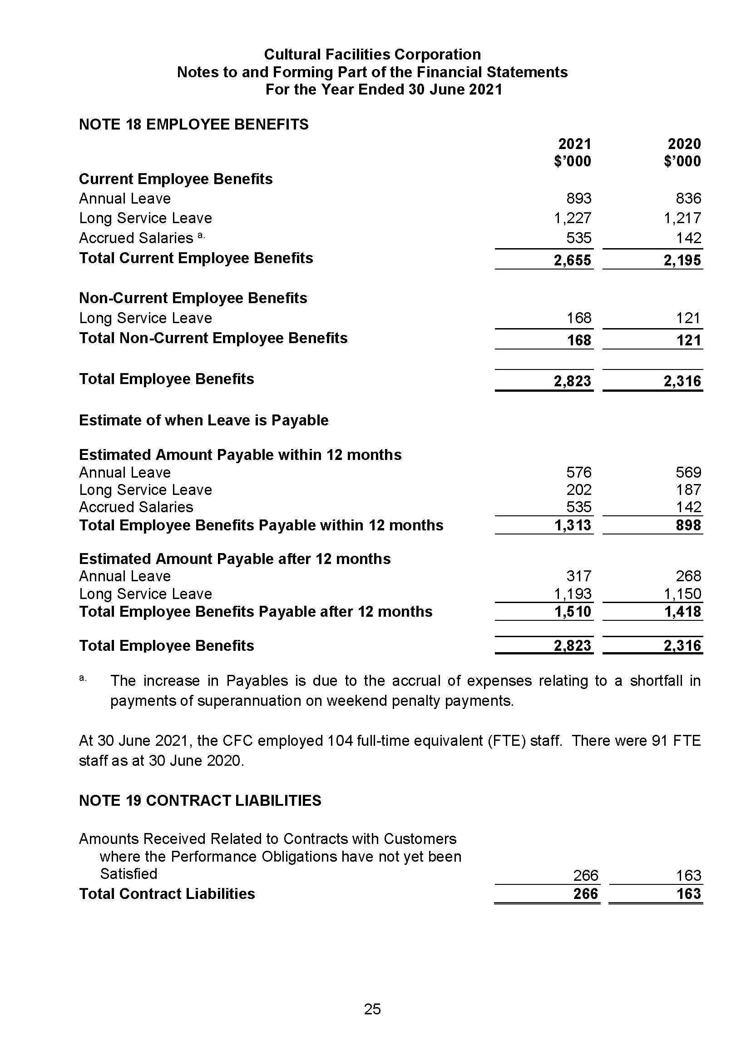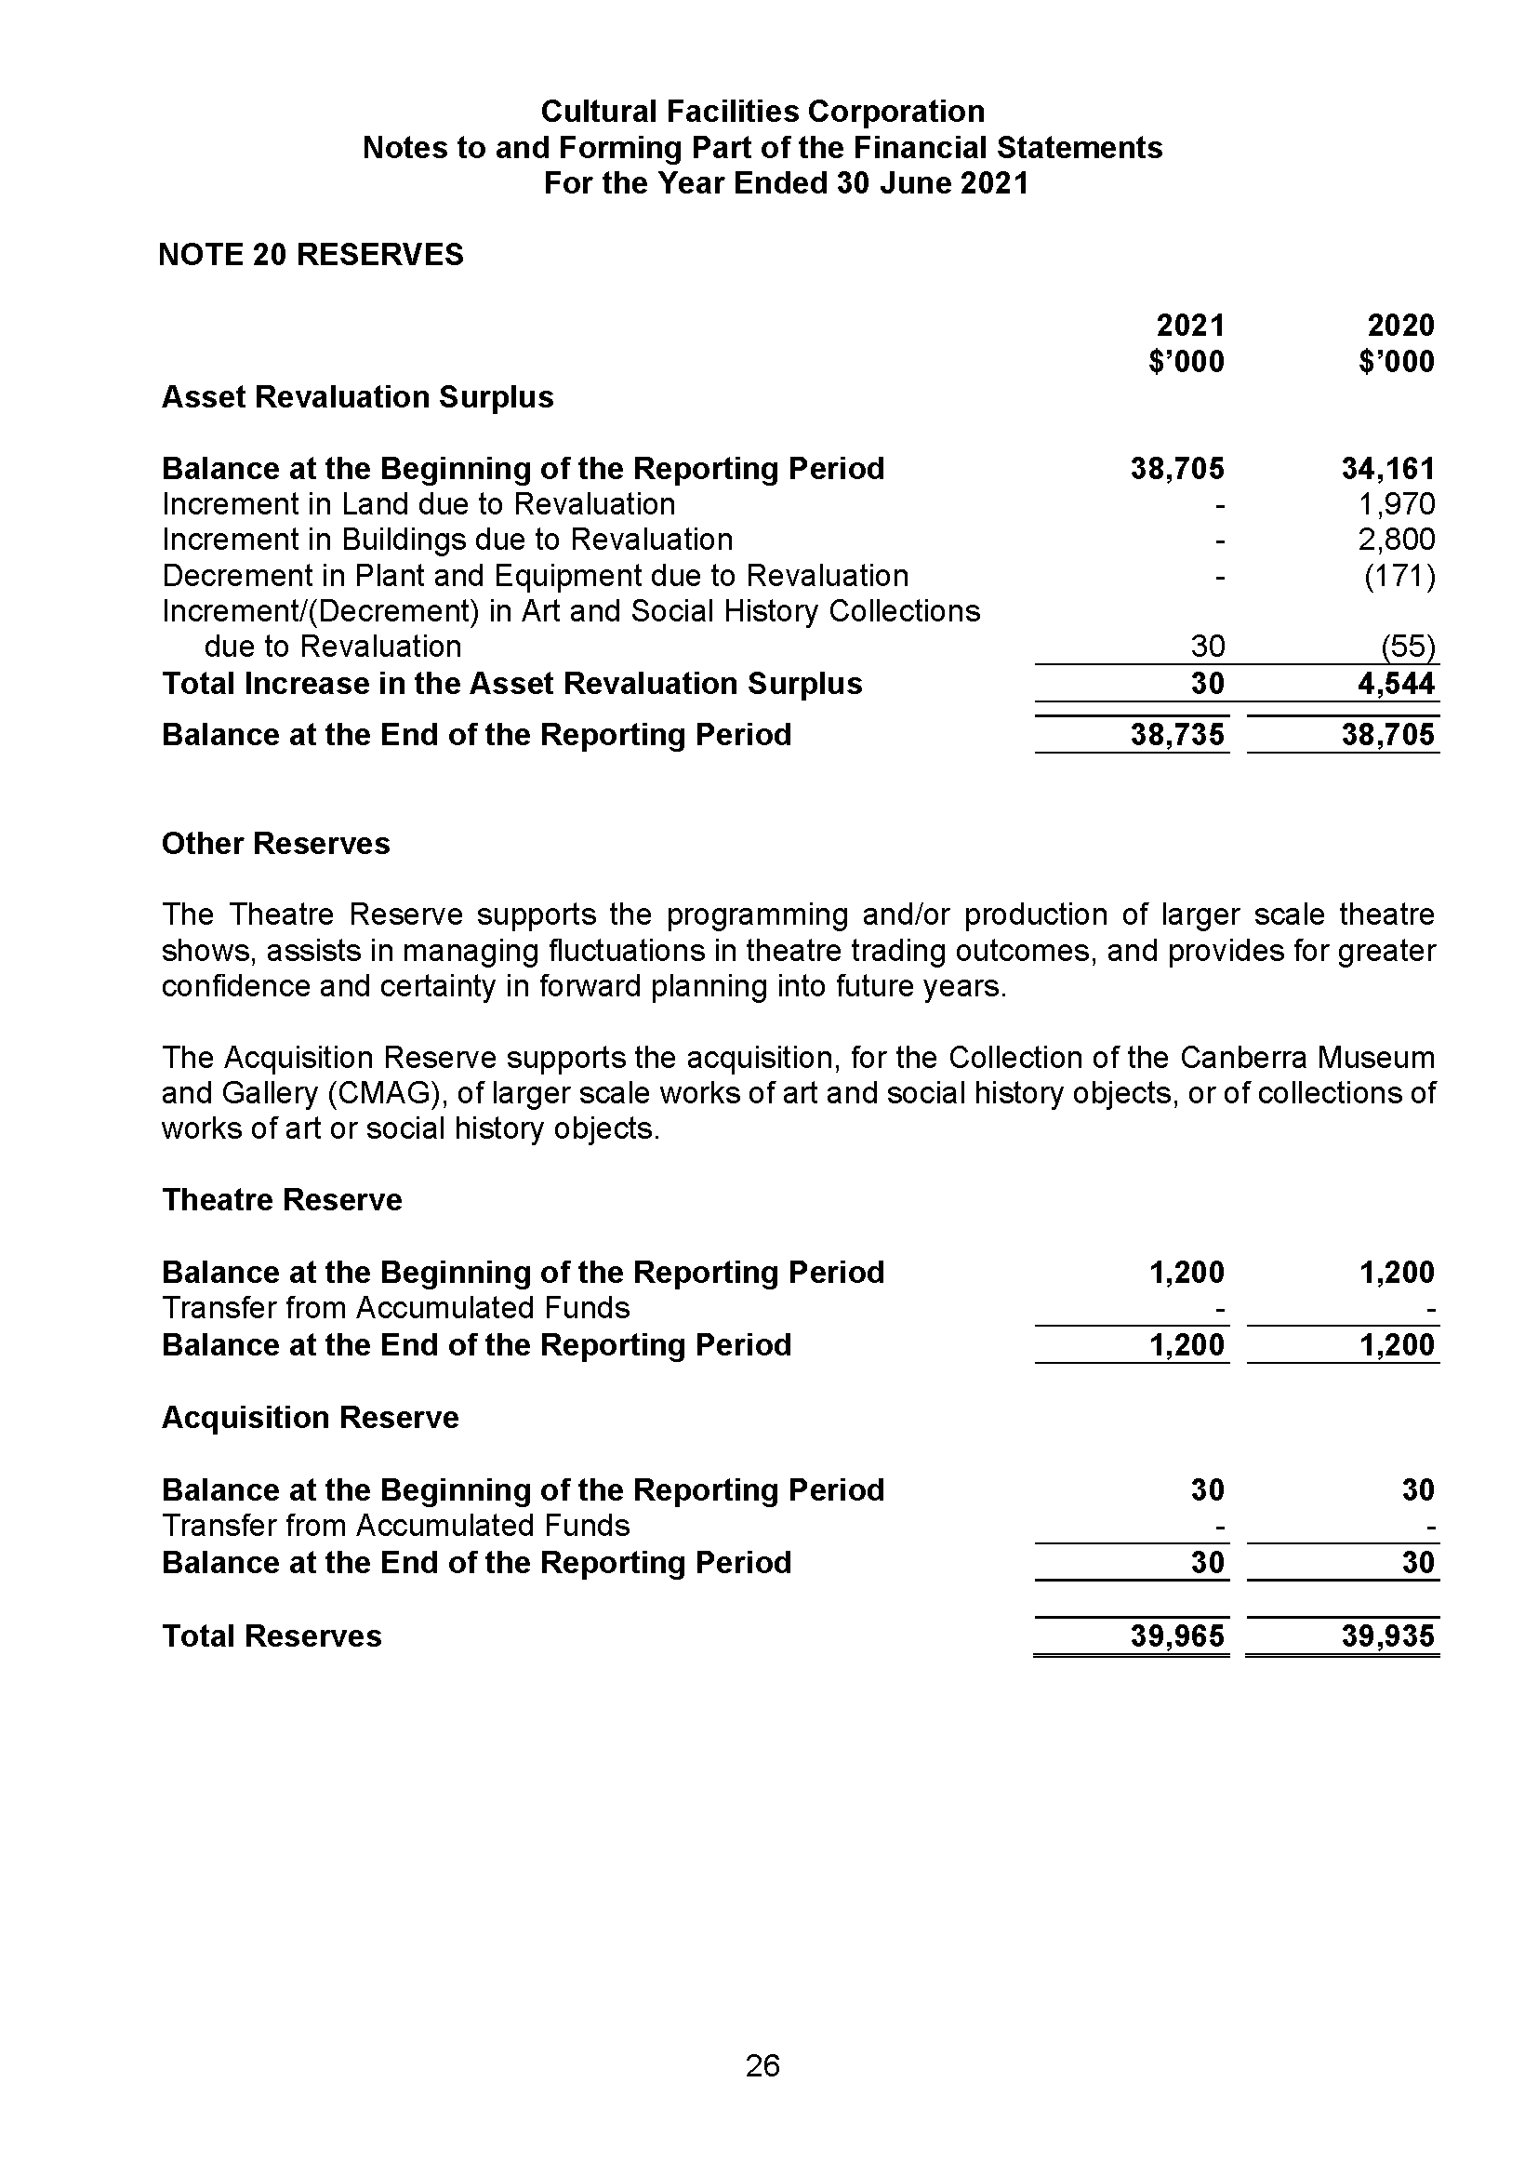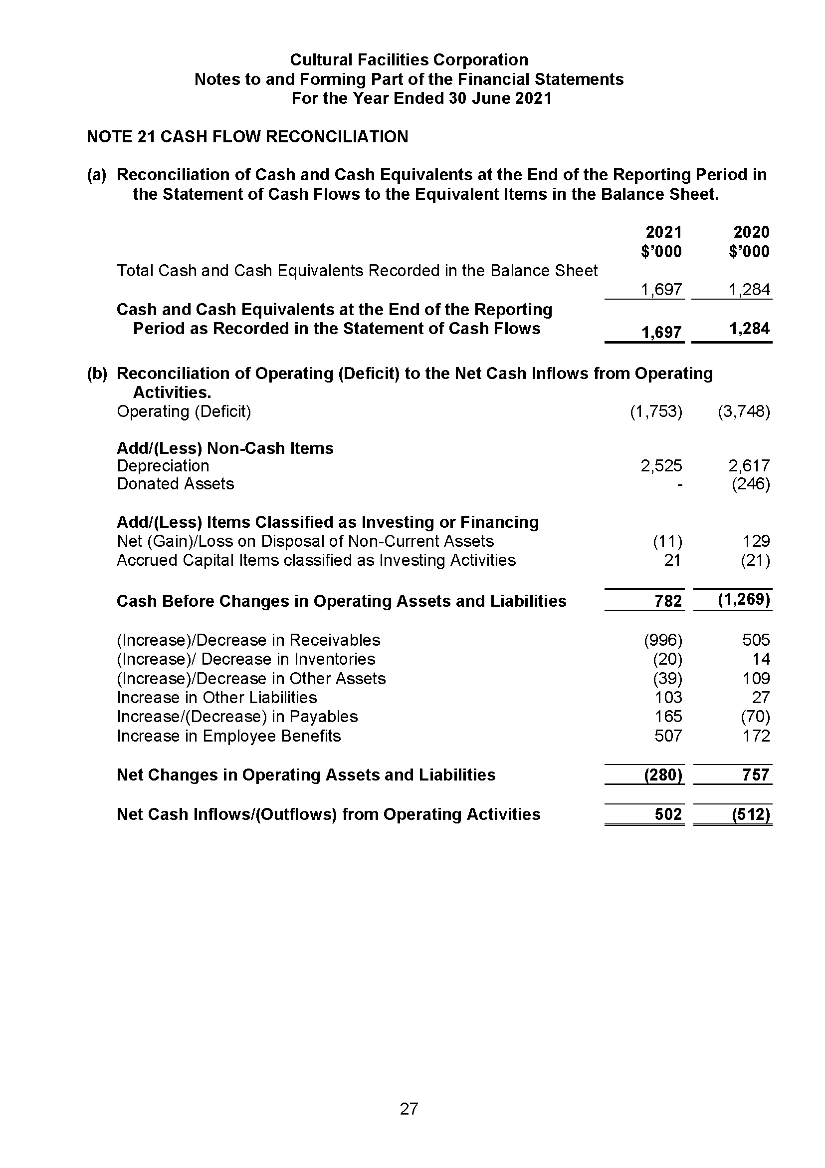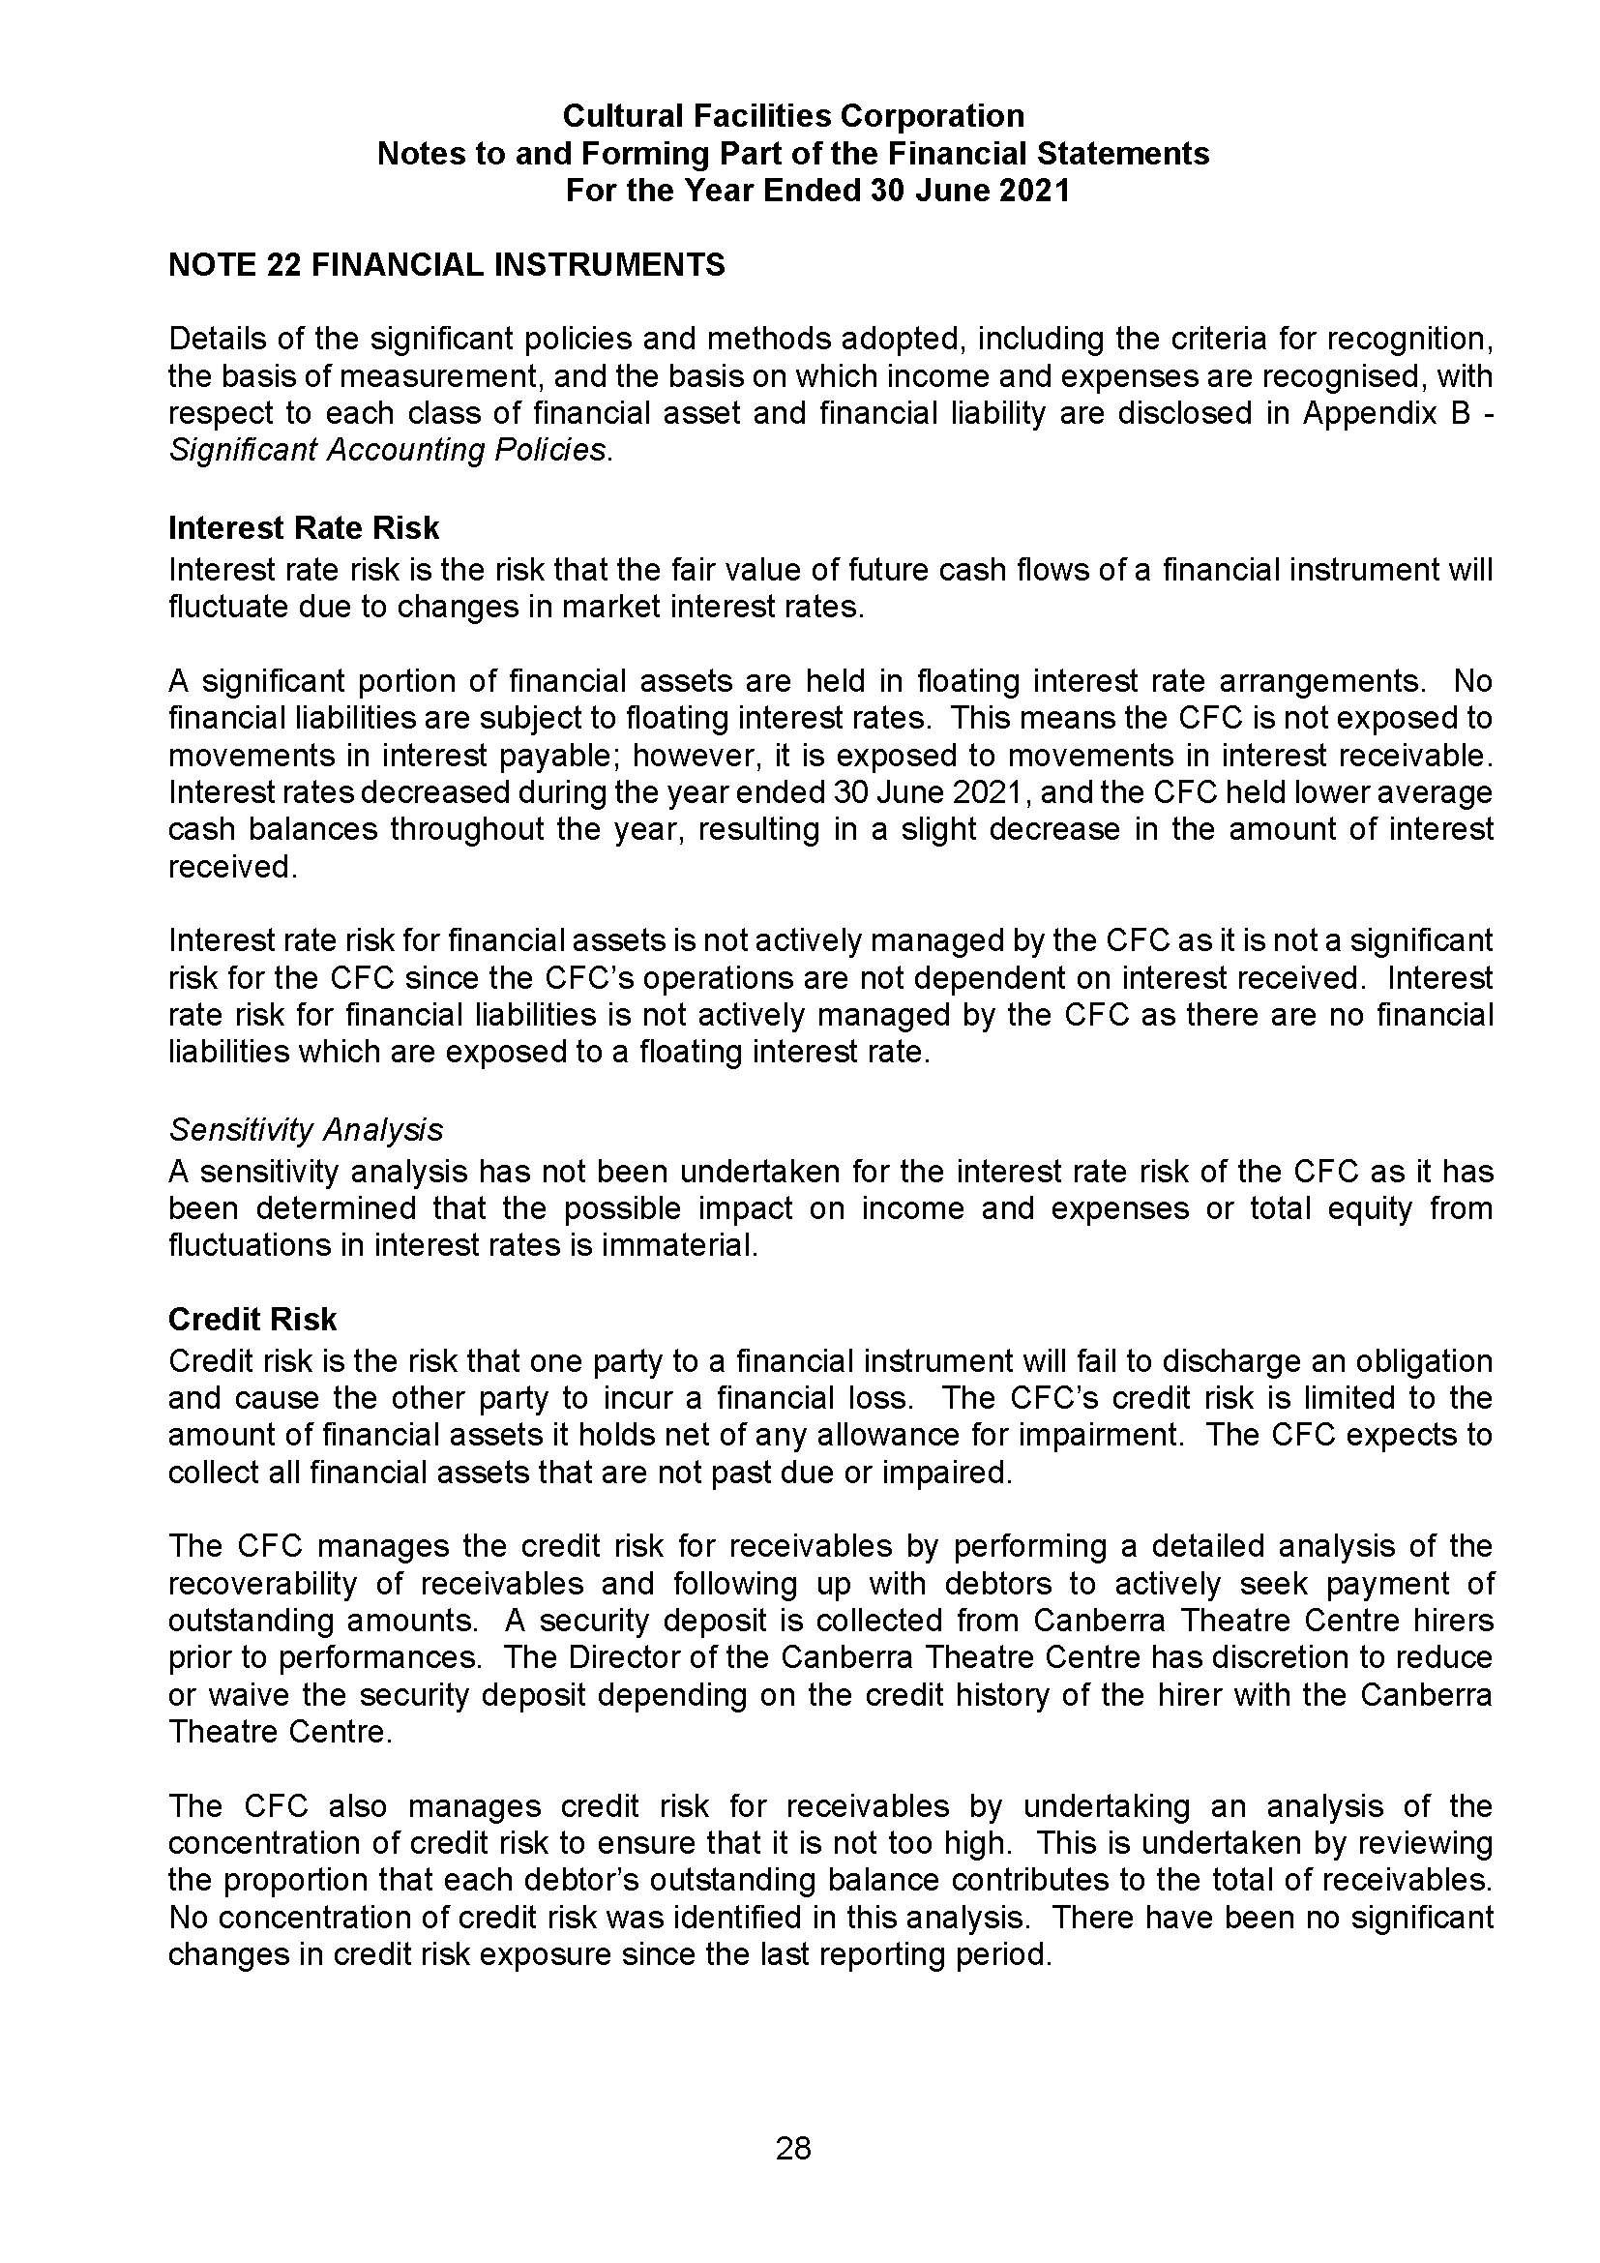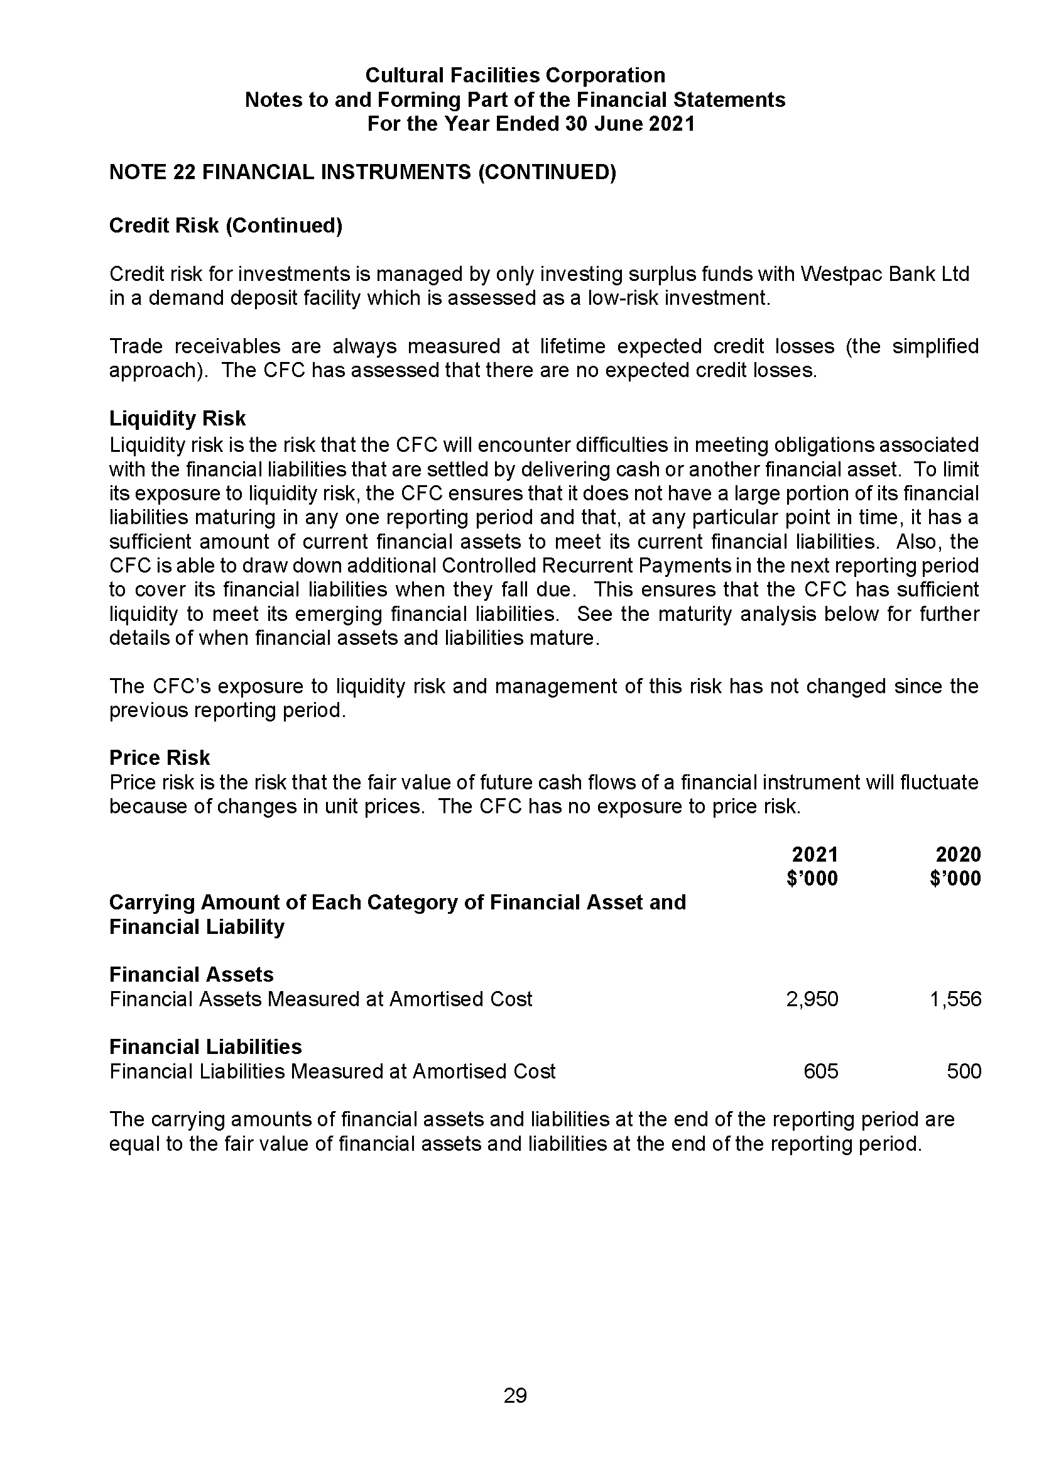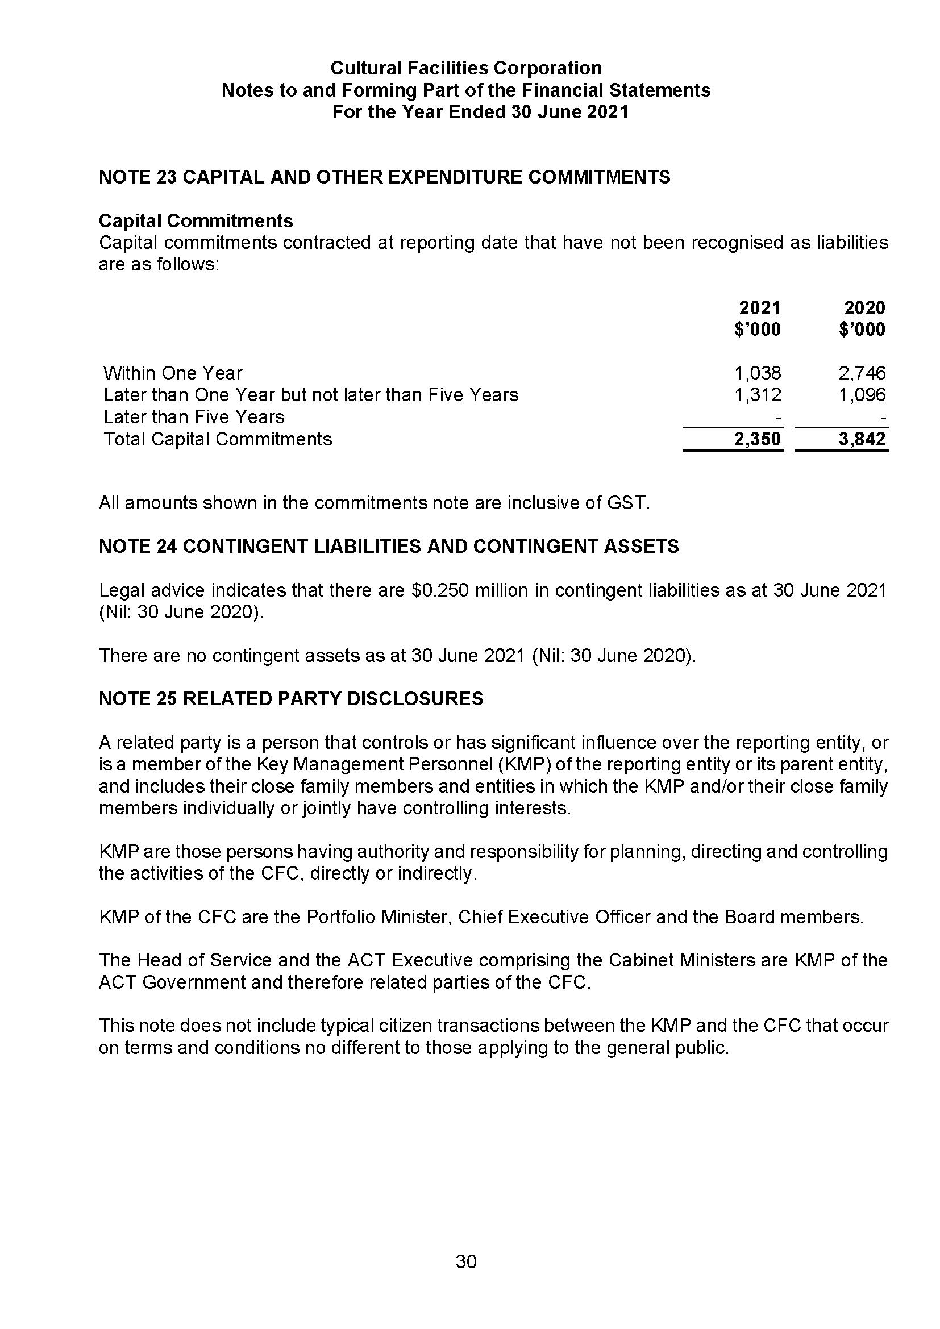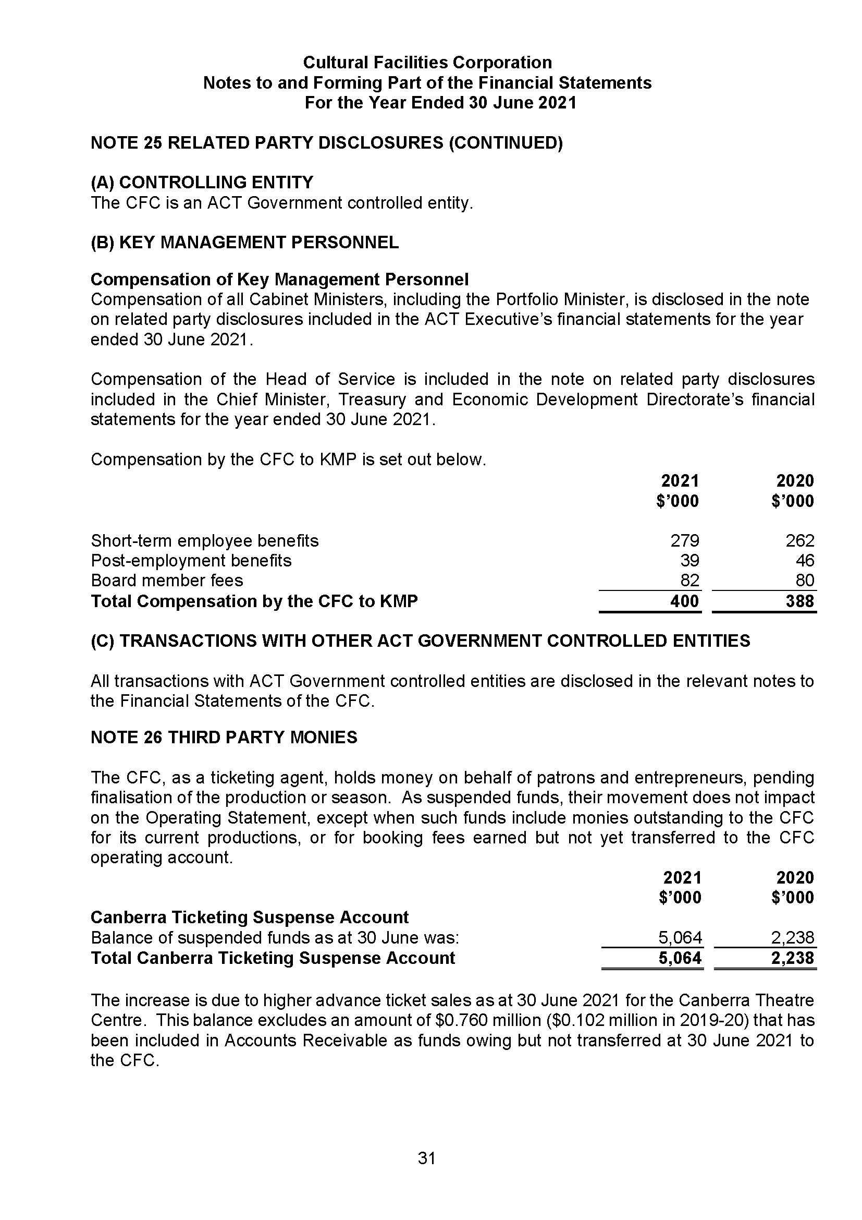
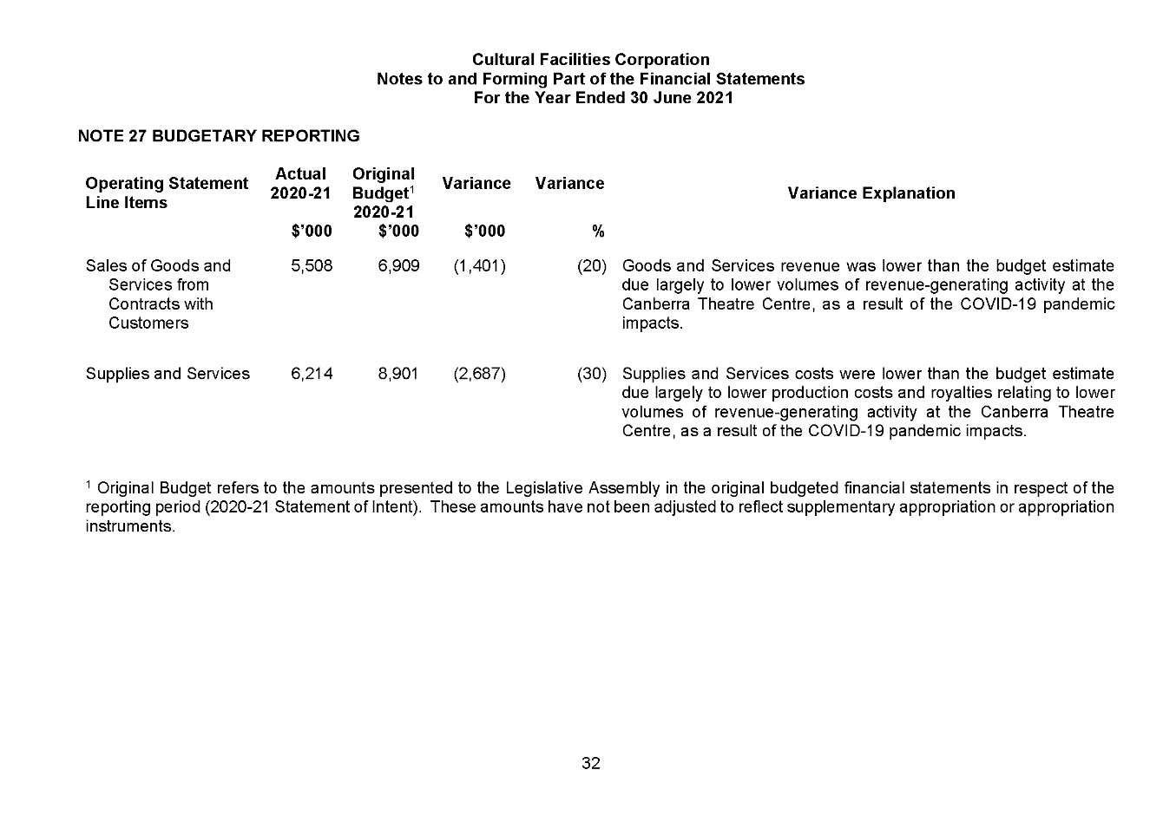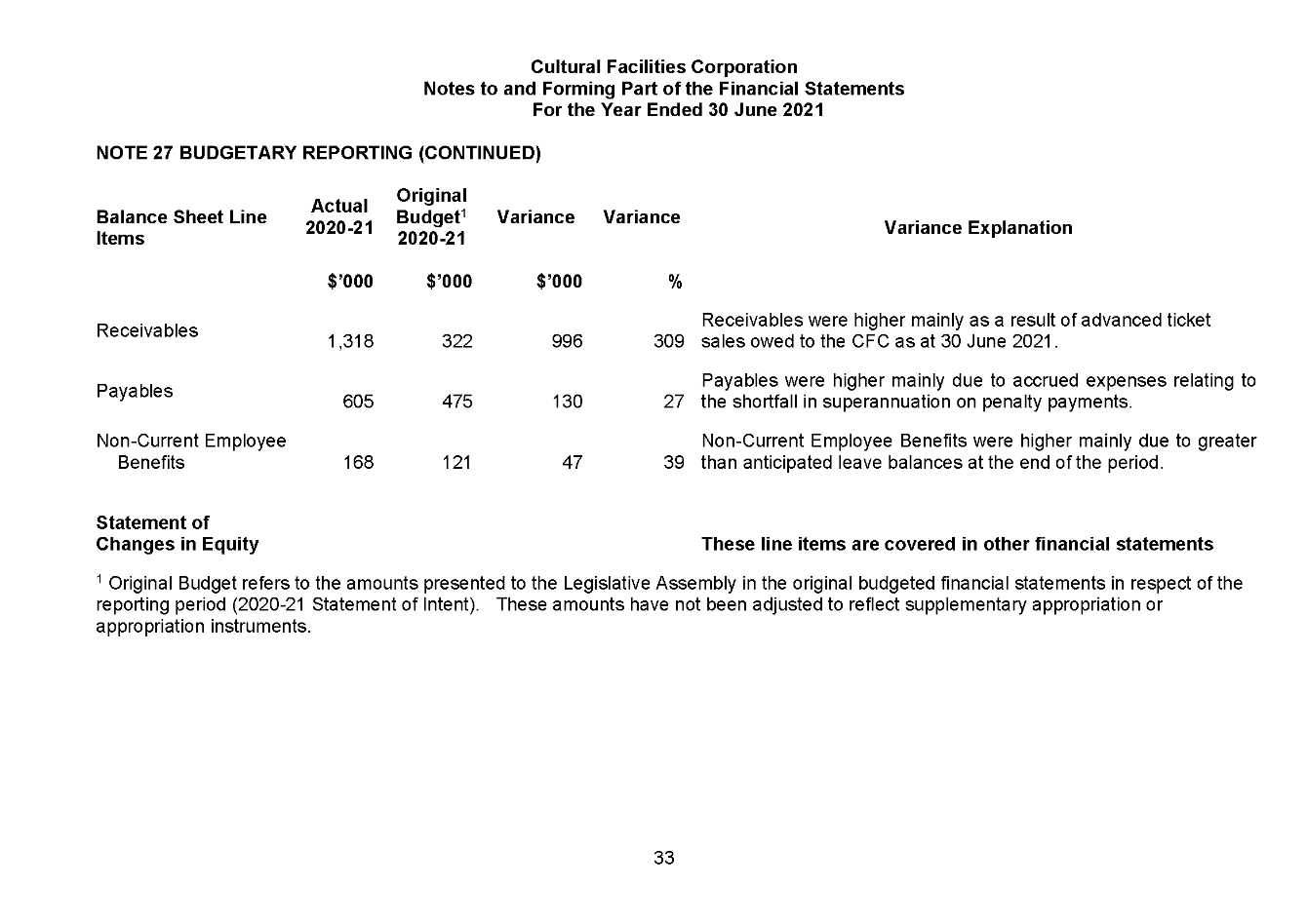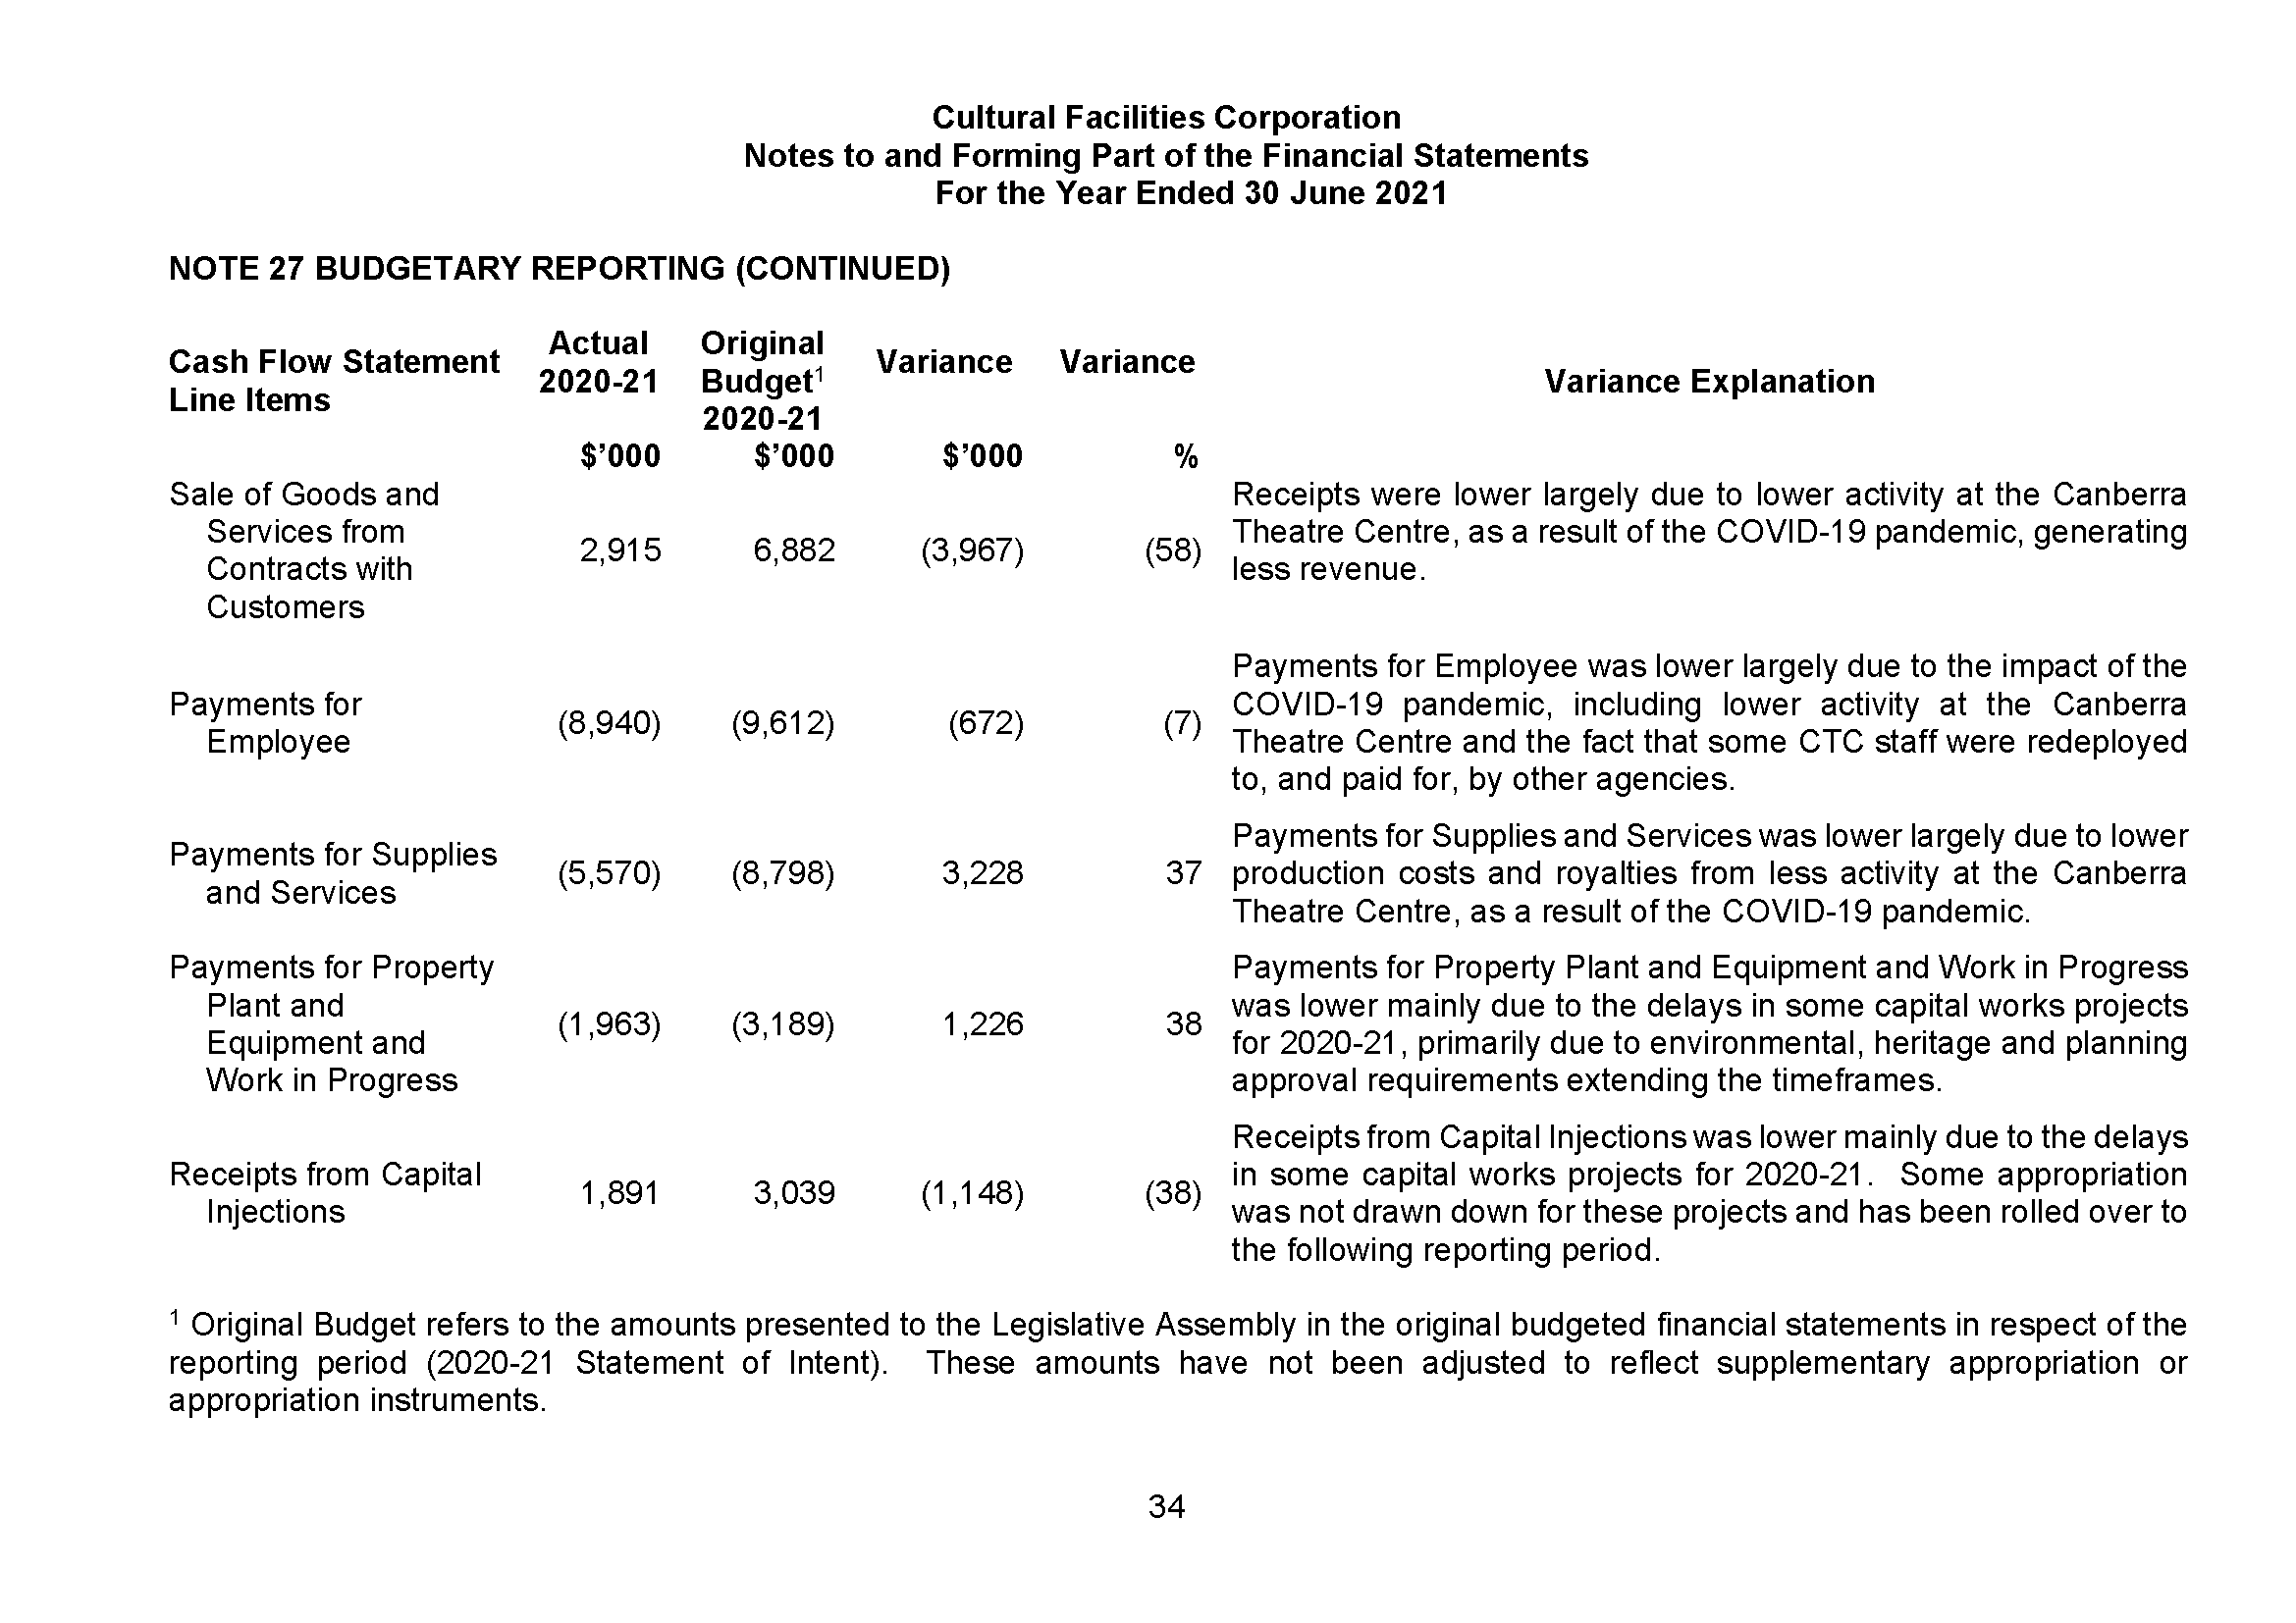
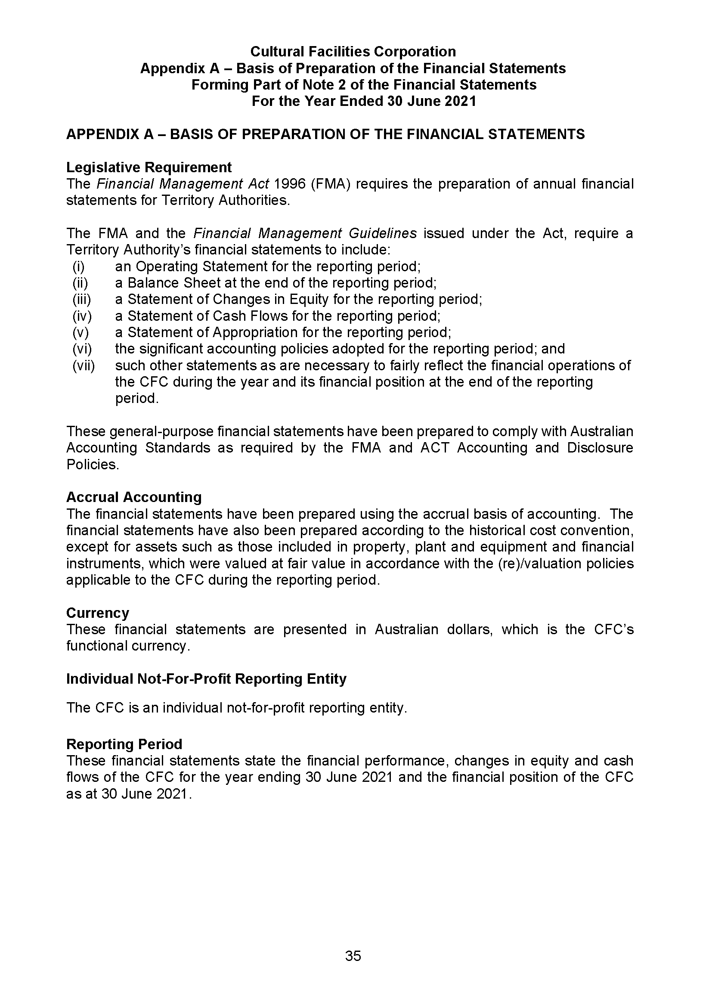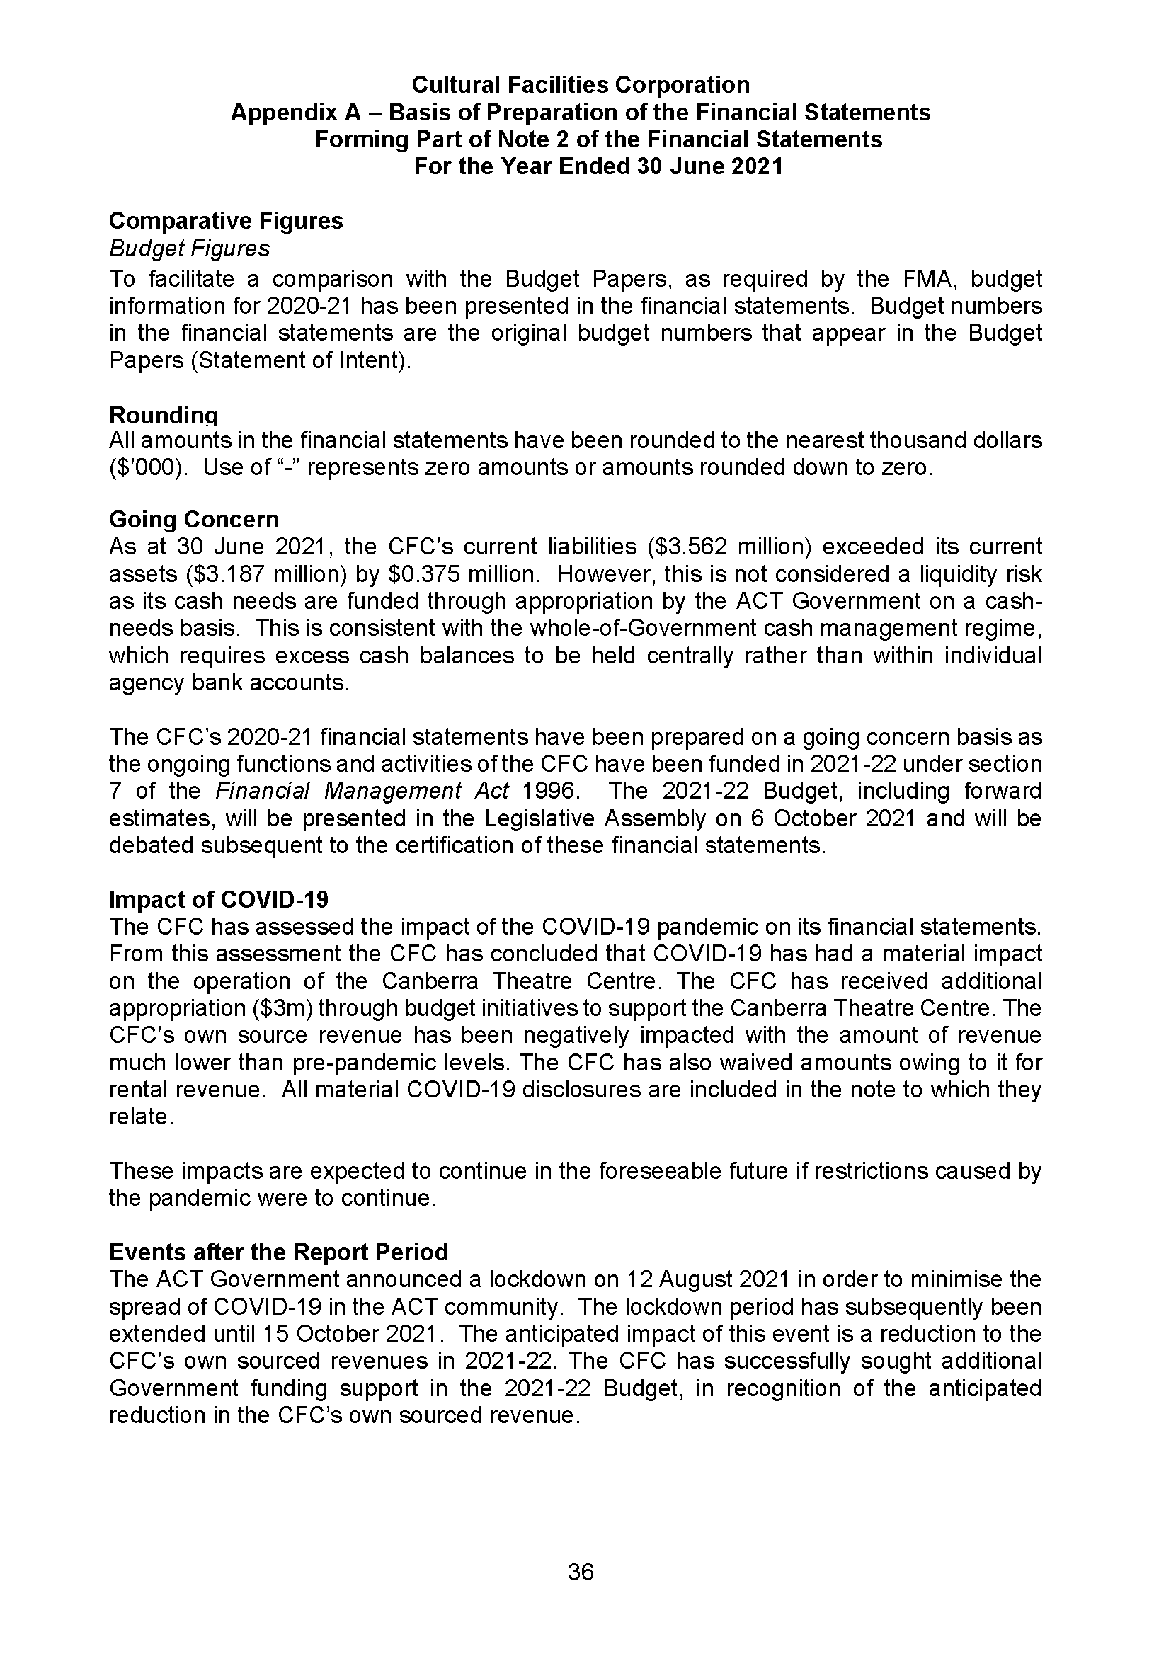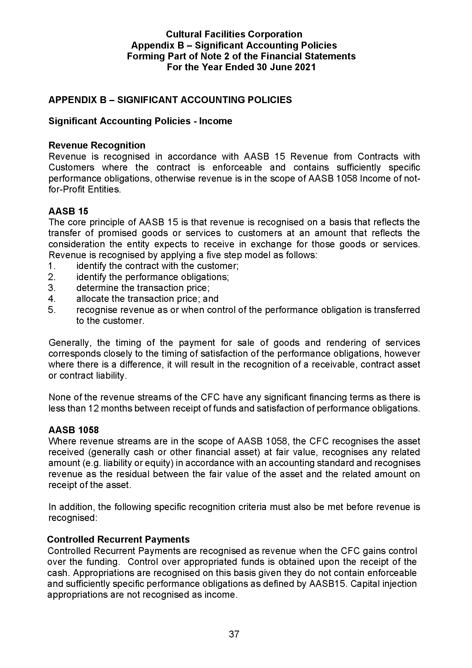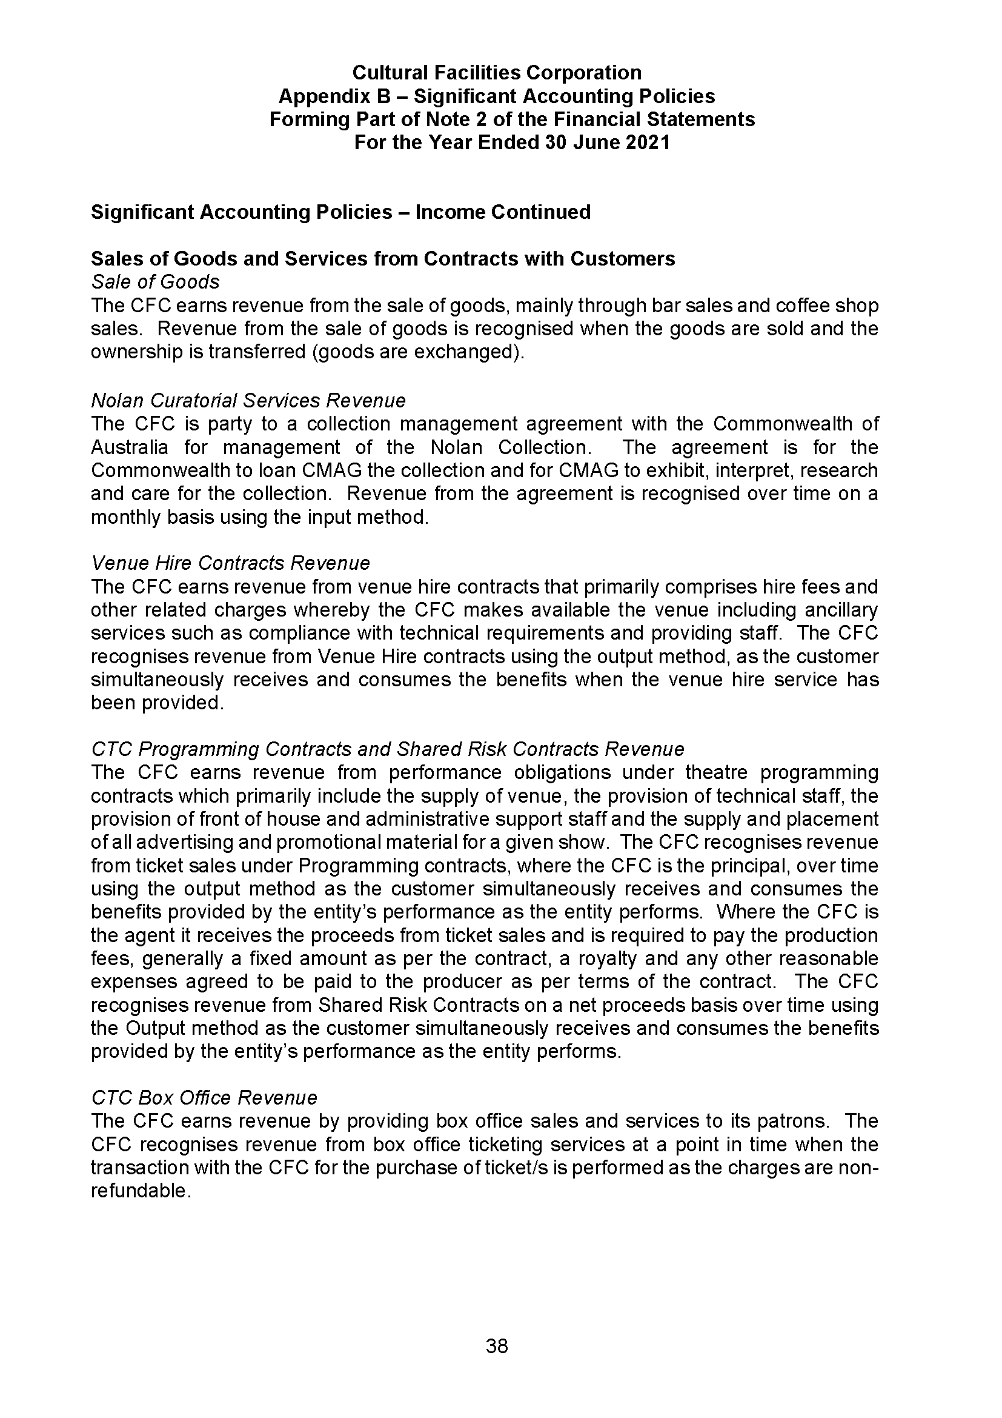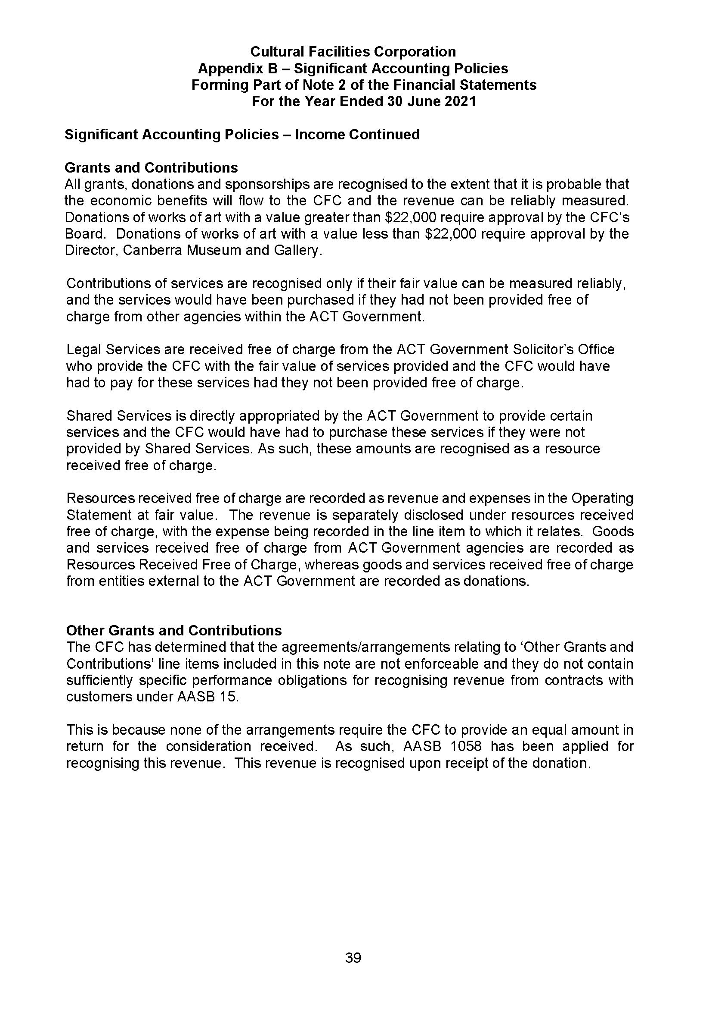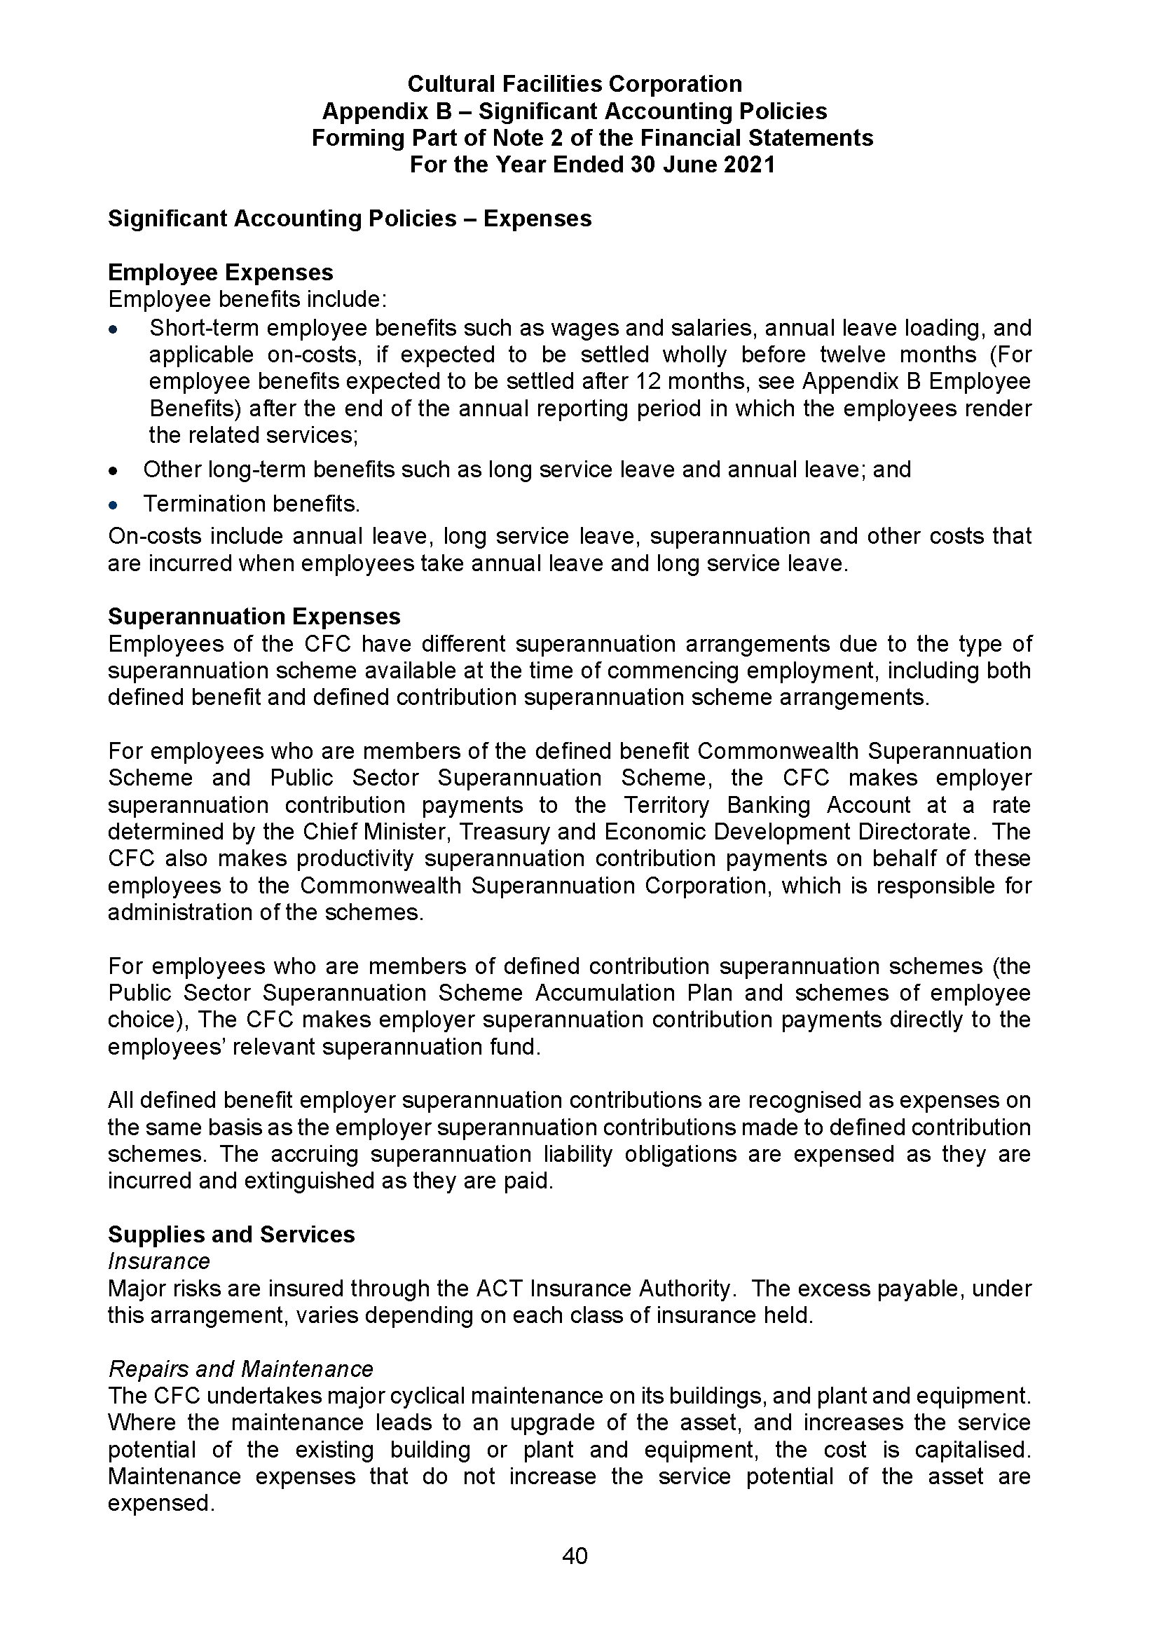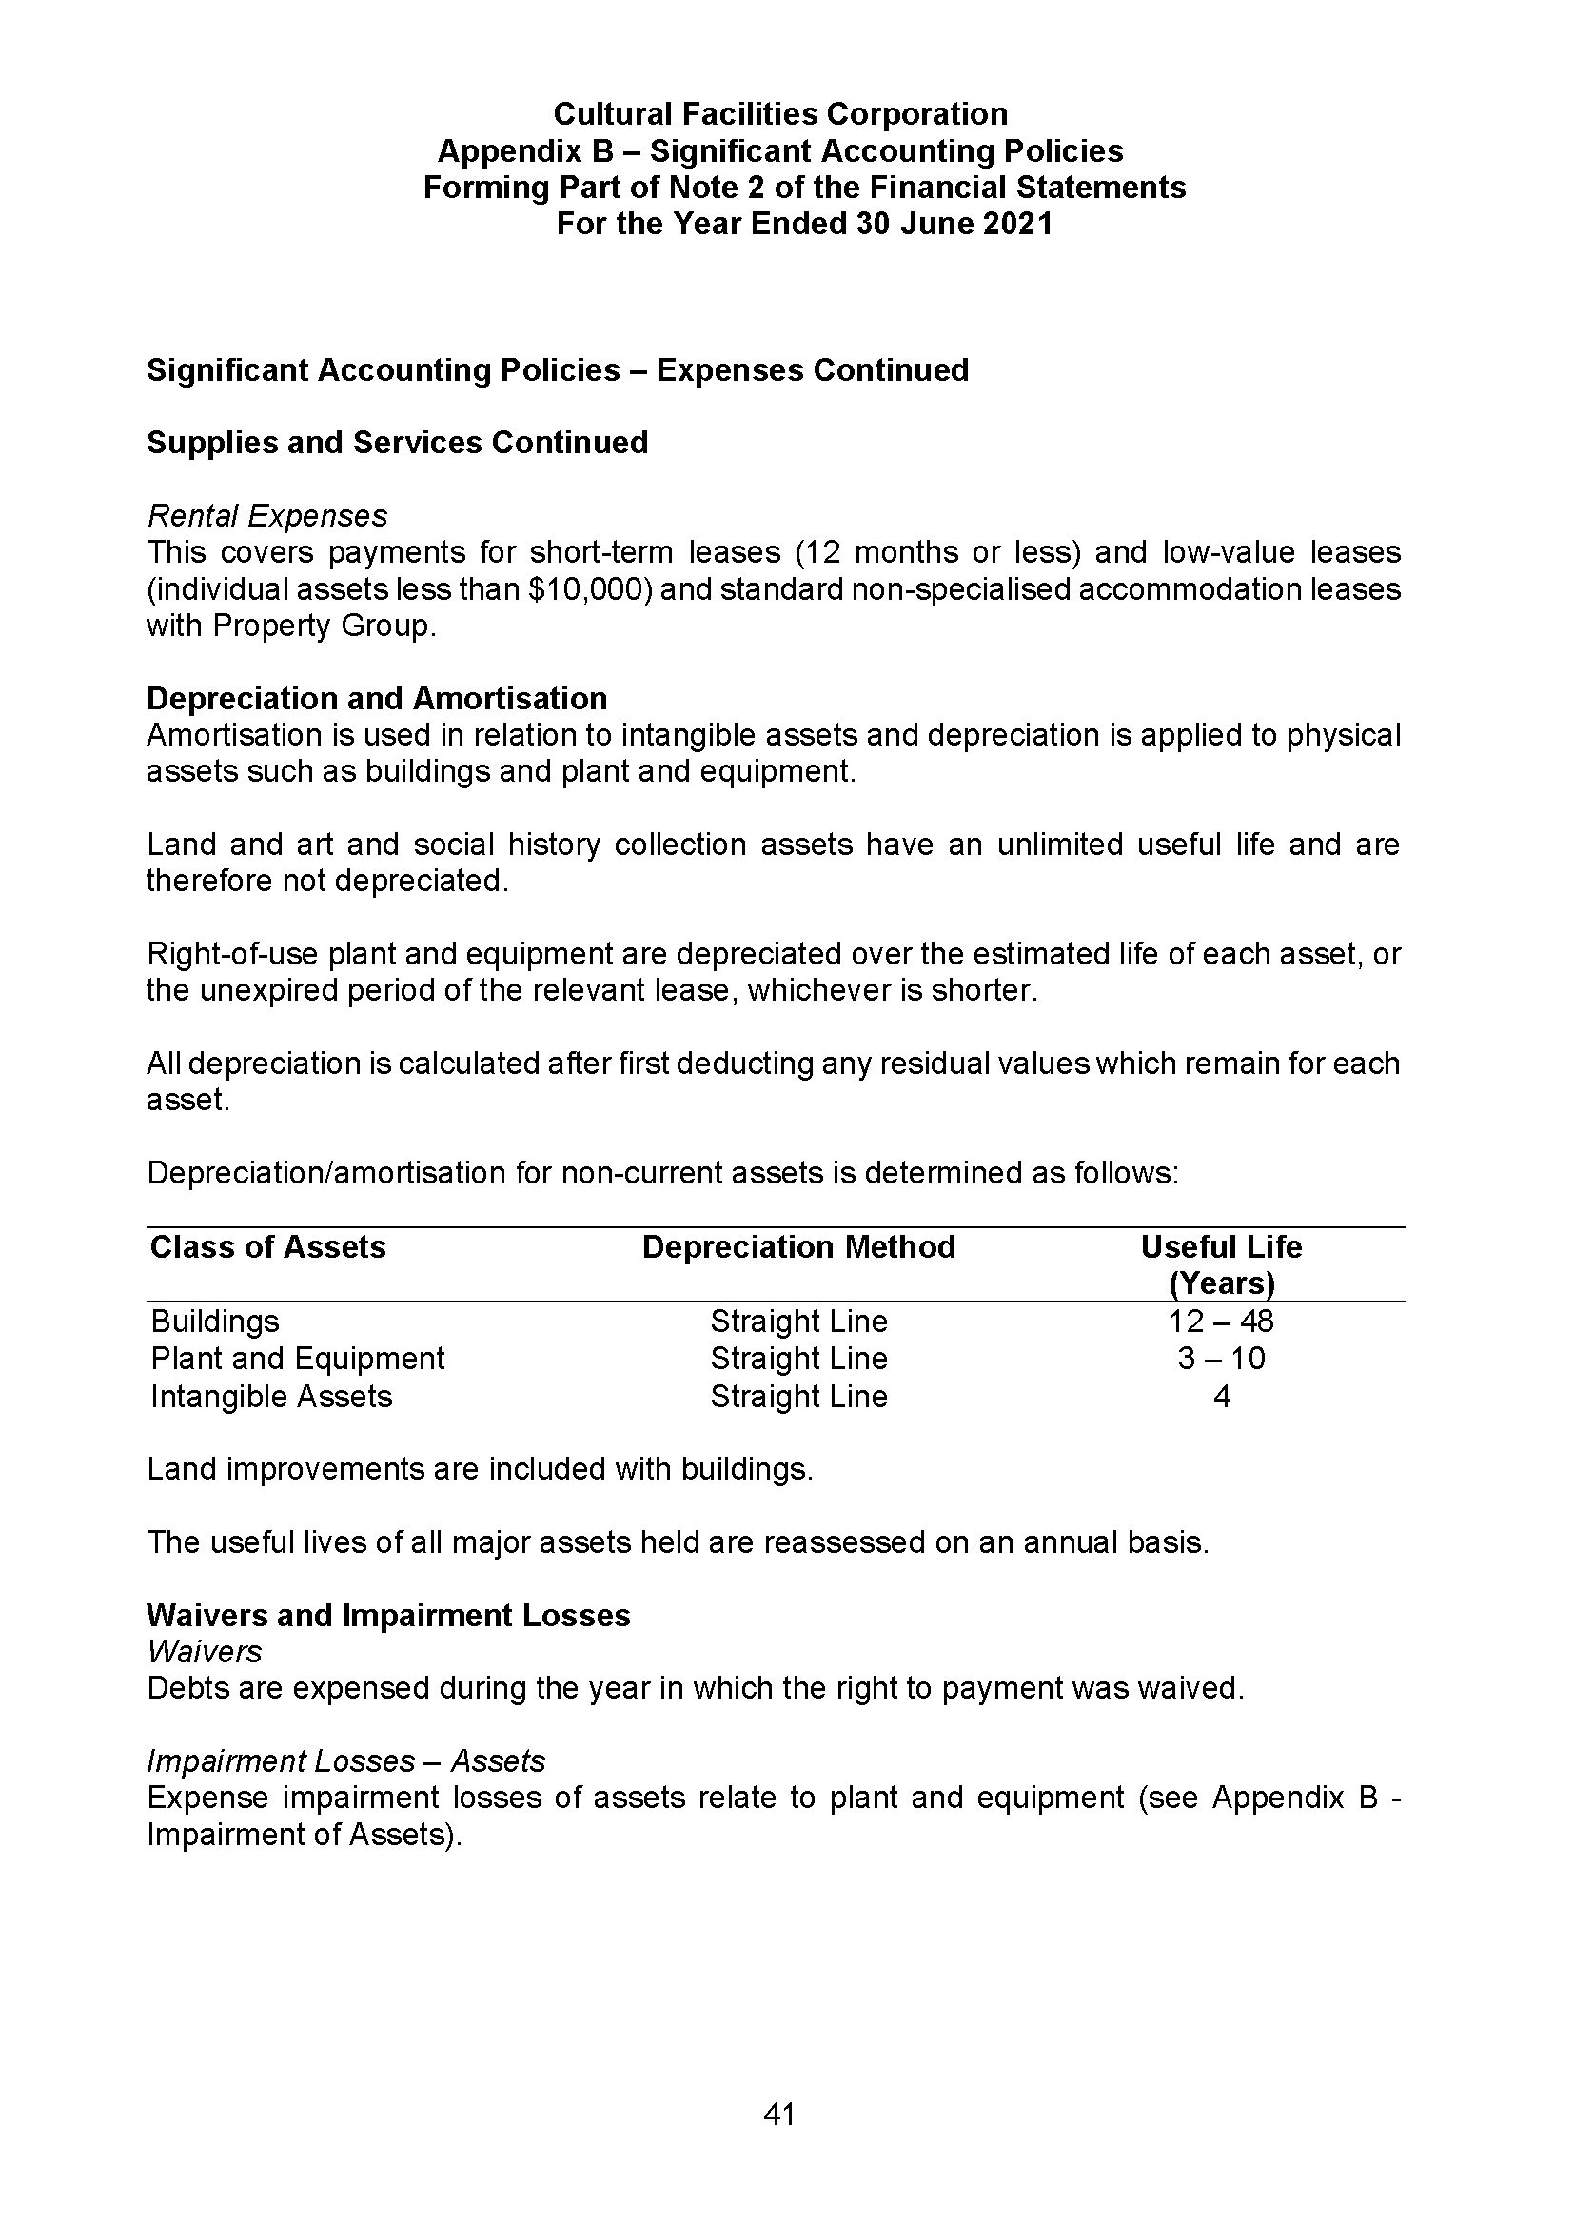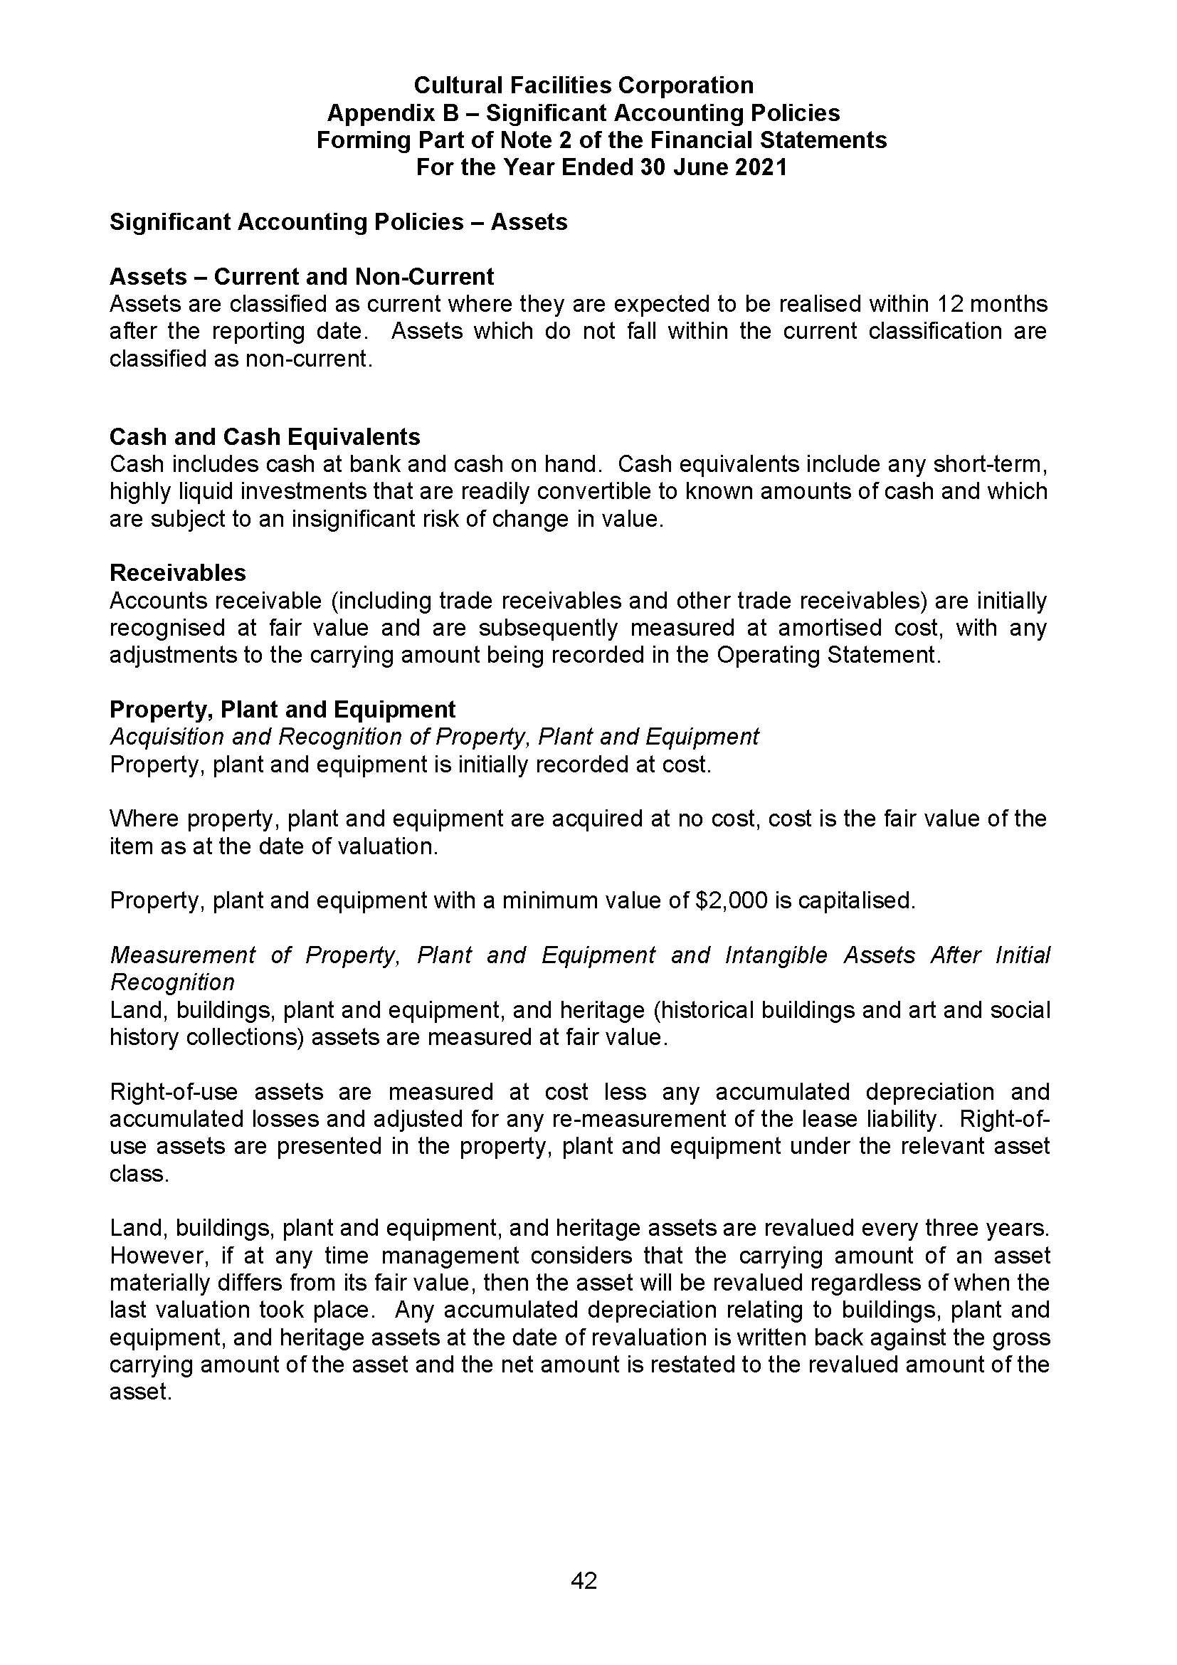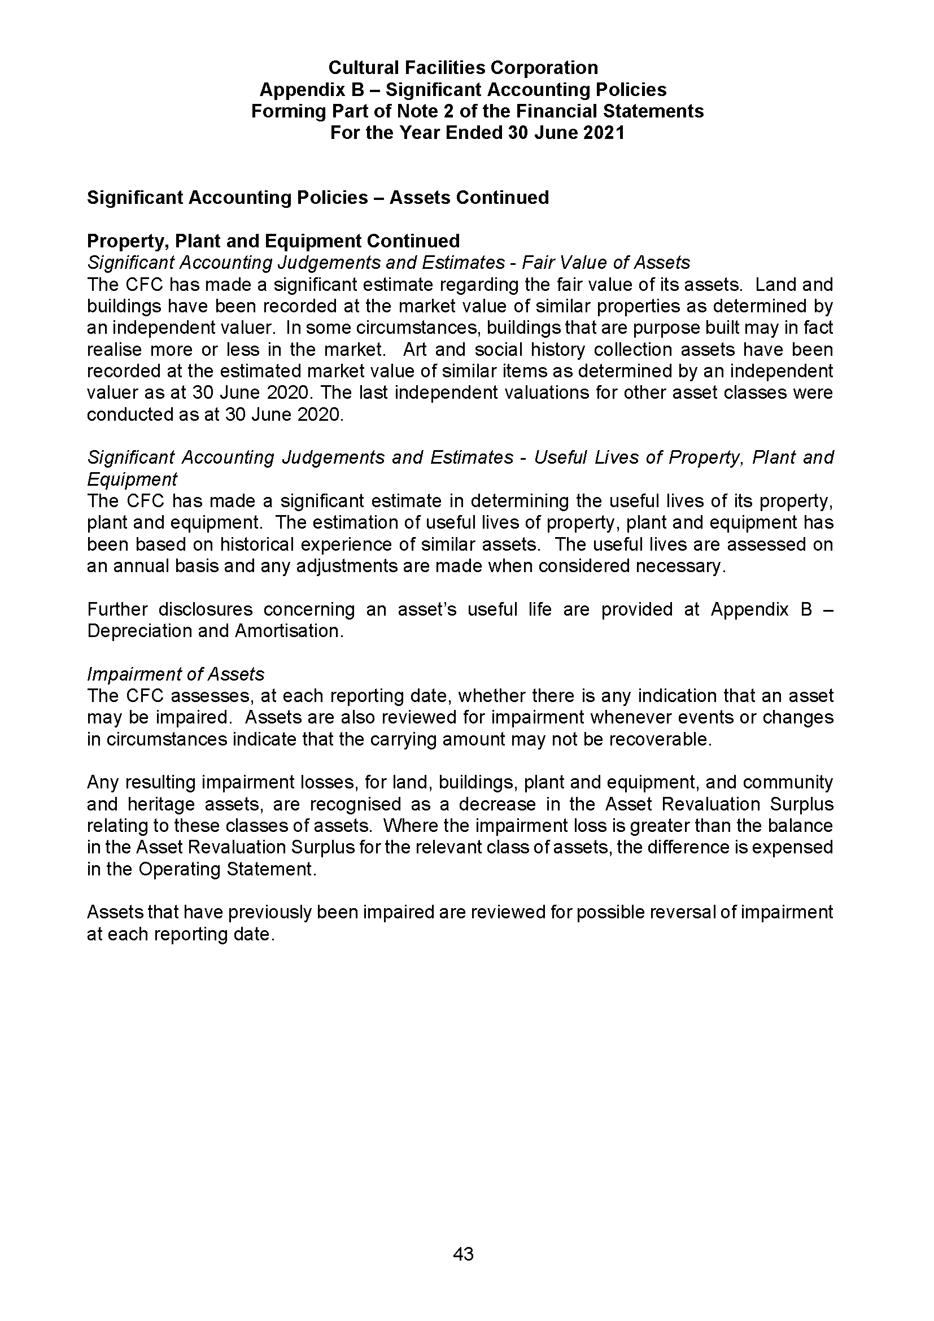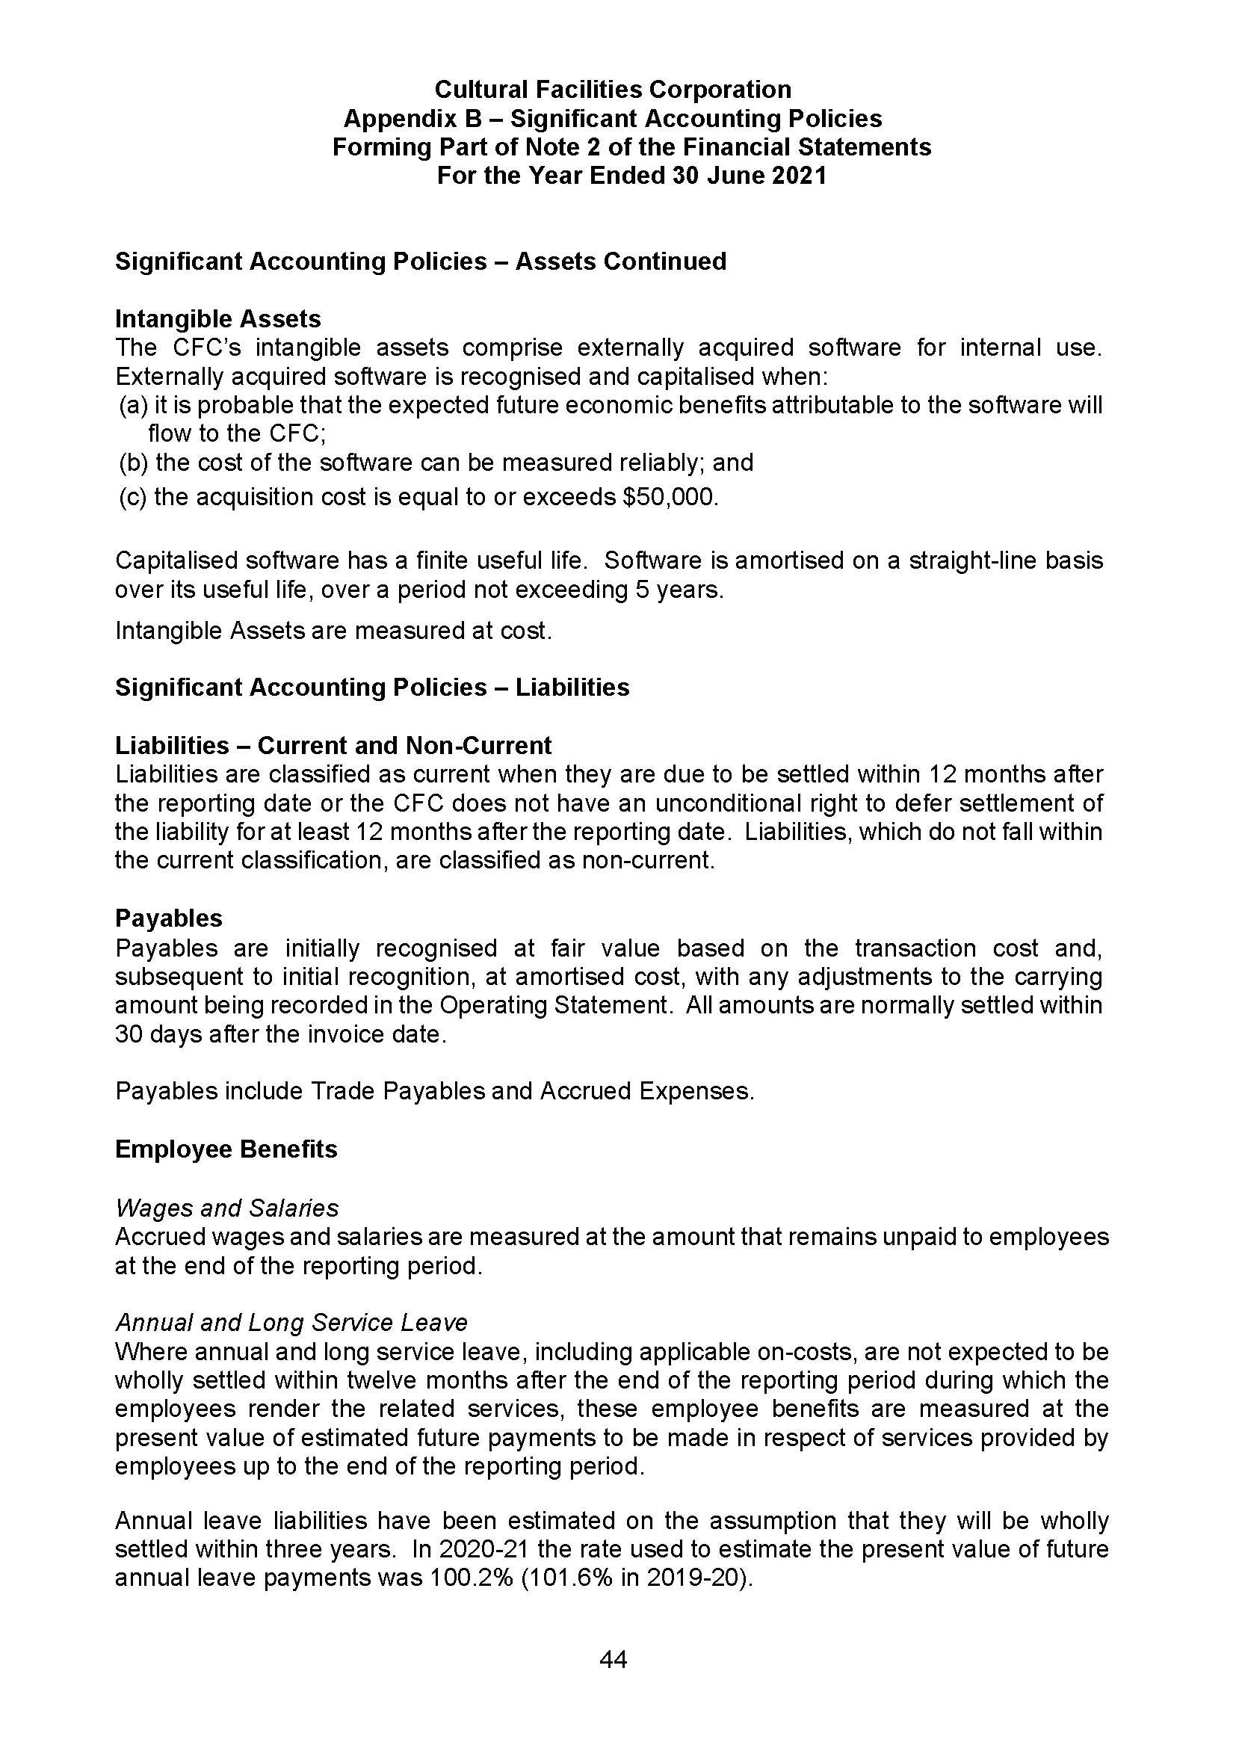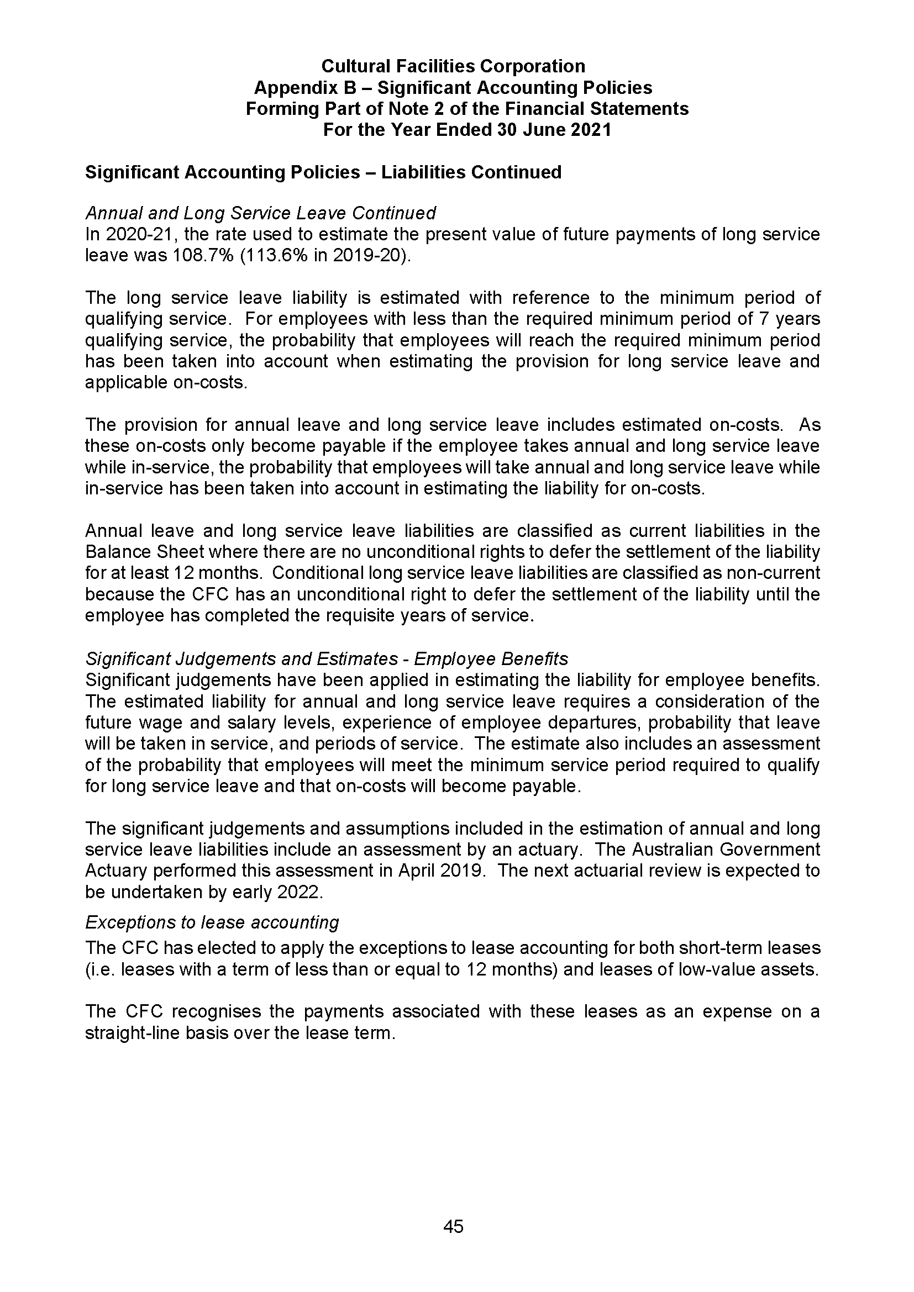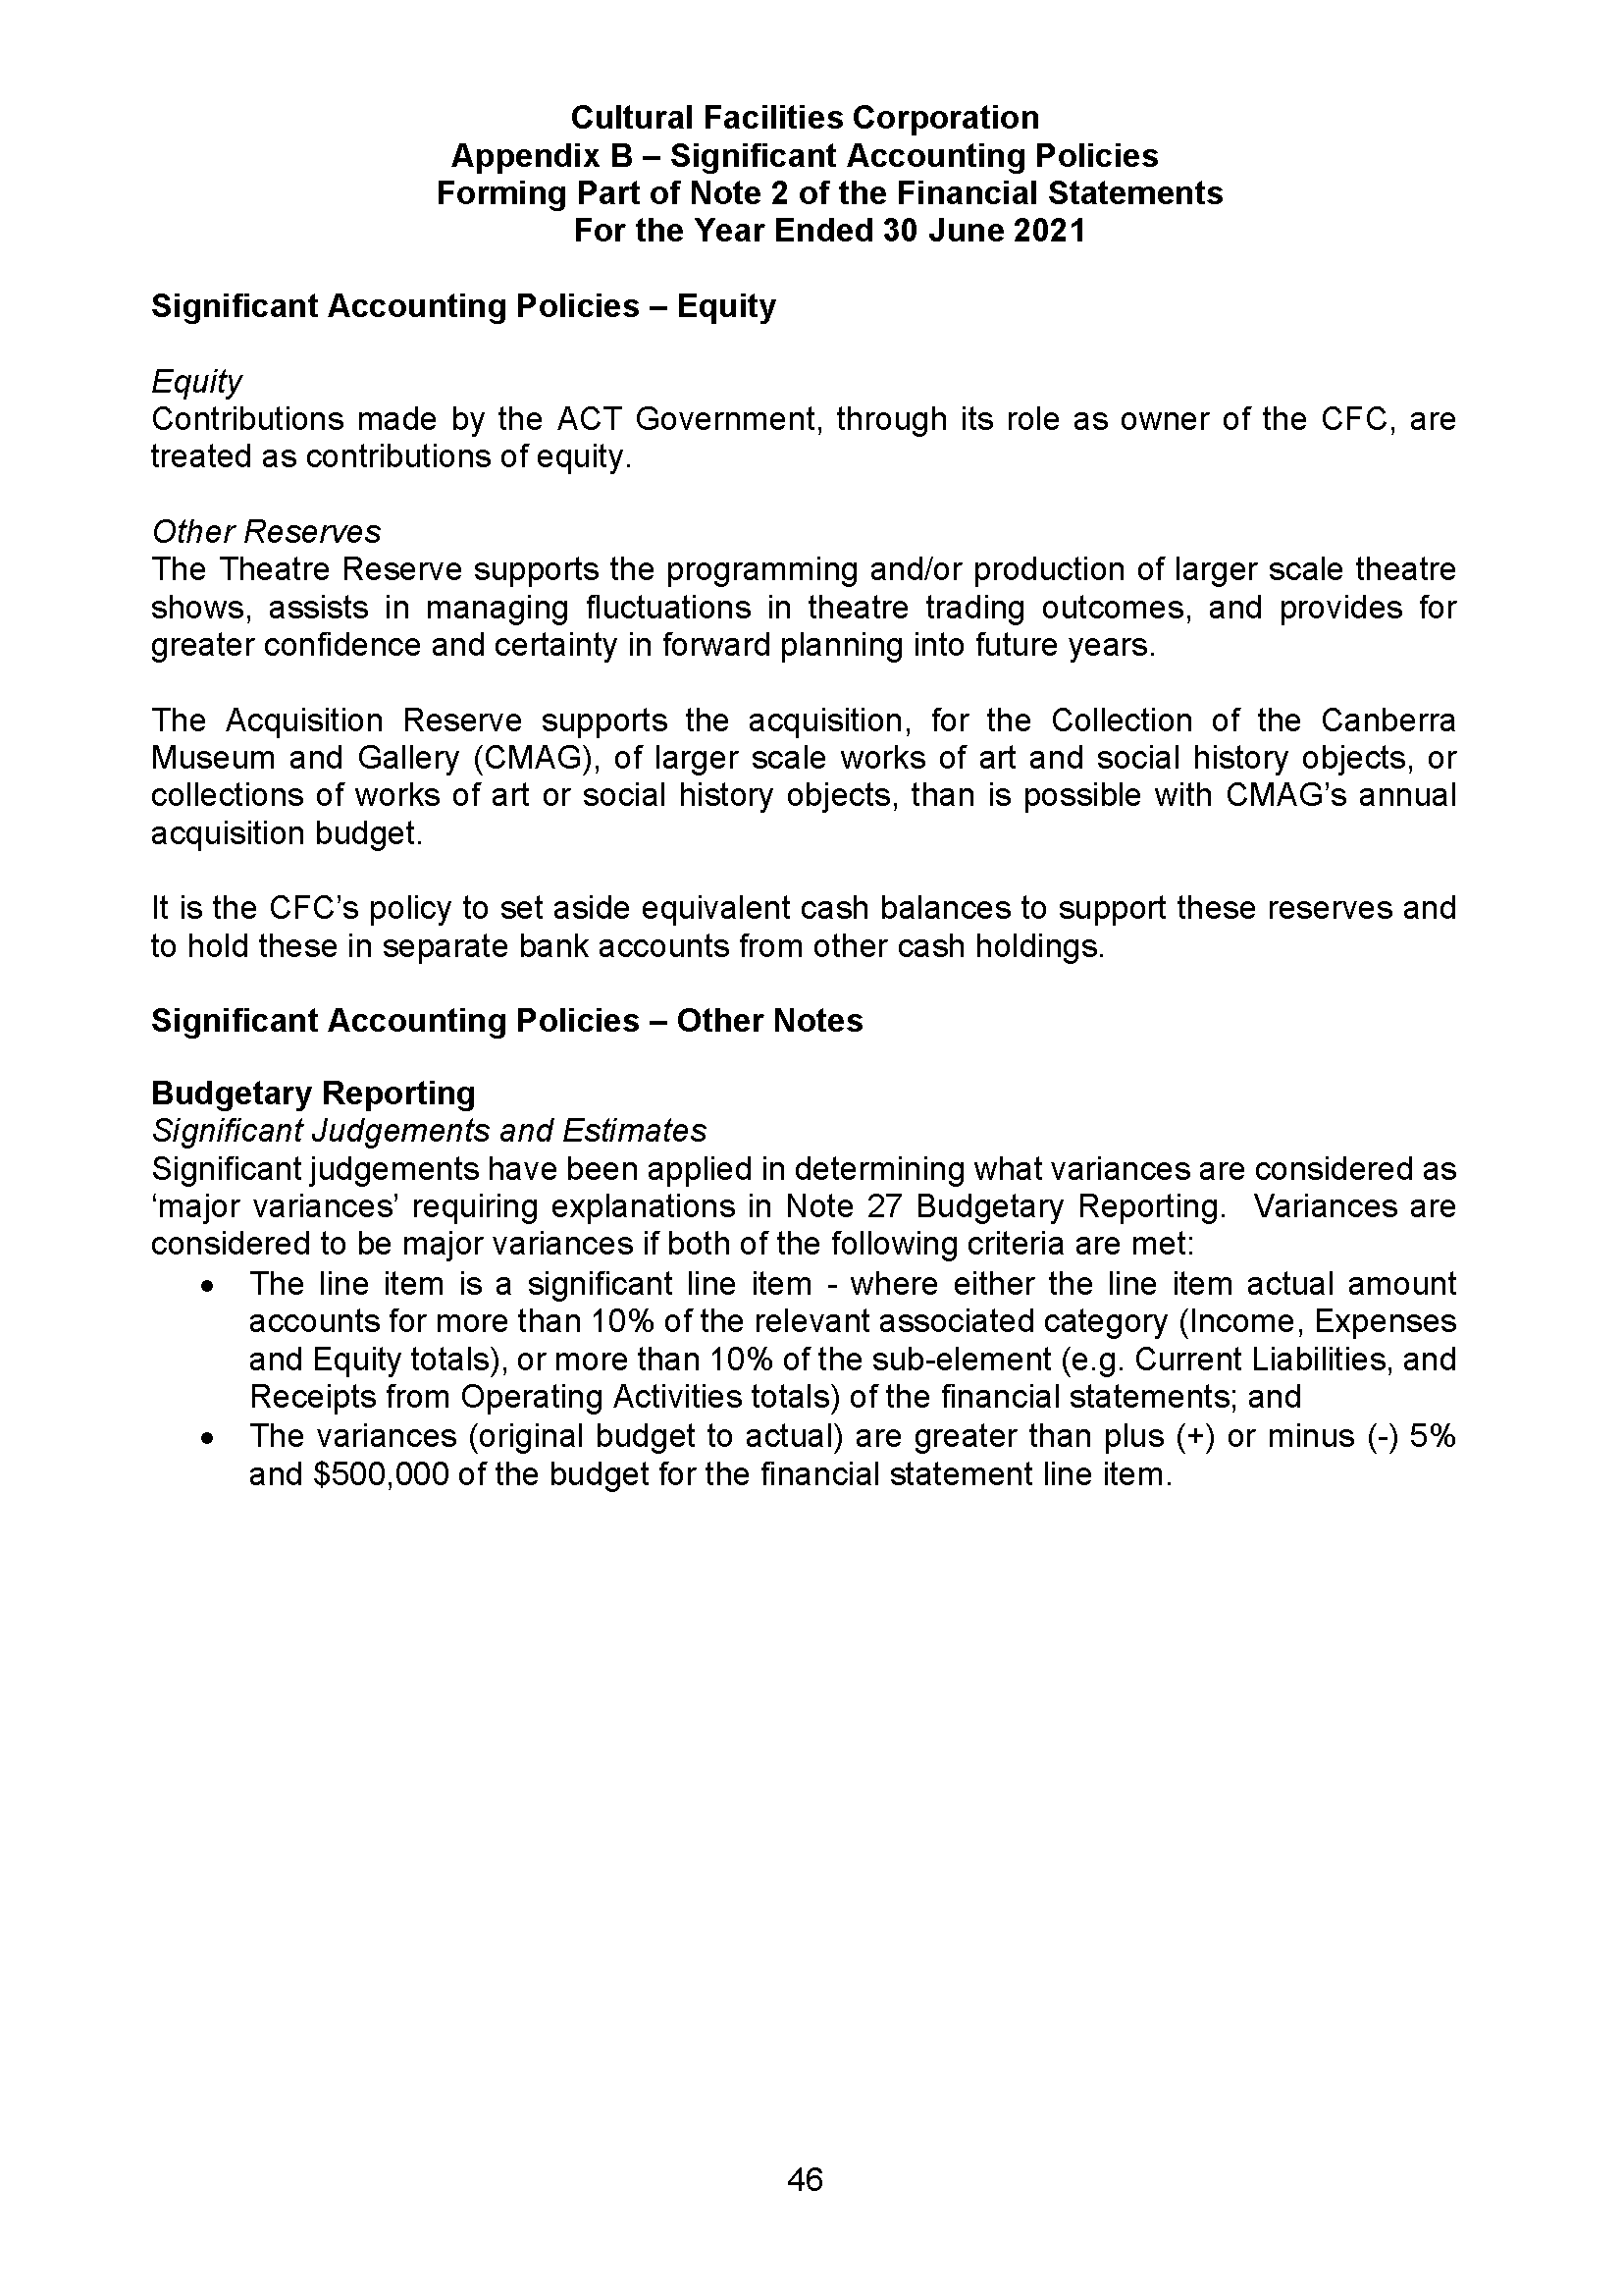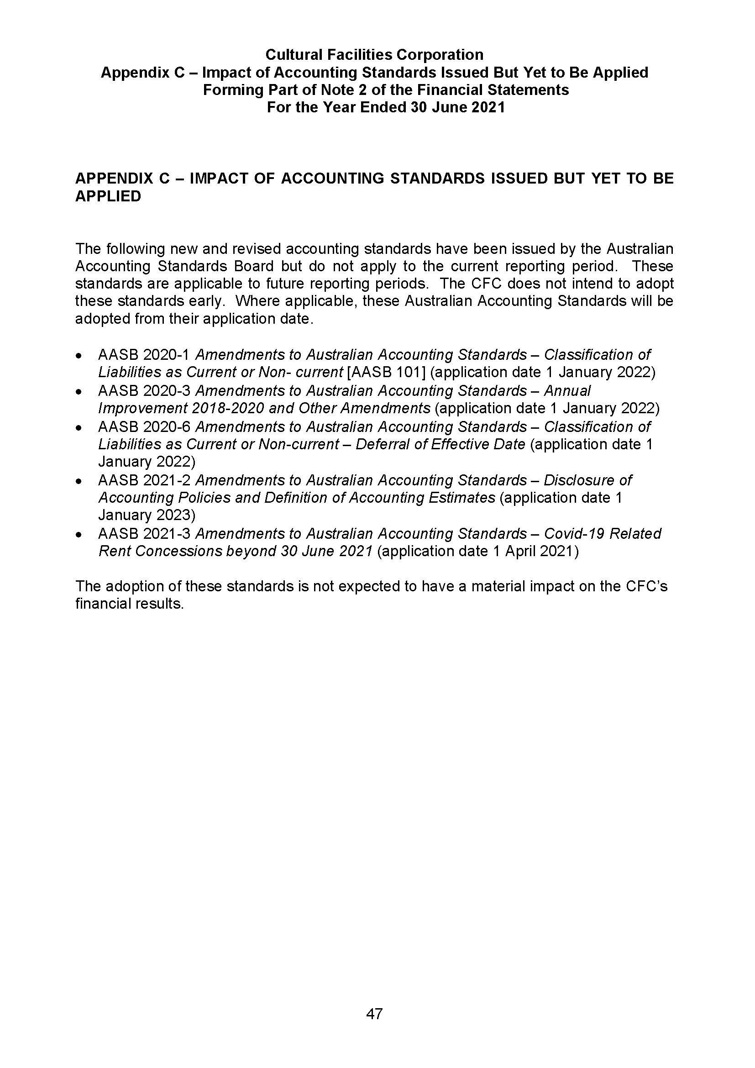
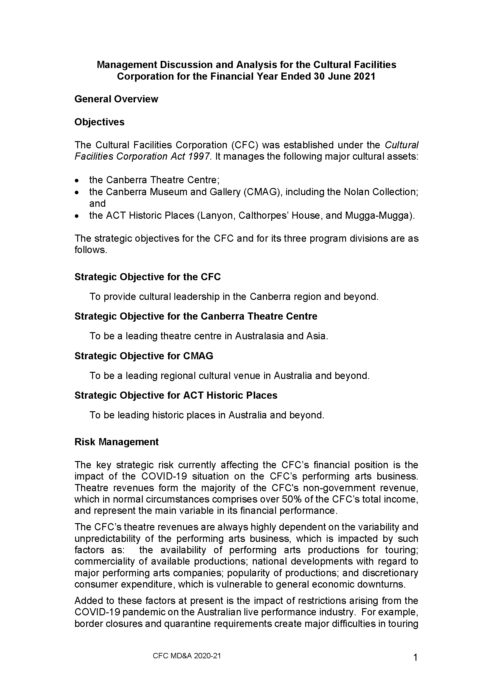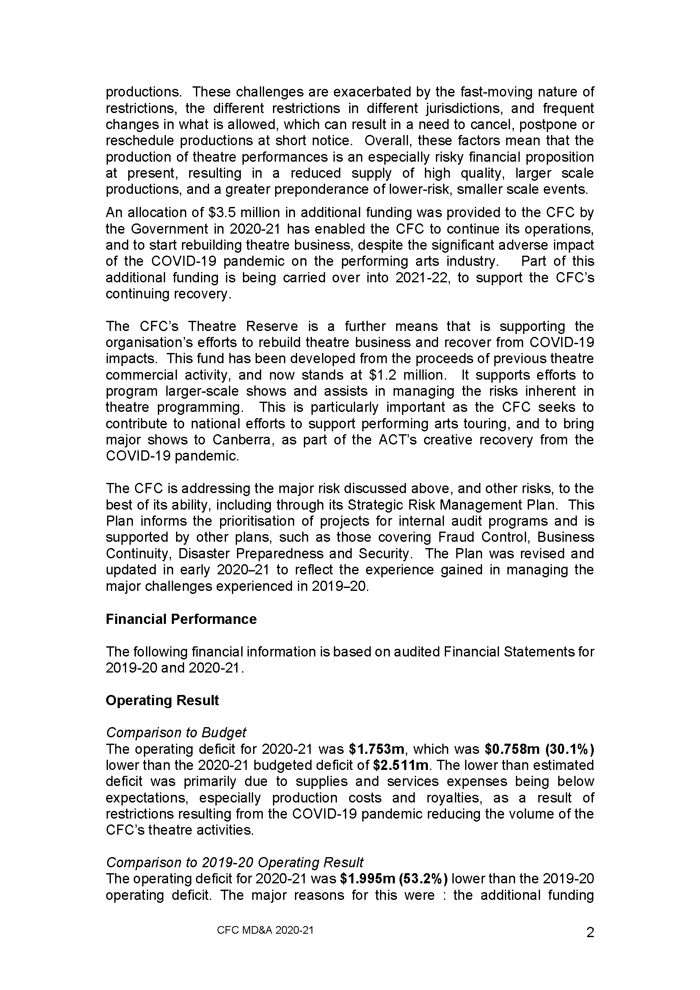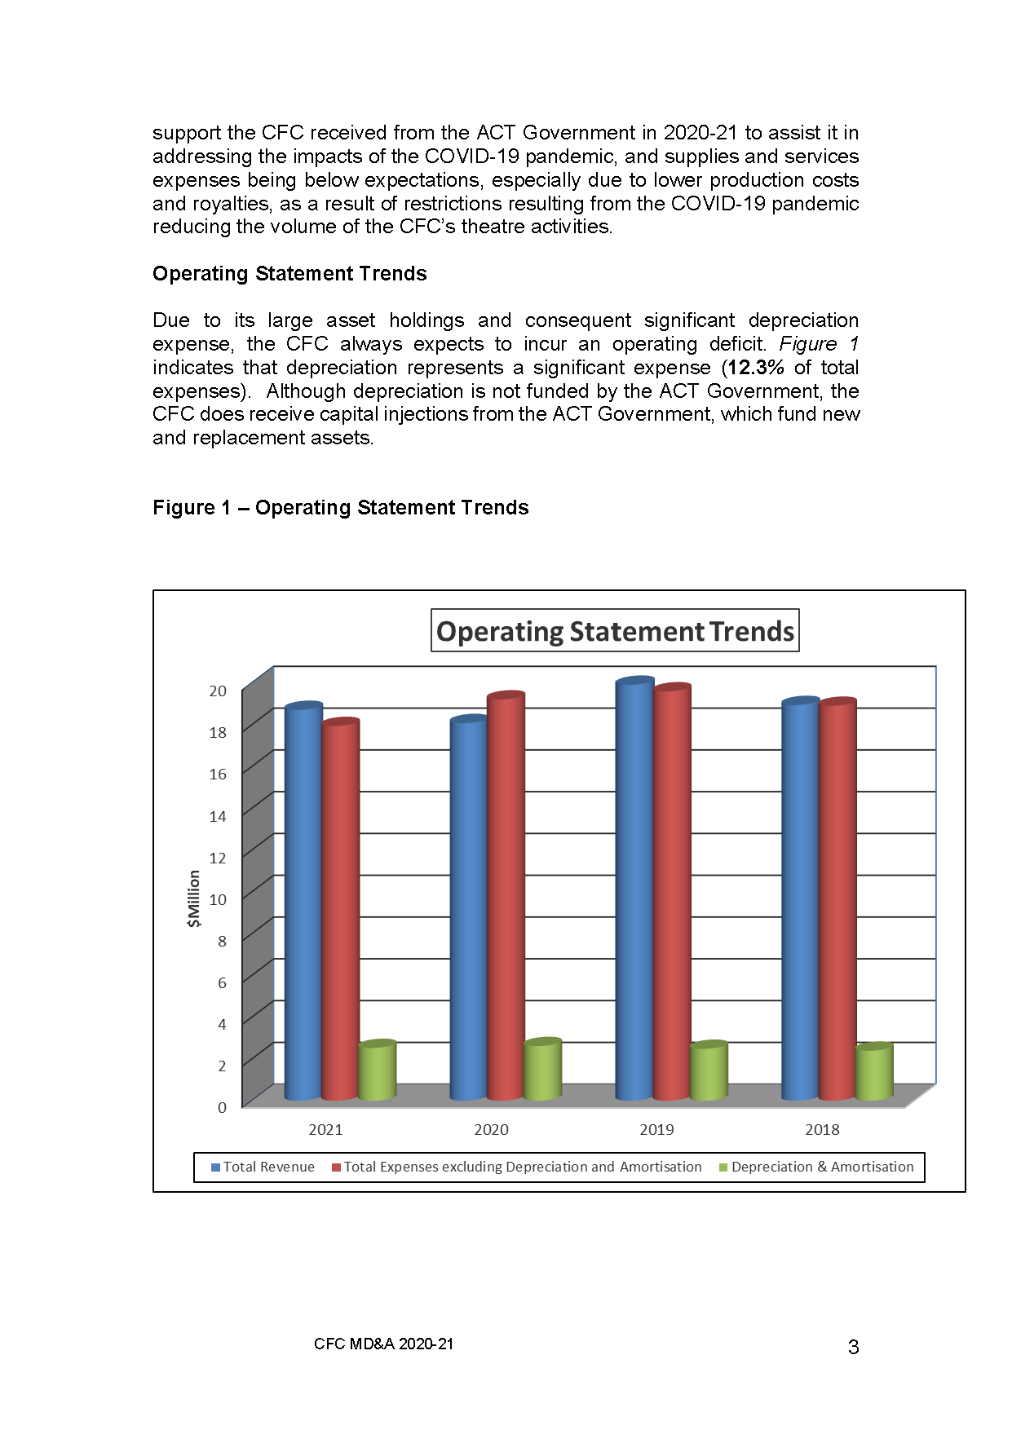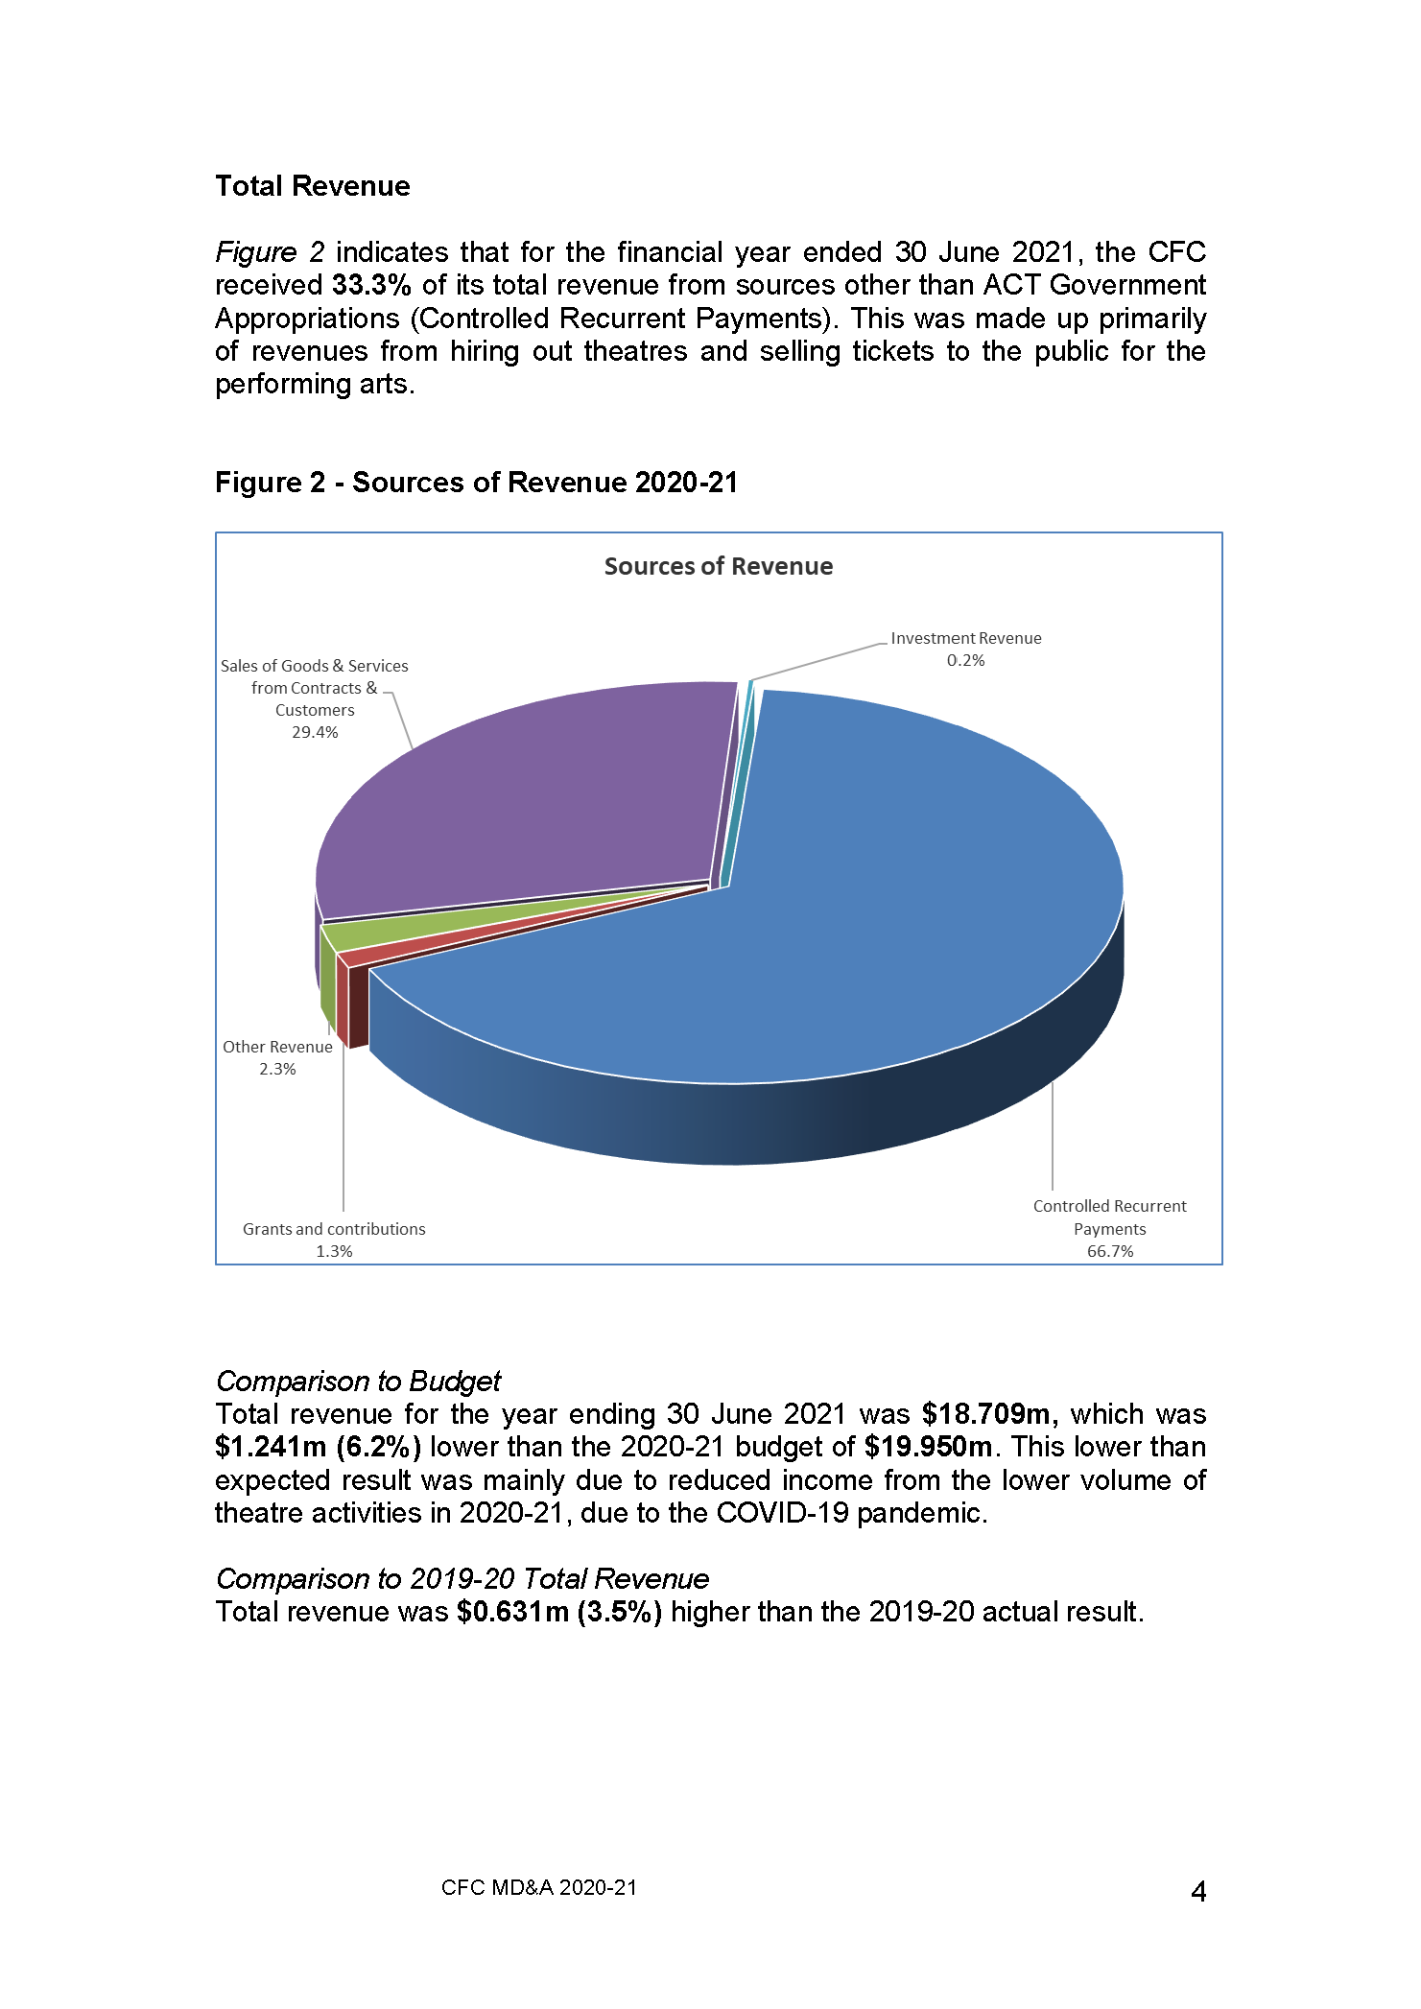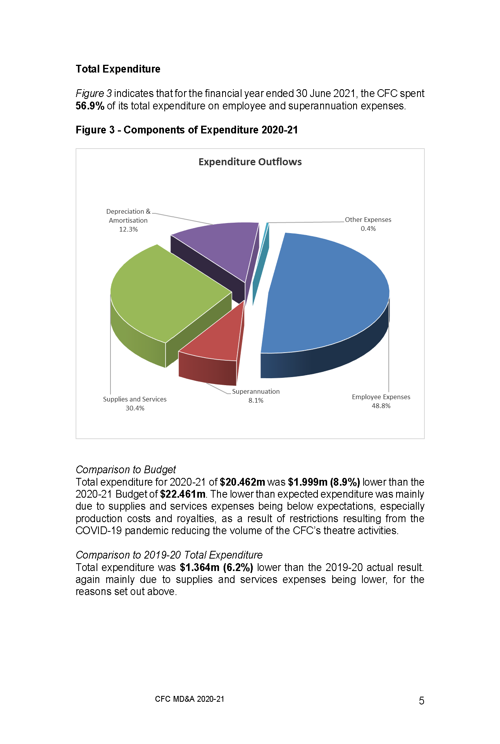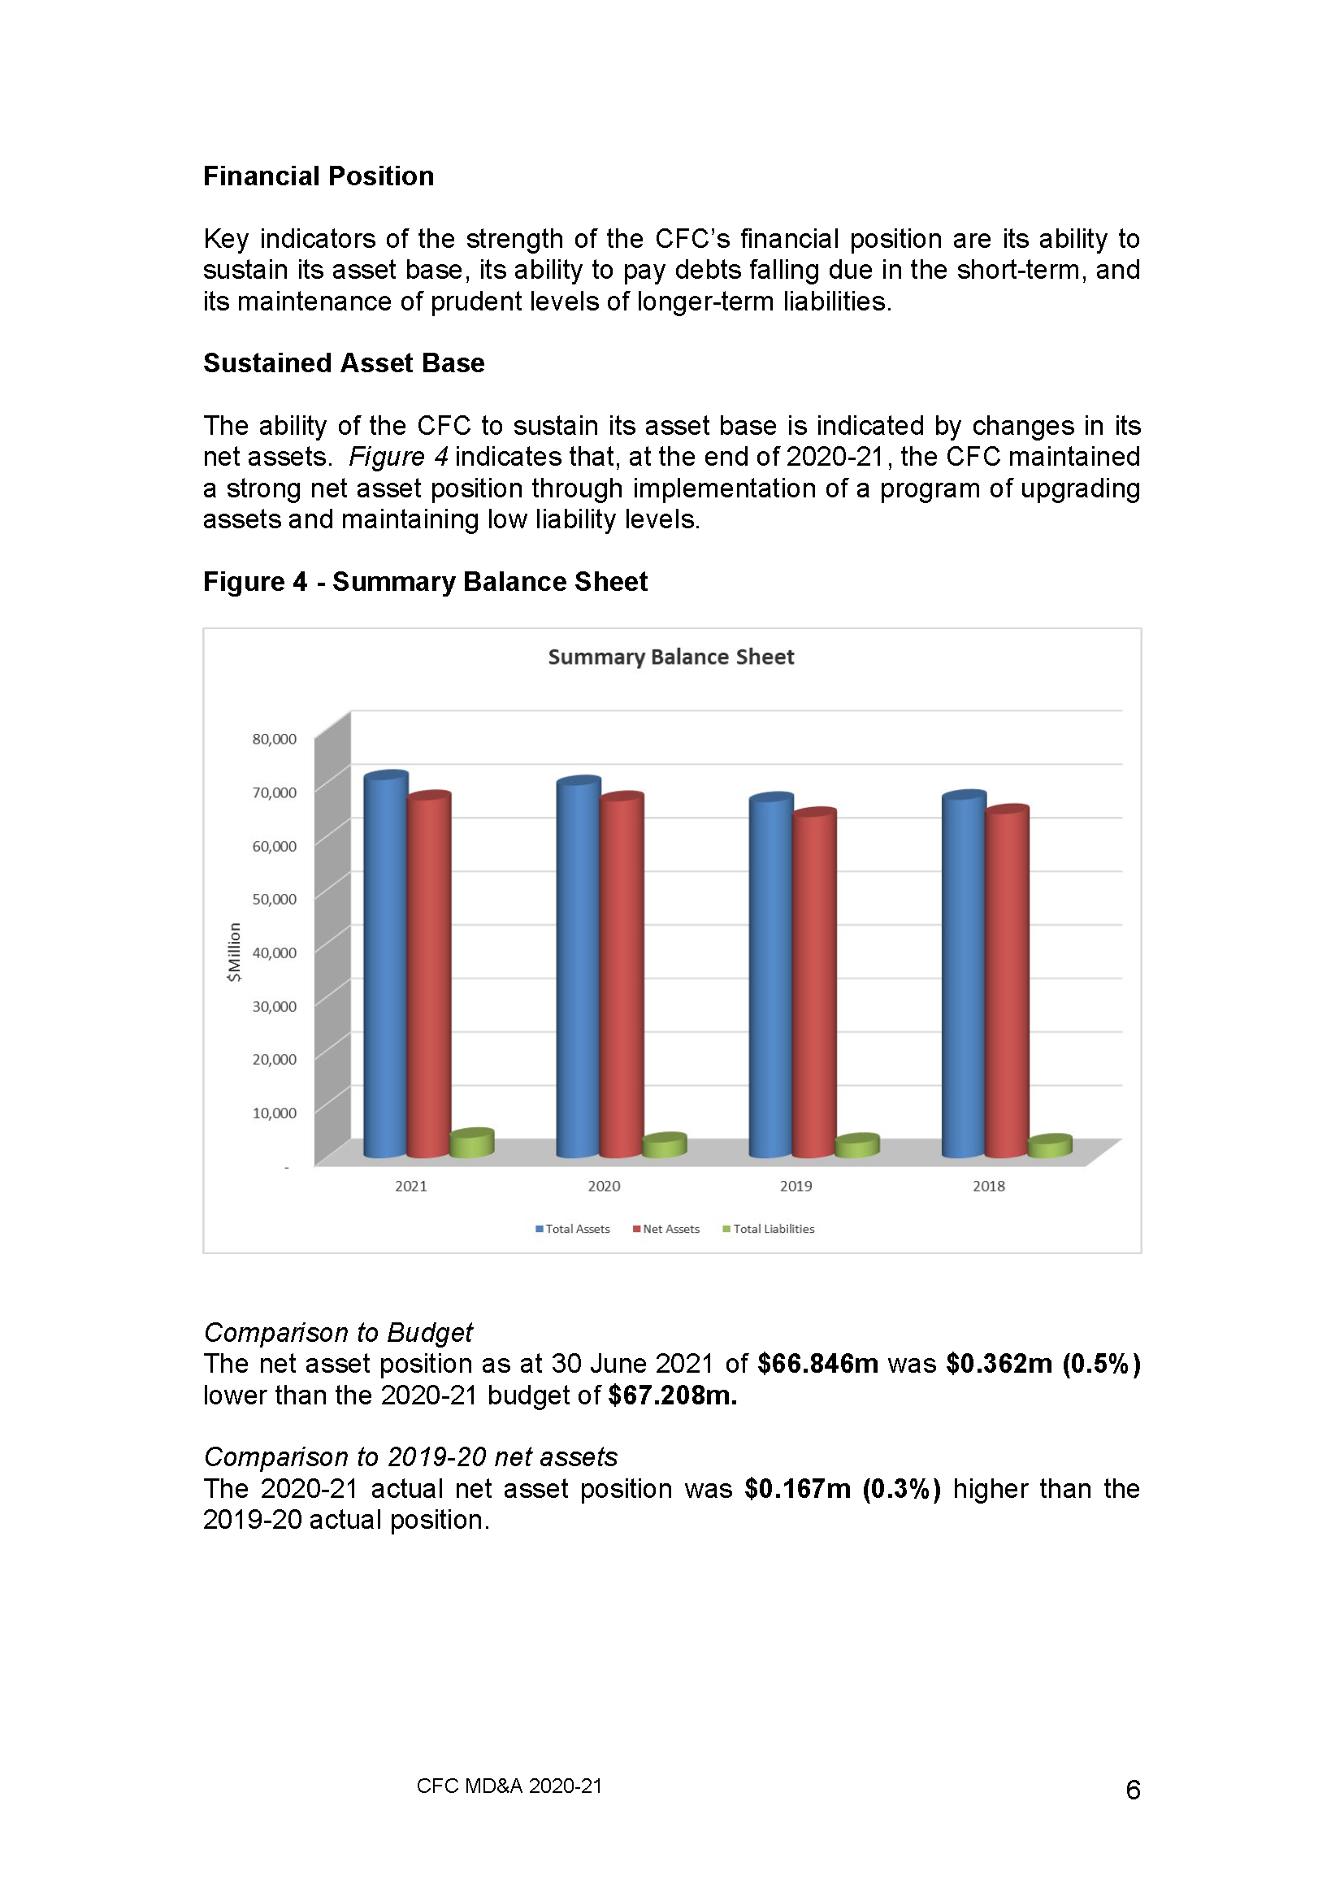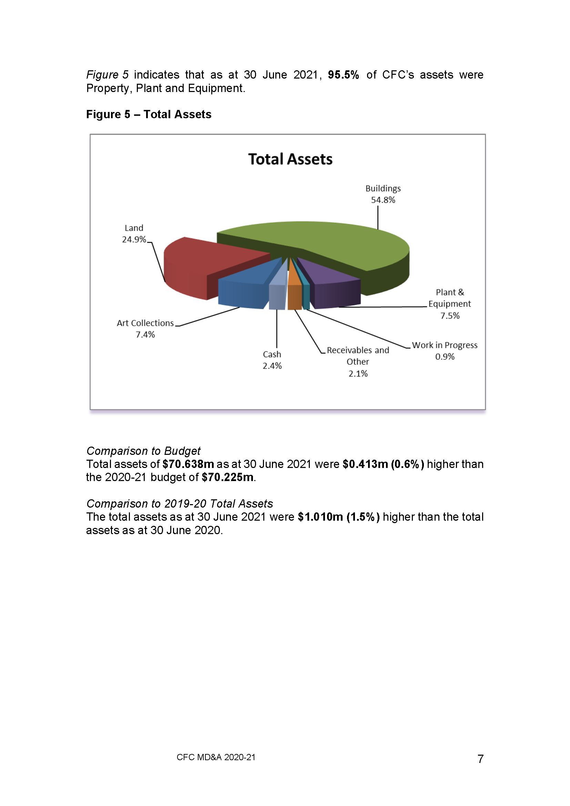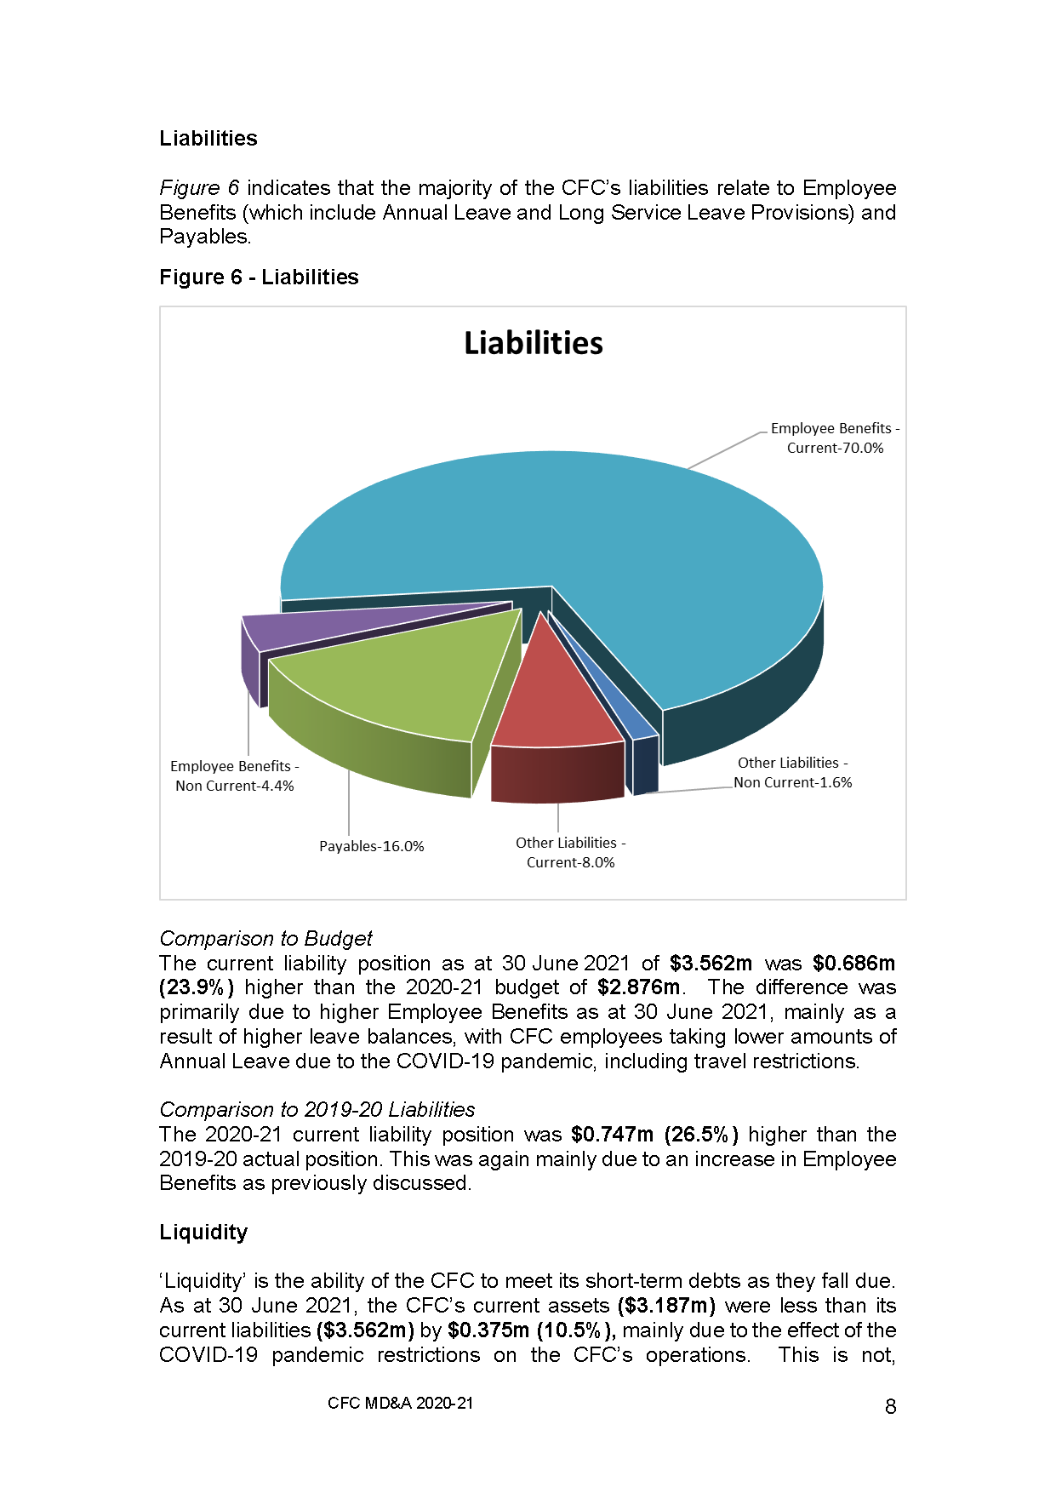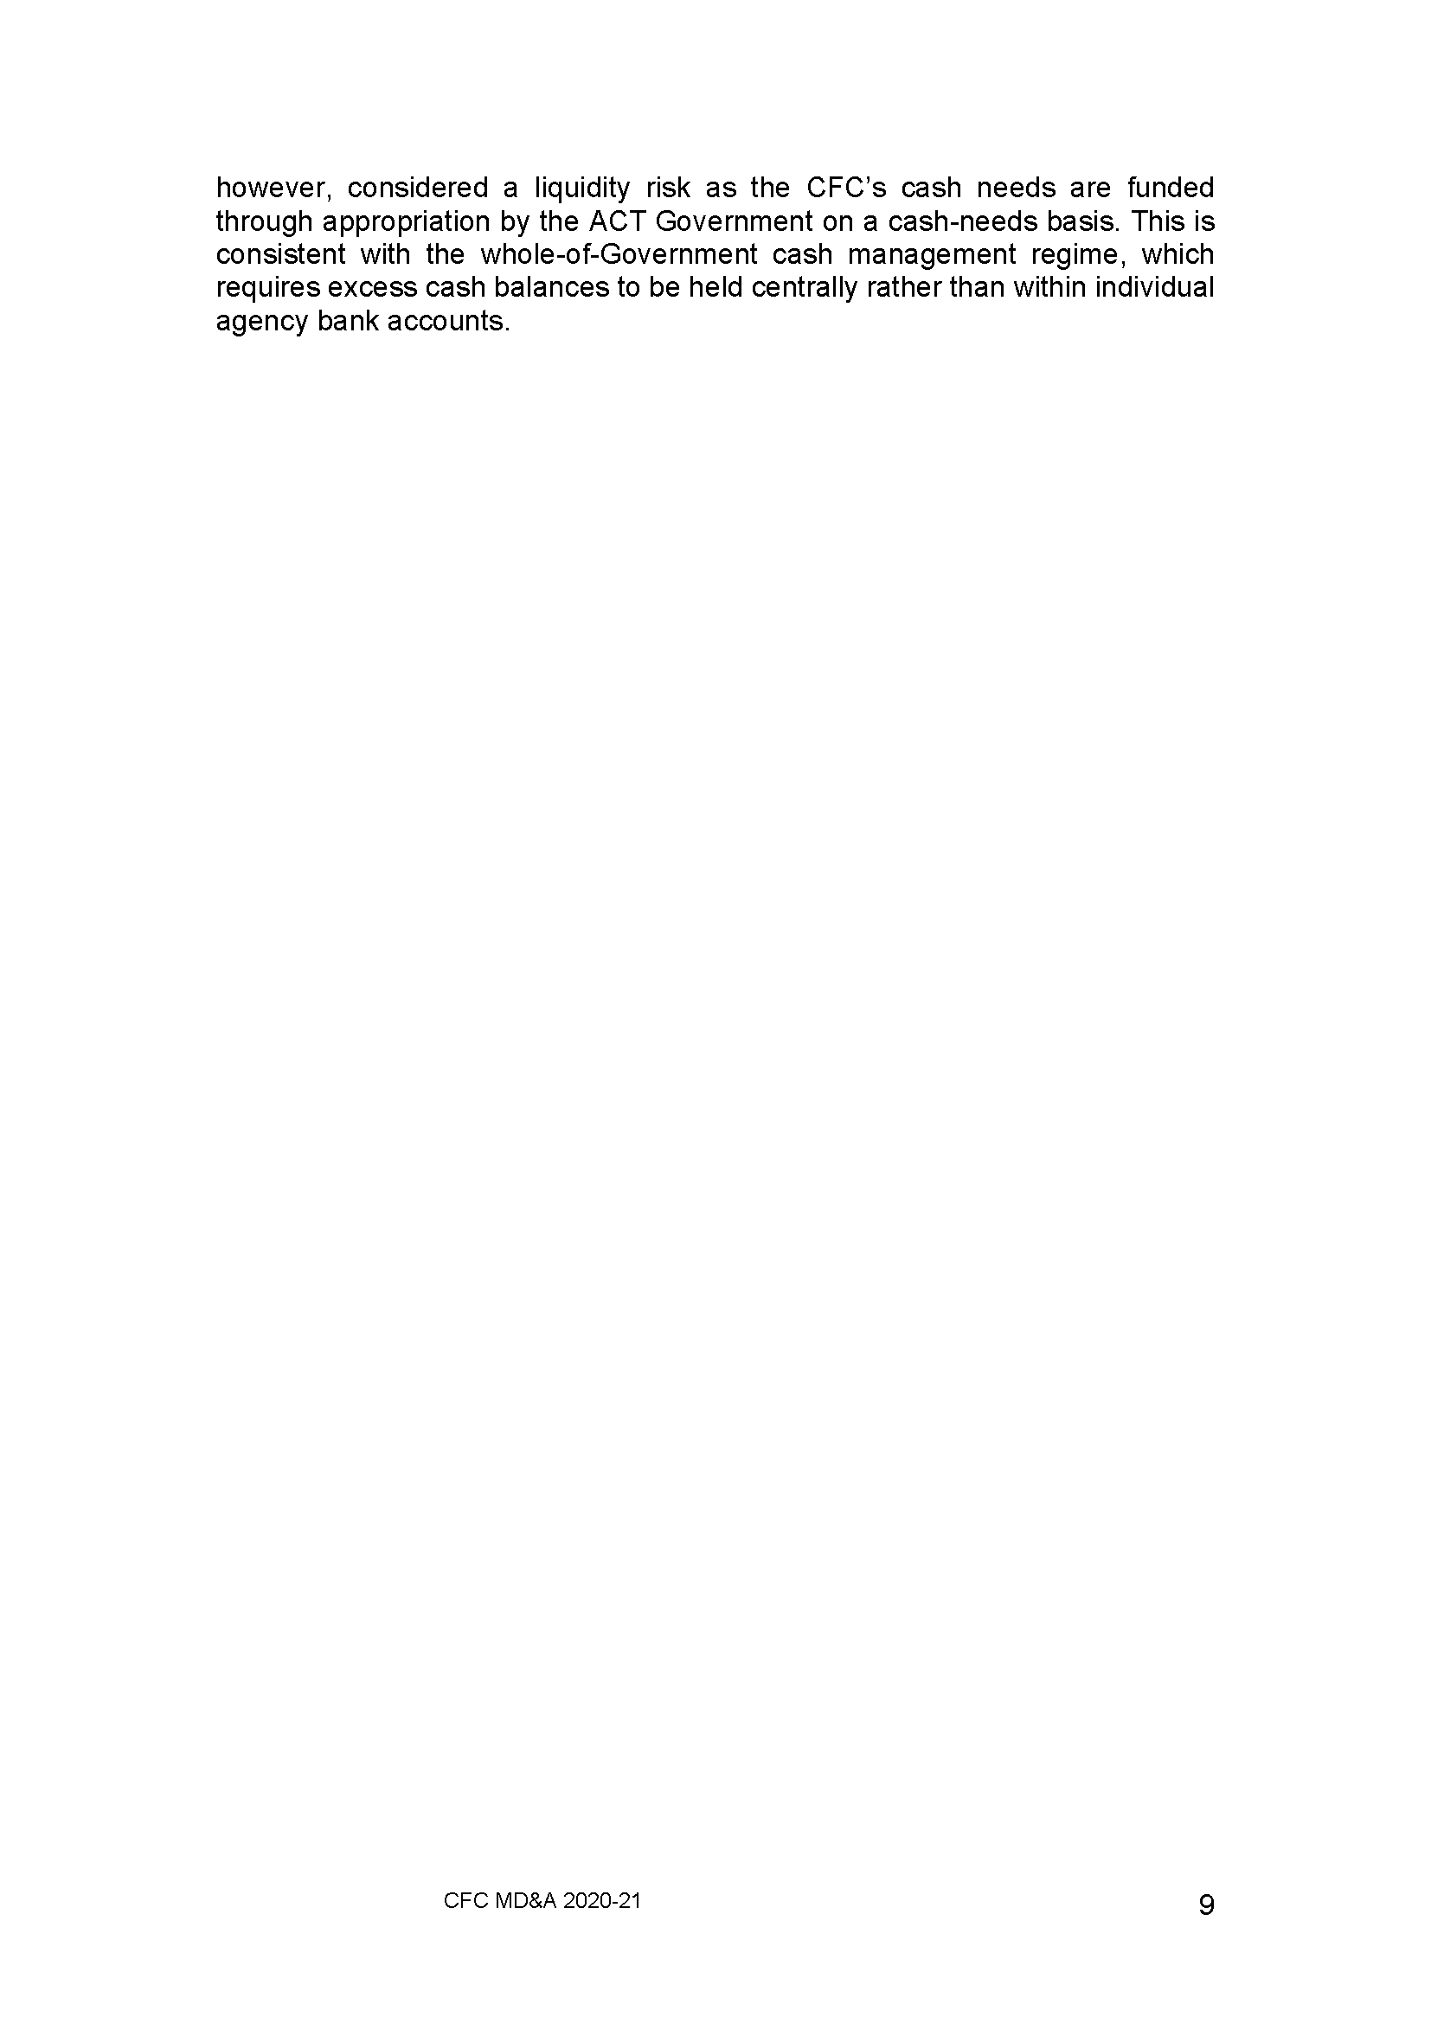

STATEMENT OF PERFORMANCE

FOR THE YEAR ENDED

30 JUNE 2021

CULTURAL FACILITIES CORPORATION

INDEPENDENT LIMITED ASSURANCE REPORT

To the Members of the ACT Legislative Assembly

Conclusion
I have undertaken a limited assurance engagement on the statement of performance of the Cultural Facilities Corporation (Corporation) for the year ended 30 June 2021.
Based on the procedures performed and evidence obtained, nothing has come to my attention to indicate the results of the accountability indicators reported in the statement of performance for the year ended 30 June 2021 are not in agreement with the Corporation’s records or do not fairly reflect, in all material respects, the performance of the Corporation, in accordance with the Financial Management Act 1996.

Basis for conclusion
I have conducted the engagement in accordance with the Standard on Assurance Engagements ASAE 3000 Assurance Engagements Other than Audits or Reviews of Historical Financial Information. My responsibilities under the standard and legislation are described in the
‘Auditor-General’s responsibilities’ section of this report.
I have complied with the independence and other relevant ethical requirements relating to assurance engagements, and the ACT Audit Office applies Australian Auditing Standard
ASQC 1 Quality Control for Firms that Perform Audits and Reviews of Financial Reports and Other Financial Information, Other Assurance Engagements and Related Services Engagements.
I believe that sufficient and appropriate evidence was obtained to provide a basis for my conclusion.

Corporation’s responsibilities for the statement of performance
The Governing Board is responsible for:
- preparing and fairly presenting the statement of performance in accordance with the Financial Management Act 1996 and Financial Management (Statement of Performance Scrutiny) Guidelines 2019; and
- determining the internal controls necessary for the preparation and fair presentation of the statement of performance so that the results of accountability indicators and accompanying information are free from material misstatements, whether due to error or fraud.

Auditor-General’s responsibilities
Under the Financial Management Act 1996 and Financial Management (Statement of Performance Scrutiny) Guidelines 2019, the Auditor-General is responsible for issuing a limited assurance report on the statement of performance of the Corporation.
My objective is to provide limited assurance on whether anything has come to my attention that indicates the results of the accountability indicators reported in the statement of performance are not in agreement with the Corporation’s records or do not fairly reflect, in all material respects, the performance of the Corporation, in accordance with the Financial Management Act 1996.

In a limited assurance engagement, I perform procedures such as making inquiries with representatives of the Corporation, performing analytical review procedures and examining selected evidence supporting the results of accountability indicators. The procedures used depend on my judgement, including the assessment of the risks of material misstatement of the results reported for the accountability indicators.
Limitations on the scope
The procedures performed in a limited assurance engagement are less in extent than those required in a reasonable assurance engagement and consequently the level of assurance obtained is substantially lower than the assurance that would have been obtained had a reasonable assurance engagement been performed. Accordingly, I do not express a reasonable assurance opinion on the statement of performance.
This limited assurance engagement does not provide assurance on the:
- relevance or appropriateness of the accountability indicators reported in the statement of performance or the related performance targets;
- accuracy of explanations provided for variations between actual and targeted performance due to the often subjective nature of such explanations; or
- adequacy of controls implemented by the Corporation.

Ajay Sharma
Assistant Auditor-General, Financial Audit
22 September 2021
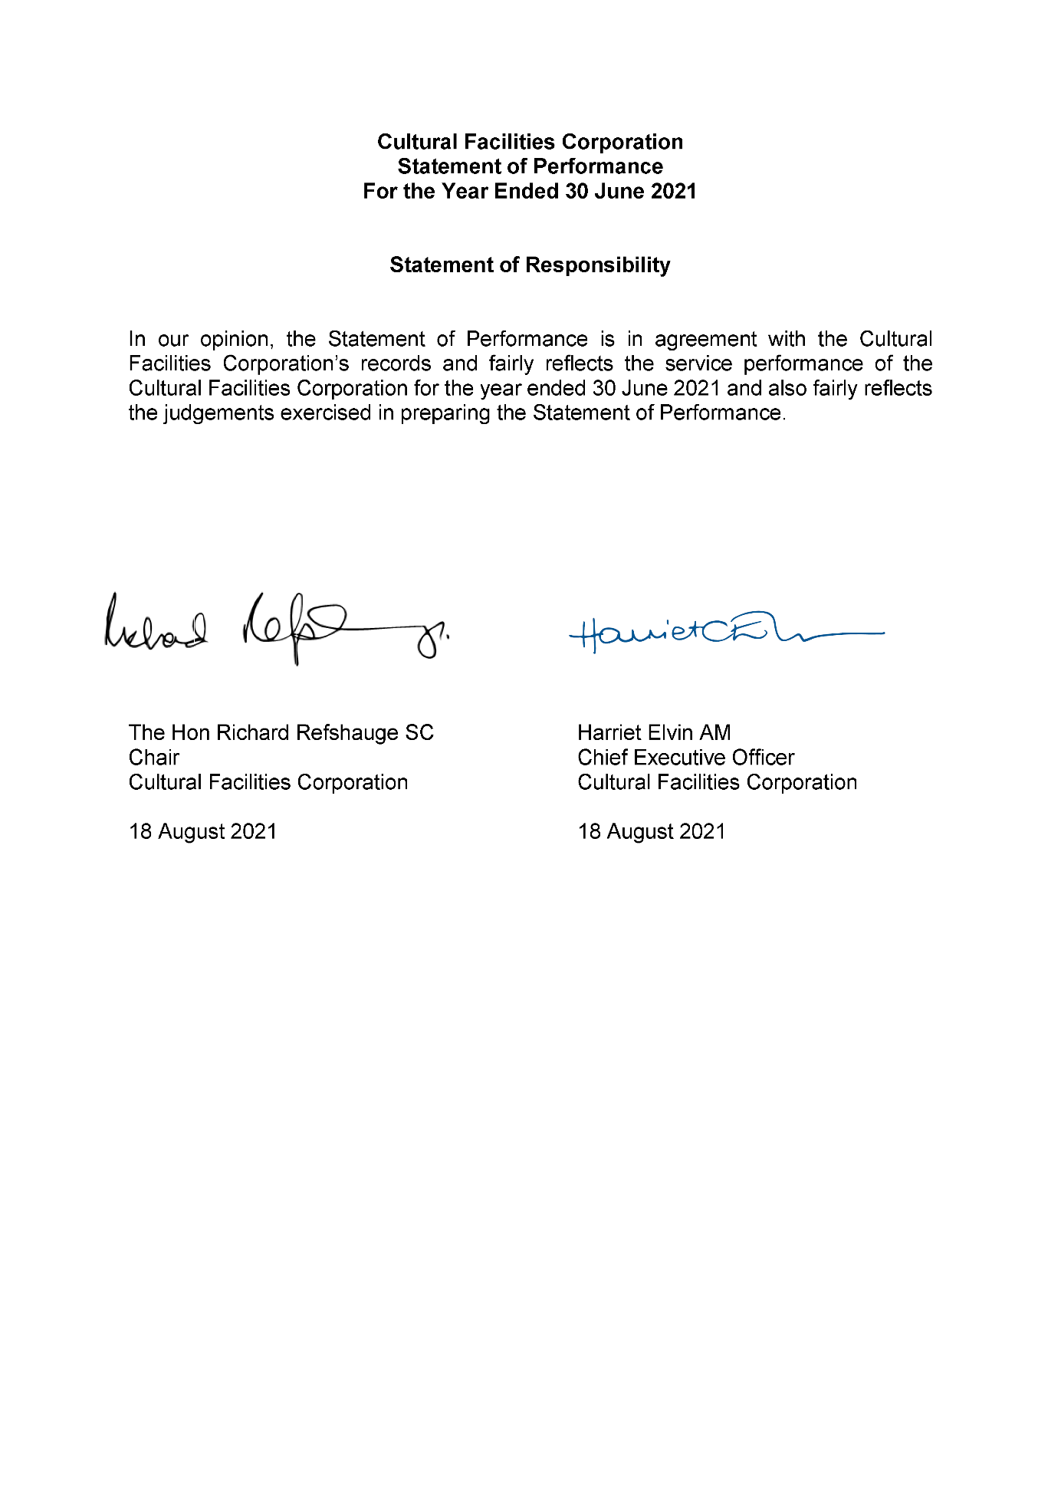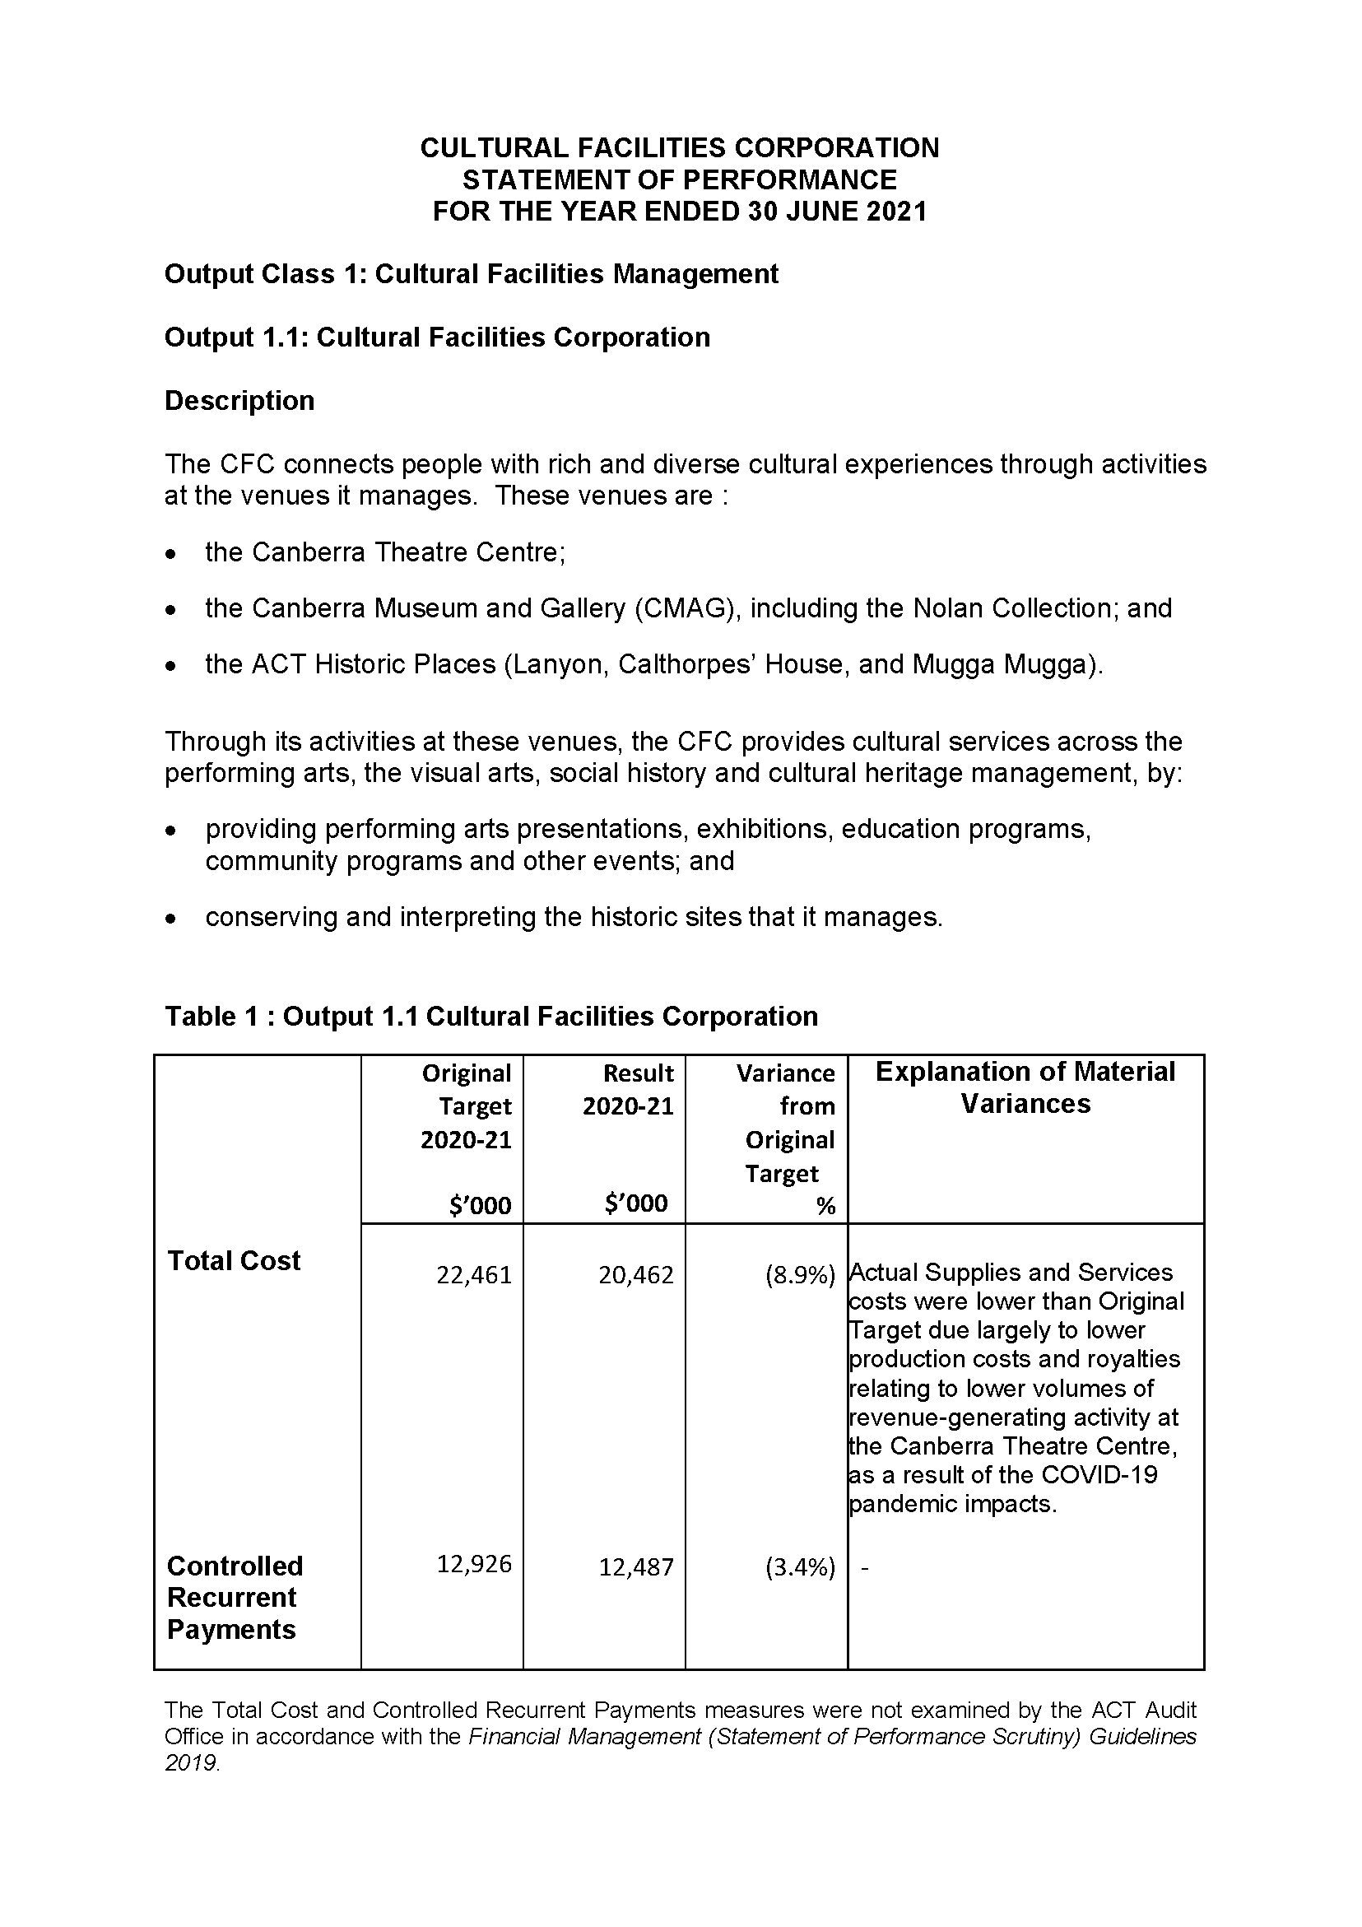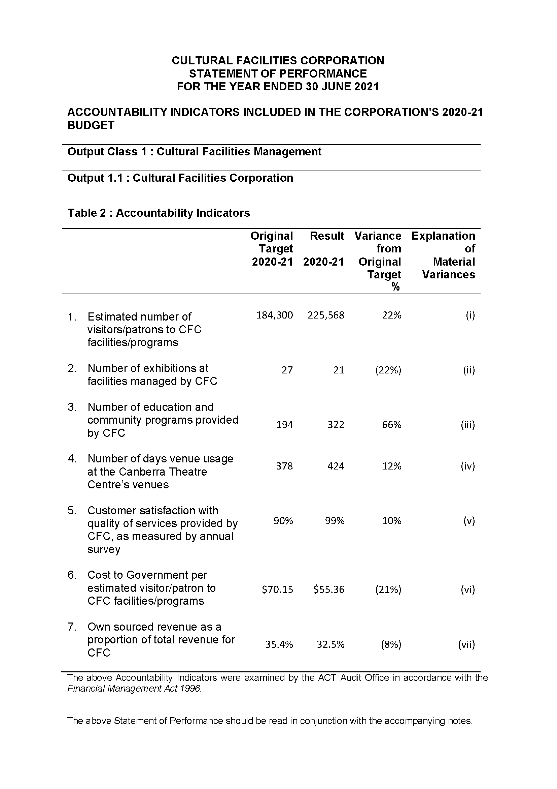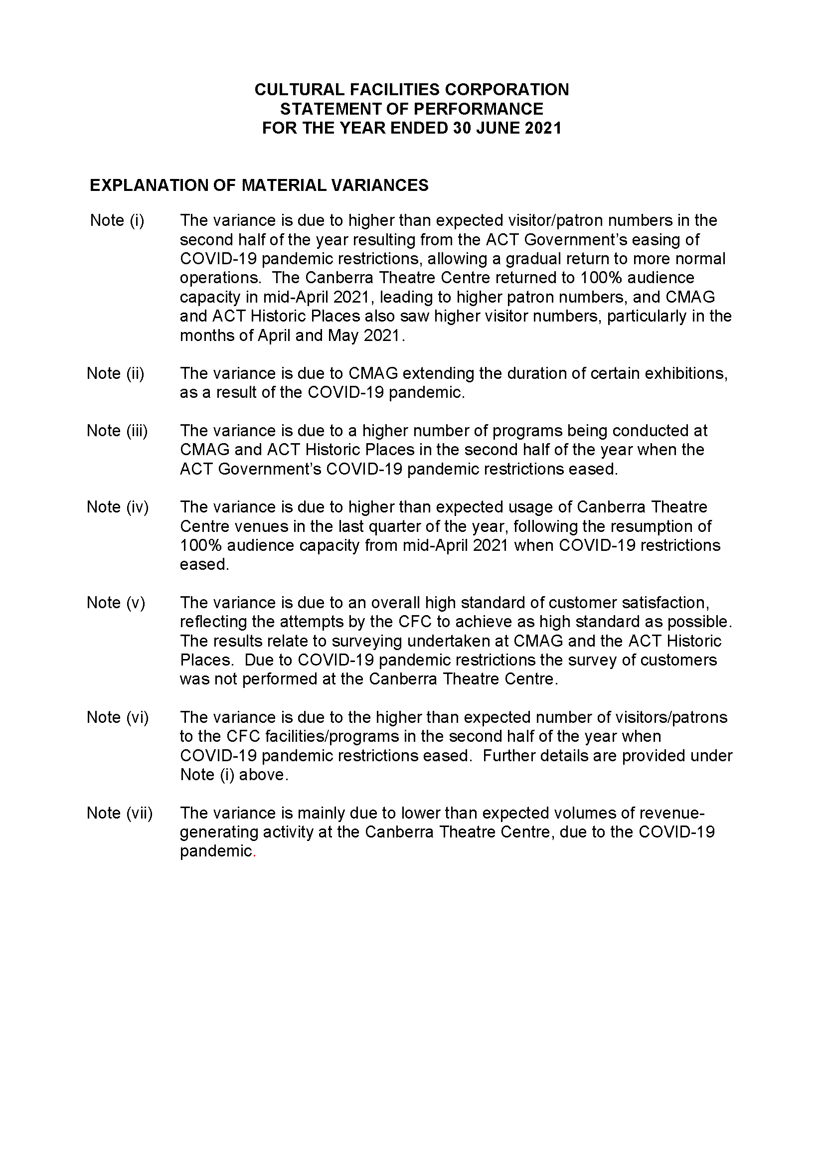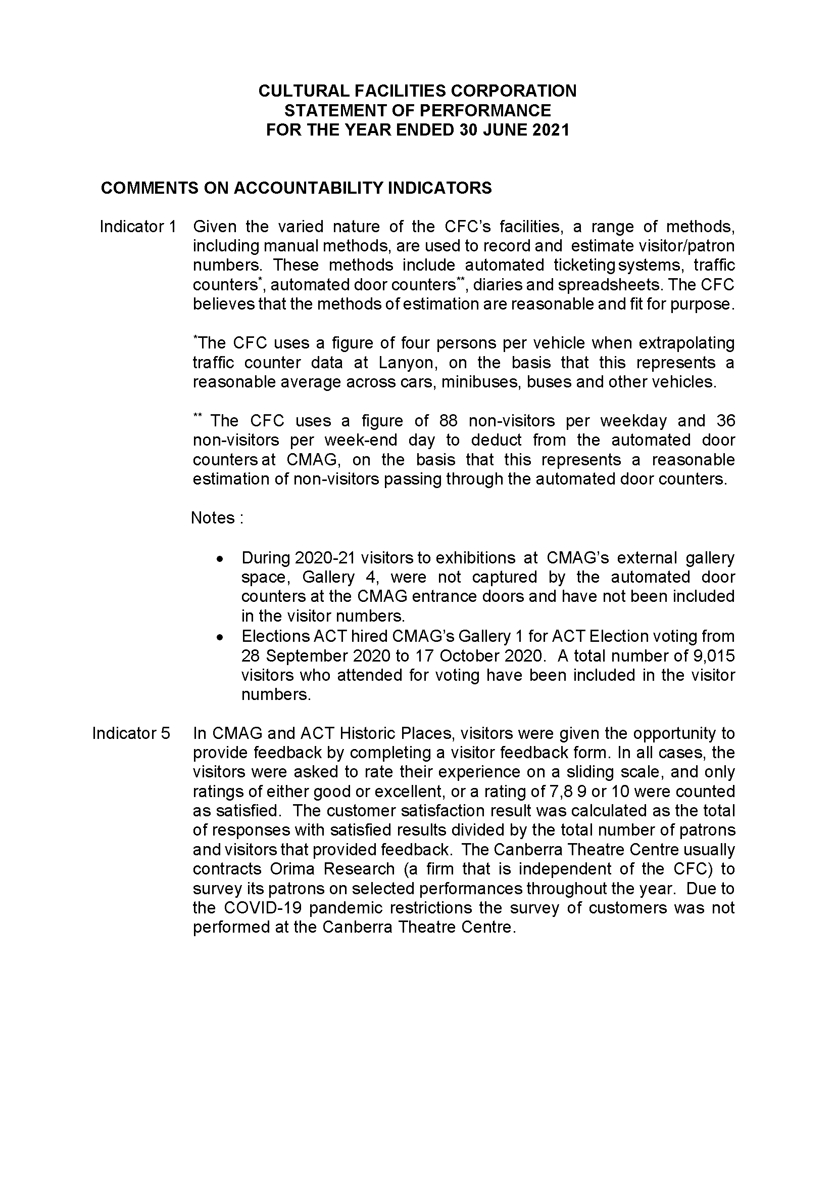

Abbreviations and Acronyms

ABC | Australian Broadcasting Corporation
ACC | Agency Consultative Committee
ACT  ACTHP | Australian Capital Territory  ACT Historic Places
ACTEWAGL | ACT Electricity and Gas
ACTPS | ACT Public Service
AM  AMaGA | Member of the Order of Australia  Australian Museums and Galleries Association
ANU | Australian National University
AO  ASO | Officer of the Order of Australia  Administrative Services Officer
ASOC  ATSIPP | Artist Society of Canberra  Aboriginal and Torres Strait Islander Procurement Policy
BA  BCP | Bachelor of Arts  Business Continuity Plan
BSc  the Centre | Bachelor of Science  Canberra Theatre Centre
CEO | Chief Executive Officer
CFC | Cultural Facilities Corporation
CFO | Chief Financial Officer
CMAG | Canberra Museum and Gallery
CMTEDD | Chief Minister, Treasury and Economic Development Directorate
CNG  CMP | Compressed Natural Gas  Conservation Management Plan
CPI | Consumer Price Index
CRA  CRM  DA  ESA | City Renewal Authority  Client Relationship Management  Development Application  Emergency Services Agency
EPSDD | Environment, Planning and Sustainable Development Directorate
ESD | Ecologically Sustainable Development
ESP | Enterprise Sustainability Platform
FBT | Fringe Benefits Tax
FCP | Fraud Control Plan
FM | Financial Management
FMA | Financial Management Act 1996
FM | Frequency Modulation
FTE | Full Time Equivalent
GHG | Green House Gas
GSO | General Services Officer
GST | Goods and Services Tax
HR | Human Resources
ICOMOS | International Council on Monuments and Sites
IT | Information Technology
Kg | Kilogram
kWh | kilowatt hour
LED | Light-emitting diode
LPA | Live Performance Australia
LPG | Liquid Petroleum Gas
MBA | Master of Business Administration
MD&A | Management Discussion and Analysis
MEAA | Media Entertainment and Arts Alliance
MLA  MWh | Member of the Legislative Assembly  megawatt hour
NAIDOC | National Aboriginal and Torres Strait Islander Peoples Day Observance Committee
NSW | New South Wales
PD | Professional Development
PhD  PHEV | Doctor of Philosophy  Plug-in Hybrid Electric Vehicle
PO | Professional Officer
RED | Respect, Equity and Diversity
S | Section
SES | Senior Executive Service
SOG | Senior Officer Grade
SPO  SRMP | Senior Professional Officer  Strategic Risk Management Plan
t | Tonne
the Centre | Canberra Theatre Centre
UK | United Kingdom
VET | Vocational Education and Training
WHS  ZEVs | Work Health and Safety  Zero Emissions Vehicles

Compliance Statement
The Cultural Facilities Corporation’s (CFC) Annual Report must comply with the Annual Report Directions (the Directions) made under section 8 of the Annual Reports (Government Agencies) Act 2004. The Directions are found at the ACT Legislation Register : http://www.legislation.act.gov.au.
The Compliance Statement indicates the subsections, under Parts 1 to 5 of the Directions, that are applicable to the CFC and the location of information that satisfies these requirements.
Part 1 Directions Overview
The requirements under Part 1 of the Directions relate to the purpose, timing and distribution, and records keeping of annual reports. The CFC’s Annual Report complies with all subsections of Part 1 under the Directions.
In compliance with section 15 Feedback, Part 1 of the Directions, contact details for the CFC are provided within the CFC’s Annual Report to provide readers with the opportunity to provide feedback.
Part 2 Reporting entity Annual Report Requirements
The requirements within Part 2 of the Directions are mandatory for all reporting entities and the CFC complies with all subsections. The information that satisfies the requirements of Part 2 is found in the CFC’s Annual Report as follows :
- A. Transmittal Certificate, see page 5;
- B. Organisational Overview and Performance, inclusive of all subsections,
see pages 11–72; and
- C. Financial Management Reporting, inclusive of all subsections, see pages 73–78.
Part 3 Reporting by Exception
The CFC has nil information to report by exception under Part 3 of the Directions for the 2020–21 reporting year.
Part 4 Reporting entity Specific Annual Report Requirements
The following subsection of Part 4 of the 2021 Directions is applicable to the CFC.
- Ministerial and Director‐General Directions
The CFC has nil information to report for the 2020–21 reporting period.
Part 5 Whole of Government Annual Reporting
All subsections of Part 5 of the Directions apply to the CFC. Consistent with the Directions, the information satisfying these requirements is reported in the one place for all ACT Public Service directorates, as follows :
- Bushfire Risk Management, see the annual report of the Justice and Community Safety Directorate;
- Human Rights, see the annual report of the Justice and Community Safety Directorate;
- Legal Services Directions, see the annual report of the Justice and Community Safety Directorate; and
- Territory Records, see the annual report of Chief Minister, Treasury and Economic, Development Directorate.
Part 6 State of the Service report
- Public Sector Standards and Workforce Profile, see the annual State of the Service Report.
ACT Public Service Directorate annual reports are found at the following web address : http://www.cmd.act.gov.au/open_government/report/annual_reports

INDEX

Aboriginal and Torres Strait Islander Reporting, 65
Acquisitions, 96
ACT Audit Office, 15, 35, 62
ACT Government, 15
ACT Heritage, 15
ACT Heritage Council, 33
ACT Historic Places, 12, 14, 22, 28, 29, 33, 48, 54, 55, 66, 71, 77, 85, 87, 88, 95, 99
ACT Legislative Assembly, 62
ACT Remuneration Tribunal, 82
Advisory Committees, 29, 85
Agency Consultative Committee, 28
Asset management, 38, 77
Assets, 18
Audit Committee, 29, 35, 62, 63
Board Members 7, 28, 80
Box Office, 69
Business, 20
Calthorpes’ House, 12, 13, 14, 54, 55, 61, 77, 92, 94, 95
Canberra Region Treasures Fund, 98
Canberra Theatre, 8, 9, 10, 12, 19, 24, 31, 39, 65, 83, 89, 91,
Canberra Theatre Centre, 12, 14, 28, 29, 40, 75, 76, 77, 85, 91, 99
Capital Works, 75, 76, 77
CFC COVID-19 Crisis Management Group, 6, 17, 26, 28, 33
Childers Group, 33
City Renewal Authority, 15, 17, 33, 42, 53, 89, 94
Clients and stakeholders, 14
Climate Change, 70
CMAG, 12, 14, 20, 29, 33, 48, 49, 50, 52, 77, 83, 85, 91, 92, 93, 94
CMTEDD, 14
Community and education programs, 93
Community Engagement and Support, 64
Conservation, 59, 87, 91, 92
Conservation and Housekeeping, 54
Corporate Plan, 33, 34
Courtyard Studio, 9, 12, 19, 40, 42, 91
COVID-19, 6, 7, 26
COVID-19 pandemic, 25
COVIDSafe, 17, 19, 20, 33, 36, 40, 42, 43, 49, 50, 94
Cultural Facilities Corporation, 33
Cultural Facilities Corporation Act 1997, 13
Current and future challenges, 25
Customers, 19, 21, 22
Donations, 96
Ecologically Sustainable Development, 70
Education Centre, 92
Exhibitions, 14, 91, 93, 98
Facilities and business/activities under management, 91
Finances, 18
Financial Management, 73, 74
Financial Management Act 1996, 28
Financial Statements, 74, 101
Fraud Prevention, 63
Freedom of Information, 35, 63
Gardens and Grounds, 54
Governance, 17
Governance Charter, 28, 29, 62
Government Contracting, 78
Health and Safety Representative Committee, 66, 67
Human Resources, 68
Internal Accountability, 28
Internal Audit, 62
interpretation, 91, 92
Lanyon, 12, 14, 77, 91, 94, 95
Lanyon Heritage Centre, 61
Leadership, 17, 20, 22, 23
Learning and Development, 68
Management Discussion and Analysis, 74, 151
Minister’s Creative Council, 33
Mugga-Mugga, 7, 12, 14, 55, 61, 77, 92, 94, 95
National Trust volunteers, 7
Organisational Chart, 15
Organisational Overview, 12
Organisational structure, 14
Outlook, 24
People, 18
Performance Analysis, 30
Performance outcomes, 17
Performance outcomes – Financial Management, 16
Programming, 19, 21, 22
Records management, 38
Recovery from the COVID-19 pandemic, 17, 19, 20, 22, 25, 33, 40, 49, 55
Research, 91, 92
Risk Management, 62
Role, functions and services, 13
Scrutiny, 62
Senior Management, 28
Senior Managers, 83
sponsorship and support, 98
Staffing Profile, 68
Statement of Intent, 15, 30
Statement of Performance, 16, 30, 35, 78, 160
Stewardship, 21, 23
Strategic Asset Management Plan, 77
Strategic objectives and indicators, 30
Strategic Plan, 12, 15, 29, 33, 34
Strategic Risk Management Plan, 62
Summary of performance in achieving objectives and targets, 16
the Centre, 46, 91
The Nolan Collection, 14, 77, 91, 92
The Playhouse, 3, 9, 10, 12, 20, 40, 46, 91
Transmittal Certificate, 169
Vision, mission and values, 12
Work Health and Safety, 36, 66, 67
Work Health and Safety Committee, 28, 67
Year at a Glance, 8

