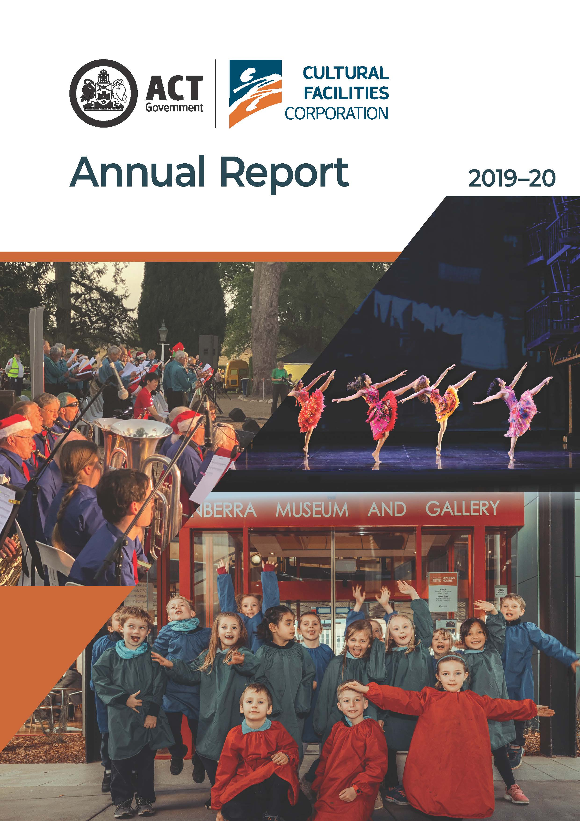

CULTURAL FACILITIES CORPORATION
ANNUAL REPORT
2019–2020

The Cultural Facilities Corporation acknowledges the Traditional Custodians of the ACT, the Ngunnawal people. We acknowledge and respect their continuing culture and the contribution they make to the life of this city and this region.
CULTURAL FACILITIES CORPORATION
PO Box 939
CIVIC SQUARE ACT 2608

ABN : 88187240846

Published by the Cultural Facilities Corporation, Canberra.

This work is copyright. Apart from any use as permitted under the Copyright Act 1968, no part may be reproduced by any process without written permission from the Cultural Facilities Corporation, PO Box 939, Civic Square ACT 2608.

The report is available electronically at http://www.culturalfacilities.act.gov.au and via the Open Access website – http://www.act.gov.au/open-access. Hard copies of the report are available by contacting
(02) 6207 3962 or emailing cfccorporatefinance@act.gov.au.

The ACT Government is committed to making its information, services, events and venues accessible to as many people as possible. If you have difficulty reading a standard printed document and would like to receive this publication in an alternative format – such as large print and audio – please call the Canberra Blind Society on (02) 6247 4580. If English is not your first language and you require the translating and interpreting service, please call the Telephone Interpreter Service on 131 450. If you are deaf or hearing impaired and require assistance, please call the National Relay Service on 133 677.

Enquiries about this publication should be directed to :
Telephone : (02) 6207 3962
Email : cfccorporatefinance@act.gov.au

For more information on the activities of the Cultural Facilities Corporation please visit the following websites :
- www.culturalfacilities.act.gov.au
- www.canberratheatrecentre.com.au
- www.cmag.com.au
- www.historicplaces.com.au

Front cover images : West Side Story performed in the Canberra Theatre, credit Jeff Busby; Year 1 students from Ainslie School participated in the Young Nolan Project at CMAG in July 2019, credit Fahad Akhand; and Lanyon Christmas Carols and Picnic – Tuggeranong Valley Band, credit Jodie Cunningham
Printed on recycled paper
Table of Contents
A. TRANSMITTAL CERTIFICATE 5
B. ORGANISATION OVERVIEW AND PERFORMANCE 13
B.1 Organisational Overview 14
B.2 Performance Analysis 34
B.3 Scrutiny 66
B.4 Risk Management 66
B.5 Internal Audit 66
B.6 Fraud Prevention 67
B.7 Freedom of Information 67
B.8 Community Engagement and Support 68
B.9 Aboriginal and Torres Strait Islander Reporting 69
B.10 Work Health and Safety 70
B.11 Human Resources Management 72
B.12 Ecologically Sustainable Development 74
C. FINANCIAL MANAGEMENT REPORTING 79
C.1 Financial Management Analysis 80
C.2 Financial Statements 80
C.3 Capital Works 81
C.4 Asset Management 83
C.5 Government Contracting 84
C.6 Statement Of Performance 85
APPENDICES 87
Appendix 1 – Members and Remuneration of the CFC Board during 2019–20 88
Appendix 2 – Senior Managers of the CFC 91
Appendix 3 – Advisory Committees 93
Appendix 4 – Facilities and business/activities under management 100
Appendix 5 – Canberra Museum and Gallery and ACT Historic Places venues –
schedule of exhibitions, programs and events 102
Appendix 6 – Canberra Museum and Gallery –
Acquisitions (purchases and donations) 105
Appendix 7 – Major funding, sponsorship and support 108

Attachment 1 – Financial and Performance Statements and
Management Discussion and Analysis (MD&A) 111
Abbreviations and Acronyms 184
Compliance Statement 186
Index 188

Transmittal Certificate

A

Section
Ms Tara Cheyne MLA
Minister for the Arts
ACT Legislative Assembly
CANBERRA ACT 2601
Dear Minister
We are pleased to present to you the 2019–20 Annual Report of the Cultural Facilities Corporation (CFC), which has been prepared in accordance with Section 7(2) of the Annual Reports (Government Agencies) Act 2004, other applicable legislation, and the Annual Report Directions.
We certify that information in this Annual Report, and information provided by the CFC for whole of government reporting, are honest and accurate, and that all material information on the operations of the CFC has been included for the period 1 July 2019 to 30 June 2020. We also certify that fraud prevention has been managed in accordance with the Public Sector Management Standards 2016.
Section 13 of the Annual Reports (Government Agencies) Act 2004 normally requires the presentation of annual reports to the ACT Legislative Assembly within 15 weeks after the end of the reporting year. For 2019–20 reports, however, an extension of time has been granted under this legislation, to 18 December 2020, in view of the impact of the COVID-19 pandemic on agency operations.

2019–20 was the most challenging year of the CFC’s existence as a result of the successive impacts on its operations of the major bushfire threats and severe smoke haze experienced in Canberra during the summer months, followed by the COVID-19 pandemic. The CFC took a range of measures in relation to the bushfire threats and smoke haze situation, to ensure the safety and wellbeing of its staff, volunteers, visitors and tenants, as well as to protect the collections and places it manages. These measures included closing sites at times, particularly Lanyon, which was directly in the path of the Orroral Valley Fire but fortunately did not suffer any damage.
The COVID-19 pandemic, and consequent health-related restrictions, had a significant impact on the CFC’s activities from mid-March 2020. The CFC’s various sites were closed to the public for most, or all, of the final quarter of the 2019-20 year, and normal programming suspended. Staff were encouraged to work from home where their work functions could be carried out remotely, and measures were put in place to support their health and wellbeing. Staff members, including the CFC’s large regular casual workforce, continued to be engaged and provided with work, in some cases by placing CFC staff in agencies such as ACT Health that needed resources. A robust framework was established to manage and report on COVID-19 impacts on the CFC, including through regular meetings of a CFC COVID-19 Crisis Management Group, and regular updates on key developments to the Minister, Board, staff and other stakeholders.
The combined effect of the bushfire threats, severe smoke haze and COVID-19 pandemic led to the organisation failing to achieve most of its 2019–20 performance targets, and ending the year with a considerably worse than budgeted result, due particularly to a major downturn in theatre revenues.
The challenges of COVID-19 did, however, produce a range of new opportunities, allowing the CFC to innovate rapidly in customer engagement and work practices. New digital programming included the Canberra Theatre Centre’s CTC@Home initiative, presenting free livestreamed performances by Canberra region artists, while both CMAG and the ACT Historic Places developed new online resources.
There were many other positive aspects to the 2019–20 year. A major highlight was Opera Australia’s production West Side Story at the Canberra Theatre. Other highlights included Bangarra’s 30th Anniversary season and Shakespeare in Love at the Canberra Theatre, and major exhibitions at CMAG, including Activism : forces for change in Canberra and Hi-Vis Futures. Activities at the ACT Historic Places included Suburban Apparitions | Magic Lanterns at Calthorpes’ House, in conjunction with Enlighten 2020; and an Indigenous program at Lanyon, Fireside Storytelling : Wiradjuri Echoes. Overall, and despite the year’s challenges, over 290,000 people attended the CFC’s venues and programs in 2019–20.
During the year, the CFC continued to work closely with other ACT Government agencies to plan future directions of the city centre and future cultural facilities in Civic. Particular areas of focus were the work towards a major new theatre for Canberra and towards a Civic, Arts and Cultural Precinct Plan, and the provision of detailed input into the heritage listing of the Civic Square Precinct.
In providing this Annual Report to you, we acknowledge that the CFC’s achievements in 2019–20 were due to the efforts of many people. Firstly we thank our fellow Board members, who provided direction and guidance to the CFC throughout the year. In December 2019, Virginia Haussegger concluded her six-year term on the Board, making significant contributions through her expertise in communications, her commitment to promoting the role of women, and her personal generosity in supporting the CFC’s work. In February 2020, we welcomed new Board member, Julian Widdup. Julian’s strong background in finance and risk management will be a major benefit to the Board.
As Chair and Chief Executive Officer, we are ably supported by the very dedicated staff of the CFC. This year, we especially appreciated the efforts of staff as they managed through major bushfire threats, smoke haze challenges and the COVID-19 situation, with courage, resilience and skill.
A series of senior staff changes in 2019–20 saw Bruce Carmichael retire from the position of Director of the Canberra Theatre Centre and Shane Breynard resign from his role as Director of CMAG. We congratulate them both for their significant contributions to the CFC. We welcomed Anna Wong, who joined the senior management team as Director, ACT Historic Places, and Alex Budd as Director of the Canberra Theatre Centre. We thank Sophie Chessell and Gill Hugonnet for so capably filling the roles of acting Director of CMAG, and acting Director of the Canberra Theatre Centre.
The CFC benefits from the generosity, assistance and support of many volunteers. These include the CFC’s three advisory committees. Other volunteers make a vital contribution to the work of the ACT Historic Places. We record our gratitude for the contribution made by all our volunteers and advisory committee members during the year.
Finally, we are pleased to acknowledge the contribution of our principal funding agencies and our many sponsors, donors and supporters. The CFC receives its primary funding from the ACT Government and, in 2019–20, we particularly welcomed and appreciated the decision by the ACT Government to provide major additional funding to the CFC in the year ahead, to help manage the impact of COVID-19 on our finances.
Our sponsors and donors again provided generous support. The CFC was grateful for the extent of donations to CMAG, including monetary donations by private individuals such as longstanding donor Meredith Hinchliffe. We were fortunate to enjoy the support of many other sponsors and donors, too numerous to mention here but documented in full in this Annual Report.
The efforts and commitment of the CFC’s Board, staff, volunteers, sponsors and supporters continue to be vital as we seek to take a major role in the ACT’s creative recovery from COVID-19, as well as continuing our role of providing cultural leadership, enriching the cultural life of Canberra, and delivering the highest standards of service to the community.
We commend this Annual Report to you and look forward to working with you in the year ahead.
Yours sincerely
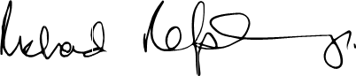  The Hon Richard Refshauge SC  Chair  Cultural Facilities Corporation  11 December 2020 |   Harriet Elvin  Chief Executive Officer  Cultural Facilities Corporation  11 December 2020

YEAR AT A GLANCE
JULY 2019  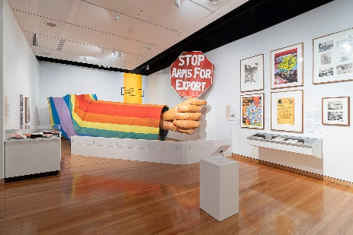  Display from CMAG exhibition Activism : forces for change in Canberra  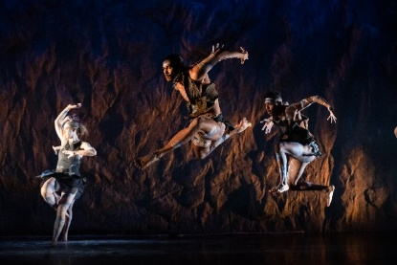  Bangarra – 30 years of 65 Thousand,  credit Daniel Boud |  | - CMAG exhibition Activism : forces for change in Canberra opened. (Opposite picture)  - CMAG hosted a panel 50th Anniversary of LGBTIQ Activism and Reform in Canberra with Chief Minister, Andrew Barr MLA, providing the welcome.  - Bangarra : 30th Anniversary Season performed in the Canberra Theatre. (Opposite picture)  - CMAG hosted a NAIDOC Week event at CMAG – Ngambri-Ngunawal custodian Paul House and glass artist Tom Rowney discussed creating the glass yidaki that was on display in the Ramp Showcase.  - Lanyon presented Fireside Storytelling : Wiradjuri Echoes – Wiradjuri man, Duncan Smith OAM, shared his Dreamtime stories and their symbols.  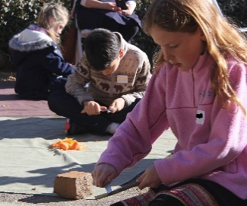  - Calthorpes’ House hosted school holiday workshop What’ll you whittle? (Opposite picture)  Children learning the art of whittling at Calthorpes’ House,  credit Kate Gardiner
AUGUST 2019  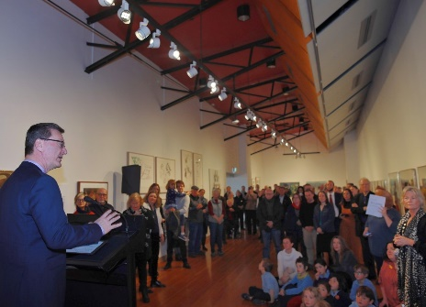Minister Ramsay launching The Nolan Collection in its new Gallery |  | - Minister Ramsay launched The Nolan Collection in its new location in CMAG’s refurbished Gallery 5, including the new Nolan Children’s Gallery. (Opposite picture)  - CMAG hosted Children’s Workshop Puppet making with Hilary Talbot, exploring the exhibition Activism : forces for change in Canberra.  - Calthorpes’ House hosted a Wattle Day display to celebrate National Wattle Day.  - Melbourne Theatre Company’s Shakespeare in Love performed in the Canberra Theatre including an opening night gala with pre-show In conversation and post-show function, a tactile tour, and a captioned and audio described matinee performance.
SEPTEMBER 2019  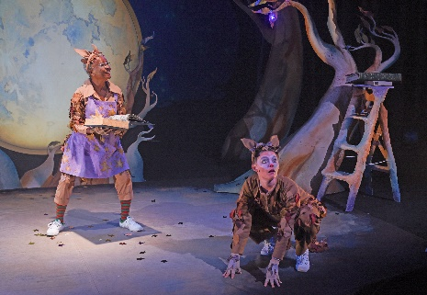  Monkey Baa Theatre Company’s Possum Magic performed in the Canberra Theatre    Doing the Flowers at Lanyon display |  | 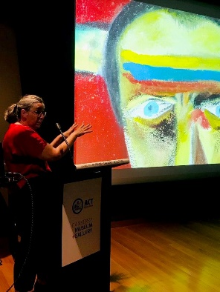CMAG floor talk Unmasking Nolan’s hidden paintings with Dr Paula Dredge in the Theatrette |  |  | - Monkey Baa Theatre Company’s Possum Magic performed in the Canberra Theatre. (Opposite picture)  - Wakakirri 2019 performed in the Canberra Theatre, including an awards night.  - 2019 Come Alive – Festival of Museum Theatre performed in the Courtyard Studio.  - Lanyon hosted a workshop Doing the Flowers at Lanyon. (Opposite picture)  - CMAG presented a floor talk Aboriginal Tent Embassy, in conjunction with the exhibition Activism : forces for change in Canberra.  - CMAG provided various children activities themed to coincide with Floriade.  - CMAG hosted a floor talk Unmasking Nolan’s hidden paintings with Dr Paula Dredge.  (Opposite picture)
OCTOBER 2019  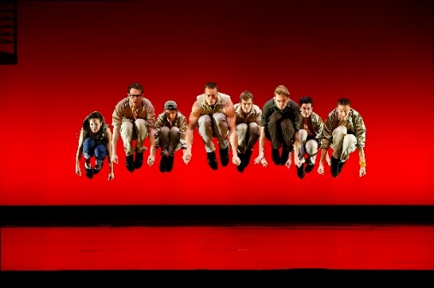  Opera Australia’s West Side Story, credit Jeff Busby  - Opera Australia’s West Side Story was held at the Canberra Theatre including preview performances, a gala opening night and post-show reception, and a captioned and audio described matinee performance. (Above picture)  - Minister Ramsay launched the 2020 Subscription Season for the Canberra Theatre Centre. |  |  |  | - Lanyon hosted a craft program Bugs and Blooms : Children’s Holiday Activity, coinciding with Floyd the Floriade Gnome’s visit to Lanyon Homestead.  (Below picture)  - Lanyon presented a Family Activity : Ngunnawal Children’s Toys.  - CMAG hosted a floor talk Mandarin language tour of The Nolan Collection.  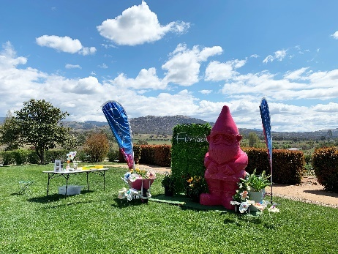  Paper flower making activity to coincide with arrival of Floyd, Floriade’s giant gnome, in the garden at Lanyon, credit Kate Gardiner
  NOVEMBER 2019  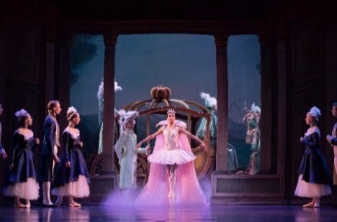  Queensland Ballet Company’s Cinderalla,  credit David Kelly  CDP Theatre Producers’ Spot, credit Heidrun Lohr |  |  | - Queensland Ballet Company’s Cinderella performed in the Canberra Theatre including an opening night with post-show function, matinee performances and a special On Point event. (Opposite picture)  - CMAG exhibition Hi-Vis Futures opened.  - CDP Theatre Producers’ Spot performed in the Canberra Theatre. (Opposite picture)  - Mugga-Mugga hosted a Performance : A Mugga Ceilidh.  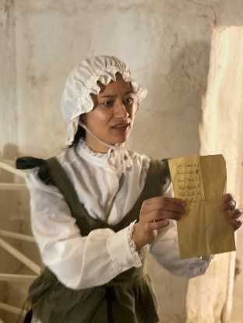  - Lanyon hosted an Indigenous Women’s Possum Skin Cloak Making Workshop.  - Lanyon presented Live History: Lanyon Escape Hunt: 1835 edition - an interactive, escape room style performance designed for adults in the grounds of Lanyon Homestead. (Opposite picture)  Lanyon Escape Hunt performance by Live History Shows at Lanyon Homestead,  credit Jodie Cunningham
DECEMBER 2019  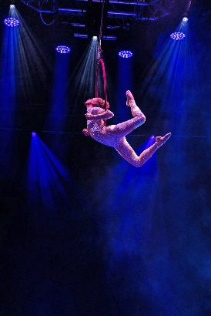  The Works Entertainment’s Cirque Stratosphere performed in the Canberra Theatre | 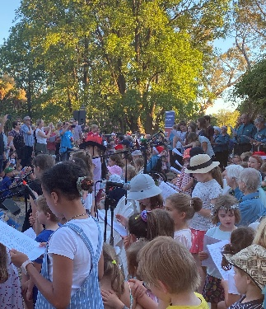Lanyon Christmas Carols and Picnic, credit Jodie Cunningham |  |  | - CMAG hosted an In Conversation : Collaboration in Art and Music in Hi-Vis Futures, where Alexander Boynes, Mandy Martin and musician and composer Tristen Parr discussed the process involved in creating the Hi-Vis Futures exhibition.  - The Works Entertainment’s Cirque Stratosphere performed in the Canberra Theatre. (Opposite picture)  - Three mentees hosted by the CFC graduated in the Audrey Fagan Board Mentorship Program.  - Lanyon presented the Lanyon Christmas Carols and Picnic. (Opposite picture)  - CMAG exhibition Growing Up Optional opened.  - The Wiggles – Party Time! Big Show! performed in The Playhouse.  - Paul McDermott & Gatesy Go Solo performed in The Playhouse.
JANUARY 2020  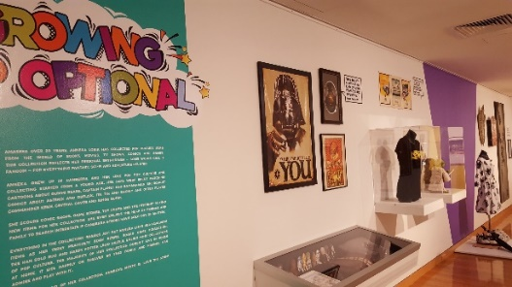  CMAG exhibition Growing Up Optional |  |  |  | - CMAG hosted an In Conversation with Anneka Losik : Pop Culture Obsession, in conjunction with the exhibition Growing Up Optional. (Opposite picture)  - CMAG presented community program Board Game Marathon Drop-In-Day, in conjunction with the exhibition Growing Up Optional. (Opposite picture)  - Lanyon hosted the Australia Day Picnic at Lanyon, including tours of the homestead, garden and outbuildings.  - The Australian Ballet’s Storytime Ballet : The Nutcracker performed in the Canberra Theatre.  - Catch Jazida performed in the Courtyard Studio.
FEBRUARY 2020  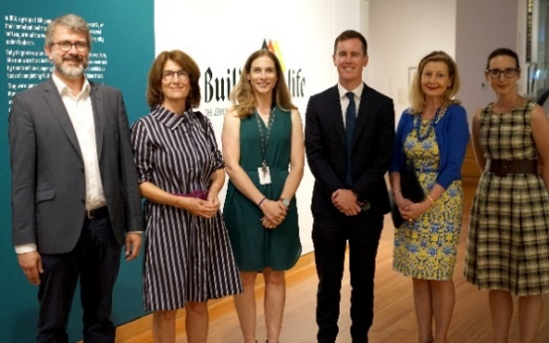  Deputy Ambassador of the German Embassy Canberra Andreas Radtke, CFC Deputy Chair Helen O’Neil, Curator Sharon Bulkeley, Minister Steel, CEO Harriet Elvin, CMAG A/g Director Sophie Chessell at the opening of CMAG exhibitIon Building a Life : The Jennings Germans story, credit Shaya Dastinezhad |  |  |  | - Minister Steel opened CMAG exhibition Building a Life : The Jennings Germans story. (Opposite picture)  - German Ambassador, Dr Thomas Fitschen and his wife, Dr Ilona Stölken-Fitschen attended a guided tour of the CMAG exhibition Building a Life : The Jennings Germans story.  - CMAG hosted Family Spaces during the 2020 National Multicultural Festival.  - Music@Midday performed two shows in the Canberra Theatre.  - Carl Barron : Skating Rink for Flies performed in the Canberra Theatre.  - Jason Alexander – The Master of his Domain Tour performed in the Canberra Theatre.
MARCH 2020  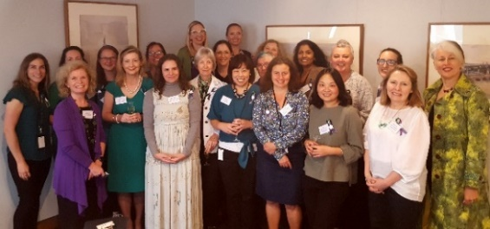  Staff and guests at the International Women’s Day lunch at CMAG  - David Williamson’s Family Values performed in The Playhouse including an opening night gala.  - CMAG exhibition Seeing Canberra opened on Canberra Day.  - The CFC’s venues closed in March 2020 in response to COVID-19 restrictions. Closures continued during April and May 2020 but venues started reopening with limited visitation in June 2020. |  |  |  | - The CFC hosted an International Women’s Day lunch, with Georgeina Whelan, ACT Emergency Services Commissioner as guest speaker. (Opposite picture)  - To celebrate International Women’s Day, an In-conversation event was held in the Link Foyer, and an evening concert in The Playhouse.  - The CFC provided an International Women’s Day morning tea for staff and volunteers, with the 2020 CFC International Women’s Day quiz.  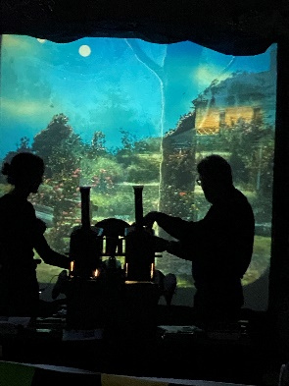  - Calthorpes’ House hosted a contemporary performance – Suburban Apparitions | Magic Lanterns at Calthorpes’ House in conjunction with the Enlighten Festival 2020. (Opposite picture)  Suburban Apparitions | Magic Lanterns at Calthorpes’ House  credit Jodie Cunningham
APRIL AND MAY 2020
- 15,000 bulbs and annuals were planted at Lanyon in preparation for Floriade : Reimagined. Lanyon was chosen as the main southside site.
- CMAG online learning program Seeing Canberra : What Do Artist’s Make? was launched to assist teachers and students working from home.
- During CMAG’s closure period, the foyer and venue hire rooms were repainted, and wooden floors buffed and polished.
- Box Office staff were kept busy processing the many cancelled or rescheduled performances at the Canberra Theatre Centre (the Centre).
- Funding under the ACT Government’s COVID-19 “screwdriver ready” stimulus package allowed the Centre to undertake projects such as the refurbishment of public bathrooms and security upgrades.
- The CFC’s regular casual staff were provided with work, including in other ACT agencies, to ensure they had regular income during CFC site closures.
- A flu vaccination program was provided to all staff.
JUNE 2020  - CMAG, Lanyon and The Barracks Cafe reopened to the public with limited visitation on 10 June 2020, with Calthorpes’ House reopening on 27 June 2020 (and Mugga-Mugga on 4 July 2020).  - The CMAG Café and the Centre’s Box Office reopened on the 29 June 2020.  - The 2020 ACTUP! Student Fringe Festival was presented via the Centre’s website, with over 200 students participating.  - The Centre launched its digital season of free streamed performances CTC@Home, delivering a variety of productions including family content, literary readings, music, drama and plenty of surprises, all featuring Canberran artists, speakers and personalities.  (Opposite picture) |  |  |  |  | 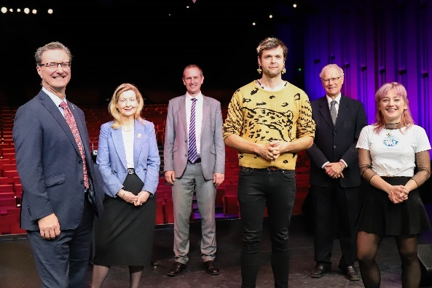  Minister Ramsay, CEO Harriet Elvin, Director, Canberra Theatre Centre Alex Budd, performer Chris Endrey, CFC Chair Richard Refshauge and performer Cathy Diver at the CTC@Home launch

Organisation Overview and

Section

B

B.1 Organisational Overview

B.1.1 Vision, mission and values
The CFC’s 2016–21 Strategic Plan provides the overarching framework for the organisation’s planning activities over a five-year period, including for the development of its annual corporate plans.
The Strategic Plan identifies the CFC’s role, vision, key values and principles, and key priorities. It also identifies the mission, purpose, vision and key strategies both for the organisation as a whole and for its three program delivery divisions :
- the Canberra Theatre Centre;
- the Canberra Museum and Gallery (CMAG), including The Nolan Collection; and
- the ACT Historic Places : Lanyon, Calthorpes’ House and Mugga-Mugga.
Overarching Vision for the CFC
Our vision is for Canberra to be a creative capital that values the arts for their intrinsic qualities, their contribution to building a more inclusive and resilient society, their support for making the city an exciting place to live and an attractive destination for business and tourism, and their important role in the economy of the ACT and region.
We see the CFC as a leader in this creative city, providing high quality cultural experiences based on the arts and heritage resources that we hold in trust for the people of Canberra, and playing a significant role in the region’s cultural and economic life.
Mission
Mission/purpose statements (What we are/What we do) are identified in the Strategic Plan for the CFC as a whole and for each division. These are supported by vision statements for each area and statements as to what the CFC is seeking to achieve in a number of areas, as set out below.
CFC
What we are | An enterprise of the ACT Government that manages a number of Canberra’s major cultural facilities
What we do | We connect people with rich and diverse cultural experiences through activities at our venues
Our vision | To provide cultural leadership in the Canberra region and beyond
What we want to achieve | Leadership : A cultural leader in the ACT region and beyond  Strategy : A clear direction for our future  Governance : An accountable and dynamic organisation  People : An employer of choice  Finances : Long-term financial sustainability  Assets : Support for delivering high quality cultural experiences
Canberra Theatre Centre
What we are | The Canberra region’s main theatre centre, incorporating the Canberra Theatre, The Playhouse and the Courtyard Studio
What we do | We connect people with theatre experiences of national and international quality
Our vision | To be a leading theatre centre in Australasia and Asia
What we want to achieve | Customers : Audiences that are growing, diverse, engaged and entertained  Programming : A diverse, high quality, entertaining and distinctive program  Business : Venues, systems and people that support high quality live performances  Leadership : An integral part of the cultural life of the Canberra region and beyond

CMAG
What we are | A museum and gallery dedicated to the visual arts and social history of the Canberra region
What we do | We connect people with the Canberra region’s rich and diverse stories, sense of place, and contemporary identity
Our vision | To be a leading regional cultural venue in Australia and beyond
What we want to achieve | Customers : Audiences that are growing, diverse and engaged  Programming : Exhibitions and programs that reflect Canberra’s unique identity  Stewardship : Venues and collections that allow us to tell the many stories of Canberra  Leadership : An integral part of the cultural life of the Canberra region and beyond

ACT Historic Places
What we are | Three historic places that reflect different aspects of Canberra’s history : Lanyon, Calthorpes’ House and Mugga-Mugga
What we do | We connect people with Canberra’s rich and diverse stories and heritage
Our vision | To be leading historic places in Australia and beyond
What we want to achieve | Customers : Audiences that are growing, diverse and engaged  Programming : Programs that explore Canberra’s history by interpreting each place  Stewardship : Buildings, grounds and collections that are conserved and researched  Leadership : An integral part of the cultural life of the Canberra region and beyond

Key Values and Principles

Leadership
- We are committed to providing cultural leadership, excellence and innovation, including leadership in using digital applications to enhance our systems and programs.

Engagement
- We actively seek to engage our communities in a greater understanding of the value of the arts, and of our cultural heritage, through our programs and activities, placing customer service as our primary goal and recognising the diverse needs and expectations of our customers.

Collaboration
- We value cooperative and strategic partnerships across all areas of our activities.

Professionalism
- We place major importance on maintaining professional standards in the management of our facilities and in the design and delivery of our programs.
In observing these values, we are committed to implementing the :
- ACT Government Service Values : respect, integrity, collaboration and innovation;
- Principles of the 2015 ACT Arts Policy : participation and access to the arts; great arts and great artists; vitality of the Canberra region arts ecology; and engagement with Aboriginal and Torres Strait Islander arts and cultures; and
- The ACT Government’s Strategic Priorities.

B.1.2 Role, functions and services
The CFC was established under the Cultural Facilities Corporation Act 1997 (the CFC Act), which came into operation as from 1 November 1997.
The functions of the CFC, as set out in the CFC Act (Section 6) are :
- to manage, develop, present, coordinate and promote cultural activities at designated locations and other places in the ACT;
- to establish and research collections;
- to conserve and exhibit collections in the possession or under the control of the CFC;
- to undertake activities, in cooperation with other people if appropriate, to exercise its other functions; and
- to exercise other functions given to the CFC under this Act or another Territory Law.
The CFC Act (Section 7) requires that the CFC, in exercising its functions, must consider :
- any cultural policies or priorities of the Executive known to the CFC; and
- other cultural activities in the ACT.
The CFC is responsible for :
- the Canberra Theatre Centre;
- CMAG, including The Nolan Collection; and
- the ACT Historic Places : Lanyon, Calthorpes’ House and Mugga-Mugga.
The CFC’s functions therefore include the performing arts, the visual arts, social history and cultural heritage management. The organisation delivers a range of cultural services to the community by providing activities such as theatre presentations, exhibitions, and education and community programs, and through conserving and presenting significant aspects of the ACT’s cultural heritage.
Additional information about the CFC can be found at the following websites :
- www.culturalfacilities.act.gov.au covering whole of CFC matters;
- www.canberratheatrecentre.com.au covering the Canberra Theatre Centre;
- www.cmag.com.au covering CMAG and The Nolan Collection; and
- www.historicplaces.com.au covering the ACT Historic Places.
Clients and stakeholders
During 2019–20, the CFC reported to the Minister for the Arts, Creative Industries and Cultural Events. The Chief Minister, Treasury and Economic Development Directorate (CMTEDD) is the “parent” directorate for the CFC. The CFC’s other clients and stakeholders include :
- the community of the ACT and region;
- visitors to the ACT;
- the arts, cultural, heritage, education, business and tourism sectors, including other cultural organisations;
- national producers of performing arts, including commercial and funded companies;
- the diplomatic community; and
- the media, especially the Canberra media.

B.1.3 Organisational structure, environment and planning framework

Organisational structure
The CFC is organised into three program delivery divisions: the Canberra Theatre Centre, CMAG, and the ACT Historic Places, together with a central finance/corporate section. The CFC’s top level organisational chart as at 30 June 2020 is provided below.
Figure B.1.3a CFC Organisational Chart

Organisational environment
During 2019–20, the CFC had close working relationships with a number of ACT Government agencies and entities including the City Renewal Authority, artsACT, Minister’s Creative Council, Major Projects Canberra, Transport Canberra and City Services Directorate, Environment, Planning and Sustainable Development Directorate, ACT Heritage Council, Reconciliation Day Council, Libraries ACT, Shared Services, ACT Property Group, Territory Records Office, Public Sector Workforce Health, Safety and Wellbeing, Theo Notaras Multicultural Centre, ACT Treasury and ACT Audit Office.
Planning Framework
As noted in Section B.1.1, the CFC has adopted a five-year Strategic Plan that provides the overarching framework for the organisation’s planning activities, including for the development of its annual corporate plans.

The CFC’s 2019–20 Corporate Plan, based on its 2016–21 Strategic Plan, identified the actions the CFC intended to take during the year to work towards the Strategic Plan. Results relating to these actions are reported in summary in this section and in detail in Section B.2, page 34.
The CFC’s accountability indicators and targets for 2019–20 were identified in the CFC’s 2019–20 Statement of Intent, which was included in the 2019–20 ACT Budget papers. The Statement of Intent also identified the CFC’s strategic objectives and indicators. Results relating to the CFC’s accountability and strategic indicators are reported in summary in this section. Further details about the CFC’s accountability indicators are provided in the 2019–20 Statement of Performance at Attachment 1, page 175 to this report. Further details about the CFC’s strategic indicators are provided in Section B.2, page 34.

B.1.4 Summary of performance in achieving objectives and targets
Performance outcomes for the CFC in 2019-20 were significantly affected by restrictions arising from the COVID-19 situation, especially the closure of CFC venues for approximately a quarter of the reporting period. Other detrimental impacts on performance outcomes related to the severe bushfire threats and smoke haze affecting Canberra in the 2019-20 summer season. These factors resulted in the CFC not meeting the majority of its accountability indicator targets for the year. In summary, during 2019-20 the CFC :
- welcomed an estimated 291,789 visitors and patrons to its facilities and programs, a figure 27% below target;
- provided 267 education and community programs, a figure 39% below target; and
- recorded 476 days in total of venue usage at the Canberra Theatre Centre’s venues, a result 24% below target.

The CFC did, however, achieve a higher number than expected of exhibitions for the year, presenting 26 in total, compared with a target of 22, and including an additional exhibition that became available at short notice through a partnership with the Embassy of Cuba. In another above-target result, the overall customer satisfaction rate for the year of 97% exceeded the target of 90%.
Detailed performance results and variance explanations are included in the 2019–20 Statement of Performance at Attachment 1, page 175 to this report.

Performance outcomes – Financial Management
The CFC’s overall financial result for 2019–20 was an operating deficit of $3.748m, which was 52.6% higher than the budgeted deficit of $2.456m. It should be noted that, due to its large asset holdings and consequent significant depreciation expenses, the CFC always expects to have an operating deficit as it is not funded for depreciation, but receives capital injections through the capital works program. The budget deficit for 2019-20 was, however, significantly worse than budget and this was due to COVID-19 closures and restrictions impacting on the theatre activities of the CFC, with a consequent reduction in revenue.
The CFC achieved an own-sourced revenue figure of 49.0% as a proportion of total revenue for
2019–20, against a target of 50.7%. The below-target result was due primarily to the loss of own-sourced revenue during the period of theatre closures, partially offset by higher than expected theatre-related revenues generated in the pre-closure period. The CFC recorded a result for Cost to Government per estimated visitor/patron of $31.40 against a target of $23.03, the worse than target result reflecting the below-target number of visitors and patrons.
The CFC completed the majority of its 2019–20 capital works and capital upgrade projects by year-end, although some expenditure on, and funding for, capital projects for ACT Historic Places and Canberra Theatre Centre, was deferred from 2019–20 into 2020–21, as a result of revised project scheduling.
A full analysis of the CFC’s financial results and financial position is set out in the Management Discussion and Analysis at Attachment 1, page 166 to this report.
Performance outcomes – Strategic Objectives/Indicators
Strategic Objective 1 – The CFC provides cultural leadership in the Canberra region and beyond.
Strategic Indicator 1 : The extent to which the CFC connects people with rich and diverse cultural experiences through activities at its venues, in the following areas.
- Leadership : A cultural leader in the ACT region and beyond
- Throughout the year, the CFC pursued its goal of providing leadership in cultural planning, administration and management.
- The CFC continued to work closely with other ACT Government agencies on initiatives to plan future directions of the city centre and the future provision of cultural facilities in Civic. A particular area of focus again this year was the CFC’s participation in work on a full business case for a major new theatre for Canberra, and its involvement in the development of a Civic Arts and Cultural Precinct Plan.
- During the year, the CFC was closely involved in consultation on the heritage listing of the Civic Square Precinct, in view of the implications of this listing for the CFC’s existing facilities in the Precinct, and for the new theatre project. The CFC supported the heritage registration of the Precinct but sought to ensure that the wording of the registration would enable appropriate changes to take place in the Precinct, in order to maintain and enhance its cultural significance, including through the new theatre project.
- The Childers Group, with support from the CFC, presented an Arts Forum at CMAG for the ACT arts community, Sustainable arts practice : creativity and business, in November 2019.
- Strategy : A clear direction for the future
- The CFC’s five-year Strategic Plan, covering the period 2016–21, continued to provide the framework for the CFC’s operations.
- During the year, the CFC’s 2019–20 Corporate Plan, based on the Strategic Plan, was used to guide the work of the Board, advisory committees, staff and volunteers. Reports on progress towards the CFC’s key priorities and tasks were provided to each Board meeting during 2019–20. For the April and June 2020 meetings, reporting to the Board focused on the CFC’s management of impacts from the COVID-19 situation.
- The CFC’s Corporate Plan for 2020-21 was developed in June 2020, based on four key priorities to guide the CFC’s operations in the year ahead, including COVID-19 management and recovery.

- Governance : An accountable and dynamic organisation
- The CFC maintained robust governance systems in order to provide a high standard of accountability throughout the year.
- A Board renewal program was completed during the year. This resulted in changes to the sequencing of Board appointment terms, whereby for the six Ministerially-appointed members on the CFC Board, there are now three appointment term conclusion dates, each for two members. This sequencing of appointment terms ensures better continuity in Board matters and a smoother transition in membership.
- The CFC participated in the 2019 Audrey Fagan Board Mentorship Program, providing mentorship for three young women. A graduation ceremony was held for the participants at a dinner following the December 2019 Board meeting.
- The CFC’s Security Executive Group met, generally fortnightly, during the year to discuss security matters, and physical security policies, plans and procedures for each business unit were developed.

- People : An employer of choice
- The CFC continued to focus on attracting, developing and retaining highly skilled staff and volunteers, and on ensuring its sites are safe and rewarding places to work. The CFC regularly attracted a good field of high quality applicants for advertised vacancies.
- A number of changes took place in the senior management team during the year, including for the positions Director of the Canberra Theatre Centre; Director, ACT Historic Places; and Director, Canberra Museum and Gallery.
- CFC staff participated in a range of training, staff development opportunities and networking programs in 2019–20. Staff were invited to sit on boards, committees and judging panels, open exhibitions, attend major conferences, and deliver lectures at other institutions.
- Workplace Health and Safety (WHS) and injury management improvement strategies continued to be implemented throughout the year, with regular reports to the Board, and meetings of the CFC WHS Committee and of work unit Health and Safety Committees.
- The CFC’s three advisory committees operated throughout the year and attended a range of meetings and workshops. All committee members provided their time on a voluntary basis. The first advisory committee meeting of 2019–20 was held as a plenary strategic planning workshop for all three committees on 14 October 2019. The workshop included a presentation by the CEO. Members of CFC’s three advisory committee all agreed to continue their membership through to 30 June 2021 following a renewal process undertaken in early 2020.

- Finances : Long-term financial sustainability
- In 2019–20 the CFC maintained high standards of financial management and reporting, with a major focus during the final quarter of the year on oversight of the impact of the COVID-19 situation on the organisation’s finances.
- The audit of the CFC’s 2019–20 Financial Statements by the ACT Auditor-General resulted in an unmodified audit and no new audit findings.
- For 2019–20, the CFC achieved own sourced revenue of 49.0% compared with a target of 50.7%, the below-target figure relating primarily to the loss of theatre revenues due to the COVID-19 situation.
- The CFC achieved a cost to government per visitor outcome of $31.40 compared with a target of $23.03. The worse than target figure related to the lower than expected number of visitors/patrons, due to the closure of CFC sites for approximately a quarter of the reporting period to comply with COVID-19 restrictions.
- Assets : Support for delivering high quality cultural experiences
- High quality asset management continued to be a key priority for the CFC during 2019–20, in view of its responsibility for managing major cultural sites.
- Work continued on facilitating access to the CFC’s sites for those with special needs; for example, through use of the electric people mover at Lanyon to assist people with limited mobility to move around the site, and upgrades to bathroom facilities at the Canberra Theatre Centre, which provided an ambulatory cubicle in all toilet blocks.
- The CFC’s 2019–22 Resource Management Plan continued to provide the framework for the CFC’s sustainability and energy efficiency practices.
Further details regarding outcomes against Strategic Objective 1 and Strategic Indicator 1 are provided under Section B.2, page 34.
Strategic Objective 2 – The Canberra Theatre Centre is a leading theatre centre in Australasia and Asia.
Strategic Indicator 2 : The extent to which the Canberra Theatre Centre connects people with theatre experiences of national and international quality, in the following areas.
- Customers : Audiences that are growing, diverse, engaged and entertained
- During 2019–20, the Canberra Theatre Centre (the Centre) continued to focus on providing a high-quality experience for its patrons. A 97% approval rate was recorded from post-performance surveys. Many value-adding activities were presented by the Centre during the year to enhance the patron experience. These included pre-show In Conversations, post-show question and answer sessions, foyer activations and an exhibition.
- The Centre continued its commitment to inclusivity in 2019–20, by ongoing implementation of its Access Action Plan, providing a range of access services for patrons with special needs, together with captioned performances, audio-described performances and tactile tours.
- The Centre’s ongoing Social Capital program provided 561 tickets to the value of $37,356 to charities and community organisations between July 2019 and March 2020. In collaboration with the RMC Band from Duntroon, the Centre delivered a program of Music@Midday concerts during the year, raising over $7,000 for local charities from donations at these concerts.
- With the closure of the Centre from March 2020 as a result of COVID-19 restrictions, the Centre’s focus shifted to timely, accurate communications with patrons about changes to events and to the venue, resulting in positive feedback via Facebook and email.

- Programming : A diverse, high quality, entertaining and distinctive program
- During 2019–20, the Centre continued to program a broad selection of works both inside and outside its subscription seasons. This program showcased the diversity and range of contemporary Australian arts practice and brought a range of art forms to Canberra audiences, including contemporary dance, drama, musicals, comedies, political satire, adaptations of classic movies, and works that showcased Australian First Nations stories and culture.
- Opera Australia and GWB Entertainment’s West Side Story was successfully presented at the Centre in October 2019 to more than 20,000 attendees, with over a quarter of these being visitors to Canberra.
- With the closure of the Centre from March 2020 as a result of COVID-19 restrictions, the Centre developed new strategies and products to engage with audiences in a virtual format. These included curating a program of Australian and international theatrical streaming options, and presenting a digital season of free live streamed performances by Canberra artists, CTC@Home, with funding support from the ACT Government. The Centre also worked closely with presenters during the COVID-19 closure period, to reschedule or cancel productions, and to minimise the financial effects of these reschedules and cancellations.
- Throughout the year, local creative development was promoted by the Centre : presenting the CTC@Home program of local artists; supporting the script development of new work; supporting local companies and producers to present work at the venue; implementing the Centre’s Local Arts Engagement Policy; and creating opportunities for local theatre makers to sit in on rehearsals or other elements of the pre-production process of selected shows.

- Business : Venues, systems and people that support high quality live performances
- During 2019–20, the Centre continued a program of upgrades to retain its functionality and status as a professional performing arts centre, including through funds made available under the COVID-19 “screwdriver-ready” stimulus package. The upgrades included : refurbishment of public bathrooms to include an ambulatory cubicle in all toilet blocks and to improve functionality; installation of safe material handling anchor points; upgrading computerised controls for the Heating Ventilation and Air Condition systems; and commencement of an upgrade to the Centre’s security and access control systems.
- A number of improvements were made to the Centre’s systems and operating arrangements during the year, including the implementation of new event management software, and the migration of the website to a new server, to reduced the risk of website overload and to increase security.
- During the COVID-19 closure period, a major focus for the Centre was on putting in place systems and arrangements to enable certain operations to be undertake remotely, including the installation of new telephone equipment to allow Box Office staff to work from home, by accessing the Canberra Ticketing call centre offsite.
- Regular casual staff continued to be engaged and provided with work during the COVID-19 closure at the Centre. The work included : site-specific tasks; work that could be undertaken remotely; and, in some cases, work placements either elsewhere in the CFC or in other ACT Government agencies, such as Access Canberra and ACT Health. Technical staff completed a range of repair and maintenance projects, which resulted in major improvements across the Centre’s facilities, including a full refresh of Canberra Theatre and Playhouse dressing rooms and back of house areas, and the repair of The Playhouse pit.

- Leadership : An integral part of the cultural life of the Canberra region and beyond
- The Centre’s marketing team worked closely with GWB Entertainment and Opera Australia to roll out a large-scale marketing campaign for West Side Story, which included a major regional marketing campaign, and hosted the international premiere of The Works Entertainment’s new production Cirque Stratosphere.
- During the year, the Centre’s profile was raised by the participation of senior managers in major industry organisations. The contribution of the outgoing Director of the Centre, Bruce Carmichael, received national recognition from the performing arts industry, on his retirement. Both the Live Performance Australia Executive Council and the Board of the Performing Arts Centres Australia moved formal statements of appreciation for Mr Carmichael’s role in the industry.
- The Centre’s major commitment to Discovery and Learning activities during 2019–20 was demonstrated by a wide-ranging program of activities, including hosting work experience students, university students and an Indigenous intern; working with the Canberra Institute of Technology to continue offering a Certificate III in Live Production and Services; supporting school drama teachers in professional development; supporting the Come Alive Festival and ACTUP! Student Fringe Festival; and providing pre- and post-show activities, master classes, workshops, and venue tours.
- Centre staff played a key role in supporting the development of the business case for a major new theatre for Canberra, including by attending meetings of the project control group for the business case; hosting venue tours for consultants working on the business case; and supplying a range of information to support the project’s financial analysis.
Further details regarding outcomes against Strategic Objective 2 and Strategic Indicator 2 are provided under Section B.2, page 34.
Strategic Objective 3 – CMAG is a leading regional cultural venue in Australia and beyond.
Strategic Indicator 3 : The extent to which CMAG connects people with the Canberra region’s rich and diverse stories, sense of place, and contemporary identity, in the following areas.
- Customers : Audiences that are growing, diverse and engaged
- Throughout the year, CMAG focused on providing high-quality experiences for its customers, resulting in an 89% approval rate, based on visitor feedback.
- Comments from visitors were used to improve various aspects of CMAG’s operations; for example, the exhibition Building a Life : The Jennings Germans story was extended for a longer period, in response to social media feedback.
- CMAG continued to engage actively in tourism sector initiatives. VisitCanberra staff were invited to familiarisation sessions in association with the major exhibitions Hi-Vis Futures and The Nolan Collection, and Access and Learning staff created a range of Floriade themed children’s activities in Spring 2019, and hosted Floyd the Pink Floriade Gnome in the CMAG Courtyard.
- Digital initiatives during the year included the development of a new exhibition template for the CMAG website to extend access to exhibitions, with the exhibition Building a Life : The Jennings Germans story being the first exhibition to feature in this format. A Seeing Canberra online learning program was developed, providing resources to students and teachers during the period of CMAG’s closure due to COVID-19 restrictions.
- Programming : Exhibitions and programs that reflect Canberra’s unique identity
- Major exhibitions held during the year included VOID; Building a Life : The Jennings Germans story; Activism : Forces for change in Canberra; and Seeing Canberra.
- New interpretation and branding for The Nolan Collection was developed for the installation of these works in the newly refurbished Gallery 5, and the Young Nolan Project was launched, whereby CMAG invites an individual school to work on an extended program to explore the work of Sidney Nolan, and to present the resulting art to the public.
- CMAG presented a comprehensive range of community and education programs and other activities, often in association with specific exhibitions or special events. To mark the opening of the exhibition Seeing Canberra and Canberra Day, CMAG hosted a conversation with Canberra Living Treasure Dawn Waterhouse, focusing on reflections of life in Canberra from 1928 to 1951. The event was recorded and shared online.
- A focus on Indigenous engagement during the year included CMAG’s NAIDOC week event for 2019 : a talk with Ngambri-Ngunnawal elder Paul House and Tom Rowney about their collaboration to create the glass yidaki recently acquired by CMAG, and an opportunity to hear Paul House play the yidaki in the gallery.

- Stewardship : Venues and collections that allow us to tell the many stories of Canberra
- During the year, CMAG completed a major upgrade of storage and display areas funded through the 2018–19 ACT Budget. These works included refurbishments to upgrade temperature and humidity controls in Gallery 5; extending the Collection Store area into Gallery 1; and installing additional painting racks in the original Collection Store. The entire CMAG Collection was safely moved back into the extended Collection Store area following the completion of the works.
- A photography project on the Nolan Foundation Collection works was completed in June 2020. The reverse sides of these works were photographed, revealing details of the history and provenance of the works. These photographs will form the basis of research for a proposed exhibition Back Story in which the photographs of the backs will be featured next to the paintings themselves.
- Digitisation of the CMAG collection continued, including digitisation of 2,953 photographs from the Canberra Press Photography Collection. CMAG invested in a Digital Asset Management System to assist in the storage of digitised photographs.

- Leadership : An integral part of the cultural life of the Canberra region and beyond
- CMAG took an active role in the planning of the national conference of Australian Museums and Galleries Association Conference (AMaGA) in Canberra, which will now be held in 2021 due to the COVID-19 situation. A MuseumHack tour of The Nolan Collection gallery will be made available to delegates at the conference.
- CMAG staff presented a number of speeches and seminars for the museums sector. For example, Senior Curator Virginia Rigney spoke at the Heritage of the Air Conference in November 2019 and Assistant Director, Access and Learning Samantha Rutter delivered a national online webinar on museum education for AMaGA, and spoke about CMAG’s approach to learning programming.
- CMAG partnered with Civic Library and ACT Playgroups to offer a National Multicultural Festival Family Space during the 2020 National Multicultural Festival, with over 1,000 visitors participating in activities over the course of the day.

Further details regarding outcomes against Strategic Objective 3 and Strategic Indicator 3 are provided under Section B.2, page 34.

Strategic Objective 4 – The ACT Historic Places are leading historic places in Australia and beyond.

Strategic Indicator 4 : The extent to which ACT Historic Places connects people with the Canberra region’s rich and diverse stories and heritage, in the following areas.
- Customers : Audiences that are growing, diverse and engaged
- Throughout the year, ACT Historic Places focused on providing high-quality experiences for its customers, resulting in an 93% approval rate.
- 40,402 people visited ACT Historic Places (Lanyon, Mugga-Mugga and Calthorpes’ House) in 2019–20. This figure includes casual visitors, group bookings, education and public programs and venue hire.
- Engagement with Indigenous communities continued to be a focus in 2019–20. Highlights included the hosting of an Indigenous Women’s Possum Skin Cloak Making Workshop for the Winnunga Nimmityah Aboriginal Health group at Lanyon; ongoing collaboration with Buru Ngunnawal Aboriginal Corporation to provide the Canoe Tree Walk at Lanyon; the program Fireside Storytelling: Wiradjuri Echoes, featuring Wiradjuri man, Duncan Smith OAM; and Ngunnawal elder Wally Bell giving a Welcome to Country at the 2019 Lanyon Christmas Carols and Picnic.
- ACT Historic Places’ digital strategy continued to be implemented, using digital media to enhance and extend audience experiences, including the use of digital guides at each site. During the COVID-19 closure period, new video content was developed for use on social media. This included blogs designed to replace cancelled public programs, children’s activities and short ‘Object Stories by ACT Historic Places Staff’.
- ACT Historic Places volunteers attended for a total of 761 hours of service across a range of activities at each property, including guiding, collection care and the training of new volunteers. During the year, a call for new volunteers attracted a good field of applicants.

- Programming : Programs that explore Canberra’s history by interpreting each place
- The programs offered by ACT Historic Places during 2019–20 provided a broad range of events and encounters that linked heritage with positive social, cultural, environmental and economic outcomes, including celebrating anniversaries, special events and festivals.
- While the number of learning programs provided during the year was impacted by bushfire threats, smoke haze and closures due to the COVID-19 situation, programs were still provided to 2,694 students and teachers from 34 schools.
- Lanyon was host to a series of events during the year including an Australia Day Picnic and Lanyon Christmas Carols and Picnic. In partnership with EventsACT, Lanyon hosted Floyd the Pink Floriade Gnome during Floriade 2019 and provided the supporting children’s holiday program Bugs and Butterflies. A highlight at Calthorpes’ House was the public program presented by Dr Martyn Jolly, Suburban Apparitions | Magic Lanterns at Calthorpes’ House, while at Mugga-Mugga, Performance : A Mugga Ceildh was particularly successful, being fully subscribed and with the Irish Ambassador in attendance.
- ACT Historic Places partnered with the University of Canberra, ACT Health, Tidbinbilla Nature Reserve and the National Arboretum to develop a pilot program for older adults to improve physical well-being through nature and heritage. The pilot program was a success and will be used as a basis to develop inter-generational programs to provide physical, social and mental well-being benefits through heritage and nature-based experiences.
- Stewardship : Buildings, grounds and collections that are conserved and researched
- A range of activities was undertaken throughout the year in keeping with ACT Historic Places’ remit to conserve, manage, research and interpret the Historic Places.
- Work progressed during the year on capital works projects funded through the 2019–20 ACT Budget, including on the documentation and design of a new water supply infrastructure system for Lanyon, and on the design of an upgrade of security at Lanyon, Calthorpes’ House and Mugga-Mugga. Under the ACT’s COVID-19 Economic Stimulus Package, ACT Historic Places received funds to support repair and upgrade works to two cottages at Lanyon.
- The “green collections“ of the ACT Historic Places were a focus of attention in 2019–20. Initiatives included completion of a Tree Condition Assessment and Database for the three sites, and preparation of a Grasslands Management Plan to guide the conservation and management of the Environment Protection and Biodiversity Conservation listed native temperate grasslands at Mugga-Mugga.
- The ACT Historic Places Bushfire Action Plan was reviewed and updated, in view of longer bushfire seasons and higher frequency of extreme weather conditions. The Bushfire Action Plan was activated in January 2020 due to the high fire danger and bushfire threat, and provenance-based items were relocated from Lanyon Homestead to CMAG for safe storage. This was done as a precautionary measure given the worsening situation from the Orroral Valley Fire in the southern region of Canberra.

- Leadership : An integral part of the cultural life of the Canberra region and beyond
- ACT Historic Places undertook productive partnerships with a range of groups during the year. A particular focus of attention was the preparation for Lanyon’s major involvement in the 2020 Floriade festival, Floriade : Reimagined, where ACT Historic Places partnered with EventsACT to include Lanyon as a National Attraction location for the event, and joined with Cuppacumbalong Homestead and Canberra Institute of Technology to develop joint programs for the festival.
- Lanyon continued to be popular as a venue for private events and celebrations, although the number of events held in 2019-20 was impacted by site closures due to bushfire threats and the COVID-19 situation. There were 16 venue hires in 2019–20, six of which were weddings.
- To support venue hire business, the ACT Historic Places Venue Hire fee structure was reviewed and updated, and work progressed on a new micro website specific to ACT Historic Places venue hire, to better promote the capacity to cater to corporate, families and wedding clients, including a new focus on the children’s party sector.
- Preparation of an Aboriginal Cultural Heritage Survey of Mugga-Mugga was completed and will help to interpret the Aboriginal cultural values and sites, as well as informing a grasslands fencing project.
Further details regarding outcomes against Strategic Objective 4 and Strategic Indicator 4 are provided under Section B.2, page 34.

B.1.5 Outlook
Current and future priorities
In view of COVID-19 impacts on the CFC’s operations, in June 2020 the CFC Board reviewed the six key priorities it had previously identified in the CFC’s 2016–21 Strategic Plan as the major goals for this five year period. The Board decided, in place of these, to adopt the following four priorities as the main focus for the organisation for 2020–21.

- Manage through, and recover from, the COVID-19 pandemic, ensuring that, to the extent possible:
- negative impacts of COVID-19 on the CFC’s venues and operations are minimised;
- positive impacts are retained and built upon;
- the CFC’s financial sustainability is maintained; and
- the CFC provides cultural leadership in the recovery from COVID-19.
- Play an active role in planning towards a major new theatre for Canberra, and position the Canberra Theatre Centre for the development of this new theatre by programming large-scale performing arts productions, with consequential benefits for tourism and the visitor economy.
- Play an active role in planning towards a revitalised cultural precinct around Civic Square.
- Develop a new Strategic Plan during 2020–21, covering the period from 2022 to 2025, as the basis for future annual corporate plans.

In addition to the four key areas identified above, other specific issues to be pursued by the CFC in 2020–21 include the following, to the extent that these can be progressed within restrictions arising from the COVID-19 situation.

- Encouraging visitation to, access to, and patronage of, the CFC’s facilities, programs and collections.
- Presenting exhibitions, learning and community programs, including outreach activities and partnership programming.
- Presenting a varied program of performing arts productions, including by attracting major theatre presentations to Canberra.
- Completing Stages 5 and 6 of a continuing program of upgrades for the Canberra Theatre Centre, in order to enhance the safety of patrons, ensure a high level of WHS standards for staff, implement accessibility improvements, enhance security infrastructure, and upgrade the Centre’s building management system.
- Continuing to implement a program of infrastructure upgrades at Lanyon, to facilitate effective business operations and achieve high standards of WHS, especially by completing a new workshop, progressing a new water infrastructure project, undertaking building stabilisation measures, and upgrading security infrastructure.
- Undertaking ongoing programs of other infrastructure upgrades and capital projects, in order to ensure the CFC’s cultural facilities remain fit for purpose and support the delivery of high-quality cultural experiences.
Apart from the areas identified above, the main ongoing priority of the CFC is to achieve its vision and mission, by providing cultural leadership through a high standard of service to the community. In keeping with this priority, the CFC will continue to promote the value of a vibrant cultural life, not only in terms of serving the existing community of the ACT, but also as a contribution to Canberra’s economic development and its attractiveness as both a business and tourist destination into the future. In the years ahead, the CFC’s activities will be an important aspect of the ACT’s creative recovery from COVID-19.

Current and future challenges
2019–20 was the most challenging year of the CFC’s existence as a result of the successive impacts on its operations of major bushfire threats, severe smoke haze, and the COVID-19 pandemic. These challenges are each addressed below, together with comments as to how each was managed.
Major bushfire threats
The CFC took a range of measures in relation to the bushfire threats that impacted on Canberra during the summer of 2019–20. The primary purpose of these measures was to protect the safety and wellbeing of CFC staff and volunteers, visitors to the CFC’s venues, and CFC tenants at Lanyon and Mugga-Mugga. The next consideration was to protect the collections and places managed by the CFC, including the Nolan Collection managed by CMAG.
The bushfire threats related mainly to the two historic places managed by the CFC that are outside Canberra’s urban fringe : Lanyon and Mugga-Mugga. Lanyon was particularly impacted by the Orroral Valley bushfire and was in an area controlled by roadblocks at the times of highest risk from this fire, but fortunately did not suffer any damage. The CFC monitored the bushfire situation through close liaison with the ACT Emergency Control Centre and the Emergency Services Agency. It activated the ACT Historic Places Bushfire Action Plan and implemented appropriate measures for the various levels of bushfire risk, especially the risk presented by the Orroral Valley fire. These included :
- preparing the Lanyon site to be able to withstand a bushfire to the extent possible;
- closing the site to visitors at times of highest risk, including from 28 January to 6 February 2020 inclusive;
- relocating staff to other sites;
- providing appropriate notification to the public about the closures;
- providing advice to tenants at Lanyon about the threat levels;
- relocating priority, provenanced collection items from Lanyon to the collection store at CMAG, as a precaution;
- moving Bunya nuts and other heritage stock from Lanyon to other sites, to enable generation of replacement trees and plants if the Lanyon gardens had suffered damage; and
- undertaking a risk assessment, once the threat level of the Orroral Valley bushfire was downgraded, and reopening Lanyon to the public on 7 February 2020.

Severe smoke haze

The CFC also took a range of measures in relation to the severe smoke haze situations that affected Canberra during the summer of 2019–20. Again, the primary purpose of these measures was to protect the safety and wellbeing of CFC staff and volunteers, visitors to the CFC’s venues, and CFC tenants at Lanyon and Mugga-Mugga, with the further consideration of protecting the collections and places managed by the CFC.
During the period of poor air quality in Canberra, the CFC monitored air quality levels generally in the ACT, as well as undertaking indoor air quality monitoring at the Canberra Theatre Centre and CMAG. This allowed the CFC’s venues to determine appropriate actions on a day to day basis to protect staff, visitors and collections, such as :
- restricting the number of doors open in venues, or closing venues temporarily in situations of very low air quality (for example, CMAG was closed to the public on 6 January 2020 and closed early on 11 January 2020 due to the poor air quality in Civic at those times);
- for those venues with air conditioning systems, checking filters on air conditioning units, and where necessary and possible, arranging for these to be cleaned or adjusted, to restrict the level of intake of outside air;
- providing staff with information about air quality issues and how to protect their health when air quality was poor; and
- making masks available to staff, especially those working outside, and offering alternative work arrangements for staff affected by smoke.
COVID-19 pandemic
The COVID-19 pandemic, and consequent health-related restrictions, had a significant impact on all areas of the CFC’s activities from mid-March 2020, with major aspects summarised below.
Site closures and suspension of most on-site activities
- All performance venues at the Canberra Theatre Centre were closed from 18 March 2020 through the final quarter of 2019–20, resulting in a very significant workload for staff of the Centre to cancel, or reschedule and reticket, booked theatre shows. The Centre’s approach to show cancellations and reschedules was guided by advice from the ACT Government Solicitor regarding contractual issues.
- During the closure period, the Centre was, however, able to host certain small scale events that were not open to the public, such as Chief Minister press conferences, since the venue’s large spaces allowed these activities to be held in a COVIDSafe manner.
- All community programs, events, guided tours and group tours at CMAG and the ACT Historic Places were discontinued from 18 March 2020, followed by the total closure of these sites from 24 March 2020. The various sites remained closed for either most, or all, of the final quarter of 2019–20.

Provision of activities remotely
- During the site closure periods, each area of the CFC adopted new ways of engaging with its audiences through digital means. Examples of this digital engagement are provided below.
- The Canberra Theatre Centre curated a list of Australia and international theatre streaming options, and posted these on its website to encourage continued connection to the performing arts. The Centre also launched a digital season of free livestreamed performances by Canberra region artists, CTC@Home, including family content, literary readings, music and drama.
- CMAG launched an online learning program, Seeing Canberra: What Do Artists Make? to assist teachers while most students were learning from home. The program provided a virtual tour through CMAG’s Seeing Canberra exhibition, with links to hands-on activities.
- ACT Historic Places developed new video content for use on social media. This included blogs designed to replace cancelled public programs; children’s activities; and short Object Stories by staff members.

Staffing arrangements
- The health and wellbeing of the CFC’s staff and volunteers were a priority during the COVID-19 closure period.
- During this time, staff were encouraged to work from home except where functions needed to be done on site, such as asset management tasks. This involved putting in place new arrangements to enable complex functions such as the Canberra Theatre Centre Box Office, and the CFC’s payroll and accounts payable functions, to be carried out remotely in a secure manner.
- Connections were maintained to the workplace for staff and volunteers, through the use of applications like WebEx and Microsoft Teams, and by initiatives like “virtual morning teas”.
- Resources such as the Mental Health Guru were provided to assist staff in looking after their own wellbeing, and special measures were put in place to support the CFC’s more vulnerable staff members, including those older staff members and volunteers at the ACT Historic Places.
- Regular casual staff continued to be engaged and provided with work during the closure period, including the large regular casual team at the Canberra Theatre Centre. The work provided to these staff included : site-specific tasks, such as work on asset upgrades; work that could be undertaken remotely, such as cataloguing of collection material; and work placements in other parts of the CFC or in ACT agencies that needed additional resources, such as Access Canberra and ACT Health.

Management of, and reporting on, COVID-19 impacts on the CFC
- The CFC provided regular updates on the impact of COVID-19 on its activities to a whole-of- Government “COVID-19 Binder” of agency reports.
- From early April 2020, the CEO sent a weekly CEO COVID Update to staff, to keep them informed about the main COVID-related issues for the organisation.
- Regular reporting was provided to the CFC Board during this time, both by providing copies of the CFC’s updates to the COVID-19 Binder, and of the CEO COVID Updates, and by more detailed reports to the April and June 2020 Board meetings, including on financial impacts of the crisis.
- Decisions on key matters, such as the closure of the CFC’s sites, were made by resolutions of the Board, and the Board also reviewed and agreed to arrangements for dealing with a range of strategic activities of the CFC that were impacted by the COVID-19 situation.
- The Minister was kept informed through the CFC’s inputs to the COVID-19 Binder, the CEO COVID Updates, and more detailed reporting on key matters such as COVID-related impacts on the CFC’s finances.
- The CFC’s senior management team started meeting as a CFC COVID-19 Crisis Management Group from mid-March 2020. Meetings were initially held daily, to address and record the wide range of complex issues the organisation was facing at that time. By year-end, the Group had met a total of 29 times, with the frequency of meetings reducing to weekly by that stage, due to the stabilising situation.

Phased resumption of normal activities and site reopening
- With the easing of government restrictions in June 2020, the CFC commenced a phased reopening of its sites and a phased resumption of programs, enabling arrangements for hygiene and social distancing to be tested with low capacity numbers before building back to larger activities on-site.
- CMAG and Lanyon (including the Lanyon Café) reopened on the 10 June 2020, and Calthorpes’ House reopened on the 27 June 2020, for limited visitation, with Mugga-Mugga reopening on
4 July 2020. The Canberra Theatre Centre Box Office and the CMAG Café reopened to the public on 29 June 2020.
- Post crisis recovery strategies were implemented with the reopening of these sites, such as the use of site-specific COVIDSafe plans covering procedures for hygiene and cleaning, physical distancing, and adjustments to business operations.
In addition to the major issues discussed above, in 2019–20 the CFC also dealt with a range of other challenges relating to its business operations. These are summarised below.
Construction of the Constitution Place development adjacent to the Canberra Theatre Centre : the CFC continued to liaise closely with the project developers and managers to ensure easy access and wayfinding around the construction site, and appreciated the close working relationships achieved, at both a strategic and operational level, and the care taken by the project managers to minimise disruption to theatre activities. Close liaison with the Constitution Place project developers and managers will continue to be a priority in 2020–21 as the project is completed and the new facilities commence operation.
Capital works projects undertaken by the CFC during the year : these presented certain challenges in terms of the lead time required to implement certain projects, and the need to ensure operational continuity, as far as possible, during the works programs. COVID-related site closures had the benefit, however, of allowing works at these sites to take place without interruption. This facilitated the completion of a range of scheduled works as well as additional stimulus projects, such as “screwdriver ready” projects at the Canberra Theatre Centre and at Lanyon, and refurbishing of CMAG’s foyer and stairs.

Changes in the CFC’s senior staff : a series of major changes in the CFC’s senior management team that commenced in 2018–19 continued into 2019–20, presenting the challenge of maintaining continuity in the leadership of the organisation. This challenge was addressed by appointing suitably qualified and experienced staff to act in the various roles prior to their substantive filling.
- The Director of CMAG, Shane Breynard, resigned from the role after taking an extended period of leave to commence work on a doctorate. Sophie Chessell continued acting in the Director role throughout the year, providing much-needed leadership and stability to CMAG at a time of major external challenges. The role will be advertised for substantive filling early in 2020–21.
- Bruce Carmichael retired from the role of Director of the Canberra Theatre Centre in November 2019, after taking extended leave. Gill Hugonnet continued acting as Director very capably until the arrival of the new Director, Alex Budd, who commenced in the role in February 2020.
- Dr Anna Wong was selected for the role of Director of ACT Historic Places, and was promoted to this position in October 2019.

Hailstorm damage : the severe hailstorm that affected Canberra on 20 January 2020 resulted in limited damage, fortunately, to the CFC’s sites. The main impact was damage to the awning over the deck at Mugga-Mugga, which has since been repaired under insurance.
Apart from the specific risks and challenges experienced in 2019-20 and discussed above, the main continuing challenge for the CFC remains the variability and unpredictability of the performing arts business, which impacts directly on the CFC's main non-government income source: its theatre-related revenues.
The creation of a Theatre Reserve is a key strategy that the CFC has put in place in seeking to manage the unpredictability of its income levels. The Reserve has been increased where good theatre trading results have allowed this, and now stands at $1.2 million. It assists in managing the risks inherent in theatre programming, as well as supporting efforts to bring larger-scale shows to Canberra. This will be particularly important as the CFC seeks to rebuild theatre business and contribute to national efforts to support performing arts touring, following the COVID-19 closures.
The CFC will continue to address all the risks identified above, and other risks, to the best of its ability, including through its Strategic Risk Management Plan. This Plan informs the prioritisation of projects for internal audit programs and is supported by other plans, such as those covering Fraud Control, Business Continuity, Disaster Preparedness and Security. The Plan will be revised and updated early in 2020–21 to reflect the experience gained in managing the major challenges experienced in 2019–20.

B.1.6 Internal Accountability
Senior Management of the CFC
During 2019–20, the senior management team of the CFC comprised the following positions :
- the Chief Executive Officer;
- the Chief Finance Officer;
- the Director, CMAG and Corporate Strategy;
- the Director, Canberra Theatre Centre; and
- the Director, ACT Historic Places.

The names and information about the occupants of these positions are provided at Appendix 1,
page 88 (for the Chief Executive Officer, as a CFC Board member) and Appendix 2, page 91 (for the other four senior management positions). Information about remuneration for the Chief Executive Officer, as the only senior executive position in the CFC, is provided at Appendix 1, page 88.

The responsibilities of each senior management position are reflected in the organisational chart at page 17. Further information relating to the structure of the organisation is provided at Section B.1.3, page 17.

The senior managers meet as a Senior Management committee every fortnight to discuss matters of CFC-wide interest. Other significant committees of the CFC include the WHS Committee (refer to Section B.10, page 70), the Agency Consultative Committee (refer to page 72), and the Security Executive Group (refer to page 39). In addition, in response to the COVID-19 crisis, the CFC established in March 2020 a CFC COVID-19 Crisis Management Group, comprising the CEO and senior managers.
Board of the CFC
- Composition
Section 10 of the CFC Act provides for the CFC Board to have seven members.
The Chair, Deputy Chair, and four Members of the CFC Board are appointed by the Minister in accordance with the provisions of the Financial Management Act 1996 (the FM Act), Sections 78–79. The CFC’s Chief Executive Officer is also a Member of the CFC Board in accordance with Section 80 of the FM Act.
The functions of the Chair, Deputy Chair, Chief Executive Officer, and associated provisions relating to Board Members, are set out in the FM Act (Division 9.3).
Details of the CFC Board’s membership and remuneration during 2019–20 are provided at Appendix 1, page 88.

Meetings
The CFC’s Board meetings are convened and conducted in accordance with the provisions of the FM Act (Division 9.4).
A schedule of the CFC’s Board meetings held during 2019–20, and information about attendances at these meetings, are at Appendix 1, page 88.

Board Charter
The Board has adopted a Board Charter to guide its operations and performance. This is available at http://www.culturalfacilities.act.gov.au.
Audit Committee of the Board
The CFC has established the Audit Committee as a sub-committee of the Board, with a formal charter setting out its role and functions in relation to oversight of financial, audit, and compliance matters, including risk management and internal controls.
The Audit Committee Charter is provided as Part G of the CFC Board Charter, available at http://www.culturalfacilities.act.gov.au. Membership details and a schedule of meetings held during 2019–20 are provided at Section B.5, page 66.
Advisory Committees
The CFC has established three Advisory Committees, in accordance with Section 8 (i)(a) of the CFC Act, to provide expert strategic advice in relation to their respective specialist areas.
The committees include :
Name of Committees | Role of Committees
CMAG Advisory Committee | To provide the CFC Board with expert strategic advice, within the context of the CFC’s Strategic Plan for 2016–21 and its annual Corporate Plans.  The committees provide expert advice and assistance on a voluntary basis. This support is valuable in contributing to the CFC’s policy development, business planning and community participation activities.
Historic Places Advisory Committee

Canberra Theatre Centre Advisory Committee
The Committees were appointed for a three year term to 30 June 2019 and extended for a further period to 30 June 2020. Due to COVID-19 impacts and the resulting disruption to normal activities, it was difficult to arrange a full renewal process in 2019–20 and a decision was made to invite all current committee members to continue for a further period, to 30 June 2021. All members accepted this invitation.
The advisory committees’ first meeting of the year was held as a plenary strategic workshop, which included a presentation by the CFC’s CEO, together with breakout sessions to allow the committees to meet individually. Individual advisory committee meetings were held throughout the year, although it was not possible to hold the plenary planning workshop scheduled for June 2020, due to COVID-19 restrictions.
In 2019–20, members of the three advisory committees attended for approximately 56 hours of time in total.
The operation of the advisory committees is governed by an Advisory Committees Charter, which is available at http://www.culturalfacilities.act.gov.au.
Details about Advisory Committee memberships, together with information about advisory committee meetings held during 2019–20, are provided at Appendix 3, page 93.
Further information about the operation of the advisory committees, including their interaction with the CFC Board, is provided under Section B.2.

B.2 PERFORMANCE ANALYSIS
The CFC’s 2019–20 Statement of Intent was prepared in accordance with Section 61 of the FM Act and published in the 2019–20 ACT Budget papers. The Statement of Intent identified the CFC’s strategic objectives and indicators. Performance against these is summarised under Section B.1.4, page 18.
The 2019-20 Statement of Intent also identified targets for the CFC’s accountability indicators, which represent the CFC’s key performance indicators. A detailed analysis of outcomes against these targets is presented in the CFC’s 2019-20 Statement of Performance at Attachment 1, page 175, with a summary provided under Section B.1.4, page 18.
To allow an understanding of trends relating to these key performance indicators, charts are presented below of results for the indicators from 2016–2020.
Figure B.2a : Estimated number of visitors/patrons to CFC facilities/programs
The upward trend in the estimated number of visitors/patrons to the CFC in the past two years was reversed in 2019–20. The lower outcome for the year was primarily due to the closure of CFC venues to the public for approximately a quarter of the reporting period, to comply with restrictions relating to the COVID-19 situation. Severe bushfire threats and smoke haze also had a detrimental impact on visitor numbers for the 2019-20 summer season. Overall, the result for the year was 27% below target.
Figure B.2b : Number of exhibitions at facilities managed by the CFC
The outcome of 26 exhibitions for 2019–20 was higher than the target of 22. This was due to a higher number of exhibitions being presented than originally scheduled, including an additional exhibition that became available to CMAG at short notice through a partnership with the Embassy of Cuba, Havana Passion : the magic of 500 years.
Figure B.2c : Numbers of education and community programs provided by the CFC
Reduced program numbers in 2019–20 were a result of the suspension of all programs from 18 March 2020 to the end of 2019–20, to comply with restrictions relating to the COVID-19 situation. The outcome of 267 programs was 39% below target, reversing an above-target trend for this indicator in the past three years.
Figure B.2d : Number of days venue usage at the Canberra Theatre Centre’s venues
Above-target usage rates were achieved for the venues of the Canberra Theatre Centre over the past three years but were not maintained in 2019-20, due to the COVID-19 situation. The Centre’s venues were closed to the public for approximately a quarter of the reporting period. There were 476 days of venue usage in 2019–20, 24% below target.
Figure B.2e : Customer satisfaction with quality of services provided by the CFC, as measured by annual survey
Customer satisfaction levels over the past four years have been above target, reflecting attempts by each venue to achieve as high a standard as possible. The level for 2019–20 was 97%, 8% above target.
Figure B.2f : Cost to Government per estimated visitor/patron to CFC facilities/programs
The downward trend in the Cost to Government per estimated visitor/patron in the past two years was reversed in 2019–20, where the outcome was $31.40 against a target of $23.03, or 36% worse than target. This was due to a lower than expected number of visitors/patrons, resulting primarily from the closure of CFC venues to the public for approximately a quarter of the reporting period, to comply with COVID-19 restrictions. Visitor numbers in the 2019–20 summer season were also impacted by the severe bushfire threat, smoke haze and poor air quality experienced at that time.
Figure B.2g : Own Sourced Revenue as a Proportion of Total Revenue for the Corporation
The upward trend against this indicator in recent years was reversed in 2019–20. The result for the year was 49.0%, against a target of 50.7%. This negative variance related to the loss of own-sourced revenue during the period of venue closures at the Canberra Theatre Centre, partially offset by higher levels of theatre-related revenues generated in the pre-closure period.

CORPORATE/FINANCE/HR
AT A GLANCE
FULL TIME EQUIVALENT  STAFF  105   | QUALITY OF SERVICE  97%  of visitors satisfied with quality of the CFC’s services | FINANCE  Over 4,472 invoices processed for payments totalling more than $11.2 million    127 total show acquittals including programming and venue hire  GENDER COMPOSITION OF CFC WORKFORCE  Female 59%  Male 41%  OWN SOURCED REVENUE  49.0%
ADVISORY COMMITTEES  16 members attended for  56 hours    HUMAN RESOURCES  46  The number of staff that attended Respect, Equity and Diversity training | PAYROLL  6,270 individual pays  CASUAL STAFF  12 casual staff placed with Access Canberra and ACT Health to assist in their service areas during CFC’s site closures due to COVID-19

The following section analyses in detail the organisation’s performance against the CFC, Canberra Theatre Centre, CMAG and ACT Historic Places mission/purpose statements as set out in the CFC’s 2019–20 Corporate Plan, which in turn is based on the CFC’s 2016–21 Strategic Plan.
In each case, the start of the section (What we are, What we do and Our vision) and the shaded area (Strategies to achieve this) set out the long-term strategies identified in the 2016–21 Strategic Plan.
The next area contains the key outcomes achieved against these strategies during the course of 2019-20. Some of the key outcomes were not fully achieved in 2019-20 due to restrictions relating to COVID-19 impacting on the CFC’s operations.

B.2.1 CULTURAL FACILITIES CORPORATION (CFC)
What we are : an enterprise of the ACT Government that manages a number of Canberra’s major cultural facilities

What we do : we connect people with rich and diverse cultural experiences through activities at our venues

Our vision : to provide cultural leadership in the Canberra region and beyond
Leadership – A cultural leader in the ACT region and beyond
Strategies to achieve this :
- Play a key role in planning the Civic Square/City Hill cultural precinct, and the wider city centre, emphasising the importance of car parking for visitors to our city-based facilities.
- Provide leadership in cultural planning, administration and management.
- Contribute to major policies, reviews and studies that are relevant to our cultural leadership role, highlighting the importance of the arts to economic and social wellbeing.
Key outcomes in 2019–20 against the above strategies
- Throughout the year, the CFC pursued its goal of providing leadership in cultural planning, administration and management.
- The CFC continued to work closely with other ACT Government agencies on initiatives to plan future directions of the city centre and the future provision of cultural facilities in Civic, including new theatre facilities.
- The CFC engaged with the City Renewal Authority (CRA) on the revitalisation of Civic and on cultural planning for the city, especially through continued work on developing the Civic Arts and Cultural Precinct Plan. This engagement included the CEO of the CRA attending the August 2019 CFC Board meeting to make a presentation on the Plan, and a number of CFC Board members attending the February 2020 Board meeting of the CRA for strategic discussions.
- CFC representatives also attended a workshop of interested parties, convened by the CRA in June 2020, to discuss development of the Civic Arts and Cultural Precinct Plan in detail.
- Further information about progress towards the new theatre project is provided under Section B.2.2.
- Throughout 2019–20, the CFC worked closely with the developers and managers of the Constitution Place project as the project progressed towards completion. The CFC sought to :
- minimise impacts of the project on the CFC’s city-based facilities during the construction phase, in terms of pedestrian and vehicle access, construction noise and vibration, and car parking availability; and
- maximise benefits of the completed project for the CFC, in terms of car parking availability and services for visitors, patrons, and visiting theatre companies, including pre- and post-theatre dining and hotel accommodation.
- Good communication was maintained between the Constitution Place project team and the Canberra Theatre Centre on operational matters such as site access and storage of materials, and a site tour of the development was provided for CFC staff in June 2020.
- During the year, the CFC was closely involved in consultation on the heritage listing of the Civic Square Precinct, in view of the implications of this listing for the CFC’s existing facilities in the Precinct, and for the new theatre project.
- The ACT Heritage Council decided to provisionally register the Precinct on the ACT Heritage Register in September 2019.
- The CFC’s involvement in consultation on this provisional registration included :
- making a preliminary submission in October 2019, during the initial period of consultation;
- meeting with representatives of the ACT Heritage Council, at the February 2020 CFC Board meeting and at a separate meeting in April 2020, to discuss the heritage listing in more detail; and
- providing a more detailed submission during a further period of consultation, prior to the finalisation of the registration process in early 2020–21.
- The position taken by the CFC in these submissions and discussions was to support the heritage registration of the Precinct but to seek to ensure that the wording of the registration would enable changes to take place in the Precinct that would maintain and enhance its cultural significance, including through the new theatre project.
- Representatives of the Minister’s Creative Council attended the December 2019 CFC Board meeting to discuss areas of mutual interest, including the needs of the local performing arts sector and how these could be incorporated into the new theatre project.
- Throughout the year, staff of the CFC participated in a range of activities with peak cultural and tourism bodies, including participation in conferences and meetings of the Association of Asia Pacific Performing Arts Centres, the Australian Museums and Galleries Association, Performing Arts Connections Australia and the Australiana Fund.
- The Childers Group, with support from the CFC, presented an Arts Forum at CMAG for the ACT arts community, Sustainable arts practice : creativity and business, in November 2019.
- Representatives of the Reconciliation Day Council attended the October 2019 CFC Board meeting to discuss ways in which the CFC could support the Council’s work and could further develop the CFC’s commitment to reconciliation. One immediate outcome of these discussions was the inclusion of an Acknowledgement of Country at the start of each CFC Board meeting from December 2019.
Strategy – A clear direction for our future
Strategies to achieve this :
- Use the Strategic Plan as the basis for our annual corporate plans.
- Use the Strategic Plan to guide the work of the Board, advisory committees, staff and volunteers.
- Monitor and report on progress towards the Strategic Plan on a regular basis.
- Use the Strategic Plan to guide how we communicate with our stakeholders.
Key outcomes in 2019–20 against the above strategies
- The CFC’s five-year Strategic Plan, covering the period 2016-21, continued to provide the framework for the CFC’s operations.
- During the year, the CFC’s 2019–20 Corporate Plan, based on the Strategic Plan, was used to guide the work of the Board, advisory committees, staff and volunteers. Reports on progress towards the CFC’s key priorities and tasks were provided to each Board meeting during 2019–20.
- For the April and June 2020 meetings, reporting to the Board focused on the CFC’s management of impacts from the COVID-19 situation.
- Information compiled during the year has been used as the basis for reporting against the 2019–2020 Corporate Plan in this 2019–2020 Annual Report.
- At its June 2020 Board meeting, the CFC Board approved four key priorities to guide the CFC’s operations in 2020–21, including COVID-19 management and recovery. These four key priorities provided the framework for the CFC’s 2020–21 Corporate Plan.
- The CFC’s web portal was updated, and key documents were uploaded during the year. In complying with the Freedom of Information Act 2016, documents that are of public interest are also accessible via the Open Access Information Scheme website.
- A register of key documents continued to be used by the CFC during the year, in order to centralise policies, develop consistent formatting, ensure alignment to the Strategic Plan, and identify timeframes for review, updating and approval.

Governance – An accountable and dynamic organisation
Strategies to achieve this :
- Ensure that our governance systems provide a high standard of accountability.
- Maintain the Board at full strength, with members who are skilled, diverse, well informed and committed to continuous improvement.
- Focus on performance as well as conformance at Board level.
Key outcomes in 2019–20 against the above strategies
- The CFC maintained robust governance systems to provide a high standard of accountability throughout the year.
- A series of changes were made to the CFC Board Charter and these were approved at the February 2020 Board meeting.
- A Board renewal program was completed during the year, when Julian Widdup commenced his term on the CFC Board in February 2020.
- As part of this Board renewal program, changes were made to the sequencing of Board appointment terms. For the six Ministerially-appointed Board members, there are now three appointment term conclusion dates, each for two members. This sequencing of appointment terms ensures better continuity in Board matters and a smoother transition in membership.
- Representatives of the ACT Audit Office were invited to all meetings of the CFC’s Audit Committee during 2019–20. A representative of the ACT Audit Office briefed the Audit Committee at the Committee’s September 2019 meeting on the audit of the CFC’s 2018–19 Financial Statements and 2018–19 Statement of Performance.
- The CFC’s quality assurance program for the year focused on key risks identified through its Strategic Risk Management Plan, Fraud Control Plan and Audit Committee discussions.
- The Senior Management team commenced a review and update of the CFC’s Strategic Risk Management Plan and Fraud Control Plan in June 2020. The updated plans will be provided to the Audit Committee and the CFC Board in early 2020-21 for approval.
- During the year, the CFC’s Security Executive Group met, generally fortnightly, to discuss security matters. Physical security policies, plans and procedures for each business unit were developed in 2019–20, following on from physical security risk assessments that had been undertaken previously.
- The CFC participated in the 2019 Audrey Fagan Board Mentorship Program, providing mentorship for three young women : Jo Clay, Thea McGrath and Holly Zhang. A graduation ceremony was held for the participants at a dinner following the December 2019 Board meeting.

People – An employer of choice
Strategies to achieve this :
- Attract, develop and retain staff and volunteers who are highly skilled and passionate about their work.
- Ensure our workplace is safe and rewarding for staff and volunteers.
Key outcomes in 2019–20 against the above strategies
- The CFC continued to focus on attracting, developing and retaining highly skilled staff and volunteers, and on ensuring its sites are safe and rewarding places to work.
- Senior staffing changes during the year included :
- the retirement of Bruce Carmichael, Director of the Canberra Theatre Centre and commencement of Alex Budd as the new Director;
- the promotion of Dr Anna Wong to the role of Director, ACT Historic Places; and
- the resignation of Shane Breynard from the role of Director, Canberra Museum and Gallery, with Sophie Chessell acting in this position.
- CFC staff participated in a range of training, staff development opportunities and networking programs in 2019–20. Staff were invited to sit on boards, committees and judging panels, open exhibitions, attend major conferences and deliver lectures at other institutions.
- The CFC continued to implement the Respect, Equity and Diversity Framework, with training provided both for supervisors and for general staff. A total of 46 staff attended RED training during the year.
- The CEO’s “start the year” email for 2020 emphasised the need to adhere to the Code of Conduct, to display appropriate behaviour in dealing with members of the public and colleagues, and to focus on the ACT Government Service values, particularly during challenging conditions.
- The CFC established a new Agency Consultative Committee in 2019–20 , with staff representatives from each business unit.
- Workplace Health and Safety (WHS) and injury management improvement strategies continued to be implemented throughout the year, and a report on workplace safety was provided to all Board meetings.
- In addition to these regular reports, a further report was provided to the Board each six months on key safety risks identified for CFC workplaces, and how these risks were being managed.
- The Board’s October 2019 meeting was attended by Nicole Baccon, Assistant Director, WHS CMTEDD and Bob Alford, Director, Enforcement and Compliance, for strategic discussions about the ACT Government’s new Mental Health Strategy and other trends and priorities in WHS.
- The CFC WHS Committee met in August and November 2019, and in February and May 2020 to discuss WHS issues across the organisation. Representatives from the CPSU and MEAA (unions with coverage in the CFC) were invited to these meetings. CFC Work Unit Health and Safety meetings were also held throughout the year.
- Wellbeing in the Workplace initiatives continued to be implemented in the CFC, with a particular focus on staff wellbeing during the COVID-19 situation. Initiatives included :
- providing Employee Assistant Provider services to staff;
- offering flu vaccinations to all staff in April 2020;
- holding a Here.wellbeing Yoga workshop for staff in a CMAG gallery space (picture next page);
- providing staff with information about the ACT Government’s Healthy Minds - Thriving Workplace Strategy 2019–2022 and Mental Health and Wellbeing During COVID-19 initiatives; and
- access to Mental Health Guru on-Line training.

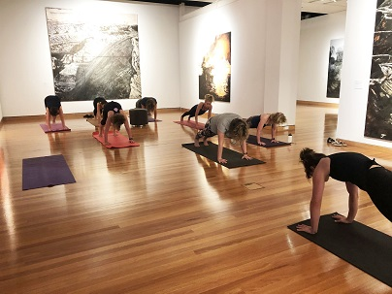
Staff participating in a yoga workshop in CMAG gallery space
- Volunteers at Lanyon, Calthorpes’ House and Mugga-Mugga attended for a total of 761 hours in 2019–20. The CFC provided volunteers with two visitor experience workshops, a thank you morning tea, an International Women’s Day morning tea, and a Christmas brunch.
- The CFC’s three advisory committees operated throughout the year and attended a range of meetings and workshops. All committee members provide their time on a voluntary basis. The first advisory committee meeting of 2019–20 was held as a plenary strategic planning workshop for all three committees on 14 October 2019. The workshop included a presentation by the CEO.
- The three committees met for individual sessions on the following dates : CMAG Advisory Committee on 29 June 2020; Canberra Theatre Centre Advisory Committee, on 9 October 2019 and 12 May 2020; and ACT Historic Places Advisory Committee on 25 June 2020.
- Members of CFC’s three advisory committee all agreed to continue their membership through to 30 June 2021 following a renewal process undertaken in early 2020.

Finances – Long-term financial sustainability
Strategies to achieve this :
- Maintain high standards of financial management and reporting.
- Maximise both government and own-sourced income, to ensure financial sustainability and support future growth.
- Ensure all our customers – both internal and external – are paid accurately and promptly.
Key outcomes in 2019–20 against the above strategies
- In 2019–20 the CFC maintained high standards of financial management and reporting.
- The audit of the CFC’s 2019–20 Financial Statements by the ACT Auditor-General resulted in an unmodified audit and no new audit findings.
- For 2019–20, the CFC achieved own sourced revenue of 49.0% compared with a target of 50.7%, the below-target figure relating primarily to the loss of theatre revenues due to the COVID-19 situation.
- The CFC achieved a cost to government per visitor outcome of $31.40 compared with a target of $23.03. The worse than target figure related mainly to lower than expected number of visitors/patrons due to the closure of CFC sites for approximately a quarter of the reporting period, to comply with COVID-19 restrictions. The bushfire threats and smoke haze situation in the 2019–20 summer also reduced visitor numbers.
- The CFC’s 2019–20 internal budget included strategies to address salary and CPI increases. Close monitoring of the CFC’s internal budget took place through the work of the Audit Committee, with a formal mid-year review process undertaken in early 2020, and particular oversight of the impact of the COVID-19 situation on the organisation’s finances in the final quarter of the year.
- The Corporate Finance area continued to meet deadlines for payroll, theatre show acquittals, accounts payments and the collection of receivables.
- Due to the COVID-19 situation having a major impact on theatre revenues, the CFC was not able to make an addition to the Theatre Reserve at the end of 2019–20.
- During the year, the Board oversaw implementation of the CFC’s fundraising efforts. The Board discussed and agreed on the CFC’s overall approach to fundraising at the October 2019 CFC Board meeting, and approved updated Ethical Sponsorship Guidelines at the December 2019 CFC Board meeting.

Assets – Support for delivering high quality cultural experiences
Strategies to achieve this :
- Maintain high standards of asset management.
- Achieve high standards of disability access.
- Ensure IT systems deliver business outcomes.
- Review and improve administrative, financial and customer service systems.
Key outcomes in 2019–20 against the above strategies
- High quality asset management continued to be a key priority for the CFC during 2019–20, in view of its responsibility for major cultural sites.
- Work continued on facilitating access to the CFC’s sites for those with special needs; for example, through use of the electric people mover at Lanyon to assist people with limited mobility to move around the site, and upgrades to bathroom facilities at the Canberra Theatre Centre, which provided an ambulatory cubicle in all toilet blocks.
- Cyclical maintenance needs were addressed in assessing priorities for the 2019–20 Better Infrastructure Fund (capital upgrade) program.
- During the year, IT assets continued to be monitored for best cost effectiveness use.
- The consultancy firm Risk Logic provided Crisis Management testing and COVID-19 Pandemic Planning training for senior managers and key staff in March 2020, and the CEO, CFO and Acting Director CMAG attended a COVID-19 Whole of Government Planning Workshop.
- The Records Management Plan was implemented during the year, with staff training, continual rollout of the Electronic Records Management System and ensuring record disposals schedules were actioned. All staff have been advised of the Records Management Program and their responsibilities to keep accurate records. Staff members have been designated as the CFC’s records managers, to assist staff and ensure compliance with records management procedures.
- A staff member represents the CFC in the Records and Information Management Community of Practice meetings facilitated by the Territory Records Office and the Digital Records Capability Working Group meetings facilitated by Records Services.
- The CFC’s 2019–22 Resource Management Plan continued to provide the framework for the CFC’s sustainability and energy efficiency practices.

CANBERRA THEATRE CENTRE
AT A GLANCE
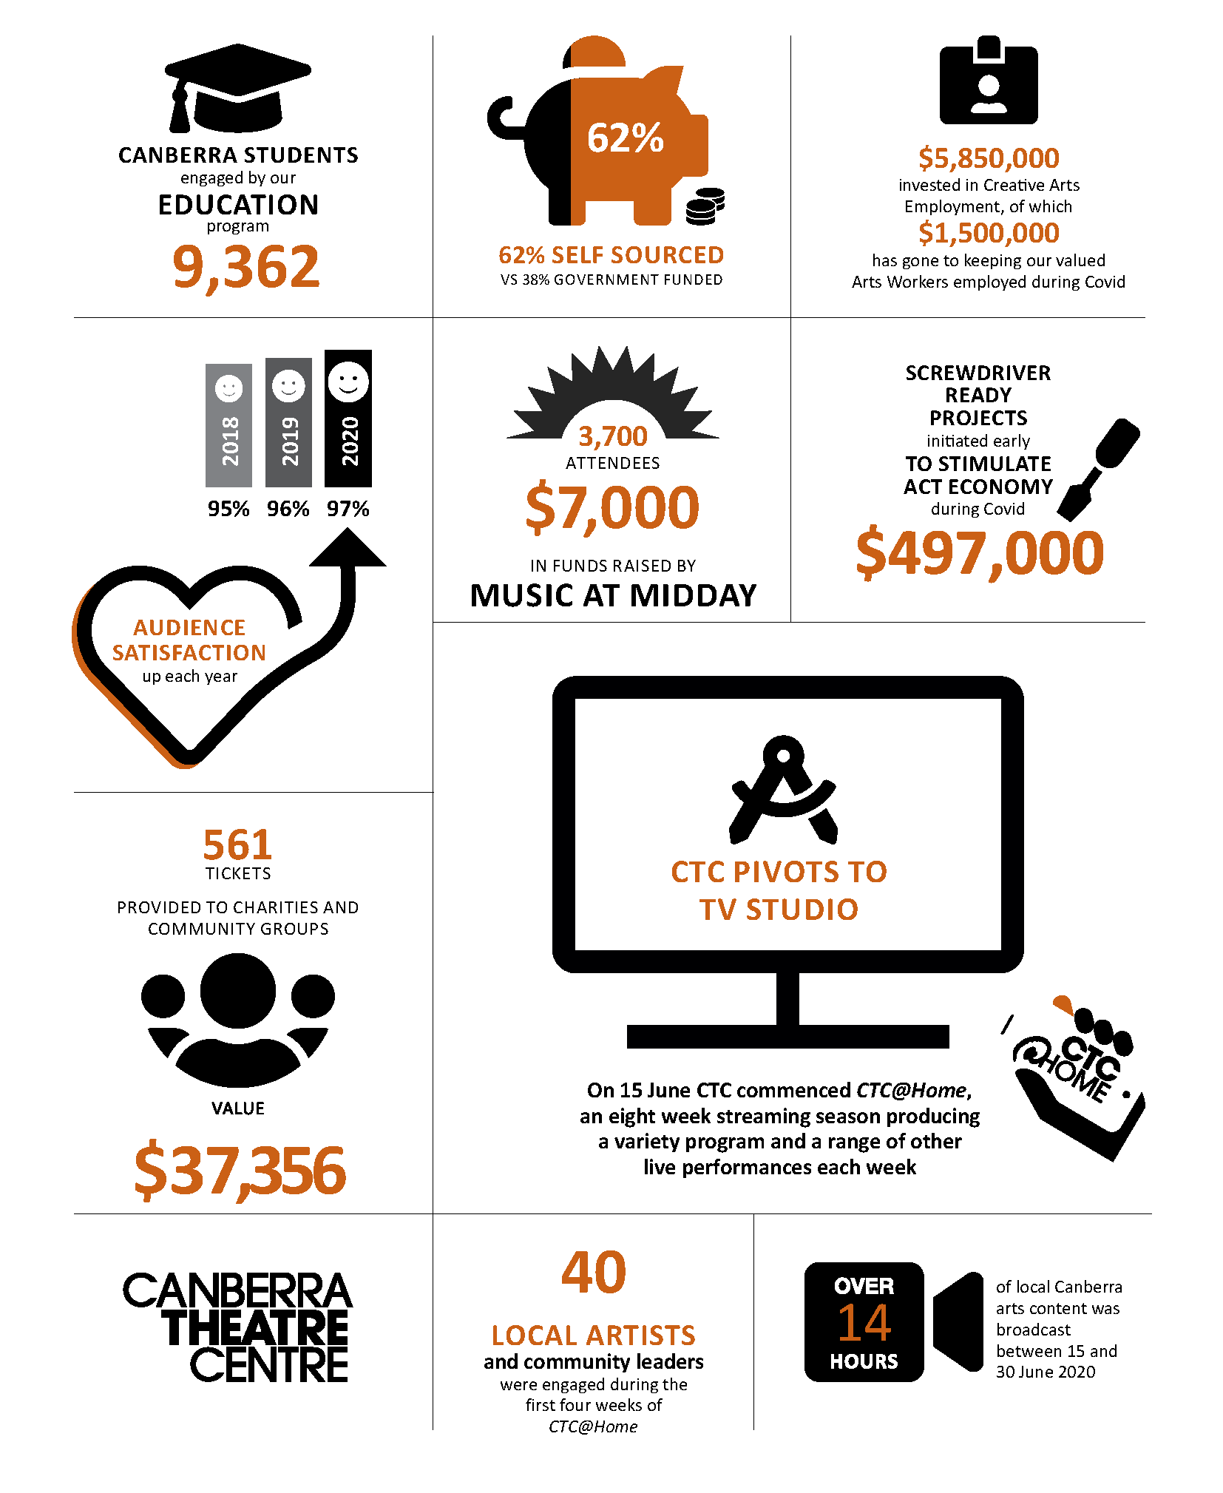

B.2.2 CANBERRA THEATRE CENTRE
What we are : the Canberra region’s main theatre centre, incorporating the Canberra Theatre, The Playhouse and the Courtyard Studio
What we do : we connect people with theatre experiences of national and international quality
Our vision : to be a leading theatre centre in Australasia and Asia
Customers – Audiences that are growing, diverse, engaged and entertained
Strategies to achieve this :
- Ensure our customers are the focus of all our activities.
- Provide public programs to enhance the onstage experience.
- Target initiatives to address special needs in the community.
- Develop young patrons, to ensure a future audience.
- Increase audiences, including from the region.
Key outcomes in 2019–20 against the above strategies
- During 2019–20, the Canberra Theatre Centre (the Centre) continued to focus on providing a high-quality experience for its patrons. A 97% approval rate was recorded from post-performance surveys conducted with patrons attending 81 productions throughout the year. Patrons were offered the opportunity to win tickets in exchange for completing post-performance surveys, resulting in an increased volume of participants, which allowed the Centre to better track economic impact and patron experience.
- With the closure of the Centre from March 2020 because of COVID-19 restrictions, the Centre’s focus shifted to clear communications with patrons about changes to events and to the venue. Patron feedback was monitored and collated to ensure timely and accurate responses to queries. The quality of communications resulted in positive feedback via Facebook and email. The Centre also received over 1,200 responses to a survey sent out to understand how subscribers and other past ticket buyers felt about returning to the Centre after the lifting of COVID-19 restrictions.
- Many value-adding activities were presented by the Centre during the year to enhance the overall patron experience. These included pre-show In Conversations, post-show question and answer sessions, foyer activations and a special foyer exhibition delivered in collaboration with the Museum of Australian Democracy, to complement the Canberra season of The Wharf Revue.
- The Centre continued its commitment to inclusivity in 2019–20, by ongoing implementation of its Access Action Plan. Patrons with special needs were assisted at every performance through access services, including the National Companion Card, the foyer audio loop, and the provision of wheelchair accessible seating and seating for those with limited mobility.
- In addition to these services, captioned and audio described performances, and tactile tours were offered for six productions during the year. The Centre also completed its upgrade of all public toilet facilities to include ambulatory cubicles.
- The Centre’s Social Capital program provided 561 tickets to the value of $37,356 to charities and community organisations between July 2019 and March 2020.
- The Centre delivered eight RMC Band Music@Midday concerts between July 2019 and February 2020. These concerts were attended by more than 3,700 patrons and raised over $7,000 for the following charities : Marymead, ACT War Widows Guild, Make A Wish Australia and Pegasus Riding for the Disabled. Due to COVID-19 restrictions, the Music@Midday concerts for April and June 2020 were postponed. The nominated charities for these months will be provided with alternative dates.

Programming – A diverse, high quality, entertaining and distinctive program
Strategies to achieve this :
- Program high quality, innovative shows that engage and entertain, and which include international companies and performers, digital programs, and connections to the Asian market.
- Ensure the range of genres presented at the Centre is appropriate for the venues, the marketplace and the supply of product.
- Provide culturally diverse shows as a part of regular programming, including shows featuring Indigenous cultures.
- Program to complement existing festivals and foster new festivals.
- Develop and extend programming for new audiences, with a particular focus on young people.
- Support local performing artists.
- Support producers that take the financial risk at the Centre.
- Attract large-scale shows to Canberra on a regular basis, including opportunities for exclusive Canberra seasons.
Key outcomes in 2019–20 against the above strategies
- During 2019–20, the Centre continued to program a broad selection of works both inside and outside its subscription seasons, showcasing the diversity and range of contemporary Australian arts practice.
- The 2019 subscription season brought a range of art forms to Canberra audiences, including contemporary dance, drama, musicals, comedies, political satire, adaptations of classic movies, and works that showcased Australian First Nations stories and culture. It included seasons from Bangarra Dance Theatre, State Theatre Company of South Australia, Sydney Theatre Company and Bell Shakespeare as well as a large scale adaptation of Shakespeare in Love from the Melbourne Theatre Company.
- 22 performances of Opera Australia and GWB Entertainment’s West Side Story were successfully presented at the Centre in October 2019 to more than 20,000 attendees, with over a quarter of these being visitors to Canberra.
- The Centre also presented The Irresistible in 2019, bringing a nationally recognised independent work from two leading Western Australian theatre companies to Canberra audiences.
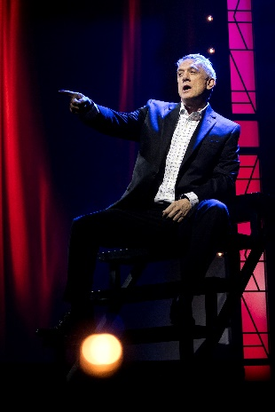  The Wharf Revue 2019,  credit Brett Boardman | 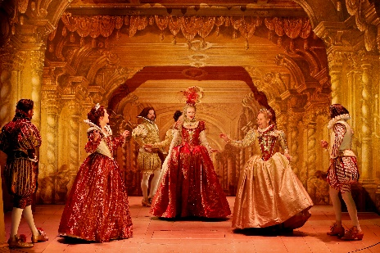  Shakespeare in Love, credit Jeff Busby |   The 39 Steps, credit Shane Reid
- In December 2019, the Centre and The Works Entertainment partnered to present the family friendly Cirque Stratosphere, bringing world-class international entertainment to an engaged audience of adults and children..
- The 2019 Collected Works season sold more than 30,000 tickets.
- The 2020 Collected Works season opened in February 2020 with Monty Python’s SPAMALOT by One Eyed Man Productions and was followed by Griffin Theatre Company’s Family Values. Four further season productions scheduled before 30 June 2020 were cancelled or rescheduled due to COVID-19 restrictions.
- As at 30 June 2020, the COVID-impacted 2020 Collected Works season achieved more than 12,500 ticket sales. In aggregate the Centre sold 167,895 tickets in the 2019–2020 year to a total of 127 productions, concerts and events.
- With the closure of the Centre from March 2020 because of COVID-19 restrictions, the Centre’s staff worked to develop new strategies to engage with audiences in a virtual format.
- The Centre curated a list of Australian and international theatrical streaming options which were posted on the venue’s website to encourage a continued connection to the performing arts. In the first two weeks the page was live, it reached 1,600 unique visitors.
- The Centre launched its eight-week digital season of free live streamed performances CTC@Home in early June 2020, with funding support from the ACT Government. The season delivered to virtual audiences a variety of productions including family content, literary readings, music and drama, all featuring professional Canberra artists, speakers and personalities. Approximately 14 hours content were livestreamed in June 2020.
- The program positively increased key digital marketing metrics including engagement, likes, shares and video views across the Centre’s website and social channels. In total, nearly 600 hours of CTC@Home were viewed directly from the Centre’s Facebook page to 30 June 2020.
- The Centre also worked closely with its presenters during the COVID-19 closure period, to ensure productions could be rescheduled or cancelled with the least financial effect. Staff engaged in ongoing discussions with venues around Australia to create a roadmap to reopening venues to live audiences, recognising the far-reaching impacts of COVID-19 on national and international touring.
- In other programming-related activities for the year, Programming and Marketing staff met with VisitCanberra to advise on upcoming major tours that have the potential to benefit Canberra’s visitor economy, and continued to network with major presenters and producers by phone, face-to-face, and by appearing at industry conferences and events to discuss potential hires and investments.
- During the year, the Centre continued to invest in the development of new work to increase the supply of product, and to support the local theatre industry. For example, the Centre :
- continued to support local companies and producers to present work at the venue, contributing over $42,000 in sponsorship and subsidies to local hirers;
- supported Canberra Youth Theatre, Christopher Samuel Carroll, Chris Endrey, and Everyman Theatre through the Centre’s new Local Arts Engagement Policy;
- created opportunities for local theatre makers to observe rehearsals and productions; and
- provided paid performance opportunities to over 40 local artists, through the Centre’s CTC@Home livestream program.

Business – Venues, systems and people that support high quality live performances
Strategies to achieve this :
- Maintain the Centre’s venues and facilities to industry standards through the Asset Management Plan.
- Ensure all business areas are resourced, including staffing, for current and future levels of activity.
- Ensure marketing operations maximise ticket sales and support brand identity.
- Ensure Canberra Ticketing maximises ticket sales and seeks entrepreneurial ticketing opportunities.
- Ensure front-of-house operations create a high quality customer experience and maximise financial returns.
- Ensure technical operations support high quality theatre experiences.
- Increase Theatre Reserve through the Centre’s commercial activities.
- Use business metrics as a basis for future growth.
Key outcomes in 2019–20 against the above strategies
- During the year the Centre continued a program of upgrades to retain its functionality and status as a professional performing arts centre. These included continuing the refurbishment of public bathrooms; installing safe material handling anchor points; upgrading computerised controls for the Heating Ventilation and Air Condition systems; and commencing an upgrade of the Centre’s security and access control systems.
- Additional funding made available under the COVID-19 “screwdriver-ready” stimulus package was used for the refurbishment of remaining public bathrooms, and Stage 2 of a security upgrade.
- A number of improvements were made to the Centre’s systems and operating arrangements during the year. For example, the VenueOps event management software was implemented, and work commenced on migrating the email marketing system to a product that includes a dashboard to use data more efficiently. The website was migrated to a new server that reduced the risk of website overload and increased security. Arrangements were also put in place to ensure the timeliness and accuracy of the large volumes of email cancellation messages and website updates resulting from rescheduling and cancellations of performances due to COVID-19.
- During the COVID-19 closure period, a major focus for the Centre was on putting arrangements in place to allow certain operations to be undertake remotely. In particular, following comprehensive planning and testing of ticketing operations, Box Office staff were able to work from home from early April 2020. This included the installation of new telephone equipment enabling staff to access the Canberra Ticketing call centre offsite.
- Other staff members were able take home essential equipment to enable effective and safe work from home environments. Digital solutions such as Microsoft Teams and WebEx were implemented across all areas to support staff members working from home.
- Regular casual staff continued to be engaged and provided with work during the COVID-19 closure at the Centre. The work included : site-specific tasks, such as work on asset upgrades; work that could be undertaken remotely; and, in some cases, work placements either elsewhere in the CFC or in other ACT Government agencies, such as Access Canberra and ACT Health. Technical staff completed a range of repair and maintenance projects, that resulted in major improvements across the Centre’s facilities including a full refresh of Canberra Theatre and Playhouse dressing rooms and back of house areas, and the repair of The Playhouse pit.
- As a result of the COVID-19 situation and consequent impact on theatre revenues, no increase was made to the Theatre Reserve at the end of 2019–20. The Reserve, which currently stands at $1.2m, will be critical to support the rebuilding of theatre activity, as part of the ACT’s creative recovery from COVID-19.
Leadership – An integral part of the cultural life of the Canberra region and beyond
Strategies to achieve this :
- Maintain a distinctive, clear and consistent brand for the Centre.
- Provide leadership in theatre education, including programs that link to the Australian curriculum, and vocational education and training (VET) programs in technical skills.
- Research and promote the importance of the Centre as a key driver of business activity in the city centre and a key contributor to the economy of the Canberra region.
- Develop a major new theatre appropriate for the nation’s capital.
Key outcomes in 2019–20 against the above strategies
- High-quality, consistent venue branding continued to be a priority during the year.
- The Centre’s marketing team worked closely with GWB Entertainment and Opera Australia to roll out a large-scale marketing campaign for West Side Story, which included a major regional marketing campaign.
- The Centre hosted the international premiere of The Works Entertainment’s new production Cirque Stratosphere. Marketing content was shared with Sydney Opera House and the Arts Centre Melbourne to promote their seasons.
- A final report measuring the Centre’s economic impact for 2019–20 will be prepared after 30 June 2020. This report will also assist in identifying the financial impact on the Centre’s operations of COVID-19.
- The Centre’s profile was raised during the year by the participation of senior managers in major industry organisations, such as Live Performance Australia, OZPAC, the Australian Performing Arts Centres Association, and the Association of Asia Pacific Performing Arts Centres. Programming staff attended industry conferences at The Australian Performing Arts Market, AsiaTOPA, Arts On Tour Salon, and The Performing Arts Exchange.
- The contribution of former Director of the Centre, Bruce Carmichael (a member of staff of the Centre from 1985 and Director from 2007 to 2019), received national recognition from the performing arts industry on the occasion of his retirement during the year, including by the Live Performance Australia Executive Council and the Board of the Performing Arts Centres Australia.
- The Centre’s major commitment to Discovery and Learning activities during 2019–20 included :
- hosting 21 work experience students in 2019;
- hosting two students from the Faculty of Education at the University of Canberra, to work on preparing material for upcoming productions;
- hosting a student through the Indigenous mentoring and internship program CareerTrackers – the student produced a piece on the Ngunnawal community in the Canberra region;
- working with the Canberra Institute of Technology to continue offering a Certificate III in Live Production and Services, with 13 enrolments in 2020;
- training three further teachers in the School Drama Program, who will join the Centre’s other Teaching Artists to continue to roll out school drama to schools, and arranging mentoring for a further four new teachers;
- hosting 75 teachers at a STEM theatre workshop, as part of an All Colleges Day that was open to all teachers within the ACT Education Directorate college system;
- working with nine schools and a total of 145 students for the Come Alive Festival, which was presented in the Courtyard Studio;
- presenting the 2020 ACTUP! Student Fringe Festival on the Centre’s website, rather than physically, due to COVID-19 restrictions, with 213 students participating;
- providing pre and post-show activities for the family shows Possum Magic and Spot, and liaising with ACT Libraries to provide library activities for Possum Magic at Gungahlin and Civic libraries and for Spot at Erindale and Dickson libraries; and
- providing a range of other Discovery and Learning activities, including master classes, workshops, and venue tours.
- During the year, staff from the Centre played a key role in supporting the development of the business case for a major new theatre for Canberra. This included : attending meetings of the project control group for the business case; hosting venue tours for consultants working on the business case; and supplying a range of information to support the project’s financial analysis.

CMAG at a glance
QUALITY OF SERVICE  89%  approval rating |  |   2,151  OBJECTS ON DISPLAY | PROGRAMS  104  learning programs delivered for CMAG and the Nolan Collection  21 EXHIBITIONS  50 PRETZELS at the exhibition opening Building a Life : The Jennings Germans story  2,953 photos from the Canberra Photography Collection catalogued    VENUE HIRE  2,030 people attended private events at CMAG
  1,074 visitors to the National Multicultural Festival Family Space at CMAG | VISITORS  51,986  252 OBJECTS  added to the CMAG Collection
17 SCHOOLS 
accessed CMAG’s programs – many multiple times
130 running metres of new shelving in the Collection store

B.2.3 CANBERRA MUSEUM AND GALLERY
What we are : A museum and gallery dedicated to the visual arts and social history of the Canberra region
What we do : We connect people with the Canberra region’s rich and diverse stories, sense of place, and contemporary identity
Our vision : To be a leading regional cultural venue in Australia and beyond
Customers – Audiences that are growing, diverse and engaged
Strategies to achieve this:
- Ensure our customers are the focus of all our activities.
- Target initiatives to address special needs and interests in the community, extend the demographic of our customers, and reach out to those who do not currently access our services.
- Review visitor surveys and data to enable greater responsiveness in services and programming.
Key outcomes in 2019–20 against the above strategies
- Throughout the year, CMAG focused on providing high-quality experiences for its customers, resulting in an 89% approval rate, based on visitor feedback.
- Comments from visitors were used to improve various aspects of CMAG’s operations; for example, adjustments were made to summer opening hours for CMAG and the CMAG Café. The exhibition Building a Life : The Jennings Germans story was extended for a longer period, in response to social media feedback.
- During the year, in addition to regular visitor surveying, CMAG conducted a survey specifically focused on family programming. Key recommendations, taken into account in planning future programs, included introducing a CMAG on Saturday program, with smaller class sizes, a slightly longer session time, and a wider age range to allow whole families to attend.
- CMAG continued to engage actively in tourism sector initiatives. VisitCanberra staff were invited to familiarisation sessions in association with the major exhibitions Hi-Vis Futures and The Nolan Collection, and CMAG’s Marketing Coordinator attended National Capital Attractions Association meetings during the year.
- Access and Learning staff created a range of Floriade themed children’s activities in Spring 2019, and hosted Floyd the Pink Floriade Gnome in the CMAG Courtyard.
- Work continued during the year on planning improvements to CMAG’s facilities, including the refurbishment of the public toilets and installation of automatic gallery doors.
- CMAG continued to implement its digital strategy, as follows.
- A quiz, #NolanCrush, was developed for The Nolan Collection.
- A new exhibition template was developed for the CMAG website to extend access to exhibitions and in some cases replace a physical catalogue. The first published site focused on the exhibition Building a Life : The Jennings Germans story.
- The Seeing Canberra online learning program was developed, providing resources to students and teachers during the period of CMAG’s closure due to COVID-19 restrictions. This program was one of a number of digital projects developed to maintain and enhance public engagement during CMAG’s closure, including the development of a social media publications calendar.

Programming – Exhibitions and programs that reflect Canberra’s unique identity
Strategies to achieve this:
- Program high quality, innovative exhibitions, education and community programs and other activities, using digital applications to enhance programs and systems.
- Ensure cultural diversity is part of regular programming, including exhibitions and programs featuring Indigenous cultures.
- Develop and extend programming for young audiences.
- Provide programs that complement, but make a point of difference with, the national cultural institutions, highlighting CMAG’s unique focus on the Canberra region including by featuring regional artists.
Key outcomes in 2019–20 against the above strategies
- CMAG presented an exhibition program in 2019-20 that reflected the diverse interests of the Canberra community.
- Djinjama : Defying the grid featured a work developed in association with the Design Canberra Festival by Danièle Hromek, Robyn Hromek and Siân Hromek, Budawang women of the Yuin nation.
- VOID, a travelling exhibition developed by Wiradjuri curator Emily McDaniel and toured by Museums and Galleries of NSW, explored the diverse ways contemporary Aboriginal artists from across the country visually articulate the unknown as space, time and landscape.
- Seeing Canberra, a visual arts focused exhibition drawn from the CMAG collection, explored different ways of viewing Canberra and included works by Aboriginal artists. The exhibition included new acquisitions by Brenda Croft and Dean Cross.
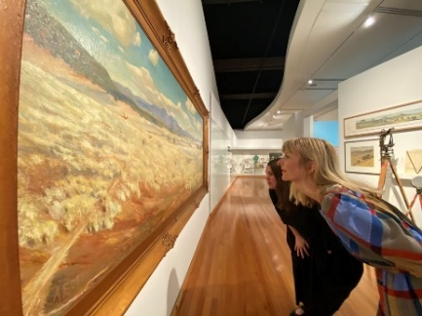 | 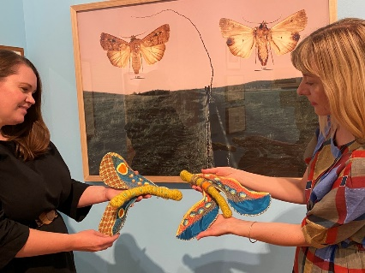
CMAG staff Tiffany Cole and Sarah Hutchinson viewing Early Canberra by A E Macdonald and work by Dean Cross and Dimity Kidston in association with CMAG exhibition Seeing Canberra

- Building a Life : The Jennings Germans story explored the history of the German group of migrants who came to Canberra in the 1950s to work for the construction company AV Jennings. Many of these men stayed in the region and contributed to the development of a strong German community in Canberra. This exhibition involved collaborations with the Canberra German community, the AV Jennings company, the Harmonie German Club and the Germany Embassy, and included CMAG’s first online exhibition.

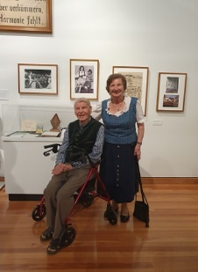 | 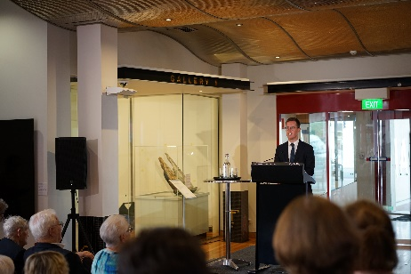 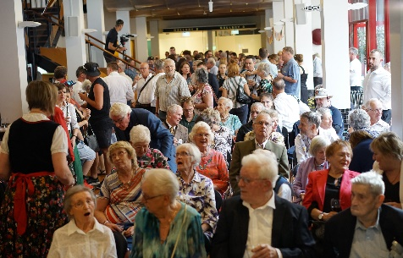  Minister Steel opened CMAG exhibition Building a Life : The Jennings Germans story,  credit Robert Losik (above pictures)  Edgar Weiss – an original Jennings German and his wife Lotte enjoy the CMAG exhibition Building a Life : The Jennings Germans story, credit Sharon Bulkeley (opposite picture)
- Activism : Forces for change in Canberra explored the history of activism in the ACT. Puppeteer Matthew Armstrong wrote a blog in association with the exhibition, An independent Street Puppet Cartoonist, and an Activism Trail for promotion on the Culture Loop bus was developed in partnership with the Museum of Australian Democracy.
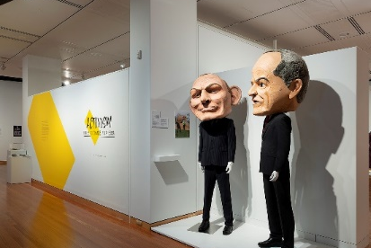
CMAG exhibition Activism : forces for change in Canberra

- New interpretation and branding for The Nolan Collection was developed for the installation of these works in the newly refurbished Gallery 5. This gallery space includes a wall for changing displays; for example, the display, Threads and Connections, featured works from The Nolan Collection which are on public display less often than the main Foundation Collection.
- During the year, CMAG presented a comprehensive range of community and education programs and other activities, often in association with specific exhibitions or special events.
- CMAG’s NAIDOC week event for 2019 was a talk with Ngambri-Ngunnawal elder Paul House and Tom Rowney about their collaboration to create the glass yidaki recently acquired by CMAG, and an opportunity to hear Paul House play the yidaki in the gallery.
- The exhibition Activism : Forces for change in Canberra included stories of Aboriginal activism in Canberra. To provide further insight into the exhibition, CMAG hosted a talk with Aboriginal activists, Michael Anderson of the Euahalayi Nation and Wiradjuri man Paul Coe about their experiences in association with the Aboriginal Tent Embassy. Community programs for this exhibition also involved a partnership with ANU Heritage to deliver a walk themed around activism on the ANU campus, and a floor talk on environmental activism in which a Year 9 Canberra student was invited to speak about their activism alongside a veteran activist.
- Drop-in activities during the Spring School Holidays were offered in conjunction with Floriade, including a visit from Floyd the Pink Floriade Gnome.
- In association with the 2019 Design Festival, CMAG’s Senior Visual Arts Curator Virginia Rigney and Architect and Heritage Consultant David Hobbes discussed Civic Square and the Utopian City Ideal.
- A Youth Climate Forum in association with exhibition Hi-Vis Futures was held at CMAG with experts including Kate Auty, ACT Commissioner for Sustainability and Environment; Professor Will Steffen, Emeritus Professor Fenner School of Environment and Society; and PhD Candidate Aaron Tang, Climate Change Institute and Fenner School of Environment and Society. A blog reflecting on this event and connecting with the participants was posted on the CMAG website.
- An Artist Talk and Yarning Circle with Danièle Hromek was hosted in connection with her exhibition Djinjama : Defying the grid.
- To mark the opening of exhibition Seeing Canberra, CMAG hosted a conversation with Dawn Waterhouse on Canberra Day. The focus of the conversation was reflections of life in Canberra from 1928 to 1951. The event was recorded and shared online.

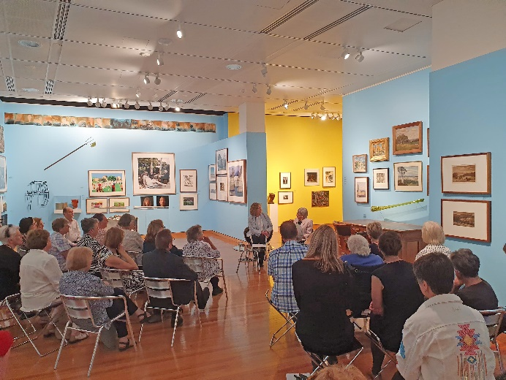
Celebrating Canberra Day at CMAG with Dawn Waterhouse (one of Canberra’s longest residents) in conversation with Senior Curator Virginia Rigney reflecting on the exhibition Seeing Canberra.
- CMAG presented a range of learning and community programs relating to The Nolan Collection.
- The Young Nolan Project was launched in August 2019. Under this new initiative, CMAG invites an individual school to work on an extended program to explore the work of Sidney Nolan and present the resulting art to the public. Ainslie School was the first school to participate in the project, and Rosary Primary School has been selected to participate in the program in 2020–21.
- CMAG hosted several talks and events following the reopening of The Nolan Collection in Gallery 5.
  - CMAG’s Senior Visual Arts Curator Virginia Rigney and Mark Fraser, Curator for the estate of Lady Nolan, widow of Sir Sidney Nolan, discussed the legacy of the works on display including the recent CMAG acquisition, Rite of Spring, and the continuing interest in Nolan’s work.
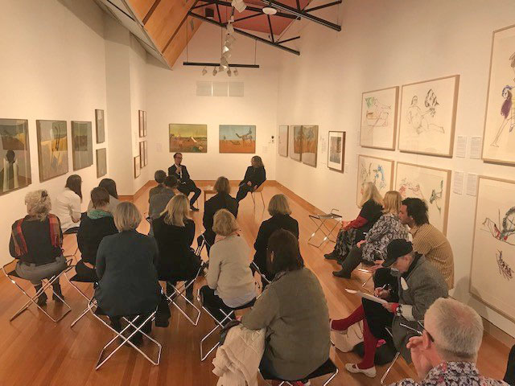
The Nolan Collection floor talk with guest speaker Mark Fraser
  - Dr Paula Dredge discussed her research about the paint Sir Sidney Nolan used.
  - A Mandarin language tour was conducted of the works on display.
  - Research undertaken by Dr Antonino Nielfi, considering the influence of Paul Cezanne and Arthur Rimbaud on Nolan, was presented in a talk given in the Gallery.
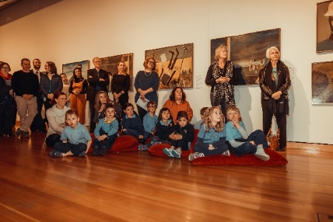 |  | 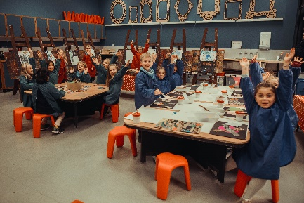
Ainslie School students in attendance at the launch of The Nolan Collection contributors to the Young Nolan Project | Year 1 students from Ainslie School participating in the Young Nolan Project at CMAG in July 2019, credit Fahad Akhand

Stewardship – Venues and collections that allow us to tell the many stories of Canberra
Strategies to achieve this:
- Maintain CMAG’s venues and facilities to industry standards.
- Develop, conserve and research CMAG’s integrated visual arts and social history collection.
- Digitise CMAG’s collection.
- Care for the Nolan Collection and enhance its presentation.
Key outcomes in 2019–20 against the above strategies
- During the year, CMAG completed a major upgrade of storage and display areas funded through the 2018–19 ACT Budget. These works included refurbishments to upgrade temperature and humidity controls in Gallery 5; extending the Collection Store area into Gallery 1; and installing additional painting racks in the original Collection Store. Following the completion of the works, the entire CMAG Collection was safely moved back into the extended Collection Store area. An audit in June 2020 found that all works were in their correct locations as listed on the Collection Management System.
- A review of CMAG’s Collection Development Strategy, Collections Policy and Collection Management Procedures Manual was progressed, including through consultation with the CMAG Advisory Committee.
- A photography project on the Nolan Foundation Collection works was completed in June 2020. The reverse sides of these works were photographed, revealing details of the history and provenance of the works. These photographs will form the basis of research for a proposed exhibition, Back Story, in which the photographs of the backs will be featured next to the paintings themselves.
- CMAG’s Senior Visual Arts Curator Virginia Rigney worked with the Heide Museum of Modern Art to facilitate a loan for an upcoming major exhibition about Nolan. CMAG will also borrow works from the Heide Museum for a forthcoming exhibition focused on Nolan and his connection to St Kilda.
- A work from the CMAG Collection by Ham Darroch was lent for a solo exhibition of the artist’s work at the Drill Hall Gallery.
- Digitisation continued of the CMAG collection, including digitisation of 2,953 photographs from the Canberra Press Photography Collection. CMAG invested in a Digital Asset Management System to assist in the storage of digitised photographs.

Leadership – An integral part of the cultural life of the Canberra region and beyond
Strategies to achieve this:
- Enhance and extend CMAG’s presence and profile in North Building, to provide greater visibility on Civic Square and London Circuit; more spaces to deliver a greater range of exhibitions and activities; a dedicated family and children’s space; a retail space; a larger café facility; improved venue hire areas, including a large foyer space and a rooftop terrace; and a city centre hub for visitor information.
- Promote the role of CMAG as a major visitor attraction, information hub and happening place in the city centre of Canberra, and as a venue of regional importance.
- Pursue productive partnerships with other cultural organisations, Canberra region artists, and the wider community in developing and delivering our programs.
Key outcomes in 2019–20 against the above strategies
- CMAG’s growing status as a leading regional museum and gallery was again demonstrated by a range of activities during the year.
- Assistant Director Exhibitions and Collections, Rowan Henderson, is President of the ACT Australian Museums and Galleries Association (AMaGA) branch and led the active role CMAG took in the planning of the national conference of AMaGA in Canberra, which will now be held in 2021 due to the COVID-19 situation. A MuseumHack tour of The Nolan Collection gallery will be made available to delegates at the conference.
- CMAG staff presented a number of speeches and seminars for the museums sector. For example, CMAG’s Senior Curator of Visual Arts Virginia Rigney spoke at the Heritage of the Air Conference in November 2019 and Assistant Director, Access and Learning Samantha Rutter delivered a national online webinar on museum education for AMaGA, and spoke about CMAG’s approach to learning programming.
- CMAG continued to maintain existing, and develop new, partnerships with other organisations and institutions.
- CMAG partnered with Civic Library and ACT Playgroups to offer a National Multicultural Festival Family Space during the 2020 National Multicultural Festival, with over 1,000 visitors participating in activities over the course of the day.
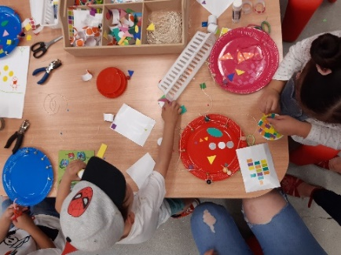  CMAG hosted the Make a musical instrument program during the National Multicultural Festival | 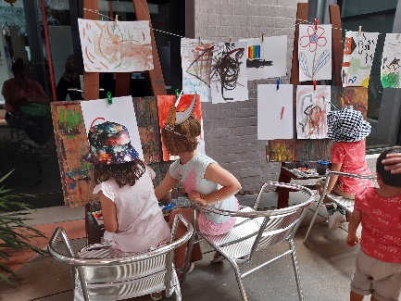  CMAG hosted a Courtyard Watercolour painting program during the National Multicultural Festival

- The major CMAG exhibition, Activism : Forces for change in Canberra, involved partnering with multiple organisations to secure loans, including the National Library of Australia, the National Museum of Australia, the National Gallery of Australia, the Jessie Street National Women’s Library, AIATSIS and the ACT Heritage Library.
- An Activism Trail for promotion on the Culture Loop bus was developed in partnership with the Museum of Australian Democracy.
- A range of improvements were carried out to CMAG’s facilities during the year.
- Gallery 4 was renamed ‘CMAG on the Square’. The branding and signage were launched in conjunction with the exhibition Djinjama : Defying the grid.
- During CMAG’s closure due to COVID-19, the opportunity was taken to refurbish and polish the wooden floor in the foyer and foyer stairs, and to repaint venue hire rooms and the foyer.
- Joinery in the Boardroom was refinished, and the Front of House team kitchen area was refurbished.
- The CMAG café continued to provide a welcoming addition to the visitor experience, with a number of improvements made during the year through additions to the menu, a new loyalty program and a change in suppliers. Plans to introduce a limited catering menu for CMAG venue hire clients will be progressed when COVID-19 restrictions are lifted to allow catering for large groups.

ACT HISTORIC PLACES AT A GLANCE
VISITORS  40,402  WEDDINGS AND EVENTS  6  weddings celebrated at Lanyon  BUILDINGS  Date on  Bell at Lanyon  1838  Number of air raid shelters  = 1 at Calthorpes’ House | GARDENS AND GROUNDS    913 trees assessed and surveyed    15,000  bulbs and annuals planted at Lanyon as part of  Floriade : Reimagined | PUBLIC PROGRAMS  163 learning and community programs    4 Beehives maintained by University of Canberra – each hive contains up to 10,000 bees and produces between 10–20 kilograms of honey
 | CONSERVATION AND HOUSEKEEPING    Over 340 collection items received specialist conservation cleaning  Over 50 items rehoused and stored within HP Collection Storage  Over 180 moth, rodent and mouse station checks made  Over 80 technician checks of pest activity monitors | VOLUNTEERS    Volunteers attended for 761  hours

B.2.4 ACT HISTORIC PLACES
What we are : three historic places that reflect different aspects of Canberra’s history: Lanyon Homestead, Calthorpes’ House and Mugga-Mugga
What we do : we connect people with Canberra’s rich and diverse stories and heritage
Our vision : to be leading historic places in Australia and beyond
Customers – Audiences that are growing, diverse and engaged
Strategies to achieve this:
- Ensure our customers are the focus of all our activities.
- Target initiatives to address special needs and interests in the community, extend the demographic of our customers, and reach out to those who do not currently access our services.
- Review visitor surveys and data to enable greater responsiveness in services and programming.
Key outcomes in 2019–20 against the above strategies
- Throughout the year, ACT Historic Places focused on providing high-quality experiences for its customers, resulting in an 93% approval rate.
- Customer evaluation surveys were undertaken after each program and event. 61% percent of attendees at public programs rated their experience as 5 out of 5 and the average approval rating for overall experience of Public Programs was 4.6 out of 5. 61% of teachers rated their experience of Learning Programs as 5 out of 5 and the remaining 39% gave an average rating of 4.8 out of 5.
- New surveys were launched in 2020, which included a targeted visitor survey, a learning program survey and a public program survey, with a view to better understanding audiences and their experiences. The surveys can be completed in two minutes on an iPad, and record and analyse more data categories than previously administered.
- 40,402 people visited ACT Historic Places (Lanyon, Mugga-Mugga and Calthorpes’ House) in 2019–20. This figure includes casual visitors, group bookings, education and public programs and venue hire.
- The new branding and imagery ACT Historic Places, Step into the Stories, was used for the website, seasonal calendar, print and digital marketing.
- During the COVID-19 closure period, new video content was developed for use on social media. This included blogs designed to replace cancelled public programs, children’s activities and short Object Stories by ACT Historic Places staff.
- ACT Historic Places’ digital strategy continued to be implemented, including the use of digital guides at each site. The ACT Historic Places website, Twitter, Facebook, Instagram, YouTube and Mailchimp were used to promote each property, events and public programs. The reach of these channels continued to grow, with significant increases in Facebook likes and in Instagram followers.
- ACT Historic Places volunteers attended for a total of 761 hours across a range of activities at each property including guiding, collection care and the training of new volunteers. During the year, a call for new volunteers attracted a good field of applicants.

Programming – Programs that explore Canberra’s history by interpreting each place
Strategies to achieve this :
- Program high quality, innovative education and community programs and other activities, using digital applications to enhance programs and systems.
- Ensure cultural diversity is part of regular programming, including exhibitions and programs featuring Indigenous cultures.
- Develop and extend programming for young audiences.
- Provide visitors with additional insights into the historic sites through permanent and temporary exhibitions.
Key outcomes in 2019–20 against the above strategies
- The programs offered by ACT Historic Places during 2019–20 provided a broad range of events and encounters that linked heritage with positive social, cultural, environmental and economic outcomes, including celebrating anniversaries, special events and festivals.
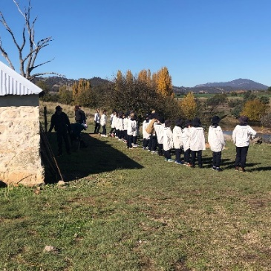  Learning Program Convicts at Lanyon Homestead credit, Jodie Cunningham | - While the number of learning programs provided during the year was impacted by bushfire threats, smoke haze and closures due to the COVID-19 situation, programs were still provided to 2,694 students and teachers from 34 schools.  - ACT Historic Places launched a trial program aimed at the ‘vacation care’ market in 2019. The feedback was positive and will continue to develop when COVID-19 restrictions ease.
- ACT Historic Places supported Dr Martyn Jolly to conduct research into the history of Calthorpes’ House to develop his public program Suburban Apparitions | Magic Lanterns at Calthorpes’ House. This involved several meetings with Dawn Waterhouse (nee Calthorpe), collecting oral histories and discussing ideas.
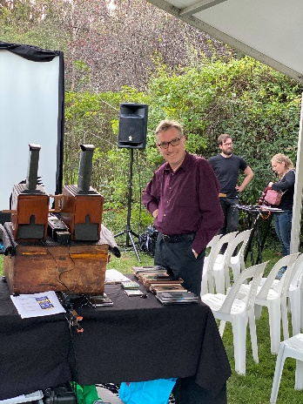  Suburban Apparitions | Magic Lanterns at Calthorpes’ House – Dr Martyn Jolly, credit Jodie Cunningham | 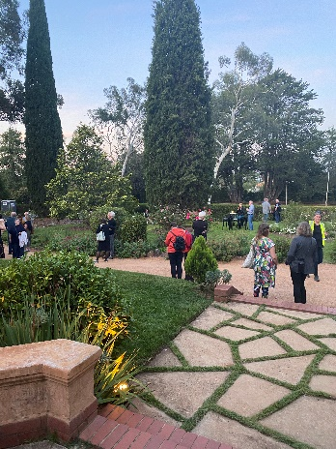  Suburban Apparitions | Magic Lanterns  at Calthorpes’ House,  credit Jodie Cunningham | 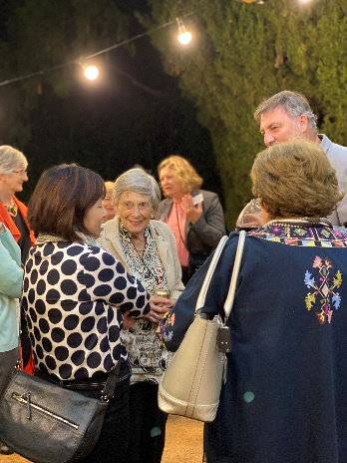  Suburban Apparitions | Magic Lanterns at Calthorpes’ House, Dr Anna Wong, Dawn Waterhouse and family,  credit Jodie Cunningham
- Lanyon was host to a series of events during the year including an Australia Day Picnic and Lanyon Christmas Carols and Picnic. In partnership with EventsACT, Lanyon hosted Floyd the Pink Floriade Gnome during Floriade 2019 and provided the supporting children’s holiday program Bugs and Butterflies.
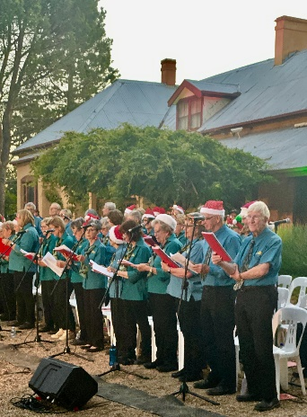  Lanyon Christmas Carols and Picnic – Sing Australia Choir,  credit Jodie Cunningham | 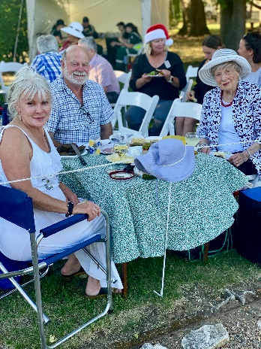  Lanyon Christmas Carols and Picnic – Dawn Waterhouse and Family,  credit Jodie Cunningham |  |   Christmas Tree at Lanyon,  credit Jodie Cunningham
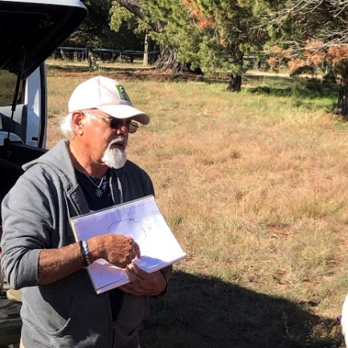  Canoe Tree Walk at Lanyon Homestead –  Wally Bell, credit Jodie Cunningham |  | 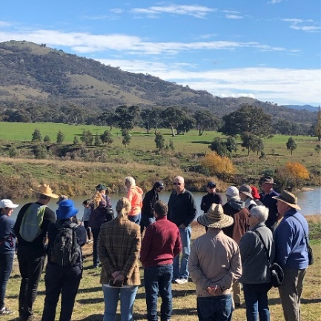  Canoe Tree Walk at Lanyon Homestead,  credit Jodie Cunningham
- Engagement with Indigenous communities continued to be a focus in 2019-20. One highlight was the hosting of an Indigenous Women’s Possum Skin Cloak Making Workshop for the Winnunga Nimmityah Aboriginal Health group at Lanyon, facilitated by Amanda Reynolds in collaboration with Dr Kirrily Jordon at the Australian National University.
- ACT Historic Places’ ongoing collaboration with Buru Ngunnawal Aboriginal Corporation continued to support the Canoe Tree Walk at Lanyon. Through the program Fireside Storytelling: Wiradjuri Echoes, Wiradjuri man, Duncan Smith OAM shared his Dreamtime stories and their symbols, and played the digeridoo around the fireside.
- Ngunnawal elder Wally Bell gave a Welcome to Country at the 2019 Lanyon Christmas carols and Picnic – the first time that a Welcome to Country was provided at this event.
- At Mugga-Mugga, a number of programs were provided to activate the site during opening house times. The Performance : A Mugga Ceildh was particularly successful, being fully subscribed and with the Irish Ambassador in attendance.
- Temporary exhibitions were presented to showcase different historical stories and collections, including the Wattle Day Display at Calthorpes’ House, and Christmas Decorations at Lanyon Homestead and Calthorpes’ House.
- Gardening, performance and craft workshops continued to be very popular, with the In the Garden series and Doing the Flowers at Lanyon program at Lanyon; Live History - Lanyon Escape Hunt : 1835 edition; and What’ll you Whittle school holiday program.
- ACT Historic Places partnered with University of Canberra, ACT Health, Tidbinbilla Nature Reserve and the National Arboretum to develop a pilot program for older adults to improve physical well-being through nature and heritage. The pilot program was a success and will be used as a basis to develop inter-generational programs to provide physical, social and mental well-being benefits through heritage and nature-based experiences.

Stewardship – Buildings, grounds and collections that are conserved and researched
Strategies to achieve this:
- Maintain, conserve and research the buildings, grounds and collections of the Historic Places, within the framework of the Conservation Management Plan for each site.
- Develop Lanyon’s collection of decorative and fine arts.
- Digitise the Historic Places collections.
- Position the heritage-listed gardens of the Historic Places as ‘green collections.’
Key outcomes in 2019–20 against the above strategies
- A range of activities was undertaken throughout the year in keeping with ACT Historic Places’ remit to conserve, manage, research and interpret the Historic Places.
- As part of the annual program, housekeeping, conservation treatment and preventive measures were implemented across all three sites to maintain and conserve the collections and interior fabrics.
- Further storage shelving and resources were installed to support efforts to consolidate and care for the Historic Places collection within the Lanyon Heritage Centre.
- Work progressed during the year on capital works projects funded through the 2019–20 ACT Budget, including on the documentation and design of a new water supply infrastructure system for Lanyon, and on the design of an upgrade of security at Lanyon, Calthorpes’ House and Mugga-Mugga.
- Under the ACT’s COVID-19 Economic Stimulus Package, ACT Historic Places received additional funds to support repair and upgrade works to two cottages at Lanyon.
- A centralised asset management system is being developed through the implementation and building of MEX Buildings Asset Management System.
- The “green collections” of the ACT Historic Places were a focus of attention in 2019–20.
- A Tree Condition Assessment and Database was completed for trees at Lanyon, Calthorpes’ House and Mugga-Mugga. This included recommended tree maintenance and removal based on the physical condition of the trees, and will guide future horticultural programs.
- Propagation of historic plants and trees at Lanyon continued, to ensure replacement of significant plantings and ensure the ongoing lineage of significant plantings where possible.
- The Kitchen Garden at Lanyon continued to be seasonally planted with heirloom and occasionally modern plants for educational purposes.
- A trial was implemented of interspersing native plants that display similar qualities to the exotic plants in the cut flower and shrubbery beds at Lanyon, in response to limited water capabilities and changing climate conditions.
- In recognition of the significant native grasslands at Mugga-Mugga, a Grasslands Management Plan was prepared to guide the conservation and management of the Environment Protection and Biodiversity Conservation listed native temperate grasslands.
- An environmental grant, secured in partnership with the Southern Catchment Group, will fund the construction of fencing at Mugga-Mugga. This will enable rotational grazing, to help repair the temperate grasslands.
- ACT Historic Places worked with ACT Wildlife to help treat mange-affected wombats at Lanyon. This includes the regular treatment application and camera monitoring of the many wombats on site.
- ACT Historic Places continued to take part in DisACT, an association providing support in Disaster preparedness for cultural institutions within the Canberra region.
- The ACT Historic Places Bushfire Action Plan was reviewed and updated, in view of longer bushfire seasons and higher frequency of extreme weather conditions. The Bushfire Action Plan was activated in January 2020 due to the high fire danger and bushfire threat, and provenance-based items were relocated from Lanyon Homestead to CMAG for safe storage. This was done as a precautionary measure given the worsening situation from the Orroral Valley Fire in the southern region of Canberra.

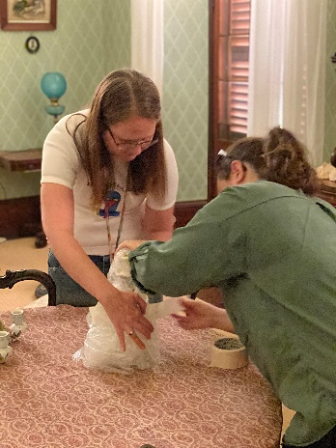  Staff packed up Lanyon collection items for relocation to CMAG as a precaution during the Orroral Valley Fire threat - Tian Zampaglione and Rowan Henderson, credit Jodie Cunningham | 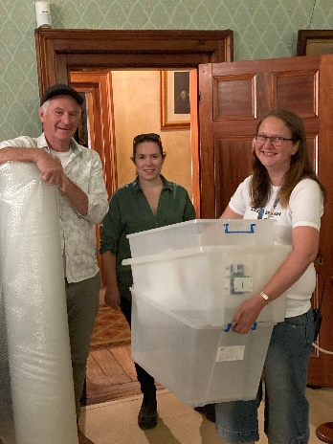  Staff packed up Lanyon collection items for relocation to CMAG as a precaution during the Orroral Valley Fire threat - Paul Webb, Tian Zampaglione and Rowan Henderson, credit Jodie Cunningham

Leadership – An integral part of the cultural life of the Canberra region and beyond
Strategies to achieve this:
- Develop Lanyon as a heritage tourism hub and a ‘must see’ attraction for visitors wanting to experience Australia’s settlement history.
- Use the Lanyon Heritage Centre to welcome visitors to the Lanyon site and to research and promote Lanyon’s significance.
- Open up more spaces in Lanyon homestead for historical interpretation.
- Present Calthorpes’ House as Australia’s best example of a domestic museum of the 1920s.
- Present Mugga-Mugga as an authentic setting to experience life on the Limestone Plains before Canberra was established.
- Ensure the Historic Places are used as examples of best practice in cultural heritage management, including for tertiary education.
- Extend the portfolio of Historic Places, to include sites that allow Canberra’s more recent history to be explored.
Key outcomes in 2019–20 against the above strategies
- ACT Historic Places undertook productive partnerships with a range of groups during the year, as a means to support and expand its activities and programming, including through joint grant applications.
- A particular focus of attention was the preparation for Lanyon’s major involvement in the 2020 Floriade festival, Floriade : Reimagined, where ACT Historic Places has partnered with EventsACT to include Lanyon as a National Attraction location for the event, and joined with Cuppacumbalong Homestead and Canberra Institute of Technology to develop joint programs for the festival, which will take place early in 2020–21.
- In other initiatives to support the role of the ACT Historic Places as visitor destinations, a ticket is now presented to each visitor to Lanyon who books onsite with a QR code linked to the review platform on TripAdvisor. Staff promote this review opportunity and have a target of improving Lanyon’s already favourable rating on TripAdvisor.
- Lanyon continued to be popular as a venue for private events and celebrations, although the number of events held in 2019–20 was impacted by site closures due to bushfire threats and the COVID-19 situation. There were 16 venue hires in 2019–20, six of which were weddings.
- To support venue hire business, the ACT Historic Places Venue Hire fee structure was reviewed and updated, and work progressed on a new micro website specific to ACT Historic Places venue hire, to better promote the capacity to cater to corporate, families and wedding clients. The new micro website will be launched in 2020–21. Lanyon continues to be a premium choice in the Canberra wedding market, and a new children’s party package is being developed, in recognition of the scope this market segment offers for increasing visitation and revenues.
- Preparation of an Aboriginal Cultural Heritage Survey of Mugga-Mugga was completed and will help to interpret the Aboriginal cultural values and sites, as well as informing a grasslands fencing project.

B.3 Scrutiny
Auditor-General Report No. 2/2018 – ACT GOVERNMENT STRATEGIC AND ACCOUNTABILITY INDICATORS
Recommendation No. 2 summary | Action | Status
CFC’s strategic indicators should be improved so they meet the Quantifiable measurement criterion. If the strategic indicators cannot meet the criterion of Quantifiable through supporting quantitative data, CFC should use qualitative data that can be assessed and explained through commentary. | Once CMTEDD update the Performance and Accountability Framework, CFC will use the revised criteria as the basis for assessing the suitability of its Strategic and Accountability indicators. | In progress. CMTEDD has now updated the Performance and Accountability Framework. The CFC will refer to the updated Framework in reviewing its strategic indicators for use in future Statements of Intent.
There were no Auditor-General reports that related specifically to the CFC in 2019–20.
There were no Legislative Assembly Committee reports that related specifically to the CFC in
2019–20.
For further information contact : CFO, CFC Corporation Finance (02) 6205 2195

B.4 Risk Management
The CFC has a comprehensive Strategic Risk Management Plan (SRMP) which is implemented and monitored on an ongoing basis. This document provides the framework for supporting strategies and plans relating to more specific areas of risk, such as disaster preparedness and business continuity plans.
A review of the SRMP commenced in June 2020. The updated plan will be provided to the CFC’s Audit Committee and Board in early 2020–21 for approval.

B.5 Internal Audit
The CFC Audit Committee met on six occasions during 2019–20. Meetings were held on 11 July 2019, 26 September 2019, 21 November 2019, 30 January 2020, 21 April 2020 and 28 May 2020. The number of meetings attended by Committee members was as follows :
Name of Member | Position | Meetings attended
Shad Sears | Chair | Six
Harriet Elvin | Member | Six
Helen O’Neil | Member | Five
The CFO is invited to each meeting as an observer and an invitation is also extended to the ACT Audit Office to send an observer to each meeting.
The Audit Committee Charter is provided as Part G of the CFC Board Charter available at http://www.culturalfacilities.act.gov.au and incorporates specific roles for risk management and audit matters.

INTERNAL AUDIT
The Audit Committee reviews and approves an internal audit/quality assurance plan for each financial year. A Chief Executive Financial Instruction has been issued dealing with audit committee and internal audit matters.
During the year an internal audit commenced on Canberra Theatre Centre Ticketing and Revenue. The final internal audit report will be received during 2020–21.

B.6 Fraud Prevention
The CFC has a comprehensive Fraud Control Plan (FCP) which is implemented and monitored on an ongoing basis. Oversight of this plan is undertaken by the Audit Committee, as one of the roles under its Charter – refer to http://www.culturalfacilities.act.gov.au.
A review of the FCP commenced in June 2020. The updated plan will be provided to the CFC’s Audit Committee and Board in early 2020–21 for approval.
The CEO’s “start the year” email for 2020 reminded staff of their responsibilities with regard to fraud control and prevention.

b.7 FREEDOM OF INFORMATION
Open Access Information - Section 96 (3) (a) (i), (ii) and (iii)
- Number of decisions to publish Open Access information. 12
- Number of decisions not to publish Open Access information. 0
- Number of decisions not to publish a description of Open Access information withheld. 0
FOI Applications received and decision type - Section 96 (3) (a) (iv), (vii), (viii) and (ix)

- Number of access applications received. 0
- Number of applications where access to all information requested was given. 0
- Number of applications where access to only some of the information requested was given (partial release). 0
- Number of applications where access to the information was refused. 0
FOI processing timeframe - Section 96 (3) (v) and (vi); Section 96 (3) (d)
- Total applications decided within the time to decide under section 40. 0
- Applications not decided within the time to decide under section 40. 0
- Number of days taken to decide over the time to decide in section 40 for each application. 0
Amendment to personal information - Section 96 (a) (x) and Section 96 (3) (e)
- Number of requests made to amend personal information, and the decisions made (e.g. amended, refused, notation added to record, other). 0
Reviews – Section 96 (3) (b); Section 96 (3) (c)
- Number of applications made to Ombudsman under section 74 and the results of the application (e.g. affirmed, varied, set aside and substituted, withdrawn, other). 0
- Number of applications made to ACT Civic and Administrative Tribunal under section 84 and the results of the application (e.g. affirmed, varied, set aside and substituted, withdrawn, other). 0
Fees - Section 96 (3) (f)
- total charges and application fees collected from access applications. 0
FOI requests can be made by contacting the Cultural Facilities Corporation FOI Information Officer, PO Box 939 CIVIC SQUARE ACT 2608 or emailing CFCcorporatefinance@act.gov.au.
Further information can be found at http://www.culturalfacilities.act.gov.au. There are no access applications applicable for registration on the CFC FOI Disclosure Log.

b.8 COMMUNITY ENGAGEMENT AND SUPPORT
The CFC actively seeks to engage its communities in a greater understanding of the value of the arts, and of cultural heritage, through its programs and activities, placing customer service as its primary goal and recognising the diverse needs and expectations of customers. A summary of actions taken by the CFC during 2019-20 in terms of community engagement and support is provided below, with detailed information presented about each of these actions under Section B2.
During the year, CMAG and ACT Historic Places presented a diverse range of high quality exhibitions, learning and community programs and other activities, on site, off site (through outreach programs) and online. Productive partnerships were developed with other cultural organisations, the tourism sector and the wider community in developing and delivering programs and events. The Canberra Theatre Centre connected the community with the performing arts, including through initiatives that addressed special needs in the community. The Centre provided a wide range of activities for the education system and wider community.
The CFC’s digital strategies provided new community engagement opportunities during 2019-20, through the use of social media and digital programming. Digital engagement activities were particularly important for maintaining contact with the communities the CFC serves during the period of site closures from March to June 2020 due to COVID-19 restrictions, and a number of new digital initiatives were introduced, such as online theatre programming and museum learning programs.
The CFC continually seeks to improve customers’ satisfaction with their visit to, and experience of CMAG, ACT Historic Places and the Canberra Theatre Centre venues. Customer satisfaction surveys were conducted throughout the year and reported as part of the CFC’s 2019–20 Statement of Performance. Information gained from the surveys was used in future planning to improve facilities and services.
A major community engagement activity for the CFC is the operation of its three CFC advisory committees. In 2019–20, the CFC’s advisory committees provided advice on a range of specialised matters relating to the operation of the CFC’s three program areas : CMAG; the ACT Historic Places; and the Canberra Theatre Centre.
Engagement tools included a plenary workshop of all committee members in October 2019 and individual sessions of each committee throughout the year. 16 advisory committee members participated in these, providing expert strategic advice to the CFC throughout the year, on a voluntary basis, and providing important links between the CFC and the wider community.

B.9 ABORIGINAL AND TORRES STRAIT ISLANDER REPORTING
The CFC ensures cultural diversity is an essential feature of its regular programming, including exhibitions, theatre presentations and programs featuring Indigenous cultures. Examples of activities in each area of the CFC in 2019–20 are provided below.
Canberra Theatre Centre
- The Centre continued to present a diverse range of performances developed by Aboriginal and Torres Strait Islander and associated companies including :
- Bangarra Dance Theatre’s Bangarra 30th Anniversary Season;
- Auspicious Arts Projects Inc’s Spinifex Gum, including a workshop with schools groups; and
- Tura New Music Ltd’s Kimberley Echoes.
- The Centre continued to maintain relationships with a range of members of the Aboriginal community including Maeve Powell and Sam Provost from ANU, Richie Allen from Burrunju Aboriginal Corporation, Ngambri-Ngunnawal Elder Matilda House, and Ngunnawal Elder Violet Sheridan. This engagement provided valuable support to the Centre in its efforts to ensure diversity in its programming.
- The Centre hosted an intern in December 2019 and January 2020 as part of the Indigenous mentoring and internship program CareerTrackers. The intern produced a piece on the Ngunnawal community in the Canberra region.
CMAG
CMAG’s focus on Indigenous engagement during the year included the following.
- As part of NAIDOC week, Ngambri-Ngunnawal custodian Paul House and glass artist Tom Rowney presented a floor talk discussing the process of collaborating to create the glass yidaki representing the Murrumbidgee river that was on display. After the talk, visitors enjoyed an exclusive opportunity to listen to the sound of this work as Paul House played the yidaki in the gallery.
- The following learning programs were delivered in 2019-20, each featuring Indigenous content in response to the key cross curriculum priority of Aboriginal and Torres Strait Islander Histories and Cultures in the Australian Curriculum.
- Every Picture Tells a Story – onsite and online learning program for Preschool to Year 2 students. During this program, students are introduced to Indigenous place names and Ngunnawal language, which is woven through the stories found in Sidney Nolan’s paintings.
- What Do Artists Make – online learning program for Preschool to Year 2 students. This program was developed and offered to schools in the Canberra region in response to the temporary closure of CMAG due to COVID-19. During this program students engage with works by Aboriginal artists Dean Cross and Kevin Gilbert.
- The Art Box – outreach learning program for Kindergarten to Year 3 students. This resource features the work by Matilda House, Murrumbeja Dooligah, 1996, lithograph.
The following CMAG exhibitions featured Indigenous cultures.
- VOID
This travelling exhibition developed by Wiradjuri curator Emily McDaniel and toured by Museums & Galleries of NSW opened in February 2020, and explored the diverse ways contemporary Aboriginal artists from across the country visually articulate the unknown as space, time and landscape. CMAG engaged Ribana Catering (Aboriginal and Torres Strait Islander enterprise) to provide catering for the exhibition launch. Budawang (of Yuin Nation) spatial designer Dr Danièle Hromek spoke at the opening event. Rhiannah McIntyre, a previous CMAG CareerTrackers Intern and Ngiyampaa/ Wongaibon woman, was employed to assist in the installation of the exhibition.
- Seeing Canberra
This visual art-focused exhibition, drawn from the CMAG Collection and exploring different ways of viewing Canberra, opened in March 2020 and included works by Aboriginal artists. The exhibition included new acquisitions by Aboriginal artists Brenda Croft and Dean Cross.
- Activism : forces for change in Canberra
An important aspect of this exhibition was the stories of Aboriginal activism in Canberra. To provide further insight into the exhibition, CMAG hosted a talk with Aboriginal activists, Michael Anderson of the Euahalayi Nation and Wiradjuri man Paul Coe about their experiences in association with the Aboriginal Tent Embassy, established in front of Parliament House.
- Djinjama : Defying the grid
Budawang (of Yuin Nation) spatial designer Dr Danièle Hromek with mother, Robyn Hromek and sister Siân Hromek, drew on their ancestors’ ancient techniques to create fishing nets that recast their ancestors back into the landscape, breaking the urban grids through a filter of culture.
Dr Danièle Hromek led an artist talk and yarning circle in association with the Civic Square installation prior to the opening of the associated exhibition VOID.
ACT Historic Places
ACT Historic Places’ commitment to strengthen its relationship with Indigenous communities was expressed during the year through continued collaboration with Buru-Ngunawal Aboriginal Corporation and through specific activities, including the following.
- Lanyon hosted the program Canoe Tree Walk. Ngunnawal custodian Wally Bell led a walk where people learnt about the Aboriginal connection to the area and the Murrumbidgee River, and discovered more about the significance of the canoe tree to the Ngunnawal people.
- Lanyon also presented Fireside Storytelling : Wiradjuri Echoes. Around the fireside, Wiradjuri man, Duncan Smith OAM, shared his Dreamtime stories and their symbols, and played the didgeridoo.
- Lanyon hosted a four-day Indigenous Women’s Possum Skin Cloak Project for the Winnunga Nimmityjah Aboriginal Health group who made a possum skin cloak. The project was a collaboration between the ANU Centre for Aboriginal Economic Policy Research, ANU School of Art and Design, and Winnunga Nimmityjah Aboriginal Health Service.
- Ngunnawal elder Mr Wally Bell gave a Welcome to Country at the annual public program Lanyon Christmas Carols and Picnic. This was the first year that a Welcome to Country had been done at this event.
- Canberra Tracks signage was developed to interpret the Aboriginal and non-Indigenous heritage at Mugga-Mugga.
- Preparations were undertaken for an Aboriginal Cultural Heritage Survey of Mugga-Mugga Cottage to help ACT Historic Places conserve and interpret the Aboriginal cultural values and sites.
- Welcome to Country signage is being developed for Lanyon, in consultation with Indigenous representatives.

B.10 Work Health and Safety
The CFC is committed to maintaining the health, safety and welfare of its employees. Workplace Health and Safety (WHS) is managed in accordance with the statutory provisions of the Work Health and Safety Act 2011.
CFC venues and activities closed in March 2020 in response to COVID-19 restrictions. The CFC committed to prioritising the health and safety of its employees, volunteers and visitors/patrons by ensuring compliance with COVID-19 guidelines and restrictions.
The CFC has :
- adopted a CFC WHS Policy Statement, which has been advised to all staff;
- updated the Work Health and Safety Committee - Terms of Reference in January 2020;
- nominated eight Health and Safety Officers;
- established a WHS Committee and work unit Health and Safety Committees; and
- ensured that WHS issues are discussed at each fortnightly meeting of the CFC senior management committee – refer to B.1.6, page 31.
The CFC’s WHS arrangements operate as part of the ACT WHS and Injury Management Improvement Strategy, which commits ACT Government employers and employees to high standards of workplace health and safety. The CFC’s WHS arrangements also acknowledge the targets set by the ACT Government for improving WHS performance, injury management and prevention.
The CFC Board receives a WHS report at each meeting. These reports include information about : accidents or incidents; outcomes and corrective action from previous accidents or incidents; risk assessments undertaken; meetings of the WHS Committee and work unit Health and Safety Committees, together with key issues discussed at these meetings; training provided on WHS; progress on development of the Safety Management System; and other WHS matters, such as security management.
In addition, every six months, a further report is provided to the Board on key WHS risks in the CFC, together with risk controls and risk treatment strategies.
Work Health and Safety Act 2011
In 2019–20, the CFC did not receive notices of improvement, prohibition, or non-disturbance under Part 10 of the Work Health and Safety Act 2011.
In 2019–20, the CFC did not receive notices of enforceable undertakings under Part 11 of the Work Health and Safety Act 2011.
In 2019–20, the CFC did not receive notices of failure to comply with a safety duty under Part 2, Division 2.2, 2.3 or 2.4 of the Work Health and Safety Act 2011.
In 2019–20, CFC staff members were trained in WHS through participation in a number of courses, including :
- Respect, Equity and Diversity training;  - Mental Health for Managers;  - Mental Health Guru Anxiety and Depression modules (online);  - Fire Warden training; | - Manual Handling;  - Emergency Control Organisation training;  - First Aid training; and  - Riskman Risk Register workshop.
There was one serious injury reported to WorkSafe ACT in accordance with Part 3 Section 38 of the Work Health and Safety Act 2011 in 2019–20.
There was one dangerous incident reported to WorkSafe ACT in accordance with Part 3 Section 38 of the Work Health and Safety Act 2011 in 2019–20.

B.11 Human Resources Management

B.11. 1 Human Resources Management
The CFC’s approach to Human Resources (HR) management and workforce planning is through the ongoing implementation and review of its HR Plan. Further information about HR management is provided in Section B.2.1, page 37.

B.11.2 Learning and Development
The CFC places high importance on staff training and development. During 2019–20, staff attended many formal training courses, a range of conferences and seminars, and other professional development opportunities. These ranged from training courses on specific topics, such as Respect, Equity and Diversity; Mental Health; Risk and Crisis Management Planning through to attendances at meetings and conferences for the arts and museum sector, such as annual conferences of The Australian Performing Arts Market, AsiaTOPA : Asia-Pacific Triennial of Performing Arts, Arts On Tour Salon and The Performing Arts Exchange and various Australian Museums and Galleries Association webinars.
Other examples of professional development opportunities attended by staff in 2019–20 included ACT Insurance Authority Cyber Security Risk Awareness forum; ACT Audit Office - Governance and Risk Management in an Interconnected World Forum; Canberra Region Tourism Advisory Forum; Live Theatre Forum session titled Roadmap to Reopening by Live Performance Australia (online); Visitor Research Forum (online); QMusic’s BigSound Music Conference; and Institute of Public Accountants National Conference. The CFC also undertakes performance management/skills development assessment programs. Further information is provided under Section B.2.1, page 37.
Expenditure on staff training and professional development during 2019–20 amounted to $60,346. This amount includes membership fees for professional development programs, staff training and conference fees. Associated travel and accommodation costs are not included in this amount.
During the year, one staff member participated in the ACTPS study assistance program or in courses provided by ACTPS training panel providers, at a total cost of $1,240.
The CFC convenes meetings of its Agency Consultative Committee (ACC) consisting of staff, management and union representatives, when needed. The ACC met on the 14 November 2020 and updated the ACC Terms of Reference.

B.11.3 Staffing Profile
The CFC’s Staffing Profile as at 22 June 2020 (the last pay date for the 2019–20 financial year) was as follows.

FTE and headcount by division/branch
Division/branch | FTE | Headcount
Cultural Facilities Corporation | 105 | 162

FTE and headcount by gender
 | Female | Male | Total
Full Time Equivalent | 58 | 47 | 105
Headcount | 95 | 67 | 162
Percentage of workforce | 59% | 41% | 100%

Headcount by classification and gender
Classification groups | Female | Male | Total
Apprentice | 0 | 0 | 0
ASO2 | 16 | 4 | 20
ASO3 | 3 | 0 | 3
ASO4 | 10 | 6 | 16
ASO5 | 8 | 6 | 14
ASO6 | 6 | 5 | 11
GSO2 | 0 | 1 | 1
GSO4 | 0 | 0 | 0
GSO5 | 0 | 2 | 2
GSO7 | 0 | 1 | 1
GSO9 | 0 | 1 | 1
PO1 | 8 | 1 | 9
PO2 | 3 | 0 | 3
SOGA | 0 | 1 | 1
SOGB | 2 | 0 | 2
SOGC | 6 | 2 | 8
SPOC | 0 | 0 | 0
Executive Contract | 1 | 1 | 2
Box Office | 7 | 1 | 8
Patron Services | 21 | 13 | 34
Stage Door | 0 | 1 | 1
Tech. Level 1 | 3 | 16 | 19
Tech. Level 2 | 1 | 2 | 3
Tech. Level 4 | 0 | 3 | 3
Total | 95 | 67 | 162

Headcount by employment category and gender
 | Female | Male | Total
Casual | 46 | 36 | 82
Permanent Full-time | 22 | 16 | 38
Permanent Part-time | 14 | 2 | 16
Temporary Full-time | 8 | 12 | 20
Temporary Part-time | 5 | 1 | 6
Total | 95 | 67 | 162

Headcount by diversity group
Division/branch | Headcount | Percentage of agency workforce
Aboriginal and Torres Strait Islander Peoples | 1 | 1%
Culturally and Linguistically diverse | 13 | 9%
People with Disability | 2 | 1%
Prospective employees of the CFC are asked to identify their ethnicity or disability. However, declaring this information is not mandatory.

Headcount by age group, gender and average length of service
Age Group | Female | Average length of service | Male | Average length of service
Under 25 | 12 | 2 | 11 | 2
25-34 | 17 | 3 | 8 | 3
35-44 | 22 | 5 | 21 | 3
45-54 | 24 | 8 | 10 | 7
55 and over | 20 | 12 | 17 | 9

Recruitment and separation rates for the agency
Classification | Recruitment rate | Classification | Separation rate
GSO5 | 2% | GSO5 | -
GSO7 | 2% | GSO7 | -
ASO3 | 4% | ASO3 | 2%
ASO4 | 2% | ASO4 | -
ASO5 | 2% | ASO5 | 2%
ASO6 | 2% | ASO6 | -
PO1 | 2% | PO1 | -
SOGC | 4% | SOGC | 2%
SOGB | - | SOGB | 4%
SPOB | 2% | SPOB | -
Executive level | 2% | Executive level | -
The statistics exclude Board members and people on leave without pay.

B.12 Ecologically Sustainable Development

Climate Change and Greenhouse Gas Reduction policies and programs
- The Canberra Theatre Centre upgraded computerised controls for its Heating Ventilation and Air Condition systems.
- Gallery 5 at CMAG was refitted with museum standard temperature and humidity controls.
- Documentation and design of the new water supply infrastructure system for Lanyon Homestead commenced in 2019–20.
- Construction of a renewable energy pilot project at Mugga-Mugga commenced in mid-2020.

Sustainable development performance 2019–20 and 2018–19
Indicator as at 30 June | Unit | 2019–20 | 2018–19 | Percentage  change
Stationary energy usage
Electricity use | Kilowatt hours | 1,771,865 | 1,977,015 | (10%)
Natural gas use (non-transport) | Megajoules | 3,916,736 | 4,315,859 | (9%)
Diesel (non-transport) | Kilolitres | - | - | -
Transport fuel usage
Electric vehicles | Number | - | - | -
Hybrid vehicles | Number | - | - | -
Hydrogen vehicles | Number | - | - | -
Total number of vehicles | Number | 5 | 5 | -
Fuel use – Petrol | Kilolitres | 1.4 | 2.0 | (30%)
Fuel use – Diesel | Kilolitres | 1.7 | 1.4 | 21%
Fuel use – Liquid Petroleum Gas (LPG) | Kilolitres | - | - | -
Fuel use – Compressed Natural Gas (CNG) | Gigajoules | - | - | -
Water usage
Water use | Kilolitres | 8,640 | 8,491 | 2%
Resource efficiency and waste
Reams of paper purchased | Reams | 333¹ | 576¹ | (42%)
Recycled content of paper purchased | Percentage | 50% | 48% | 4%
Waste to landfill | Litres² | 45,760³ | 233,076³ | (80%)
 | Tonnes² | 23.6³ | 17.0³ | 39%
Co-mingled material recycled | Litres² | 28,600³ | 51,480³ | (44%)
 | Tonnes² | 18.6³ | 20.6³ | (10%)
Paper & Cardboard recycled (incl. secure paper) | Litres | 22,880 | 22,880 | -
 | Tonnes | 1.4 | 1.8 | (24%)
Organic material recycled | Litres | Note⁴ | Note⁴
Greenhouse gas emissions
Emissions from electricity use | Tonnes CO₂-e | -⁵ | 504 | (100%)
Emissions from natural gas use (non-transport) | Tonnes CO₂-e | 202 | 222 | (9%)
Emissions from diesel use (non-transport) | Tonnes CO₂-e | - | - | -
Emissions from transport fuel use | Tonnes CO₂-e | 8 | 9 | (11%)
Total emissions | Tonnes CO₂-e | 210 | 735 | (71%)
The information used for calculations in the above table was provided by ActewAGL, ICON Water, ACT Property Group, WINC, Suez, Recall/Iron Mountain, Cleanaway, Elgas, AAAWater and SG Fleet Australia Pty Ltd., with assistance from : the Environment, Planning and Sustainable Development Directorate (EPSDD); Climate Change and Sustainability—Carbon Neutral Government Program; and the Enterprise Sustainability Platform.
CFC venues were closed at various times in 2019–20, especially in the final quarter of the year, due to the impacts of smoke, bush fire threat and COVID-19, resulting in a lower amount of energy consumption in most areas.

- The decrease in reams of paper purchased is due to staff printing less paper, in particular as a result of staff working from home, and greater use of electronic devices and digital documentation.
- Not all service providers of waste collection from CFC facilities report the amounts of waste collected in litres. Some provide the amounts in tonnes. It is not possible to convert tonnes to litres, therefore both figures are provided.
- The decrease in Waste to Landfill (Litres) but increase in Tonnes is due to the Lanyon supplier providing 2019–20 waste collected in tonnes - in previous years waste collected has been supplied in litres. In addition, the Canberra Theatre Centre reduced Waste to Landfill and Co-mingled material recycled collections from weekly to fortnightly in April 2020 as there was a decrease in waste due to the venue closure.
- Large amounts of garden waste are collected, composted and re-used to replenish the gardens at the ACT Historic Places. However, it is not possible to quantify the amount of organic material recycled.
- Surrender of renewable energy certificates generated by the ACT Government has ensured that the ACT can claim zero emissions from electricity for the entire 2019–20 financial year.

The following statements have been provided by the EPSDD; Climate Change and Sustainability for inclusion in this report.
Please note that some data reported for FY 2018–9 in the table above may differ slightly from figures reported in the 2018–19 Annual Report. These are due to updates to agency occupancy and historical consumption data, and annual adjustments to ACT specific electricity emissions factors. Where actual data is not available, the Enterprise Sustainability Platform provides estimations using an accruals function. Accruals are calculated from the average annual daily consumption of the most current 12 month period applied for the number of days of missing data.
Emissions reported for stationary energy and transport fuels include Scope 1 and Scope 2 emissions only. Scope 1 are direct emissions from sources owned and operated by the government including: emissions from transport fuel and natural gas use. Scope 2 are indirect emissions from mains electricity.
Emission factors used to calculate natural gas and fleet fuel are based on the latest National Greenhouse Accounts factors. Greenhouse gas emissions for electricity consumption have been calculated using the following emissions factors based on the latest ACT Electricity Emissions Factor Report released in 2020 :
- a factor of 0.255 kilogram (kg) CO2-e / kilowatt hour (kWh) or 0.255 tonne (t) CO2-e /megawatt hour (MWh) has been used to calculate electricity emissions (Scope 2) for the 2018–19 period. It is based on actual historical data and is a retrospective adjustment of the original 0.507 factor (Scope 2) used for 2017–18 annual reporting; and
- the ACT met it’s 100% renewable electricity target in 2019–20. This is the first year that the ACT Government will be reporting zero greenhouse gas emissions from electricity use. The ACT Government is committed to maintaining 100% renewable electricity supply beyond 2020.
Treatment of plug-in hybrids
For the purposes of annual reporting plug-in hybrids have been treated as electric vehicles. A plug-in hybrid electric vehicle (also known as a range-extended vehicle) is fuelled by electricity as well as having either a petrol or diesel tank to extend the range of the vehicle for long trips. These vehicles can be run either on electricity or fuel, but are considered to be zero emissions vehicles as it is most likely that the vehicle will be run on electricity for the majority of trips (due to lower cost for charging than re-fuelling).

C. FINANCIAL MANAGEMENT REPORTING

Section

C

C.1 FINANCIAL MANAGEMENT ANALYSIS
A full analysis of the CFC’s 2019–20 financial results and financial position is set out in the Management Discussion and Analysis at Attachment 1, page 166 to this report.

C.2 Financial Statements
The CFC’s 2019–20 Financial Statements are set out in Attachment 1, page 111 to this report.

C.3 CAPITAL WORKS

2019–20 CAPITAL WORKS TABLE
Project | Estimated completion date | Actual completion date | Original project value  $0,000 | Revised project value  $0,000 | Prior year expenditure  $0,000 | Current year expenditure  $0,000 | Total expenditure to date  $0,000
New Capital Works
Upgrading Lanyon Homestead | June 23 | - | 3,097 | 3,097 | - | 150 | 150
Improving facilities at the Canberra Theatre | June 21 | - | 995 | 995 | - | 698 | 698
Upgrading the Canberra Theatre Centre | June 21 | - | 1,480 | 1,480 | 1,001 | 104 | 1,105
Upgrading the Canberra Museum and Gallery | June 20 | June 20 | 350 | 350 | 119 | 231 | 350
Conserving and improving ACT Historical Places | June 20 | - | 680 | 680 | 240 | - | 240
Better Infrastructure Fund
Cultural Facilities Corporation | June 20 | June 20 | 298 | 298 | - | 298 | 298
Fast-Tracked Infrastructure and Maintenance Stimulus
Canberra Theatre Centre Security | June 20 | June 20 | 310 | 310 | - | 310 | 310
Canberra Theatre Centre Bathroom Upgrades | June 20 | June 20 | 187 | 187 | - | 187 | 187
ACT Historic Places Cottages Upgrades | June 20 | June 20 | 120 | 120 | - | 119 | 119
Total Capital Works Program |  |  | 7,517 | 7,517 | 1,360 | 2,097 | 2,097

2019–20 CAPITAL WORKS RECONCILIATION
 | 2019–20 Approved  Financing  $0,000 | 2019–20 Drawdown  Amount  $0,000 | 2019–20 Actual Expenditure  $0,000
New Capital Works
Upgrading Lanyon Homestead | 530 | 150 | 150
Improving facilities at the Canberra Theatre | 760 | 698 | 698
Upgrading the Canberra Theatre Centre | 200 | 200 | 104
Upgrading the Canberra Museum and Gallery | 305 | 305 | 231
Conserving and improving ACT Historical Places | 440 | - | -
Better Infrastructure Fund
Cultural Facilities Corporation | 298 | 298 | 298
Total Capital Works Program | 2,533 | 1,651 | 1,481
Works Funded From Other Sources
Adjusted for Capital funded through Own Sourced Revenue | - | - | 164
Fast-Tracked Infrastructure and Maintenance Stimulus | - | 494 | 494
Balances per Capital Works Management | 2,533 | 2,145 | 2,139
Revised Wage Parameters | 19 | 19 | -
Balances per cash flow statements | 2,552 | 2,164 | 2,139
For further information contact : CFO, CFC Corporate Finance (02) 6205 2195

C.4 ASSET MANAGEMENT

C.4.1 Assets Managed
The CFC managed assets with a total value of $67,908,000 as at 30 June 2020. The CFC’s major assets and approximate values are :
Description | $0,000
Canberra Theatre Centre, and extensions at fair value | 33,270
Land at fair value | 17,580
Historic Places buildings at fair value | 5,550
Plant and Equipment at fair value | 5,384
Art and Social History Collection | 5,114
Capital Works in Progress | 956
Intangible Assets | 54
During 2019–20 the following major assets were added to the CFC’s asset register :
Description | $0,000
Canberra Museum and Gallery storage expansion | 616
Art and Social History objects (including donated art) | 291
There were no significant assets removed from the CFC’s asset register during 2019–20.

C.4.2 Assets Maintenance and Upgrade
The CFC maintains its assets in accordance with the CFC’s Strategic Asset Management Plan.
Major asset upgrades (including works funded and reported through the capital works program) completed during 2019–20 were :
Description | $0,000
Works in Progress improving facilities at the Canberra Theatre Centre | 683
Canberra Theatre Centre security upgrades | 310
Canberra Theatre Centre bathroom upgrades | 187
ACT Historic Places cottages upgrade | 119
For building assets, the expenditure on repairs and maintenance was $481,000, which represented 1% of the assets written down value. For Plant and Equipment assets, the expenditure on repairs and maintenance was $270,000, which represented 5% of the assets written down value.
A three year rolling independent valuation of the CFC’s assets has been implemented to ensure all items are reflected at fair value in the CFC’s asset register and any impairment is identified.

C.4.3 Office Accommodation
CFC staff members occupy or use premises at the Canberra Theatre Centre, CMAG, Lanyon, Calthorpes’ House, Mugga-Mugga and North Building administration area locations.
In view of the wide range of workplaces in which CFC staff work (including historic places, theatre and gallery environments, where areas used by staff as offices may be combined with other uses such as ticketing, patron servicing etc.), it is difficult to provide a precise figure of the average area occupied by each employee. An estimate of the total office area occupied as at 30 June 2020 is
1,147 square metres and an estimate of the average area occupied by each (FTE) employee as at 30 June 2020 is 10 square metres.

C.5 GOVERNMENT CONTRACTING

C.5.1 Procurement Principles and Processes
The CFC engaged external sources of goods, services and works during 2019–20 and these goods, services and works were procured with the support and assistance of ACT Procurement and Capital Works as required.
The CFC believes that its procurement selection and management processes comply with the Government Procurement Act 2001 and Government Procurement Regulation 2007. It liaises regularly with ACT Procurement and Capital Works on procurement matters including through the involvement of officers of ACT Procurement and Capital Works in the more complex or higher value procurement processes.
Creative Services Panel
The Creative Services Panel is a whole of government arrangement for the purchase of creative services, including:
- advertising
- marketing
- communications and engagement
- digital
- graphic design
- photography and video
- media buying.
During 2019–20, Cultural Facilities Corporation spent $25,893 value through the panel. This includes marketing, advertising and graphic design creative work for various performances at the Canberra Theatre Centre and for exhibitions and programs at CMAG and ACT Historic Places.

C.5.2 External Sources of Goods, Services and Works
Contracts entered into in 2019–20 with a value exceeding $25,000
Contract Number | Contract Title | Procurement Methodology | Procurement Type | Exemption from Quotation and Tender Threshold requirements | Contractor Name | Contract Amount | Execution Date | Expiry Date
CTCGRAPHICCDESIGN2020 | CTC Graphic Design contract | Quotation | Services (non-consultancy) | No | Greer’s House | $100,000 | 21/01/2020 | 21/01/2021
Aboriginal and Torres Strait Islander Procurement Policy (ATSIPP) Performance Measures
No. | ATSIPP Performance Measure | Result
1. | The number of unique Aboriginal and Torres Strait Islander Enterprises that respond to Territory tender and quotation opportunities issued from the Approved Systems. | 1
2. | The number of unique Aboriginal and Torres Strait Islander Enterprises attributed a value of Addressable Spend in the financial year. | 1
3. | Percentage of the financial year’s Addressable Spend that is spent with Aboriginal and Torres Strait Islander Enterprises – target 1%. | less than 1%

C.6 STATEMENT OF PERFORMANCE
The CFC’s 2019–20 Statement of Performance is set out in Attachment 1 to this report, page 175.

APPENDICES

Appendices

appendix 1 –
MEMBERS AND REMUNERATION OF THE CFC BOARD DURING 2019–20
JUSTICE RICHARD REFSHAUGE
(Chair appointment – 1 January 2019 to 30 June 2022)
Richard Refshauge BA (Hons) LLB graduated from the ANU and commenced private legal practice in 1976 with local firm, Macphillamy Cummins & Gibson. He became a partner in 1981 and senior partner in 1992. The firm merged with Sly & Weigall in 1994 and he became Chairman of the Canberra partners. The firm changed its name in 1995 to Deacons Graham & James. In 1998, he was appointed the third ACT Director of Public Prosecutions and in 2008 a Judge of the ACT Supreme Court, a position from which he retired in May 2017. He has presented guest lectures at the ANU College of Law, where he has been, since 2001, an Adjunct Professor. He is also an Adjunct Professor of the School of Law at the University of Canberra. Richard has had a long involvement with the arts in Canberra. He was President of the Arts Council of Australia (ACT Division) and Director of the Arts Council of Australia. He was a member of the Canberra Theatre Trust. He was Chair of the Board of Fortune Theatre Company, of Reid House Theatre Workshop, of Canberra Youth Theatre and of the Australian Choreographic Centre. He was a member and then the second Chair of the ACT Cultural Council. In 2014–15 he was a member of the Board of the Cultural Facilities Corporation. He is currently Chair of the Board of QL2 and Deputy Chair of the Board of the National Institute of Dramatic Art. He has also been involved in many welfare organisations in Canberra and is currently a member of the Board of the Greater Good Foundation and is Chancellor of the Anglican Diocese of Canberra and Goulburn.
HELEN O’NEIL
(Deputy Chair appointment – 27 November 2018 to 31 December 2022)
Chair of Performing Arts Connections, representing arts centres, touring companies and service organisations in Australian live performance, and Chair of South East Arts. Former Board member of Craft ACT, Currency House Inc and the Australian Film Finance Corporation. Executive experience includes roles as Country Director of the British Council in Australia leading cultural relations in the arts, science and higher education; as Executive Director of the Australian Major Performing Arts Group and the Council for the Humanities, Arts and Social Sciences; and with Opera Australia. In public policy she was Senior Adviser to the Minister for the Arts, The Hon Simon Crean and also worked with the Minister for Communications, The Hon Kim Beazley. Worked in screen and digital areas with News Ltd, and as a journalist with the ABC and The Age. She has degrees from the University of Melbourne (BA) and from Harvard University's Kennedy School (MPA).
HARRIET ELVIN
(Ex officio as Chief Executive Officer)
Holds degrees at undergraduate and graduate level from Cambridge University, and the Australian National University (ANU), in classics, law, international law, business administration, art history and curatorship. Former General Manager, ACT Bureau of Arts and Heritage. Recipient of inaugural ACT Government – ANU MBA Scholarship (1997). Member of : the External Advisory Board of the ANU College of Business and Economics; the Canberra Region Tourism Advisory Forum; and the Australiana Fund National Council and Canberra Committee. Chair of the Cambridge Society, ACT Branch. Fellow of the Institute of Managers and Leaders, Australia and New Zealand. Fellow of the Australian Institute of Company Directors. 2001 ACT Telstra Business Woman of the Year. Awarded Centenary Medal for service to Australian society in business leadership.
VIRGINIA HAUSSEGGER AM
(Member appointment to 31 December 2019)
Virginia Haussegger AM, is Chair of the 50/50 by 2030 Foundation, at the University of Canberra’s Institute for Governance and Policy Analysis (IGPA), and Chief Editor of BroadAgenda. She is ACT 2019 Australian of the Year.
An award-winning television journalist, Virginia’s extensive media career spans more than 25 years. She has reported from around the globe for leading current affair programs on Channel 9, 7, and the ABC.
For 15 years Virginia anchored the ABC’s flagship TV News in Canberra (2001–2016), and is widely published across print media. A former weekly columnist with the Canberra Times Virginia continues to contribute to the Sydney Morning Herald and the Age. She has served on a number of boards and committees including, UN Women National Committee Australia; the SnowyHydro SouthCare Trust; and the Canberra International Film Festival. Virginia is a founding committee member of Women in Media Canberra, and Patron of the Canberra Rape Crisis Centre.
SHAD SEARS
(Member appointment – 27 November 2018 to 31 December 2021)
Shad is a Partner within the PwC Assurance practice in Canberra. Shad has over 21 years experience providing professional services and advice to government and private sector clients. Shad holds Master degrees in both Cyber Security and Information Technology, a Bachelor of Commerce and is also a Fellow of the Institute of Chartered Secretaries and Administrators.
GENEVIEVE JACOBS
(Member appointment – 27 November 2018 to 31 December 2021)
Genevieve Jacobs has been a journalist for 30 years, working in print and radio. She spent over a decade as a broadcaster for ABC Canberra, and is now the Group Editor for Region Media and a graduate of the Australian Institute of Company Directors. Genevieve co-chairs the ACT Reconciliation Council and chairs the Minister's Creative Council. She sits on the boards of the National Folk Festival and Canberra International Music Festival, and is a director of the Conflict Resolution Service and the Australian Centre for Christianity and Culture. Genevieve has an enduring interest in building and strengthening community engagement.
VICKY DARLING
(Member appointment – 1 January 2019 to 30 June 2022)
Since September 2017, Vicky Darling has been the Chief Executive Officer of Volunteering and Contact ACT, the peak body for volunteering and community information services in the Canberra region. Following completion of a Bachelor of Arts in Recreation Administration, Vicky worked in the travel and recruitment industries before pursuing a career in public policy and community engagement. She has held executive leadership positions in the private sector, government, peak bodies, and charities and served in the Queensland Parliament. Vicky also serves on the Board of Sustainability Victoria.
JULIAN WIDDUP
(Member appointment – 1 February 2020 to 31 December 2022)
Julian Widdup is an experienced director having served on the boards of major Australian and international companies including airports, power utilities, port corporations, financial services, hospitals and public sector enterprises. Julian has a strong background in finance and risk management, having held executive leadership roles with Palisade Investment Partners, Access Capital Advisers and previously worked with the Australian Government. Julian is a fully qualified actuary, a Fellow of the Australian Institute of Company Directors and has a Bachelor of Economics from ANU. Julian has a strong interest in the arts. He is currently a director of Screen Canberra, the ASX-listed Rural Funds Group and Australian Catholic Superannuation and Retirement Fund.
Remuneration
The FM Act (Division 9.2, Clause 78(6)) provides that the remuneration of the CFC’s Chair, Deputy Chair, and appointed Members shall be determined by the ACT Remuneration Tribunal.
The current annual remuneration rates, set by the Tribunal’s Determination No. 13 of 2019 are :
Chair | $28,120
Deputy Chair | $14,070
Member | $9,860
The Chief Executive Officer’s remuneration is determined by the ACT Remuneration Tribunal under normal senior executive remuneration arrangements.
2019–20 Meetings of the CFC Board
- 22 August 2019
- 24 October 2019
- 12 December 2019
- 27 February 2020
- 30 April 2020
- 25 June 2020
The convening of these meetings, and their procedures, complied with the requirements of Division 9.4 of the FM Act.
A quorum was achieved at all meetings (refer to Division 9.4, Section 95 of the FM Act).

Appendix 2 –
Senior Managers of the CFC
IAN TIDY – CHIEF FINANCE OFFICER
Ian is a member of Chartered Accountants Australia and New Zealand and has held previous financial roles in retail with Discount Variety Group and in the audit team at BDO Kendalls in Brisbane. He has been employed with the CFC since December 2005, most recently as the Financial Controller before taking up this position. He has an undergraduate degree in Business with QUT and has experience in the not-for-profit sector, previously serving on the Board of ArtSound FM.
SHANE BREYNARD – DIRECTOR, CMAG AND DIRECTOR, CORPORATE STRATEGY CFC
(resigned 29 November 2019)
Shane is passionate about regional galleries and museums, photography and the moving image, in particular, the role these technologies play in the rediscovery of Australian history, and the plural nature of Australian identity. He is also interested in the opportunities and implications posed for Australian public culture by our increasing use of online technologies.
Shane is a member of the National Council of the Australian Museums and Galleries Association and UNESCO Australian Memory of the World Committee. He is a PhD candidate at the School of History at The Australian National University through which he is exploring Canberra’s history on screen.
Shane previously studied at the Australian National University School of Art where he was awarded a first class honours degree, The University Medal and a master of arts degree by research. He subsequently gained a second master degree, in environment, from the University of Melbourne. After a period working in the United Kingdom, Shane returned to Canberra in 2000 and was awarded an Australia Council for the Arts grant to work in collaboration with a young artist in Brasilia. Shane has worked as managing editor of Art Monthly Australia, as a cultural planner and in a number of government arts policy and arts infrastructure roles. From 2008 to 2011 Shane was senior advisor, and latterly Chief of Staff, to the former ACT Chief Minister, Jon Stanhope.
SOPHIE CHESSELL – A/G DIRECTOR, CMAG AND DIRECTOR, CORPORATE STRATEGY CFC
(commenced 1 April 2019)
Sophie has worked at institutions including the National Archives of Australia and also in historic houses and an archaeological research centre in the United States. She manages the Access and Learning section’s programs at Canberra Museum and Gallery (CMAG). She is a passionate about connecting the Canberra community with their visual arts and social history. Sophie started work for the organisation in 2008 and has been working in her current position of Assistant Director: Access and Learning since 2011.
BRUCE CARMICHAEL – DIRECTOR, CANBERRA THEATRE CENTRE (retired 29 November 2019)
Bruce has been working in the Performing Arts sector for over 40 years. He began his career in contemporary music in 1977 and accepted the role of Director of the Canberra Theatre Centre in 2007. Bruce holds a Postgraduate Certificate in Management (Arts Administration), QUT, and is a Graduate, Public Venue Management School, Venue Managers Association. He also serves as an Executive Member of the Association of Asia Pacific Performing Arts Centres (AAPPAC) and a Board Member of South East Arts.
Bruce is passionate about shaping the theatre’s creative direction, cementing Canberra Theatre Centre’s position on the national touring circuit, and programming shows for younger audiences.
GILL HUGONNET – A/G DIRECTOR, CANBERRA THEATRE CENTRE (17 June 2019 to
31 January 2020)
Gill has worked in the performing arts for over 30 years. Gill began working at the Canberra Theatre Centre (the Centre) in 2004 in Venue Bookings and has been the Programming Manager since 2009. She has extensive experience in theatre programming and has delivered many successful subscription seasons for the Centre. She was also responsible for developing the Centre’s Education Program and oversaw the creation of the Centre’s VET program. Gill has acted as Director on many occasions and has continued to drive the Centre’s strategic and artistic outcomes. Gill has developed an extensive network of artistic and professional peers through her contribution to associations such as OZPAC and AAPPAC and has also been the Deputy Chair of the Helpmann Awards Panel for Theatre and Touring Productions.
DR ANNA WONG – DIRECTOR, ACT HISTORIC PLACES (commenced 1 October 2019 – formerly
A/g Director from 29 April 2019)
Anna has worked in the heritage management and museum industry across a broad range of historic, cultural and natural places in Australia and the USA. Her doctoral research examined the Australian heritage conservation movement through the house museum genre and how this shaped our national identity and cultural representation of Australia’s past and present.
Anna has a deep interest in social history and the integration of contemporary programs and stories at historic places to ensure that heritage continues to be relevant to current communities and audiences.
ALEX BUDD – DIRECTOR, CANBERRA THEATRE CENTRE (commenced 3 February 2020)
Alex Budd commenced his arts career in the lighting department at the Canberra Theatre Centre. He was a founding member of the Canberra based Chamber Opera Company Stopera. He later worked as Head Electrician and Touring Lighting Designer for Sydney Dance Company , realising lighting designs for Graeme Murphy's ballets across Australia, Europe and the Americas. Alex joined Opera Australia as Tour Manager, Oz Opera in 2000, and has held several roles in Oz Opera and the wider company. After a year at Royal Opera House Covent Garden project managing the Paul Hamlyn Performances, Alex returned to Opera Australia as Manager, Oz Opera , before setting up the Company's Enterprises division. In 2004 Alex was appointed to the Federal Government's Playing Australia Committee, and sat on the Committee for seven years. In 2008 he became General Manager, Melbourne and Enterprises, and in 2016 Executive Producer, Touring and Commercial: the Melbourne based member of the Company's Executive, with oversight of the music theatre, regional and schools touring and commercial projects of the Opera Australia business. Alex produced 16 New Year's Eve Galas at the Sydney Opera House, as well as the musical tours of South Pacific, The King & I, Anything Goes, My Fair Lady, Evita and West Side Story. Alex was appointed Director, Canberra Theatre Centre in late 2019, and in early 2020 returned to head the organisation where his career began.

Appendix 3 –
Advisory Committees
The CFC has established three Advisory Committees, in accordance with Section 8 (i)(a) of the CFC Act, to provide expert strategic advice in relation to their respective specialist areas. The committees include the Canberra Museum and Gallery Advisory Committee; Historic Places Advisory Committee; and Canberra Theatre Centre Advisory Committee.

CANBERRA MUSEUM AND GALLERY ADVISORY COMMITTEE

Membership during 2019–20
Professor Nicholas Brown (Convenor)
Nicholas Brown is a professor in the School of History, College of Arts and Social Sciences, Australian National University. He has recently served as the Visiting Cabinet Historian with the National Archives of Australia, and is currently a member of the ACT Heritage Council and the Commonwealth and ACT Working Party of the Australian Dictionary of Biography. He is the author and co-author of a number of books, edited collections, and journal articles, most recently A History of Canberra (2016) with Cambridge University Press.
Dr Roslyn Russell (Deputy Convenor)
Roslyn Russell is an historian, author, editor and museum consultant who has lived and worked in Canberra since 1982. Her published works include Literary Links : Celebrating the Literary Relationship between Australia and Britain, and One Destiny! The Federation Story : How Australia Became a Nation (with Philip Chubb). She edited a selection of Manning Clark’s correspondence, published in 2008 as Ever, Manning : Selected Letters of Manning Clark 1938–1991. Other books include The Business of Nature: John Gould and Australia, and High Seas & High Teas: Voyaging to Australia, both published by the National Library of Australia; and Not Without a Fight: the story of the Friends of the National Museum of Australia (with Louise Douglas). Roslyn is Chair of the UNESCO Australian Memory of the World Committee.
Dr Guy Hansen
Dr Guy Hansen is Director of Exhibitions as the National Library of Australia. He has worked in museums for over twenty years. An historian by training, Guy holds degrees from Sydney University and the University of Technology, Sydney. He has worked as the lead curator on numerous exhibition projects including Nation : Symbols of Australia (2001), Captivating and Curious (2005), League of Legends (2008) and Keepsakes: Australians and the Great War (2015). Guy has also been head of the National Museum of Australia’s Collection Development Unit and the Australian Society and History Program. Guy’s research interests include the history of sport in Australia, the history of the car and political cartooning.
Professor Denise Ferris
Denise Ferris is an educator and art practitioner, and the Head of the Australian National University School of Art & Design. She is the Chair of the Australian Council of Universities of Art and Design (ACUADS) and a member of the Art Monthly Australasia board. Denise holds degrees from Sydney University and University of Technology Sydney.
Her photographs are held in Australian public collections, including the National Gallery, National Library, Australian War Memorial, ACT Legislative Assembly Art Collection and Canberra Museum and Gallery as well as international collections including the District Six Museum, Cape Town and Nara City, Japan.
Squadron Leader Gary Oakley
Currently serving in the Royal Australian Air Force in Aboriginal and Torres Strait Islander Programs as the Indigenous Cultural Custodian for Air Force. Also holds the position as the National President of the Aboriginal and Torres Strait Islander Veterans and Services Association.
Started his career as a 16 year old Junior Recruit in the Royal Australian Navy (RAN) and served for 22 years mostly in submarines. Also a Vietnam War veteran for service in HMAS Sydney.
Left the RAN to take up a position as an Assistant Curator in the Military and Heraldry Section of the Australian War Memorial and after several years moved to the then Gallery Development later Exhibitions section as the Exhibitions curator in which time he curated most of the galleries currently in the Memorial. He also spent time researching and as a curator at the Bavarian Army Museum in Ingolstadt Germany. He was the first Indigenous Liaison Officer appointed by the Memorial. Whilst a curator at the Memorial he stayed in the RAN Reserve doing programs with the Navy History Section and Australian Defence Force Indigenous Affairs. Offered a position in Air Force in their newly set up Equity and Diversity branch he retired from the Public Service to take up a commission in the Air Force.
Yolande Norris
Yolande Norris is a writer and creative producer based in Braidwood, NSW. A graduate from the ANU School of Art, she has worked with a range of visual arts organisations including the National Gallery of Australia, Canberra Contemporary Art Space and Ainslie and Gorman Arts Centres. Her work extends into arts festivals, including roles as co-director of Critical Animals, a creative research symposium taking place annually in Newcastle as a part of This Is Not Art, and as a founder of You Are Here, an annual experimental and cross-arts festival in Canberra, which she produced from 2010 to 2013 and again in 2018. As a producer and coordinator for community arts projects Yolande has worked with Big hART - Australia’s leading arts and social change company, and for Girls Rock! Canberra - a music education and mentorship program for girls, trans and non-binary youth. Yolande currently works in art programs for artsACT, the ACT Government’s arts agency. She has written memoir, poetry and essays on art, culture, social history and motherhood for a range of publications and platforms, including Meanjin, Art Monthly, Overland and The Griffith Review.
Meetings during 2019–20
The Advisory Committee met on these dates :
- the first meeting of the three committees was held as a plenary workshop on 14 October 2019; and;
- the Canberra Museum and Gallery Advisory Committee meeting was held on 29 June 2020.

HISTORIC PLACES ADVISORY COMMITTEE

Membership during 2019–20
Barbara Reeve, FIIC, M.ICOMOS (Convenor)
Barbara served as the Australian War Memorial's Head, Collection Services, 1998 – 2014, responsible for the Conservation, Registration, and Collection Management System teams, then stepped into the role of Manager, Heritage Preservation Projects, until her retirement in 2017. Prior to moving to Canberra she was the inaugural Head of Conservation, Australian National Maritime Museum, 1993-98. Professional training includes : BSc (Conservation) University of London; BA (Archaeology) Bryn Mawr College; Museum Leadership Program, 2001, 2003, 2005; Visiting Scholar, Wolfson College, Cambridge, 2010. A Fellow, and Ordinary Member of Council for the International Institute for Conservation, and former Director, AusHeritage, her international experience includes establishing conservation training at Hong Kong University, and work for museums, collectors, and archaeological excavations in Europe, the Asia-Pacific, and the Middle East. Her professional interests and publications include conservation education and practice, bushfire recovery, and eco-effectiveness in the heritage sector.
Dr Dianne Firth OAM (Deputy Convenor)
Dr Dianne Firth is Adjunct Associate Professor in the Faculty of Arts and Design at the University of Canberra and is a registered landscape architect and Fellow of the Australian Institute of Landscape Architects. She was Head of the Landscape Architecture program at the University of Canberra until 2012 and was Deputy Chair of the ACT Heritage Council until March 2018. In 2017 Dianne was awarded an OAM for her service to landscape architecture and education. Her PhD, Behind the Landscape of Lake Burley Griffin: landscape, water, politics and the national capital 1899-1964’ was completed in 2000. The current focus of her research, publication and lecturing is Canberra’s landscape: its design, legacy and heritage.
Megan Lovell
Ms Lovell is head of the English and Humanities faculty at the University of Canberra High School Kaleen. She worked on the development of the History component of the Australian Curriculum, and is a strong advocate for students engaging in history through experiences at the many museums, galleries and sites in the ACT, interstate and overseas. Before qualifying as a teacher, Megan worked as a broadcaster and journalist.
Greg Peters
Chief Conservator & Director, Patinations Furniture Conservation Services Pty Ltd. Furniture conservator/restorer working with materials that relate to furniture and architectural timbers. Associated with Historic Places ACT and working professionally across their properties for 20 years. Awarded an Institute of Specialised Skills Fellowship in 2005 to work with conservators and scientists at the Smithsonian Centre for Materials Research and Education, The Winterthur Collection, University of Delaware and the Victoria and Albert Museum. Also a recipient of a Churchill Fellowship in 2000, providing an opportunity to work alongside many of the world’s leading furniture conservators throughout Europe and the UK. Professional Member of the Australian Institute of Conservators of Cultural Material.

Pip Giovanelli
Pip is a Canberra based heritage and conservation consultant with over 20 years of experience in the profession. He has a background in building and a degree in Architecture and has worked in private practice, the Australian Heritage Commission, the ACT Heritage Unit and for local government in NSW. He has provided sessional lectures on the management of heritage buildings for the University of Canberra and the ANU and is currently a heritage advisor to several councils in regional NSW. He has a particular interest in vernacular buildings.
Meetings during 2019–20
The Advisory Committee met on these dates :
- the first meeting of the three committees was held as a plenary workshop on 14 October 2019; and
- the Historic Places Advisory Committee meeting was held on 25 June 2020.

CANBERRA THEATRE CENTRE ADVISORY COMMITTEE

Membership during 2019–20
Lynn Petersen (Convenor)
Lynn is an educator and arts practitioner.

Lynn has a passion for education and working to build the greatest capacity in our young people. Lynn has had the privilege of taking on roles as a Principal and Deputy Principal in a number of ACT schools. She has a strong focus on arts education and the use of drama or theatre to enhance and deepen the delivery of a range of different curriculum areas. She has worked as a clinical teaching specialist at the University of Canberra, fostering the development of our future teachers and continues this association on a sessional basis.

Lynn loves the arts, and the theatre in particular. Lynn's involvement in theatre includes directing, acting (with a love of improvisation) and as an audience member. Two of her strong interests are exploring how theatre interweaves with other art forms within productions; and how the theatre experience directly connects with and engages or challenges an audience. Lynn is an active participant in Canberra's Short and Sweet Festival.

There are many opportunities for the Canberra Theatre Centre to further develop innovative creative learning programs. By working with the advisory committee, Lynn endeavours to support staff in realising the potential for these programs to connect with Canberra's young people and enhance the value of the arts within the Canberra community.
Joanne Garrisson
Joanne has studied, lived and worked in Canberra for over 40 years. She considers Canberra is a great place to live and raise children, both her own and now her four grandchildren; and she has enjoyed seeing our city and region grow into the exciting place it has become. Joanne has a passion for all aspects of the arts and is a regular audience member and exhibition attender and appreciative of the excellent and diverse opportunities that Canberra provides for her, her family and friends.
Joanne is committed to ensuring the best possible opportunities are available to young people as they grow and develop into contributing members of our community. She has led and influenced significant education reforms and filled nearly every educator role within the ACT Education Department. Currently Joanne works for the ACT Association of Independent Schools as a senior manager Strategic Programs.
Dianna Nixon
Dianna has built a unique practice over 40 years, combining her skills as pianist, singer, actor, director and producer, to work on projects for major festivals, for state opera and theatre companies, in community cultural development as well as concert, cabaret, TV, film, and touring music theatre. Awarded a Churchill Fellowship in 2012 for her work with voice, Dianna runs a private voice and piano studio, Wild Voices Music Theatre. Dianna provides professional development activities with her company including partnering on the Music Theatre Startup at The Street Theatre in 2019. Online masterclasses in 2020 have included with master teachers, Chris Nolan (Melbourne) and Jaron LeGrair (USA). Theatre voice coaching includes The Street Theatre’s Venus in Fur, Cold Light, The Faithful Servant, and The Chain Bridge; and preparing the children’s choir for Opera Australia’s Marriage of Figaro. 2016, Dianna directed The Sonnets Out Loud, at The Street (also creating the soundtrack), and created a promenade-style event, Wild Shakespeare, for the Enlighten Festival. 2017, Dianna coached three concerts for Canberra Choral Society, accompanied a recital at Wesley Music Centre for their Art Song series, and acted in The Street Theatre's Boys Will Be Boys. 2018, in partnership with Wesley Music Centre, and with funding from the City Renewal Authority, Wild Voices Music Theatre presented the classical popup event, One Sunday in the City. Dianna presented a dropin choir activity at the National Gallery of Australia throughout winter 2018, and in winter 2019 coordinated the choir who actualized In Harmonia Progressio, a vocal work conceived by Indonesian artist, Duto Hardono, for NGA Contemporary Worlds. Dianna has founded Music Theatre Projects Ltd, a not-for-profit production company to creatively develop and produce works of theatre, music theatre, TV, film, online content and concert events. Dianna has a deep involvement in arts activism, with a passion for building sustainability, capacity and community and a track record of memberships on boards and committees of both small scale and large arts organisations in Victoria, Queensland, the ACT and NSW.
Ruth Pieloor
Ruth is a theatre-trained Actor (BA Theatre Nepean, Uni Western Sydney), Puppeteer (Terrapin Puppet Theatre), Improviser (ImproACT) director, writer and Drama Teacher (Bachelor Teaching UWS). Ruth’s teaching career spans more than 20 years, including facilitating performance workshops in schools, corporate settings, universities, and youth theatre companies in Hobart and regional Tasmania, Sydney, Cowra, Wagga Wagga, Wollongong, Merimbula, Pambula and Moruya. Ruth has tutored and directed for 10 years with Canberra Youth Theatre, with ImproACT, and is a guest tutor in various schools and locations throughout ACT.
Previous productions at The Street Theatre include Under Sedation, The Very Sad Fish
Lady, Homefront, Crescendo, Displaced, Imperson8, X-Voice Idol and Out of the Box. Local Improvised plays: Bridesquad and Proppets with Chrysalis Theatre and multiple ‘Improvention’ festival performances (ImproACT 2010–18). Puppet productions: Mightly Little Puppet Show, (Melbourne Fringe 2016), Baby Blues (Best Actress ‘Short and Sweet’ Sydney Gala Finals 2016, and ‘Best Actress’ Canberra 2015), Toddler Slap for ‘Kids Don’t Talk’, Vanity Insanity (‘Short and Sweet’ Canberra 2013) and multiple Terrapin Puppet Theatre productions. Ruth has performed in various short films, including Begging For It by Ashlee Robertson, making it to the Lights Camera Action finals 2019. Ruth was resident writer in The Street Theatre’s Hive program 2015–2017 and artsACT development recipient for her visual theatre play Under My Bed with supporting partners AGAC and CYT.

Ruth is a proud MEAA Actors Equity Ambassador, a regular ‘simulated patient’ for ANU Medical School, and resident Clown Doctor at The Canberra Hospital for The Humour Foundation.
Ruth returned to The Street Theatre in August 2019 in Berkoff’s adaptation of Kafka’s
Metamorphosis directed by Adam Broinowski.
Sarah Stewart
Sarah Stewart (MBA, MA) is a midwife by trade and currently Acting Director at the Nursing and Midwifery Office, ACT Health. Sarah's theatrical experience comes from taking part in amateur productions when she lived in New Zealand. Since moving to Canberra a few years ago, she has become an enthusiastic advocate of Canberra having been a 101 Human and guest reviewer/blogger for the Canberra International Film Festival, as well as a Board Director of the Canberra YWCA. Sarah is a member of the Canberra Theatre Centre Advisory Committee as a result of her passion for Canberra, the Canberra Theatre Centre, and her experience of being a member of the theatre-going public.

Meetings during 2019–20
The Advisory Committee met on these dates :
- the first meeting of the three committees was held as a plenary workshop on 14 October 2019; and
- the Canberra Theatre Centre Advisory Committee meetings were held on 9 October 2019 and
12 May 2020.

APPENDIX 4 –
facilities and business/activities under management
CFC – MAIN UNDERTAKINGS
Asset |  | Business/Activity |  | General Description of Business Activity
Canberra Theatre Centre, comprising –  - Canberra Theatre (1,239 seats).  - The Playhouse Theatre (614 seats).  - The Courtyard Studio (90 seats).  - Other venues and spaces including : Link/Foyer; Technical Workshop; and the Centre Forecourt. |  | - Presentation of live performances.  - Technical services support to presenters.  - Marketing/sales support to presenters.  - Front of house support to presenters.  - Front of house services to patrons.  - Box Office services.  - Building maintenance services, asset management etc.  - Discovery and Learning. |  | - Presentation of live performances.  - Providing excellent patron experiences.  - Foster performing arts skills through creative learning and vocational education and training.
Canberra Museum and Gallery (including The Nolan Collection), comprising –  - Gallery spaces, art studio, theatrette, meeting rooms, foyer, and collection storage area. |  | - Visual arts/social history (exhibitions, museological activities, etc) programs – either curated by the facility or in partnership with community groups, private organisations or other institutions.  - Front of house services to visitors.  - Technical services support for exhibition installation.  - Research, learning and community programs.  - Venue Hires/usage by commercial/community users.  - CMAG Café. |  | - Development and presentation of visual arts and social history programs.  - Development, conservation and research of an integrated social history and visual arts collection.
Lanyon, Homestead/Historical Precinct |  | - House museum and grounds, with associated tours, activities etc.  - Conservation management  - Commercial/community venue hire (weddings etc).  - Research, learning and community programs.  - Technical/caretaking/gardening services.  - Catering/concessions. |  | - Conservation, interpretation and presentation of cultural heritage resource with associated supporting services and facilities.  - Presentation of exhibitions and outdoor performances and events especially in association with festivals.
Calthorpes’ House,  Red Hill |  | - House museum and gardens with associated tours, activities etc.  - Conservation management  - Research, learning and community programs.  - Technical/gardening/security support services. |  | - Conservation, interpretation and presentation of cultural heritage resource associated with support services.
Mugga-Mugga,  Symonston |  | - House museum and grounds with associated tours, activities etc.  - Conservation and management  - Education Centre and associated programs.  - Commercial/community hires/usages.  - Technical/gardening/security support services. |  | - Conservation, interpretation and presentation of cultural heritage resource associated with support services.  - Presentation of events especially in association with festivals.  - Environmental education activities.
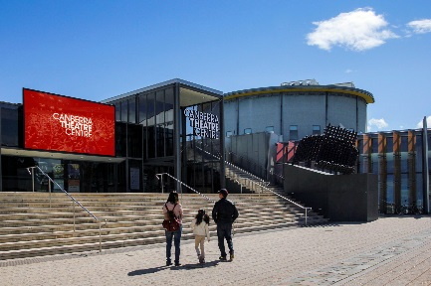Canberra Theatre Centre | 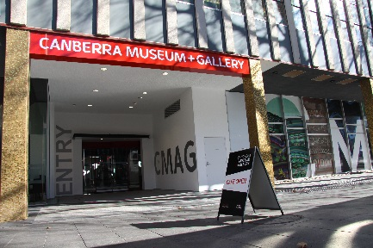CMAG |  | 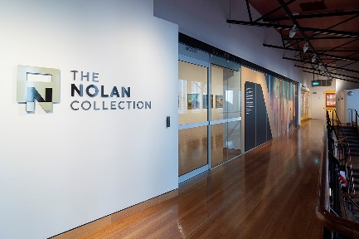The Nolan Collection
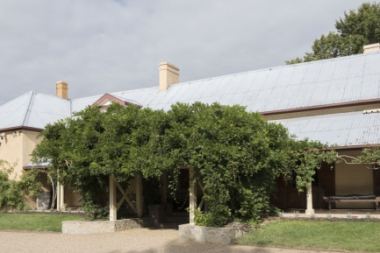Lanyon Homestead | Calthorpes’ House |  | 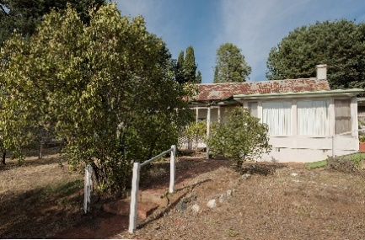Mugga-Mugga

APPENDIX 5 –
canberra museum and gallery and act historic places venues – schedule of exhibitions, programs and events
The following is a list of exhibitions, community and education programs and events at CMAG and the ACT Historic Place venues in 2019–20.
CANBERRA MUSEUM AND GALLERY
Exhibitions
* Exhibitions recorded in 2018–19 Annual Report
* Gosia Wlodarczak : frost drawing | 8 May 2016–30 June 2020
* Form Beyond Function : Nigel Lendon’s Plastic Cameras | 6 April–27 July 2019
* French Collection Nicola Dickson | 12 April–10 August 2019
The Foundation Collection (Nolan Gallery) | Permanent Exhibition
Canberra Stories | Permanent Exhibition until 13 July 2019
The Art of Giving : Works from the Meredith Hinchcliffe Fund | 1 July–24 August 2019
Activism : forces for change in Canberra | 13 July–2 November 2019
Redefining Leadership | 13 July–2 November 2019
Old Graham : Collecting in the bush | 10 August–30 November 2019
Tom Buckland : Apollo lunar module (1:2 scale) 2019 | 17 August–19 October 2019
The Garden City | 7 September–2 November 2019
Hi-Vis Futures | 16 November 2019–1 February 2020
Djinjama : Defying the grid | 2 November 2019–22 February 2020
Emeirely Nucifora-Ryan : Wavelength | 9 November 2019–14 March 2020
Growing Up Optional | 14 December 2019–28 March 2020
Building a Life : The Jennings Germans story | 15 February–7 November 2020
VOID | 15 February–1 August 2020
THE MASS | 28 February–6 June 2020
Seeing Canberra | 7 March–12 September 2020
Crafting Canberra | 7 March–12 September 2020
Place : A travelling Exhibition of artists’ books | 21 March–31 October 2020
Havana Passion : the magic of 500 years | 14 April–1 August 2020
Martyn Jolly’s Phantasmagoria | 10 June–5 September 2020
Ngaio Fitzpatrick - Dissonance | 13 June–3 October 2020
Learning and Community Programs
Floor Talks : Conducted by artists and CMAG staff for the following exhibitions : Activism : Forces for change in Canberra; Djinjama : Defying the grid; Seeing Canberra; Old Graham : Collecting in the bush; Hi-Vis Futures; and Building a Life : The Jennings Germans story.
Reel Classics : The Reel McCoy Film Society presented classic cinema film screenings throughout the year.
Other programs included :
- Seeing Canberra online learning program developed to provide resources to students and teachers during the COVID-19 public closure. This program is one of a number of digital projects developed to maintain and enhance public engagement during CMAG’s closure.
- Ngambri-Ngunnawal elder Paul House and Tom Rowney talked about their collaboration to create the recently acquired glass yidaki, with an opportunity to hear Paul play the yidaki in the gallery as part of NAIDOC week.
- A Youth Climate Forum in association with exhibition Hi-Vis Futures was held at CMAG with experts including Kate Auty, ACT Commissioner for Sustainability and Environment; Professor Will Steffen, Emeritus Professor Fenner School of Environment & Society; and PhD Candidate Aaron Tang, Climate Change Institute & Fenner School of Environment and Society. A blog reflecting on this event and connecting with the participants was posted on the CMAG website.
- CMAG hosted a Panel - 50th Anniversary LGBTIQ Activism and Reform in Canberra in partnership with the ACT Government Office for LGBTIQ Affairs.
- Children’s activity tables in school holidays.
- Board games marathon drop-in-day.
- National Multicultural Festival, Family Space.
Outreach Programs
Exhibition in a Suitcase was loaned to Forrest Primary School.
Programs conducted in association with The Nolan Collection
Floor Talk : Unmasking Nolan’s hidden paintings with Dr Paula Dredge.
Every Picture Tells a Story : A learning program exploring the paintings of Sidney Nolan, attended by various Preschools.
Other programs included : The Nolan Collection launch in new gallery at CMAG; In Conversation : Mark Fraser and CMAG Senior Curator Virginia Rigney re Sidney Nolan; In Conversation : Threads and connections with
Dr Antonino Niefi; Young Nolan project - Ainslie Primary School; Creatively Connecting People Places and Priorities–Ainslie Primary School; Nolan Hack tour; Mandarin language tour; and self guided tour by
St Thomas More school.
Outreach Programs
The Art Box : Animals and Plants was loaned to Forrest Primary School; Every Picture Tells a Story loaned to Theodore Preschool; and Stop Motion Nolan suitcases were loaned to Kaleen Primary School.
Venue Hire : Venues within CMAG were hired by 43 different organisations during 2019–20, with a number of these organisations hiring venues on multiple occasions such as the Office of Aboriginal and Torres Strait Islander Affairs, National Capital Design Review Panel, ACT Integrity Commission, Canberra Critics Circle, University of Canberra, YaMogu Lettering and Design Brush classes and the Orijen Group. The organisations ranged from Federal and ACT agencies to not-for-profit organisations, community groups, and private sector organisations.
ACT HISTORIC PLACES
Exhibitions
Lanyon
Within Living Memory | Permanent exhibition
The Cunningham Family Album | Permanent exhibition
The Convict Years | Permanent exhibition
Calthorpes’ House
Calthorpes’ House Orientation Exhibition | Permanent exhibition
Mugga-Mugga
Getting It Together | Permanent exhibition
Learning and Community Programs
Lanyon
Convicts and Who were the Convicts? : Learning programs discussing the profiles of convicts assigned to Lanyon, attended by various schools.
James’ Diary : Learning programs providing a tour of the homestead in the footsteps of James Cunningham, attended by various schools.
Child’s Play : Learning programs exploring the world of old-fashioned games and Victorian paper dolls, attended by various schools.
Other Programs included : Fruit Tree planting and pruning with ACT Historic Places Horticultural team leader, Neil Walsh; Fireside Storytelling : Wiradjuri Echoes program; Doing the Flowers workshop; Pink Floyd child’s activity in conjunction with Floriade; Spinning History vacation care program; Wally Bell Canoe Tree Walk; Indigenous Women’s Possum Skin Cloak Project; In the Garden–Summer Vegetables with ACT Historic Places Gardener, Michael Yeo; Live History–Lanyon Escape Hunt : 1835 edition; ACT Walking for Pleasure river walk; Australia Day Beyond the Homestead tours; and Lanyon Christmas Carols and Picnic.
Group tours : Legacy Widows Group; Jerrabomberra Probus Group; Galston Garden Club; National Trust Bowral; Scenic Horizons; Tranzit Tours; Tuncurry Tours; On Course Tours; Cargo Garden and Friendship Club; Diplomatic Spouses Club; ACT Walking for Pleasure group; and Dementia Australia.
Calthorpes’ House
Dawn’s Surprise : Program taking children on a journey around the house, attended by various primary schools.
Group tours : Australian Catholic University; Diplomatic Spouses Club; and Narrabundah College Architectural students.
Other programs included : What’ll you Whittle? School holiday program; and Magic Lanterns.
Mugga-Mugga
At the Garden Gate : Program that focuses on the landscape and environment of Mugga-Mugga, attended by various primary schools and early learning centres.
Group tours : Padden walking group and Indian High Commission.
Other programs included : A Mugga Ceilidh performance; Digging Googong; and meet and greet with family history society.
Historic Places Outreach Programs
Artefact Chat Boxes and Dawn's Suitcase were loaned to various primary schools.
Venue Hire/Function Usage : Spaces within Lanyon and Mugga-Mugga were used by 16 different organisations and groups during 2019–20. Lanyon was popular for weddings, birthday parties as well as other community uses. Mugga-Mugga hosted Christmas parties and a Birthday party.

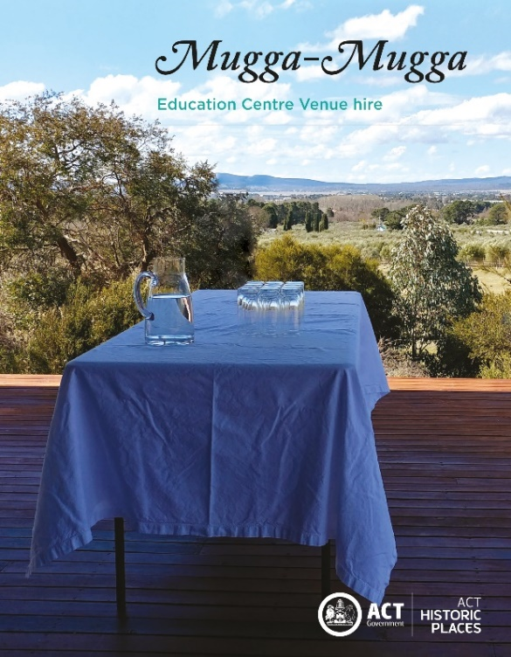
Mugga-Mugga Venue hire information brochure

APPENDIX 6 –
canberra museum and gallery – acquisitions (purchases and donations)

Purchases
Social History
- Rex Davis Meat cover silver dome
- Rex Davis Winchester trademark (1903 22 calibre automatic rifle)
- Bluewatervinyl (Ebay vendor) Vinyl record by Paul Josef and Friends from the Rainbow Region
- Designer Op Shop Tracey Lord Hat
Visual Arts
- Tom Bass Ethos Head, bronze sculpture
- Trevor Dickinson Acton, Liversidge St, A1 digital print
- Trevor Dickinson Amaroo, Mirrabei Drive, A1 digital print
- Trevor Dickinson Aranda, Bandjalong Cres, A1 digital print
- Trevor Dickinson Campbell, Constitution Ave Cres, A1 digital print
- Trevor Dickinson Chisholm, Benham St, A1 digital print
- Trevor Dickinson Fyshwick, Gladstone Street, A1 digital print
- Trevor Dickinson Giralang, Baldwin Drive, A1 digital print
- Trevor Dickinson Isabella Plains, Ellerston Ave, A1 digital print
- Trevor Dickinson Narrabundah, Caley Crescent, A1 digital print
- Trevor Dickinson Parkes, King George Terrace, A1 digital print
- Trevor Dickinson Symonston, Narrabundah Lane, A1 digital print
- Trevor Dickinson Yarralumla, Schlich Street, A1 digital print
- Brenda L. Croft Dot 21 and Joe 33 Cooma 1959, 2018, pigment print, 110x110cm
- Brenda L. Croft Joe, Red Hill Lookout, Canberra, 2018, pigment print, 110x110cm
- Dean Cross Untitled Landscape (Bogong Moths), 2018, digital print
- Dean Cross Untitled Landscape (Double Self Portrait with horse), 2018, digital print
- Dean Cross T.N (it started here), 2016, oil on linen
- OAT Studio Tunnels- Earth, printed on linen, 2m
- OAT Studio Out-takes - Oatmeal/Bigger, printed on Oatmeal linen, 2m
- OAT Studio Outlines – Terracotta, printed on Oatmeal linen, 2m
- Anika Romeyn Endurance IV 2019, watercolour monotype on paper
- Waratah Lahy Playing in the apocalypse, Ink & watercolour on paper image 12 x 14 cm
- Waratah Lahy Warning Sign, Ink & watercolour on paper image 12 x 14 cm
- Ian Jones, Basket with Gold Luster 2019
- Ruth Oliphant, Kiln 2 2019

Donations
Social History
- Bill Carney 6 x black and white photographs
- Capital Metro Foam tram and cardboard model tram
- Klaus Tschorn Tools and documents
- Ann de Wouytch Souvenir card addressed to E.W. Solly
- Urban Renewal Branch, Environmental, Planning and Sustainable Development Directorate Sign 'block 1' from Northbourne Flats
- Penny Jurkiewicz Jurkiewicz Collection including documents, photos and clothing
- Bovis Lend Lease Fire is an enemy without a conscience sign
- John McLaren William Alexander McLaren items including medals, caricature and photograph
- John Bundock Canberra Club items including port bottle, jumper and tie
- Lorne Parker-Doyle and Anne McNamara Mock-up for book titled 'Mister Furoche'
- Lenore Rays and Tim Bass Canberra Coat of Arms items including drawings, folder and print
- Eric Martin Cotton tea towel with the text GLASS-FCC-CLOTH
- Lady Lois Hicks Hicks Collection items including razor kit, child's shoes and rag rugs
- Alison Ryan (nee Marks) Dairy related items including a receipt and delivery book
- ACT Heritage Library 5 x Sydney 2000 Canberra Soccer Banners
- Morgyn Phillips Posters by David Pope, Annie Franklin, Deej Fabyc and Toni Robertson
- Libby Quinn Souvenir tray with Canberra buildings
- Meredith Hinchliffe T-shirts associated with ACT Heritage week, Human Veins Dance Theatre, Eureka! Theatre Company, 2XX and Canberra tourist map and 1985 Canberra Festival badge
- Susan Dovey and Mary Mills Thank you letter to George Fane De Salis for WW1 service on Buckingham Palace letterhead
- Petronella Wensing Lace image of St Christopher's Cathedral in Manuka
- Canberra Mothercraft Society Various items associated with Canberra Mothercraft Society and Queen Elizabeth II centre
- Llois Cutts Trophy, tiara, ballgown and ephemera related to Miss ACT competition, 1958
- Rex Davis Family Bible of William Davis (1837) and Canberra book
- Christopher BOGG Photographs of Ethos statue and Civic Square
- Christian Poulson 'Canberra, visit your National Capital' poster and Canberra High School Blazer
- Margaret Ryan Canberra florin brooch featuring Parliament House

Visual Arts
- John Robinson The Universe 1976-77, Bronze, 66cm(h)
- John Robinson Galaxies 1976-77, Tapestry of Australian wool 100 x 160cm
- John Robinson Ra 1976-77, Bronze 48cm(h)
- John Robinson Eclipse 1976-77, Bronze 33cm(h)
- John Robinson Solar Motion 1976-77, Bronze 29cm(h)
- John Robinson Water Planet 1976-77, Tapestry of Australian wool 100 x 160cm
- John Robinson Time 1976-77, Bronze 26cm(h)
- John Robinson Time Flux 1976-77, Tapestry of Australian wool 160 x 100cm
- John Robinson Water 1976-77, Bronze 35.5cm(h)
- John Robinson Fruit 1976-77, Bronze 23cm(h)
- John Robinson Lingham 1976-77, Bronze 24cm(h)
- John Robinson Yoni 1976-77, Bronze 20cm(h)
- John Robinson Fertility 1976-77, Bronze 43cm(h) 27cm(h)
- John Robinson Spring 1976-77, Tapestry of Australian wool 160 x 100cm
- John Robinson Sexual Attraction 1976-77, Bronze 27cm(h)
- John Robinson Adam and Eve 1976-77, Bronze 46cm(h)
- John Robinson Love Knot 1976-77, Bronze 29cm(h)
- John Robinson Dependent Beings 1976-77, Bronze 30cm(h)
- John Robinson Love Union 1976-77, Tapestry of Australian wool 100 x 160cm
- John Robinson Marriage of Minds 1976-77, Bronze 31cm(h)
- John Robinson Summer 1976-77, Tapestry of Australian wool 100 x 160cm
- John Robinson Sun moon ovary 1976-77, Bronze 32cm(h)
- John Robinson Sun moon sperm 1976-77, Bronze 29cm(h)
- John Robinson Dominance and submission 1976-77, Bronze 31cm(h)
- John Robinson Vortex of Ecstasy 1976-77, Bronze 51cm(h)
- John Robinson Wave 1976-77, Bronze 28cm(h)
- John Robinson Womb 1976-77, Bronze 38cm(h)
- John Robinson Conception 1976-77, Bronze 29cm(h)
- John Robinson Tribe 1976-77, Tapestry of Australian wool 100 x 160cm
- John Robinson Man child 1976-77, Bronze 31cm(h)
- John Robinson Growth 1976-77, Bronze 35cm(h)
- John Robinson Embryo 1976-77, Bronze 30cm(h)
- John Robinson Miracle of life 1976-77, Bronze 25cm
- John Robinson Mother and child 1976-77, Bronze 29cm(h)
- John Robinson Birth cycle 1976-77, Bronze 31cm(h)
- John Robinson Mortality 1976-77, Bronze 28cm(h)
- John Robinson Autumn 1976-77, Tapestry of Australian wool 160 x 100cm
- John Robinson Shadow of evening 1976-77, Bronze 28cm(h)
- John Robinson Conscience 1976-77, Bronze 26cm(h)
- John Robinson Winter 1976-77, Tapestry of Australian wool 100 x 160cm
- John Robinson Eternity 1976-77, Bronze 31cm(h)
- John Robinson Transcend 1976-77, Bronze 43cm(h)
- John Robinson Tranquility 1976-77, Tapestry of Australian wool 100 x 160cm
- John Robinson Creed 1976-77, Bronze 32cm(h)
- John Robinson Hymn of praise 1976-77, Bronze 43cm(h)
- John Robinson Bonds of friendship 1976-77, Bronze 22cm(h)
- John Robinson Trust bonds 1976-77, Tapestry of Australian wool 100 x 160cm
- John Robinson Golden rule 1976-77, Bronze 31cm(h)
- John Robinson Adagio 1976-77, Bronze 40cm(h)
- John Robinson Twentieth Century reflections 1976-77, Bronze 17cm(h)
- John Robinson Enigma 1976-77, Bronze 48cm(h)
- Dorothy Thornhill Canberra Landscape c. 1940-2, Oil on stretched canvas 51.5 x 61.6 cm

Note : in some cases the acquisition process was being finalised as at 30 June 2020.

APPENDIX 7 –
major funding, sponsorship and support
The CFC enjoyed the continuing support of Government agencies and of several major sponsors, as well as the assistance of many donors and supporters during 2019-20. Without their generous support many of the CFC’s performances, exhibitions, programs and events would not be possible.

CFC Government Funding
ACT Government

CANBERRA MUSEUM AND GALLERY
Government Funding
Commonwealth Department of Infrastructure, Transport, Cities and Regional Development

Major Non-Government Support (over $10,000)
Meredith Hinchliffe
Anonymous donation - John Robinson Collection

Supporters (up to the value of $10,000 and major in-kind support)
John Hindmarsh AM (former CFC Chair)
Harriet Elvin (CFC CEO)
Embassy of the Federal Republic of Germany
AV Jennings

Contributions to the Canberra Region Treasures Fund 2014–2020
John Hindmarsh AM (former CFC Chair)
Louise Douglas (former CFC Chair)
Virginia Haussegger AM (CFC Board Member)
Harriet Elvin (CFC CEO)
Dawn Waterhouse
Laura Cree
Maureen Fisher
John Mulvaney AO
Kerry-Anne Cousins
Koula Notaras
John Olsen OBE AO
Jody Turner
Frank Bergersen
John and Dianne Firth
Dr Howard Galloway
Dr Charlotte Galloway
Rosanna Burston
Phoebe Bischoff OAM
Robyn A Duncan
Lady L D Yeend
Jacqueline Pinkava
Estelle Barnes
Bill and Beverley Wood
Dorothy Cameron
Marian Hill
Judith Bibo
Gabrielle Watt
Karina Harris and Neil Hobbs
Dr Roslyn V Russell
Kristine Reithmiller
Joan Adler
Paul G White PSM

ACT Historic Places

ACT Government Funding
Environment, Planning and Sustainable Development Directorate

Canberra Theatre Centre

Supporters (up to the value of $10,000 and major in-kind support)
Gordon Ramsay - MLA
Helen O’Neil (CFC Board Member)
Stephanie Gill
Attachment 1 –

Financial and Performance Statements and MD&A


Attachment 1
Financial and Performance Statements and MD&A

INDEPENDENT AUDITOR’S REPORT

To the Members of the ACT Legislative Assembly

Opinion
I have audited the financial statements of the Cultural Facilities Corporation (Corporation) for the year ended 30 June 2020 which comprise the operating statement, balance sheet, statement of changes in equity, statement of cash flows, statement of appropriation and notes to the financial statements, including a summary of significant accounting policies and other explanatory information.

In my opinion, the financial statements:
- present fairly, in all material respects, the Corporation's financial position as at 30 June 2020, and its financial performance and cash flows for the year then ended; and
- are presented in accordance with the Financial Management Act 1996 and comply with Australian Accounting Standards.

Basis for opinion

I conducted the audit in accordance with the Australian Auditing Standards. My responsibilities under the standards are further described in the ‘Auditor’s responsibilities for the audit of the financial statements’ section of this report.

I am independent of the Corporation in accordance with the ethical requirements of the Accounting Professional and Ethical Standards Board’s APES 110 Code of Ethics for Professional Accountants (including Independence Standards) (Code). I have also fulfilled my other ethical responsibilities in accordance with the Code.

I believe that the audit evidence obtained is sufficient and appropriate to provide a basis for my opinion.

Responsibilities of the Corporation for the financial statements
The Governing Board is responsible for:
- preparing and fairly presenting the financial statements in accordance with the Financial Management Act 1996, and relevant Australian Accounting Standards;
- determining the internal controls necessary for the preparation and fair presentation of the financial statements so that they are free from material misstatements, whether due to error or fraud; and
- assessing the ability of the Corporation to continue as a going concern and disclosing, as applicable, matters relating to going concern and using the going concern basis of accounting in preparing the financial statements.

Auditor’s responsibilities for the audit of the financial statements

Under the Financial Management Act 1996, the Auditor-General is responsible for issuing an audit report that includes an independent opinion on the financial statements of the Corporation.

My objective is to obtain reasonable assurance about whether the financial statements as a whole are free from material misstatement, whether due to fraud or error, and to issue an auditor’s report that includes my opinion.

Reasonable assurance is a high level of assurance, but is not a guarantee that an audit conducted in accordance with Australian Auditing Standards will always detect a material misstatement when it exists. Misstatements can arise from fraud or error and are considered material if, individually or in aggregate, they could reasonably be expected to influence the economic decisions of users taken on the basis of the financial statements.

As part of an audit in accordance with Australian Auditing Standards, I exercise professional judgement and maintain professional scepticism throughout the audit. I also:
- identify and assess the risks of material misstatement of the financial statements, whether due to fraud or error, design and perform audit procedures responsive to those risks, and obtain audit evidence that is sufficient and appropriate to provide a basis for my opinion. The risk of not detecting a material misstatement resulting from fraud is higher than for one resulting from error, as fraud may involve collusion, forgery, intentional omissions, misrepresentations, or the override of internal control;
- obtain an understanding of internal controls relevant to the audit in order to design audit procedures that are appropriate in the circumstances, but not for expressing an opinion on the effectiveness of the Corporation’s internal controls;
- evaluate the appropriateness of accounting policies used and the reasonableness of accounting estimates and related disclosures made by the Corporation;
- conclude on the appropriateness of the Corporation’s use of the going concern basis of accounting and, based on audit evidence obtained, whether a material uncertainty exists related to events or conditions that may cast significant doubt on the Corporation’s ability to continue as a going concern. If I conclude that a material uncertainty exists, I am required to draw attention in this report to the related disclosures in the financial statements or, if such disclosures are inadequate, to modify my opinion. I base my conclusions on the audit evidence obtained up to the date of this report. However, future events or conditions may cause the Corporation to cease to continue as a going concern; and
- evaluate the overall presentation, structure and content of the financial statements, including the disclosures, and whether they represent the underlying transactions and events in a manner that achieves fair presentation.

I communicate with the Governing Board regarding, among other matters, the planned scope and timing of the audit and significant audit findings, including any significant deficiencies in internal control that I identify during my audit.


Ajay Sharma
Assistant Auditor-General, Financial Audit
28 September 2020
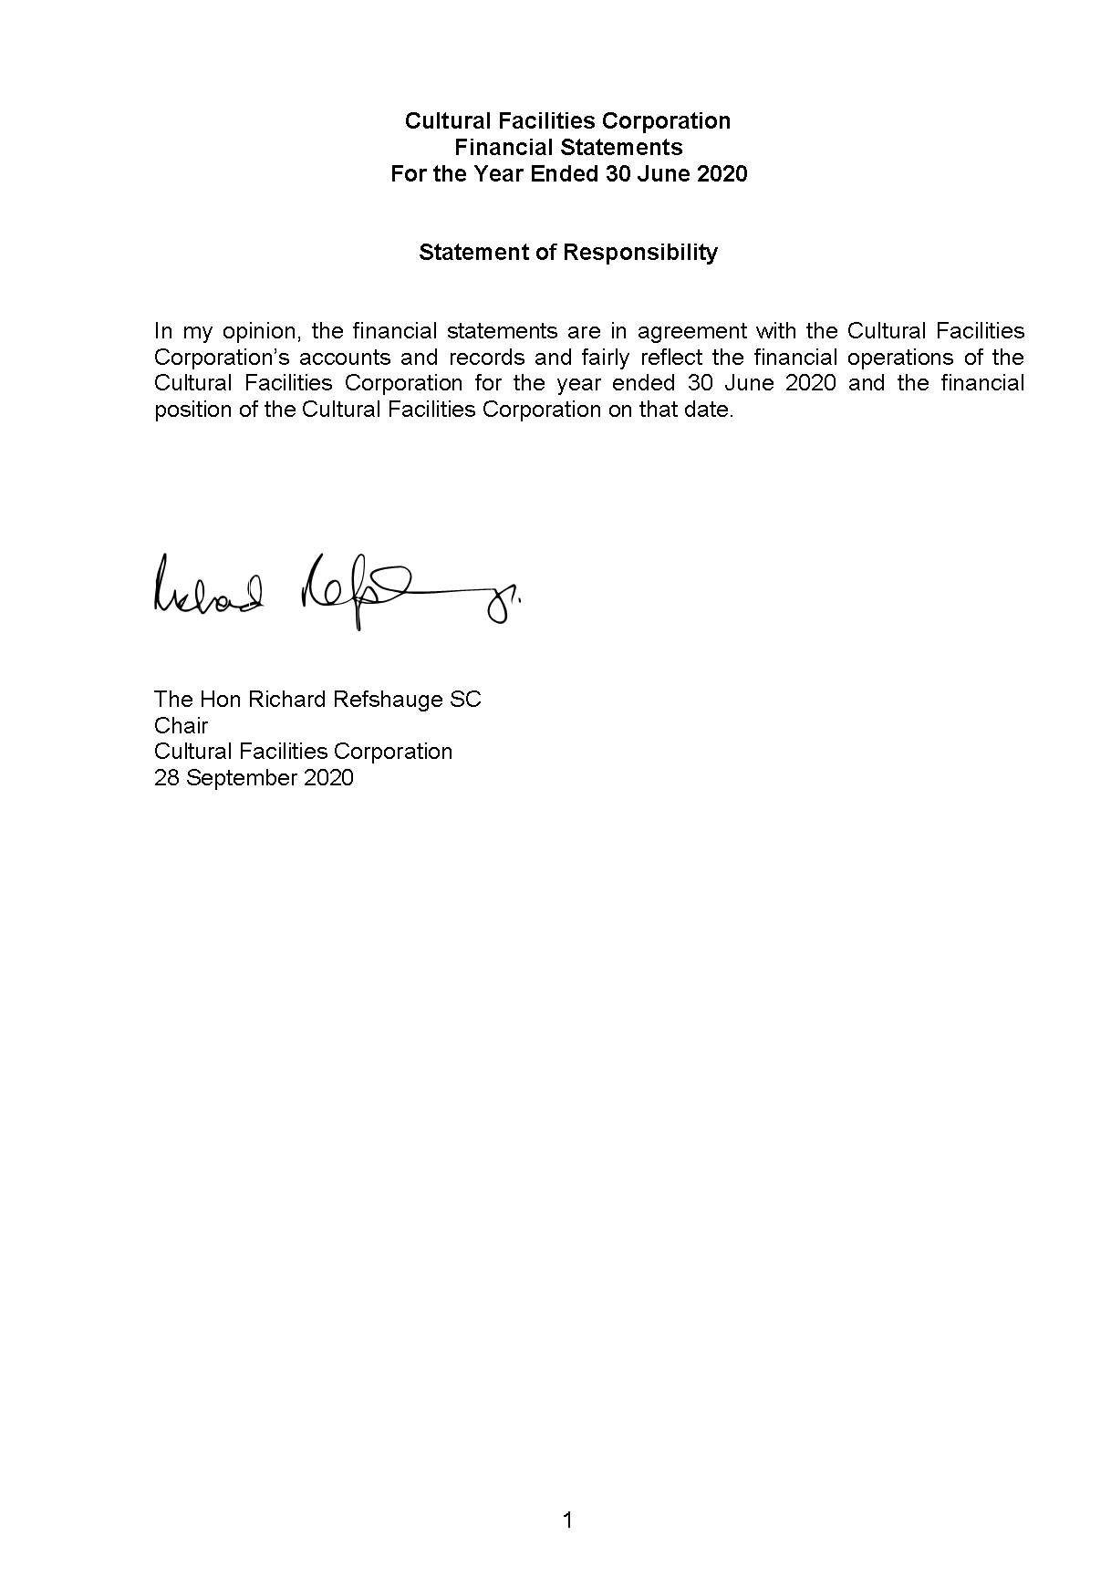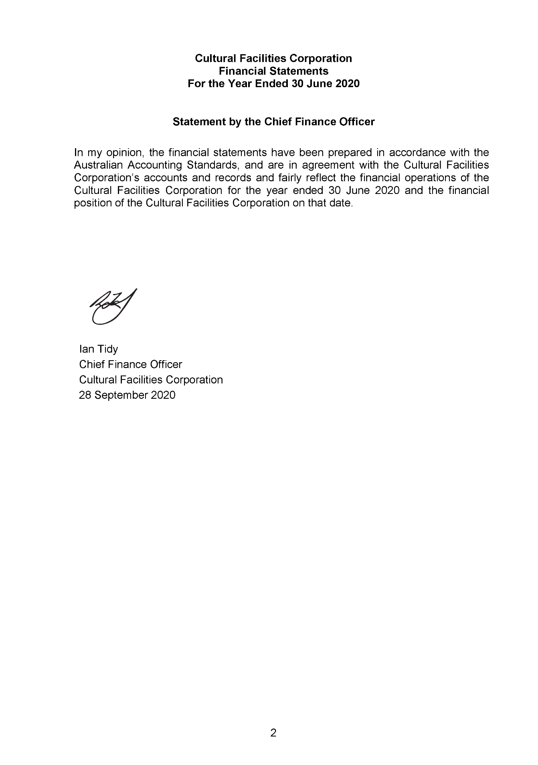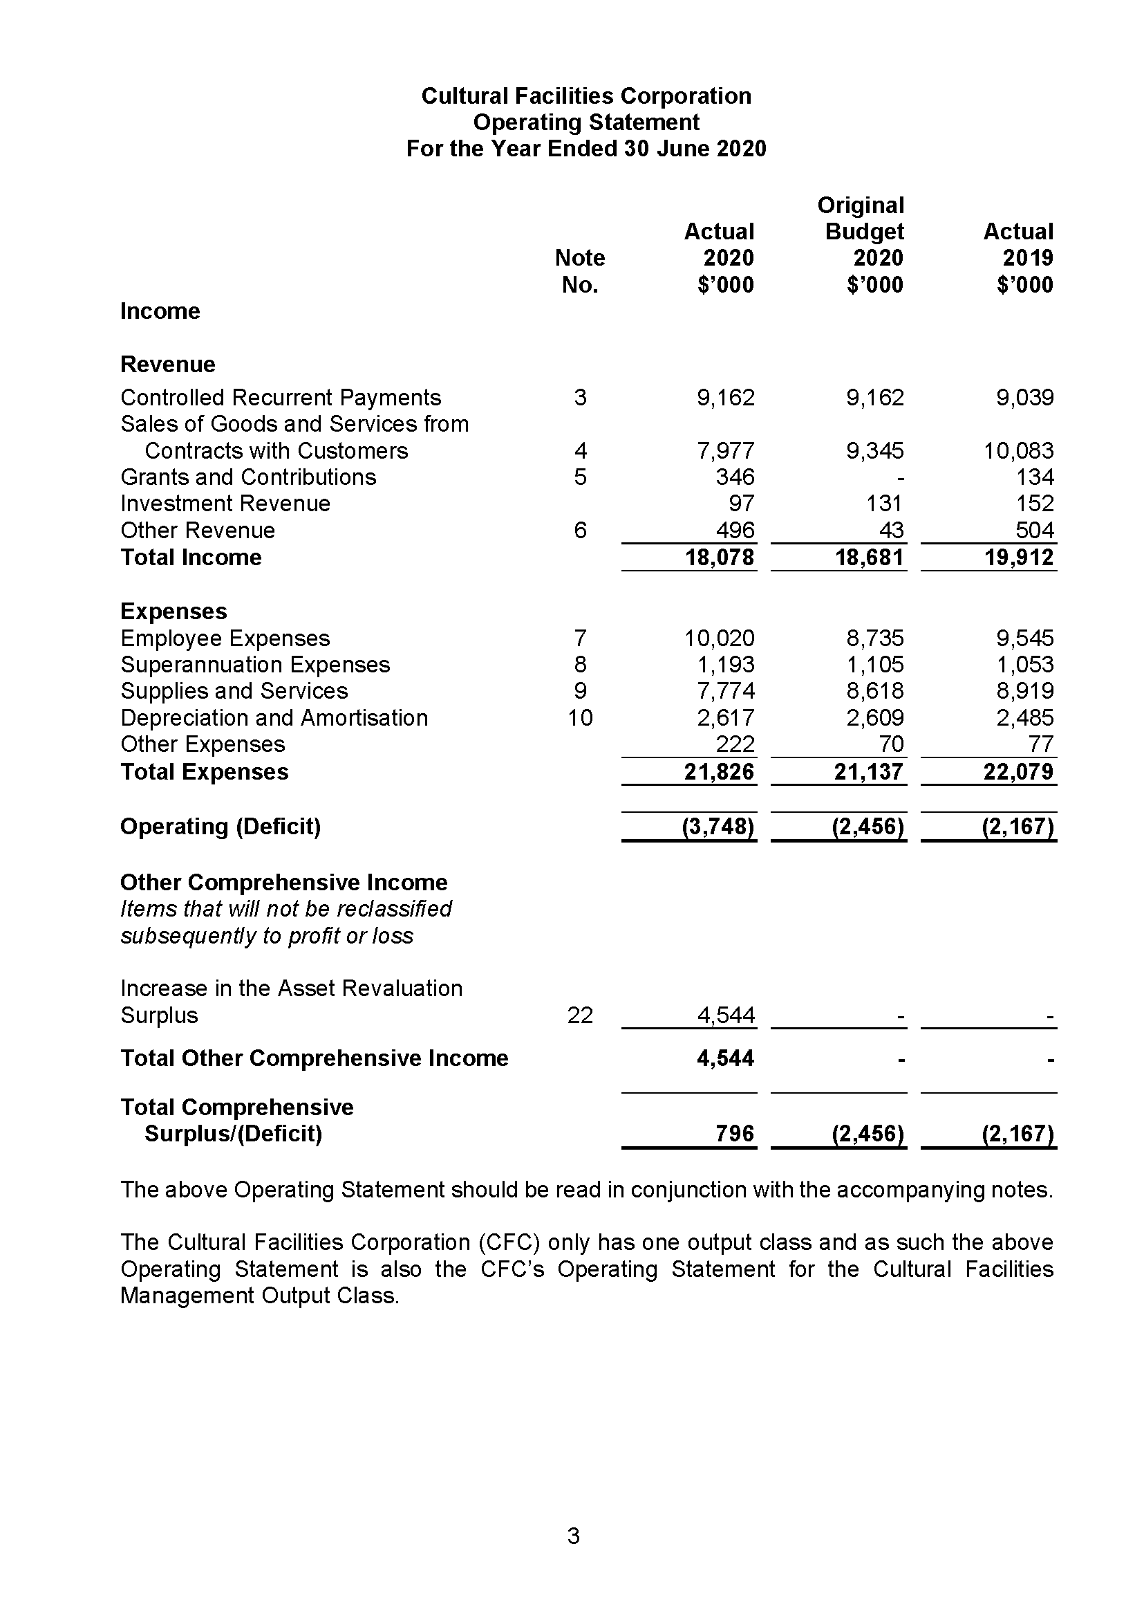
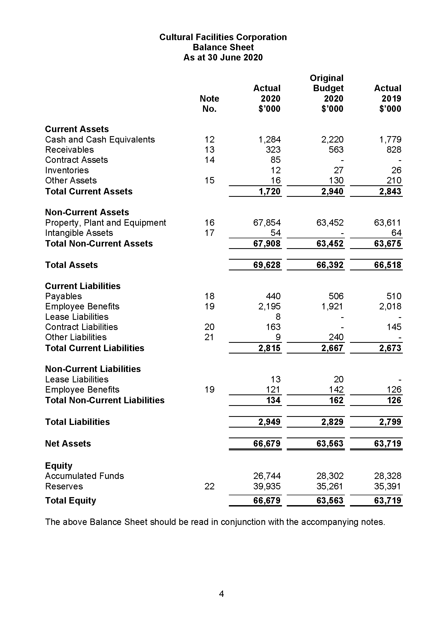
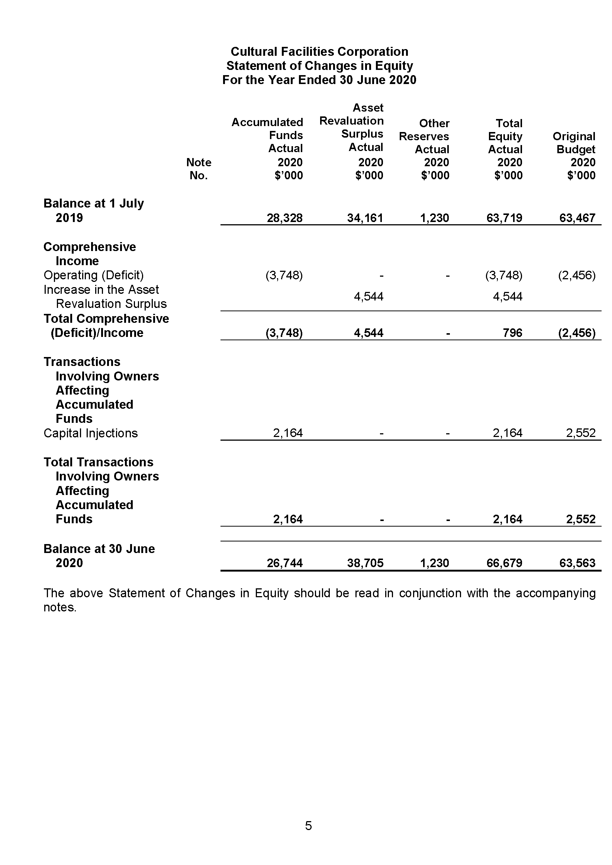

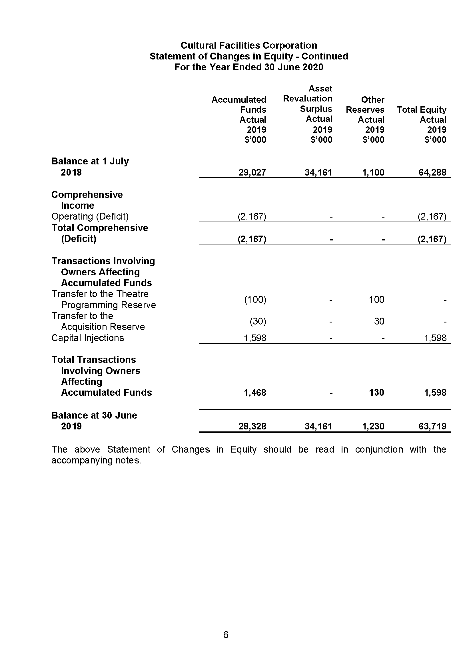
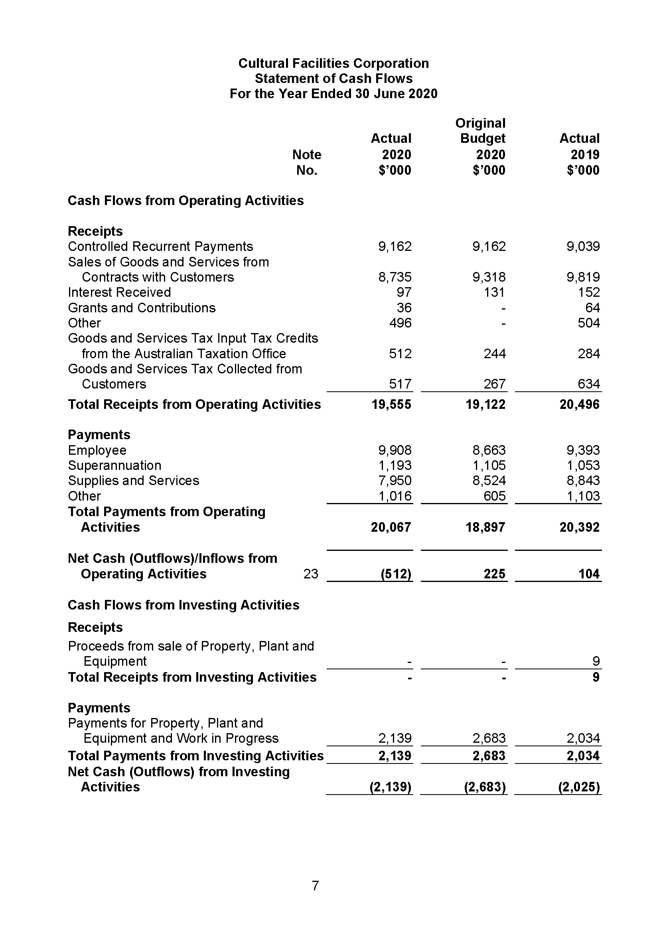

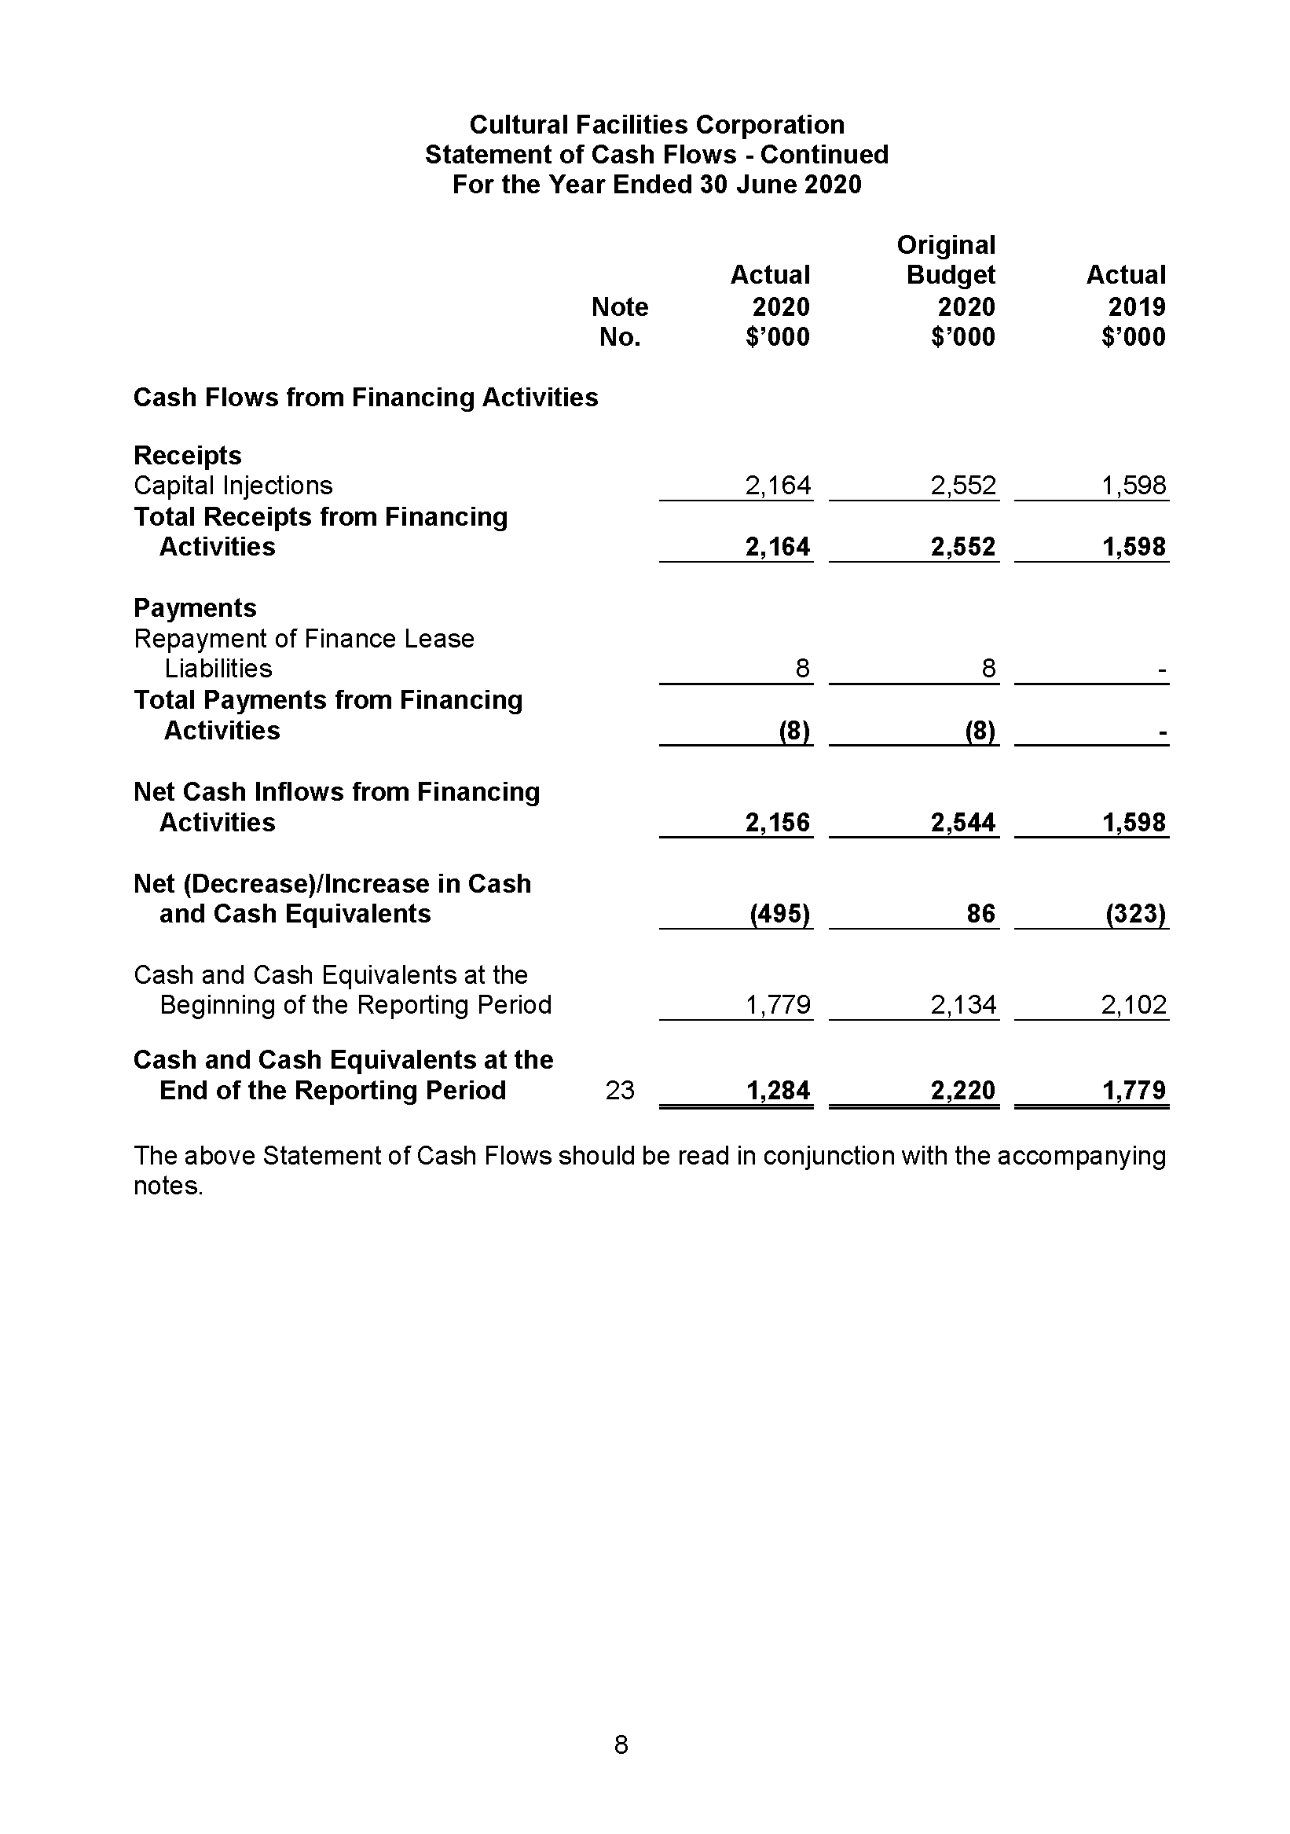

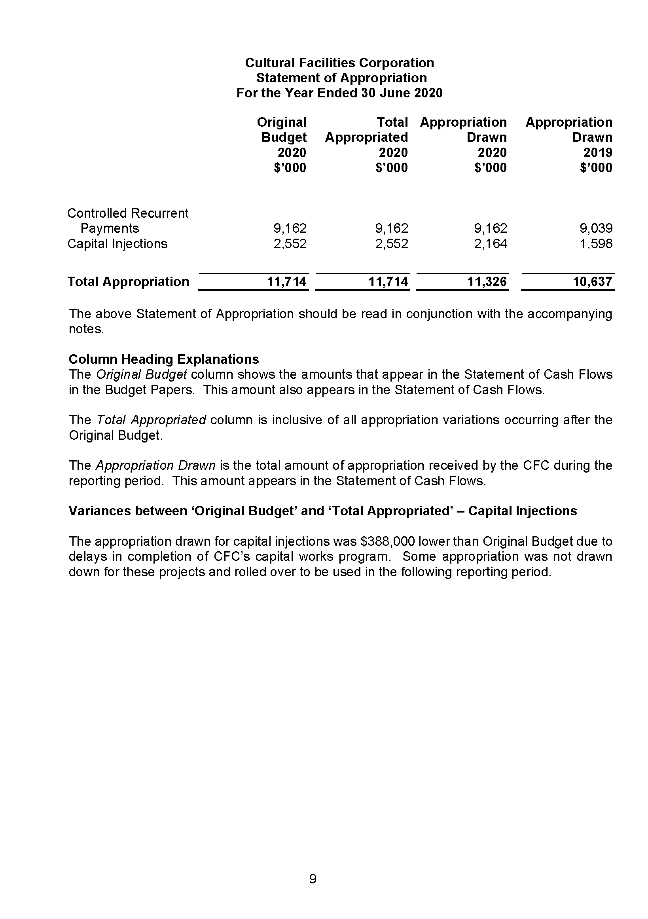
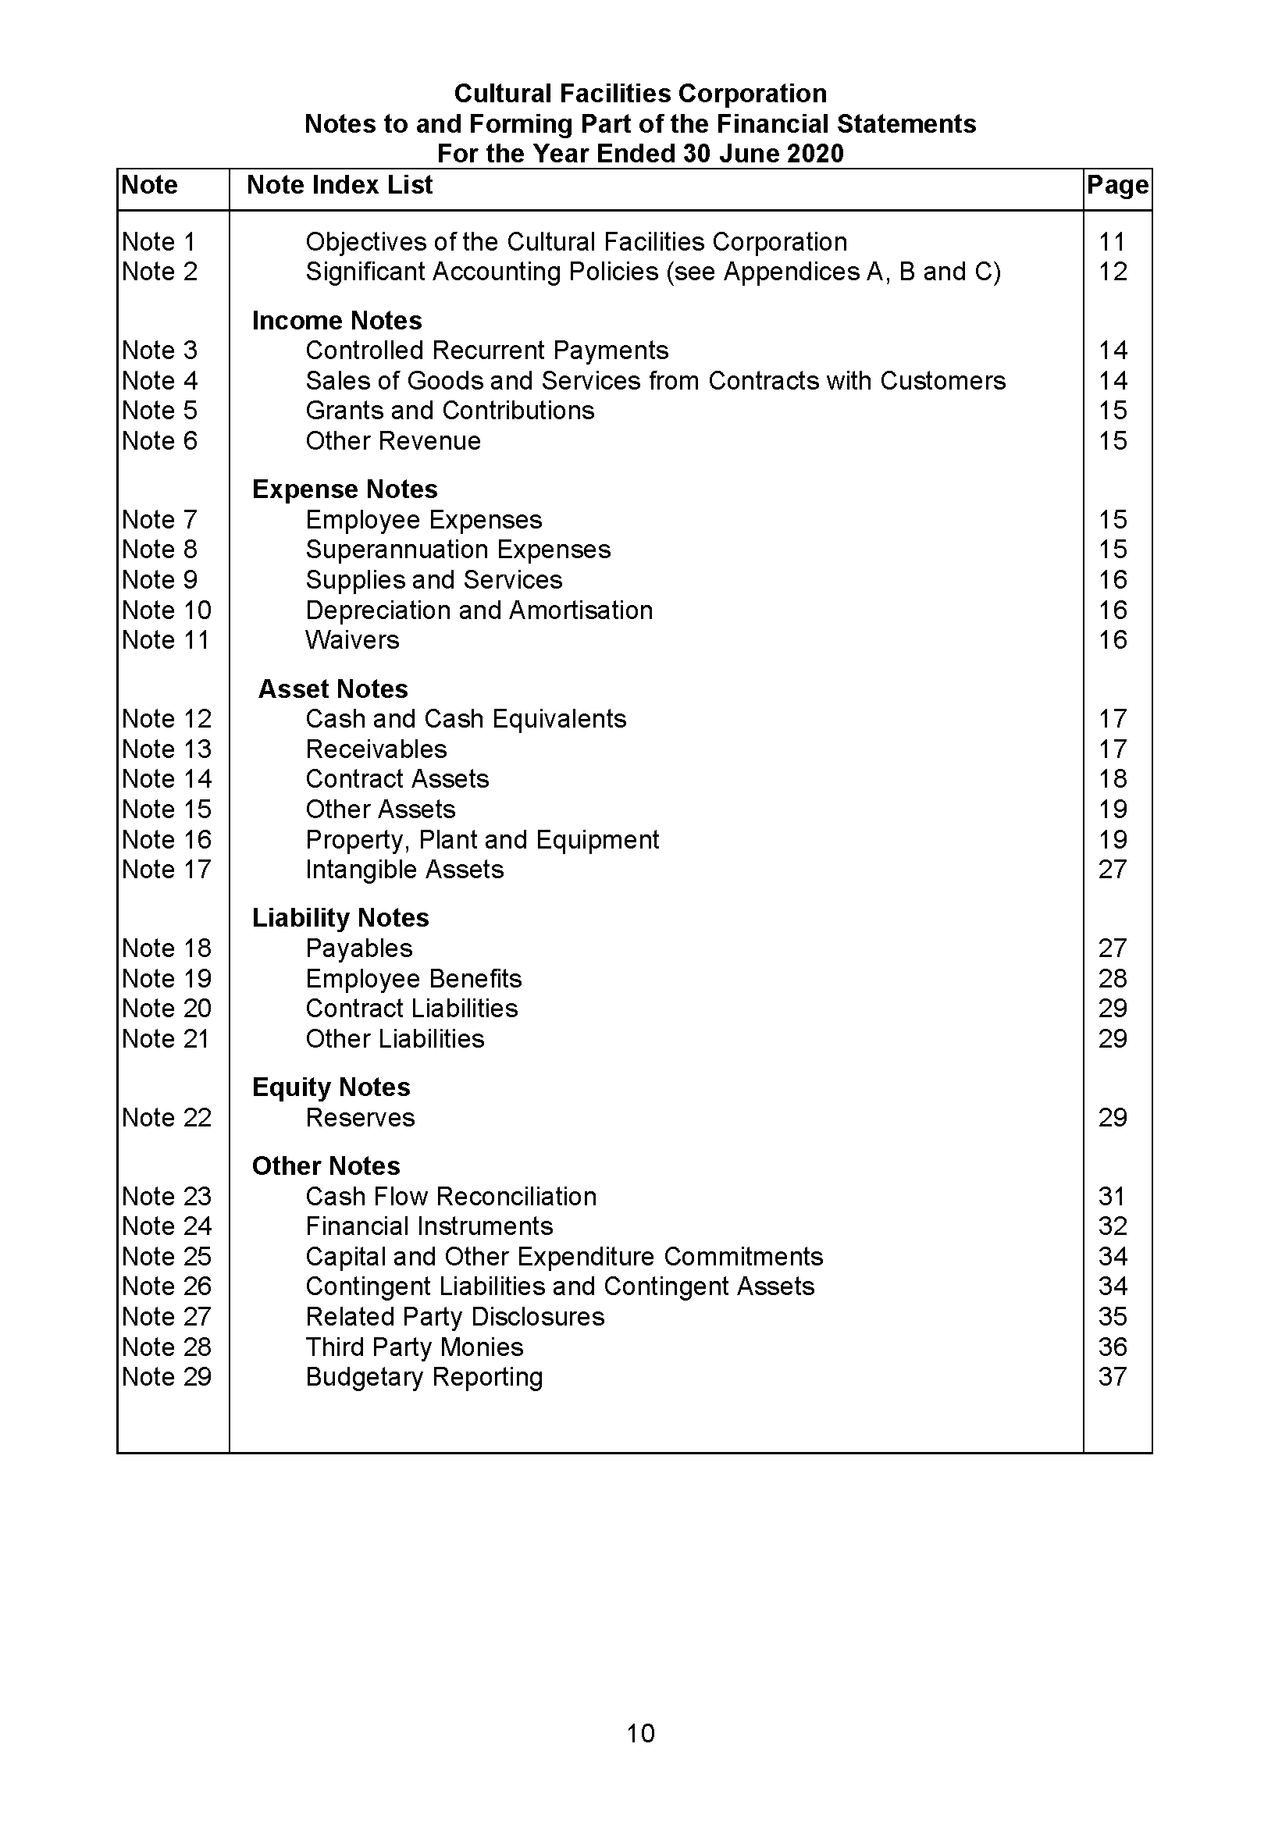

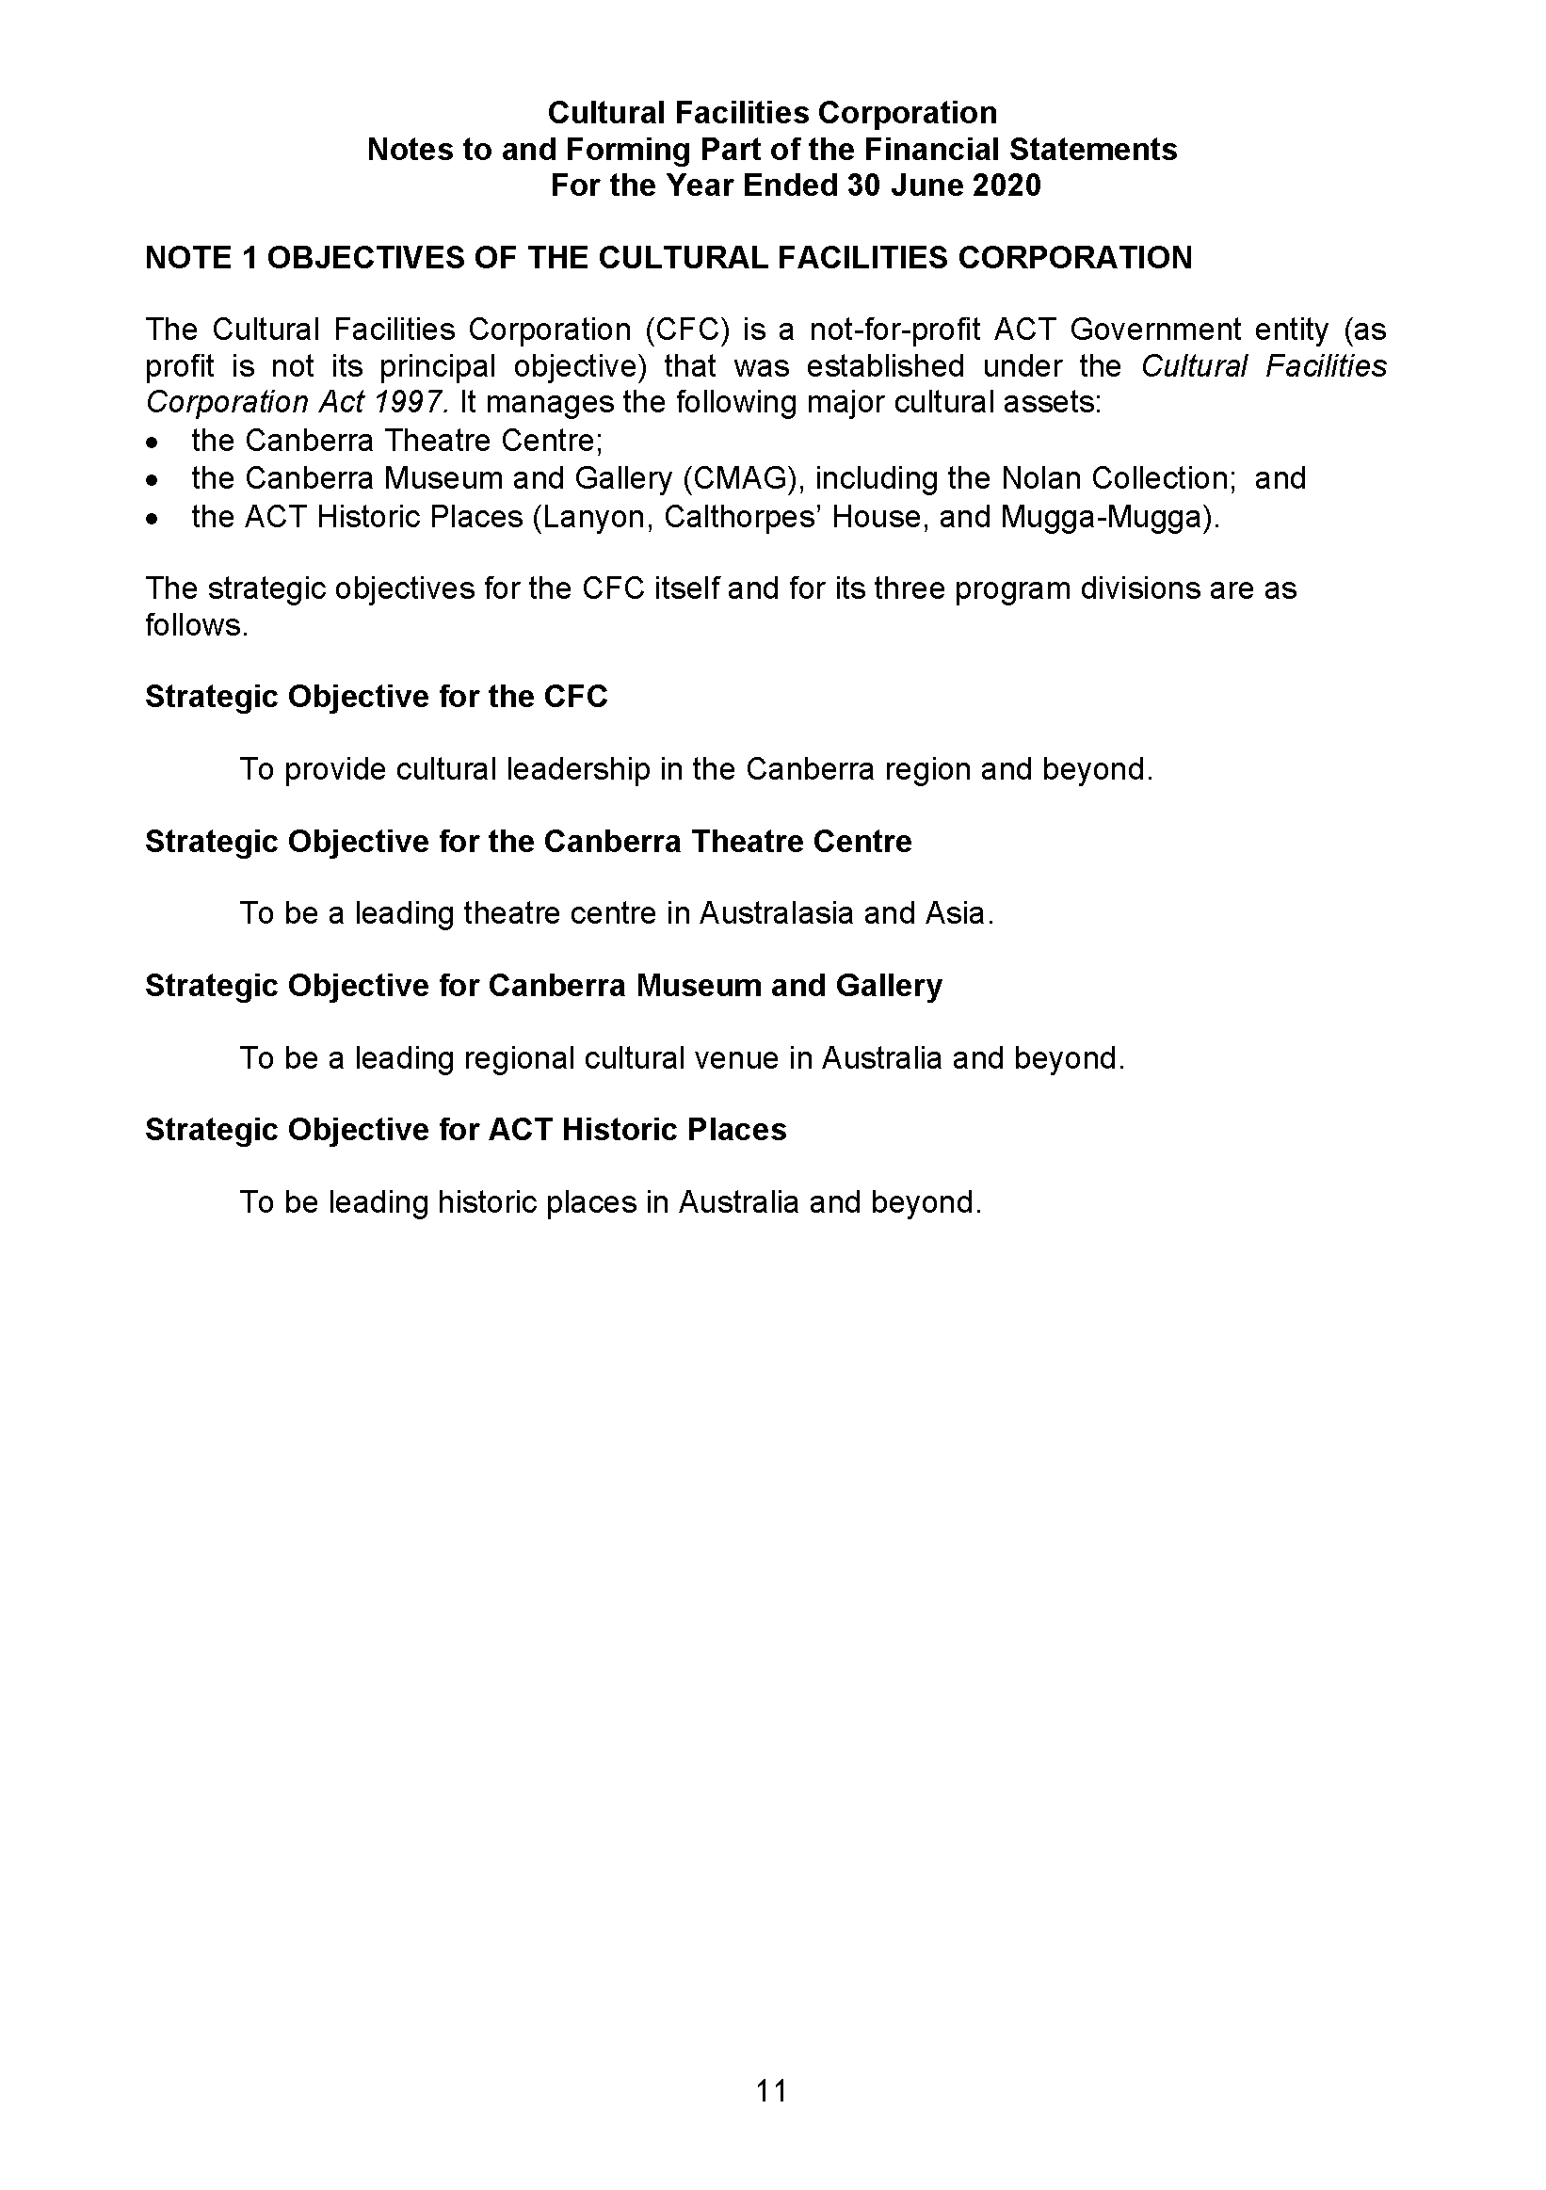

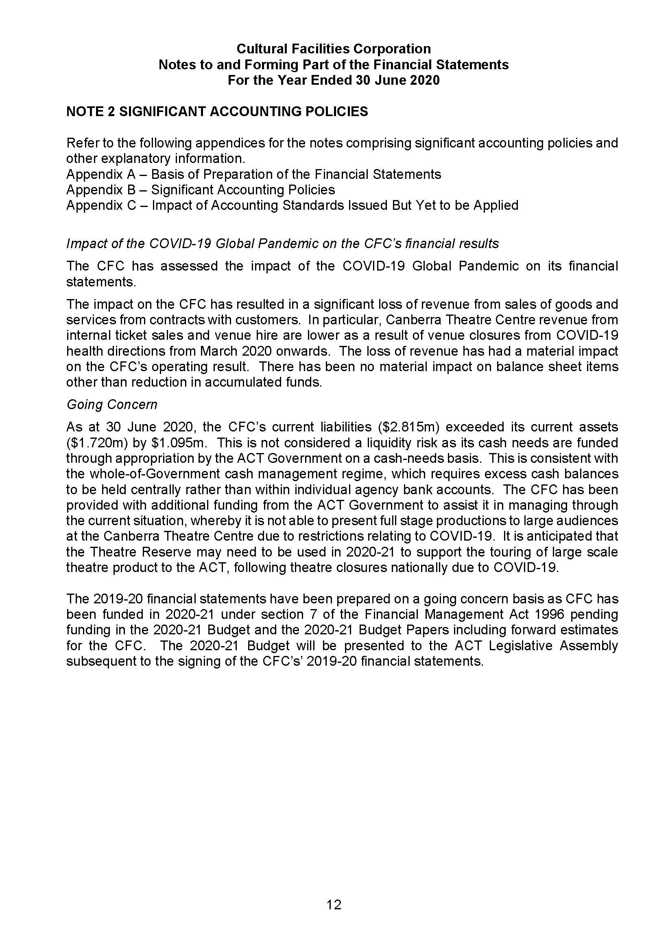

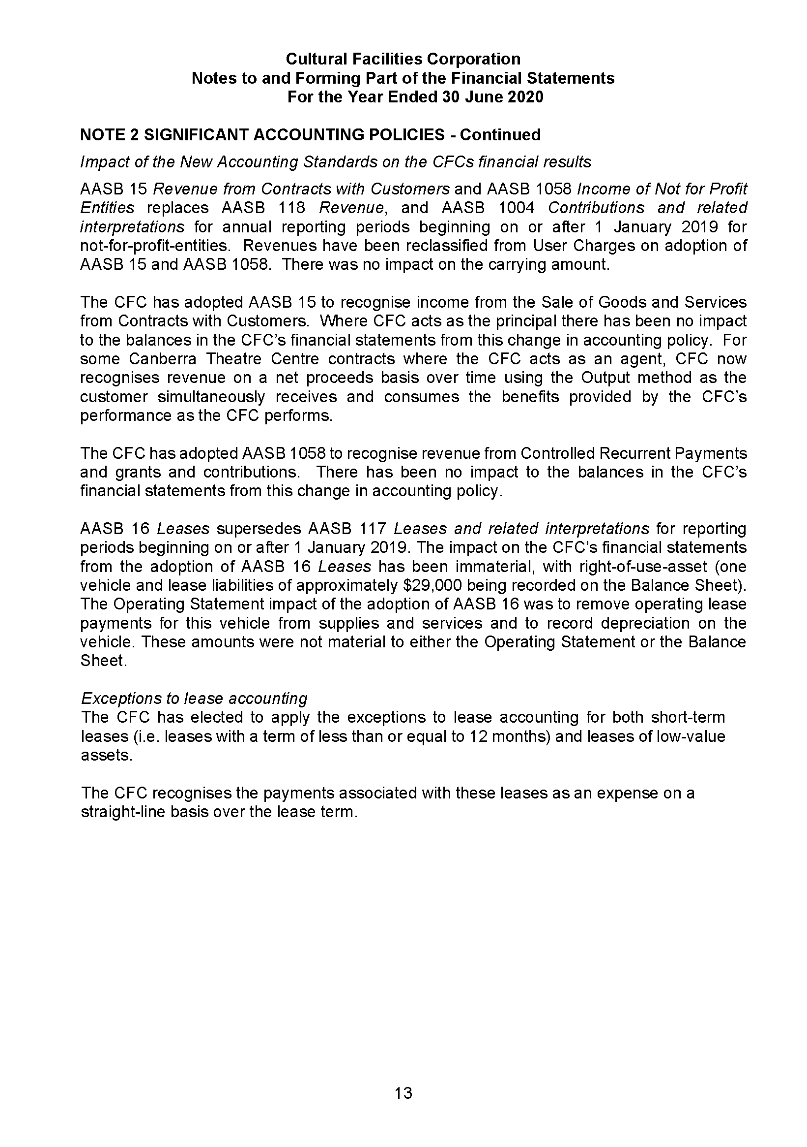

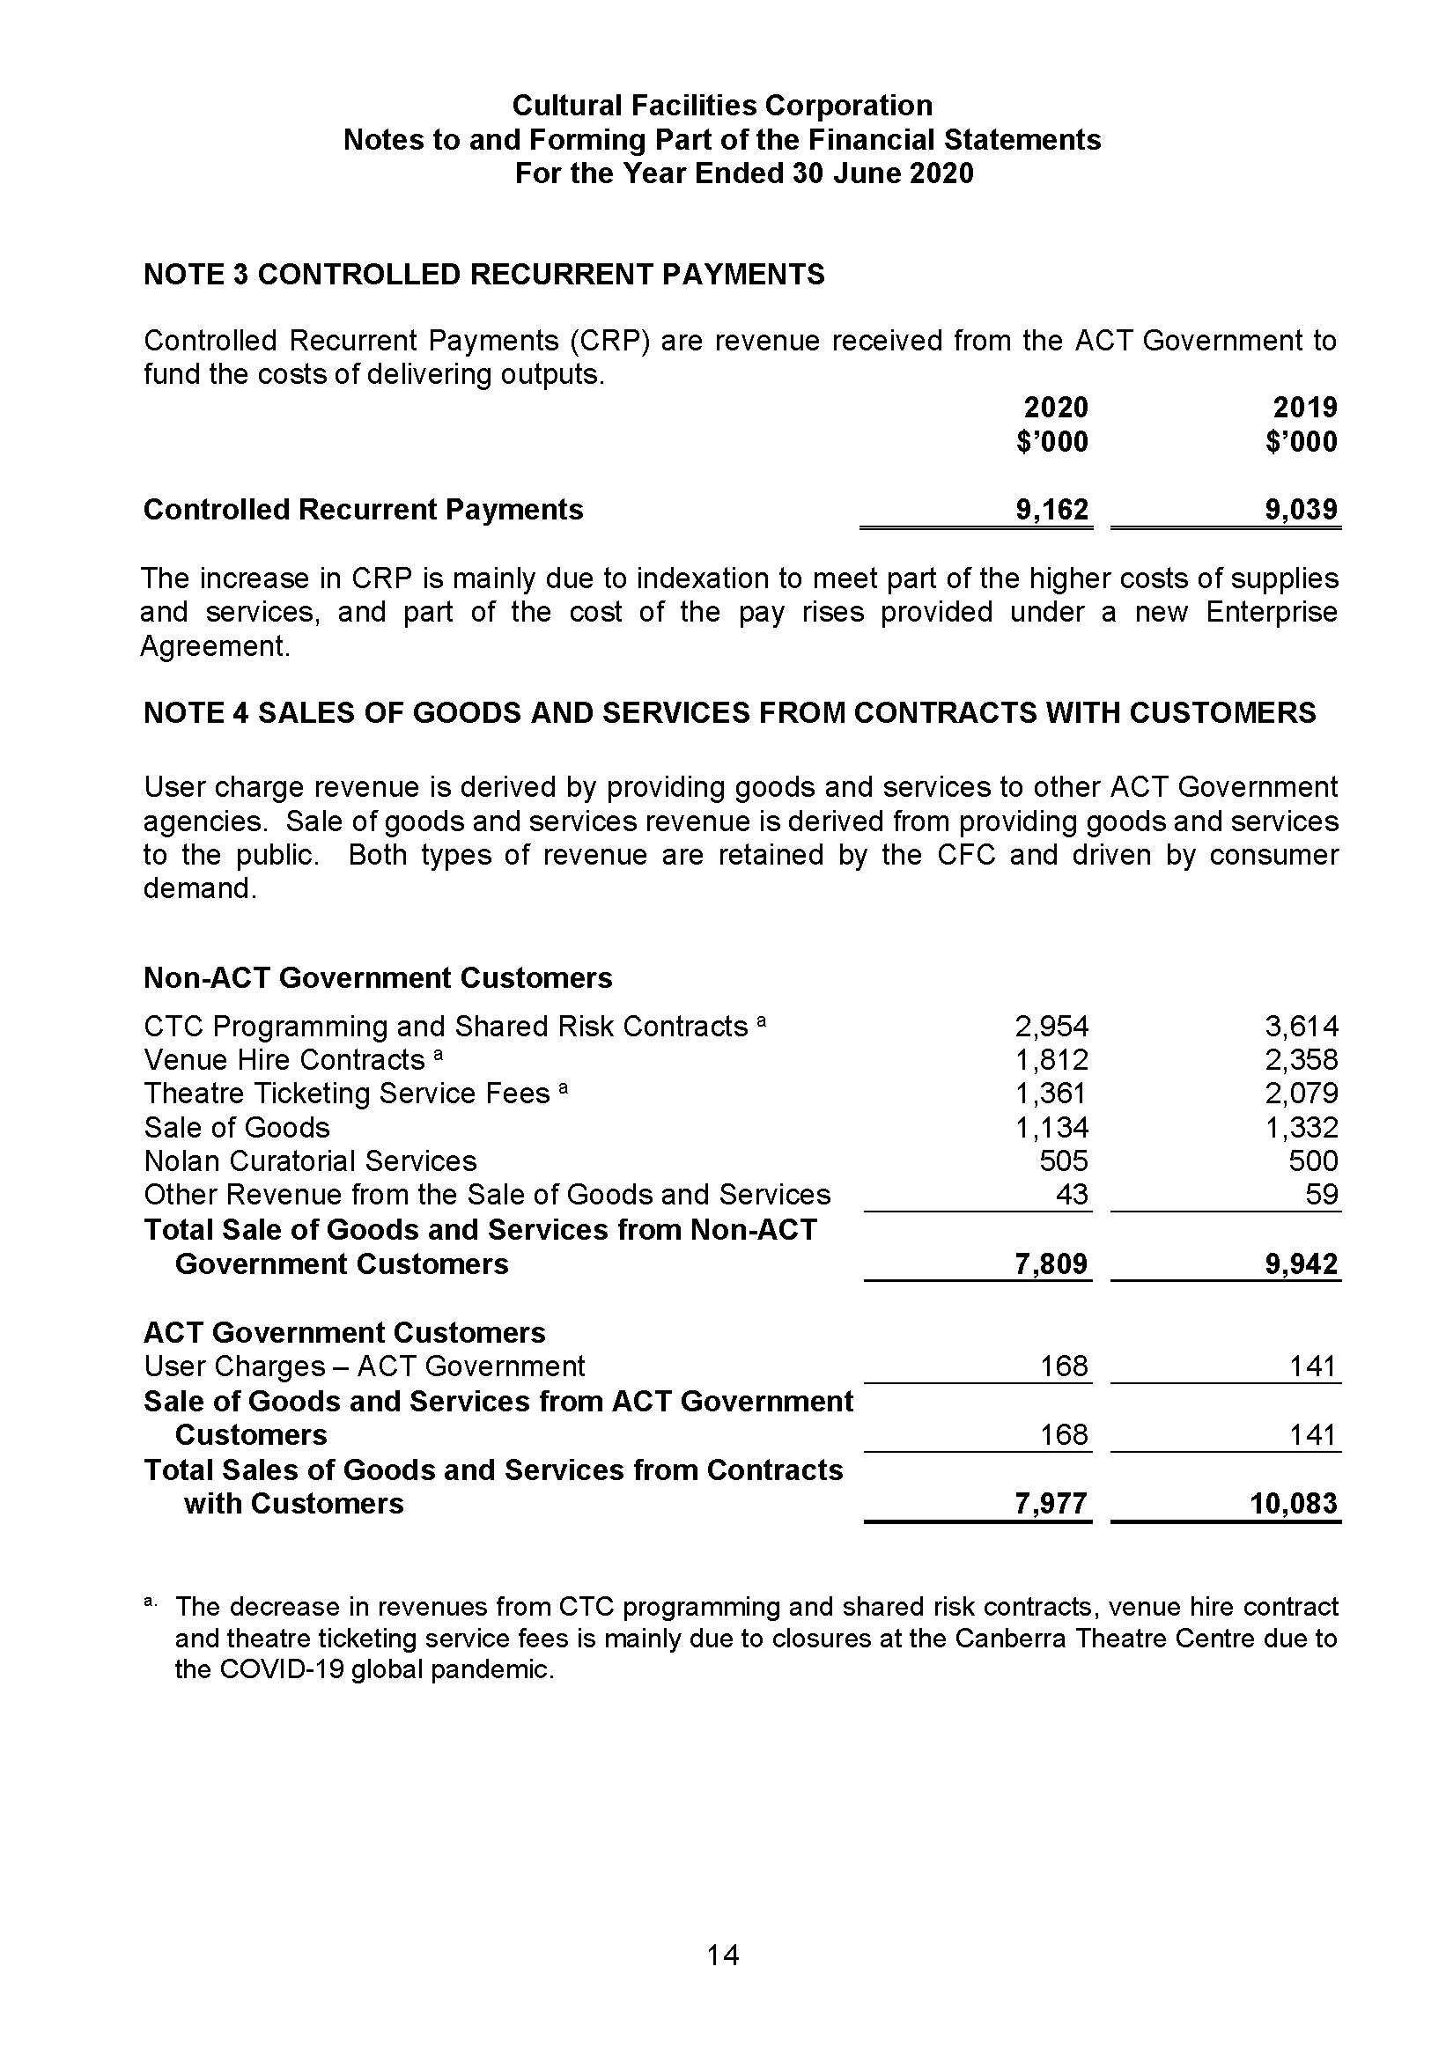

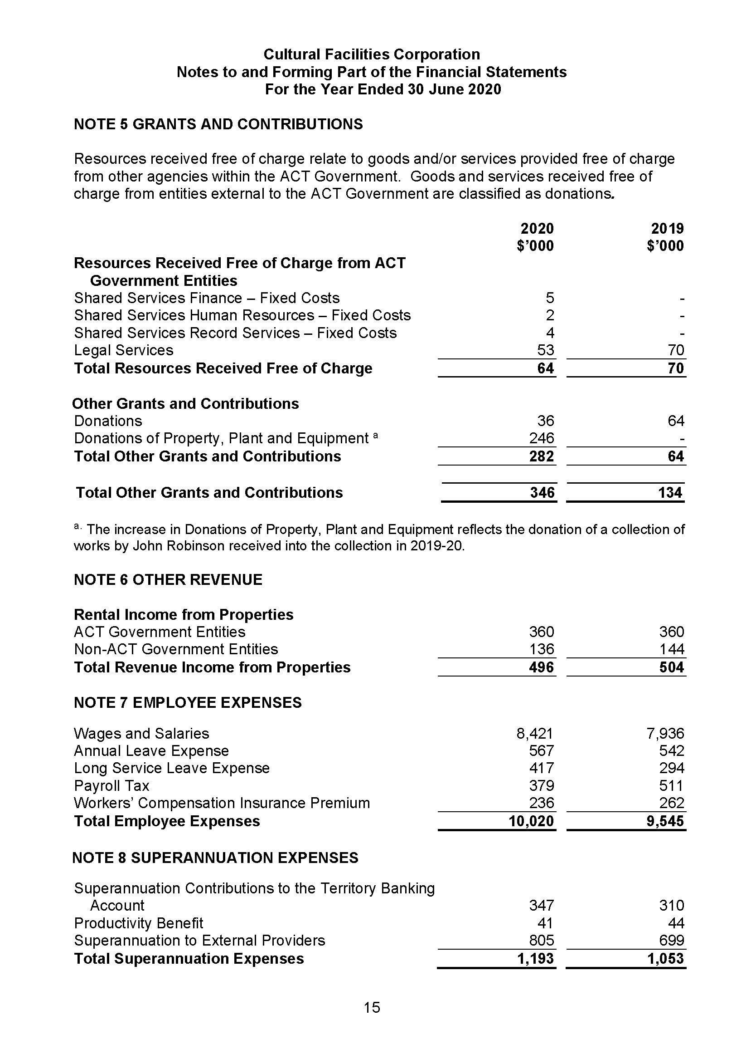

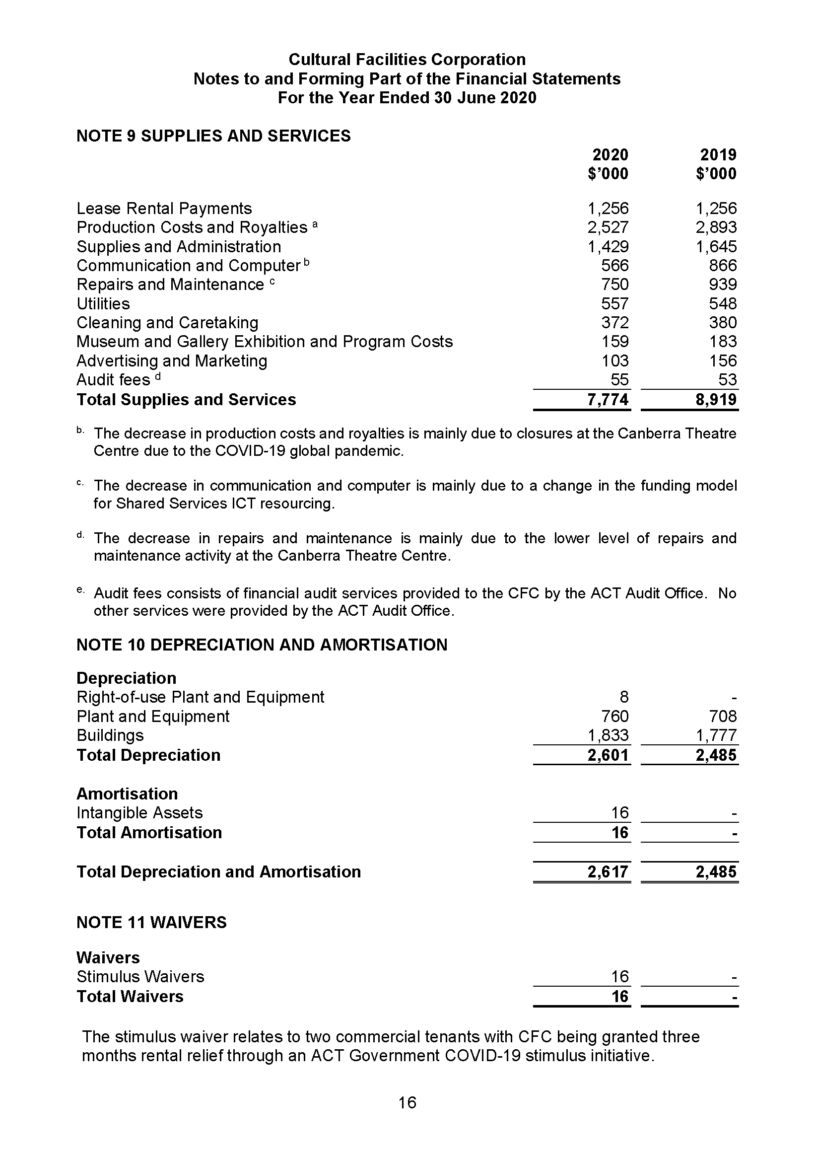

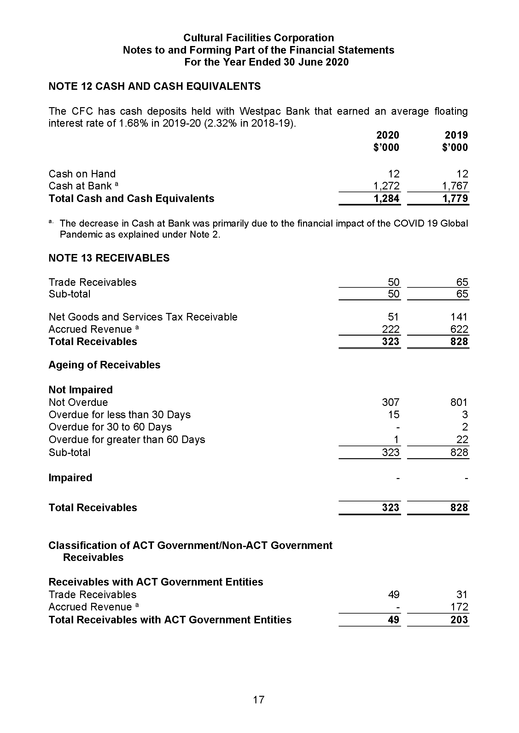

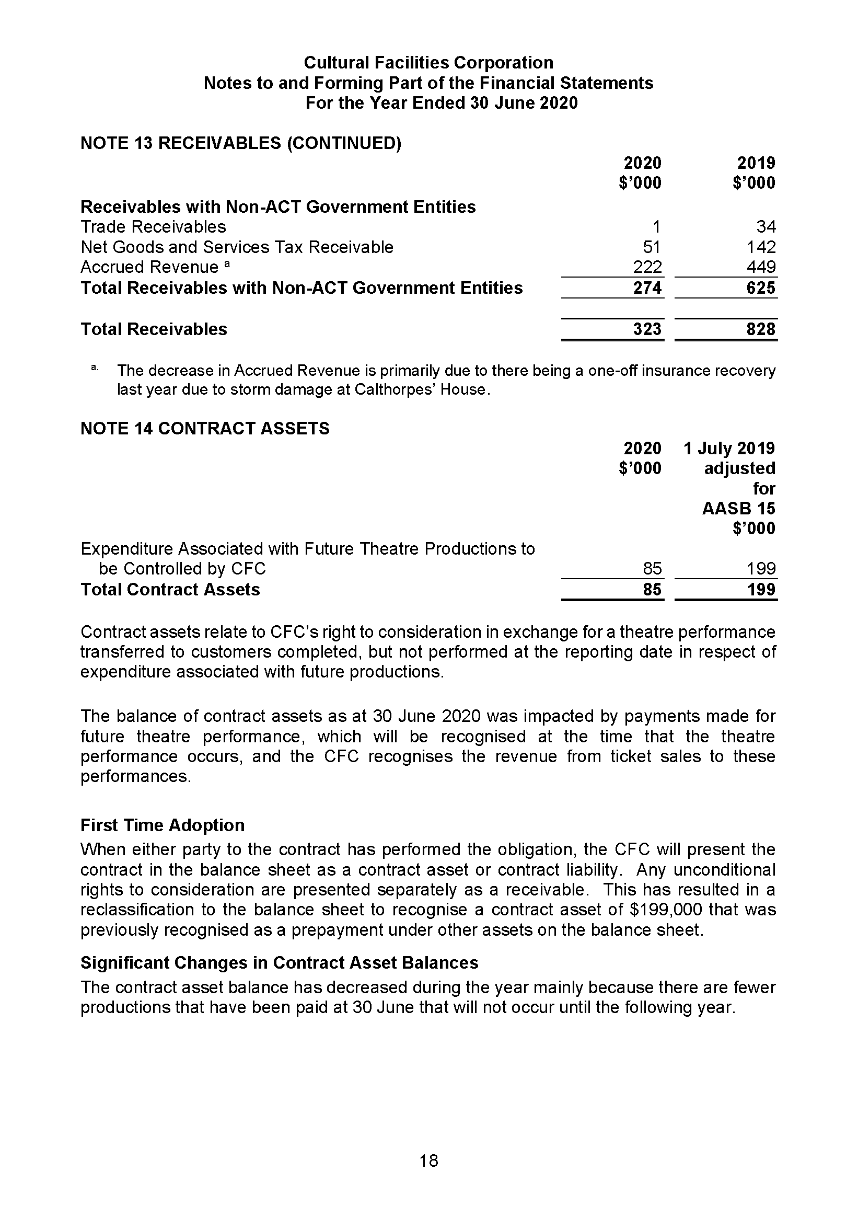

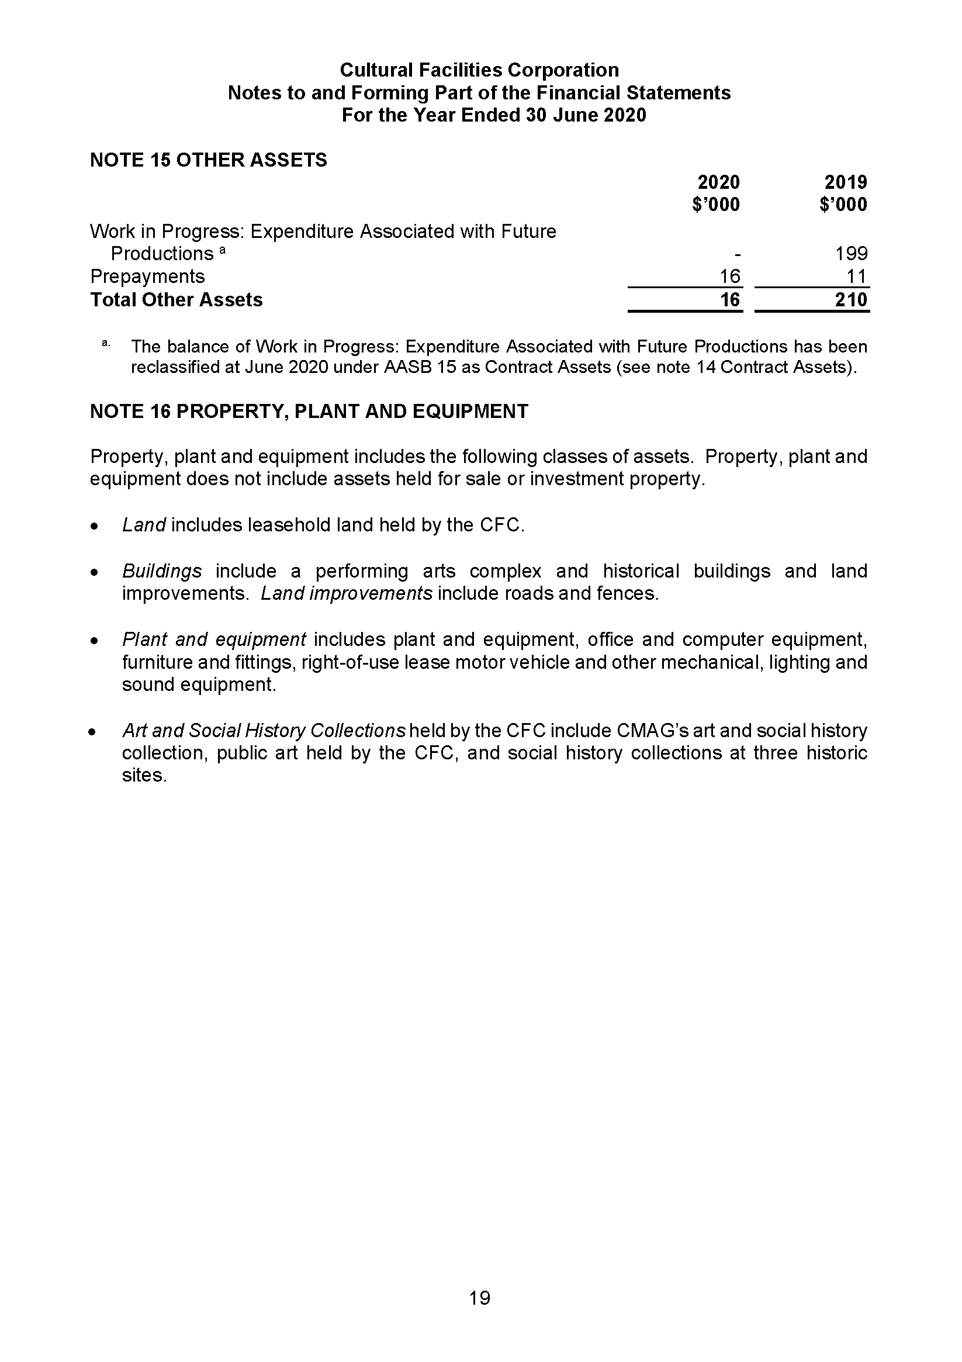

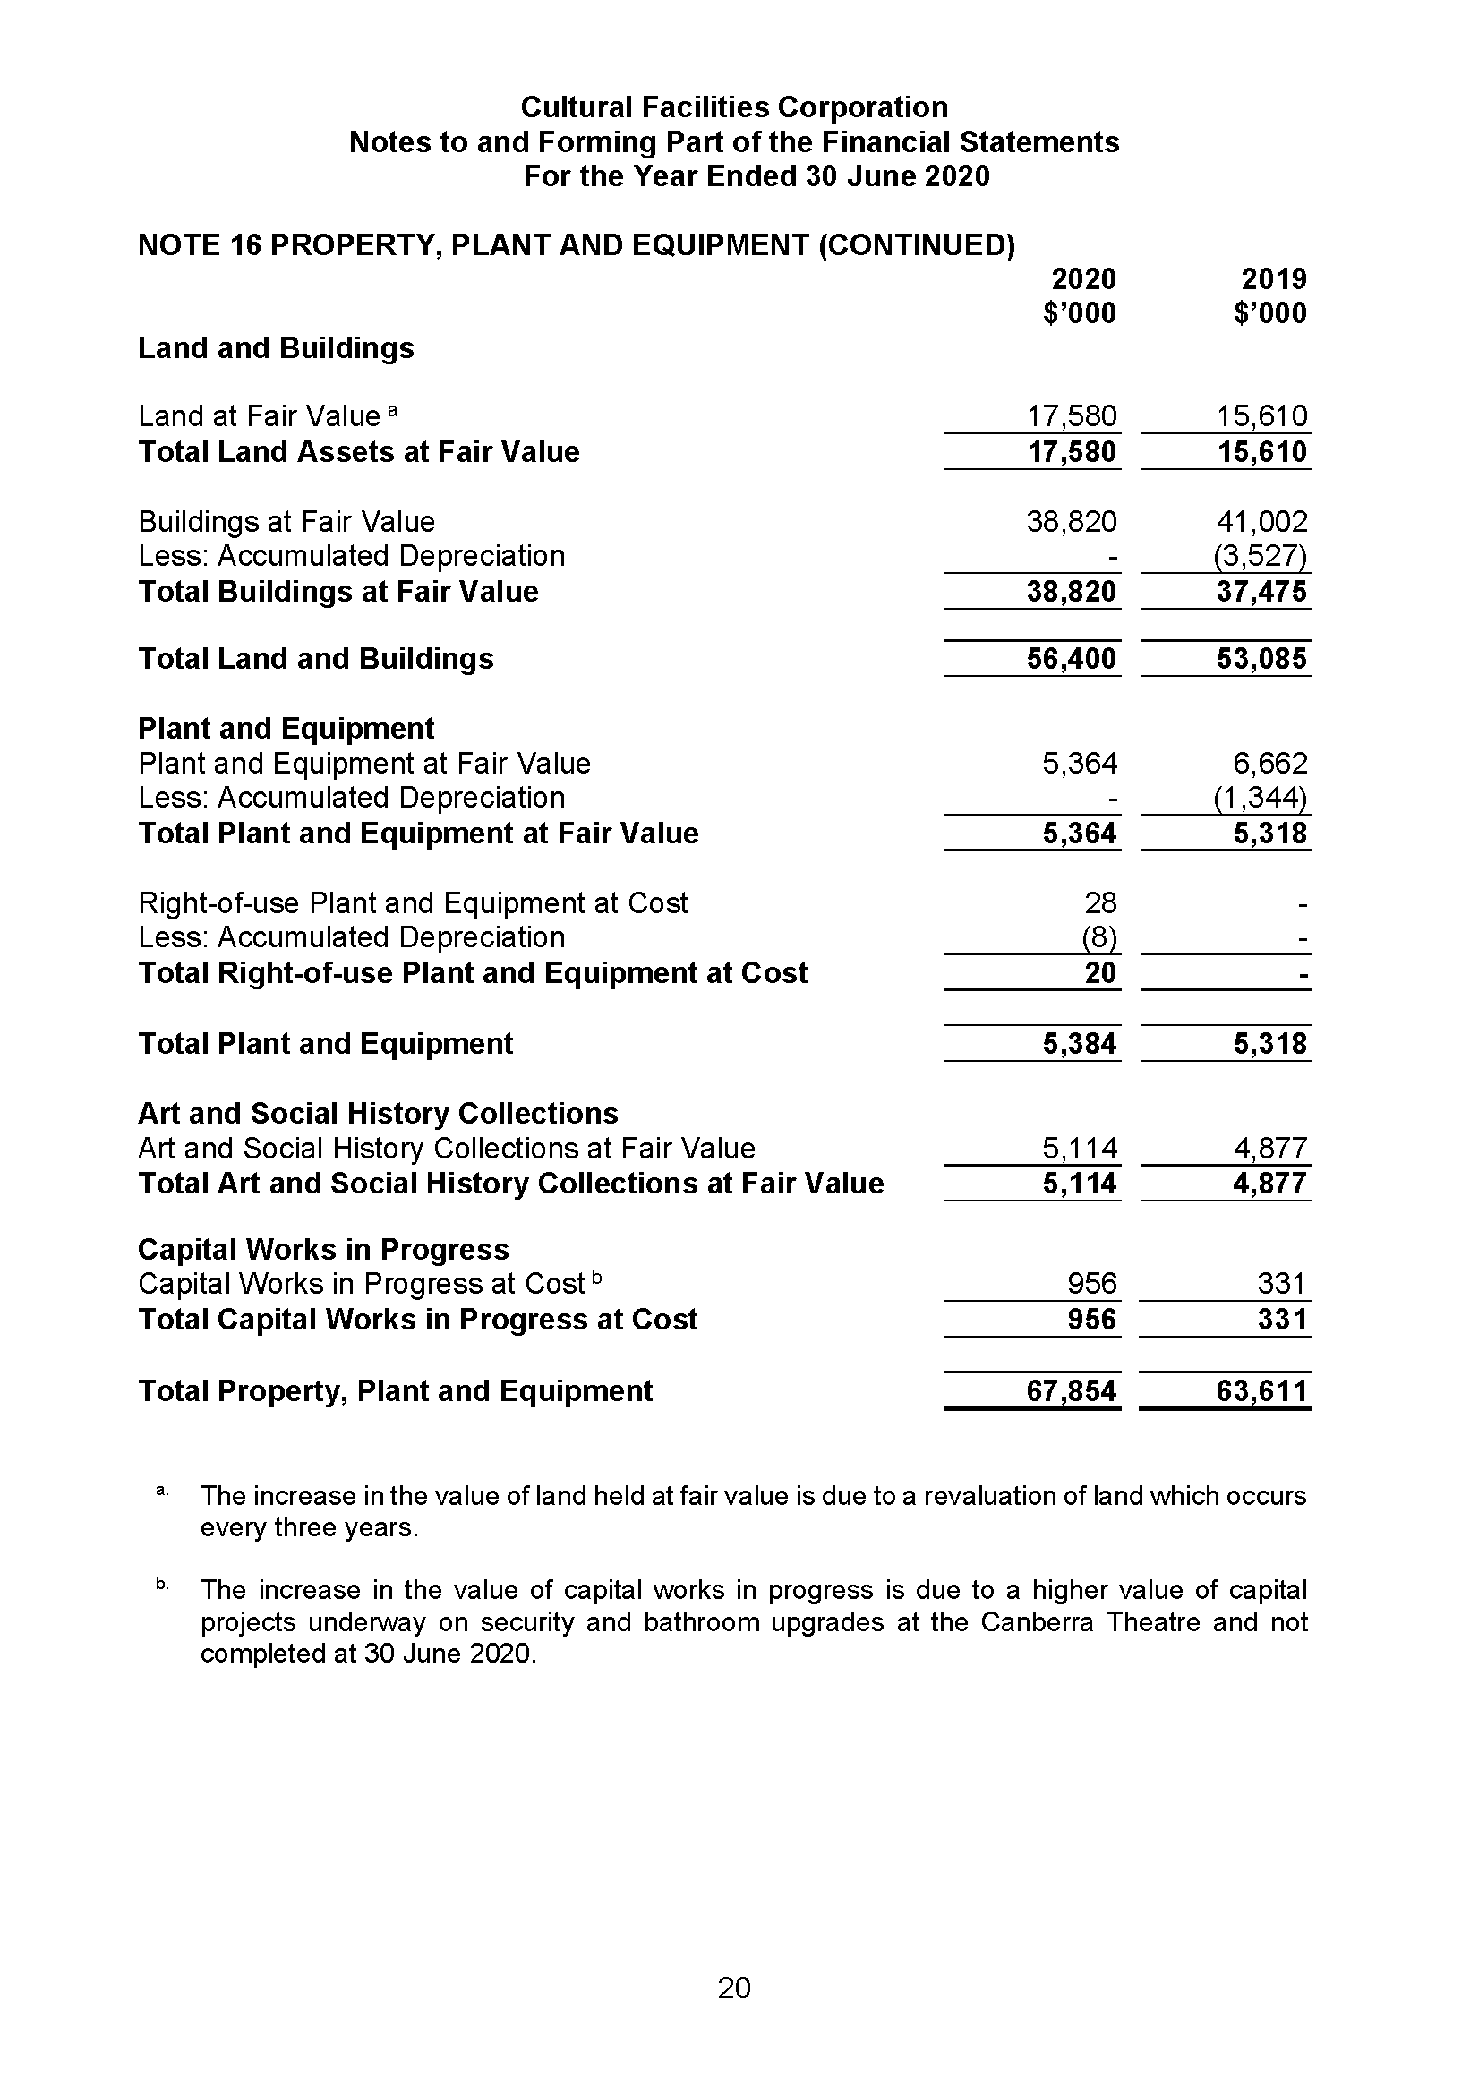

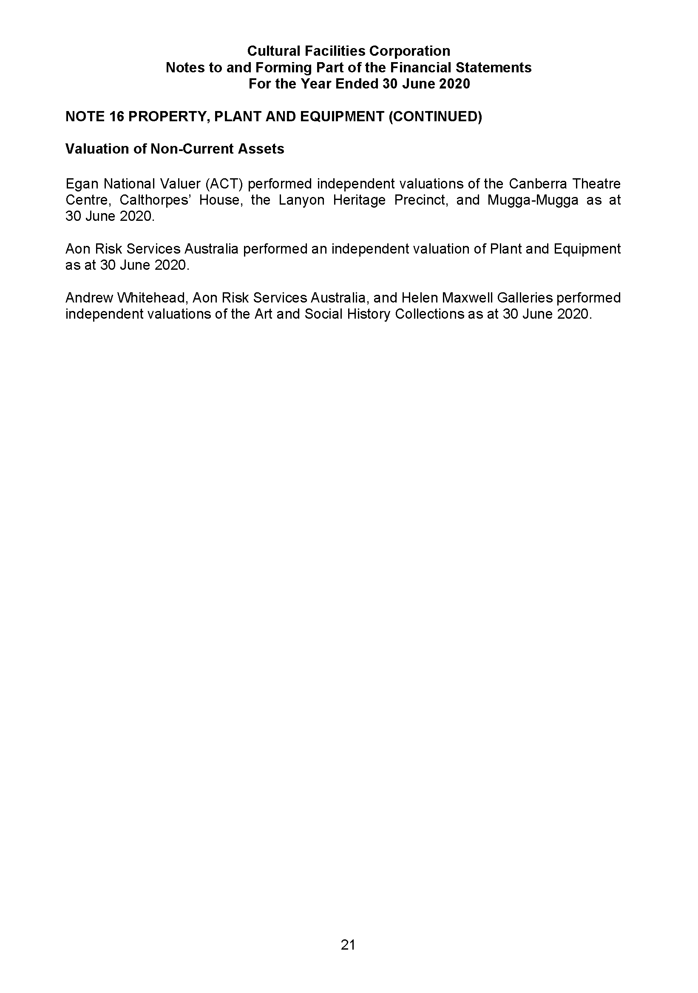
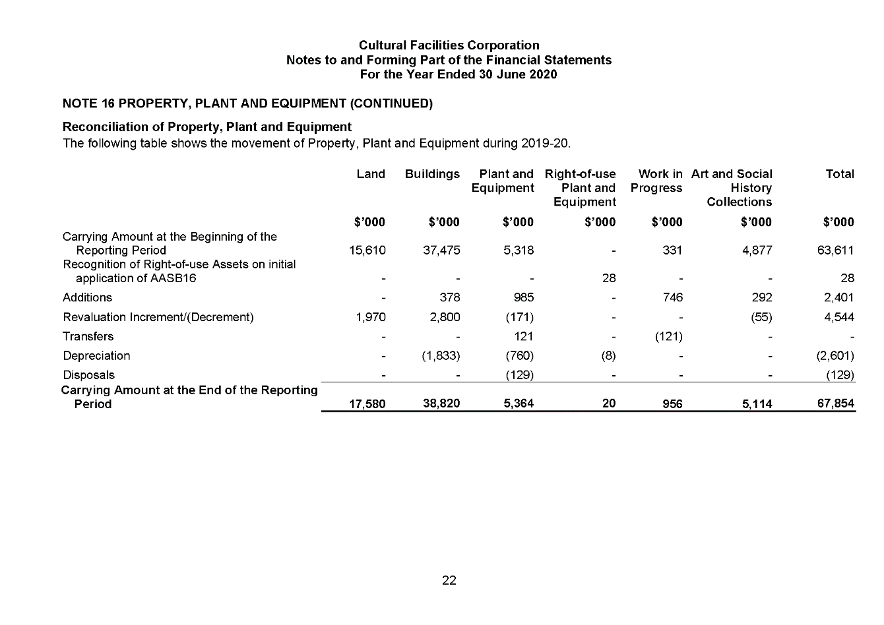
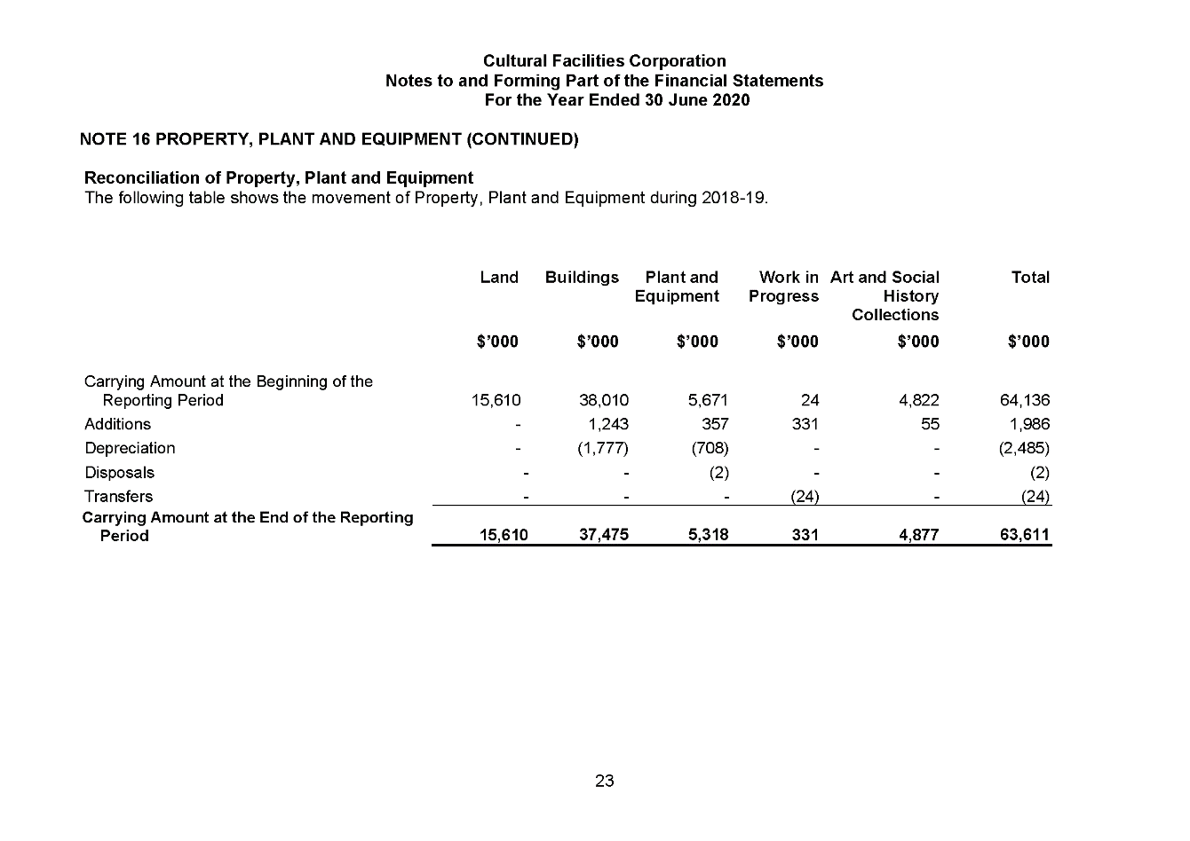
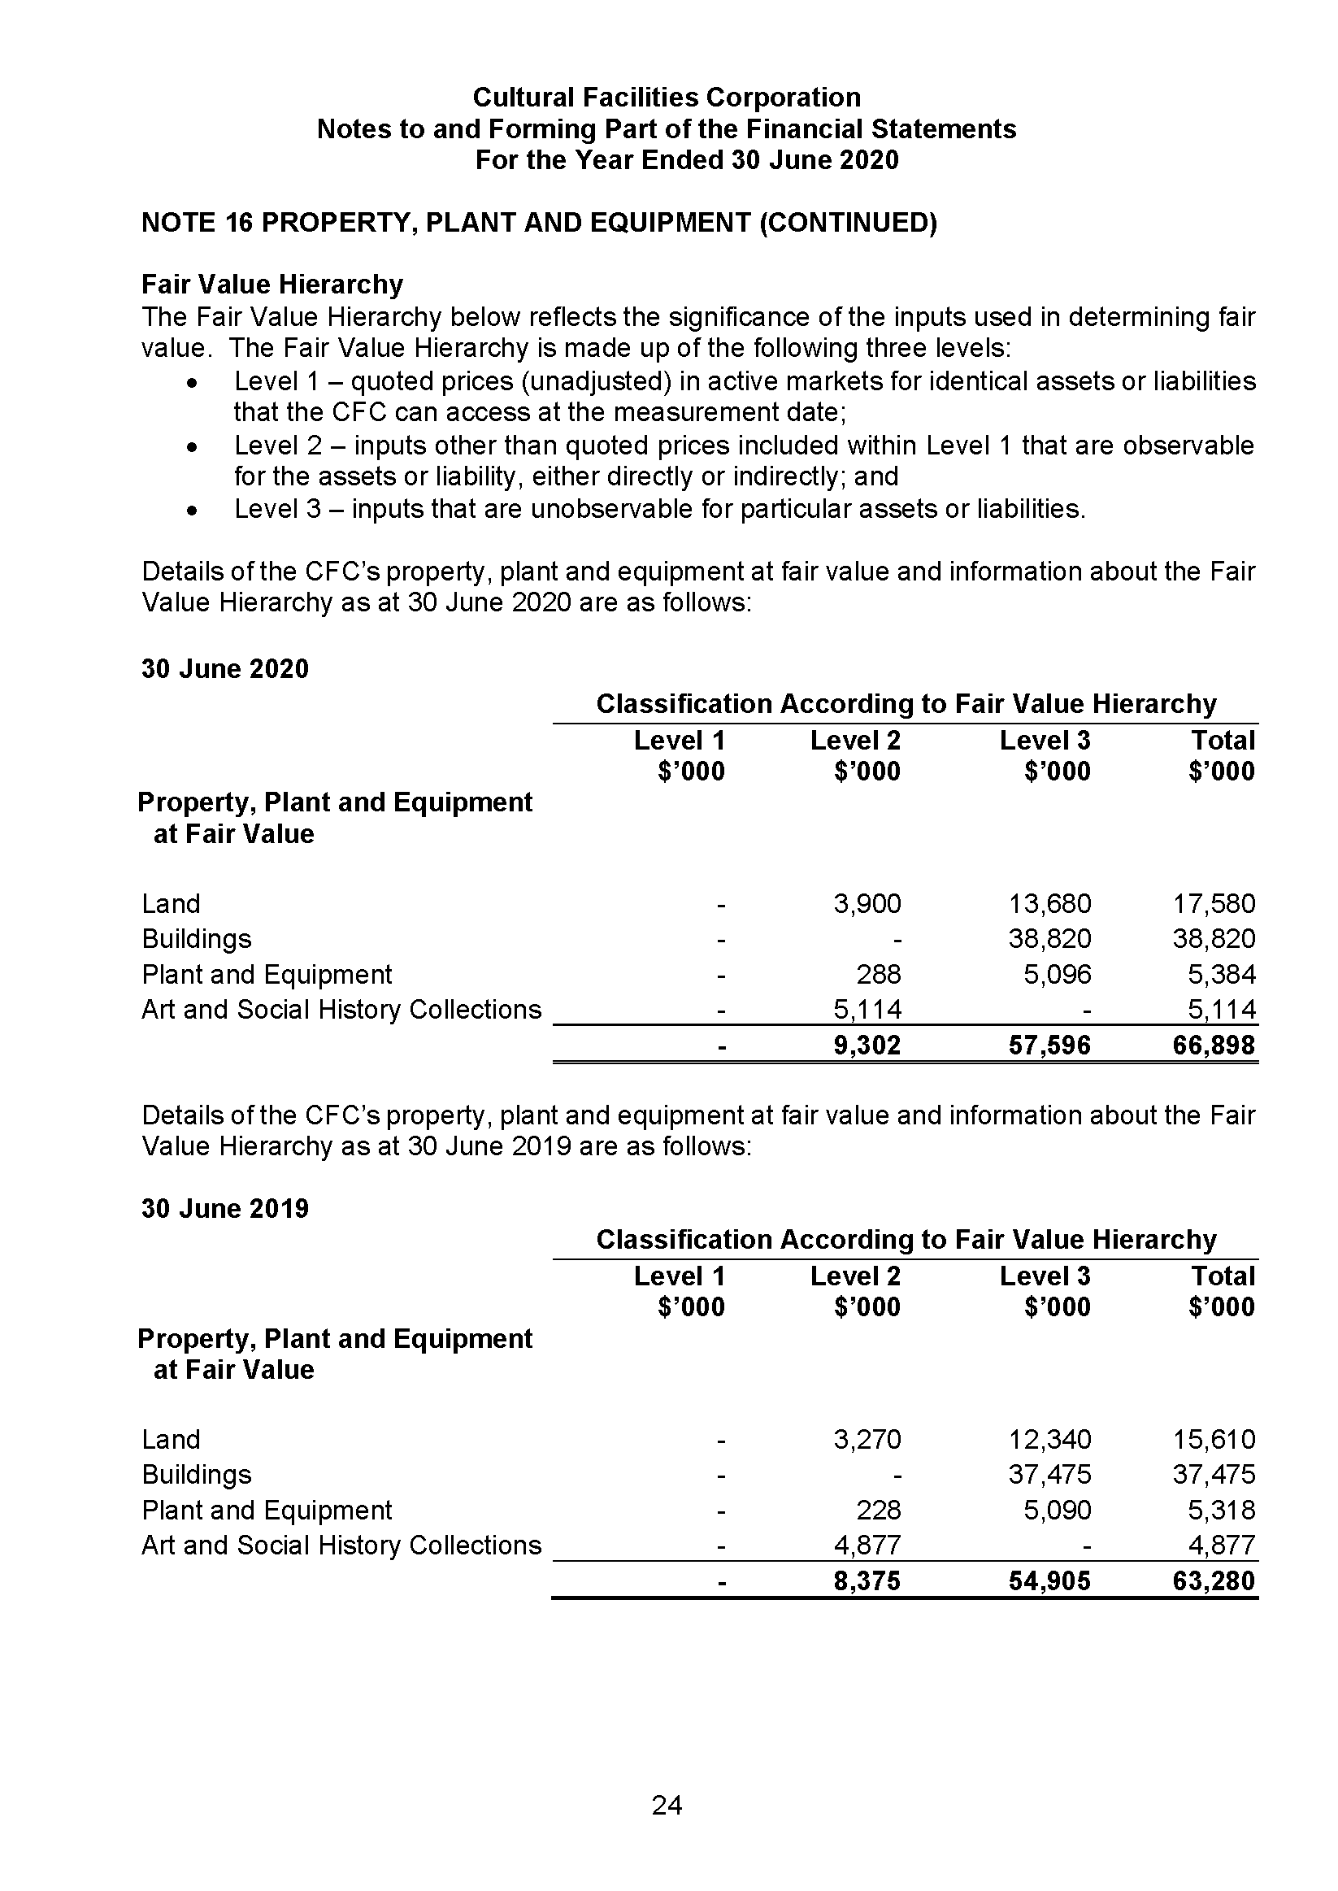
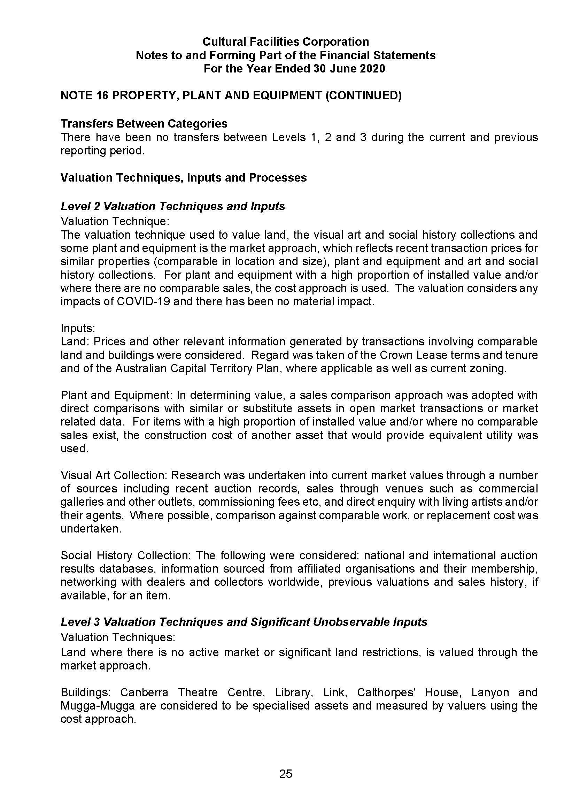
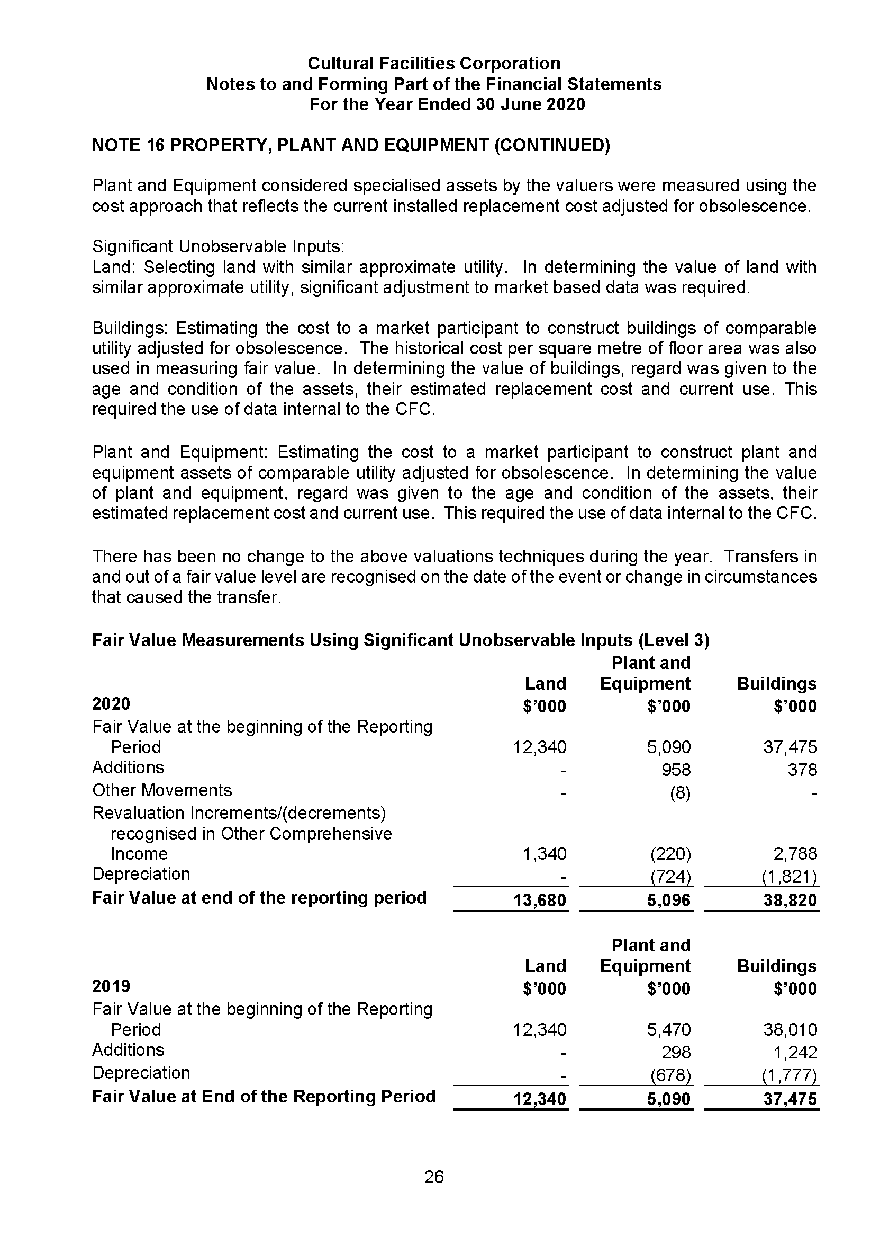
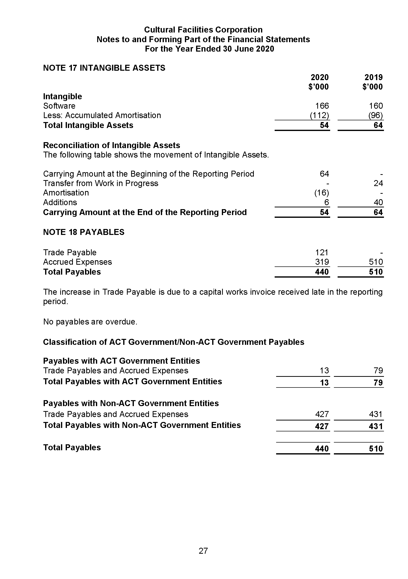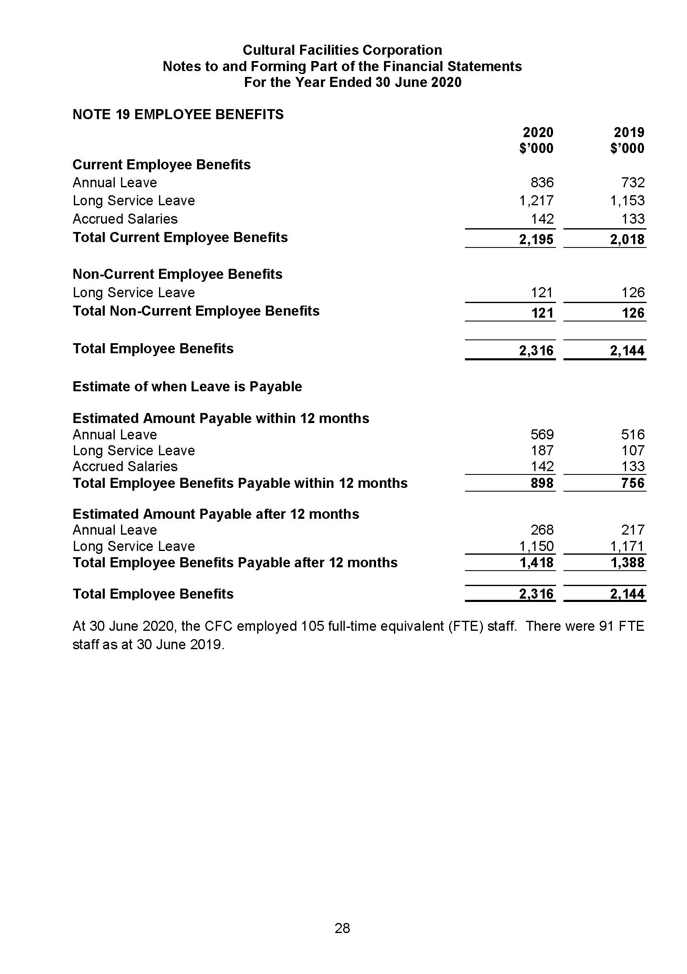

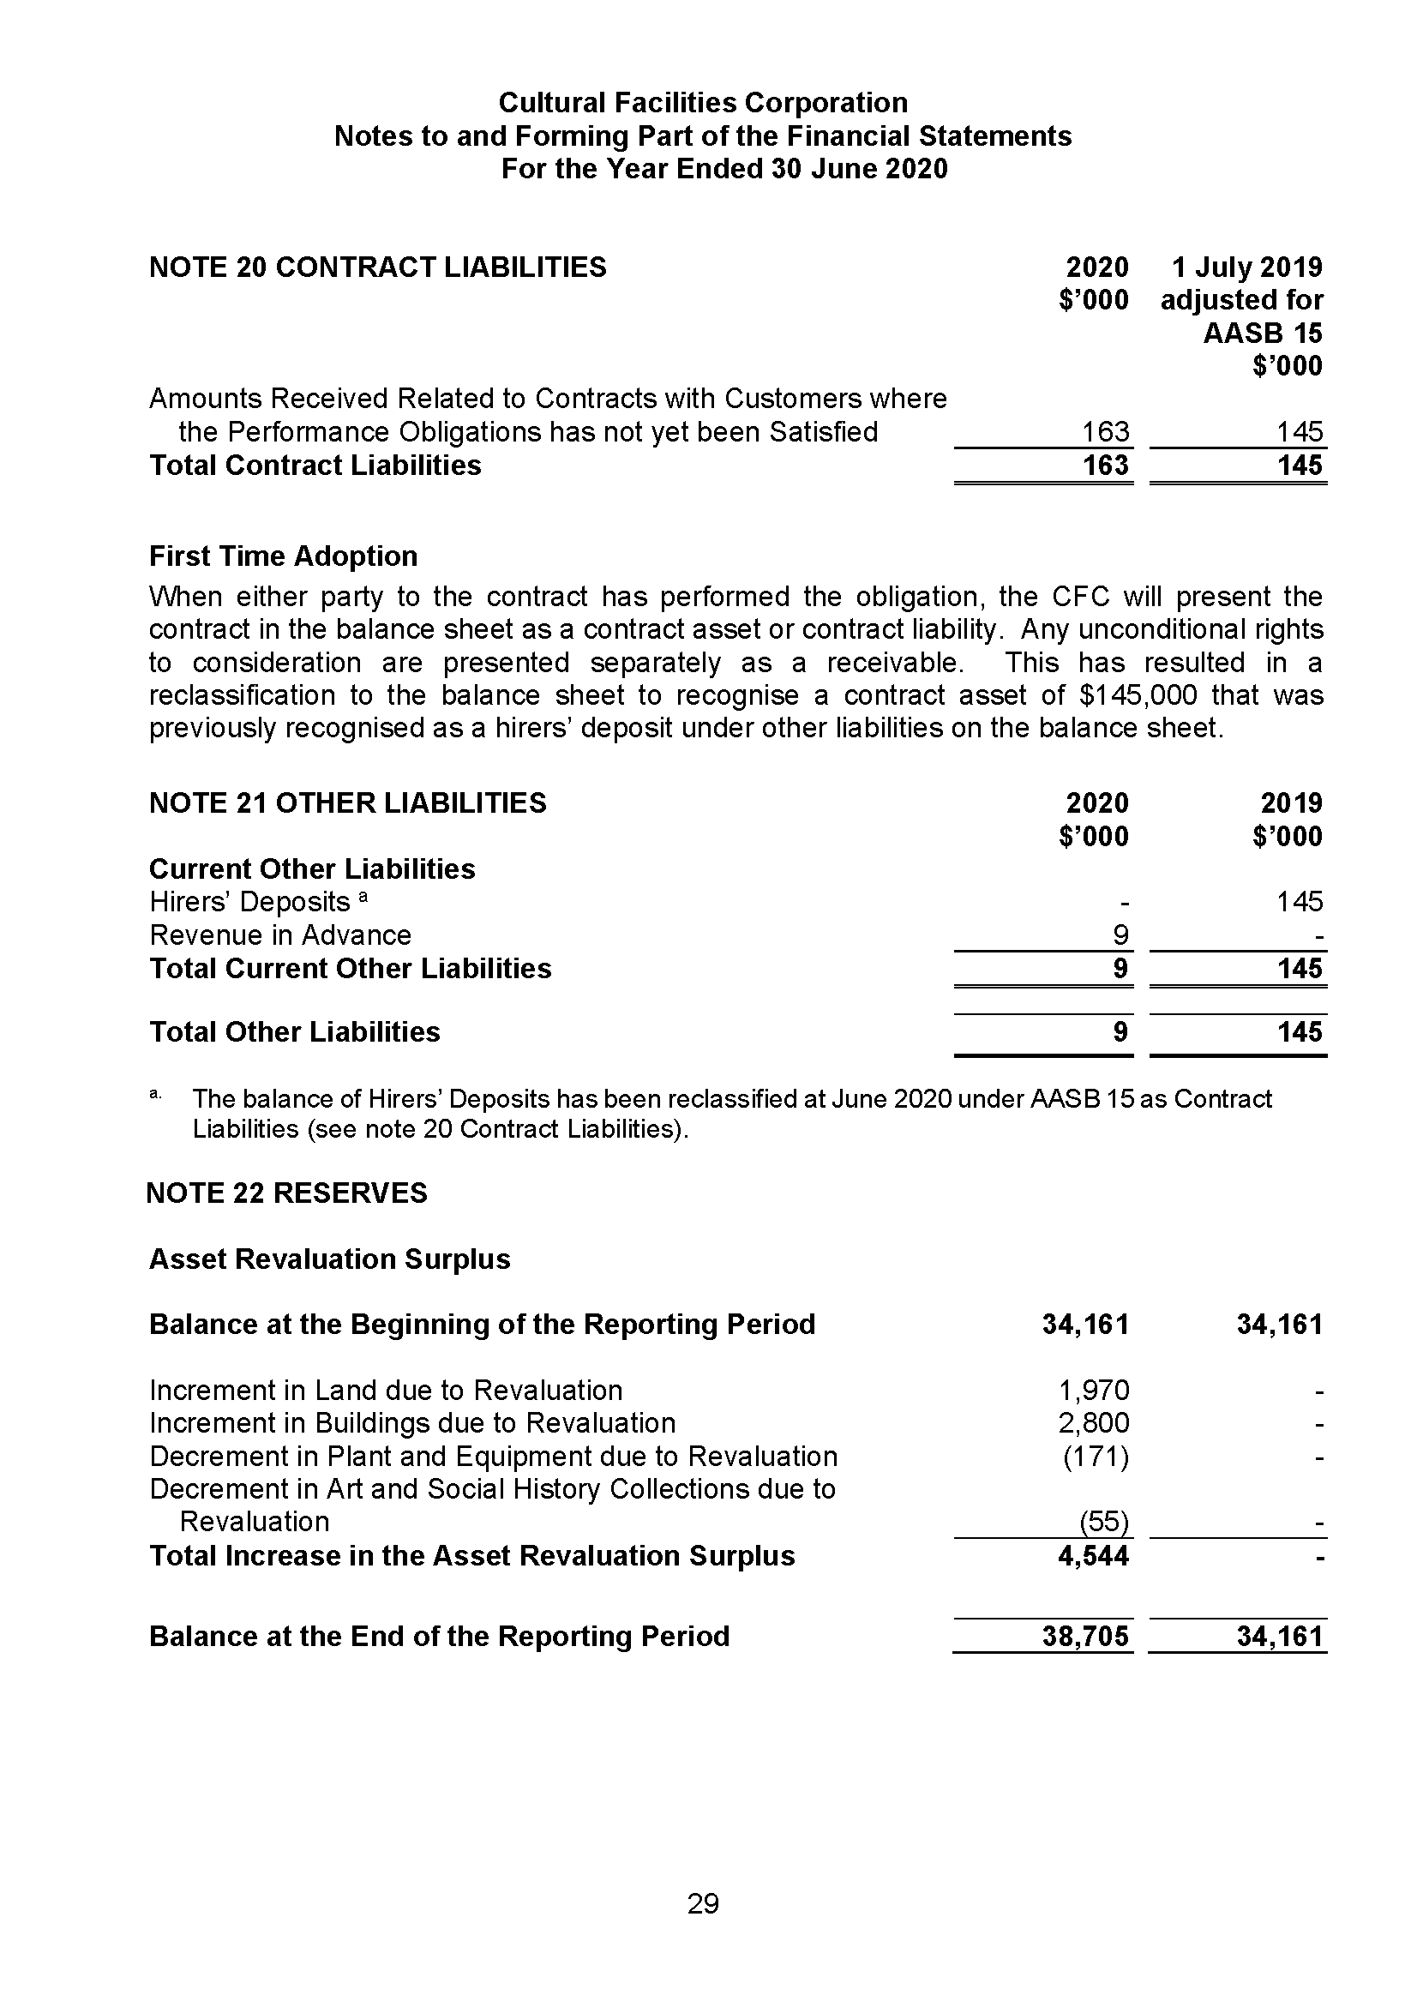
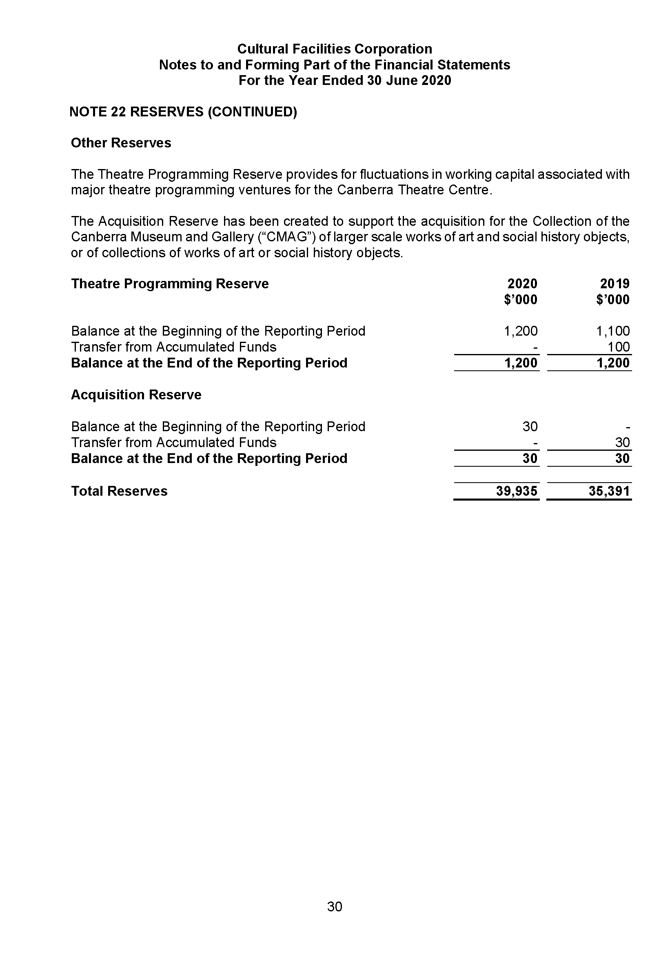

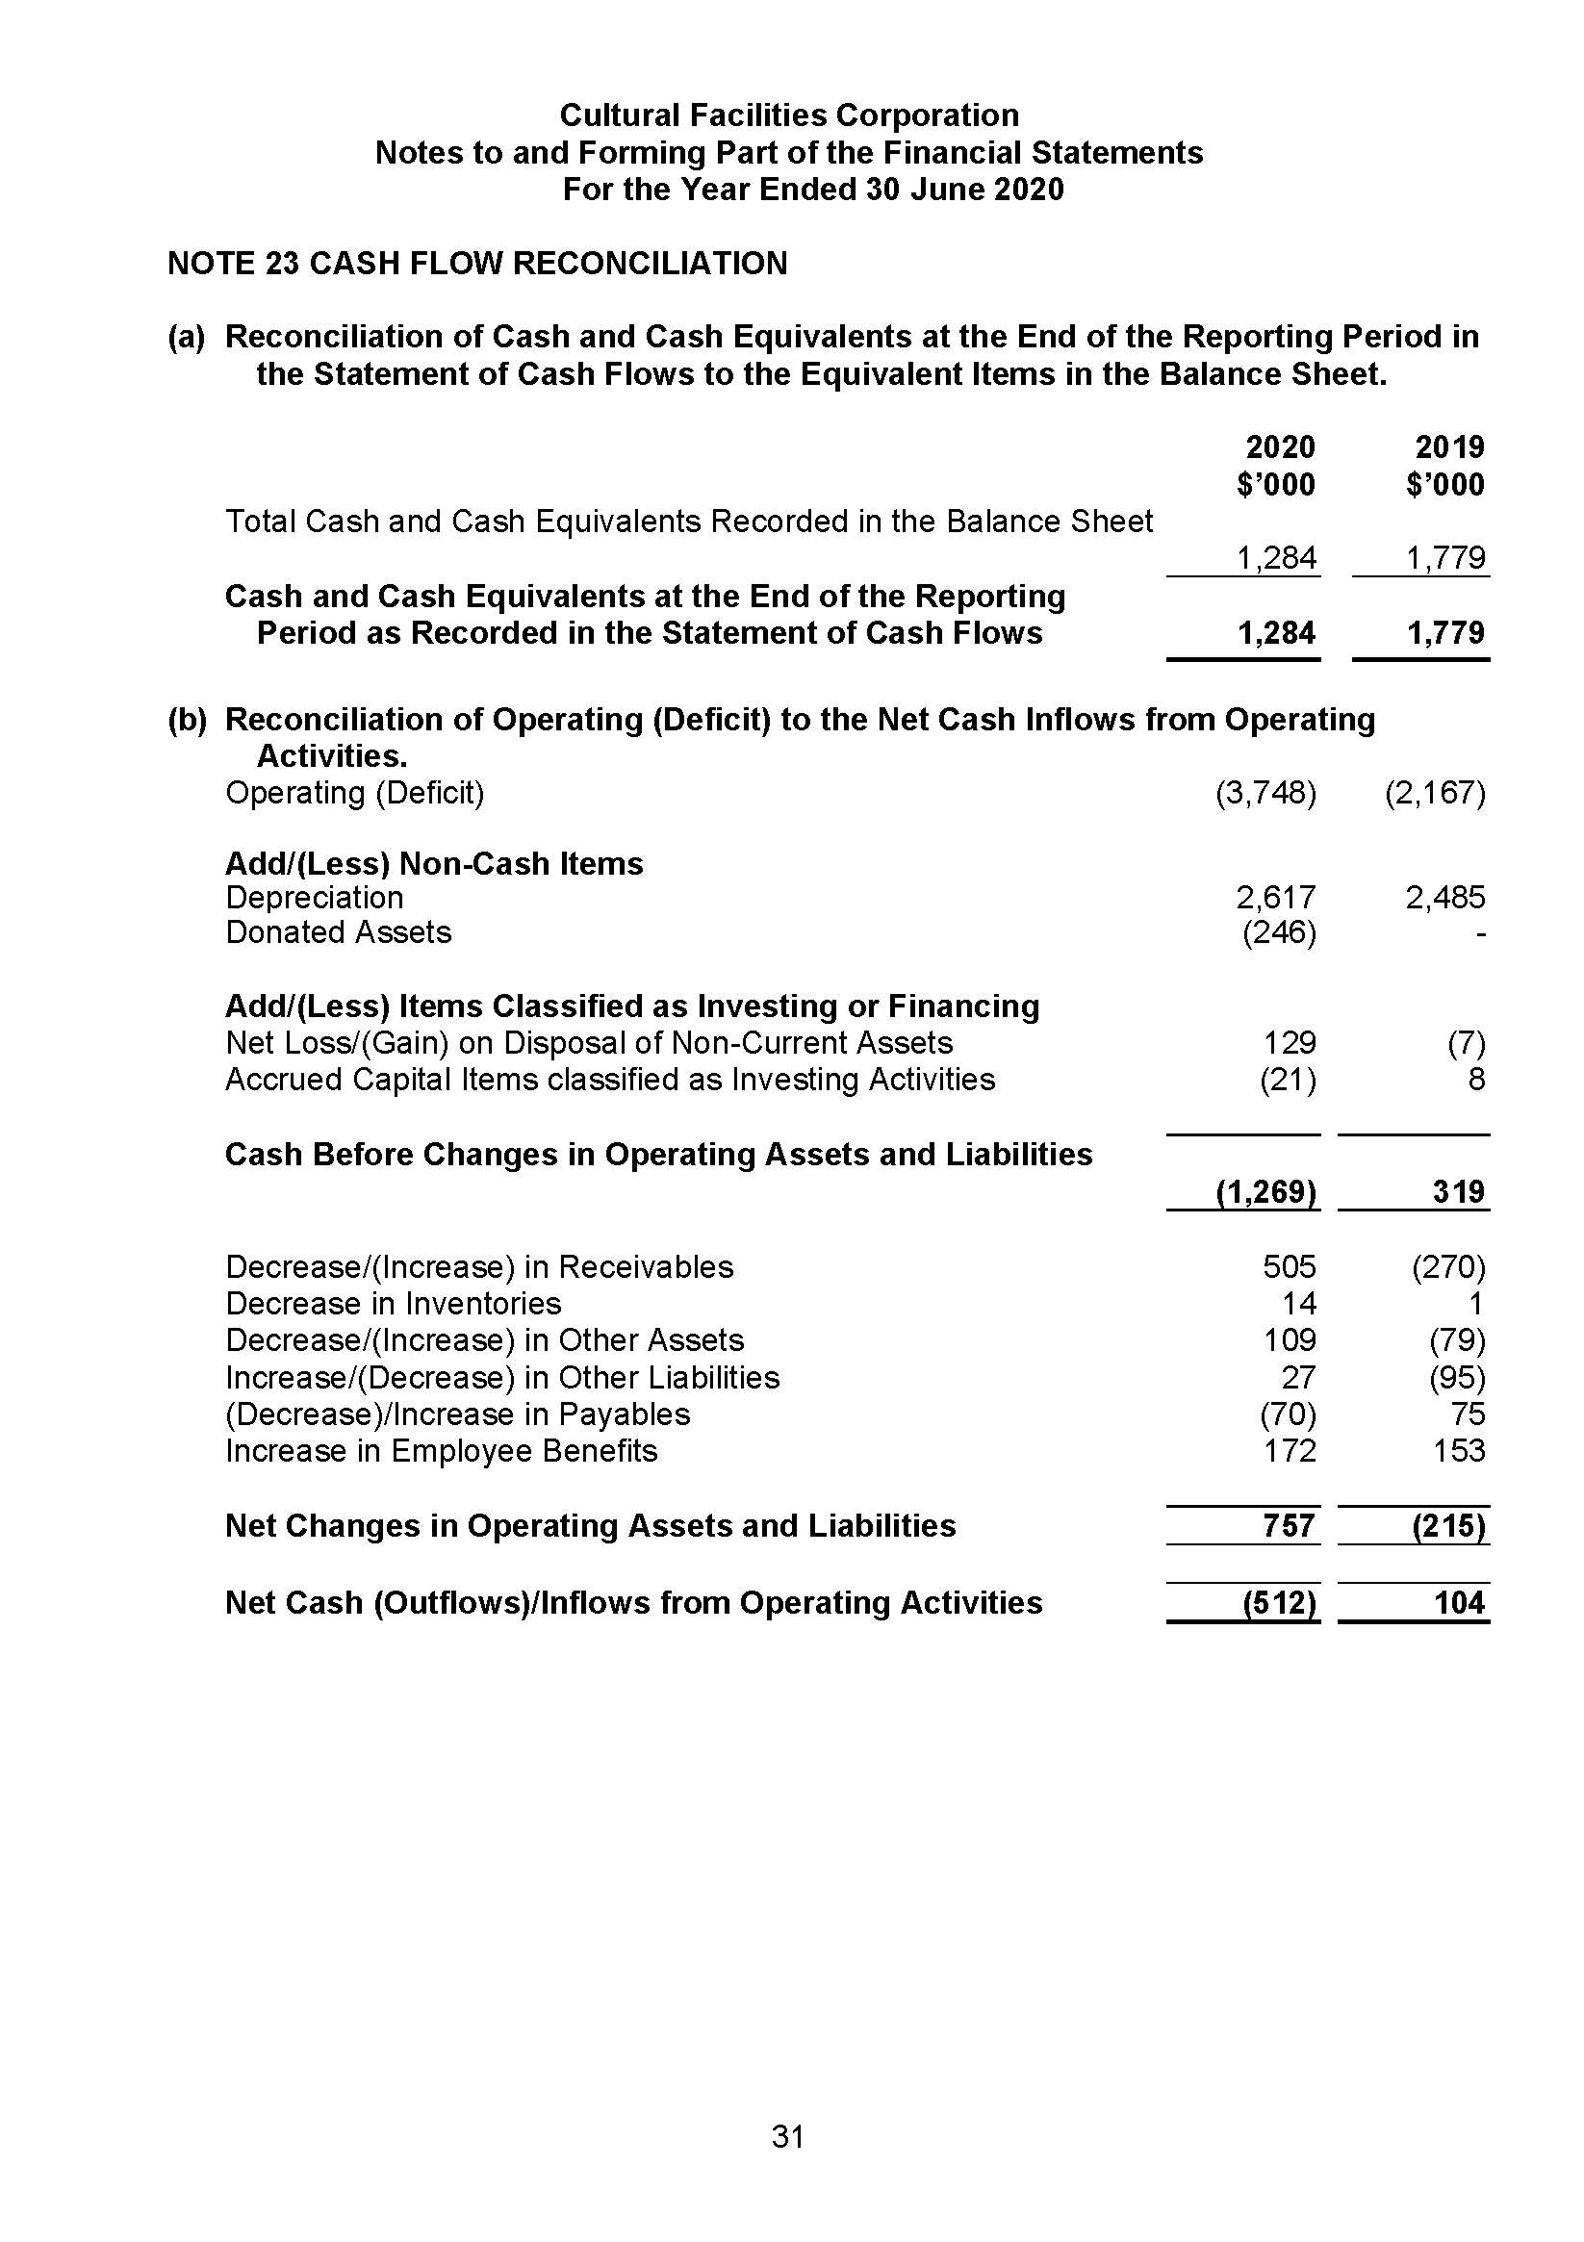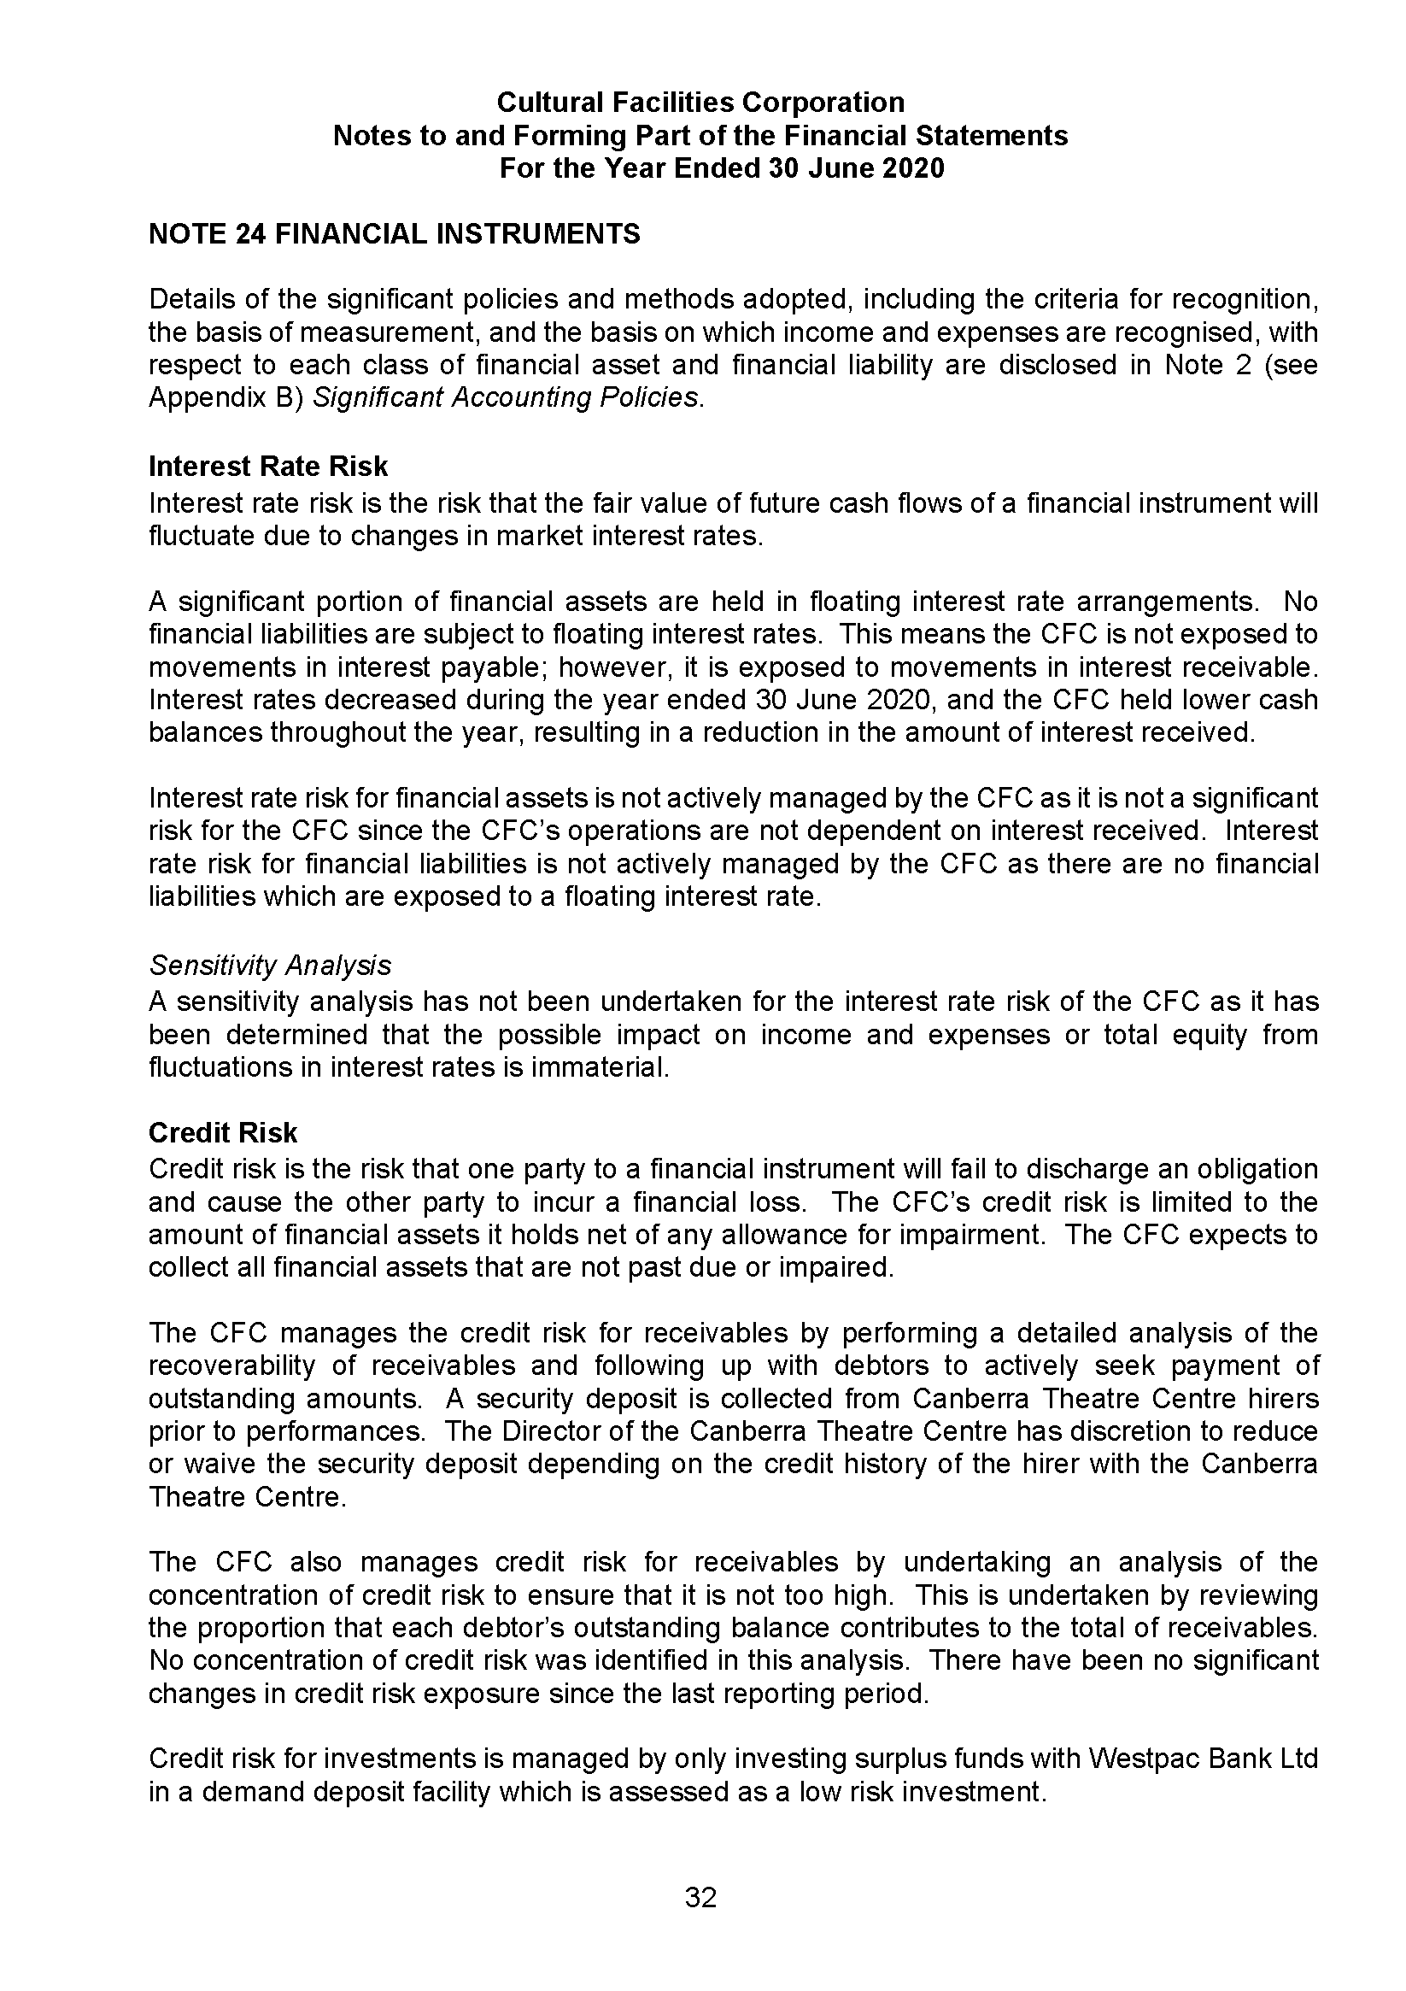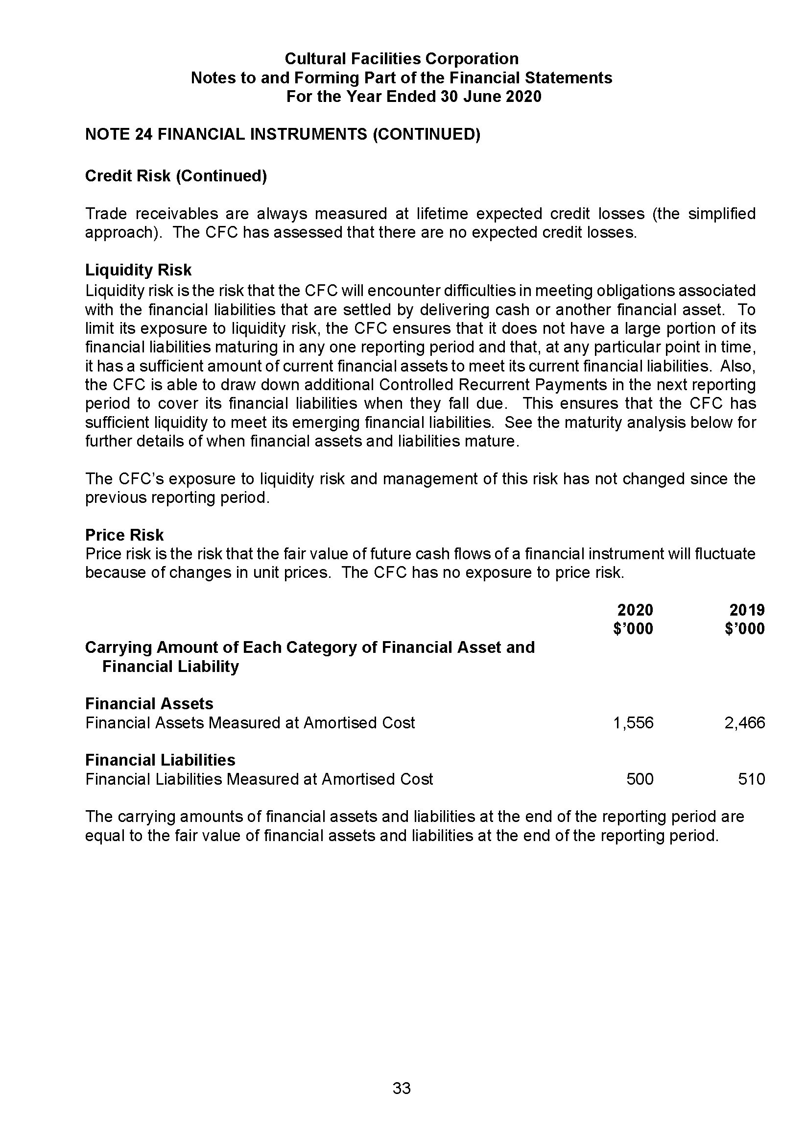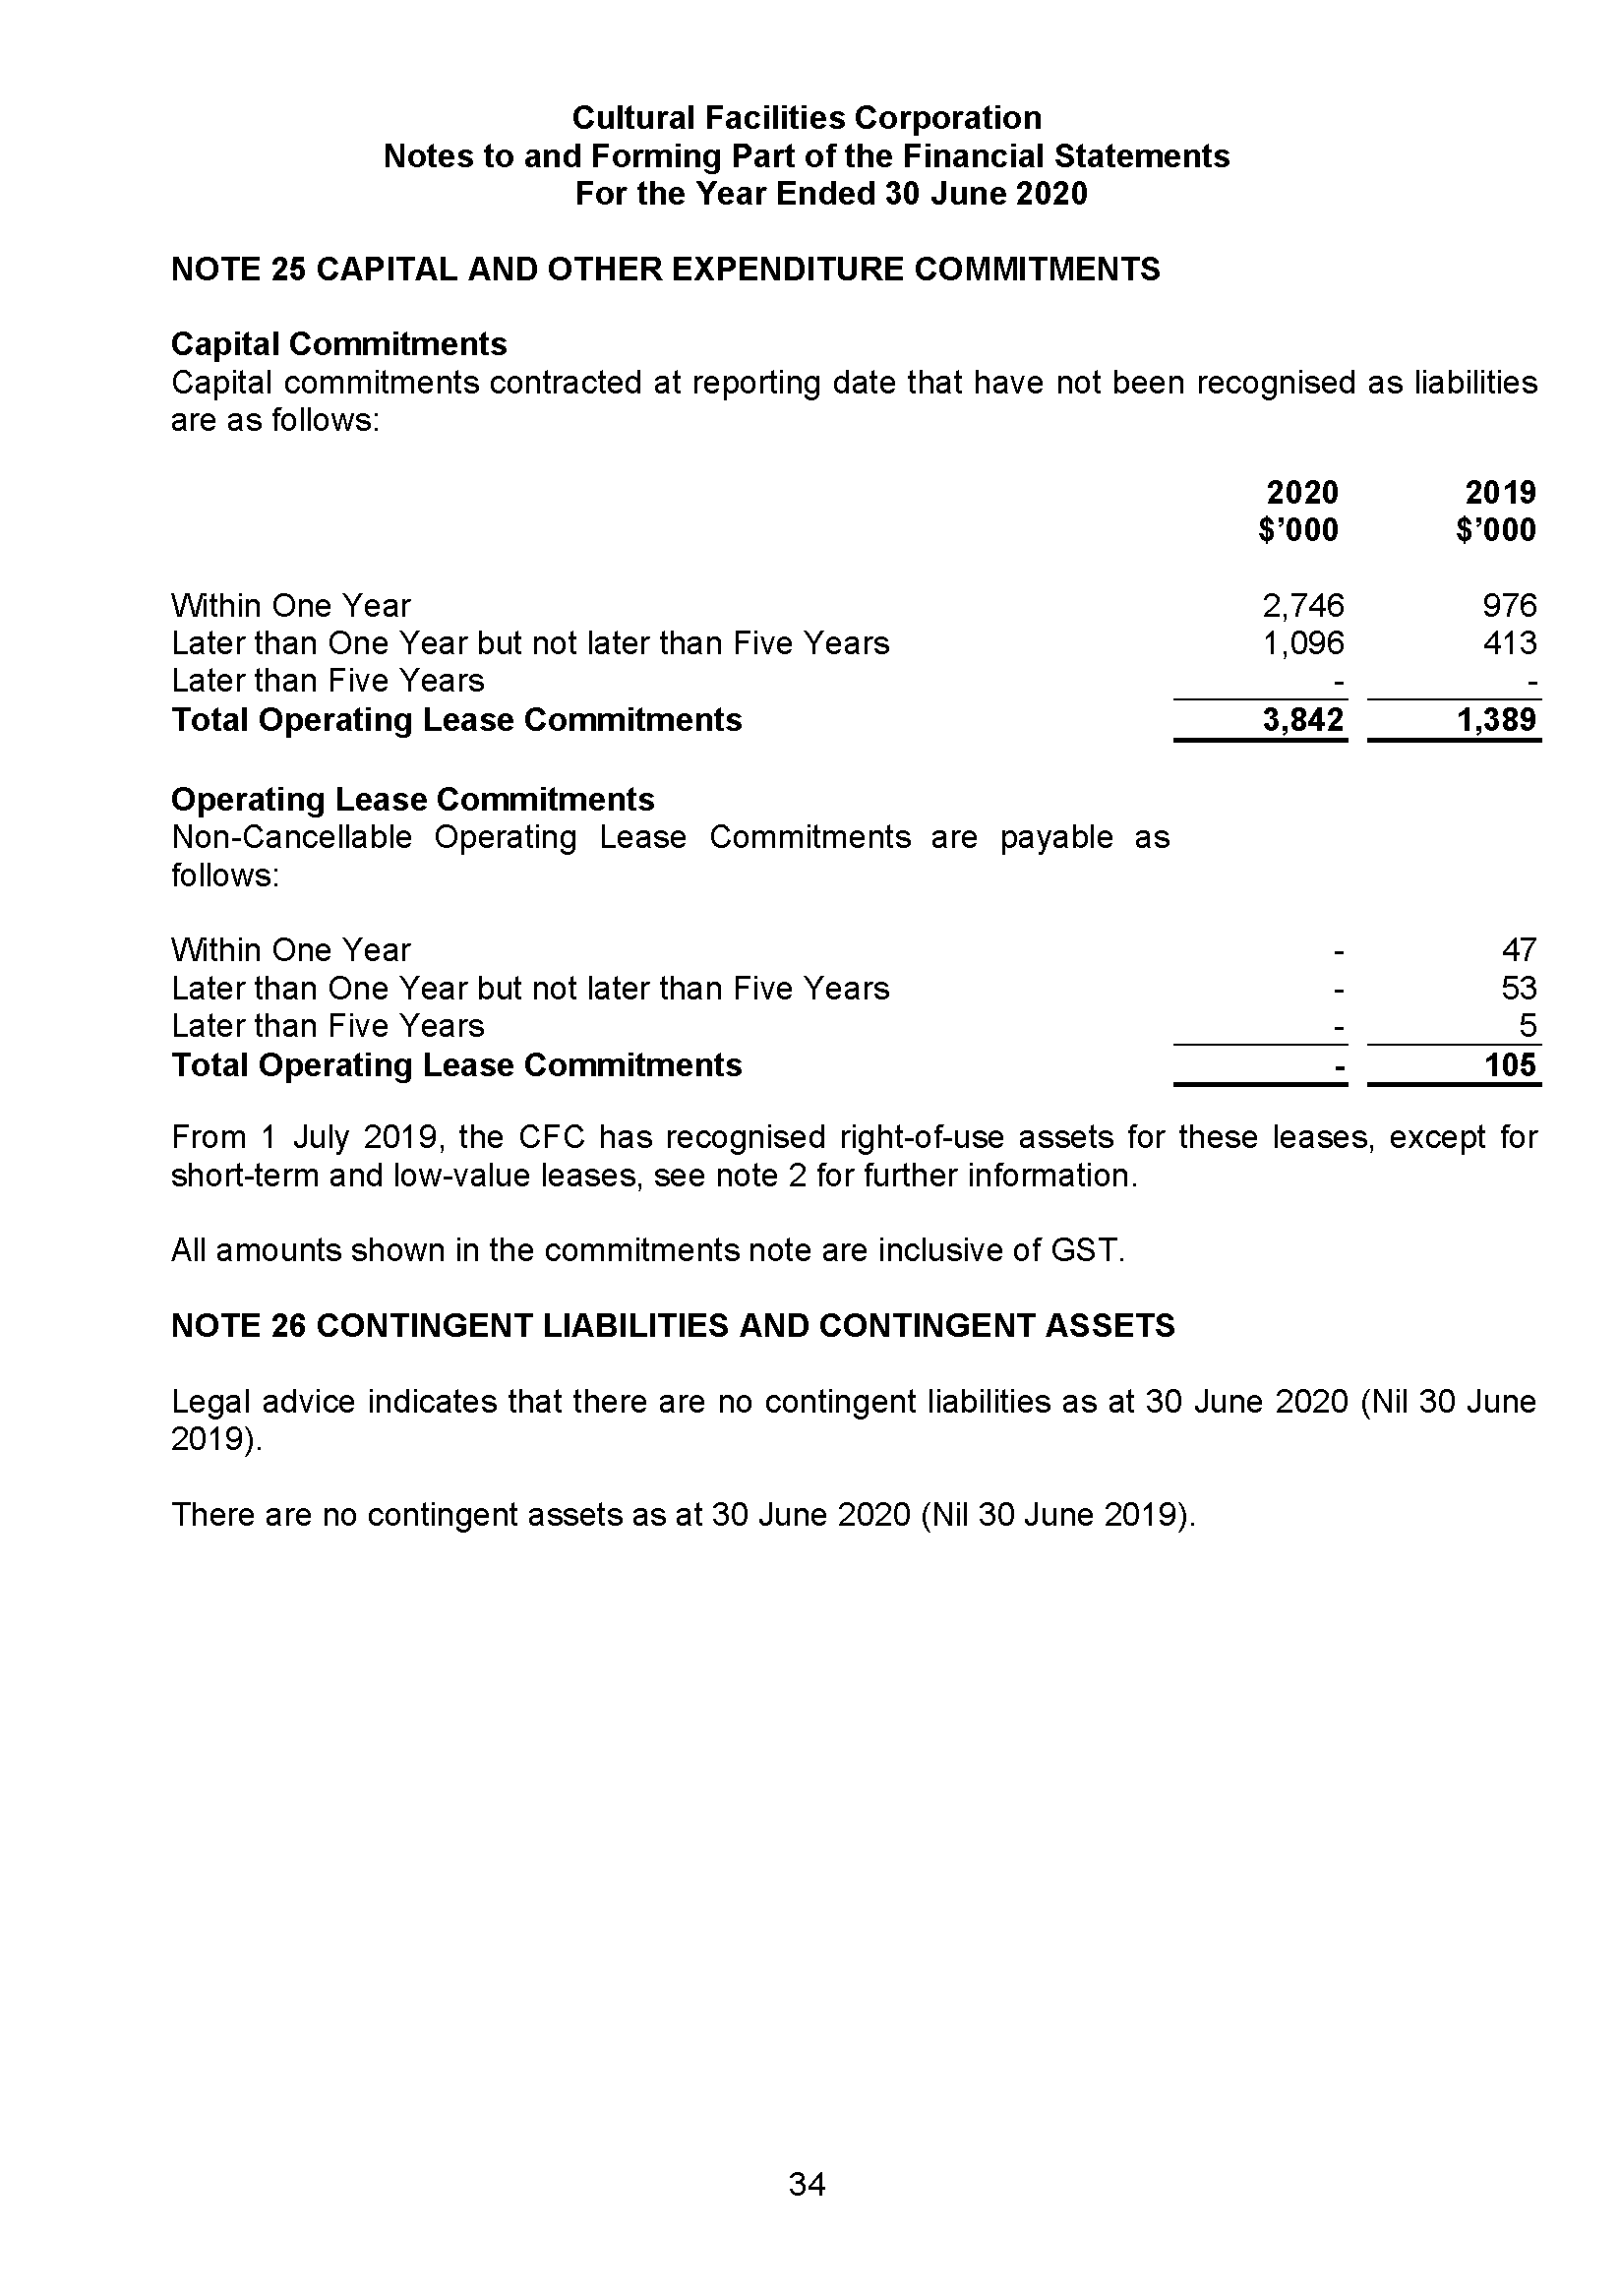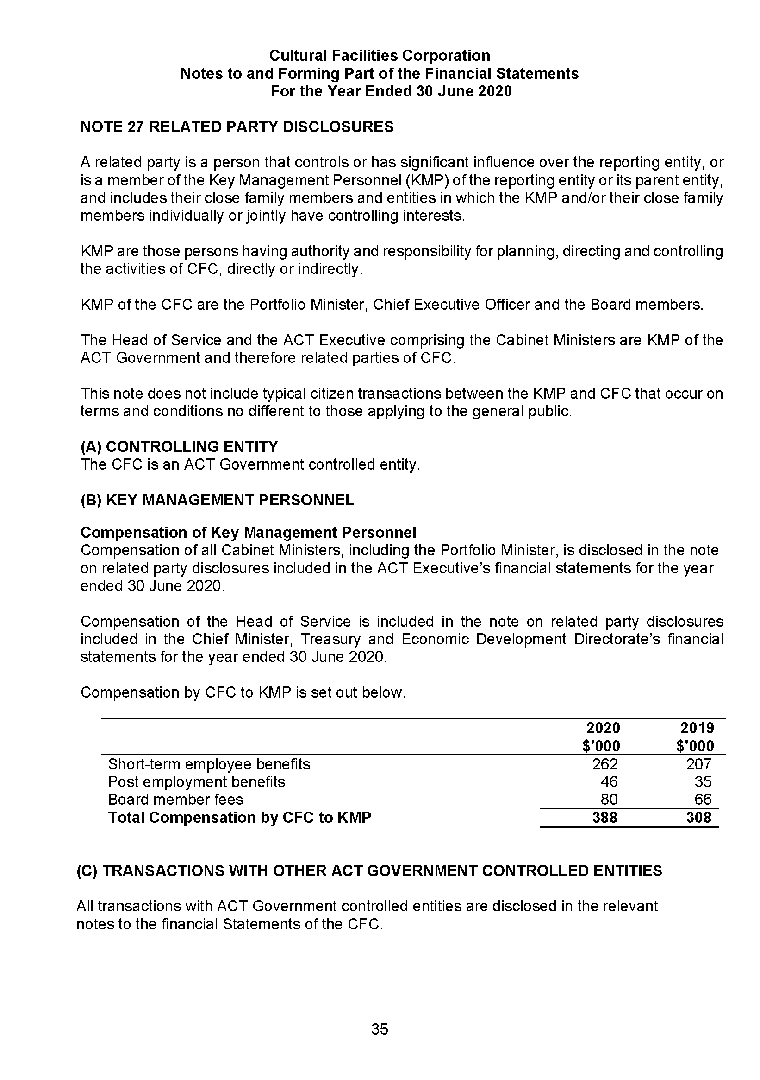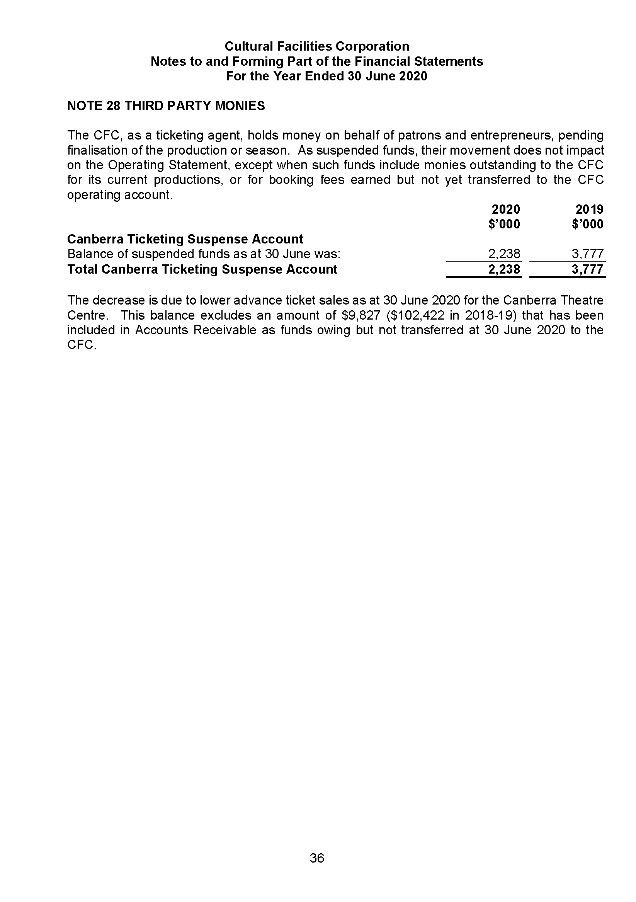

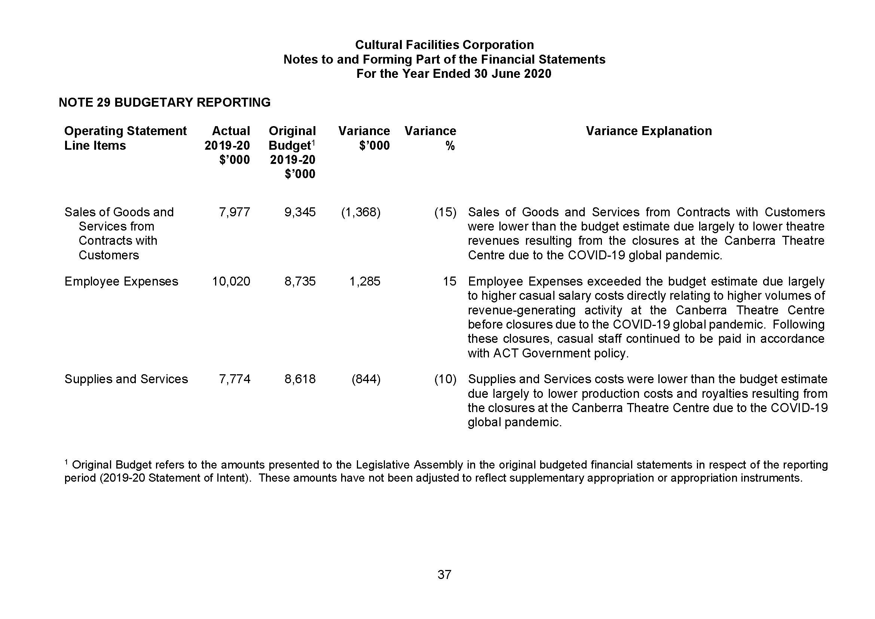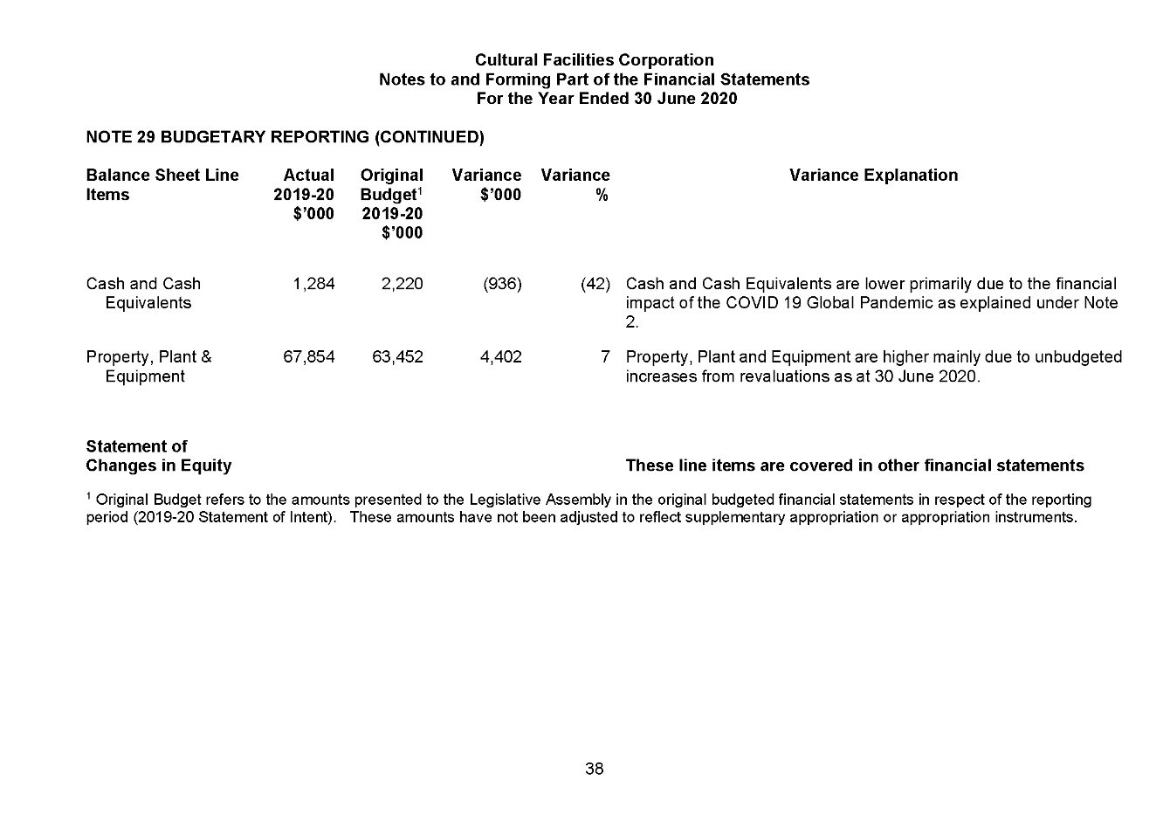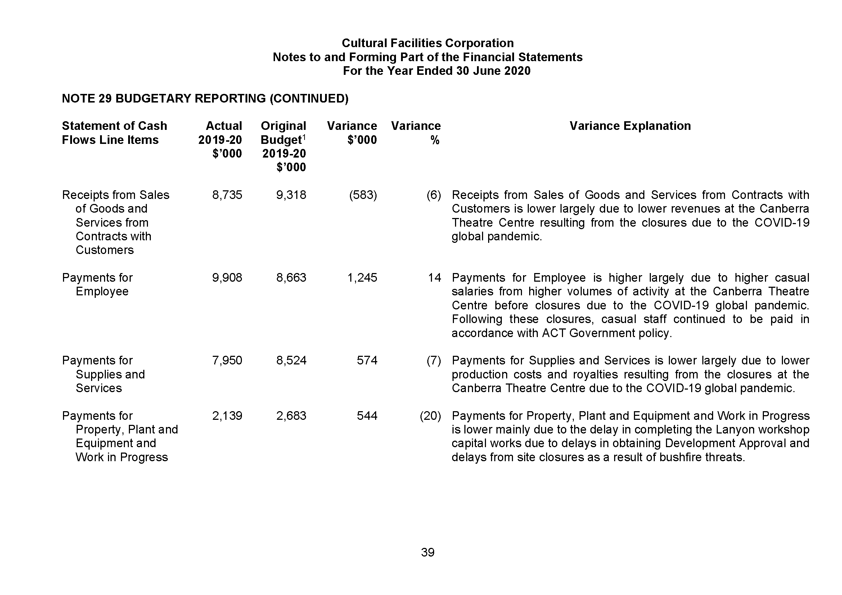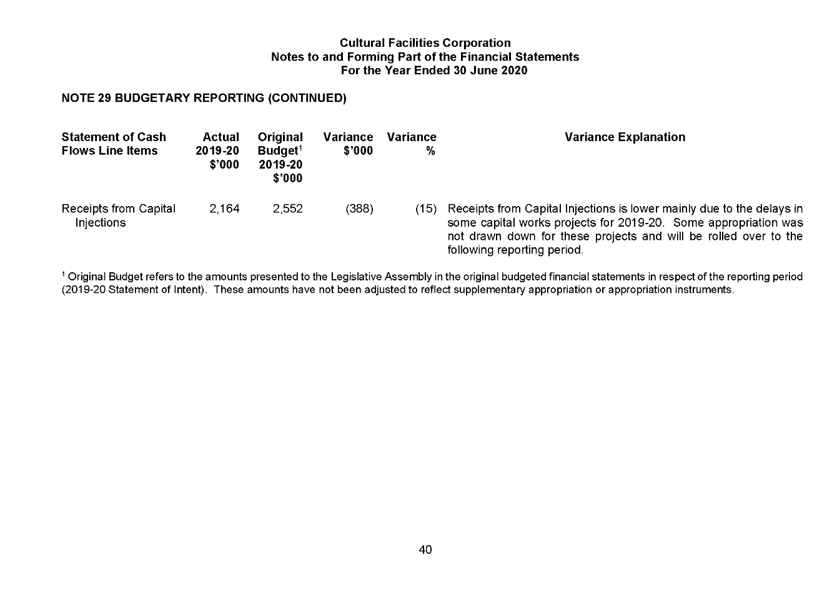
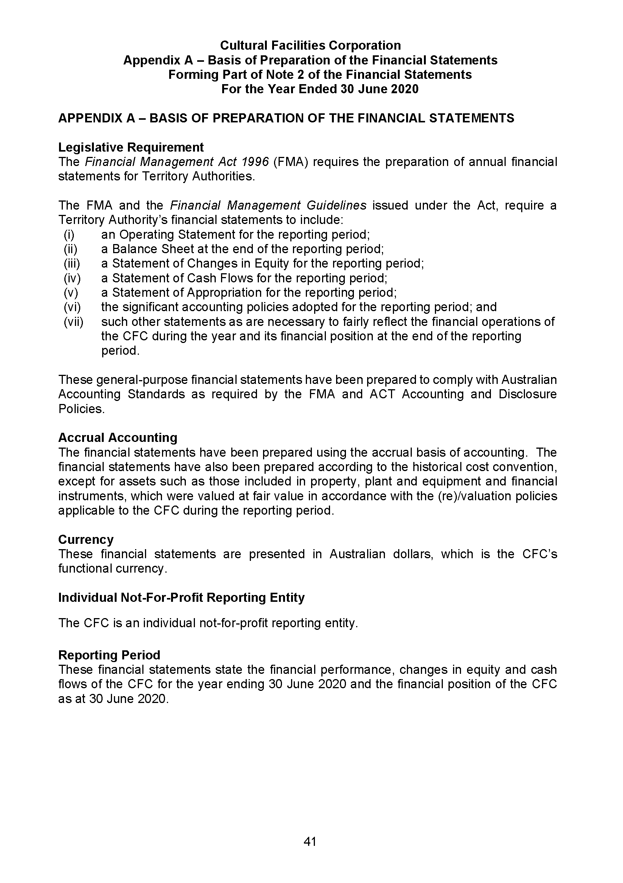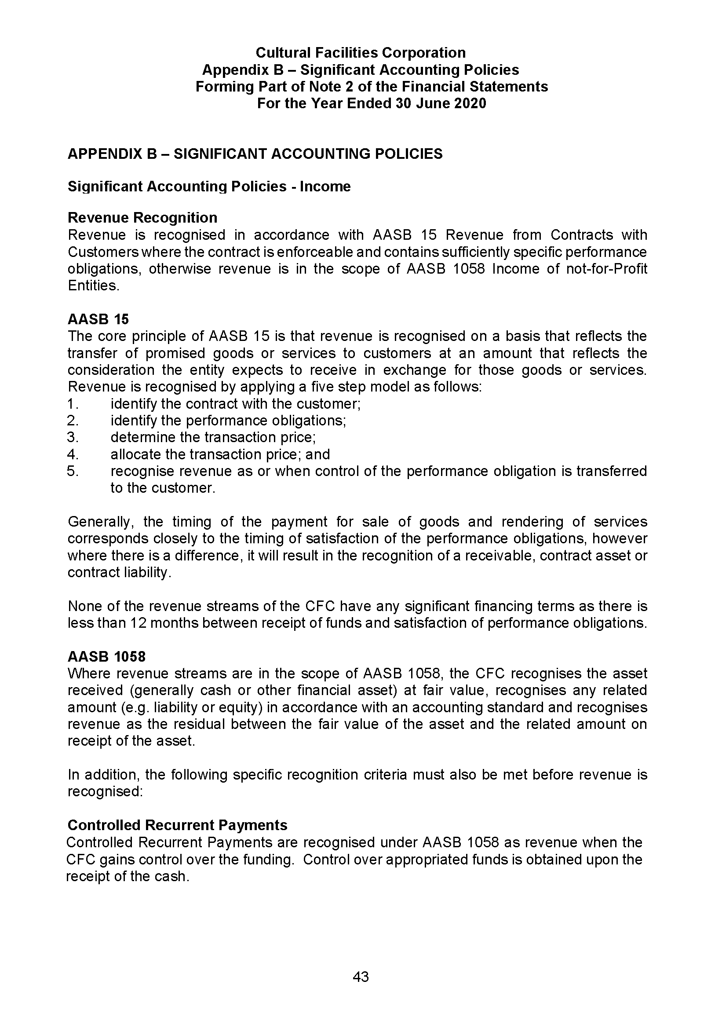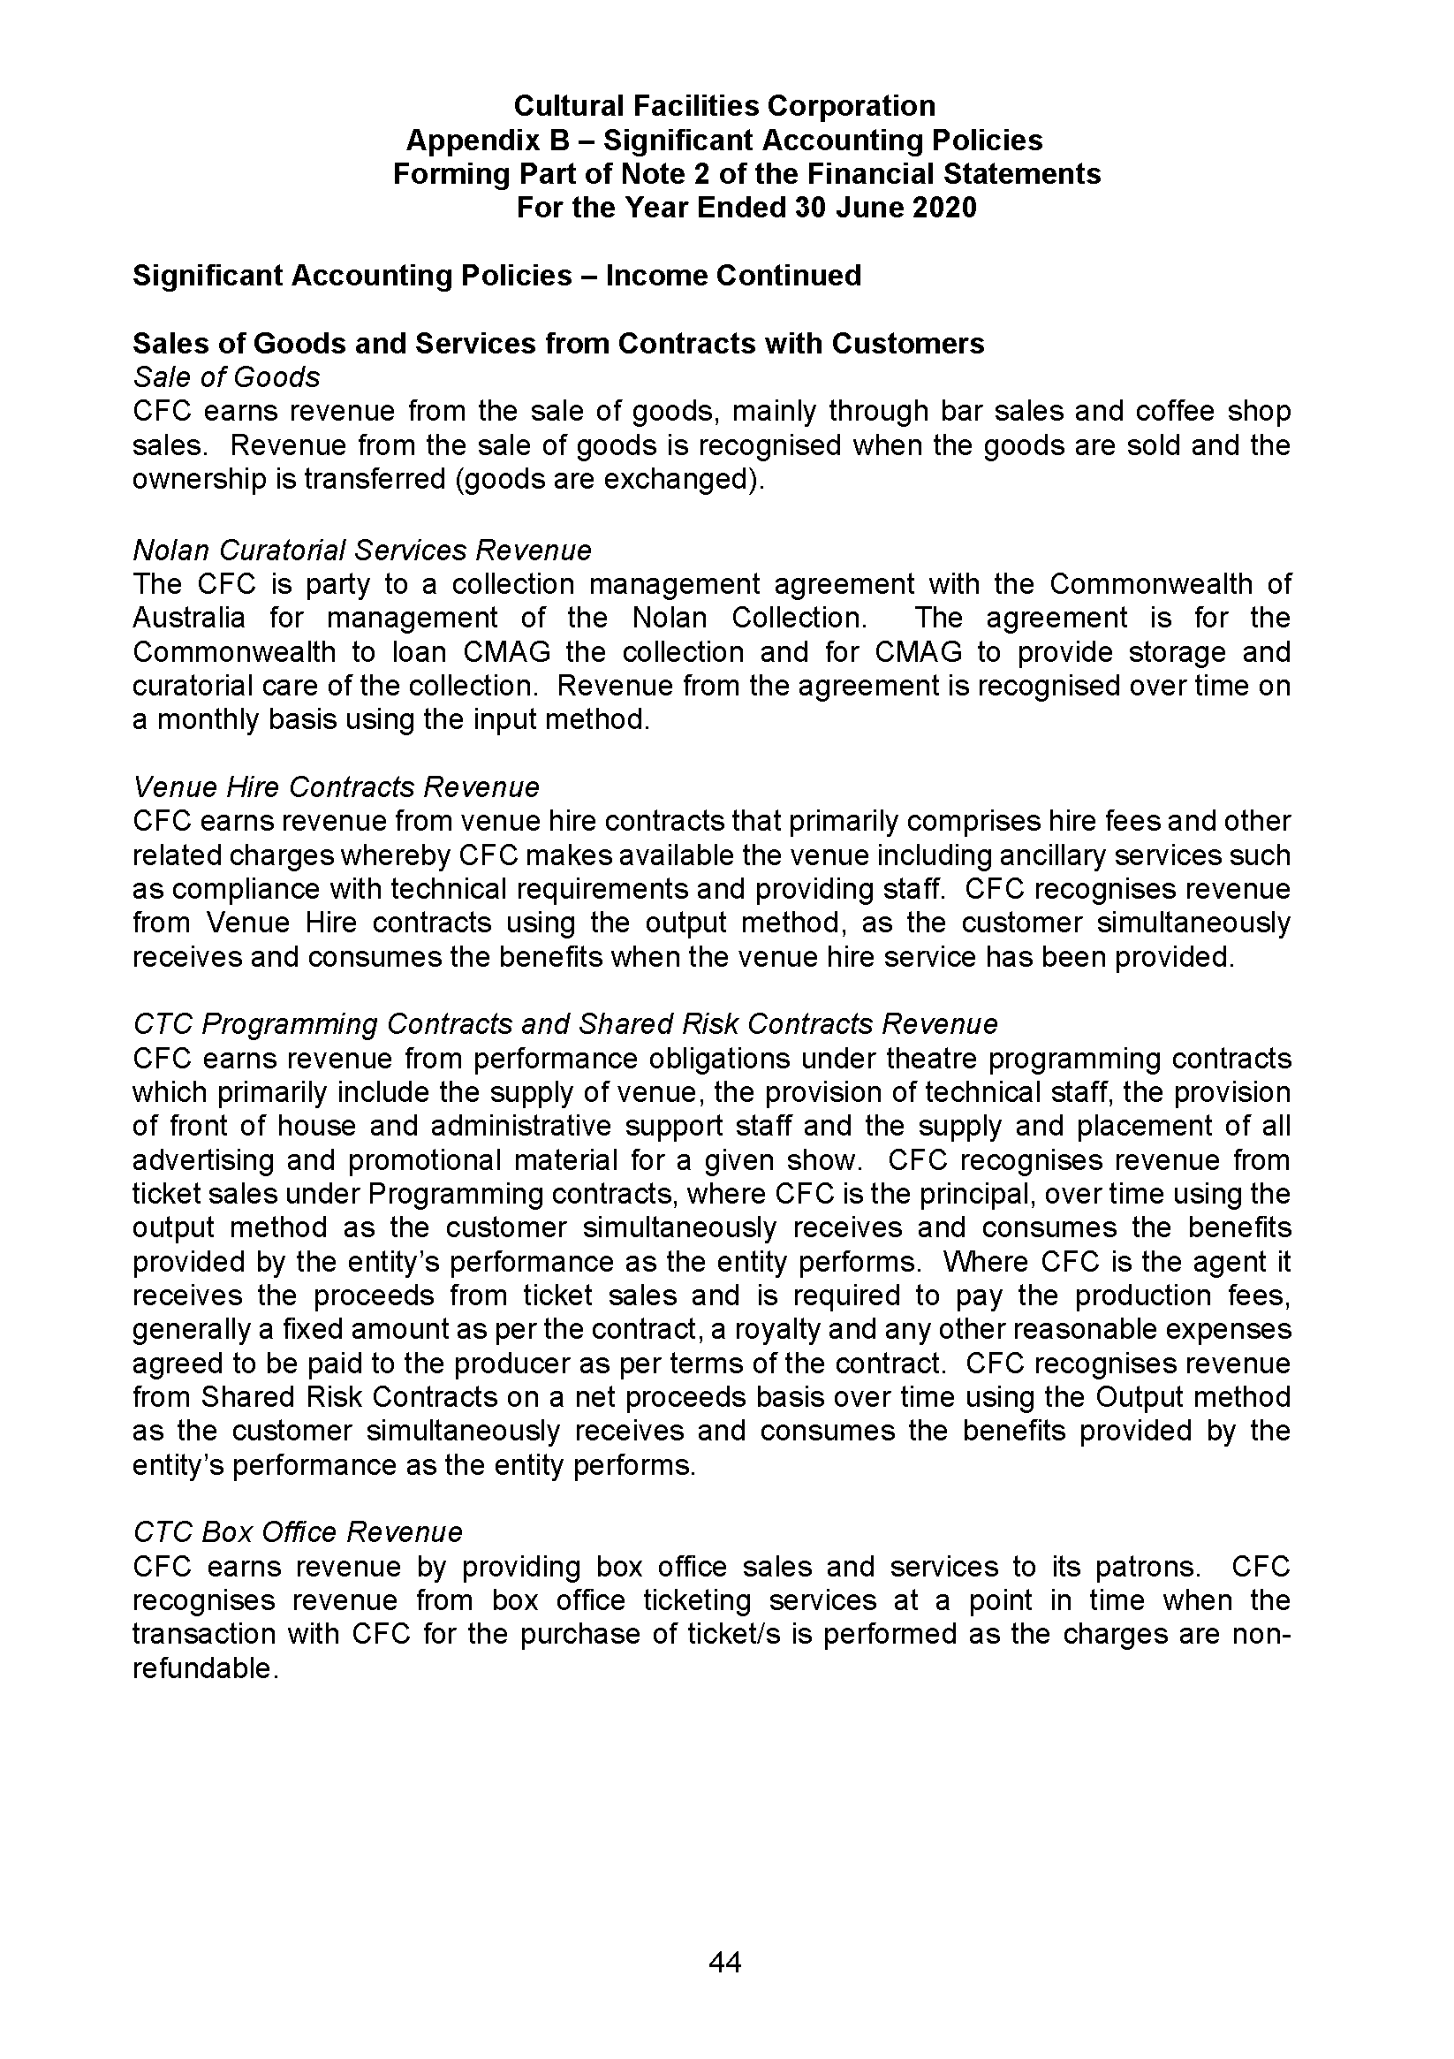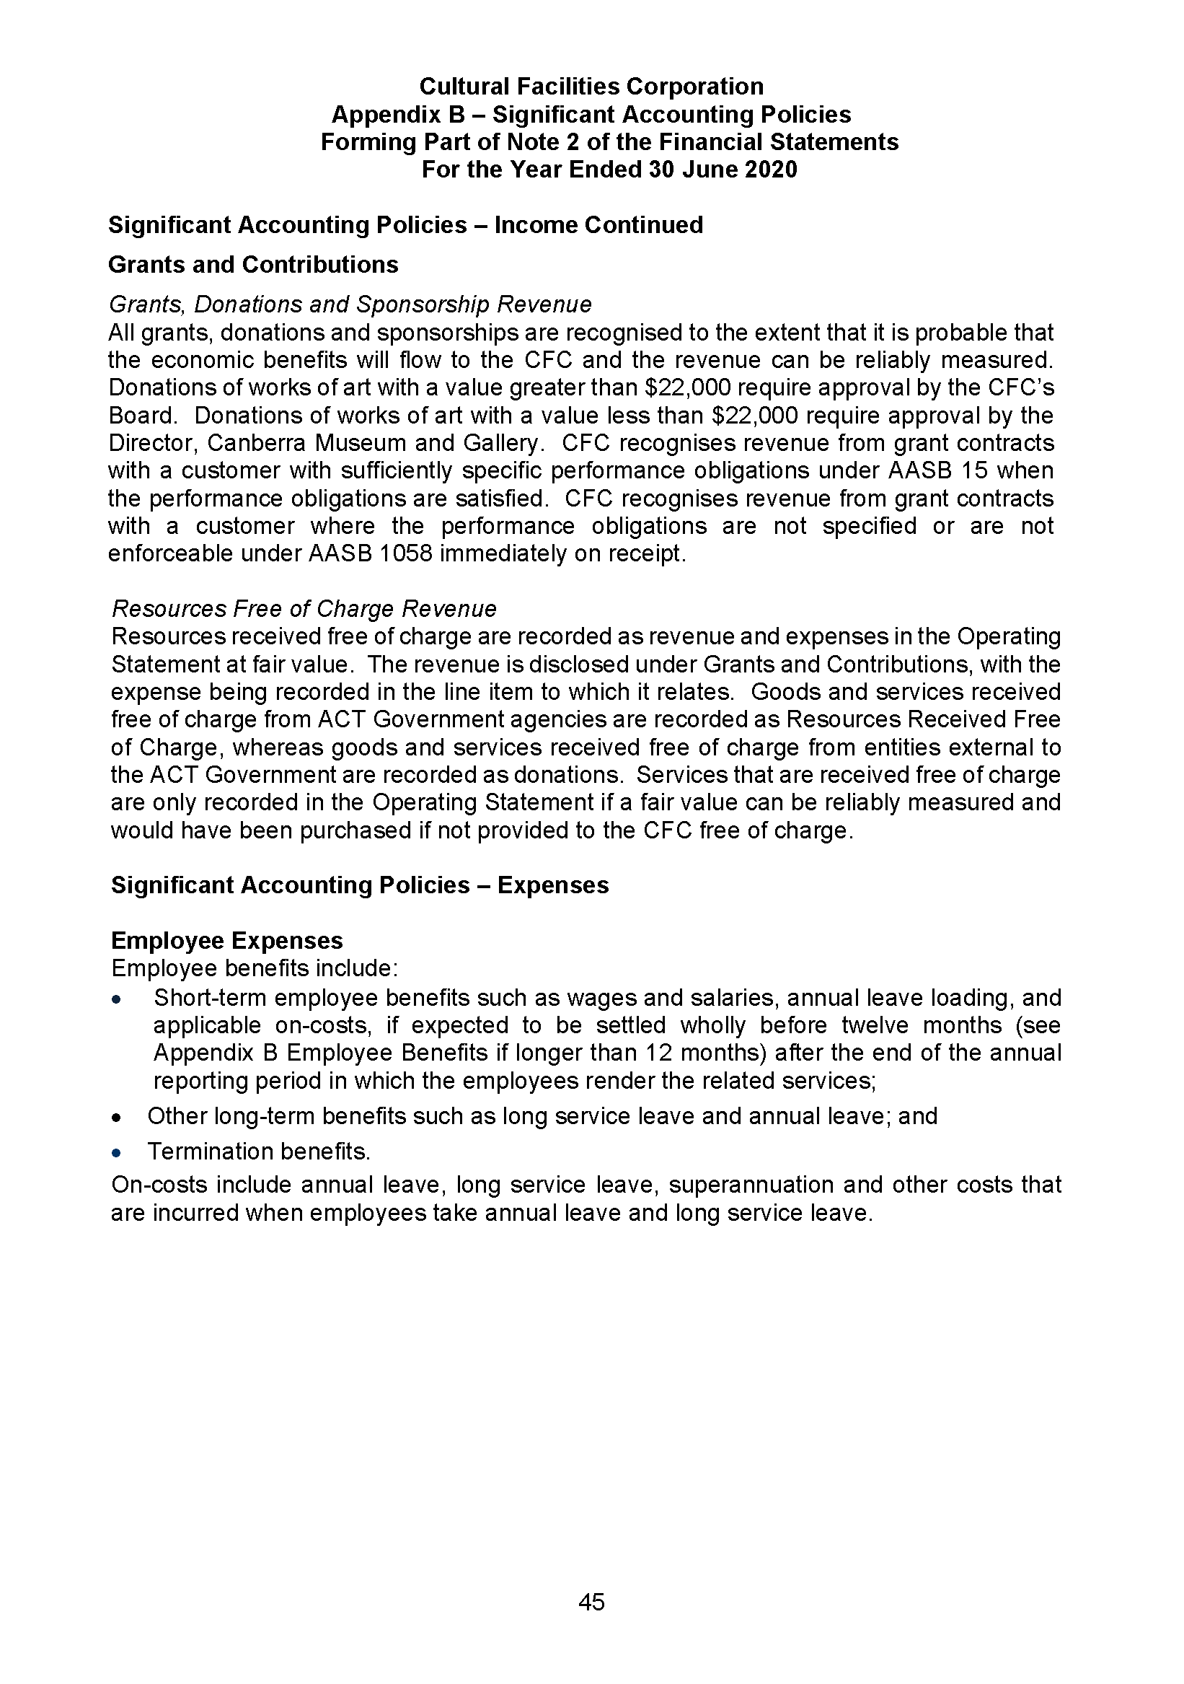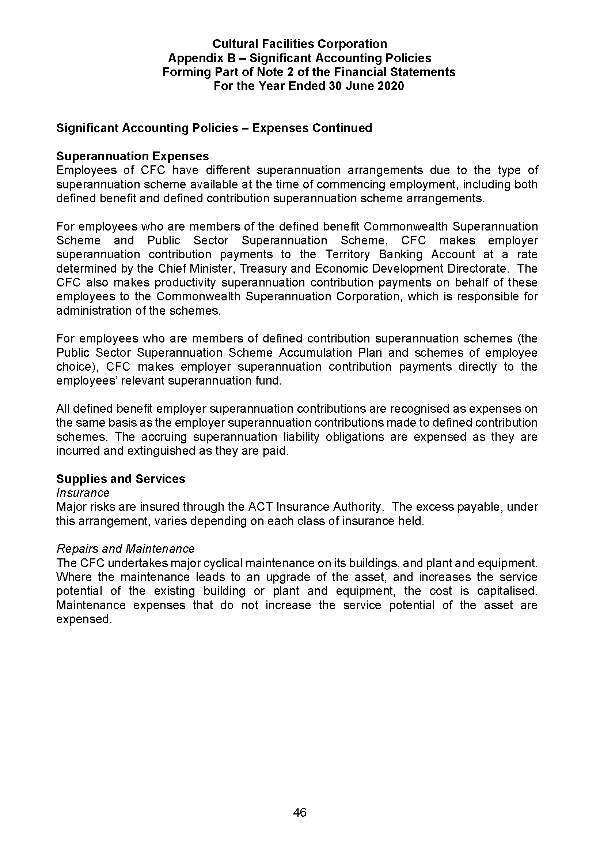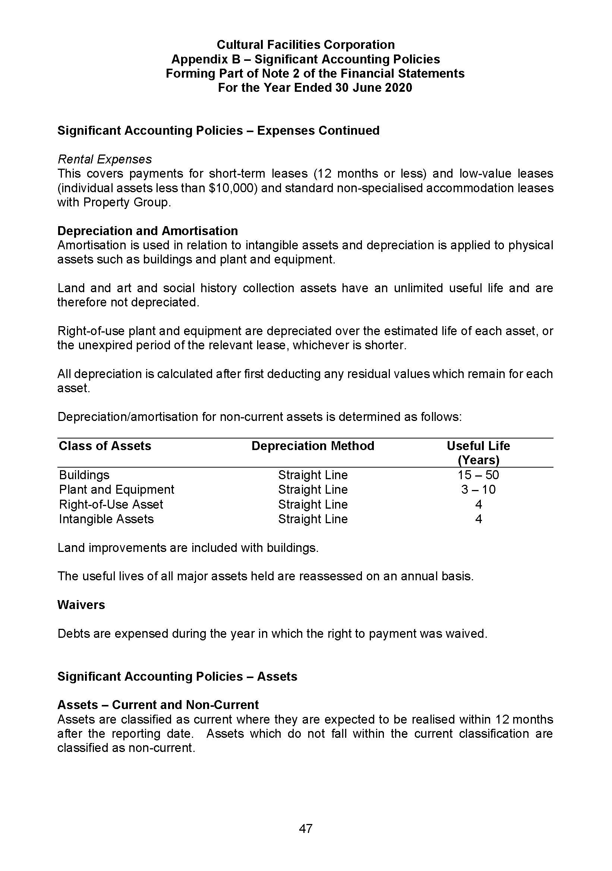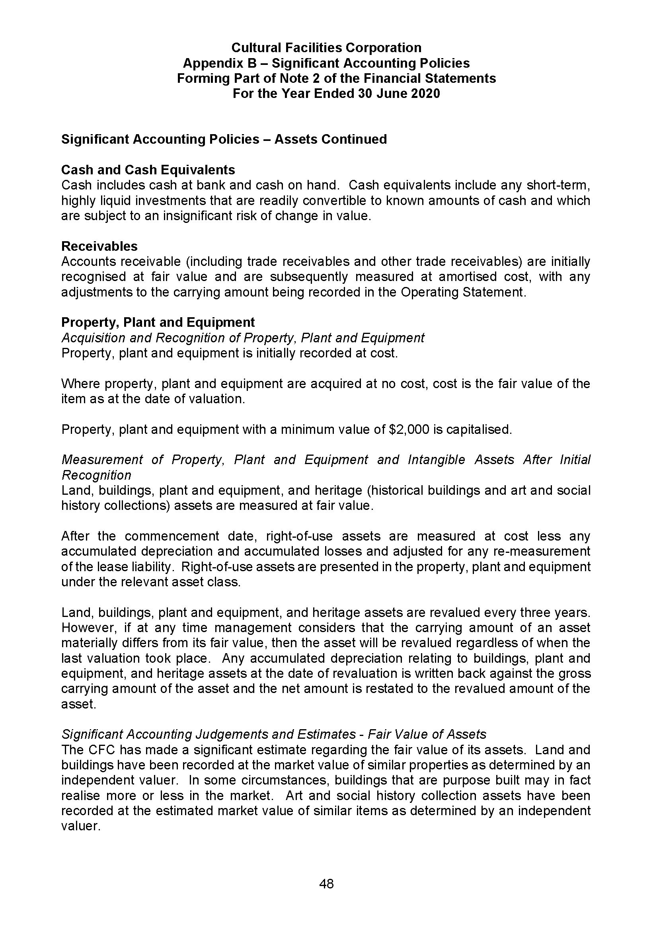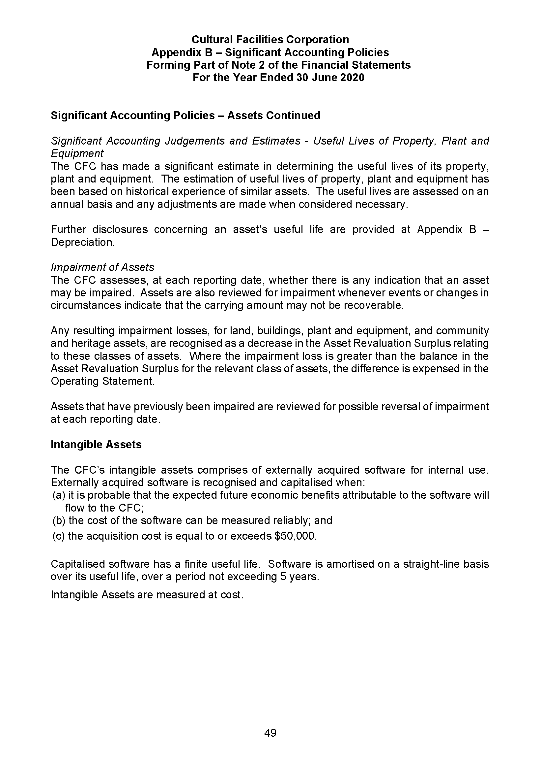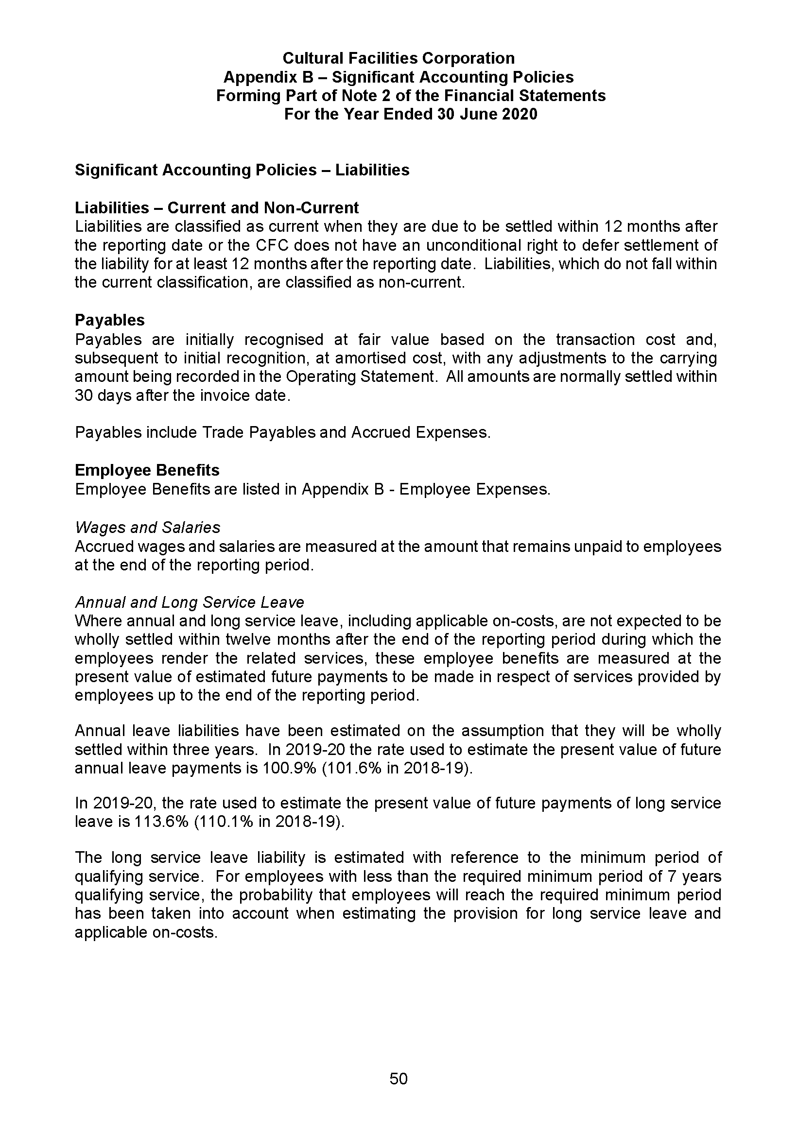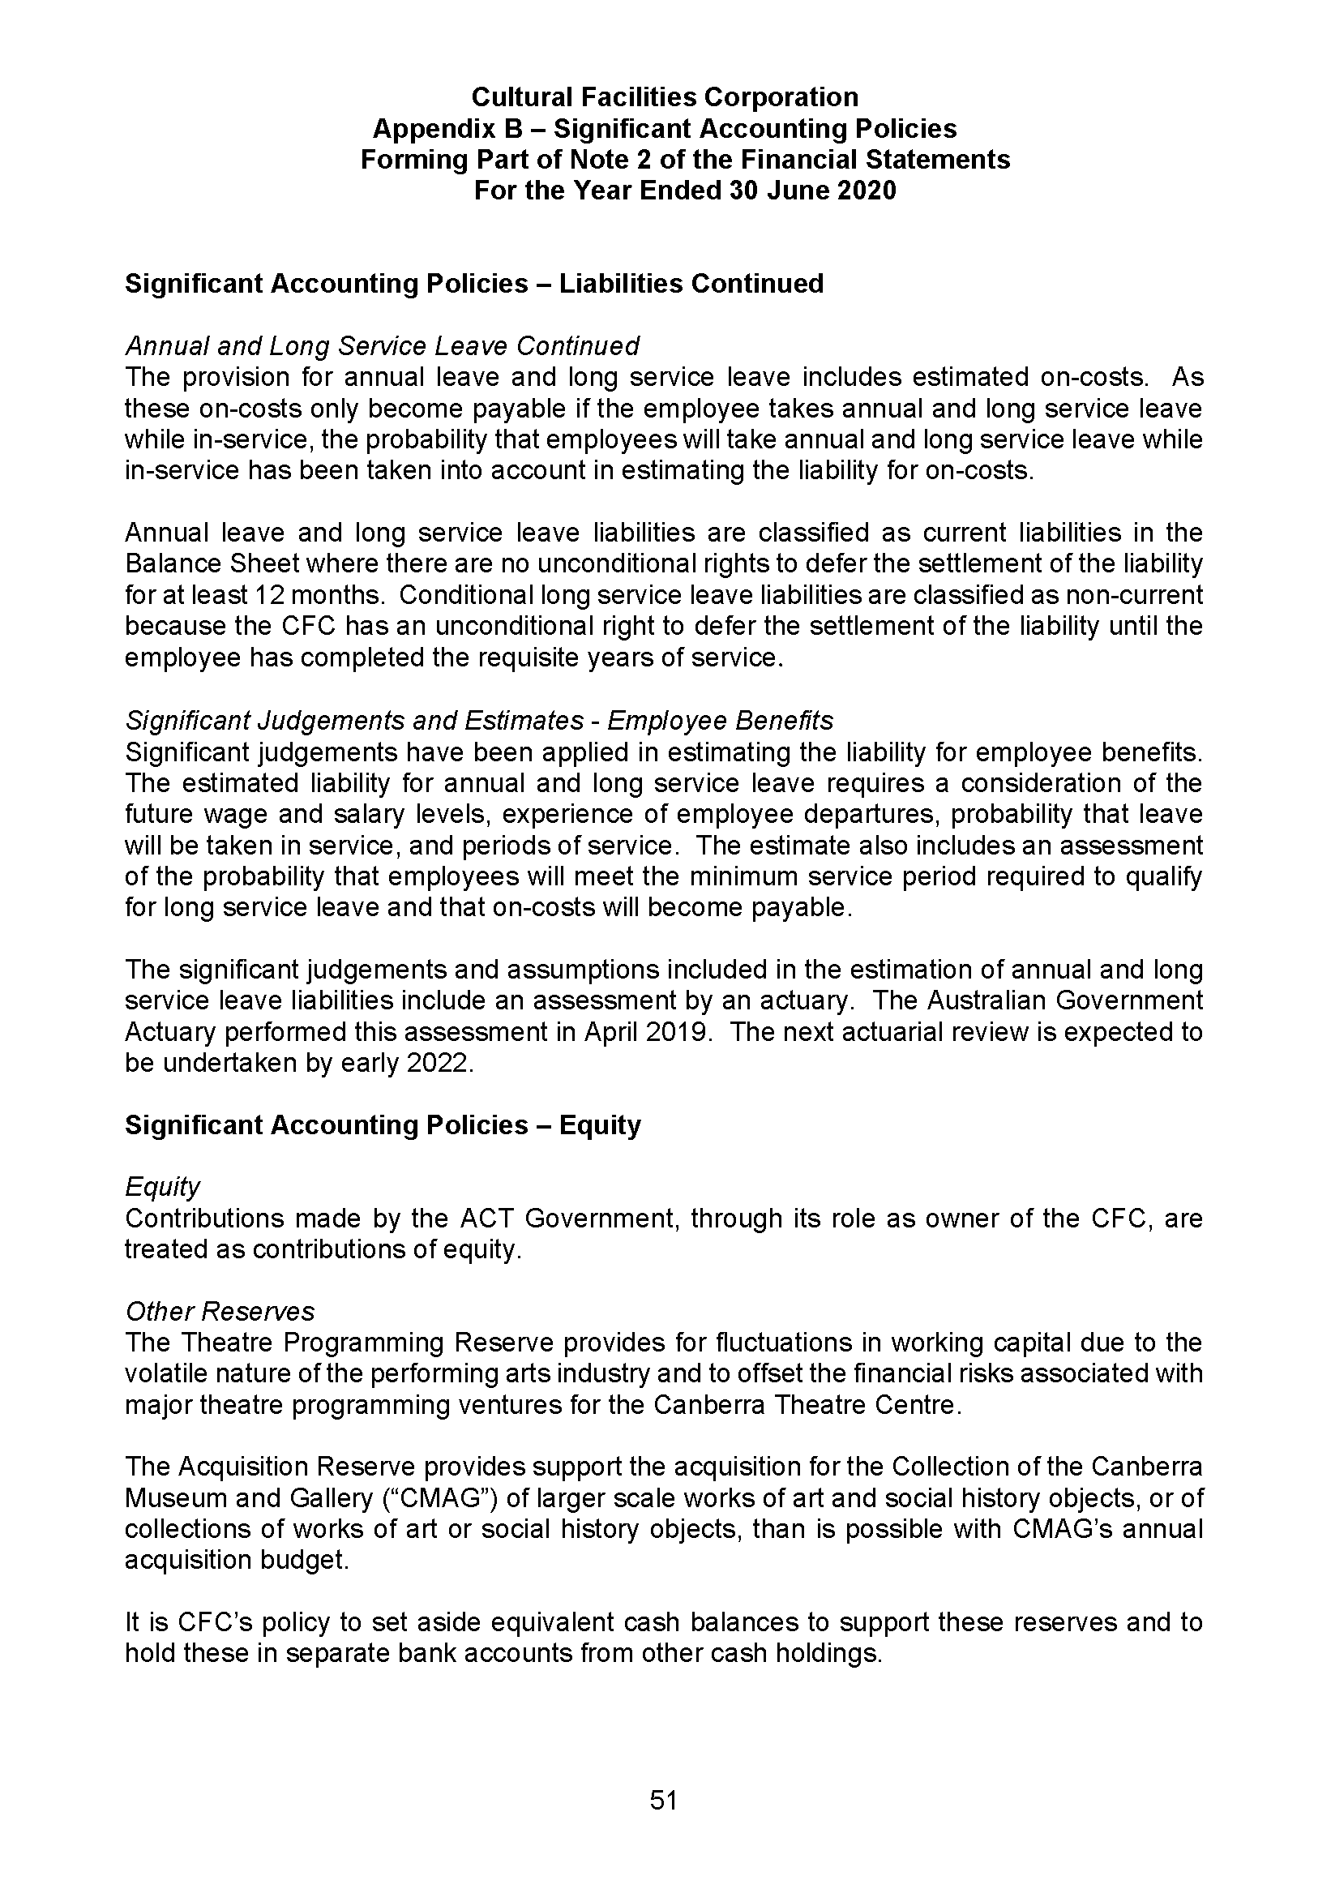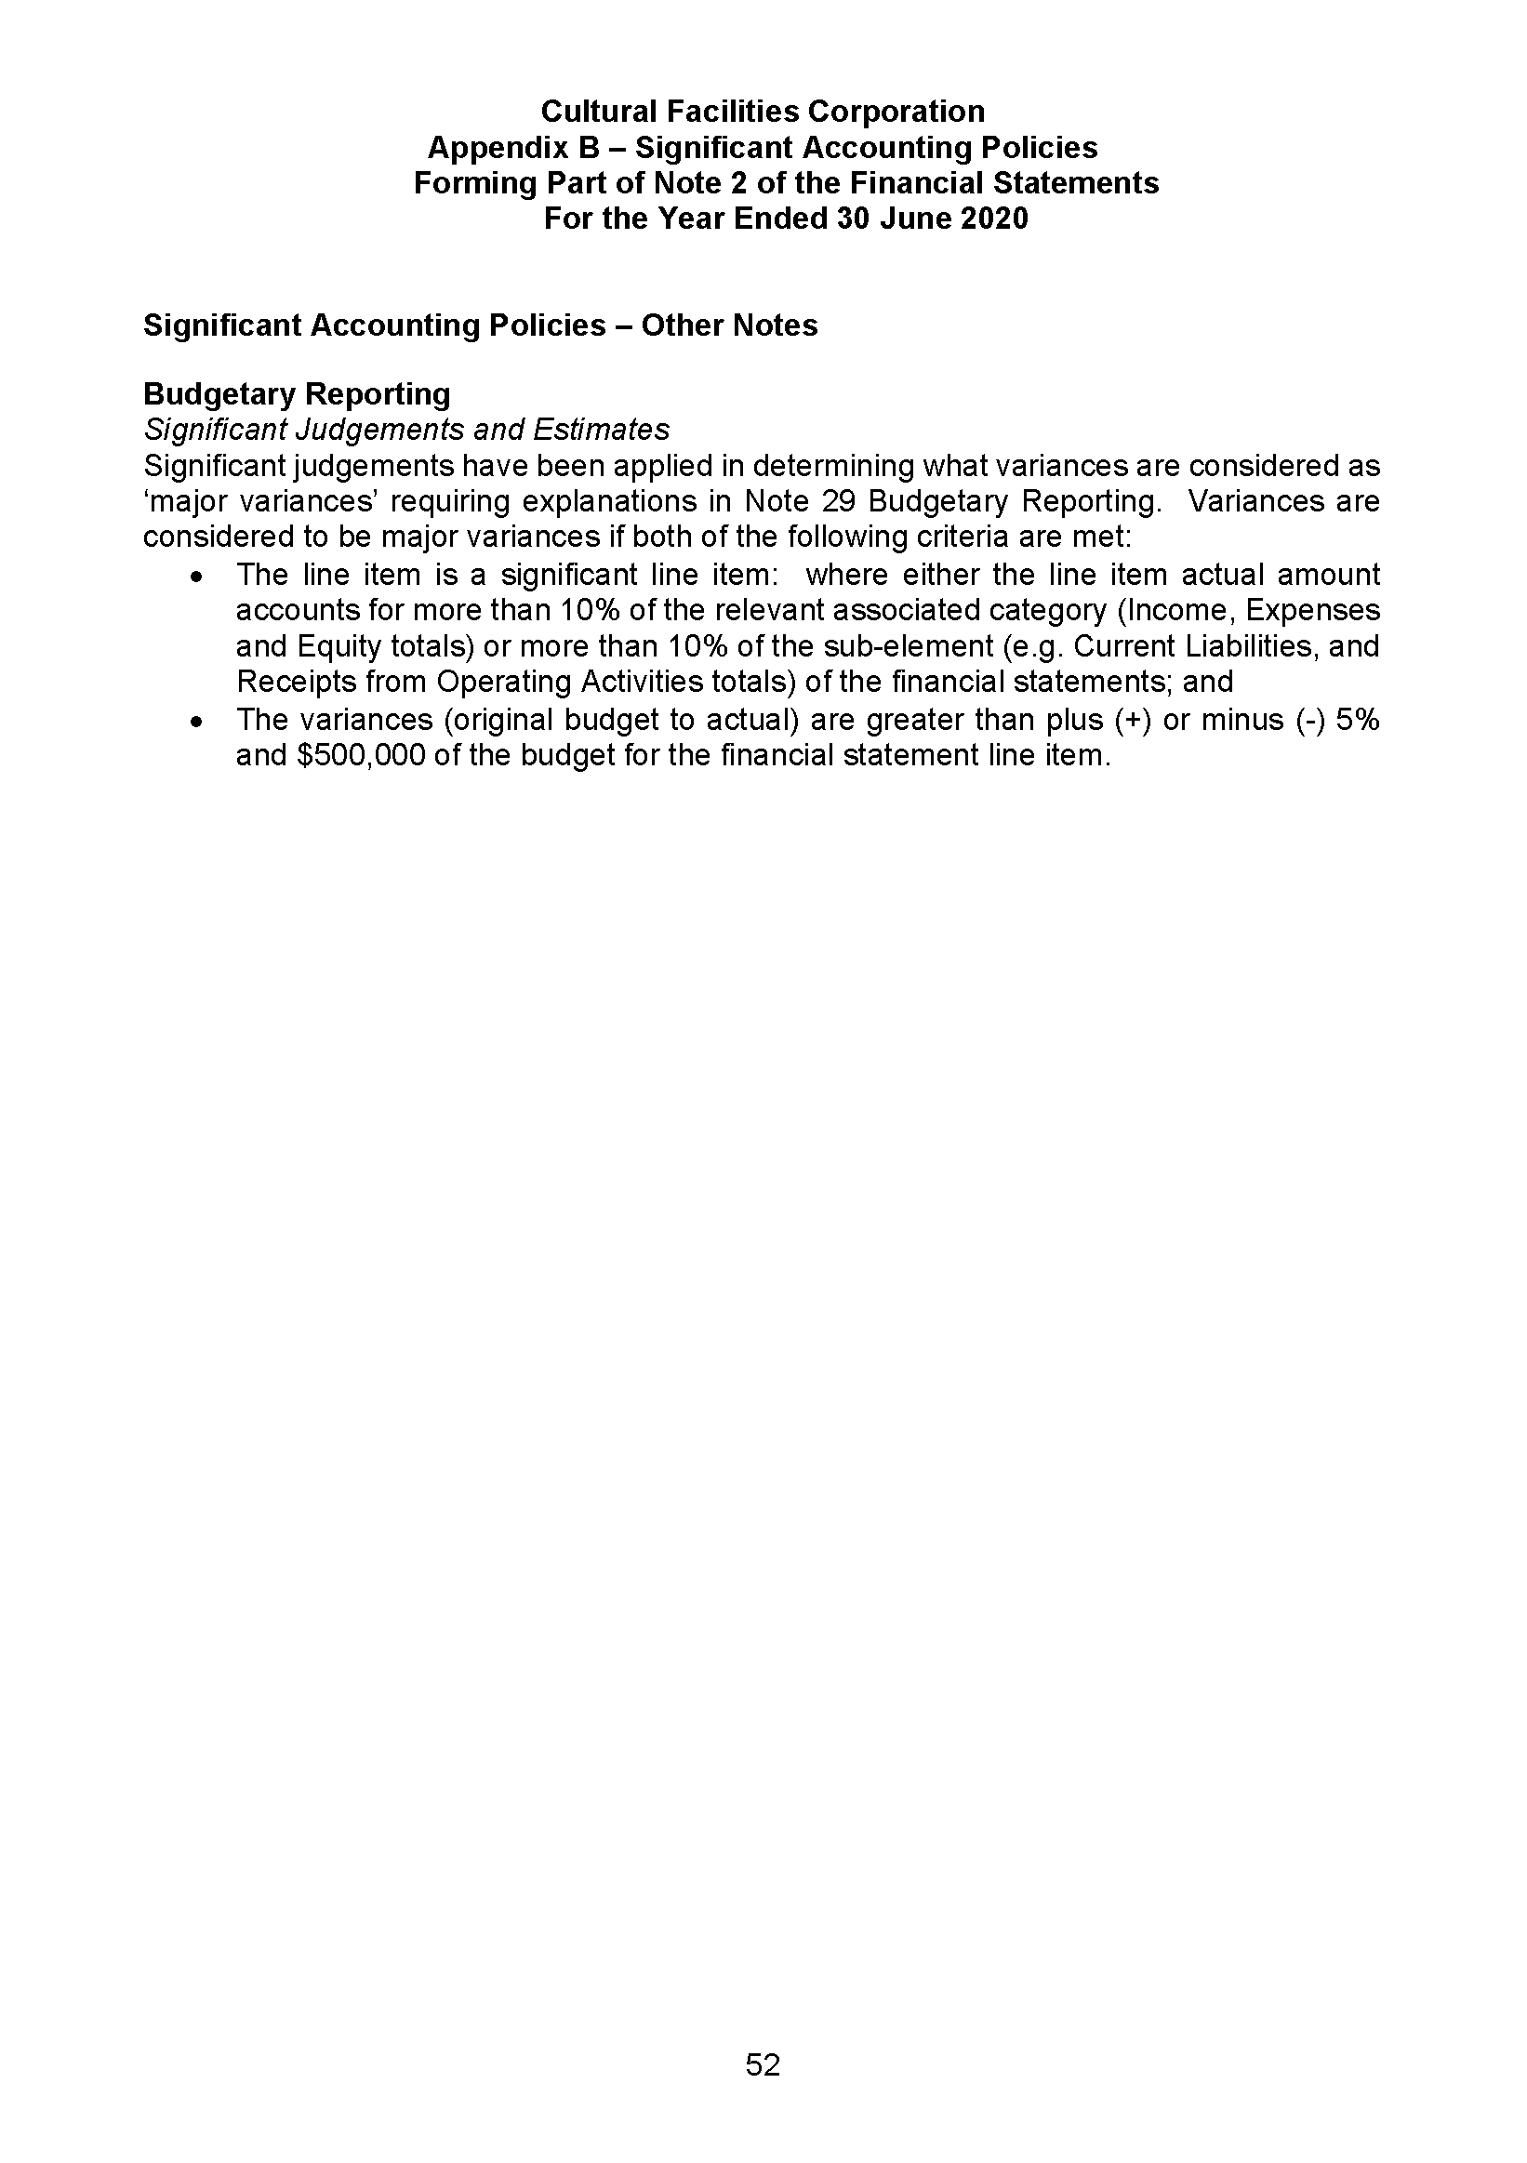

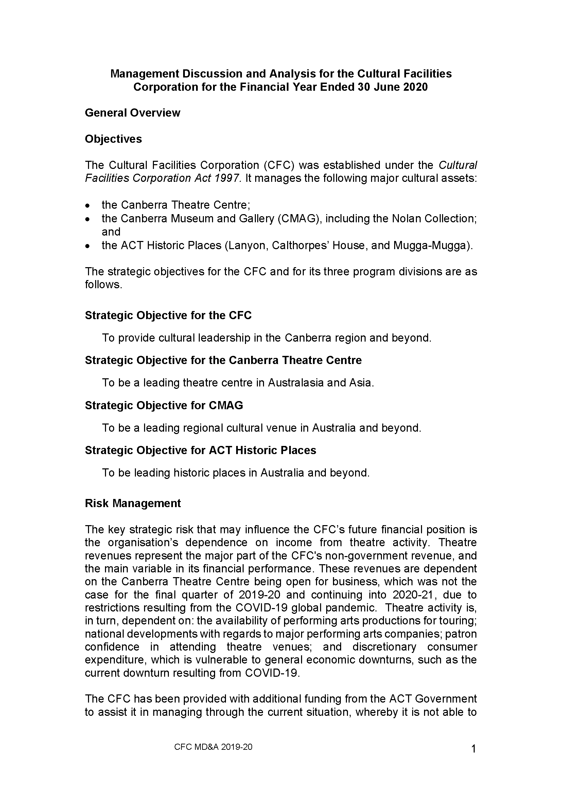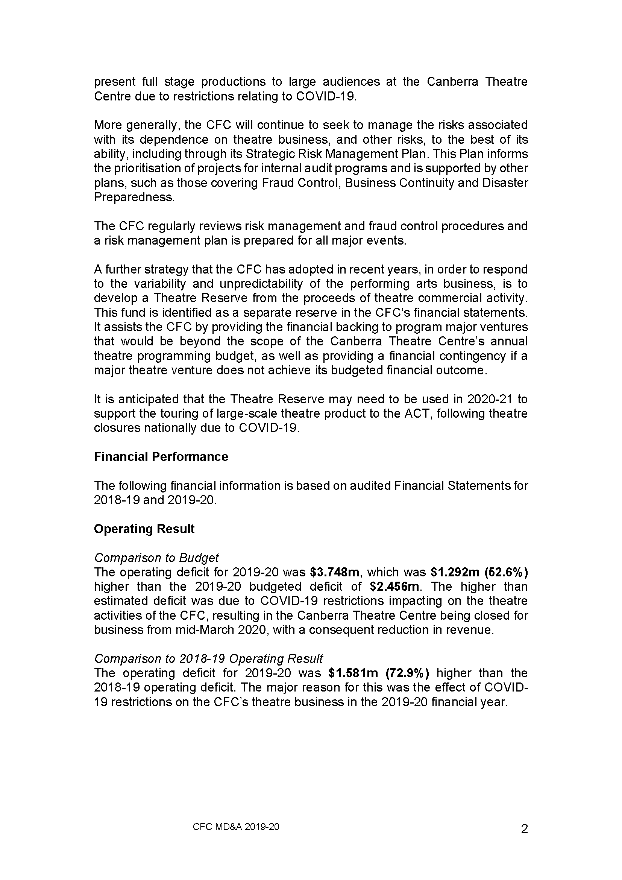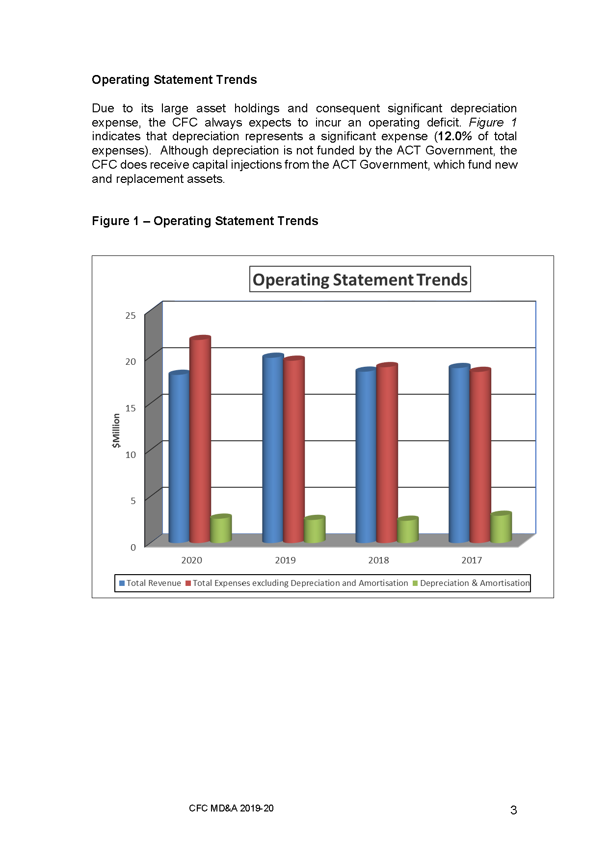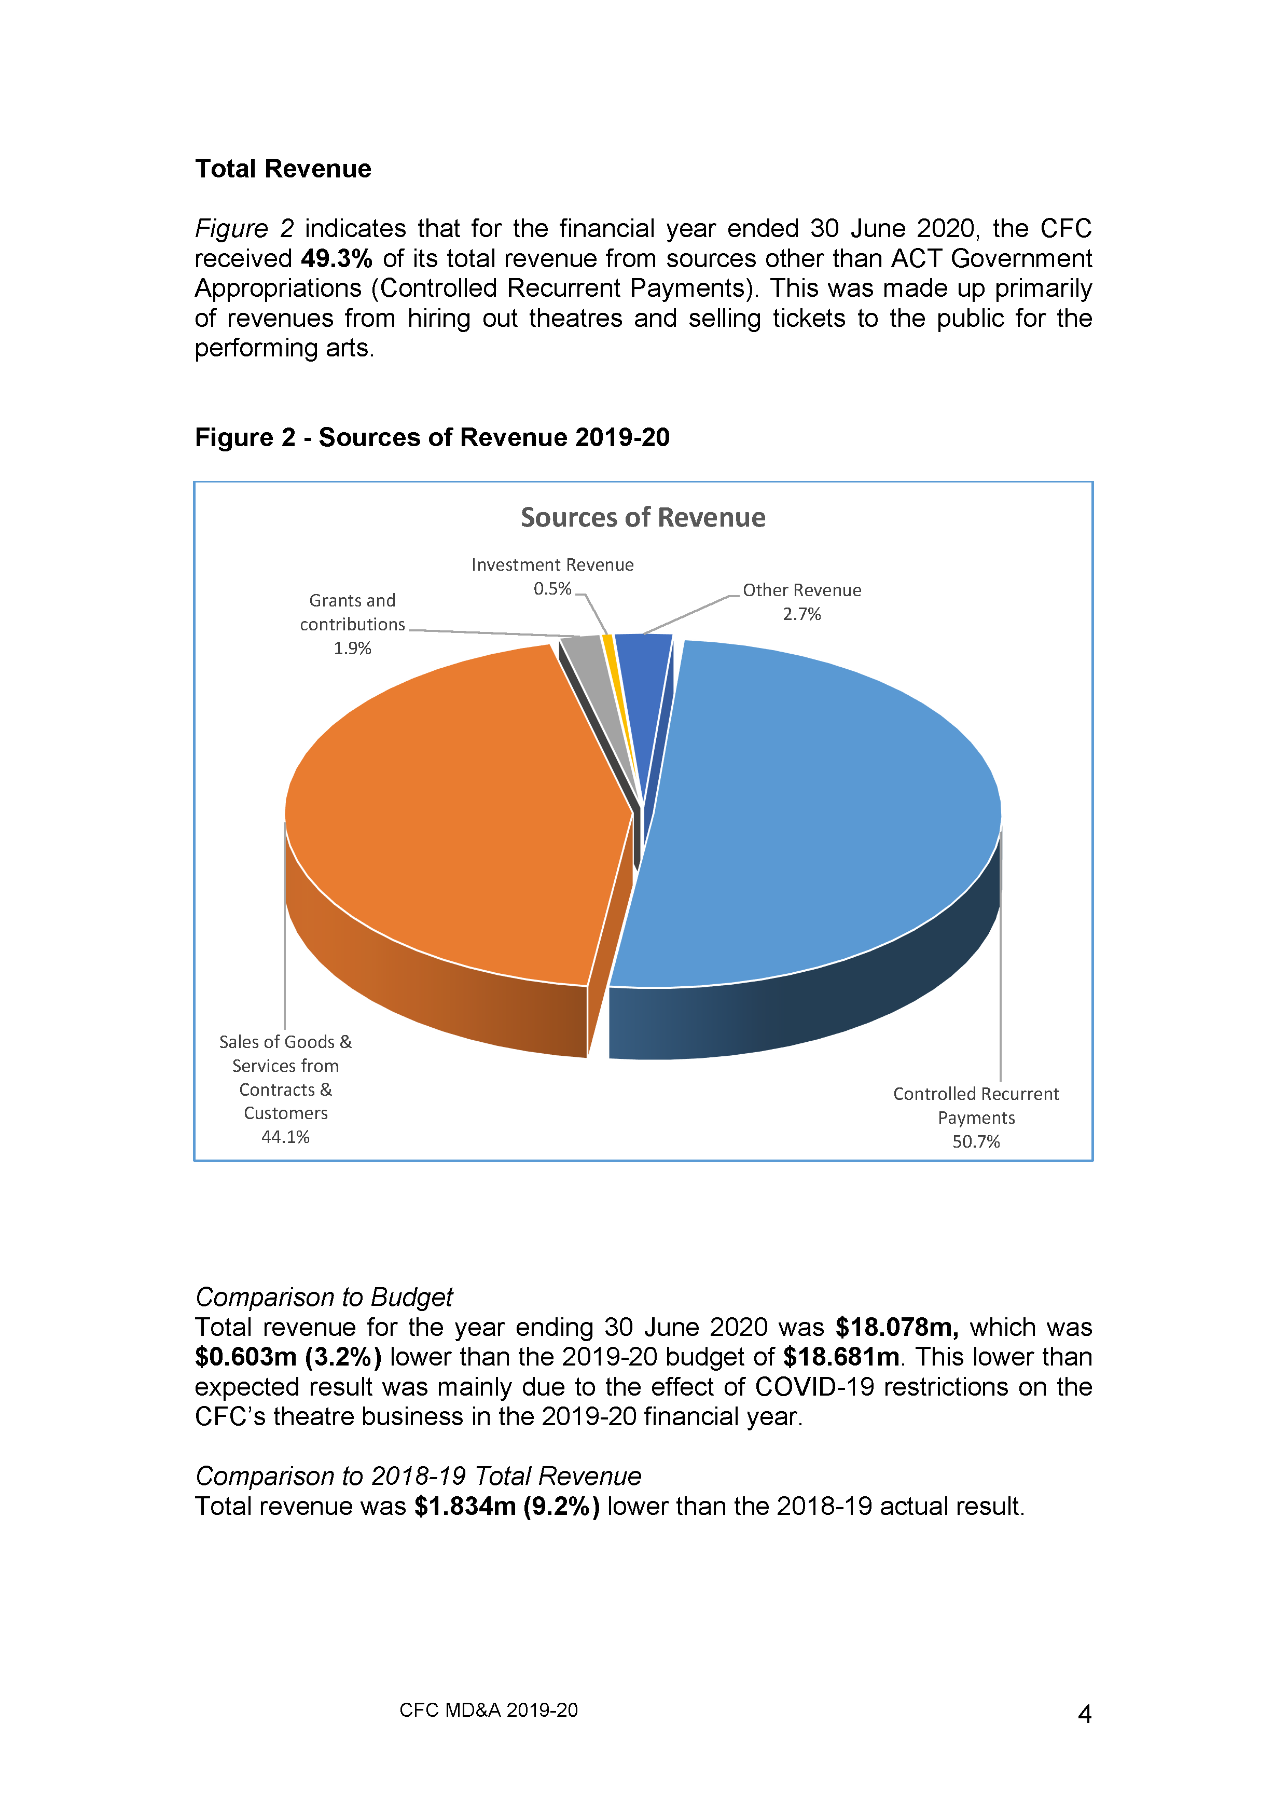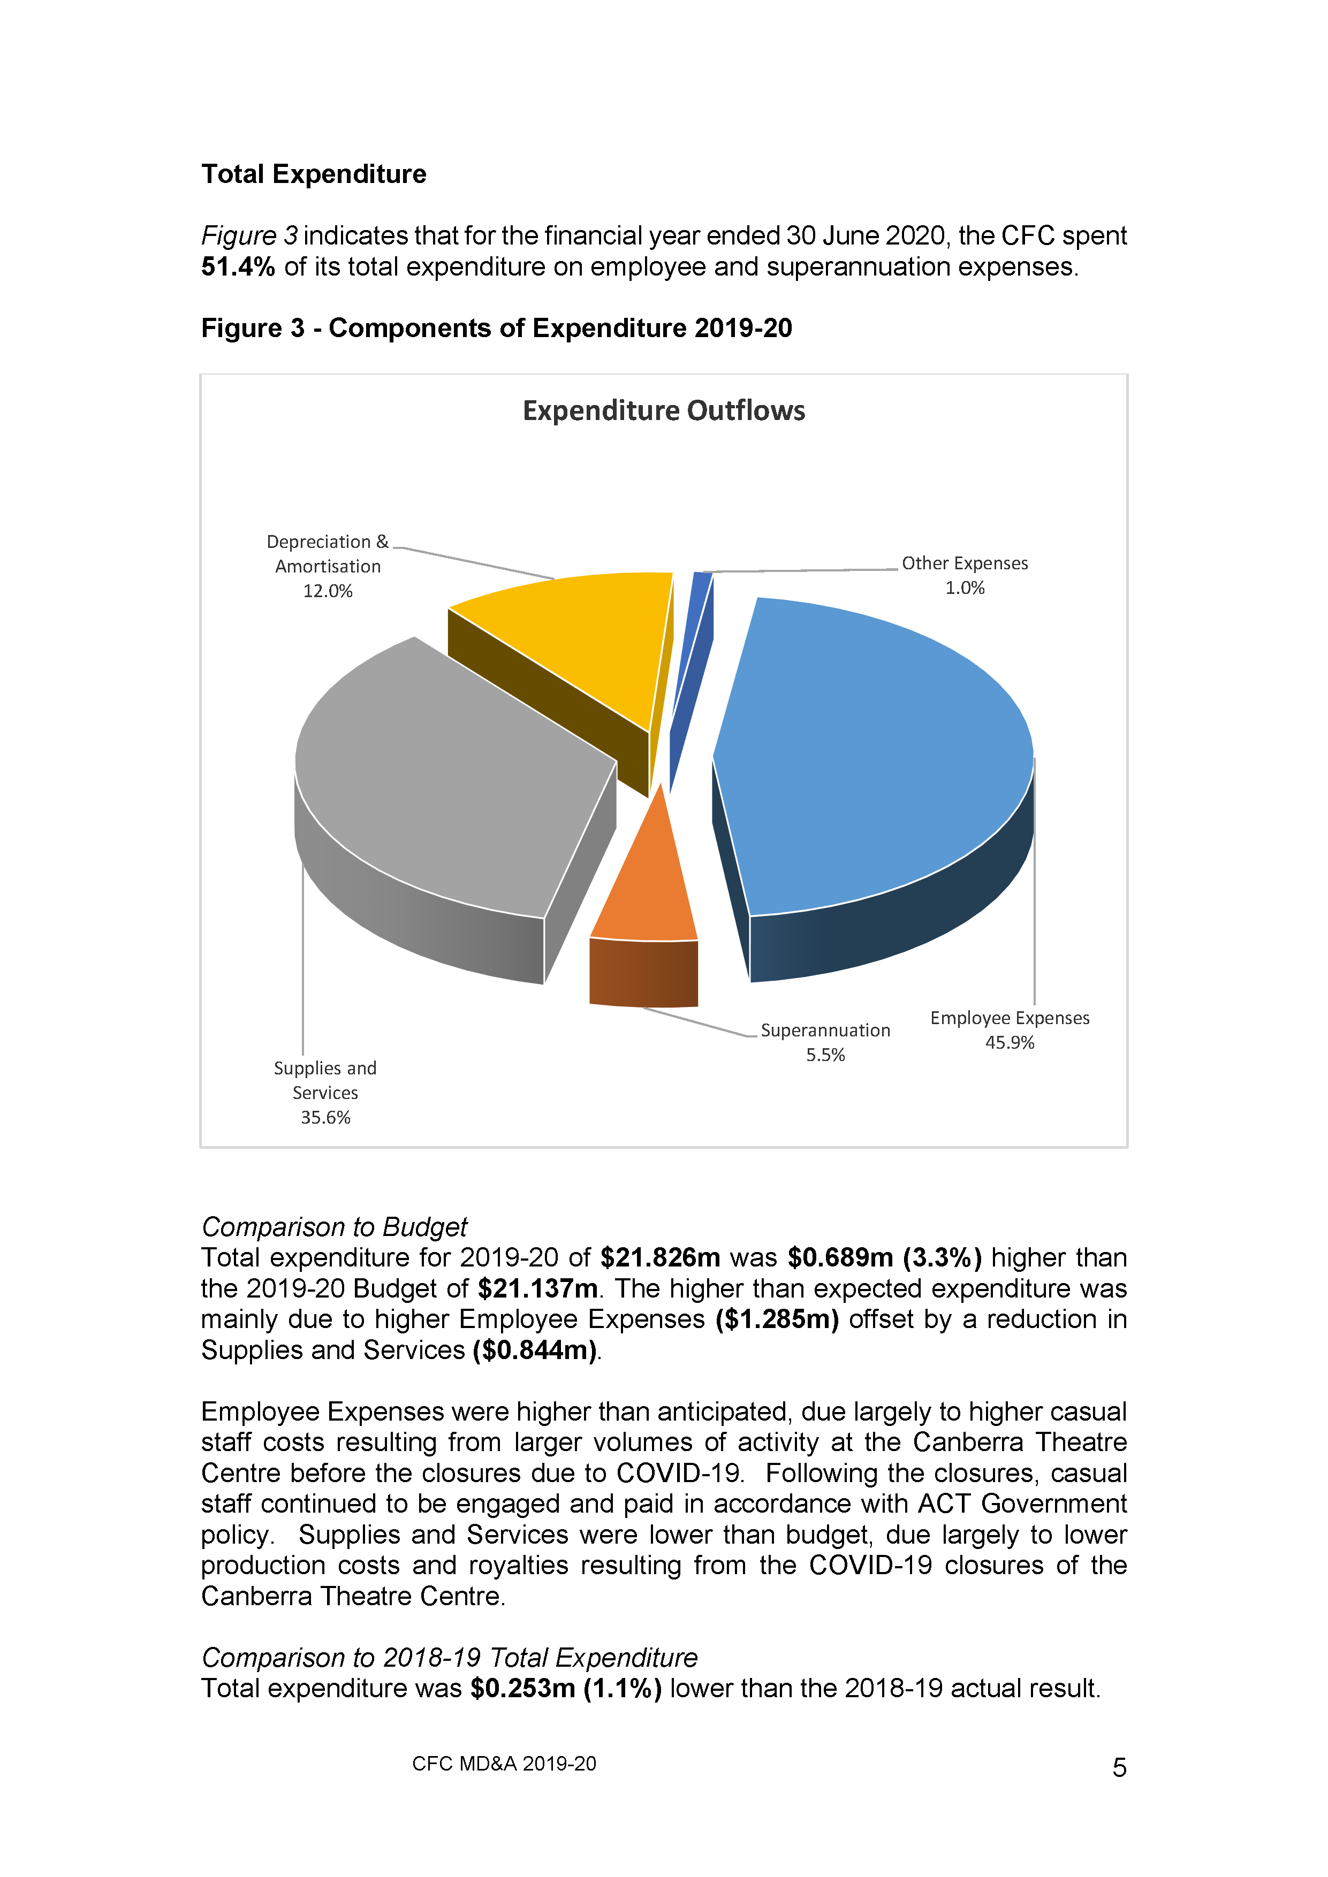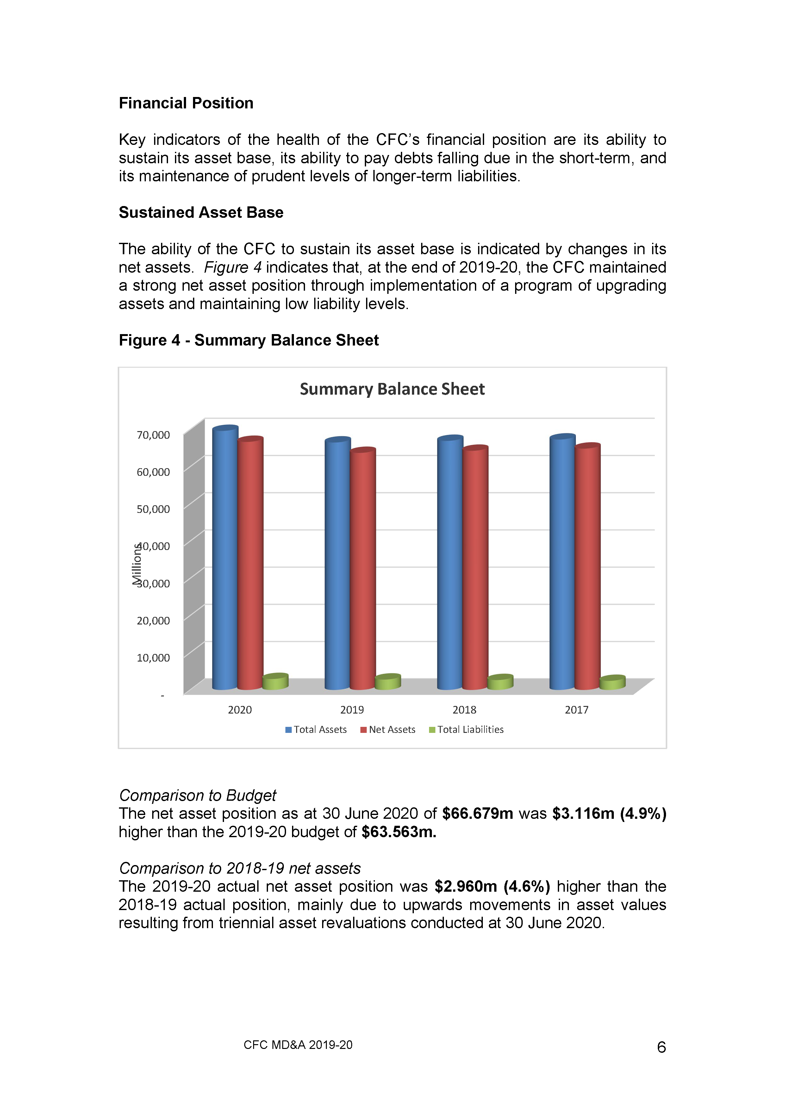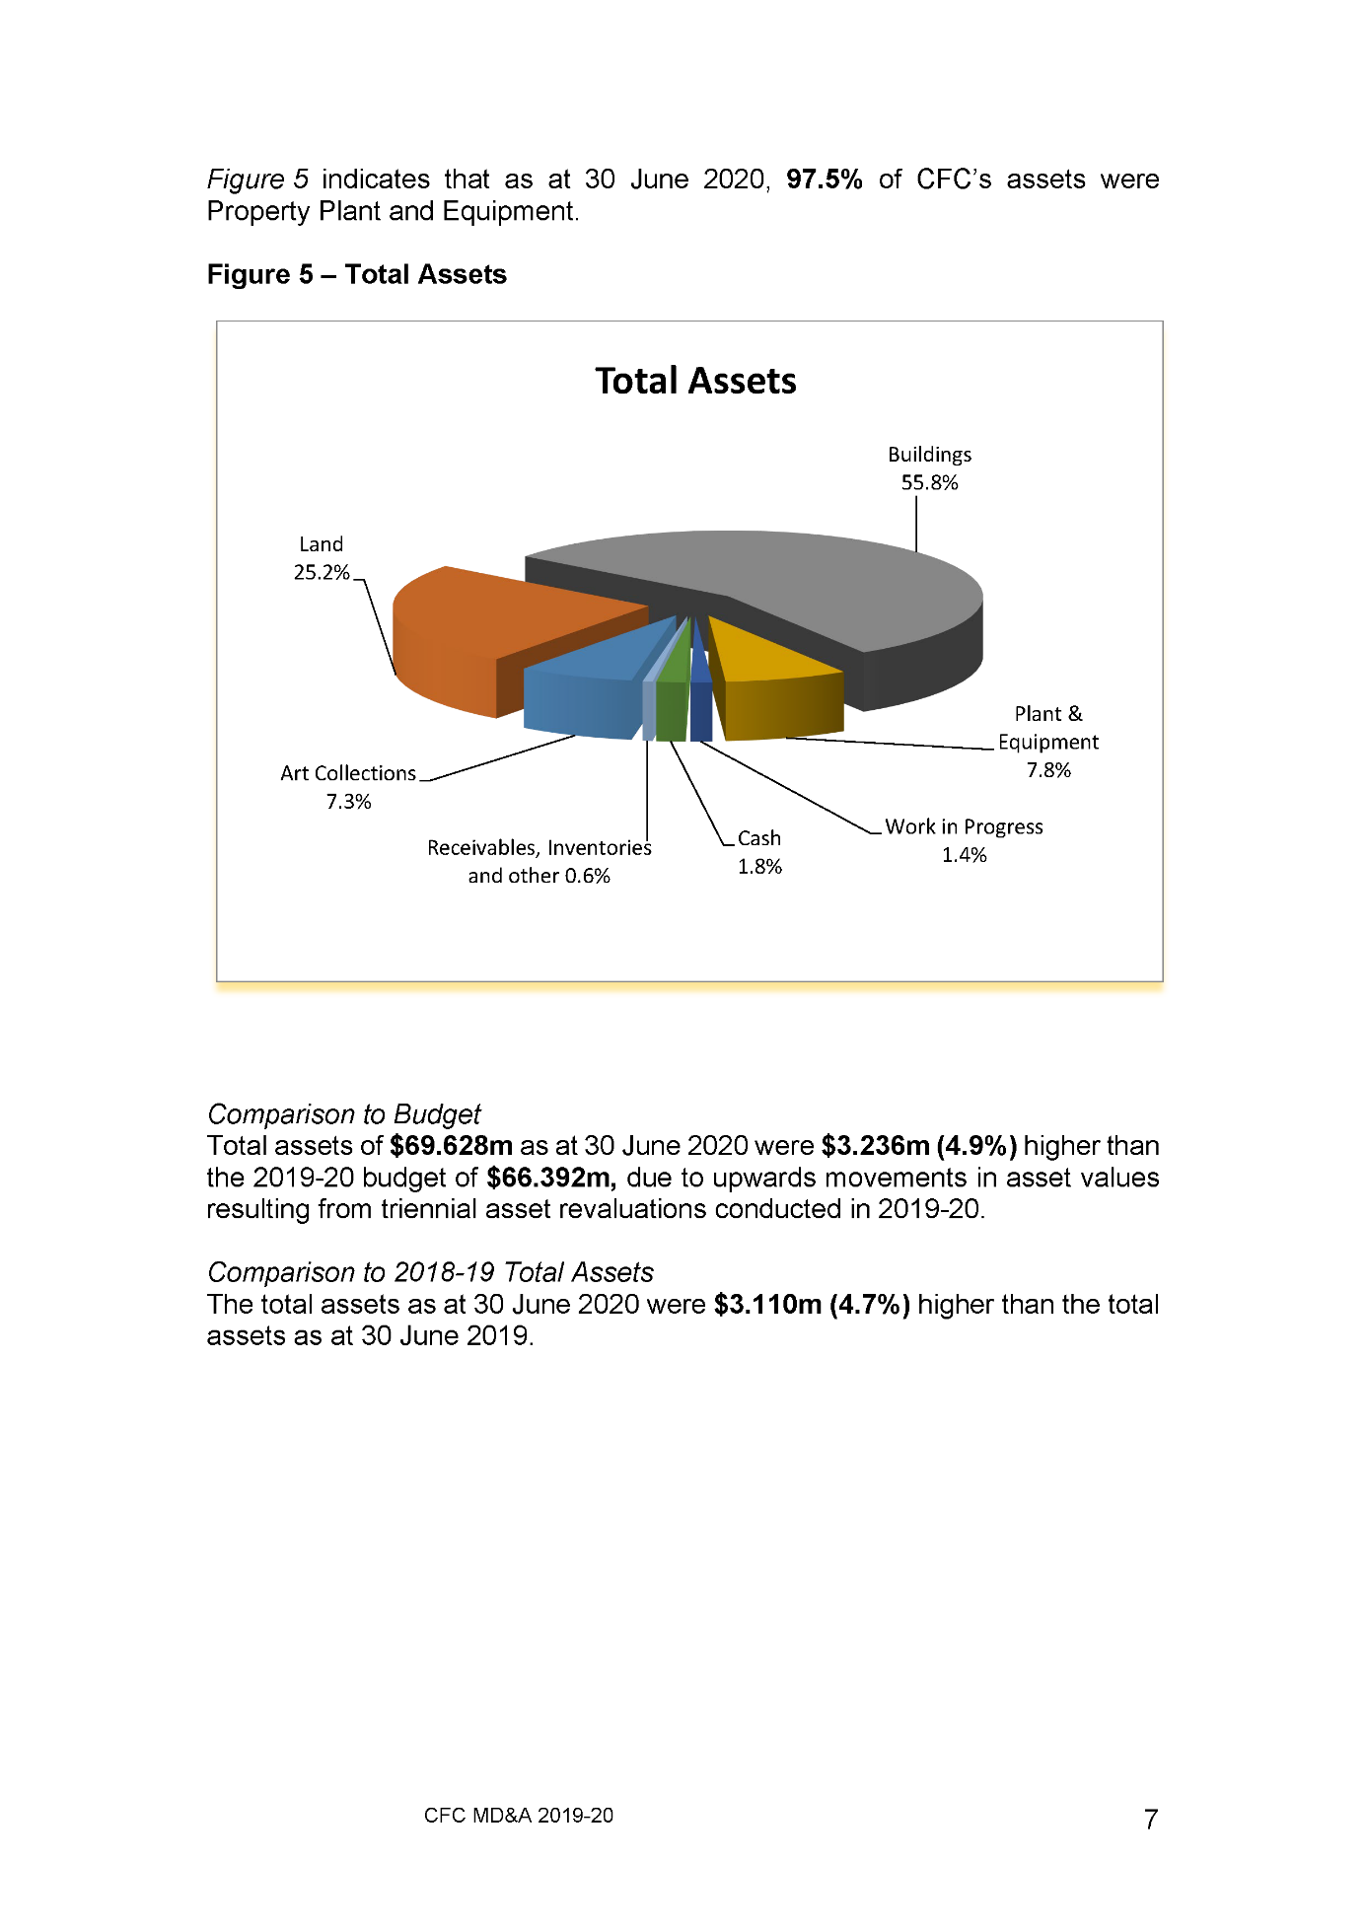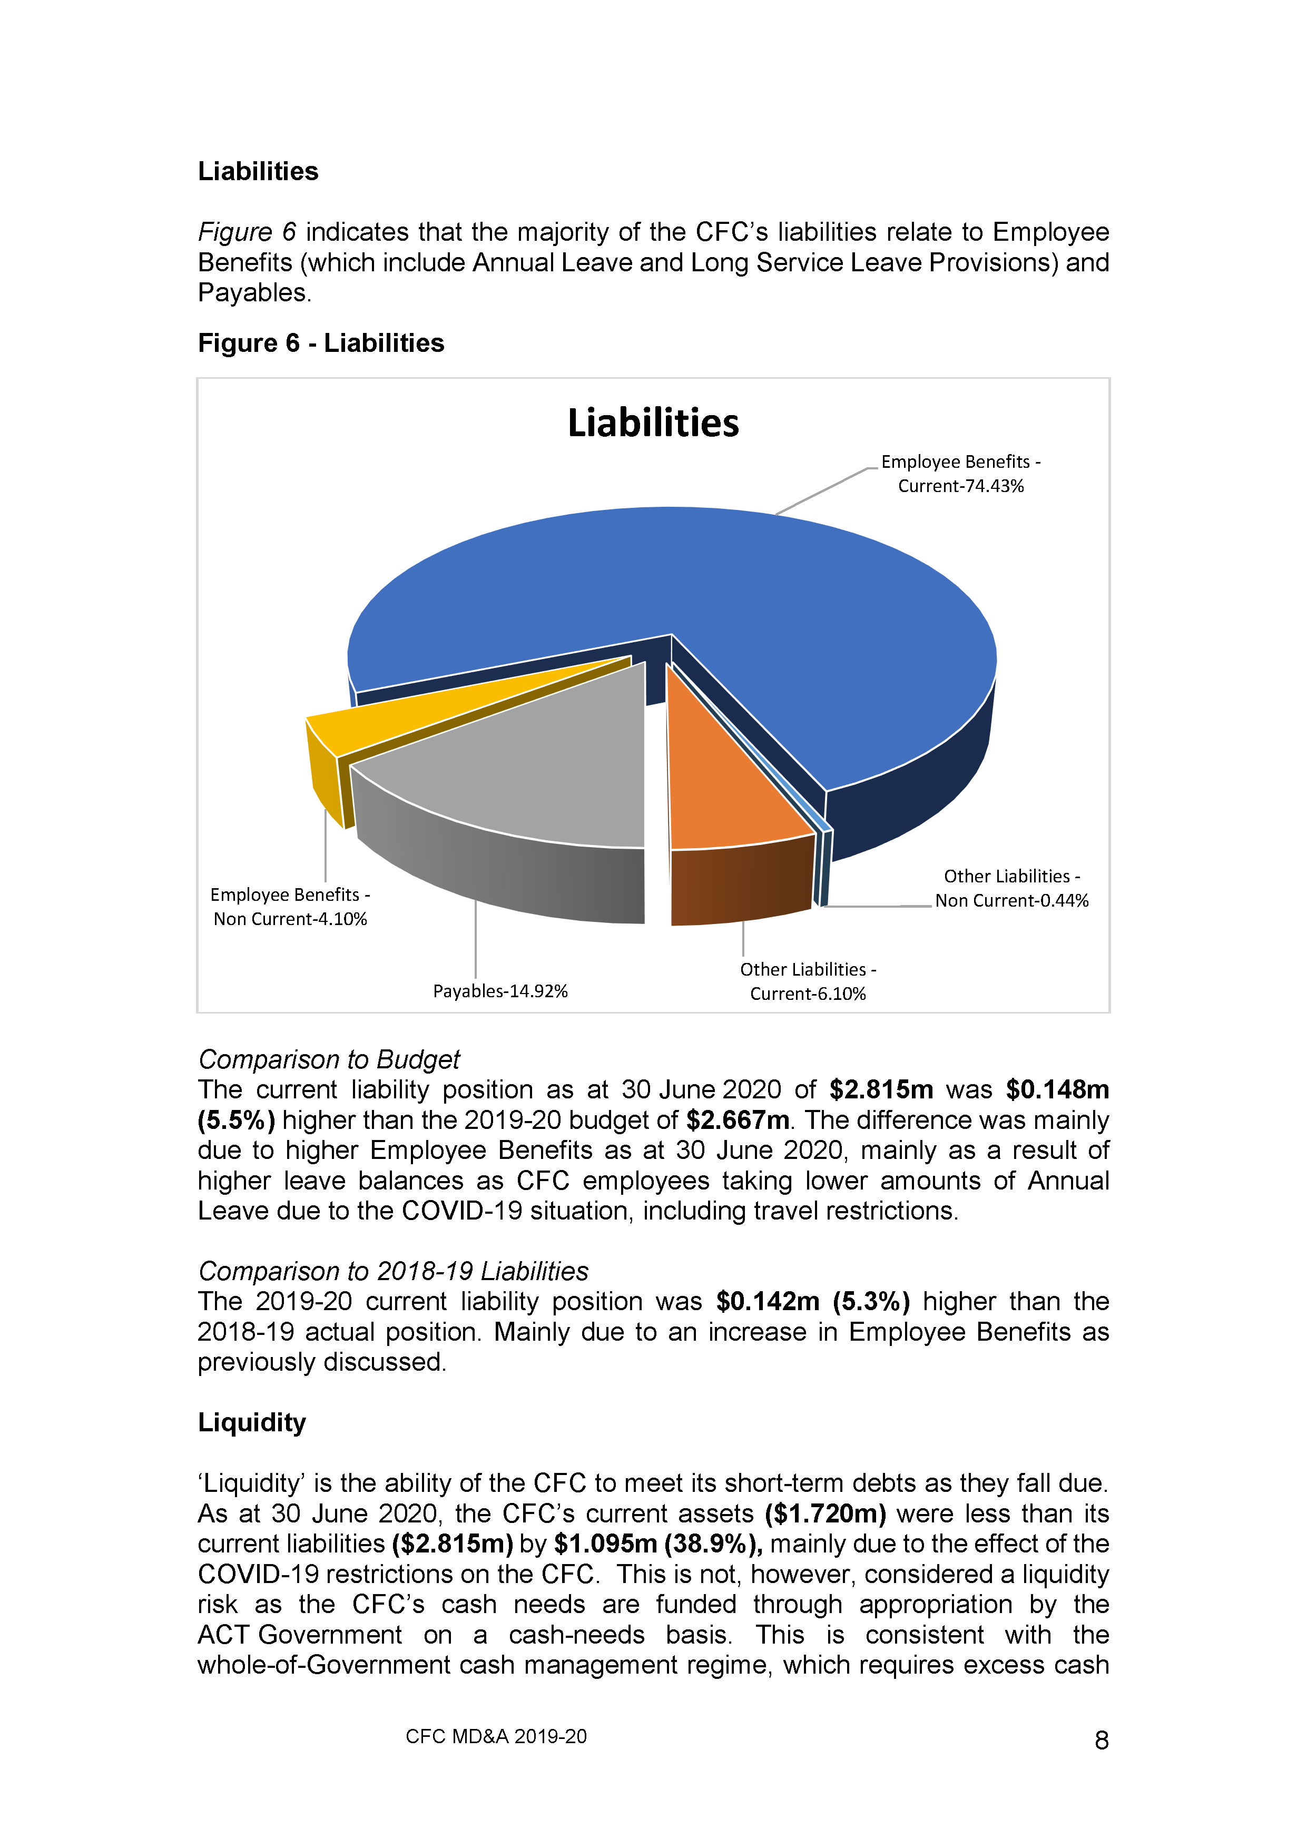

STATEMENT OF PERFORMANCE

FOR THE YEAR ENDED

30 JUNE 2020

CULTURAL FACILITIES CORPORATION

INDEPENDENT LIMITED ASSURANCE REPORT

To the Members of the ACT Legislative Assembly

Conclusion
I have undertaken a limited assurance engagement on the statement of performance of the Cultural Facilities Corporation (Corporation) for the year ended 30 June 2020.
Based on the procedures performed and evidence obtained, nothing has come to my attention to indicate the results of the accountability indicators reported in the statement of performance for the year ended 30 June 2020 are not in agreement with the Corporation’s records or do not fairly reflect, in all material respects, the performance of the Corporation, in accordance with the Financial Management Act 1996.

Basis for conclusion
I have conducted the engagement in accordance with the Standard on Assurance Engagements ASAE 3000 Assurance Engagements Other than Audits or Reviews of Historical Financial Information. My responsibilities under the standard and legislation are described in the
‘Auditor-General’s responsibilities’ section of this report.
I have complied with the independence and other relevant ethical requirements relating to assurance engagements, and the ACT Audit Office applies Australian Auditing Standard
ASQC 1 Quality Control for Firms that Perform Audits and Reviews of Financial Reports and Other Financial Information, Other Assurance Engagements and Related Services Engagements.
I believe that sufficient and appropriate evidence was obtained to provide a basis for my conclusion.

Corporation’s responsibilities for the statement of performance
The Governing Board is responsible for:
- preparing and fairly presenting the statement of performance in accordance with the Financial Management Act 1996 and Financial Management (Statement of Performance Scrutiny) Guidelines 2019; and
- determining the internal controls necessary for the preparation and fair presentation of the statement of performance so that the results of accountability indicators and accompanying information are free from material misstatements, whether due to error or fraud.

Auditor-General’s responsibilities
Under the Financial Management Act 1996 and Financial Management (Statement of Performance Scrutiny) Guidelines 2019, the Auditor-General is responsible for issuing a limited assurance report on the statement of performance of the Corporation.
My objective is to provide limited assurance on whether anything has come to my attention that indicates the results of the accountability indicators reported in the statement of performance are not in agreement with the Corporation’s records or do not fairly reflect, in all material respects, the performance of the Corporation, in accordance with the Financial Management Act 1996.
In a limited assurance engagement, I perform procedures such as making inquiries with representatives of the Corporation, performing analytical review procedures and examining selected evidence supporting the results of accountability indicators. The procedures used depend on my judgement, including the assessment of the risks of material misstatement of the results reported for the accountability indicators.
Limitations on the scope
The procedures performed in a limited assurance engagement are less in extent than those required in a reasonable assurance engagement and consequently the level of assurance obtained is substantially lower than the assurance that would have been obtained had a reasonable assurance engagement been performed. Accordingly, I do not express a reasonable assurance opinion on the statement of performance.
This limited assurance engagement does not provide assurance on the:
- relevance or appropriateness of the accountability indicators reported in the statement of performance or the related performance targets;
- accuracy of explanations provided for variations between actual and targeted performance due to the often subjective nature of such explanations; or
- adequacy of controls implemented by the Corporation.

Ajay Sharma
Assistant Auditor-General, Financial Audit
29 September 2020
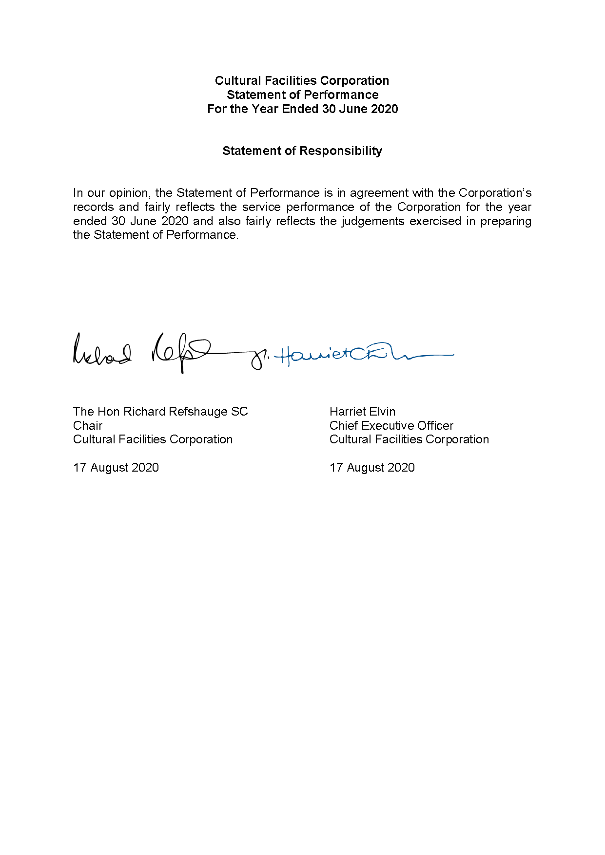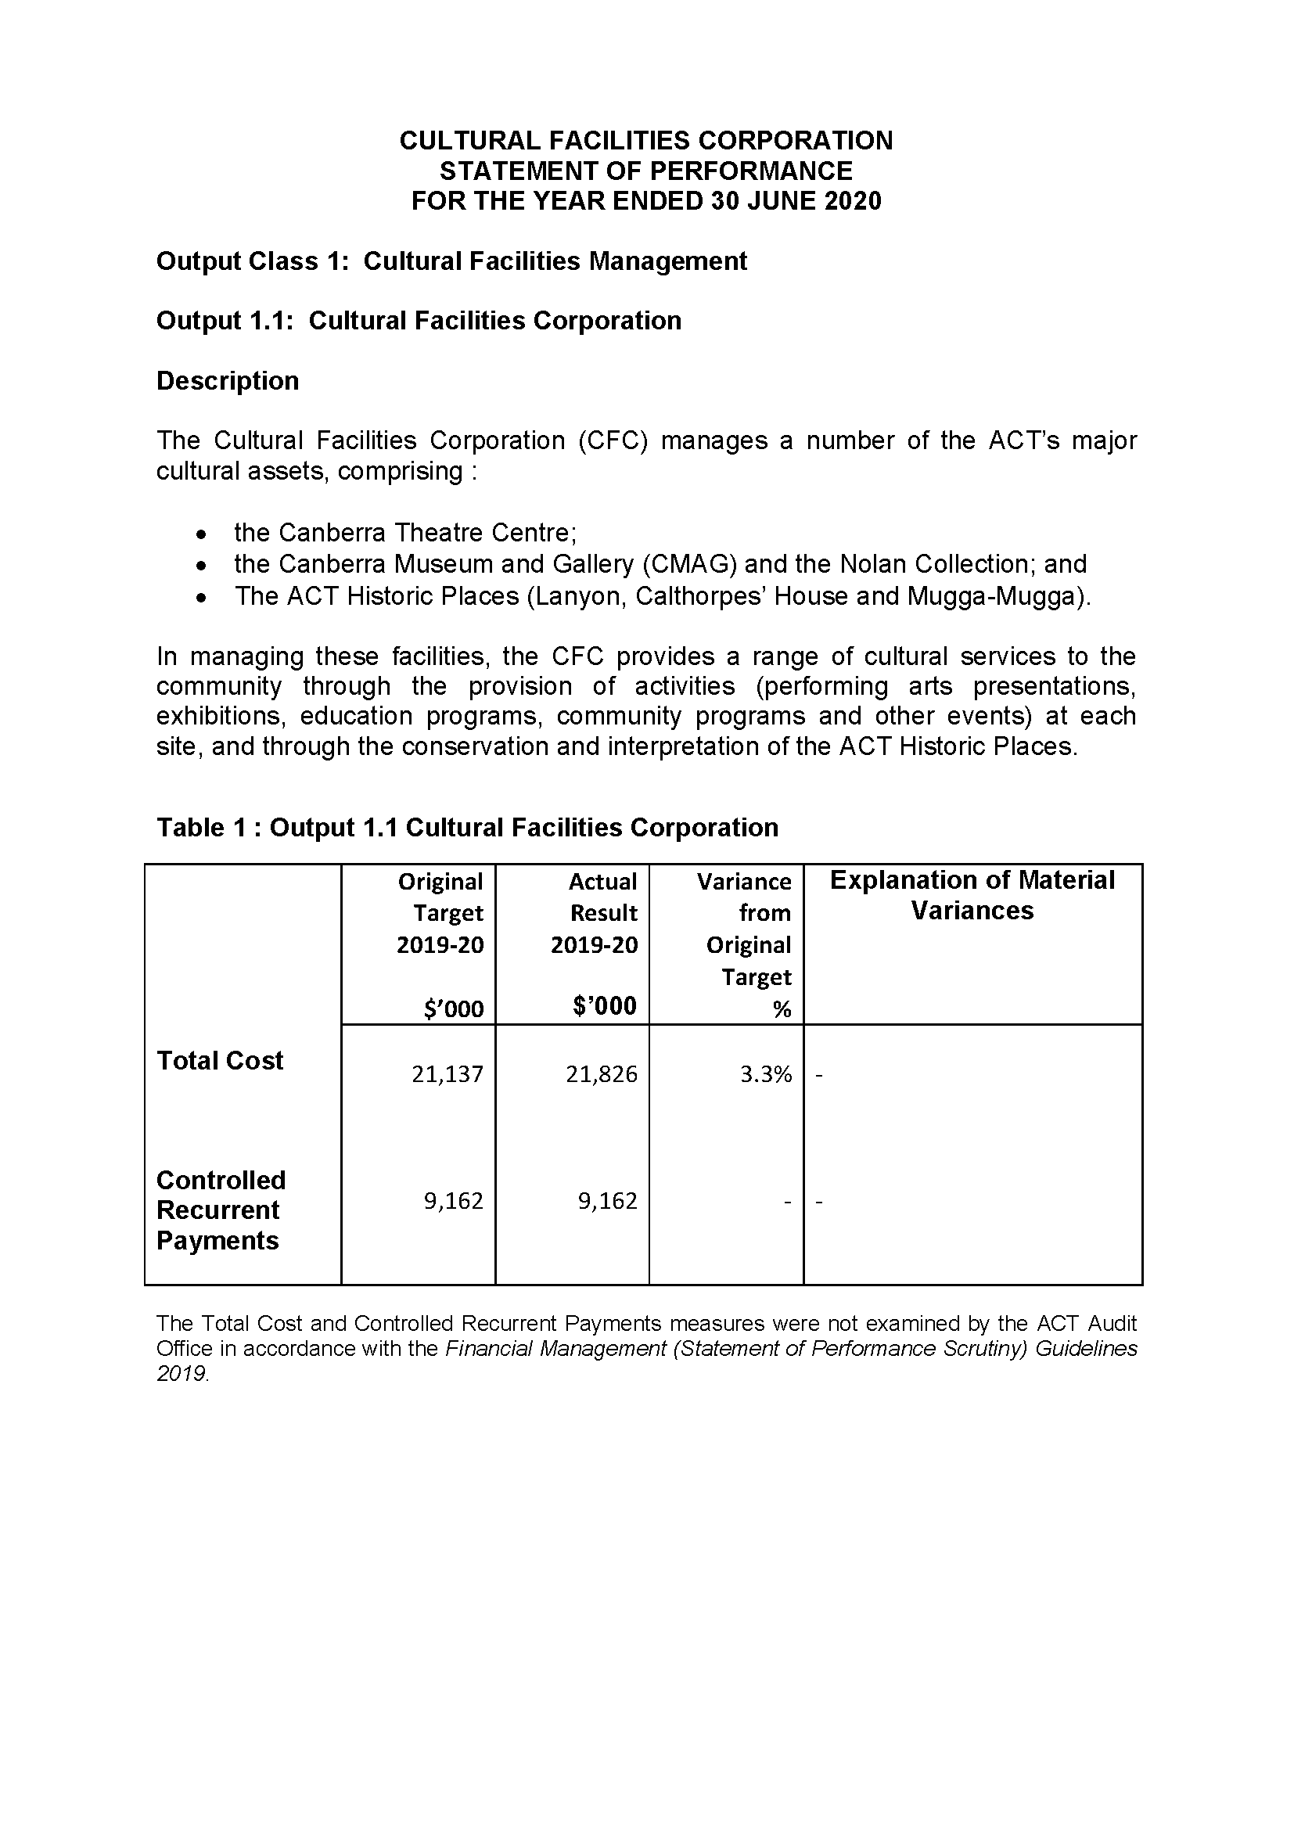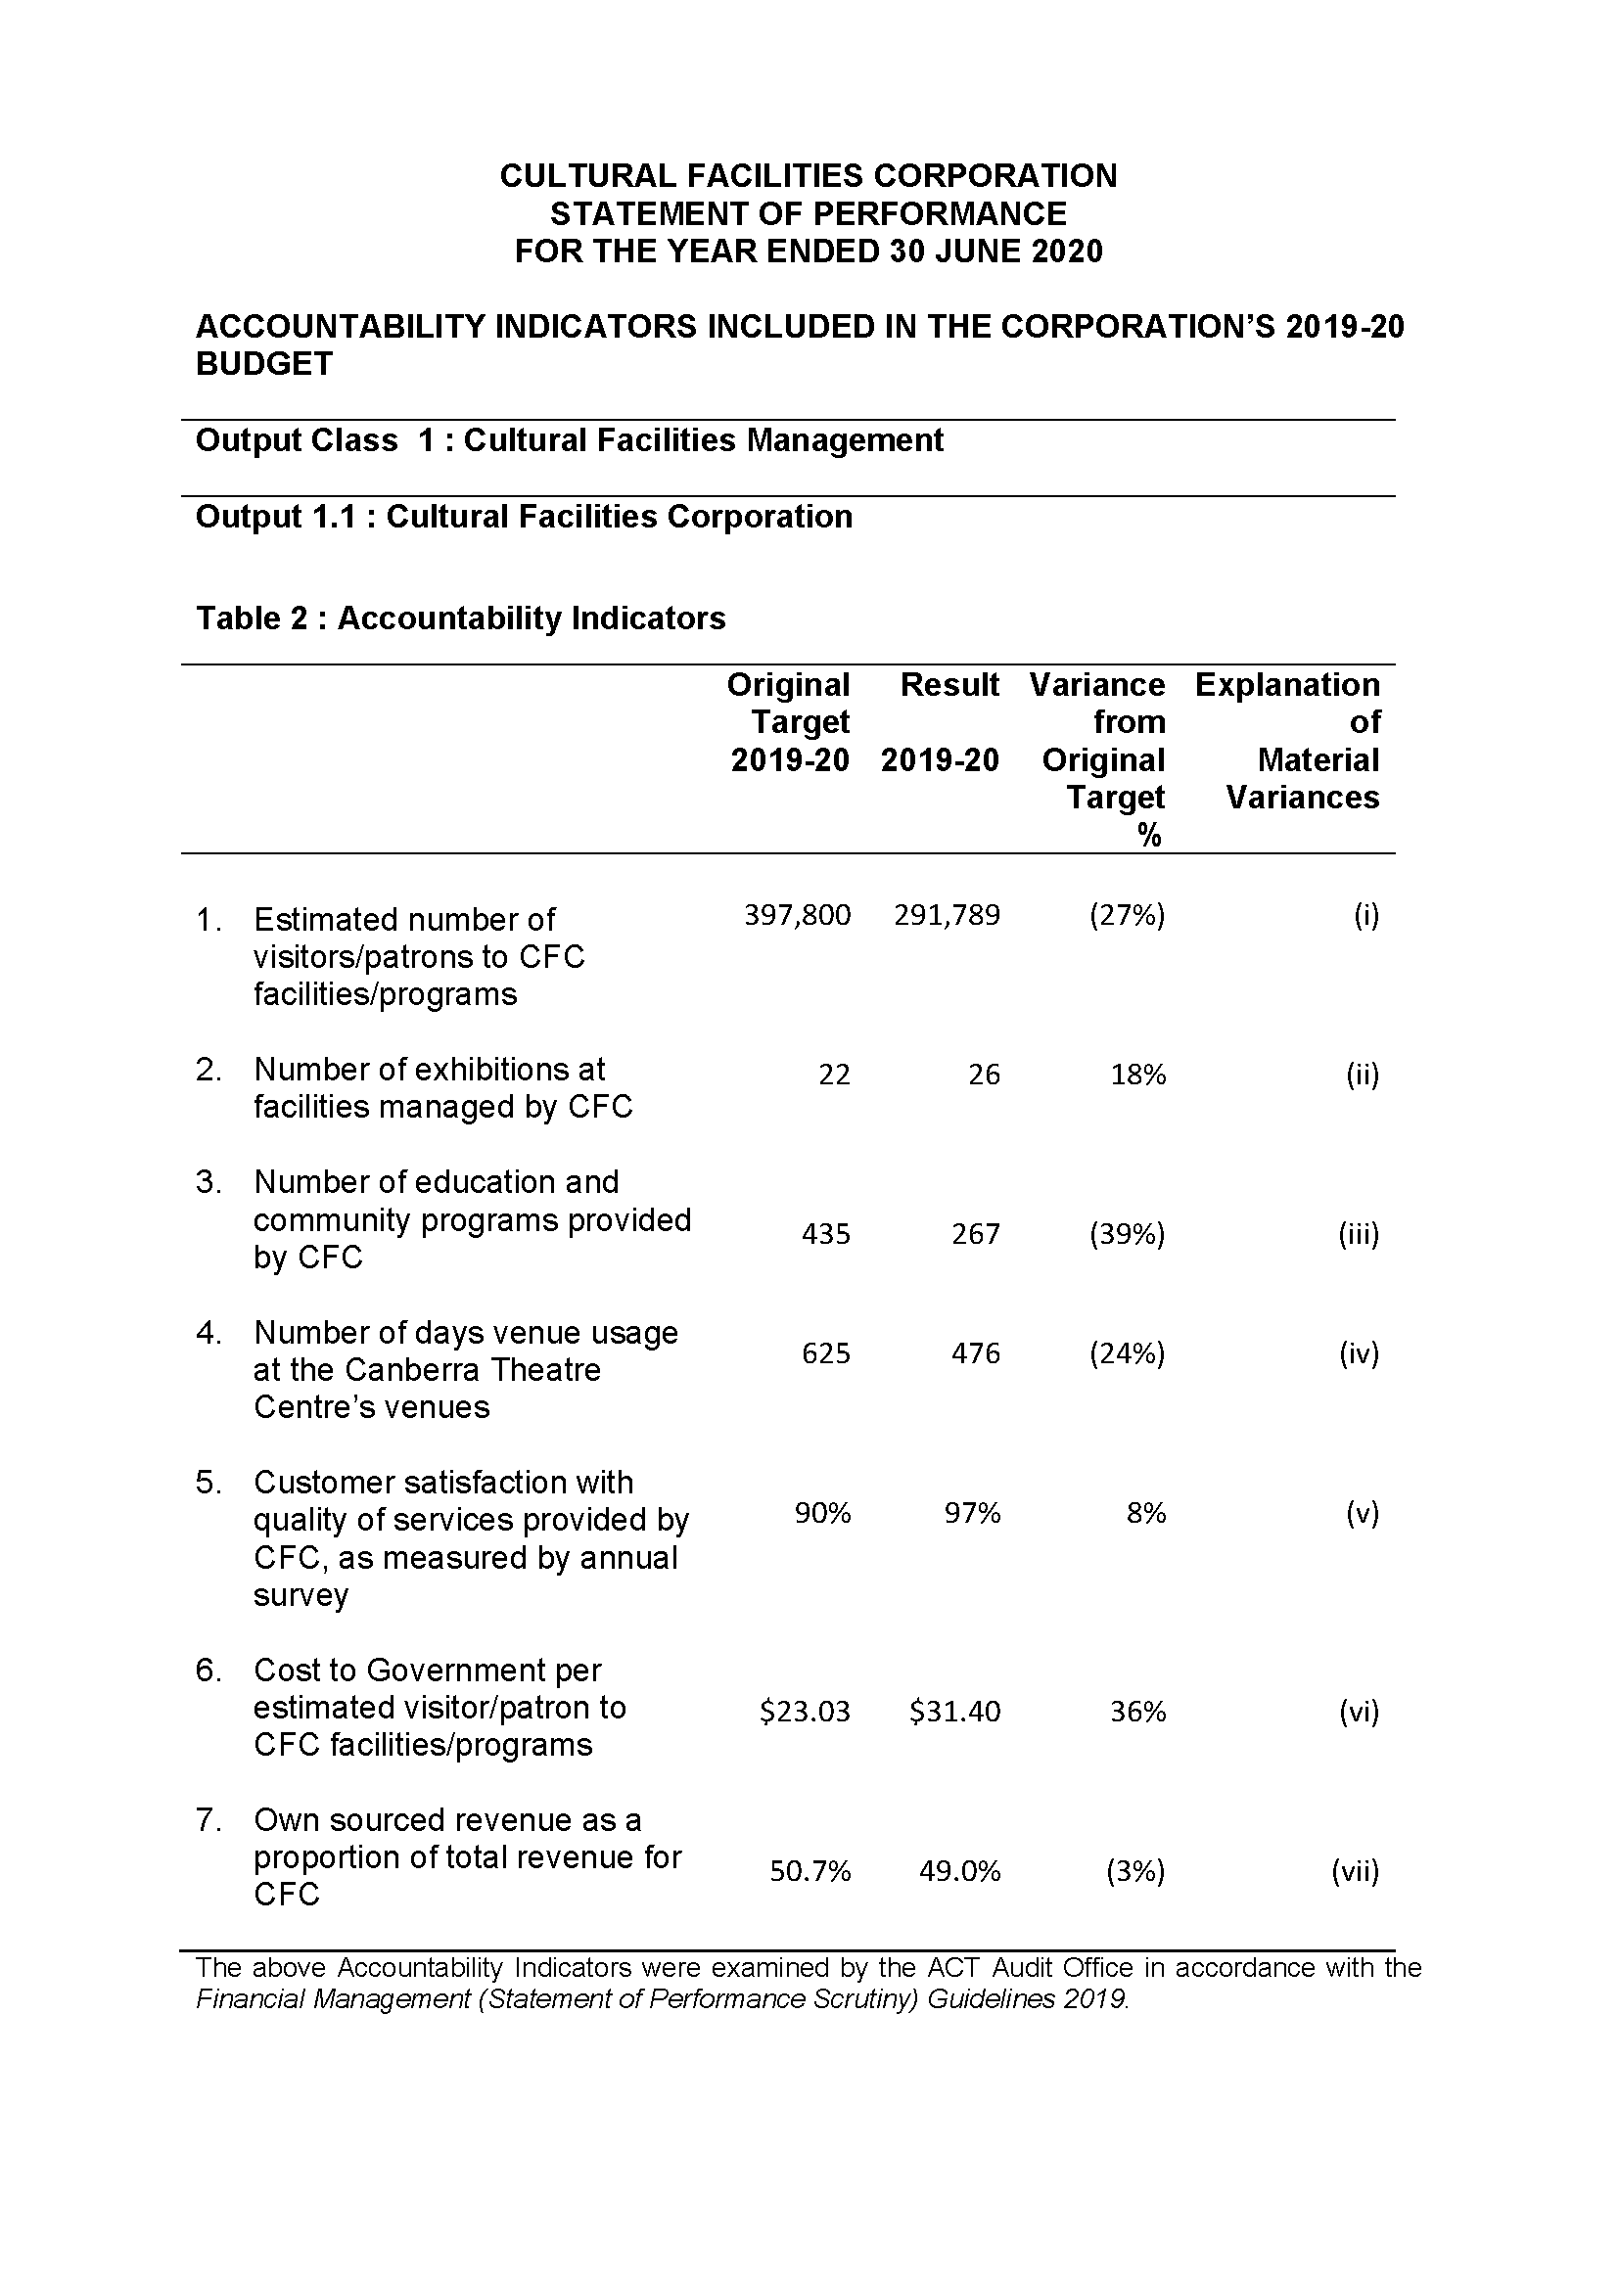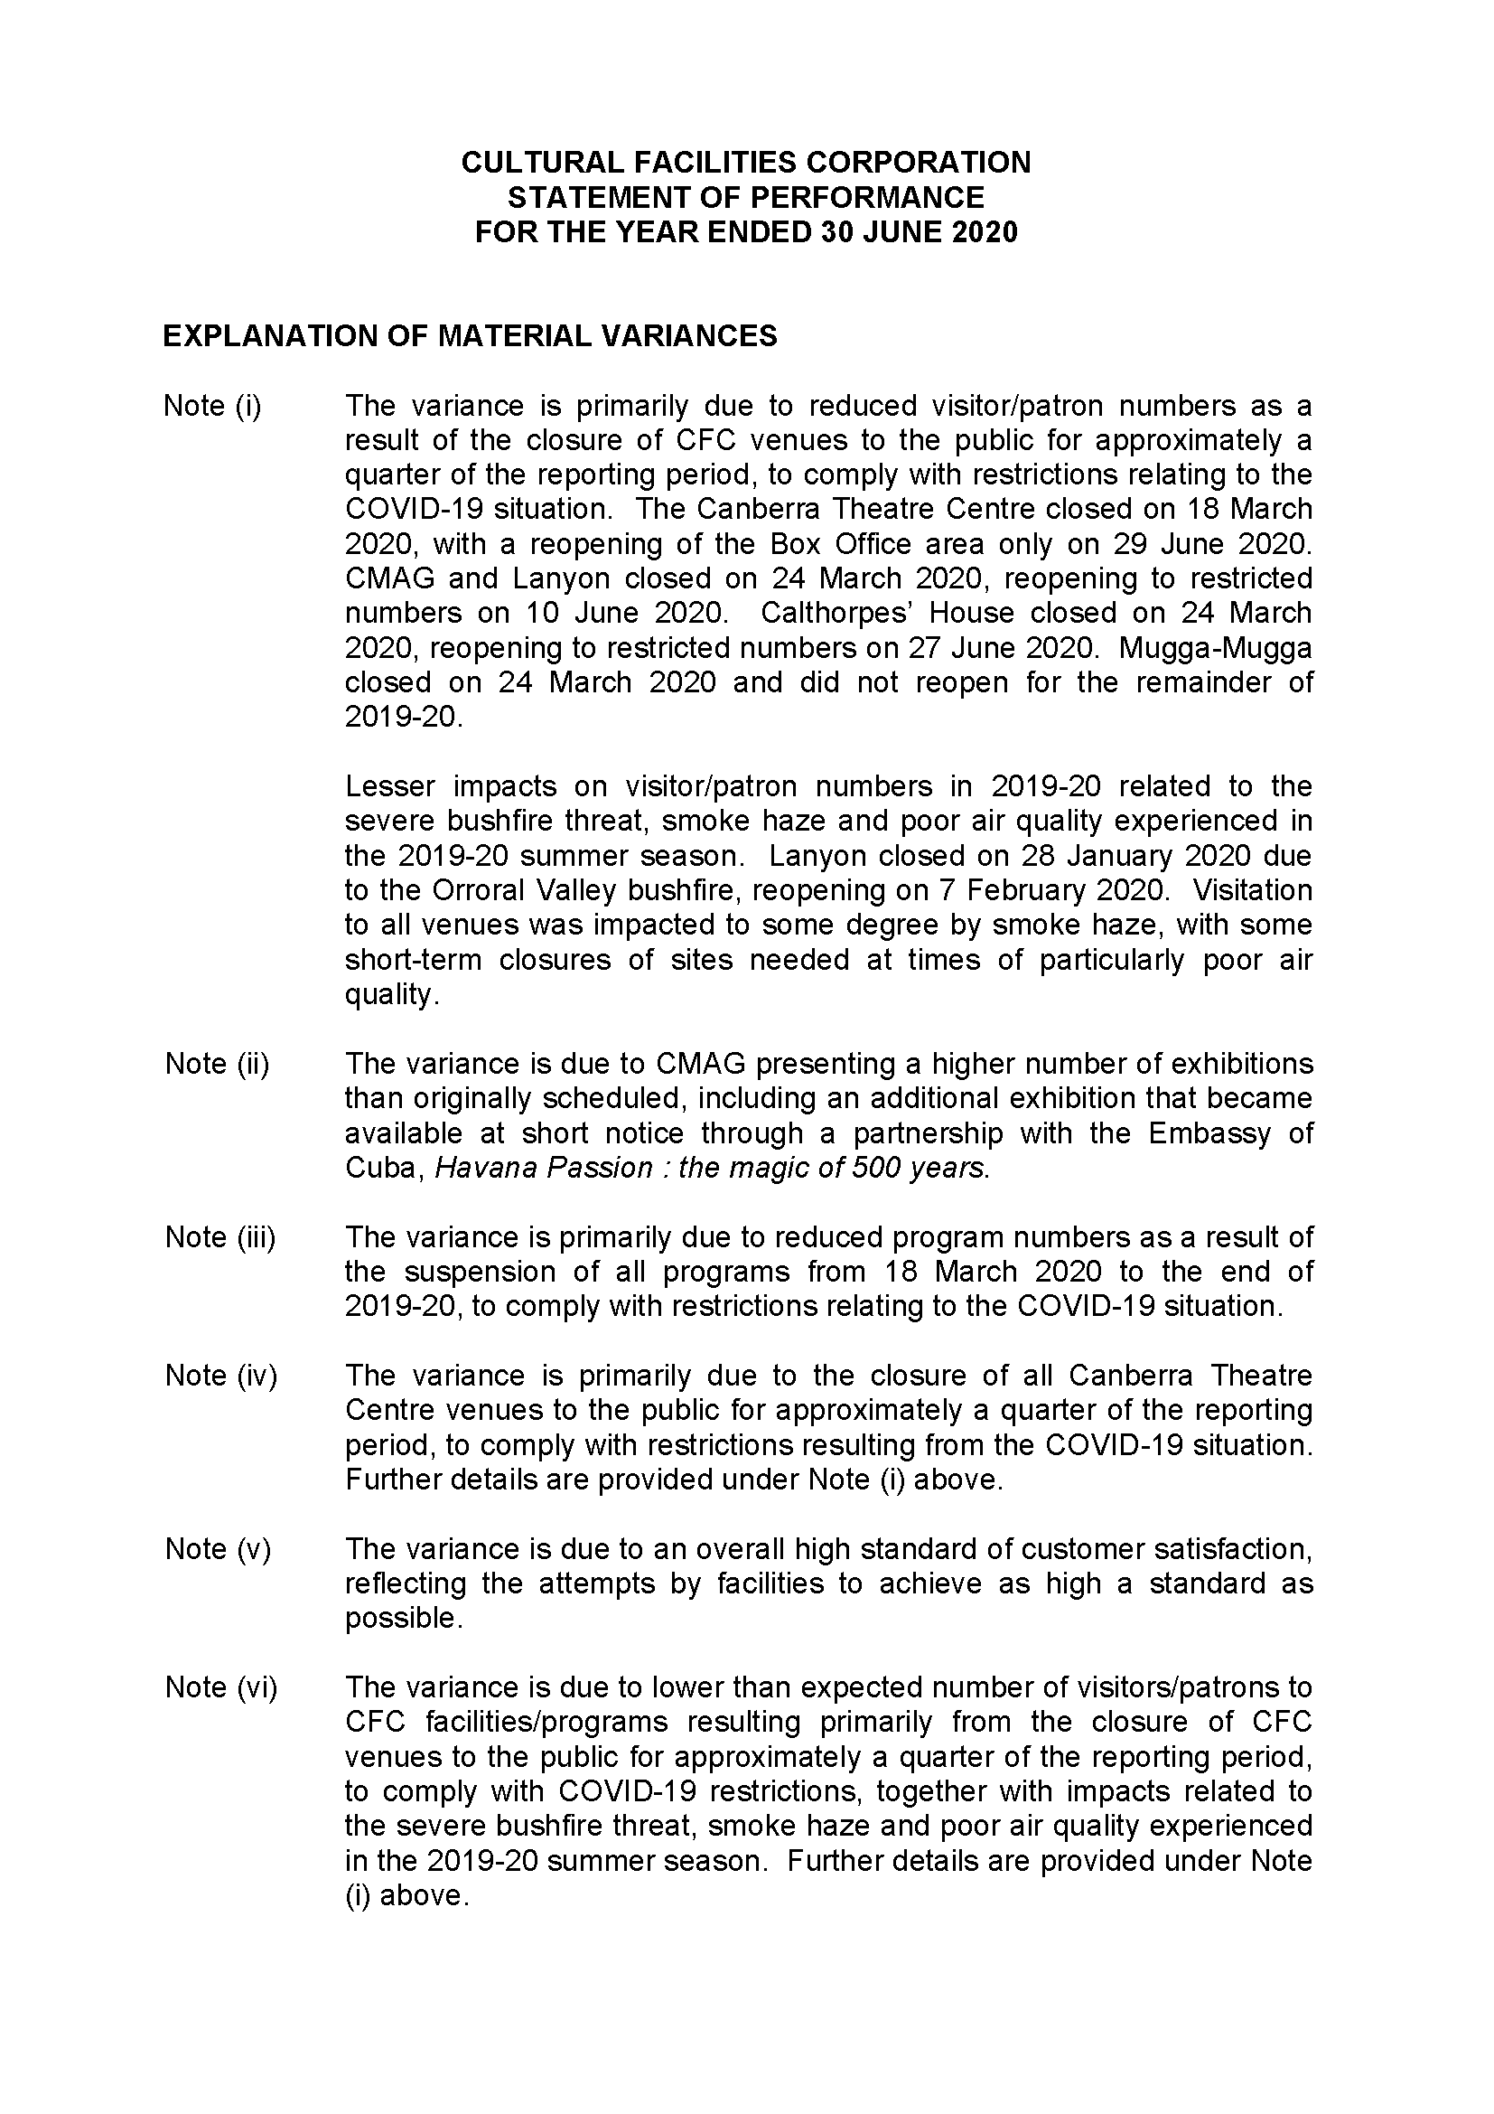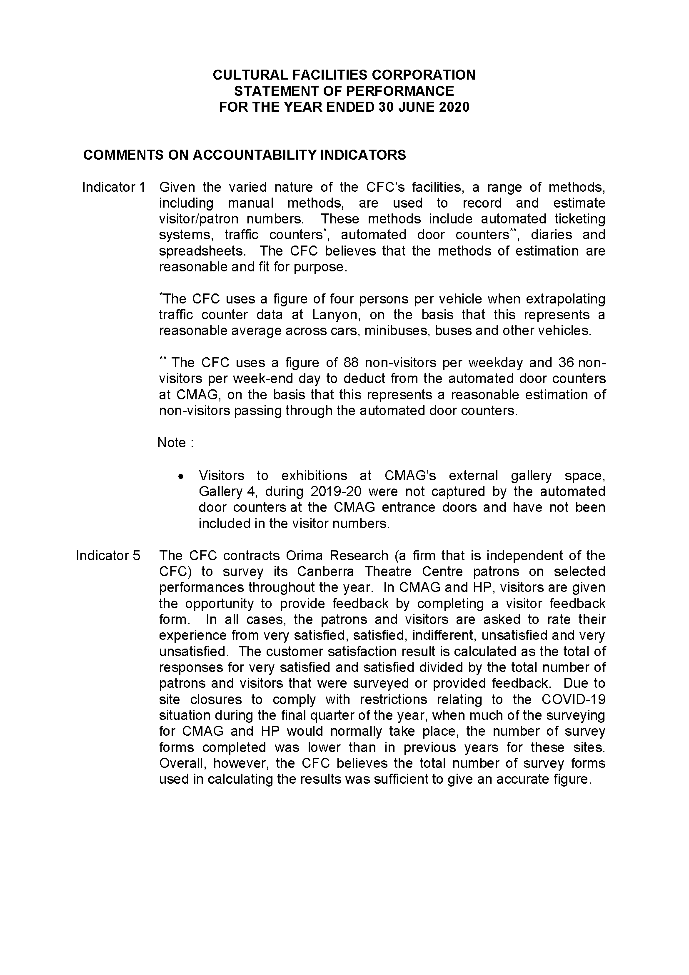

Abbreviations and Acronyms

AAPPAC | Association of Asia Pacific Performing Arts Centres
ABC | Australian Broadcasting Corporation
ACC | Agency Consultative Committee
ACT | Australian Capital Territory
ACTEWAGL | ACT Electricity and Gas
ACTPS | ACT Public Service
AM  AMaGA | Member of the Order of Australia  Australian Museums and Galleries Association
ANU | Australian National University
AO | Officer of the Order of Australia
ASO  ATSIPP | Administrative Services Officer  Aboriginal and Torres Strait Islander Procurement Policy
BA | Bachelor of Arts
BSc  the Centre | Bachelor of Science  Canberra Theatre Centre
CEO | Chief Executive Officer
CFC | Cultural Facilities Corporation
CFO | Chief Financial Officer
CMAG | Canberra Museum and Gallery
CMTEDD | Chief Minister, Treasury and Economic Development Directorate
CNG | Compressed Natural Gas
CPI | Consumer Price Index
CRA | City Renewal Authority
EPSDD | Environment, Planning and Sustainable Development Directorate
ESD | Ecologically Sustainable Development
ESP | Enterprise Sustainability Platform
EU | European Union
FBT | Fringe Benefits Tax
FCP | Fraud Control Plan
FM | Financial Management
FMA | Financial Management Act 1996
FM | Frequency Modulation
FTE | Full Time Equivalent
GHG | Green House Gas
GSO | General Services Officer
GST | Goods and Services Tax
HR | Human Resources
ICOMOS | International Council on Monuments and Sites
IT | Information Technology
Kg | Kilogram
kWh | kilowatt hour
LED | Light-emitting diode
LPA | Live Performance Australia
LPG | Liquid Petroleum Gas
MBA | Master of Business Administration
MWh | megawatt hour
MEAA | Media Entertainment and Arts Alliance
MLA | Member of the Legislative Assembly
NAIDOC | National Aboriginal and Torres Strait Islander Peoples Day Observance Committee
NSW | New South Wales
PD | Professional Development
PhD | Doctor of Philosophy
PO | Professional Officer
RED | Respect, Equity and Diversity
S | Section
SES | Senior Executive Service
SOG | Senior Officer Grade
SPO | Senior Professional Officer
t | Tonne
the Centre | Canberra Theatre Centre
UK | United Kingdom
VET | Vocational Education and Training
WHS | Work Health and Safety

Compliance Statement
The Cultural Facilities Corporation’s (CFC) Annual Report must comply with the Annual Report Directions (the Directions) made under section 8 of the Annual Reports (Government Agencies) Act 2004. The Directions are found at the ACT Legislation Register : http://www.legislation.act.gov.au.
The Compliance Statement indicates the subsections, under Parts 1 to 5 of the Directions, that are applicable to the CFC and the location of information that satisfies these requirements.
Part 1 Directions Overview
The requirements under Part 1 of the Directions relate to the purpose, timing and distribution, and records keeping of annual reports. The CFC’s Annual Report complies with all subsections of Part 1 under the Directions.
In compliance with section 13 Feedback, Part 1 of the Directions, contact details for the CFC are provided within the CFC’s Annual Report to provide readers with the opportunity to provide feedback.
Part 2 Reporting entity Annual Report Requirements
The requirements within Part 2 of the Directions are mandatory for all reporting entities and the CFC complies with all subsections. The information that satisfies the requirements of Part 2 is found in the CFC’s Annual Report as follows :
- A. Transmittal Certificate, see page 5;
- B. Organisational Overview and Performance, inclusive of all subsections,
see pages 13–77; and
- C. Financial Management Reporting, inclusive of all subsections, see pages 79–85.
Part 3 Reporting by Exception
The CFC has nil information to report by exception under Part 3 of the Directions for the 2019–20 reporting year.
Part 4 Reporting entity Specific Annual Report Requirements
The following subsection of Part 4 of the 2019 Directions is applicable to the CFC.
- Ministerial and Director‐General Directions
The CFC has nil information to report for the 2019–20 reporting period.
Part 5 Whole of Government Annual Reporting
All subsections of Part 5 of the Directions apply to the CFC. Consistent with the Directions, the information satisfying these requirements is reported in the one place for all ACT Public Service directorates, as follows :
- Bushfire Risk Management, see the annual report of the Justice and Community Safety Directorate;
- Human Rights, see the annual report of the Justice and Community Safety Directorate;
- Legal Services Directions, see the annual report of the Justice and Community Safety Directorate; and
- Territory Records, see the annual report of Chief Minister, Treasury and Economic, Development Directorate.
Part 6 State of the Service report
- Public Sector Standards and Workforce Profile, see the annual State of the Service Report.
ACT Public Service Directorate annual reports are found at the following web address : http://www.cmd.act.gov.au/open_government/report/annual_reports

INDEX

Aboriginal and Torres Strait Islander Reporting, 69
Acquisitions, 105
ACT Audit Office, 18, 39, 66
ACT Government, 18
ACT Heritage, 18
ACT Historic Places, 14, 15, 16, 17, 24, 31, 32, 37, 52, 59, 60, 70, 76, 83, 93, 95, 96, 104, 109
ACT Legislative Assembly, 66
ACT Remuneration Tribunal, 90
Advisory Committees, 32, 33, 93
Agency Consultative Committee, 31, 72
Asset Management, 42, 83
Assets, 21
Audit Committee, 32, 39, 66, 67
Board Members, 31
Box Office, 73
Bushfire Threats, 6, 18, 27
Business, 22
Calthorpes’ House, 14, 15, 16, 59, 60, 64, 83, 100, 101, 103, 104
Canberra Museum and Gallery, 14, 15, 16, 17, 23, 37, 52, 53, 54, 57, 58, 83, 91, 93, 100. 101, 102, 103
Canberra Region Treasures Fund, 108
Canberra Theatre, 14, 16, 17, 31, 32, 35, 37, 44, 81, 82, 83, 93, 98, 99, 100, 101, 109
Capital Works, 81, 82, 83
CFC Board, 7, 32, 88
Clients and Stakeholders, 16
Climate Change, 74
CMTEDD, 16
Community and Education Programs, 102
Community Engagement and Support, 68
Conservation, 63, 95, 100, 101
Corporate Plan, 37
Covid-19, 6, 28, 29, 71
Covidsafe, 28
Cultural Facilities Corporation, 37
Cultural Facilities Corporation Act 1997, 16
Current and Future Challenges, 27
Current and Future Priorities, 26
Customers, 21, 23, 24
Department of Regional Australia, Local Government, Arts and Sport, 108
Donations, 105
Ecologically Sustainable Development, 74
Education Centre, 101
Exhibitions, 16, 20, 40, 100, 102, 108
Facilities and Business/Activities Under Management, 100
Finances, 20
Financial Management, 80
Financial Management Reporting, 79
Financial Statements, 80
Fraud Prevention, 67
Freedom Of Information, 67
Governance, 20
Governance Charter, 32, 66
Government Contracting, 84
Health and Safety Representative Committee, 71
Human Resources, 72
Internal Accountability, 31
Internal Audit, 66
Interpretation, 100, 101
Lanyon, 14, 16, 83, 100, 103
Lanyon Heritage Centre, 64
Leadership, 19, 22, 24, 25
Learning and Development, 72
Management Discussion and Analysis, 80, 111, 166
Mugga-Mugga, 7, 14, 15, 16, 60, 64, 83, 101, 103, 104
National Trust, 7
Nolan Collection, 16, 100, 101, 103
Nolan Gallery, 83
Organisational Chart, 17
Organisational Overview, 14
Organisational Structure, 17
Outlook, 26
People, 20
Performance Analysis, 34
Performance Outcomes, 19
Programming, 21, 23, 25
Records Management, 42
Research, 100
Risk Management, 66
Role, Functions And Services, 16
Scrutiny, 66
Senior Management, 31
Senior Managers, 91
Smoke Haze, 6, 28
Sponsorship and Support, 108
Staffing Profile, 72
Statement of Intent, 18, 34
Statement of Performance, 18, 34, 39, 175
Stewardship, 24, 25
Strategic Asset Management Plan, 83
Strategic objectives and indicators, 34
Strategic Plan, 14, 18, 32, 37
Strategic Risk Management Plan, 66
Strategy, 19
Summary of performance In achieving objectives and targets, 18
The Centre, 45, 49, 50, 100
The Playhouse, 100
Theatre Reserve, 49
Transmittal Certificate, 186
Vision, Mission and Values, 14
Work Health and Safety, 40, 70, 71, 185
Work Health and Safety Committee, 31, 71
Year at a Glance, 8

