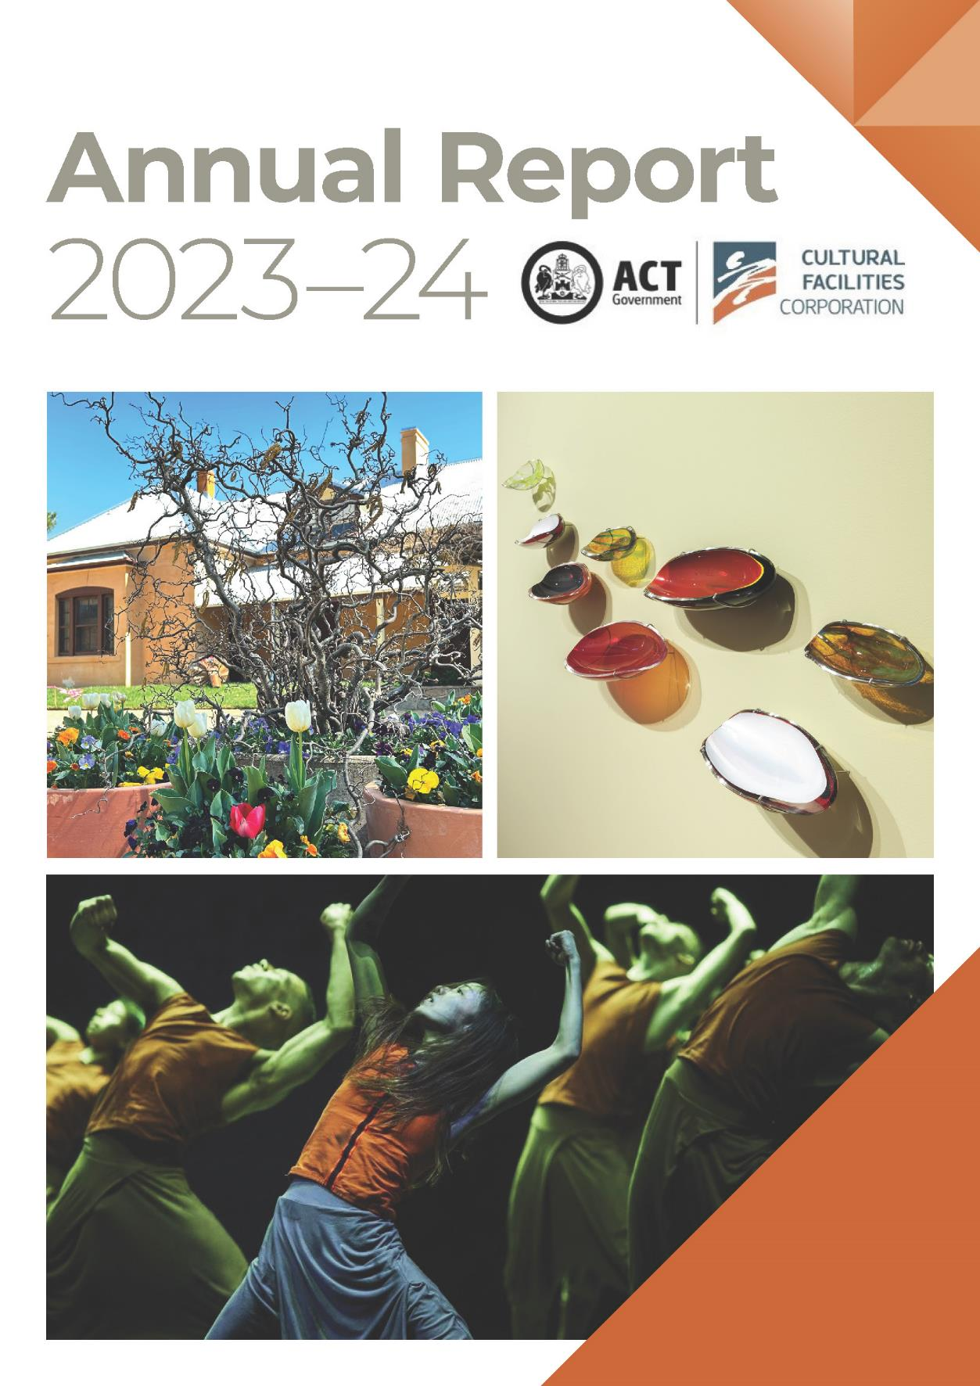

Cover page
- Floriade at Lanyon - Hazel tree and Homestead
Image: GMH
- Materiality…but not as we know it - Paul Girrawah House - Coolamons
Image: CFC
- Akram Khan’s The Jungle Book Reimagined
Image: Camilla Greenwell

The Cultural Facilities Corporation acknowledges the Ngunnawal people as traditional custodians of the ACT and recognises any other people or families with connection to the lands of the ACT and region.
We respect the Aboriginal and Torres Strait Islander people, particularly our Aboriginal and Torres Strait Islander staff, and their continuing culture and contribution they make to the Canberra region and the life of our city.

Contact for this report
General enquiries about this report should be directed to:
Telephone: (02) 6207 3962
Email: cultural.facilities@act.gov.au

CULTURAL FACILITIES CORPORATION
GPO Box 782
Canberra City ACT 2601
ABN: 88187240846
Published by the Cultural Facilities Corporation, Canberra.

Freedom of Information
Freedom of information requests can be made
by emailing: cultural.facilities@act.gov.au.

Accessibility
The ACT Government is committed to making its information, services, events and venues accessible to as many people as possible.
If you are deaf, or have a hearing or speech impairment, and need the telephone typewriter (TTY) service, please phone
13 36 77 and ask for 13 22 81.

For speak and listen users, please phone
1300 555 727.

For more information on these services, contact us through the National Relay Service: www.accesshub.gov.au.
If English is not your first language and you require a translating and interpreting service, please telephone Access Canberra on 13 22 81.
ISBN: 978-0-642-60870-3
© Australian Capital Territory

This work, Cultural Facilities Corporation Annual Report 2023-24, is licensed under a Creative Commons Attribution 4.0 licence. You are free to re-use the work under that licence, on the condition that you credit the Australian Capital Territory Government as author, indicate if changes were made and comply with the other licence terms.

The licence does not apply to the ACT Coat of Arms, the Cultural Facilities Corporation logo and branding, images, artwork, photographs and any material protected by trademark.

Information about the Cultural Facilities Corporation and an electronic version of this annual report can be found on the website www.culturalfacilities.act.gov.au.

For more information on the activities of the Cultural Facilities Corporation please visit the following websites: www.culturalfacilities.act.gov.au
www.canberratheatrecentre.com.au www.cmag.com.au and www.historicplaces.com.au.

Contents

Organisation Chart 5
PART A TRANSMITTAL CERTIFICATE
Transmittal Certificate 7
PART B ORGANISATIONAL OVERVIEW & PERFORMANCE
B.1 Organisational Overview 9
B.2 Performance Analysis 36
B.3 Scrutiny 71
B.4 Risk Management 71
B.5 Internal Audit 72
B.6 Fraud Prevention 72
B.7 Freedom of Information 73
B.8 Community Engagement 74
B.9 Aboriginal and Torres Strait Islander Reporting 76
B.10 Multicultural Act 2023 Reporting 79
B.11 Work Health & Safety 81
B.12 Human Resource Management 83
B.13 Ecologically Sustainable Reporting 89
PART C FINANCIAL MANAGEMENT & REPORTING
C.1 Financial Management Analysis 92
C.2 Financial Statements 92
C.3 Capital Works 93
C.4 Asset Management 95
C.5 Government Contracting 96
C.6 Statement of Performance 97
APPENDICES
Appendix 1 – Members of the CFC Board 100
Appendix 2 – Senior Leadership Team of the CFC 103
Appendix 3 – Advisory Committees 106
Appendix 4 – Presentations & Exhibitions 112
Appendix 5 – Acquisitions (Purchases & Donations) 120
Appendix 6 – Funding, Sponsorship & Support 121
ATTACHMENTS
Attachment 1 - Financial & Performance Statements & Management Discussion
& Analysis……………………………………………………………………………………………………………………………121
Abbreviations & Acronyms 186
Compliance Statement 187

Organisation Chart
The 2023-24 organisation chart reflects the Cultural Facilities Corporation’s (CFC’s) high-level structure as of 30 June 2024.

To deliver on the vision, mission and goals of the CFC under the 2023-27 Strategic Plan, the CFC established three main creative expressions, being Galleries, Museums and Heritage (GMH), Canberra Theatre Centre (CTC), and District and Events, supported by centralised Finance, Corporate, Human Resources, and Facility Operations and Capital Works (FOCW) teams.

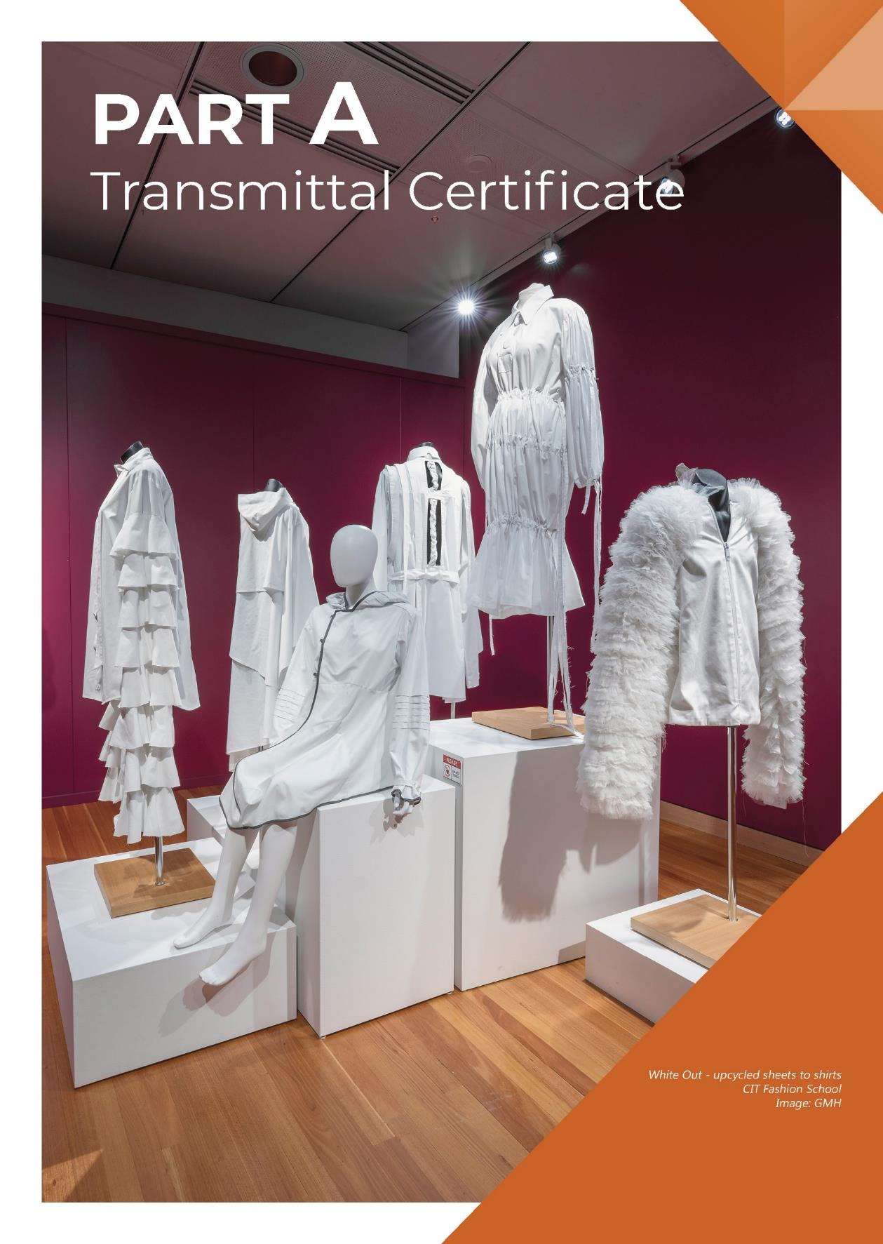
Transmittal Certificate
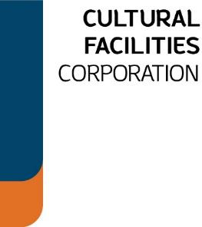

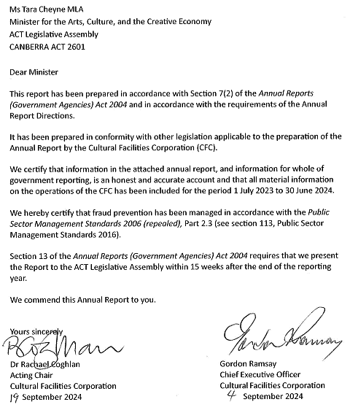
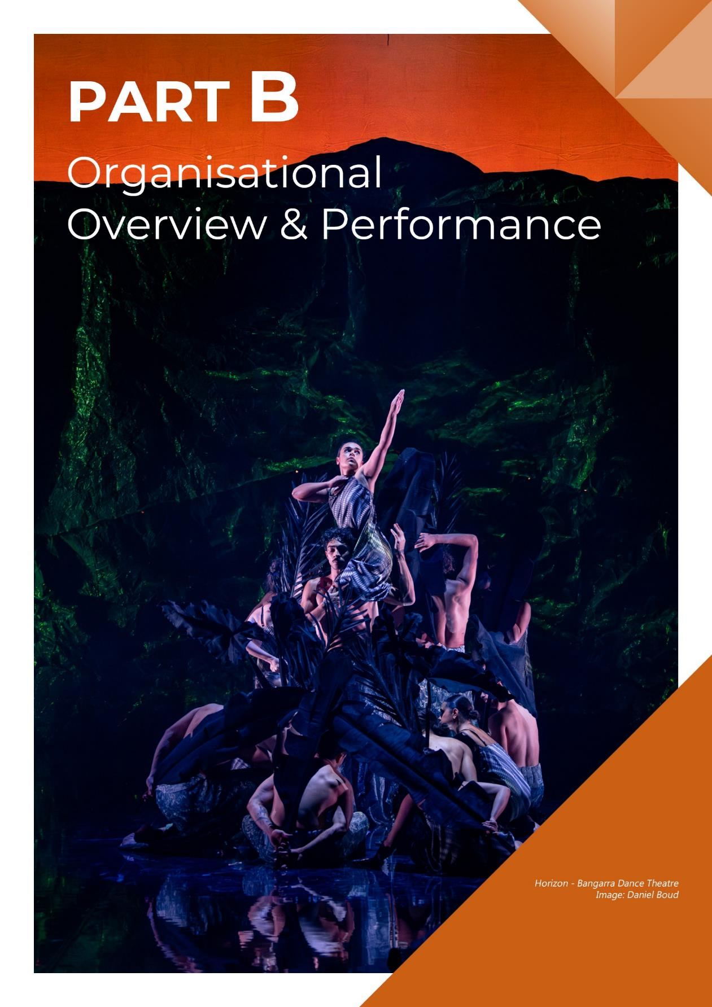

B.1 Organisational Overview
PART B

Organisational Overview & Performance

B.1.1 Vision, Mission & Values
The CFC supports the ACT Government’s Statement of Ambition for the Arts 2021-26 as a major contributor to creating, developing, and promoting arts, culture, creativity and heritage under Canberra: Australia’s Arts Capital - Arts, Culture and Creative Policy 2022-26.

The CFC’s Strategic Plan 2023-27 defines a vision and mission for the CFC as well as dynamic values and ambitious goals. These emphasise the importance of the CFC’s responsibilities as a custodian of the ACT and region’s stories and, as a sector leader, the need for organisational growth and financial sustainability, with the current key focus on the redevelopment of CTC. In observing our values, we are committed to implementing the ACT Government Service Values of respect, integrity, collaboration and innovation.

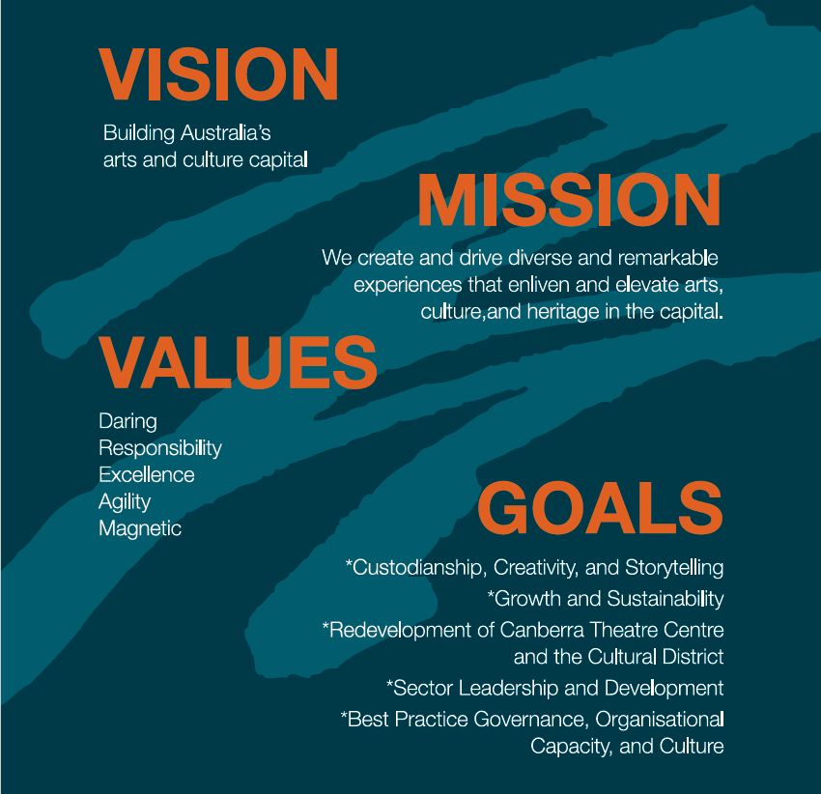

The CFC’s vision, mission and values are lived out in our five strategic goals.

Strategic Goals
- Custodianship, Creativity, and Storytelling

We will deliver creative excellence and custodianship for the CFC’s activities, deepen our contribution to the ACT’s arts, culture and heritage ecology, and grow our national role.
- Growth and Sustainability
We will position the CFC for the future by expanding its income streams and relevance to the arts, culture, and heritage sectors, audiences, and economy.
- Redevelopment of the Canberra Theatre Centre and Canberra Civic and Culture District
We will provide a vision and key leadership for the redevelopment of the CTC and CCCD, developing our organisation to leverage the opportunities these present.
- Sector Leadership and Development
We will lead our sector in the ACT, growing audiences, engaging artists, and developing people.
- Best Practice Governance, Organisational Capacity, and Culture
Our operational model will be best practice.

B.1.2 Functions & Services

The CFC is a statutory corporation of the ACT Government and the ACT’s largest cultural organisation, managing a unique mix of performing arts, visual arts, social history and heritage venues.

The CFC was established under the Cultural Facilities Corporation Act 1997 (the CFC Act), which came into operation from 1 November 1997. The CFC connects people with rich and diverse cultural experiences, activities and functions as set out in the CFC Act (Section 6) with responsibility for:
- The Canberra Theatre Centre (CTC)
- The Canberra Museum and Gallery (CMAG) including the Nolan Collection
- Lanyon Homestead
- Calthorpes House, and
- Mugga-Mugga.

Through its activities at these venues, the CFC provides a range of cultural services across the performing arts, the visual arts, social history and cultural heritage management, by:
- managing, developing, presenting, coordinating and promoting cultural activities at designated locations and other places in the ACT
- providing theatre presentations, exhibitions, education and community programs
      - establishing and researching collections
      - conserving and exhibiting collections in the possession or under the control of the CFC
  - undertaking activities, in cooperation with other people if appropriate, to exercise its other functions, and
  - exercising other functions given to the CFC under the Act or another Territory Law.

The CFC Act (Section 7) requires that the CFC, in exercising its functions, must consider:
  - any cultural policies or priorities of the Executive known to the CFC, and
  - other cultural activities in the ACT.

The CTC is the major presenter of performing arts in the region. It presents a range of programming and independent productions, and also works with community and commercial hirers to deliver a broad program of theatre, dance and music. In particular, the New Works and Sector Development Program supports local artists and producers in the commissioning, creative development, and presentation of live performances.

The CTC is also connected to major performing arts centres across the nation and regularly works with leading national theatre and dance companies. The planned redevelopment of the Centre will support the growth of Canberra's performing arts industry by creating further spaces for artists and arts workers to develop, rehearse and perform productions. The transformed CTC will include modern rehearsal facilities, and both large and intimate stages where productions can be created that can tour nationally and internationally, increasing the profile of Canberra creatives and lifting Canberra’s reputation as a performing arts destination.

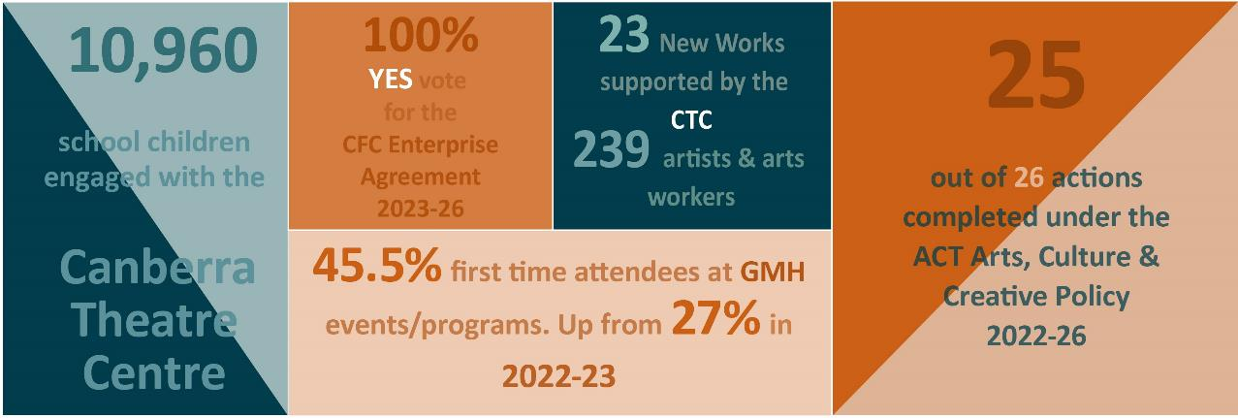

The GMH arm of the CFC has creative, curatorial, exhibition, collections management, research, and public engagement responsibilities relating to CMAG, the Nolan Collection, Lanyon Homestead, Mugga-Mugga, and Calthorpes House and, collaboratively, of the curatorial, collections management, social history, and heritage aspects more broadly within the CFC.
CMAG manages a collection of over 10,000 artworks and objects, including paintings, ceramics, photographs, prints, textiles, glass, drawings, mixed media, as well as social history items including signs, clothing, domestic items, furniture, and maps.

CMAG’s various gallery spaces provide platforms for local artists as well as for touring exhibitions of different scales and in a range of formats, including digital, interactive, and multi-media, with some gallery areas dedicated to showcasing local community and private collections. Notably, CMAG has an award-winning permanent exhibition - Canberra/Kamberri, Place and People - devoted to the unique story of Canberra. It is also the custodian of the 141 works that comprise the Commonwealth Nolan Collection, including the 24 Foundation Collection of iconic paintings from the Ned Kelly, St Kilda, and Burke and Wills series, donated by the artist to the nation in 1974.

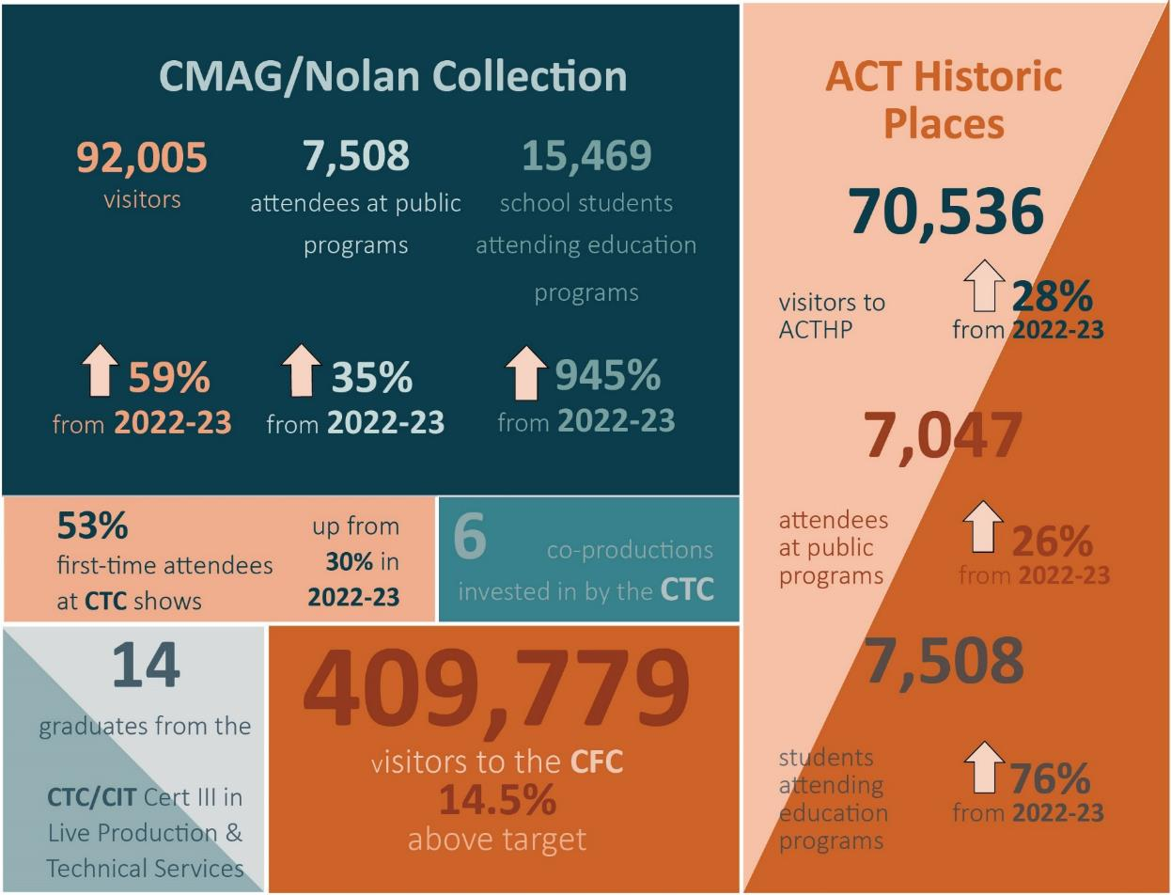

The three heritage-listed historic places in the CFC’s care showcase aspects of the ACT’s significant natural and cultural heritage.

Lanyon Homestead, built in 1859, is located along the Murrumbidgee River and Brindabella ranges, encompasses the important Indigenous and non-Indigenous heritage values of the landscape, and the history of European settlement and pastoralism in the Canberra region.

Mugga-Mugga Cottage, a stone cottage built in the 1850s, is one of only three surviving workers’ cottages built as part of the expansive
Duntroon estate. It includes the rare domestic working-class collection of the Curley family, former Duntroon estate workers who moved to Mugga-Mugga Cottage in 1913 when Duntroon was resumed by the Commonwealth for the creation of the Federal Capital. The Cottage is also surrounded by listed endangered native temperate grasslands.

Calthorpes House was built in 1927 and was one of the earliest residences constructed in the new Federal Capital of Canberra. The Calthorpe family had continuous occupation to the 1980s, when it was purchased by the Commonwealth government, including the domestic furnishings and personal belongings of the Calthorpes family. It provides an insight into the taste and experiences of the new population moving to Canberra in the 1920s and 30s.

With two of the CFC’s key venues located in Civic Square, the CFC is also a contributor
to activating the Square as a public space in the heart of Canberra, serving as a hub for cultural events and activities. In addition to seeking to grow audiences to CFC facilities, the CFC collaborates with other agencies and organisations to host and promote cultural events and activities, with the goal of fostering a vibrant and culturally rich community in
the ACT.

ACTHP Art Prize
Robyn Campbell - DWELLLNG PLACE
Image: GMH
ACTHP Art Prize
Lynne Flemons - HOMAGE
Image: GMH
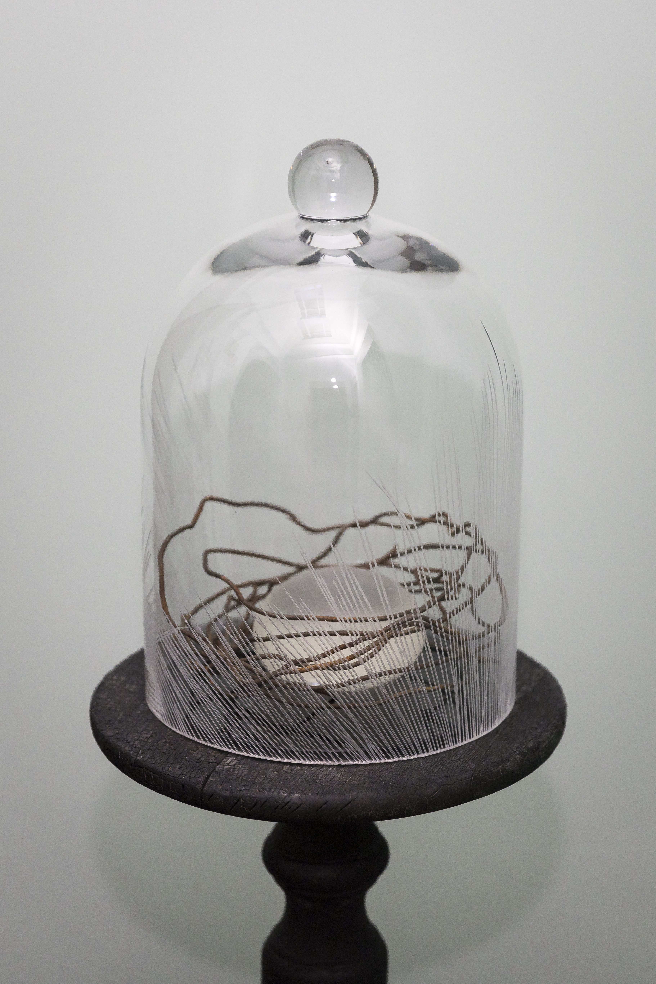
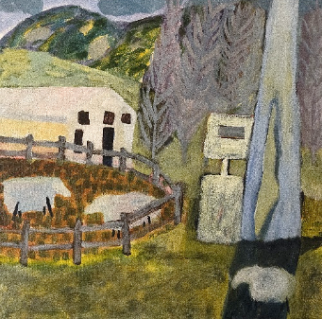

ACTHP Art Prize
Jessika Spencer - OCHRE
Image: GMH


ACTHP Art Prize
Craft + Design Prize - Sue Peachey -
ELIZABETH’S HANDKERCHIEF WITH MOTH
Image: GMH

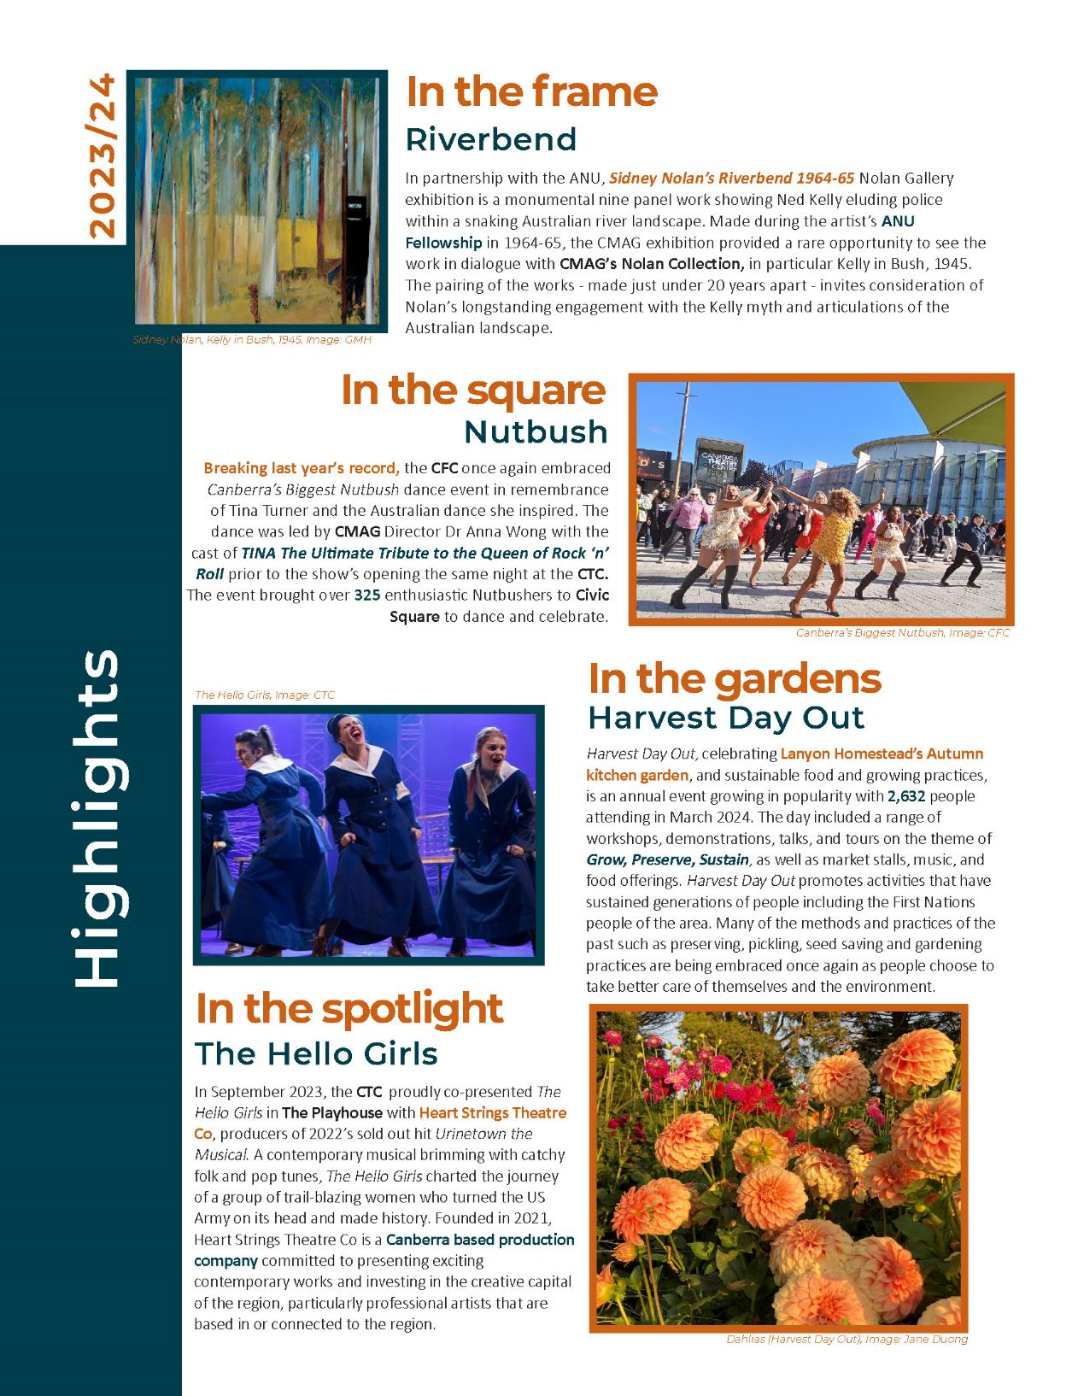
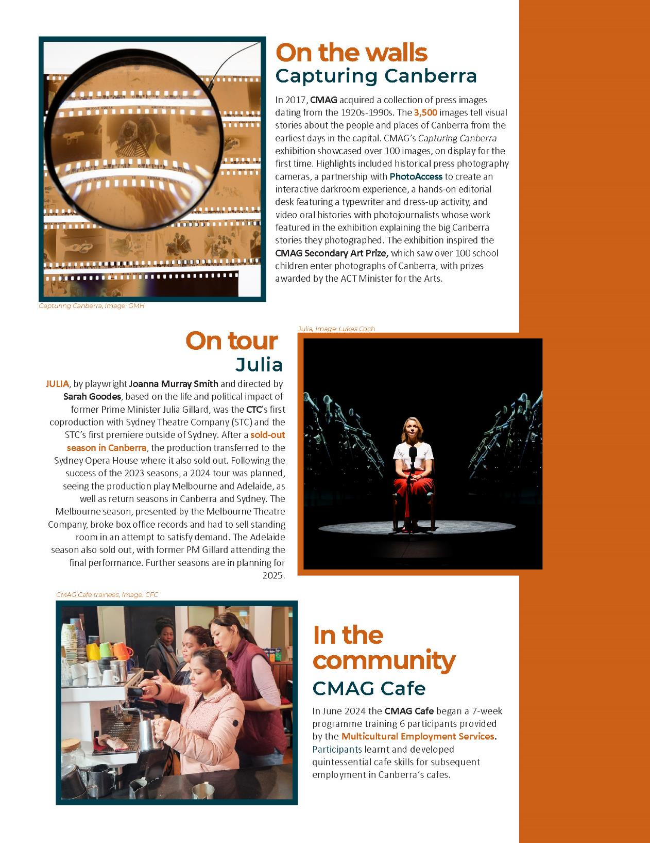
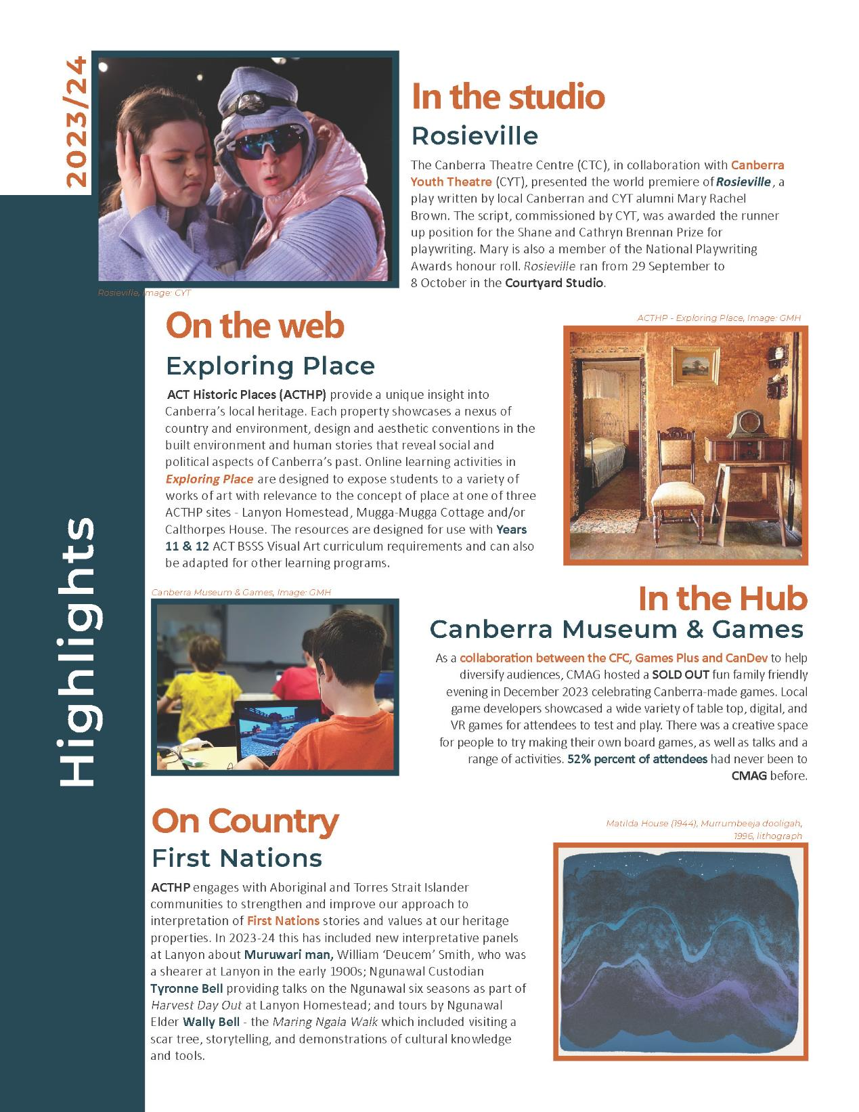
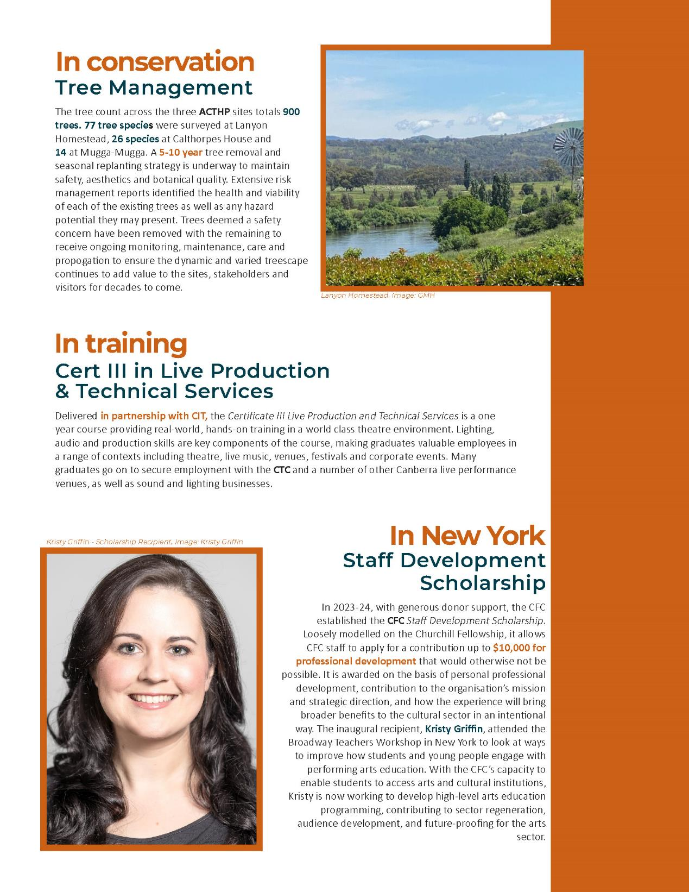

Key Clients & Stakeholders

The CFC’s mission to create diverse and remarkable experiences in arts, culture, and heritage relies on understanding and meeting the needs of its stakeholders, including artists, audiences, cultural organisations, and the broader community. Stakeholder engagement is at the heart of our values of being daring, responsible, agile, and magnetic, and pursuing excellence, to ensure that the work of the CFC remains relevant, inclusive, and impactful.

Engaging with stakeholders helps the CFC preserve cultural assets, support local artists, expand our audience, and enhance financial sustainability. Being a collaborative and accessible part of the broader ACT arts ecology means we can foster participation through programming and events, support artists in creating new works, and promote inclusive access.

During 2023-24, the CFC reported to the Minister for the Arts. In addition to our ACT Government stakeholders listed on page 19, our broader stakeholder network is far-reaching and inter-connected through:
- Ngunnawal and other First Nations peoples
- artists and arts workers
- local ACT arts, culture, and heritage organisations
- our patrons and the wider community of the ACT and region
- visitors to the ACT including school students and, broadly the wider education, business, night-time economy, and tourism sectors
- venue hirers including local ACT and community hirers
- national cultural institutions including:
  - National Gallery of Australia
  - National Portrait Gallery
  - National Film and Sound Archive
  - National Archives of Australia, and

  - National Museum of Australia
- relevant Commonwealth Agencies including the Office for the Arts and the National Capital Authority
- key touring companies and other Australian arts centres and galleries
- key industry associations and research organisations including:
  - Australian Performing Arts Centres Association
  - Creative Australia
  - Australia Museums and Galleries Association
  - National Capital Attractions Association
  - Australian National University (ANU) Schools of Art and Design, Music, History Astronomy and Astrophysics
  - University of Canberra Centre for Creative and Cultural Research

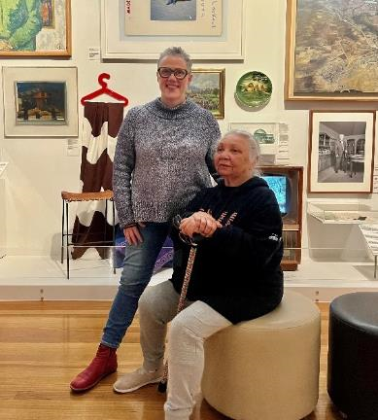
Dr Brenda Croft with Dr Matilda House
Canberra/Kamberri: Place + People
Image: GMH

- local arts advocates including the Childers Group
- national producers of the performing arts, including commercial and funded companies
- the City Renewal Authority (CRA) and Major Projects Canberra (MPC)
- artsACT and ACT Heritage
- the diplomatic community and the Office of International Engagement
- Events ACT, Visit Canberra, Canberra and Region Tourism Leaders Forum, and
- National Capital Attractions Association.
Flyscreen Sculpture at Mugga-Mugga
Autumn School Holiday Workshop
Image: GMH

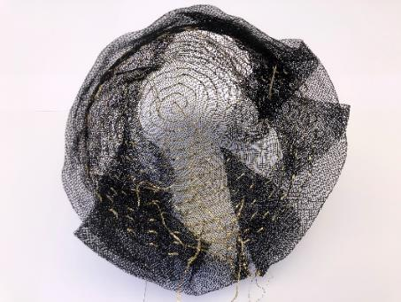

B.1.3 Organisational Structure, Environment & Strategic Planning Framework

Organisational Structure

& Environment

To deliver on the vision, mission, and goals of the CFC under the 2023-27 Strategic Plan, the CFC has established three main creative expressions, being Galleries, Museums and Heritage (GMH), Canberra Theatre Centre (CTC), and District and Events, supported by centralised Finance, Corporate, and Facility Operations and Capital Works (FOCW) teams. The high-level organisational structure is at page 5.

During 2023-24, the CFC had close working relationships with a number of ACT Government agencies and entities including: artsACT, Events ACT, VisitCanberra, Territory Records Office, Public Sector Workforce Health, Safety and Wellbeing, and Access Canberra within the Chief Minister, Treasury and Economic Development Directorate (CMTEDD); Minister’s Creative Council; CRA; MPC, including ACT Property Group; ACT Health; Environment, Planning and Sustainable Development Directorate including ACT Heritage; ACT Government Solicitor; Transport Canberra and City
Services; and the ACT Audit Office.

Strategic & Operating

Framework

The CFC is an ACT Government entity established under the Cultural Facilities Corporation Act 1997 and its operations are also subject to other relevant legislation and governance documents including the Government’s Statement of Expectations, and the CFC’s Statement of Intent.

The Strategic Plan 2023-27 provides the overarching framework for the CFC’s activities, including for the development of its business plan and work plans. The CFC’s over-arching business plan connects the CFC’s Vision, Mission, and Goals to its Accountability Indicators and internal key performance indicators, articulating the key business activities that support each goal as well as the supporting key plans, policies, and procedures.

In addition to the Accountability Indicators reported on at Attachment 1, the CFC reports internally on a range of key performance indicators across areas of assets, supporting artists, growing visitor numbers, revenue growth, developing new audiences, theatre redevelopment milestones, sector leadership, First Nations representation, children and youth programming, and workforce capability.

Further details about the CFC’s accountability indicators are provided in the 2023-24
Statement of Performance at Attachment 1 to this report. Detailed reporting against the CFC’s strategic goals is at Section B.2.

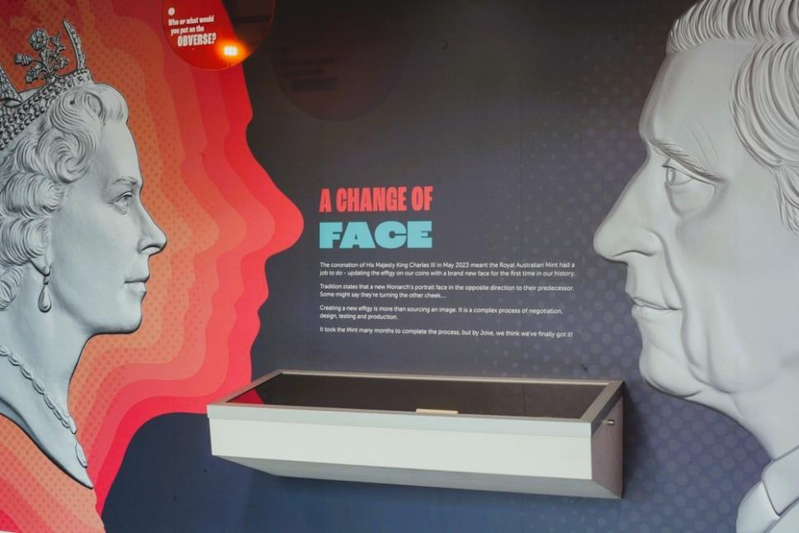

The Hub - The Royal Australian Mint Coin Shop
Image: CFC

B.1.4 Summary of CFC’s Performance in Achieving Objectives & Targets

The CFC’s accountability indicators and targets for 2023-24 are identified in the CFC’s 2023-24 Statement of Intent, which was included in the 2023-24 ACT Budget statements.

Performance outcomes for the CFC in 2023-24 were higher than the previous year as the result of increased activity in all of the CFC’s venues. This resulted in the CFC meeting or exceeding the majority of its accountability indicator targets for 2023-24. During 2023-24 the CFC welcomed over 409,000 visitors and patrons to its facilities and programs, 14.5% above target, and recorded 737 education and community programs across the CFC, 169.5% above target.

Detailed performance results and variance explanations are included in the 2023-24 Statement of Performance at Attachment 1 to this report.

Summary of Performance Outcomes
The CFC’s overall financial result for 2023-24 saw an increase in own sourced revenue. This reflects an increase in programming shows and patron activity during the financial year and is the highest proportion of own source revenue in the CFC’s history.

It should be noted that, due to its large asset holdings and consequent significant depreciation expenses, the CFC always expects to have an operating deficit as it is not funded for depreciation but receives capital injections through the capital works program. The higher than estimated deficit was primarily due to additional accrued employee expenses for expected increases from the enterprise bargaining agreement and higher depreciation expenses following the asset revaluation in 2022-23.

As of 30 June 2024, the CFC had completed all of its 2023-24 Asset Renewal Program works, capital improvements on CMAG’s exterior profile and disability access to Gallery One, as well as upgrading the CTC administrative area to address Work Health and Safety concerns. Delays were experienced in some capital
projects, mainly due to upcoming event booking schedules, weather conditions, insurance claims and staffing constraints of the Facility Operations and Capital Works Unit.
The CFC has exceeded targets on six of our seven Accountability Indicators with the exception of Indicator 4 - nights of usage at CTC - which is an indicator highly subject to market force beyond the CFC’s control.

The increase in visitor numbers is attributable to appealing product development, highly effective marketing, and a focus on audience diversification across all areas of the CFC. The above-target visitor numbers correspondingly lower the cost-to-government per patron indicator, as well as a higher than forecast increase in the CFC’s proportion of own-sourced revenue.

The higher-than-anticipated number of exhibitions is reflective of the commitment by our GMH team not only to tell the stories of Canberra and the region, but also to be agile when presented with unplanned opportunities to collaborate on exhibitions and installations.
Education and community (public) programs run by the CFC experienced an unprecedented uptake in activity due to more public programs at CMAG and ACTHP as well as the delivery of education programs by the Royal Australian Mint when they temporarily relocated to CMAG.

A full analysis of the CFC’s financial results and financial position is set out in the Management Discussion and Analysis at Attachment 1.

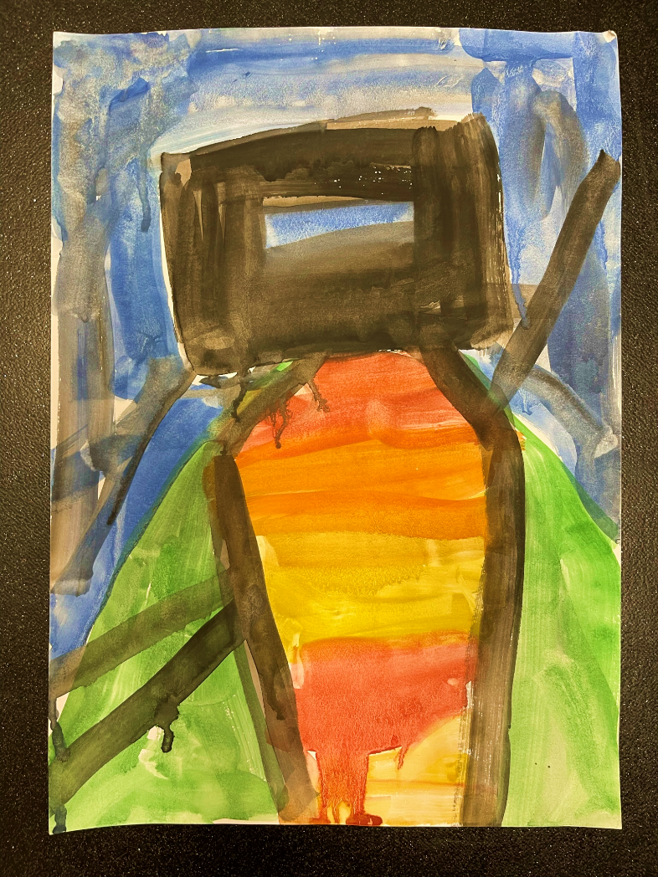

Every Picture Tells a Story
Nolan Early Learning Program
Image: GMH

Performance Outcomes

The 2023-24 Statement of Intent identified targets for the CFC’s accountability indicators, which represent the CFC’s key performance indicators. A detailed analysis of outcomes against these targets is presented in the CFC’s 2023-24 Statement of Performance at Attachment 1, with a summary provided under Section B.1.4.

To allow an understanding of trends relating to these key performance indicators, charts are presented below as a visual representation of the results for the indicators from 2020-21 to 2023-24.

CFC Performance Indicators - Graphs

Visitor numbers for
2023-24 were 409,779 -
14.5% above target and, the highest since 2018-19, before the pandemic.

CFC-managed exhibitions have met the CFC’s targets for 2023-24 with 41 exhibitions, up 2.5% from our target.

Education and community programs remained strong, accelerating to 737, 168% above the CFC’s target for 2023-24.

There were 597 days of venue usage (18.2%) on the previous financial year. This below target result in 2023-24 was primarily due to a major touring production removing Canberra from its run.

Customer satisfaction levels over the past four years have remained above target, reflecting a commitment by each venue to achieve as high a standard as possible. The level for 2023-24 was 94%, 4.4% above target.
With a reduced cost to government target of $29.05 in 2023-24, the CFC achieved an actual cost of $25.36 for 2023-24, resulting in a 12.7% reduction per visitor/patron to CFC facilities/programs this financial year.

CFC’s own sourced revenue increased significantly during 2023-24 reaching 57.7%, 13.4% above the target of 50.9%.This is the highest proportion of own sourced revenue in the CFC’s history.
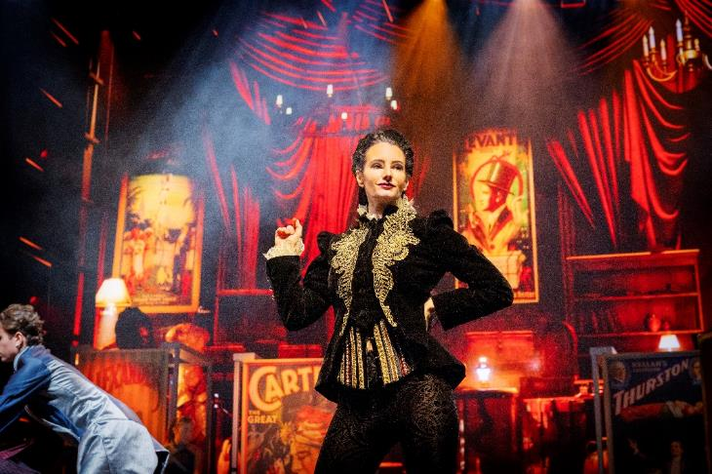

Metaverse of Magic - CTC
Image: Jeff Busby

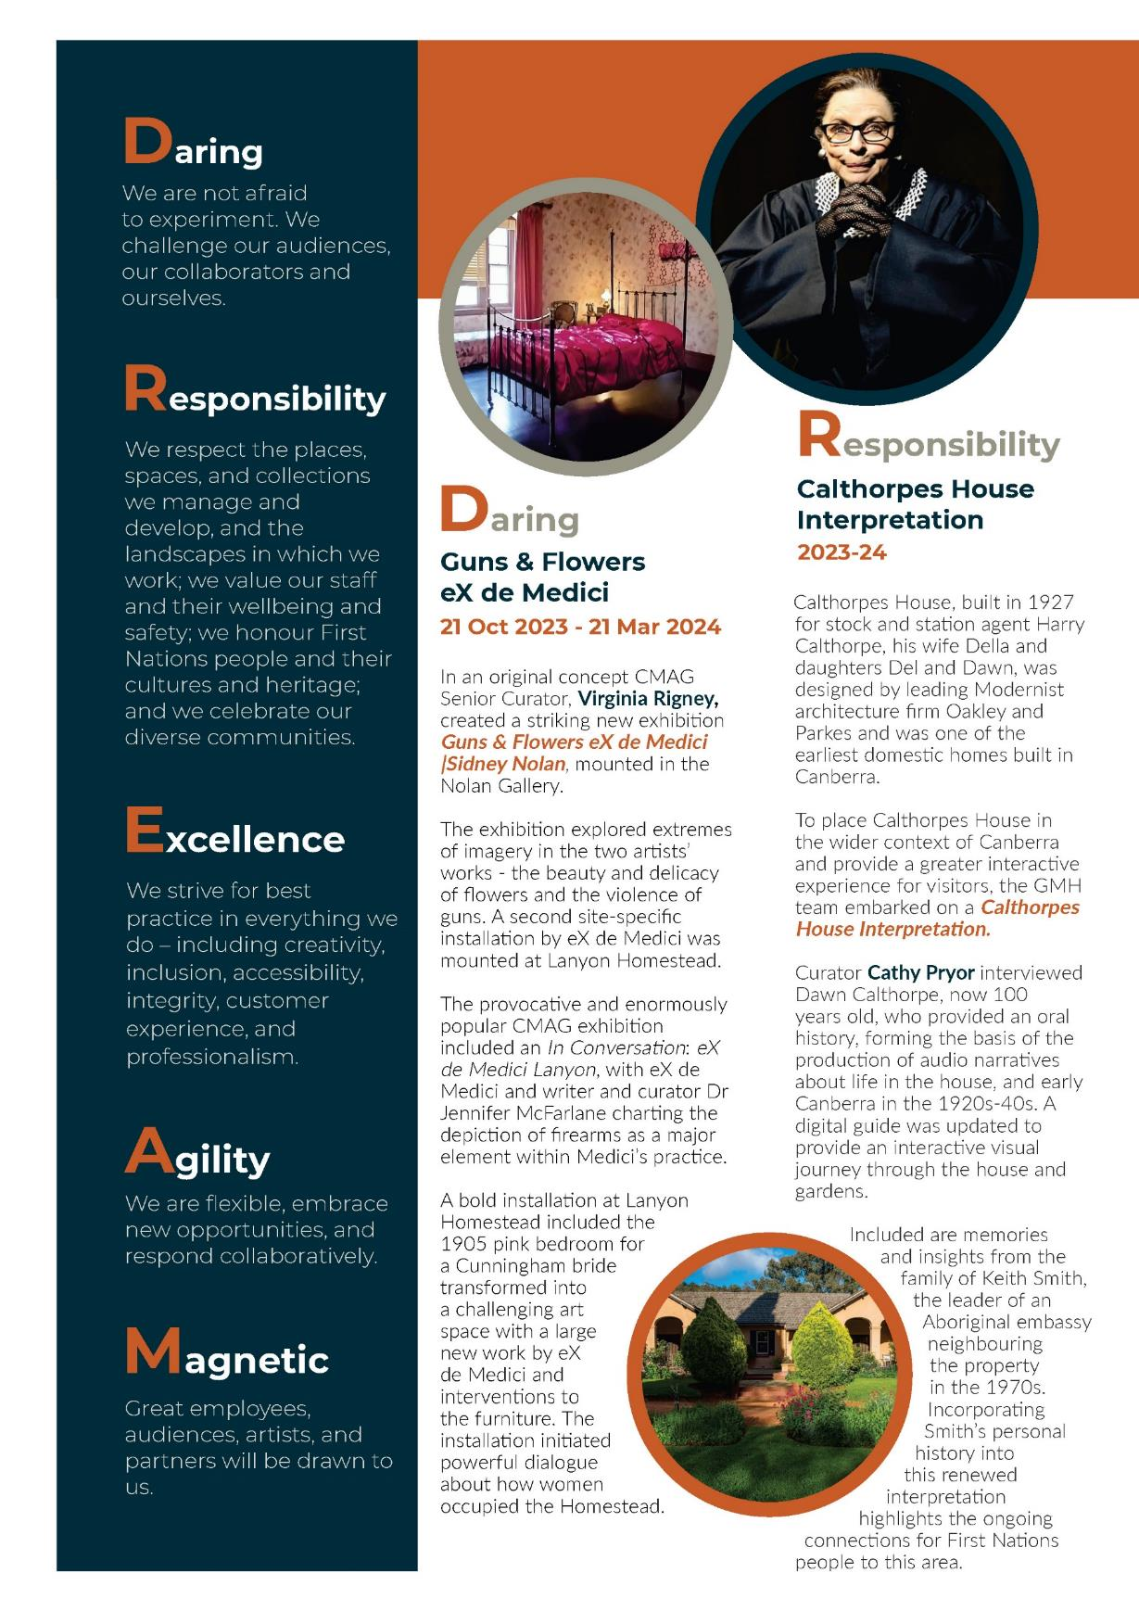
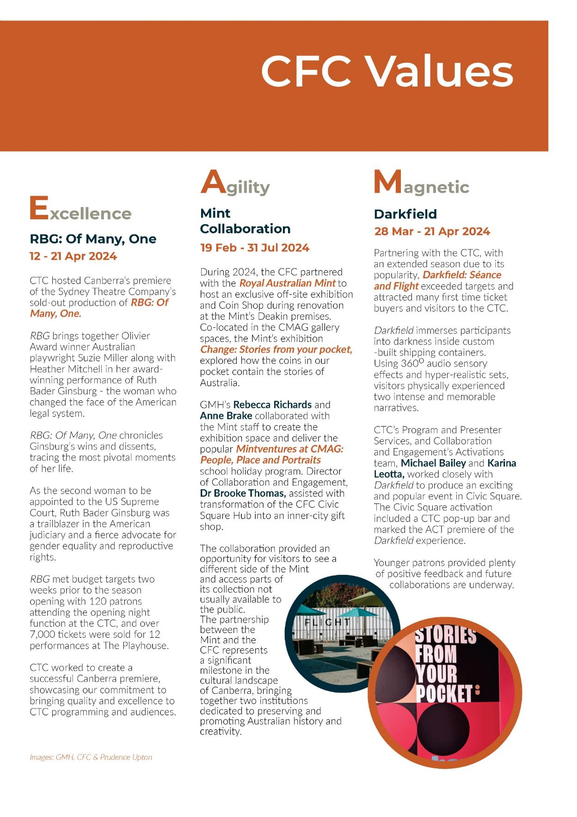

B.1.5 Outlook

The coming year will be one of important milestones as the CFC celebrates two big anniversaries and continues work on the redevelopment of the CTC.

The 60th anniversary of the opening of the CTC, and the 50th anniversary of the Sidney Nolan’s initial gift of 24 of his iconic paintings to the nation and ultimately into the care of CMAG, are opportunities for celebration and reflection that will bring into focus both the redevelopment of the CTC and the future of CMAG in a reimagined Canberra Civic and Cultural District (CCCD).

A key priority for the next several years, as expressed in the CFC’s Strategic Goal No. 3, is the redevelopment of the CTC - itself the leading edge of a new vision for the Civic Square precinct. The CFC’s vision for the expansion and redevelopment of the CTC will see the centre elevated to a contemporary arts centre of national and global significance, fully integrated into the city's fabric and identity, and serving as a destination for storytelling, reflection, and engagement across artforms, cultures, and generations.

This significant cultural infrastructure investment will enable the CFC to deliver sustainable community, cultural, and economic benefits for the ACT and be a major driver in positioning Canberra as Australia's arts capital, supporting artistic creativity and development of local, national, and global works. The redeveloped CTC will enhance community access to arts and cultural experiences for all generations and cultures, increase visitation to the ACT, grow the economy, create jobs, and open up commercial growth opportunities.
A key commitment of this project is the continued access of local art organisations to theatre venues and to the ongoing development of new works. We aspire to grow the next generation of performing artists, foster the creation of new works by local artists that tell stories of national significance, inspire young performers with access to a world class facility, be a training ground for people both on stage and backstage, and lift and encourage the entire local sector.

The redevelopment will also offer expanded opportunities for many performance genres including musical theatre, contemporary music, ballet, opera, classical music, circus, and immersive performances, as well as enabling the expansion of the scope and depth of artistic programming, with a focus on First Nations, community, diversity, and youth representation.
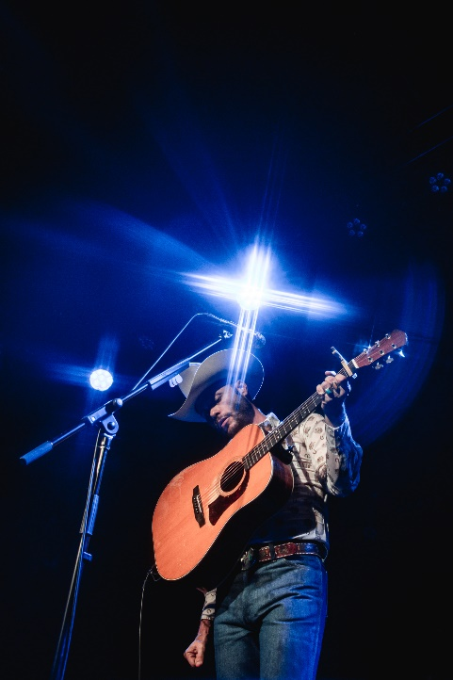
Charley Crockett
Image: Ian Laidlaw

The CFC’s planning for the redevelopment involves working closely with MPC to ensure the design meets operational needs, performer expectations, audience needs, and architectural excellence; procurement and construction are appropriate and value for money; that there is a programming strategy in place to address protracted disruption to usual business; and that the organisation is scaled up in capacity and capability, ready to operate a theatre centre of significantly greater size and complexity in the future.

We are also building an ambitious philanthropy strategy, aligned with our broader organisational Strategic Plan, with the ambition of providing the CFC with a balanced and sustainable program consisting of annual giving, major gifts (individual, foundation, corporate) and planned giving.

We continue to work toward greater financial sustainability through investigating other potential revenue streams. Among these, we
are excited about the possibilities for a holistic approach to food and beverage across our unique and diverse property portfolio that includes bars, cafes, and gardens.
Momentum is also growing for transformation of the CCCD, encompassing the CTC, CMAG, Civic Square and surrounds to create a modern, meaningful, engaging heart to Canberra’s arts and community life. The CFC will be at the centre of this reimagined district, driving programming and outdoor activations, attracting visitors, and supporting both the visitor, and night-time economies.

In the immediate planning years, the CFC will focus on strengthening our capacity to provide governance, oversight, and management for the future District, and contemplating what a future CMAG could look like in this space in terms of its building, collections, programs, and audiences.

Kelly and Horse, 1945
Image: Nolan Collection, GMH
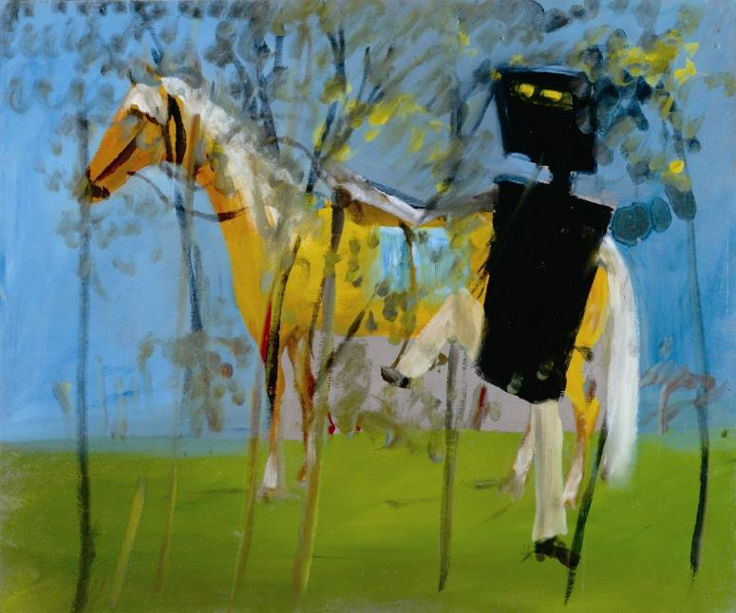

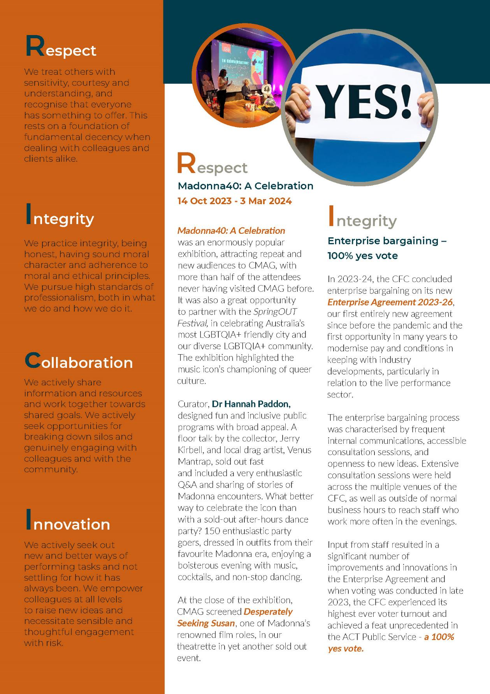
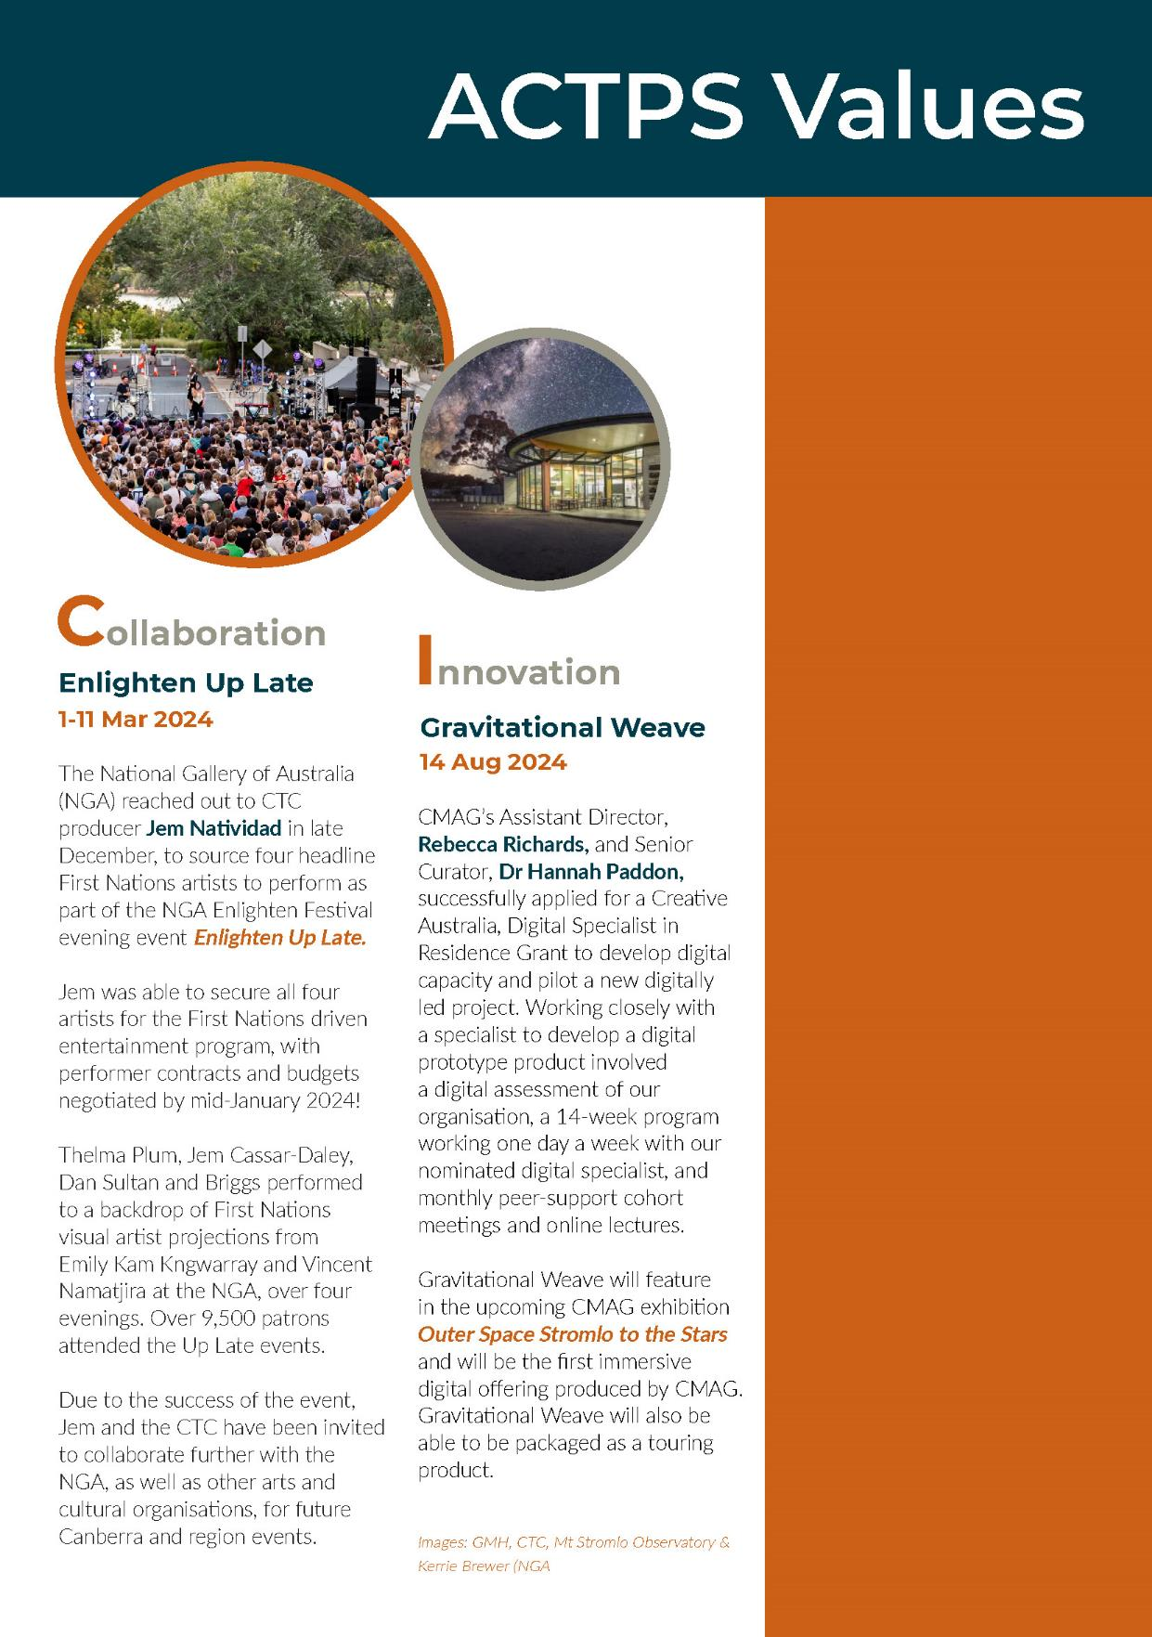

B.1.6 Internal Accountability

CFC Leadership Team
The Leadership team of the CFC is currently comprised of the following positions:
Information about the Leadership Team is provided at Appendix 1, (for the Chief Executive Officer, as a CFC Board member) and Appendix 2, (for the other six leadership team positions). Further information relating to the structure of the organisation and the responsibilities of the leadership team are provided at Section B.1.3.

The Senior Leadership Team meet every fortnight to discuss strategic, operational, financial and collaboration matters. Other significant committees of the CFC include the WHS Committee, the Agency Consultative Committee, and Audit and Risk Management.

Senior Leadership Team
Chief Executive Officer
Gordon Ramsay

Chief Financial Officer
Sharon Lu

Director - Galleries, Museums & Heritage
Dr Anna Wong
Director - Canberra Theatre Centre
Alex Budd

Director - Collaboration & Engagement
Dr Brooke Thomas

Director - Facilities Operations
& Capital Works
Danielle Buffier

Board of the CFC

The Board of the CFC promotes, and is responsible for, good governance of the CFC.

Board Charter
The Board has adopted a Board Charter to guide its operations and performance. The Charter sets out the framework within which the Board operates, and the Board’s role, composition, and responsibilities.

The CFC’s system of governance is intended to ensure the strategic leadership of the organisation and the effective oversight by the

Board of management, in order to:
• ensure the CFC achieves its mission and purpose
• enhance organisational performance
• understand and manage risks to minimise negative consequences and maximise opportunities
• strengthen stakeholder confidence
• enhance the CFC’s public reputation through enhanced transparency and accountability, and
• oversee the way in which the CFC is discharging its legal, stakeholder and ethical obligations.

The Board Charter is available at www.culturalfacilities.act.gov.au.

Composition
Section 10 of the CFC Act provides for the CFC Board to have seven members. The Chair, Deputy Chair, and four Members of the CFC
Board are appointed by the Minister in accordance with the provisions of the Financial Management Act 1996 (the FM Act), Sections 78-79. The CFC’s Chief Executive Officer is also a Member of the CFC Board in accordance with Section 80 of the FM Act.

CFC Board Members
Chair
Helen O’Neil

Deputy Chair
Dr Rachael Coghlan

Members
Genevieve Jacobs AM
Christine Shannon
Tim Lo Surdo
Michael Sollis
Gordon Ramsay
(Ex officio as CEO)

The functions of the Chair, Deputy Chair, Chief Executive Officer, and associated provisions relating to Board Members, are set out in the FM Act (Division 9.3).

Remuneration
The FM Act (Division 9.2, Clause 78 (6)) provides that the remuneration of the CFC’s
Chair, Deputy Chair, and appointed Members shall be determined by the ACT Remuneration Tribunal.

The current annual remuneration rates, set by the Tribunal’s Determination No. 18 of 2023 are:

Remuneration Rates
Chair | $30,585
Deputy Chair | $15,310
Members | $10,730

The Chief Executive Officer’s remuneration is determined by the ACT Remuneration Tribunal under normal senior executive remuneration arrangements.

Board member terms as at

30 June 2024:
- Chair, Helen O’Neil
(2 July 2022 - 31 December 2024)
- Deputy Chair, Dr Rachael Coghlan
(2 July 2022 - 30 June 2024)
- Genevieve Jacobs
(2 July 2022 - 31 December 2024)
- Michael Sollis
(2 July 2022 - 30 June 2025)
- Tim Lo Surdo
(1 January 2023 - 31 December 2025)
- Christine Shannon
(14 April 2023 - 31 December 2025)

Further information about the 2023-24 Board members is provided at Appendix 1.

Meetings
The CFC’s Board meetings are convened and conducted in accordance with the provisions of the FM Act (Division 9.4).

Board Meetings
2023 | 2024
17 August | 15 February
19 October | 11 April
7 December | 20 June

The convening of these meetings, and their procedures, complied with the requirements of Division 9.4 of the FM Act.

Audit Committee
The CFC’s financial and risk management is supported by the work of the Audit Committee of the Board and through the CFC’s Strategic Risk Management Plan, Internal Audit Program and Fraud Control Plan. The CFC established the Audit Committee as a sub-committee of the Board, with a formal charter setting out its role and functions in relation to oversight of financial, audit, and compliance matters, including risk management and internal controls.

The Audit Committee Charter is provided as Part G of the CFC Board Charter, available at: www.culturalfacilities.act.gov.au.

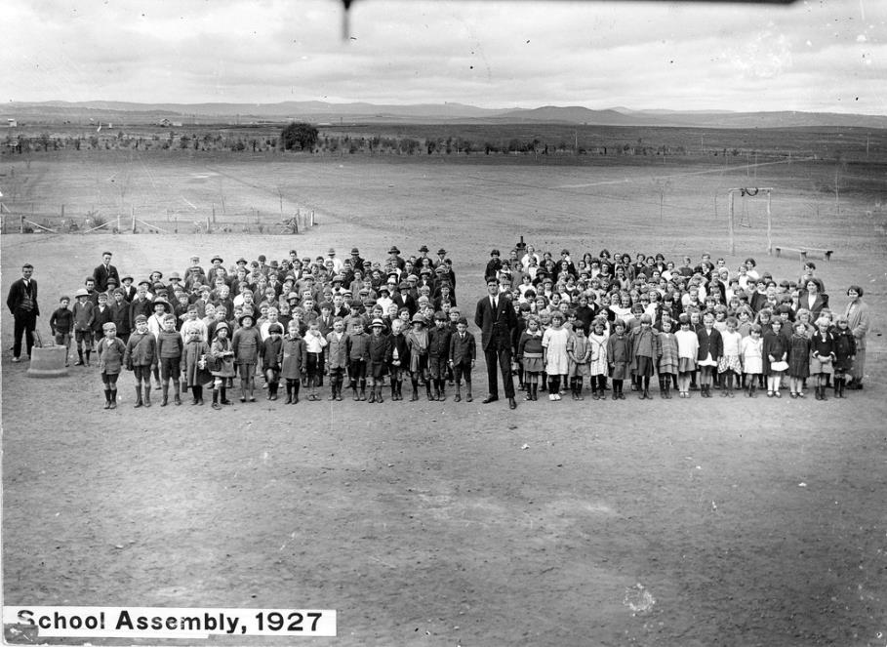
Telopea Park School 100 Years Exhibition
Image: GMH

Advisory Committees
In accordance with Section 8 (i)(a) of the CFC Act, the CFC has three established Advisory Committees. The Advisory Committees are responsible to the Board of the CFC (through the CFC’s CEO) for providing strategic and policy advice on how the CFC provides cultural leadership, excellence and innovation through its three business arms - CMAG, CTC and ACTHP. The current advisory committee members’ terms are from 1 January 2022 to 31 December 2024.

The operation of the advisory committees is governed by an Advisory Committees Charter, which is available at www.culturalfacilities.act.gov.au. Further details about Advisory Committee members are provided at Appendix 3.

Advisory Committee Membership
CMAG  Advisory Committee  To provide strategic and policy advice in the presentation and interpretation of visual arts and social history through its collection and exhibition functions. |  | Prof Nicholas Brown (Convenor)  Prof Denise Ferris  Squadron Leader Gary Oakley OAM  Dr Charlotte Craw  Sara Kelly  Amelia Zaraftis
CTC  Advisory Committee  To provide strategic and policy advice  in relation to how the planned  development of the CTC can provide  cultural leadership, excellence and  innovation. |  | Claudia Santangelo (Convenor)  Soelily Consen-Lynch  Fredeliza Campos  David Hobbes  Kels Bagust
ACTHP  Advisory Committee  To provide strategic and policy advice on how ACT Historic Places (Lanyon, Calthorpes House and Mugga-Mugga) can provide cultural leadership, excellence and innovation in cultural heritage management and interpretation. | Barbara Reeve, FIIC, M ICOMOS (Convenor)  Dr Dianne Firth OAM (Deputy Convenor)  Alistair Grinbergs  Joanne Lisinski  Shannyn Palmer

B.2 Performance Analysis
The CFC’s 2023-24 Statement of Intent was prepared in accordance with Section 61 of the Financial Management ACT 1996 and published in the 2023-24 ACT Budget statements. The Statement of Intent identified the CFC’s strategic objectives and indicators. Performance against these is summarised under Section B.1.4.
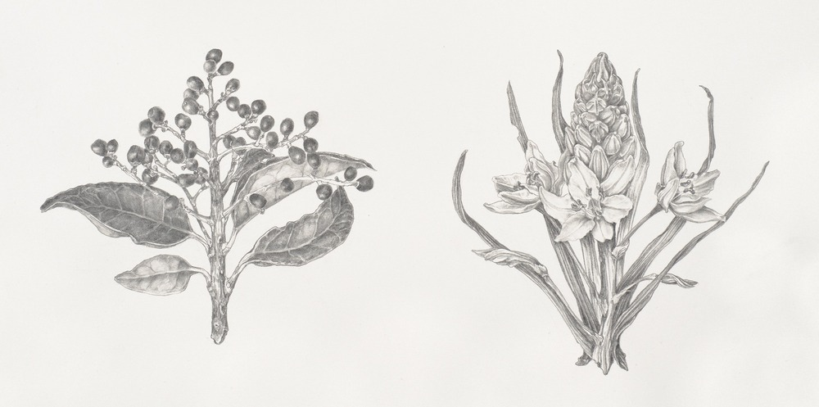

CMAG Masterclass - Watercolour with Nicola Dickson
‘Privet-Bulbine Lily 2022’
Image: Brenton McGeachie

Overview
2023-24 was a year of significant growth, activity, and diversification for the CFC with most areas of the organisation achieving record numbers of visitors/patrons including participants in education and public programs, and notable success in attracting new audiences.

Much work was done in advancing the CTC Redevelopment Project, and CTC’s New Works program reached an all-time high in both the number of works supported and the number of arts workers employed.

The organisational realignment commenced in 2022-23 and implemented gradually, reached its end result in 2023-24 of centralising a Facility Operations and Capital Works team and the Marketing team, in addition to centralised CFC Corporate Finance and Human Resources services.

The benefits of this structural transformation include:
- increased collaboration to amplify the offering, reach and appeal of our programs, presentations, products, exhibitions, experiences, and events while fostering teamwork and communication within the organisation, and
- improved efficiency through streamlining processes, eliminating duplication of roles across the organisation, and grouping up service contracts to achieve better value for money, reduce overheads and optimise resource allocation.

The new structure allows the CFC to better align its resources and efforts with its vision, mission and strategic goals. This section details the CFC’s progress against its strategic goals in 2023-24.

Strategic Goal 1
Custodianship, Creativity & Storytelling
We will deliver creative excellence and custodianship for the CFC’s activities, deepen our contribution to the ACT’s arts, culture, and heritage ecology, and grow our national role.
Operational Priorities
- Reinforcing the CFC’s role to preserve, keep, and present the collections and assets under our management including sharing the stories of this place.
- Enhancing our programming strategy, events, and productions to contribute to the ACT calendar of events, linked to the ACT’s tourism strategy, and including expansion into festivals, to help build new markets and attract visitors.
- Fostering participation in the arts and heritage - including through virtual access - for everyone - audiences, students, artists, our community, and other organisations.
- Supporting artists in the creation of new works, development, education, and residencies.
- Commissioning or producing new Australian works and capturing the voices of the nation.
- Establishing priority company relationships with the CTC and enticing world class artists to Canberra.

OUR ACHIEVEMENTS

Canberra Theatre Centre
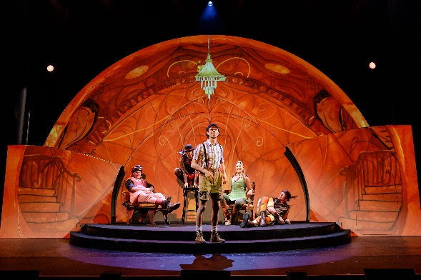
James and the Giant Peach
Image: Shake and Stir

- In 2023-24 the CTC exceeded its financial year and patron number targets
- The CTC presented original theatre from many leading national companies including Sydney Theatre Company, Belvoir St Theatre, Bangarra Dance Theatre, and Bell Shakespeare
- The CTC co-commissioned the Farm’s Stunt Double, in partnership with Brisbane

Festival, Darwin Festival, Perth Festival and HOTA
- The CTC presented 8 works for young audiences and schools, with successes including The Visitors, Possum Magic, The Very Hungry Caterpillar Show and The River That Ran Uphill
- A complete list of presentations at the CTC is provided at Appendix 4
- The CTC’s ongoing New Works program continued to deliver an expanded program of capacity building and artistic development programs including:
- 39 one-on-one artist chats
- 2 x industry networking sessions Chips, Dips and Sips
- a week-long program for the seeding of new work The New Ideas Lab
- 4 x week-long Creative Developments of Must Go On by Nick Delatovic and
Charley Allanah, Fortuna by Sugar Kaye Grefaldeo, The Complete Works of Scomo (Abridged) by Paul McDermott and Glenn Morehouse, and Shame by Charlie Wan
- supported developments of Diamond by Liz Lea, How These Things Go by Thea Jade, Only Everything by Show within a Show, and
- provided a Mentor Chat for Lisa Richards with Deborah Conway.
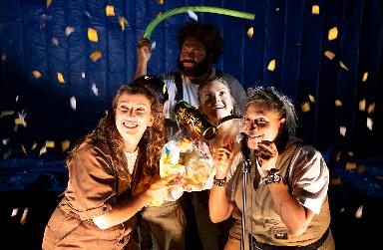

The River That Ran Uphill
Image: Andy Rasheed

- In 2023-24, New Works supported a total of 23 works and provided employment for 239 artist and arts workers
- The CTC’s New Works and Sector Development Program supports artists and producers in the commissioning, creative development, and presentation of live performances. The multi-year approach to programming connects artists who live and work in Canberra and the region to a national network of live performance makers through mentorship and collaborative opportunities. The program aims to:
  - create opportunities for Canberra professional artists to develop new work at the CTC
  - develop greater capacity and visibility for the region’s performing artists, with an opportunity for these artists to leverage this support for future projects and collaborations, including with the CTC, which result in excellent, vibrant, and dynamic new performance made in Canberra, and
  - establish a reputation for the ACT as a site for making live performance work of national significance that includes meaningful engagement with ACT artists.
- Through the New Works program, the CTC also supported the presentation of Co:Lab_24 by Australian Dance Party, The Hello Girls with Heart Strings Theatre Company, and mentored Lucid Theatre in their use of the Courtyard Studio Space for their original work People You May Know
- The New Works program is funded within the existing CTC Programming budget, which is managed separately from ACT Government Infrastructure and Capital Works projects
- The CTC also supports the local theatre industry in a range of ways in addition to the New Works Program by:
- purchasing productions, such as in 2023-24 Heart String Theatre Co’s The Hello Girls and House of Sand’s Manage Your Expectations. The CTC pays artist fees and covers presentation costs, and
- offering rental subsidies, and supporting access to technical, front of house, marketing and box office for local companies including in 2023-24 Canberra Youth Theatre, QL2 Dance, Australian Dance Party, Lucid Theatre Co, You Are Here Canberra, and Heart Strings Theatre Co.
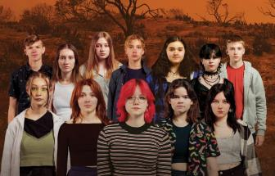

The Trials - Canberra Youth Theatre
Image: CYT

- In 2023-24, the CTC also supported presentations by local artists and companies:
- Canberra Youth Theatre’s
– The Trials (pictured)
– You Can’t Tell Anyone, and
– Rosieville
- QL2 Dance’s Subject to Change (pictured), and Gather: The Meet Up Performance
- You Are Here’s Cahoots Lab 2023
– Implications by Ashlee Bye and
Beth Lane, and
– Colony in the Spirit by Lynden
Bassett.
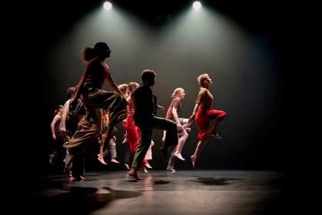
QL2 Dance’s - Subject to Change
Image: Olivia Wikner

- Many pieces supported by the New Works program have gone on to be performed locally, nationally and internationally. In 2023-24 this included:
- Alienation by Jake Silvestro was performed at the Melbourne Fringe Festival 2023
- Paul McDermott and Glenn Moorhouse’s The Complete Works of Scomo (Abridged) was performed at Smith’s Alternative in May 2024
- Melanie Lane’s Mountain was performed at Phoenix Central Park in Sydney in November 2023, and
- The Hello Girls by Heart Strings Theatre transferred to Sydney for a successful season at the Hayes Theatre in early 2024.
- At least 60% of artists employed as part of the New Works Program live and work in the ACT. Artists from outside the region are also employed so that ACT-based artists are connected to a national network of practice, helping to build sustainable careers for our local artists
- In 2022-24, the CTC also provided local artists opportunities to connect with the international and national arts community. This included an Akram Kahn Company workshops with QL2 Dance, and a Circa workshop with Warehouse Circus
- The CTC also supports local organisations and artists in their “Canberra Spotlight” section of our e-news which is sent to over 120,000 people, and on their social media channels
- Comedy remained popular with Canberra audiences, with over 29,000 ticket sales. The CTC attracted the presentation of many high-quality comedians, including:
- John Cleese
- Randy Feltface
- Tommy Little
- Myf Warhurst & Zan Rowe, and
- Ross Noble.
- Over 40 artists performed across 39 events of the Canberra Comedy Festival 2024, amounting to over 11,000 ticket sales
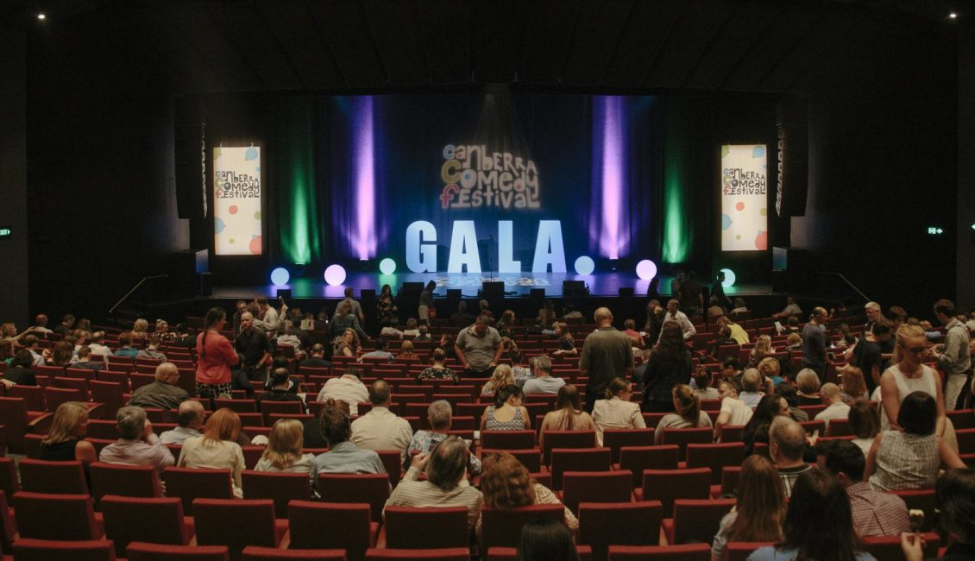
Canberra Comedy Festival Gala
Image: CTC

- The CTC continues to attract high quality contemporary music events throughout the year, with over 30,000 tickets sold, with performers including:
- The Teskey Brothers
- The Waifs
- Morgan Evans
- Kate Miller-Heidke
- Wilco
- Kate Ceberano
- Satinder Sartaaj
- Vika & Linda
- James Bay, and
- Dirty Three.
- CTC collaborated with the National Gallery of Australia’s Enlighten Up Late program, featuring leading First Nation performers, and attracted an estimated 19,000+ attendants over four performances
- The CTC increased partnerships, participation, and audience attendance for the ACT UP! Secondary Schools festival. This festival increased programming alignment with Reconciliation Week activities, and engaged First Nations playwright Dylan van den Berg as Festival Ambassador. NIDA, Slingsby and Australian Theatre Live also partnered on the event to give secondary school students a robust experience of industry immersion, and
- During 2023-24, a new ticketing system was implemented which improves customer experience notably by including offering virtual stage views when selecting seats for purchase.

Galleries, Museums & Heritage
- The CFC continued its important role of collecting, conserving, and interpreting significant objects, collections and cultural heritage places that represent the visual arts, social and cultural history of Canberra and the region. The CFC also continued to manage the Nolan Collection on behalf of the Commonwealth
- In 2024-24, CMAG acquired 214 objects, including:
- Paul Girrawah House, Walgalu/ Gundungurra/Ngunnawal/Wiradjuri b. 1969 - Gulamons (10 elements), blown and cold worked glass with associated metal mounts made at Canberra Glassworks, 2023-2024. Purchased 2024 (pictured)
- Hannah Gason, b. 1980 - Twelve Hours of Daylight, engineered glass, stainless steel, 2023. Donated by the Canberra Centre, and
- Faunce Sterling Silver Service - Eight items, dated 1789-1839. Purchased 2023.
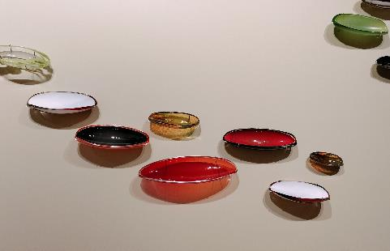

Gulamons (10 elements)
- Paul Girrawah House
Image: CFC

- A complete list of new acquisitions in
2023-24 is at Appendix 5.
- 991 objects were digitised, and 4,868 objects were prepared for display at CMAG, Lanyon Homestead, Mugga-Mugga Cottage and Calthorpes House
- 41 exhibitions were presented across the CFC’s museums and galleries, with 39 exhibitions curated in-house that promoted and interpreted the visual arts and social history of Canberra and the Nolan Collection. Exhibition highlights included:
- Capturing Canberra
- Materiality...but not as we know it, and
- Guns and Flowers, eX de Medici | Sidney Nolan.
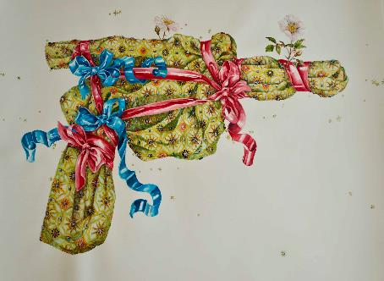

Guns and Flowers
eX de Medici|Sidney Nolan
Image: courtesy of private collection - Sullivan+Strumpf, photo by RDLI

- The CFC featured 73 practising artists
through its exhibition program and 50 practising artists through its public
programs. The Craft + Design Canberra Artist in Residence program was based at ACTHP properties in 2024, with related exhibitions to be held at the Craft + Design Canberra gallery in 2025
- Community-based Canberra stories featured strongly at CMAG through exhibitions like Telopea Park School 100 Years and Duntroon: Work with all your Might that brought together objects from community and private collections, as well as objects from CFC’s collections to showcase local Canberra history
- We also increased access to our collections and stories through two new digital exhibitions, including:
- Happy 100th Birthday Dawn. A celebration of the 100th birthday of Dawn Waterhouse (nee Calthorpe) was held in December 2023. Dawn is the youngest daughter of the Calthorpe family who built and resided at Calthorpes House. The house and gardens were built in 1927 for the Calthorpe family, who lived there continuously until it was purchased by the Commonwealth. The house includes the intact domestic collection owned by the family. It was one of the first suburban houses built in the newly established Federal Capital, and
- Duntroon: Work with all your Might extended the onsite exhibition to provide a more in-depth history of the Duntroon estate, the Campbell family, and the families and workers who were part of the estate. The digital exhibition included objects and photographs from range of private, community and government collections. It was the first time that these objects and archival material were brought together to tell the story of Duntroon, which was the largest European landholding in Canberra prior to its resumption by the Commonwealth to establish the Federal Capital.
- In 2023-24, the CFC saw an increase of 45% in visitation to its galleries, museums and historic sites compared to last year. CMAG visitation of 92,005 people marked a 59% increase from last year and was the highest level of visitation since 2013-14, when Canberra celebrated its Centenary. This growth was due to greater diversity of exhibition and event programming, which included exhibitions targeted at children. This included the touring exhibitions, How Cities Work and On the Move, and the in-house Nolan exhibition - Fly! Fly!: Sidney Nolan’s Birds
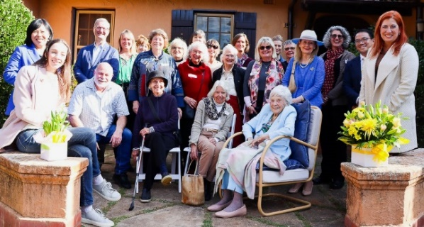

Dawn Waterhouse’s 100th Birthday
Image: GMH

- 66% of visitors to the two touring exhibitions were first time visitors to CMAG. The strong visitation numbers at CMAG were also generated by the partnership with the Royal Australian Mint, who delivered its school program at CMAG while the Mint’s Deakin premises was being upgraded. The Mint school program contributed 14% of CMAG visitation
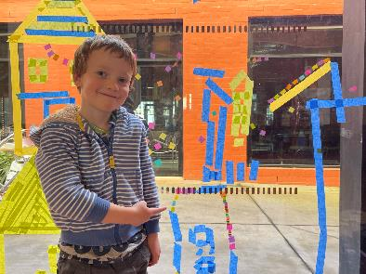
How Cities Work Workshop
Image: GMH

- Visitation to tour historic places museums increased by 28% from last year with visitation to Lanyon Homestead at its highest for over 15 years. The increase in visitation to Lanyon is due to the successful programming, particularly the signature annual event Harvest Day Out, and the month-long programming in Spring to coincide with Floriade. The CFC continued to build new audiences through new partnerships, such as the Dinner with the Stars events at Lanyon Homestead with Mount Stromlo Observatory (ANU)
- The Summer school holidays saw significant growth in visitor numbers this year:
- 60% of visitors to the On the Move children’s exhibition were first time visitors to CMAG, with 13% from interstate, and
- ACTHP saw 3,016 visitors - a 22% increase from the previous financial year and CMAG attracted 2,844 visitors - an increase of 26%.

Winter at CMAG
Curatorial & Exhibitions
- Mr Fluffy: Our Voices - personal accounts by impacted Canberrans
- Capturing Canberra - CMAG’s Press Photography 3,500 strong collection, recently acquired and on display for the first time
- Telopea Park School 100 Years exhibition
- White-out: upcycled sheets to shirts from CIT Fashion School
- How Cities Work - a touring exhibition from the Museum of History NSW, and
- Tom Buckland’s Bird Machine (pictured).

Visitor Engagement & Interpretation:
- A Flock of Birds! Poetry and art workshop inspired by Fly, Fly!: Sidney Nolan Bird’s exhibition
- Creative Workshop: celebrate NAIDOC Week ’For our Elders’ with Indigenous Artist Sarah Richards (pictured)

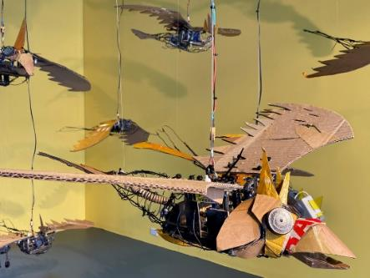
Tom Buckland’s Bird Machine
Image: GMH
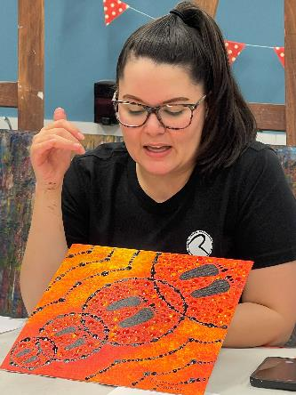

NAIDOC Week - ’For our Elders’ Creative Workshop
Image: GMH

- Art Workshop: Pop Up City - a touring workshop with illustrator and designer James Gulliver Hancock and Art Workshop: Design your own vehicle, inspired by the How Cities Work exhibition
- CMAG launched its Secondary School Art Prize with over $700 in prizes. The medium, photography, linked with CMAG’s Capturing Canberra exhibition of press photography of Canberra. The Art Prize was open to secondary students attending school in Canberra. Prizes were awarded in two categories: Year 7 to 10 and Year 11 to 12, with a selection of entries displayed in CMAG’s gallery
- 1st prize - Year 10 Amelia Bobbin, BIKE REFLECTIONS
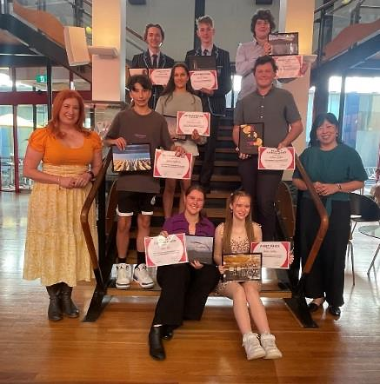
Secondary School Art Prize recipients with Minister for the Arts, Tara Cheyne
CMAG Foyer
Image: GMH

- 1st prize - Year 11 Zachary Pile, THE WINTER WALK
- Capturing Canberra - CMAG’s Press Photography Collection - kids drop-in poetry and art workshop inspired by the Capturing Canberra exhibition
- Songs and Poems Lyric Writing Workshop with Mr Tim and Nathalie, and
- Celebrating Telopea Park School 100 Year Anniversary with Esther Davies, Telopea School archivist.

Winter at ACTHP
Curatorial & Exhibitions
- The ACT Historic Places Art Prize was launched in 2023 and held at Lanyon Homestead from July to October 2024. Supporting ACT and regional artists, to exhibit their works, and to encourage a deeper appreciation of Canberra’s cultural and natural heritage through artistic engagements with our cultural places, winners and finalists’ works were exhibited at Lanyon Homestead until 15 October with Minister for the Arts, Tara Cheyne, presenting at the awards ceremony and announcing the winners and finalists on
29 July 2023
- The 2023-24 winners (pictured below) included:
- 1st prize ($7,000) - Robyn Campbell, DWELLING PLACE
- 2nd prize ($3,000) - Jessika Spencer, OCHRE
- 3rd Prize Tuggeranong Arts Centre Prize - Lynne Flemons, HOMAGE, and
- Craft + Design Prize - Sue Peachey, ELIZABETH’S HANDKERCHIEF WITH MOTH.
ACTHP Art Prize recipients
Lanyon Homestead
Image: GMH
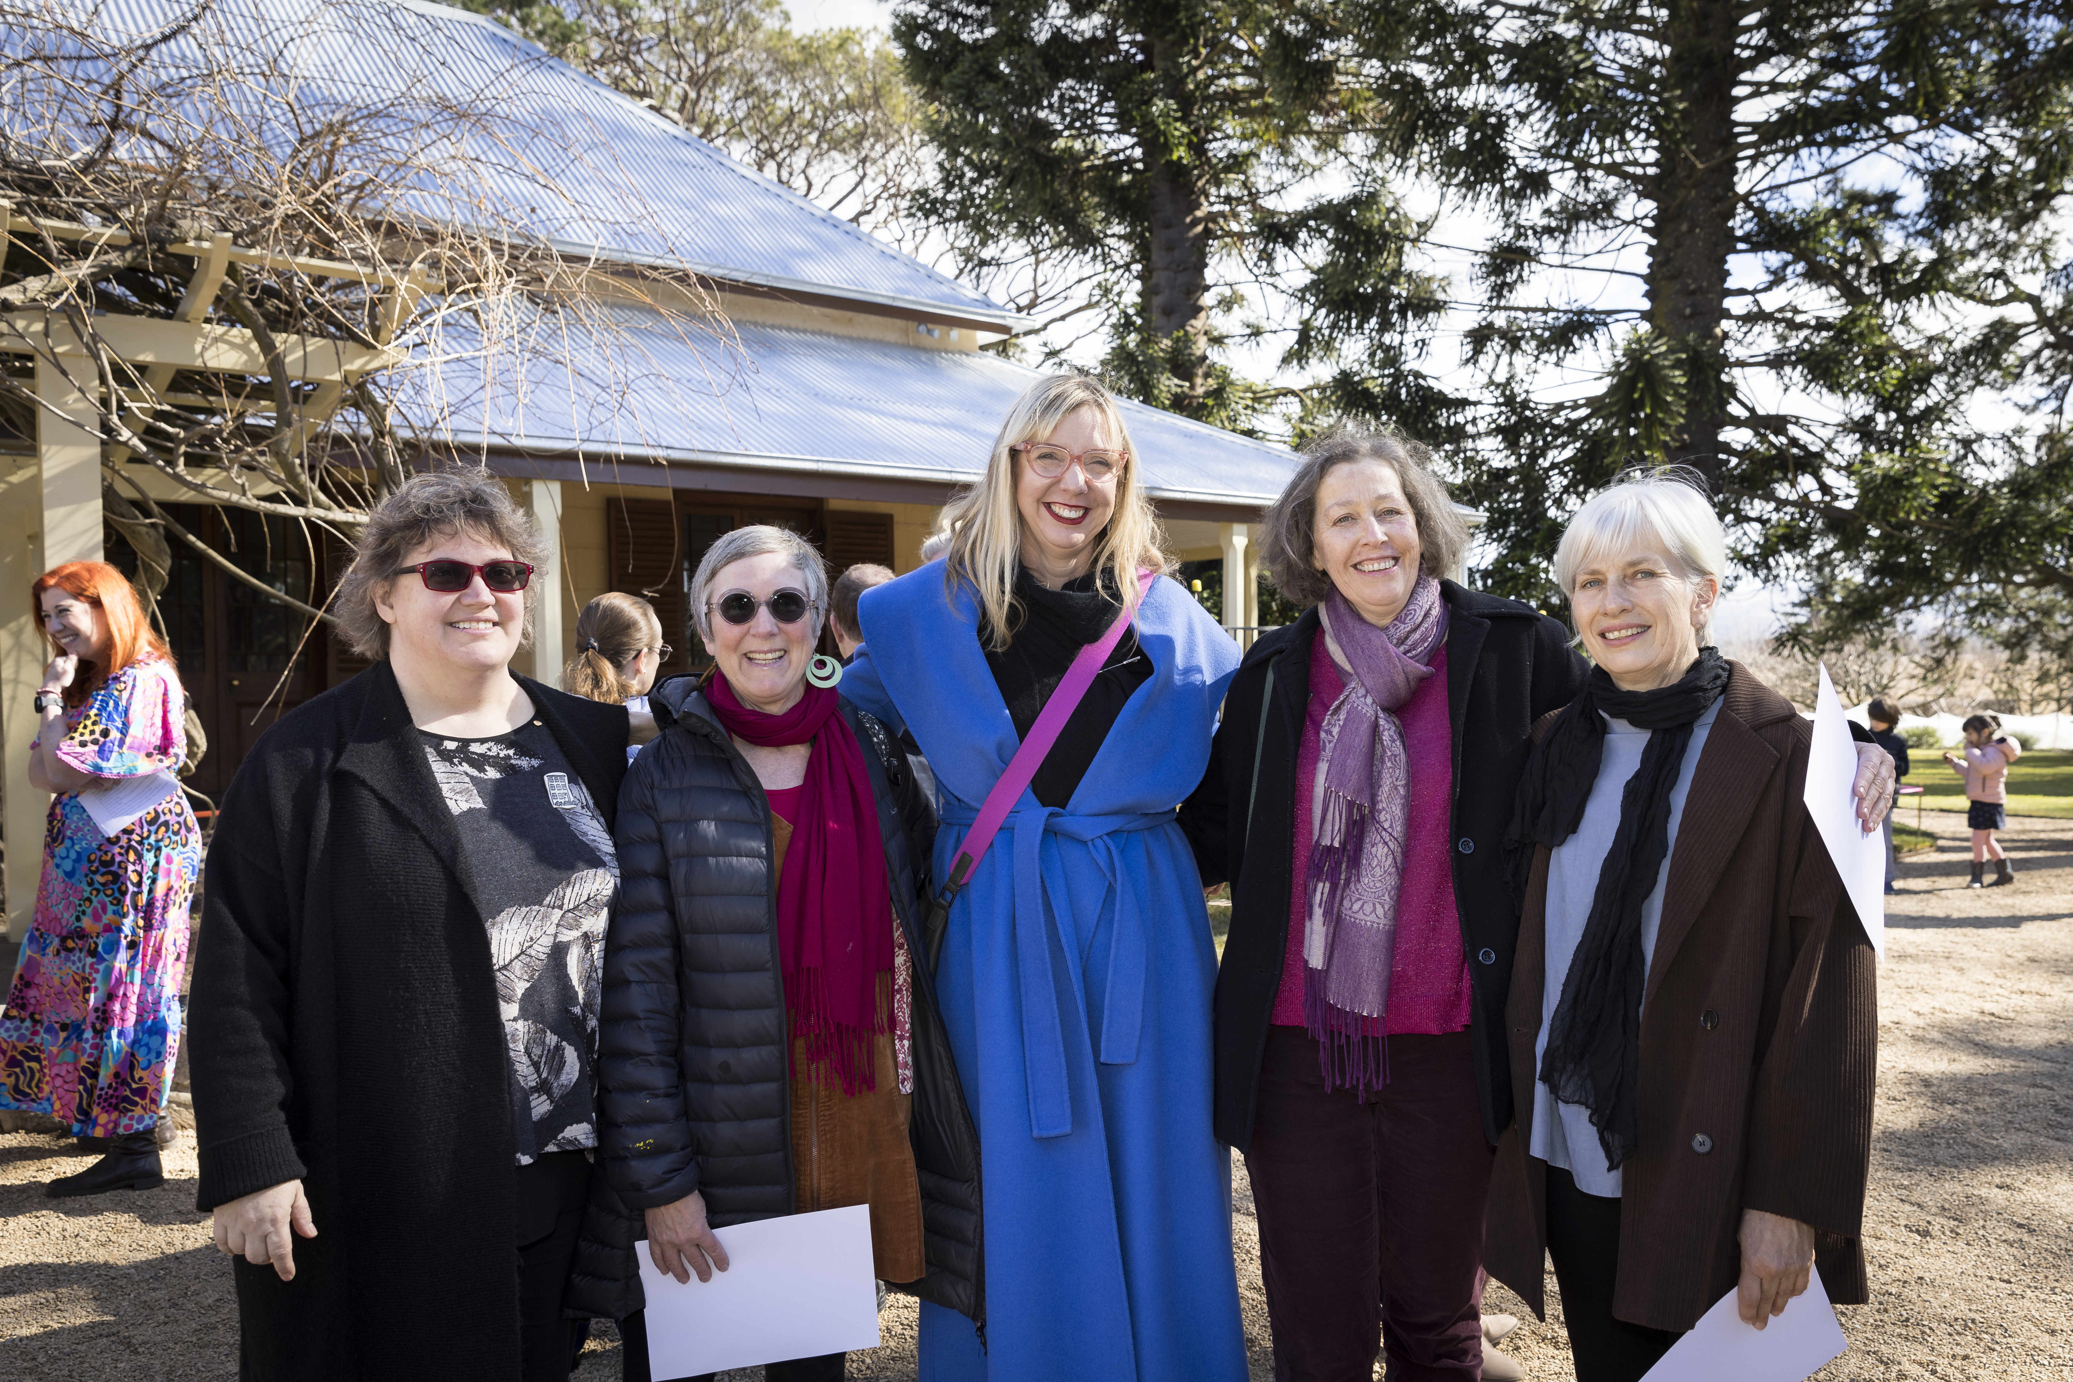

Visitor Engagement & Interpretation
- Lanyon Homestead re-opened in July 2024 after the completion of significant conservation and maintenance works to the main Homestead. Lanyon was open again for tours and exhibitions from
30 July 2024

Spring at CMAG
Curatorial & Exhibitions
- Madonna 40: A Celebration
- Nara - Canberra: 30 years of friendship
- eX de Medici’s Guns and Flowers in the Nolan Gallery
- On the Move (touring children’s exhibition), and
- Royal Australian Mint exhibition, Change: Stories from your Pocket.
Visitor Engagement & Interpretation
- Masterclass: Watercolour with Nicola Dickson provided an introduction to the art of botanical drawing and painting during September
- October School Holiday Program Unlocking Cities, Block by Block! a SOLD-OUT immersive Minecraft experience was held in the CMAG foyer inspired by the How Cities Work exhibition
- CMAG offered an eight-week mentored black and white darkroom photography workshop Canberra on Film presented in conjunction with CMAG's Capturing Canberra exhibition. The workshops were fully booked
- CMAG on Saturday: Sew What? Inspired by the ‘Kelly and Horse’ painting from the Nolan Collection, and
- In conversation: Madonna40 collector Jerry Kirbell and local drag artist Venus Mantrap discussed their passion for all things Madonna and the artist's impact in the queer community.

Spring at ACTHP
Curatorial & Exhibitions
- Special Christmas displays at Lanyon, Mugga-Mugga and Calthorpes House opened in late-mid November to
17 December 2023.

Visitor Engagement & Interpretation:
- Find, Make, Renew: Sustainable Art Workshops Series II commenced with a series of artist led workshops linked to the history of Mugga-Mugga Cottage and upcycling programmed for November 2023 was sold out
- During Spring 2023 Lanyon Homestead became the inaugural Floriade Satellite site during September and October, with additional plantings and gorgeous floral displays. Strong visitor results followed the official satellite site. As well as additional floral garden displays, Spring programming included:
- Spring Wonderland Picnic Concert with the Canberra Symphony Orchestra String Quintet and Rachael Thoms
- Grow Your Garden Plant Fair
- Drought and Other Plays by Milicent Armstrong
- ACTHP Art Prize Finalist Exhibition, and
- Garden tours.

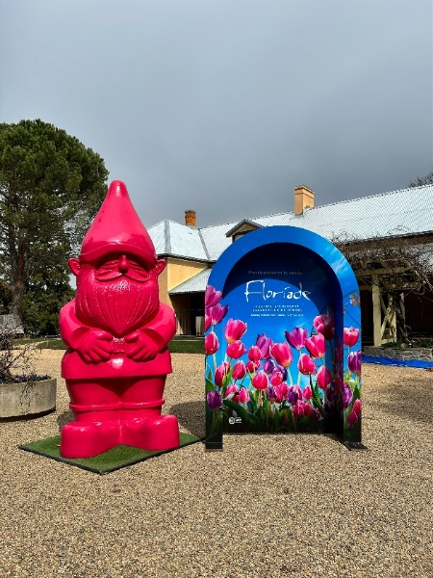
Floriade at Lanyon Homestead
Image: GMH

- Visitation patterns included:
- a 307% increase in overall visitation (compared with the same period in
2022)
- 95% booked capacity for guided tours (compared to 35% booked capacity the previous year), and
- 42% first time visitors for the Canberra Symphony Orchestra concert with 27% from Tuggeranong, 10% from the ACT region (NSW), and 1% from interstate (beyond the ACT region).
Guns and Flowers: eX de Medici
Lanyon Homestead
Image: GMH

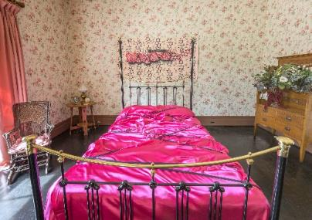

- Guns and Flowers: eX de Medici/Nolan, including and installation at Lanyon Homestead (pictured) as an extension of the exhibit as well as an In Conversation: eX de Medici, Curator Virginia Rigney and Dr Jennifer McFarlane held at Lanyon.

Summer at CMAG
Curatorial & Exhibitions
- Stephen Harrison’s The Sphinx Bureau
- Materiality - but not as we know it
- Backyard Archaeology (pictured), and

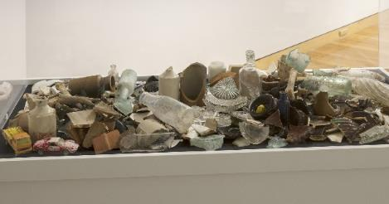
Backyard Archaeology Exhibition
Image: CFC

- Duntroon Estate: Work with all your Might showcasing never before seen objects and images form the house, families, woolshed and dairy.

Visitor Engagement & Interpretation
- Flights of Fancy Creative Workshop with artist Mariana del Castillo, inspired by the Fly, Fly!: Sidney Nolan Bird’s exhibition (pictured)
- A special screening of Desperately Seeking Susan was shown at the CMAG Theatrette, part of the Madonna40 celebrations, and
- As part of the National Multicultural Festival CMAG provided a Children’s Sanctuary and workshops.

Summer at ACTHP
Curatorial & Collections
- A joint Dark Sky public and education program with Mount Stromlo/ANU commenced in Lanyon in March 2024.

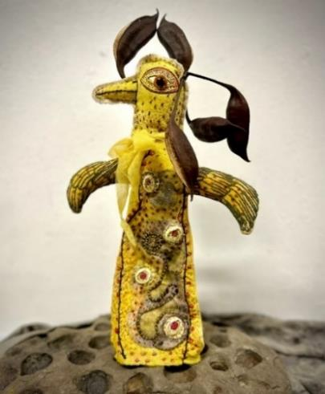
CMAG Creative Workshop
Flights of Fancy with Mariana del Castillo
Image: Courtesy of the artist

Visitor Engagement & Interpretation
- CMAG launched a digital exhibition celebrating Dawn Waterhouse’s 100th birthday and her childhood at Calthorpes House. GMH supported family celebrations with special openings of Calthorpes House for Dawn’s family and friends.

Autumn at CMAG
Visitor Engagement & Interpretation

CMAG After Dark coincided with Enlighten's Illuminations and the CRA's Before Us|A Night Walk Through Time in Civic Square, creating a collaborative sculpture connecting Civic Square to CMAG’s Materiality exhibition and Lucy Irvine’s Civic Systems workshop
- Artist Lucy Irvine hosted Civic Systems workshops as part of the Materiality…but not as we know it CMAG exhibition
- Senior Curator Virginia Rigney hosted In Conversation: with eX de Medici as part of the International Women’s Day events
- CMAG on Saturday: Imagination into the World inspired by Stephen Harrison’s The Sphinx Bureau exhibition
- Kids Workshop: Mintventures inspired by Canberra/Kamberri: People + Place and the MINT collaboration
- Panel Talk: Memory, Identity and the Past- Connecting Canberrans to Territory Collections as part of the Heritage Festival 2024 brought together curators, archivists and librarians
- CMAG’s Dr Hannah Paddon facilitated Curator Talk: Duntroon Estate and its People as part of the 2024 Heritage Festival
- Senior Curator Virginia Rigney hosted Curator Talk: Materiality
- Artists Talk: Materiality Collaboration with artist Errol Evans, Tanya Singert and Trent Jansen (pictured)
Artists Talk: Materiality Collaboration with artists Errol Evans, Tanya Singert & Trent Jansen
Image: GMH
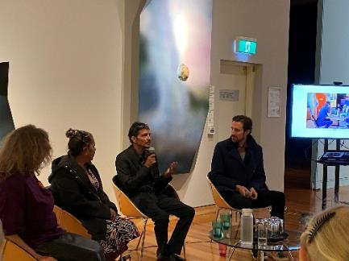

- Symposium: Backyard Archaeology for National Archaeology Week, and
- To celebrate Reconciliation Week CMAG held Artist Talk: Materiality with Paul Girrawah House.

Autumn at ACTHP
Visitor Engagement
As part of the 2024 Harvest Day Out, Lanyon held a wide range of workshops, tours and talks, market stalls, music and eateries including:
- Ngunawal Seasons Talk
- Rockabilly with The Fuelers
- Making Clay Seed Pod Animals Kids Workshop
- Ikebana With Upcycled Materials Workshop
- A Garden Through Time with Lanyon’s Head Gardener Tour
- Communities Making Climate Cooling Microforests Talk
- Cool Jazz at the Homestead, and

Making Mrs Calthorpe's Marmalade and Other Preserves (pictured - Dr Anna Wong, Director GM H demonstrating the historical preserving recipes from Calthorpes House (Making Mrs Calthorpes' Marmalade Workshop, Harvest Day Out at Lanyon Homestead).
Dr Anna Wong making Mrs Calthorpes’ Marmalade
Image: GMH

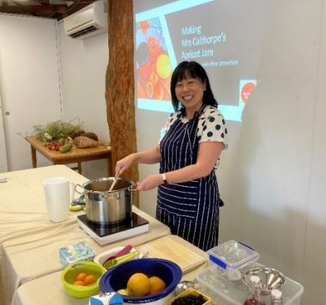

Dinner with the Stars - Dinner and Stargazing at Lanyon Homestead in partnership with the Stromlo Observatory

Calthorpes House Garden Tours as part of the Canberra and Region Heritage Festival, and
- Legends of Lanyon tour, talk and dinner with Tim the Yowie Man.

District & Events
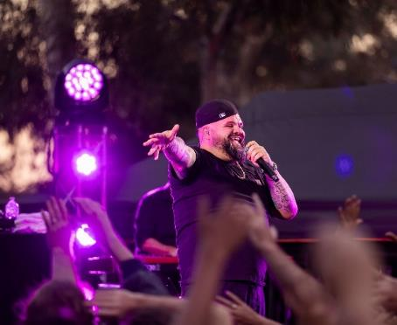

Briggs - Enlighten Up Late
Image: Kerrie Brewer (NGA)

Collaboration & Engagement
- The CFC continued to evolve the former Elections ACT office - now known as the CFC Civic Square Hub - into a multi-purpose art space able to host and support a number of different arts activations. This included:
  - supporting CRA-funded arts activators through hosting PeopleLab’s Festival of Everyday Art exhibition July 2023
  - hosting the Uncharted Territory Festival hub in our Civic Square Hub in July 2023 which included the Canberra 2060 Workshop by Boho Interactive as part of Uncharted Territory, and
  - creating pop-up bars with live music in summer.
- For the second half of 2023-24, the Hub was leased to the Royal Australian Mint (see Goal 2 below)
- The CFC participated in the National Capital Attractions Association Director Showcase at Parliament House on 18 October 2023 to promote the CFC alongside the National Cultural Institutions and other major ACT Visitor destinations. The CFC displayed Dr Matilda House’s Possum Skin Cloak, showcased concepts for the Theatre Redevelopment, and gave out heritage recipe postcards connected to our historic properties and exhibition catalogues
- The CFC Events team hosted Christmas Carols on the Terrace alongside the CTC’s A Christmas Carol theatre performances and
assisted with delivery of the immersive sensory experience Darkfield: Séance and Flight in Civic Square
- The CFC had a strong partnership with the 2023 SpringOUT Festival, hosting four sold out Queer Elders Speak events at CMAG:
- Queer Elders Speak Event 1: Tales from the Lesbian Sisterhood presented by TRANZ Aust and SpringOUT
- Queer Elders Speak Event 2: Mateship and Memories Gay Gentlemen’s Chronicle
- Queer Elders Speak Event 3: Bisexual Journey’s - Between Two Worlds, and
- Queer Elders Speak Event 4: The Rainbow Collective.
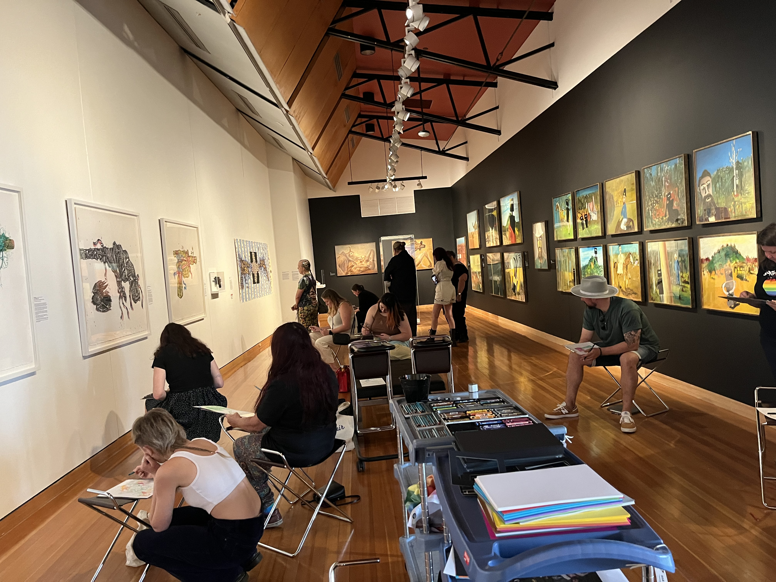
Queering CMAG Workshop
Image: GMH

- CMAG held a QUEERING CMAG workshop with artists Fox May and Gerald Jones holding drawing sessions in the Guns and Flowers exhibition (pictured).

Facility Operations & Capital Works
- Lanyon Homestead conservation works were commenced and completed with internal works, roofing and landscaping activities undertaken.
- Tree assessments at the CFC’s heritage sites were undertaken and our database updated. With a large number of trees at end of life, a program of removal and replacement gained headway in 2023-24, in addition to the clearing of fallen trees and arboricultural works on other trees
- Further geotechnical investigations were made at Lanyon to inform the road design package of works for the Driveway restoration
- Refurbishment of the North Building office space was undertaken with completion and re-occupancy in March 2024. This is the first
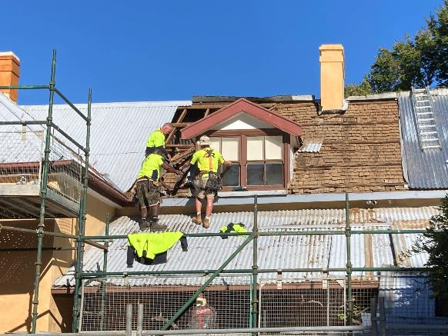
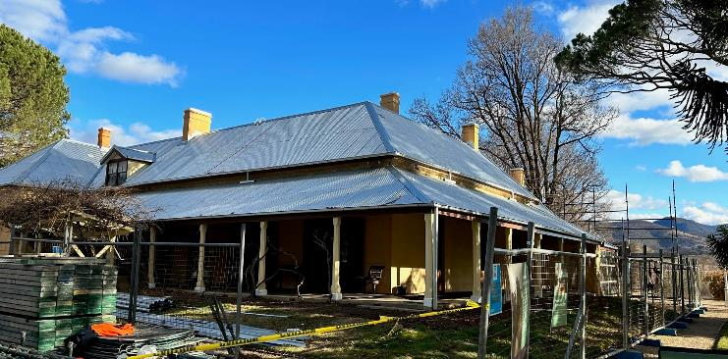

major update to the administration areas which are now more user friendly and welcoming
- The CTC staff administration area also underwent a refurbishment, creating a better work environment and enabling co-location for those working on the CTC re-development project
- Final designs were completed for the adaptive re-use of the Lanyon heritage centre into staff accommodation, and
- A centralised FOCW operating model was developed to support the management, maintenance and enhancement facilities and assets in line with industry standards and expectations.

Conservation works at Lanyon Homestead - original shingle roof
Image: GMH

Conservation works at Lanyon Homestead - new corrugated iron roof
Image: GMH

Strategic Goal 2
Growth & Financial Sustainability
We will position the CFC for the future by expanding its income streams and relevance to the arts, culture and heritage sectors, audiences, and economy.

Operational Priorities
- Expanding and diversifying revenue streams to support the vision of the CFC, including building philanthropic engagement and funding partnerships; commercial activation of sites; and expanding our ticketing, retail, food and beverage offering.
- Ensuring relevance for our existing audiences and building new audiences by making programming decisions focussed on the patron experience, informed by data.
- Contributing to growing the ACT visitor economy and advocating to a greater understanding of the ACT’S arts, culture, and heritage in the visitor economy.
- Creating new and increased reserves for future acquisitions and innovative and adaptive re-use investments.

OUR ACHIEVEMENTS

Corporate Finance

- In 2023-24 the CFC maintained high standards of financial management and reporting
• The audit of the CFC’s 2023-24 Financial Statements by the ACT Auditor-General resulted in an unmodified audit
• The CFC has been funded in the ACT Government 2024-25 Budget and the Budget Papers include forward estimates for the CFC
• For 2023-24, the CFC achieved own-sourced revenue of 57.7% comparable with a target of 50.9%
• The CFC achieved a cost to government per visitor outcome of $25.36 compared with a target of $29.05. The better-than-target figure relates primarily to higher-than-expected visitors/patrons due to strong attendance at events at Lanyon, popular family-focused exhibitions at CMAG, presence of the Mint, and new CFC run events including in Civic Square, capturing new audiences
- The Government provided $0.380 million in 2023-24 to the CFC for its Enterprise Agreement bargaining and pay offers.
- The CFC developed two bids which were funded in the 2023-24 ACT Budget, leading to funding for the jointly delivered CTC-CIT Certificate III in Live Production and Technical Services for the training of backstage theatre professionals, and funding to support the ongoing expansion of CMAG into vacant ground floor spaces in the North Building and to contribute to the activation of Civic Square. These are the Circuit Gallery (formerly the Mr Wei restaurant) and the Civic Square Hub (formerly the Elections ACT office). The new
areas in turn support future financial sustainability through the income generation opportunities they present
• The Corporate Finance area continued to meet deadlines for payroll, theatre show acquittals, accounts payments and the collection of receivables
- The CFC Audit Committee met four times in 2023-24. Representatives of the ACT Audit Office were invited to all meetings of the CFC’s Audit Committee. An ACT Audit Office representative provided a briefing to the September 2023 Audit Committee meeting on the audit of the CFC’s 2022-23 Financial Statements and 2022-23 Statement of Performance
- In January 2024, the Board endorsed the CFC Risk Appetite Statements which guides decision-making for the Board, Executive and Staff in the areas of reputational, artistic, financial, asset and people risk. The Risk Management Framework and Policy, Risk Management Plan, Fraud and Corruption Prevention Plan and Strategic and Fraud Risk Registers were subsequently approved by the Board at its June 2024 meeting, and
- The CFC’s quality assurance program for the year focused on petty cash, asset stock take, delegation and signature register and ICT asset audit.

Canberra Theatre Centre
• QTix was confirmed as the successful new ticketing system tenderer, with the implementation of Nliven (the CTC’s new ticketing management system) integrated and went live in July 2024
• In the 2023-24 financial year, the CTC commenced a brand refresh for Canberra Ticketing in order to develop ACT’s leading ticketing agency after implementation of the new ticketing management system
• A review of food and beverage options to enhance the customer experience and generate increased revenues was expanded as a collaborative project across the CFC within the 2023-24 financial year and will continue throughout 2024-25
• The CTC continued to promote opportunities for customers to engage in dialogue with and provide feedback through its patron survey, social media community engagement, direct phone calls to Box Office, and in person with Box Office and FOH staff
- The CTC continued to refine post-performance surveys, adding 27 questions, to gain a deeper and more nuanced understanding of the patron experience
- Further audience development initiatives included:
- collaborations with a wide range of national and local institutions including the National Gallery of Australia, National Film and Sound Archive, Ausdance ACT, Canberra Symphony Orchestra, and the National Portrait Gallery
Akram Khan’s The Jungle Book Reimagined
Image: Production Shot
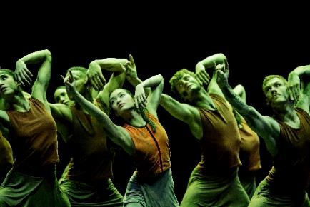

- marketing Akram Khan’s The Jungle Book Reimagined into Sydney and Melbourne, and working with national contacts and partners including A by Adina, The Saturday Paper, Bell Shakespeare, and Carriageworks to promote the work and the CTC’s role in bringing it to Australia. The campaign doubled our average interstate attendance for The Jungle Book season
- multiple sold-out performances for Sydney Theatre Company’s RBG, supported by a highly successful waitlist campaign

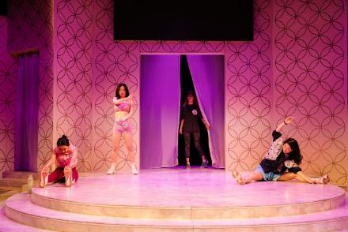
Miss Peony
Image: Jason Lau

- a successful outreach campaign to people with Chinese heritage and language in partnership with a local consultant and Region Media Chinese outlets for Miss Peony
- collaboration with Jones Theatre Co. to deliver the world’s first interactive magic spectacular, Metaverse of Magic, developing bespoke content for the campaign, which has since toured internationally
- launch of our largest post-COVID education and young audience programs to date
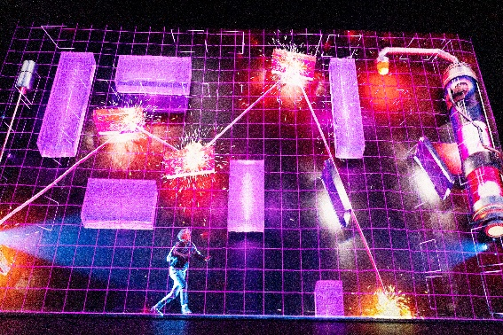

- successful promotion of our New Works opportunities, resulting in the most diverse group of candidates to date
- launch of ticket sales for Chicago, organising a media event featuring Lucy Maunder alongside the Chief Minister at a speakeasy in Canberra, with the campaign achieving the highest ever first-week sales for any major musical at the CTC, and
- Secondary school audiences increased through other engagement opportunities including access to Akram Khan’s The Jungle Book: Reimagined, and teacher engagement has been high due to digital, face to face and professional learning opportunities.
- The new ticketing system now includes views from seats that customers can access when selecting seats for purchase. In 2023-24, the night usage of the CTC venues was split almost equally between local and national acts - 48% local and 50% national - with the remaining 2% being international acts. This is clear demonstration of the high level of usage of the CTC by the local live performance sector.

Metaverse of Magic
Image: Jeff Busby

Galleries, Museums & Heritage
- The ticketed model for the How Cities Work exhibition demonstrated income generating potential of paid experiences at CMAG. Subsequently On the Move was ticketed for the summer holiday period
- The CFC leveraged the CRA’s Winter in the City ice and snow experience in Civic Square and Ainslie Place to boost visitation to CMAG through complementary and co-marketed school holiday activities
- A ticketed Spring Wonderland Picnic Concert was a successful pilot for potential paid concert series at Lanyon Homestead, drawing an audience of 750 patrons
- Dinner with the Stars, a ticketed partnership with Mount Stromlo Observatory at Lanyon launched in March 2024 (pictured). This dark sky gazing experience proved to be immensely popular, repeatedly selling out

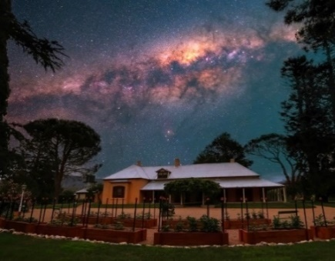
Dinner with the Stars - Lanyon
Image: James Harcombe

- The established partnership with Tim the Yowie Man is ongoing with future events to be held at Lanyon, creating positive partnerships
- The Commonwealth Government, through the Office for the Arts, renewed the Nolan Collections Management Agreement for a further 3 years
- During 2023-24, the CMAG Café refined its
staffing model and menu, and attracted an exclusive coffee bean partner. The

purchase of a coffee cart allowed café service to be run in Civic Square and at Historic places events. Overall, café revenue is increasing
- CMAG venues were hired by 42 different organisations during 2023-24, with a number of these organisations hiring venues on multiple occasions. Organisations ranged from Federal and ACT agencies to not-for-profit organisations, community groups, as well as private sector organisations, and
- Spaces within Lanyon and Mugga-Mugga were used by 12 different organisations and groups during 2023-24.

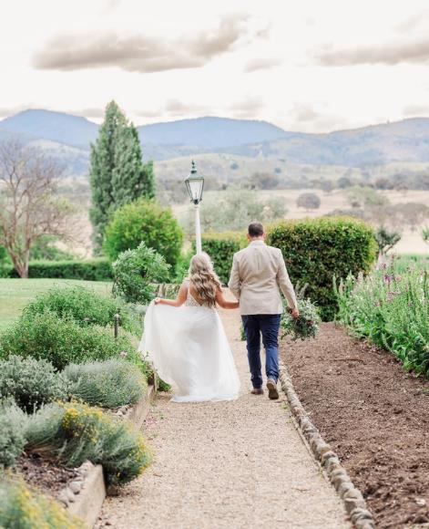
Wedding at Lanyon
Image: Kali Rebecca Photography

District & Events
Collaboration & Engagement
- In January 2024, the CFC entered into an arrangement with the Royal Australian Mint for short-term lease of the Hub, Circuit Gallery and CMAG Theatrette from February to July to continue the Mint’s education and public programs and to open a pop-up shop while their Deakin premises were being renovated
- The CFC Events team created a dance party - Into the Groove - in the CMAG foyer to celebrate the Madonna40 exhibition in November 2023. The event sold-out at 150 tickets, made a significant profit, and received extremely positive feedback in the post-event survey
- In December 2023, the CFC held a new audience development event, Canberra Museum and Games, in partnership with GamePlus and CanDev. The sold-out ticketed family friendly evening celebrated Canberra-made games with local developers showcasing a wide variety of tabletop, digital and VR games for patrons to test, play, make and buy. The event saw largely first-time visitors to CMAG and included access to CMAG's interactive family-friendly exhibition On the Move
- To trial possible future revenue generation opportunities from Lanyon gardens produce, the CFC collaborated with Canberra Brewers for a small test batch of beer from hops grown at Lanyon.
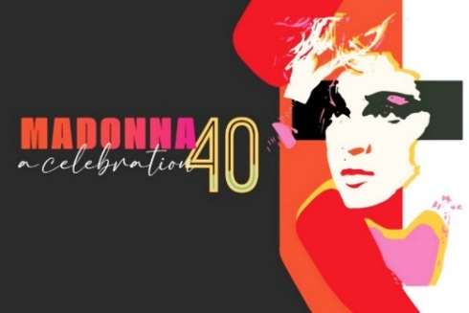

Into the Groove Madonna40 Dance Party
Image: CFC

- A private tasting held for the Chief Minister received positive feedback on our English Pale Ale
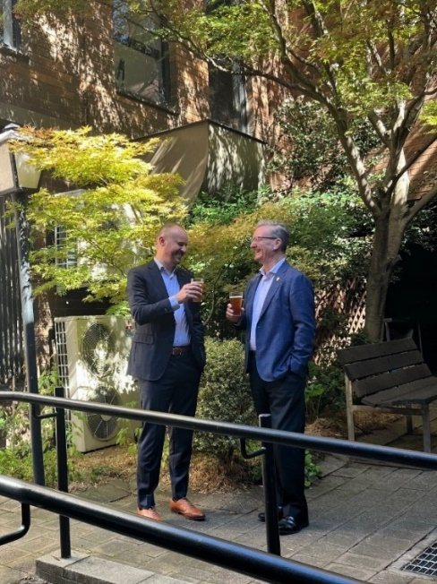

Chief Minister Barr with
CFC CEO Gordon Ramsay
- tasting the Lanyon beer
Image: CFC

- In June 2024, we commissioned a Lanyon Gin with Big River Distillery which will become part of a range of retail products under development in the CFC, and
- During December 2023 CMAG hosted pop-up terrace bars, musicians, and carolers outdoors to enliven the Square in the Summer evenings.

Strategic Goal 3
Redevelopment of the Canberra Theatre Centre
& Cultural District
We will provide a vision and key leadership for the redevelopment of the CTC and CCCD, developing our organisation to leverage the opportunities these present.
Operational Priorities
- Ensuring the development and management of the project around design, disruption, construction, and operating model; with design to include safety, public approval and engagement, and excellence.
- Supporting the processes for procurement, design, and construction of world class plans, and funding to develop the new Theatre and CCCD.
- To strengthen the CFC’s capacity to provide governance, oversight, and management for the CCCD and the CTC.
- Rethinking the position of CMAG in the CCCD to lift CMAG’s visibility, profile, and audiences.
- Developing the capabilities to oversee, operate, and activate in the new venue and district and in so doing create a national hub of creative excellence.

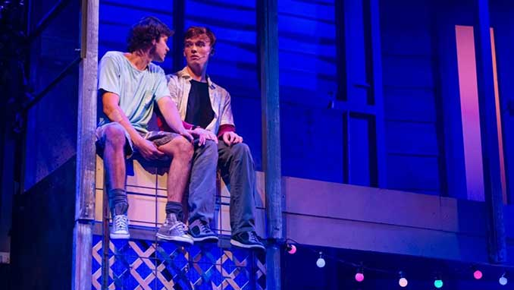
Fourteen
Image: Joel Devereux

OUR ACHIEVEMENTS

Canberra Theatre Redevelopment
- The CFC continues its exciting journey of the transformation of the CTC. With a focus on designing a world-class performing arts centre and patron experience, we are committed to fostering artistic creativity, supporting the development of local stories,

and creating works of local, national, and global, significance
- Community engagement has been a key
focus of the project, with consultations beginning in October 2023. The CTC has provided various opportunities for the public to engage with the project, including online surveys, on-site pop-up iPad stands, and interactions with a pop-up team at selected performances
- Engagement with the ACT cultural sector is ongoing, including meetings with the Performing Arts Reference Group, as well as First Nations peoples, people living with disabilities, people from the multicultural community, and broader sector stakeholders
- The ACT Government is now seeking industry involvement and partnership to advance the project. Suitably experienced and qualified contractors will be asked to submit their interest to work in partnership with MPC and the CFC on a transformed CTC
- The partnership will be an early contractor involvement (ECI) delivery model, with procurement starting in July 2024. This will be a two-stage process. Following assessment of the Expressions of Interest, the ACT Government will invite shortlisted tenderers to respond to the Request for Tender stage
- Consultation will continue with stakeholders to test design functionality
- In alignment with these design and construction efforts, the Canberra Theatre Redevelopment Project (CTRP) team, along with the Business Improvement Manager, is also focusing on operational readiness planning. This includes workforce planning and growth, systems change and integration, and the commercialisation of the CTC’s services
- Pre-planning is underway for disruption and operational readiness next financial year
- The Project presents a place-making opportunity to transform Canberra’s Civic and Cultural District and create a vibrant and energised precinct in the heart of the city, and
- Investing in this precinct now will secure a fit-for-purpose creative environment for the future and realise the ACT Government’s ambition to be recognised as Australia's arts capital.

Facility Operations & Capital Works
- In 2023-34, the FOCW team supported the Canberra Theatre Redevelopment Project through representation on the Redevelopment Risk Management Committee and Design Control Group to assess and address underpinning business systems.

Galleries, Museums & Heritage
- As part of the CCCD Master Plan being worked on by the CRA, the CFC is providing future requirements for a “re-imagined CMAG” and possible new uses for the North Building
- The Master Plan aims to revitalise the area around Civic Square and the CTC, creating a vibrant arts and cultural hub
- The redevelopment is intended to feature new cultural attractions and public spaces designed to foster a sense of community and celebrate the region’s rich cultural heritage
- The transformation is expected to bring significant economic benefits, including job creation in the creative sector and increased investment in the area, and
- The reimagined CMAG will continue to celebrate Canberra’s social history and visual arts with dynamic exhibitions and community programs.

District & Events
Collaboration & Engagement
- The CFC remains closely involved in Stakeholder Communications about the CTR Project which is led by MPC
- at the Executive Level, the CEO and Director CTC sit on the CTR Project Board, and the CEO additionally chairs the District Coordination Committee
- at the senior officer level, a cross-directorate Working Group meets fortnightly to plan and discuss stakeholder engagement in relation to the CTR Project, and
- in collaboration with the Danish Embassy, the CFC Events team facilitated a demonstration in Civic Square of the National Danish Performance Team to celebrate architects Henning Larsen involvement in the CTR Project.

Strategic Goal 4
Sector Leadership & Development
We will lead our sector in the ACT, growing audiences, engaging artists, and developing people.
Operational Priorities
- Being a leader in the ACT cultural sector to promote Canberra as a creative capital; coordinating programming and collaborations within the sector; and promoting professional development opportunities.
- Being committed to providing a means of respectful connection to First Nations arts, cultures, and history, and to do so with authentic engagement.
- Continuing to grow our role in research.
- Celebrating and elevating Canberra through our collections, interpretation, and programs through the growth of collecting, curatorial, exhibiting, conservation, and education expertise.
- Growing unique, diverse, and high-quality products and experiences, including specific links to education, children, and youth.
- Collaborating within the CFC and across the arts, events and festival sector to develop programming and audience experiences that are aligned with and contribute to Canberra’s signature events.

OUR ACHIEVEMENTS

Promoting professional development

- During 2023-24, the CFC continued its partnership between the CTC and CIT for delivery of the Certificate III in Live Production and Technical Services. This course provides career pathways into the ACT sector. Each year the course supports 10 - 15 students to complete the qualification and gain experience in Lighting, Sound and AV operation as well as bump-in and bump-out processes and career management in the live production industries. In 2023-24, 14 people graduated from this course
- The CTC connected with local artists, teachers, students, and undergraduates through training in design and stagecraft planning
- The WEX (Work Experience) program continues to be fully subscribed and sought-after, including strong interest from interstate participants. Each program runs for five days, hosting up to ten Year 9-12 students, and providing hands-on experience in various aspects of theatre production, including directing, stage management, lighting, sound, and more. It is a creative immersion program including guest speakers, creative projects, viewing a performance and several technical drills/exercises
- GMH also hosted work experience students and interns, in addition to the Career Trackers student above
- The CTC’s creation of marketing and publicity materials across 2023-24 was supported by over 20 freelancers and small businesses within the ACT, including designers, photographers, videographers, and printers, and
- CMAG Café hosted a free seven-week barista course plus work experience for six young people referred from the Multicultural Centre.

First Nations
- CTC continued its commitment to showcasing and promoting the work of First Nations artists and strengthening the diversity and cultural connection of its program through the presentation of the following events:
- Bangarra Dance Theatre’s Yuldea
- The Visitors, co-produced by Sydney Theatre Company and Moogahlin Performing Arts, and
- Walanbaa Yulu-Gi - Australian ballroom dance company Burn the Floor collaboration with Indigenous dance star Mitch Tambo in a new production.
- The ACT UP! Secondary Schools festival increased programming alignment with Reconciliation Week activities, and engaged First Nations playwright Dylan van den Berg as Festival Ambassador
- CMAG’s Aboriginal and Torres Strait Islander engagement during the year included the following:
- works by First Nations artists Paul Girrawah House and James Tylor in CMAG’s exhibition and accompanying publication Materiality...but not as we know it, and
- CMAG hosted a CareerTrackers intern in Exhibitions and Collections. This program supports Aboriginal and Torres Strait Islander university students to gain industry experience, achieve high academic marks, and secure full-time employment upon graduation.
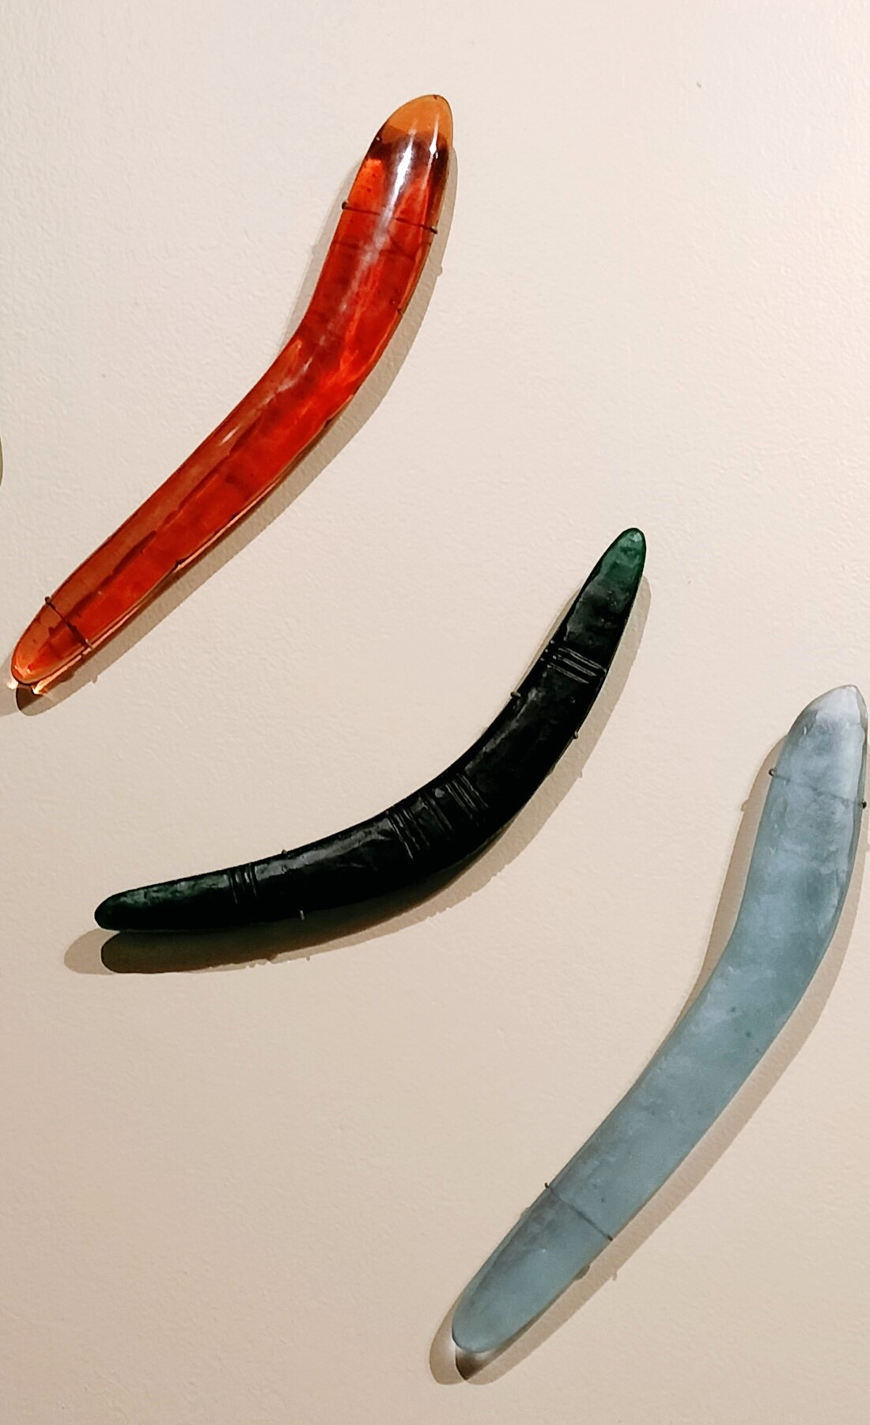

Paul Girrawah House - Boomerangs
Materiality…but not as we know it Exhibition
Image: CFC

- In 2023-24, ACTHP engaged with Aboriginal and Torres Strait Islander communities to strengthen and improve its approach to interpretation and management of First Nations stories and values through specific activities, including the following:
- extensive research was undertaken on Calthorpes House and Lanyon to better understand the connections of the Aboriginal people to these places, and to foreground their stories in the future interpretation of these historic places, and
- Historic Places programming for Harvest Day Out, NAIDOC week and Reconciliation Week featured talks, tours and children’s activities by traditional custodians
- First Nation’s woman, Jessika Spencer, won second prize in the inaugural ACT Historic Places Art Prize with her work, Ochre
- Further detail on the CFC’s First Nations engagement is at Section B.9.

Elevating the Capital
- The CFC CEO, Director CTC, and Director of Collaboration & Engagement appeared as witnesses at a hearing for the Joint Standing Committee on the National Capital and External Territories’ inquiry into fostering and promoting the significance of Australia’s National Capital. Key focus was to make the case for Federal investment in a National Performing Arts company and Theatre Redevelopment
- The CFC CEO chairs the District Coordination Group leading government consideration of the future of the CCCD. The CEO also sits on the Board of the Canberra and Region Tourism Leaders Forum; and hosts regular meetings of all the heads of the National Cultural Institutions
- At the working level, the CFC is a member of the monthly National Capital Authority’s facilitated National Triangle network meetings. This forum fosters
cooperation between the National Cultural Institutions and other major cultural attractions on events and promotion
- The CTC hosted a meeting of the Confederation of Australian State Theatre companies (CAST). The CAST was briefed by the CTC Director on the CTR Project, as well as on current and future programming aspirations by the CTC Head of Programming
- CMAG hosted Learning Program Workshop on the Canberra/Kamberri Place + People for the Arts Up Front Conference in February
2024, and also hosted a Royal Australian Mint AMaGA event, and
- Backyard Archaeology Symposium with University of Canberra
- Throughout the year, CFC staff participated in a range of activities with peak cultural and tourism bodies, including conferences and meetings of the Canberra Region Tourism Advisory Forum, VisitCanberra, the National Capital Attractions Association, the Australian Museums and Galleries Association, the International Society for the
Performing Arts (ISPA) Congress, Aotearoa NZ Festival of the Arts, the ANU Symposium - Discomfort in the National Capital, and the Diversity Council’s - Beyond Binary session.
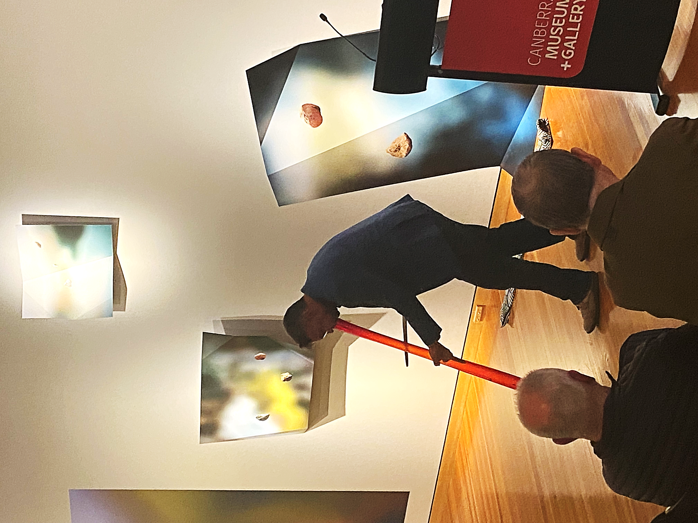

Paul Girrawah House - Playing the Yidaki
Image: CFC

Education experiences
- The CTC offers a variety of school programs designed to engage students of all ages in the performing arts:
- School Performances tailored for different age groups, from early childhood to secondary students, aligned to the school curriculum
- Teacher Resources to help teachers integrate performing arts into their curriculum. This includes risk assessments and educational materials related to past performances, and
- Special Programs including workshops and interactive sessions that allow students to engage directly with theatre professionals and learn about different aspects of theatre production.
- In 2023-24, 10,960 students benefited from these CTC programs
- CMAG offers a variety of educational programs designed to engage students with art and history through interactive experiences:
- Onsite programs for Lower Primary (Years 1-4) and Upper Primary (Years 5-6): Programs about Canberra/Kamberri: Place + People
- Foundation to Year 2 programs such as Every Picture Tells A Story and What Do Artists Make? allow students to engage with artworks and create their own in the CMAG studio
- Self-Guided Tours available for all year levels, allowing students to explore exhibitions at their own pace
- Outreach Programs provide resources to enhance classroom lessons with materials related to CMAG’s exhibitions
- Images and materials from the CMAG collection are available for teachers to use in the classroom
- The Nolan Secondary Learning, and Resource is designed for Years 7-12, to helps students investigate and draw inspiration from the Nolan Collection.

These programs are designed to make learning engaging and interactive, providing students with a deeper understanding of art and history.
Yr 10 CMAG Art Prize winner - Amelia Bobbin
Bike Reflections
Image: GMH


- In 2023-24, 15,469 students benefited from these CMAG programs
- CMAG also launched a Secondary School Art Prize in July 2023 with its theme - Photography linked thematically to the Capturing Canberra exhibition There were 109 entries from 37 students across public and private schools.


Yr 11/12 CMAG Art Prize winner
Zachary Pile - The Winter Walk
Image: GMH

- ACTHP offers a variety of educational programs across its three sites: Mugga-Mugga, Calthorpes House, and Lanyon Homestead. These programs emphasize heritage, history, and the environment, providing immersive and hands-on experiences for students
- Onsite Programs include:
- Mugga-Mugga Cottage - Humans and Nature (Years 1-2) exploring
the connections between humans, animals, and the environment; and At The Garden Gate (Foundation - Year 2), examining how Canberra’s landscape has changed over time
- Lanyon Homestead - James’ Diary (Foundation - Year 2) looks at children’s lives in mid-19th century pastoral Australia; and Convicts (Years 3-6) offering a day-in-the-life experience of a convict (image below), and
- Calthorpes House – Dawn’s Surprise (Foundation - Year 2) which compares childhood in the 1930s to today.
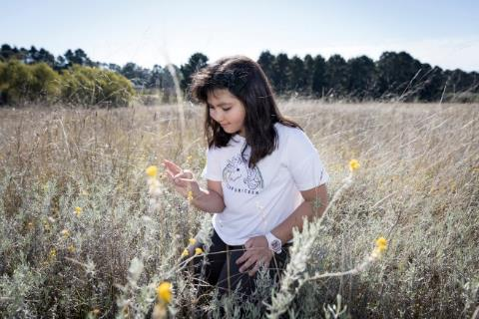
Humans and Nature - Mugga-Mugga
Image: GMH

- Outreach Programs, Artefact Chat, Dawn’s Suitcase and Convicts, and
- Online resources, Exploring Place - Visual Art Teacher Resource (Year 11-12) which exposes students to various artworks related to the concept of place at ACT Historic Places

These programs are designed to make learning engaging and interactive, providing students with a deeper understanding of history and heritage. In 2023-24, 7,090 students benefited from these Historic Places programs.

Contributing to Canberra’s signature events
The CFC contributed to a number of signature ACT events - Uncharted Territory, Winter in the City, Floriade, SpringOUT, the National Multicultural Festival, Enlighten, the ACT Heritage Festival, providing programs, venues, events, and activations. Highlights included:
- CMAG created a hub of children’s activities, workshops, and exhibitions to align with the Winter in the City activation and the Uncharted Territory Festival during the July school holidays. Children’s workshops were programmed with the children’s exhibitions How Cities Work and Fly, Fly! Sidney Nolan’s Birds. CMAG exhibition and program participants contributed over 12% of the Uncharted Territory attendees.
- The CTC partnered with the ANU and the Australasian Dance Collective during Uncharted Territory to mount the innovative dance production, Lucie in the Sky, where human dancers performed on stage alongside drones
- Lanyon Homestead became the first official satellite Floriade site in September-October 2023 featuring additional floral garden displays and a month of programs including Grow Your Garden Plant Fair, outdoor play, Art Prize Exhibition, special garden tours and the Spring Wonderland Picnic Concert with the Canberra Symphony Orchestra String Quintet and Rachel Thoms. 42% of concert goers were first-time visitors to Lanyon Homestead; 17% were children
- In November 2023 the CFC partnered with the SpringOUT Festival to host a ticketed dance party linked to the CMAG Madonna40 exhibition. Lunchtime forums were also held on Saturdays with Queer Elders Speak
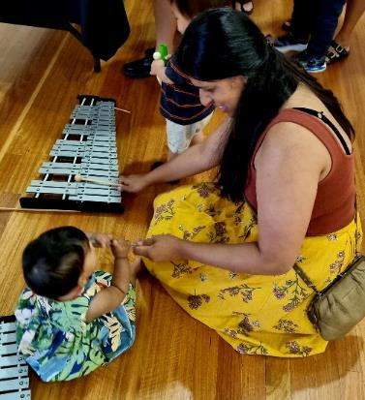
CMAG Sanctuary - National Multicultural Festival
Image: GMH
- CMAG was again the ‘Sanctuary’ area for the National Multicultural Festival with a range of free children’s activities in a cool and quiet environment. CMAG provided a range of free children and family-friendly activities. 3,356 visitors came to CMAG during the Multicultural Festival weekend, which was a 78% increase from the 2023 weekend
- CMAG hosted an International Women’s Day program of events in collaboration with Liz Lea and the BOLD Festival. The day included the BOLD Bites launch with Liz Lea as part of the BOLD Festival. Activities included dance by QL2 Dance, The Chamaeleon Collective, Asparas Arts, Canberra Dance Theatre’s GOLD dancers and Vilaisan Campbell. There was also a focus on the eX de Medici exhibition with yoga, talks, and a lunch
- GMH Director Dr Anna Wong presented at the CAS-ASHA Archaeology Symposium as part of the ACT Heritage Festival, and there was a tour of Lanyon Homestead

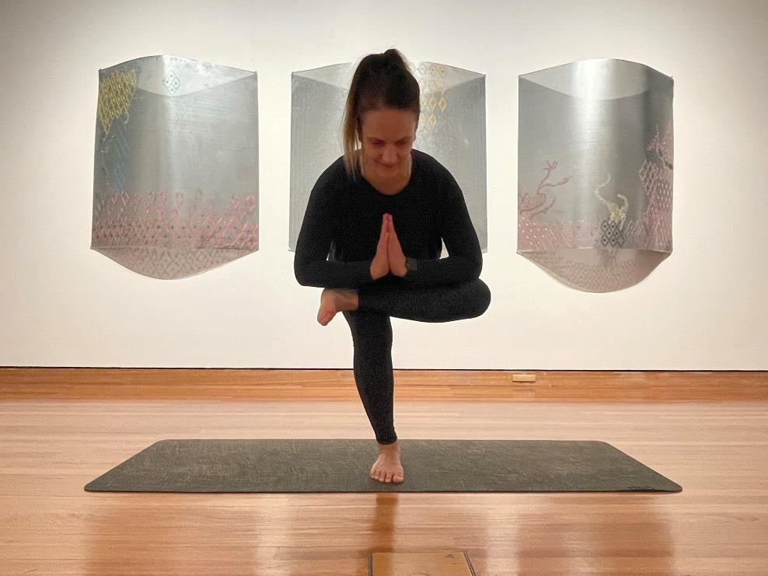

Yoga in the Gallery
Image: GMH

conservation works with ICOMOS and the ACT National Trust in October 2023. Anna also opened the Backyard Archaeology Symposium as part of Archaeology Week, and
- The CFC supported Ausdance ACT’s launch of Australian Dance Week with the CTC supporting the mounting of Australian Dance Party’s Co:Lab_24 in the Courtyard Studio and a formal launch event with dance film screenings held at CMAG attended by the Minister for the Arts.

Strategic Goal 5
Best Practice Governance, Organisational Capacity
& Culture
Our operational model will be best practice.
Operational Policies
- Ensuring the CFC governance is rigorous and transparent.
- Reviewing the identity, brand, and naming of the CFC and of sub-entities of the CFC.
- Continue reviewing the CFC’s organisational structure to ensure resources can be deployed most effectively for the CFC to achieve its goals. As such, aligning the growth of the CFC with the capacity and volume of its resources, existing and new.
- Building a secure and resilient workforce, offering development and other opportunities for our staff so we are an employer of choice and a training ground for people seeking careers with us and the sector.
- Demonstrating a workplace culture that lives the values of the CFC and the ACT Public Service.
- Ensuring best practice management and development of our assets and collections.
- Increasing productivity through continuous upgrading of systems, frameworks, and practices.

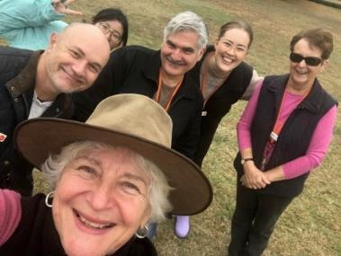
OUR ACHIEVEMENTS
- The CFC’s key achievement in 2023-24 in pursuit of the goal of building a secure and resilient workforce was the successful conclusion of enterprise bargaining. Extensive staff consultation resulted in the new CFC Enterprise Agreement 2023-26 achieving a number of significant improvements and innovations in pay and conditions, the highest ever CFC eligible voter participation, and an unprecedented 100 % yes vote
        - An all-staff Mental Health Month event was held on 21 November 2023 including a curator-led tour of eX de Medici’s Guns & Flowers, and a presentation from our EAP service called “Choosing your Mindset”
        - During National Volunteer Week in May 2023, ACTHP held a thank you morning tea

Happy GMH staff
Image: GMH

for volunteers to recognise and celebrate their contributions
- The CFC developed its first Gender Action Plan which is summarised at Section B.12.4
- The annual Don Aitkin awards acknowledging outstanding contributions by staff to the work of the CFC were held on 6 December 2023 with the Minister for the Arts and the CFC Board Chair Helen O’Neil attending. This year a record number of staff nominations for the Award were received. Ian Tidy (outgoing CFO), Anne Brake (ACTHP), Yoshni Chandra (CTC) and Virginia Rigney (CMAG) were this year’s recipients (pictured)
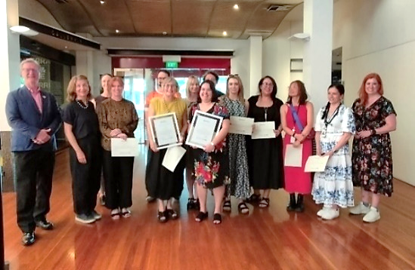

CFC 2023 Don Aitkin Awards
Image: CFC

- During 2023-24 the CFC continued to implement its Core Learning Framework, which provides consistency for staff induction and the development of essential ACT Public Service knowledge and skills. In 2023-24 CFC staff achieved 445 course completions. Expenditure on staff training and professional development during 2023-24 amounted to $103,393. For details on Learning and Development, see Section B.12.2
- After extensive planning and consultation, the CFC’s Work Health and Safety Management Policy 2023-26 began implementation. To support our staff and workers to be safe at work the CFC has

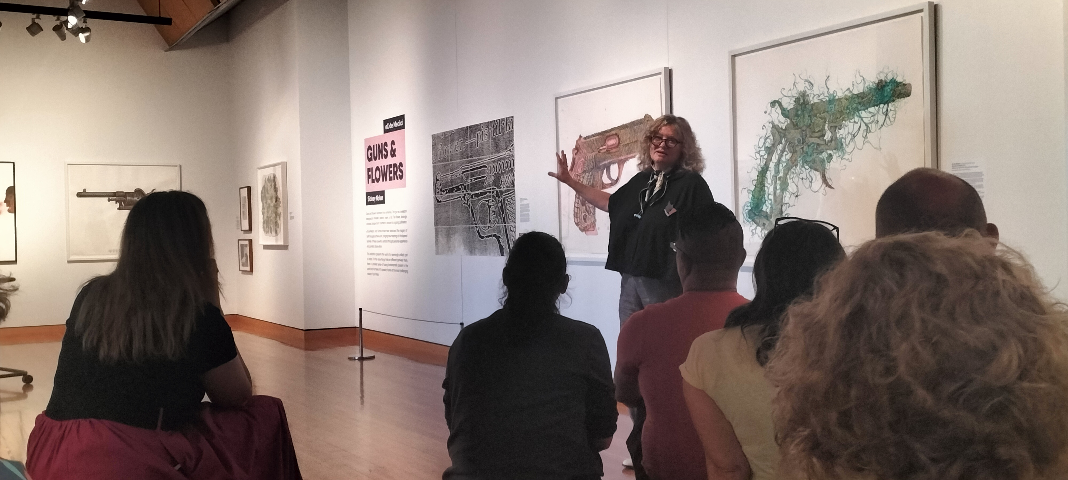

developed, implemented, and
communicated to its workers a new WHS Strategic Plan and Action Schedule, and
WHS Management Policy. The CFC Work Health and Safety Committee meets every 3 months. For details on Work Health and Safety, see Section B.11.

Facility Operations & Capital Works
- The centralised FOCW operating model was established during 2023 to support the management, maintenance and enhancement facilities, and assets in line with industry standards and expectations
- Delivery of the new FOCW Governance Framework, WHS & Risk Management, Financial Management, FOCW Human Resource Management, Maintenance Plan and Capital Works Management Plans were developed
- WHS inspections across all CFC sites were completed in 2023-24
- Data capture practices were implemented for all incoming sources of maintenance requests
- Centralised Specifications for the management, maintenance and enhancement of facilities and assets were developed in line with industry standards and expectations.
Mental Health Week - Curator Virginia Rigney led tour of
eX de Medici’s Guns & Flowers
Image: CFC

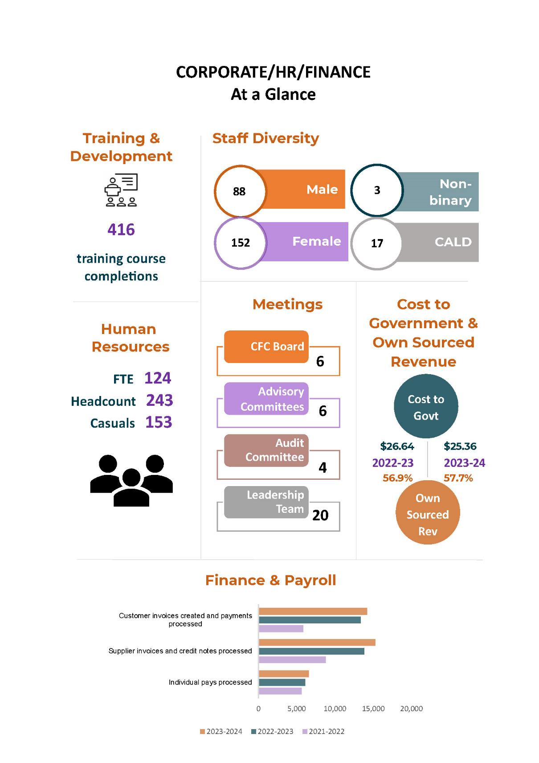

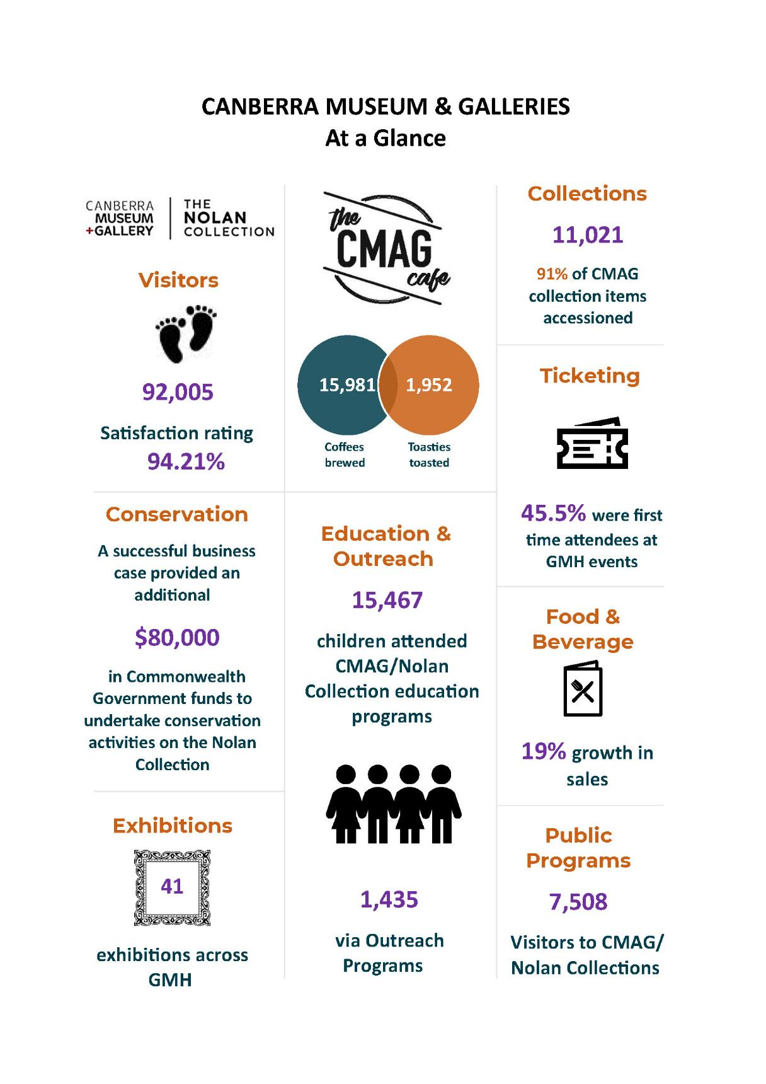

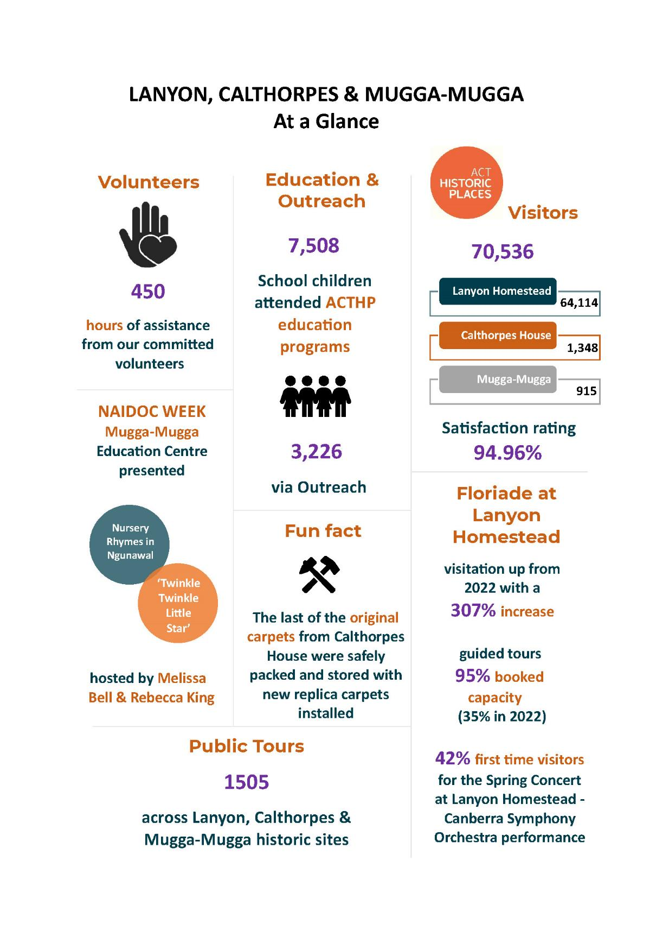

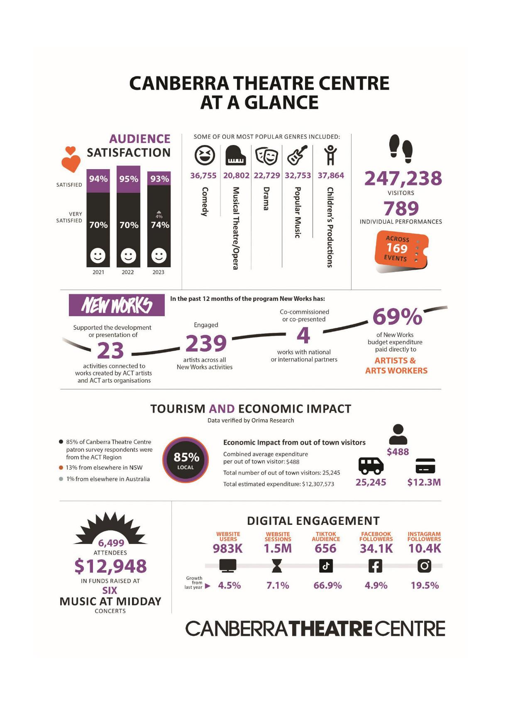

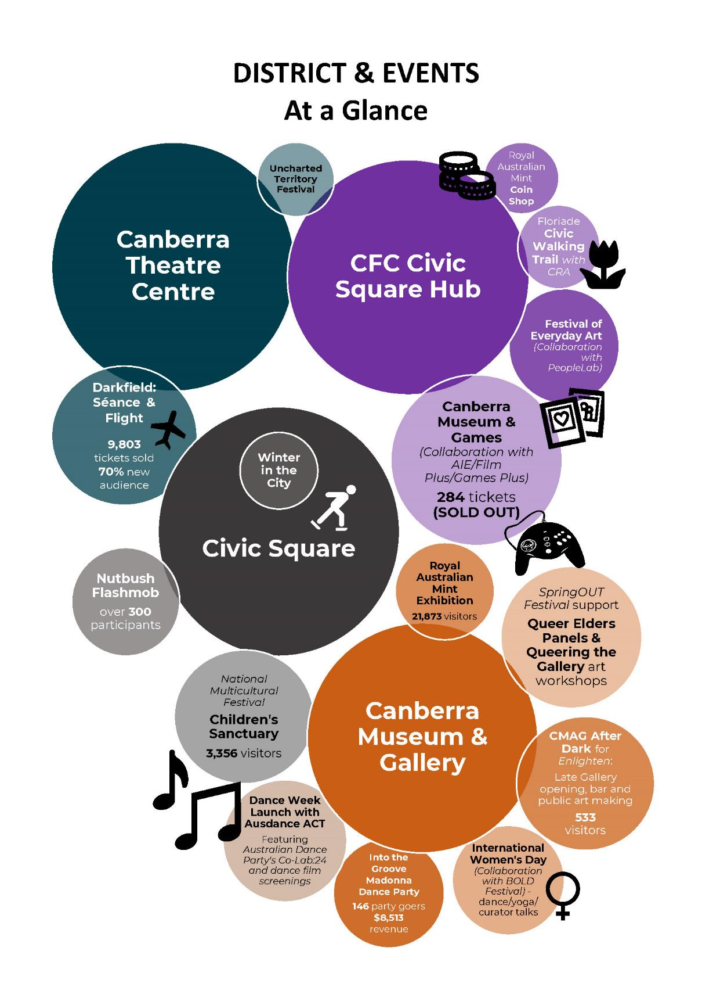

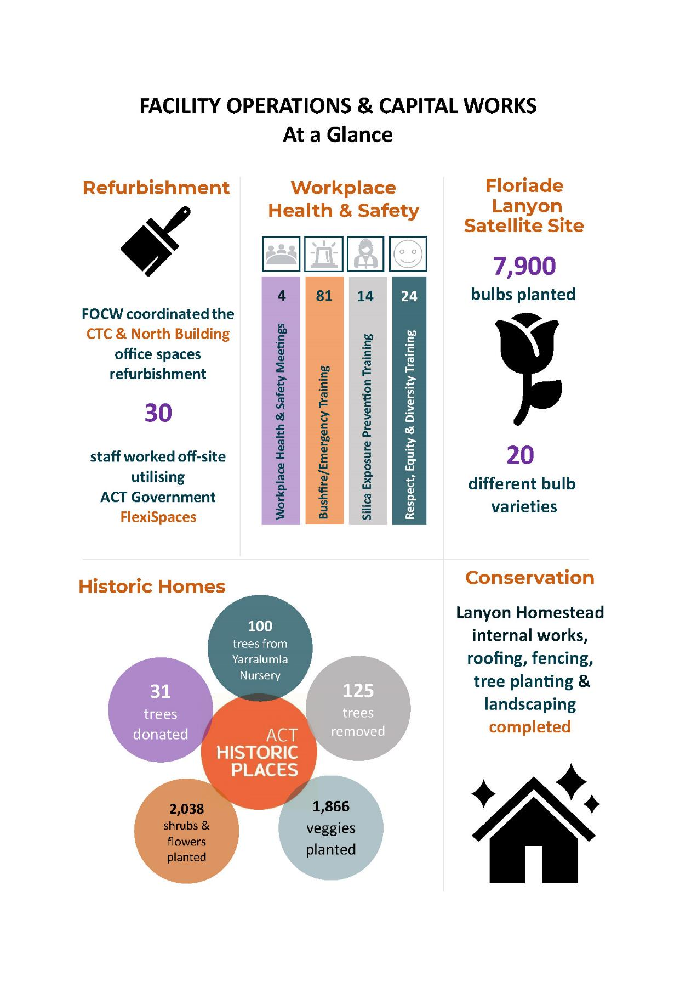

B.3 Scrutiny
There were no Auditor-General, ACT Ombudsman or Legislative Assembly Committee reports that related specifically to the CFC in 2023-24.

For further information contact: CFO, CFC Finance (02) 6205 9658.

B.4 Risk Management
The CFC’s Risk Management Framework and Policy and Risk Management Plan guide and inform risk management activities across the CFC including CFC’s Strategic Risks, Fraud Corruption and Control, and Work Health and Safety. The CFC has in place a comprehensive Strategic Risk Management Register, which is implemented, monitored and updated on an ongoing basis. This register provides the framework for supporting strategies and plans relating to more specific areas of risk, such as disaster preparedness and business continuity plans.

The CFC pursues its mission and vision within a Risk Appetite Framework that guides decision-making for its Board, Executive, and staff in the areas of reputational, artistic, financial, asset, and people risk. Consideration of risk and of appropriate levels of mitigation is done in alignment with the CFC Values and ACT Public Service Values and in the knowledge that the CFC expects compliance with all relevant legislation across all aspects of the organisation's operations.

In January 2024, the Board endorsed the CFC’s Risk Appetite Statements. The CFC pursues its mission and vision within a Risk Appetite Framework that guides decision-making for its Board, Executive, and staff in the areas of reputational, artistic, financial, asset, and people risk. Consideration of risk and of appropriate levels of mitigation is done in alignment with the CFC Values and ACT Public Service Values and in the knowledge that the CFC expects compliance with all relevant legislation across all aspects of the organisation's operations. The CFC’s Risk Management Framework and Policy and Risk Management Plan guide and inform risk management activities across the CFC including CFC’s Strategic Risks, Fraud Corruption and Control, and Work Health and Safety. The CFC has in place a comprehensive Strategic Risk Management Register, which is implemented, monitored and updated on an ongoing basis. This register provides the framework for supporting strategies and plans relating to more specific areas of risk, such as disaster preparedness and business continuity plans.

The Risk Management Framework and Policy, Risk Management Plan and Strategic Risk Register were approved by the Board in June 2024.

B.5 Internal Audit
The CFC Audit Committee, a subcommittee of the CFC Board, met on four occasions during 2023-24. Meetings were held on 14 July 2023, 28 September 2023, 1 February 2024 and 23 May 2024.

CFC Audit Committee
Name of Member | Position | Meetings Attended
Christine Shannon | Chair | 4
Dr Rachael Coghlan | Member | 4
Julian Widdup | External Member | 4

The CEO, CFO, and CFC Financial Controller are invited to each meeting as observers, and an open invitation is extended to the ACT Audit Office to send an observer to each meeting.

Part G of the CFC Board Charter sets out the operations for the Audit Committee and incorporates specific roles for risk management and audit matters. It is available at www.culturalfacilities.act.gov.au.

Internal Audit
The Audit Committee approved the CFC’s internal audit program for 2023-26 and an internal audit on payroll process and compliance has been conducted in 2023-24. An annual Quality Assurance Program was also undertaken to ascertain that CFC policies and procedures are working properly, ensure that the policies and procedures are effective, provide information to inform a continuous improvement program so that policies and procedures are improved when required and remain relevant, and identify causes and recommend solutions where problems are discovered. The Quality Assurance Program for 2023-24 focused on petty cash, asset stock take, delegation and signature register and ICT asset audit.

This financial year the CFC finalised its triennial taxation compliance review which commenced in 2022-23. The next taxation compliance review is due in 2025-26.

B.6 Fraud Prevention
The CFC is subject to the ACT Public Service Integrity Framework, and has a comprehensive Fraud and Corruption Prevention Plan and Policy, supported by a Fraud Risk Register, both of which are implemented and monitored on an ongoing basis. Both were most recently updated in June 2024. Oversight of this plan is undertaken by the Audit Committee, as one of the roles under its Charter - refer to www.culturalfacilities.act.gov.au.

The CFC’s staff Induction packages and Core Leaning Framework and Policy support employees to ensure they act in accordance with the law and behave in a manner consistent with the ACT Public Sector Code of Conduct. Staff have access to a range of resources on the CFC Workplace Integrity Intranet page.

The CFC had no reports or allegations of fraud or corruption throughout 2023-04. In person training was last conducted in April 2024 by the ACT Integrity Commission.
Details of risk assessments conducted: 0
Fraud awareness training: 13 senior staff attended
No. of reports or allegations of fraud or corruption received and investigated (and any action taken): 0

B.7 Freedom of Information
Basis of requirement: Freedom of Information Act 2016 (the FOI Act), section 96.
Open Access Information - Section 96 (3) (a) (i), (ii) and (iii)
- Number of decisions to publish Open Access information. 1
- Number of decisions not to publish Open Access information. 0
- Number of decisions not to publish a description of Open Access information withheld. 0

FOI Applications received and decision type - Section 96 (3) (a) (iv), (vii), (viii) and (ix)
- Number of access applications received. 1
- Number of applications where access to all information requested was given. 1
- Number of applications where access to only some of the information requested was given (partial release). 0
- Number of applications where access to the information was refused. 0

FOI processing timeframe - Section 96 (3) (v) and (vi); Section 96 (3) (d)
- Total applications decided within the time to decide under section 40. 1
- Applications not decided within the time to decide under section 40. 0
- Number of days taken to decide over the time to decide in section 40 for each application. 0

Amendment to personal information - Section 96 (a) (x) and Section 96 (3) (e)
- Number of requests made to amend personal information, and the decisions made (e.g., amended, refused, notation added to record, other). 0

Reviews - Section 96 (3) (b); Section 96 (3) (c)
- Number of applications made to Ombudsman under section 74 and the results of the application (e.g., affirmed, varied, set aside, and substituted, withdrawn, other). 0
- Number of applications made to ACAT under section 84 and the results of the application (e.g., affirmed, varied, set aside, and substituted, withdrawn, other). 0

Fees - Section 96 (3) (f)
- Total charges and application fees collected from access applications. 0

FOI requests can be made by contacting the CFC FOI Information Officer, GPO Box 782 Canberra City ACT 2601 or emailing CFCcorporatefinance@act.gov.au.

Further information can be found at www.culturalfacilities.act.gov.au.

B.8 Community Engagement
The CFC actively seeks to engage its communities in a greater understanding of the value of the arts, and of cultural heritage, through its programs and activities, placing customer service as its primary goal and recognising the diverse needs and expectations of customers. A summary of actions taken by the CFC during 2023-24 in terms of community engagement is provided below. This supplements the Clients and Stakeholders information in Section B1.1.

Community Engagement Activities
During the year, GMH presented a diverse range of high-quality exhibitions, learning and community programs and other activities, including on site, off site (through outreach programs) and online. Productive partnerships were developed with other cultural organisations, the tourism sector, and the wider community in developing and delivering programs and events.

Stories at Sunset
Lanyon Homestead
Image: Karen Paula Beaumont
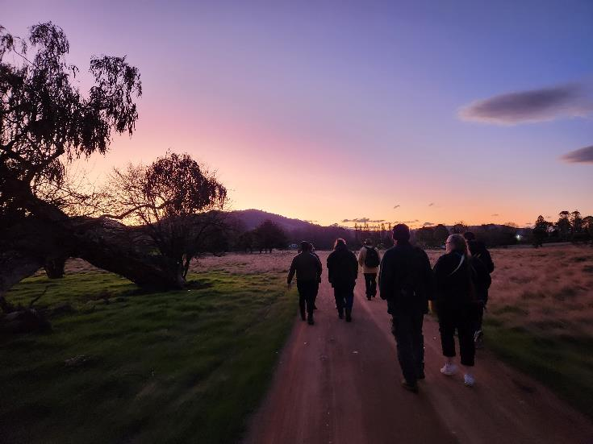

The CTC connected the community with the performing arts, including through initiatives that addressed special needs in the community. The CTC provided a wide range of activities for the education system and wider community.

For the CTR Project, the CFC collaborated with MPC to deliver community consultations throughout the design phases, not only to test design directions but also to ensure that we consider all angles of patron, performer, and arts worker experience. These consultations included engaging with First Nations, local creative, multicultural, and disability communities through a range of in person and online sessions and more focused meetings where necessary. The Performing Arts Reference Group (PARG) was assembled and consulted robustly. The CTC hosted a youth event which allowed for youth focused consultations of over 200 young people within the Canberra region. The CTRP team also committed to ensuring CFC staff were across the status and progress of the project. A user experience consultation was coordinated by the design partners engaging CFC and MPC staff in mapping user pathways.
2023-24 Consultation of the Theatre redevelopment
Community consultation on preferred experience | YourSay website, CTC foyer and Canberra local spots
First Nations | 1 meeting with the Aboriginal and Torres Strait Islander Elected Body as well as individual artist consultations and Ngunnawal design consultations via Yerrabingin
Schools workshop | 1 in person consultation with teachers from local schools and dance schools
Local performing arts venues | 1 in-person workshop
User Experience | 1 hybrid workshop
Disability community | 1 online workshop
Multicultural community | 1 online workshop
Youth consultation | 6 sessions with a total of 200 students and 12 teachers over one day
CTRP All CFC Staff updates | 2 sessions
Performing Arts Reference Group | 7 meetings

The CFC continually seeks to improve customers’ satisfaction with their visit to, and experience of its venues. Customer satisfaction surveys were conducted throughout the year and reported as part of the CFC’s 2023-24 Statement of Performance. Information gained from the surveys is used in future planning to improve facilities and services.

A major community engagement activity for the CFC is the operation of its three CFC advisory committees. In 2023-24, the CFC’s advisory committees provided advice on a range of specialised matters relating to CTC, CMAG and ACTHP.
The CFC also engages with the community via the media. Throughout the year CTC Director, Alex Budd, spoke to ABC Radio Canberra and The Canberra Times about the musical Rent, CTC’s family and kids programming, and the behaviours of Canberra audiences. Alex was also interviewed by Amplify about the upcoming season of Chicago and star Hayden Baum, as well as speaking to media about the Sydney Dance Company’s production Momenta. Programming Manager, Daniel Clarke spoke to Her Canberra to discuss future CTC programming and events. GMH Director Anna Wong represented the CFC with media interviews on ABC Radio Canberra regarding the Telopea Park School Centenary and CMAG Exhibition, and the ACTHP Plant Fair and Spring Wonderland Picnic.
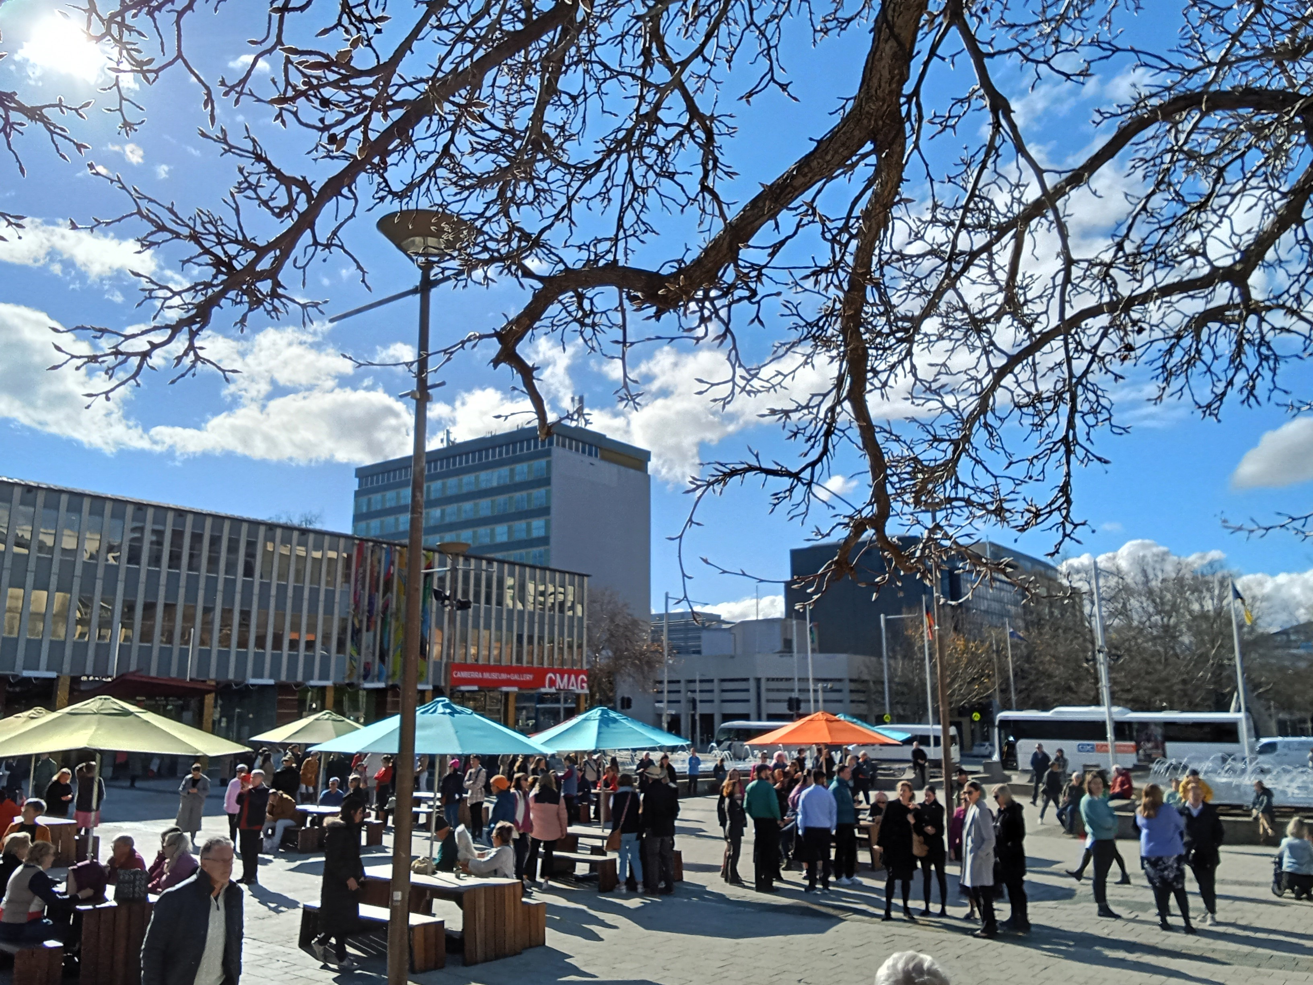

Canberra’s Biggest Nutbush Dance
A community record-breaking event in Civic Square
with Dr Anna Wong, Director GMH, interviewed by Canberra media
Image: CFC
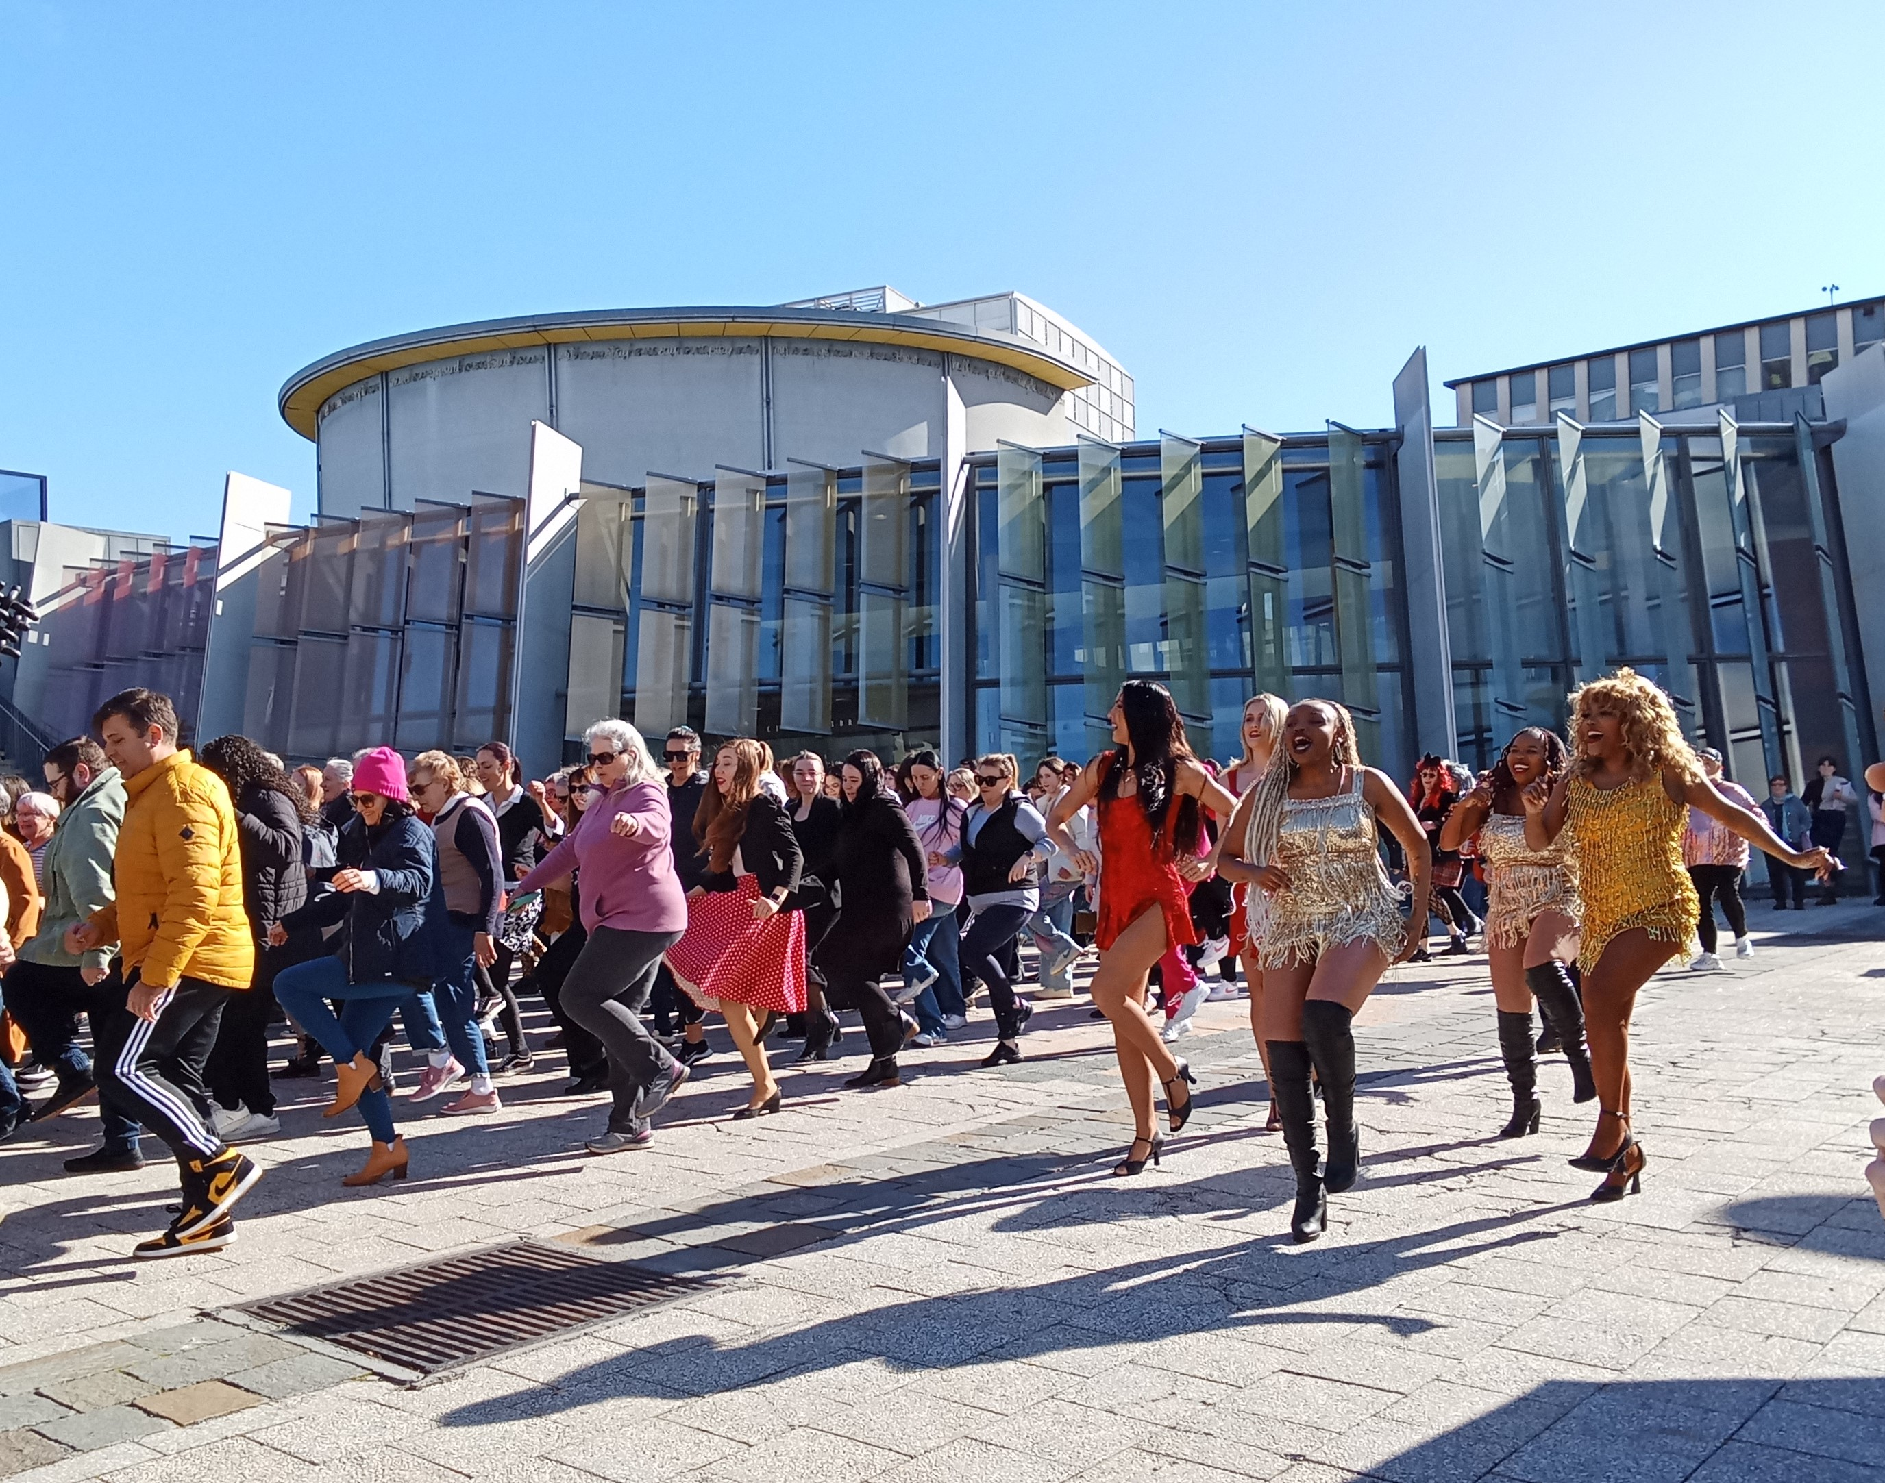

B.9 Aboriginal and Torres Strait Islander Reporting
The CFC ensures cultural diversity is an essential feature of its regular programming, including exhibitions, theatre presentations and programs featuring Australian First Nations cultures. Examples of activities in each area of the CFC in 2023-24 are provided below.

Canberra Theatre Centre
The CTC continued its commitment to showcasing and promoting the work of First Nations artists and strengthening the diversity and cultural connection of its program through the presentation of the following events:
- Bangarra Dance Theatre’s Yuldea - a powerful dance performance that explores the cultural and spiritual significance of water in Aboriginal culture, blending traditional and contemporary dance
- The Visitors - co-produced by Sydney Theatre Company and Moogahlin Performing Arts, reimagines the arrival of the First Fleet from the perspective of the Aboriginal people, blending historical events with contemporary themes
- Walanbaa Yulu-Gi - Australian ballroom dance company Burn the Floor collaboration with Indigenous dance star Mitch Tambo in a new production
- The ACT UP! Secondary Schools festival increased programming alignment with Reconciliation Week activities, and engaged First Nations playwright Dylan van den Berg as Festival Ambassador
- New Work development by Liz Lea and Muruwarri woman Tammi Gissell - a one woman show Diamond, a dance-theatre piece that explores themes of resilience and transformation, inspired by Liz Lea’s personal journey with a life-changing diagnosis
- Embedding First Nations principles into the culture of the CTC is the first of four guiding principles in the CTC’s Vision for our Future that provides guiding principles for the theatre redevelopment. First Nations perspectives are integral through the process of Designing with Country, led by Yerrabingin, so that the theatre can become a place for traditional storytelling and gathering of First Nations people, facilitating greater opportunities for elevation, participation, and community connection with respect to First Nations art and culture, local First Nations people and the broader community.
Horizon - Bangarra Dance Theatre
Image: Daniel Boud
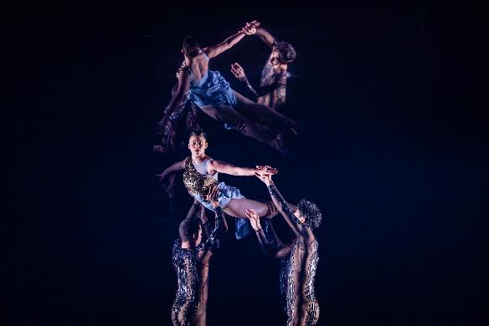

Galleries, Museums and Heritage
CMAG engages with Aboriginal and Torres Strait Islander communities to strengthen and improve our approach to interpretation and management of First Nations stories and values through specific activities, including the following in 2023-24:
• GMH presented a new exhibition and accompanying publication Materiality...but not as we know it, featuring work by First Nations artists Paul Girrawah House and James Tylor. Paul Girrawah House gave the Welcome to Country at the launch of the publication
• CMAG hosted a CareerTrackers intern in Exhibitions and Collections. This program supports Aboriginal and Torres Strait Islander university students to gain industry experience, achieve high academic marks, and secure full-time employment upon graduation
- In partnership with the Humanities Research Centre (HRC) of the ANU and Canberra Glassworks, CMAG submitted a proposal to co-host Visiting Fellow, Yorta Yorta/Wamba Wamba/Mutti Mutti/Boonwurrung artist Maree Clarke, who will undertake a research project on the reed necklace on long-term loan to CMAG and hold an exhibition in CMAG on the Square in 2025 as an outcome of her residency
• The Researcher and Curator of ACTHP undertook extensive research on Calthorpes House and Lanyon. These properties, based on Aboriginal land, have long connections to First Nations People and as part of this research ACTHP has made connections with several First Nations

community members. It is our aim that First Nations stories will be front and centre in the future interpretation of these places
- The Calthorpes Garage interpretation received a new fit-out that included First Nations connections to the area, including the neighboring Aboriginal Embassy, in consultation with the Smith Family
- The Lanyon Machinery shed’s new interpretative panels, to be installed next Financial Year includes a didactic panel on former Lanyon shearer, Muruwari man, William ‘Deucem’ Smith, produced in consultation with the Smith Family (pictured)
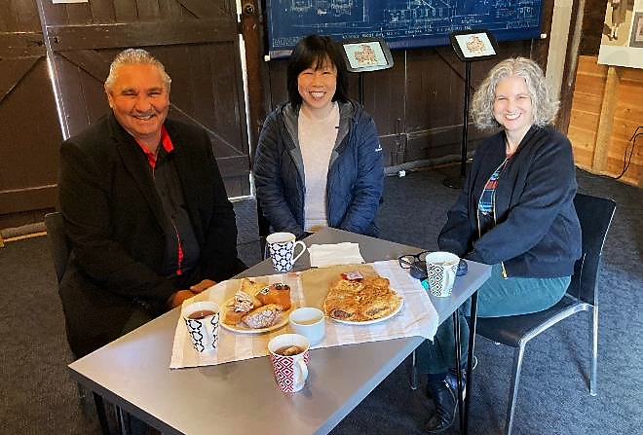

Bunja Smith, Dr Anna Wong & Cathy Pryor
Calthorpes House
Image: GMH
- Nursery Rhymes in Ngunawal: Twinkle Twinkle Little Star was presented by Melissa Bell and Rebecca King at Mugga-Mugga Education Centre as part of NAIDOC Week
- First Nation’s woman, Jessika Spencer, won second prize in the ACT Historic Places Art Prize with her work, Ochre
- Ngunawal Custodian, Tyronne Bell presented a talk on the Ngunawal six seasons as part of Harvest Day Out, held at Lanyon Homestead in March 2024
- Harvest Day Out also included a talk by Curator, Cathy Pryor which focused on rare objects in the Historic Places collection, including a station book owned by the Cunninghams. Entries in the station book indicated First Nations people were employed at Lanyon Homestead during the Cunningham era (1850s - 1920s), and
- The CFC celebrated Reconciliation Week with two tours by Ngunawal Elder Wally Bell - Maring Ngala Walk at Lanyon Homestead. The walk from the Homestead to a scar tree includes storytelling and demonstrations of cultural knowledge and tools.

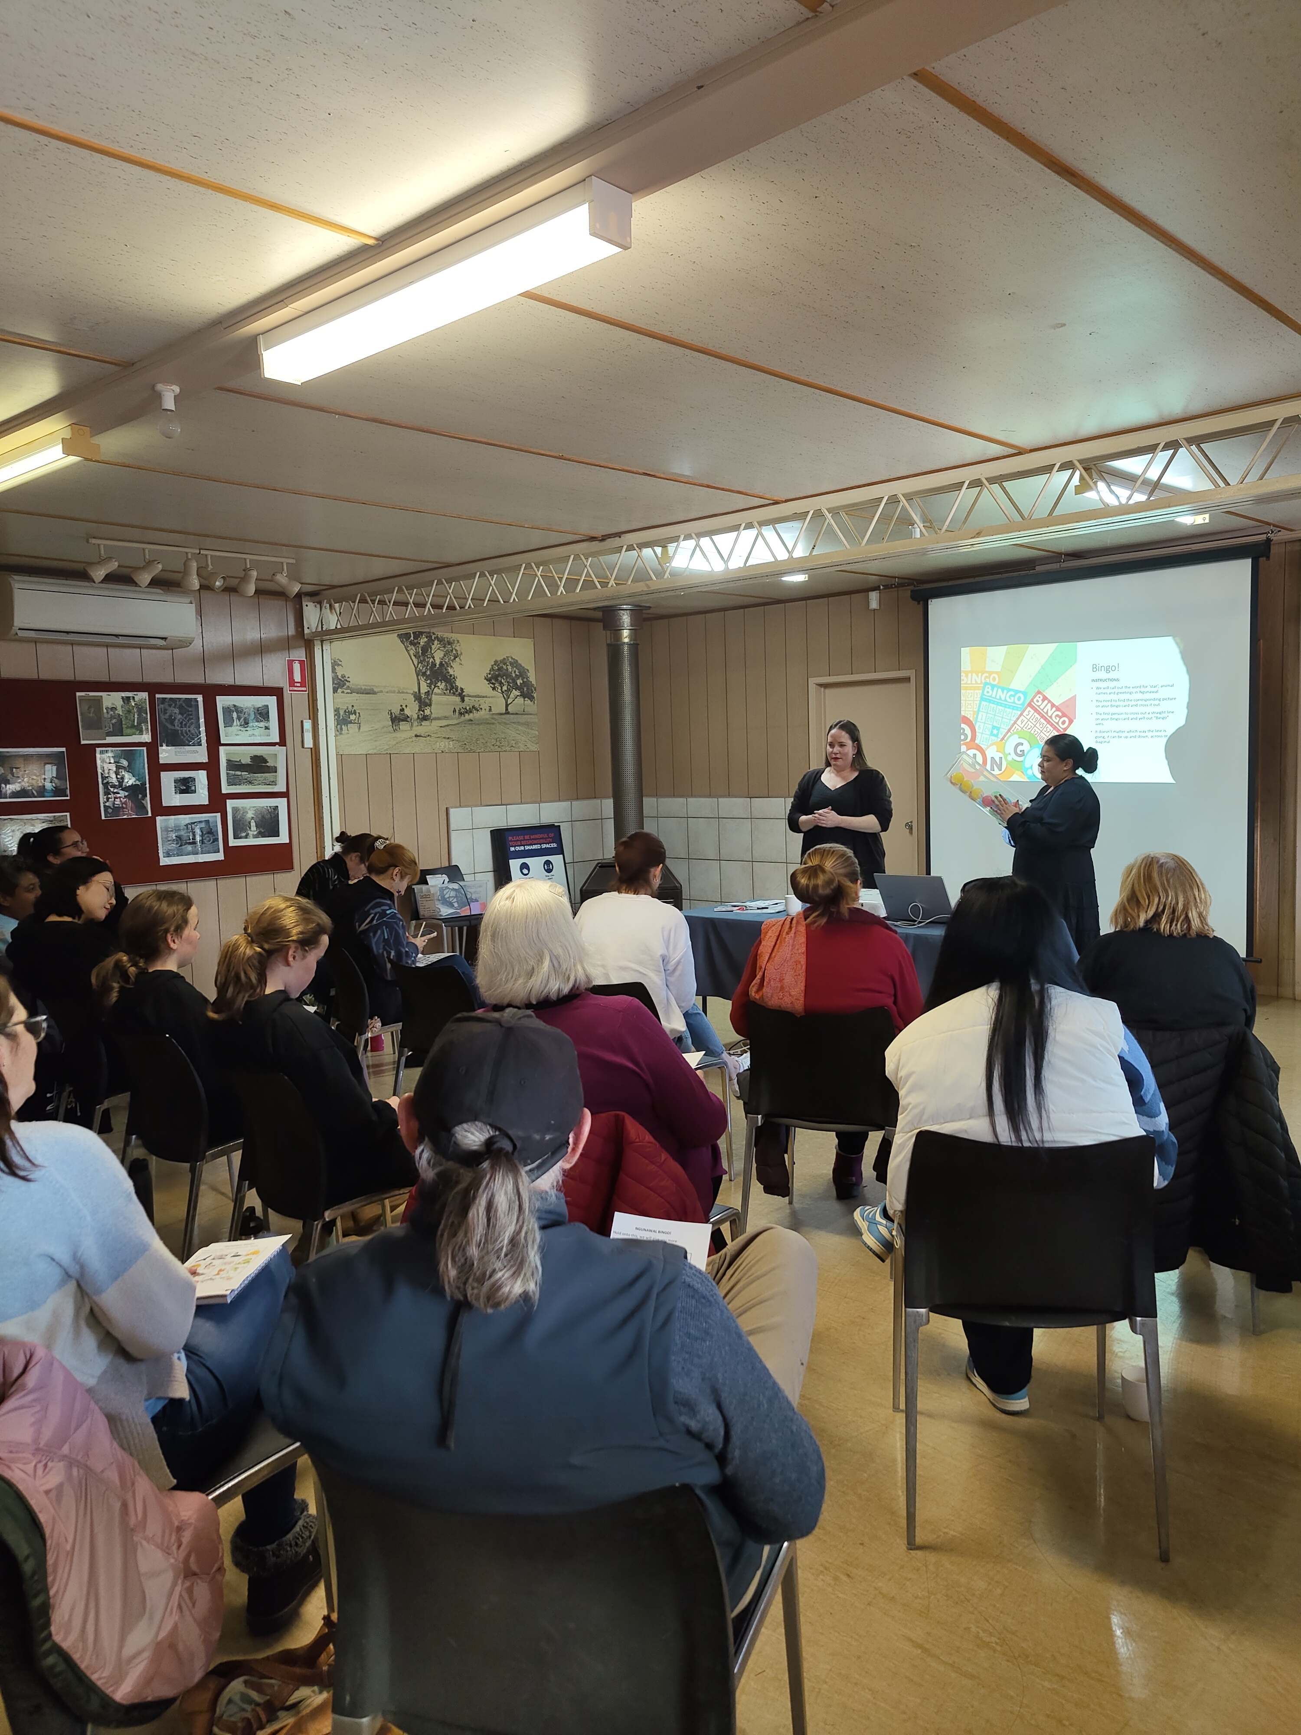

Ngunawal Language Workshop - GMH Staff
Mugga-Mugga Education Centre
Image: GMH

Facility Operations & Capital Works
- When approaching the market to deliver works, FOCW actively utilises the Aboriginal and Torres Strait Islander Enterprise List Database to identify known Aboriginal and Torres Strait Islander enterprises (inclusive of head contractors for large projects/sub-contractors) in the Canberra Region
- We encourage our contractors to look for opportunities for Aboriginal and Torres Strait Islander enterprises as sub-contractors on large projects and our contracts, where possible are designed to include for Indigenous participation targets. These targets are verified under the Contract administration process. We also ensure use of the Aboriginal and Torres Strait Islander Policy and the Canberra Region Local Participation Policy
- Securing local jobs is of particular importance and interest to the CFC FOCW team due to the nature and specialty components of our facilities and collections. Keeping that knowledge and skill close assists us in ensuring exemplary and reliable services are received.

B.10 Multicultural Act 2023 Reporting
The role of the CFC is to tell the stories of the ACT and region, and this includes ensuring that our programming reflects the community of which we are a part.

As a statutory authority and cultural institution, the CFC makes independent creative decisions, informed by Board-endorsed Exhibition, Collections, and Programming policies. Decisions about exhibitions, acquisitions, or theatre shows are not made in consultation with any other entity but, in accordance the above polices, are intended to reflect and engage the wider community, tell stories of the region’s history and identity, celebrate the diversity of our community, and challenge and entertain in ways that are meaningful to Canberrans.

In this way, the CFC supports the tenets of the ACT Multicultural Charter.

Canberra Theatre Centre

CTC’s multicultural programming during 2023-24 included:
- Miss Peony by Michelle Law - a heartfelt comedy about a young Australian-born Chinese woman navigating her cultural identity and family expectations through a beauty pageant, developed by Belvoir St Theatre
- Jungle Book Reimagined by Akram Khan Company - a dance-theatre retelling of Kipling’s classic, set in a dystopian future where Mowgli is a climate refugee, highlighting the urgent environmental crises
- Afrique en Cirque - a vibrant circus show, inspired by West African culture, featuring acrobatics, dance, and live Afro-Jazz music, created by Kalabanté Productions
- Shen Yun performing arts show, celebrating China’s rich cultural heritage through classical Chinese dance and music, and
- The River That Ran Uphill by Slingsby Theatre Company - the true story of Edgell Junior, a Ni-Vanuatu man from Pentecost Island, who survived Cyclone Pam in 2015. The play highlights the importance of community cooperation and resilience in the face of natural disasters, set in the Pacific Islands.

Participants in New Works program and New Ideas Lab in 2023-24:
- Sugar Kaye Sañejo Grefaldeo, presenting Fortuna is a one-woman dance theatre work about Sugar’s journey as a Filipino migrant to Australia
- Actor-writer-artist, Linda Chen, with mentor Yasemin Sabuncu, developing work, t(here), about long- distance relationships in the digital age, and
- Actor and emerging playwright, Isha Menon, with mentor Tasnim Hossain, developing satirical work, The Coming of Babaur.

The CTRP team also engaged with the ACT multicultural community as part of stakeholder consultation on design of the new theatre.

Galleries, Museums & Heritage

CMAG’s multicultural programming during 2023-24 included:
- An exhibition in collaboration with Mongolian Embassy, Melbourne through the eyes of Mongolian Artist, by artist Erdenekhuyag Dashorj, and
- An exhibition in collaboration with Japanese Embassy, Nara - Canberra: 30 years of Friendship.

CMAG was also the ‘Sanctuary’ area for the National Multicultural Festival with a range of free children’s activities in a cool and quiet environment. CMAG provided a range of free children and family-friendly activities.

In 2023-24, there were instances of direct consultation with the Ministerial Advisory Council for Multiculturalism. Additionally, the CFC engaged with the following multicultural entities:
- The ACT Multicultural Centre - CMAG Café hosted a free seven-week barista course plus work experience for six young people referred from the Multicultural Centre
- International Organisation for Migration as hirer of our training spaces, and
- Spanish Language Day as an event hire.

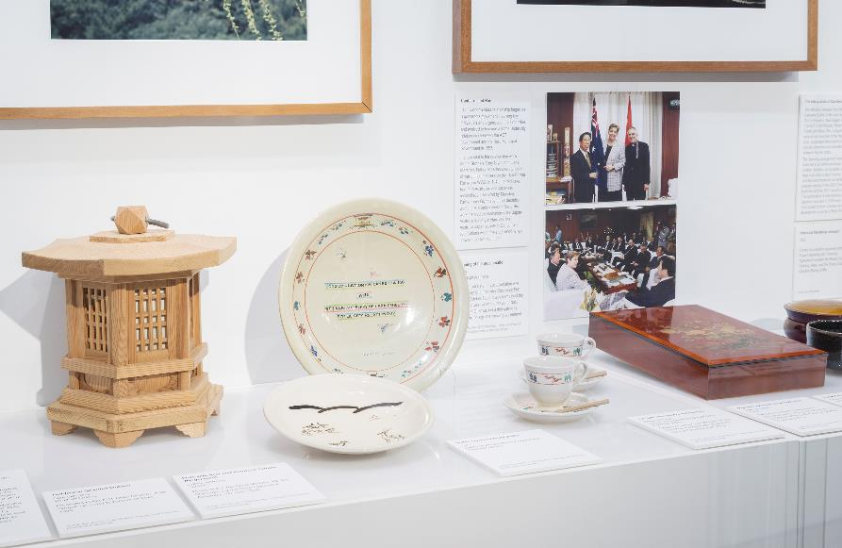

Nara - Canberra: 30 years of Friendship Exhibition
Image: GMH

B.11 Work Health & Safety
The CFC recognises that the physical and psychological health, safety, and wellbeing of our workers is of primary importance, and is committed to providing a safe and healthy work environment in accordance with the Work Health and Safety Act 2011.

Further to this, the CFC strives to meet the targets set by the ACT Government for improving WHS performance, injury management and prevention.

Governance
The CFC Board has established key performance indicators in relation to the timeliness of WHS incident reporting, lost time injuries, and training. It receives a report for each of its two-monthly meetings, including statistical information on reported incidents, KPIs, and WHS strategy and policy.
To support its officers and workers to meet this commitment, the CFC has developed, implemented, and communicated to its workers a new WHS Strategic Plan and Action Schedule, and WHS Management Policy.

In addition, every six months, a further report is provided to the Board on key WHS risks in the CFC, together with risk controls and risk treatment strategies.

The CFC Work Health and Safety Committee (WHSC) comprises the CFC Senior Leadership Team and elected Health and Safety Representatives. They meet every three months, and the minutes are posted on WHS noticeboards, including the virtual noticeboards on the CFC intranet.

WHS Risk Management
The highest rated risks for the CFC include:
- electrocution
- fire and emergency management, and
- working at heights.

The controls implemented by the CFC to address these risks include regular testing and tagging of electrical equipment, improved emergency response procedures, emergency evacuation exercises, and the professional maintenance of lifting equipment.

CFC staff participated in workshops and user acceptance testing for the new ACT Government Safety Portal, which replaced RiskMan.

Capability & Capacity
The CTC continues to improve its induction program, combining e-learning and face-to-face learning to ensure all new workers participate in a well-structured induction to the ACT Public Service, CFC, and their business area. The new business area induction checklist has a strong focus on physical and psychological health and safety.
To increase the knowledge, skills, and confidence of its workers in relation to WHS, the CFC provided formal training and awareness raising to its workers:
- 28 in pre-season bushfire training, conducted in collaboration with the ACT Rural Fire Service
- 14 in crystalline silica awareness
- 63 in emergency control organisation training
- 14 in How we can all contribute to a safe and healthy workplace (CFC Monthly Webinar)
- 29 in provide first aid
- 13 in respect, equity, and diversity, and
- 13 in What's new on the CFC Intranet (CFC Monthly Webinar).
These webinars were recorded and made available to workers on the CFC Intranet.

Work Health and Safety Act 2011
In 2023-24, the CFC received no improvement notices, notices of enforceable undertakings, or notices of failure to comply with a safety duty under the Work Health and Safety Act 2011.

B.12 Human Resource Management

B.12.1 Human Resources Management

The CFC employs its staff under, and subject to, the conditions of the Public Sector Management Act 1994 as executives or officers of the ACTPS. The organisation has a single Enterprise Agreement with sections to articulate employee pay and conditions for the many specialist occupations that do not exist elsewhere in ACT Government including, for example, museum and gallery curatorial and collections officers and theatre technicians and ushers.

Human Resources management in the CFC is aligned to our Operational Priorities under Goal 5 of our Strategic Plan 2023-27: Best Practice Governance, Organisational Capacity and Culture.

The key priorities under this goal are:
- Building a secure and resilient workforce, offering development and other opportunities for our staff so we are an employer of choice and a training ground for people seeking careers with us and the sector, and
- Demonstrating a workplace culture that lives the values of CFC and the ACT Public Service.

Our approach is also informed by the CFC value of being Magnetic - attracting great employees, audiences, artists, and partners.

The CFC’s key achievement in 2023-24 in pursuit of the goal of building a secure and resilient workforce was the successful conclusion of enterprise bargaining. Extensive staff consultation resulted in the new CFC Enterprise Agreement 2023-26 achieving a number of significant improvements and innovations in pay and conditions, the highest ever CFC eligible voter participation, and an unprecedented 100 % yes vote.

The CFC then duly convened its Agency Consultative Committee (ACC) consisting of staff, management, and union representatives to provide ongoing feedback on industrial relations matters. Under its Terms of Reference and in accordance with the Enterprise Agreement, the ACC meets at least twice a year.

During 2023-24 the CFC participated in all four whole-of-government Secure Work Conversion Rounds with no employees found eligible for conversion.

B.12.2 Learning & Development

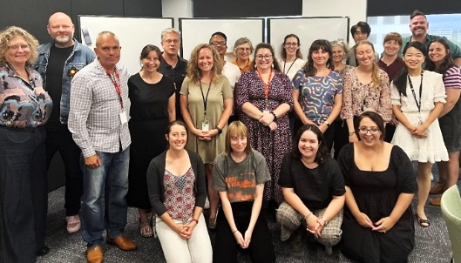
Ngunawal Language Workshop - CTC & North Building staff
Image: Tyronne Bell

The CFC places high importance on staff having the knowledge, skills, and confidence to perform their roles effectively, efficiently, and safely. During 2023-24 the CFC continued to implement its Core Learning Framework, which provides consistency for staff induction and the development of essential ACT Public Service knowledge and skills.

In 2023-24 CFC staff participated in 17 separate ACT Public Service courses, including those provided by CMTEDD, ACTIA, ACT Integrity Commission and ACT Property Group, as well as a wide range of other training sessions, listed below. In total there were 445 instances of completion by CFC staff.

Expenditure on staff training and professional development during 2023-24 amounted to $103,393. This includes membership fees for professional development programs, staff training and conference fees. Associated travel and accommodation costs are not included in this amount.

ACTPS Training learning items completed | CFC initiated courses
ACT Government Probity in Procurement Training | Best Practice Recruitment & Staff Selection
ACT Government Procurement Module 1 | Canberra Museum and Gallery Emergency Warden Training
ACT Integrity Commission Back to Basics | Canberra Theatre Centre Emergency Warden Training
ACT Public Service Induction Program  e-Learn | CFC All Staff Induction Session
ACTIA - Introduction to Risk Management | CFC Business Area Induction
Cyber Security Essentials | CFC Crystalline Silica Awareness Training
Effective Risk Management: The Basics (ACTIA) | CFC Webinar: How we can all contribute to a safe and healthy workplace
General Awareness Information Privacy e-Learn | CFC Webinar: New Strategic Plan for a growing organisation
General Awareness Record Keeping and Freedom of Information e-Learn | CFC Webinar: Our New Organisational Structure
General Awareness Work, Health, Safety  e-Learn | CFC Webinar: Recruitment Top Tips
Introduction to Risk in the ACT Government | CFC Webinar: The New Cultural Facilities Corporation Enterprise Agreement
North Building Emergency Warden Training | CFC Webinar: The role of the CFC in Tourism
Procurement ACT - Aboriginal and Torres Strait Islander Procurement Policy | CFC Webinar: What's new on the CFC Intranet?
Procurement ACT- Charter of Procurement Values | Cultural Facilities Corporation Provide First Aid
Protective Security Policy Framework Awareness (e-Learning) | Information session - New proposed Enterprise Agreement for the Cultural Facilities Corporation
Provide First Aid | Respect, Equity and Diversity In Practice - General Training
Social Media Guidelines e-Learn. | Ngunawal Language Workshop
Correctly Engaging Contractors | CTC Leadership Workshop
A range of licensing training was undertaken for theatre technicians, and maintenance and horticultural staff including forklift, chainsaw, high risk, scissor lift, dogging, and electrical test & tag.
Staff also attended a range of conferences and seminars to further their professional development. This included attendance at meetings and conferences for the arts and museum sector, such as the International Society for the Performing Arts (ISPA) Congress, Aotearoa NZ Festival of the Arts, the ANU Symposium - Discomfort in the National Capital, and the Diversity Council’s - Beyond Binary session.

In 2023-24, with generous donor support, the CFC established the CFC Staff Development Scholarship. Modelled on the Churchill Fellowship, it allows CFC staff to apply for a contribution up to $10,000 for professional development that would otherwise not be possible. It is awarded on the basis of personal professional development, contribution to the organisation’s mission and strategic direction, and how the experience will bring broader benefits to the cultural sector in an intentional way. The story of inaugural recipient of this scholarship is at page 17.

B.12.3 Staffing Profile

The CFC’s Staffing Profile at 27 June 2024 (the last pay date for the 2023-24 financial year) was as follows:

Full-time equivalent (FTE) & headcount by branch
Division/Branch | FTE | Headcount
Cultural Facilities Corporation | 124 | 243

FTE & headcount by gender
 | Female | Male | Non-  Binary | Total
Full Time Equivalent | 75 | 47.9 | 1.1 | 124
Headcount | 152 | 88 | 3 | 243
Percentage of Workforce | 63 | 36 | 1 | 100

Headcount by classification & gender
Classification groups | Female | Male | Non-  Binary |  | Total
Administrative Service Officers | 50 | 14 |  | 1 |  | 65
General Service Officers (incl apprentices) | 6 | 10 |  | 1 |  | 17
Professional Officers | 7 | 0 |  | 0 |  | 7
Senior Officers | 13 | 5 |  | 0 |  | 18
Executive Contract | 0 | 2 |  | 0 |  | 2
Theatre Box Office Staff | 9 | 6 |  | 0 |  | 15
Theatre Patron Services Staff | 50 | 15 |  | 0 |  | 65
Theatre Technical Services Staff | 17 | 36 |  | 1 |  | 52
Total | 152 | 88 |  | 3 |  | 243

Headcount by employment category & gender
Category |  | Female |  | Male |  | Non-  Binary | Total
Casual | 95 |  | 56 |  | 2 |  | 153
Permanent Full-time | 36 |  | 26 |  | 1 |  | 66
Permanent Part-time | 10 |  | 3 |  | 0 |  | 13
Temporary Full-time | 7 |  | 1 |  | 0 |  | 8
Temporary Part-time | 1 |  | 2 |  | 0 |  | 3
Total | 152 |  | 88 |  | 3 |  | 243

Headcount by diversity group
Diversity Group | Headcount | % of agency workforce
Aboriginal and Torres Strait  Islander Peoples | 0 | 0%
Culturally and Linguistically Diverse | 17 | 12%
People with Disability | 2 | 1.5%
Prospective employees of the CFC are asked to identify their ethnicity or disability. However, declaring this information is not mandatory.

Headcount by age group, gender & average length of service
Age  Group | Female | Av. length  of service | Male | Av.  length  of service | Non-  Binary | Av.  length  of service
Under 25 | 40 | 1 | 24 | 2 | 0 | 0
25 - 34 | 34 | 1 | 14 | 5 | 3 | 1
35 - 44 | 24 | 4 | 14 | 5 | 0 | 0
45 - 54 | 22 | 4 | 17 | 6 | 0 | 0
55 & over | 32 | 7 | 11 | 8 | 0 | 0

Recruitment & separation rates for the agency
Division/Branch | Recruitment rate | Separation rate
Cultural Facilities Corporation | 21% | 18%

Attraction & Retention Incentives (ARIns)
 | Total
Number of ARIns as at 30 June 2024 | 3
The statistics exclude Board members and people on leave without pay.

Special Employment Arrangements (SEAs)
 | Total
Number of SEAs as at 30 June 2024 | 0

B.12.4 Gender Action Plan & Gender Impact Assessment Reporting

In 2023-24, the CFC developed a Gender Action Plan in alignment with the key focus areas of the ACTPS Gender Equity Strategy 2023-2028.

The plan is based on a Gender Impact Assessment that reviewed CFC payroll data, staff survey results, and incident reports to identify proposed actions and areas for further research. The CFC Gender Action Plan aims to benefit all genders, including gender-diverse and non-binary individuals. Workforce data challenges arise due to the low number of people identifying as such in HR systems. However, the CFC Gender Action Plan actions, along with other initiatives across CFC and ACTPS, aim to create safe and inclusive work environments where all genders are respected and valued.

The CFC's gender distribution mirrors broader ACTPS trends, showing a majority female workforce and with a higher percentage of non-binary employees compared to the wider public service. Despite this inclusivity, gender segmentation is evident in specific roles. Almost all outdoor roles are held by men, while nearly all Curatorial, Collections, and Exhibitions staff are female. Additionally, male theatre technical staff outnumber female technical staff two to one, and female theatre patron services staff outnumber male patron services staff three to one.

The CFC Gender Action Plan aims to foster a workplace culture that is consistently safe and free from gender discrimination and violence by implementing a zero-tolerance policy, led by the Senior Leadership Team. Key actions include increasing education and awareness among all staff and leadership, implementing specific training programs on domestic, family, and sexual violence, and ensuring compliance with relevant discrimination laws. Leadership training will focus on maintaining a safe and inclusive environment, while efforts to address gender segmentation in certain roles will involve mentorships, internships, and unbiased recruitment practices. Additionally, the CFC aims to enhance gender diversity in gender-segmented roles through equitable access to resources and opportunities, promotion of flexible work arrangements, and support for work/life balance for all genders. Managers will play a critical role in supporting these initiatives by incorporating work/life flexibility goals into performance plans and providing training on time management and remote work strategies.

The CFC will review its Gender Action Plan annually every June until at least 2028, with the first review scheduled for June 2025. Concurrently, we will conduct a Gender Assessment Impact analysis, timed to coincide with the ACTPS Orima Survey set for March 2025. This annual review process will enable us to evaluate the Plan's effectiveness and implement adjustments based on the latest data.

Lucy Irvine - Made of holes, 2016
Materiality…but not as we know it
Image: CFC

B.13 Ecologically Sustainable Reporting

Sustainable Development Performance: 2023-24 & 2022-23

Indicator as  at 30 June 2024 | Unit | Current  FY | Previous  FY | %  Change
Stationary energy usage
Electricity use | Kilowatt hours | 1,917,995 | 1,881,568 | 2%
Fossil fuel gas use (non-transport) | Megajoules | 4,391,017 | 6,383,449 | (31%)
Diesel use (non-transport) | Kilolitres | N/A | - | -
Liquid Petroleum Gas | Kilolitres | N/A | - | -
Transport fuel usage
Zero Emissions Vehicles (ZEV) | Number | N/A | - | -
Plug-in Hybrid Electric Vehicles (PHEV) | Number | N/A | - | -
Hybrid Electric Vehicles (HEV) | Number | N/A | 1 | -
Internal Combustion Engine (ICE) vehicles | Number | N/A | - | -
Total number of vehicles | Number | 4 | 4 | 0
Fuel use - Petrol | Kilolitres | .6 | .5 | 20%
Fuel use - Diesel | Kilolitres | .7 | .3 | 133%
Fuel use - Liquid Petroleum Gas (LPG) | Kilolitres | N/A | - | -
Fuel use - Compressed Natural Gas (CNG) | Gigajoules | N/A | - | -
Water usage
Water use | Kilolitres | 5,516 | 4,958 | 11%
Resource efficiency & waste
Waste to landfill | Litres | 48,267 | 38,955 | 24%
Co-mingled material recycled | Litres | 35,594 | 51,123 | (30%)
Paper & cardboard recycled (incl. secure paper) | Litres | 23,958 | 54,951 | (56%)
Organic material recycled | Litres | N/A | - | -
Greenhouse gas emissions
Emissions from natural gas use (non-  transport) | Tonnes CO2-e | 226 | 329 | (31%)
Emissions diesel use (non-transport) | Tonnes CO2-e | N/A | - | -
Emissions from transport fuel use | Tonnes CO2-e | 4.7 | 2 | 135%
Emissions from refrigerants | Tonnes CO2-e | 97 | 97 | 0%
Total emissions | Tonnes CO2-e | 328 | 428 | (23%)
Note that Government agencies have differing levels of data granularity available to them. For example, some can differentiate between the different types of fossil fuel-gas use, or diesel use for transport and non-transport purposes, while others do not have access to these separated figures. Where data cannot be provided for a given category, "N/A" has been recorded.

Climate Change & Greenhouse Gas Reduction Policies & Programs

The information used for calculations in the above table was provided by ActewAGL, Weston Energy, ICON Water, ACT Property Group, Veolia, Iron Mountain, Cleanaway, Elgas, AAAWater and SG Fleet Australia Pty Ltd., with assistance from: the Environment, Planning and Sustainable Development Directorate (EPSDD); Climate Change and Energy - Zero Emissions Government, Schools and Community; and the Enterprise Sustainability Platform.

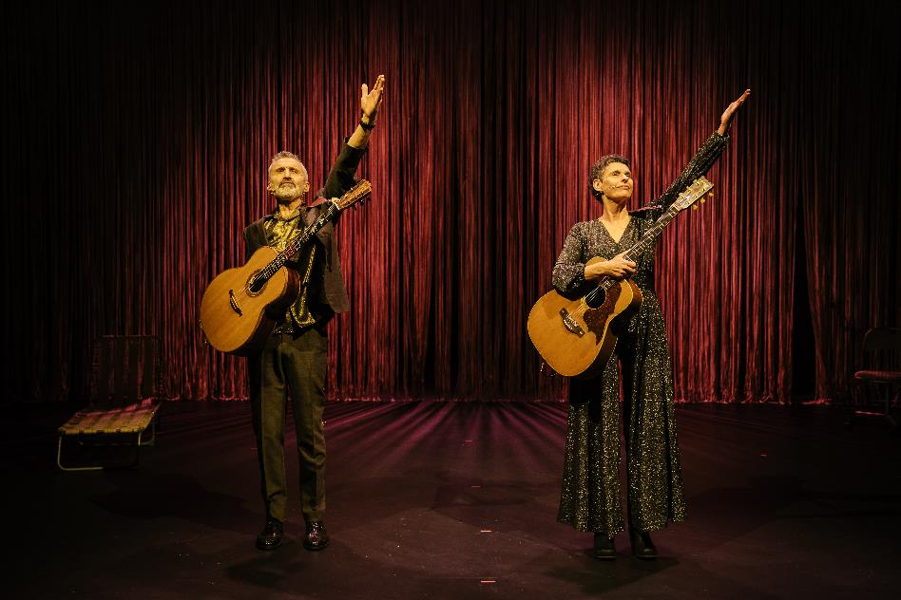

Deborah Conway and Willy Zygier
Image: Jason Lau

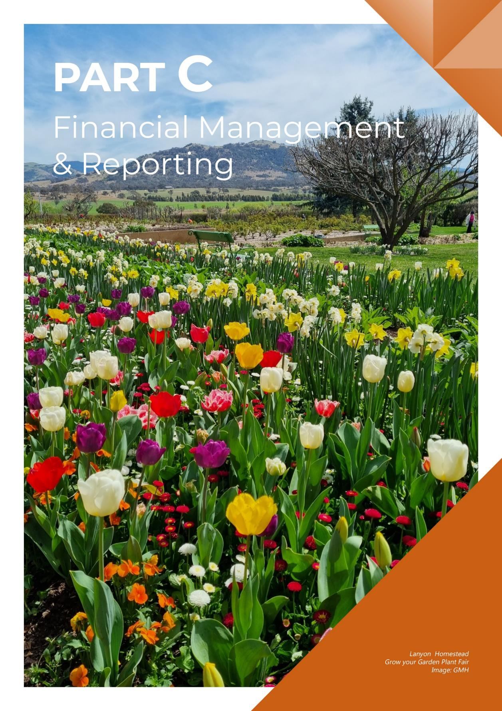

C.1 Financial Management Analysis
A full analysis of the CFC’s 2023-24 financial results and financial position is set out in the Management Discussion and Analysis at Attachment 1 to this report.

C.2 Financial Statements
The CFC’s 2023-24 Financial Statements are set out at Attachment 1 to this report.

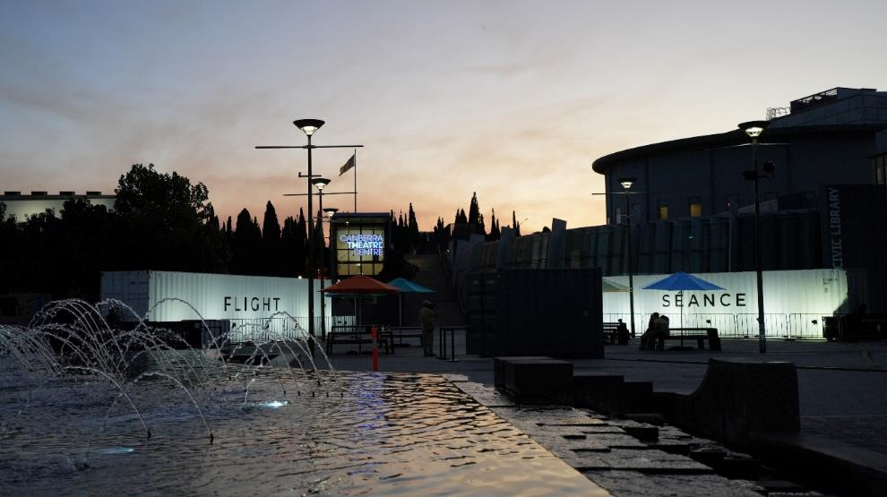
Darkfield - Séance and Flight
Civic Square
Image: CFC
C.1 Financial Management Analysis
A full analysis of the CFC’s 2023-24 financial results and financial position is set out in the Management Discussion and Analysis at Attachment 1.

C.2 Financial Statements
The CFC’s 2023-24 Financial Statements are set out at Attachment 1.

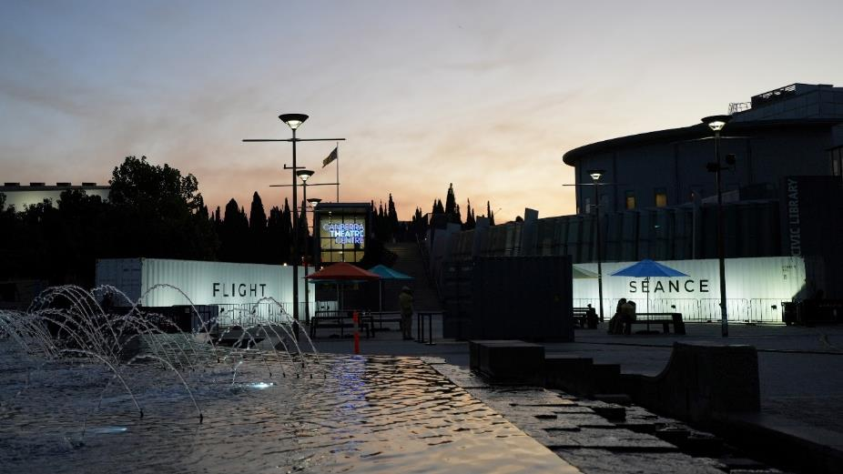
Darkfield – Séance and Flight
Civic Square
Image: CFC

C.3 Capital Works

2023-24 Capital Works Table
Project | Estimated completion  date | Actual completion  date | Original project  value  $000 | Revised  project  value  $000 | Prior year expenditure  $000 | Current year expenditure  $000 | Total  expenditure  to date  $000
New Capital Works
Transforming Canberra Museum and Gallery and developing Canberra Theatre Centre Technicians | June 25 | - | 423 | 423 |  | - |  | 163 |  | 163
Works in Progress
Arts and culture - Canberra Theatre Centre expansion and redevelopment | June 26 | - | 2,393 | 2,393 |  | 268 |  | 415 |  | 683
Arts and culture - Lanyon Homestead upgrades | June 26 | - | 951 | 951 |  | 27 |  | 229 |  | 256
Lanyon Urgent Driveway Upgrades and Stabilisation of the Shearers’ Precinct | June 26 | - | 3,903 | 3,903 |  | 7 |  | 26 |  | 33
Improvements to the Canberra Museum and Gallery and the North Building | June 24 | June 24 | 600 | 600 |  | 376 |  | 224 |  | 600
Improvements to the Canberra Theatre Centre | June 25 | - | 1,442 | 1,442 |  | 657 |  | 549 |  | 1206
Upgrading Lanyon Homestead | June 25 | - | 3,097 | 3,097 |  | 1,604 |  | 1,004 |  | 2608
Better Infrastructure Fund
Cultural Facilities Corporation | June 24 | June 24 | 461 | 461 |  | - |  | 461 |  | 461
Total Capital Works Program |  |  | 13,270 | 13,270 |  | 2,939 |  | 3,072 |  | 6,011

2023-24 Capital Works Reconciliation
 |  |  | $000
Original Capital Works Program Financing |  |  | 5,969
Add: Capital Injection for Projects not in the Capital Works Program¹ |  |  | 698
Less: Capital Injection Not Drawn in 2023-24 |  |  | (2,909)
Capital Injection from Government per Statement of Cash Flow |  |  | 3,758
Less: Expenditure funded by Capital Injection not in the Capital Works Program¹ |  |  | (698)
Less: Net Impact of Accruals between Financial Years |  |  | 378
Total Purchase of Capital Works per Statement of Cash Flows |  |  | 2,682
Note 1: Capital injection for projects not in the capital works program mainly relates to payout of accrued employee entitlements and Enterprise Bargaining backpay.

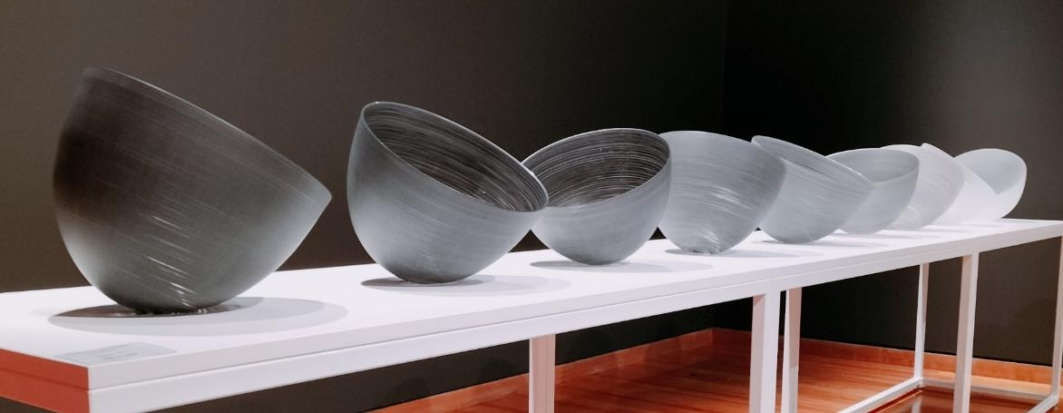
Mel Douglas, Tonal Value (1-9), 2019
Materiality…but not as we know it
Image: CFC

C.4 Asset Management

C.4.1 Assets Managed
The CFC managed assets with a total value of $74,930,000 as at 30 June 2024. The CFC’s major assets and approximate values are:

Major Asset | Value
Description | $000
Canberra Theatre Centre at fair value | 33,391
Land at fair value | 21,203
Historic Places buildings at fair value | 6,544
Plant and equipment at fair value | 2,180
Art and Social History Collection | 5,744
Capital Works in Progress | 3,939
Leasehold Improvements at fair value | 1,929

During 2023-24 the following major assets were added to the CFC’s asset register:

Major Asset | Value
Description | $000
Property, plant and acquisitions | 550
Building upgrades | 437
Art and Social History Objects (including donated art) | 59
There were no significant assets removed from the CFC’s asset register during 2023-24.

C.4.2 Assets Maintenance & Upgrade
The CFC maintains its assets in accordance with the CFC’s Strategic Asset Management Plan.

Major asset upgrades (including works funded and reported through the capital works program) completed during 2023-24 were:

Major Asset Upgrades | Value
Description | $000
Works in Progress improving facilities at the Canberra Theatre Centre | 576
Upgrading Lanyon Homestead | 1,007
CMAG Expansion and Activation | 163

For building assets, the expenditure on repairs and maintenance was $364,000, which represented 0.9% of the assets written down value. For Plant and Equipment assets, the expenditure on repairs and maintenance was $109,000, which represented 2.7% of the assets written down value.

A three-year rolling independent valuation of the CFC’s assets has been implemented to ensure all items are reflected at fair value in the CFC’s asset register and all assets are reviewed annually for any impairment.

C.4.3 Office Accommodation
CFC staff members occupy or use premises at the CTC, CMAG, Lanyon, Calthorpes House, Mugga-Mugga and North Building administration area locations.

In view of the wide range of workplaces in which CFC staff work (including historic places, theatre and gallery environments, where areas used by staff as offices may be combined with other uses such as ticketing, patron servicing etc.), it is difficult to provide a precise figure of the average area occupied by each employee. An estimate of the total office area occupied as at 30 June 2024 is 1,147 square metres and an estimate of the average area occupied by each (FTE) employee as at 30 June 2024 is 9.25 square metres.

C.5 Government Contracting

C.5.1 Procurement Principles & Processes
The CFC engaged external sources of goods, services and works during 2023-24 and these goods, services and works were procured with the support and assistance of Procurement ACT as required. The CFC believes that its procurement selection and management processes comply with the Government Procurement Act 2001 and Government Procurement Regulation 2007. It liaises regularly with Procurement ACT on procurement matters including through the involvement of officers of Procurement ACT in the more complex or higher value procurement processes.

C.5.2 External Sources of Goods, Services & Works
The online ACT Government Contracts Register records contracts with suppliers of goods, services and works, with a value of $25,000 or more.

A full search of CFC contracts notified with an execution date from 1 July 2023 to 30 June 2024 can be made at www.tenders.act.gov.au/contract/search.

Secure Local Jobs Code
The CFC was granted an exemption in relation to procurements for heritage conservation works related to Lanyon and Mugga-Mugga Cottage.

These works were highly specialised heritage and conservation works to ACT Historic Places and there were no suitable entities available at reasonable cost to tender or contract for the respective Procurements that would enable the requirements in section 22G (1), (2) and (3) of the Government Procurement Act 2001 to be met. This exemption was in relation to specialist heritage trade contractors only and did not extend to general trades engaged as third party subcontractors to complete associated works captured by the Code requirements.

Aboriginal & Torres Strait Islander Procurement Policy
(ATSIPP) Performance Measures

No. | ATSIPP Performance Measure | Result
1. | The number of unique Aboriginal and Torres Strait Islander Enterprises that respond to the reporting entity’s tender and quotation opportunities. | 3
2. | The number of unique Aboriginal and Torres Strait Islander Enterprises attributed a value of addressable spend in the financial year. | 3
3. | Percentage of the financial year’s addressable spend which is spent with Aboriginal and Torres Strait Islander Enterprises. | Less than 1%

C.6 Statement of Performance
The CFC’s 2023-24 Statement of Performance is set out in at Attachment 1 to this report.

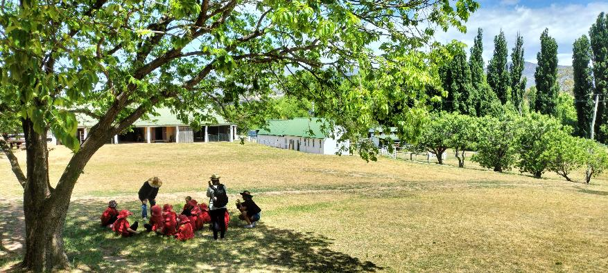

Lanyon Homestead Learning Programs
Image: CFC

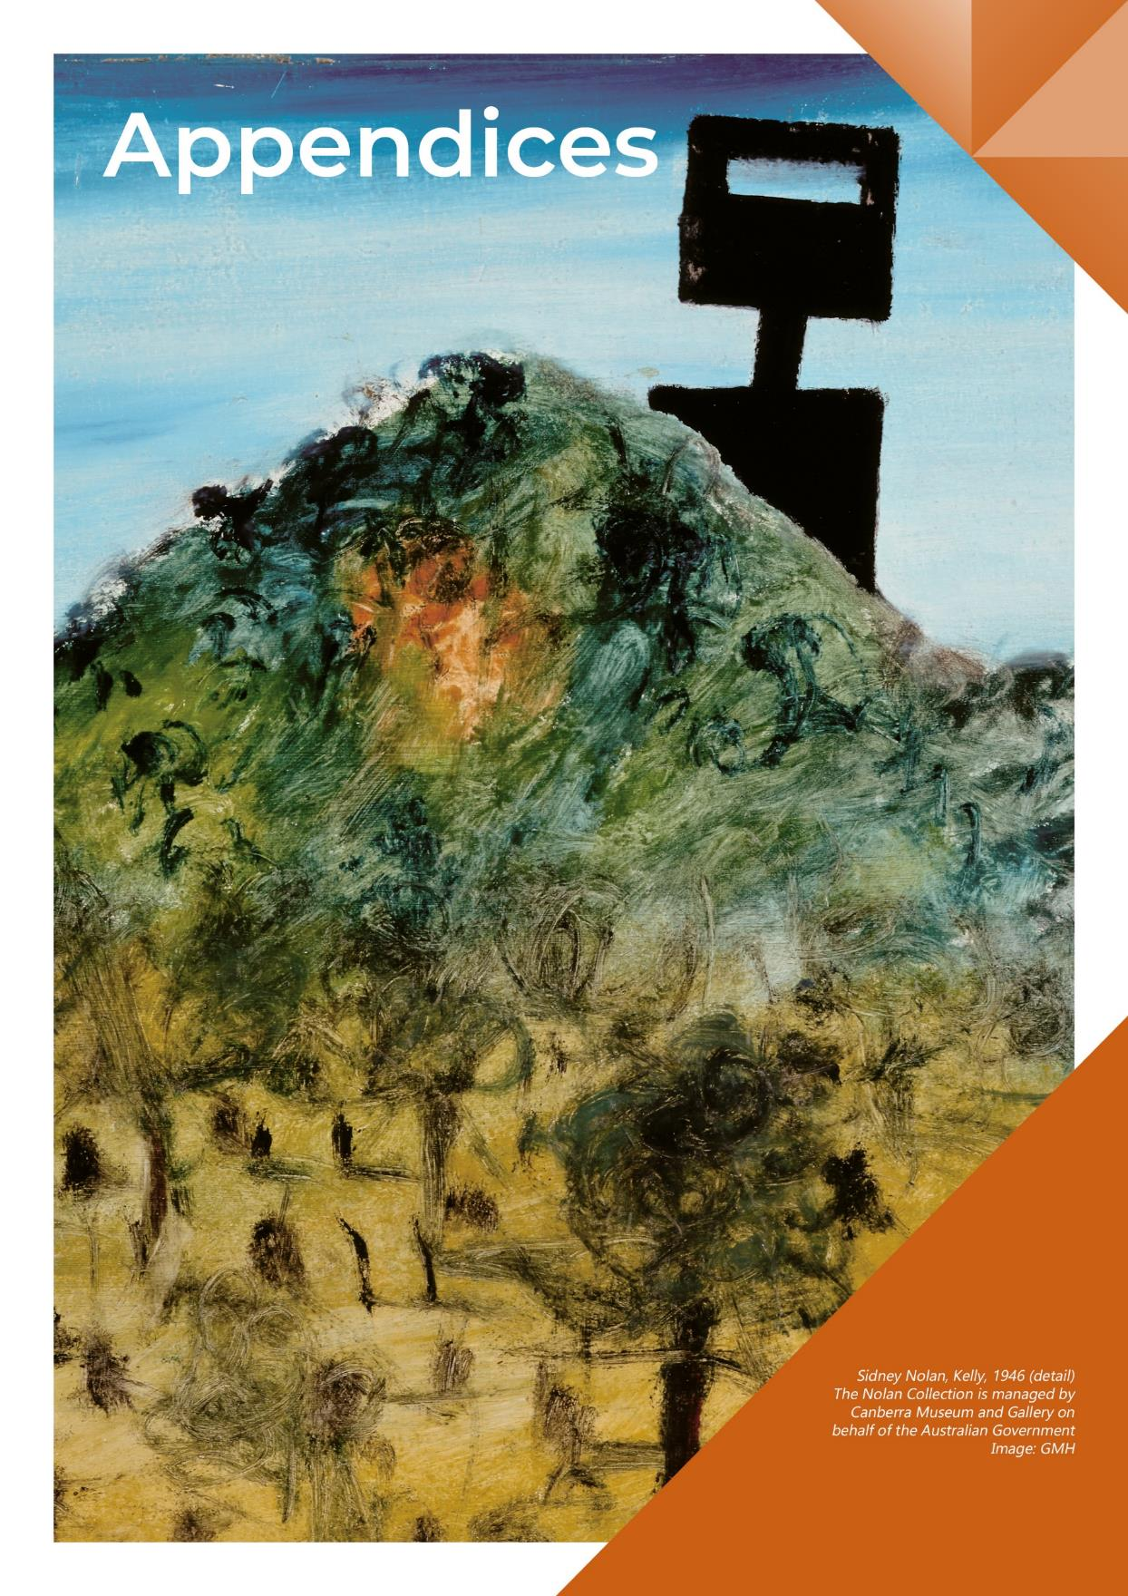

Appendix 1

Members of the CFC Board During 2023-24

Helen O’Neil
Chair

Helen is an experienced non-executive director and leader in the arts and creative industries. She was Chair of Performing Arts Connections, representing arts centres, touring companies and service organisations in Australian live performance, and of South East Arts. Helen was a Board member of Craft ACT, Currency House Inc, and the Australian Film Finance Corporation. Her executive experience includes roles as Country Director of the British Council in Australia leading cultural relations in the arts, science and higher education; Executive Director of the Australian Major Performing Arts Group and the Council for the Humanities, Arts and Social Sciences; and with Opera Australia. In public policy Helen was Senior Adviser to the Minister for the Arts, The Hon Simon Crean. She has worked in screen and digital areas with News Ltd, and as a journalist with the ABC and The Age. Helen has degrees from the University of Melbourne (BA) and from Harvard University's Kennedy School (MPA). She is also a Councillor in the Bega Valley Shire.

Dr Rachael Coghlan
Deputy Chair

Rachael Coghlan is an experienced CEO, cultural strategist, and Board Director with a track record of executing well-designed change management and strategic renewal programs in complex environments to achieve organisational outcomes. Rachael is CEO of the Winston Churchill Memorial Trust which offers fellowships to travel the world, further knowledge in a chosen field, and make a contribution to Australian society. She recently

led the strategic transformation of Parliament House’s public engagement and implemented a renewal program of retail strategy (instore and online) to nurture enduring confidence in, and appreciation for, Australia’s parliament and democracy. As CEO/artistic director of Craft ACT and the DESIGN Canberra festival, Rachael forged international partnerships to build visibility and income for local artists, and her commitment to interdisciplinary collaboration was acknowledged by the Australian Institute of Architects (ACT) Clem Cummings Medal. Rachael was awarded a PhD from the ANU examining how museums can become relevant, multi-vocal platforms for the wider social good.

Gordon Ramsay
Ex Officio
as Chief Executive Officer

Gordon is a former member of the ACT Executive (2016-2020) during which he held a range of portfolios, including Attorney-General and Minister for the Arts and was a member of various national ministerial councils. He has a Bachelor of Arts and a Bachelor of Law (Hons) from Sydney University and a Bachelor of Theology from the Sydney College of Divinity. After working as a lawyer in commercial and intellectual property at Freehill Hollingdale and Page, he and his family moved to Canberra where he led Kippax Uniting Church and UnitingCare Kippax for 19 years working in areas of service, social equality, inclusion and poverty. He led governance and organisational restructure with UnitingCare NSW.ACT (and then Uniting) from 2011-2016. He led the ACT Targeted Assistance Strategy and was a member of the ACT Community Inclusion Board between 2006-2008. He has provided consultancy support on policy and organisational governance, strategy and structure locally and nationally for much of the past two decades. He has been an ACT Community Inclusion Advocate, member of the ACT Better Services Taskforce, Community Champion for the “Time to talk: Canberra 2030” and led ACT Anti-Poverty work. He is a former member of the Board of The Neighbourhood Canberra and the Uniting Church National Assembly Taskforce to develop an apology to the LGBTIQ+ community. He currently serves on the Board of the Australian Centre for Christianity and Culture. He was recognised in the Australian of the Year awards as an ACT Local Hero finalist in 2015.

Genevieve Jacobs AM
Member

Genevieve Jacobs has been a journalist for 30 years, working in print and radio. She was a long time ABC Canberra presenter and is now the Group Editor for Region Media and a graduate of the Australian Institute of Company Directors. Genevieve is a director of the CFC, the Conflict Resolution Service and the Australian Centre for Christianity and Culture. She chaired the ACT Minister's Creative Council and Canberra International Music Festival and has an enduring interest in building and strengthening community engagement.
Michael Sollis
Member

Michael Sollis is an interdisciplinary artist who promotes how the arts can nurture creative mindsets which generate new ideas. This has included work as founder, composer, and director of the Griffyn Ensemble, the very first Artistic Director, Education for Musica Viva Australia, and co-artistic director of the National Folk Festival. As a teaching artist, Michael has facilitated projects in places such as Scottish prisons, Egyptian schools, urban, rural, and remote schools across Australia, and lectured in composition at the ANU. Michael is currently completing a PhD at the ANU, exploring how families can be empowered to be creative when engaging with nature. His work on sung stories in the Papua New Guinea highlands is published by ANU E-Press and the Australian Journal of Linguistics. Michael was one of several artists who brought together the ACT Creative community to form the Canberra Artists Action Group and was the founding chair of the International Music Council’s Youth Board. Michael was born and raised on Ngunnawal country, following the footsteps of custodians who have listened to this land for centuries.

Tim Lo Surdo
Member

Tim is the Founder of Democracy in Colour, Australia's first racial and economic justice organisation led by people of colour. Before starting Democracy in Colour, he worked with low-paid workers to set up Hospo Voice, a new union in hospitality. Previously, Tim was the Head of Campaigns at Oaktree, a senior adviser to two Senators, the Campaigns Director at Jhatkaa, the National Communications Director at UN Youth Australia, and co-founded Open Sky. Tim has served on 22 not-for-profit and government Boards. He is currently the Chairperson of No to Violence and the Jane Goodall Institute Australia and a Non-Executive Director of Plan International Australia, the Australian Marine Conservation Society, Environment Victoria, the Alliance for Gambling Reform, Inner Melbourne Community Legal, the CFC, the Consumer Policy Research Centre, the Funders Initiative for Civil Society, the Jane Goodall Institute Global, and the Victorian Government's Sustainability Fund. He is also a member of the International Advisory Board of the University of Western Australia's Public Policy Institute, the Australian Red Cross's Divisional Advisory Board, the Multicultural Queensland Advisory Council, and Australia's Open Government Forum. For his work, Tim was named an Asia-Pacific Obama Leader, the 2021 Victorian Young Achiever of the Year, a Commonwealth Young Person of the Year finalist, one of the 40 Under 40 Most Influential Asian-Australians, and one of 17 UN Young Leaders for the Sustainable Development Goals.

Christine Shannon
Member

Christine Shannon has been appointed as a member of the Board and as well as Chair of the CFC’s Audit and Risk Committee. Christine brings over 25 years of experience in delivering risk and financial management expertise and strategy, as well as governance operations leadership, to the CFC. Her career highlights include delivering the first whole-of-Defence governance and accountability framework and enterprise risk management framework for the
then Defence Materiel Organisation's $6 billion capital investment program. With her extensive global and local cultural networks, Christine is well-positioned to support the CFC's growth strategy, including the redevelopment of the CTC and the expansion of CMAG. Her astute business acumen in anticipating and managing political and corporate risks, and in building stakeholder support, will be invaluable to the CFC in achieving its objectives. Christine is a governance expert and legal professional who has advised corporations on marketing and growth strategies, legal risk, enterprise-level risk, and optimal corporate structures with experience in leading workforce change, cyber security, and asset management. She is a fellow of the Australian Institute of Company Directors, and holds a Master of Laws, MBA, Bachelor of Commerce/Laws degrees and AMusA.

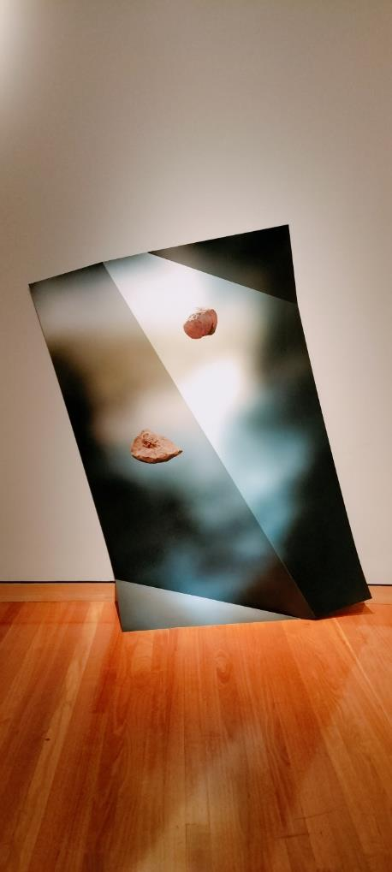

Marian Drew, Your body is heavy, 2026;
Ashley Jameson Eriksmoen, Cool New Things for your house, 2024
Materiality…but not as we know it
Images: CFC
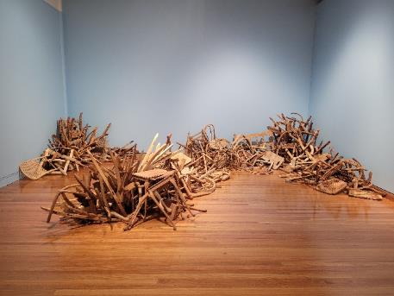

Appendix 2

Senior Managers of the CFC
Dr Anna Wong
Director
Galleries, Museums & Heritage
Alex Budd
Director
Canberra Theatre Centre

Alex Budd commenced his arts career in the lighting department at the CTC. He was a founding member of the Canberra based Chamber Opera Company, Stopera. He later worked as Head Electrician and Touring Lighting Designer for Sydney Dance Company, realising lighting designs for Graeme Murphy's ballets across Australia, Europe and the Americas. Alex joined Opera Australia as Tour Manager, Oz Opera in 2000, and has held several roles in Oz Opera and the wider company. After a year at Royal Opera House Covent Garden project managing the Paul Hamlyn Performances, Alex returned to Opera Australia as Manager, Oz Opera, before setting up the Company's Enterprises division. In 2004 Alex was appointed to the Federal Government's Playing Australia Committee and sat on the Committee for seven years. In 2008 he became General Manager, Melbourne and Enterprises, and in 2016 Executive Producer, Touring and Commercial, the Melbourne-based member of the Company's Executive, with oversight of the music theatre, regional and schools touring and commercial projects of the Opera Australia business. Alex produced 16 New Year's Eve Galas at the Sydney Opera House, as well as the musical tours of South Pacific, The King & I, Anything Goes, My Fair Lady, Evita, and West Side Story. Alex was appointed Director, CTC in late 2019, and returned to Canberra to lead the organisation where his career began. Alex has served on the Executive Council for Live Performance Australia and is a currently an Executive Council Member of the Association of Asia Pacific Performing Arts Centres.

Anna has worked in the museum and cultural heritage management sectors across a broad range of historic, cultural, and natural places and museums in Australia, including precinct-based activation of cultural sites. She previously held archaeology, cultural heritage, planning and museum-related positions with the NSW Government Architect’s Office (NSW Department of Public Works), NSW National Trust, NSW National Parks and Wildlife Service and the National Capital Authority. She was previously a Lecturer in Heritage Studies at the University of Sydney. Her doctoral research examined the Australian heritage conservation movement through the house museum genre and how this shaped our national identity and cultural representation of Australia’s past and present through collections, conservation, exhibitions, public programs, and community engagement. In 2005, Anna was awarded research fellowships at the International Centre for Jefferson Studies at Monticello and the Winterthur Museum in the USA. Anna has a deep interest in cultural history and the integration of contemporary programs, stories, and site activation to ensure that collections, museums, and our cultural environment continue to be relevant to current communities and audiences.
School Holiday Program – CMAG
Sidney Nolan Riverbend Workshop
Image: GMH



Dr Brooke Thomas
Director
Collaboration & Engagement

Brooke has 20 years’ experience in a range of public service, tertiary sector, community arts, and political advisory roles with expertise in social policy development and implementation, complex program management, stakeholder engagement, organisational change, and international relations. She has a PhD in Literature and is an active contributor to the ACT community dance scene as a teacher, performer, volunteer, and fundraiser. Her role at the CFC has a broad remit covering leading on human resources management and a range of corporate governance areas, ministerial and parliamentary matters, strategic coordination of communications and stakeholder engagement, driving organisational capability building through a range of projects, and leading on collaboration, business development, and audience diversification.
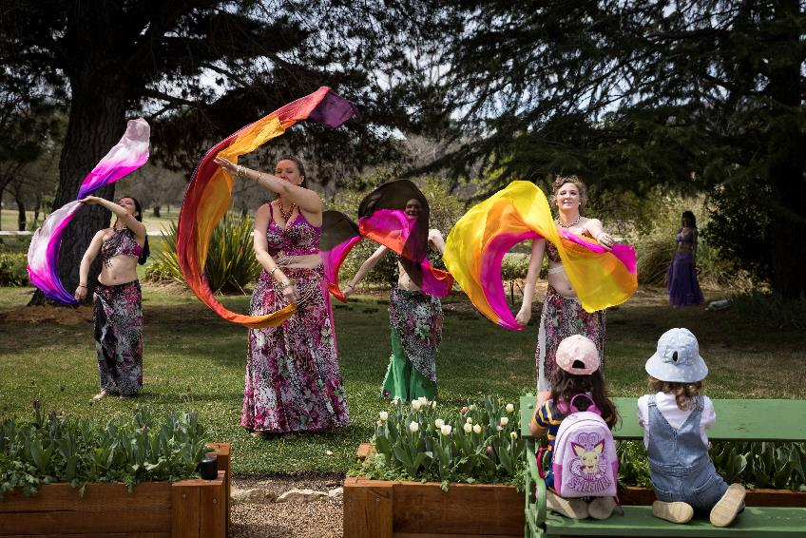

Sharon Lu
Chief Financial Officer
(from 5 December 2023)

Sharon is a member of Certified Practising Accountants Australia. She has a Master of Professional Accounting and a Master of Financial Management from the ANU. Following her experience in the not-for profit sector, Sharon joined the ACT Government in 2013 and has held various managerial positions in the ACT Government to promote financial sustainability, strong governance, and stakeholder collaboration. Before joining the CFC in 2023, Sharon was the acting Chief Finance Officer and a member of the Senior Executive Leadership group of MPC, guiding the organisation through complex financial landscapes and driving strategic
decision-making in the infrastructure delivery of the ACT Government.

Dancers perform at the Historic Places Plant Fair
Lanyon Homestead
Image: Jane Duong

Danielle Buffier
Director
Facility Operations & Capital Works (from 19 June 2024)

Danielle is the Director, Facilities Operations and Capital Works (FOCW), CFC and is a highly experienced Program and Project Management Leader with over 25 years of experience spearheading large-scale civil engineering, transportation, and infrastructure projects. Danielle is adept at driving strategic initiatives, delivering excellence, and fostering innovation within cross-functional teams and has a proven track record of successfully managing multi-million-dollar projects. Recognised as a values-driven leader and a champion of innovation, she creates a shared vision for success and builds positive relationships with teams based on credibility, trust and authenticity. Danielle loves building high-performing teams and fostering a culture of positivity, problem solving, and no problem is too large or small. She believes in lifting the team together, mentoring, leading equality and cohesive behaviours and caring for staff and team members on an individual basis. Danielle is skilled in leading programs and projects from inception to completion, and has extensive experience in managing civil engineering projects, including roadways, bridges, interchanges, and airport infrastructure. Danielle has also worked on programs and initiatives such as solar farms, wind farms, Indigenous housing, education facilities, health facilities, and highly technical projects such as air traffic control and airport terminals. She is all about the team, rolling up your sleeves and digging in together.

The River that Ran Uphill
Image: Andy Rasheed Eyefood

Ian Tidy
Chief Financial Officer
(end date 4 December 2023)

Ian is a member of Chartered Accountants Australia and New Zealand and has held previous financial roles in retail with Discount Variety Group and in the audit team at BDO Kendalls in Brisbane. He has been employed with the CFC since December 2005, previously as the Financial Controller before taking up this position in 2010. He has an undergraduate degree in Business with QUT and has experience in the not-for-profit sector, previously serving on the Board of ArtSound FM. Ian retired from the CFC in July 2024.

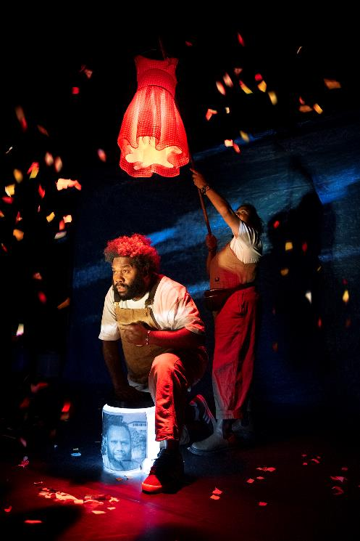

Appendix 3

Advisory Committees 2023-24

The CFC’s three Advisory Committees, operating in accordance with Section 8 (i)(a) of the CFC Act, provide expert strategic advice in relation to their respective specialist areas. The committees include the Canberra Museum and Gallery Advisory Committee, Historic Places Advisory Committee, and the Canberra Theatre Centre Advisory Committee.

Canberra Museum & Gallery Advisory Committee

Professor Nicholas Brown
Convenor

Nicholas Brown FASSA is a professor in the School of History, College of Arts and Social Sciences, ANU. He has recently served as the Visiting Cabinet Historian with the National Archives of Australia, on the ACT Heritage Council and continues as a member of the Commonwealth and ACT Working Party of the Australian Dictionary of Biography. He is the author and co-author of a number of books, edited collections, and journal articles, including A History of Canberra (2016) with Cambridge University Press.

Professor Denise Ferris
Member

Denise Ferris is an Emeritus Professor at the ANU, in the School of Art & Design where she was previously Head of School. She is a co-opted board member of the Deans and Directors of Creative Arts (DDCA), a peak body for the tertiary art and design sector, and a board member of South East Arts. Denise holds degrees from Sydney University and University of Technology Sydney. An art practitioner, Ferris’ photographs are held in Australian public collections, including the NGA, National Library, Australian War Memorial, ACT Legislative Assembly Art Collection and CMAG as well as international collections including
the District Six Museum, Cape Town and Nara City, Japan.

Squadron Leader
Gary Oakley OAM
Member

Gary is currently serving in the Royal Australian Air Force (RAAF) in the History and Heritage section as the Indigenous Historian/Curator. He also holds the position of National President of the Aboriginal and Torres Strait Islander Veterans and Services Association. Starting his career as a 15-year-old Junior Recruit in the Royal Australian Navy (RAN) Gary served for 22 years, mostly in submarines. As a Vietnam War veteran for service in HMAS Sydney, he left to take up a position as an Assistant Curator in the Military and Heraldry Section of the Australian War Memorial. After several years Gary moved to the then Gallery Development, later Exhibitions, section as the Exhibitions Curator to curate most of the galleries currently in the Memorial. Gary was the first Indigenous Liaison Officer appointed by the Memorial. Whilst a curator at the Memorial Gary spent time as a curator and research at the Bavarian Army Museum in Ingolstadt, Germany. As a RAN Reservist Gary worked with the Navy History Section and Australian Defence Force Indigenous Affairs. Gary was offered a position in the Air Force in their newly set up Equity and Diversity branch and retired from the Public Service to take up a commission in the RAAF.

Dr Charlotte Craw
Member

Charlotte Craw is an arts, culture and heritage professional with experience working in cultural institutions, public policy, community arts and tertiary education in Australia, Cambodia and New Zealand. She holds a PhD in Australian Indigenous Studies, and her most recent roles have focused on Aboriginal and Torres Strait Islander cultures and heritage. She is a co-author of the Ningaloo Coast and Sambor Prei Kuk World Heritage nominations, and her other publications include academic articles, art criticism, poetry and short fiction.
Sara Kelly
Member

Since early 1982 Sara has worked in art galleries and museums at a National, State, University and Local level. Roles undertaken include Director, Curator, Registrar, and Loans and Collections Manager. In addition to a Fine Arts degree from the ANU, she has a Diploma in Law and Collection Management. The latter qualification facilitated extensive work on state and international transport logistics and compliance across a number of areas, including Indemnity and Sanctions and their reporting for the movement of cultural material. For the last five years Sara has undertaken consulting work, and volunteer research and committee work for cultural institutions.

Sara has undertaken consulting work, and volunteer research and committee work for cultural institutions.
Amelia Zaraftis
Member

Amelia Zaraftis is an executive leader, fundraiser, educator, artist, and reconciliation advocate, living on Ngunnawal Ngambri Country. As the Director of Advancement at Burgmann College, a not-for-profit residential college on the ANU campus, Amelia leads the College’s alumni relations, communications, and fundraising program, and champions the College’s Reconciliation program. At the ANU School of Art & Design, Amelia also co-leads the ArtsACT-funded Sharing Stories Arts Exchange project which facilitates artists’ engagement with First Nations communities in Canberra and surrounds. Early in her career, Amelia was the Education and Community Programs Officer at CMAG. In 2018, Amelia was a co-recipient of the ANU Vice Chancellor’s Award for Reconciliation. Amelia holds a Bachelor of Visual Arts (First Class Honours) from the ANU and a Bachelor of Education from the University of Canberra.

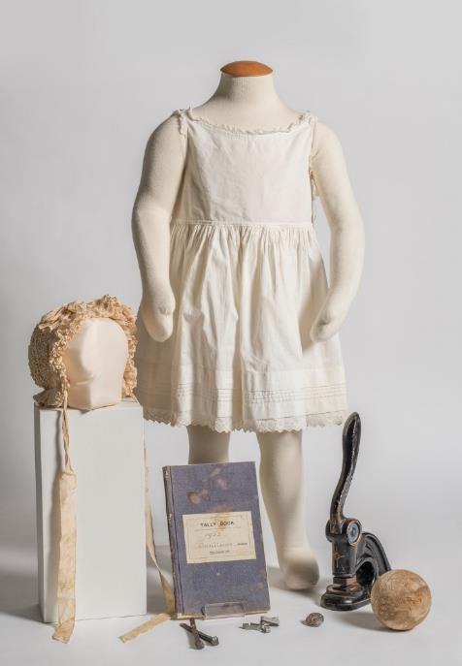
Objects from CMAG, Australian Army Museum Duntroon, Canberra and Disctrict Historical Society and the Campbell Family; Duntroon Estate: Work with all your might exhibition
Image: Brenton McGeachie

ACT Historic Places Advisory Committee

Barbara Reeve, FIIC,
M.ICOMOS, CPHD
Convenor

Barbara qualified as a Certified Passivhaus Designer/Consultant (CPHD) and Owner-Builder in 2020, and this year will move into the Passivhaus home she designed to replace her family home. From 1998-2014 she served as the Australian War Memorial's Head of Collection Services, responsible for the Conservation, Registration, and Collection Management System teams. Stepping into the role of Manager, Heritage Preservation Projects, (2014-2017), she managed the Reconstruction of the AWM's Commemorative Area, construction of the Flanders Fields Memorial Garden, and the transport and installation of the Menin Gate Lions in Ypres, amongst other projects. Prior to moving to Canberra, she was the inaugural Head of Conservation, Australian National Maritime Museum (1993-98). Her professional training includes: BA (Archaeology) Bryn Mawr College; BSc (Conservation) University of London; Museum Leadership Program, 2001, 2003, 2005; Visiting Scholar, Wolfson College, Cambridge, 2010; Advance Professional Development course, Best Practice in Managing Heritage Places, ANU, 2014; Certified Passivhaus Designer/Consultant, Passivhaus Institut, 2020. A Fellow and past Ordinary Member of Council for the International Institute for Conservation, and former Director, AusHeritage, her international experience includes establishing conservation training at Hong Kong University, and work for museums, collectors, and archaeological excavations in Europe, the Asia-Pacific, and the Middle East. Barbara’s professional interests and publications include conservation education and practice, bushfire recovery, and sustainability/eco-effectiveness in the building and heritage sectors.

Dr Dianne Firth OAM
Deputy Convenor

Dr Dianne Firth is Adjunct Associate Professor in the Faculty of Arts and Design at the University of Canberra and is a registered landscape architect and Fellow of the Australian Institute of Landscape Architects. She holds a PhD, B Land Arch, BSc, and Dip Ed. She was Head of the Landscape Architecture program at the University of Canberra until 2012 and was Deputy Chair of the ACT Heritage Council until March 2018. In 2017 Dianne was awarded an OAM for her service to landscape architecture and education. Her PhD, Behind the Landscape of Lake Burley Griffin: landscape, water, politics, and the National Capital 1899-1964, was completed in 2000. The current focus of her research, publication and lecturing is Canberra’s landscape: its design, legacy, and heritage. She has served as chair for the review of the National Capital Open Space System for the National Capital Authority, as a member of the Design Review Panel for the ACT Government, and as a landscape expert on the ACT Government's Tree Renewal Strategic Plan. Firth is also an acknowledged textile artist with works in public collections in Australia and overseas.

Alistair Grinbergs
Member

Alistair is an archaeologist and heritage management consultant working across the First Nations, historic and natural heritage environments with a particular focus on the mining and natural resources sectors in Western Australia and New South Wales. From 1993 to 1997: NSW National Parks & Wildlife Service - responsible for advice on First Nations and historic heritage places and values in the context of environmental impact assessment and negotiation with NSW and Commonwealth Government agencies on the management of legacy Snowy Mountains Scheme assets within Kosciuszko National Park. From 1997 to 1999: Australian Heritage Commission - responsibility for coordinating complex advice to the Government on National Estate listed places and related policy matters including amendments to the Environment Protection and Biodiversity Conservation Act. In 2000: Australian National Antarctic Research Expedition to Heard & McDonald Islands - led a heritage assessment of the former Australian base at Atlas Cove. During 2001 to 2003: Environment Australia - managing a review of the Ozone Protection Act and associated amendments to the legislation to include synthetic greenhouse gasses used as alternatives to ozone depleting substances. From 2003 to 2008: Independent consulting practice - completed a range of projects including organisational restructures of Booderee and Kakadu National Parks, a national review of heritage tourism in protected areas and the assessment of National Heritage List values of the Australian Alps National Parks. From 2008 to 2016: Ironbark Heritage & Environment - Director of a consulting practice that focused on First Nations heritage assessments in the rapidly expanding WA iron ore mining sector. During 2017 to 2020: EcoLogical Australia and later Lantern Heritage. 2021-2022: Research
scholar with the Centre for Creative and Cultural Research at the University of Canberra.
Joanne Lisinski
Member

Joanne is a Conservator and specialises in modern materials and materials analysis. She has experience in archaeological and built heritage preservation and management and is currently a Senior Conservator at the Australian War Memorial. Prior to this, Joanne worked in the Middle East for 15 years in Conservation and Technical Art History. She completed Master’s degrees in Conservation Science (University College London), Middle Eastern and Central Asian Studies (ANU), and Undergraduate studies in Fine Arts (RMIT). She has particular interest in experimental and contemporary art practice. Joanne is a Board Member at You Are Here (YAH) and Secretary of the Australian Museums and Galleries Association Art, Craft and Design National Network (AMaGA ACD NN). In 2020, Joanne was selected to attend the Audrey Fagan Board Traineeship Program and completed a one-year mentorship program with CFC’s then CEO. Her professional interests and publications include conservation science, collection hazard and risk management, and workplace health and safety.

Dr Shannyn Palmer
Member

Shannyn is a community-engaged practitioner, researcher, and writer. She currently works as a consultant, helping organisations and institutions to achieve best practice in community engagement and create meaningful collaborations. She has over a decade of experience working in community engagement, facilitation, and research with First Nations and Culturally and Linguistically Diverse peoples and communities, and government and non-government organisations in the arts, cultural and cultural heritage sectors. She has a PhD in History from the ANU and recently published her first book with Melbourne University Press, Unmaking Angas Downs: Myth and History on a Central Australian Pastoral Station, which traces a history of colonisation in Central Australia from the perspective of Anangu who lived there. She is committed to the development of community-engaged practice and meaningful intercultural conversations and collaborations.

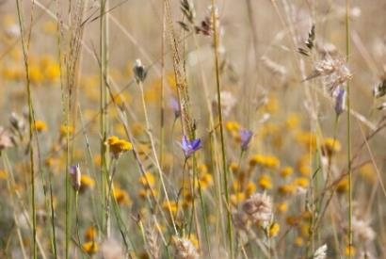
Mugga-Mugga grassland species.
Image: Carolyn Young

Canberra Theatre Centre Advisory Committee

Claudia Santangelo
Convenor

Claudia is the Stakeholder Engagement Manager at Yardhura Walani (meaning strong, powerful and health energy and place in Ngunnawal). Yardhura Walani is the National Centre for Aboriginal and Torres Strait Islander Wellbeing Research at the ANU. Claudia supports this Indigenous led, and governed team with funding partnerships, grant writing, project delivery and stakeholder relations to support the successful growth and operations of the Centre. Prior to joining Yardhura Walani, she worked for eight years as a major gift fundraiser at ANU driving philanthropic growth in support of Aboriginal and Torres Strait Islander-led projects, and environment and public health initiatives. Claudia has a strong background in the arts industry. She has produced her own shows for Sydney Fringe, Co-Directed a multi-day arts and music festival, and spent three years as Manager of Sydney Film Festival’s Travelling Film Festival, among other production and events management gigs. Through 2013- 2015 Claudia worked in Timor-Leste, first as an Australian Youth Ambassador with the Association of Community Radio, supporting this local collective to build their profile, funding and reach. She then worked with the Timor-Leste’s President’s office, successfully establishing a national nutrition awards program. In a Graduate scholarship position at IBM, she managed IBM’s Cape York Program, working with Indigenous Enterprise Partnerships to coordinate staff secondments supporting community driven projects. Claudia also currently serves as member of the Board of Directors for Arts Capital Limited.
Briefs
Image: Naomi Reed
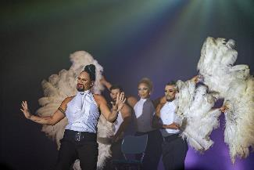

Kels Bagust
Member

Kels is an experienced producer, curator and nighttime economy specialist more than 10 years’ experience within commercial, public sector and DIY music contexts. Between 2017 and 2021, Kels worked as Live Music Manager at University of Canberra. In 2022, Kels relocated to Gadigal to work as the Contemporary Music producer at Sydney Opera House. Currently, Kels applies their industry at City of Sydney, managing the delivery of place and sector based economic development. Underlining this work is a deep commitment to diversity, accessibility and sustainability.
Soëlily Consen-Lynch
Member

Soëlily Consen-Lynch is a Dutch trained legal professional in employment law and industrial relations, working as Assistant Director Industrial Relations in ACT Government. Prior to moving to Canberra with her family in 2013, she worked in corporate law and legal aid in the Netherlands. Advocacy has been her passion from early on and as she felt a void "helping people" in Australia, she commenced volunteering in various community organisations as she always tries to look for ways to support and empower people and improve people's quality of life where possible. In 2019 she joined the Multicultural advisory council of the ACT Minister of Multicultural Affairs, a position she recently vacated in April 2022, to give other community members a chance to join the council. In 2021, she was the chair of the ACT chapter of the Mental Health Foundation Australia Multicultural Ambassadors, and she was also a Volunteer Coordinator for UN Women IWD Committee Canberra. Besides work on various committees and panels, Soëlily is also a regular volunteer for ACT Government as MC for citizenship ceremonies, National Multicultural Festival, Enlighten and Floriade.
- Current - Canberra Theatre Centre Advisory Committee
- 2022 - Celebrate Gungahlin Festival Reference Group
- 2022 - Sexual Health and Family Planning ACT, Member of the Youth Advisory Group
- November 2021- March 2022, UN Women Australia/ IWD ACT Chapter - Volunteer Coordinator
- October 2019 - April 2022, Member ACT Multicultural Advisory Council to the Minister of Multicultural Affairs
- 2019, ACT Government JACS Appeal Panel - Employee Representative
- March 2021 - November 2021, Chair ACT Chapter Multicultural Ambassadors- Mental Health Foundation Australia
- 2021, Co-organiser Think Tank - Youth Growth, Empowerment and Mentoring Group.
Fredeliza Campos
Member

Fredeliza Campos is an archaeologist and an ethnomusicologist. In the Philippines, she has held various music related positions, such as A&R for BMG Records, Music Specialist for the National Philharmonic Orchestra and as an Archivist for the music instrument collection of the University of the Philippines, Center for Ethnomusicology. She completed her postgraduate studies at the University of the Philippines (Master of Science in Archaeology) and the University of Hong Kong (Master of Philosophy in Ethnomusicology). As an academic, Fredeliza has received fellowships to conduct in-depth analyses of zoological specimens and musical instruments from institutional collections, such as the Field Museum of Natural History in Chicago, Naturalis Biodiversity Center in Leiden, and museums in the Philippines. She is currently affiliated with the ANU as part of the secretariat for the Indo-Pacific Prehistory Association, a large organisation of archaeologists, anthropologists and other specialists in similar fields working in the Indo-Pacific region. She has ongoing research on cultural and religious festivals, specifically looking at the performance of traditional musical instruments and their early forms. Fredeliza is also a member of Rondanihan, a rondalla musical group based in Canberra, and plays an active role in various cultural activities as part of the Philippine-Australian diaspora.
David Hobbes
Member

David was a practising architect in Sydney and Canberra for over 30 years and also a heritage consultant during the last 20 years he has lived
in Canberra. Having retired from architectural practice he continues on a variety of heritage projects in Canberra and the surrounding region, is Heritage Advisor to Goulburn Mulwaree Council and Yass Valley Council, and was recently appointed to the ACT Heritage Council. He has worked on many significant Canberra buildings including the Canberra Theatre having co-authored the Conservation Management Plan for Civic Square. He is a keen supporter of Canberra’s public life, culture and institutions. With the time he has left he is renovating an 1895 workers cottage in the Snowy Mountains.

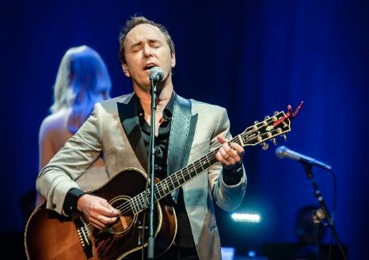
Damien Leith
Image: Michael Oliver

Appendix 4

Presentations & Exhibitions

The following is a list of presentations at the CTC, and exhibitions and gallery activities at CMAG, the Nolan Gallery, and the ACT historic properties in 2023-24.

Canberra Theatre Centre - Presentations

JULY
- Come From Away (Newtheatricals)
- Pony (Griffin Theatre Company)
- Let's Celebrate (Dance Northside)
- Robyn Archer: An Australian Songbook
- Gather: The Meet Up Performance (QL2 Dance Inc)
- Lucie in the Sky (pictured) (Australasian Dance Collective)
- The Waifs: Up all Night Tour
- Pete Murray: Greatest Hits Tour
- The Ten Tenors: Greatest Hits Tour
- Yuldea (Bangarra Dance Theatre)
- Are We There Yet? (CDP Theatre Producers)
- Vanessa Larry Mitchell - Teardrops on my Dildo
- Hiccup! (Windmill Theatre Company)
- Swag on the Beat: Unplugged
- The Music of Hans Zimmer with the George Ellis Symphony Orchestra
- Ross Noble - Jibber Jabber Jamboree

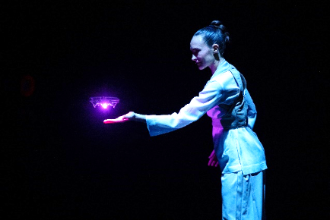
Lucie in the Sky
Image: David Kelly

AUGUST
- Wakakirri 2023
- Randy Feltface - Feltopia
- You Can’t Tell Anyone (pictured) (Canberra Youth Theatre)
- Rhythms of Ireland - 15th Anniversary Tour
- Music at Midday (The Royal Military College Band)
- An Evening with the Late John Cleese
- Frankie’s Guys (Samuel Klingner Entertainment)
- Walanbaa Yulu-Gi (Burn the Floor)
- Sydney Comedy Festival Showcase Tour
- Diesel
- Miss Peony (Belvoir)
- Queen: It's a Kind of Magic
- The Simon and Garfunkel Story
- Tommy Little: Rapidly Ageing F*ckboy
- Family Business: A killer comedy (Lightbulb Improv)
- Hans Disco Spectacular Tour 2023

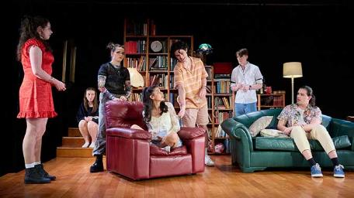
You Can’t Tell Anyone
Image: Andrew Sikorski

SEPTEMBER
- Nathan Cavaleri - Miracles Album Tour
- Morgan Evans - Life Upside Down Tour
- Pseudo Echo - The Ultimate Tour 2023
- The Hello Girls (Heart Strings Theatre Co)
- Darren Criss
- Disney’s Winnie the Pooh: The New Musical Stage Adaptation
- Mel Buttle - Let Me Know Either Way?
- Wakakirri ACT Awards Night
- Jon Stevens: The Noiseworks & INXS Collection
- Kate Ceberano: My Life Is A Symphony
- Hobba & Hing's Last Show Ever
- The White Album Concert
- Sleeping Beauty (Royal Czech Ballet)
- Yes Yes Yes (Tandem Productions)
- Possum Magic (Monkey Baa Theatre Company)
- I Love China 2023 - Mid-Autumn Festival Gala
- Tex Perkins playing the songs of Johnny Cash
- Rosieville (Canberra Youth Theatre)
- Mystique (Boyd Productions)
- Les Divas: An All-Male Revue

OCTOBER
- TEDxCanberra 2023: BEYOND
- Sing Australia National Gathering
- Twelfth Night (Bell Shakespeare)
- Hedley Thomas The Teacher's Pet Live
- Music at Midday (The Royal Military College Band)
- Bread and Circuses (Ausdance ACT)
- Creative Development Paul McDermott
- A Taste of Ireland (Pace Live)
- My Cousin Vlad - Catastropha!
- The Wharf Revue - Pride in Prejudice
- A Midsummer Night’s Dream (pictured) (Queensland Ballet)
- Life Uncut Live with Laura Byrne and Brittany Hockley

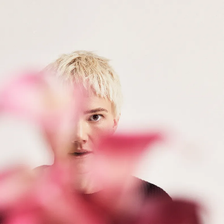
A Midsummer Night’s Dream
Image: QLD Ballet
Image Tyronne Bell

NOVEMBER
- Bohemian Symphony
- Damien Leith in concert
- The Wiggles: A Wiggly Big Day Out Tour!

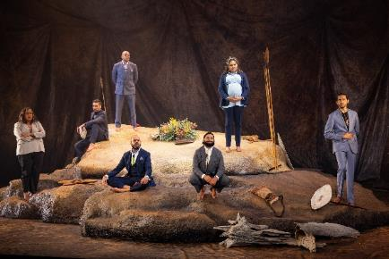
The Visitors
Image: Daniel Boud

- The Visitors (pictured) (Sydney Theatre Company and Moogahlin Performing Arts)
- Fearless & Intrepid (Dance Central)
- Metaverse of Magic (Jones Theatrical Group)
- Paul McDermott Plus One - Blood Orange
- Protégé (Play)
- The Greatest Show on Earth (Classical Ballet Centre)

DECEMBER
- Jessica Maree Music Studio End of Year Concert
- Burgmann Anglican School End of Year Celebrations
- Interplay (Dance Development Centre)
- Trip A Little Light Fantastic (Kim Harvey School of Dance)
- Music at Midday - with The Royal Military College Band
- The War on 2023: Annual Comedy Gala
- When You Wish Upon A Star (Lisa Clark Dance Centre)
- Deliverance (Capital Dance Studios)
- People You May Know (Canberra Youth Theatre)
- UCSSC Lake Ginninderra Graduation
- Dickson College Graduation
- Corkhill Bros Christmas Party
- Charles Dickens’ A Christmas Carol (Shake & Stir Theatre Co)
- A Very Canberra Comedy Festival Christmas

JANUARY
- Alice in Wonderland (pictured) (Bonnie Lythgoe Productions)
- Storytime Ballet: Cinderella (Australian Ballet)
- Circus of Illusion (Boyd Productions)
- Diamond - Liz Lea Creative Development
- Dr Suess's The Cat in the Hat (Showcase Entertainment)
- Kate Miller-Heidke - Catching Diamonds Tour
- The Teskey Brothers - The Winding Way Tour.
- The Very Hungry Caterpillar (CDP Theatre Productions)
- Jungle Book Reimagined (Akram Khan Company)

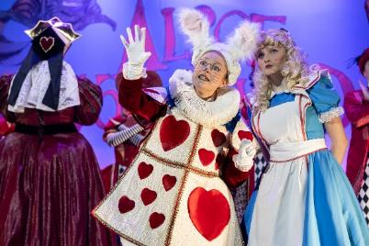
Alice In Wonderland
Image: Ben Fon

FEBRUARY
- Charley Crockett and Emma Donovan
- River (Australian Chamber Orchestra)
- The Best of the Bee Gees with The George Ellis Orchestra
- The Australian Eagles Show - Life in the Fast Lane
- Kevin McCloud's Home Truths
- Monkey King Cabaret - Beneath the Dragon Moon
- Deborah Conway & Willy Zygier: Songs From The Book of Life
- Music at Midday (The Royal Military College Band)
- Josh Thomas - Let's Tidy Up (pictured)
- Ian Moss - Rivers Run Dry
- Henry Winkler - The Fonz and Beyond

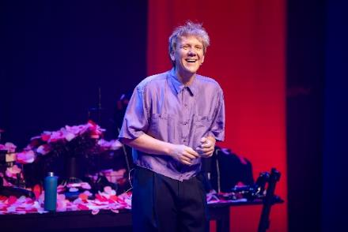
Josh Thomas
Image: Daniel Boud
MARCH
- The Canberra Comedy Festival:
- Canberra Comedy Festival Gala opening night
- Michelle Brasier Trilogy - Average Bear/Reform/Legacy
- Sarah Ison - You Laugh Therefore I am
- Chris Marlton - Mouthcave Helicopter
- Nick Schuller - Still Dry White
- Door to Door - One For Us, One For You: Australia’s Sexiest Sketch Comedy Show
- Chris Ryan - Good-O
- Jeff Shen, Mitchell Woolfenden, Fateh Singh - Cool Cats
- Jeffrey Charles, Anneli Cole, Dylan Holmes - Thirty Something
- Suma Iyer & Felix McCarthy - The Burden of Excellence
- Bronwyn Kuss - Pillows xxxx
- Nath Valvo - Anyway, back to me
- Mark Simmons - Quip off the Mark
- Koori Crack-Up
- Annabel Crabb - 50 odd Years of Crabb
- Anti-Experts - Wankernomics 2.0
- Geraldine Hickey - Don’t Tease Me About My Gloves
- Kirsty Webeck - I’ll be the Judge of That
- Felicity Ward - I'm Exhausting
- Sh!tfaced Shakespeare - MacBeth
- Jimeoin - Who's your man?
- Fern Brady - I Gave You Milk to Drink
- Tom Ballard - Good Point Well Made
- Rob Carlton - Willing Participant
- Wil Anderson - Wilegitimate
- Melanie Bracewell - Attack of the Melanie Bracewell
- Akmal - Red Flags
- Celia Pacquola - I'm as Surprised as you are
- Class Clowns 2024 - the national secondary school comedy competition
- The Animals 60th Anniversary - The Farewell Tour: Greatest Hits
- Cheap Trick & The Angels
- Long lost loves (and Grey Suede Gloves) (Musica Viva Australia)
- Afrique en Cirque! (pictured) (Global Arts)
- Shen Yun 2024 (Falun Dafa Association)
- Karen Jacobsen – Misogyny Opus
- James Bay
- Peter Garrett & The Alter Egos - The True North Tour
- Stunt Double (Performing Lines)
- Miriam Margolyes: OH MIRIAM!
- Séance and Flight (Darkfield)
- Wilco
- The Kings Singers (Snow Concert Hall)

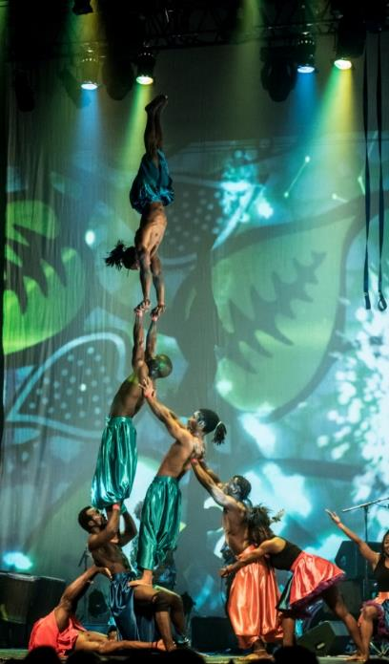
Afrique en Cirque
Image: Her Canberaa
Image: CTC

APRIL
- Potted Potter (Potted Productions)
- A Kind of Hush - The Magic of Karen Carpenter
- Missy Higgins - The Second Act Tour
- Myf Warhurst and Zan Rowe - Bang On Live
Bjorn Again
Image: Dara Nannis
- John Williamson
- The Michael Jackson History Show
- Dog Man: The Musical (CDP Productions)
- Spellbound (Base Entertainment)
- Co_Lab: 24 (Australian Dance Party)
- Reuben Kaye - Apocalipstik
- Shannon Noll - That’s What I’m Talkin’ About
- RBG: Of Many, One (pictured) (Sydney Theatre Company)
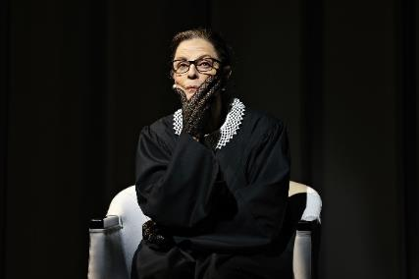
RGB: Of Many, One
Image: Prudence Upton
MAY
- Eireborne (Mellon Touring)
- Jessica Mauboy - Yours Forever Tour
- Fourteen (Shake n Stir Theatre Co)
- Gaslight (Newtheatricals)
- The World of Musicals in Concert (Rockitz Entertainment)
- Realm of a Poet - Shayar Sartaag Live
- Tom Gleeson - Gear
- Humans 2.0 (pictured) (Circa)
- Subject to Change (QL2 Dance)
- Joyce Yang (Snow Concert Hall)
- The Dollop Down Under 7
- Geoffrey Robertson AO, KC - How to Fix a Turbulent World
- Eric Bogle in concert
- Ari Shaffir: The Wrong Side of History
- The Guilty Feminist Live
- Beauty and the Beast (Victorian State Ballet)
- Bjorn Again (pictured) - The Waterloo Anniversary Tour
- Kaz and Jude's - Menopausal Night Out
- The River That Ran Uphill (Slingsby)
- ACT UP! 2024



JUNE
- Boney M - The Farewell Tour
- Rent (LPD Productions)
- A Midsummer Night’s Dream (Bell Shakespeare)
- Music at Midday (the Royal Military College Band)
- James and the Giant Peach (Shake n Stir Theatre Co)
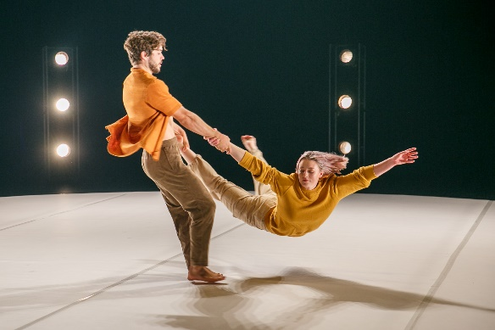

- Dirty Three
- Forest Song & Don Quixote (Grand Kyiv Ballet)
- Momenta (Sydney Dance Company)
- An Evening with Vika & Linda
- Reflections (Dance Northside)
- Melbourne International Comedy Festival
- TINA The Ultimate Tribute to the Queen of Rock n Roll

Humans 2.0 CIRCA
Image: Yaya Stempler

Galleries, Museums & Heritage - Exhibitions

JULY - DECEMBER
- *Stronger Together: Artists’ perspectives on the ACT COVID-19 frontline health response
- *Fly Fly! - Sidney Nolan's Birds
- *Karena Keys: Wanna Sip
- *How Cities Work
- Mr Fluffy: Our Voices
- Telopea Park School 100 Years
- Capturing Canberra - CMAG’s Press Photography Collection
- CMAG’s Secondary Students Art Prize Exhibition
- ACTHP Art Prize Exhibition
* Exhibitions previously also recorded in 2022-23 Annual Report.

- White-out: upcycled sheets to shirts from CIT Fashion School
- Tom Buckland: Bird Machine
- Nara - Canberra: 30 years of friendship (pictured)
- Madonna40: A Celebration
- Guns & Flowers. eX de Medici | Sidney Nolan
- eX de Medici: Pink for Boys
- On the Move
- John Robinson, and
- Canberra Museum & Games

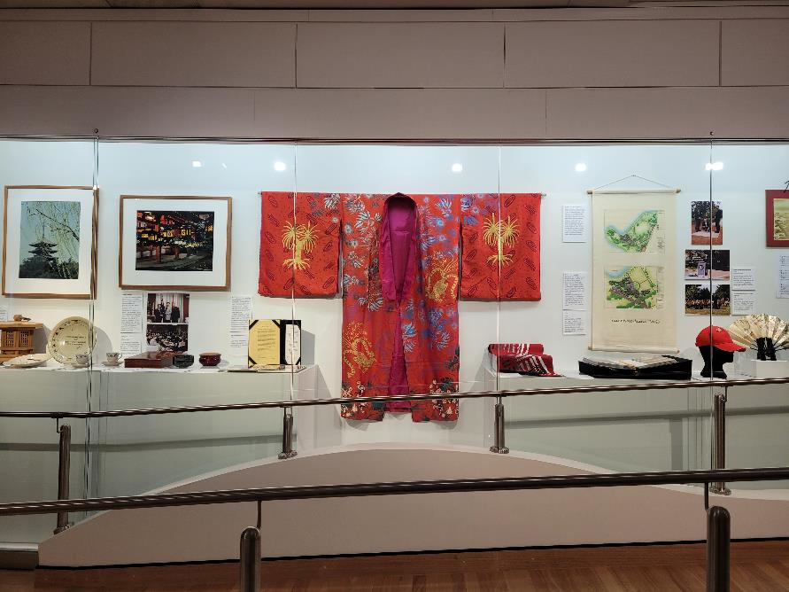

Nara - Canberra: 30 years of friendship
Image: GMH

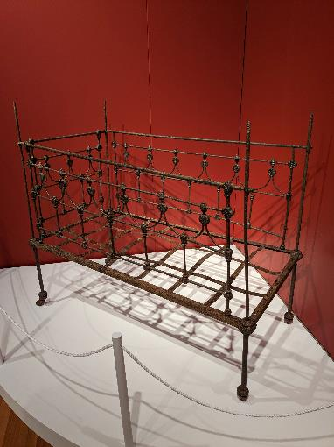

JANUARY - JUNE
- Stephen Harrison: The Sphinx Bureau (pictured)

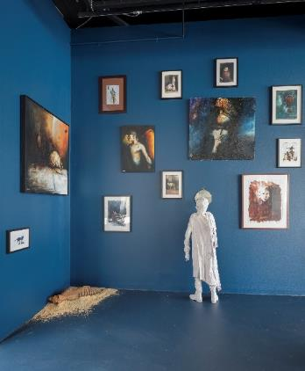
Stephen Harrison - The Sphinx Bureau
Image: GMH
- The Royal Australian Mint - Change: Stories from your pocket
- Duntroon Estate: Work with all your Might (pictured)
- Materiality… but not as we know it (pictured over)
- Backyard Archaeology

Duntroon Estate Work with all your Might
Image: CFC

- Riverbend
- Motoring in Canberra
- Madonna Pride Month
- Hannah Gason: Shades of Shadows, and
- Melbourne through the eyes of Mongolian artist Erdenekhuyag Dashorj.

Permanent Exhibitions
- The Nolan Collection
- Brian Corr: Timeshel
- Canberra/Kamberri: Place & People
- Jan Brown
- Calthorpes House re-interpretation and Sonic Suburbia Audio Stories
- Within Living Memory
- The Cunningham Family Album
- The Convict Years
- Getting it Together
- Calthorpes House Orientation Exhibition (updated in 2024)
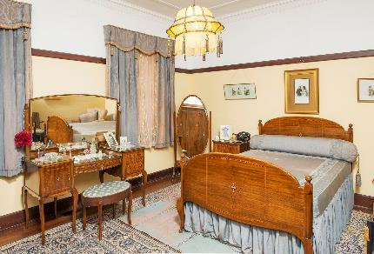
Calthorpes House
Image: GMH

Permanent Online Exhibitions
- Christmas for the Cunninghams
- Preserving the Past
- Happy 100th Birthday Dawn
- An Exciting New World at Calthorpes
- Duntroon Estate (launched 23 December 2023).

Activities in the Gallery conducted by artists, panels, CMAG staff and other experts in the field for the following exhibitions:

Activities and Events
- Sidney Nolan + eX de Medici: Guns and Flowers (pictured) - Launch with guest speaker Brigadier Alison Creagh AM CSC

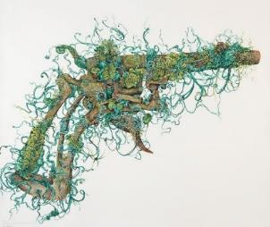
Sidney Nolan I eX de Medici:
Guns and Flowers
Image: GMH
- eX de Medici: Pink for Boys - exhibition Curator Virginia Rigney and writer and curator Dr Jennifer McFarlane on Nolan and the theme of firearms in Nolan and eX de Medici’s work
- In Conversation with eX de Medici for International Women’s Day
- Friends of the Drill Hall Gallery and CMAG Members Event with curators Tony Oates, Oscar Capezio and Virginia Rigney - Riverbend (pictured)
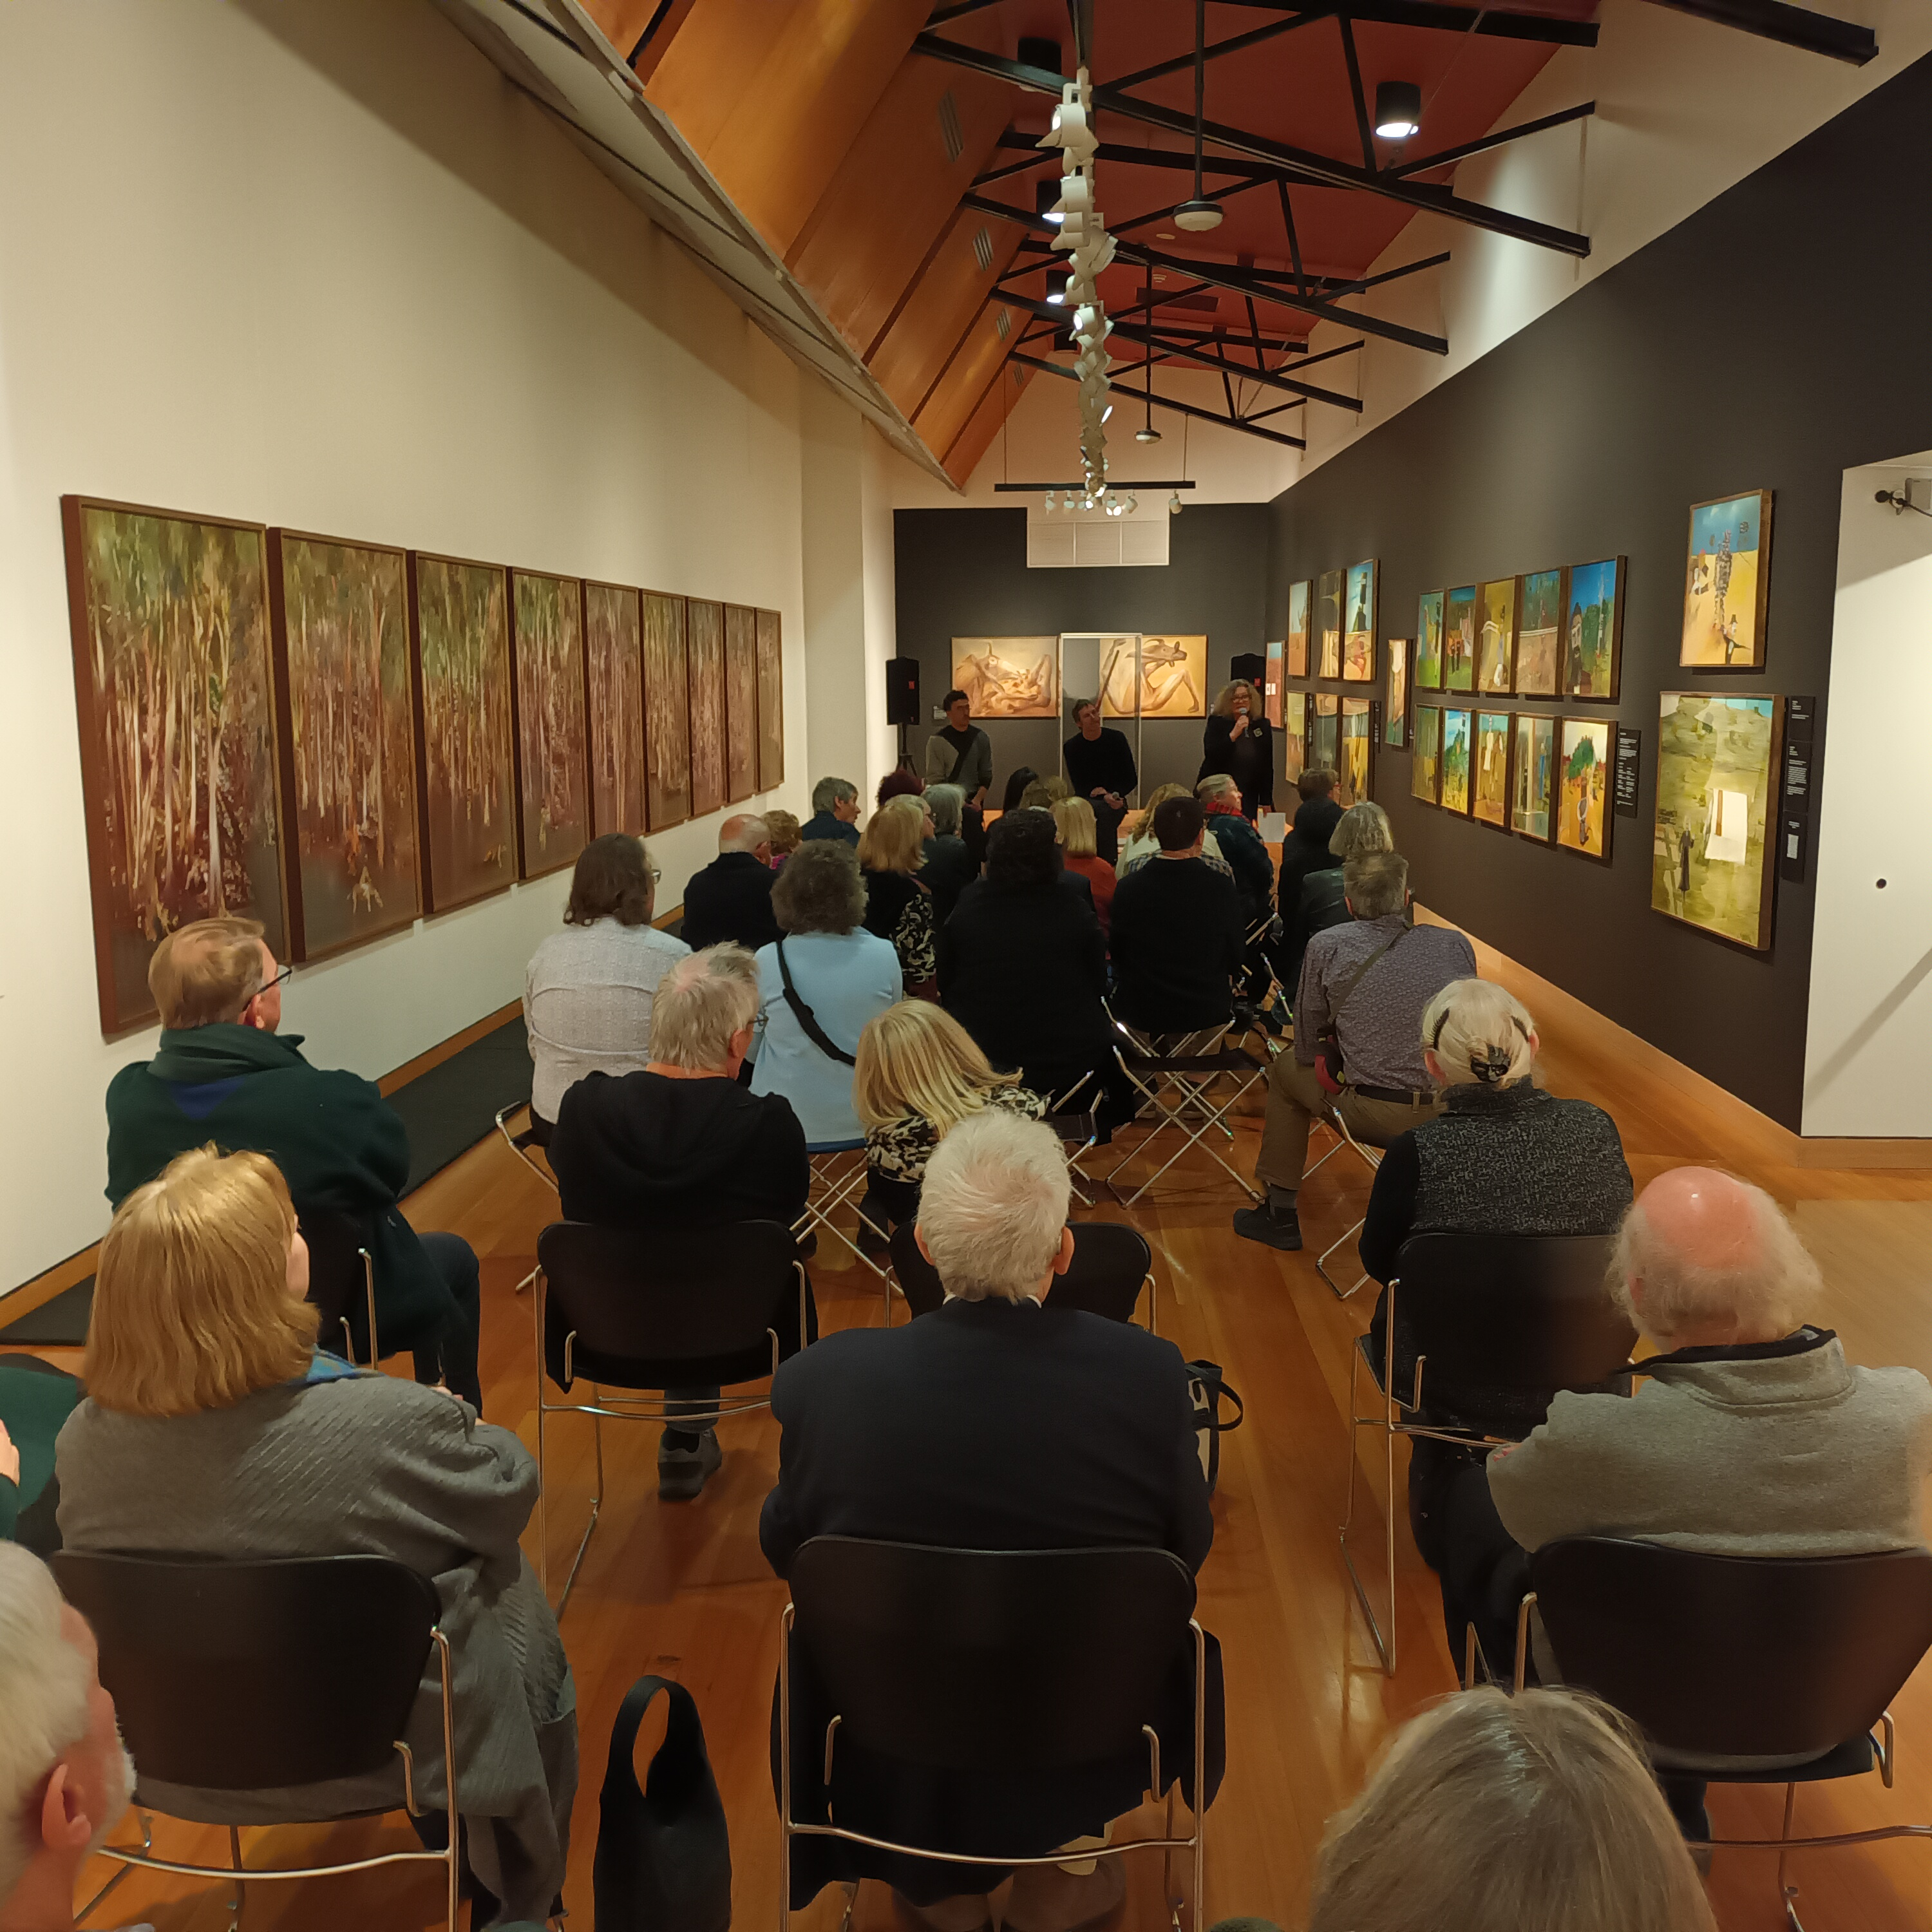
Riverbend Curators talk
Image: GMH

- In conversation: Nolan scholars Tony Oates, Oscar Capezio, Tim Bonyhady and Virginia Rigney
- Sidney Nolan: Search for Paradise - MakerSpace NedHead
- Queering CMAG, in partnership with SpringOUT Festival and queer artists May Fox and Gerald Jones
- Poetry Workshop: Flock of Words! Poetry and Art inspired by Sidney Nolan
- Wellness Event: Yoga in the Gallery
- Creative Workshop: For our Elders
- CraftACT Workshops
- Art Workshop: Pop Up City
- Art Workshop: Design your vehicle
- Drop-in Workshop: Build a City
- Finding Art Workshop 2: Festival of Everyday Art
- Reel Classics: Film Group - “The Searchers” (1956) and “The Insult” (2017)
- Snapping Canberra Kids Drop in Poetry Workshop
- Songs are Poems Lyric Writing Workshop
- Lucie in the Sky VIP Event
- Boho interactive Workshop
- Talk: Telopea Park School - 100-year Anniversary
- Reel Classics: Film Group - “Be Natural” (2018) and “Seven Brides for Seven Brothers” (1954)
- CMAG on Saturday
- CMAG Highlights Tour
- Self-Guided Tour - Marist College Canberra
- Creative Workshop: Flights of fancy ; Mariana del Castillo
- Reel Classics: Film Group - ”The Rules of the Game” (1939) and “The Spanish Prisoner” (1997)
- CMAG Secondary School Students Art Prize Awards
- Masterclass: Watercolour with Nicola Dickson
- School Holiday Workshop: Minecraft
- Reel Classics: Film Group - “The Ghost Writer” (2010) and “Ikuru” (1952)
- PHOTOACCESS COURSE: Black and White Darkroom
- Spring Out - Queer Elders Speak Event 1
- CMAG on Saturday - Sew What?
- EventsACT Symphony in the Park 2024 Launch
- Delegation from Malaysia
- Into the Groove - Madonna Dance Party
- Spring Out - Queer Elders Speak - Event 2
- Reel Classics: Film Group - “Come Back To The 5 & Dime, Jimmy Dean, Jimmy Dean” (1982) and “Road to Nhill” (1997)
- Spring Out - Queer Elders Speak Event 3
- Spring Out -Queer Elders Speak Event 4
- In Conversation: Madonna Pop Icon
- Screening: Desperately Seeking Susan
- National Multicultural Festival Children's Sanctuary
- Arts Up Front Conference - CKPP workshop
- Reel Classics: Film Group - “The Getaway” (1972) and “The Last Picture Show” (1971)
- Materiality Workshops with Lucy Irvine
- International Women's Day: Free Yoga class
- International Women's Day: Bold Bites Launch
- NGA Guides Talk
- CMAG on Saturday: Imagination into the World
- Reel Classics: Film Group - “The Last Days of Chez Nous” (1992) and “Rebecca” (1940)
- MintVentures at CMAG: People, Place, Portraits
- Heritage Festival - Duntroon Estate and its people
- Backyard Archaeology: Floor talk
- Materiality Curator: Floor Talk
- Reel Classics: Film Group - “The American Friend” (1977) and “Election” (1999)
- Artists' Floor Talk: Materiality…but not as we know it with Errol Evans, Trent Jansen, and Tanya Singer
- Stephen Harrison book launch
- ANU student program with Lucy Irvine
- Symposium on Backyard Archaeology
- Reel Classics: Film Group - “Heatwave” (2022) and “The Producers” (1967)
- Highlights Tour
- Materiality Artist's Floor Talk: Reconciliation Week event
- Materiality…but not as we know it: Exhibition opening and catalogue launch
- Nutbush event, and
- Reel Classics: Film Group - “The Naked City” (1948).

Lucy Irvine, Made of holes, 2016
Materiality…but not as we know it
Image: GMH

Appendix 5

Acquisitions (Purchases & Donations)

Canberra Museum & Gallery - Acquisitions (Purchases & Donations)
Purchases
Social History
- Blacksmith’s bellows with ‘prize medal’ marking on one side into wood, 1851
- 1970’s linen Canberra Bus Scroll, c. 1970s
- Alured Tasker Faunce Sterling Silver Service, eight items, 1789-1839
- Duntroon Wallpaper Reproduction, 2024
- Original Auction Site Plan, ‘Business & Residential Sites at Ainslie, Canberra, in the Federal Territory’
Visual Arts
- Colin Russell (b. 1958), Greetings from Canberra, screenprint
- Robert Emerson Curtis (1898-1996), Sketch for ‘VE Day Celebrations’, 1945, watercolour
- Hiroe Swen (b. 1934), Canberra Route, 1988, slab and coil-built stoneware
- Nancy Miller (1931-2023), Canberra from Mount Stromlo, water colour
- Harriet Schwarzrock, Chambered Pair blown studio furnace glass and mixed media. Purchased with funds from Meredith Hinchcliffe
- Paul Girrawah House, Ngambri/ Wallaballooa/ Pajong/ Wiradjuri (b. 1969), Gulamons, 2023-24, blown and cold works glass. Purchased with Funds from Meredith Hinchliffe
- Omar Musa (b. 1984) Bubu, 2024, woodcut ink on blackout cloth
- Joel Arthur, New Apartments, 2024, oil on linen. Purchased with funds from Meredith Hinchcliffe
Donations
Social History
- Studio 12 of Manuka from the Estate of Heather (Nicki) Paral
- Harold Cazneaux (1878-1953) Tumut NSW, c. 1927, silver galatin print, Gift of Gael Newton and Paul Costigan
Visual Arts
- Hannah Gason (b. 1980) Twelve Hours of daylight, 2023, Engineered glass and stainless steel, Donated by the Canberra Centre through a partnership with Canberra Glassworks in celebration of Floriade, 2023
- Norman Allen (active 1940s-1950s), Untitled (View towards Parliament House, Canberra). Gift of Stephen Carter, 2023
- Wendy Dodd (1946-2023) Keeping the goal in sight, 1994, space dyed thread
- Robert Foster (1962-2016), Perfume Bottle, Sterling Silver. Gift of Janene Pellarin

Note: In some cases, the acquisition process was being finalised as at 30 June 2024.

Appendix 6

The CFC enjoyed the continuing support of Government agencies and of several major sponsors, as well as the assistance of many donors and supporters during 2023-24. Without their generous support many of the CFC’s performances, exhibitions, programs, and events would not be possible.

Major Funding, Sponsorship & Support
Cultural Facilities Corporation Government Funding
ACT Government
Galleries, Museums & Heritage Funding
Commonwealth Department of Infrastructure, Transport, Regional Development, Communications, and the Arts.
Major Non-Government Support (over $10,000)
Meredith Hinchliffe
Supporters (up to the value of $10,000 and major in-kind support)
Ms Harriet Elvin
Ms Joan Adler
Contributions to the Canberra Region Treasures Fund 2014-2023

John Hindmarsh AM (former CFC Chair)
Louise Douglas (former CFC Chair)
Virginia Haussegger AM (former CFC Board Member)
Harriet Elvin (former CEO)
Dawn Waterhouse
Laura Cree
Maureen Fisher
John Mulvaney AO
Kerry-Anne Cousins
Koula Notaras
John Olsen OBE AO
Jody Turner
Frank Bergersen
John and Dianne Firth
Dr Howard Galloway
Dr Charlotte Galloway
Rosanna Burston
Phoebe Bischoff OAM
Robyn A Duncan
Lady D Yeend
Jacqueline Pinkava
Estelle Barnes
Bill and Beverley Wood
Dorothy Cameron
Marian Hill
Judith Bibo
Gabrielle Watt
Karina Harris and Neil Hobbs
Dr Roslyn V Russell
Kristine Reithmiller
Joan Adler
Paul G White PSM
Dr Mark Lax
Lynette Henderson
Ms Marian Hill
Richard Rolfe

Canberra Theatre Centre
Supporters (up to the value of $10,000 and major in-kind support)
Ms Helen O’Neil
Mr Gordon Ramsay

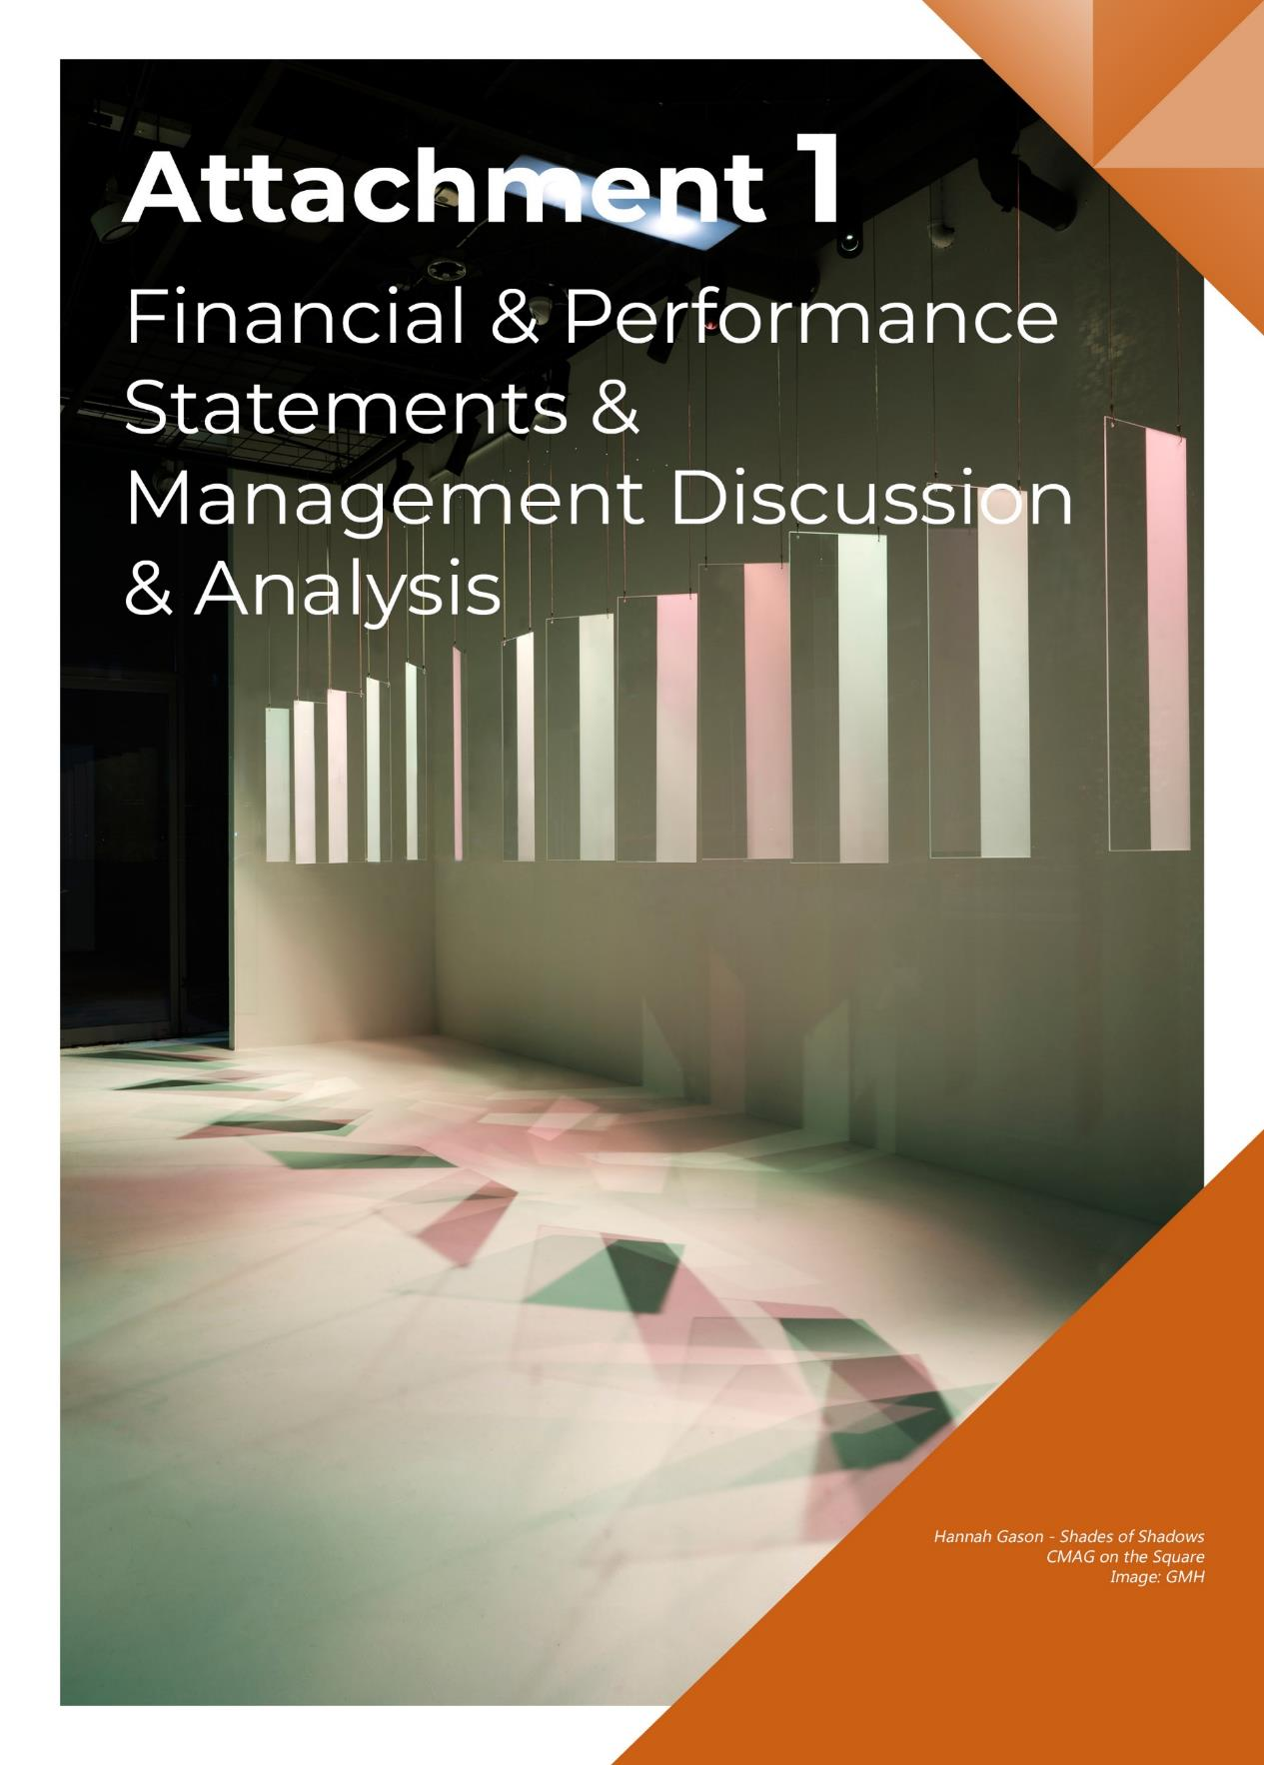

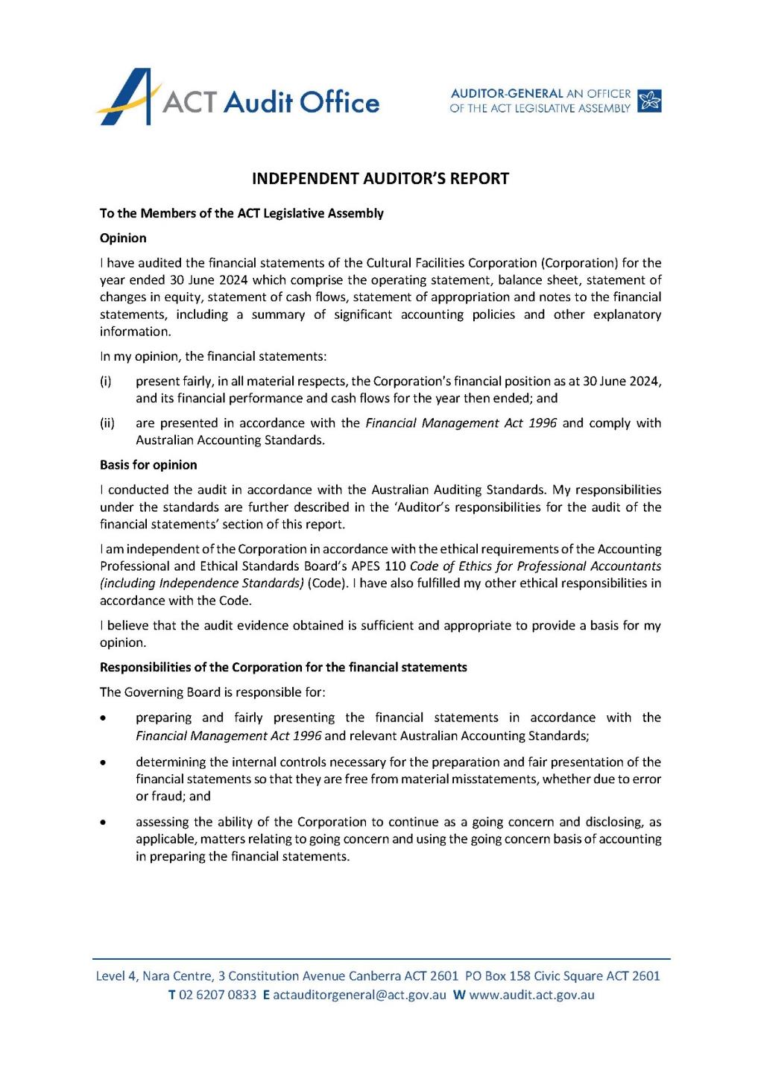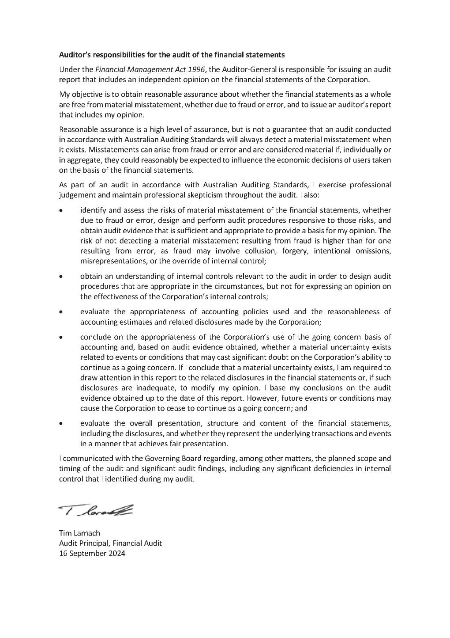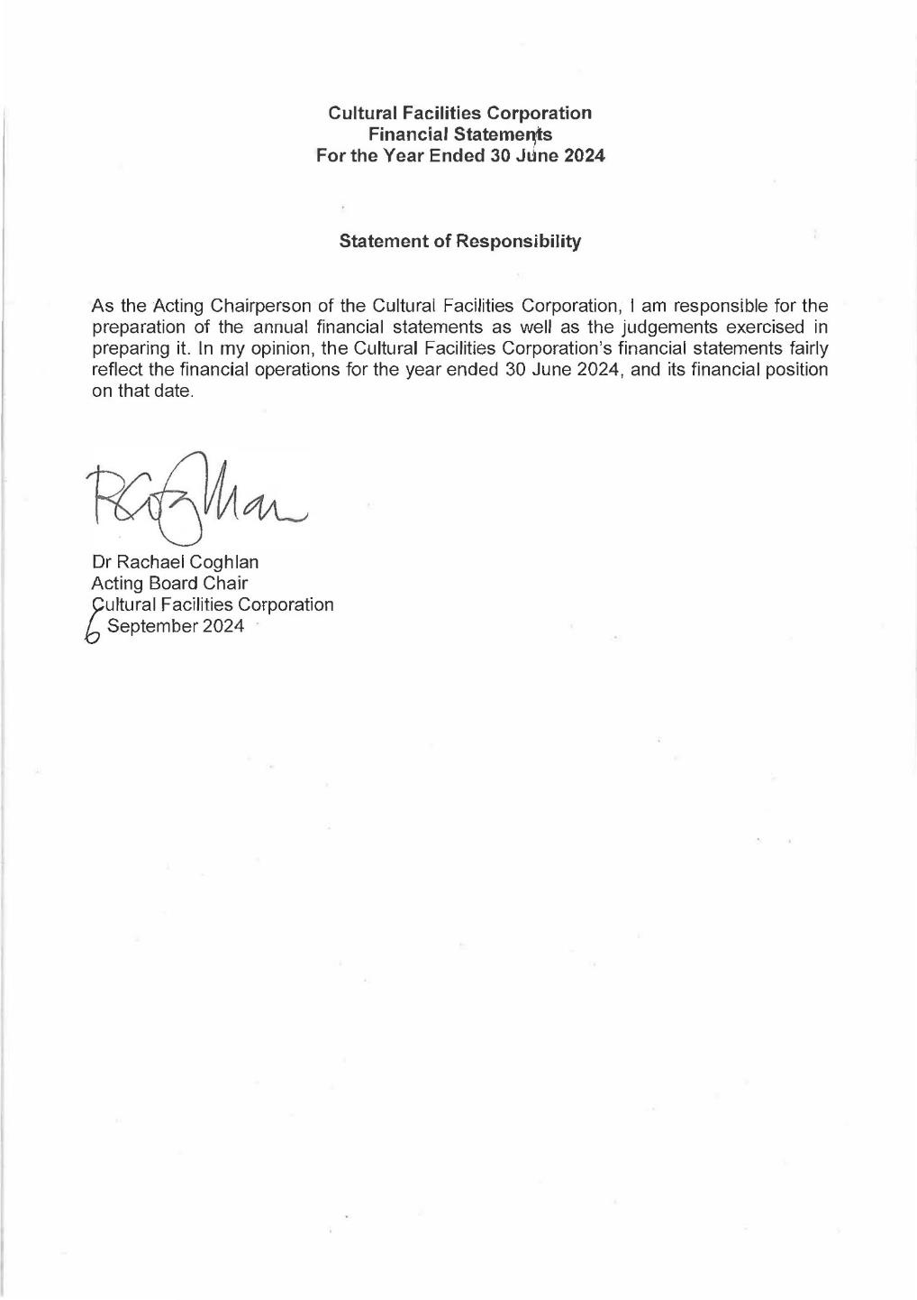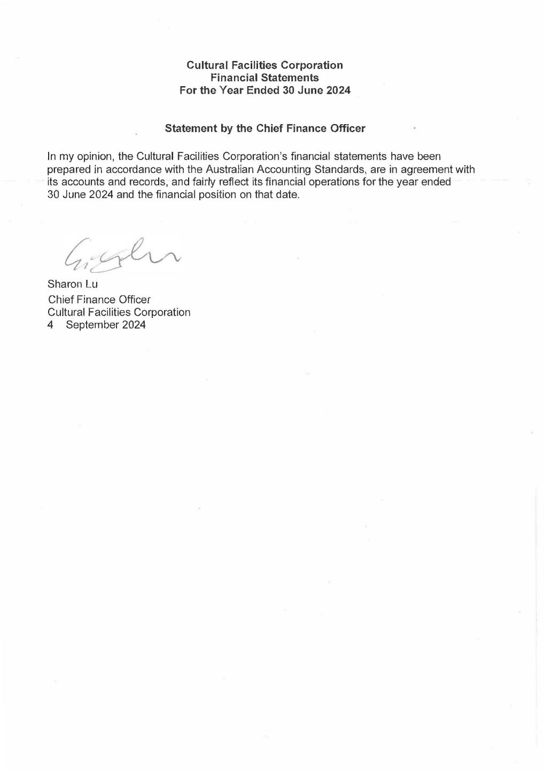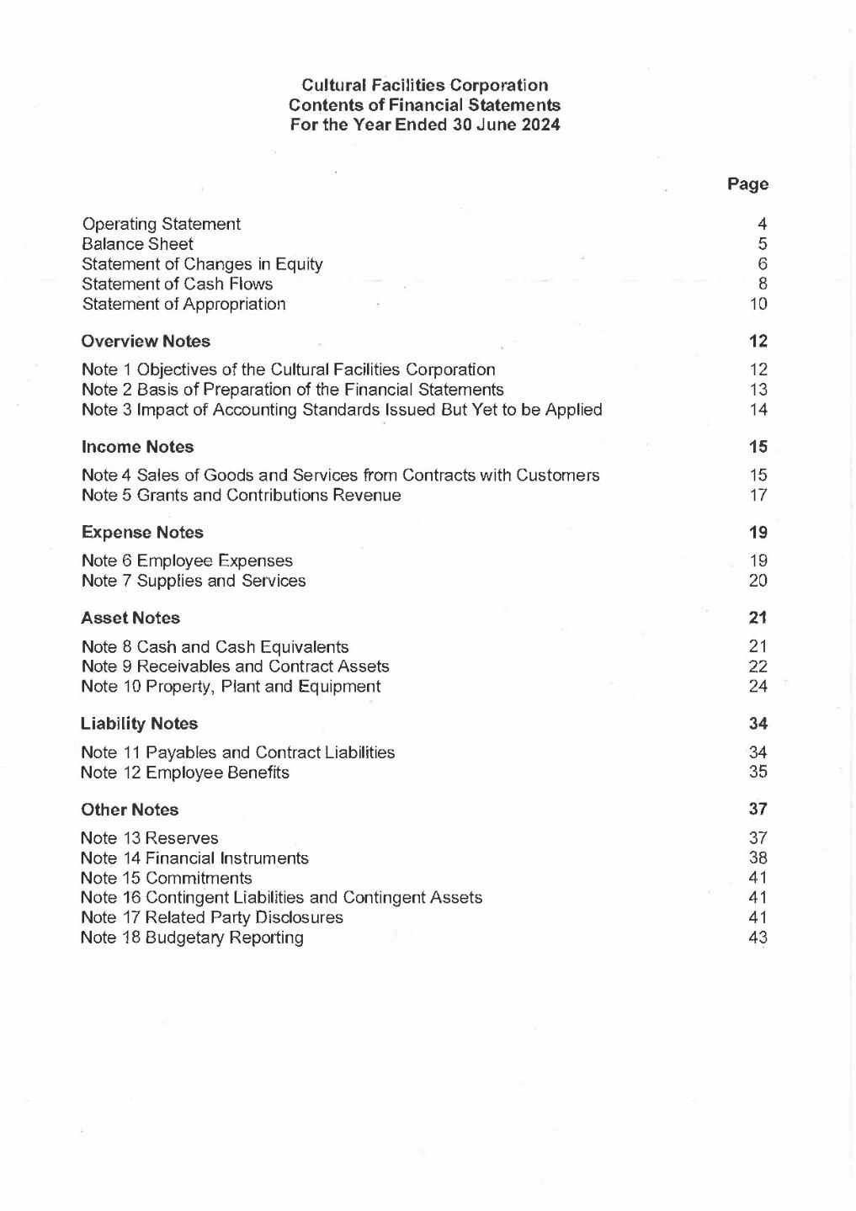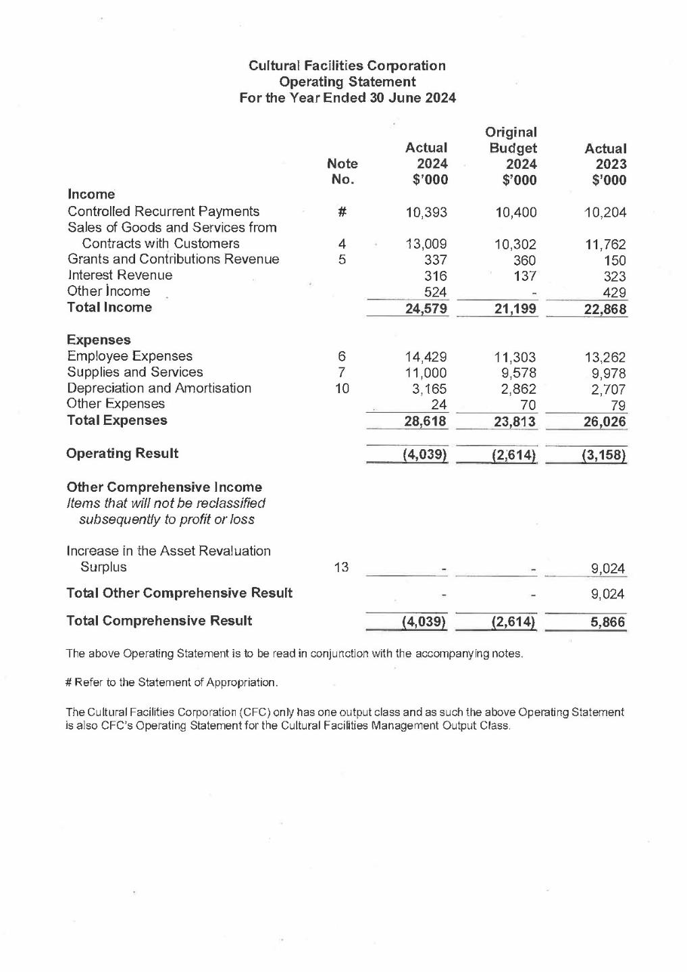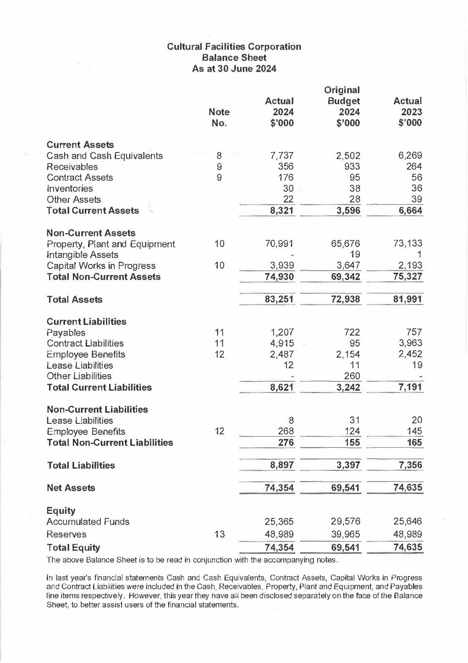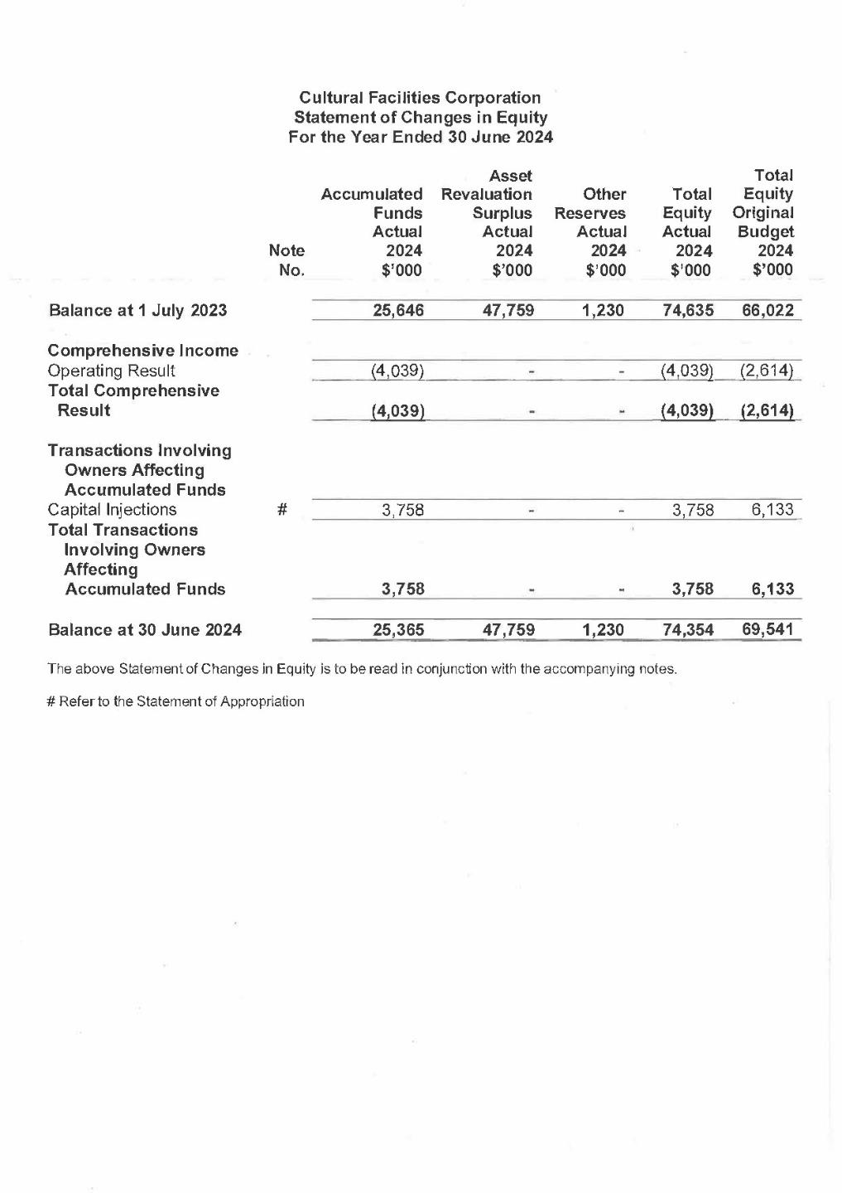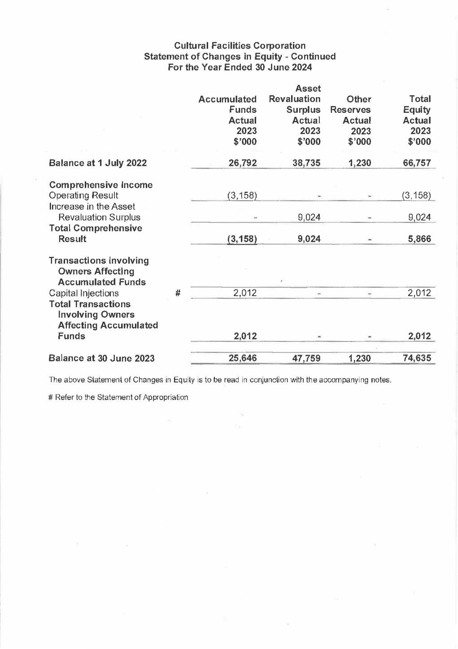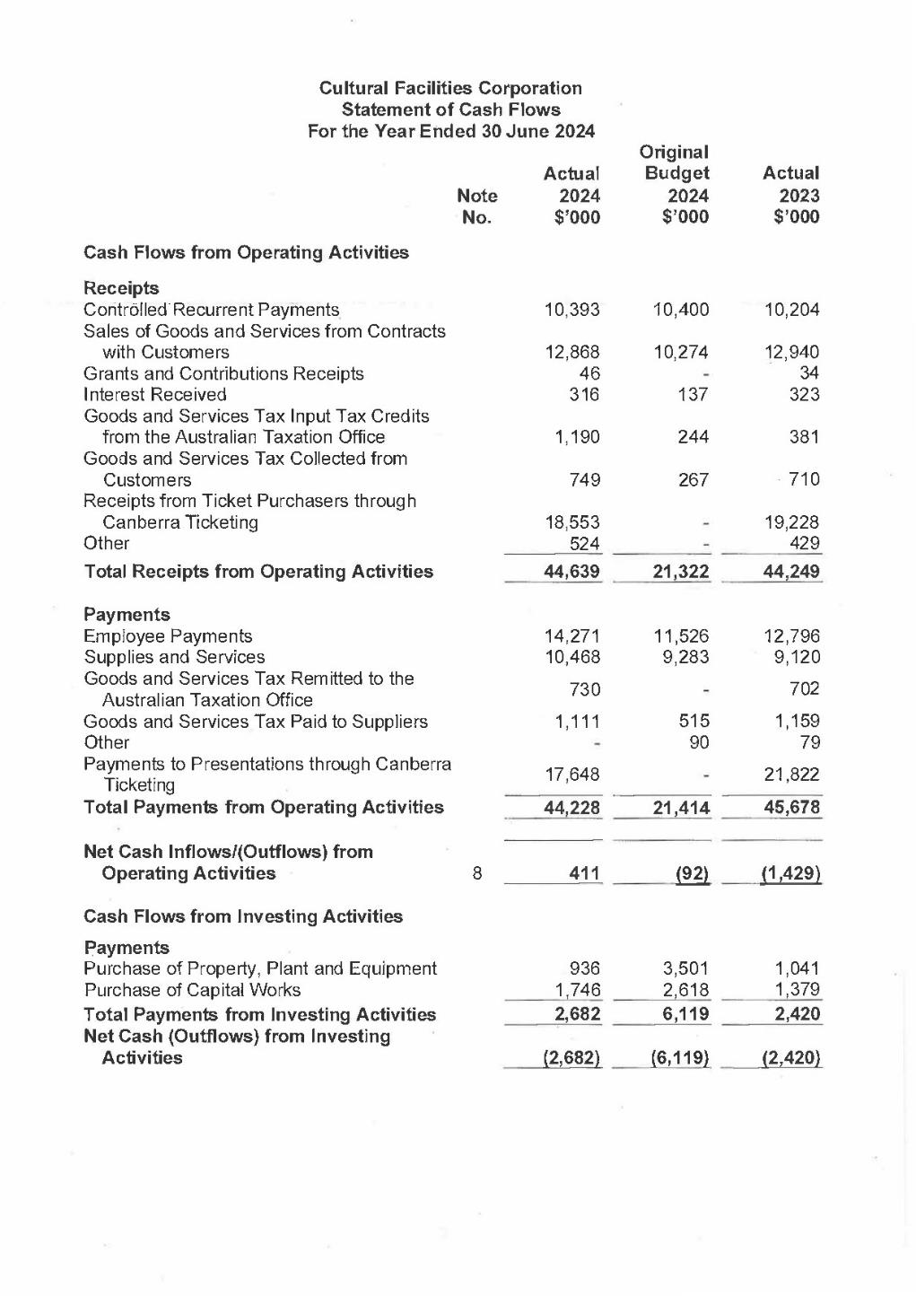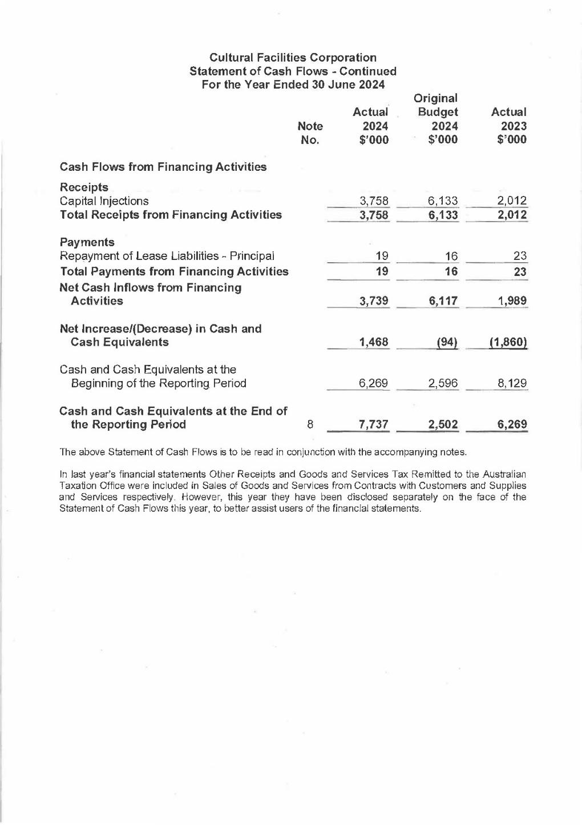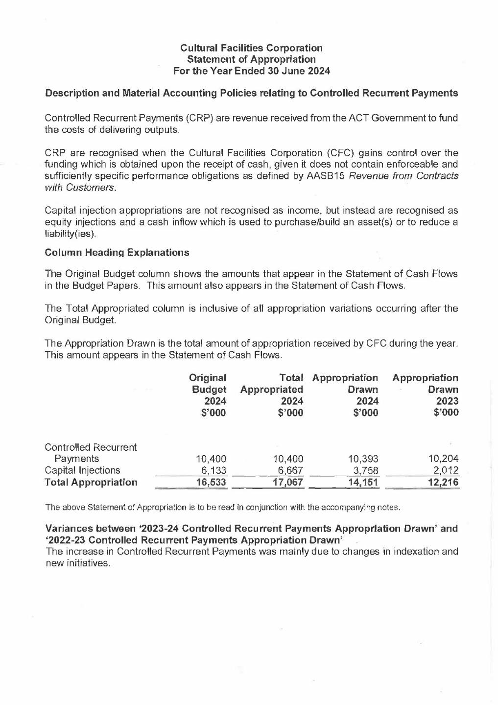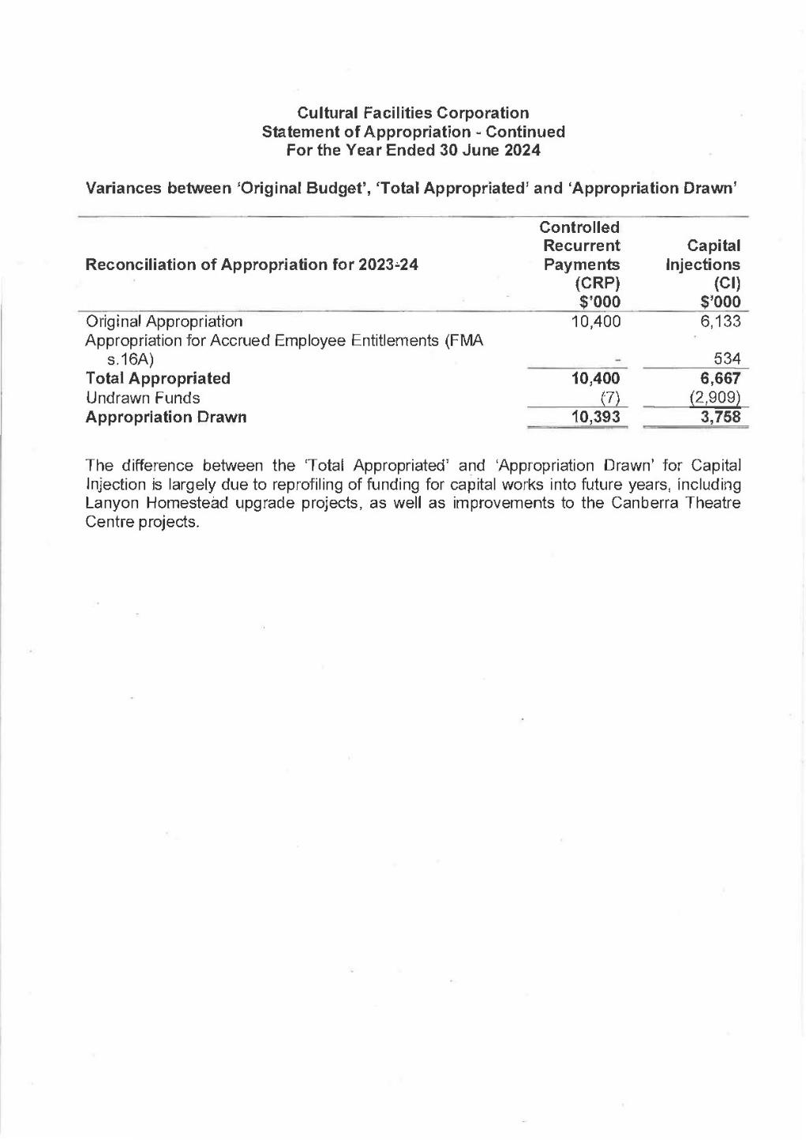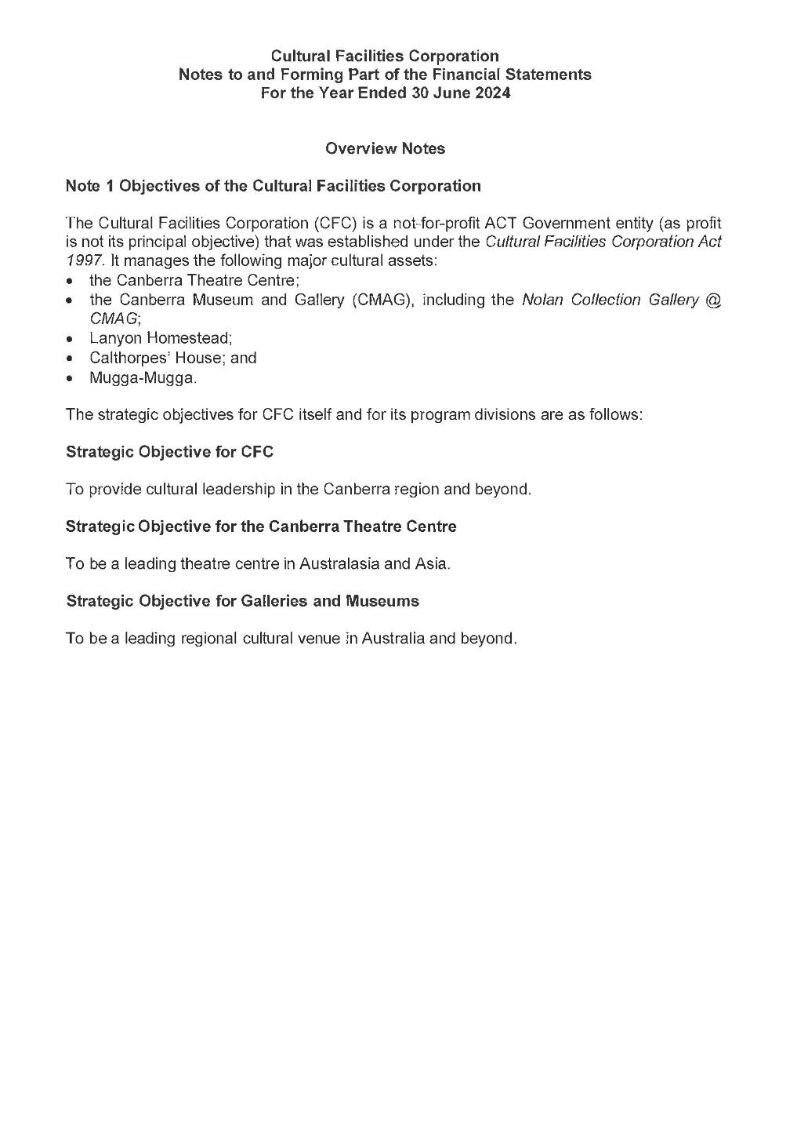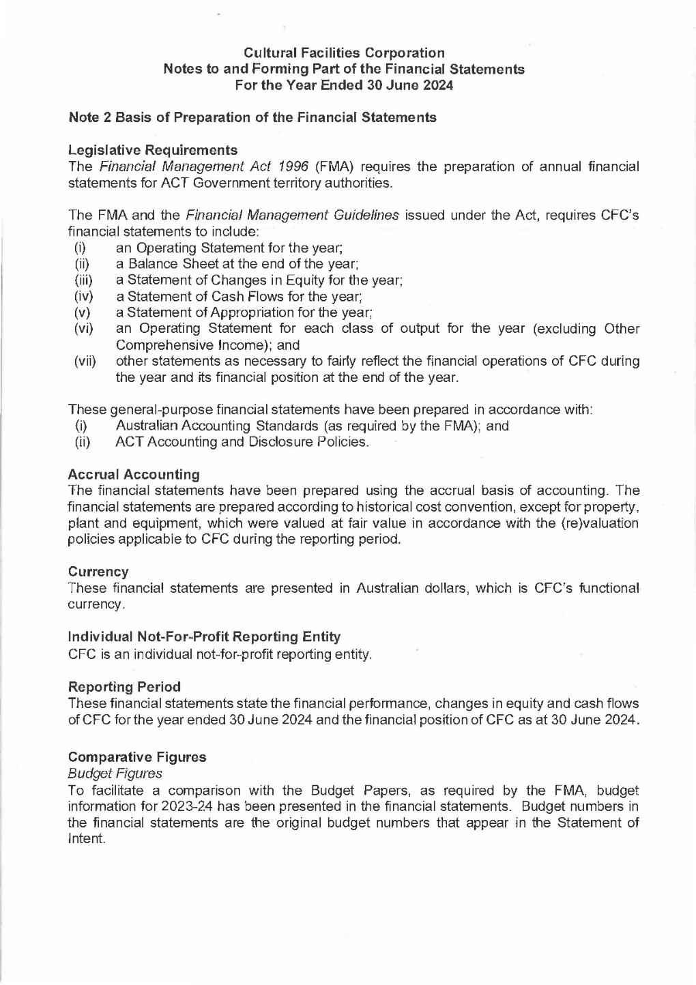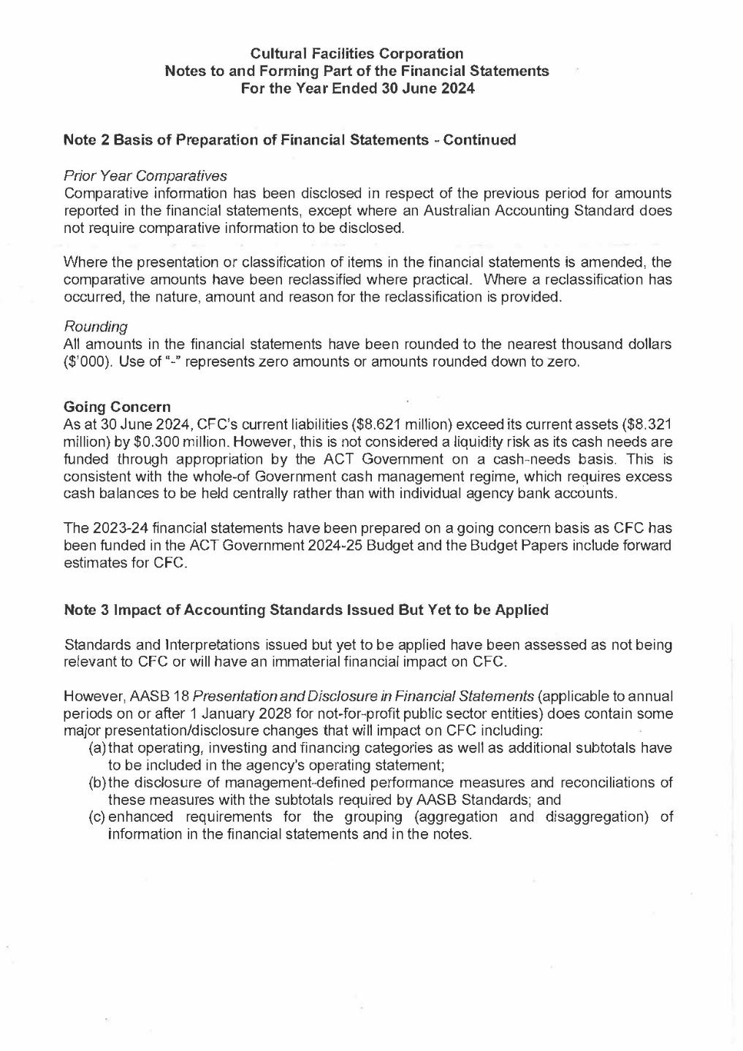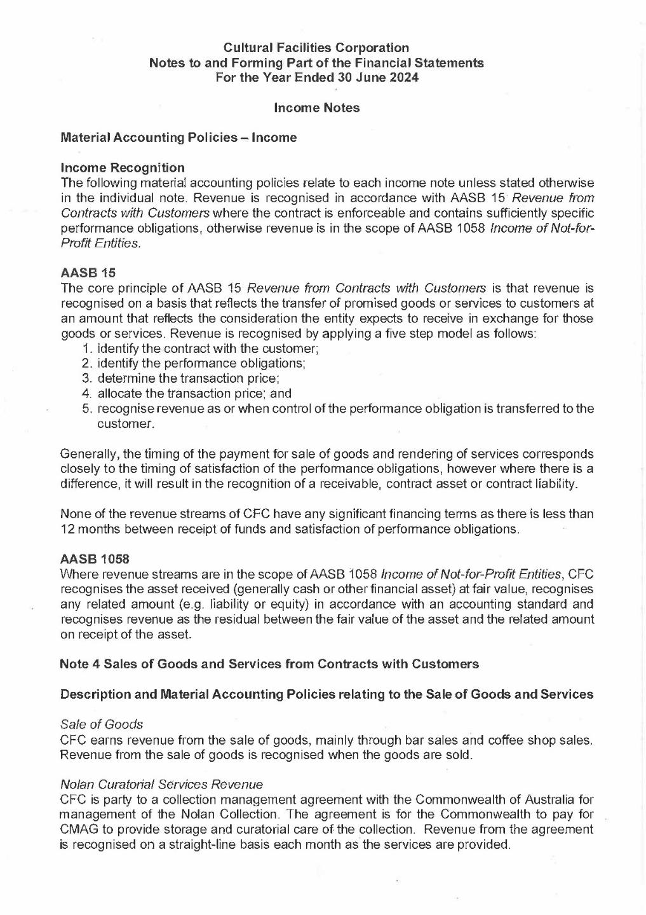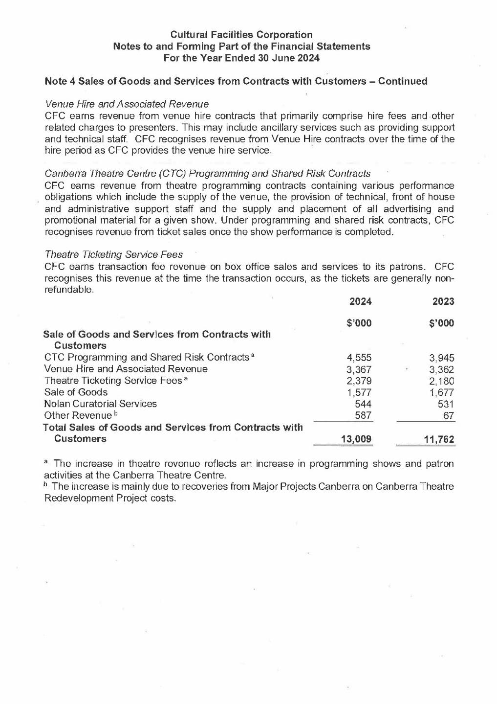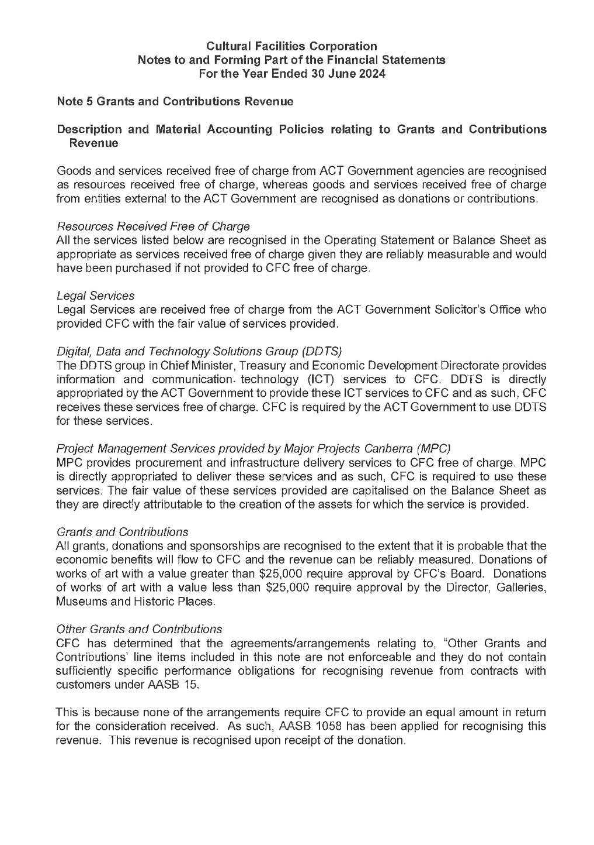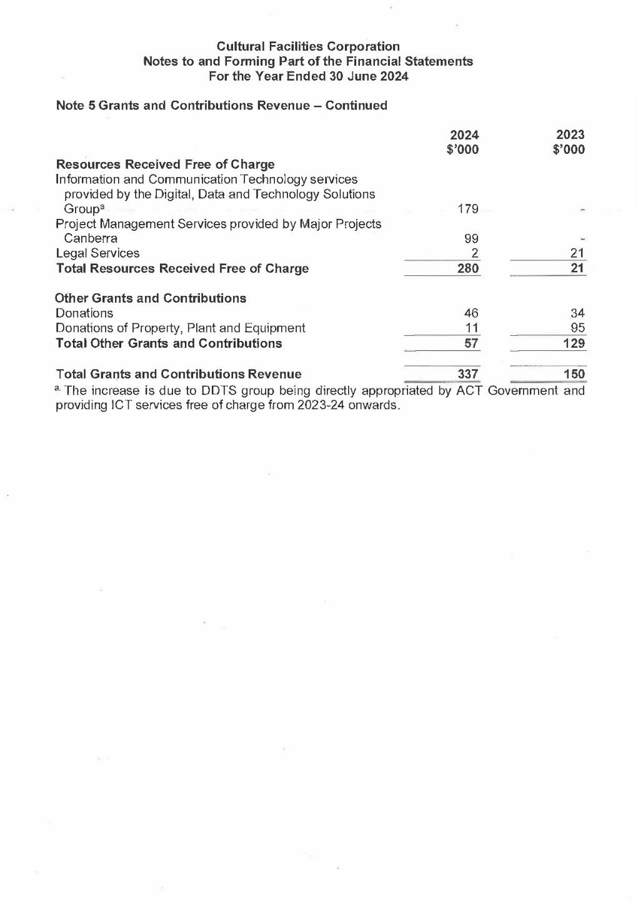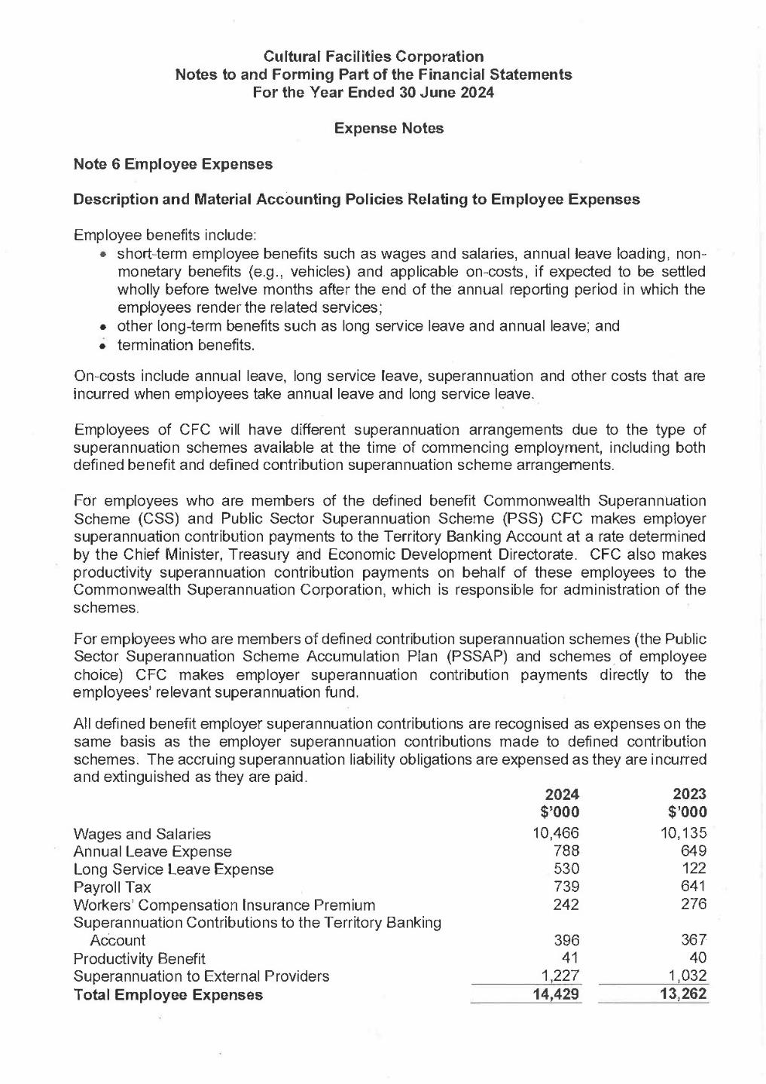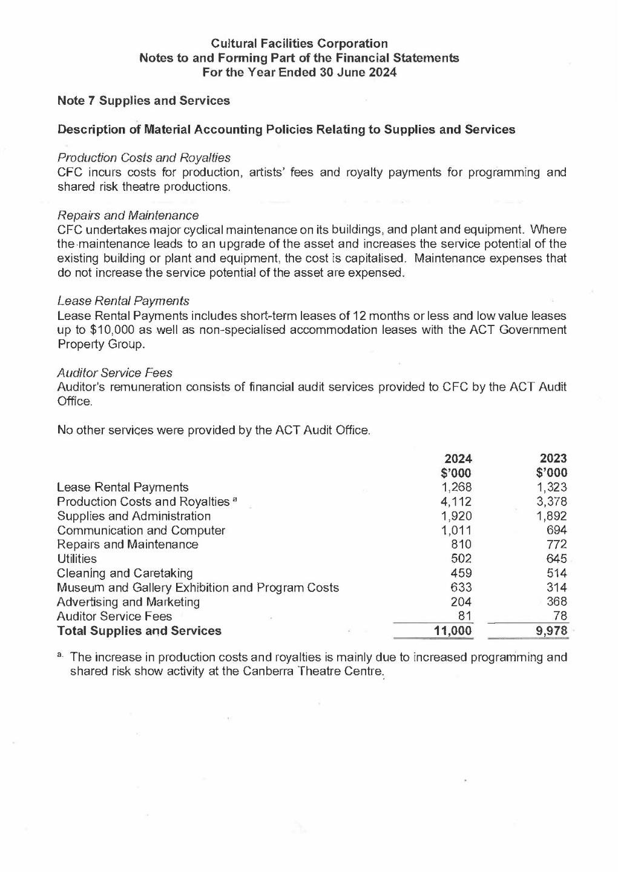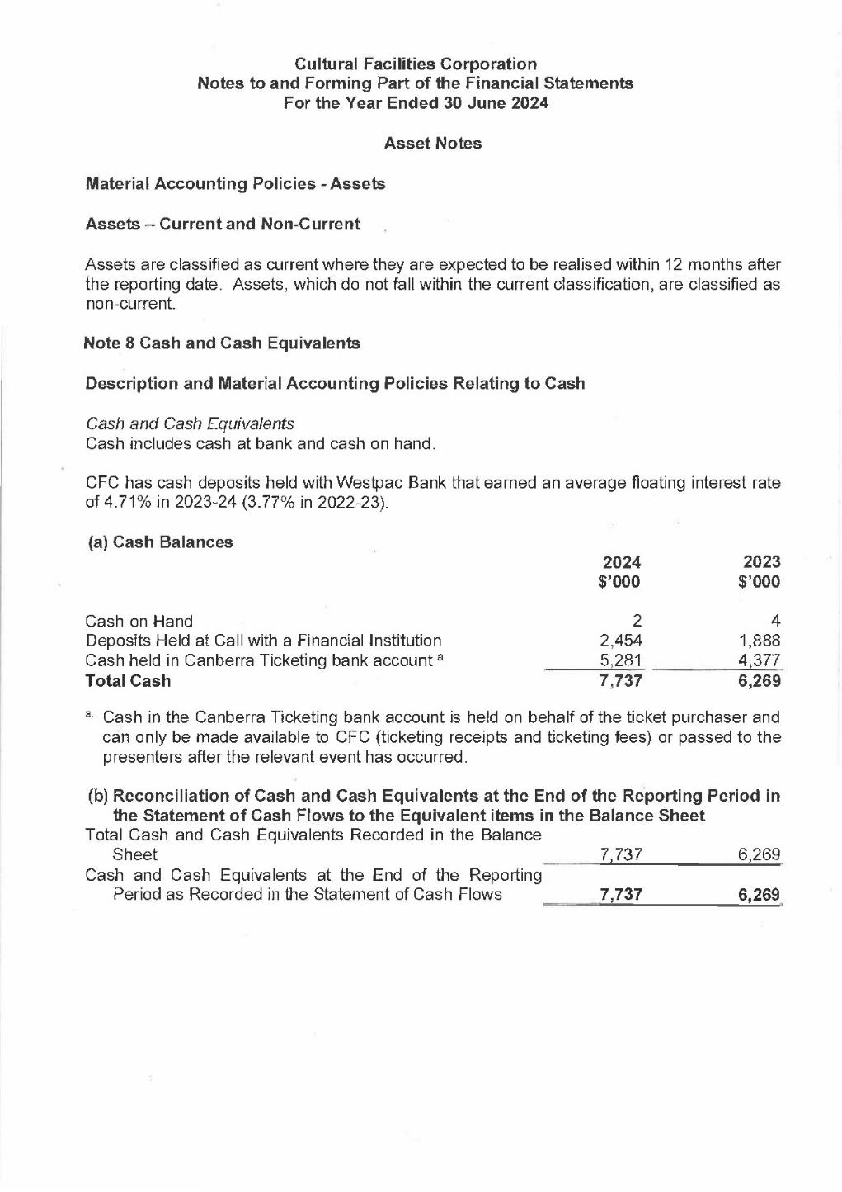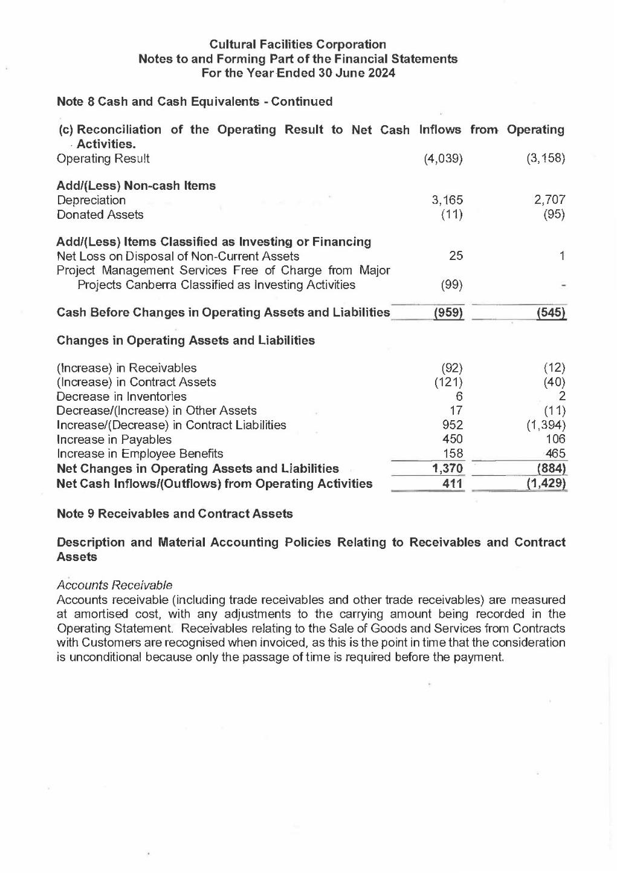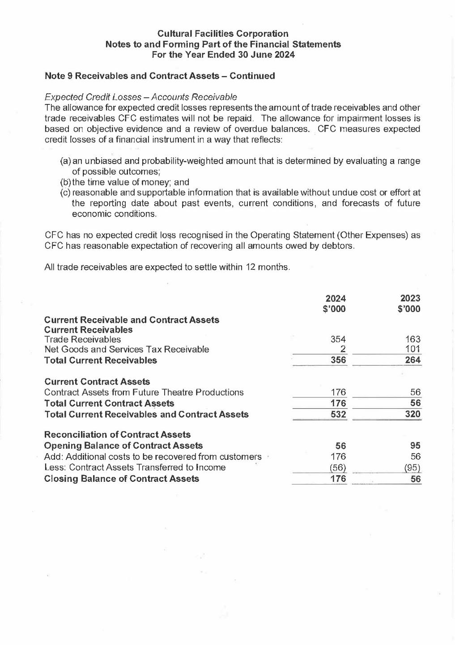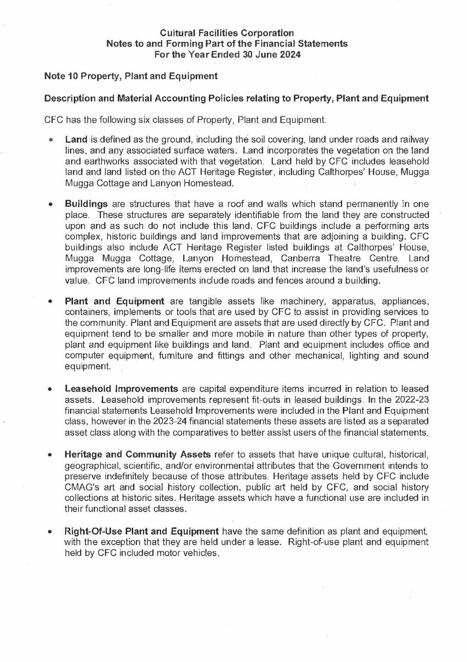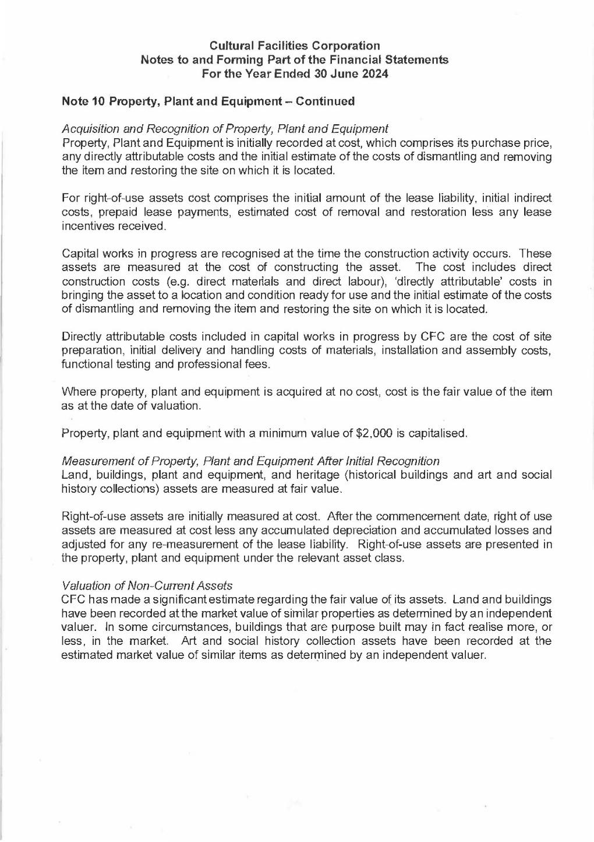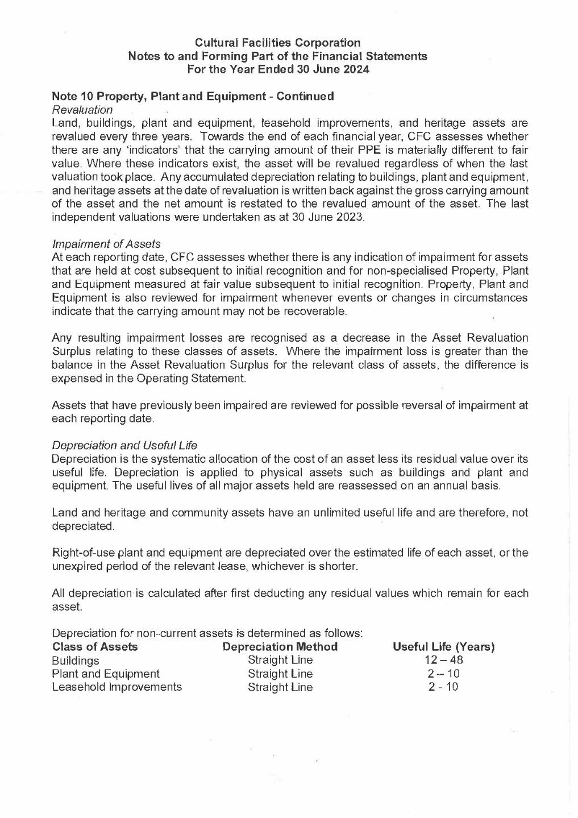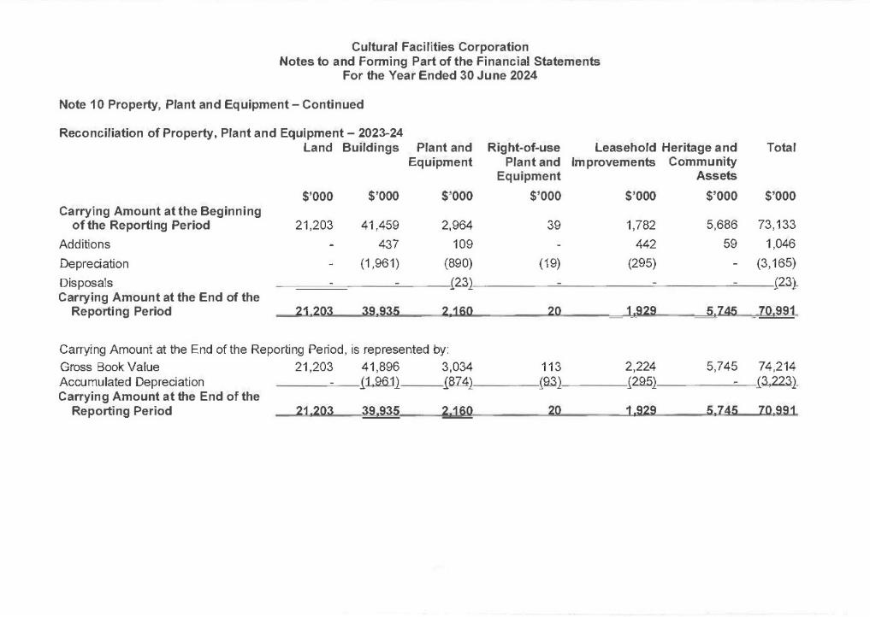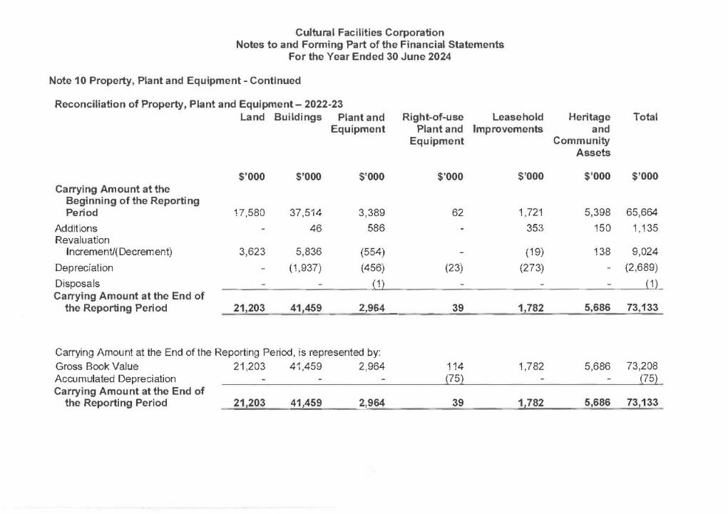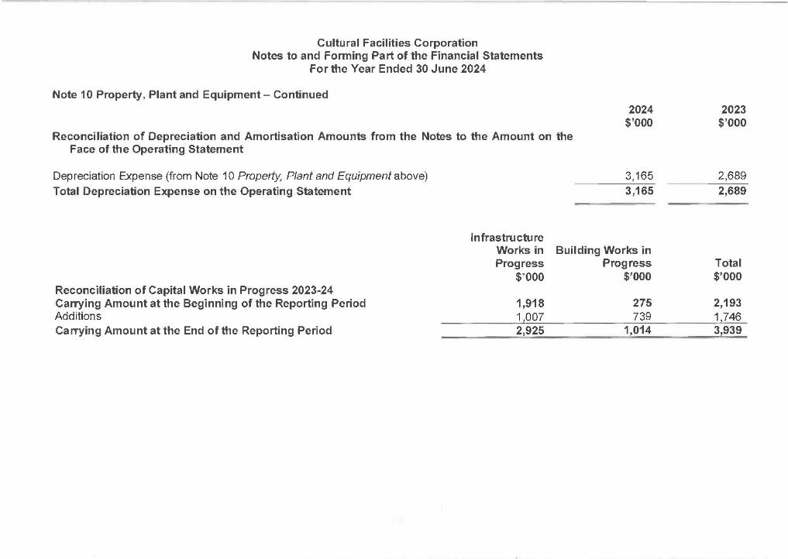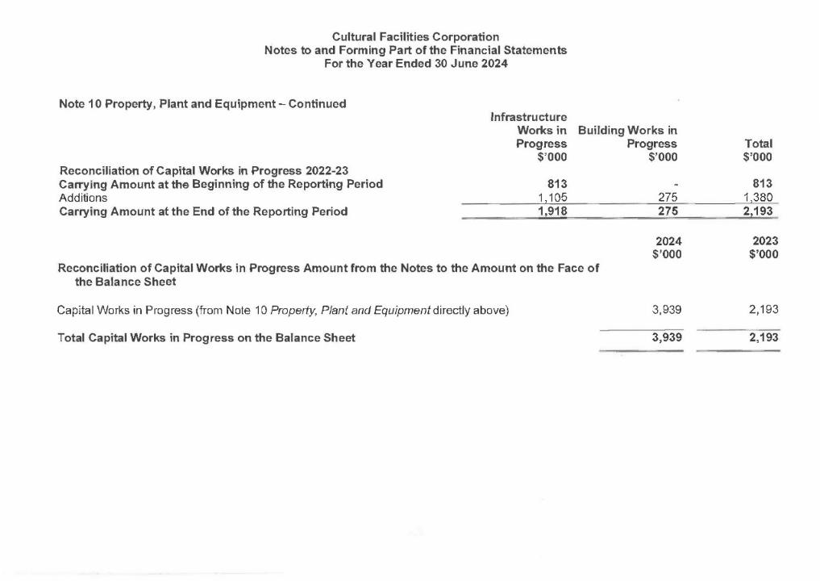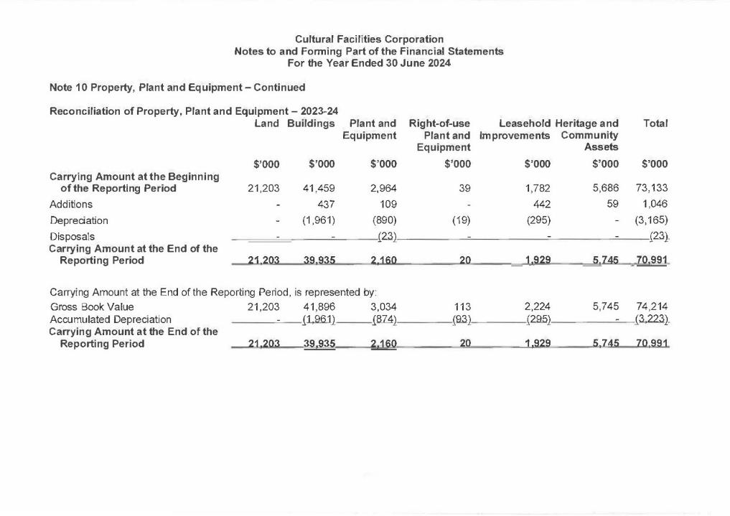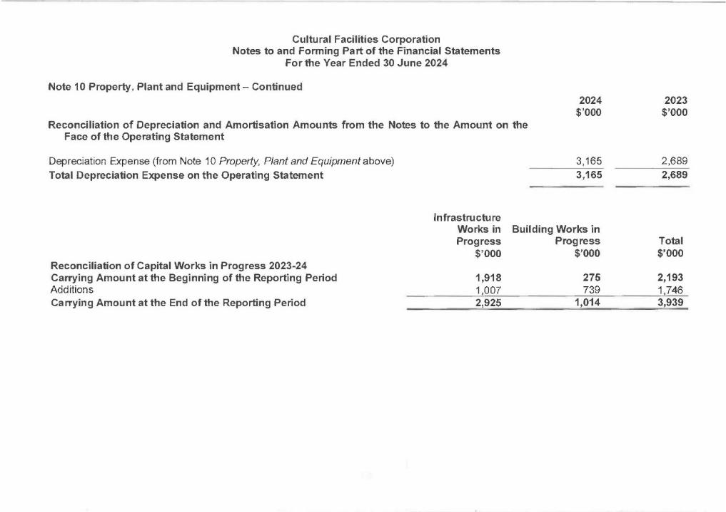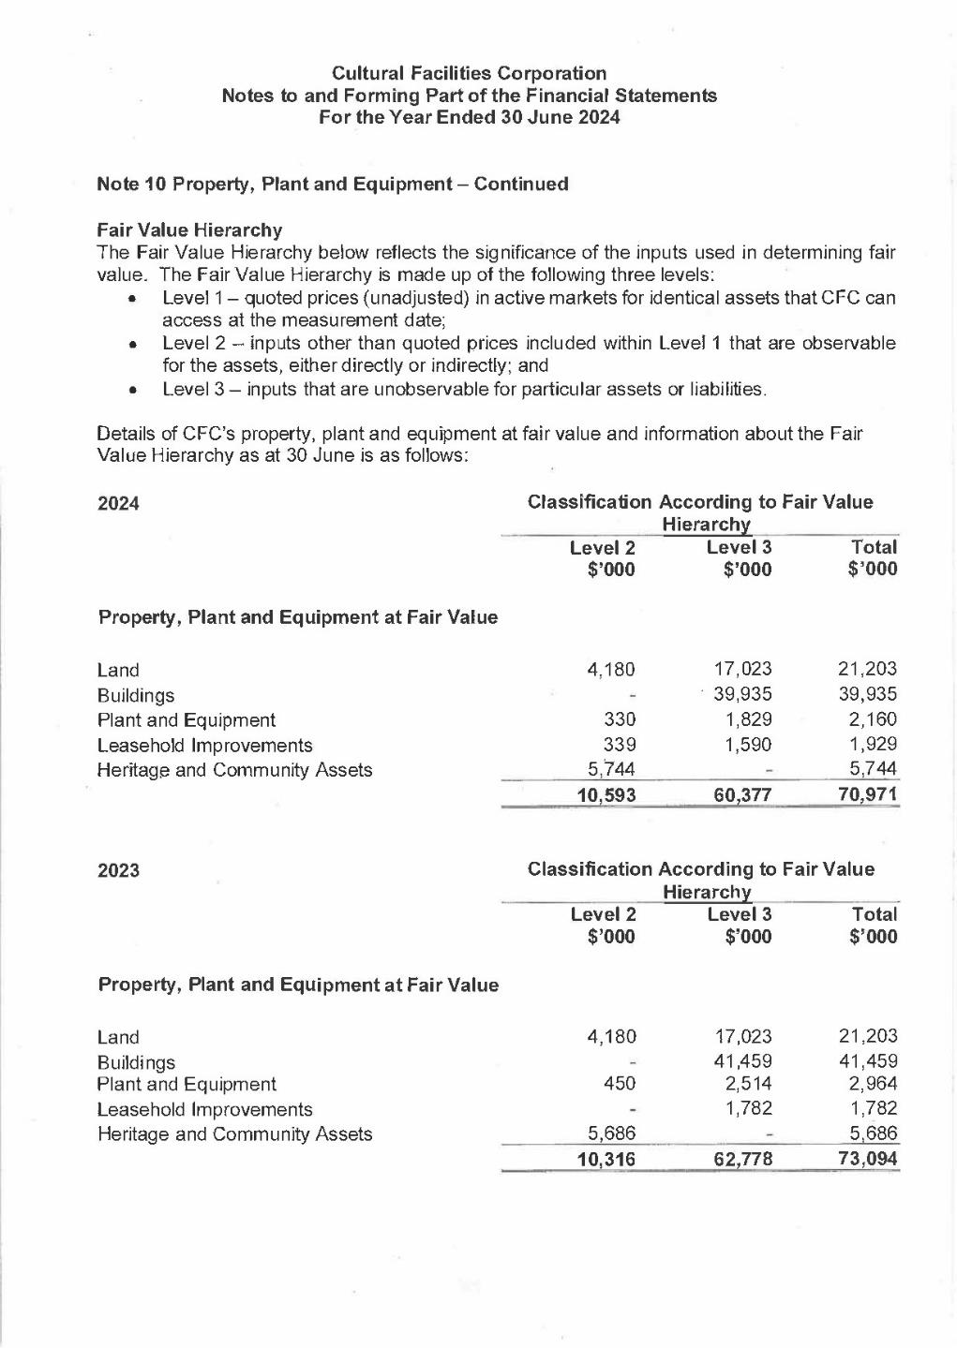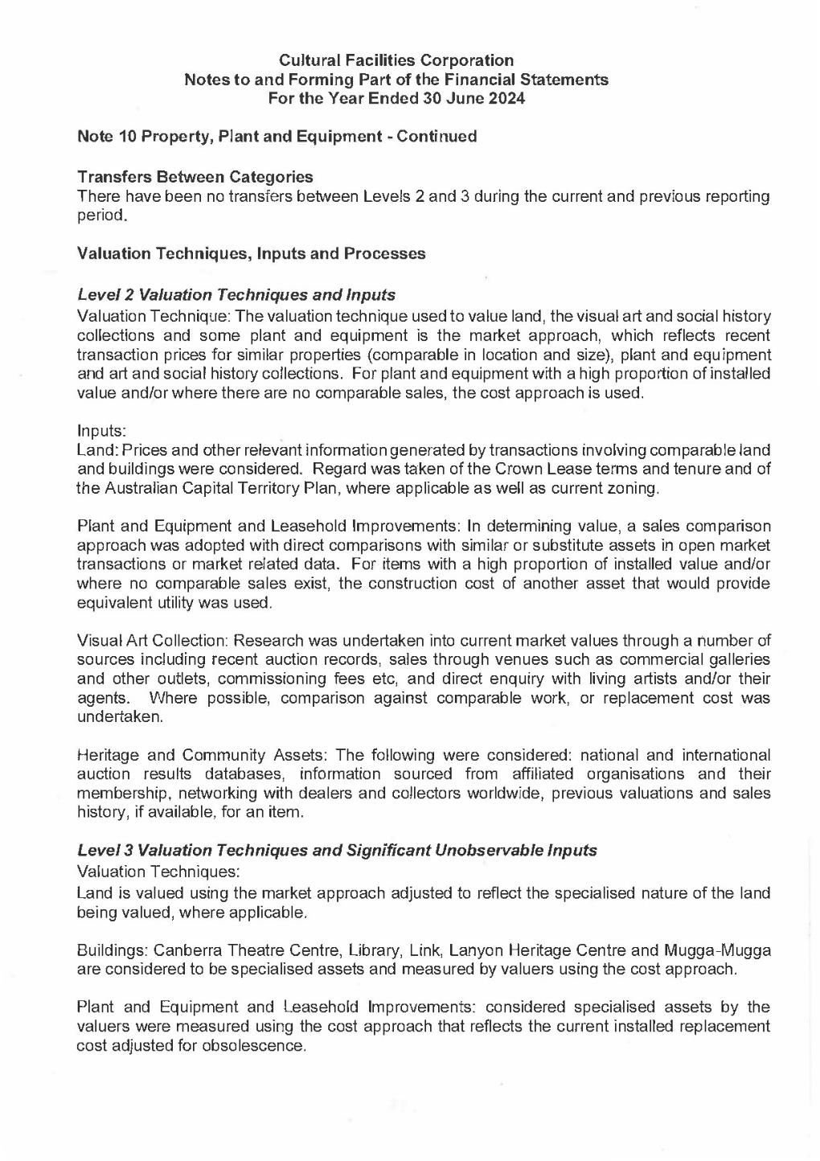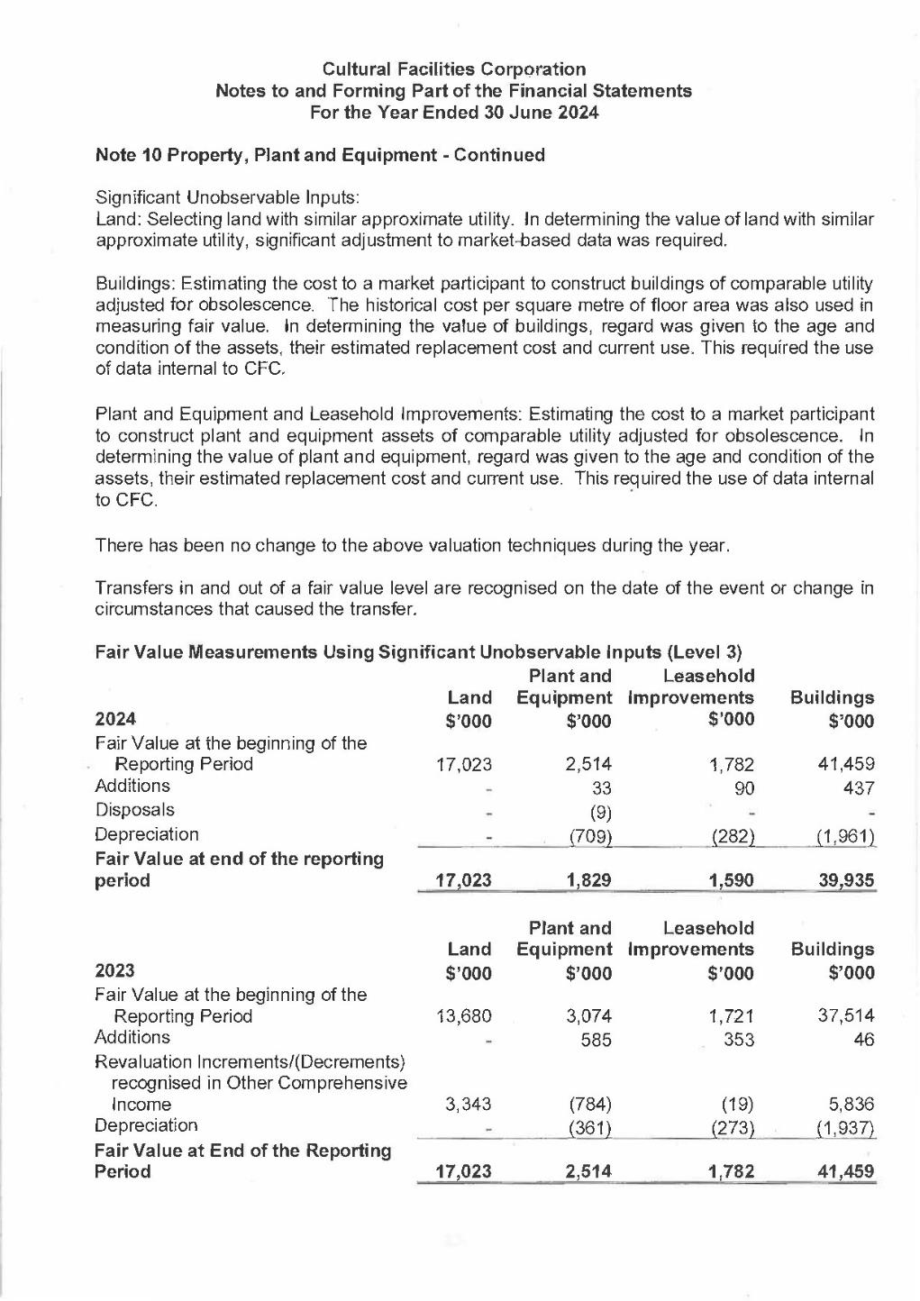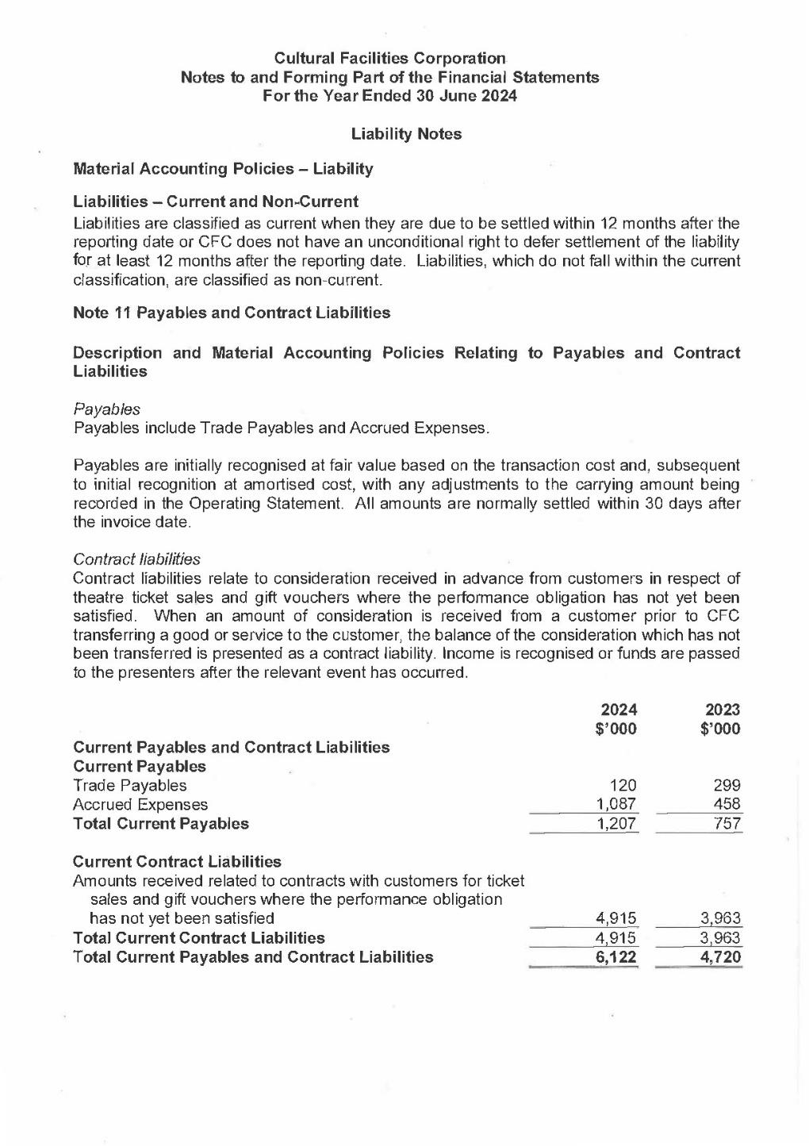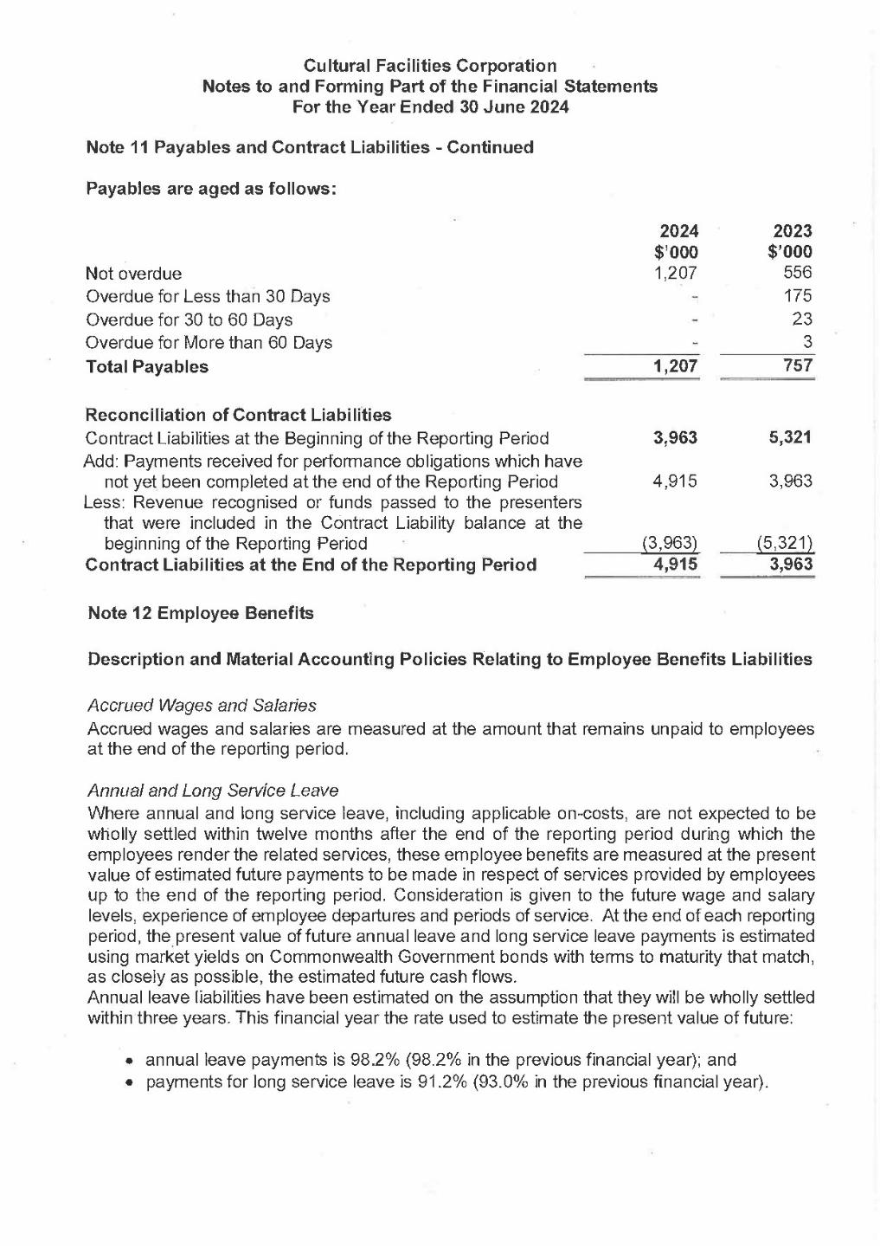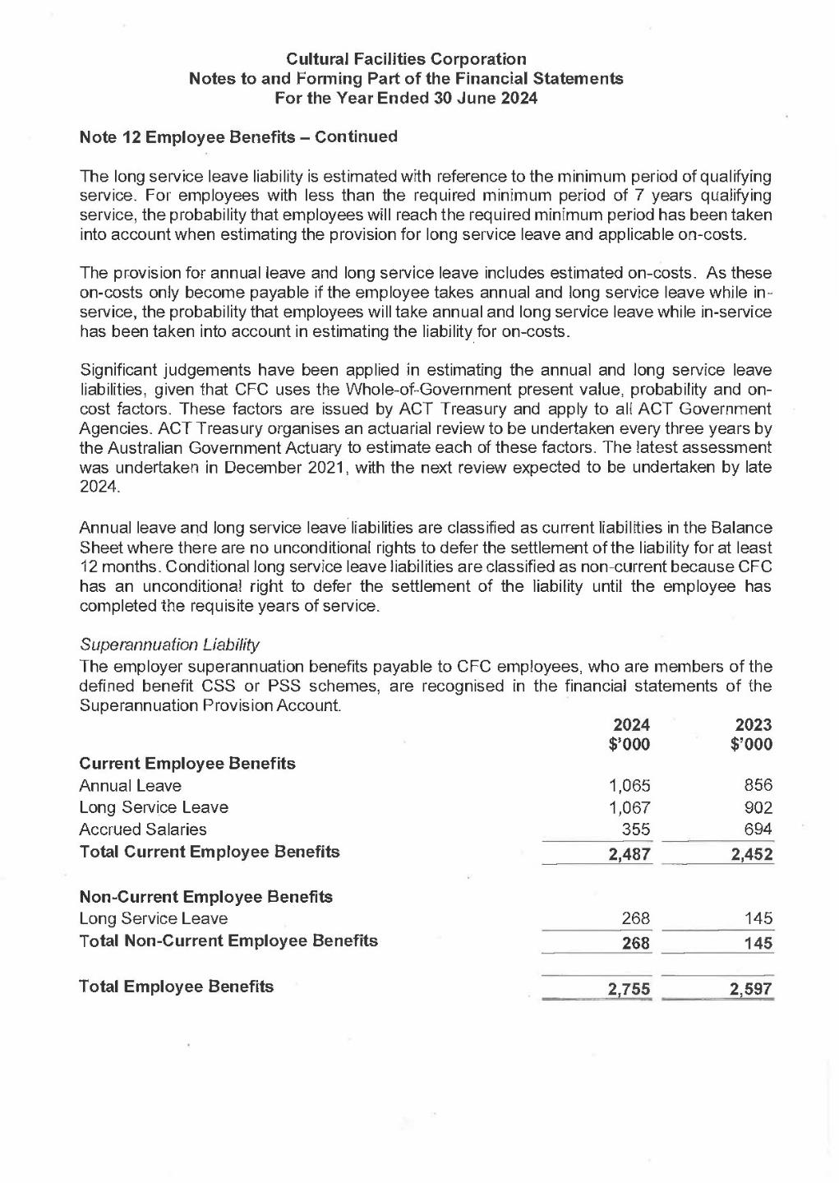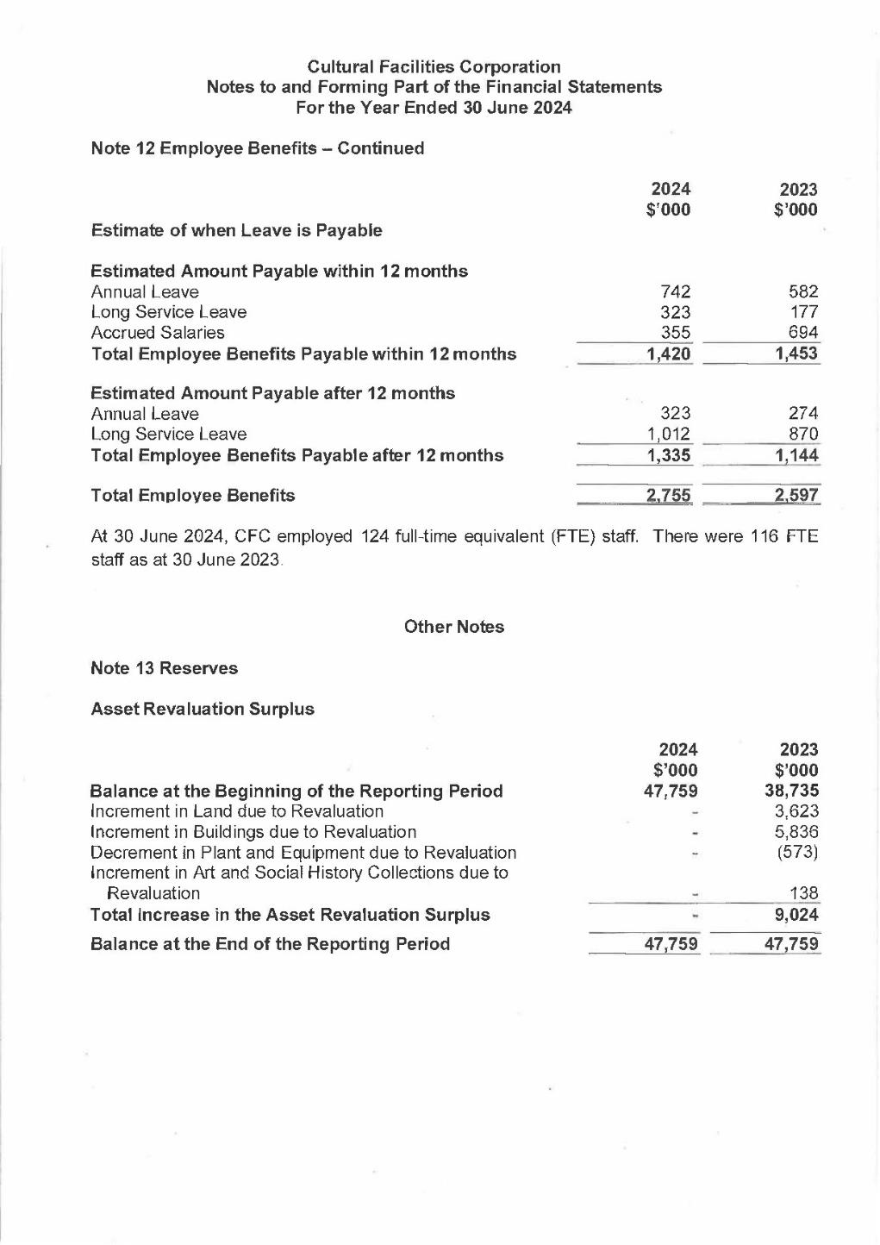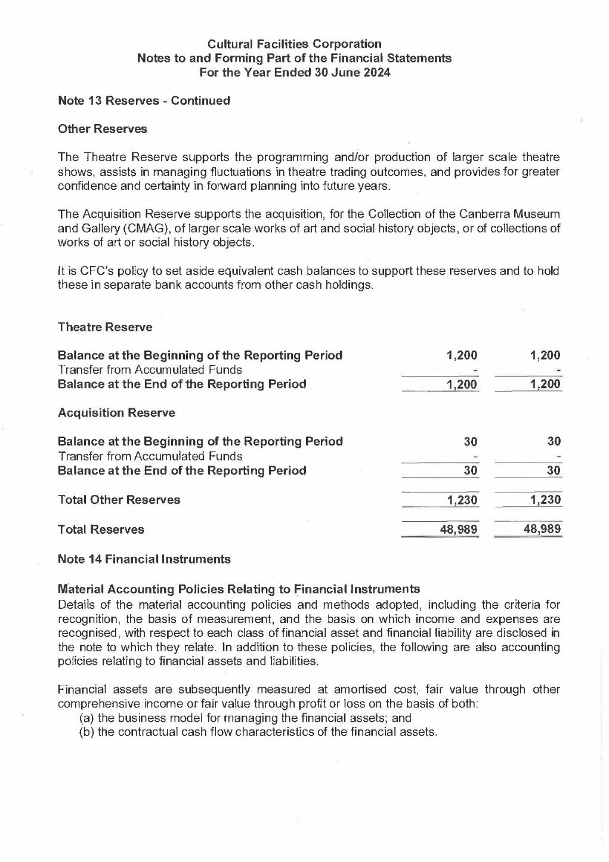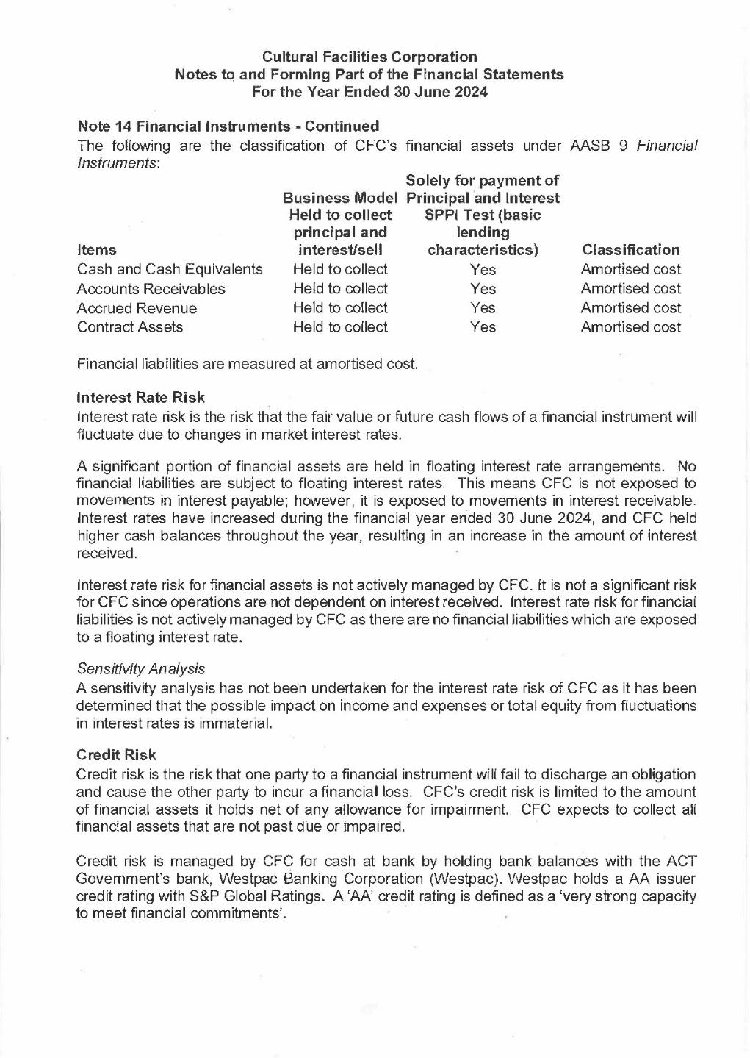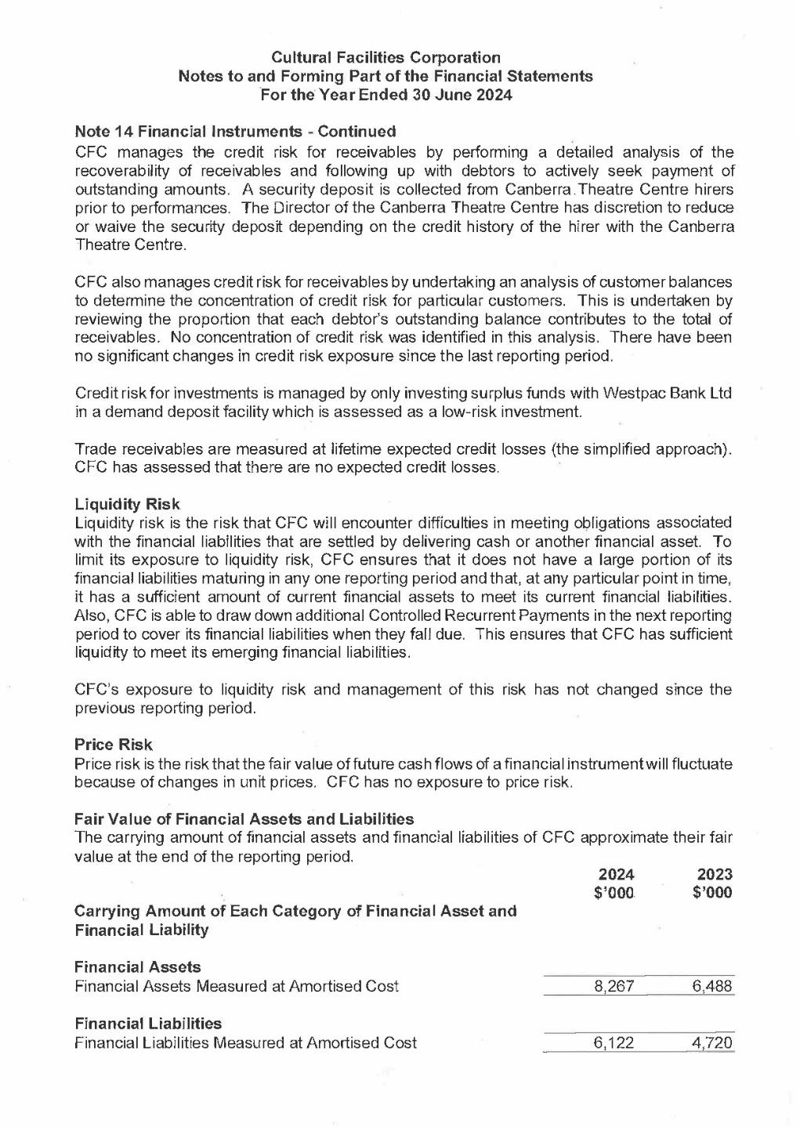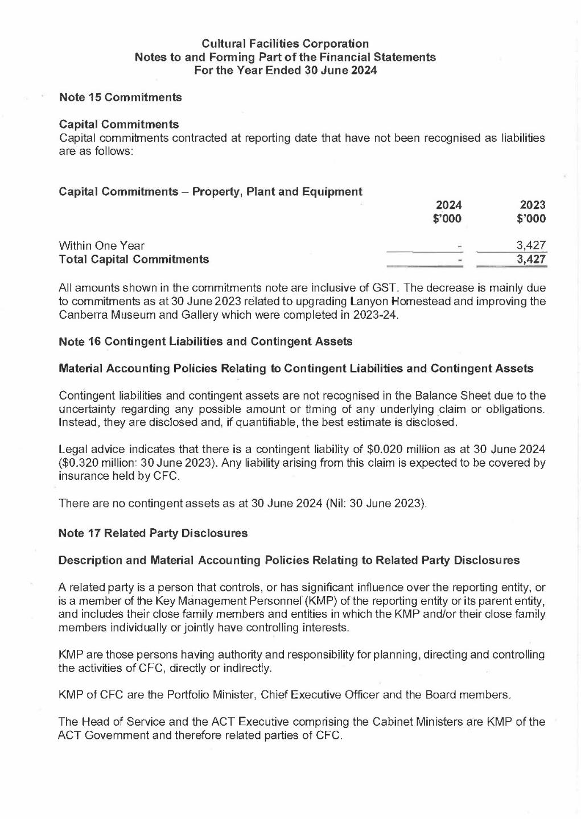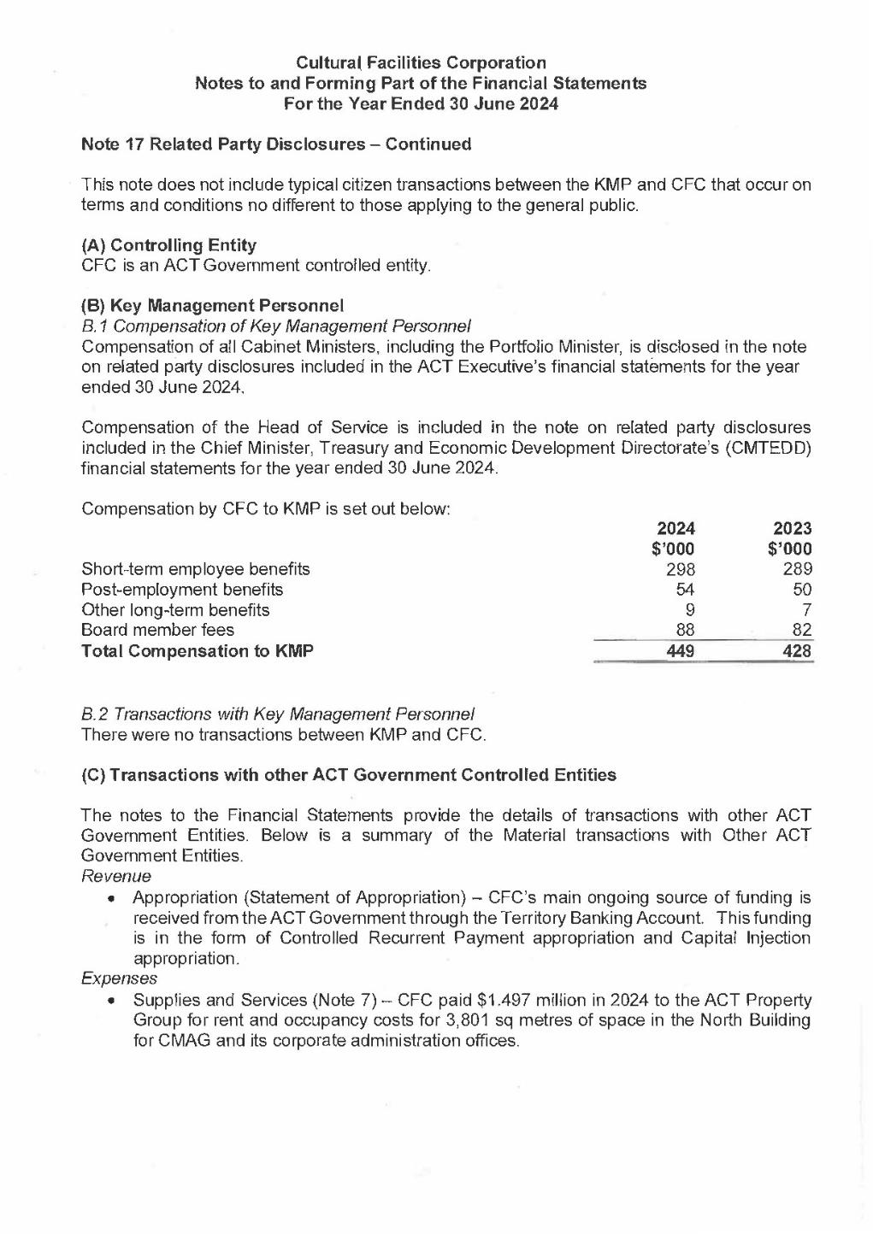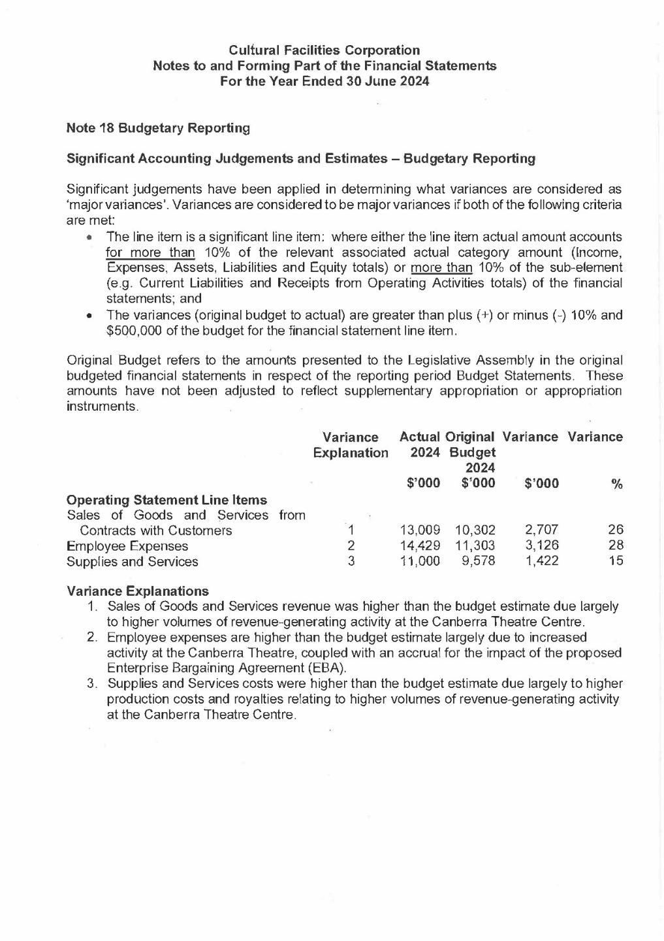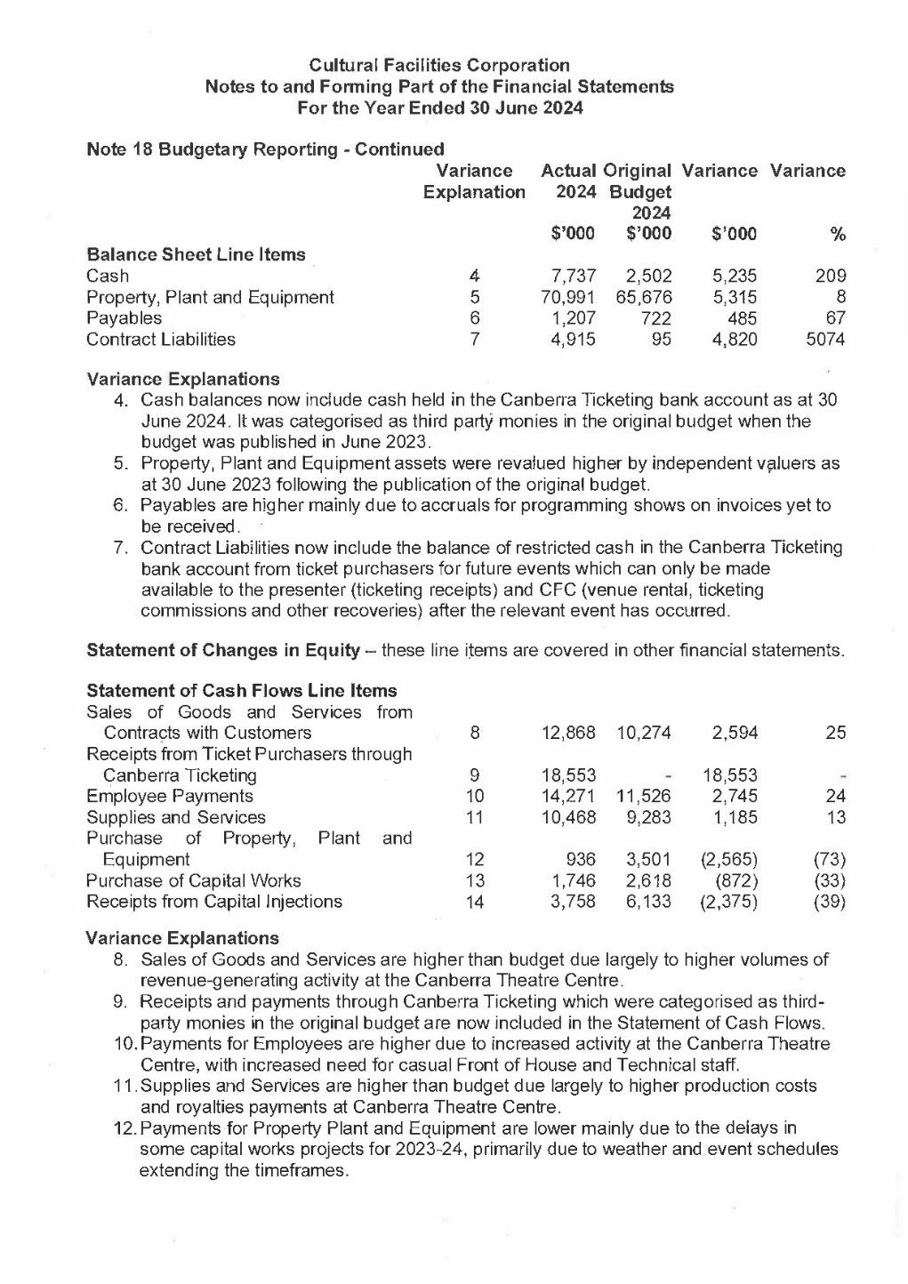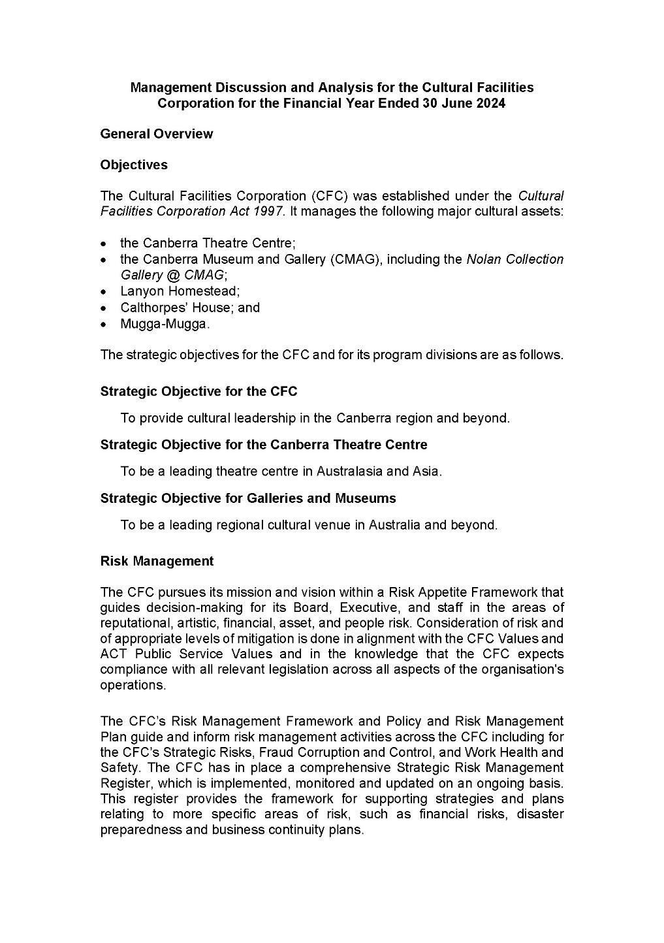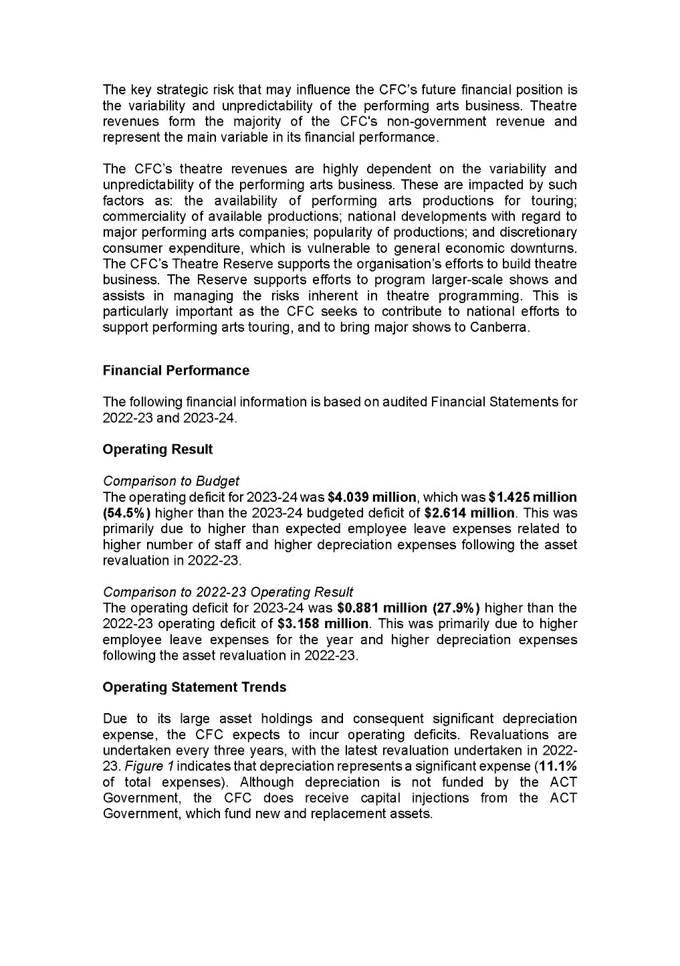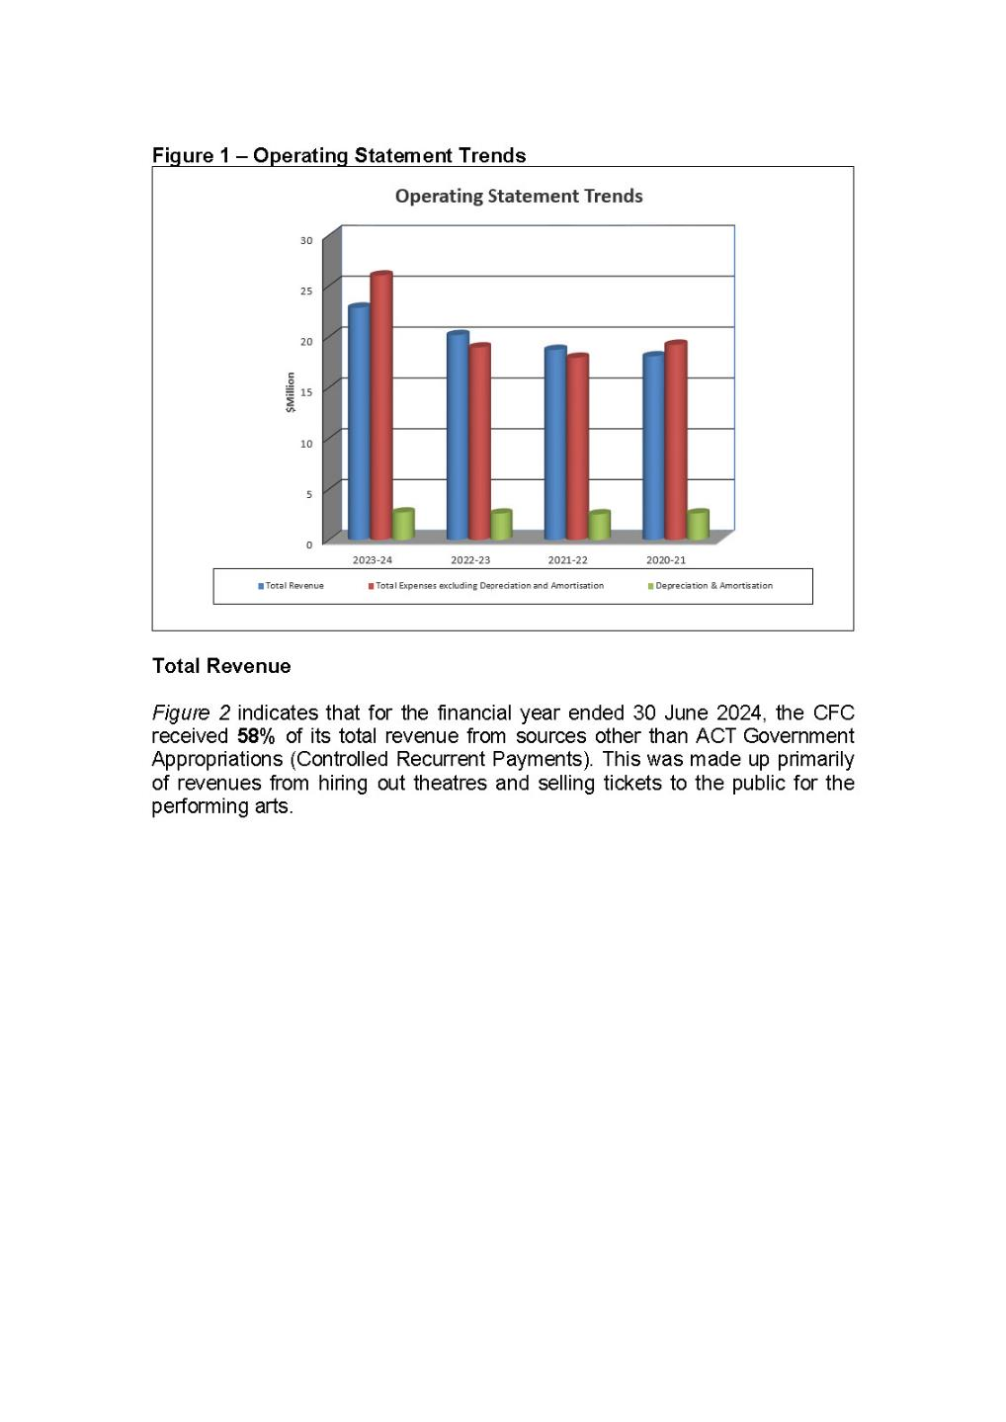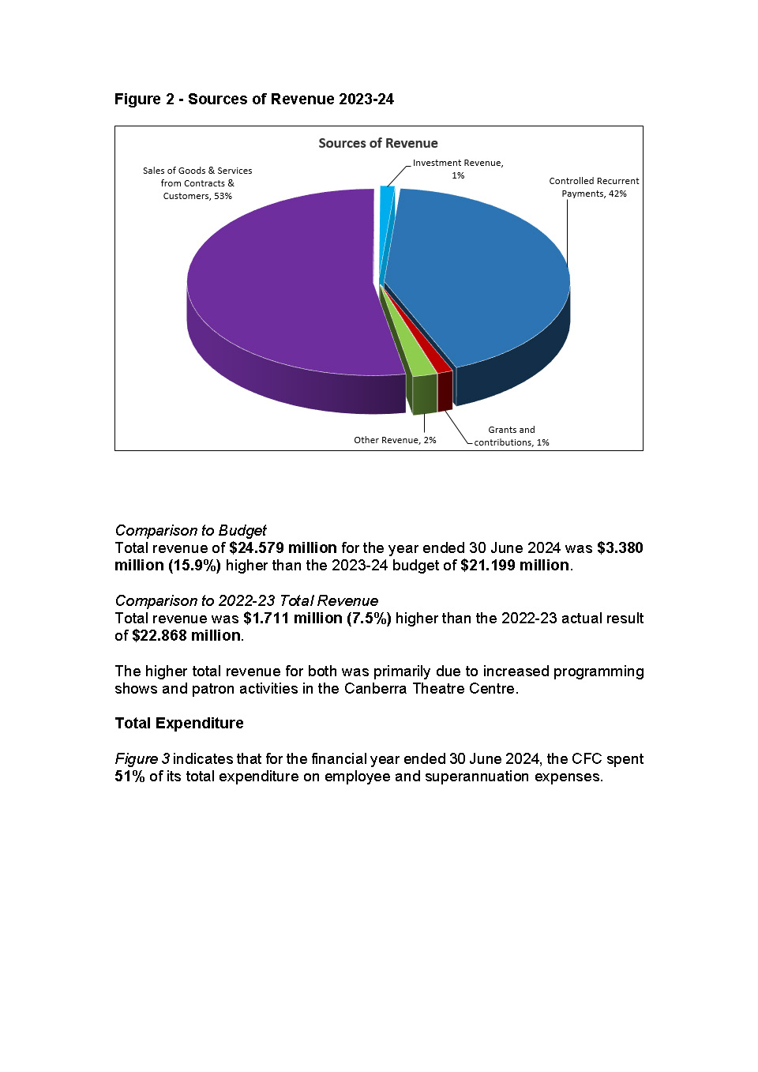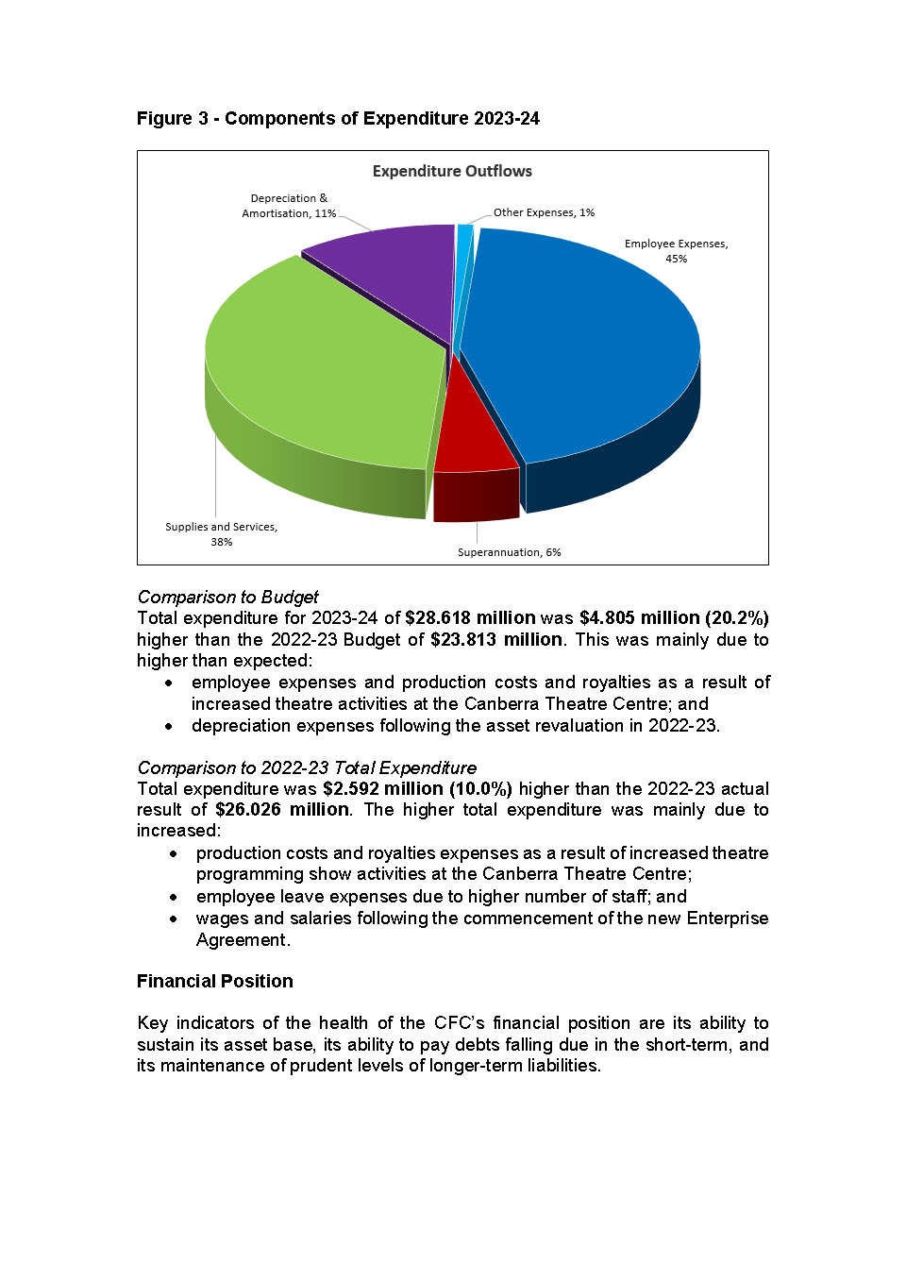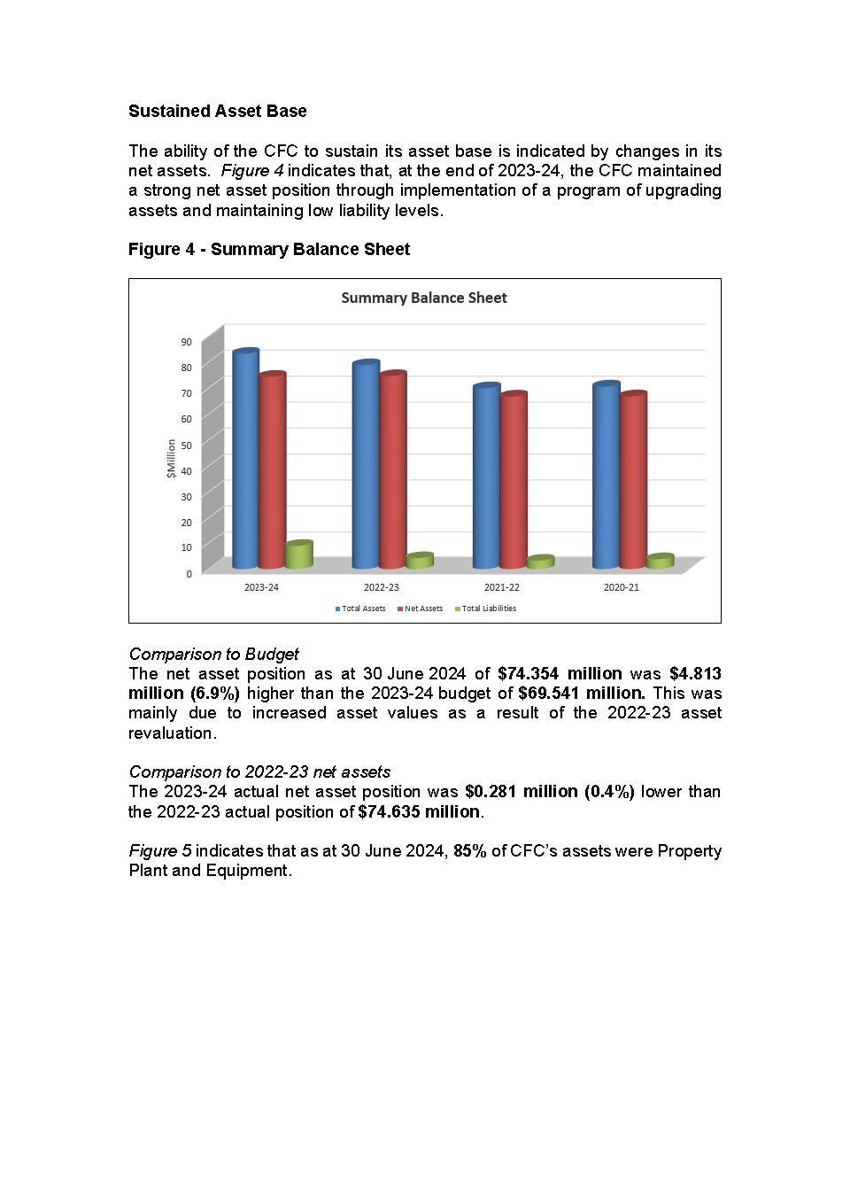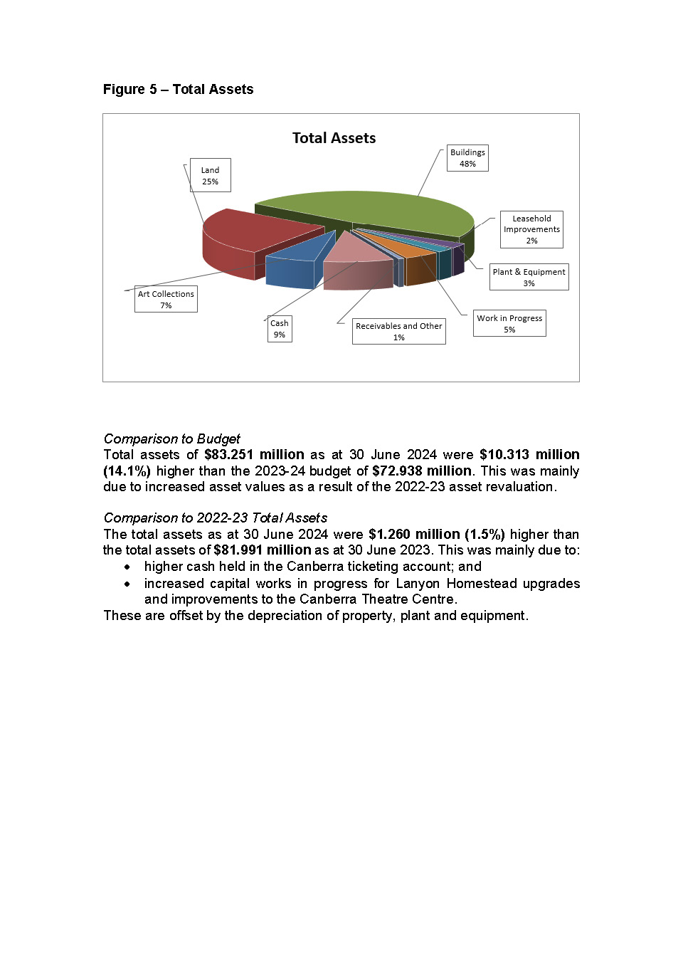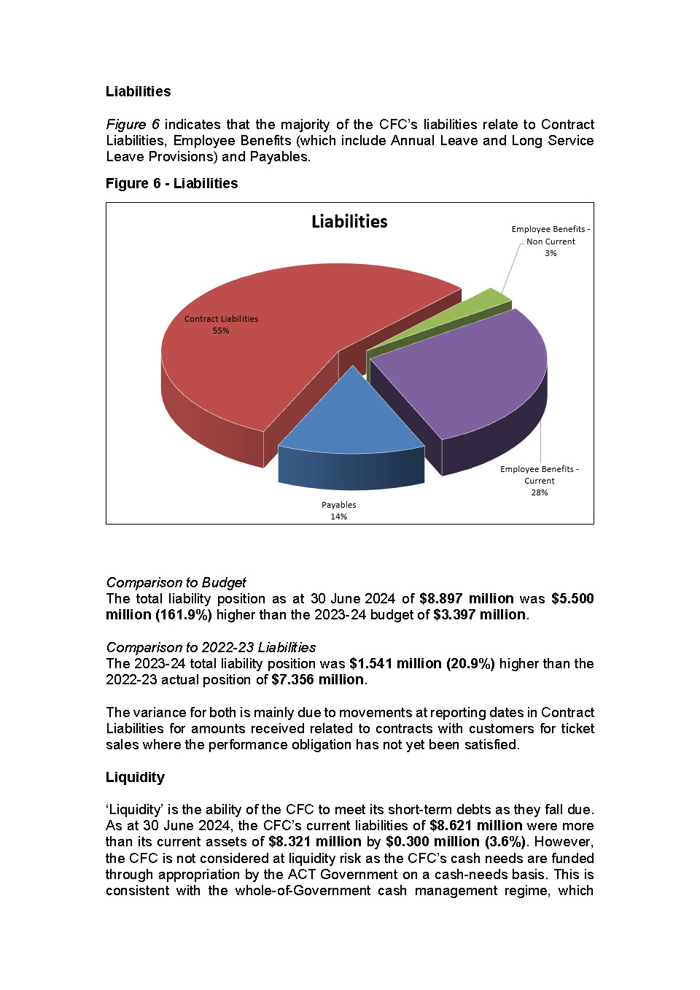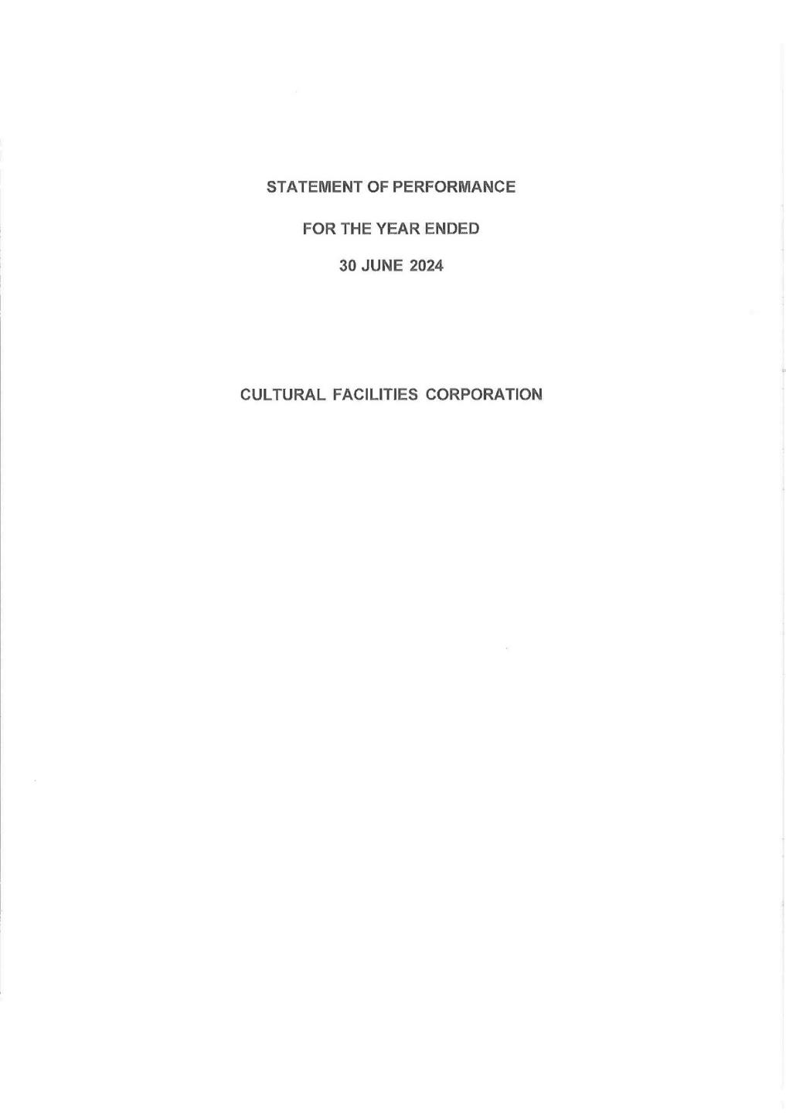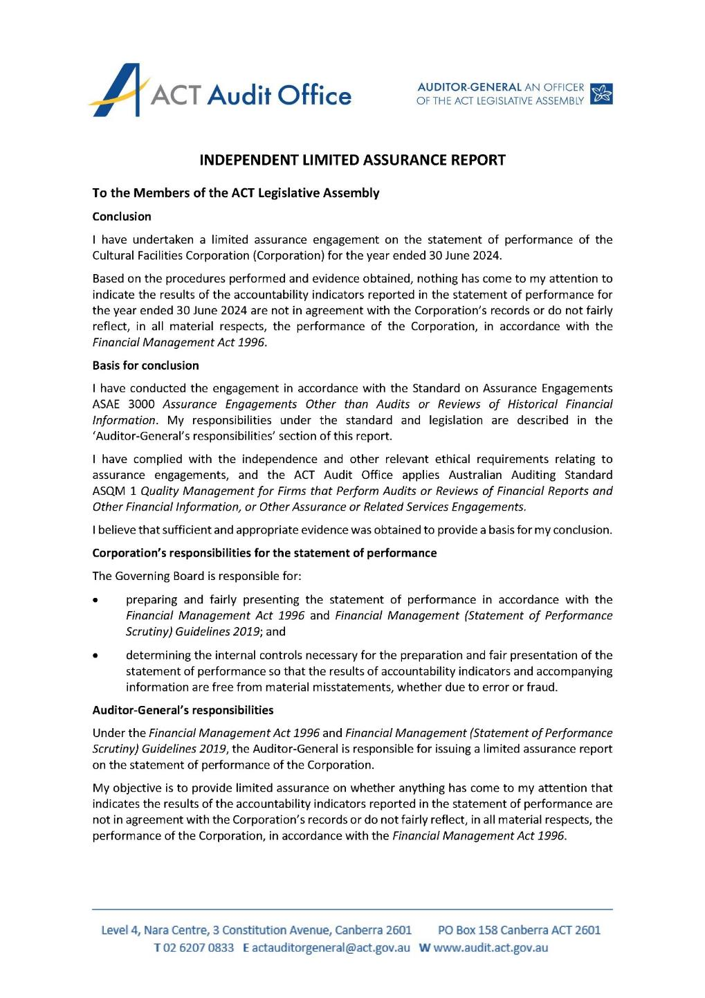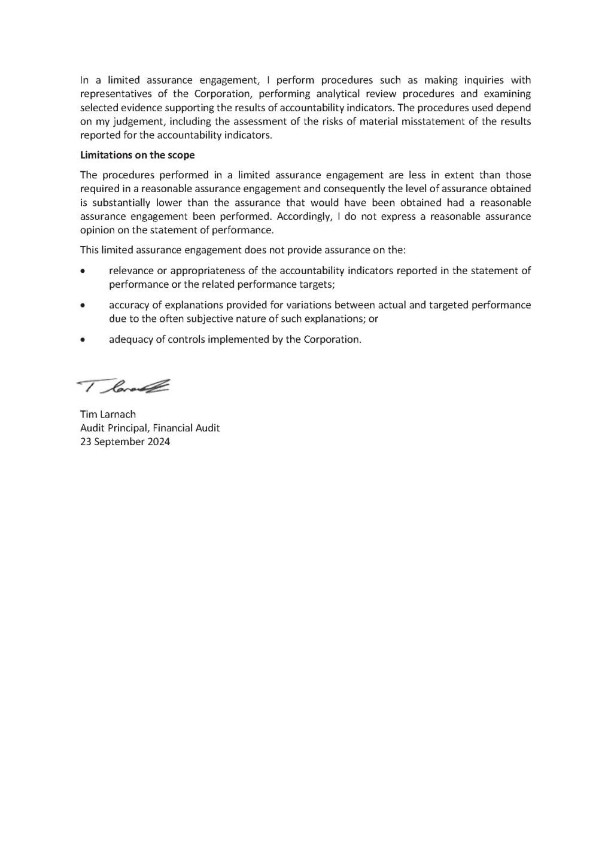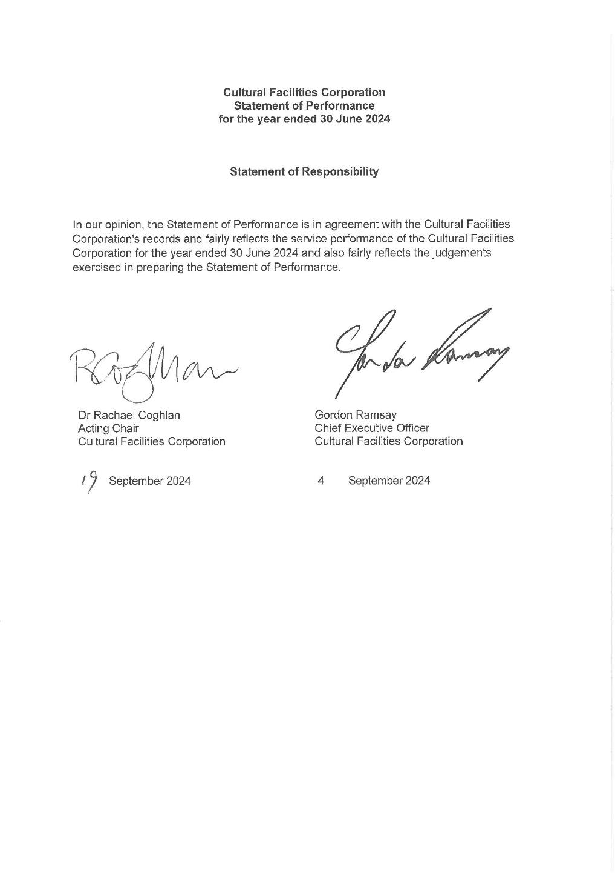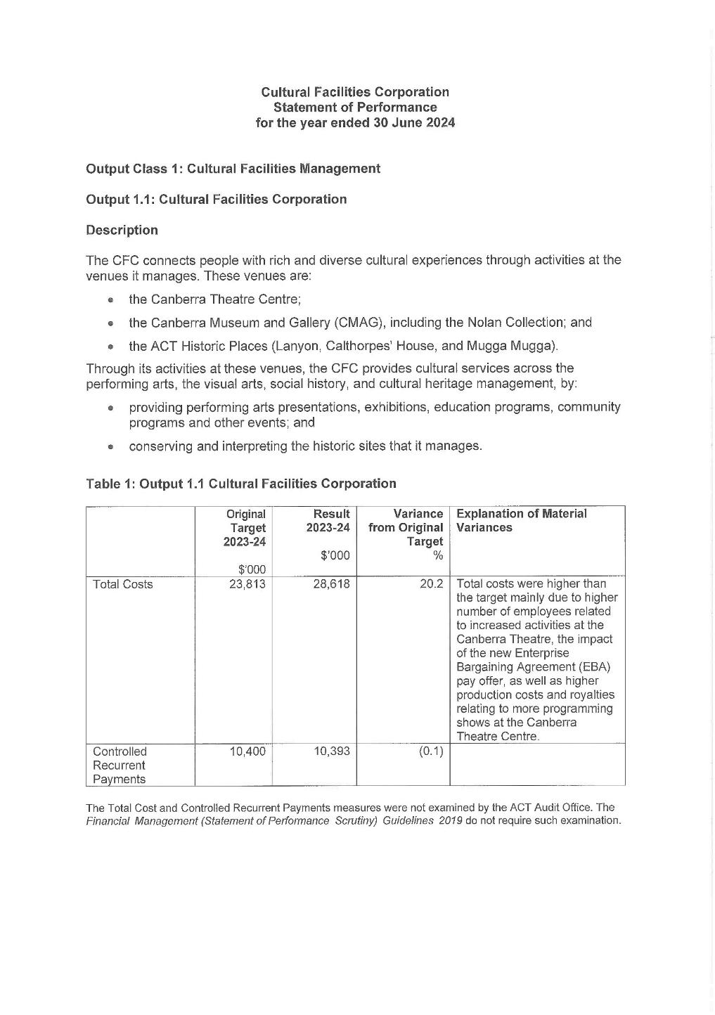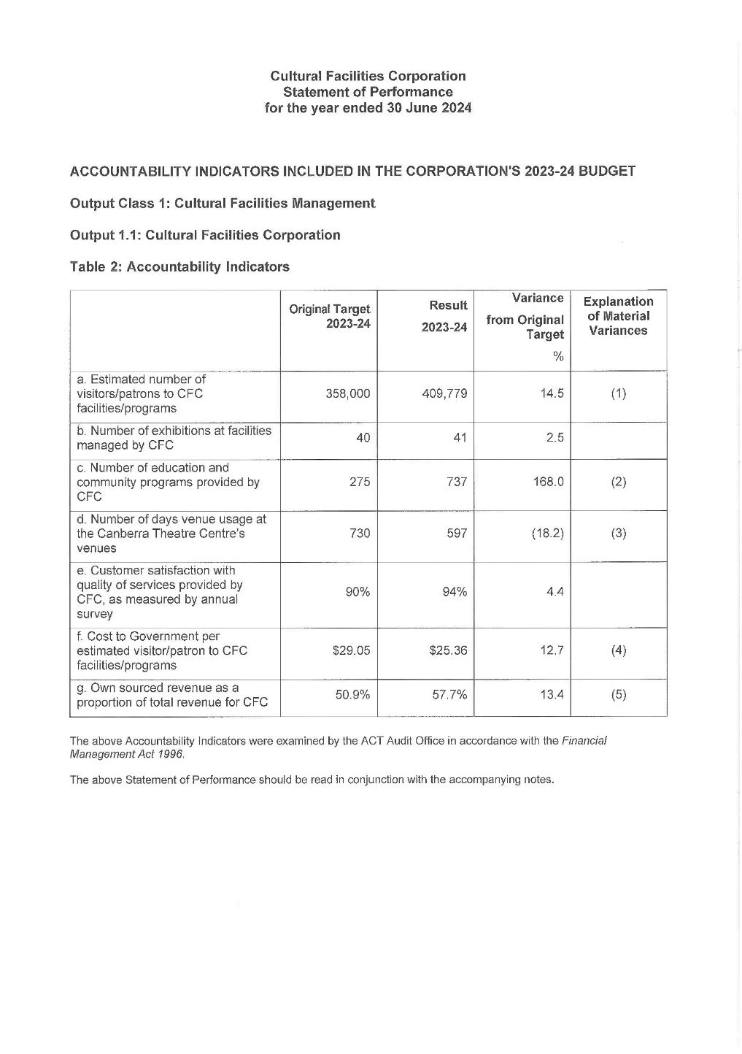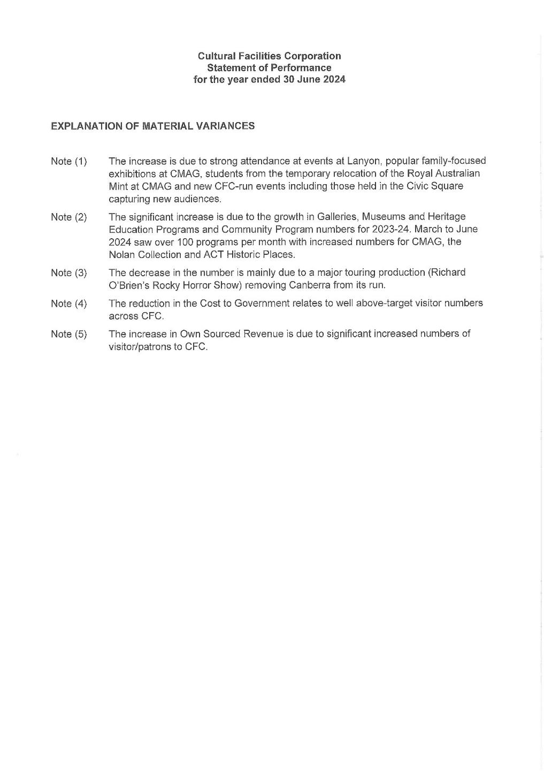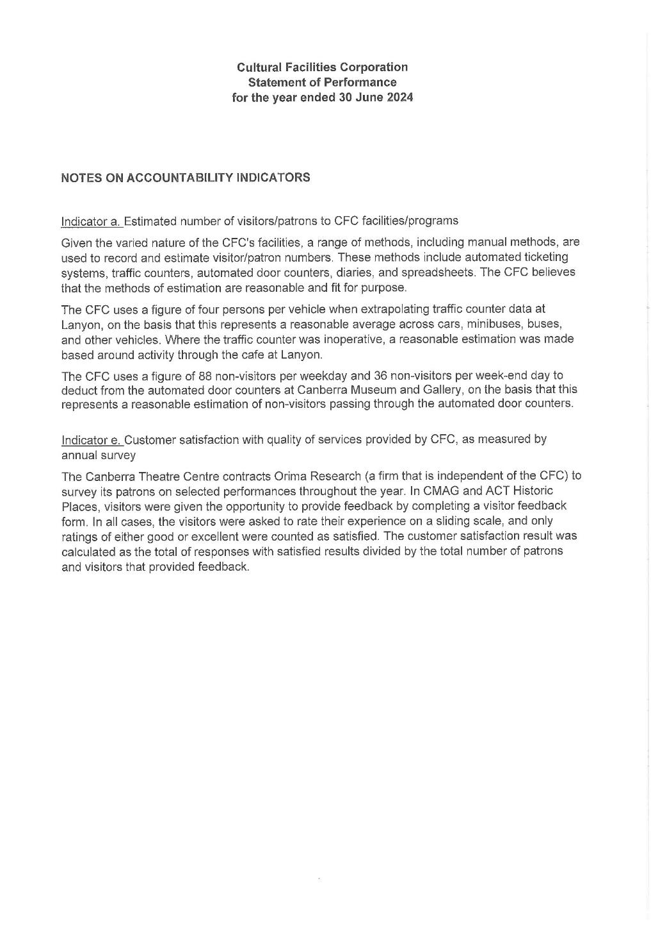

Abbreviations & Acronyms
ABC | Australian Broadcasting  Corporation
ACC | Agency Consultative Committee
ACT  ACTHP | Australian Capital Territory  ACT Historic Places
ActewAGL | ACT Electricity and Gas
ACTPS | ACT Public Service
AM  AMaGA | Member of the Order of Australia  Australian Museums and Galleries Association
ANU | Australian National University
AO  ASO | Officer of the Order of Australia  Administrative Services Officer
ASOC  ATSIPP | Artist Society of Canberra  Aboriginal and Torres Strait Islander Procurement Policy
BA  BCP | Bachelor of Arts  Business Continuity Plan
BSc  CTC | Bachelor of Science  Canberra Theatre Centre
CEO | Chief Executive Officer
CFC | Cultural Facilities Corporation
CFO | Chief Financial Officer
CMAG | Canberra Museum and Gallery
CMTEDD | Chief Minister, Treasury and  Economic Development Directorate
CNG  CMP COVID-19 | Compressed Natural Gas  Conservation Management Plan Coronavirus disease 2019
CPI | Consumer Price Index
CRA  CRM CTR  DA ESA | City Renewal Authority  Client Relationship Management  Canberra Theatre Redevelopment  Development Application Emergency Services Agency
EPSDD | Environment, Planning and  Sustainable Development Directorate
ESD | Ecologically Sustainable  Development
ESP | Enterprise Sustainability Platform
FBT | Fringe Benefits Tax
FCP | Fraud Control Plan
FM | Financial Management

FM Act | Financial Management Act 1996
FM | Frequency Modulation
FTE | Full Time Equivalent
GHG | Green House Gas
GSO | General Services Officer
GST | Goods and Services Tax
HR | Human Resources
ICOMOS | International Council on  Monuments and Sites
IT | Information Technology
Kg | Kilogram
kWh | kilowatt hour
LED | Light-emitting diode
LPA | Live Performance Australia
LPG | Liquid Petroleum Gas
MBA | Master of Business  Administration
MD&A | Management Discussion and  Analysis
MEAA | Media Entertainment and Arts  Alliance
MLA  MPC  MWh | Member of the Legislative  Assembly  Major Projects Canberra  megawatt hour
NAIDOC | National Aboriginal and Torres  Strait Islander Peoples Day Observance Committee
NSW | New South Wales
PD | Professional Development
PhD  PHEV | Doctor of Philosophy  Plug-in Hybrid Electric Vehicle
PO | Professional Officer
RED | Respect, Equity and Diversity
S | Section
SES | Senior Executive Service
SOG | Senior Officer Grade
SPO  SRMP | Senior Professional Officer  Strategic Risk Management Plan
t | Tonne
VET | Vocational Education and  Training
WHS  ZEVs | Work Health and Safety  Zero Emissions Vehicles

Compliance Statement
The Cultural Facilities Corporation’s (CFC) Annual Report must comply with the Annual Report Directions (the Directions) made under section 8 of the Annual Reports (Government Agencies) Act 2004. The Directions are found at the ACT Legislation Register: www.legislation.act.gov.au. The Compliance Statement indicates the subsections, under Parts 1 to 5 of the Directions, that are applicable to the CFC and the location of information that satisfies these requirements.

Part 1 - Directions Overview
The requirements under Part 1 of the Directions relate to the purpose, timing and distribution, and records keeping of annual reports. The CFC’s Annual Report complies with all subsections of Part 1 under the Directions.

In compliance with Section 15 Feedback, Part 1 of the Directions, contact details for the CFC are provided within the CFC’s Annual Report to provide readers with the opportunity to provide feedback.

Part 2 - Reporting entity Annual Report Requirements
The requirements within Part 2 of the Directions are mandatory for all reporting entities and the CFC complies with all subsections. The information that satisfies the requirements of Part 2 is found in the CFC’s Annual Report as follows:
- Part A. Transmittal Certificate, see page 7
- Part B. Organisational Overview and Performance, inclusive of all subsections, see page 9, and
- Part C. Financial Management Reporting, inclusive of all subsections, see page 121.

Part 3 - Reporting by Exception
The CFC has nil information to report by exception under Part 3 of the Directions for the
2023-24 reporting year.

Part 4 - Reporting entity Specific Annual Report Requirements
The following subsection of Part 4 of the 2024 Directions is applicable to the CFC.
- Ministerial and Director-General Directions - The CFC has nil information to report for the 2023-24 reporting period.

Part 5 - Whole of Government Annual Reporting
All subsections of Part 5 of the Directions apply to the CFC. Consistent with the Directions, the information satisfying these requirements is reported in the one place for all ACT Public Service directorates, as follows:
- Bushfire Risk Management, see the annual report of the Justice and Community Safety Directorate
- Human Rights, see the annual report of the Justice and Community Safety Directorate
- Legal Services Directions, see the annual report of the Justice and Community Safety Directorate, and
- Territory Records, see the annual report of Chief Minister, Treasury and Economic Development Directorate.

Part 6 - State of the Service report
- Public Sector Standards and Workforce Profile, see the annual State of the Service Report, and
- ACT Public Service Directorate annual reports are found at the following web address: www.cmtedd.act.gov.au/open_government/report/annual_reports

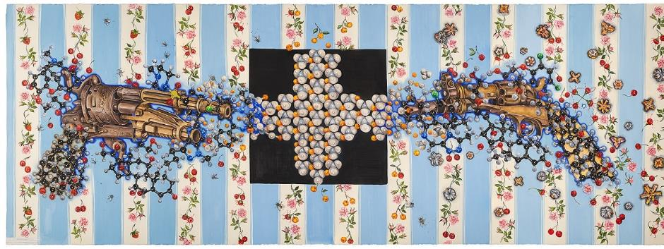
eX de Medici - Blue for Boys
Image: CFC



