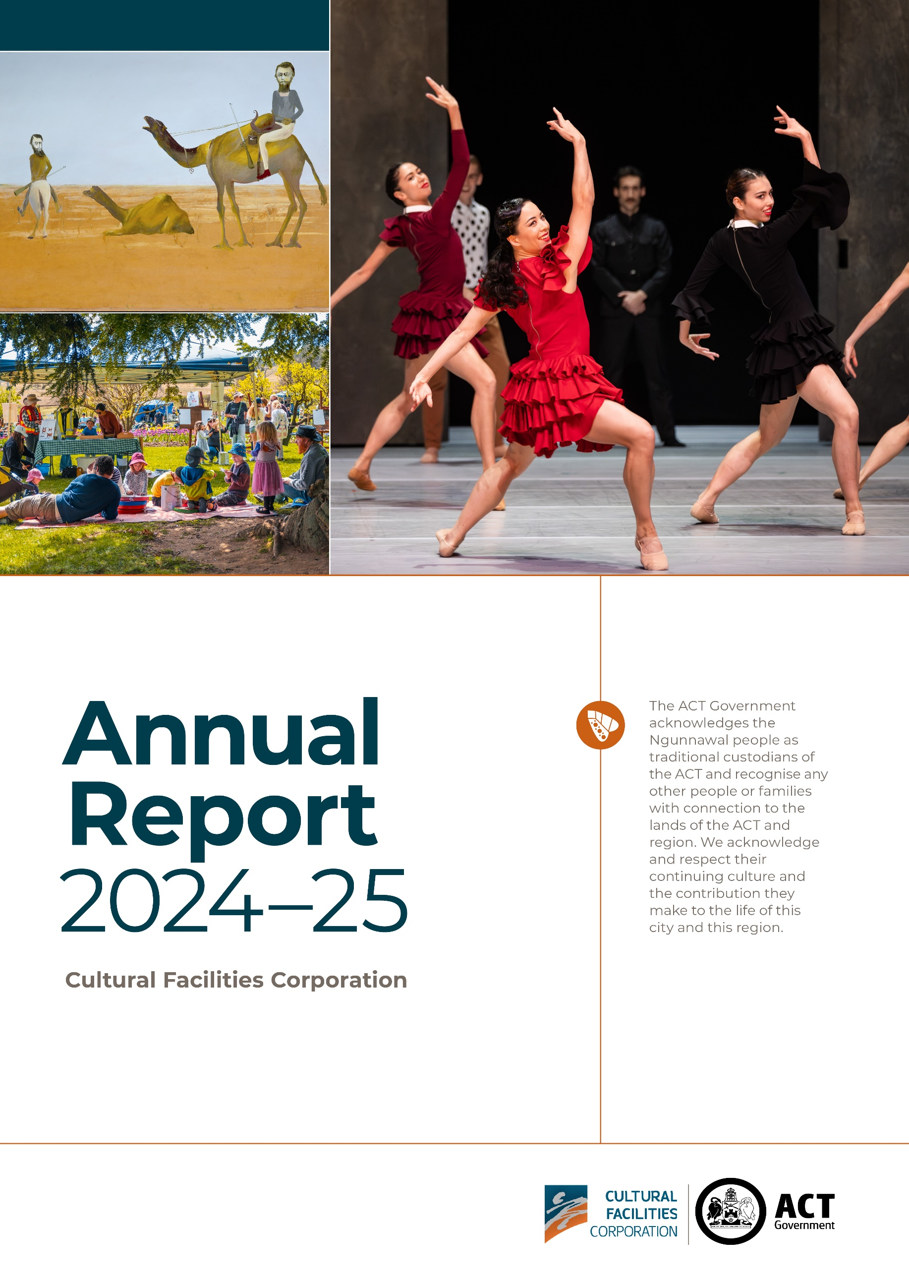

Contact
General enquiries about this report should be directed to:
Telephone: (02) 6207 3962
Email: cultural.facilities@act.gov.au

CULTURAL FACILITIES CORPORATION
GPO Box 782
Canberra City ACT 2601

Freedom of Information
Freedom of information requests can be made by emailing: cultural.facilities@act.gov.au


Acknowledgement of Country
The ACT Government acknowledges the Ngunnawal people as traditional custodians of the ACT and recognise any other people or families with connection to the lands of the ACT and region. We acknowledge and respect their continuing culture and the contribution they make to the life of this city and this region.

© Australian Capital Territory, Canberra 2025
Material in this publication may be reproduced provided due acknowledgement is made.
Produced by the Cultural Facilities Corporation Directorate. Enquiries about this publication should be directed to the Cultural Facilities Corporation Directorate.
GPO Box 158, Canberra City 2601
act.gov.au
Telephone: Access Canberra – 13 22 81

Accessibility Ph 13 22 81
Ph 131 450

Accessibility
The ACT Government is committed to making its information, services, events and venues accessible to as many people as possible. If you are deaf, or have a hearing or speech impairment, and need the telephone typewriter (TTY) service, please phone 13 36 77 and ask for 13 22 81. For speak and listen users, please phone 1300 555 727.
For more information on these services, contact us through the National Relay Service: www.accesshub.gov.au.
If English is not your first language and you require a translating and interpreting service, please telephone Access Canberra on 13 22 81.
ISBN: 978-0-642-60870-3

This work, Cultural Facilities Corporation Annual Report
2024-25, is licensed under a Creative Commons Attribution 4.0 licence. You are free to re-use the work under that licence, on the condition that you credit the Australian Capital Territory Government as author, indicate if changes were made and comply with the other licence terms.

The licence does not apply to the ACT Coat of Arms, the Cultural Facilities Corporation logo and branding, images, artwork, photographs and any material protected by trademark.

Front page credits:
Burke and Wills, 1948. Sidney Nolan. Image: The Nolan Collection
Carmen, The Australian Ballet - CTC60. Image: Daniel Boud
Kids Day Out, Lanyon Homestead. Image: Dominic Northcott

Information about the directorate and an electronic version of this annual report can be found on the website: www.culturalfacilities.act.gov.au.

For more information on the activities of the Cultural Facilities Corporation please visit the following websites: www.culturalfacilities.act.gov.au. www.canberratheatrecentre.com.au, www.cmag.com.au and www.historicplaces.com.au.

ABN: 88187240846
Published by the Cultural Facilities Corporation, Canberra.

Contents

PART A
CFC Organisation Chart 5
Transmittal Certificate 7
Compliance Statement 9

PART B
B1 Organisational Overview 12
B2 Performance Analysis 40
B3 Scrutiny 69
B4 Risk Management 70
B5 Internal Audit 71
B6 Fraud Prevention 72
B7 Freedom of Information 73
B8 Community Engagement 74
B9 Aboriginal and Torres Strait Islander Reporting 77
B10 Disability Inclusion Act 2024 Reporting 80
B11 Multicultural Reporting 83
B12 Period Products and Facilities (Access) Act 2023 Reporting 85
B13 Work Health and Safety 85
B14 Human Resource Management 89
B15 Ecological Sustainability Reporting 96

PART C
C2 Financial Statements 99
C3 Capital Work 100
C4 Asset Management 102
C5 Government Contracting 104
C6 Statement of Performance 105

APPENDICES
Appendix 1 CFC Board Members 107
Appendix 2 Senior Leadership Team 110
Appendix 3 Advisory Committees 112
Appendix 4 Presentations, Exhibitions and Events 118
Appendix 5 Canberra Museum & Gallery Acquisitions (Purchases and Donations) 129
Appendix 6 Funding, Sponsorship, Donations and Support 131

ATTACHMENT
Financial and Performance Statements and Management Discussion and Analysis 134

Glossary of Abbreviations and Acronyms 200

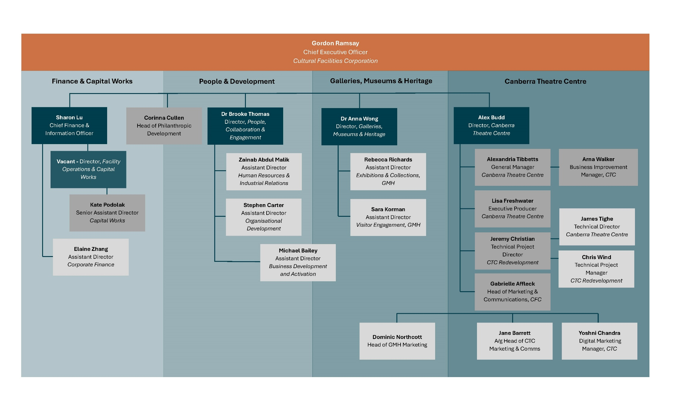

CFC Organisation Chart
Our 2024–25 organisation chart reflects the Cultural Facilities Corporation’s (CFC’s) high–level structure.


CFC Open Day – Smoking Ceremony performed by Richie Allen (Ngunnawal/Kamilaroi. Image: Martin Ollman
Ca
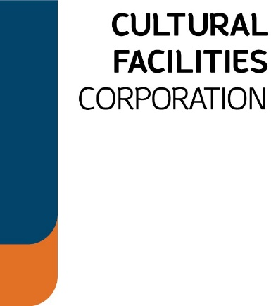

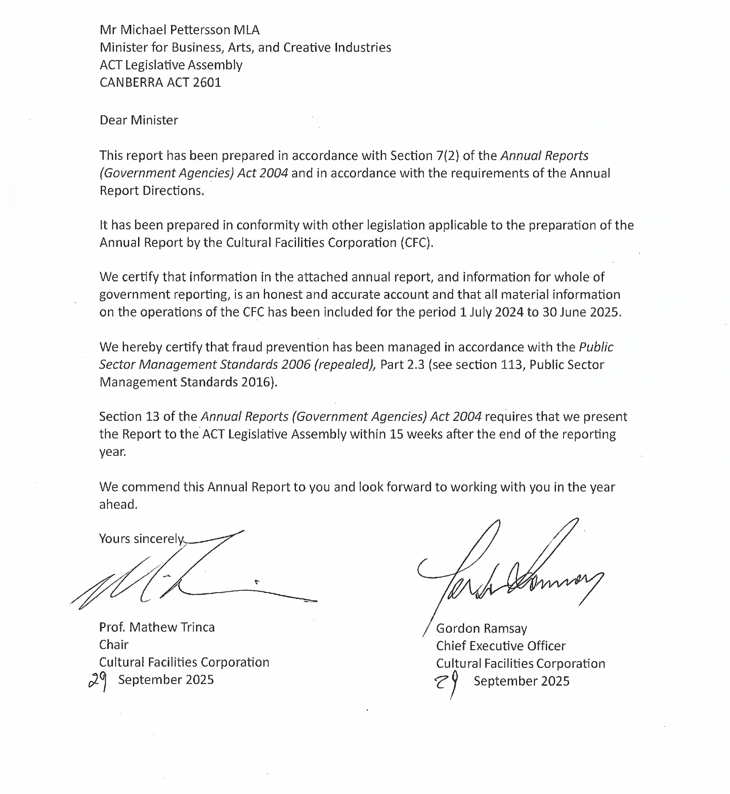
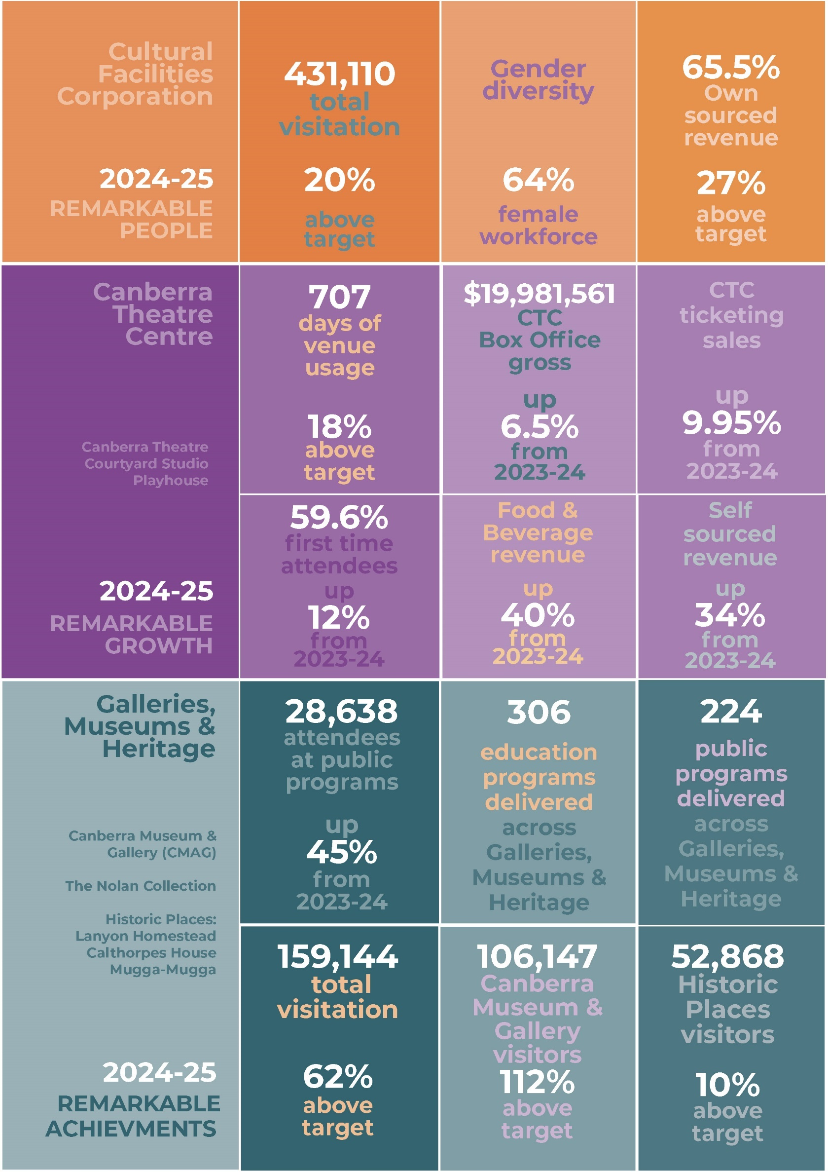

transmittal
Compliance Statement
The Cultural Facilities Corporation’s (CFC) Annual Report must comply with the Annual Report Directions (the Directions) made under section 8 of the Annual Reports Act. The Directions are found at the ACT Legislation Register: www.legislation.act.gov.au. The Compliance Statement indicates the subsections, under Parts 1 to 5 of the Directions, that are applicable to the CFC and the location of information that satisfies these requirements.

Part 1 Directions Overview
The requirements under Part 1 of the Directions relate to the purpose, timing and distribution, and record keeping of annual reports. The CFC’s Annual Report complies with all subsections of Part 1 under the Directions.

In compliance with Section 15 Feedback, Part 1 of the Directions, contact details for the CFC are provided within the CFC’s Annual Report to provide readers with the opportunity to provide feedback.

Part 2 Reporting Entity Annual Report Requirements
The requirements within Part 2 of the Directions are mandatory for all reporting entities and the CFC complies with all subsections. The information that satisfies the requirements of Part 2 is found in the CFC’s Annual Report as follows:
- Part A. Transmittal Certificate, see page 7
- Part B. Organisational Overview and Performance, inclusive of all subsections, see
page 12, and
- Part C. Financial Management Reporting, inclusive of all subsections, see page 134.

Part 3 Reporting by Exception
The CFC has nil information to report by exception under Part 3 of the Directions for the
2024-25 reporting year.

Part 4 Directorate and Public Sector Body Specific Annual Report Requirements
The following subsection of Part 4 of the 2024-25 Directions are applicable to the CFC and can be found within the CFC Annual Report 2024-25.
- Ministerial and Director-General Directions - The CFC has nil information to report for the 2024-25 reporting period.

Part 5 Whole of Government Annual Reporting
All subsections of Part 5 of the Directions apply to the CFC. Consistent with the Directions, the information satisfying these requirements is reported in the one place for all ACT Public Service directorates, as follows:
- Bushfire Risk Management, see the annual report of the Justice and Community Safety Directorate
- Human Rights, see the annual report of the Justice and Community Safety Directorate
- Legal Services Directions, see the annual report of the Justice and Community Safety Directorate
- Public Sector Standards and Workforce Profile, see the annual State of the Service Report, and
- Territory Records, see the annual report of Chief Minister, Treasury and Economic Development Directorate.

ACT Public Service Directorate annual reports are found at the following web address: https://www.act.gov.au/open/annual-reports.


Ikebana @ CMAG. Image: Sachie Terasaki

Hiroe and Cornel Swen: Making a Creative Life, CMAG Exhibition. Image: Sarah Nash

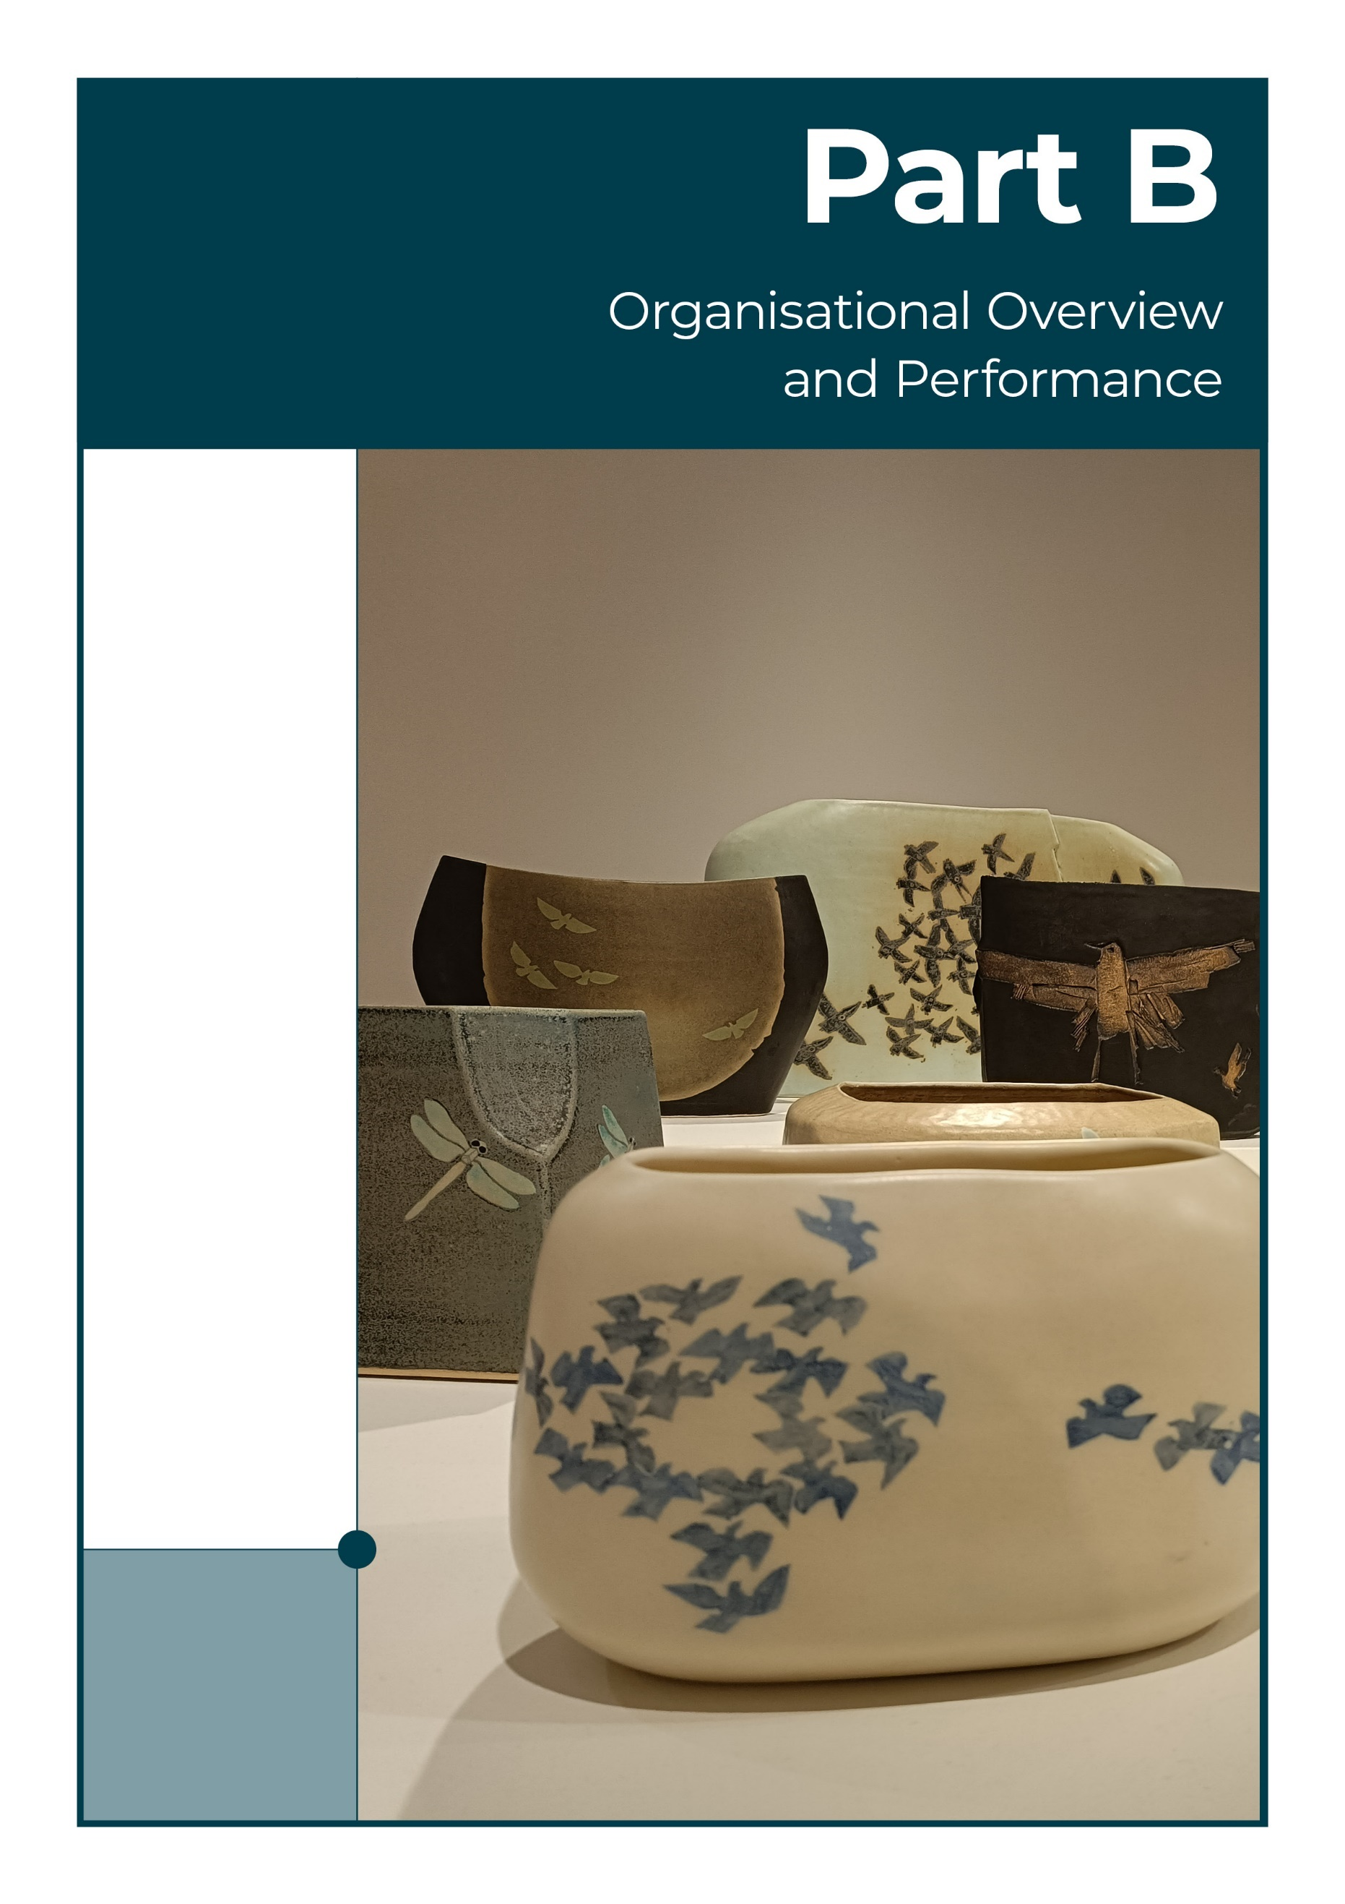
Hiroe and Cornel Swen: Making a Creative Life CMAG exhibition. Image: Sarah Nash
B1 Organisational Overview

B1.1 - Vision, Mission and Values

The CFC supports the ACT Government’s Statement of Ambition for the Arts 2021-26 as a major contributor to creating, developing, and promoting arts, culture, creativity, and heritage under Canberra: Australia’s Arts Capital - Arts, Culture and Creative Policy 2022-26.

The CFC’s Strategic Plan 2023-27 defines a vision and mission for the CFC as well as dynamic values and ambitious goals.

These emphasise the importance of the CFC’s responsibilities as a custodian of the ACT and region’s stories and as a sector leader, the need for organisational growth and financial sustainability, with the current key focus on the redevelopment of Canberra Theatre Centre (CTC). In observing our values, we are committed to implementing the ACT Government Service Values of respect, integrity, collaboration and innovation.

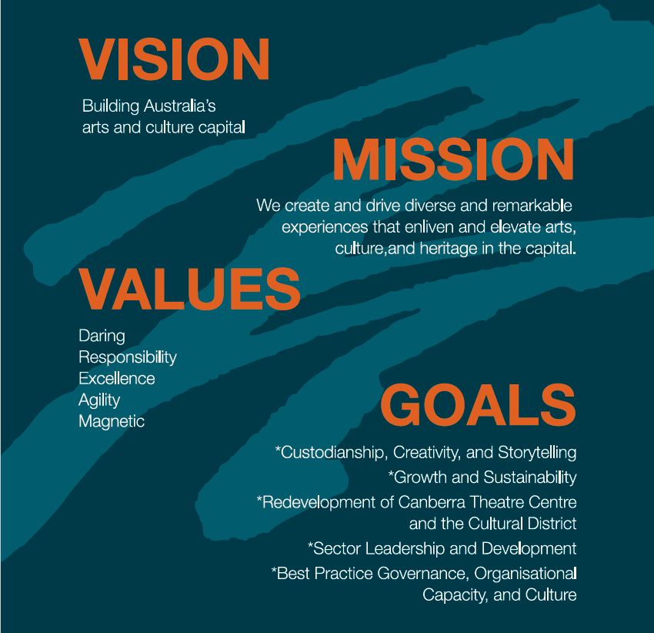

The CFC’s vision, mission and values are lived out in our five strategic goals.

CFC Strategic Goals
- Custodianship, Creativity, and Storytelling

We will deliver creative excellence and custodianship for the CFC’s activities, deepen our contribution to the ACT’s arts, culture and heritage ecology, and grow our

national role.
- Growth and Sustainability
We will position the CFC for the future by expanding its income streams and relevance to the arts, culture, and heritage sectors, audiences, and economy.
- Redevelopment of the Canberra Theatre Centre and
Canberra Civic and Culture District
We will provide a vision and key leadership for the redevelopment of the CTC and
CCCD, developing our organisation to leverage the opportunities these present.
- Sector Leadership and Development
We will lead our sector in the ACT, growing audiences, engaging artists, and
developing people.
- Best Practice Governance, Organisational Capacity,
and Culture
Our operational model will be best practice.

B1.2 - Functions and Services

The CFC is a statutory corporation of the ACT Government and the ACT’s largest cultural organisation, managing a unique mix of performing arts, visual arts, social history, and heritage venues.
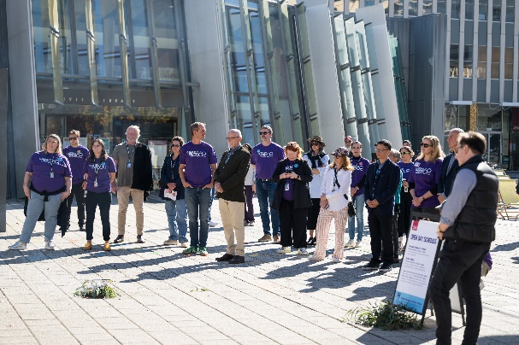
Staff at the CFC 2025 Open Day. Image: Martin Ollman

The CFC was established under the Cultural Facilities Corporation Act 1997 (the CFC Act), which came into operation from
1 November 1997. The CFC connects people with rich and diverse cultural experiences, activities and functions as set out in the CFC Act (Section 6) with responsibility for:
- Canberra Theatre Centre (CTC)
- Canberra Museum & Gallery (CMAG)
- The Nolan Collection
- Lanyon Homestead
- Calthorpes House, and
- Mugga-Mugga.

Through its activities at these venues, the CFC provides a range of cultural services across the performing arts, the visual arts, social history and cultural heritage, by:
- managing, developing, presenting, coordinating and promoting cultural activities at designated locations and other places in the ACT
- providing theatre presentations, exhibitions, education and community programs
      - establishing and researching collections
      - conserving and exhibiting collections in the possession or under the control of the CFC
  - undertaking activities, in cooperation with other people if appropriate, to exercise its other functions, and
  - exercising other functions given to the CFC under the Act or another Territory Law.

The CFC Act (Section 7) requires that the CFC, in exercising its functions, must consider:
  - any cultural policies or priorities of the Executive known to the CFC, and
  - other cultural activities in the ACT.

CTC is the major presenter of performing arts in the region. CTC presents a range of programming and independent productions and works with community and commercial hirers to deliver a broad program of theatre, dance and music. In particular, the New Works and Sector Development Program supports local artists and producers in the commissioning, creative development, and presentation of live performances.
CTC is also connected to major performing arts centres across the nation and regularly works with leading national theatre and dance companies. The planned redevelopment of the Centre will support the growth of Canberra's performing arts industry by creating further spaces for artists and arts workers to develop, rehearse, and perform productions. The transformed CTC will include modern rehearsal facilities, supporting the creation of productions that can tour nationally and internationally, increasing the profile of Canberra creatives and lifting Canberra’s reputation as a performing arts destination.
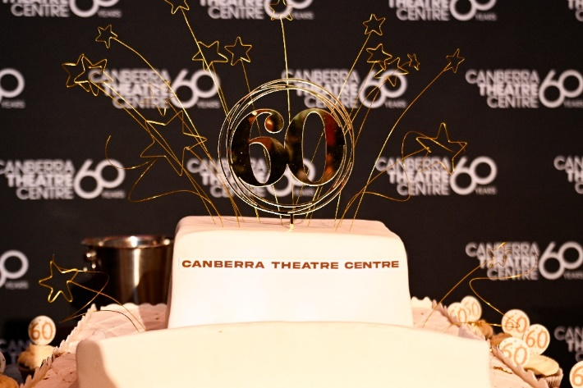 Cutting of the cake, CTC60 celebrations. Open Day. Image: Martin Ollman

Galleries, Museums & Heritage (GMH) has
creative, curatorial, exhibition, collections management, research, and public engagement responsibilities relating to CMAG, The Nolan Collection, Lanyon Homestead, Calthorpes House, and Mugga-Mugga and, collaboratively, of the curatorial, collections management, social history, and heritage aspects more broadly within the CFC.

CMAG manages the Territory’s collection of over 12,000 artworks and social history objects, including paintings, works on paper, sculpture and digital media, clothing and textiles, industrial design, furniture, and domestic items.
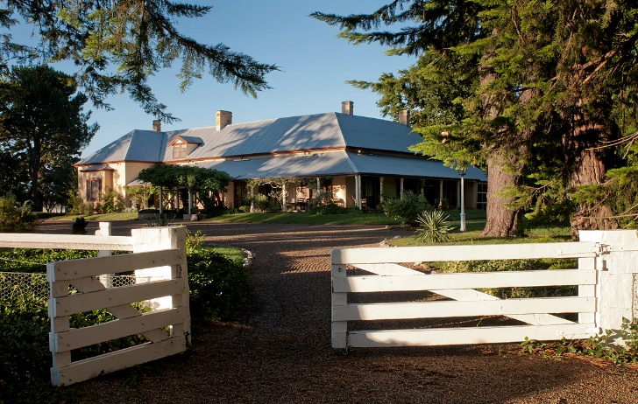
Lanyon Homestead. Image: Dominic Northcott

CMAG develops and presents exhibitions that interpret and promote significant events, places, people, and collections associated with the social history and visual arts of Canberra and the region. Notably, CMAG has an award-winning permanent exhibition Canberra/ Kamberri, Place and People devoted to the unique story of Canberra. CMAG also brings significant touring exhibitions to Canberra and provides opportunities for the exhibition of local community and private collections. It is also the custodian of the 218 works that comprise the Commonwealth Nolan Collection, including the 24 Foundation Collection of iconic paintings from the Ned Kelly,
St Kilda, and Burke and Wills series, donated by the artist to the nation in 1974.

In 2024-25 the three heritage-listed historic places in the CFC’s care showcased the ACT’s significant natural and cultural heritage.

Lanyon Homestead (pictured) is the most intact pastoral property in Canberra, established in 1835 by John Lanyon and brothers James and William Wright. The current homestead was built in 1859. The property encompasses important Indigenous and non-Indigenous heritage, cultural and natural values, and the history of European settlement, convicts and pastoralism in the Canberra region.

Calthorpes House (pictured), built in 1927, was one of the earliest residences in the new Federal Capital of Canberra. The Calthorpes lived there until the 1980s, when the Commonwealth government purchased the home, including domestic furnishings and personal items of the Calthorpe family. It provides an insight into the taste and experiences of the population moving to the region in the 1920s and 30s.

Calthorpes House. Image: GMH

Mugga-Mugga Cottage (pictured page 16), built in the 1850s, is one of only three surviving workers’ cottages from the Duntroon estate. This site was used as a shepherd’s lookout from the 1820s when Robert Campbell established the Duntroon estate. The stone cottage includes a rare domestic working-class collection of the Curley family, former Duntroon estate workers who moved to the Cottage in 1913, when Duntroon was resumed by the Commonwealth for the creation of the Federal Capital. The Cottage is surrounded by listed endangered native temperate grasslands with Aboriginal archaeological sites.

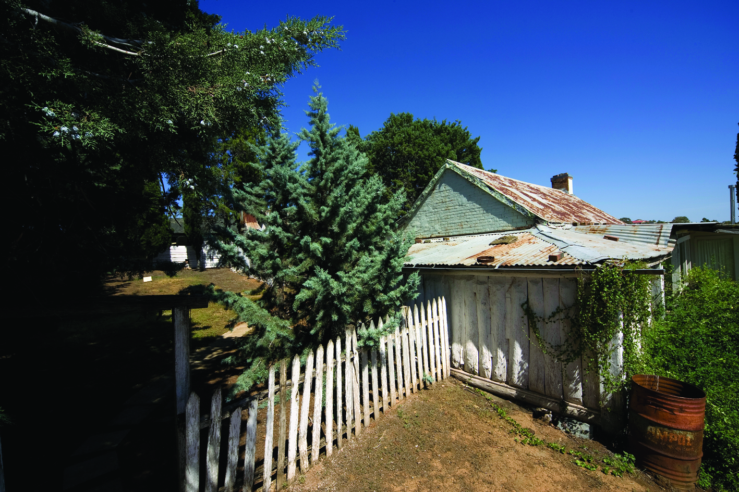
Mugga-Mugga Cottage. Image: GMH

With two of the CFC’s key venues located in Civic Square, the CFC is also a contributor to activating the Square as a public space in the heart of Canberra, serving as a hub for cultural events and activities. In addition to seeking to grow audiences to CFC facilities, the CFC collaborates with other agencies and organisations to host and promote cultural events and activities, with the goal of fostering a vibrant and culturally rich community in the ACT.

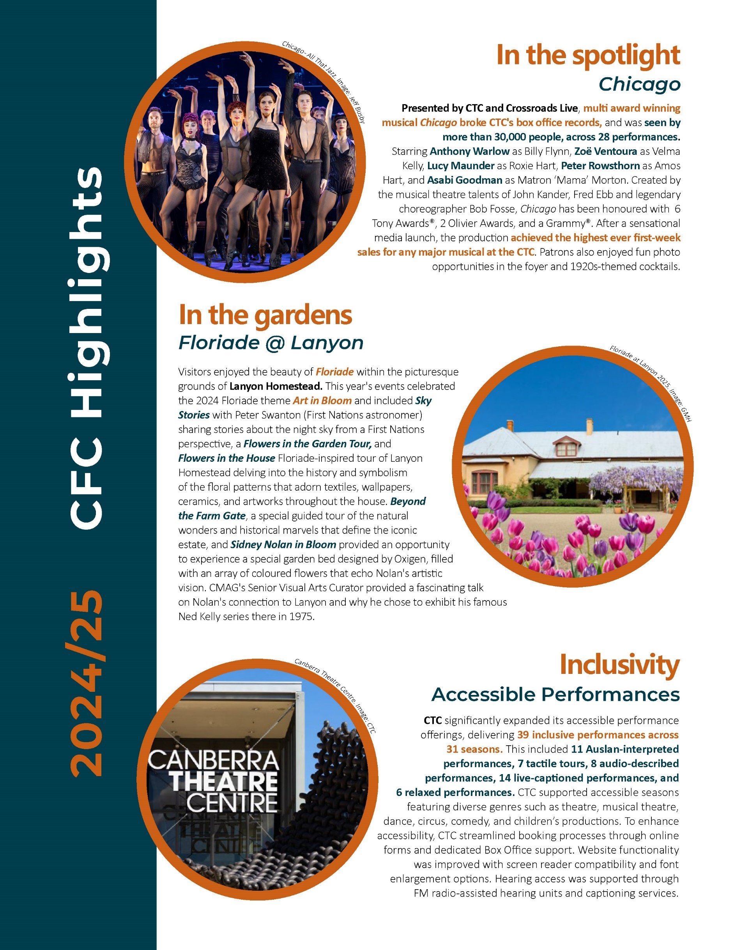
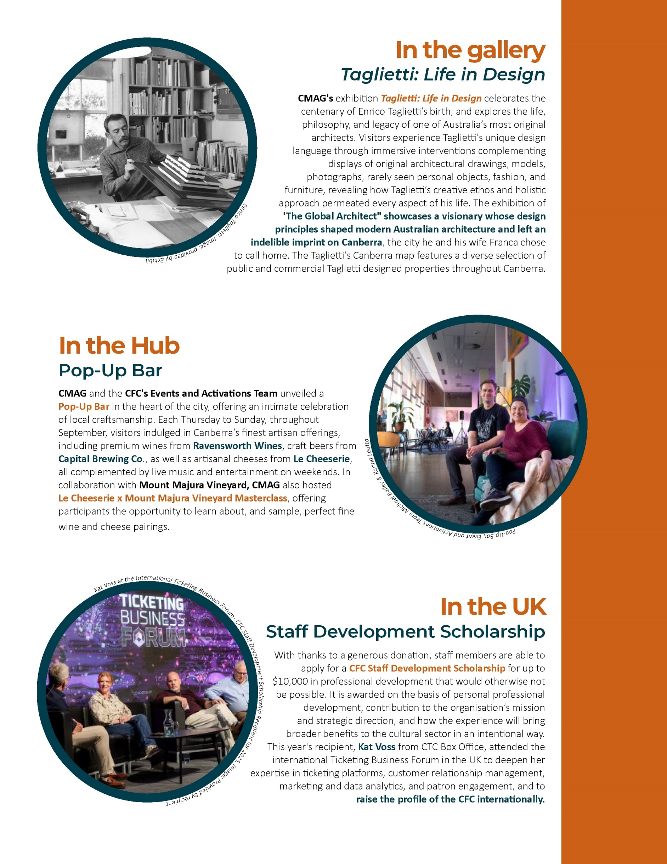
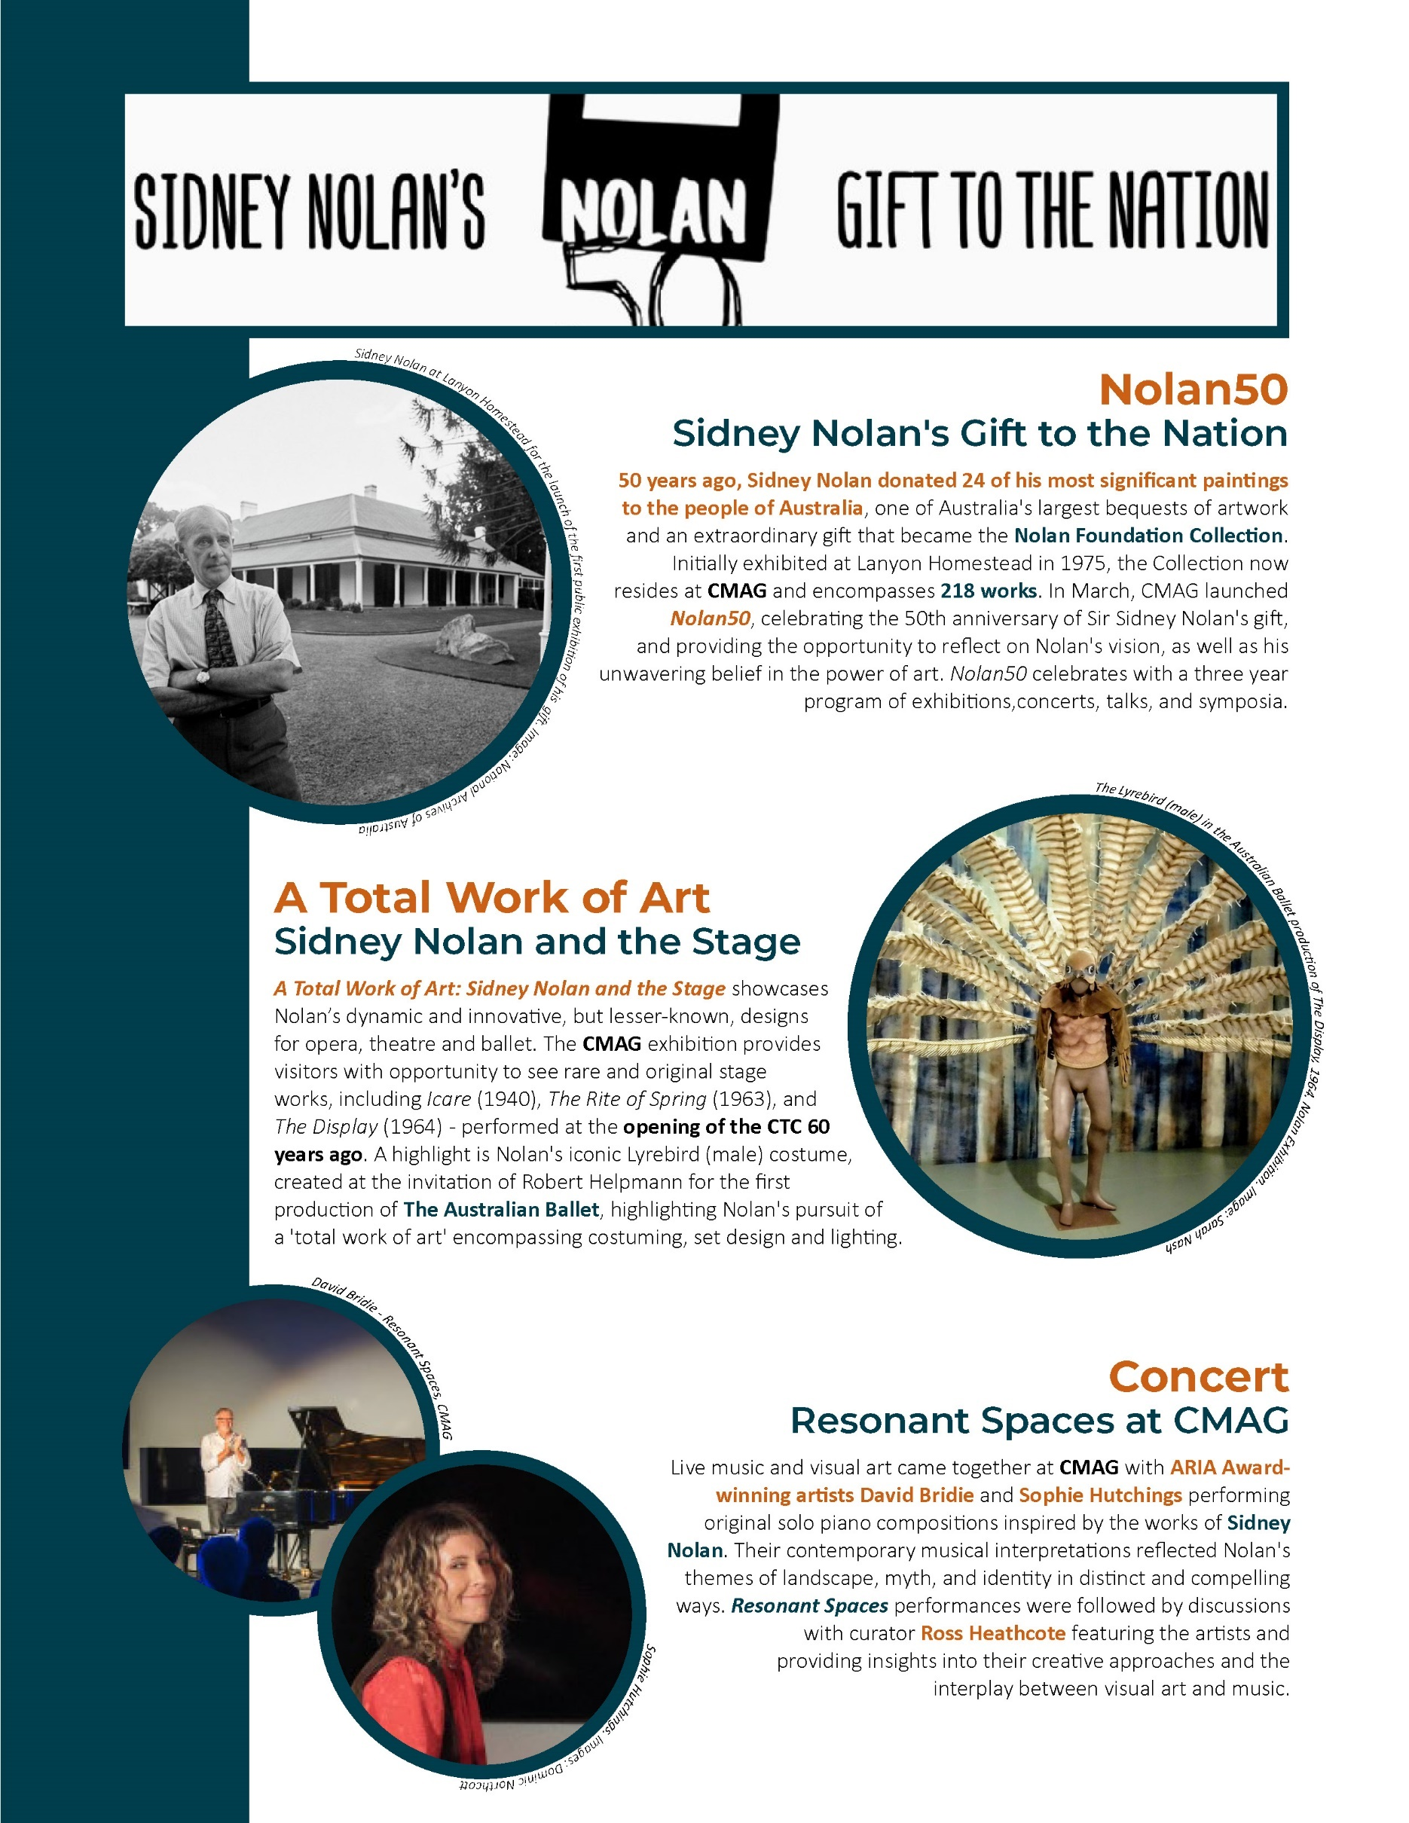
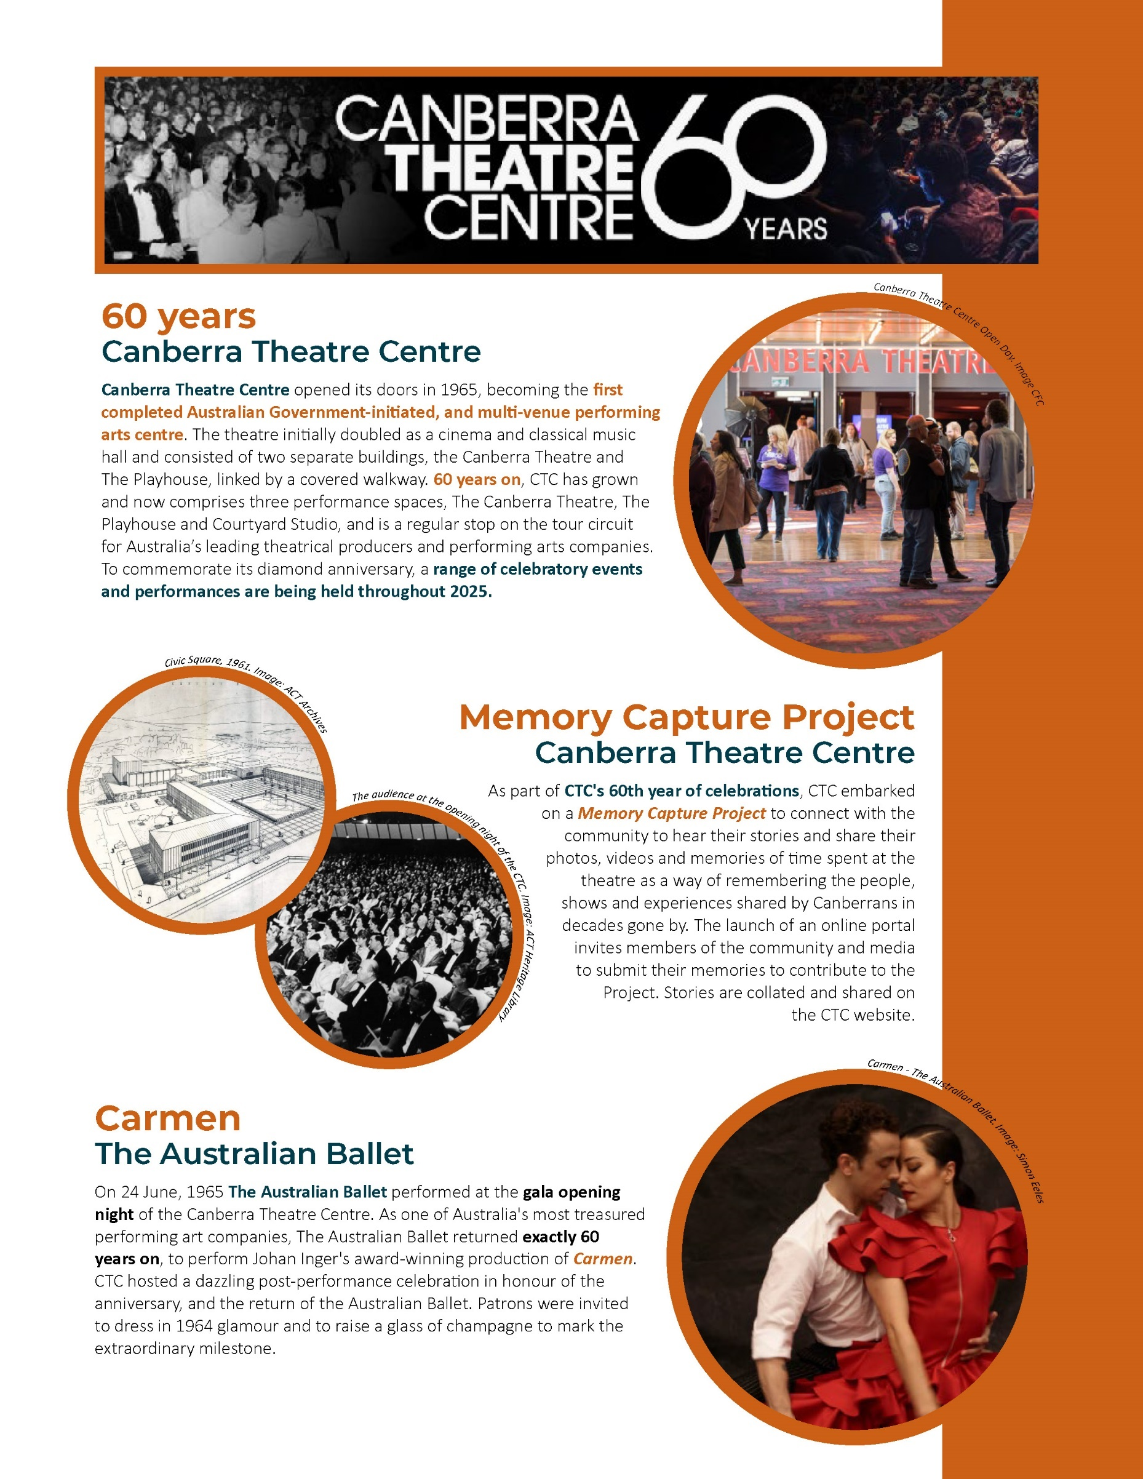
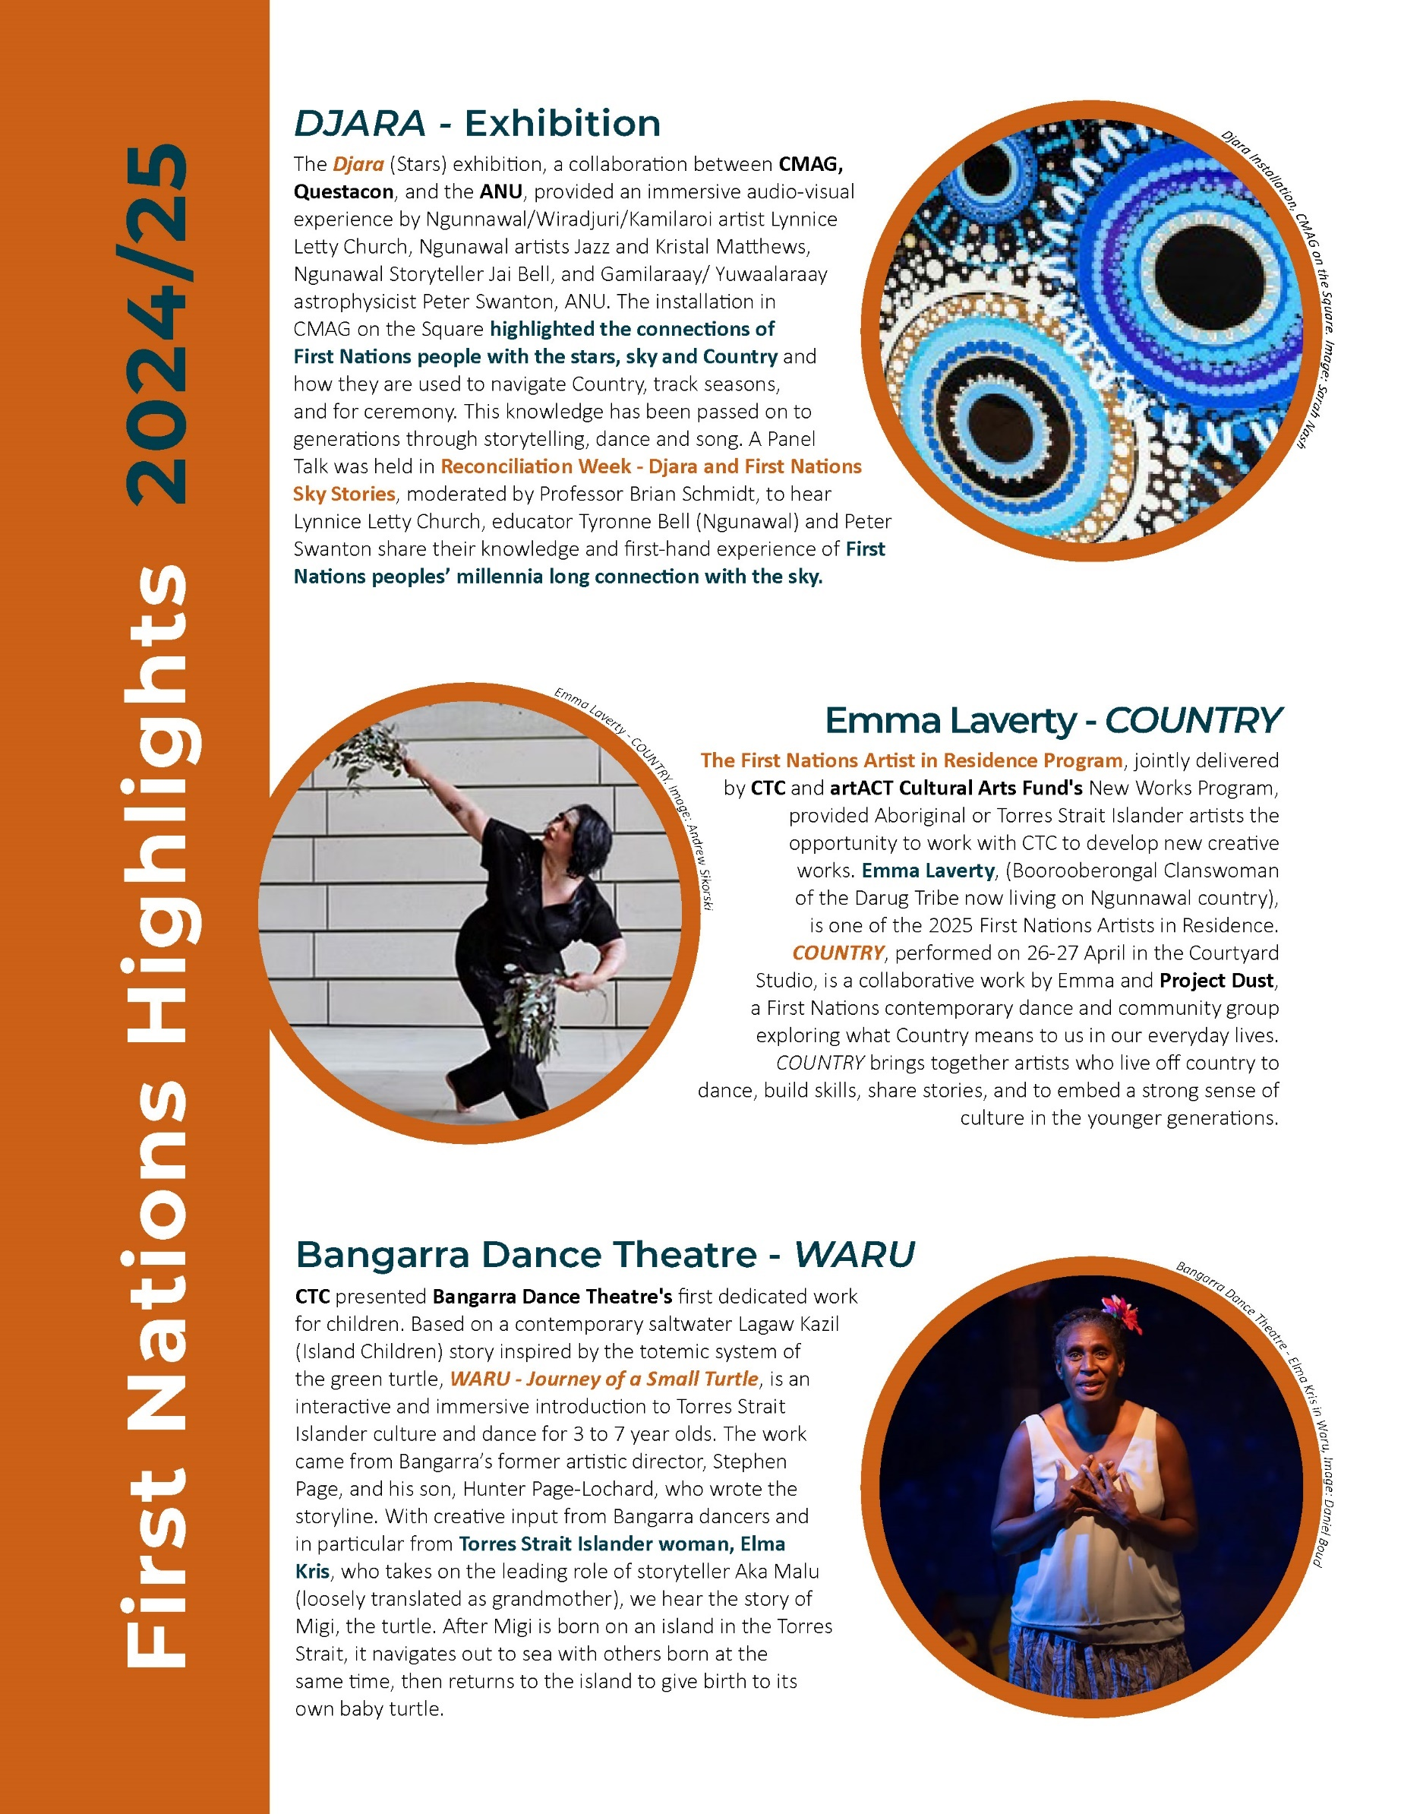
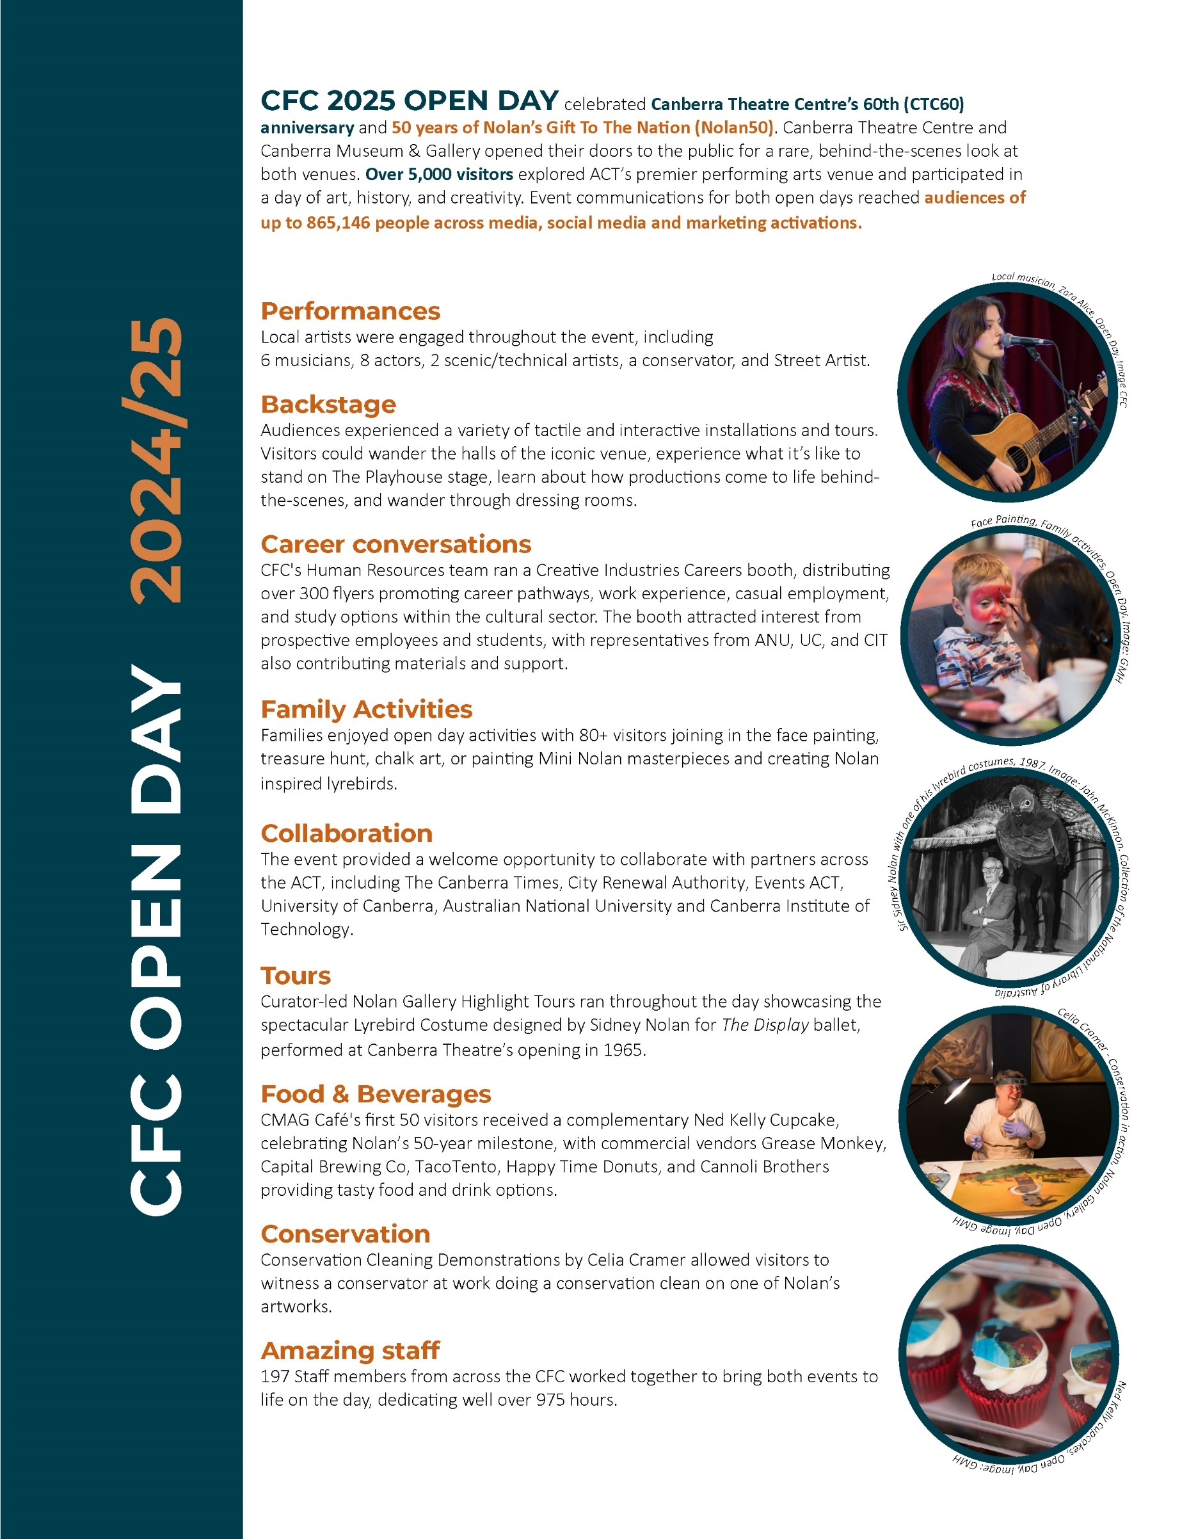
Key Clients and Stakeholders

The CFC’s commitment to our mission to create diverse and remarkable experiences in arts, culture, and heritage is grounded in an understanding of our stakeholders, including artists, audiences, cultural organisations, and the broader community. Meaningful engagement with these groups reflects our core values of being daring, responsible, agile, and magnetic, and striving for excellence to ensure our work remains inclusive, relevant, and resonant.

By actively connecting with stakeholders, the CFC is able to safeguard cultural heritage, champion local artists, broaden audience reach, and strengthen financial resilience. Our collaborative and approachable role within the ACT’s arts ecosystem enables us to encourage participation through events and programming, nurture the creation of new artistic works, and promote equitable access for all.

During 2024-25, the CFC reported to the Minister with responsibility for the Arts. The CFC has close working relationships with a number of ACT Government agencies and entities as well as key industry associations, research organisations, touring companies and other Australian arts centres and galleries. Our stakeholder network is far-reaching and inter-connected and includes:
- Ngunnawal and other First Nations peoples
- artists and arts workers
- local ACT arts, culture, and heritage organisations

- our patrons and the wider community of the ACT and region
- visitors to the ACT including school students and, broadly the wider education, business, night-time economy, and tourism sectors
- venue hirers including local ACT and community hirers
- national cultural institutions including:
  - National Gallery of Australia
  - National Portrait Gallery
  - National Film and Sound Archive
  - National Archives of Australia
  - National Library of Australia, and
  - National Museum of Australia
- relevant Commonwealth Agencies including the Office for the Arts and the National Capital Authority
- ACT Audit Office
- ACT Government Solicitor
- ACT Health
- artsACT including the Minister’s Creative Council (MCC)
- Australia Museums and Galleries Association (AMaGA)
- Australian National University (ANU) Schools of Art & Design, Music, and History, and Research School of Astronomy and Astrophysics, and Centre of Heritage and Museum Studies
- Canberra and Region Tourism Leaders Forum
- Chief Minister, Treasury and Economic Development Directorate (CMTEDD) including Access Canberra
- City Renewal Authority (CRA)
- City Services
- Creative Australia

- Environment, Planning and Sustainable Development Directorate (EPSDD) including ACT Heritage
- Events Canberra
- Infrastructure Canberra (iCBR) (formerly MPC - Major Projects Canberra) including ACT Property Group
- local arts advocates including The Childers Group
- National Capital Attractions Association (NCAA)
- national producers of the performing arts, including commercial and funded companies
- National Trust of Australia (ACT)
- Office of Industrial Relations and Workforce Strategy (OIRWS)
- Performing Arts Collection (PAC) Australia
- Territory Records Office (TRO)
- the diplomatic community and the Office of the International Engagement Commissioner
- Transport Canberra
- University of Canberra’s Centre for Creative and Cultural Research (CCCR)
- University of Queensland
- University of Melbourne, and
- Visit Canberra.

B1.3 - Organisational Structure, Environment and Strategic Planning Framework

Organisational Structure and Environment

To deliver on the vision, mission, and goals of the CFC under the 2023-27 Strategic Plan, the CFC is organised into three main creative expressions being Galleries, Museums & Heritage (GMH),
Canberra Theatre Centre (CTC), and
District and Events, supported by centralised Finance, Corporate, Human Resources, Marketing, and Facility Operations and Capital Works (FOCW) teams.

Strategic and Operating Framework

The CFC is an ACT Government entity, established under the Cultural Facilities Corporation Act 1997, and its operations are also subject to other relevant legislation and governance documents including the Government’s Statement of Expectations, and the CFC’s Statement of Intent.

The Strategic Plan 2023-27 sets the overarching direction for the CFC’s work, guiding the development of its business plan and individual work plans. It provides a clear framework that links our Vision, Mission, and Goals with both our external Accountability Indicators and internal key performance measures. Through this alignment, there is a clear line between the CFC’s strategic intent and the core activities that deliver on each goal, supported by relevant plans, policies, and procedures.

In addition to the Accountability Indicators reported on at Attachment 1, the CFC reports internally on a range of key performance indicators across areas of assets, supporting artists, growing visitor numbers, revenue growth, developing new audiences, theatre redevelopment milestones, sector leadership, First Nations representation, children and youth programming, and workforce capability.

Further details about the CFC’s Accountability Indicators are provided in the 2024-25 Statement of Performance at Attachment 1 to this report. Detailed reporting against the CFC’s strategic goals is at Section B.2.

B1.4 - Summary of CFC’s Performance in Achieving Objectives and Targets

The CFC’s Accountability Indicators and targets for 2024-25 are identified in the CFC’s 2024-25 Statement of Intent, which was included in the 2024-25 ACT Budget statements.

Performance outcomes for the CFC in
2024-25 were better than the previous year as a result of increased activity in all of the CFC’s venues. This resulted in the CFC meeting or exceeding all of its Accountability Indicator targets for
2024-25. The exhibition count reflects a strategic shift toward longer exhibition periods for major shows, enabling deeper public engagement, repeat visitation, and expanded education programming. This approach maximises value and impact. Record visitation in 2024-25 confirms that exhibition quality, duration, and diversity are meeting community expectations.

During 2024-25 the CFC welcomed over 431,000 visitors and patrons to its facilities and programs, 20% above target.

Detailed performance results and variance explanations are included in the 2024-25 Statement of Performance at
Attachment 1 to this report.

Summary of Performance Outcomes

The CFC’s overall results for 2024-25 met or exceeded targets on all of our Accountability Indicators. The increase in visitor numbers is attributable to appealing product development, highly effective marketing, and a focus on audience diversification across all areas of the CFC. The above-target visitor numbers correspondingly lower the cost-to-government per patron indicator, as well as a higher than forecast increase in the CFC’s proportion of own-sourced revenue.
The number and breadth of exhibitions reflects the CFC’s strong commitment to telling the stories of Canberra and the region, as well as agility in responding to unplanned opportunities for collaboration on exhibitions and installations. Education and community programs experienced unprecedented growth, driven by an expanded offering of public programs at both CMAG and the Historic Places.

As of 30 June 2025, the CFC had completed all of its 2024-25 Asset Renewal Program works and upgrades to CMAG to improve accessibility, as well as upgrading the CTC dimmers and chain hoists to comply with modern standards. Some capital project delivery timeframes were revised, namely some CTC upgrades that have dependencies on other projects, and the Lanyon Homestead internal roads upgrades, the scope of which is impacted by an active storm damage insurance claim.

A full analysis of the CFC’s financial results and financial position is set out in the Management Discussion and Analysis at Attachment 1.

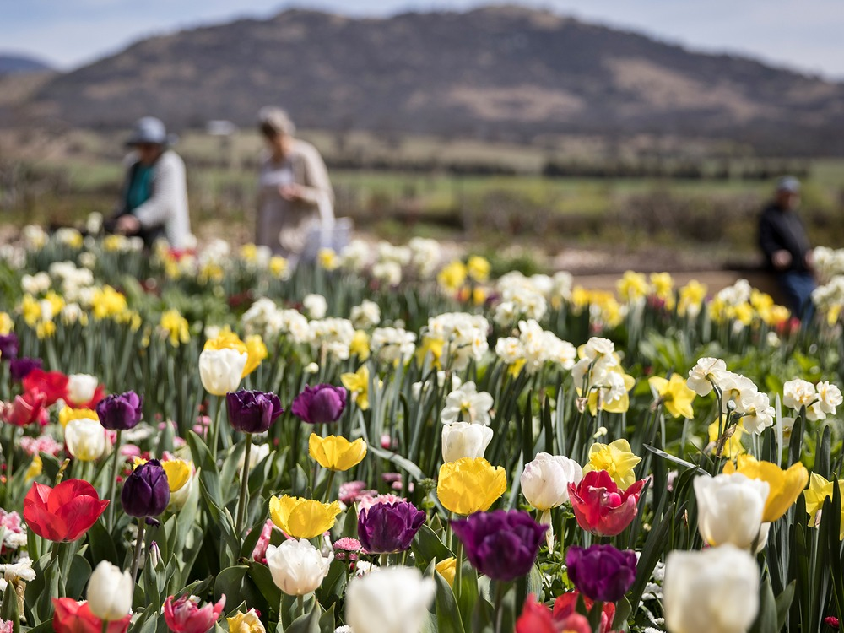
Flowers in the Garden Tour. Floriade @ Lanyon. Image: GMH

Performance Outcomes
The 2024-25 Statement of Intent identified targets for the CFC’s Accountability Indicators.
A detailed analysis of outcomes against these targets is presented in the CFC’s 2024-25 Statement of Performance at Attachment 1.

To assist in understanding the trends of these key performance indicators, graphs are presented below as a visual representation of the results for the indicators from 2021-22
to 2024-25.

CFC Performance Indicator Graphs

Figure B1.a: Number of visitors/patrons to CFC facilities/programs
Visitation to all CFC venues was higher than anticipated, due to growth in Canberra Theatre Centre ticket sales and venue usage, as well as strong exhibition attendance and participation in public programs across Galleries, Museums and Heritage.

Figure B1.b: Number of exhibitions at facilities managed by the CFC
The number of exhibitions across Galleries, Museums & Heritage was consistent with the target and included 20 new in-house curated exhibitions developed and delivered at Canberra Museum & Gallery, Lanyon Homestead, and Calthorpes House.

Figure B1.c: Number of education and community programs provided the CFC
The result for number of education and community programs provided by CFC was higher than target because additional community programs were developed and delivered at Canberra Museum & Gallery and Lanyon Homestead.

Figure B1.d: Number of days venue usage at the CTC
Venue usage at Canberra Theatre Centre exceeded expectations with an 18% increase over target, mainly due to growth in non-ticketed activities like rehearsals, community events, corporate hires, and educational programs.

Figure B1.e: Customer satisfaction with the quality of services provided by the CFC
Customer satisfaction levels over the past four years have remained above target, reflecting a commitment by each venue to achieve as high a standard as possible. The level for 2024-25 was 93%, 3% above target.

Figure B1.f: Cost to government per estimated visitor/patron to CFC facilities/programs
With a target cost to government target of $29.05 the CFC achieved an actual cost of $24.11 for 2024-25, resulting in a 17% reduction per visitor/patron to CFC facilities/programs this financial year.

Figure B1.g: Own sourced revenue as a proportion of total revenue

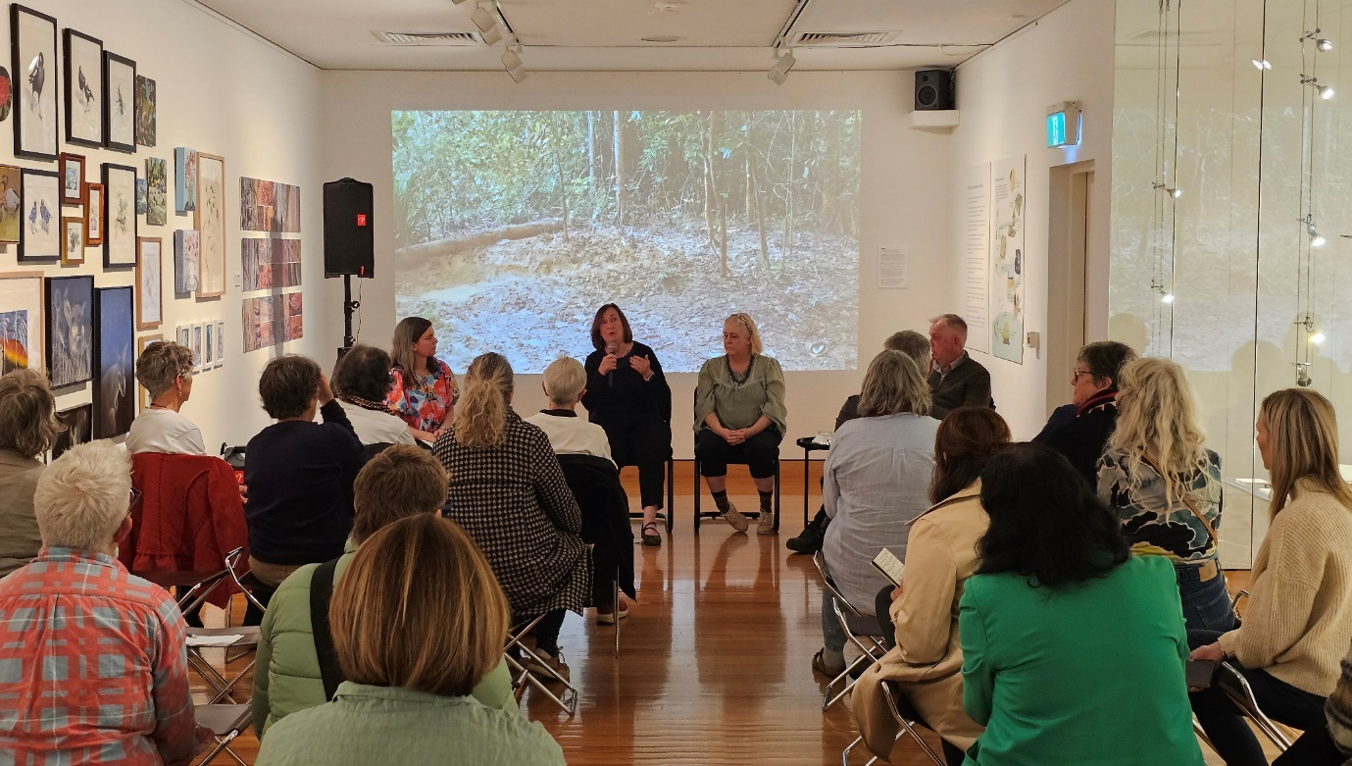
CMAG NatureArt Lab lunchtime talk with Nicole Sutherland. Image: GMH

CFC’s own sourced revenue increased significantly during 2024-25 reaching 64.6%, 27% above the target of 51.5%. This has improved on 2023-24 and is the highest proportion of own sourced revenue in the CFC’s history.

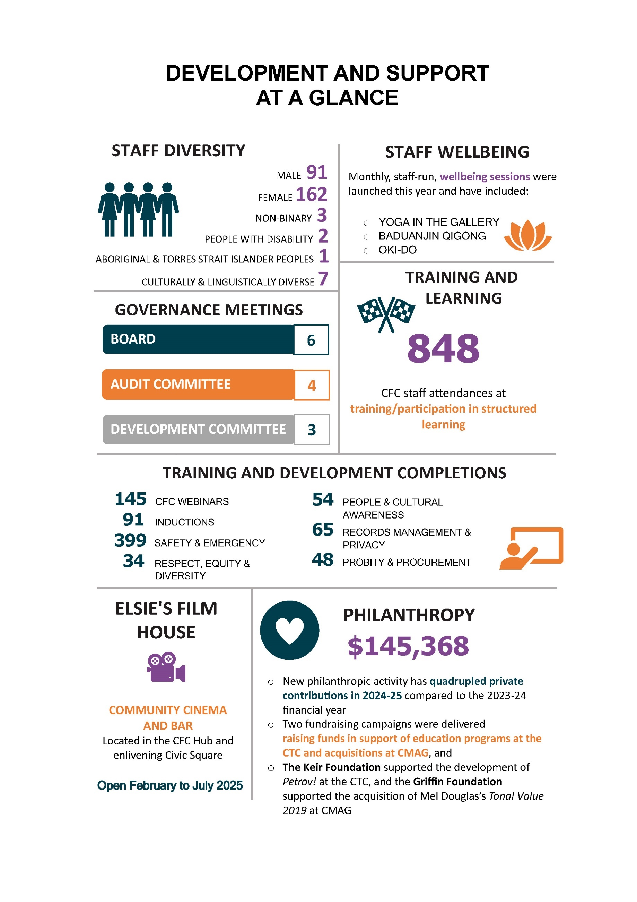
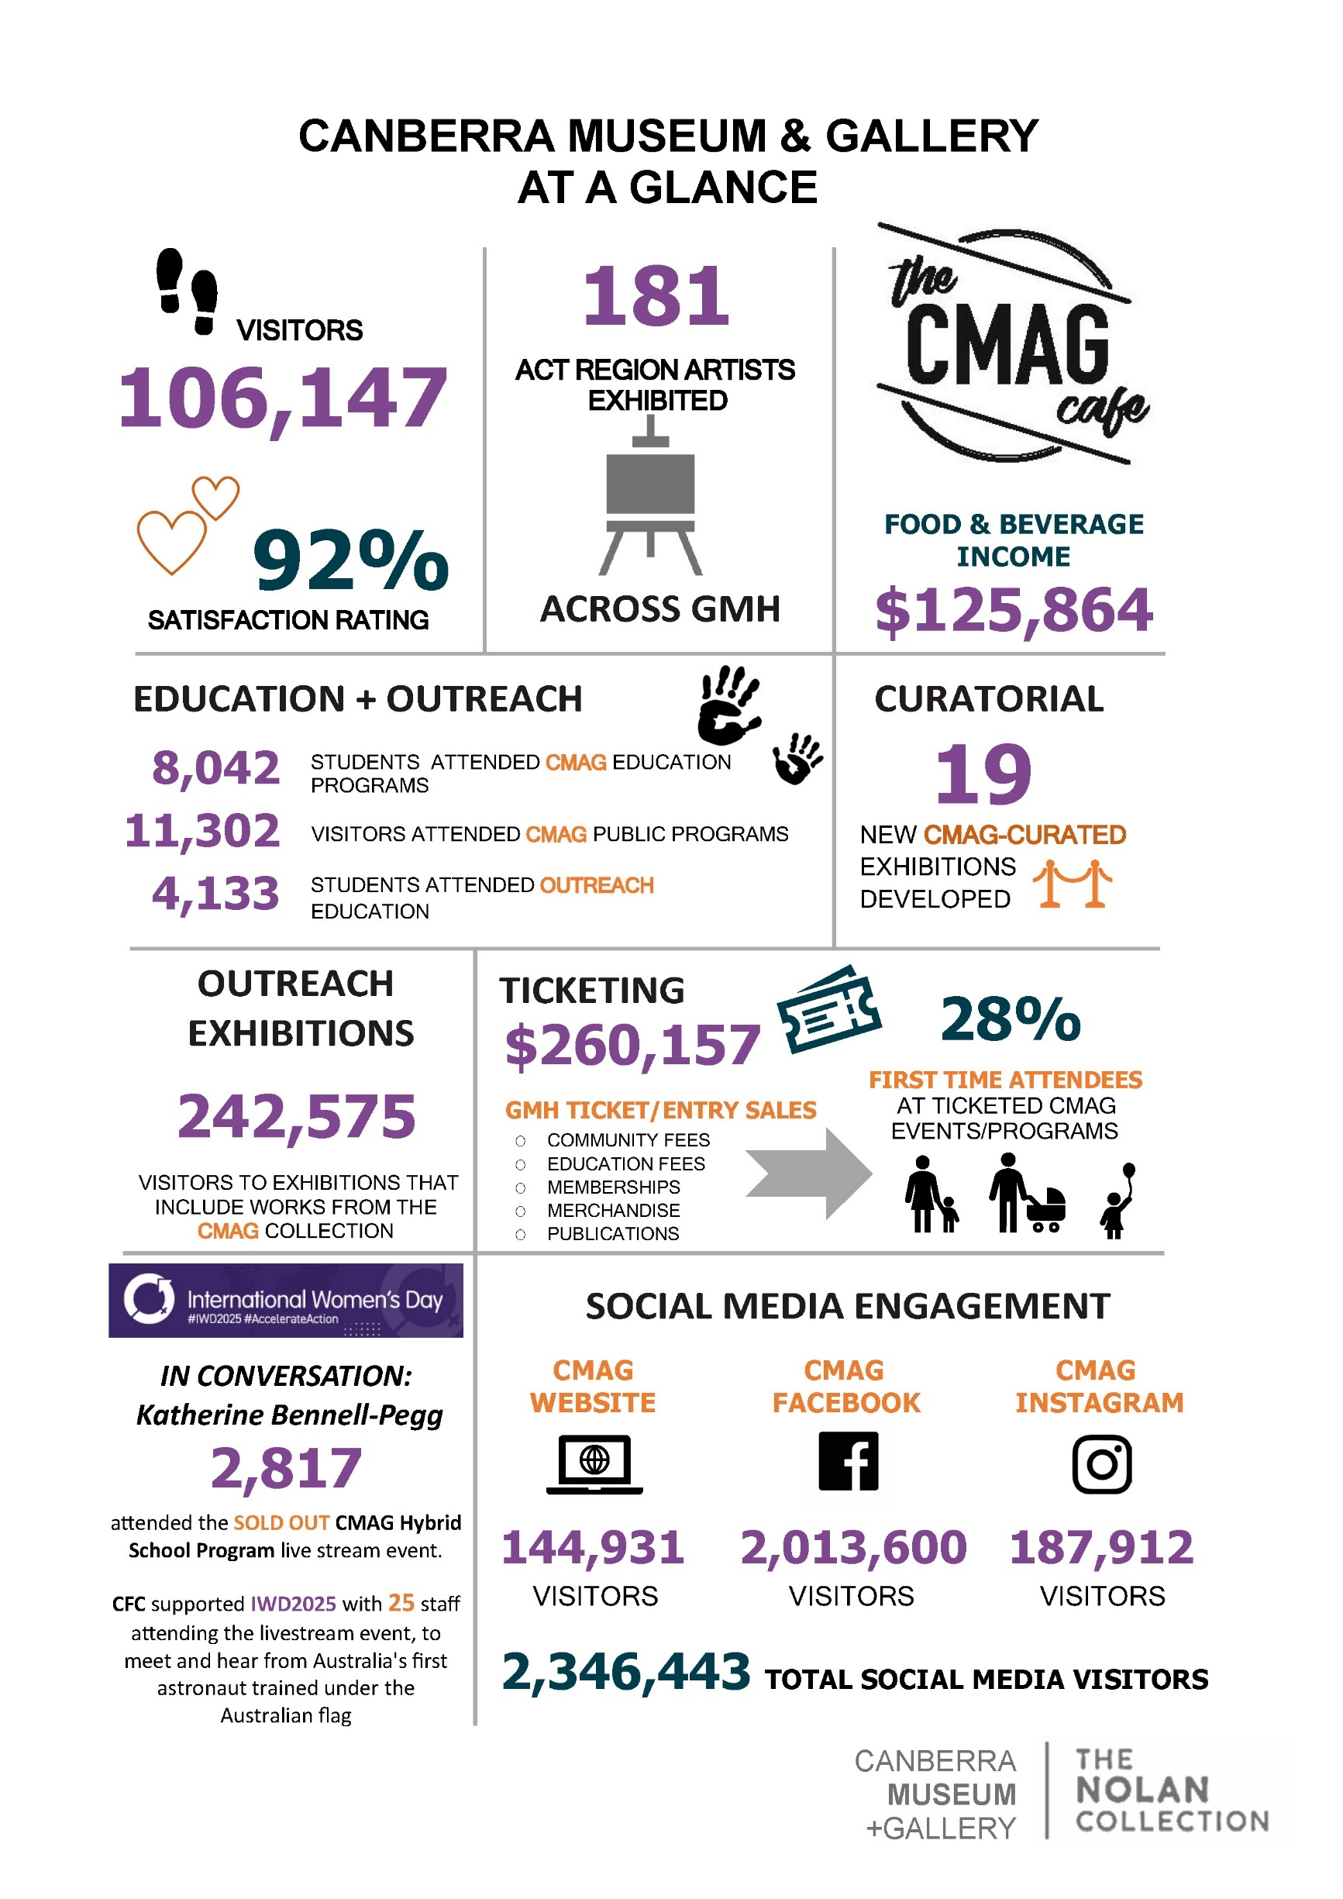
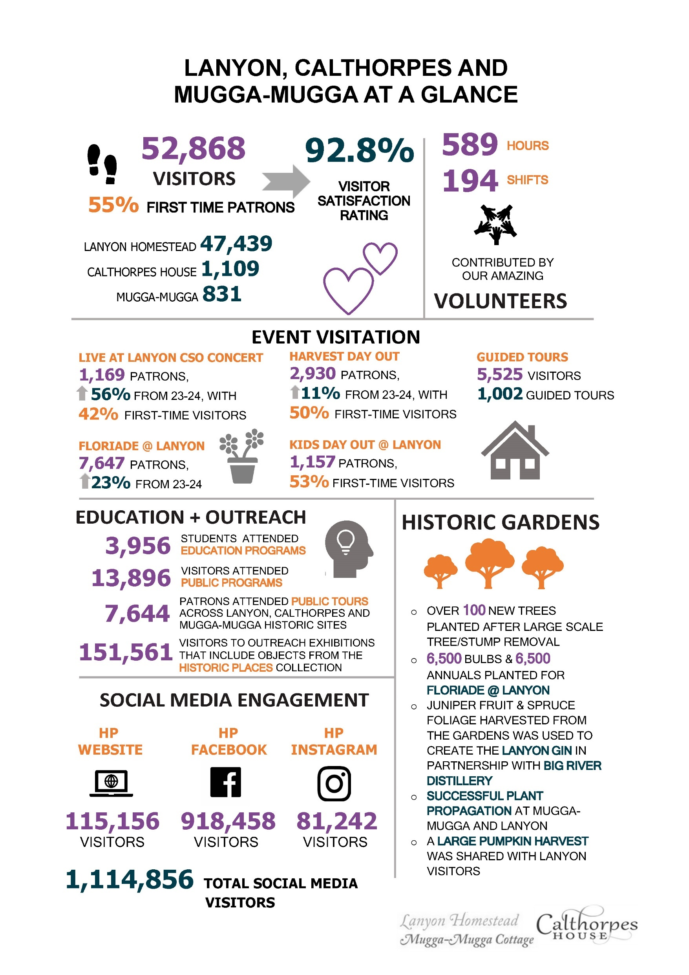
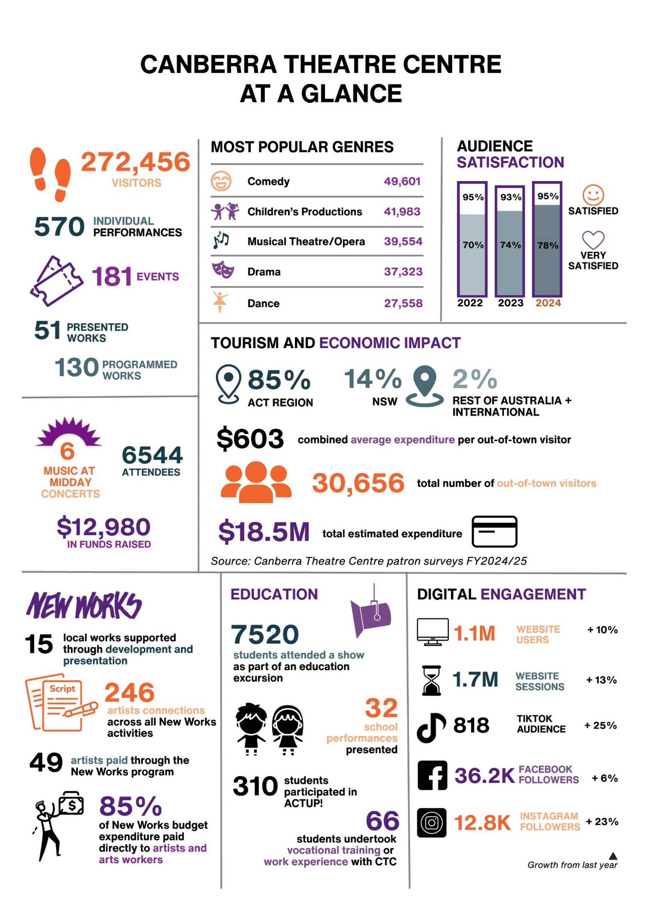
B1.5 - Outlook

The continuing celebrations of two major milestones - the 50th anniversary of Sidney Nolan’s foundational gift to the nation and the 60th anniversary of CTC - will extend through 2025-26, offering a unique opportunity to honour the past while shaping the future. For the Nolan Collection, the anniversary program extends into 2027 - which also marks the 100th birthday of Calthorpes House - followed in 2028 by the 30th birthday of CMAG. These anniversaries serve as a springboard for the CFC to advance its strategic priorities across all areas of operation.

At the heart of this momentum is the transformation of CTC, the flagship initiative under Goal 3: Redevelopment of the Canberra Theatre Centre and Canberra Civic and Cultural District (CCCD). This project will transform CTC into a contemporary arts centre of national and international significance - integrated into the city’s identity and designed to foster storytelling, creativity, and cultural
exchange across generations and communities. The redevelopment will
expand performance opportunities across genres, including musical theatre, opera, ballet, immersive works, and First Nations-led productions.
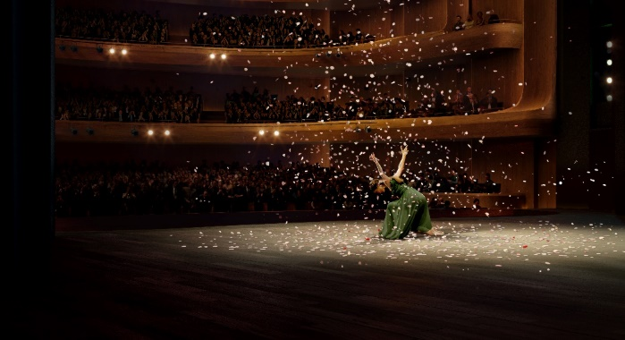
Render of imagined CTC development. Image: CTC

A key commitment of this project is to ensure continued access for local arts organisations to theatre venues and to support the development of new works.

The CFC aspires to grow the next generation of performing artists, foster the creation of locally produced works that tell stories of national significance, inspire young performers with access to a world-class facility, serve as a training ground for both on-stage and backstage talent, and uplift the entire local arts sector. The redevelopment will also enable expanded opportunities across many performance genres - musical theatre, contemporary music, ballet, opera, classical music, circus, comedy, and immersive performances - while deepening artistic programming with a focus on First Nations, community, diversity, and youth representation.
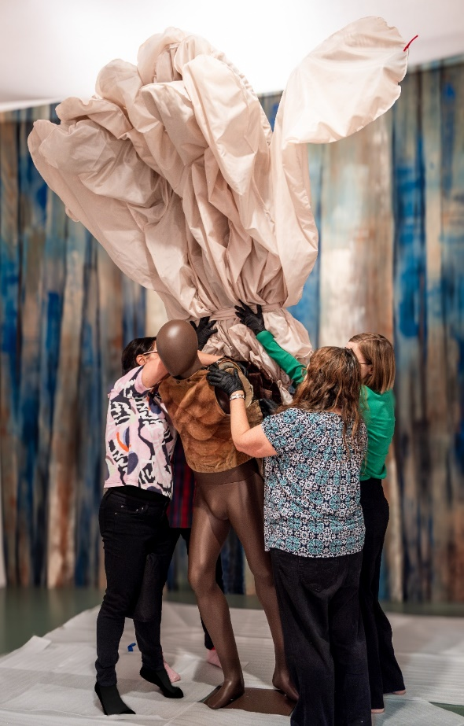
Assembly of the Lyrebird - Nolan50 - Nolan and the Stage
exhibition. Image: Dominic Northcott

The CFC is also preparing for the operational demands of a significantly larger and more complex theatre centre. In collaboration with Infrastructure Canberra, planning has focused on design excellence, operational functionality, and value for money. A robust programming strategy is in place to manage disruption during construction, and the organisation is scaling its capacity to meet future demands.

This major cultural infrastructure investment will deliver long-term community, cultural, and economic benefits for the ACT. It will increase visitation, support job creation, and open new commercial opportunities, aligning with Goal 2: Growth and Financial Sustainability. The CFC will continue to diversify its revenue streams through philanthropic partnerships, commercial site activation, expanded ticketing, retail, and hospitality offerings.

Beyond CTC, the CFC is positioned as a central stakeholder in the transformation of the CCCD. This includes envisioning a future for CMAG that reflects its role as a cultural anchor in the heart of Canberra - reimagining its building, collections, programs, and audiences. This aligns with Goal 1: Custodianship, Creativity, and Storytelling, which guides the CFC’s commitment to curating excellent art, preserving collections, supporting artists, and growing participation in the arts.

Under Goal 4: Sector Leadership and Development, the CFC will continue to champion Canberra as a creative capital, with a strong focus on First Nations engagement and inclusive programming. Through Goal 5: Best Practice Governance, Organisational Capacity and Culture, the CFC is strengthening its internal structures to ensure transparent governance, a unified identity, and a future-ready organisation.

The CFC is also working towards delivery of an ambitious philanthropy strategy aligned with our broader organisational Strategic Plan, with the ambition of providing the CFC with a balanced and sustainable program consisting of annual giving, major gifts (individual, foundation, and corporate), and planned giving.
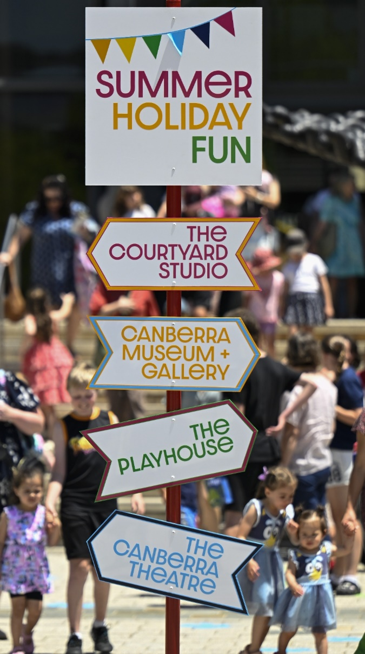
January Summer Holiday Fun. Image: Martin Ollman

B1.6 - Internal Accountability
The Leadership Team of the CFC for 2024-25 comprised of the following positions:

CFC Leadership Team
Chief Executive Officer (CEO) | Gordon Ramsay
Chief Finance and Information Officer (CFO/CIO) | Sharon Lu
Director, Canberra Theatre Centre (CTC) | Alex Budd
Director, ACT Galleries, Museums & Heritage (GMH) | Dr Anna Wong
Director, Collaboration and Engagement (C&E) | Dr Brooke Thomas
Director, Facilities Operations & Capital Works (FOCW) | Danielle Buffier
Head of Philanthropic Development | Corinna Cullen

Information about the Leadership Team is provided at Appendix 1 (for the Chief Executive Officer, as a CFC Board member), and Appendix 2 (for the other six leadership team positions). Further information relating to the structure of the organisation and the responsibilities of the leadership team are provided at Section B.1.3.

The Senior Leadership Team meets every fortnight to discuss strategic, operational, financial, and collaboration matters. Other significant committees of the CFC include the WHS Committee, the Agency Consultative Committee, and the Audit and Risk Management Committee.

Board of the CFC
The Board of the CFC promotes, and is responsible for, good governance of the CFC.
The Board operates according to a Board Charter which sets out its role, composition, and responsibilities. The CFC’s governance structure ensures the strategic leadership of the organisation and the effective oversight by the Board of management, in order to:
    - ensure the CFC achieves its mission and purpose
    - enhance organisational performance
      - understand and manage risks to minimise negative consequences and maximise opportunities
      - strengthen stakeholder confidence
      - enhance the CFC’s public reputation through enhanced transparency and accountability, and
      - oversee the way in which the CFC is discharging its legal, stakeholder and ethical obligations.

The Board Charter is available at www.culturalfacilities.act.gov.au.

2024-25 CFC Board Members and Terms
Chair | Helen O’Neil | 2 Jul 2022 - 30 Jun 2025
Deputy Chair | Dr Rachael Coghlan | 2 Jul 2022 - 30 Jun 2025
Members | Genevieve Jacobs AM  Christine Shannon  Tim Lo Surdo  Michael Sollis  Gordon Ramsay  (Ex officio as CEO) | 2 Jul 2022 - 30 Jun 2025  14 Apr 2023- 31 Dec 2025  1 Jan 2023 - 31 Dec 2025  2 Jul 2022 - 30 Jun 2025

Section 10 of the CFC Act provides for the CFC Board to have seven members. The Chair, Deputy Chair, and four Members of the CFC Board are appointed by the Minister in accordance with the provisions of the Financial Management Act 1996 (the FM Act), Sections 78-79. The CFC’s Chief Executive Officer is also a Member of the CFC Board in accordance with Section 80 of the FM Act.

The functions of the Chair, Deputy Chair, Chief Executive Officer, and associated provisions relating to Board Members, are set out in the FM Act (Division 9.3). Further information about the 2024-25 Board members is provided at Appendix 1.
The FM Act (Division 9.2, Clause 78 (6)) provides that the remuneration of the CFC’s Chair, Deputy Chair, and appointed Members shall be determined by the ACT Remuneration Tribunal. The current annual remuneration rates, set by the Tribunal’s Determination 15 of 2024
are set out in the adjacent table.

Remuneration Rates
Chair | $31,505
Deputy Chair | $15,770
Members | $11,055

The Chief Executive Officer’s remuneration is determined by the ACT Remuneration Tribunal under normal senior executive remuneration arrangements.
Board Meetings
2024 | 2025
15 August | 27 February
17 October | 1 May
6 December | 26 June

The CFC’s Board meetings are convened and conducted in accordance with the provisions of the FM Act (Division 9.4).

The convening of these meetings, and their procedures, complied with the requirements of Division 9.4 of the FM Act.

The terms of three Board members ended during the 2024-25 financial year. Chair, Helen O’Neil, and Members Michael Sollis and Genevieve Jacobs AM concluded their terms on 30 June 2025. The CFC acknowledges their significant contributions over their years of service on the CFC Board. Ms O’Neil brought deep expertise in cultural policy and governance, providing strategic leadership during a period of major planning and transformation. Mr Sollis fostered creative thinking and enhanced community connections bringing expertise from across music and the arts, and Ms Jacobs contributed valuable insights from her background in media, community engagement, and regional development, helping to strengthen the CFC’s connection with diverse audiences.

Audit Committee
The CFC’s financial and risk management is supported by the work of the Audit Committee of the Board and through the CFC’s Strategic Risk Management Plan, Internal Audit Program, and Fraud Control Plan. The CFC established the Audit Committee as a sub-committee of the Board, with a formal charter setting out its role and functions in relation to oversight of financial, audit, and compliance matters, including risk management and internal controls. The External Member of the committee is remunerated as per Determination 5 of 2025 of the Remuneration Tribunal at $545 per diem.

The Audit Committee Charter is provided as Part G of the CFC Board Charter, available at: www.culturalfacilities.act.gov.au.

Advisory Committees
In accordance with Section 8 (i)(a) of the CFC Act, the CFC has three Advisory Committees which are responsible to the Board of the CFC (through the CFC’s CEO) for providing strategic and policy advice on how the CFC provides cultural leadership, excellence and innovation at CTC, CMAG, and the Historic Places (ACTHP).

Committee | Role | Membership
CTC  Advisory  Committee | To provide strategic and policy advice in relation to how the planned development of CTC can provide cultural leadership, excellence and innovation. |  | Claudia Santangelo (Convenor)  Soelily Consen-Lynch  Fredeliza Campos  David Hobbes  Kels Bagust
CMAG  Advisory  Committee | To provide strategic and policy advice in the presentation and interpretation of visual arts and social history through its collection and exhibition functions. |  | Prof Nicholas Brown (Convenor)  Prof Denise Ferris  Squadron Leader Gary Oakley OAM  Dr Charlotte Craw  Sara Kelly  Amelia Zaraftis
ACTHP  Advisory  Committee | To provide strategic and policy advice on how ACT Historic Places (Lanyon, Calthorpes House and Mugga-Mugga) can provide cultural leadership, excellence and innovation in cultural heritage management and interpretation. |  | Barbara Reeve, FIIC, M ICOMOS (Convenor)  Dr Dianne Firth OAM (Deputy Convenor)  Alistair Grinbergs  Joanne Lisinski  Shannyn Palmer

The operation of the advisory committees is governed by an Advisory Committees Charter, which is available at www.culturalfacilities.act.gov.au. Further details about Advisory Committee members are provided at Appendix 3.

Chicago, Anthony Warlow and the female ensemble. Image: Jeff Busby
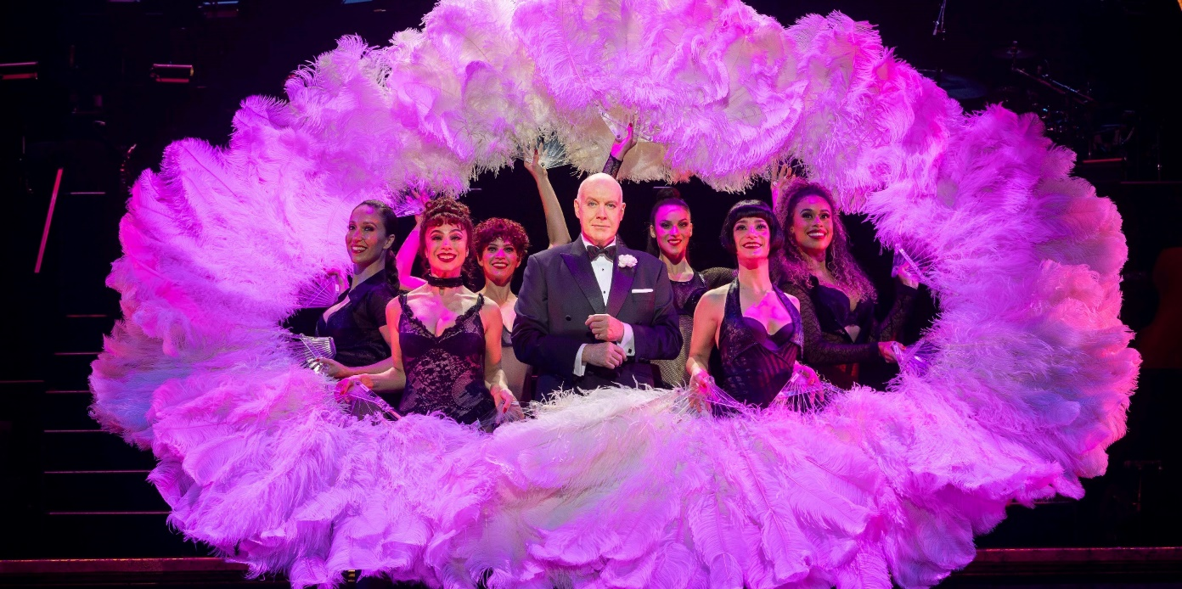

B2 Performance Analysis

The CFC’s 2024-25 Statement of Intent was prepared in accordance with Section 61 of the Financial Management ACT 1996 and published in the 2024-25 ACT Budget statements. The Statement of Intent identified the CFC’s strategic objectives and indicators. Performance against these is summarised under Section B.1.4.

Overview
In 2024-25, the CFC delivered a strong year of growth, engagement, and operational achievement, meeting or exceeding all of its Accountability Indicator targets. The CFC welcomed over 431,000 visitors and patrons to its venues and programs - 20% above target - reflecting the success of its audience diversification strategies, compelling programming, and effective marketing. This uplift in visitation contributed to a lower cost to government per patron and a significant increase in own-sourced revenue, which reached 65.5% of total revenue, well above the projected 51.46%.

CMAG welcomed 102,014 onsite visitors - an increase of 15.3% from 2023-24 and the highest level of onsite visitation since 2013-14 (Canberra’s Centenary). The continued growth across CMAG and the Historic Places has been driven by the quality of exhibitions, education and public programs, and site activation.

Education and community programs nearly doubled expectations, with 530 programs delivered across the museums and galleries - 96% above target - thanks to expanded offerings at CMAG and the Historic Places. 28,638 visitors attended our public programs.

Venue usage at CTC also exceeded targets, with a notable increase in non-ticketed activities such as rehearsals, community events, and educational programs, supporting long-term audience development and sector engagement.

The completion of the organisational realignment in 2024-25 further strengthened CFC’s operational capacity. The centralisation of Facility Operations and Capital Works, Marketing, Finance, and Human Resources has enhanced collaboration, streamlined processes, and improved resource efficiency across the organisation.

CFC’s stewardship of diverse cultural venues continues to offer rich opportunities for community engagement, education, and tourism, while presenting unique operational challenges. Through agile leadership, strong internal collaboration, and strategic coherence, the CFC continues to offer remarkable experiences across performing arts, our historic places and the multi-disciplinary exhibitions and programs that promote the history, contemporary experiences and visual arts of Canberra and the region.

Strategic Goal 1 Custodianship, Creativity  and Storytelling | We will deliver creative excellence and custodianship for the CFC’s activities, deepen our contribution to the ACT’s arts, culture, and heritage ecology, and grow our national role.
Operational Priorities
- Reinforcing the CFC’s role to preserve, keep, and present the collections and assets under our management including sharing the stories of this place.
- Enhancing our programming strategy, events, and productions to contribute to the ACT calendar of events, linked to the ACT’s tourism strategy, and including expansion into festivals, to help build new markets and attract visitors.
- Fostering participation in the arts and heritage - including through virtual access - for everyone - audiences, students, artists, our community, and other organisations.
- Supporting artists in the creation of new works, development, education, and residencies.
- Commissioning or producing new Australian works and capturing the voices of the nation.
- Establishing priority company relationships with the CTC and enticing world class artists to Canberra.

Canberra Theatre Centre
In 2024-25, the CFC exceeded its financial year and patron number targets while celebrating a significant milestone. CTC entered its 60th year in 2025, marking this diamond anniversary with signature events that highlighted the Centre's rich history and continued relevance to the Canberra community.

The anniversary celebrations included a free Open Day that welcomed 5,000+ patrons behind-the-scenes to explore how live performance is made, a Memories Capture Project documenting experiences of artists, audiences and CTC staff across six decades, a Champagne Reception

following Australian Ballet's Carmen that attracted ACT personalities and dignitaries, and a Cake Cutting Ceremony in the Canberra Theatre foyer to mark the official opening of the Centre on 24 June.



CFC Open Day - Nolan50 cupcakes. CMAG Café. Image: GMH
Major Productions and Programming Excellence
CTC presented productions from leading national performing arts companies including Sydney Theatre Company, Melbourne Theatre Company, State Theatre Company of South Australia, Bangarra Dance Theatre, and Bell Shakespeare, demonstrating the Centre's continued ability to attract premium
content. Several productions achieved exceptional commercial and artistic success:
- Chicago, presented by CTC and Crossroads Live and starring Lucy Maunder, Zoe Ventoura and Anthony Warlow, played 28 performances in the Canberra Theatre, to more than 30,000 attendees, breaking CTC box office records
- Julia (pictured), by Joanna Murray-Smith, directed by Sarah Goodes and starring Justine Clarke, returned to CTC after touring nationally. This
co-production with Sydney Theatre Company then transferred to Sydney Opera House in 2024, and Arts Centre Melbourne for a return season in 2025, showcasing CTC's role in developing work of national significance
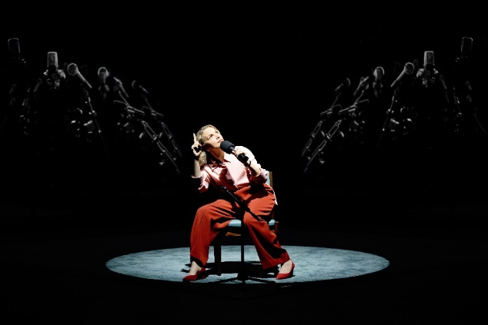
Julia. CTC. Image: Prudence Upton

- CTC invested in and presented the Australian premiere of Broadway hit Peter and the Star Catcher, produced by Dead Puppets Society and Jones Theatrical Group, which subsequently toured to Melbourne, Adelaide, Sydney, and Brisbane
- Dictionary of Lost Words (pictured), presented by CTC and State Theatre Company of South Australia, sold out and particularly resonated with Canberra audiences, with 44% of
patrons identified as first time bookers and 61 individual bookers purchasing a second performance during the season.
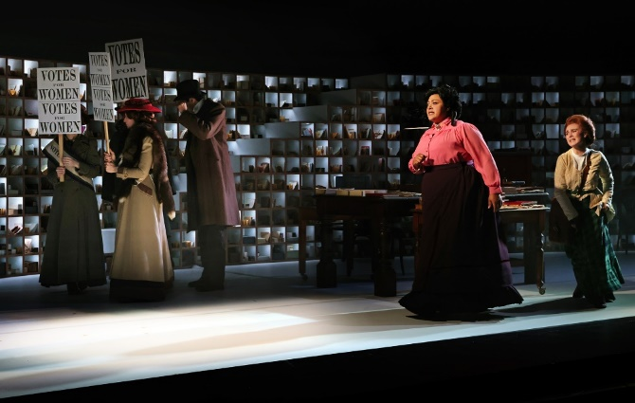
The Dictionary of Lost Words. CTC. Image: Prudence Upton

Comedy remained exceptionally popular with Canberra audiences, generating over 48,000 ticket sales. CTC attracted renowned comedians including Hannah Gadsby (Woof!), Em Rusciano (Outgrown Tour), Kaz Cooke & Judith Lucy (Kaz & Jude's Menopausal Night Out), David Sedaris (An Evening with...), Ben Elton (Authentic Stupidity), Kitty Flanagan (It's Whiteboard O'Clock), Melbourne International Comedy Festival Roadshow, Carl Barron (Trying To Work it Out),
Sammy J (The Kangaroo Effect), and Snatch Game Live!

The programming was further enhanced by the Canberra Comedy Festival 2025, which featured over 50 artists performing across 40 events, and attracted 9,550 patrons.

CTC continued to attract high-quality contemporary musical events throughout the year, with 25,000 attendees. Diverse programming included international artists such as Macy Gray (US), Joep Beving (Netherlands), Kip Moore (US), Herbie Hancock (US), Dionne Warwick (US), Damien Rice (Ireland), and Rodrigo y Gabriela (Mexico), alongside prominent Australian performers including Missy Higgins, Amy Shark, Sarah Blasko, Fanning Dempsey National Park, Jimmy Barnes, and RocKwiz Live!

Families, Education and Creative Learning Programming
CTC presented its inaugural January family program Summer Holiday Fun, featuring productions including Steve Backshall Ocean, The 78-Storey Tree House, The Listies, and Sea of Light, along with engaging foyer activations. Family favourites Bluey's Big Play and Australian Ballet's Storytime Ballet: The Nutcracker were also part of the program. Over 20,000 patrons attended events as part of Summer Holiday Fun, demonstrating a strong community appetite for family programming.

CTC presented 15 works for young audiences and schools, including successful productions such as Trophy Boys, The Peasant Prince, 360 All Stars, Waru, Saltbush, Room on a Broom, Mimi's Symphony, Night Night, and 1984.
Schools and Educational Engagement
CTC's annual ACT UP! program (pictured page 44), engaged with 19 schools, including 310 students and 30 teachers from both public and private institutions (pictured). The program facilitated theatre workshops that resulted in two performances in the Playhouse Theatre and engaged 14 local artists. The program also partnered with Australian Theatre Live, Canberra Youth Theatre, The Last Great Hunt, and CMAG.

CTC New Works and ACT Industry and Sector Development
CTC New Works continued to engage meaningfully with ACT artists and producers in commissioning, creative development, and presentation of live performances. In 2024-25, the program engaged with a total of 246 artists through creative development programs, one-on-one engagement, artist chats, professional mentorship, networking events, and presentation of local independent productions.
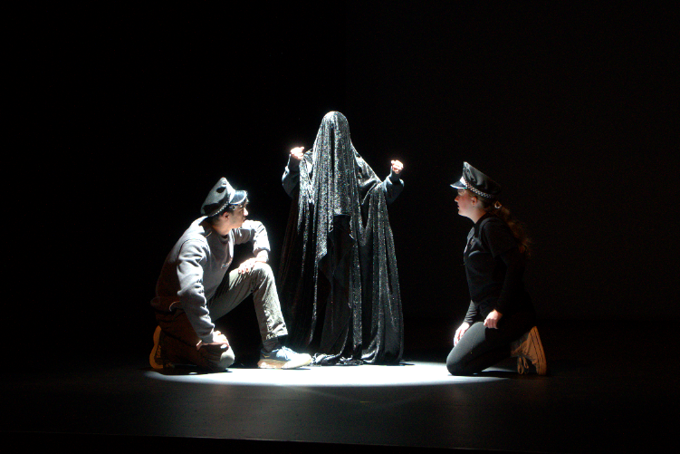
ACT UP! Image: ARW

CTC New Works contributed to 15 new works and investing more than $50,000 in local artists. Three projects supported in their applications by CTC were successful in the latest round of artsACT and Creative Australia arts funding, with two works developed through CTC New Works slated for presentation in 2025-26.

CTC New Works established the inaugural First Nations Artist in Residence, a ten-month program of mentorship and producer development with a local First Nations artist. Lead artist Emma Laverty worked with Project Dust to develop and
present their first work called Country, with the CTC Production team supporting the project through design advice and skills development.

CTC New Works delivered six creative developments, and the annual New Ideas Lab. An open EOI call out attracted a record number of submissions which were assessed by the CTC programming team and an external expert panel. Successful projects included:
- September 2024: Michael Simic and Tracy Bourne's In the Belly of the Whale, which was subsequently
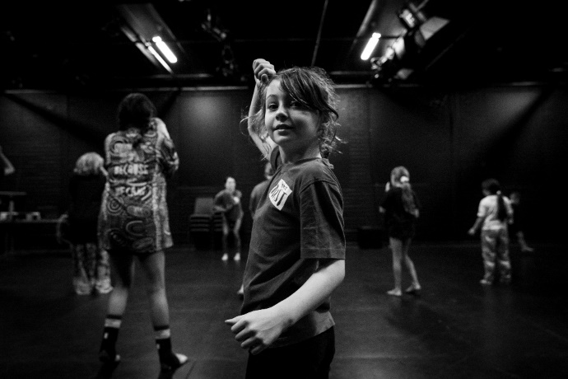
New Works Development. Image: CTC

presented at the Australian Boat Festival in Hobart in January 2025
- January 2025: James Batchelor's Resonance, scheduled for presentation in the Courtyard Studio
in October 2025, as well as at the Substation in Melbourne and Sydney Dance Company as part of IDEA 25 by Form Dance Projects
- February 2025: Michele Lee and Claire Granata's These Other Things, presented at The Capitol Theatre in Melbourne with support from RMIT Culture including TNA, Creative Wellbeing and Merrigong X
- March 2025: Yolanda Lowatta's Karbai, delivered in partnership with Ausdance ACT
- May 2025: Mary Rachel Brown's My Life in Mime, and Other Tragic Stories (early seeding stage), and
- July 2025: Luciana Harrison's Silver Spinning.

The New Ideas Lab focused on seeding new work by four local emerging artists including Jade Breen, Quinn Goodwin, Nieshanka Nanthakrishnakumar, and Eli Narev, with nationally recognised mentors Rae Perks, Mary Rachel Brown, Lewis Treston, and Christopher Gurusamy.

Professional Development and Networking
CTC New Works hosted three industry knowledge-building and networking events focused on sector development and capacity building for ACT artists, partnering with national organisations.

ACT Venue Collaboration
CTC hosted three ACT performing arts venue meetups with representatives from Belconnen Arts Centre, Tuggeranong Arts Centre, Ainslie + Gorman, The Q, and Llewellyn Hall in attendance, fostering sector-wide collaboration and knowledge sharing.

Local Arts Support
CTC engaged and supported ACT artists, producers and organisations through the:
- presentation of Canberra Youth Theatre's Work, But This Time Like You Mean It (pictured)
- presentation of Ausdance ACT Youth Dance Festival
- collaboration with Canberra Youth Theatre on their Young Critics program
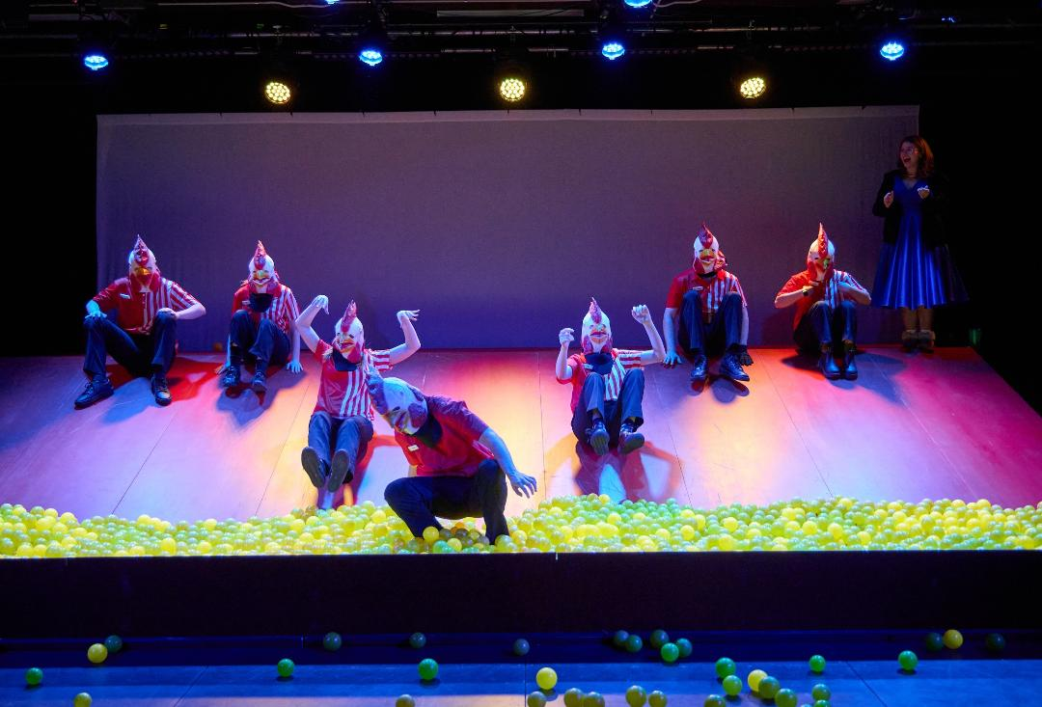
Canberra Youth Theatre's Work, But This Time Like You Mean It. Image: Andrew Sikorski

- partnership with Canberra Symphony Orchestra on several projects, including performances for Australian Ballet's Carmen and Mimi's Symphony, and
- Canberra Artist Spotlight, an ongoing open invitation for local producers to share event information through CTC's database via selected eNews and social media.

A complete list of presentations at CTC is provided at Appendix 4.

Galleries, Museums & Heritage
The CFC continued its important role in collecting, conserving, and interpreting significant objects, collections and cultural heritage places that represent the visual arts, social, and cultural history of Canberra and the region. The CFC also continued to manage The Nolan Collection on behalf of the Commonwealth.

Collections & Exhibitions
In 2024-25, CMAG acquired 64 objects, including:
- Robert Hoddle, View of Mt Tennant on the Murrumbidgee River, the resort of a notorious bushranger, dated 1828-32. Purchased 2024 from donated funds (pictured)
- Lanyon Home Station, NSW, 1869, engraving, print on paper
- Mel Douglas, Tonal Value 1-9, 2019. Purchased 2025 from donated funds
- Aiden Hartshorn, (Walgalu, Wolgal, Wolgalu, Wiradjuri), Shield III, 2024 printed vinyl on glass and Untitled Shield IV, 2024, glass. Purchased 2025 from donated funds
- Hiroe Swen AM, Vase, c. 1974, Stoneware. Purchased 2025 from donated funds
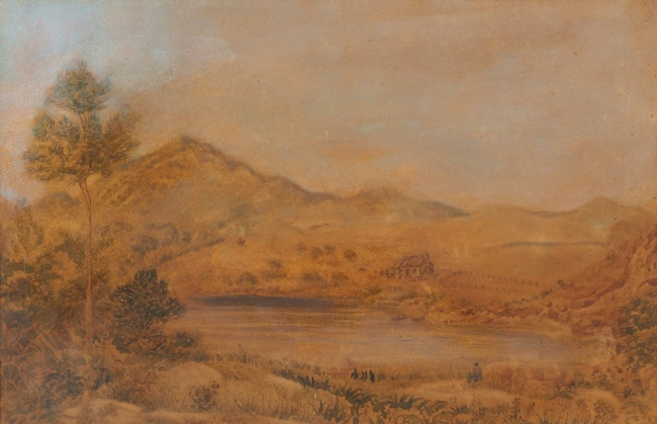
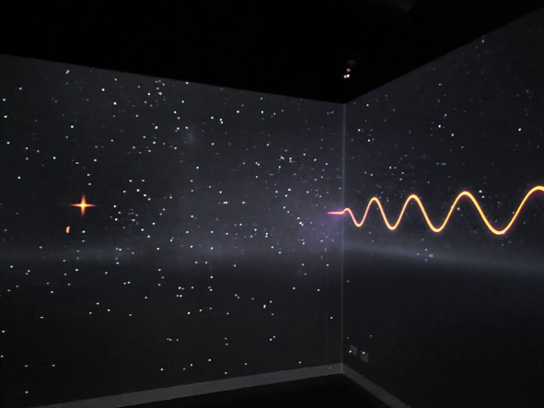 Outerspace: Stromlo to the Stars CMAG exhibition
Image: Sarah Nash

Outer Space, CMAG Exhibition. Image: GMH

- Megan Daley (Ngunnawal/Wiradjuri), grey gum scarf, silk painting, 2024
- Rechelle Turner (Wiradjuri), Dhumbaa (Spotted red gum tree) scarf, silk painting, 2024, and
- Francis Burke Fabrics, Black Opal (Canberra Theatre Curtain), 1964, screenprint on linen, by transfer Canberra Theatre Centre 2024.

A complete list of new acquisitions in 2024-25 is at Appendix 5.

912 objects/works were prepared for display at CMAG, Lanyon Homestead,
Calthorpes House and Mugga-Mugga Cottage. 375 objects were accessioned and 35 exhibitions presented across the CFC’s museums and galleries, with 33 of these curated in-house, that promoted and interpreted the visual arts and social history of the Canberra region and The Nolan Collection.

Exhibition highlights included:
- Hiroe and Cornel Swen: Making a Creative Life
- Outerspace: Stromlo to the Stars (pictured)
- Djara
- Beyond Measure: Expanding the Sky, and
- Taglietti: Life in Design.

Robert Hoddle, View of Mount Tennant. Image: GMH

The CFC featured 167 Canberra artists through its exhibition program and held
30 artist-led public programs. The Craft + Design Canberra Artist in Residence program was based at Lanyon Homestead, Calthorpes House and Mugga-Mugga Cottage in 2024, with related exhibitions and programs held at the Craft + Design Canberra gallery in 2025.

The 2025 Lanyon Art Prize was launched in January 2025. This Art Prize invites artists
from the Canberra region to submit creative works that provide interpretative responses to the history, stories, collections, and landscape at Lanyon Homestead. The Art Prize includes $20,000 in prize money and an exhibition of the finalists and winners presented at Lanyon Homestead in August 2025. The inaugural Lanyon Art Prize was in 2022-23.
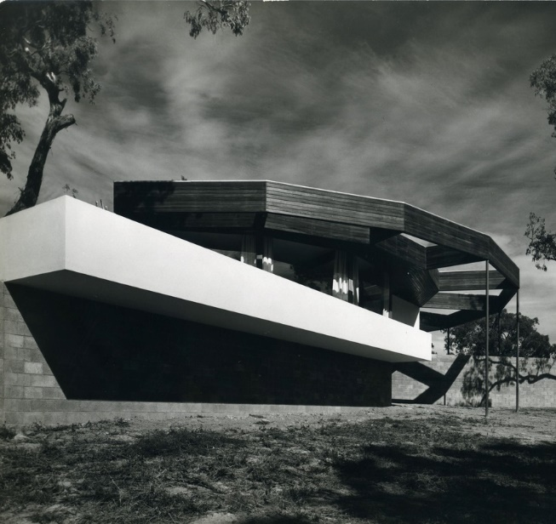
Growing Up Modern: Alex Jelinek and Canberra’s
Round House. CMAG Exhibition. Image: Wolfgang Sievers

Canberra stories and social history featured strongly at CMAG that brought together objects from community and private collections, as well as objects from CFC’s collections to showcase local Canberra history through exhibitions like:
  - Growing Up Modern: Alex Jelinek and Canberra’s Round House (pictured)
  - Tartans and Thistles: Burns Club 100 Years
  - Sylvia Curley: Woman on a Mission, and
  - Celebrating 50 Years of the Australian Honours System.

The 50th anniversary of the Nolan Collection - the collection of works gifted by Sidney Nolan to the people of Australian in 1974 and first exhibited in 1975 - was marked by launched of the Nolan50 program. This program of exhibitions, public programs, and the conservation of the foundational works will continue to 2027.
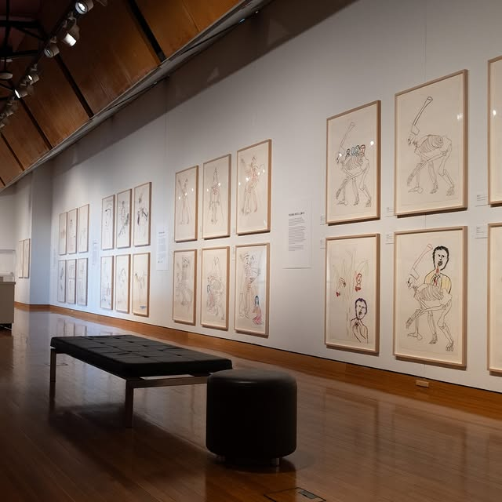
For the Term of His National Life Nolan exhibition
Image: Sarah Nash

Highlights for 2024-25 included:
  - For the Term of His National Life exhibition (pictured)
  - A Total Work of Art: Sidney Nolan and the Stage exhibition
  - Dean Cross: Looking for the Lyre digital work shown in Civic Square
  - The commencement of the conservation project for the 24 foundational works of the Nolan Collection.

A complete list of exhibitions presented in 2024-25 is included at Appendix 4.

Visitor Engagement
In 2024-25, the CFC welcomed 159,144 visitors to its galleries, museums and historic sites, which was 62% above the annual target.

CMAG saw its highest onsite visitation of 102,014 visitors, an increase of 15% from 2023-24 and surpassing the previous record in 2013-14 by 10%. This growth was due to the high quality and breadth of exhibitions and programs, and an increase in public programs and site activations delivered.
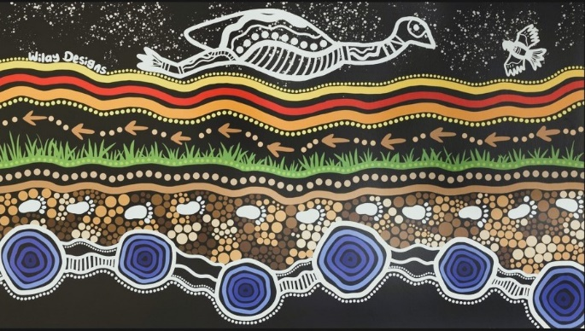
Djara. CMAG Exhibition. Image courtesy of Wilay Designs

The CFC delivered 224 public programs across its galleries, museums, and historic sites. 19,246 visitors (an increase of 45% from 2023-24) participated in workshops, talks, concerts, special tours, and children/family-friendly activities that connected audiences to our exhibitions, collections and historic sites through art,
craft, design, science, music, and performing arts, history and heritage, and the environment. We delivered 1,002 guided tours to 5,525 visitors.
Based on our ticketed programs, we welcomed 55.25% first time visitors to our historic sites/museums and 28.5% first time visitors to CMAG.

Program and event highlights include:
  - Harvest Day Out - started during Covid, this has grown into signature ACT event that celebrates the historic gardens and autumn harvest and promotes sustainable practices and First Nations culture through talks, workshops, and demonstrations at Lanyon Homestead. 2,930 visitors attended Harvest Day Out (11% increase from 2024)
  - Kids Day Out - a new multi-program event designed specifically for pre-school to primary aged children, and young families. It included hands-on art and craft activities that encouraged exploration and understanding of the gardens and environment at Lanyon Homestead. 53% of the 1,157 attendees were first time visitors
  - Live at Lanyon with the Canberra Symphony Orchestra - this family-friendly open-air Spring concert was launched in 2023 and has quickly become a local favorite with 1,169 patrons attending in 2024 (56% increase from 2023), and
  - Panel Talk: Djara and First Nations Sky Stories - moderated by Nobel Laureate Professor Brian Schmidt, artist Lynnice Letty Church (Ngunnawal, Wiradjuri, and Kamilaroi peoples), educator Tyronne Bell (Ngunawal) and astrophysicist Peter Swanton (Gamilaraay and Yuwaalaraay peoples) shared their First Nations sky knowledge as part of the Djara (pictured page 48), and Outerspace: Stromlo with the Stars exhibitions.

2,817 students from pre-schools, primary and secondary schools and universities connected to our livestream International Women’s Day event (pictured) at CMAG with Katherine Bennell-Pegg - Australia’s first astronaut.
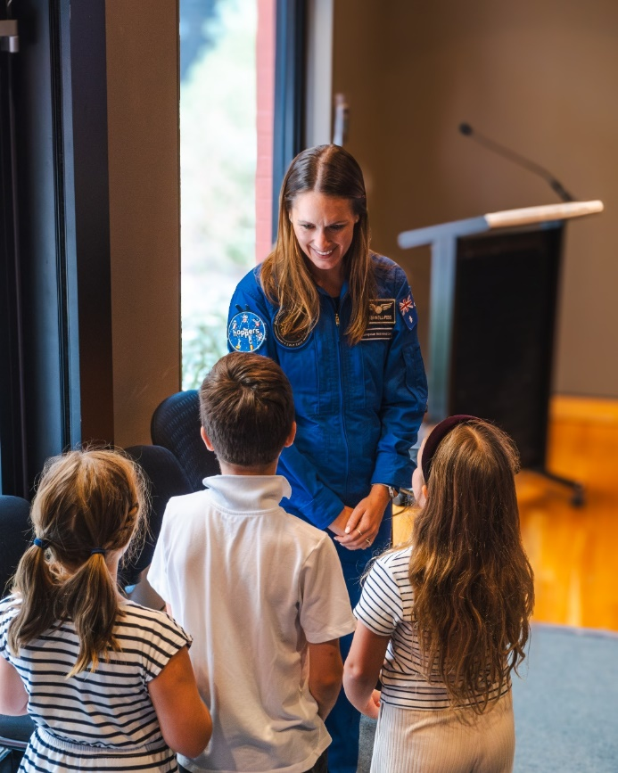
International Women’s Day event at CMAG with
Katherine Bennell-Pegg. Image: GMH

1,229 visitors attended the CMAG Open Day to celebrate the 50th anniversary of
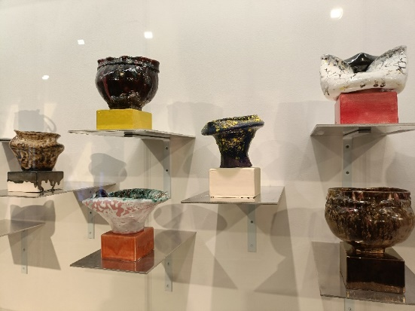
That All Just Happened, Nathan Nhan. CMAG exhibition
Image: Sarah Nash

the Nolan Collection with family-friendly activities, guided tours of the Nolan Gallery, and behind-the-scenes demonstration with a conservator (and special Nolan50 birthday cupcakes!).

Taglietti’s Songbook - in association with the Taglietti: Life in Design exhibition, a concert with the National Opera presented music and songs from the Taglietti family collection and the family’s Italian heritage.

Our galleries, museums, and historic sites featured prominently in Canberra’s festivals and major events including:
  - Floriade
    - Lanyon Homestead continued to be the official Floriade Satellite Site. Aligning with the Floriade theme of ‘Art in Bloom’ we featured a floral display reflecting Nolan’s Ned Kelly works
    - welcomed 7,647 visitors during the Floriade period (23% increase from 2023), and
    - delivered 82 museum tours and 77 public programs including talks connecting Sidney Nolan with Lanyon Homestead, themed house and garden tours, Kids Day Out, First Nations Sky Storytelling, and Dark Sky Gazing with the ANU.
  - Craft + Design Festival
    - CMAG presented the 4 exhibitions - Hiroe and Cornel Swen: A Creative Life, Bruce Reynolds: How Soon is Now, Growing Up Modern: Alex Jelinek and Canberra's Round House, and That All Just Happened (pictured), and presented
7 associated Public Programs.

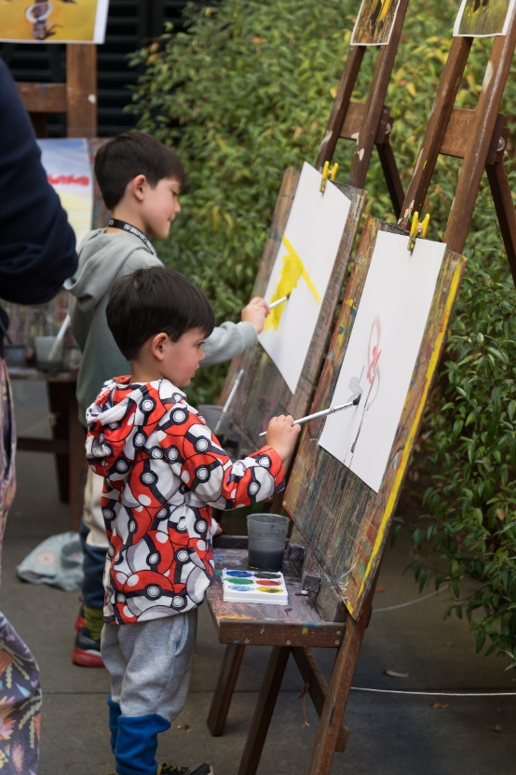
CMAG Sanctuary - National Multicultural Festival
Image: Dominic Northcott

  - National Multicultural Festival
    - CMAG welcomed 2,402 visitors to its ‘Family Sanctuary’ (pictured) as part of the National Multicultural Festival. CMAG is one of the few indoor venues that provides family activities and quiet spaces during the Festival weekend.

Sneak-a-peak at the Canberra Hospital Collection
CMAG exhibition. Image: GMH

  - Canberra and Region Heritage Festival
    - CMAG hosted the launch of the 2024 Canberra and Region Heritage Festival. Themed ‘Unearthed’, we presented
6 exhibitions and 20 public programs out of the 130 Heritage Festival event listings across our galleries, museums, and historic sites.

A list of our public programs and events is included in Appendix 4.

District and Events
The CFC continued to activate its Civic Square frontage, the Civic Square Hub, a multi-purpose art space able to host and support a range of arts activations. In 2024-25 this included:
- July 2024 - the final month of the CFC’s partnership with the Royal Australian Mint to host their retail shop while the Mint’s Deakin premises was being upgraded. Overall, the Mint delivered 342 education programs at CMAG to 12,994 students
- August 2024 - cataloguing of the Canberra Hospital Collection commenced in the Circuit Gallery and the Hub, forming part of a behind-the-scenes activation program (pictured)

- September 2024 - The Hub hosted a pop-up bar alongside the Chicago season, featuring the newly commissioned Lanyon Gin in partnership with Big River Distillery, with food by Le Cheeserie
- October 2024 - Elections ACT hired the Hub and Circuit Gallery for pre-polling and low-sensory voting spaces, supporting inclusive civic participation
- November 2024 – the CFC provided in-kind venue support for the DESIGN Canberra Festival, with the Hub serving as an exhibition, retail, event, and information space
- December 2024 – the DESIGN Canberra Festival activities continued in the Hub, including workshops and exhibitions, and
- January - July 2025 - “Elsie’s Community Cinema” (pictured), a City Renewal Authority Placemaking Grant initiative led by Alice Taylor, operated in the Hub, aligning with CFC’s programming and Civic Square activation goals.

Facility Operations and Capital Works
Accessible toilets for CMAG and auto-doors for Galleries 2 and 3 were completed in June 2025, improving visitor accessibility.
Lanyon Homestead tree conservation and replacement continued.

Detailed designs were completed on Lanyon Homestead driveway and the internal road to inform the road design package of works for the driveway restoration.

The North Building and Canberra Theatre Technical staff kitchens were refurbished to create more welcoming and collaborative spaces for staff.

Elsie’s Film House at The Hub, CMAG. Image: Dominic Northcott
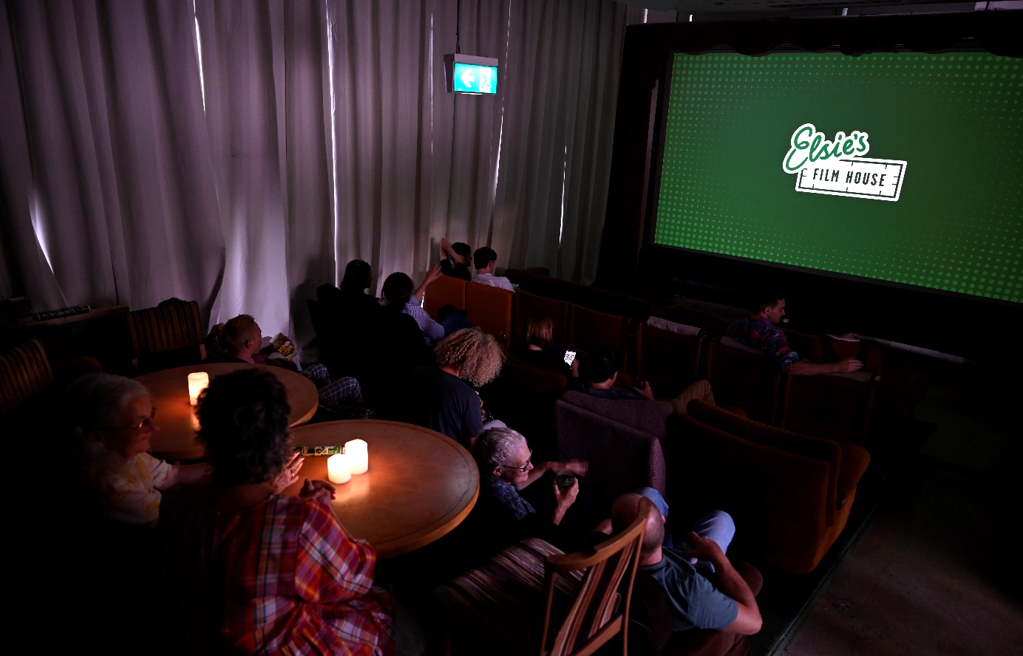

Strategic Goal 2  Growth and Financial Sustainability | We will position the CFC for the future by expanding its income streams and relevance to the arts, culture and heritage sectors, audiences, and economy.
Operational Priorities
- Expanding and diversifying revenue streams to support the vision of the CFC, including building philanthropic engagement and funding partnerships; commercial activation of sites; and expanding our ticketing, retail, food and beverage offering.
- Ensuring relevance for our existing audiences and building new audiences by making programming decisions focussed on the patron experience, informed by data.
- Contributing to growing the ACT visitor economy and advocating to a greater understanding of the ACT’S arts, culture, and heritage in the visitor economy.
- Creating new and increased reserves for future acquisitions and innovative and adaptive re-use investments.

Corporate
In 2024-25 the CFC maintained high standards of financial management and legislative compliance.

The audit of the CFC’s 2024-25 Financial Statements by the ACT Auditor-General resulted in an unmodified audit and for 2024-25, the CFC maintained its strong financial sustainability and achieved own-sourced revenue of 65.5% comparable with a target of 51.5%.

The CFC achieved a cost to government per visitor outcome of $24.11 compared with a target of $29.05. The better-than-target figure relates primarily to higher-than-expected visitors/patrons in live
performance attendance at Canberra Theatre Centre and public programs across Galleries, Museums & Heritage.
The Government provided $10.458 million in 2024-25 to the CFC for its operations and $1.948 million for capital works projects.

Corporate Finance processed 6,959 individual pays, 153 theatre show acquittals, $18.5 million revenue and $13.7 million payments requests.

The CFC Audit Committee met four times in 2024-25. Representatives of the ACT Audit Office were invited to all meetings of the CFC’s Audit Committee. CFC’s Strategic Risk and Fraud Corruption Risk registers are reviewed in each meeting.

The CFC’s quality assurance program for the year focused on petty cash, asset stock take, delegation signature register, accounts payable supplier details, and ICT asset audit.

Philanthropic Development
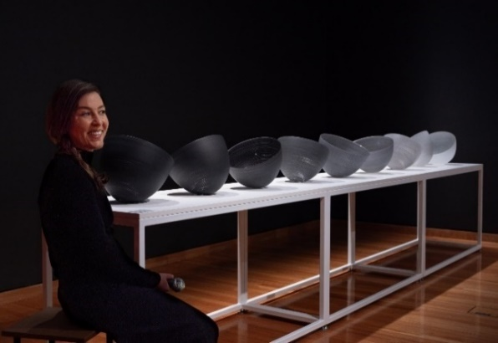
Mel Douglas, Tonal Value 1–9, 2019. Image: GMH

Philanthropic development in this financial year has been assisted by the appointment of a Head of Philanthropic Development. Philanthropic activity has included:
- the delivery of an end of financial year campaign for Galleries Museums & Heritage in support of the acquisition of early colonial watercolour by Robert Hoddle Mount Tennant, on the Murrumbidgee River, the resort of a notorious bushranger, New South Wales, 1834-1835
- Canberra Theatre Centre end of financial year campaign in support of education objectives at the centre, raising awareness of the community impact CTC has across its education programming
- notable gifts in this financial year include:
- The Griffin Foundation PL ATF‘s generous donation in support of the acquisition of glass artist Mel Douglas’s Tonal Value 2019 (pictured)
- Meredith Hinchliffe’s support of acquisitions at CMAG
- The Keir Foundation’s support of Creative Development at CTC
- former Board Chair Helen O’Neil’s donation in support of acquisitions at CMAG
- Harriet Elvin AM’s support of the CFC Staff Fellowship
- Dr Linda Young’s generous support of the Hoddle acquisition, and
- Gordon Ramsay’s generous support of Canberra Theatre Centre.

Further information about the CFC’s funding, donors and supporters is at Appendix 6.

Canberra Theatre Centre
In 2024-25, foundational work began on a centralised CRM system, including business requirements, stakeholder engagement, and product scoping. This work sets the stage for procurement in 2025-26, supporting strategic integration across ticketing, marketing, and development to drive audience engagement and growth.

Extensive work in 2024-25 has progressed the consolidation of CFC’s ticketing operations, with efforts continuing into FY26 to improve efficiency, scalability, and the patron experience - supporting broader commercial and audience engagement goals.

CTC’s data informed, patron focused programming in 2024-25 delivered strong outcomes - tickets sold rose by 9.95%, recording 59.6% of unique bookers demonstrating a strong audience engagement and growth. Driving an
18.43% increase in night usage and a 7.10% uplift in contracts managed year-on-year.
Night-time usage of CTC venues comprised 44% local acts and 56% national acts (graphs on page 55), demonstrating the high level of engagement by the local live performance sector and reinforces CTC’s role as a cornerstone venue supporting artistic talent and cultural development.

CTC’s rental income, ticketing charges, food and beverage sales, and commercial hirer services reflected strong trading activity. CTC’s generated self-source revenue increased by 34% year on year. A review of food and beverage offerings aimed at enhancing customer experience and driving revenue growth will continue throughout 2025-26, supported by the introduction of new infrastructure. This strategic review has already contributed to a 40% increase in food and beverage revenue in 2024-25 compared to the previous financial year.

CTC continued to promote customer feedback and dialogue through patron
surveys, social media engagement, direct phone contact, and in-person interactions with Box Office and Front of House staff - supporting continuous improvement in service delivery and audience experience.

Further audience development initiatives included:
- collaborations with a wide range of national and local institutions including the National Film and Sound Archive, Ausdance ACT, Canberra Symphony Orchestra, National Portrait Gallery, and Canberra Youth Theatre, and
- opening the doors to the general public for a free Open Day for the first time in ten years. Regular attendees and first time visitors were invited to explore behind-the-scenes, enjoying free entertainment and gaining valuable insight into how live performance is made (pictured).
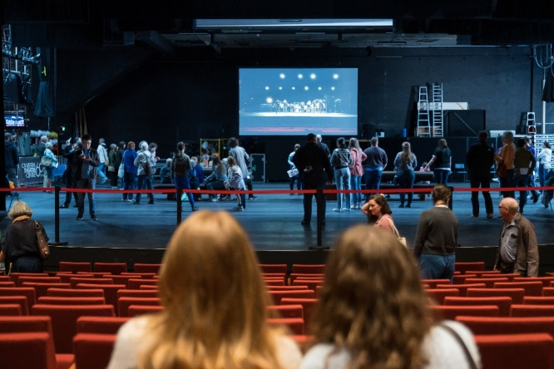
CFC Open Day. Behind the scenes at the Canberra Theatre Centre
Image: Martin Ollman

Canberra Theatre Centre, Crossroads Live and Visit Canberra worked collaboratively on a regional outreach program for Chicago. As a result, regional audiences attended with enthusiasm and constituted 26.22% of all patrons across the season.

CTC invested in and presented the Australian premiere of Broadway hit Peter and the Star Catcher, produced by Dead Puppets Society and Jones Theatrical Group, developing bespoke content for the campaign, which has since toured nationally, launching our largest education and young audience programs to date.

CTC’s inaugural families festival, Summer Holiday Fun, saw over 20,000 patrons experience both ticketed and free activations in a full-venue takeover.

The successful promotion of our New Works opportunities resulted in the most diverse group of candidates to date.

Figure B2.a Canberra Theatre Centre – Contracts by Genre – 2024–25

Stand–up Comedy 18.2%

Figure B2.b Canberra Theatre Centre – Nights usage by Genre – 2024–25

Galleries, Museums & Heritage
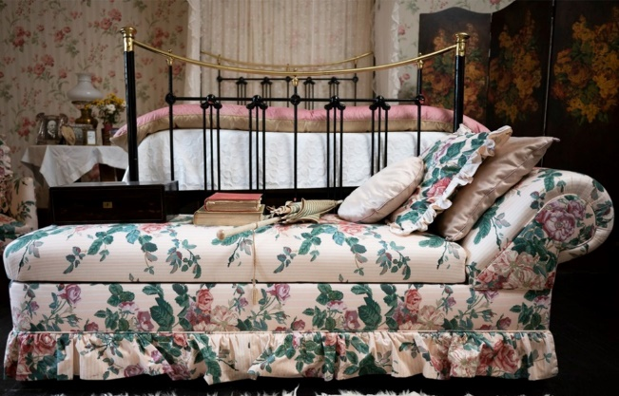
Flowers in the House tour, Floriade @ Lanyon. Image: GMH

Self-sourced revenue generated from programming, ticketing, retail, venue hire, and external funding sources increased by 23.6% in 2024-25, and the retail footprint at CMAG was broadened to provide merchandising associated with exhibitions (such as Outerspace: Stromlo to the Stars and Taglietti: Life in Design) resulting in an 18.7% increase in retail revenue.

A review of Education Program fees in 2023-24 resulted in a sustainable delivery model that provides education programs at an affordable price point while covering delivery costs. Education program revenue increased by 37% in 2024-25. Stronger marketing campaigns resulted in high levels of digital engagement (2,346,443 for CMAG and 1,114,856 for ACT Historic Places). This has supported the strong visitation numbers and program ticketing sales.

Continual improvements in understanding our audiences to inform our program design has resulted in the majority of our public programs selling out. This includes providing more family-friendly events and programs and scaling up existing major events, such as Kids Day Out, Harvest Day Out, and the Live at Lanyon concert.

Participation and partnership with major ACT events and festivals, particularly the National Multicultural Festival and Floriade, broadened our audience reach.

District and Events
Throughout 2024-25, the Hub was activated through an eclectic mix of commercial hire and in-kind support for artists and community groups. Commercial arrangements such as those with the Royal Australian Mint and Elections ACT support the CFC’s ability to enhance events like the DESIGN Canberra Festival and demonstrate the Hub’s versatility as a civic and cultural venue. At the same time, initiatives like Elsie’s Community Cinema, supported through a CRA Placemaking Grant, highlight the CFC’s commitment to community-led programming and creative placemaking. This balanced approach enabled the CFC to generate revenue while fostering inclusive access and cultural activation in Civic Square.

In 2024-25, the CFC partnered with Big River Distillery to launch Lanyon Gin, a bespoke product inspired by the heritage and character of Lanyon Homestead. Initially launched as a bar offering at CFC events, the gin has since expanded into retail sales at CMAG and Lanyon, suggesting possibilities for revenue diversification through unique, place-based products and celebrating local partnerships.

Strategic Goal 3  Redevelopment of the  Canberra Theatre Centre  and Cultural District | We will provide a vision and key leadership for the redevelopment of the CTC and CCCD, developing our organisation to leverage the opportunities these present.
Operational Priorities
- Ensuring the development and management of the project around design, disruption, construction, and operating model; with design to include safety, public approval and engagement, and excellence.
- Supporting the processes for procurement, design, and construction of world class plans, and funding to develop the new Theatre and CCCD.
- To strengthen the CFC’s capacity to provide governance, oversight, and management for the CCCD and the CTC.
- Rethinking the position of CMAG in the CCCD to lift CMAG’s visibility, profile, and audiences.
- Developing the capabilities to oversee, operate, and activate in the new venue and district and in so doing create a national hub of creative excellence.

Canberra Theatre
Redevelopment
The CFC continues its exciting journey of the transformation of CTC. With a focus on designing a world-class performing arts centre, we are committed to fostering artistic creativity, supporting the development of local stories, and creating works of local, national, and global, significance.

Community engagement - Infrastructure Canberra has provided various opportunities for the public to engage with the project, including online surveys, onsite pop-up iPad stands, and interactions with a pop-up team at selected performances.

Engagement with the ACT cultural sector is ongoing, including meetings with the
Performing Arts Reference Group, as well as First Nations peoples, people living with disabilities, people from the multicultural community, and broader sector stakeholders.

Multiplex were successful in the procurement process to engage an Early Contractor Involvement (ECI) contract. Design has continued within the ECI working towards National Capital Authority (NCA) Works Approval and towards final government decision on the Design and Construction (D&C) contract approval later
this year. Consultation will continue with stakeholders to test design functionality.

In alignment with these design and construction efforts, the Canberra Theatre Redevelopment Project (CTRP) team, along with the Business Improvement Manager, is also focusing on operational readiness planning. This includes workforce planning and growth, systems change and integration, and the commercialisation of CTC’s services. Preplanning is underway for disruption and operational readiness throughout construction.

The Project presents a place-making opportunity to transform Canberra’s Civic and Cultural District and create a vibrant and energised precinct in the heart of the city. Investing in this precinct now will secure a fit-for-purpose creative environment for the future and realise the ACT Government’s ambition to be recognised as Australia's arts capital.
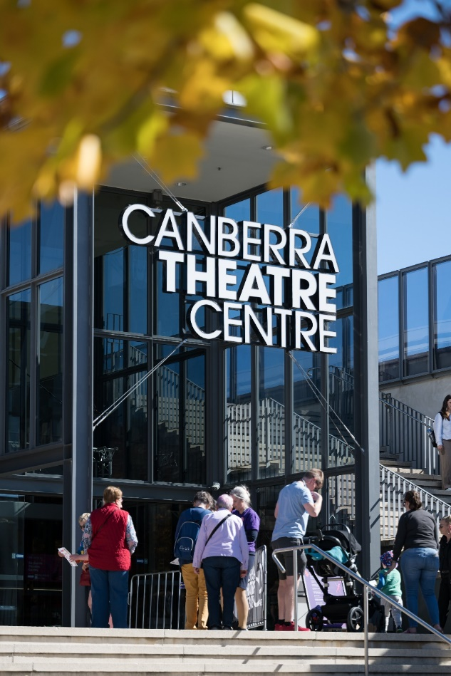
CFC Open Day 2025. Image: Martin Ollman

Galleries, Museums & Heritage
As part of the CCCD Master Plan being worked on by the City Renewal Authority, the CFC is providing future requirements for a “re-imagined CMAG” and possible new uses for the North Building.

The Master Plan aims to revitalise the area around Civic Square and CTC, creating a vibrant arts and cultural hub. The redevelopment is intended to feature new cultural attractions and public spaces designed to foster a sense of community and celebrate the region’s rich cultural heritage.

The transformation is expected to bring significant economic benefits, including job creation in the creative sector and increased investment in the area, and the reimagined CMAG will continue to celebrate Canberra’s social history and visual arts with dynamic exhibitions and community programs.

District and Events
The CFC continues to play a central role in the broader planning for and activation of the Canberra Civic and Culture District.

Executive Leadership and Governance - at the executive level, the CEO of the CFC chairs the Canberra Civic and Culture District Coordination Group, a cross-agency body that supports strategic alignment and coordination across the District. The CEO and Director of Canberra Theatre Centre also sit on the CTR Project Board, providing high-level guidance and oversight.
The Canberra Civic and Culture District Coordination Group plays a key role in maximising the impact of planning, development, and activation across the District. While not a formal decision-making body, it embodies the ACT Government’s “one government” approach, advocating for the success of the CTR Project and related initiatives.

Strategic Communications and Stakeholder Engagement - CFC remains actively involved in stakeholder communications for the CTR Project, which is led by Infrastructure Canberra. This includes coordination across government agencies to ensure consistent messaging and community engagement.

A senior officer-level Working Group meets fortnightly to plan and coordinate stakeholder engagement activities related to the CTR Project. This group facilitates information sharing, resolves interface issues, and ensures alignment with broader government priorities.

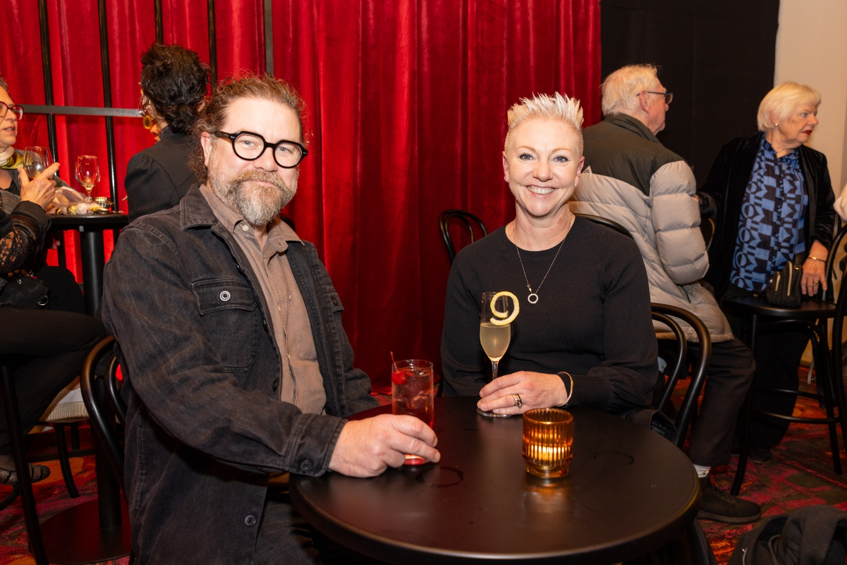
CTC Foyer for Chicago. Patrons enjoying a beverage. Image: Photox

Strategic Goal 4  Sector Leadership and Development | We will lead our sector in the ACT, growing audiences, engaging artists, and developing people.
Operational Priorities
- Being a leader in the ACT cultural sector to promote Canberra as a creative capital; coordinating programming and collaborations within the sector; and promoting professional development opportunities.
- Being committed to providing a means of respectful connection to First Nations arts, cultures, and history, and to do so with authentic engagement.
- Continuing to grow our role in research.
- Celebrating and elevating Canberra through our collections, interpretation, and programs through the growth of collecting, curatorial, exhibiting, conservation, and education expertise.
- Growing unique, diverse, and high-quality products and experiences, including specific links to education, children, and youth.
- Collaborating within the CFC and across the arts, events and festival sector to develop programming and audience experiences that are aligned with and contribute to Canberra’s signature events.

Promoting professional development
During 2024-25, the CFC continued its partnership between CTC and CIT for delivery of the Certificate III in Live Production and Technical Services. This course provides career pathways into the ACT arts sector through gaining qualifications and experience in Lighting, Sound and AV operation as well as bump-in and bump-out processes and stage management in the live production industries. In 2024-25, 21 people graduated from this course.

The WEX (Work Experience) program continues to be fully subscribed and sought-after, including strong interest from interstate participants. Each program runs for five days, hosting up to ten Year 9-12 students, and providing hands-on experience in various aspects of theatre production, including directing, stage management, lighting, sound, and more. It is a creative immersion program including guest speakers, creative projects, viewing a performance and several technical drills/exercises. In 2024-25 CTC hosted 45 WEX students.

The CFC also hosted one marketing intern from the University of Canberra Faculty of Art and Design. The CTC’s creation of marketing and publicity materials across 2024-25 was supported by over 20 small businesses within the ACT, including designers, photographers, videographers, and printers.

At the CFC Open Day in May 2025, the CFC Human Resources team ran a Creative Industries Careers booth, distributing over 300 flyers promoting career pathways, work experience, casual employment, and study options within the cultural sector. The booth attracted interest from prospective employees and students, with representatives from ANU, UC, and CIT also contributing materials and support.

First Nations
CTC continued its commitment to showcasing and promoting the work of First Nations artists and strengthening the diversity and cultural connection of its
program through the presentation of the following events:
- Bangarra Dance Theatre’s Horizon (pictured)
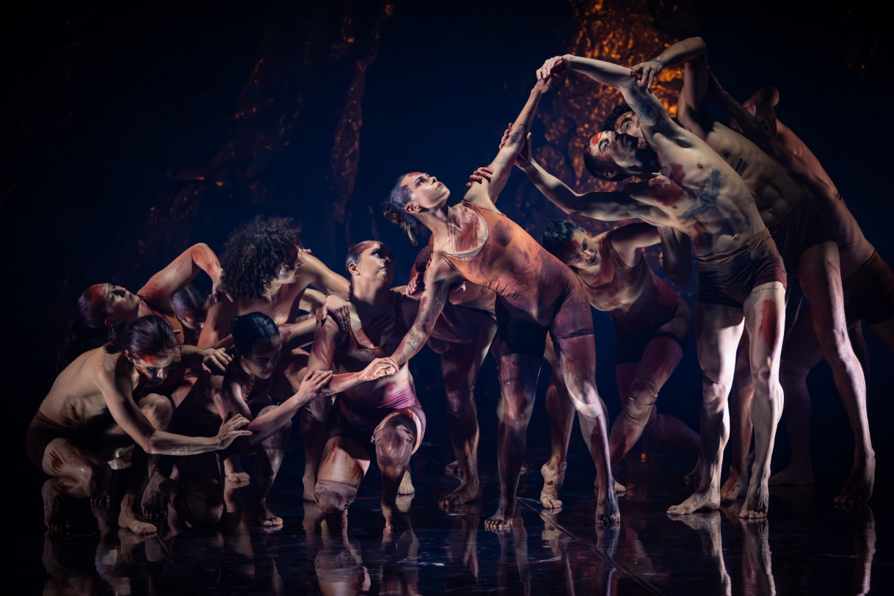
Horizon, Bangarra Dance Theatre. Image: Daniel Boud

- Bangarra Dance Theatre’s Waru
- Marrugeku’s Jurrungu Ngan-Ga - Straight Talk, and
- Insite Arts and Compagnia TPO’s Saltbush (pictured page 62).

CTC New Works established the inaugural First Nations Artist in Residence, a ten-month program of mentorship and producer development with a local First Nations artist.

GMH’s Aboriginal and Torres Strait Islander engagement during the year included the following:
- works by First Nations artists in the permanent CMAG exhibition Canberra/Kamberri: Place and People, and in the temporary exhibitions Djara (with Lynnice Letty Church, Tyronne Bell, Jai Bell and Peter Swanton) and Dean Cross’ digital work, Looking for the Lyre as part of the Nolan50 program

- 13 First Nations led public programs, including Cultural Weaving with Jessika Spencer, Bush Animal Weaving with Ronnie Jordon, First Nations Sky Stories at Lanyon Homestead with Peter Swanton, and a First Nations Sky Stories panel talk with Lynnice Letty Church, Tyronne Bell, Jai Bell, and Peter Swanton, and
- CMAG hosted a CareerTrackers intern in Exhibitions and Collections. This program supports Aboriginal and Torres Strait Islander university students to gain industry experience, achieve high academic marks, and secure full-time employment upon graduation.

Further detail on the CFC’s First Nations engagement is at Section B.9.

Elevating the Capital
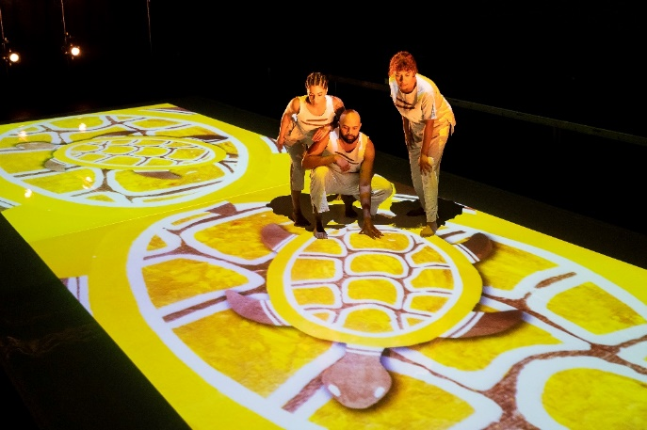
Saltbush. CTC. Image: TJ Harvie

The CFC CEO chairs the District Coordination Group leading government consideration of the future of the CCCD. The CEO also sits on the Board of the Canberra and Region Tourism Leaders Forum, and attends regular meetings of all the heads of the National Cultural Institutions.

At the working level, the CFC is a member of the monthly National Capital Authority’s facilitated National Triangle network meetings. This forum fosters cooperation between the National Cultural Institutions and other major cultural attractions on events and promotion.

CTC Director and Executive Producer represented the organisation at local, national, and international festivals and conferences including:
  - the annual conference of the Association of Asia Pacific Performing Arts Centres as an executive councillor, and to South Korea for a range of meetings and venue inspections
  - the Major Festivals Initiative at Adelaide International Festival to investigate major productions to support and invest in, and
  - the Performing Arts Network New Zealand (PANNZ) and Te Ahurei Toi o Tāmaki Auckland Arts Festival broadening networks and connecting with the Festival, producers, performing artists and companies, while discussing potential productions and collaborations for CTC.

CMAG hosted the launch of the 2025 Canberra and Region Heritage Festival in April and the end-of-year AMaGA event in 2024.

Galleries, Museums & Heritage Director and Curatorial staff presented at local, national and international conferences, forums, and openings including:
- ‘Lanyon Homestead: Exploring Multiple Histories through Contemporary Art’, Keeping House Symposium, University of Melbourne, November 2024
- Opening Speaker, ‘Regeneration’ Artists-in-Residence Exhibition and Sue Peachey’s With Moth exhibition, Craft+Design Canberra, April 2025
- ‘A smorgasbord of fascinating objects: the CMAG Social History Collection’, Canberra and District Historical Society monthly talk, October 2024
  - Panel conversation ‘Sidney Nolan and the Term of His Natural Life’ - National Film Sound Archive February 2025
  - ‘Curatorship as intervention/Shaping new understandings of place through the intersection of creative practices and histories’. International Council of Museums (ICOM) CAMOC/ COMCOL Amsterdam October 2024
(Conference for the ICOM committees of Museums of Cities and Collections Group)
  - AAANZ Canberra ANU Nov 2024 ‘Art Histories with others with Cross disciplinary curatorial practice in action’ Co-Convenor with Dr Anthea Gunn AWM
  - Catalogue Essay Tony Clark ‘Buehnenbild Two Sections from Clark’s Myriorama’ 2022 Essay in Tony Clark Buxton Contemporary University of Melbourne October 2024
  - presenting as Opening Speaker Tuggeranong Arts Centre ‘Longing and Belonging’ August 16, 2024
  - ‘Sidney Nolan Experimenter’ ANU Art History May 2024, and
  - ‘The influence of Pompeii on Australian Artists’ - National Museum of Australia Event at Embassy of Italy March 2025.
Throughout the year, CFC staff participated in a range of activities with peak cultural and tourism bodies, including conferences and meetings of the Canberra Region
Tourism Advisory Forum, Visit Canberra, the Canberra and Region Tourism Industry Council, the National Capital Attractions Association, the Australian Museums and Galleries Association, Aotearoa NZ Festival of the Arts, PANNZ, and Major Festivals Initiative.

Education experiences
CTC offers a diverse education program tailored to students from early childhood through to secondary school as follows:
  - school performances are curated to align with curriculum outcomes and provide meaningful engagement with the performing arts
  - programs include pre-show resources, risk assessment support, and tailored experiences to help schools plan enriching excursions
  - special initiatives such as
ACT UP! and The One Week Project offer students hands-on opportunities to create, perform, and manage productions in professional theatre settings
  - work experience programs allow senior students to explore careers in performance, technical production, and stage management
  - partnerships with artists and arts organisations to deliver in-school workshops and enrichment activities that deepen students’ creative learning, and
  - subsidised participation fees and inclusive programming ensure accessibility for schools with diverse needs and backgrounds.

In 2024-25, 11,000 students benefited from these CTC programs.

CMAG offers a variety of educational programs designed to engage students and provide a deeper understanding of art and history through learning and interactive experiences including:
- onsite Lower Primary (Years 1-4) and Upper Primary (Years 5-6): Programs about Canberra/Kamberri: Place + People
- Foundation to Year 2 programs such as Every Picture Tells A Story and What Do Artists Make? allow students to engage with artworks and create their own in the CMAG studio and engage with the Nolan Collection
- self-Guided Tours available for all year levels, allowing students to explore exhibitions at their own pace. Italian language tours were developed as part of the Taglietti: Life in Design exhibition (pictured)
- Outreach Programs provide resources to enhance classroom lessons with materials related to CMAG’s exhibitions
- images and materials from the CMAG collection are available for teachers to use in the classroom, and
- the Nolan Secondary Learning Resource is designed for Years 7-12 and encourages students to investigate and draw inspiration from the Nolan Collection with links to the Visual Arts Curriculum.
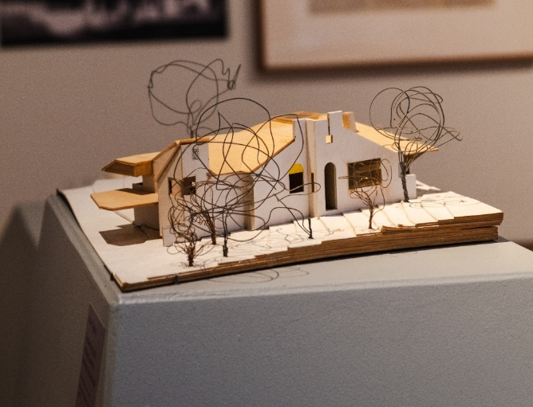 Taglietti: Life in Design CMAG exhibition. Image: Dominic Northcott

In 2024-25, 8,042 students benefited from these CMAG programs.

A highlight was the livestreaming of the International Women’s Day talk with Katherine Bennell-Pegg - the first Australian astronaut. Over 2,800 students connected to our livestream event from pre-schools, primary and secondary schools and universities.

CMAG held its annual Secondary School Photography Prize with its theme - Materiality tied to the Materiality…But not as we know it (pictured page 65). There were 75 entries across public and independent schools.

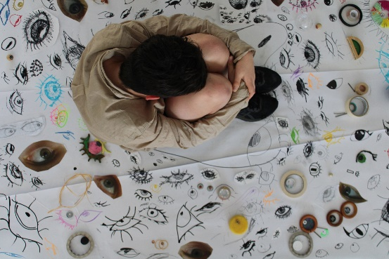
CMAG Secondary School Photography Prize
1st place: ‘I am material for the eye,
what’s the verdict’ by Aiofe-Piper Wilson


Convicts, onsite learning at Lanyon. Image: GMH

There was also a variety of educational programs offered at Mugga-Mugga, Calthorpes House, and Lanyon Homestead, with programs emphasizing heritage, history, and the environment, and providing immersive and hands-on experiences for students. Onsite Programs included:
- Mugga-Mugga Cottage - Humans and Nature (Years 1-2) exploring the connections between humans, animals, and the environment, and
At The Garden Gate (Foundation-
Year 2), examining how Canberra’s landscape has changed over time
- Lanyon Homestead - James’ Diary (Foundation-Year 2) looks at children’s lives in mid-19th century pastoral Australia, and Convicts (pictured), (Years 3-6) offering an experience of the life of a convict, and
- Calthorpes House - Dawn’s Surprise (Foundation - Year 2) compares childhood in the 1930s to today.

Outreach Programs, Artefact Chat, Dawn’s Suitcase and Convicts, and Online resources, Exploring Place - Visual Art Teacher Resource (Year 11-12) which exposes students to various artworks related to the concept of place at ACT Historic Places.

In 2023-24, 3,956 students benefited from these Historic Places programs.

Contributing to Canberra’s signature events
The CFC contributed to a number of signature ACT events - Floriade, SpringOUT, Design Canberra, the National Multicultural Festival, Enlighten, and the Canberra and Region Heritage Festival, providing programs, venues, events, and activations. Highlights included:
- CTC hosted a promotional stall at the Spring Out Market Day, promoting several upcoming shows, chatting with the community and offering the chance to win tickets to see Briefs: Bite Club, presented by CTC during the festival, and
- CTC Programmed Saltbush (pictured page 62) as part of the Enlighten Beyond Festival, welcoming audiences into the city precinct with immersive First Nations storytelling for the whole family.

Our galleries, museums, and historic sites featured prominently in Canberra’s festivals and major events including:
  - Floriade
    - Lanyon Homestead continued to be the official Floriade Satellite Site. Aligning with the Floriade theme of ‘Art in Bloom’ we featured a floral display reflecting Nolan’s Ned Kelly works
    - We welcomed 7,647 visitors during the Floriade period (23% increase from 2023), and
    - We delivered 82 museum tours
and 77 public programs including talks connecting Sidney Nolan with Lanyon Homestead, themed house and garden tours, Kids Day Out, First Nations Sky Storytelling, and Dark Sky Gazing with the ANU.
  - Design Canberra Festival
    - CMAG presented the four exhibitions Hiroe and Cornel Swen: A Creative Life, Bruce Reynolds: How Soon is Now (pictured), Growing Up Modern: Alex Jelinek and Canberra's Round House, and That All Just Happened. CMAG also presented seven associated public programs.
  - National Multicultural Festival
    - CMAG welcomed 2,402 visitors to its ‘Family Sanctuary’ as part of the National Multicultural Festival. CMAG is one of few indoor venues that provide family-friendly activities and quiet spaces during the Festival weekend.
  - Canberra and Region Heritage Festival
    - CMAG hosted the launch of the 2024 Canberra and Region Heritage Festival. Themed ‘Unearthed’, we presented 6 exhibitions and 20 public programs out of the 130 Heritage Festival event listings across our galleries, museums, and historic sites.

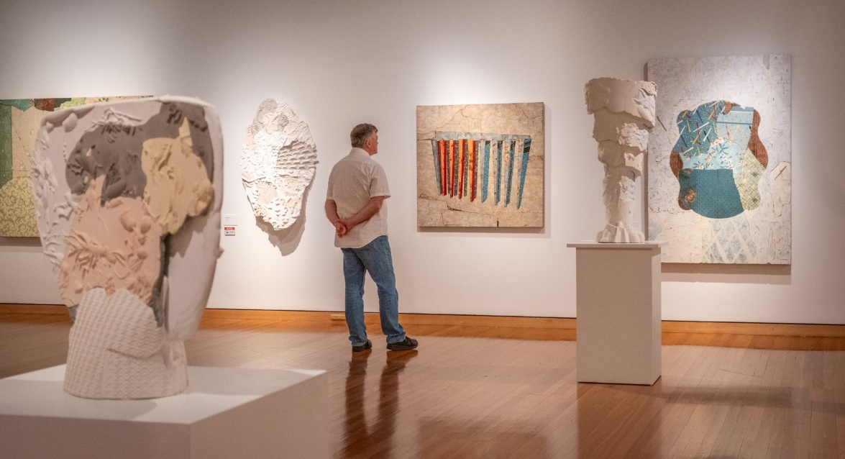
Bruce Reynolds: How Soon is Now. CMAG exhibition. Image: Dominic Northcott

Strategic Goal 5  Best Practice Governance, Organisational Capacity and Culture | Our operational model will be best practice.
Operational Policies
- Ensuring the CFC governance is rigorous and transparent.
- Reviewing the identity, brand, and naming of the CFC and of sub-entities of the CFC.
- Continue reviewing the CFC’s organisational structure to ensure resources can be deployed most effectively for the CFC to achieve its goals. As such, aligning the growth of the CFC with the capacity and volume of its resources, existing and new.
- Building a secure and resilient workforce, offering development and other opportunities for our staff so we are an employer of choice and a training ground for people seeking careers with us and the sector.
- Demonstrating a workplace culture that lives the values of the CFC and the ACT Public Service.
- Ensuring best practice management and development of our assets and collections.
- Increasing productivity through continuous upgrading of systems, frameworks, and practices.

Organisational Capability
In 2024-25, the CFC continued to foster a positive and inclusive workplace culture through a range of staff-focused initiatives. Monthly wellbeing sessions were introduced to support employee health and morale, while events such as International Women’s Day and Harmony Day provided opportunities to celebrate diversity and strengthen team connections.
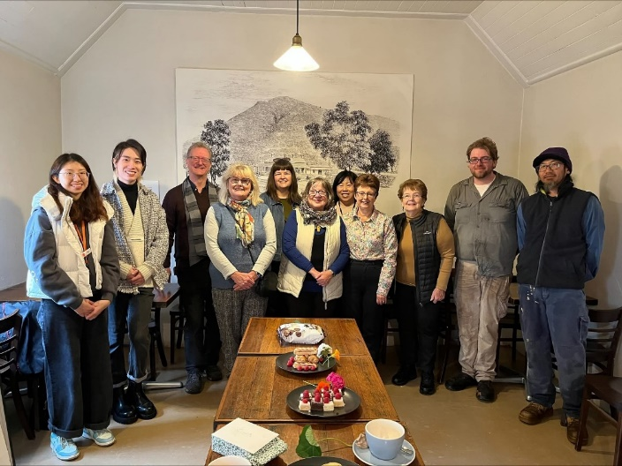
Volunteer thank you morning tea. Image: Garry Yu

During National Volunteer Week in May 2025, GMH held a thank you morning tea
for Historic Places volunteers to recognise and celebrate their contributions (pictured).

The annual Don Aitkin Awards acknowledging outstanding contributions by staff to the work of the CFC were held on 5 December 2024 with CFC Board Chair Helen O’Neil attending. With a strong field of 18 nominations, Jem Natividad (CTC), Rebecca Richards (GMH), Cerri Murphy (Finance) and Karina Leotta (Events and Activations) were this year’s deserving recipients (pictured).

During 2024-25 the CFC matured its Core Learning Framework, which provides consistency for staff induction and the development of essential ACT Public Service knowledge and skills.
In 2024-25 CFC staff achieved 848 course completions, and expenditure on staff training and professional development during 2024-25 amounted to $136,176.

For details on Learning and Development, see Section B.14.

To improve the timeliness and accuracy of work health and safety incident reporting the CFC produced a range of online resources and conducted webinars on use of the ACT Government’s Safety Portal system. The CFC Work Health and Safety Committee meets every three months. For details on Work Health and Safety, see Section B.13.

CFC Don Aitkin Award recipients with CFC CEO Gordon Ramsay. Image: Sarah Nash
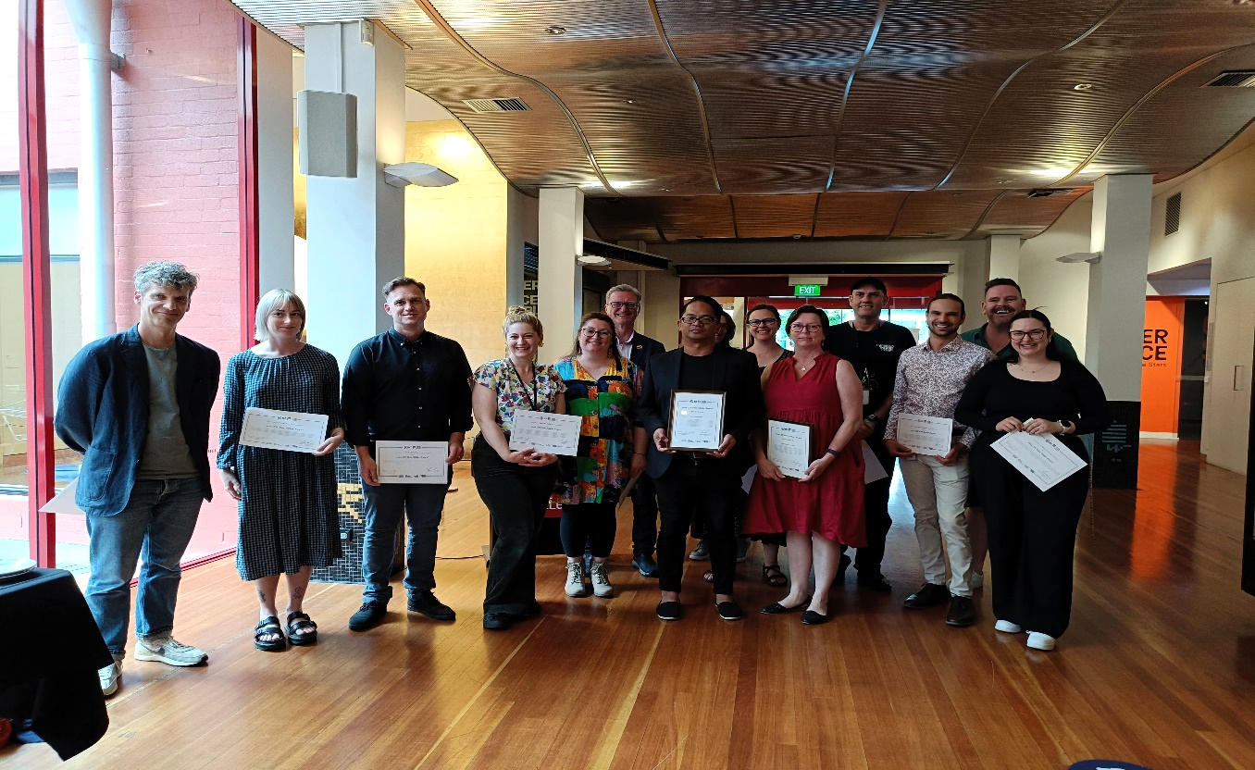

B3 Scrutiny

In 2024-25, the CFC was part of the ACT Auditor-General Audit of Governing Boards of selected ACT Government entities (Report 11/2024) 29 November 2024. In response to this audit, the CFC has agreed to a series of recommendations aimed at strengthening governance practices. The CFC supports the clarification of the status of its Advisory Committees, pending finalisation of the review of the Cultural Facilities Corporation Act 1997. The CFC also agreed to update its Board Charter to define the handling of matters of material interest.

To enhance strategic alignment, the CFC will strengthen the connection between its strategic objectives and organisational risks in the next update of its Strategic
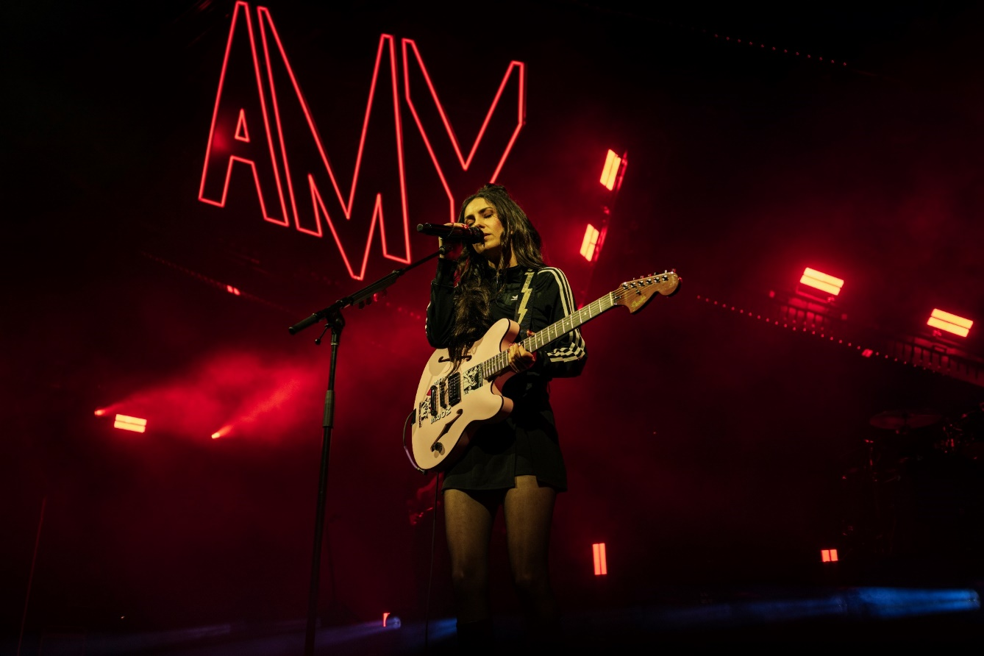
Amy Shark, CTC. Image: Jackson Loria

Plan, scheduled for 2027. Additionally, the CFC will formalise and strengthen its processes for reviewing board performance, ensuring regular evaluations, documentation of outcomes, and monitoring of implementation actions.

These measures reflect the CFC’s commitment to continuous improvement and best practice governance.

There were no ACT Ombudsman or Legislative Assembly Committee reports that related specifically to the CFC in
2024-25.

For further information contact: CFO, CFC Finance (02) 6205 9658.

B4 Risk Management

The CFC manages risk through a Risk Appetite statement, a comprehensive Risk Management Framework and Policy and Risk Management Plan that guide activities across the organisation, including in areas of strategic risk, fraud and corruption control, and work health and safety. These documents provide a structured approach to identifying, assessing, and mitigating risks, ensuring that risk management is embedded in all aspects of CFC’s operations. The CFC has in place a comprehensive Strategic Risk Management Register, which is implemented, monitored, and updated on an ongoing basis. This register outlines supporting strategies and plans relating to more specific areas of risk, such as financial risks, disaster preparedness,
and business continuity plans.
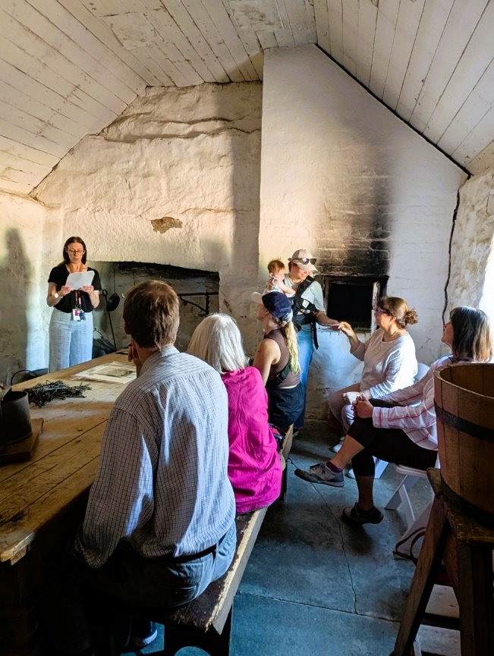
Curator Talk, Harvest Day Out, Lanyon. Image: GMH
The CFC pursues its mission and vision within the Risk Appetite statement and the framework that informs decision-making by the Board, Executive, and staff. The risk appetite statement covers key risk categories including reputational, artistic, financial, asset, and people risk, and ensures that decisions are made with a clear understanding of acceptable risk levels. Risk considerations are aligned with both the CFC’s organisational values and the ACT Public Service Values, reinforcing a culture of integrity, accountability, and transparency, and compliance with all relevant legislation.
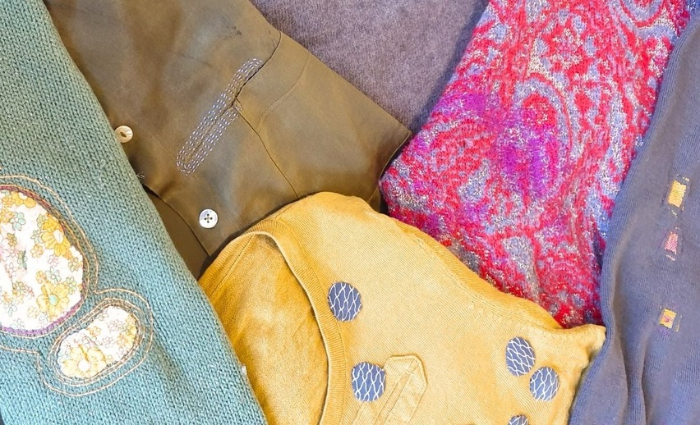
Visible Mending workshop with Michele Grimston,
Mugga-Mugga Cottage. Image: GMH

B5 Internal Audit
The CFC Audit Committee, a subcommittee of the CFC Board, met on four occasions during 2024-25. Meetings were held as follows:

Audit Committee Meetings
Meeting Dates | Members and Positions | Meetings Attended
15 July 2024  26 September 2024  20 February 2025  29 May 2025 | Christine Shannon  Chair | 4
 | Dr Rachael Coghlan  Member | 4
 | Julian Widdup  External Member | 4

The CEO, CFO, and Assistant Director, Finance are invited to each meeting as observers. An open invitation is extended to the ACT Audit Office to send an observer to each meeting.
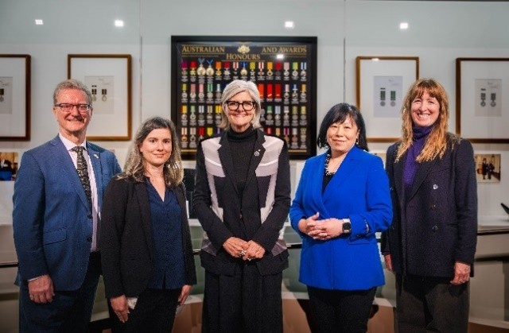
Exhibition Launch - Celebrating 50 Years of the Australian Honours
System with Governor-General Her Excellency the Honourable
Sam Mostyn AC. Image: Dominic Northcott

Part G of the CFC Board Charter sets out the operations for the Audit Committee and incorporates specific roles for risk management and audit matters.

The Charter is available at www.culturalfacilities.act.gov.au.

Internal Audit
The Audit Committee approved the CFC’s internal audit program for 2023-26 and an internal audit on contract management process and compliance has been conducted in 2024-25.

In 2024 -25, the annual Quality Assurance Program continued to ensure the effectiveness and relevance of CFC policies and procedures, supporting continuous improvement and identifying areas for corrective action. This year’s focus areas included petty cash, asset stock take, delegation signature register, accounts payable supplier details, and ICT asset audit.

B6 Fraud Prevention

The CFC maintains a strong commitment to fraud prevention and integrity, underpinned by a comprehensive governance framework. The CFC’s Fraud and Corruption Prevention Plan and Fraud Risk Register - last updated in May 2025 and due for review in April 2026 - form the foundation of our fraud control strategy. These documents are aligned with the ACT Integrity Policy and Australian Standard 8001:2021, and are reviewed biennially by the Board and Audit Committee.

The CFC’s fraud risk assessment identifies and categorises risks across revenue, expenditure, assets, and other areas, using a qualitative risk matrix. Risks deemed unacceptable are addressed through targeted mitigation strategies, with responsibilities and timelines clearly defined.

Fraud prevention measures include robust internal controls such as information security, staff timesheets, and policies on gifts, hospitality, and travel. The CFC also promotes a proactive culture of awareness through mandatory fraud and corruption training.
English. CTC. Image: Pia Johnson
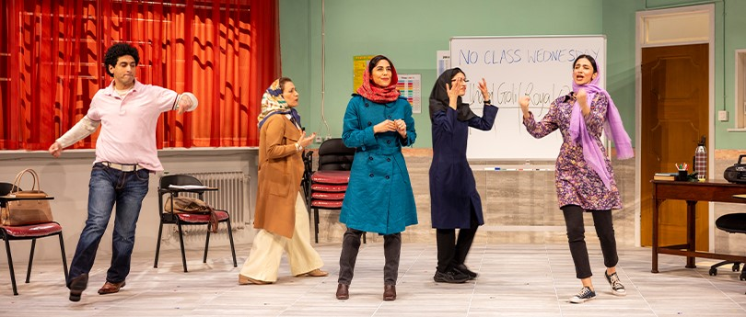

The CFC’s Staff Induction packages and Core Leaning Framework and Policy support employees to ensure they act in accordance with the law and behave in a manner consistent with the ACT Public Sector Code of Conduct. Staff have access to a range of resources on the CFC Workplace Integrity Intranet page and access to relevant training from the ACT Integrity Commission.

The Audit Committee plays a key oversight role, ensuring that fraud-related processes are current and effective. The CFC Board is responsible for setting strategic direction and approving risk management policies.

The CFC had no reports or allegations of fraud or corruption during the 2024-25 reporting period, reflecting the effectiveness of its prevention and detection strategies.

B7 Freedom of Information
Basis of requirement: Freedom of Information Act 2016 (the FOI Act), section 96.

Open Access Information - Section 96 (3)(a) (i), (ii) and (iii)
Number of decisions not to publish Open Access information. | 0
Number of decisions to publish Open Access information. | 0
Number of decisions not to publish a description of Open Access information withheld. | 0
FOI Applications received and decision type - Section 96 (3)(a) (iv), (vii), (viii) and (ix)
Number of access applications received. | 0
Number of applications where access to all information requested was given. | 0
Number of applications where access to only some of the information requested was given (partial release). | 0
Number of applications where access to the information was refused. | 0
FOI processing timeframe - Section 96 (3)(v) and (vi); Section 96 (3)(d)
Total applications decided within the time to decide under section 40. | 0
Applications not decided within the time to decide under section 40. | 0
Number of days taken to decide over the time to decide in section 40 for each application. | 0
Amendment to personal information - Section 96 (a)(x) and Section 96 (3)(e)
Number of requests made to amend personal information, and the decisions made (e.g., amended, refused, notation added to record, other). | 0
Reviews - Section 96 (3)(b); Section 96 (3)(c)
Number of applications made to Ombudsman under section 74 and the results of the application (e.g., affirmed, varied, set aside, and substituted, withdrawn, other). | 0
Number of applications made to ACAT under section 84 and the results of the application (e.g., affirmed, varied, set aside, and substituted, withdrawn, other). | 0
Fees - Section 96 (3)(f)
Total charges and application fees collected from access applications. | 0

B8 Community Engagement
In 2024-25, the CFC continued to prioritise meaningful engagement with its diverse audiences, deepening public understanding of the value of the arts and cultural heritage through a wide range of programs and initiatives. With patron experience at the heart of its operations, the CFC tailors its offerings to meet the varied needs and expectations of audiences across its venues, from immersive heritage experiences to contemporary exhibitions, and live performances. The following summary outlines key community engagement activities undertaken during the year, complementing the Clients and Stakeholders information provided in Section B1.1.

Community Engagement Activities
During the year, GMH presented a diverse range of high-quality exhibitions, learning and community programs and other activities, including on site, off site (through outreach programs), and online. Productive partnerships were developed with other cultural organisations, the tourism sector, and the wider community in developing and delivering programs and events.

CTC connected the community with the performing arts, including through initiatives that addressed special needs. CTC also provided a wide range of activities for the education system.
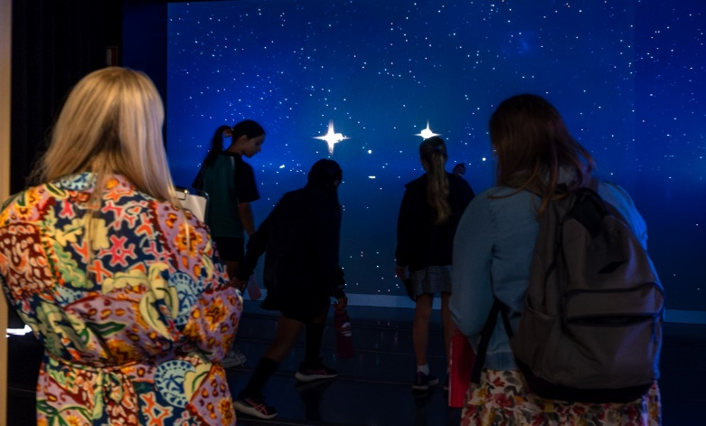Outerspace Learning at CMAG. Image: Dominic Northcott

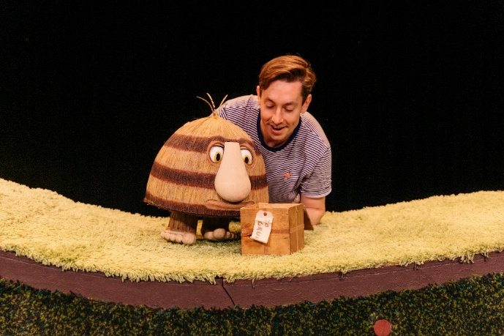
Grug. CTC. Image: Sia Duff

Professional Development and Networking
CTC New Works hosted three industry knowledge-building and networking events focused on sector development and capacity building for ACT artists, partnering with national organisations including TNA, Creative Wellbeing, and Merrigong X.

ACT Venue Collaboration
CTC hosted three ACT performing arts venue meetups with representatives from Belconnen Arts Centre, Tuggeranong Arts Centre, Ainslie + Gorman, The Q, and Llewellyn Hall in attendance, fostering sector-wide collaboration and knowledge sharing.

Local Arts Support
CTC engaged and supported ACT artists, producers and organisations through:
- presentation of Canberra Youth Theatre's Work, But This Time Like You Mean It
- presentation of Ausdance ACT Youth Dance Festival
- collaboration with Canberra Youth Theatre on their Young Critics program
- partnership with Canberra Symphony Orchestra on several projects, including performances for Australian Ballet's Carmen and Mimi's Symphony, and
- Canberra Artist Spotlight, an ongoing open invitation for local producers to share event information through CTC's database via selected eNews and social media.

In 2024-25, 64% of content in CMAG’s 28 exhibitions and displays featured works by Canberra artists. A total of 181 Canberra artists were exhibited. CMAG also manages the Nolan Collection and hosts touring exhibitions, enriching the local arts landscape. Through initiatives like the Lanyon Art Prize and public programs, GMH provides career-building opportunities for local artists.

Education and Young People
The CFC delivers a wide range of education and youth engagement programs across CTC and GMH, designed to inspire curiosity, creativity, and learning through hands-on experiences in the arts, heritage, and performance. In 2024-25, the CFC recorded

its highest-ever participation in education and public programs, reflecting our commitment to accessible, curriculum-aligned learning opportunities for students of all ages and backgrounds.

Community Consultations
As part of the CTR Project, CFC worked with Infrastructure Canberra to deliver community consultations throughout the design phase. These consultations helped test design directions and ensured that the needs and perspectives of patrons, performers, and the broader arts community were thoroughly considered.
These consultations included engaging with First Nations, LGBTQI+, local creative, multicultural, and disability communities through a range of in person and online sessions and more focused meetings where necessary.

The three advisory committees are also a key part of the CFC’s community engagement, providing advice on a range of specialised matters relating to CTC, CMAG, and the Historic Places.

Customer Satisfaction
The CFC continually seeks to improve customers’ satisfaction with their visit to, and experience of, its venues. Customer satisfaction surveys were conducted throughout the year and reported as part of the CFC’s 2024-25 Statement of Performance. Information gained from the surveys is used in future planning to improve facilities and services.

Media Activity
The CFC maintained a strong and consistent media presence throughout the year, showcasing the work of Canberra Theatre Centre and Galleries, Museums & Heritage, and connecting with the community through diverse media channels.

The Director, CTC featured extensively in outlets including Artshub, ABC Radio and TV News, WIN News, The Canberra Times, HerCanberra, Region Media, and Capital Radio, speaking on a wide range of topics.

Media engagement reached a peak during the CTC Open Day and the Centre’s 60th Anniversary celebrations, which attracted significant coverage and widespread public interest.
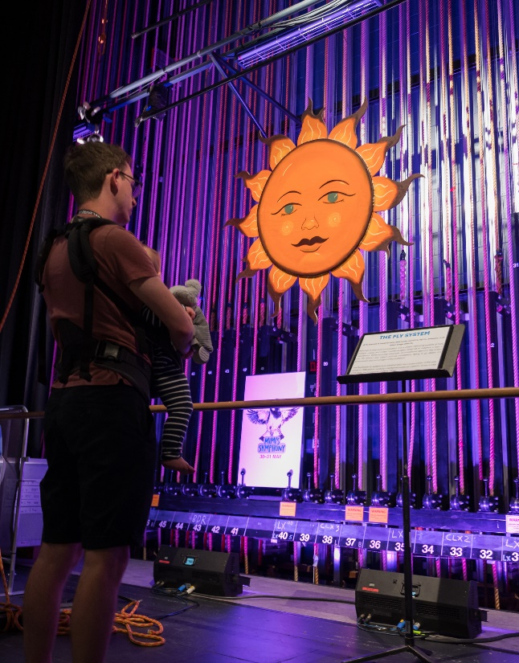
CTC Open Day, CTC. Image: Martin Olman

CTC’s Executive Producer also gave several high-profile interviews to promote major productions such as Shirley Valentine (pictured), 1984, Marrow, and La Bohème. Together, these efforts amplified the CTC’s profile, strengthened audience connections, and reinforced its reputation as a leading voice in the arts.
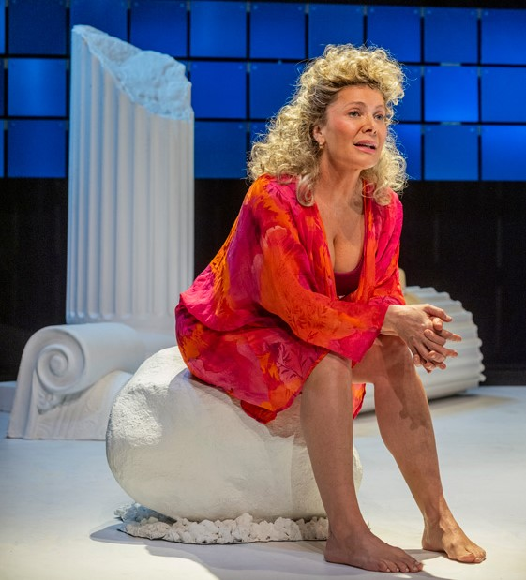
Shirley Valentine. Image: CTC

Media coverage of GMH events also surged in 2024-25, with a total reportable reach exceeding 17 million. The Director, GMH and her team were interviewed by both ACT-based and national media,
shining a spotlight on several high-profile projects, including the Nolan50 celebrations, Outerspace: Stromlo to the Stars, Kids Day Out (2024), and Live at Lanyon. This unprecedented visibility further elevated the CFC’s cultural profile and strengthened its connection with audiences across the region and the nation.

B9 Aboriginal and Torres Strait Islander Reporting

The CFC is committed to respectfully celebrating and amplifying the voices, stories, and cultures of Aboriginal and Torres Strait Islander peoples through its programming and engagement. Across exhibitions, theatre presentations, and public programs, the CFC continues to embed First Nations perspectives as a vital part of its cultural offering. The following examples highlight how each area of the CFC contributed to this commitment during 2024-25.

Canberra Theatre Centre
CTC continued its commitment to showcasing and promoting the work of First Nations artists and strengthening the diversity and cultural connection of its program through the following presentations and activities:
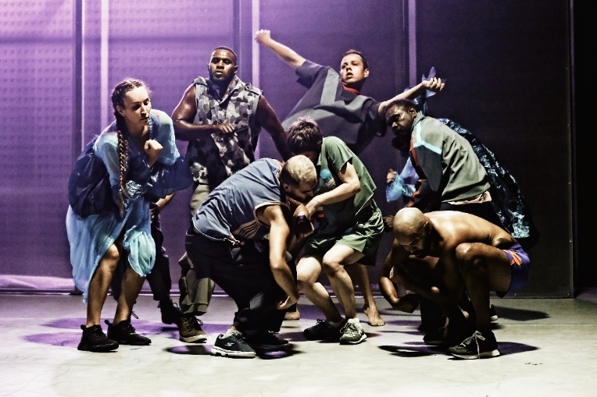
Marrugeku’s Jurrungu Ngan-Ga-Straight Talk. Image: Prudence Upton
- Bangarra Dance Theatre’s Horizon - Bangarra’s first mainstage cross-cultural collaboration saw leading Māori choreographer and Arts Laureate Moss Te Ururangi Patterson collaborate with Bangarra alumna Deborah Brown. Together they guided Bangarra’s award-winning ensemble in stories that honour their mother countries and the spirit that calls them home
- Bangarra Dance Theatre’s Waru - Bangarra’s first dedicated work for children inspired by the totemic system of the green turtle. Waru was an interactive and immersive introduction to Torres Strait Islander culture and dance for 3 to 7-year-olds
- Marrugeku’s Jurrungu Ngan-Ga - Straight Talk (pictured), a new and urgent work by co-artistic directors, Dalisa Pigram and Rachael Swain connected the shockingly disproportionate levels of Indigenous Australians in custody and the indefinite detention of asylum seekers in Australia’s immigration detention centres in a story told through energetic and inventive choreography

- Insite Arts and Compagnia TPO’s Saltbush centred around the journey of two friends and their spiritual guide on foot as they cross Australian landscapes told through spoken word, dance and multi-media by acclaimed Aboriginal artists Lou Bennett (music), Delwyn Mannix (visual art), Deon Hastie and Anna Balducci (choreography), and Sasha Zahra (dramaturgy), under the artistic direction of Jason Cross and Davide Venturini
- ACT UP! Secondary Schools festival increased programming alignment with Reconciliation Week activities and engaged First Nations playwright Dylan van den Berg as Festival Ambassador, and
- CTC New Works established the inaugural First Nations Artist in Residence, a ten-month program of mentorship and producer development with a local First Nations artist. Lead artist Emma Laverty worked with Project Dust to develop and present their first work called Country, with the CTC Production team supporting the project through design advice and skills development.

Embedding First Nations principles into the culture of CTC is the first of four guiding principles in CTC’s Vision for our Future that provides guiding principles for the theatre redevelopment. First Nations perspectives are integral through the process of Designing with Country, led by Yerrabingin, so that the theatre can become a place for traditional storytelling and gathering of First Nations people. This facilitates greater opportunities for elevation, participation, and community connection with respect to First Nations art and culture, local First Nations people and the broader community.

Galleries, Museums & Heritage
CMAG and the Historic Places engage with Aboriginal and Torres Strait Islander communities to strengthen and improve our approach to interpretation and management of First Nations stories and values through specific activities in 2024-25 including:
- works by First Nations artists in the permanent CMAG exhibition Canberra/Kamberri: Place and People; Djara (with Lynnice Letty Church, Tyronne Bell, Jai Bell, and Peter Swanton) and Dean Cross’ digital work, Looking for the Lyre as part of the Nolan50 program
      - 13 First Nations led public programs, including Cultural Weaving with Jessika Spencer, Bush Animal Weaving with Ronnie Jordon, First Nations Sky Stories at Lanyon Homestead with Peter Swanton, and a First Nations Sky Stories panel talk with Lynnice Letty Church, Tyronne Bell, Jai Bell, and Peter Swanton
      - hosting a CareerTrackers intern in Exhibitions and Collections. This program supports Aboriginal and Torres Strait Islander university students to gain industry experience, achieve high academic marks, and secure full-time employment upon graduation
- in partnership with the Humanities Research Centre (HRC) of the ANU and Canberra Glassworks, CMAG co-hosted Visiting Fellow, Yorta Yorta/Wamba Wamba/Mutti Mutti/Boonwurrung artist Maree Clarke, who undertook a research project on the reed necklace on long-term loan to CMAG. Maree will hold an exhibition in CMAG on the Square in 2025 as an outcome of her residency, and
• the Lanyon Machinery shed’s interpretative panels include a didactic panel on former Lanyon shearer, Muruwari man, William ‘Deucem’ Smith, produced in consultation with the Smith Family.

Facility Operations and Capital Works
In delivering capital works projects, the FOCW team actively engages with the Aboriginal and Torres Strait Islander Enterprise List Database to identify Indigenous businesses (both head contractors and subcontractors) within
the Canberra region.
Contractors are encouraged to seek opportunities for Indigenous enterprise involvement, particularly on larger projects, and contract structures are designed, where feasible, to include Indigenous participation targets. These targets are verified through the contract administration process, in alignment with the Aboriginal and Torres Strait Islander Policy and the Canberra Region Local Participation Policy.

The FOCW team places strong emphasis on securing local employment, recognising the importance of retaining specialist knowledge and skills related to the CFC’s unique facilities and collections. This local expertise ensures the delivery of high-quality, reliable services and supports the long-term sustainability of operations.

First Nations Sky Stories at Lanyon Homestead with Peter Swanton. Image: GMH


B10 Disability Inclusion Act 2024 Reporting
Measures to Support the Development and Implementation of Disability Inclusion Strategies and Plans

In 2024-25, the CFC continued to prioritise access and inclusion for people with disability across its venues and programs. While a formal Disability Inclusion Plan framework is anticipated for development in 2025-26, the CFC has proactively delivered a range of inclusion initiatives and infrastructure improvements throughout the year. These measures reflect the CFC’s commitment to reducing barriers and fostering welcoming environments across its business units, including Canberra Theatre Centre and Galleries, Museums & Heritage.

Inclusion Measures (2024-25)

While awaiting the development of a formal framework in 2025-26, the CFC has implemented the following inclusive initiatives:
- inclusive employment partnerships with The Disability Trust and Rebus Theatre at CTC, creating supported work and training opportunities for people with disability
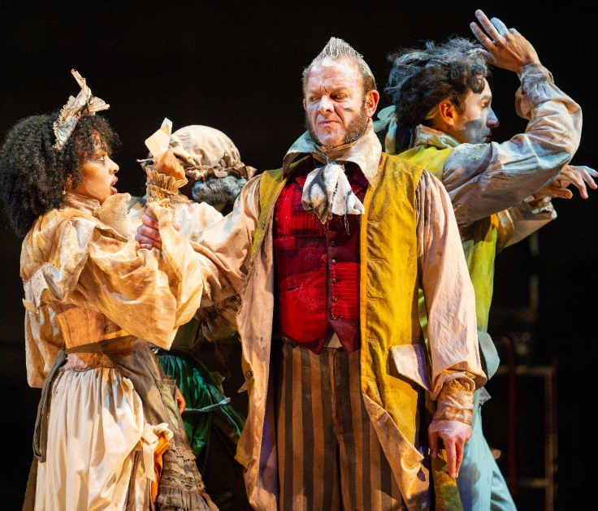
Jack Maggs. CTC. Image: Matt Byrne

- expanded access programming at CTC, offering a growing number of accessible performances, including Auslan, audio description, tactile tours, relaxed performances, and captioning services
- digital and physical accessibility upgrades to CTC’s booking systems, website, and performance spaces, with dedicated staff training to support these services, and
- facility upgrades at CMAG including the installation of a new accessible public toilet and gallery auto doors to improve physical access for all visitors.

These interim actions demonstrate the CFC’s early alignment with the intent of the Disability Inclusion Act 2024 and set the foundation for longer-term,
sustainable inclusion planning.

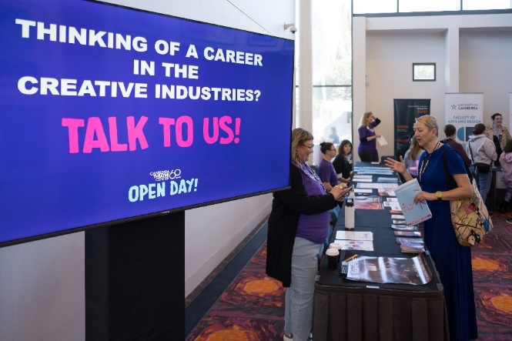
Open Day Careers booth. Image: CTC

Disability Inclusion Strategies
The CFC has supported the ACT Government’s broader disability strategies through active engagement in infrastructure planning and service delivery. As part of the Canberra Theatre Redevelopment Project, the CFC has worked closely with Infrastructure Canberra to prioritise accessibility in the design of a new Lyric Theatre. Community consultation has informed inclusive design features such as:
- level access throughout the auditorium, stage, and front/back of house areas
- lift access to technical areas including the grid and sound/light box
- change facilities and accessible amenities for patrons and staff, and
- integration of current and emerging access technologies, including hearing augmentation.

These design proposals aim to deliver an equitable experience for all theatre users and reflect the ACT community’s diverse needs.
CTC Enhancing Access Services and Inclusive Programming
In 2024-25, CTC significantly expanded its accessible performance offerings, delivering 39 inclusive performances across 31 seasons - an increase from 21 performances in 2023-24. This included:
- 11 Auslan-interpreted performances
- 7 tactile tours
- 8 audio-described performances
- 14 live-captioned performances, and
- 6 relaxed performances.

CTC supported 16 accessible seasons, featuring diverse genres such as theatre, musical theatre, dance, circus, comedy, and children’s productions. To enhance accessibility, CTC streamlined booking processes through online forms and dedicated Box Office support. Website functionality was improved with screen reader compatibility and font enlargement
options. Hearing access was supported through FM radio-assisted hearing units and captioning services.

Facilities and Physical Accessibility Improvements
CTC has continued its focus on mobility assistance and seating customisation, including:
- wheelchair seating with staff prioritisation at collection
- lift access to the first balcony in The Playhouse

- special seating request processes for patrons with access needs, and
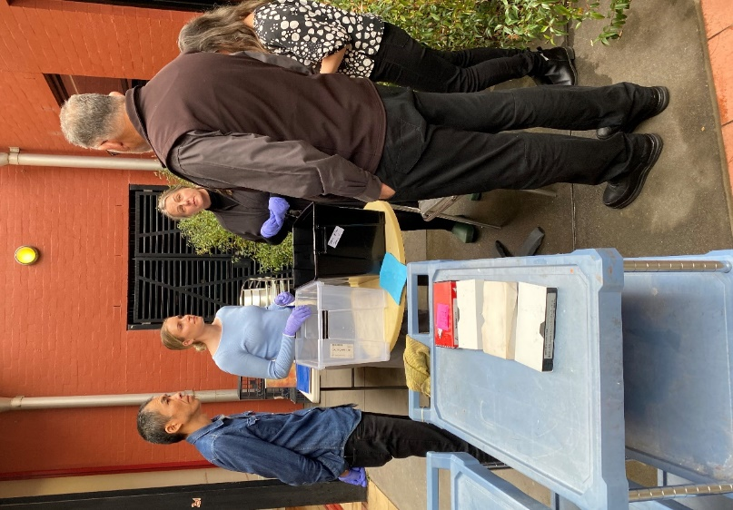
CFC staff Disaster Response Training. Image: CFC

- continued collaboration with access service providers including Vision Australia, Better Hearing Australia, and The Captioning Studio.

These collective efforts reflect the CFC’s ongoing commitment to creating inclusive, accessible, and welcoming cultural spaces for all members of the ACT community. As we progress toward a formal Disability Inclusion Plan in 2025-26, our focus remains on embedding equity and participation across every aspect of our operations.

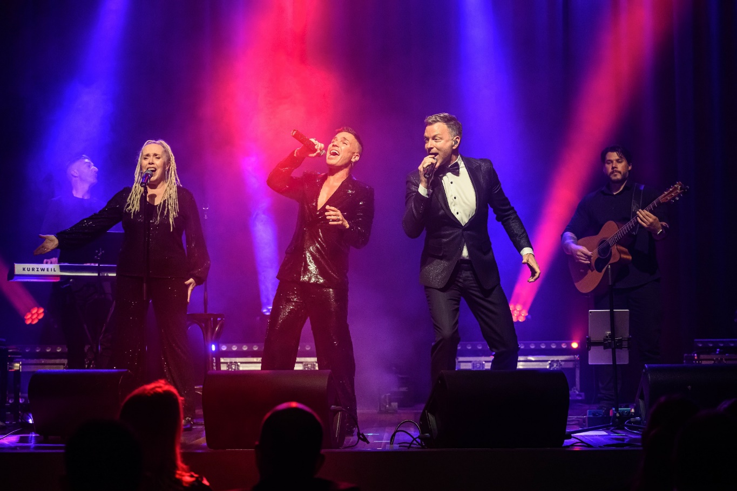
Anthony Callea and Tim Campbell. Image: CTC

B11 Multicultural Reporting

The CFC plays a vital role in telling the stories of Canberra and the surrounding region: stories that are diverse, dynamic, and deeply rooted in the lived experiences of our community.

As a statutory authority and cultural institution, CFC makes independent creative decisions guided by Board-endorsed exhibition, collections, and programming policies. These decisions are shaped by a commitment to reflect and engage the wider community, explore the region’s history and identity, and present work that entertains, challenges, and resonates with Canberrans.

In doing so, CFC actively supports the principles of the ACT Multicultural Charter, which affirms the right of all individuals to express and celebrate their cultural identity safely and freely. CFC’s programming increasingly showcases the cultural and linguistic diversity of Canberra, ensuring that people from all backgrounds feel welcomed and represented in our venues.

This commitment is reflected in:
- inclusive programming that highlights diverse artistic voices and traditions.
- accessible cultural spaces where communities can gather, perform, and celebrate.
- equitable participation in Canberra’s cultural life through outreach and engagement.
- promotion of mutual respect and understanding through storytelling and shared experiences.

Through this approach, the CFC continues to foster a sense of belonging and inclusion, ensuring that our cultural institutions remain vibrant, relevant, and reflective of the community they serve.

Canberra Theatre Centre
Highlights from CTC’s multicultural programming during 2024-25 included:
- The Peasant Prince - an award-winning children’s work by Monkey Baa. The children’s version of Li Cunxin’s iconic autobiography, Mao’s Last Dancer, The Peasant Prince told the remarkable true story of a 10 year old peasant boy’s journey from impoverished rural China to the international dance scene
- English - Sanaz Toossi’s Pulitzer award winning script produced by Melbourne Theatre Company, directed by Canberran Tasnim Hossain and starring Osamah Sami (ABC’s Savage River), English explored the choices that people who seek a new home must make, and all that they lose and gain along the way
- Briefs Bite Club - Led by Fez Faanana (aka Shivanana) Briefs' Dirty Laundry was a bold cabaret performance that blends circus, drag, and burlesque with political edge. The Briefs Factory International collective prioritises cultural diversity, with company members who have come from a diverse background of cultures, genders and archetypes, and
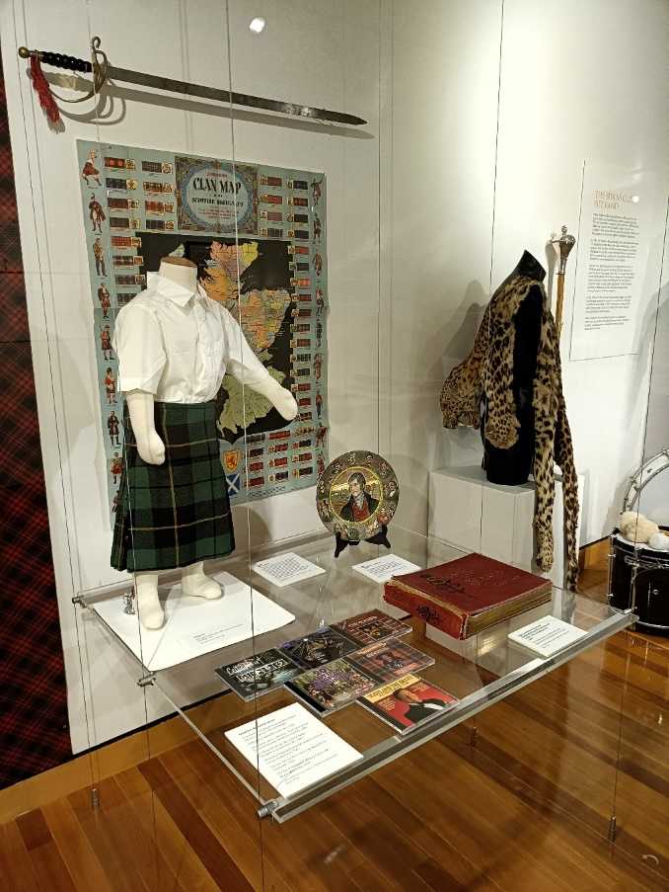
Tartans and Thistles: Burns Club 100 Years CMAG
exhibition. Image: Sarah Nash
- Rodrigo Y Gabriela - a Mexican guitarist duo, brought their instrumental flamenco roots into their own sound, influenced by nuevo flamenco, heavy metal, and rock n’ roll.

The CTRP team also engaged with the ACT multicultural community as part of stakeholder consultation on design of the new theatre.

Galleries, Museums & Heritage
Multicultural programming at our museums during 2024-25 included:
- Hiroe and Cornel Swen: A Creative Life exhibition, celebrating the artistic works and partnership of renowned Japanese Australian ceramicist Hiroe Swen and her late husband, Dutch Australian graphic designer and artist Cornel
- Taglietti: Life in Design exhibition celebrating the design legacy of Italian Australian architect Enrico Taglietti. Italian language tours have been developed for visitors and schools
- Tartans and Thistles: Burns Club 100 Years exhibition (pictured) marking the 100th anniversary of the Burns Club and Scottish migration and community in Canberra

- Growing up Modern: Alex Jelinek and Canberra's Round House exhibition and the design by Czech emigree architect Alex Jelinek
- Ikebana @ CMAG featuring vessels by 7 contemporary artists and Ikebana creations by artist Sachie Terasaki
- CMAG was also the ‘Sanctuary’ area for the National Multicultural Festival with a range of free children’s activities in a cool and quiet environment. CMAG provided a range of free children and family-friendly activities, and
- a talk by Fernando Pino on Chilean migrant workers employed at Lanyon Homestead during the 1860s, as part of the 2025 Canberra and Region Heritage Festival.

B12 Period Products and Facilities (Access) Act 2023 Reporting

The CFC does not manage any premises that are required to provide free access to period products. As a workplace, the CFC provides access to relevant facilities and provides information via the intranet for employees regarding menstruation and menopause flexible work arrangements and leave entitlements.

B13 Work Health and Safety

The CFC is committed to the physical and psychosocial health, safety, and wellbeing of our workers, and strives to provide a safe and healthy work environment in accordance with the Work Health and Safety Act 2011.

A key focus in 2024-25 has been improving the scope and timeliness of incident and hazardous situation reporting. This has included the publication of a new incident and hazardous situation reporting flowchart, a webinar to support this new resource, and webinars for staff and managers on the effective use of Safety Portal.

Governance
The CFC Board has established key performance indicators in relation to the timeliness of WHS incident reporting, lost time injuries, and training. It receives a report for each of its two-monthly meetings, including statistical information on reported incidents, KPIs, and WHS strategy and policy. In addition, every six months, a further report is provided to the Board on key WHS risks in the CFC, together with risk controls and risk treatment strategies.

The CFC Work Health and Safety Committee (WHSC) comprises the CFC Senior Leadership Team and elected Health and Safety Representatives. They meet every three months, and the minutes are posted on WHS noticeboards, including the virtual noticeboards on the CFC intranet.
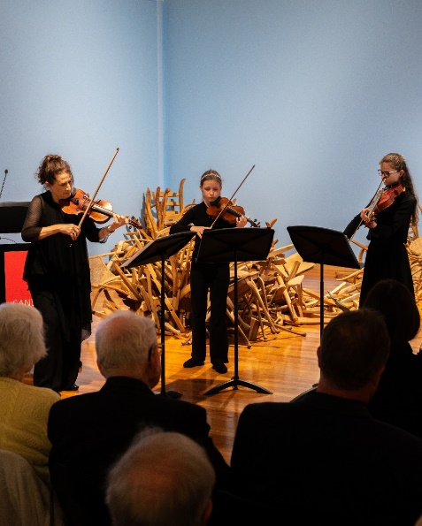

Canberra Symphony Orchestra (CSO) launch. CMAG. Image: Dominic Northcott

WHS Risk Management
The highest rated risks for the CFC include:
- electrocution
- fire and emergency management, and
- working at heights.

The controls implemented by the CFC to address these risks include regular testing and tagging of electrical equipment, improved emergency response procedures and training, emergency evacuation exercises, and the professional maintenance of lifting equipment.

CFC staff participated in ACT Insurance Authority (ACTIA) workshops to enhance their understanding of risk management principles and practices (see Capability and Capacity).
Capability and Capacity
The CFC has adapted its standard induction program format and learning items to include casual staff and volunteers. The all-staff induction session has been adapted to meet changing ACT Government and CFC structures and systems.

To increase the knowledge, skills, and confidence of its workers in relation to WHS, the CFC continues to develop its induction, learning and webinar programs, and connect to whole of government learning.

Authorised Persons Number of completions
ACT Government Solicitors Office Authorised Persons | 5
Emergency Training
Bushfire pre-season training (conducted in collaboration with the ACT Rural Fire Service) | 24
Canberra Theatre Centre Smoke Detector Isolation Training | 9
Chief Warden training | 21
Emergency control organisation training | 77
Emergency Procedures Training | 24
First attack/fire extinguisher training | 34

Hazardous Manual Tasks Training
Hazardous Manual Tasks | 1
Health and Safety Representative Training
Health & Safety Representative Training - 5 days | 1
Induction
CFC All Staff Induction Session | 39
CFC Business Area Induction | 25
General Awareness Work, Health, Safety e-Learn | 25
Protective Security Training
Protective Security Policy Framework Awareness | 22
Respect, Equity and Diversity
Respect, Equity and Diversity in Practice - General Training | 34
Respectful Behaviours Workshop | 2
Safe Use of Fleet Vehicles Webinar
Our fleet vehicle policy and arrangements have changed. What does this mean for you? | 33
Sharps
Safe Handling of Sharps and Infectious Waste | 3
WHS incident reporting Webinars
Welcome to Safety Portal | 17
Safety Portal for Supervisors | 25
Timely Reporting of WHS incidents for directors, managers, and supervisors | 17
WHS Risk Management
ACTIA Bespoke Introduction to Risk Management | 29
ACTIA Risk Community of Practice | 3
ACTIA Risk Register Development/Review Workshop | 31

Webinars were recorded and made available to workers on the CFC Intranet.

Work Health and Safety Act 2011
In 2025-26, the CFC received no improvement notices, notices of enforceable undertakings, or notices of failure to comply with a safety duty under the Work Health and Safety Act 2011.
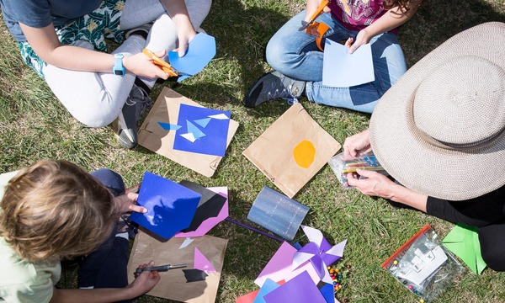
At the Garden Gate, Mugga-Mugga Cottage learning. Image: GMH

B14 Human Resource Management

B14.1 - Human Resources Management

The CFC employs its staff under the provisions of the Public Sector Management Act 1994, with appointments made as executives or officers of the ACT Public Service. The organisation operates under a single Enterprise Agreement, which includes tailored provisions to reflect the diverse and specialised roles unique to the CFC - such as museum and gallery curators, collections officers, theatre technicians, and front-of-house staff - roles not typically found elsewhere in the ACT Government.

Human resource management at the CFC is closely aligned with Goal 5 of the Strategic Plan 2023-27: Best Practice Governance, Organisational Capacity and Culture. This goal prioritises building a secure and resilient workforce by offering professional development and career pathways, positioning the CFC as both an employer of choice and a training ground for the cultural sector. It also emphasises fostering a workplace culture that reflects the values of both the CFC and the ACT Public Service.

This approach is further guided by the CFC’s core value of being Magnetic - attracting and retaining exceptional employees, artists, audiences, and partners.

The CFC’s Agency Consultative Committee (ACC) plays a key role in supporting effective workplace relations and governance. Established under Clause F1.5 of the ACT Public Sector Cultural Facilities Corporation Enterprise Agreement 2023-2026, the ACC monitors the operation and implementation of the Enterprise Agreement, reviews proposed changes to related policies and guidelines and provides a forum for consultation on workplace matters that significantly affect employees. Through these functions, the ACC ensures that staff perspectives are considered in decision-making, and that the CFC maintains a collaborative and transparent working environment. In 2024-25, the ACC met four times.

During 2024-25 the CFC participated in all whole-of-government Secure Work Conversion Rounds with two employees found eligible for conversion.

B14.2 - Learning and Development

The CFC is committed to its staff having the knowledge, skills, and confidence to perform their roles effectively, efficiently, and safely. During 2024-25 the CFC continued to broaden the implementation of its Core Learning Framework, which provides consistency for staff induction and the development of essential ACT Public Service knowledge and skills.

ACTPS Training learning items completed
Aboriginal and Torres Strait Islander Cultural Awareness Workshop
ACT Public Service Induction Program e-Learn
ACTIA - Bespoke Introduction to Risk Management
ACTIA - Risk Register Development/Review Workshop
ACTPS SBS Culture Module 1
Best Practice Recruitment & Staff Selection
Core Inclusion Program Part 1 of 4 (SBS) e-Learning
Cyber Security Essentials
Cyber Security Essentials for Executives
Essential Writing Skills: Government Emails and Letters
Excel for Finance Staff - Intermediate/Advanced
Foundational Procurement Modules:
- ACT Government Procurement Framework
- Value for Money
- Probity in Procurement
- Procurement Delegations
- Charter of Procurement Values
- Aboriginal and Torres Strait Islander Procurement Policy
- Implementing and Managing Territory Contracts
- Governance in Procurement
- Understanding and Addressing Modern Slavery
- Preventing Corruption in Procurement
General Awareness Information Privacy e-Learn
General Awareness Record Keeping and Freedom of Information
Health and Safety Representative Training - 5 days
Procurement and Probity Training Video
Protective Security Policy Framework Awareness (e-Learning)
Social Media Guidelines e-Learn
Excel for Finance Staff - Intermediate/Advanced

CFC initiated courses
ACTPS Procurement Training - Notifiable Contracts
Best Practice Recruitment & Staff Selection
Business Area Induction
Canberra Theatre Centre Emergency Chief Warden Training
Canberra Theatre Centre Emergency Warden First Attack Training
Canberra Theatre Centre Emergency Warden Training
Canberra Theatre Centre Smoke Detector Isolation Training
Getting Started with DocuSign
Pre-bushfire Season Training
Respect, Equity and Diversity in Practice - General Training
CFC Webinars:
- Timely Reporting of WHS incidents for directors, managers, and supervisors
- Our fleet vehicle policy and arrangements have changed. What does this mean for you?
- Philanthropic Fundraising at the Cultural Facilities Corporation
- Safety Portal for Supervisors
- Welcome to Safety Portal
- What is the Gender Action Plan?

In 2024-25 CFC staff participated in
27 separate ACT Public Service courses, including those provided by CMTEDD, ACTIA, ACT Integrity Commission, and ACT Property Group, as well as a wide range of other training sessions, listed below. In total there were 401 instances of completion by CFC staff.

In 2024–25, CFC invested $136,176 in staff training and professional development, covering training programs and conference registrations. This figure excludes associated travel and accommodation costs.
Specialised licensing training was provided to theatre technicians and maintenance and horticultural staff, including forklift operation, working at heights, chainsaw use, high-risk work, scissor lift operation, dogging, and electrical test and tag procedures.

Staff also attended a range of conferences and seminars to support their professional growth. These included events in the performing arts and museum sectors such as the Australian Performing Arts Exchange, Culture and Business, the Australian Labour and Employment Relations Conference, and the Ticketing Business Forum in Manchester, UK.

With the continued generous donor support, the CFC maintained its Staff Development Scholarship in 2024-25. Inspired by the Churchill Fellowship model, the scholarship offers up to $10,000 to enable professional development opportunities that would otherwise be out of reach for CFC employees. Applications are assessed based on the potential for personal growth, alignment with the CFC’s mission and strategic direction, and the broader impact the experience may have on the cultural sector. One of this year’s scholarship recipients is profiled on
page 18.

B14.3 - Staffing Profile
The CFC’s Staffing Profile at 26 June 2024 (the last pay date for the 2024-25 financial year) was as follows:

Full-time equivalent (FTE) and headcount by agency
Division/Branch | FTE | Headcount
Cultural Facilities Corporation | 113 | 256

FTE and headcount by gender
 | Female | Male | Non-  Binary | Total
Full Time Equivalent | 91 | 20.75 | 1.25 | 113
Headcount | 162 | 91 | 3 | 256
Percentage of Workforce | 63.3% | 35.5% | 1.2% | 100%

Headcount by classification and gender
Classification groups | Female | Male | Non-  Binary | Total
Administrative Service Officers | 49 | 15 | 1 | 65
General Service Officers (incl apprentices) | 6 | 9 | 1 | 16
Professional Officers | 10 | 1 | 0 | 11
Senior Officers | 14 | 6 | 0 | 20
Executive Contract | 0 | 2 | 0 | 2
Theatre Box Office Staff | 9 | 6 | 0 | 15
Theatre Patron Services Staff | 53 | 18 | 0 | 71
Theatre Technical Services Staff | 21 | 34 | 1 | 56
Total | 162 | 91 | 3 | 256

Headcount by employment category and gender by agency
Category | Female | Male | Non-  Binary | Total
Casual | 103 | 53 | 2 | 158
Permanent Full-time | 41 | 29 | 1 | 71
Permanent Part-time | 10 | 5 | 0 | 15
Temporary Full-time | 7 | 4 | 0 | 11
Temporary Part-time | 1 | 0 | 0 | 1
otal | 162 | 91 | 3 | 256

Headcount by diversity group by agency
Diversity Group | Headcount | % of agency  workforce
Aboriginal and Torres Strait  Islander Peoples | 1 | 0.4
Culturally and Linguistically Diverse | 7 | 2.7
People with Disability | 2 | 0.8
Prospective employees of the CFC are asked to identify their ethnicity or disability. However, declaring this information is not mandatory.

Headcount by age group, gender and average length of service
Age  Group | Female | Av. length  of service | Male | Av.  length  of service |  | Non-  Binary | Av.  length  of service
Under 20 | 14 | 1 | 2 | 1 | 0 |  | 0
20 - 29 | 46 | 1 | 29 | 2 | 2 |  | 2
30 - 39 | 36 | 3 | 24 | 2 | 1 |  | 2
40 - 49 | 21 | 5 | 16 | 6 | 0 |  | 0
50 - 59 | 24 | 5 | 14 | 7 | 0 |  | 0
60 - 69 | 16 | 9 | 6 | 8 | 0 |  | 0
Over 70 | 5 | 7 | 0 | 0 | 0 |  | 0

Recruitment and separation rates by classification group and agency
Division/Branch | Recruitment rate | Separation rate
Cultural Facilities Corporation | 28% | 12%

Attraction and Retention Incentives (ARIns)
 | Total
Number of ARIns as at 30 June 2025 | 2

Special Employment Arrangements (SEAs)
 | Total
Number of SEAs as at 30 June 2025 | 0

B14.4 - Gender Action Plan and Gender Impact Assessment Reporting

In 2024-25, the CFC developed its first Gender Action Plan, aligned with the priority areas of the ACTPS Gender Equity Strategy 2023-2028. The plan was informed by a Gender Impact Assessment that reviewed CFC payroll data, staff survey results, and incident reports, and it continues to focus on actions that benefit all genders, including gender-diverse and non-binary employees.

While challenges remain in collecting detailed gender-diverse workforce data due to low self-identification in HR systems, the CFC is on track with the Plan’s implementation. Actions underway are designed to promote safe, inclusive, and respectful workplaces for all, supported by zero-tolerance policies on gender discrimination and violence.

Our workforce profile remains consistent with last year, broadly reflecting ACTPS trends, with a majority female workforce and a higher proportion of non-binary employees than the wider public service. Gender segmentation continues in certain role types, such as outdoor work, technical theatre, curatorial, collections, and exhibitions roles, and remains a focus in recruitment, mentorships, and training.
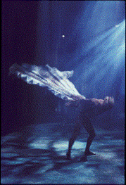
Sidney Nolan’s male Lyrebird in the Australian Ballet,
‘The Display’ 1964. Image: National Library of Australia

Throughout the year, the CFC has continued delivering training and development programs for staff and leaders to strengthen inclusive workplace practices, build awareness, and support cultural change.
Flexible work arrangements and work/life balance initiatives are also actively supported by managers through performance planning and training.

CFC will continue to build on these foundations, ensuring that gender equity remains embedded in everyday workplace culture. By keeping gender considerations central to decision-making and workplace planning, we are laying the groundwork for sustainable, long-term change. The CFC is right on target with its Gender Action Plan and remains firmly committed to achieving the goals of the ACTPS Gender Equity Strategy. The Plan and accompanying Gender Impact Assessment will be reviewed alongside the next ACTPS All Staff Survey, in late 2025, ensuring that future actions are informed by the most current workforce data and employee feedback.

B15 - Ecological Sustainability Reporting
Indicator as  at 30 June 2025 | Unit | 2024-25 | 2023-24 | %  Change
Stationary energy usage
Electricity use | Kilowatt hours | 1,955,186 | 1,917,926 | 2%
Fossil fuel gas use (non-transport) | Megajoules | 4,679,019 | 4,394,481 | 6.5%
Diesel use (non-transport) | Kilolitres | N/A | N/A | N/A
Liquid Petroleum Gas | Kilolitres | N/A | N/A | N/A
Fleet vehicles
Zero Emissions Vehicles (ZEV) | Number | 1¹ | 0 | 100%
Plug-in Hybrid Electric Vehicles (PHEV) | Number | N/A | N/A | N/A
Hybrid Electric Vehicles (HEV) | Number | 1 | 1 | 0%
Internal Combustion Engine (ICE) vehicles | Number | 2 | 3 | (67%)
Water usage
Water use | Kilolitres | 4,826² | 5,510 | (13%)
Resource efficiency and waste
Waste to landfill | Litres | 48,000³ | 48,267 | 0%
Co-mingled material recycled | Litres | 35,594 | 35,594 | 0%
Paper and cardboard recycled (incl. secure paper) | Litres | 23,958 | 23,958 | 0%
Organic material recycled | Litres | N/A | N/A | N/A
Greenhouse gas emissions
Emissions from natural gas use (non-  transport) | Tonnes CO2-e | 243 | 226 | 7%
Emissions from diesel use | Tonnes CO2-e | 5⁴ | 3 | 50%
Emissions from petrol and E10 use | Tonnes CO2-e | 1.5 | 2 | (29%)
Emissions from Compressed Natural Gas (transport) where applicable | Tonnes CO2-e | N/A | N/A | N/A
Emissions from refrigerants | Tonnes CO2-e | 97 | 97 | 0%
Total emissions* | Tonnes CO2-e | 345 | 328 | 5%

*Footnotes for 2024-25 Emissions and Utility Reporting

    - The CFC replaced their Skoda Octavia (ICE) vehicle with a BYD ATT03 (FEV) vehicle.
    - The CFC water usage figures also include external water delivery to Lanyon Homestead.
    - FY24-25 resource efficiency and waste data may differ from actual consumption due to issues regarding the primary waste contractor's migration of system resulting in confounded and unreliable data for 2024-25.The CFC was unable to source data within the required timeframe.
    - Diesel vehicle use across the CFC has increased due to supply and delivery requirements relating to new work activities at Lanyon Homestead Café.

Data for this reporting period was extracted at 4.50pm on 28 July 2025. At the time of data extraction, the Enterprise Sustainability Platform had 96.82% actual data, 2.15% estimated data, and 1.03% accrued data.

Note that some data reported for 2023-24 in the table above may differ from figures reported in the 2023-24 Annual Report. These differences are due to utility invoice data entering the system after the data extraction date (28 July 2024) and retrospective updates to agency occupancy.

Actual utility consumption and emissions may vary marginally from that reported in the table above. This is due to accrued data being used for sites where invoice data was not available at the date of data extraction. This discrepancy is likely to be
marginal in the context of annual consumption figures and will be addressed in next year’s reporting period.

Emissions reported include Scope 1 and Scope 2 emissions only. Scope 1 are direct emissions from sources owned and operated by the government, including emissions from transport fuel, fossil fuel gas, and refrigerants. Scope 2 emissions from mains electricity is considered zero in the ACT due to the ACT’s 100% renewable electricity supply.

Emission factors used to calculate natural gas and fleet fuel are based on the latest National Greenhouse Accounts factors.
Baseline (2019 calendar year) emissions have been amended to include refrigerants. Change in emissions for subsequent years has been revised accordingly.

PHEVs are no longer considered zero emissions vehicles (ZEV’s) as of 31 December 2022. Plug-in Hybrid Electric Vehicle (PHEVs) can run solely as an electric vehicle for a very short driving range (around 50km’s) and then will begin to run on petrol/diesel. As such, a PHEV is not considered a Zero Emissions Vehicle in the Territory.

Climate Change and Greenhouse Gas Reduction
Information used for the sustainability table was provided by the Enterprise Sustainability Team. Additional data was provided by ELGAS, Iron Mountain, Cleanaway, SG Fleet, Infrastructure Canberra, and AAA All Areas Water Carrying.

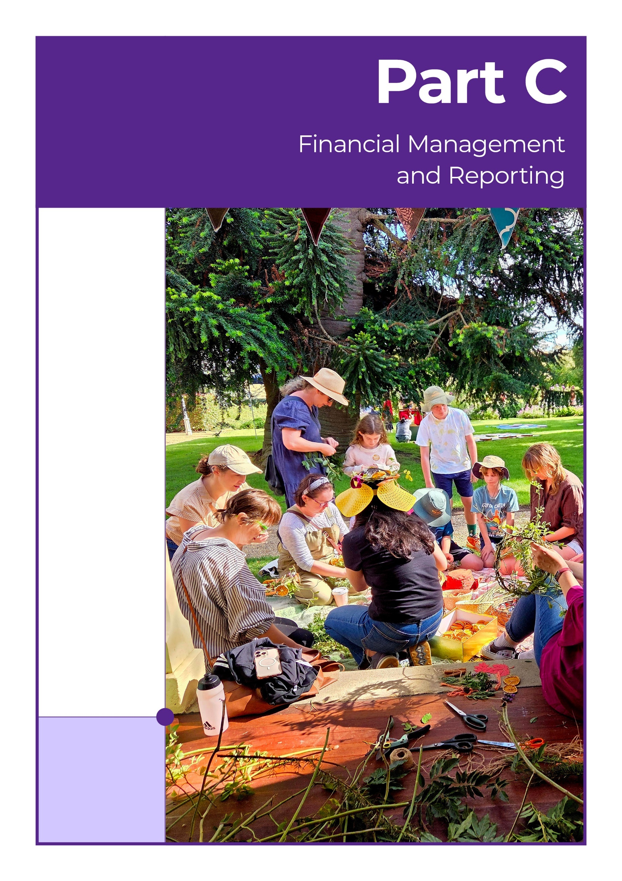
Harvest Day Out at Lanyon Homestead. Making Flower Crowns. Image: GMH
C1 Financial Management Analysis
A full analysis of the CFC’s 2024-25 financial results and financial position is set out in the Management Discussion and Analysis at Attachment 1 to this report.

C2 Financial Statements
The CFC’s 2024-25 Financial Statements are set out at Attachment 1 to this report.

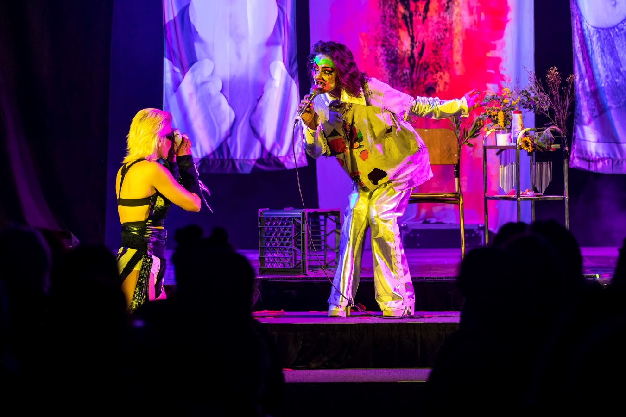
Enemies of Grooviness, CTC. Image: Joseph Mayers

C3 Capital Works

2024-25 Capital Works Projects
Project | Estimated completion date | Original  project value $000 | Actual completion date | Revised project value $000 | Prior year expenditure  $000 | Current year expenditure $000 | Total expenditure  to date  $000
Works in Progress
Arts and culture - CTC expansion and redevelopment | June 26 | 2,393 | - | 2,393 | 683 | 294 | 977
Arts and culture - Lanyon Homestead upgrades | June 26 | 951 | - | 951 | 256 | 96 | 352
Lanyon Urgent Driveway Upgrades and Stabilisation of the Shearers’ Precinct | June 27 | 3,903 | - | 3,903 | 33 | 198 | 231
Upgrading Lanyon Homestead | June 26 | 3,097 | - | 3,097 | 2,635 | 32 | 2,668
Completed works
Improvements to the Canberra Theatre Centre | June 25 | 1,442 | Sept 24 | 1,442 | 1,206 | 236 | 1,442
Transforming the Canberra Museum & Gallery and development Canberra Theatre Centre technicians | June 25 | 423 | June 25 | 423 | 163 | 260 | 423
Asset Renewal Program
Cultural Facilities Corporation |  | 707 | - | 707 | - | 707 | 707
Total Capital Works Program |  | 12,916 |  | 12,916 | 4,967 | 1,833 | 6,800

2024-25 Capital Works Reconciliation
Reconciliation of approved financing, expenditure and financial statements | $000
Approved current Capital Works Program Financing to capital injection per Cash Flow Statement 2,933
Add: Capital Injection for Projects not in the Capital Works Program | -
Less: Capital Injection Not Drawn in 2024-25 | 985
Current year expenditure to Capital Injection as per Cash Flow Statement 1,948
Less: Expenditure funded by Capital Injection not in the Capital Works Program¹ | -
Less: Net Impact of Accruals between Financial Years | 90
Total Purchase of Capital Works per Cash Flow Statement | 1,858

C4 Asset Management

C4.1 - Assets Managed
The CFC managed assets with a total value of $73,557,000 as at 30 June 2025. The CFC’s major assets and approximate values are:

Asset | Value
Description | $000
Buildings at fair value | 40,865
Land at fair value | 21,203
Plant and equipment | 2,019
Art and Social History Collection | 5,869
Capital Works in Progress | 1,480
Leasehold Improvements | 2,122

During 2024-25 the following assets were added to the CFC’s asset register:

Major Asset | Value
Description | $000
Property, plant and acquisitions | 879
Building upgrades | 640
Art and Social History Objects (including donated art) | 124
here were no significant assets removed from the CFC’s asset register during 2024-25
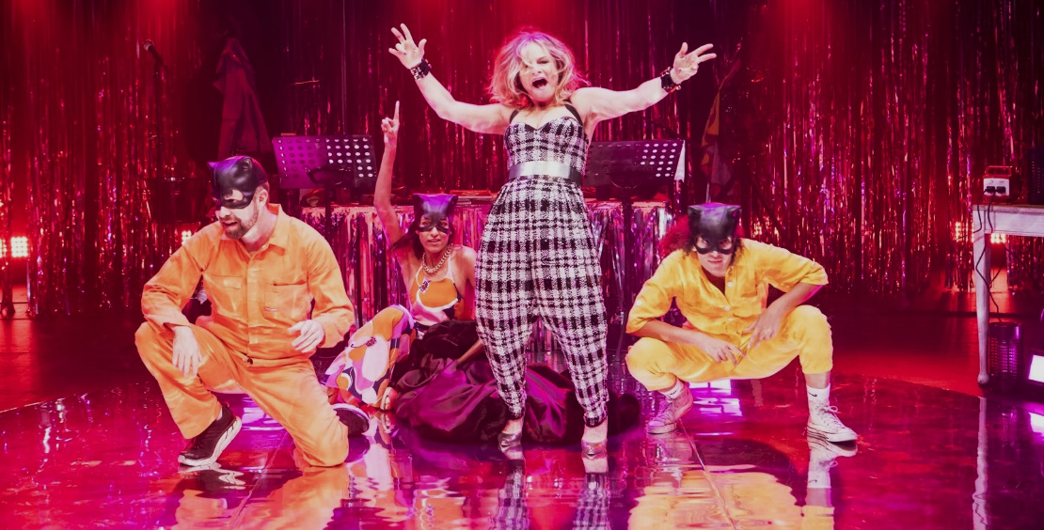
44 Sex Acts In One Week. CTC. Image: Brett Boardman

C4.2 - Assets Maintenance and Upgrade
The CFC maintains its assets in accordance with the CFC’s Strategic Asset Management Plan. Asset upgrades (including works funded and reported through the capital works program) completed during 2024-25 were:

Major Asset Upgrades | Value
Description | $000
Transforming CMAG and developing CTC Technicians | 423
Improvements to the Canberra Theatre Centre | 1,442

For building assets, the expenditure on repairs and maintenance was $367,000, which represented 0.9% of the assets written down value. For Plant and Equipment assets, the expenditure on repairs and maintenance was $88,000, which represented 2.1% of the assets written-down value.

A three-year rolling independent valuation of the CFC’s assets has been implemented to ensure all items are reflected at fair value in the CFC’s asset register and all assets are reviewed annually for any impairment.
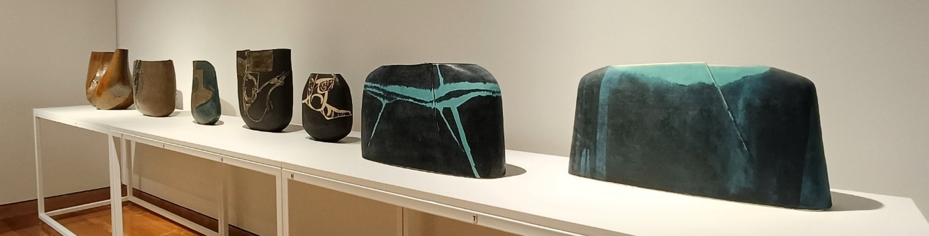
Hiroe and Cornell Swen: A Creative Life. CMAG exhibition. Image: Sarah Nash

C4.3 - Office Accommodation
As at 30 June 2025, CFC staff members occupy or use premises at Canberra Theatre Centre, Canberra Museum & Gallery, North Building, Lanyon Homestead, Calthorpes House, and Mugga-Mugga locations.

In view of the wide range of workplaces, and the collaborative nature of our work across historic places, theatre, and gallery environments, areas used by staff as offices may be combined with other uses such as ticketing, patron servicing, it is difficult to provide a precise figure of the average area occupied by each employee. An estimate of the total office area occupied by the CFC is 1,147 square metres, and an estimate of the average area occupied by each (FTE) employee as at 30 June 2025 is 10.2 square metres.

C5 Government Contracting

C5.1 - Procurement Principles and Processes
The CFC engaged external sources of goods, services and works, during 2024-25 and these goods, services and works, were procured with the support and assistance of Procurement ACT as required. The CFC’s procurement selection and management processes comply with the Government Procurement Act 2001. We liaise regularly with Procurement ACT on procurement matters including through the involvement of officers of Procurement ACT in the more complex or higher value procurement processes.

C5.2 - External Sources of Goods, Services and Works
The online ACT Government Contracts Register records contracts with suppliers of goods, services, and works, with a value of $25,000 or more. A full search of CFC contracts notified with an execution date from 1 July 2024 to 30 June 2025 can be made at www.tenders.act.gov.au/contract/search.

Secure Local Jobs Code
The CFC was granted an exemption in relation to procurements for heritage conservation works related to Lanyon and Mugga-Mugga Cottage. These works are highly specialised heritage, and conservation works to our Historic Places. No suitable entities to tender or contract for the respective Procurements would enable the requirements in section 22G (1), (2) and (3) of the Government Procurement Act 2001 to be met. While CFC did not have any active conservation works at historic sites for 2024-25, the approved exemption enables future conservation works to be completed. This exemption was in relation to specialist heritage trade contractors only and did not extend to general trades engaged as third-party subcontractors to complete associated works captured by the Code requirements.

Aboriginal and Torres Strait Islander Procurement Policy (ATSIPP) Performance Measures
No. | ATSIPP Performance Measure | Result
1. | The number of unique Aboriginal and Torres Strait Islander Enterprises that respond to the reporting entity’s tender and quotation opportunities. | 3
2. | The number of unique Aboriginal and Torres Strait Islander Enterprises attributed a value of addressable spend in the financial year. | 3
3. | Percentage of the financial year’s addressable spend which is spent with Aboriginal and Torres Strait Islander Enterprises. | Less than 1%

C6 Statement of Performance
The CFC’s 2024-25 Statement of Performance is set out in at Attachment 1 to this report.

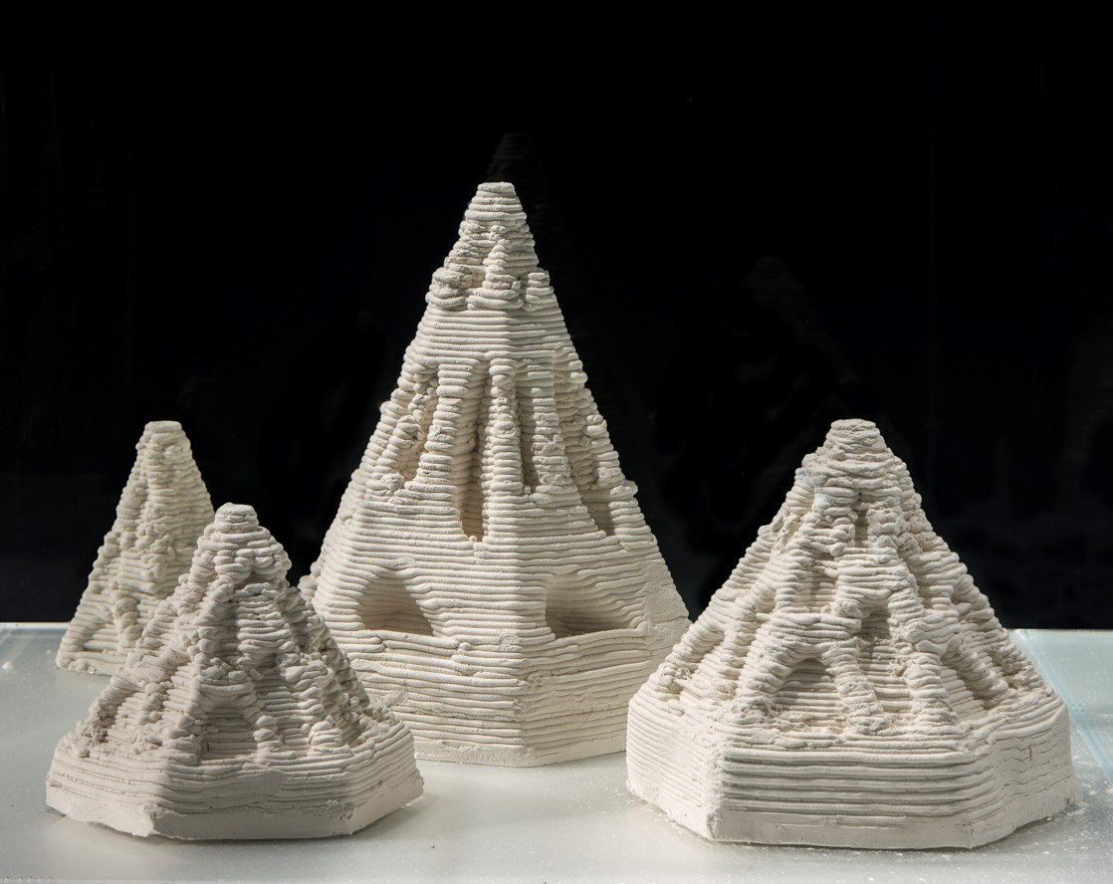
Reefinity, Beth O’Sullivan. CMAG exhibition. Image: GMH

Macy Gray - Canberra Theatre Centre. Image: Sarah Nash

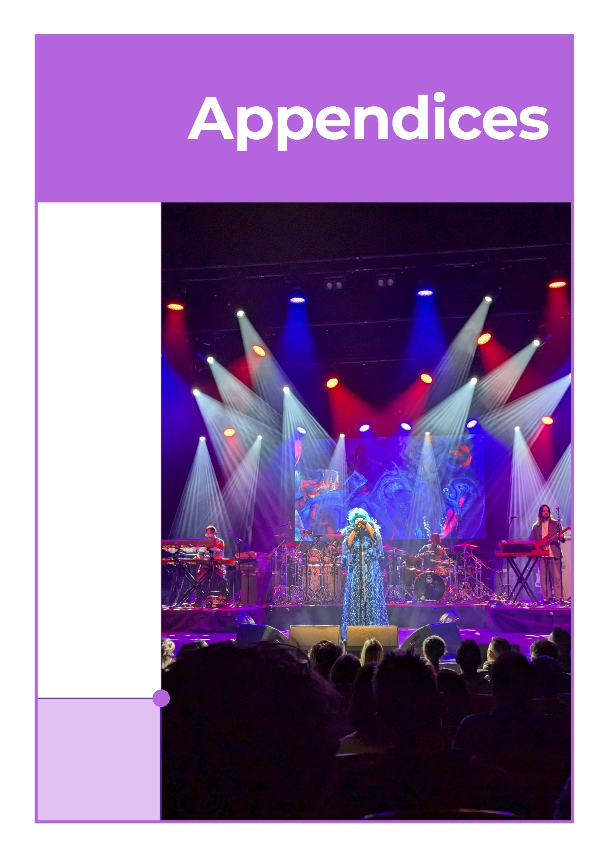
Macy Gray performing at CTC. Image: Sarah Nash

Appendix 1
Members of the CFC Board
Helen O’Neil Chair
Helen is an experienced non-executive director and leader in the arts and creative industries. She was Chair of Performing Arts Connections, representing arts centres, touring companies and service organisations in Australian live performance, and of South East Arts. Helen was a Board member of Craft ACT, Currency House Inc, and the Australian Film Finance Corporation. Her executive experience includes roles as Country Director of the British Council in Australia leading cultural relations in the arts, science and higher education; Executive Director of the Australian Major Performing Arts Group and the Council for the Humanities, Arts and Social Sciences; and with Opera Australia. In public policy Helen was Senior Adviser to the Minister for the Arts, The Hon Simon Crean. She has worked in screen and digital areas with News Ltd, and as a journalist with the ABC and The Age. Helen has degrees from the University of Melbourne (BA) and from Harvard University's Kennedy School (MPA). She is also a Councillor in the Bega Valley Shire.
Dr Rachel Coghlan Deputy Chair
Rachael Coghlan is an award-winning cultural and creative sector leader and passionate Canberran. She is an experienced Executive, CEO, Board Director and researcher with a track record of executing strategic renewal and commercial programs in complex environments to achieve quality outcomes. She led the strategic transformation of Parliament House's public engagement, implementing an ambitious renewal program across retail, visitor services, and tourism products. As CEO Craft ACT, she curated international exhibitions, strengthened stakeholder relationships, and significantly grew DESIGN Canberra festival attendance and philanthropy. Rachael has led major capital works including the National Arboretum Canberra and National Museum gallery redevelopment. Recognised with an Australian Institute of Architects Clem Cummings Award, she holds a PhD in museum studies from ANU, with her thesis receiving an Australian Museums and Galleries Association National Award for Research.
Gordon Ramsay Ex Officio as Chief Executive Officer
Gordon is a former member of the ACT Executive (2016-2020), where his portfolios included Attorney-General and Minister for the Arts. He holds a Bachelor of Arts and Bachelor of Laws (Hons) and a Bachelor of Theology. His legal career focused on commercial and intellectual property law at Freehill Hollingdale & Page. Gordon later led Kippax Uniting Church and UnitingCare Kippax for 19 years, focusing on social inclusion, poverty alleviation, and community services. From 2011-2016, he oversaw governance and structural reform at UnitingCare NSW/ACT. He has contributed to numerous ACT government initiatives, including the Targeted Assistance Strategy and Community Inclusion Board. He has led strategic consultancy across governance, policy, and organisational development and is currently on the Board of the Uniting Church NSW.ACT Synod. He was an ACT Local Hero finalist in the 2015 Australian of the Year awards.
Genevieve Jacobs AM Member
Genevieve Jacobs AM is CEO of Hands Across Canberra, the ACT’s community foundation supporting over 250 local organisations. A journalist for more than 30 years, she was a longtime presenter with ABC Canberra and later Group Editor of Region Media. She is a graduate of the Australian Institute of Company Directors and serves as a director of the Cultural Facilities Corporation, Regional Development Australia (Southern NSW/ACT), and the Australian Centre for Christianity and Culture. Genevieve chairs the Canberra International Music Festival and previously chaired the ACT Minister’s Creative Council. She is widely respected for her leadership in community engagement, strategic communication, and governance. In 2021, she was appointed a Member of the Order of Australia for her service to broadcasting and the community
Michael Sollis Member
Michael Sollis is an interdisciplinary artist and educator who explores how the arts foster creative thinking and community connection. He is founder and director of the Griffyn Ensemble, co-artistic director of the National Folk Festival, and was Musica Viva Australia’s inaugural Artistic Director, Education. Michael has led creative projects in diverse settings - from Scottish prisons to Egyptian schools - and lectured in composition at ANU, where he is completing a PhD on creativity and nature. His research on sung stories in Papua New Guinea is published by ANU E-Press and the Australian Journal of Linguistics. He was founding chair of the International Music Council’s Youth Board and helped establish the Canberra Artists Action Group. Michael was born and raised on Ngunnawal country, following in the footsteps of custodians who have listened to this land for generations.
Tim Lo Surdo Member
Tim is the Founder of Democracy in Colour, Australia’s first racial and economic justice organisation led by people of colour. He has held senior roles with Hospo Voice, Oaktree, UN Youth Australia, and Jhatkaa, and advised two Senators. Tim has served on 22 boards across government and civil society, and currently chairs No to Violence and the Jane Goodall Institute Australia. He is a Non-Executive Director of Plan International Australia, Environment Victoria, and several other national and international organisations. Tim is a member of advisory councils for the Australian Red Cross, Multicultural Queensland, and UWA’s Public Policy Institute. His work has earned recognition as an Asia-Pacific Obama Leader, Victorian Young Achiever of the Year (2021), and one of the UN’s 17 Young Leaders for the Sustainable Development Goals.

Christine Shannon Member
Christine Shannon brings over 25 years of expertise in governance, risk, and financial strategy. She led the development of Defence’s first enterprise risk and accountability frameworks for a $6 billion capital program. Internationally, she directed Australia’s public diplomacy efforts in the US, forging strategic partnerships and expanding cultural influence. Christine is a governance expert and legal professional, advising on corporate structure, legal risk, cyber security, and workforce transformation. She supports the Cultural Facilities Corporation’s growth strategy, including redevelopment of the Canberra Theatre Centre and expansion of CMAG. Christine holds a Master of Laws, MBA, Bachelor of Commerce/Laws, and AMusA, and is a member of the Australian Institute of Company Directors. She chairs the CFC’s Audit and Risk Committee.
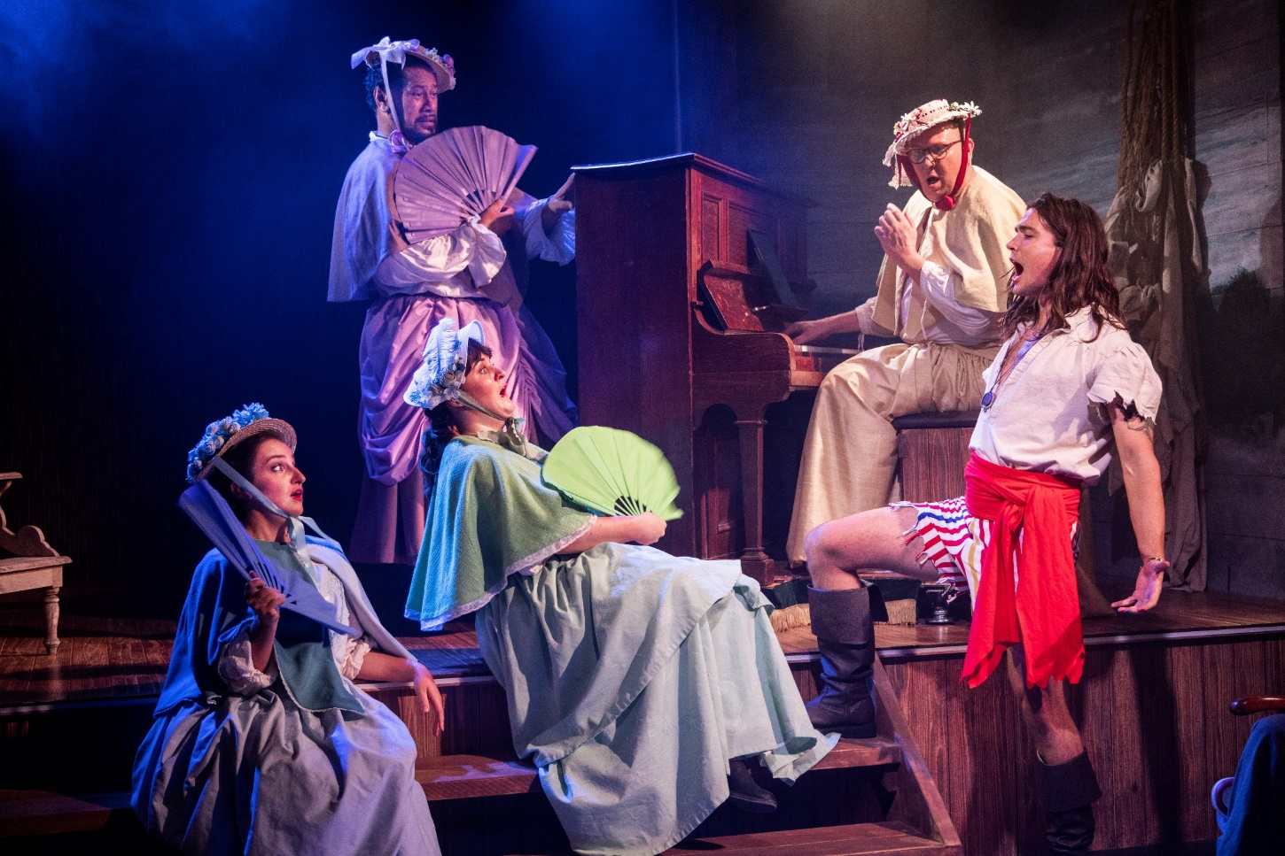
Pirates of Penzance. CTC. Image: Hayes Theatre Co.

Appendix 2
CFC Senior Leadership Team
Sharon Lu Chief Financial Officer and Chief Information Officer
Sharon is a member of Certified Practising Accountants Australia. She has a Master of Professional Accounting and a Master of Financial Management from the Australian National University. Following her experience in the not-for profit sector, Sharon joined the ACT Government in 2013 and has held various managerial positions in the ACT Government to promote financial sustainability, strong governance, and stakeholder collaboration. Before joining the CFC in 2023, Sharon was the acting Chief Finance Officer and a member of the Senior Executive Leadership group of Major Projects Canberra, guiding the organisation through complex financial landscapes and driving strategic decision-making in the infrastructure delivery of the ACT Government.
Alex Budd Director, Canberra Theatre Centre
Alex Budd is a senior arts executive with over 20 years of experience in opera, dance, musical theatre, and cultural leadership. His career began in the lighting department at Canberra Theatre Centre, where he returned in 2019 as Director. He was a founding member of Stopera and later toured internationally with Sydney Dance Company as Head Electrician and Lighting Designer. At Opera Australia, Alex held senior roles including Tour Manager, General Manager - Melbourne and Enterprises, and Executive Producer - Touring and Commercial, overseeing major productions and touring programs. He also worked at London’s Royal Opera House and served on the Federal Government’s Playing Australia Committee. Alex currently sits on the Executive Council of AAPPAC and is a former Executive Councillor, now Observer, for Live Performance Australia.
Dr Anna Wong Director, Galleries, Museums & Heritage
Anna has worked across a wide range of historic, cultural, and natural sites and museums in Australia, including precinct-based cultural site activation. Her previous roles span archaeology, cultural heritage, planning, and museum-related positions with the NSW Government Architect’s Office, NSW National Trust, NSW National Parks and Wildlife Service, and the National Capital Authority. Anna also lectured in Heritage Studies at the University of Sydney. Her doctoral research explored the Australian heritage conservation movement through the house museum genre, examining its influence on national identity and cultural representation via collections, conservation, exhibitions, public programs, and community engagement. In 2005 Anna received a research fellowship at the International Centre for Jefferson Studies at Monticello and the Winterthur Museum in the USA. Anna has a strong interest in cultural history and in integrating contemporary programs, stories, and site activation to ensure museums, collections, and cultural environments remain relevant to today’s communities and audiences.
Dr Brooke Thomas Director, Collaboration and Engagement
Brooke has over 20 years’ experience in a range of public service, tertiary sector, community arts, and political advisory roles with expertise in social policy development and implementation, complex program management, stakeholder engagement, organisational change, and international relations. She has a PhD in Literature with several publications, HR qualifications from the Australian Institute of Management, and a 20-year dance practice including performing, teaching, and governance. Her role at the CFC has a broad remit including human resources leadership, corporate governance, stakeholder engagement, government relations, business development, strategic communications, and organisational development.
Danielle Buffier Director, Facility Operations and Capital Works (until May 2025)
Danielle has over 25 years of experience in program and project management across civil engineering, transport, and infrastructure. She has led a variety of large-scale projects, including roads, bridges, airport infrastructure, and renewable energy developments. Her expertise includes guiding multidisciplinary teams and overseeing complex projects from initial planning through to completion. Danielle’s portfolio also includes work on solar and wind farms, Indigenous housing, education and health facilities, as well as highly technical initiatives such as air traffic control systems and airport terminals.
Corinna Cullen Head of Philanthropic Development
Corinna Cullen is a professional fundraiser, arts administrator, and writer experienced in communicating persuasively about the creative arts. Corinna is driving the creation of a philanthropic culture around the Cultural Facilities Corporation across all creative arms. Corinna has worked at an executive level for the National Gallery of Australia, National Museum of Australia, National Film and Sound Archive and as an independent consultant. She has worked in both commercial and government sectors of the Australian creative economy, beginning her career in 2004 at art auction house Deutscher-Menzies.
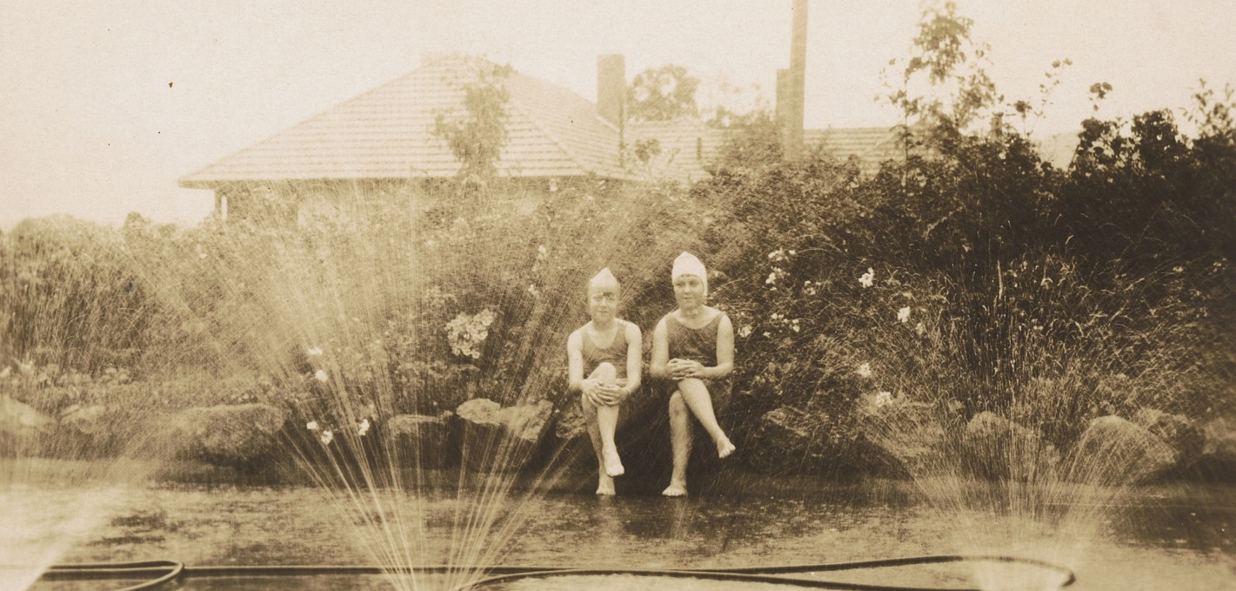
Calthorpes House garden. Dawn Waterhouse and her cousin. Image: GMH

Appendix 3
The CFC’s three Advisory Committees, operating in accordance with Section 8 (i)(a) of the CFC Act, provide expert strategic advice in relation to their respective specialist areas. The committees include the Canberra Museum & Gallery Advisory Committee, Historic Places Advisory Committee, and the Canberra Theatre Centre Advisory Committee.

Canberra Museum & Gallery Advisory Committee
Professor Nicholas Brown Convenor
Nicholas Brown FASSA is a professor in the School of History, College of Arts and Social Sciences, Australian National University. He has recently served as the Visiting Cabinet Historian with the National Archives of Australia, on the ACT Heritage Council and continues as a member of the Commonwealth and ACT Working Party of the Australian Dictionary of Biography. He is the author and co-author of a number of books, edited collections, and journal articles, including A History of Canberra (2016) with Cambridge University Press.
Professor Denise Ferris Member
Denise Ferris is an Emeritus Professor at the Australian National University, in the School of Art & Design where she was previously Head of School. She is a co-opted board member of the Deans and Directors of Creative Arts (DDCA), a peak body for the tertiary art and design sector, and a board member of South East Arts (SEA). Denise holds degrees from Sydney University and University of Technology Sydney. An art practitioner, Ferris’ photographs are held in Australian public collections, including the National Gallery, National Library, Australian War Memorial, ACT Legislative Assembly Art Collection and Canberra Museum & Gallery as well as international collections including the District Six Museum, Cape Town and Nara City, Japan.
Squadron Leader Gary Oakley OAM Member
Gary Oakley serves in the Royal Australian Air Force (RAAF) History and Heritage section as the Indigenous Historian/Curator and is National President of the Aboriginal and Torres Strait Islander Veterans and Services Association. He began his career as a 15-year-old Junior Recruit in the Royal Australian Navy (RAN), serving 22 years, mostly in submarines. A Vietnam War veteran, he later joined the Australian War Memorial as Assistant Curator, then Exhibitions Curator, curating many current galleries. He was the Memorial’s first Indigenous Liaison Officer and also worked at the Bavarian Army Museum in Germany. As a RAN Reservist, he contributed to Navy History and Defence Indigenous Affairs. He later joined the RAAF’s Equity and Diversity branch, retiring from the Public Service to take up a commission in the RAAF.
Dr Charlotte Craw Member
Charlotte Craw is an arts, culture and heritage professional with experience working in cultural institutions, public policy, community arts and tertiary education in Australia, Cambodia and New Zealand. She holds a PhD in Australian Indigenous Studies, and her most recent roles have focused on Aboriginal and Torres Strait Islander cultures and heritage. She is a co-author of the Ningaloo Coast and Sambor Prei Kuk World Heritage nominations, and her other publications include academic articles, art criticism, poetry and short fiction.
Sara Kelly Member
Since early 1982 Sara has worked in art galleries and museums at a National, State, University and Local level. Roles undertaken include Director, Curator, Registrar, and Loans and Collections Manager. In addition to a Fine Arts degree from the ANU, she has a Diploma in Law and Collection Management. The latter qualification facilitated extensive work on state and international transport logistics and compliance across a number of areas, including Indemnity and Sanctions and their reporting for the movement of cultural material. For the last six years Sara has undertaken consulting work, and volunteer research and committee work for cultural institutions.
Amelia Zaraftis Member
Amelia Zaraftis is an executive leader, fundraiser, educator, artist, and reconciliation advocate, living on Ngunnawal Ngambri Country. As the Director of Advancement at Burgmann College, a not-for-profit residential college on the ANU campus, Amelia leads the College’s alumni relations, communications, and fundraising program, and champions the College’s Reconciliation program. At the ANU School of Art & Design, Amelia also co-leads the ArtsACT-funded Sharing Stories Arts Exchange project which facilitates artists’ engagement with First Nations communities in Canberra and surrounds. Early in her career, Amelia was the Education and Community Programs Officer at CMAG. In 2018, Amelia was a co-recipient of the ANU Vice Chancellor’s Award for Reconciliation. Amelia holds a Bachelor of Visual Arts (First Class Honours) from the ANU and a Bachelor of Education from the University of Canberra.
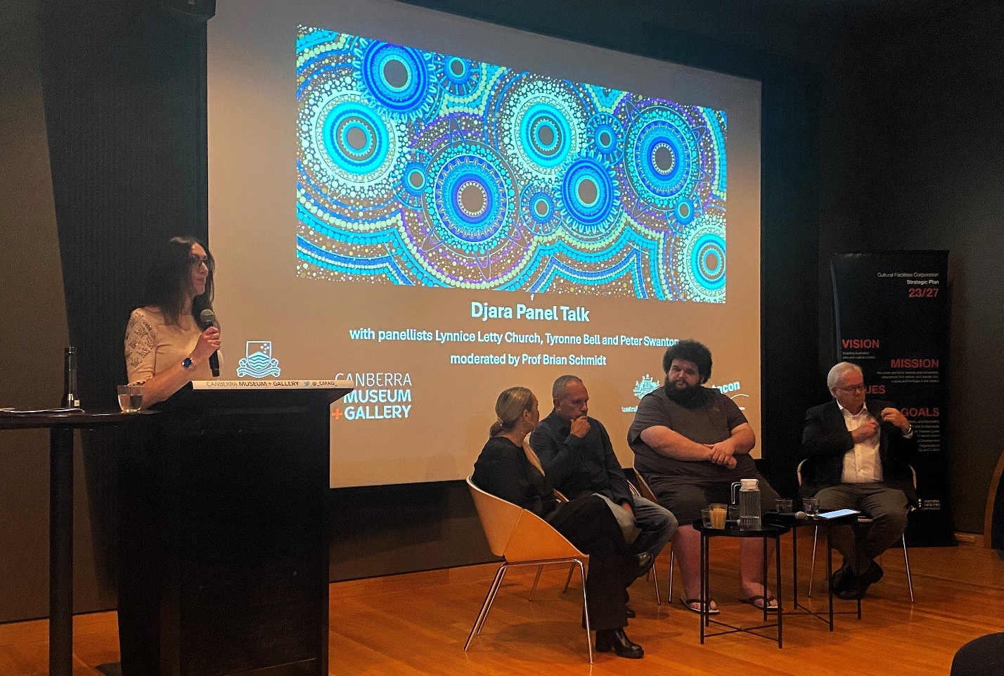

Panel Talk: Djara and First Nations Sky Stories. CMAG. Image: GMH
ACT Historic Places Advisory Committee
Barbara Reeve, FIIC, M.ICOMOS, CPHD Convenor
Barbara Reeve is a heritage professional and conservator with extensive experience in cultural institutions. She served as Head of Collection Services at the Australian War Memorial (1998-2014), overseeing conservation, registration, and collection management. As Manager of Heritage Preservation Projects (2014-2017), she led major initiatives including the reconstruction of the Commemorative Area and installation of the Menin Gate Lions in Ypres. Prior to this, she was the inaugural Head of Conservation at the Australian National Maritime Museum. Her international work includes conservation training at Hong Kong University and projects across Europe, the Asia-Pacific, and the Middle East. A Fellow of the International Institute for Conservation, Barbara’s interests include conservation education, bushfire recovery, and sustainability in heritage practice.
Dr Dianne Firth OAM Deputy Convenor
Dr Dianne Firth is Adjunct Associate Professor in the Faculty of Arts and Design at the University of Canberra, a registered landscape architect, and Fellow of the Australian Institute of Landscape Architects. She led the university’s Landscape Architecture program until 2012 and served as Deputy Chair of the ACT Heritage Council until 2018. Her PhD explored the landscape and politics of Lake Burley Griffin. Dianne’s research, publications and lectures focus on Canberra’s designed landscape and its heritage. She has contributed to major planning and heritage reviews for the ACT Government and National Capital Authority. In 2017, she received an OAM for service to landscape architecture and education. She is also a textile artist with works held in public collections in Australia and overseas.
Alistair Grinbergs Member
Alistair Grinbergs is a research scholar at the University of Canberra’s Centre for Creative and Cultural Research. His work explores how First Nations culture, experience and values can shape heritage management practices. He has held heritage advisory roles with NSW National Parks & Wildlife Service and the Australian Heritage Commission, including work on the Snowy Mountains Scheme and amendments to the EPBC Act. Alistair led a heritage assessment of Atlas Cove in the sub-Antarctic and has consulted on heritage tourism, national park restructures, and National Heritage List assessments. As Director of Ironbark Heritage & Environment, he focused on First Nations heritage in WA’s mining sector. His career spans government, academia and consulting, with a strong emphasis on inclusive and culturally informed heritage practice.
Joanne Lisinski Member
Joanne Lisinski is a Senior Conservator at the Australian War Memorial, specialising in modern materials and materials analysis. She has extensive experience in archaeological and built heritage preservation, including 15 years working in Conservation and Technical Art History in the Middle East. Joanne holds Master’s degrees in Conservation Science (University College London) and Middle Eastern and Central Asian Studies (ANU), and a Fine Arts degree from RMIT. Her interests include experimental and contemporary art practice. She is Board Chair of You Are Here (YAH) and Secretary of the AMaGA Art, Craft and Design National Network. In 2020, she joined the Audrey Fagan Board Traineeship Program and completed a mentorship with CFC’s previous CEO. Her work focuses on conservation science, collection risk management, and cultural heritage safety.
Dr Shannyn Palmer Member
Shannyn Palmer is a community-engaged practitioner, facilitator, researcher and award-winning writer living and working on the Ancestral lands of the Ngunnawal and Ngambri peoples. She works with cultural institutions and communities to facilitate ethical community engaged practice and enable meaningful intercultural collaborations. She has a PhD in History from the Australian National University and her first book, Unmaking Angas Downs: Myth and History on a Central Australian Pastoral Station, won the 2023 Prime Minister’s Literary Award for Australian History, the 2023 Northern Territory Chief Minister’s History Book Award and the 2024 Ernest Scott Prize.
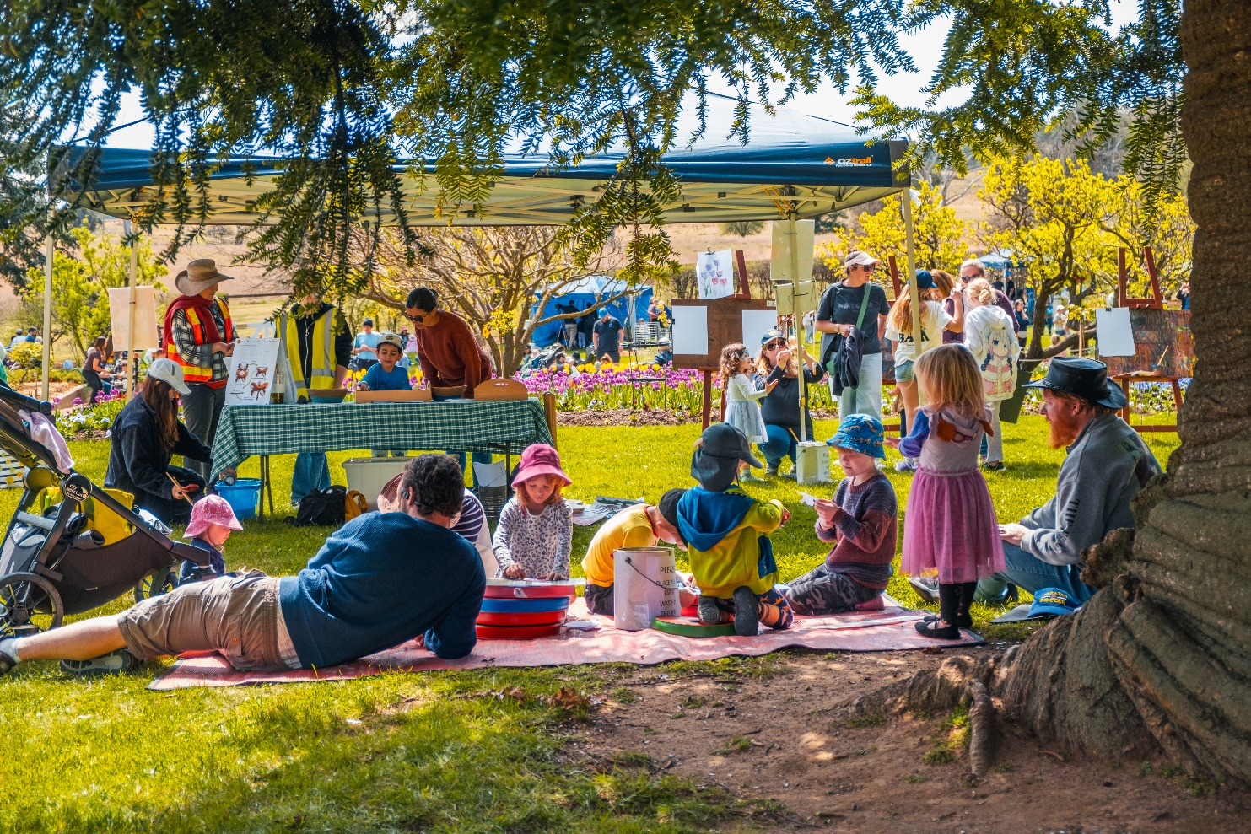
Kids Day Out. Lanyon Homestead. Image: Dominic Northcott

Canberra Theatre Centre Advisory Committee
Claudia Santangelo Convenor
Claudia is Stakeholder Engagement Manager at Yardhura Walani (meaning strong, healthy place in Ngunnawal), the National Centre for Aboriginal and Torres Strait Islander Wellbeing Research at ANU. She supports this Aboriginal and Torres Strait Islander-led team through partnerships, grant writing, and event delivery. Previously, she was a major gift fundraiser at ANU, supporting Indigenous, environmental, and public health initiatives. Claudia has a strong background in the arts, having produced shows for Sydney Fringe, co-directed a multi-day arts and music festival, and managed the Sydney Film Festival’s Travelling Film Festival. She has also worked in Timor-Leste as an Australian Youth Ambassador and DFAT consultant. Claudia currently serves on the Board of Arts Capital Limited, the Canberra Theatre Centre Advisory Committee, and the TRIMOB Partners, Fundraising & Event Subcommittee.
Kels Bagust Member
Kels is an experienced producer, curator and economic development specialist more than 10 years’ experience within commercial, public sector and DIY music contexts. Between 2017 and 2021, Kels worked as Live Music Manager at University of Canberra. In 2022, Kels relocated to Gadigal to work as the Contemporary Music producer at Sydney Opera House. Currently, Kels applies their industry knowledge at City of Sydney, managing the delivery of place and sector based economic development programs. Underlining this work is a deep commitment to diversity, accessibility and sustainability.
Soëlily Consen-Lynch Member
Soëlily Consen-Lynch is a Dutch-trained legal professional in employment law and industrial relations, currently Assistant Director in the ACT Government. Since relocating to Canberra in 2013, she has actively contributed to community and cultural life through volunteer roles and advocacy. She served on the ACT Minister’s Multicultural Advisory Council and chaired the Mental Health Foundation Australia’s ACT Multicultural Ambassadors. Soëlily regularly volunteers as MC for major events including citizenship ceremonies, Floriade, and the National Multicultural Festival. She is a member of the Canberra Theatre Centre Advisory Committee and has contributed to the Celebrate Gungahlin Festival and Sexual Health and Family Planning ACT Youth Advisory Group. Her work reflects a strong commitment to inclusion, empowerment, and cultural celebration across Canberra’s diverse communities.
Fredeliza Campos Member
Fredeliza Campos is an archaeologist and ethnomusicologist with a strong background in cultural heritage and music. In the Philippines, she held roles with BMG Records, the National Philharmonic Orchestra, and the University of the Philippines’ Center for Ethnomusicology. She holds postgraduate degrees in Archaeology and Ethnomusicology and has received fellowships to study museum collections in Chicago, Leiden, and the Philippines. Fredeliza is affiliated with ANU as part of the Indo-Pacific Prehistory Association secretariat and conducts research on cultural and religious festivals, focusing on traditional musical instruments. She is an active
member of Rondanihan, a rondalla group in Canberra, and contributes to cultural activities within the Philippine-Australian diaspora, blending academic expertise with community engagement.
David Hobbes Member
David was a practising architect in Sydney and Canberra for over 30 years and also a heritage consultant during the last 20 years he has lived in Canberra. Having retired from architectural practice he continues on a variety of heritage projects in Canberra and the surrounding region, is Heritage Advisor to Goulburn Mulwaree Council and Yass Valley Council and was recently appointed to the ACT Heritage Council. He has worked on many significant Canberra buildings including the Canberra Theatre having co-authored the Conservation Management Plan for Civic Square. He is a keen supporter of Canberra’s public life, culture and institutions. With the time he has left he is renovating an 1895 workers cottage in the Snowy Mountains.
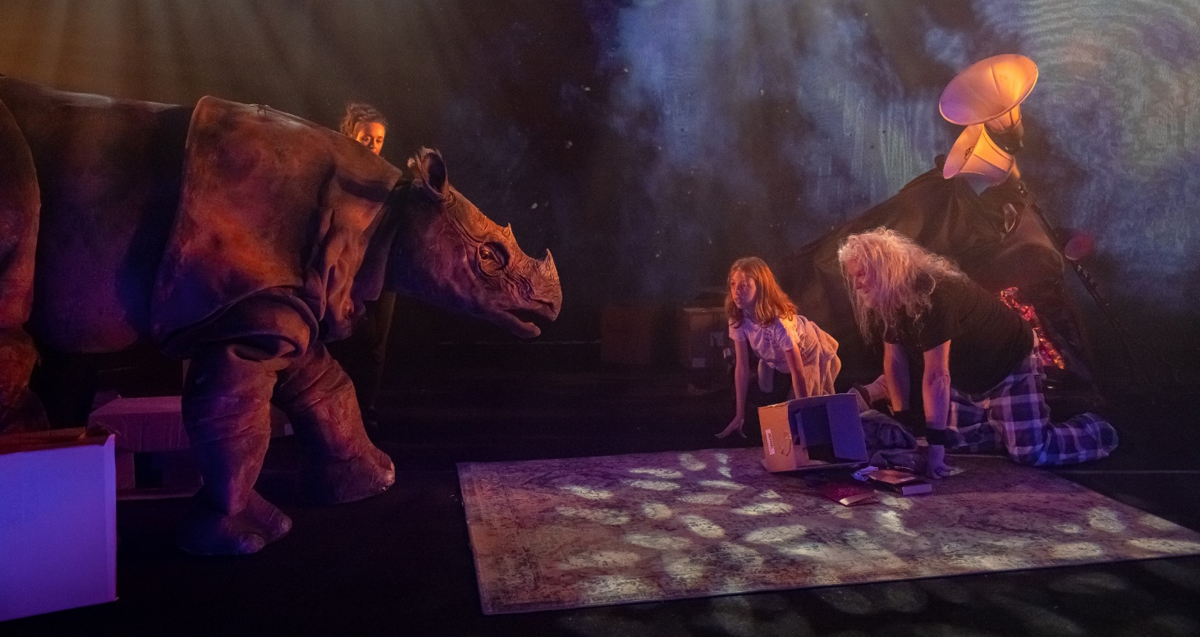
Arc by Erth. CTC. Image: Jacquie Manning

Appendix 4

The following is a list of CTC presentations and events, and GMH exhibitions and gallery activities at CMAG, the Nolan Gallery, Lanyon Homestead, Calthorpes House, and Mugga-Mugga for 2024-25:

Canberra Theatre Centre Presentations
July
- Snatch Game LIVE on Tour (In The Dark Presents Pty Ltd)
- ERAS 2024 (PLAY - The Dance Company)
- The Woman in Black (Gooding and Woodward Theatrical)
- Macy Gray - 25th Anniversary Tour (Showtune Productions Pty Ltd)
- David Hobson and Colin Lane - In Tails (Entertainment Consulting Pty Ltd)
- The Grandparents Club - A Comedy Musical (The Grandparents Club Pty Ltd)
- Horizon (Bangarra Dance Theatre)
- 44 Sex Acts in One Week (Club House Productions)
- Women's Revue 2024: It's a Femininomenon! (ANU Women's Revue)
- Secret Screening with Beau Miles (Beard & Wicket)
- Grug (Windmill Theatre Company)
- Joep Beving (Top Shelf Productions Pty Ltd)
- Hannah Gadsby - Woof! (Token Events Pty Ltd)
- Wakakirri 2024 ACT Performance Night (The Wakakirri Story Dance Association Inc)
- Seven Drunken Nights - The Story of the Dubliners (Andrew Kay & Associates P/L)
- Julia - Return Season (Sydney Theatre Company)
August
- Manage Your Expectations (House of Sand)
- Teeny Tiny Stevies: Twice the Love Tour (DoubleU Artists)
- Tommy Little Has a Regular Size Deck (Token Events Pty Ltd)
- Trophy Boys (Soft Tread Enterprises)
- Missy Higgins: The Second Act Tour - Celebrating ‘The Sound of White’ 20th Anniversary (The Frontier Touring Co Pty Ltd)
- The Comedians (A-List Entertainment)
- Queanbeyan Schools Performing Arts Festival: ICONIC (NSW Department of Education)
- Mike Oldfield's Tubular Bells in Concert (David Roy Williams Pty Ltd)
- Miss Pole Dance Australia - ACT Heats (The Brass Room)
- Em Rusciano: Outgrown Tour (The Frontier Touring Co Pty Ltd)
- Ballet International Gala: V (BIG Live Pty Ltd)
- The Comedy of Errors (ANU Shakespeare Society)
- Jurrungu Ngan-ga [Straight Talk] (Marrugeku)
- Cirque Bon Bon (JACs Entertainment)
- Wakakirri 2024 Awards (The Wakakirri Story Dance Association Inc)
- The Addams Family (ANU Musical Theatre Company)
- Yesterday's Gone - The Fleetwood Mac Legacy (Mellen Touring T/A Mellen Events)
- Music at Midday (The Royal Military College Band)
- The Peasant Prince (Arts On Tour)
- Marcia Hines: The Still Shining Tour (Moorea Holdings Pty Ltd)
- Sydney Comedy Festival Showcase Tour (Century Entertainment Australia Pty Ltd)
September
- Enemies of Grooviness Eat Sh!t (Performing Lines)
- English (Melbourne Theatre Company)
- In a Nutshell: The Poetry of Violence (Bell Shakespeare)
- New Works Creative Development - In the Belly of the Whale
- Terry Snow Memorial
- Work, But this time Like you Mean it (Canberra Youth Theatre)
- The Eagles Greatest Hits (Jeff Shane Carter)
- I Love China 2024: Friendship Beyond the Ocean (The Federation of Chinese Associations of ACT)
- CHICAGO the Musical (Crossroads Live Australia)
- Guy Montgomery - Over 50,000,000 Guy Fans Can’t Be Wrong (Live Nation Australasia Pty Ltd)
- Michael Jackson - The Legacy Tour (The Harbour Agency)
- ARC by Erth (Arts On Tour)
- Lightening the Load - Grace Tame (Fane Productions Australia Pty Ltd)
- De Birds and Degrees (ANU Arts Revue)
October
- Dracula's: Sanctuary (Newman Entertainment International)
- Mystique (Boyd Productions)
- Kaz & Jude's Menopausal Night Out (Token Events Pty Ltd)
- Peter and the Starcatcher (Peter and the Starcatcher Australia Unit Trust)
- Celtic Illusion (Base Entertainment Pty Ltd)
- Kip Moore: Nomad World Tour (The Frontier Touring Co Pty Ltd)
- New Works Program - Chips Dips and Sips
- 360 ALLSTARS (Onyx Productions)
- LOL Season (Canberra Comedy Company Pty Ltd):
- Laura Johnston - That's...Brave
- Maddy Weeks - Never Gonna Die
- Frankie McNair - An Intimate Evening with Tabitha Booth
- Andrew Hansen - Everyone Else is Wrong
- Chris Marlton - Eggplants and Cigarettes
- Paul McDermott Plus One - Redux
- Arj Barker - The Mind Field (A-List Entertainment)
- Cirque Africa (Rokitz Entertainment)
- Only Everything (Show Within a Show)
- Herbie Hancock (Live Nation Australasia Pty Ltd)
- Music at Midday (The Royal Military College Band)
- Superstars Live - Jon Stevens and Kate Ceberano (Circle Music Pty Ltd)
- The Whitlams: Love This City Tour (Craft Music)
- Abbie Chatfield - The Trauma Dump Tour (MG Live Pty Ltd)
- A Conversation with Tim Minchin - You Don’t Have to Have a Dream (Fane Productions Australia Pty Ltd)
- BOO! A trick or treat comedy (Lightbulb Improv)
- The End of the Wharf as We Know It (Soft Tread Enterprises)
November
- An Evening with John Butler Performing 'STILL SEARCHING' (Koota-Boya Pty Ltd)
- Ausdance ACT Youth Dance Festival 2024 (Ausdance ACT)
- William Dalrymple - How Ancient India Transformed the World (Fane Productions Australia Pty Ltd)
- Monty Franklin - Yeah Nah Tour (Century Entertainment Australia Pty Ltd)
- WARU: Journey of the Small Turtle (Bangarra Dance Theatre)
- The Subtle Art of Not Giving a F*ck, Live with Mark Manson (Fane Productions Australia Pty Ltd)
- Emma Memma's Boop and Twirl Tour (Live Nation Australasia Pty Ltd)
- The 60 Four: Hits of the 60s and 70s (Ben Francis t/as The 60 Four)
- METAMORPHOSIS + UNIQUELY ME (Dance Central)
- Drizzle Boy (Queensland Theatre)
- Briefs: Bite Club ft Sahara Beck (Briefs Factory International)
- Anh Do - The Happiest Refugee (A-List Entertainment)
- Rockwiz Live! (RocKwiz Pty Ltd)
- Jon Ronson's Psychopath Night 2024 (Fane Productions Australia Pty Ltd)
- Nurse Georgie Carroll - Survival of the Fittest (A-List Entertainment)
- Hocus Pocus (Kim Harvey School of Dance)
- Inside Out & Back to Front (Lisa Clark Dance Centre)

December
- PROUD 2024 (PLAY - The Dance Company)
- Music at Midday (The Royal Military College Band)
- 5678! (Dance Development Centre)
- War on 2024 - Annual Comedy Gala (The Anti-Experts)
- The Gruffalo (CDP Theatre Producers)
- Jack Maggs (State Theatre Company of South Australia)
- A Very Canberra Comedy Festival Christmas (Canberra Comedy Company Pty Ltd)
- End of Year Concert (Jessica Maree Music Studio)
- Unconditional (Capital Dance Studios)
- The Christmas Spectacular (Boyd Productions)
- The Nutcracker (BIG Live Pty Ltd)
- Cheek Live with Hannah Ferguson and Sarah-Jane Adams (Fane Productions Australia Pty Ltd)
- The Red Shoes (Ballet Canberra)
- UCSSC Lake Ginninderra Graduation
January
- New Works Creative Development - Resonance by James Batchelor
- Circus of Illusion (Boyd Productions)
- Summer Holiday Fun (CTC Programming)
- Storytime Ballet - The Sleeping Beauty (The Australian Ballet)
- Sea Of Light (Patch Theatre Company)
- Dionne Warwick - One Last Time Tour (MG Live Pty Ltd)
- Steve Blackwell - Ocean (Adrian Bohm Presents)
- The 78-Storey Treehouse (CDP Theatre Producers Pty Ltd)
- The Listies: Make Some Noise (Arts On Tour)
- Bluey's Big Play: The Stage Show (HVK Productions)
- Damien Rice (The Frontier Touring Co Pty Ltd)
- Amy Shark - The Solo Acoustic "Songs & Stories" Tour (Select Music)
- New Works Creative Development - Country
February
- An Evening with David Sedaris (Token Events Pty Ltd)
- Music at Midday (Canberra City Band)
- Sarah Blasko - I Just Need to Conquer This Mountain (Collective Artists Booking Agency)
- Carl Barron - Trying to Work it Out (A-List Entertainment)
- Lunar New Year Concert 2025 - Hong Kong String Orchestra (Ausfeng Event Productions)
- Daryl Braithwaite (Redbird Music Pty Ltd)
- Richard Clapton (Redbird Music Pty Ltd)
- Saltbush (Insite Arts International)
- New Works Creative Development - Michele Lee
- New Works Program - Chips Dips and Sips
March
- New Works Creative Development - Yolanda Lowatta
- Canberra Comedy Festival 2025 (Canberra Comedy Company Pty Ltd)
  - Alex Ward - Clip Clop, Don’t Stop
  - Anisa Nandaula - You Can’t Say That
  - ANU Law Revue - A Sketch Comedy Show!
  - Canberra Comedy Festival Gala
  - Carlo Ritchie - A Bit of This, A Bit of That
  - Chris Marlton - American Pope
  - Class Clowns
  - Community Noticeboard Live
  - Dave Hughes - WTF?
  - Festival Club
  - Geraldine Hickey - Meander
  - Gillian Cosgriff - Fresh New Worries
  - He Huang - White Man’s Burden
  - John Safran - Squatting at Kanye’s and Other Adventures
  - Kirsty Webeck - Everything I need to say about sea creatures
  - Lloyd Langford - Powerful Energy
  - Luke McGregor - Ok, Wow
  - Melanie Bracewell - A Little Treat
  - Nath Valvo - The Nath Valvo Show
  - Nick Starkey & Charlotte Kuruc - The Marketplace Of Bad Ideas
  - Sara Pascoe - I Am A Strange Gloop
  - Schalk Bezuidenhout - Crowd Pleaser
  - Sean Choolburra - Didj and Dance!
  - The Stevenson Experience - O Brother, Where Art Thou?
  - The Unholy Trinity of Music, Death, and Politics
  - The Women’s Room - Underestimated
  - Unedjamacated
- Canberra Studio Opening Event (Architectus Australia Holdings Pty Ltd)
- Shirley Valentine (Neil Gooding Productions)
- Ben Elton - Authentic Stupidity (Live Nation Australasia Pty Ltd)
- Room on the Broom (CDP Theatre Producers)
- Disney's Alice in Wonderland Jr (Perform Australia)
- Kasey Chambers - Backbone Tour 2025 (Premier Artists)
- Anthony Callea and Tim Campbell: The Songs of Elton & George (Green Room Antics Pty Ltd)
- The Pirates of Penzance (Hayes Theatre Co)
April
- Music at Midday (The Royal Military College Band)
- Swan Lake (Victorian State Ballet)
- Henry 5 (Bell Shakespeare)
- The Mirror (Gravity & Other Myths)
- Ratburger (CDP Theatre Producers)
- Rodrigo y Gabriela (Bluesfest Tours Pty Ltd)
- The Black Blues Brothers (Rokitz Entertainment)
- Rhys Darby - The Legend Returns (Adrian Bohm Presents)
- Madagascar the Musical (Showcase Entertainment Group)
- Sh!tfaced Shakespeare - A Midsummer Night's Dream (A-List Entertainment)
- Adam Kay - This Is Going to Hurt: Secret Diaries of a Junior Doctor (Adrian Bohm Presents)
- New Works - First Nations Residency - Country
- Kitty Flanagan: It's Whiteboard O’clock (Work in Progress Show) (A-List Entertainment)
May
- Sammy J - The Kangaroo Effect (Laughing Stock Productions Pty Ltd)
- The Cruel Sea - Straight into the Sun Australian Tour (Face to Face Touring Pty Ltd)
- Canberra Theatre Centre OPEN DAY - Celebrating 60 Years
- The Dictionary of Lost Words (State Theatre Company of South Australia)
- The TEN Tenors 30th Anniversary World Tour (Mellen Touring Pty Ltd)
- Alice By Heart (ANU Musical Theatre Company)
- Dion Pride Sings the Songs of his Father (Concert Events Ltd)
- Spellbound (Base Entertainment)
- Ross Noble - Cranium of Curiosities (A-List Entertainment)
- Wankernomics - Just Touching Base (The Anti-Experts)
- Fanning Dempsey National Park (Village Sounds)
- New Works - New Ideas Lab 2025
- Tommy Emmanuel (Top Shelf Pty Ltd)
- Psychology of Serial Killers (TEG Dainty Pty Ltd)
- Mimi's Symphony (Canberra Symphony Orchestra & Double Yolk Productions Pty Ltd)
- Sydney Comedy Festival Showcase 2025 (Century Entertainment Australia Pty Ltd)
- New Works Creative Development - Mary Rachel Brown
June
- ACT UP! 2025 (CTC Education)
- Music at Midday (The Royal Military College Band)
- Night Night (The Last Great Hunt)
- 1984 (shake & stir theatre co)
- Kate Ceberano - Australian Made Tour 2025 (Premier Artists)
- 2025 State Team AusCaliCarnivale Showcase (Calisthenics ACT Inc)
- Ross Wilson and the Peaceniks - 50 Years of Hits Tour (Leicashow Pty Ltd)
- Lawrence Mooney - Dead Set Country (A-List Entertainment)
- Carmen (The Australian Ballet)
- The Queen's Nanny (Arts On Tour)
- Queen: It's a Kinda Magic (Showtime Australia Pty Ltd)
- Jimmy Barnes - Defiant Tour 2025 (The Frontier Touring Co Pty Ltd)
- New Works Program - Chips Dips and Sips

Galleries, Museums & Heritage Exhibitions and Events
Exhibitions
- *Backyard Archaeology
- *Change: Stories from your pocket
- *Duntroon Estate: Work with all your might
- *Materiality…but not as we know it
- *Riverbend - Nolan
- *Shades of Shadows - Hannah Gason
- Growing Up Modern: Alex Jelinek and Canberra's Round House
- That All Just Happened
- Reinfinity: Material Science, Ecology, Ceramic Technology & Design
- Nolan: For the Term of His Natural Life
- Sneak-a-Peek of the Historic Canberra Hospital Collection at CMAG
- 2024 Secondary Students Photography Prize Exhibition
- Tartans and Thistles: Burns Club 100 Years
- Ikebana @ CMAG
- Bruce Reynolds : How Soon is Now
- Hiroe and Cornel Swen: Making a creative life
- Outer Space: Stromlo to the Stars
- Christmas at Calthorpe House
- Christmas at Lanyon Homestead
- Djara
- Resonance: Art as the Voice of Nature
- A Total Work of Art: Sidney Nolan and the Stage
- Beyond Measure: Expanding the Sky
- Celebrating 50 Years of the Australian Honours System
- Taglietti: Life in Design
Permanent Exhibitions
- Brian Corr: Timeshel
- Calthorpes House Orientation Exhibition (updated in 2024)
- Canberra/Kamberri: Place + People
- Cunningham Family Album - Lanyon Homestead
- Getting it Together - Mugga-Mugga Cottage
- Jan Brown: A Life with Art
- The Convict Life - Lanyon Homestead
- The Nolan Collection
- The Young Nolan Project
- Within Living Memory - Lanyon Homestead
- Collections: New Acquisitions
Online Exhibitions
- An Exciting New World at Calthorpes Christmas for the Cunninghams
- Creating Lanyon
- Duntroon Estate: Work with all your might
- Happy 100th Birthday Dawn
- Preserving the Past - Mugga-Mugga Cottage
- Sonic Suburbia
- Dean Cross: Looking for the Lyre
Activities and Events

SPECIAL EVENTS:
- *POP UP: Royal Australian Mint Coin Shop at CMAG (until 21 July 2024)
- Aunty Matilda 80th Birthday Event
- Canberra Symphony Orchestra 2025 season launch
- Canberra Symphony Orchestra: Family concert and instrument petting zoo
- CMAG Secondary School Photography Prize Awards Presentation
- Dinner with the Stars - Dinner and Stargazing
- Face Painting
- Family Sanctuary (National Multicultural Festival) at CMAG
- Floriade at Lanyon
- Harvest Day Out “Grow - Preserve -Sustain” - Lanyon Homestead
- Heritage Festival at CMAG and ACTHP 2025
- Kids Day Out
- Lanyon Art Prize 2025
- LAUNCH: ACT Heritage Festival
- LAUNCH: Outer Space: Stromlo to the Stars
- LAUNCH: Nolan50
- Le Cheeserie x Capital Brewing Masterclass
- Le Cheeserie x Mount Majura Vineyard Masterclass
  - Legends of Lanyon with Tim the Yowie Man - Lanyon Homestead
- Live at Lanyon Canberra with the Canberra Symphony Orchestra Concert
  - Music with The Fuelers (HDO)
- Resonant Spaces Solo Piano Concert Series with David Bridie and Sophie Hutchings
- School Holiday Fun at CMAG
- Sidney Nolan In Bloom at Lanyon
- Stargazing at Lanyon Homestead
- Stories at Sunset with Tim the Yowie Man
- Storytelling Sessions
- Taglietti’s Songbook with National Opera
- Wedding Open Days - Lanyon Homestead

ARTIST & CURATOR TALKS:
- Bruce Reynolds - How Soon is Now
- Hiroe Swen
- Marian Drew - Materiality
- Mel Douglas - Objects in Motion - Materiality

TALKS:
- Backyard Archaeology with Dr Steve Brown
- Captain Faunce - Policing Canberra's Colonial Frontier (Heritage Festival 2025)
- Celebrating Sylvia Curley - Canberra’s Trailblazing Pioneer (Heritage Festival 2025)
- Chile to Lanyon - Migration Connections and Earthen Constructions (Heritage Festival 2025)
- Djara and First Nations Sky Stories (Reconciliation Week)
- For the Term of His Natural Life
- Hiroe Swen - Lenders Afternoon Tea
- How Soon Is Now? with Bruce Reynolds
- Making a Creative Life with Hiroe Swen
- Professor Roger Benjamin - Growing up Modern - Alex Jelinek and Canberra's Round House
- Representing Convict History in Museums
- Science meets Art meets Design (Science Week)
- Taglietti: Life in Design
- War, Art and the Love Story Behind Roland Wakelin’s Canberra (Heritage Festival 2025)
- Who’s Who at Lanyon (HDO)
- World Environment Day - Exploring Biodiversity and Creativity (Panel Talk)

IN CONVERSATION:
- Elspeth Pitt with Virginia Rigney - Sidney Nolan's Ned Kelly works 1945-1947
- Katherine Bennell Pegg - International Women’s Day

TOURS:
- Calthorpes House Gardens Unearthed (Heritage Festival 2025)
- Calthorpes' House Tours
- Italian Language Tour of Taglietti: Life in Design
- Lanyon Homestead Tours
- Mugga-Mugga Cottage Tours
- The Law and the Profits - Who was who on Mugga Way? (Heritage Festival 2025)
- Wedding Open Days

WORKSHOPS:
- Art in Action - Exploring Stage Design
- Basic Ikebana with Traditional Principles
- Bush Animal Weaving with Ronnie Jordan (NAIDOC Week)
- Build a Bee Hotel (HDO)
- Build a Landscape - Monoprinting inspired by Riverbend
- Christmas Card Making
- Create a Ceramic Coral Reef
- Creating Ephemeral Clay Vessels with Fran Romano
- Creating storyboards with Valerie Kirk
- Crepe Paper Native Flower Making (School Holidays)
- Cultural Weaving (Harvest Day Out)
- Eternal Ikebana with Preserved Flowers
- Flower Crown Making (Harvest Day Out)
- Holiday Card Making
- How Soon is Now - Plaster Relief
- Demo: Mrs Calthorpe’s Apricot Jam and other historic preserves (Harvest Day Out)
- Little Looms Craft - Kids Craft (Harvest Day Out)
- Making Do at Mugga-Mugga - Art Workshop Series
- Native Plant Use and Traditional Tools (Harvest Day Out)
- Nature Journaling Landscapes at Lanyon Homestead
- Nature Art Journaling at Mugga-Mugga Cottage
- Paint N Create - Puppy Puppets
- Paint N Create - Treehouse Creations
- Planning a Vegetable Garden (Harvest Day Out)
- Pressing Matters - Plaster Relief with Bruce Reynolds
- Robots Revolutionising Agriculture (Harvest Day Out)
- Storytelling through Photography at Mugga-Mugga Cottage (Heritage Festival 2025)
- The Wandering Line - Drawing Perspectives with John Pratt
- Visible Mending with Michele Grimston
- Watercolour painting
- Weaving your Cultural Colours
- Whip Cracking (Harvest Day Out)
- Winter’s Imprint with Mariana Del Castillo

MAKERSPACE:
- Create Sun & Stars
- Emu in the Sky
- Friendship Bracelets
- Native Yam Daisies
LEARNING:
- A Meteor of Minds (Year 9-10)
- Artefact Chat 1 to 4 - Outreach (Foundation-Year 2)
- Astronomical Fun! (Years 5-6)
- At the Garden Gate - Mugga-Mugga Cottage (Foundation-Year 2)
- Blue Suitcase - Outreach
- Canberra/Kamberri: Place + People - Self Guided Tour (Foundation-Yr 12)
- CONVICTS - Lanyon Homestead (Year 3-6)
- Convicts - Outreach (Year 4-6)
- Dawn’s Surprise - Calthorpes House (Foundation-Year 2)
- Dawn’s Suitcase - Outreach (Foundation-Year 2)
- Every Picture Tells a Story (Foundation-Year 2)
- Exploring Place - Visual Art Teacher Resource - Online (Year 11-12)
- Guardian Of Our Galaxy (Years 7-8)
- Highlights Tour - Canberra/Kamberri Place + People (Primary Schools)
- James’ Diary - Lanyon Homestead (Foundation-Year 2)
- Learning Programs at CMAG (Foundation-Year 6)
- Lucy Irvine School Holiday Program
- Mugga-Mugga: Humans and Nature (Years 1-2)
- Natural Heritage and Ecological Management of Mugga-Mugga - Secondary Science Teacher Resource - Online (Secondary Students)
- Old Macdonald’s Farm - Outreach
- Outer Space: Stromlo to the Stars - Self Guided Tour (Foundation-Year 12)
- Riverbend School Holiday Program
- The Art Box: Animals + Plants
- The Art Box: Landscapes + Figures
- The Mint Education Program
- What Do Artists Make? (Foundation-Year 2)
- Who Were the Convicts - Lanyon Homestead (Years 3-6)
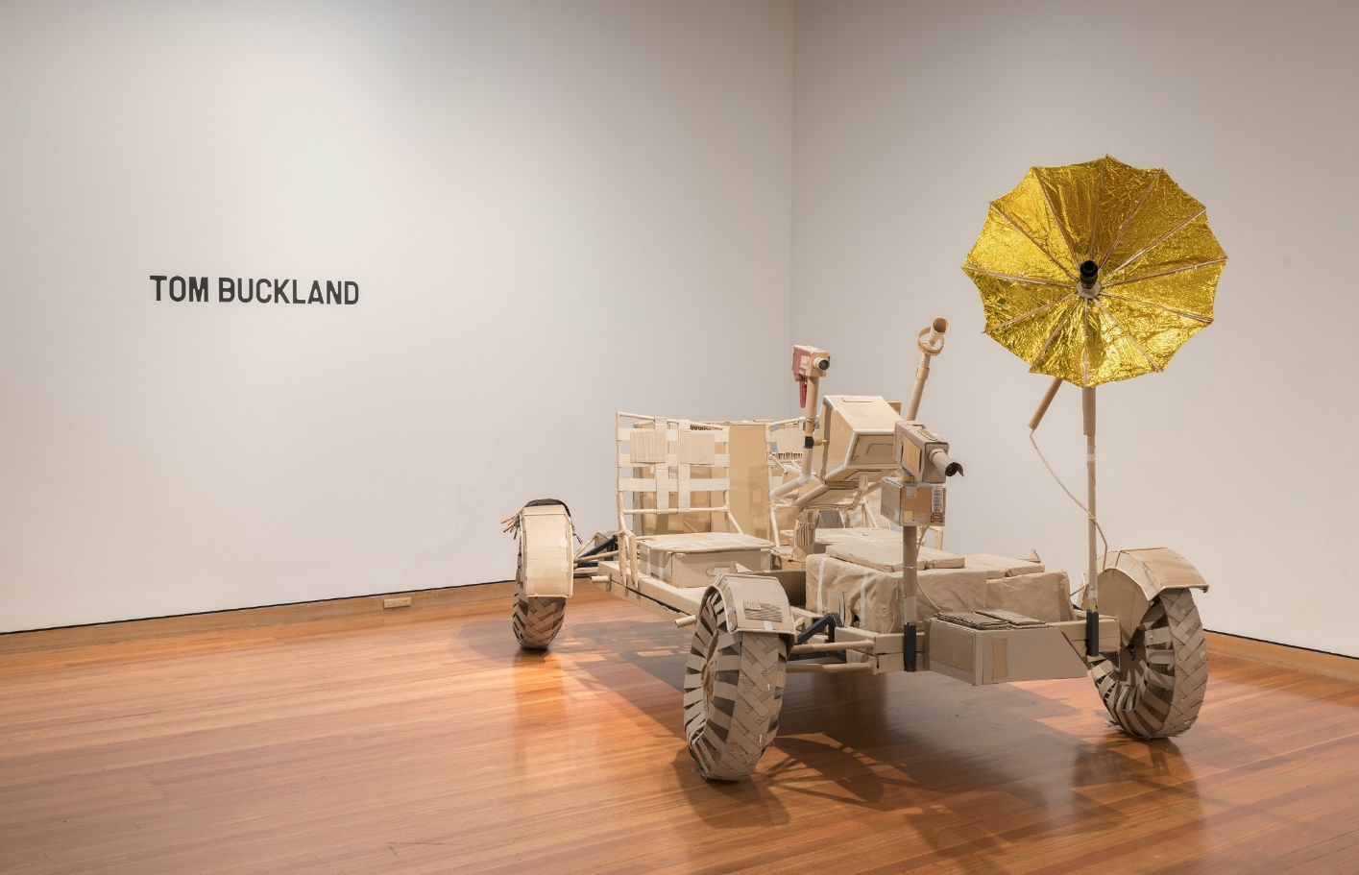
Tom Buckland - Beyond Measure Expanding the Sky. CMAG exhibition. Image: Brenton McGeachie

Appendix 5
Canberra Museum & Gallery Acquisitions
(Purchases and Donations)
Purchases Social History
- Robert Hoddle, Mount Tennant, on the Murrumbidgee River, the resort of a notorious bushranger, New South Wales, c1932, watercolour on paper.
- Lanyon Home Station, NSW, 1869, engraving.
- Lynnice Church (Ngunnawal/Wiradjuri/Kamilaroi), Djara, 2024, digital media.
- 2024 $5 Selectively Gold-Plated Fine Silver Proof Coin - Australian Paralympic Team: Adam Ball and Daniel Thorne.
- Poster, Business and residential sites at Ainslie, 1924.

Purchases Visual Arts
- Aiden Hartshorn, (Walgalu (Wolgal, Wolgalu)/Wiradjuri), Shield III, 2024 printed vinyl on glass and Untitled Shield IV, 2024, glass. Purchased with funds from the Meredith Hinchliffe Fund 2025.
- Holly Grace, Summertime in the Namadgi - Manna gum leaves with Bogong Moth, 2025, wall installation - blown glass, hot sculpted with gold lustre surfaces and Walk Lightly - Gudgenby Valley, 2024, light installation - blown glass with glass powder and metal leaf surfaces. Purchased with funds from the Meredith Hinchliffe Fund 2025.
- Sidney Nolan, Abstract, mixed media on tissue paper, 1939 and Icare Abstract, c. 1940, transfer drawing on paper.
- Aileen Dent, Road to the City, c1940 oil on board and Untitled (Red Hill), c. 1940, oil on board.
- Hiroe Swen AM, Vase, c. 1974, Stoneware, Purchased with assistance from Meredith Hinchliffe 2024.
- Douglas Pratt, Canadian Pin-Oak and Autumn Gold, Canberra c.1955- 1965, oil on canvas on board.
- Megan Daley (Ngunnawal/Wiradjuri), grey gum scarf, silk painting, 2024.
- Rechelle Turner (Wiradjuri), Dhumbaa (Spotted red gum tree) scarf, silk painting, 2024.
Donations Social History
- Canberra Services Club billiard table and ephemera, 1940-1970s, Gift of Judith Dodd and Rowan Grigg 2025.
- Photographs and ephemera relating to Sylvia Curley, 1910s-1990s, Gift of Jan Wryell on behalf of Barbara Hutchinson 2025.
- 1960s evening dress, ‘Sylvia Parsons of Canberra’, Gift of Anne Watt 2025.
- Peuan Thai Studios, Silk evening dress, 1980s, Gift of Sonja Sagar 2024.
- Collection of colour and black and white photos of Canberra, 1970s, Gift of Neil Johnston 2024.
- Clothing c.1920s, cookery books, plan of 2 Mugga Way, etc. Gift of the Tillyard Family 2025 (37 items).
- Akubra Hat and Disabled Olympics Badge, Gift of Rodney Roberts 2024.
- ‘Some of the Best Fitzgerald’ book, ‘How to vote’ leaflet, Gift of Erika Edmondstone 2024.
- Key tags, Gift of Karen Collins 2024 (49 items).
- ‘Ally Nish’ sign, Gift of Bob Cargill 2024.
- Ketley Collection (migration story), Gift of Merle Ketley 2024 (37 items).
- Crace family lace articles and letterbook, 1870s, Gift of Jacquelyn Crace and Carolyn Corkery 2024 (18 items).
- Australian Flag c.1927 and Bundy Clock, Gift of Helen McIntyre 2024.
- 2 designer hats 1950-1980s, Gift of Rebecca Richards 2024.
- ‘Beyond Q’ bookshop door, Gift of John Butcher 2024.
- Map printing plate, Gift of Warren Webb 2024.
- Menu for ‘The Tower Restaurant’, Gift of Philip Eliason 2024.
- Colour photograph of Canberra bus C-59351, Gift of John Davenport 2024.
- Colour postcard of St Andrew’s, Gift of Michael Queale 2024.
- Canberra railway station signs, Gift of Chris Bradley, 2024 (4 items).

Donations Visual Arts
- Mel Douglas, Tonal Value, 1-9, 2019. Gift of The Griffin Foundation, 2024.
- Ethel Agnes Waddell, Canberra, 1926, oil on canvas on board. Gift of Ron Ramsey and Merryn Gates, 2025.
- Ingo Kleinert, Fenced Landscape I and II, plywood from tea chest, mulga wood. Gift of Ingo Kleinert, 2025.
- Wendy Dodd, Keeping the Goal in Sight, 1994, space-dyed thread, wood, plastic beads. Gift of Dick Roe, 2024.
- Marion Halligan Collection of Australian Ceramics by Doug Alexander, Les Blakeborough, Doris Dutch, Ian Jones, Madeleine Meyer, Jeff Mincham, Milton Moon, Barbara Romulus and Elisabeth Cummings, Peter Rushforth AM, Shigeo Shiga, Hiroe Swen AM, c. 1970s-90s. Gift of Marion Halligan, 2024. In Memory of Lucy and James Halligan.
- Francis Burke Fabrics, Black Opal (Canberra Theatre Curtain), 1964, screenprint on linen, by transfer Canberra Theatre Centre 2024.

Note that some items have been accessioned in one year but purchased or acquired in previous years.

Appendix 6

Throughout 2024-25, the CFC was fortunate to receive ongoing support from government agencies, major sponsors, and a wide network of generous donors and dedicated supporters. Their commitment and contributions played a vital role in enabling the CFC to deliver an ambitious and diverse program of performances, exhibitions, and events. We are deeply grateful for their belief in our mission and for the invaluable role they play in enriching the cultural life of our community. Without their support, much of what we achieved this year would simply not have been possible.

Major Government Funding
CFC Government Funding | Galleries, Museums & Heritage
ACT Government | Commonwealth Department of Infrastructure, Transport, Regional Development, Communications, Sports and the Arts

CFC Non-Government Donors and Supporters
CFC supporters over $10,000
Harriet Elvin AM

CMAG supporters  over $50,000 | CMAG supporters  over $25,000 | CMAG supporters  over $10,000
The Griffin Foundation P/L ATF | Meredith Hinchliffe | Helen O’Neil
CMAG supporters up to the value of $10,000
Michael Bailey | Corinna Cullen | M Johnston
Judith Bibo | Glenn Davidson | Allison Jones
Andrew Blanckensee | Prue Deacon | Richard Jones
Richard Blavins | Jim Donaldson | Sara Kelly
Peter Bradley | Annette Donovan | Connie Leikas
David Brand | Robyn Duncan | Allan Mallory
The Brock Family | Prof Helen Ennis | Joseph Mann
Peter Browning | Dr Dianne Firth OAM | Anthony & Madeleine Maple
Julia Butler | Matthew Frawley | Alex Marsden
Elizabeth Charles | Rohan Goyne | Caitlin McCoull
Sophie Chessell | A J Hall | Noela McDonald
Alex & Linda Church | Steven Holland | F McGee
Cocco Corporation | Kylie Hull | Jeannie McLellan
A McGuinness | Glenn Schwinghamer | Stephen Mills
Lyn Moorhouse | Garth Setchell | Margaret Toner
Jenny & Chris Oates | Dr Maggie Shapley | J Wagner
Jacqui Pinkava | Ann Smith | Annabel Wallace
Andrew Reading | Helen Smith | David Wardle
Astrid Reed | Wendy Smith | Dr Hilary Warren
Anthony Reid | M J Smythe | Danielle Wickman
Jane Roberts | Michael Sollis | Lily Withycombe
Marie Anne Robinson | Carmel Summers | Kathy Wong
Glenys Roper | Nick Swain | Dr Linda Young
Adele Rosalky | Ken & Maggie Taylor | Peter Zanetti
Trish Ryan | R & S Telford | Amelia Zaraftis
E Sadler
Historic Places supporters over $10,000
Friends of Mugga-Mugga

Historic Places supporters up to the value of $10,000
Mary Agoni | Sandra Griffin | Sarah Philpot
Vernise Ayson | Stephen Jobling | Tracey Radbourne
Holly Berry | Sarah Jones | Charisse Ribo
Rosanna Burston | Daniel Lee | Kerry Sattler
Hannah Chan | Beverley Liddicoat | Christine Smith
Vanessa Collier | Mandy Lister | Alan Traves
Kate Deacon | Phillipa McIntyre | Sarah Treble
Sarah Deves | Heath McMichael | Sandra Gaye Watson
Kathy Ehmann | Tony Melville | Antony Webber
Merilyn Fisher | Simon Mitchell | Robert Williams
Beverley Francis | Lily Mulholland | Julie Winter
Frances Gardini | Louise Murphy | Kerry Wray
Sue Gregson | Barbara Myors

CTC supporters over $10,000
Phil Keir - The Keir Foundation
CTC supporters up to the value of $10,000
Michael Allam | John Hunt | Gordon Ramsay
M Beanland | Gary James | Pam Rodda
Nancye Burkevics | L Jones | Ian Torrance
Dr Sheon Chua | Tania Kraus | Maryanne Voyazis, Fred Smith and Olympia Smith
F J Clarke | Anne Merkel | Lachlan Woods
Sam Harkiss | Robyn Priddle

Contributions to the Canberra Region Treasures Fund 2014-2022
Joan Adler | John & Dianne Firth | John Olsen OBE AO
Estelle Barnes | Maureen Fisher | Jacqueline Pinkava
Frank Bergersen | Lynette Henderson | Kristine Reithmiller
Judith Bibo | Virginia Haussegger AM (former CFC Board Member) | Richard Rolfe
Phoebe Bischoff OAM | John Hindmarsh AM (former CFC Chair) | Dr Roslyn V Russell
Dorothy Cameron | Marian Hill | Jody Turner
Kerry-Anne Cousins | Karina & Neil Hobbs | Dawn Waterhouse
Laura Cree | Dr Mark Lax | Gabrielle Watt
Louise Douglas (former CFC Chair) | John Mulvaney AO | Paul G White PSM
Robyn A Duncan | Koula Notaras | Lady D Yeend
Harriet Elvin (former CEO)

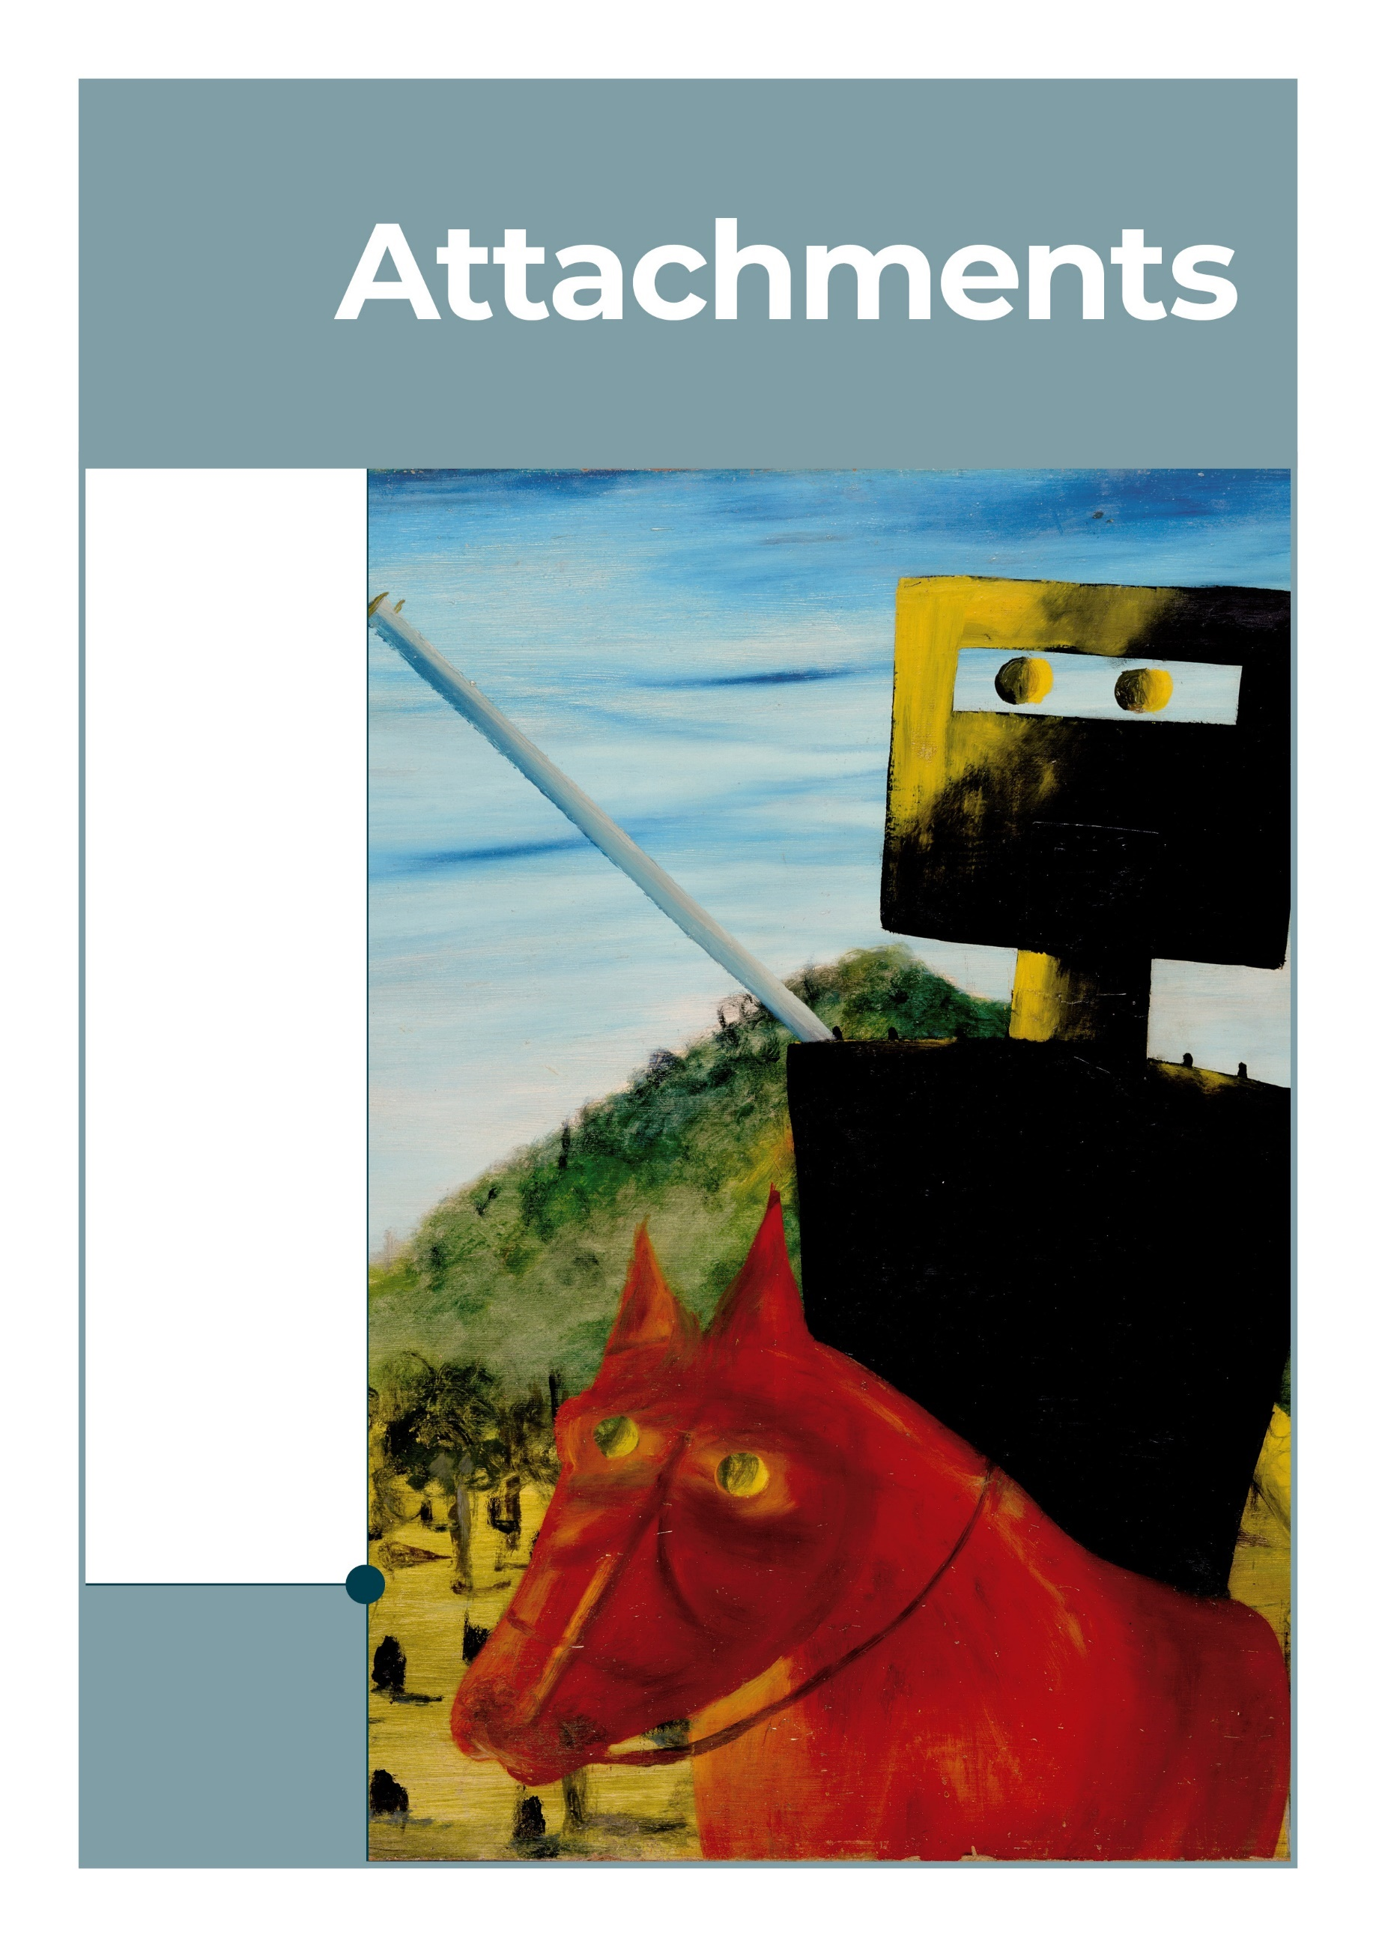
Kelly and Horse, Sidney Nolan, Nolan50. Image: The Nolan Collection, GMH
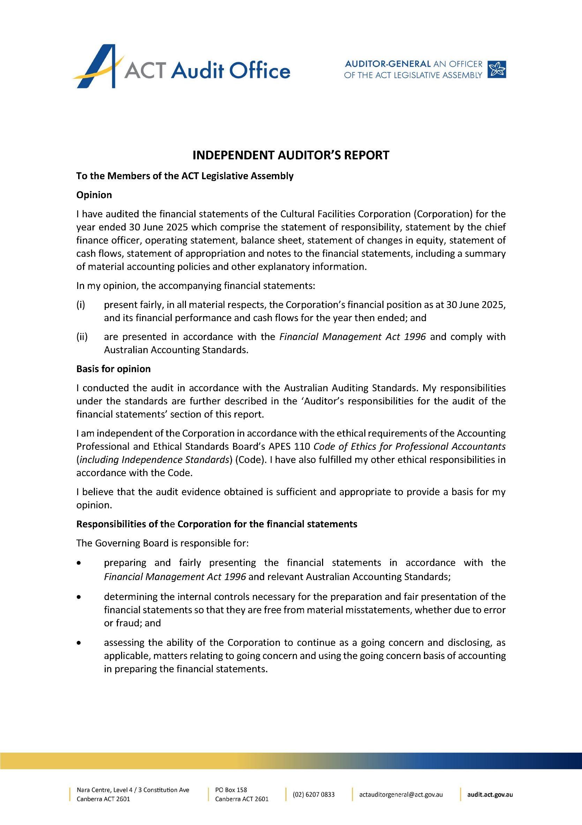
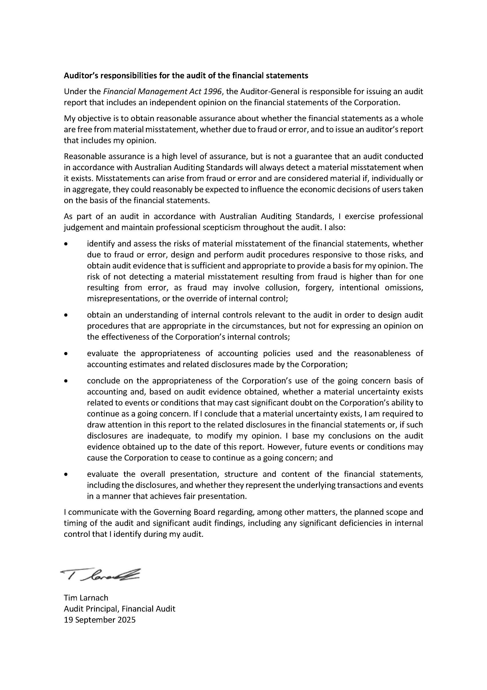
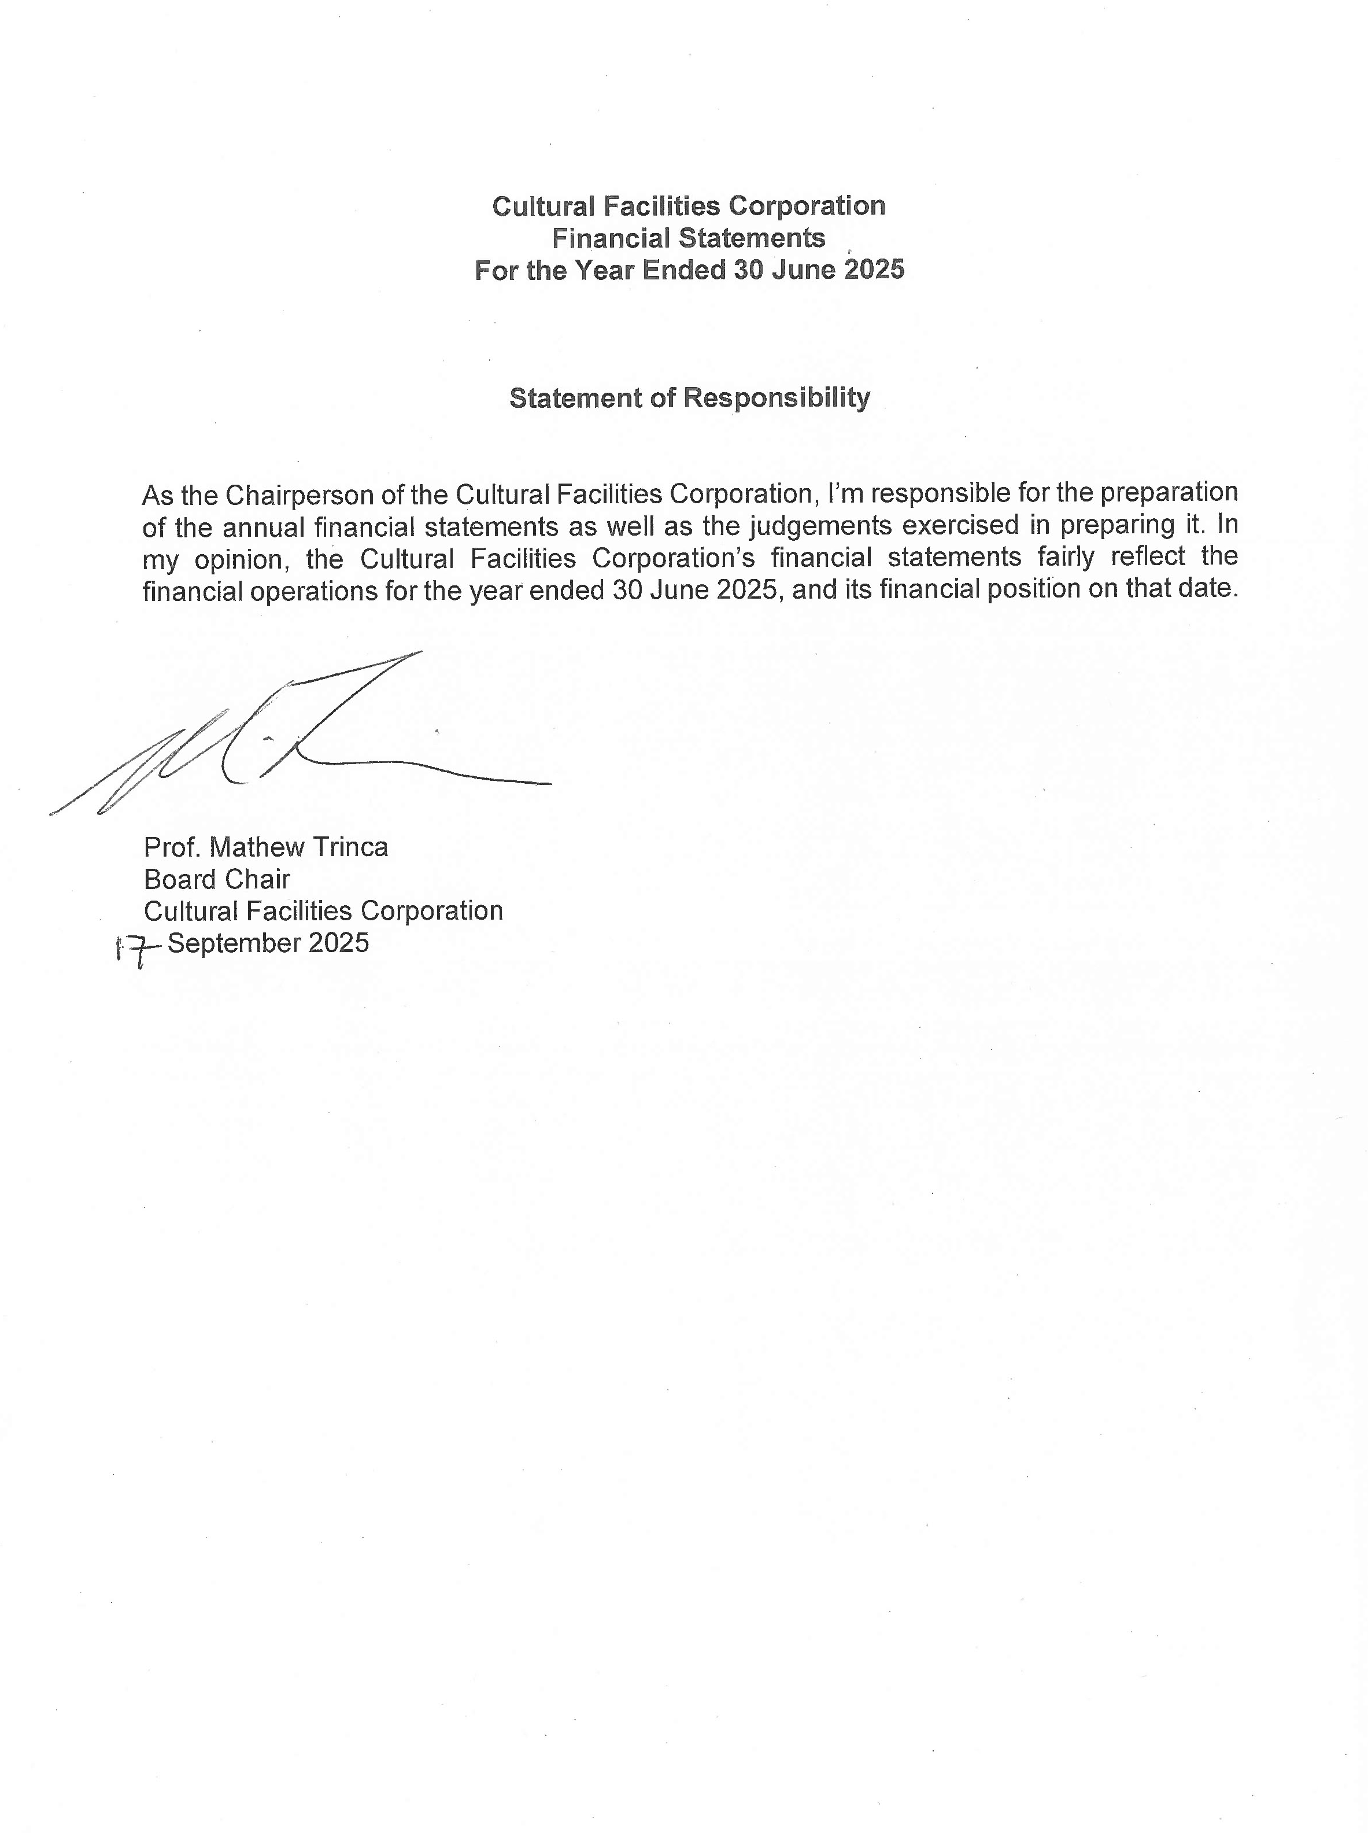
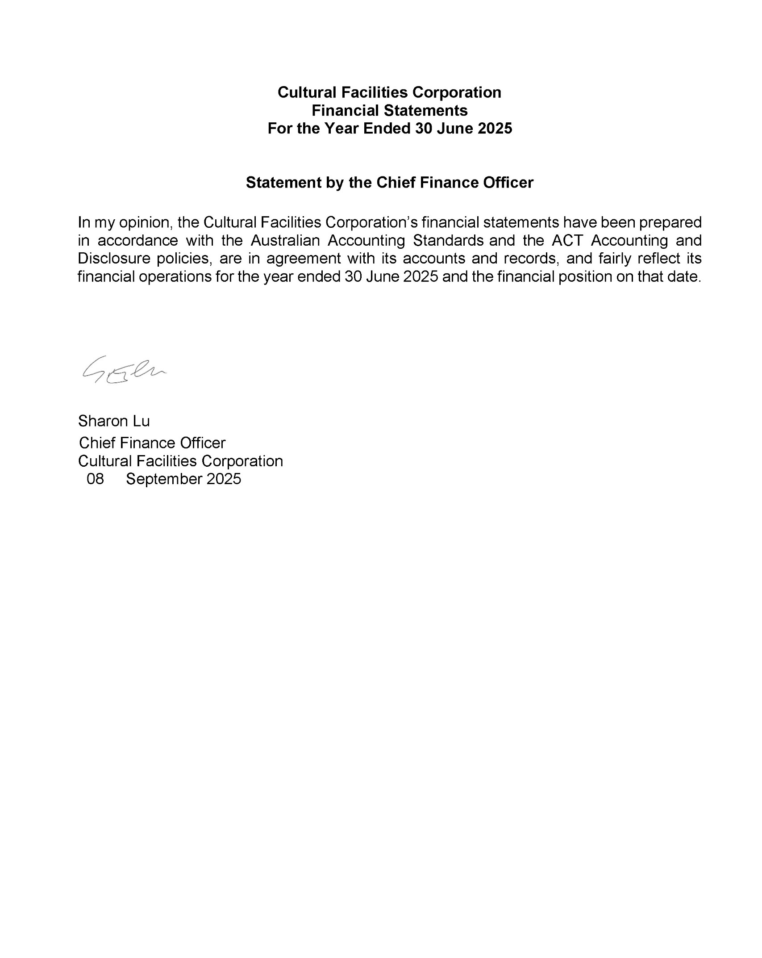
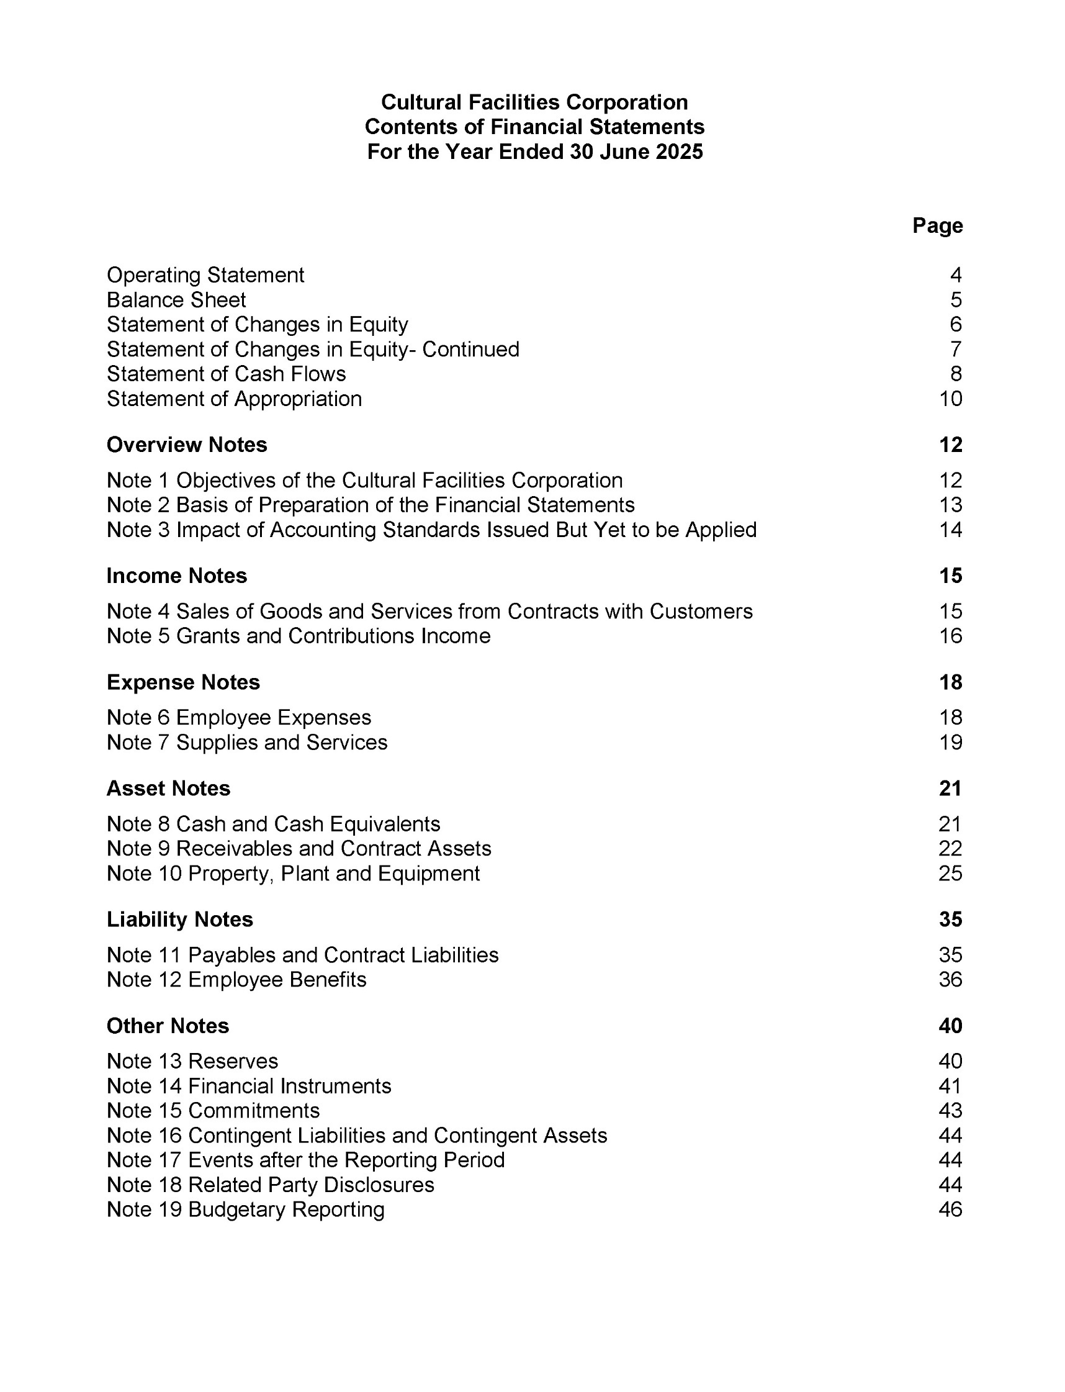
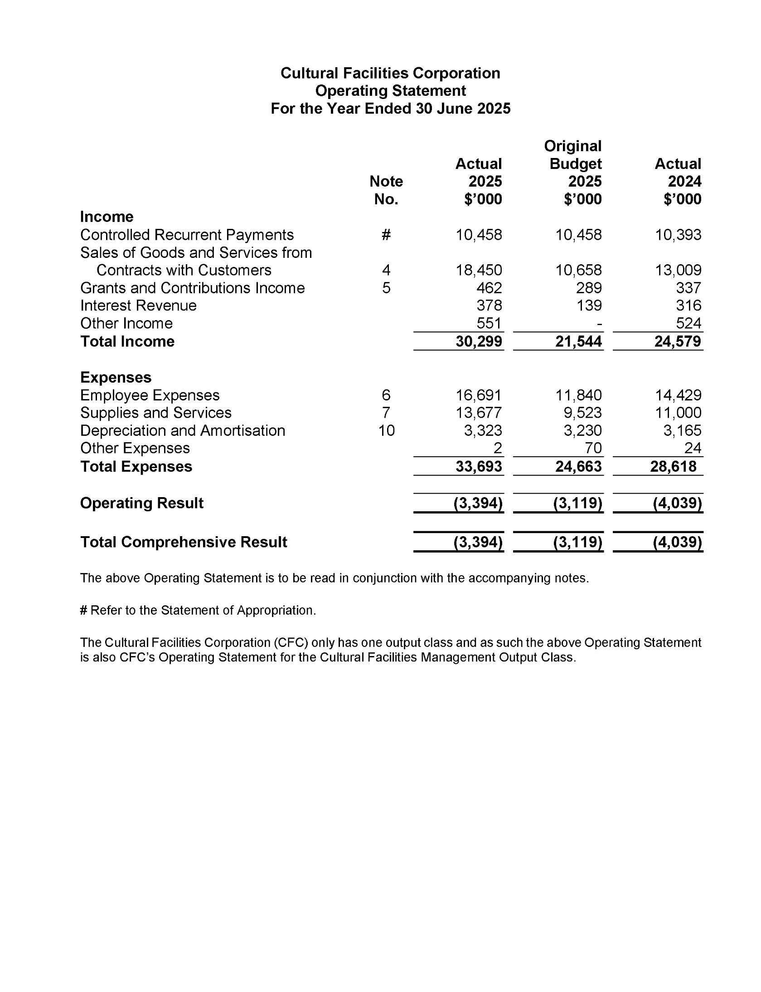
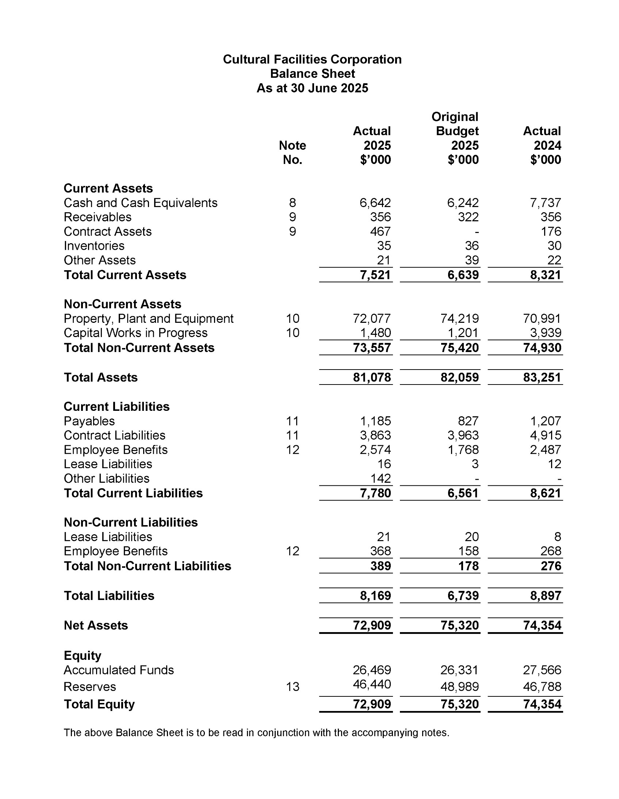
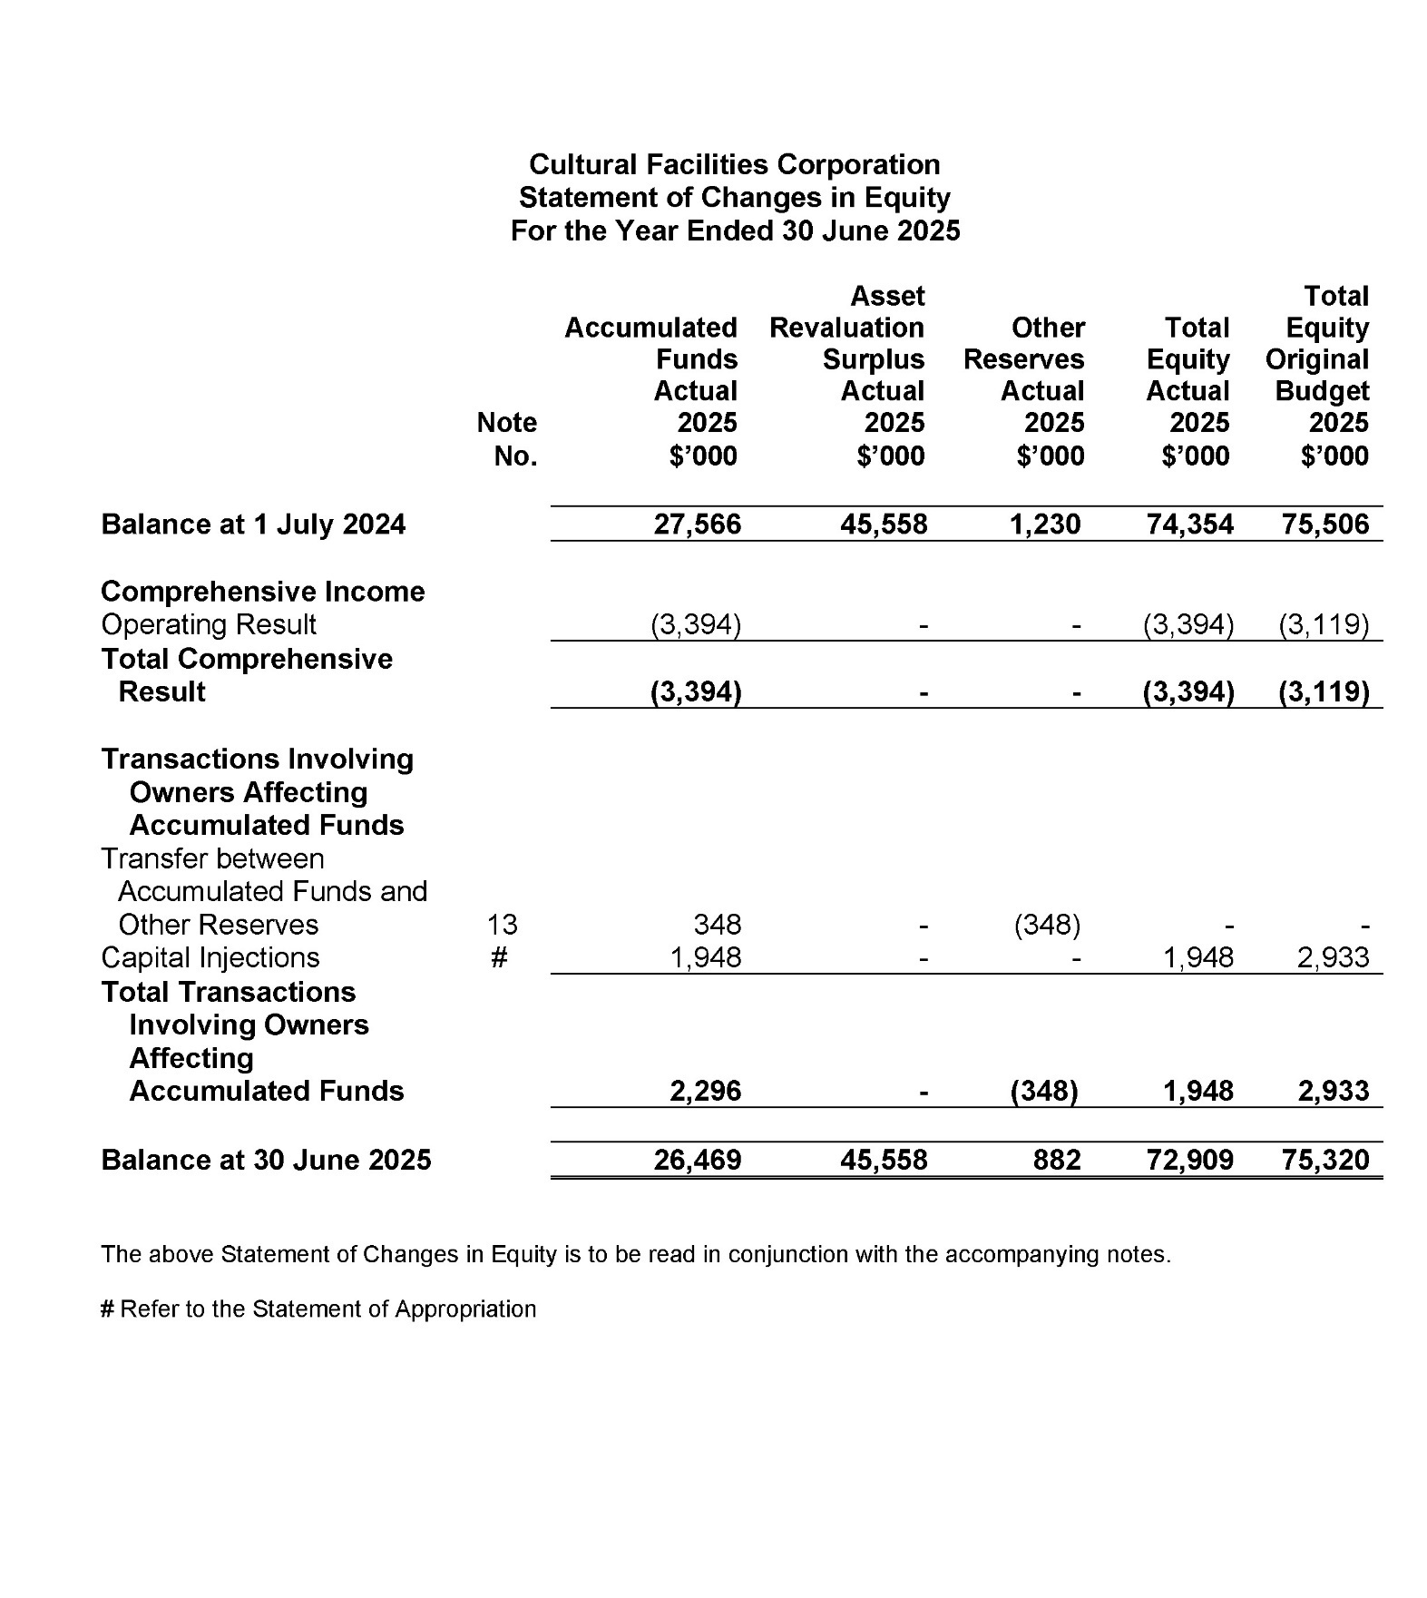

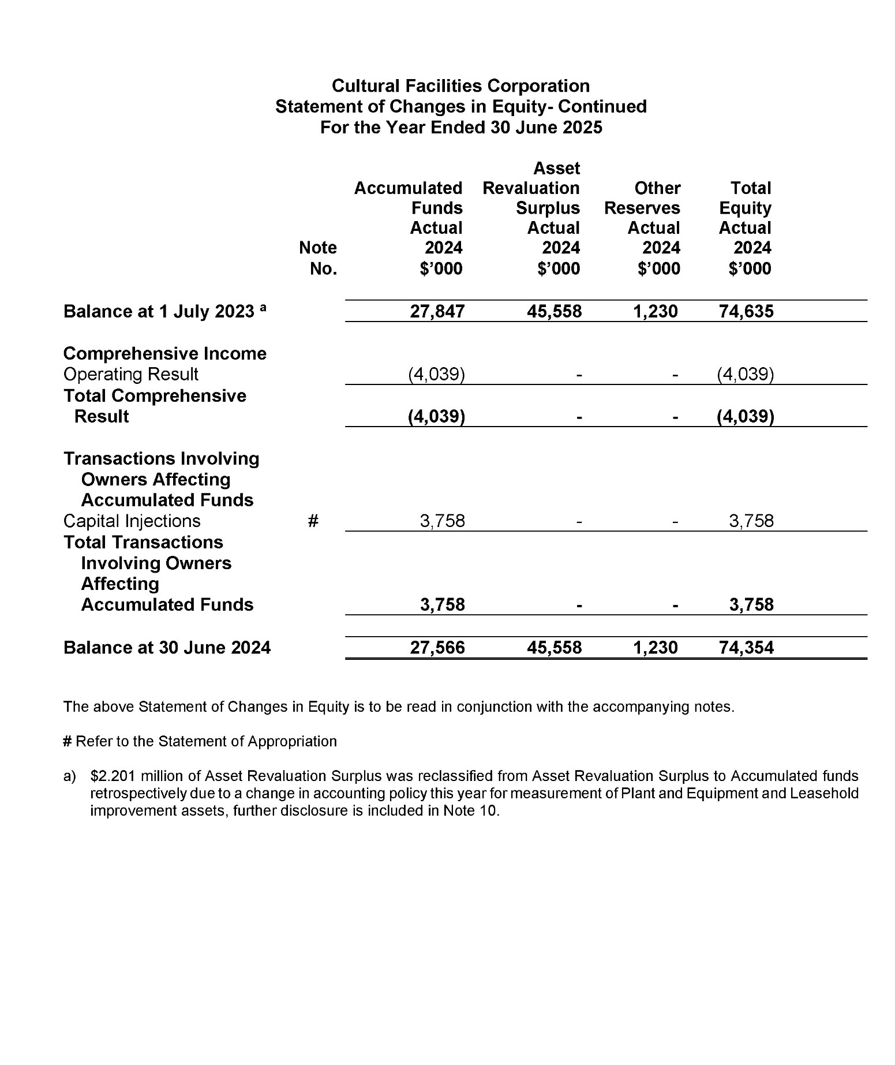
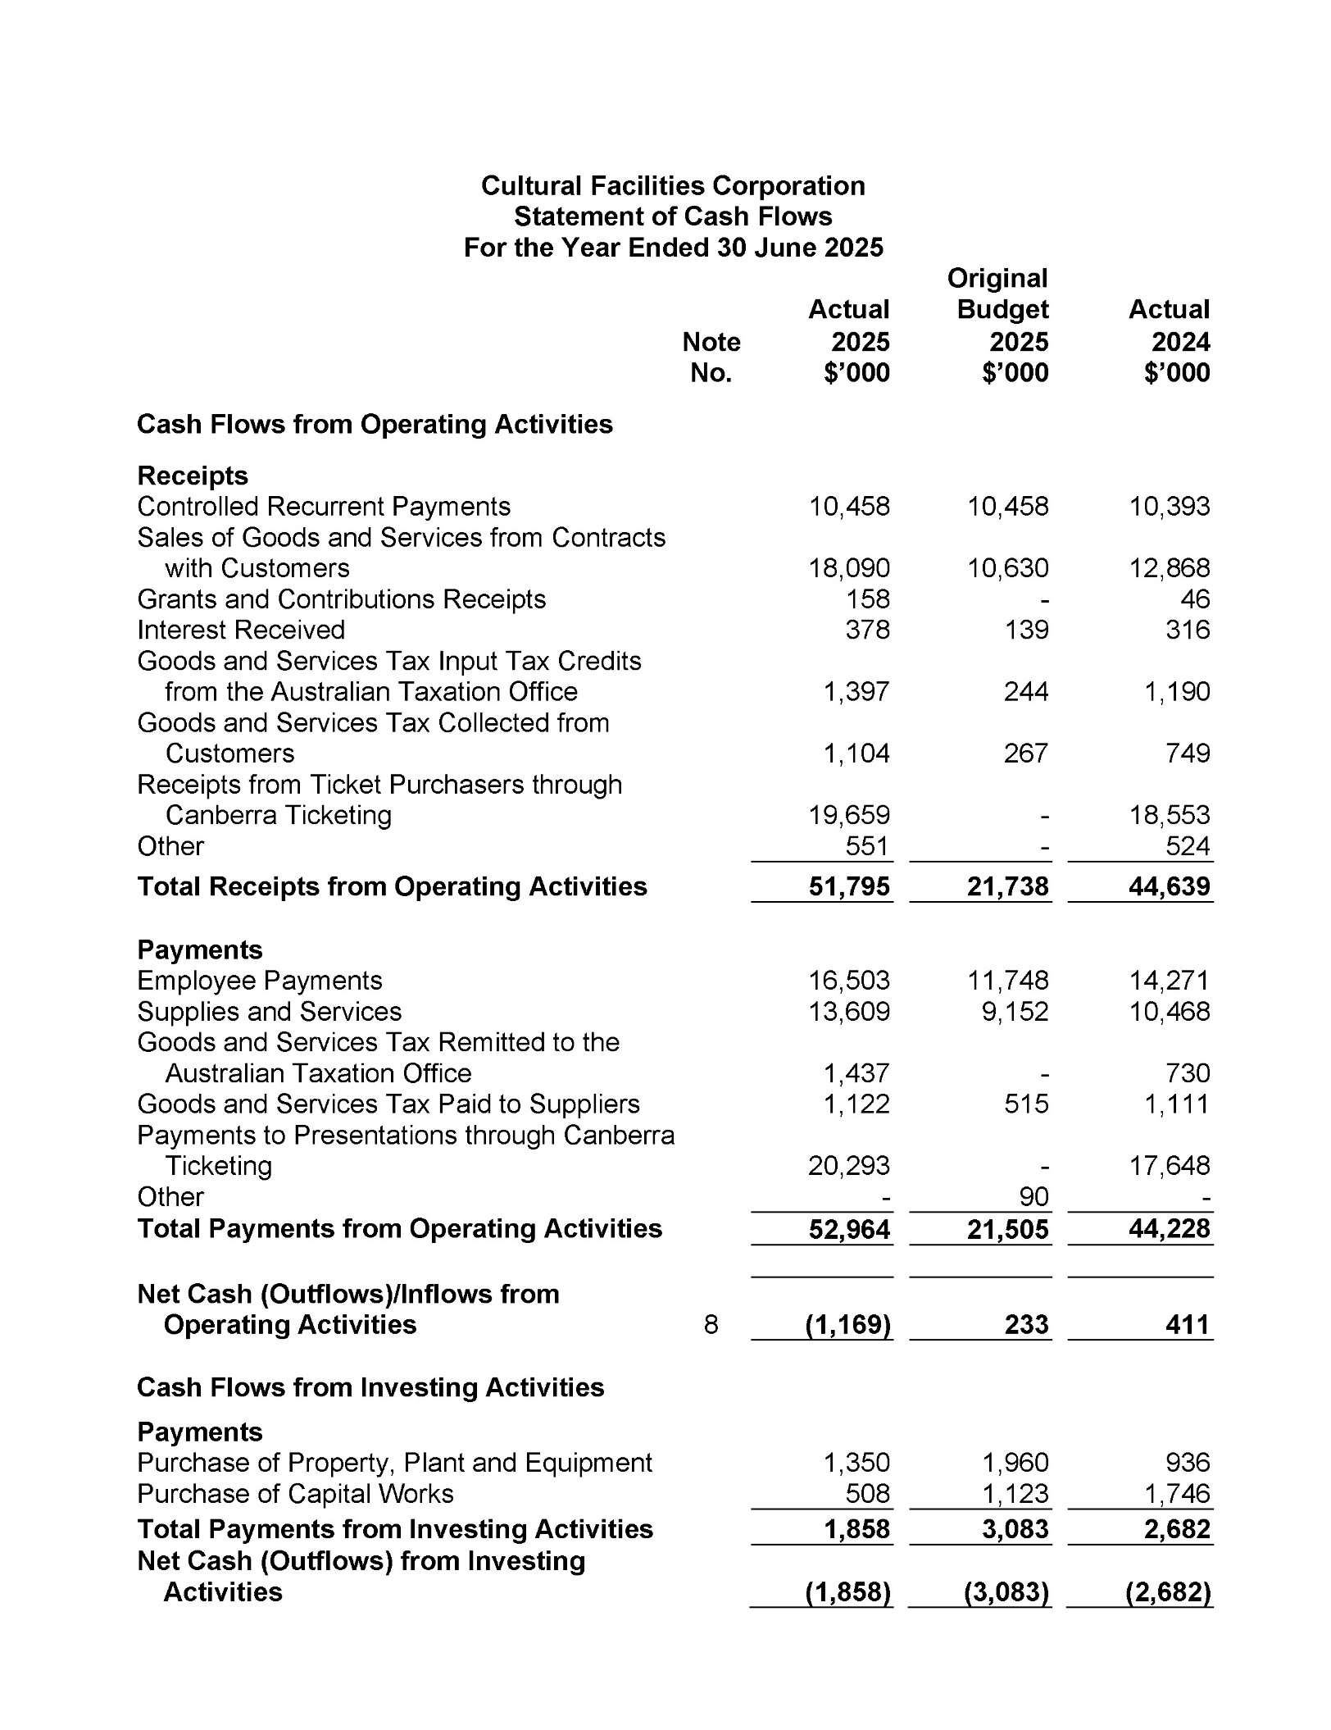
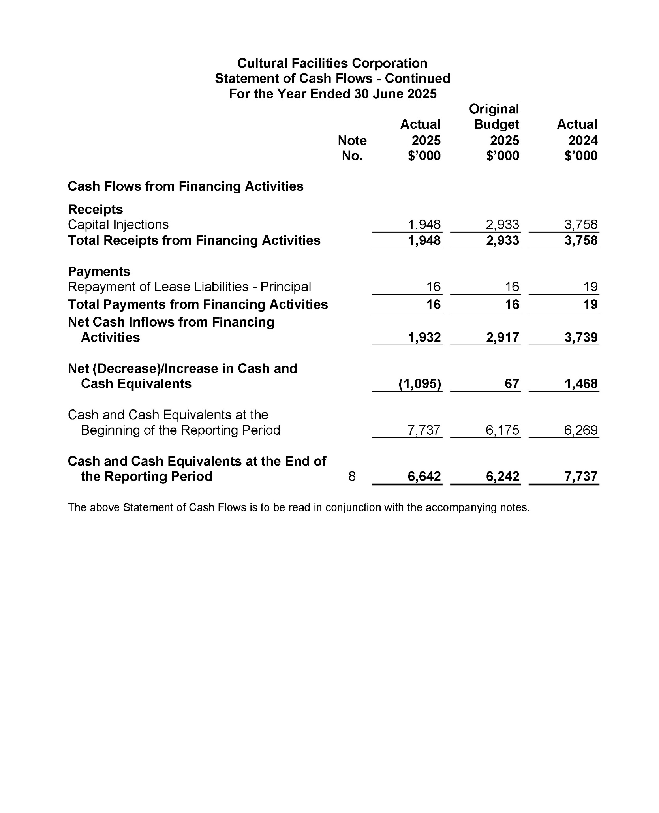
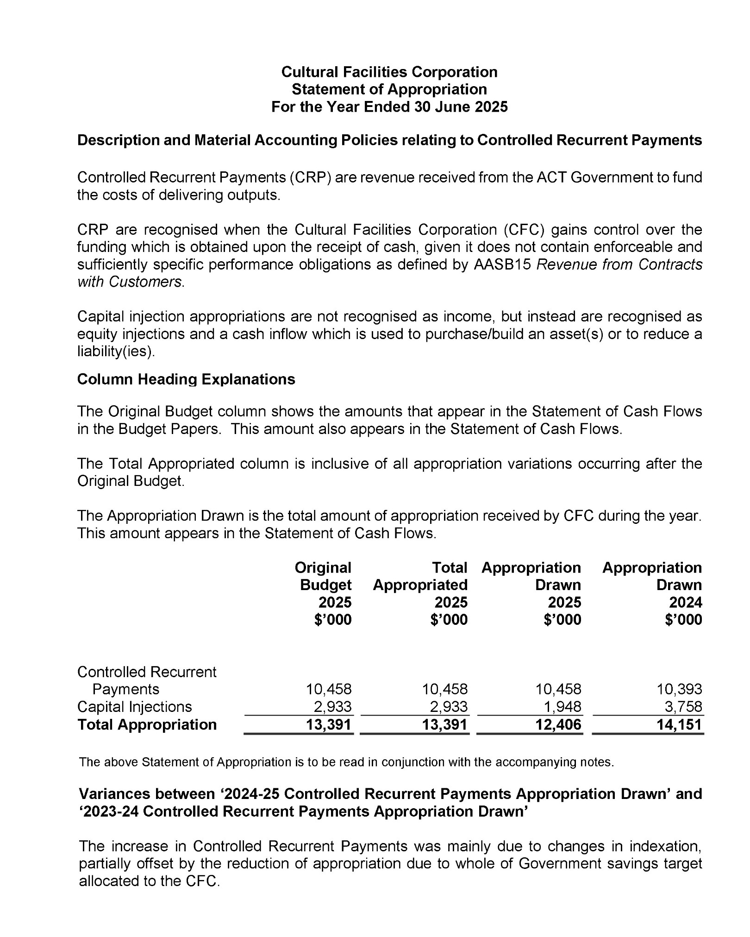
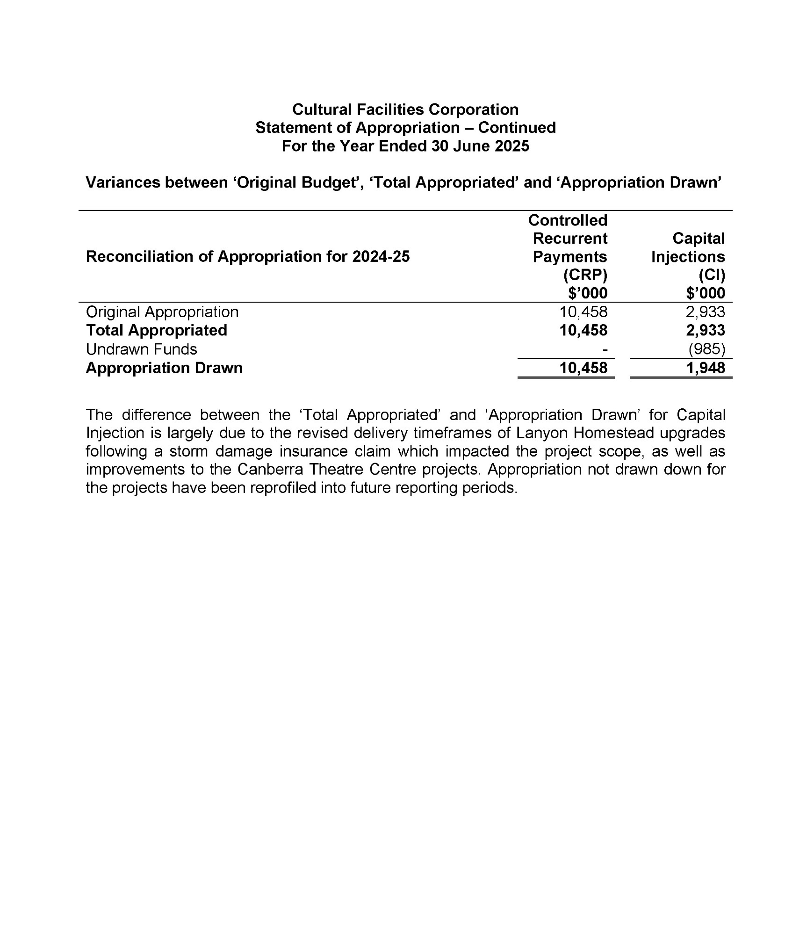
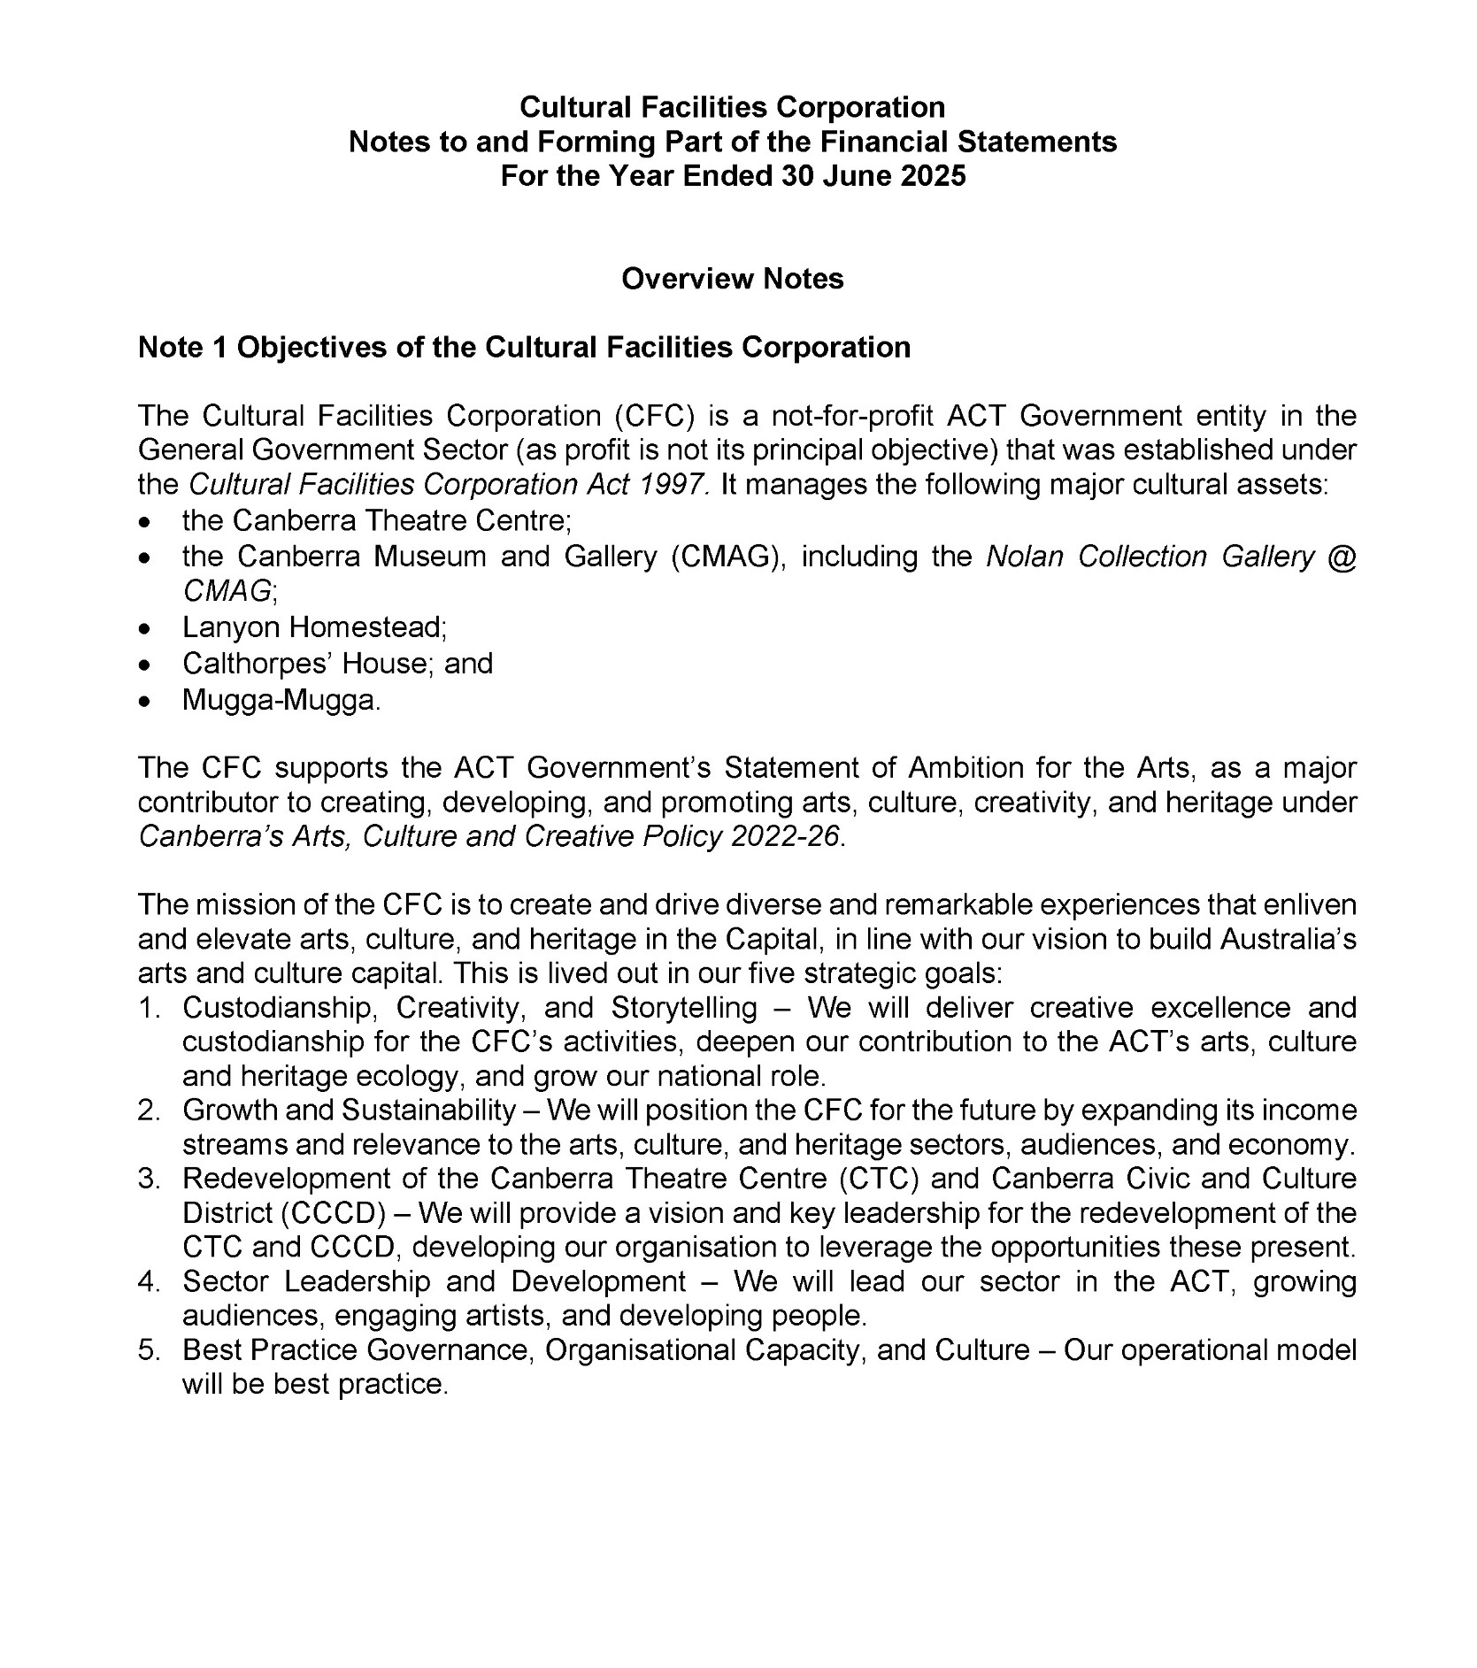

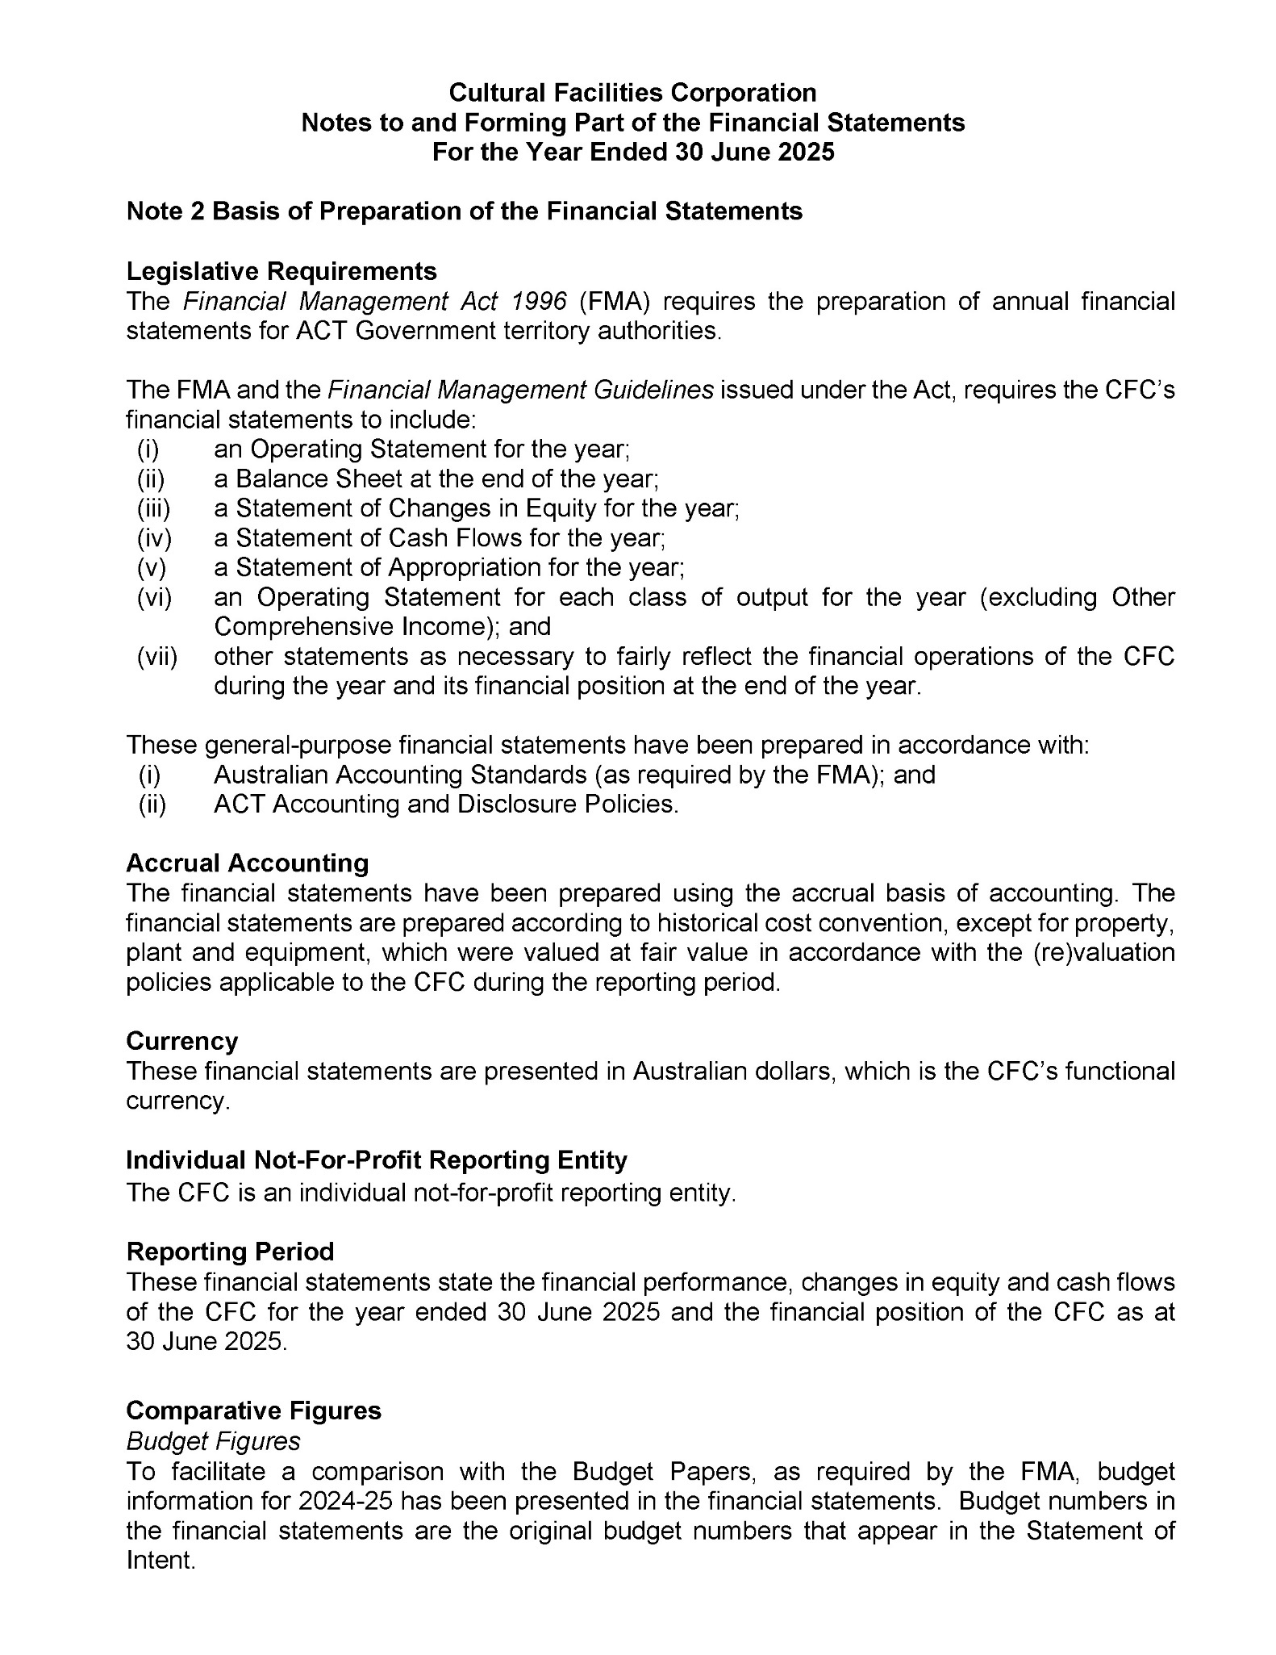
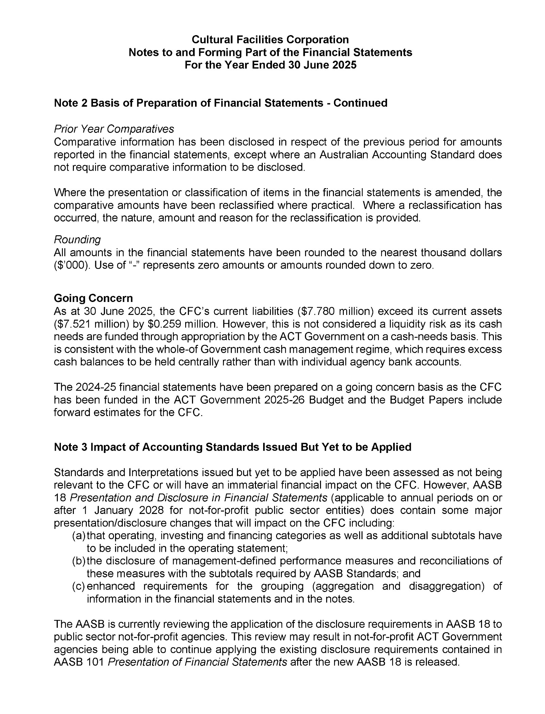
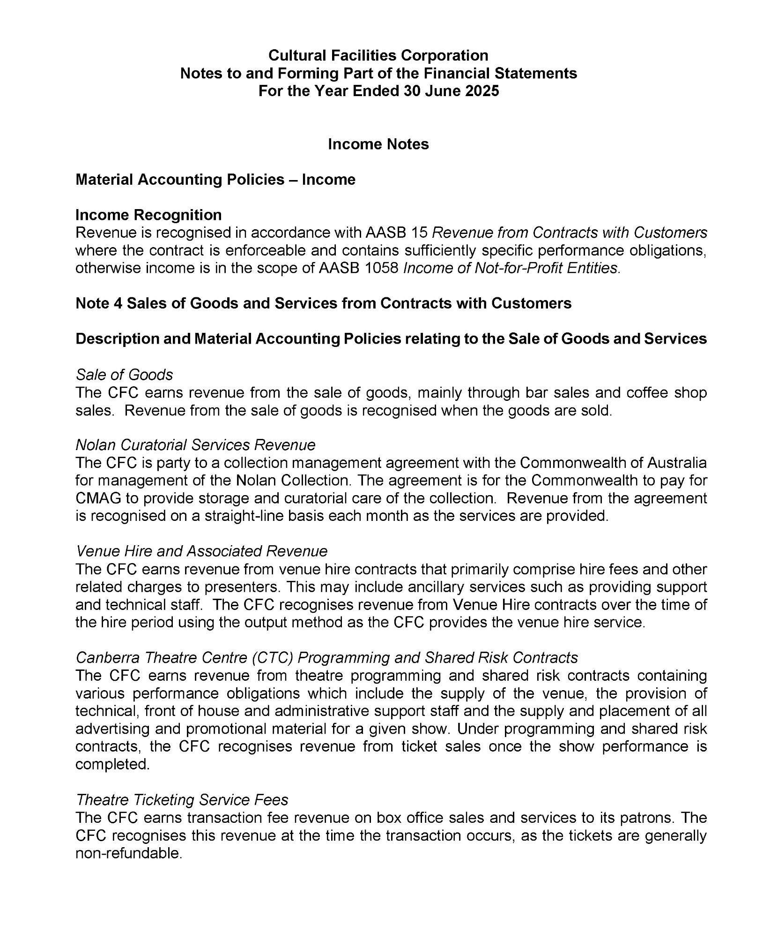
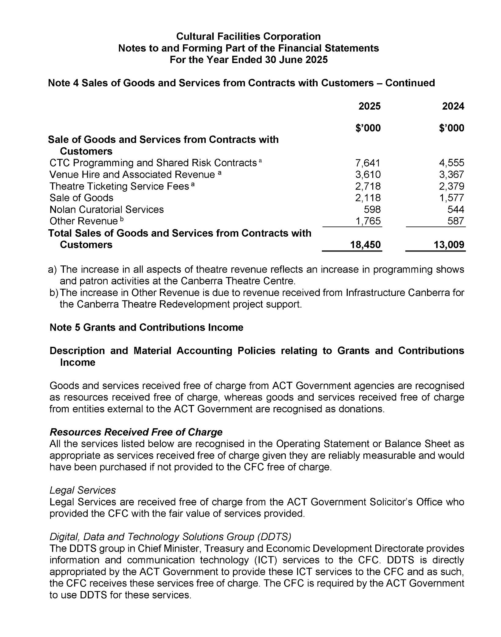
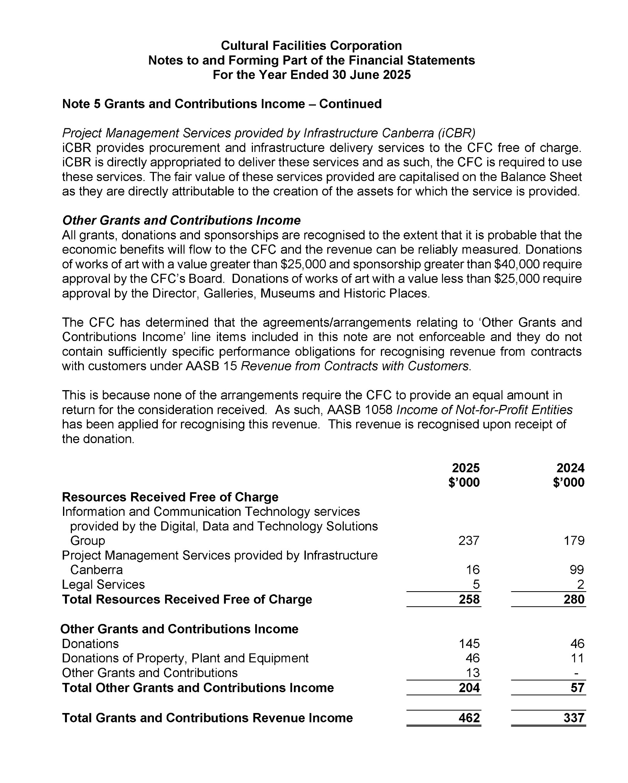
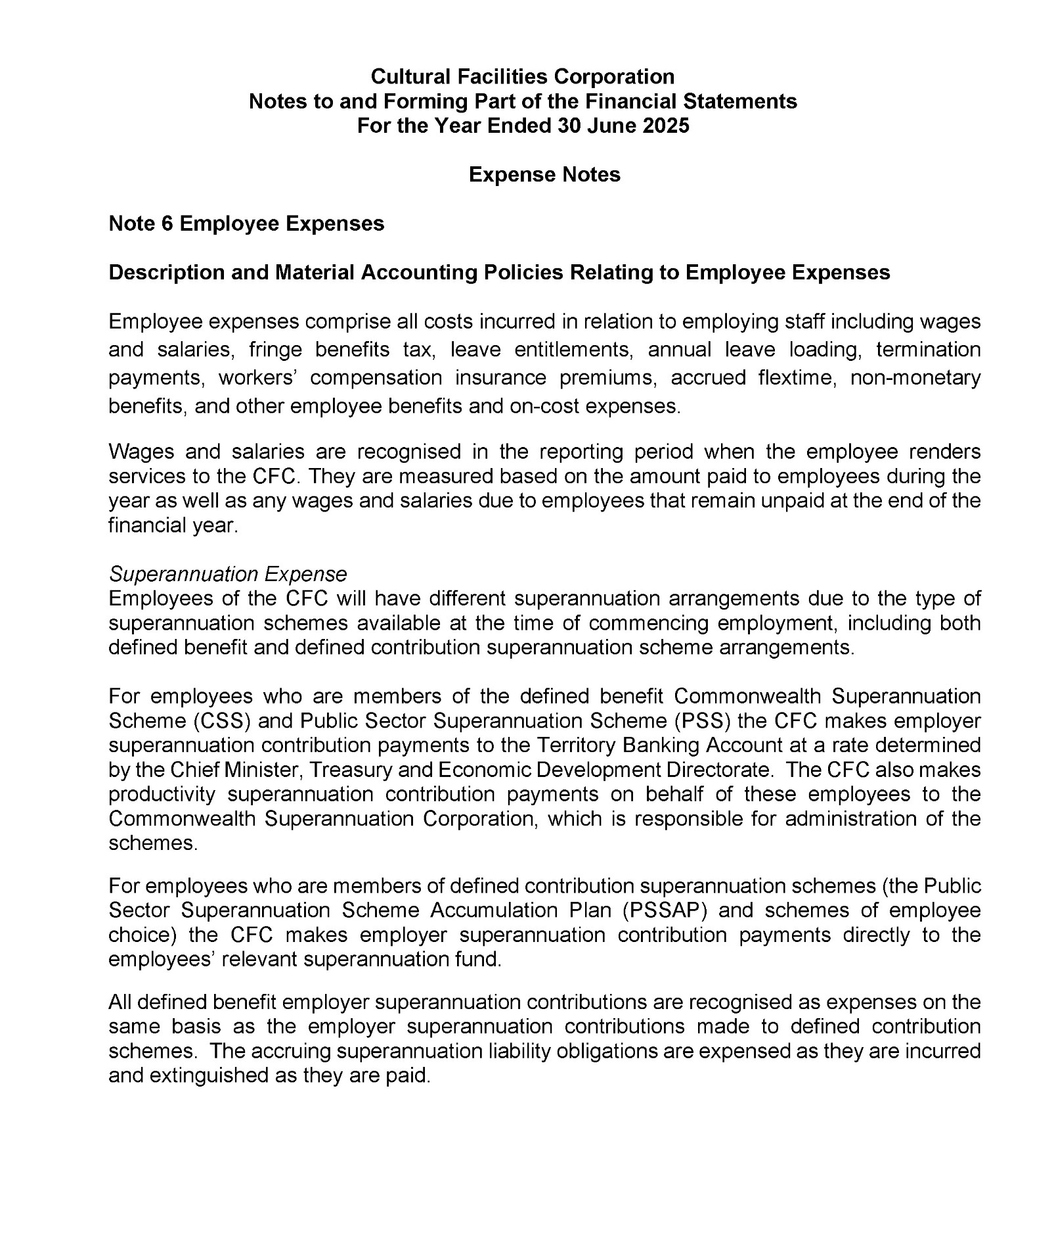
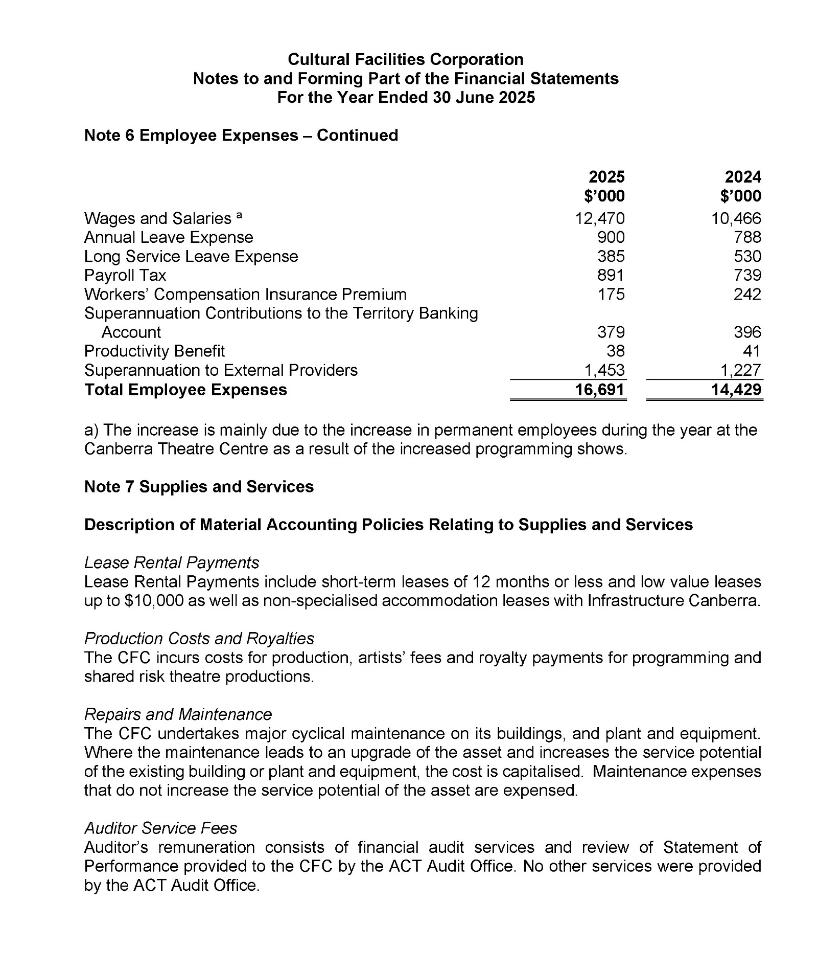

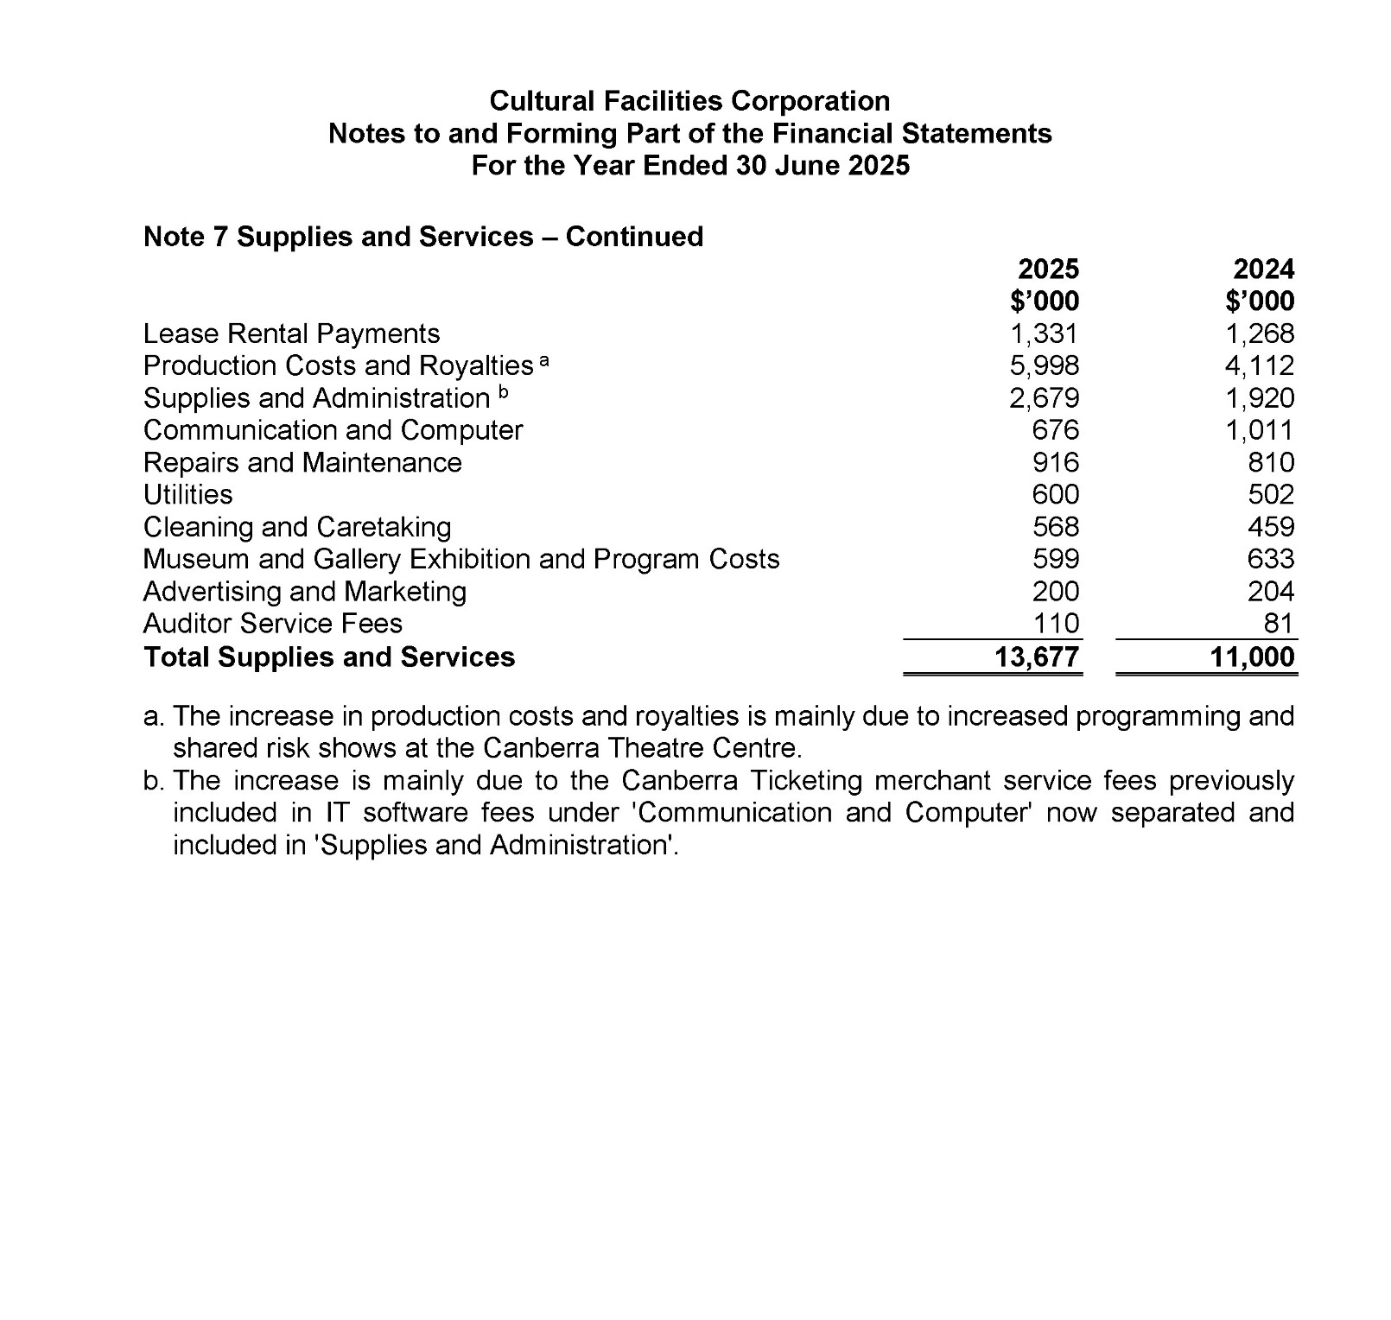

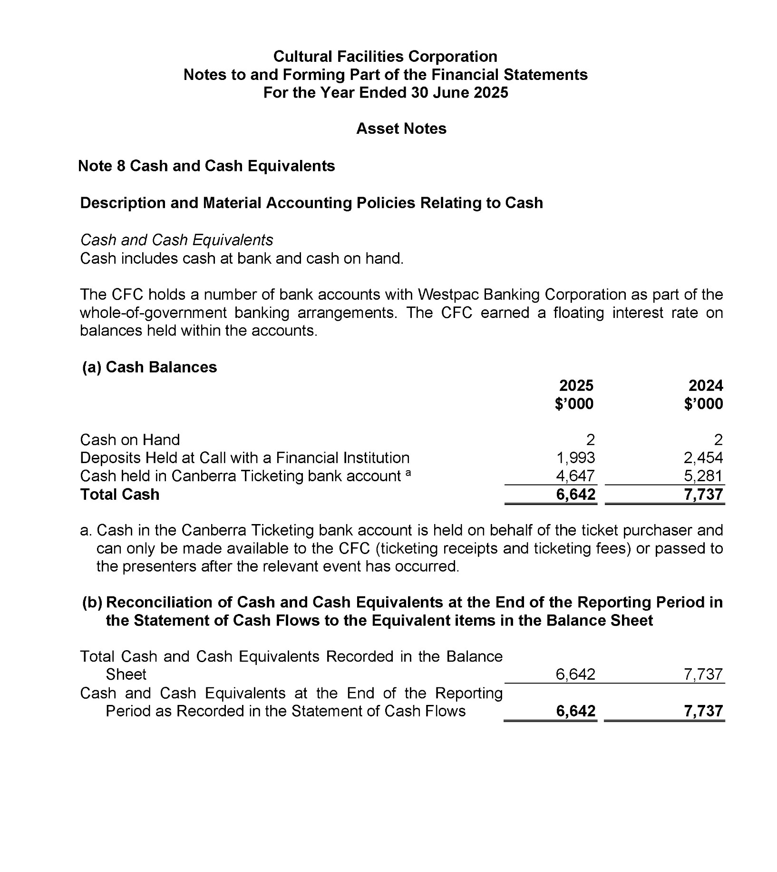
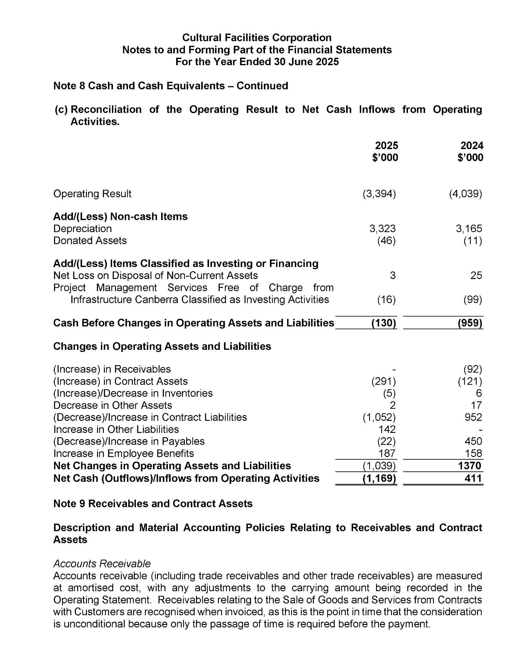
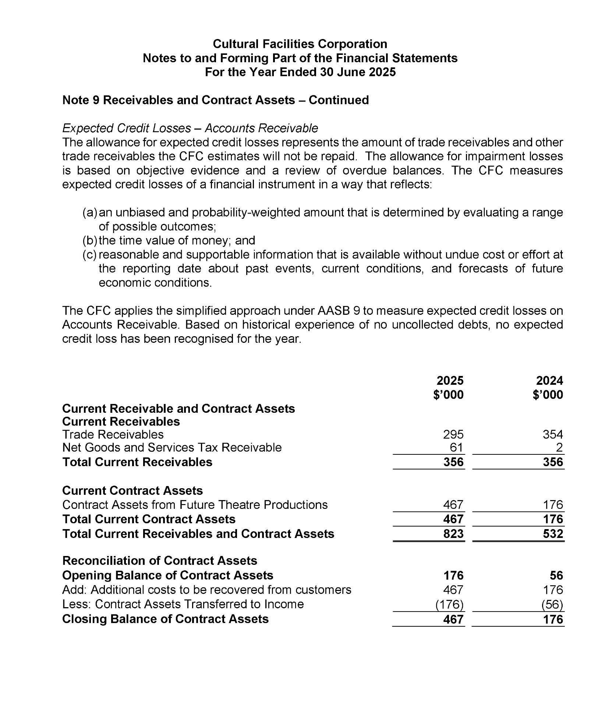
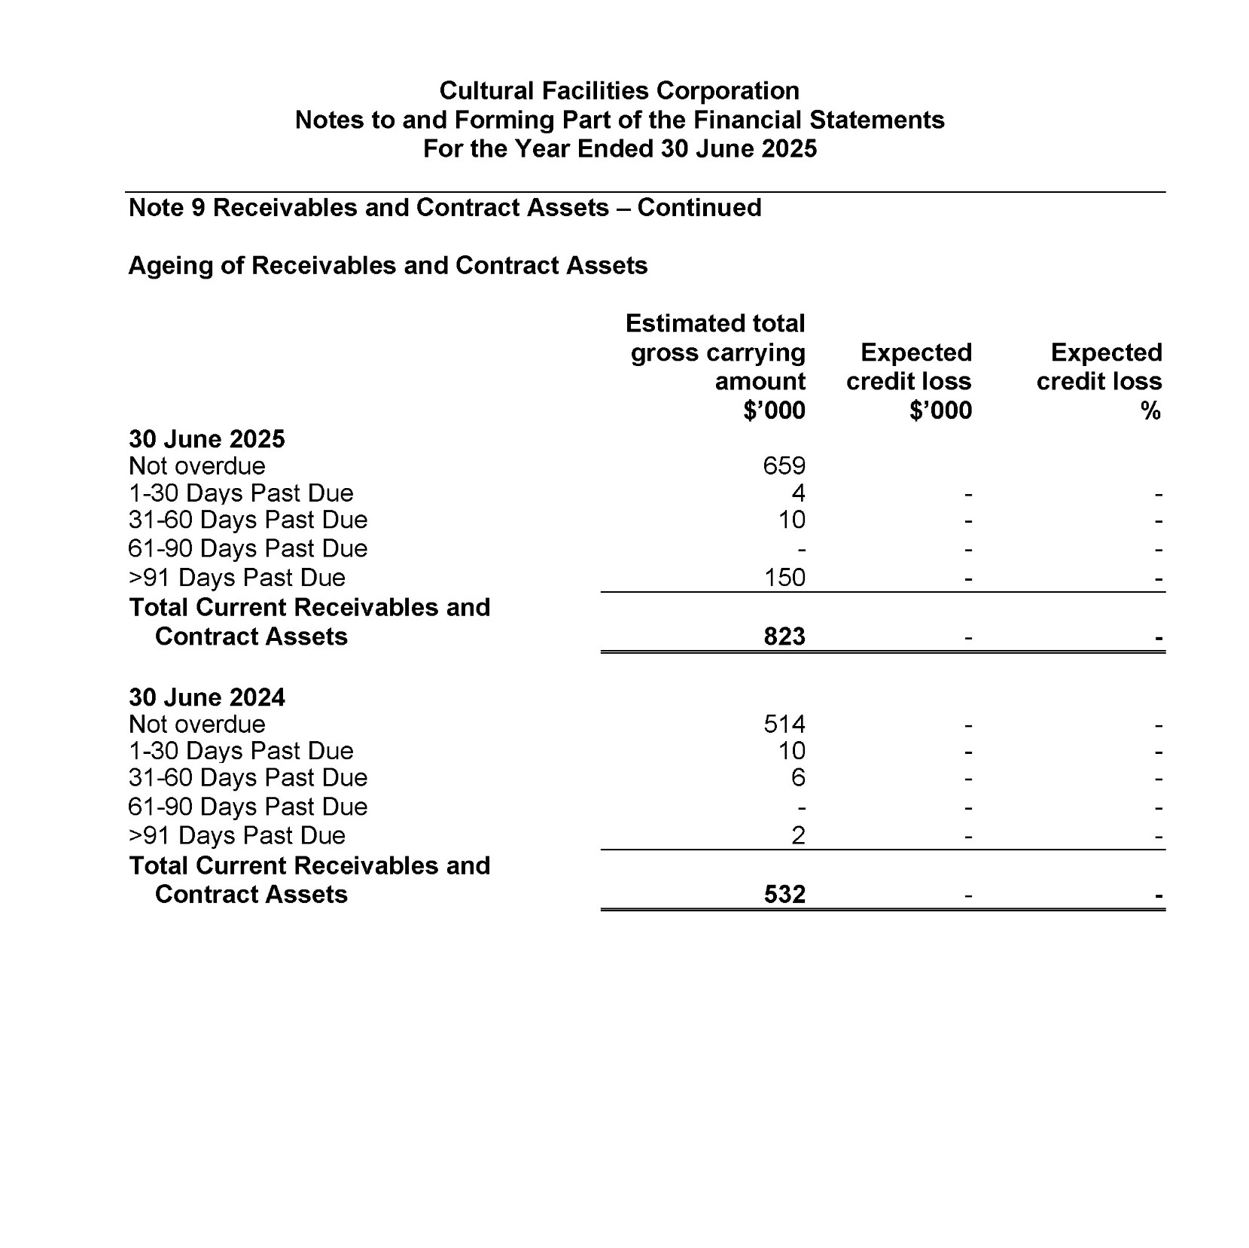

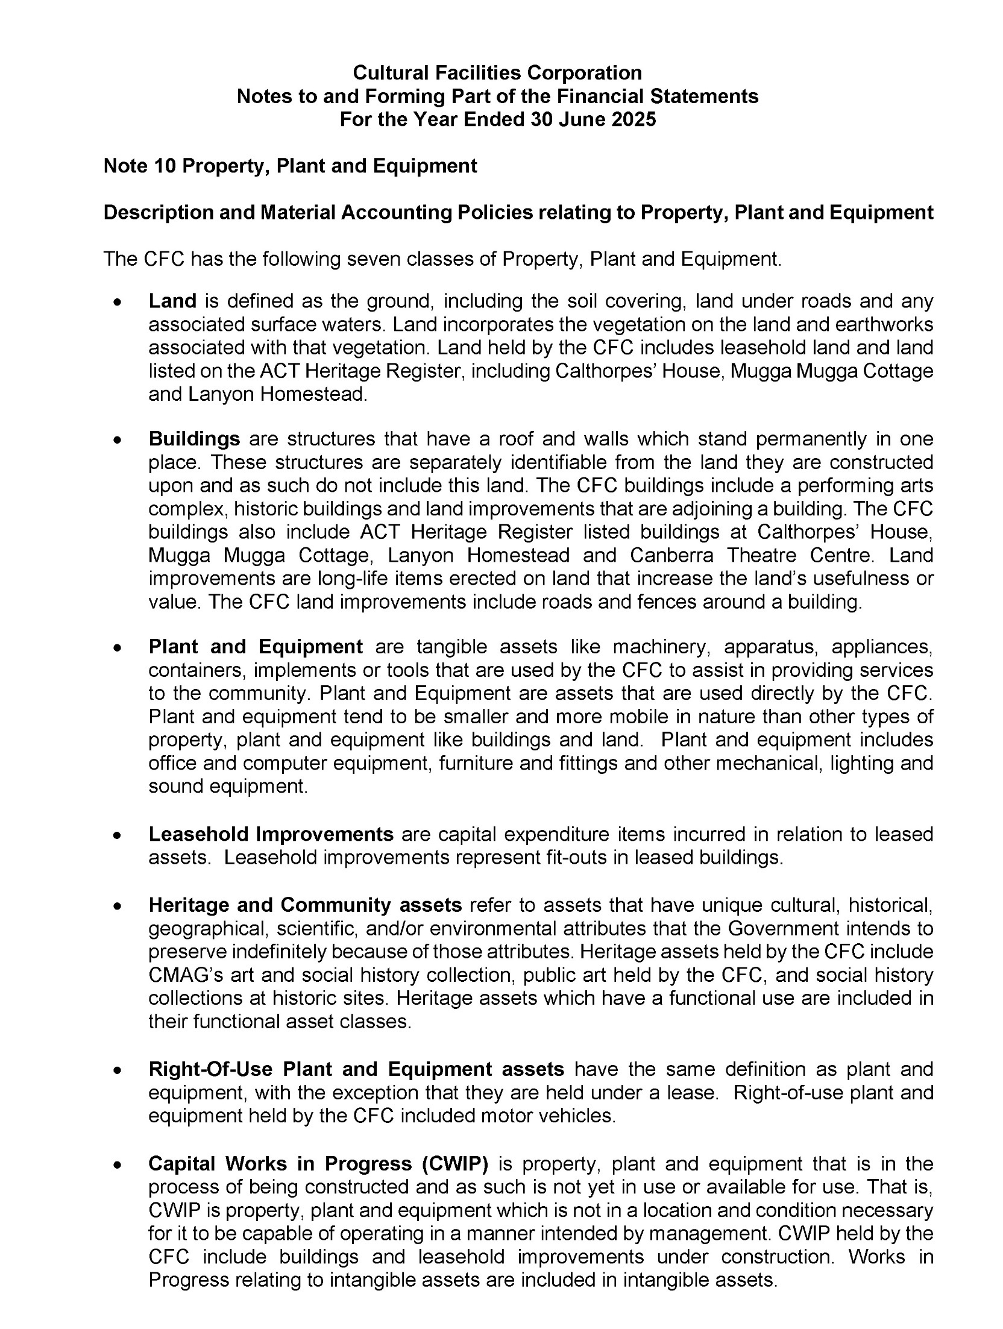
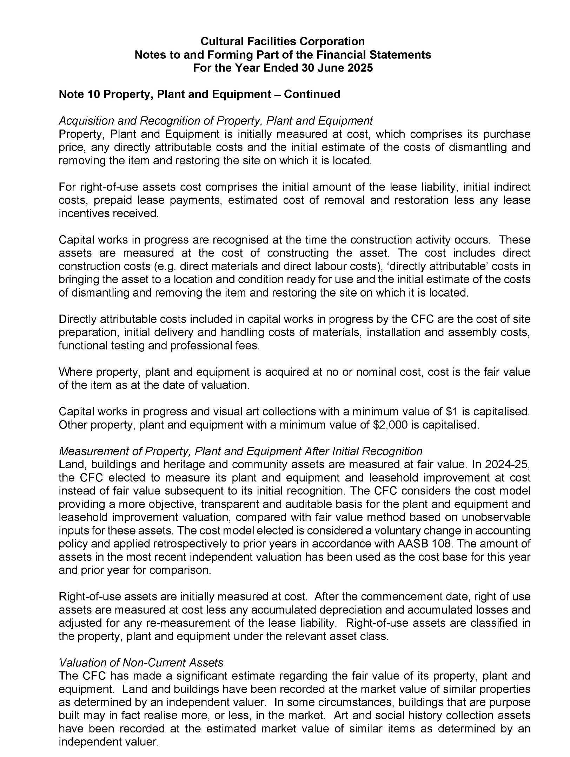
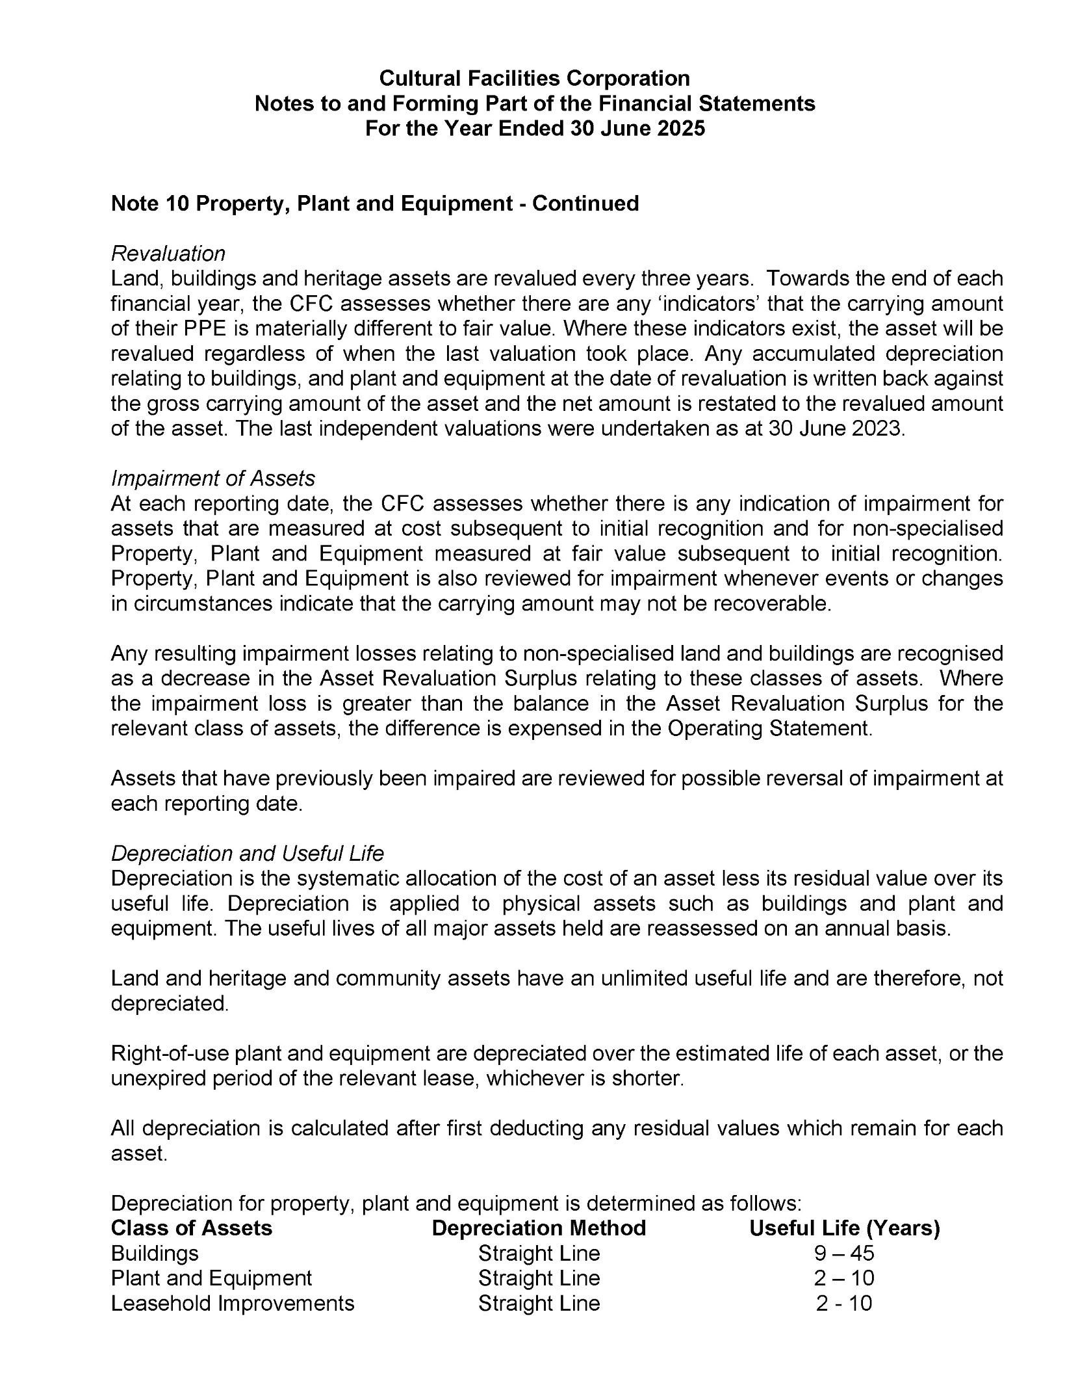

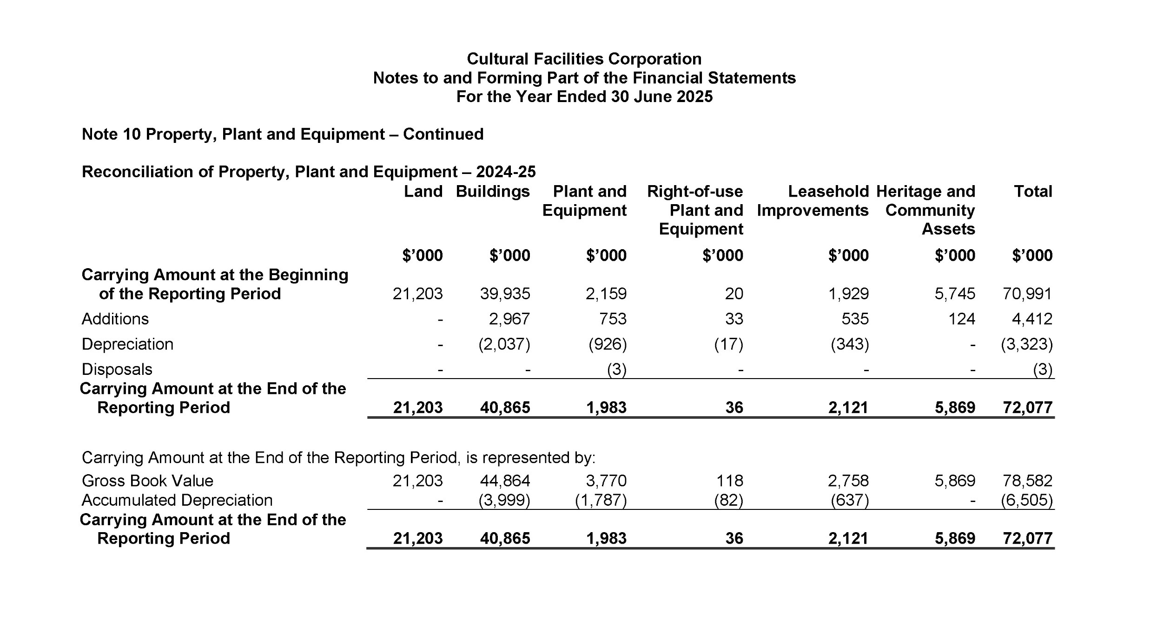
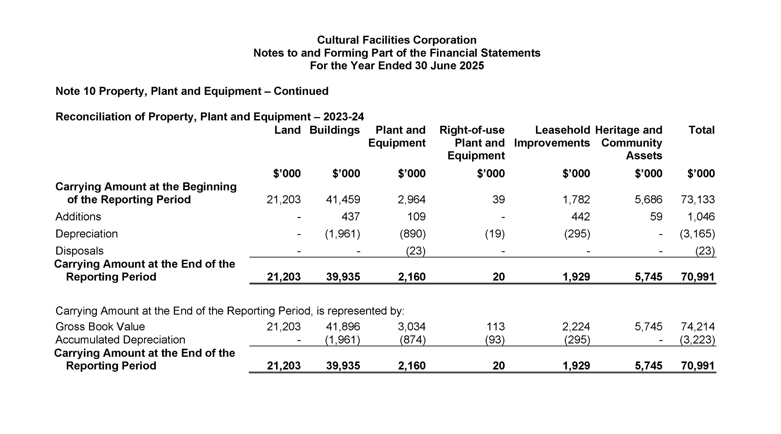
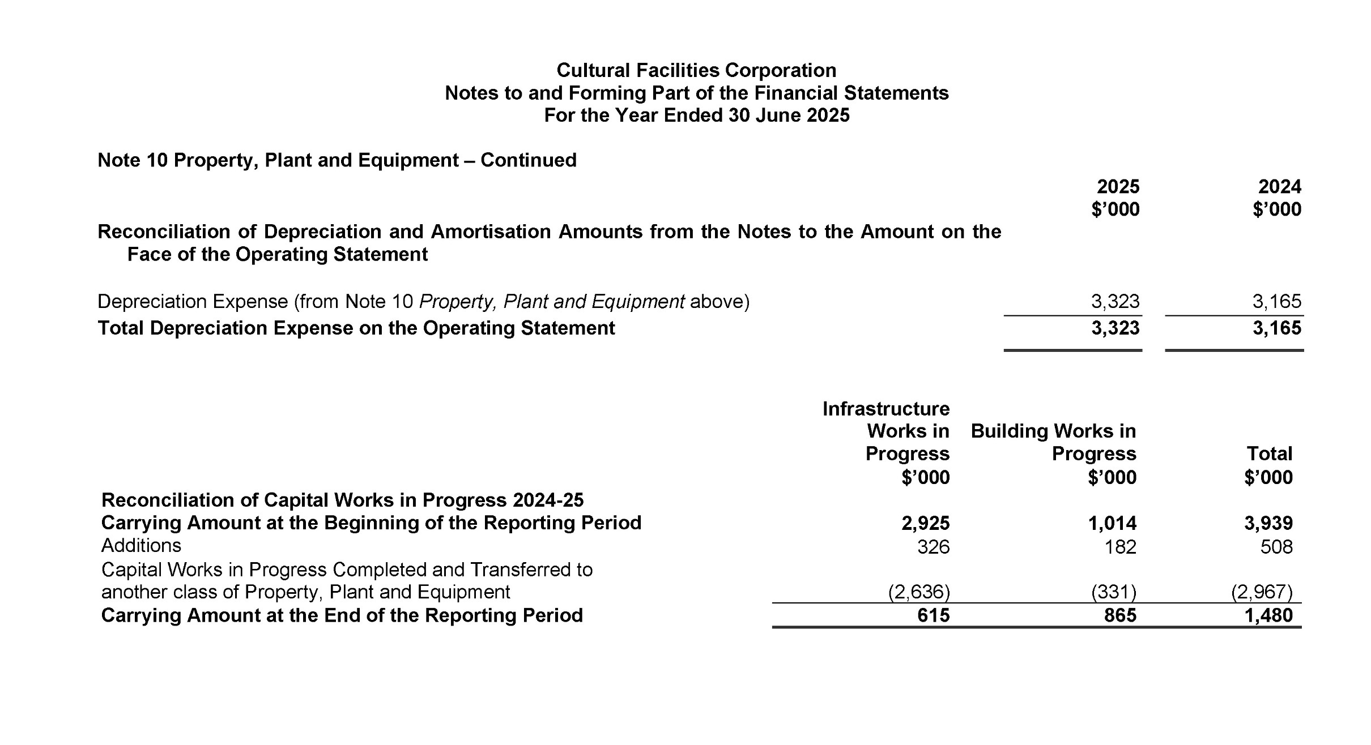
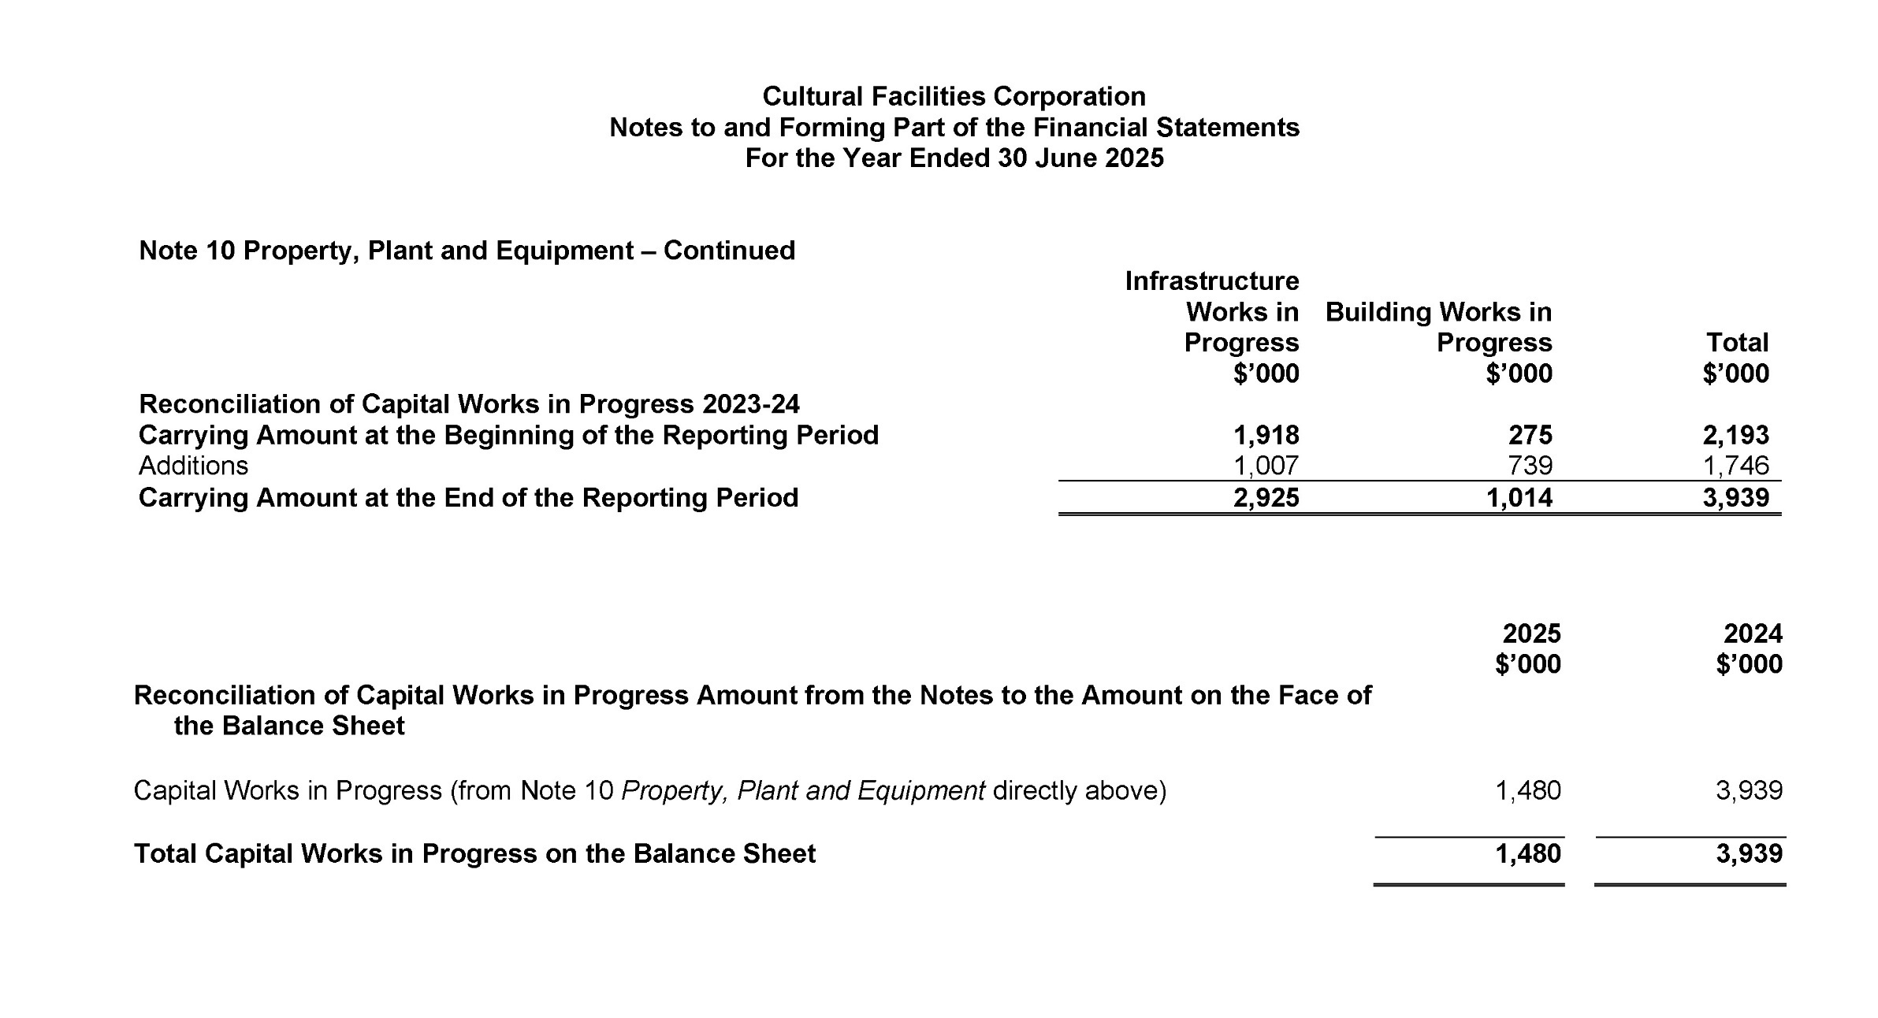

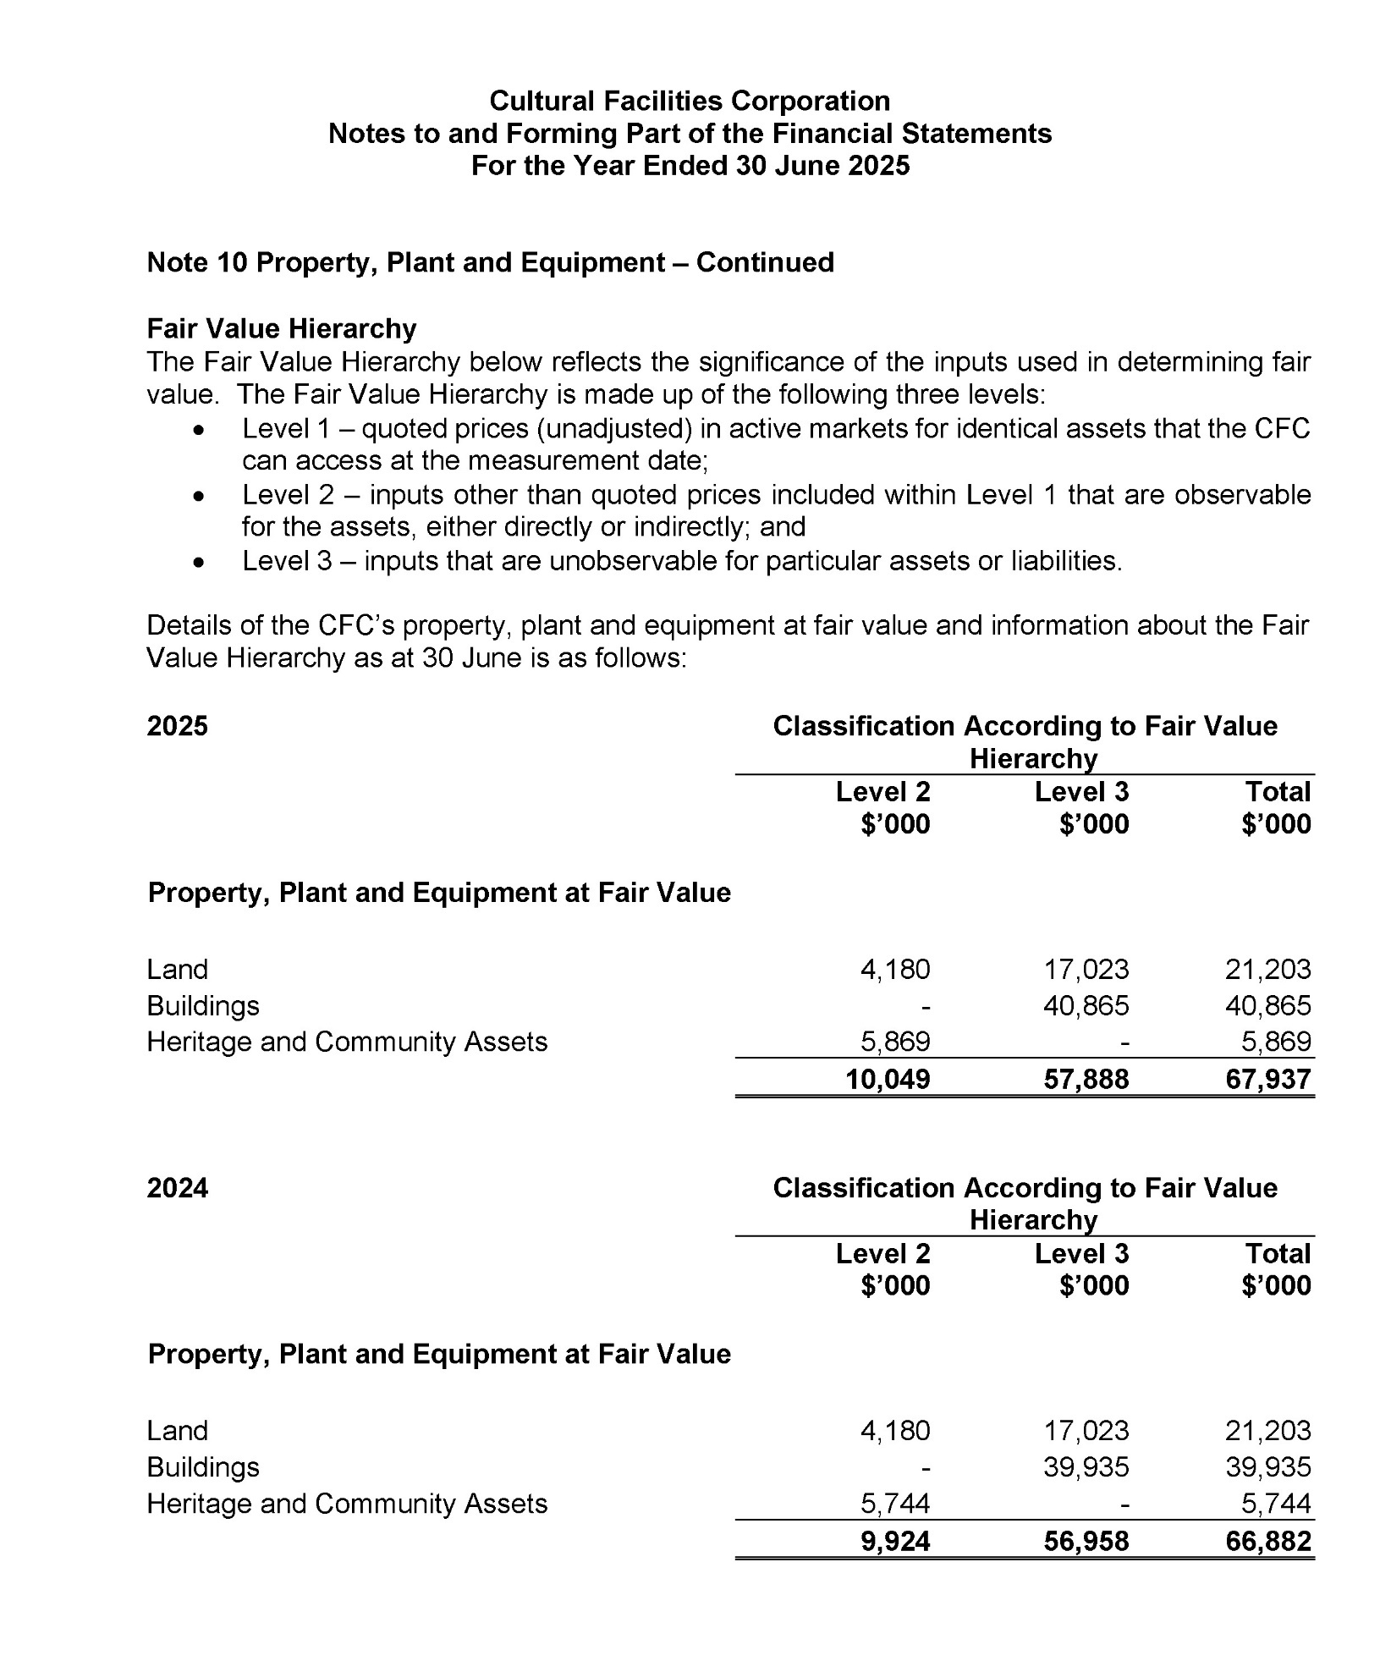
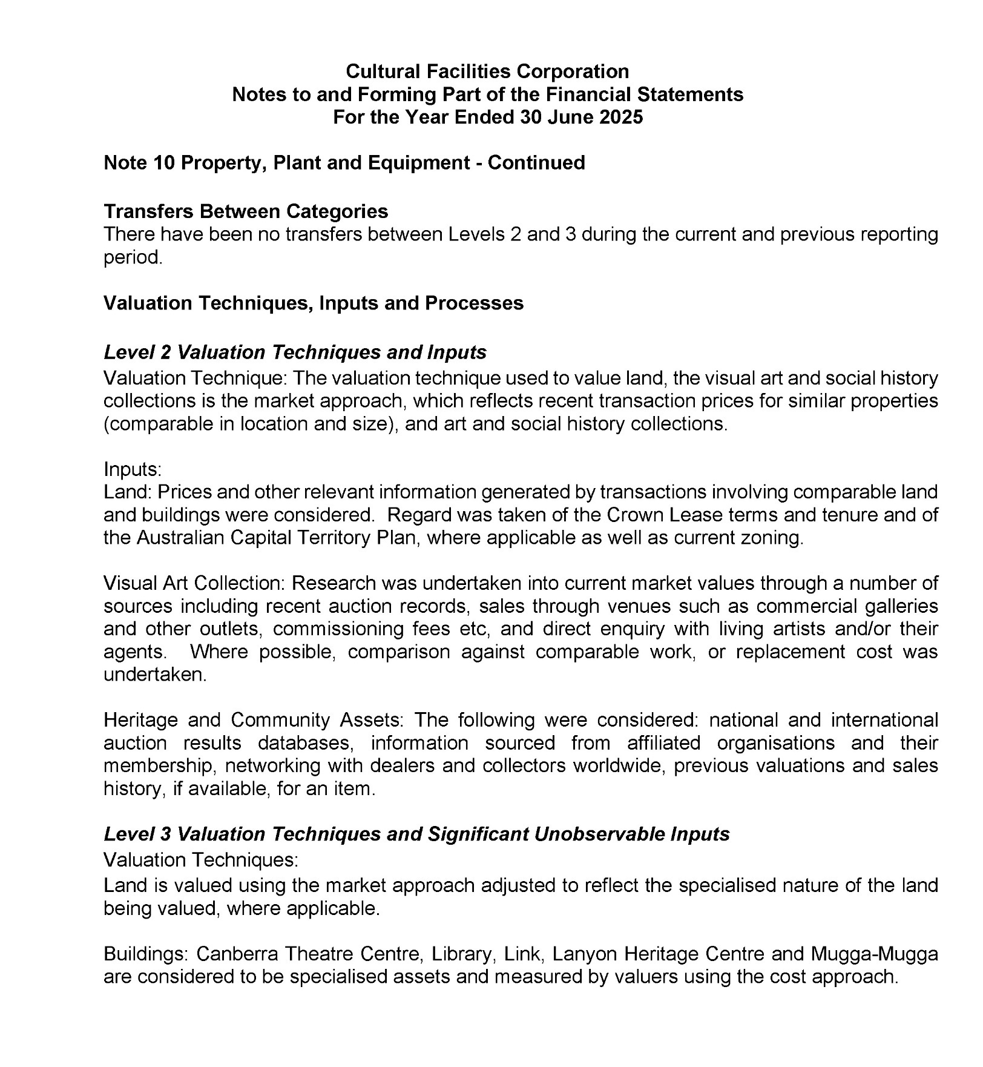

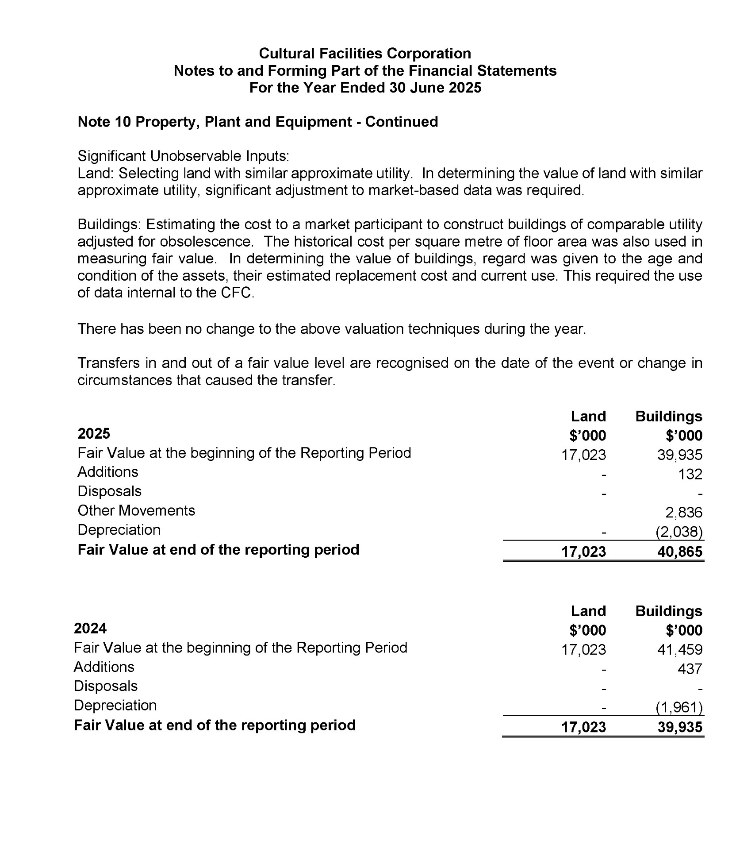
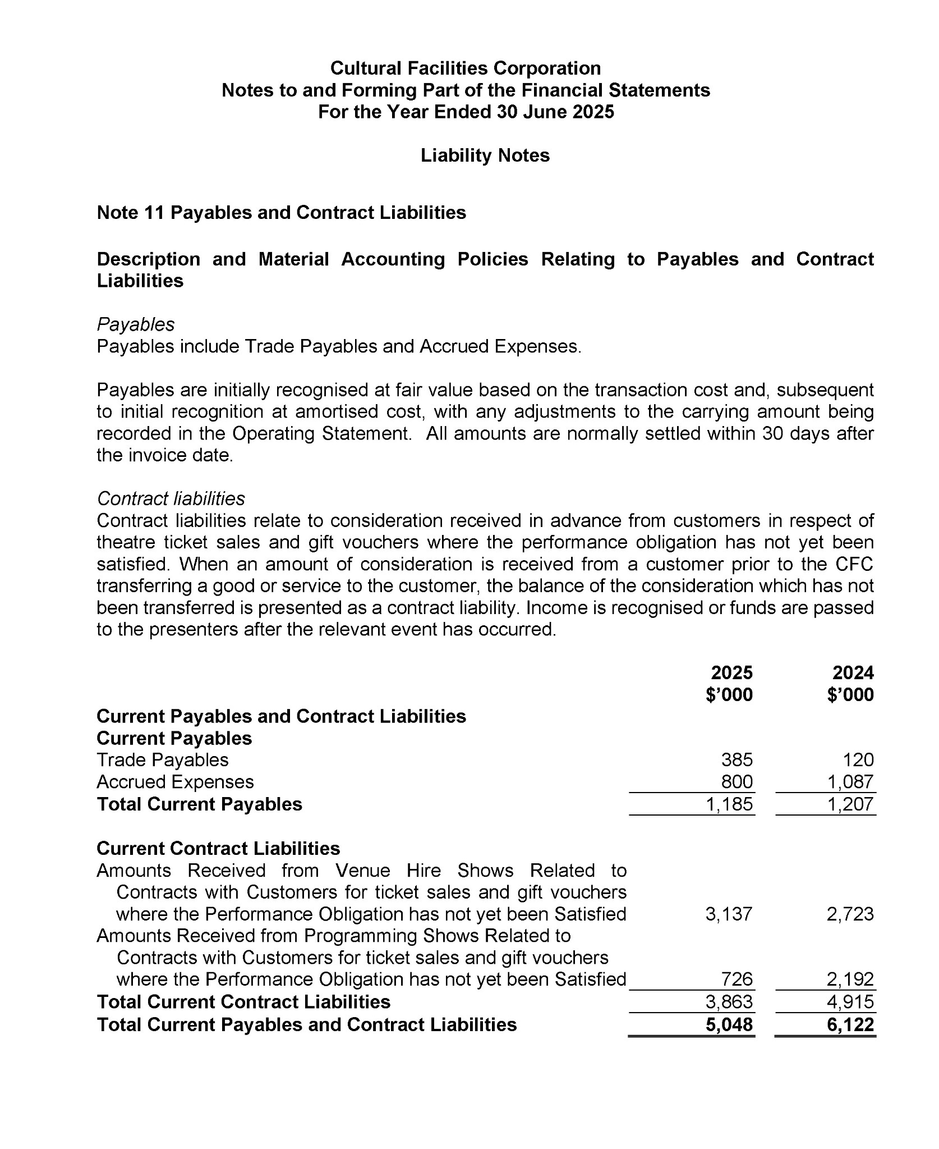
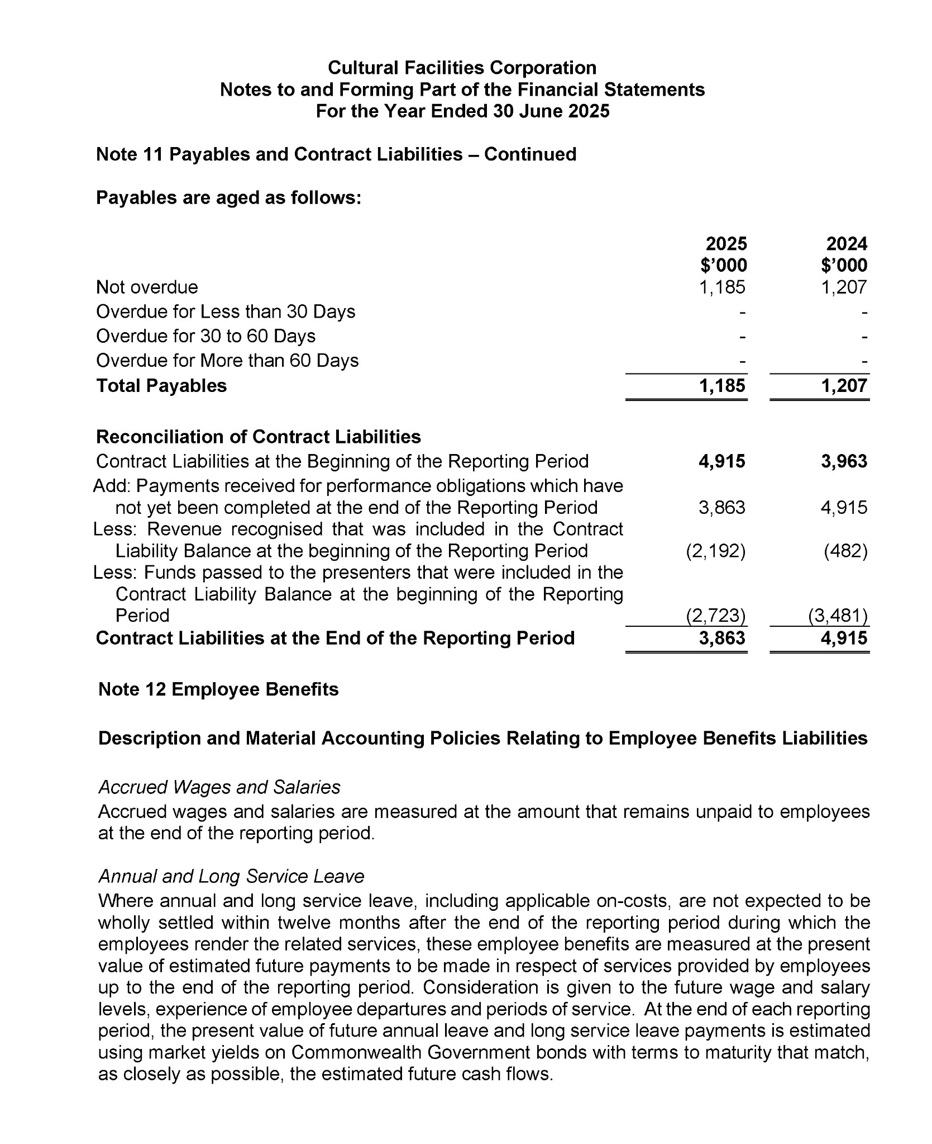
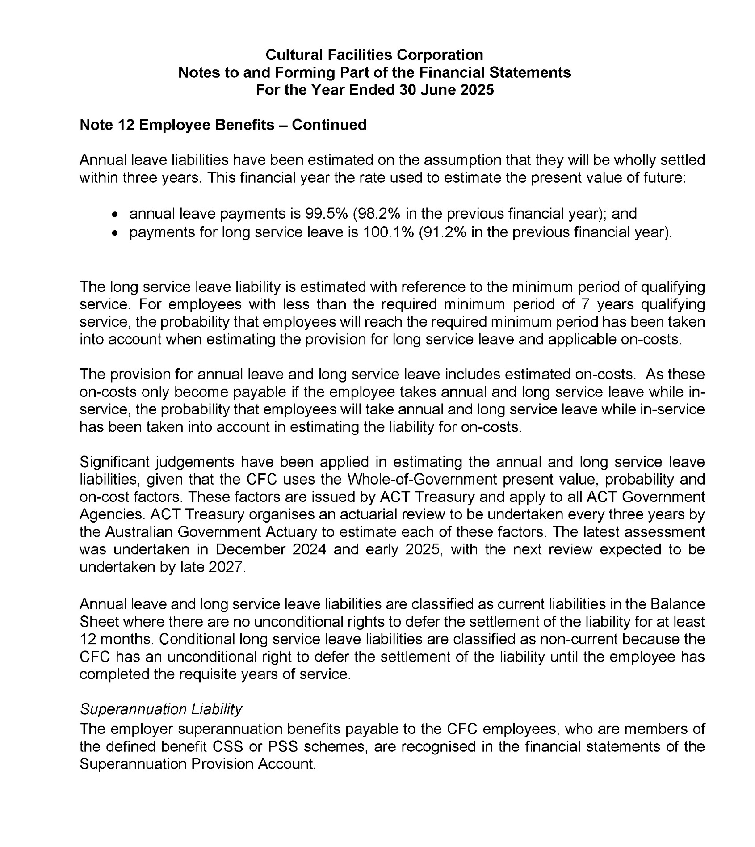
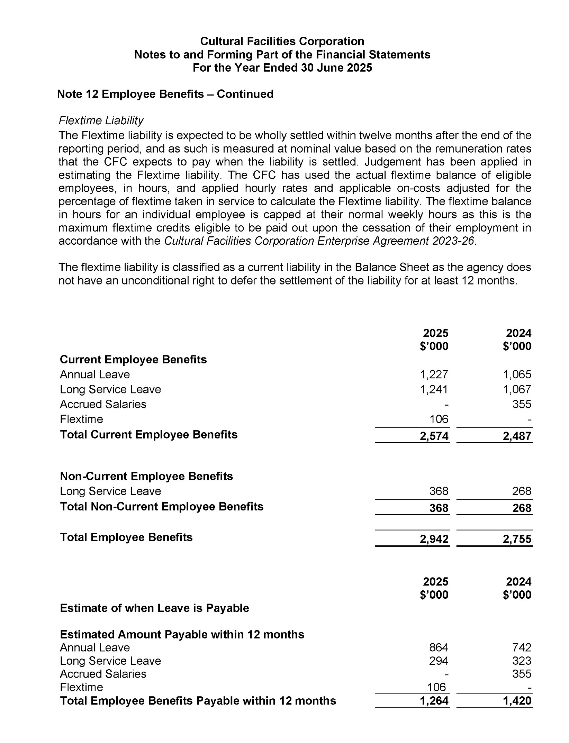
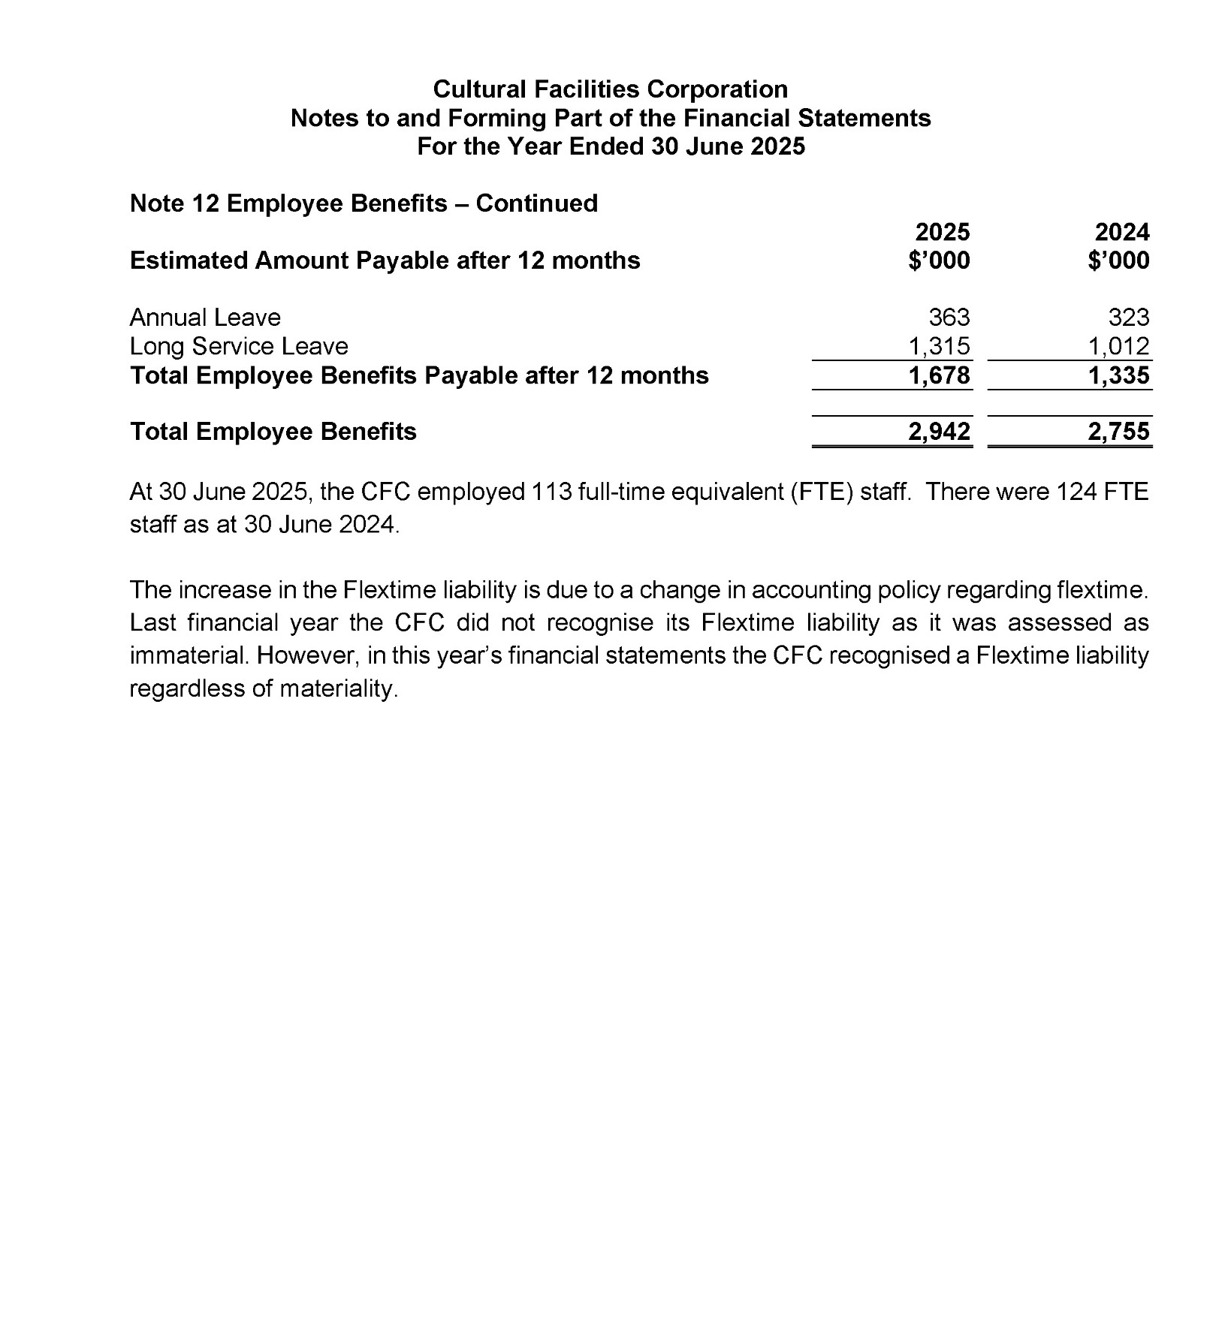
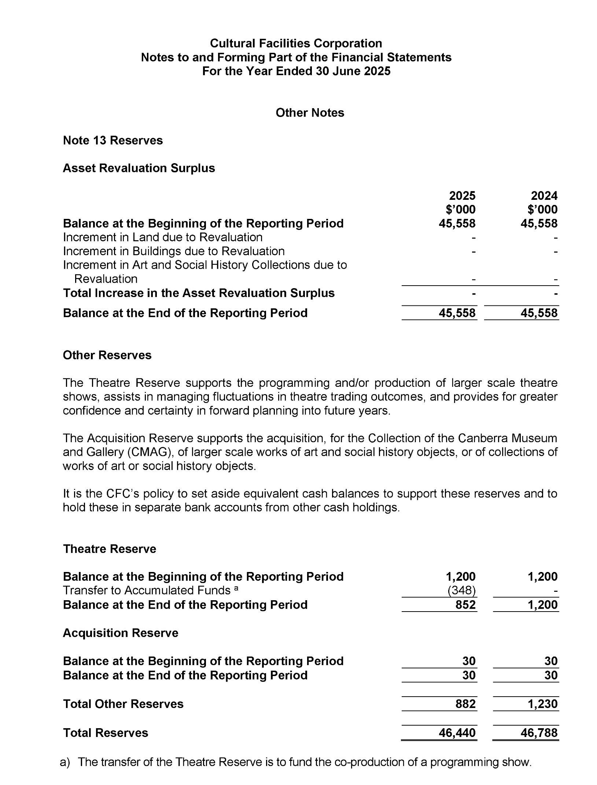
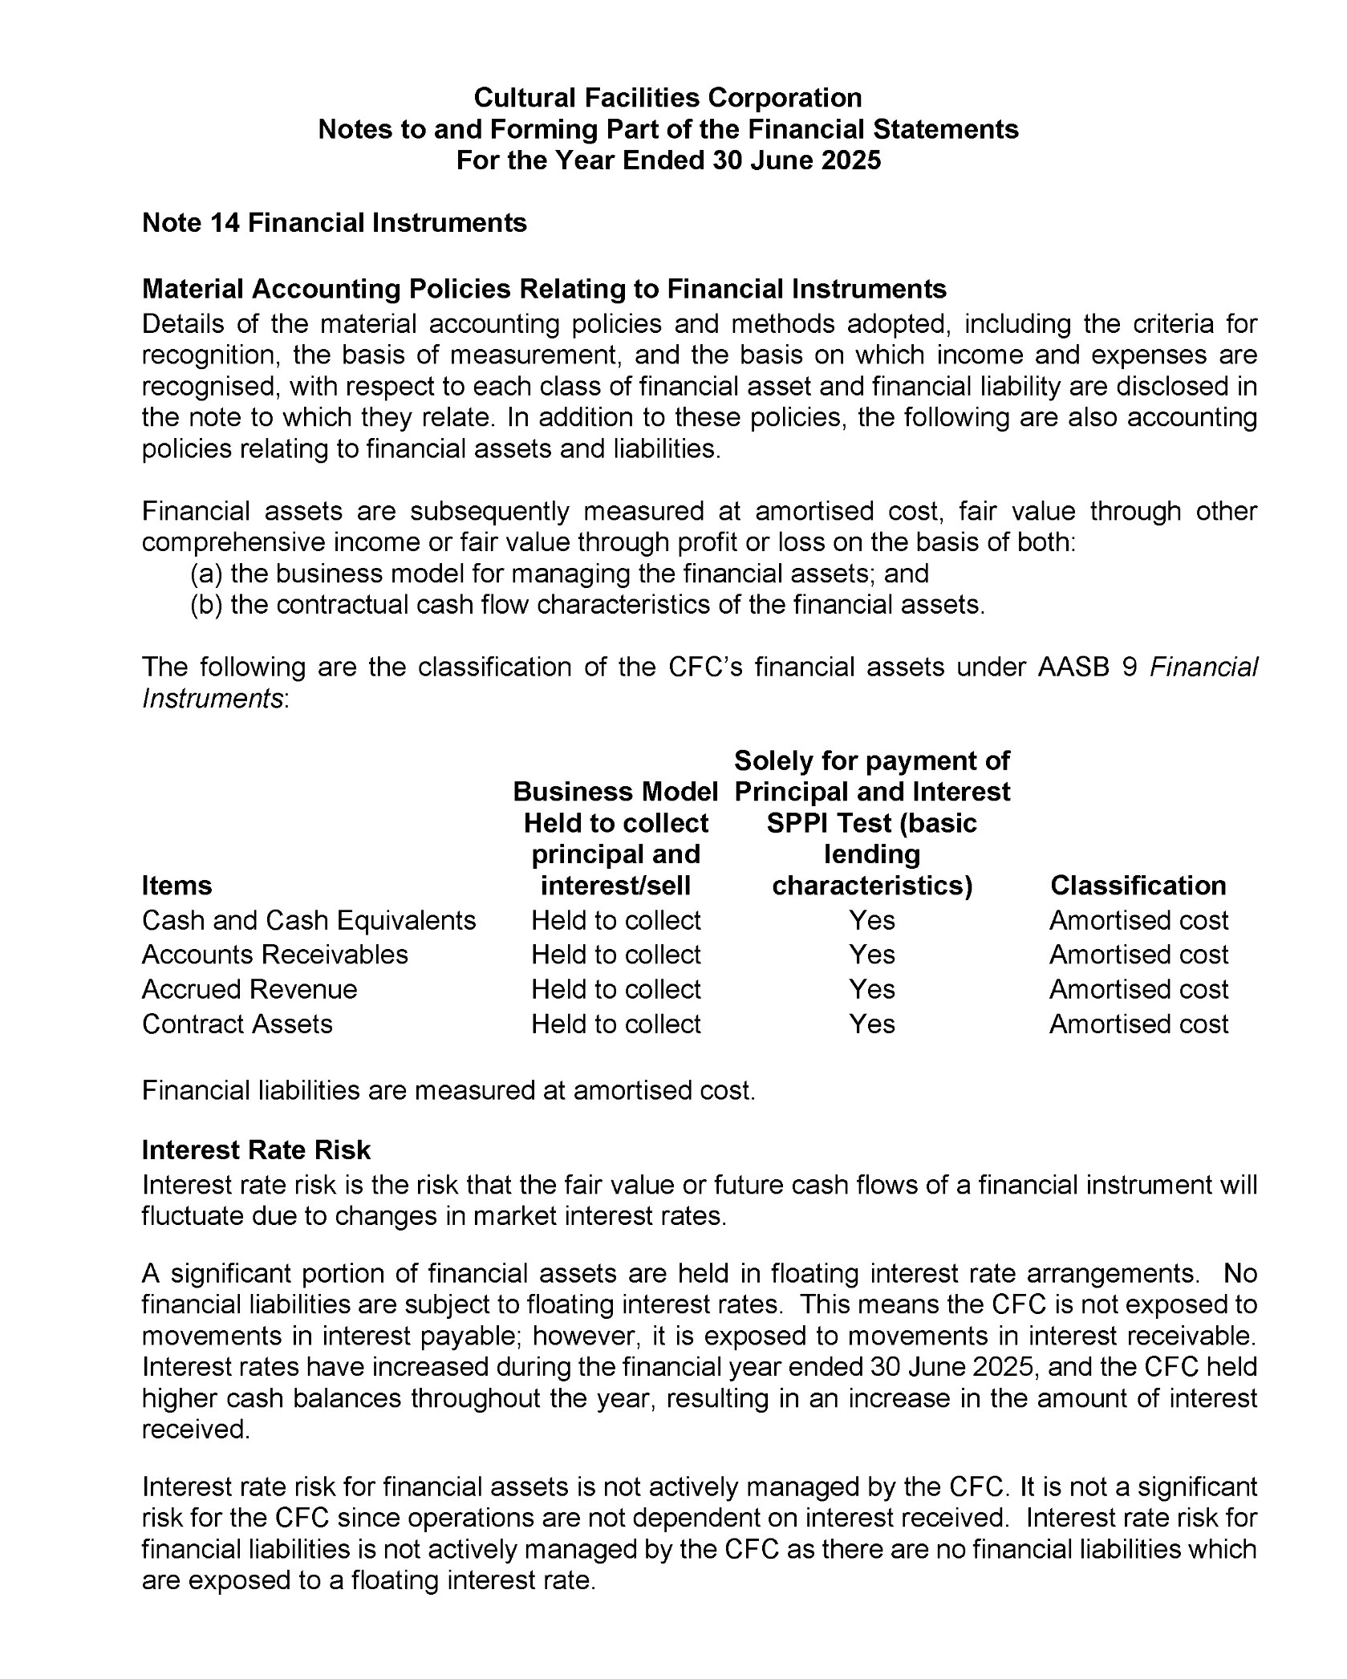
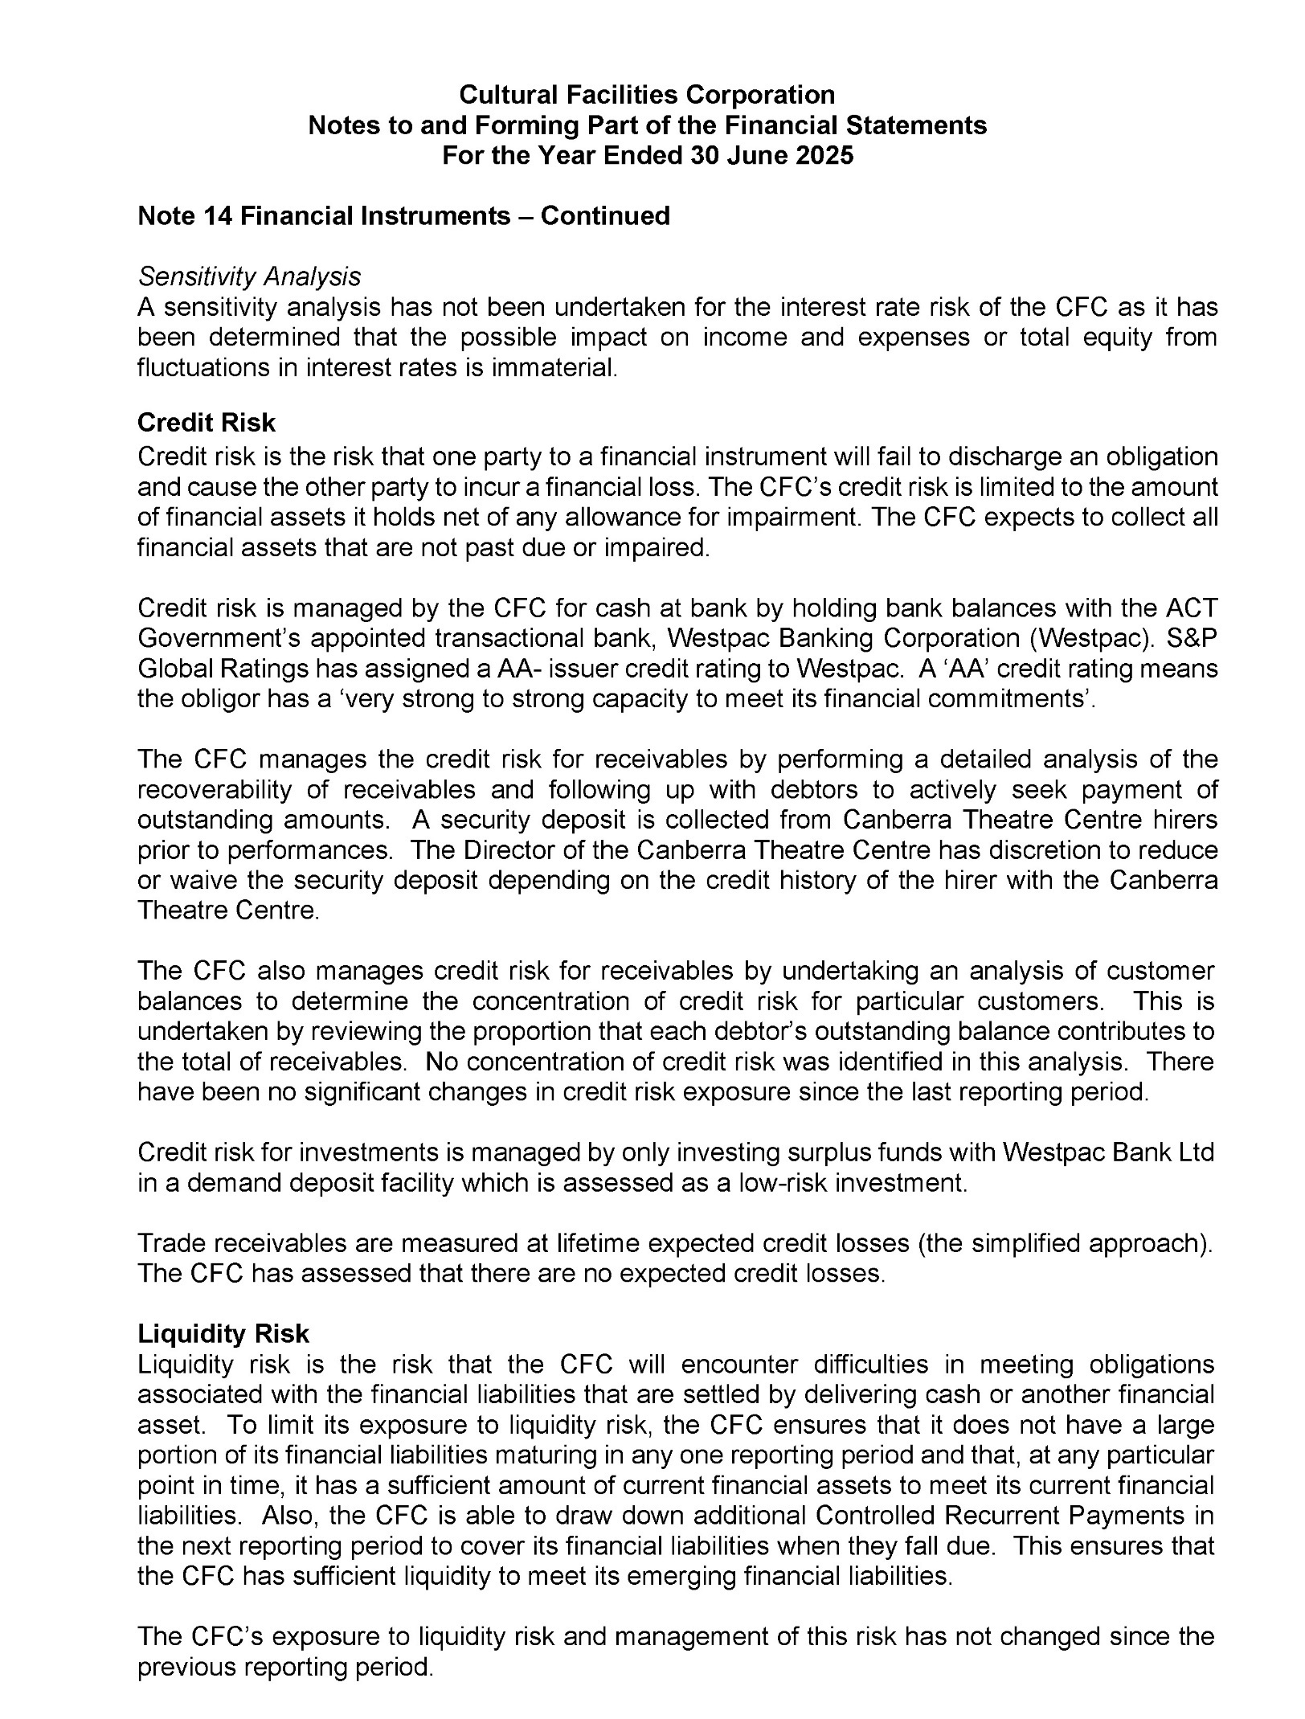
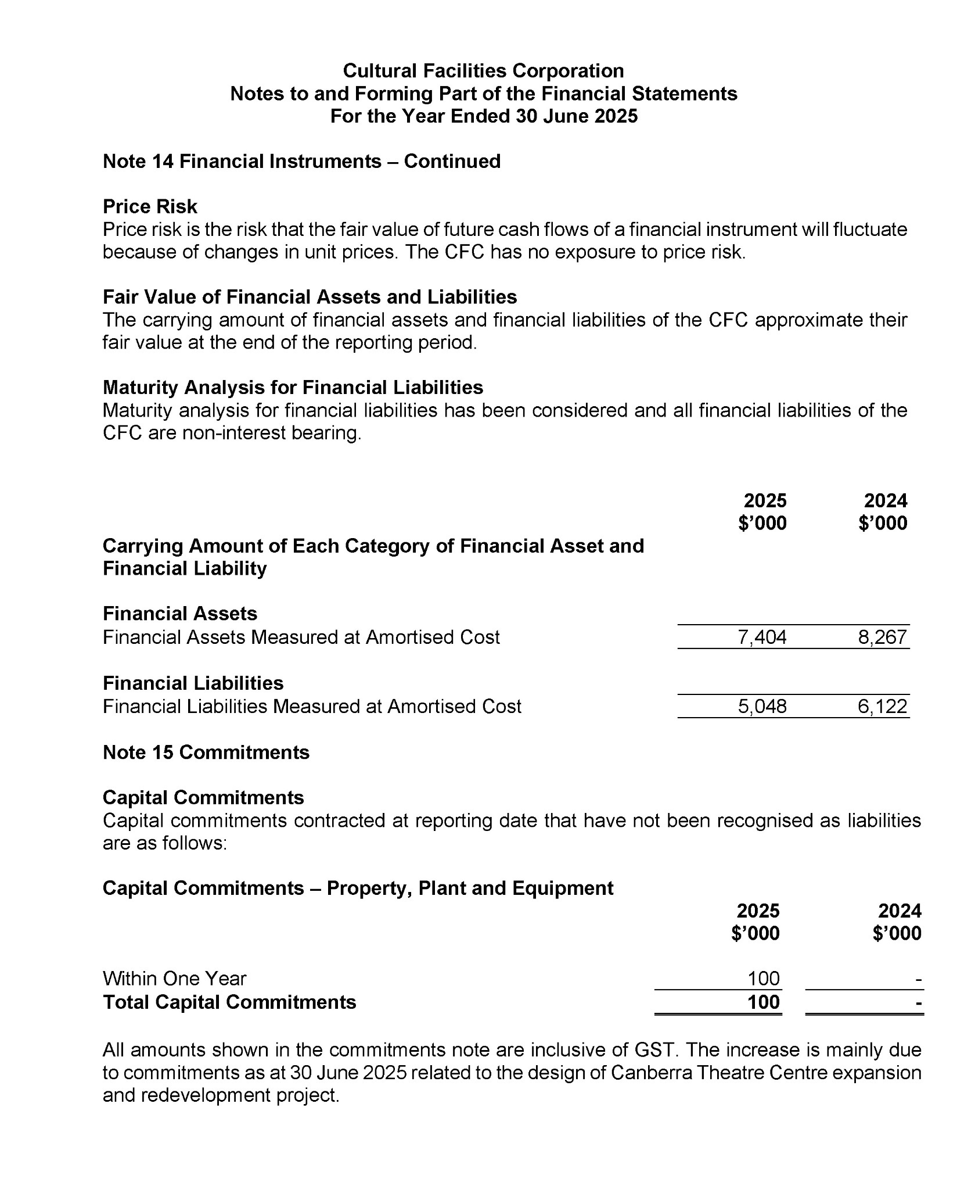
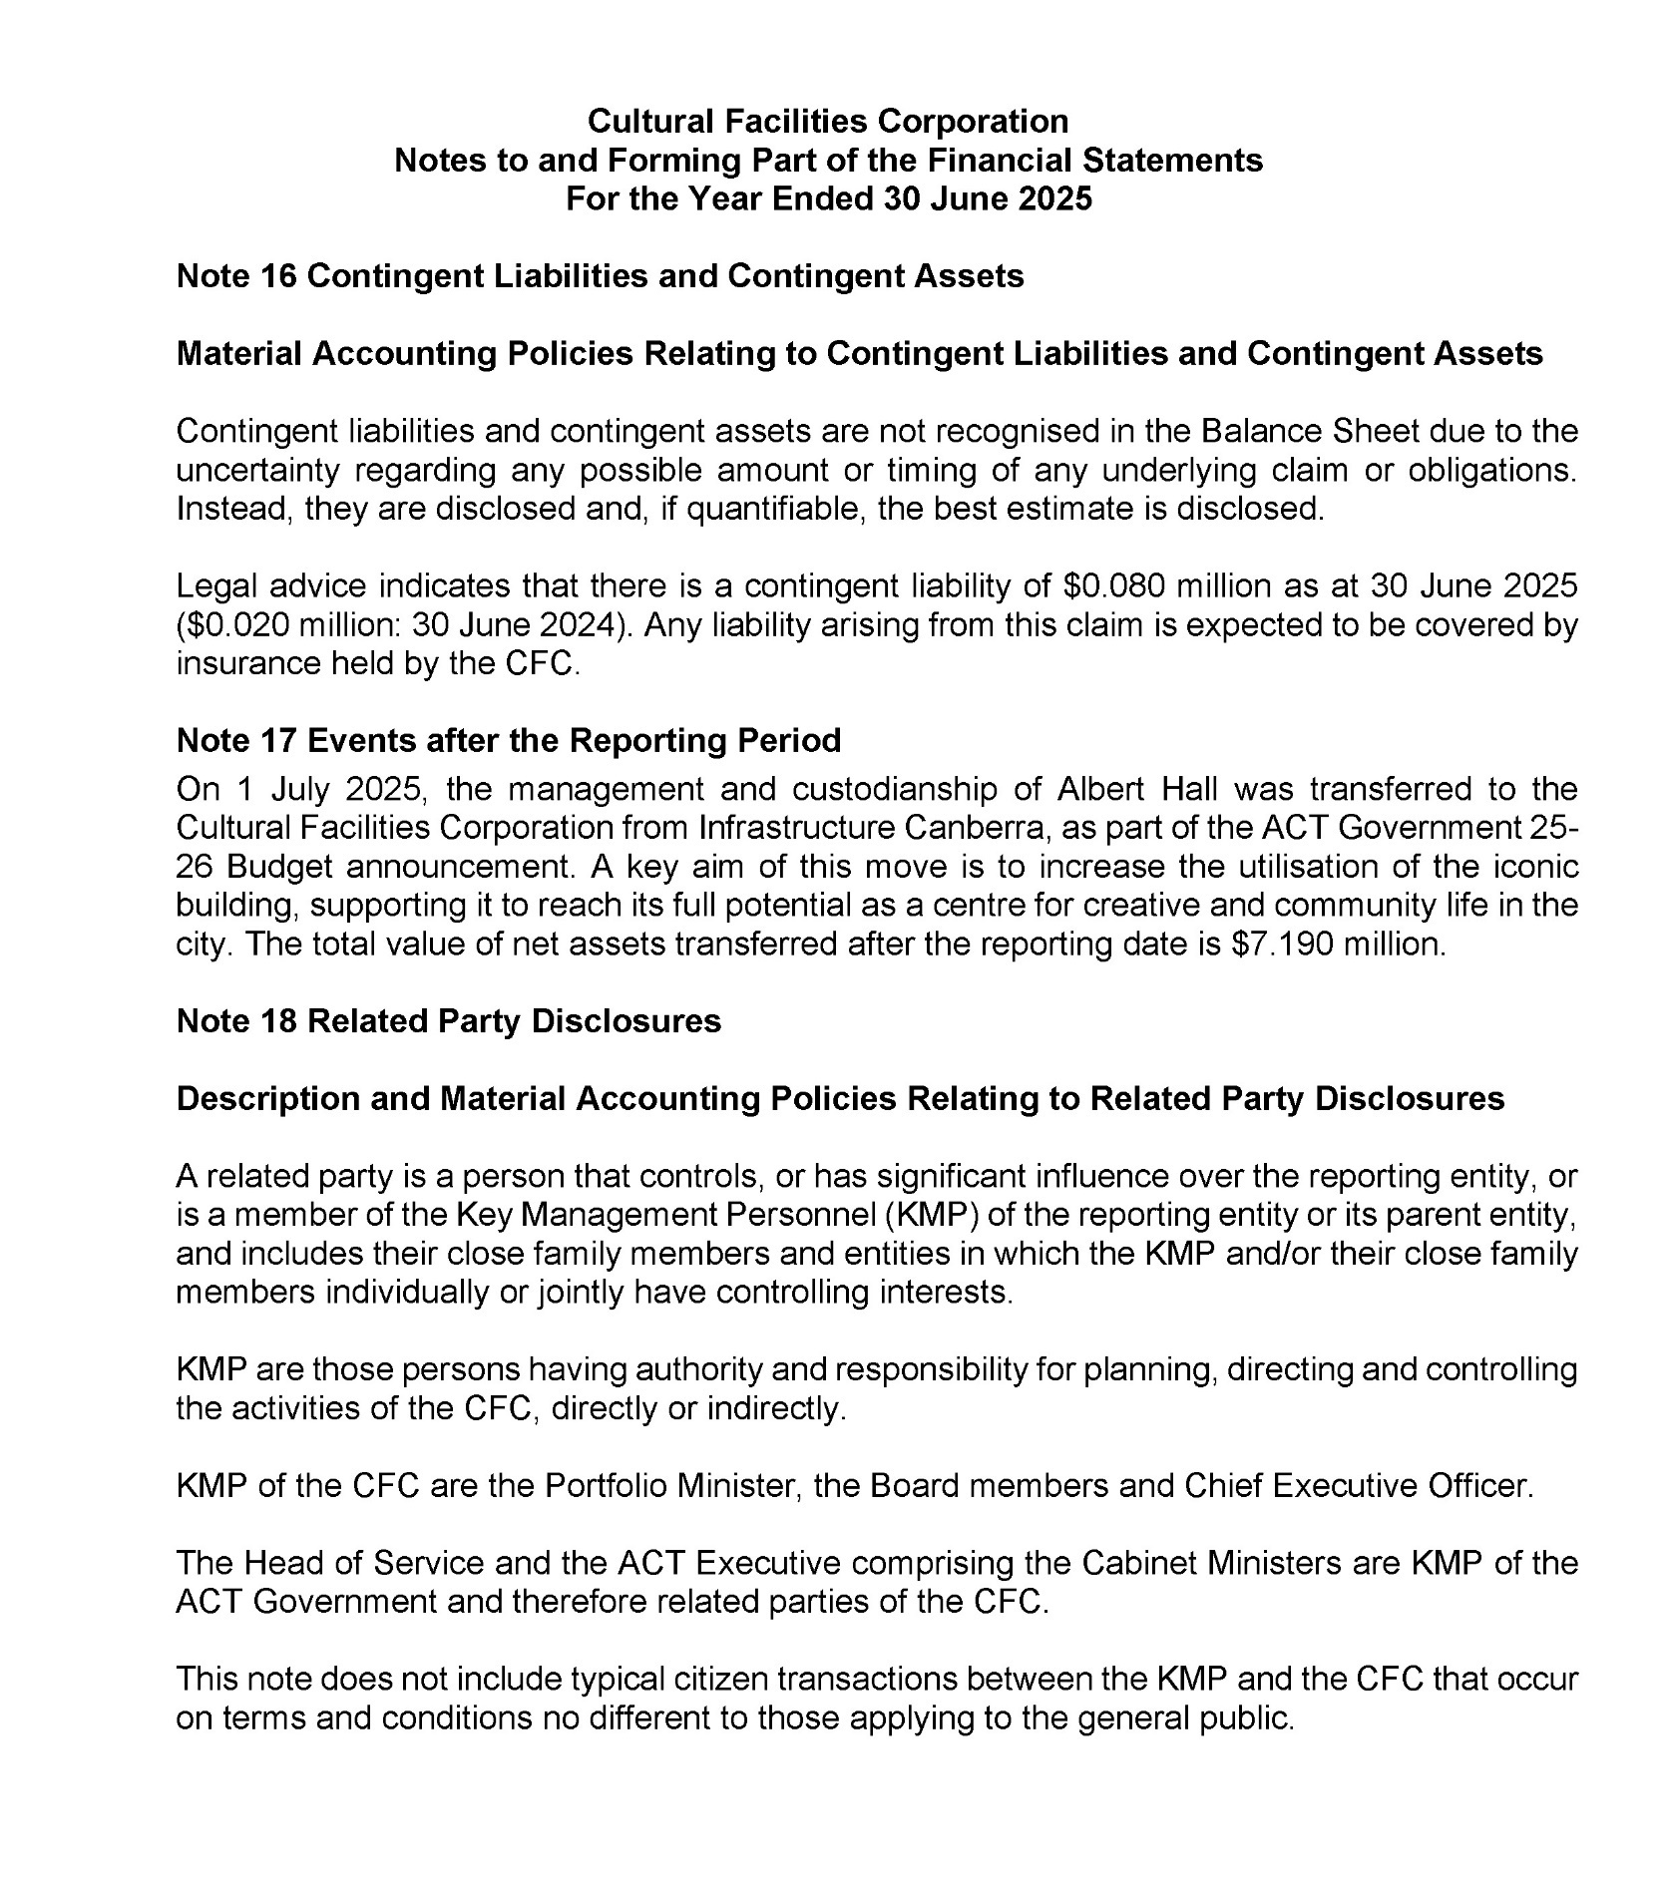
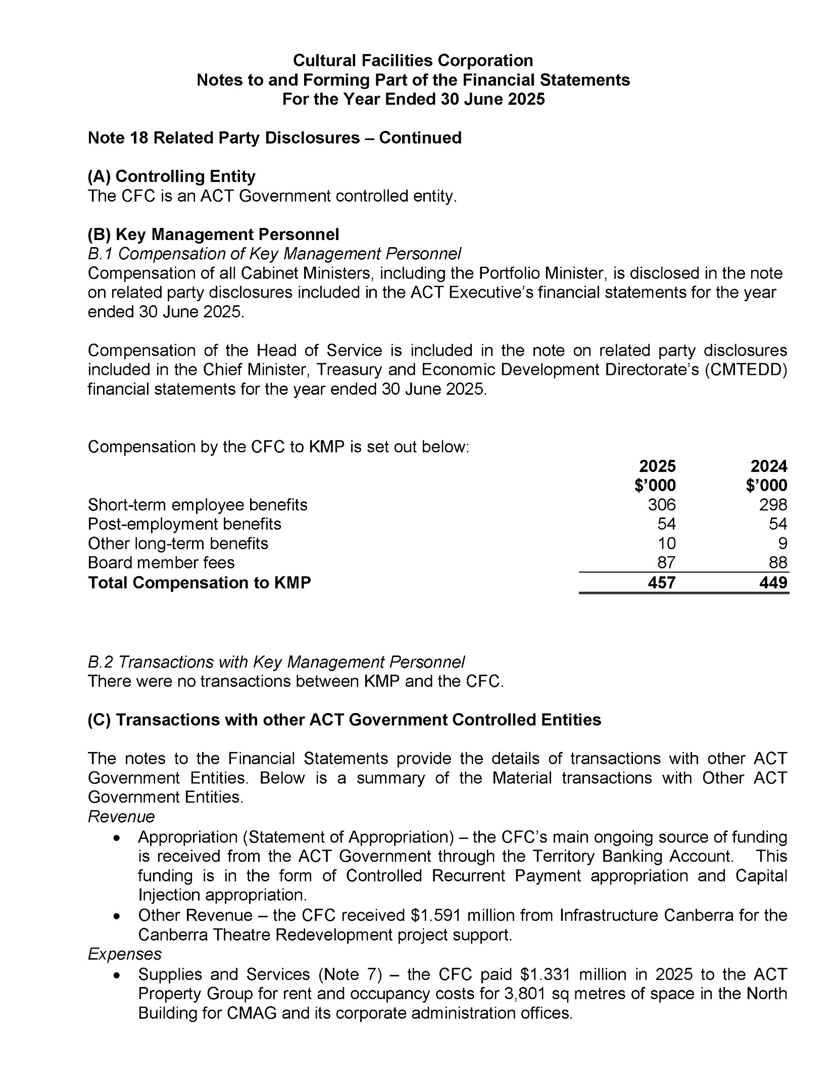
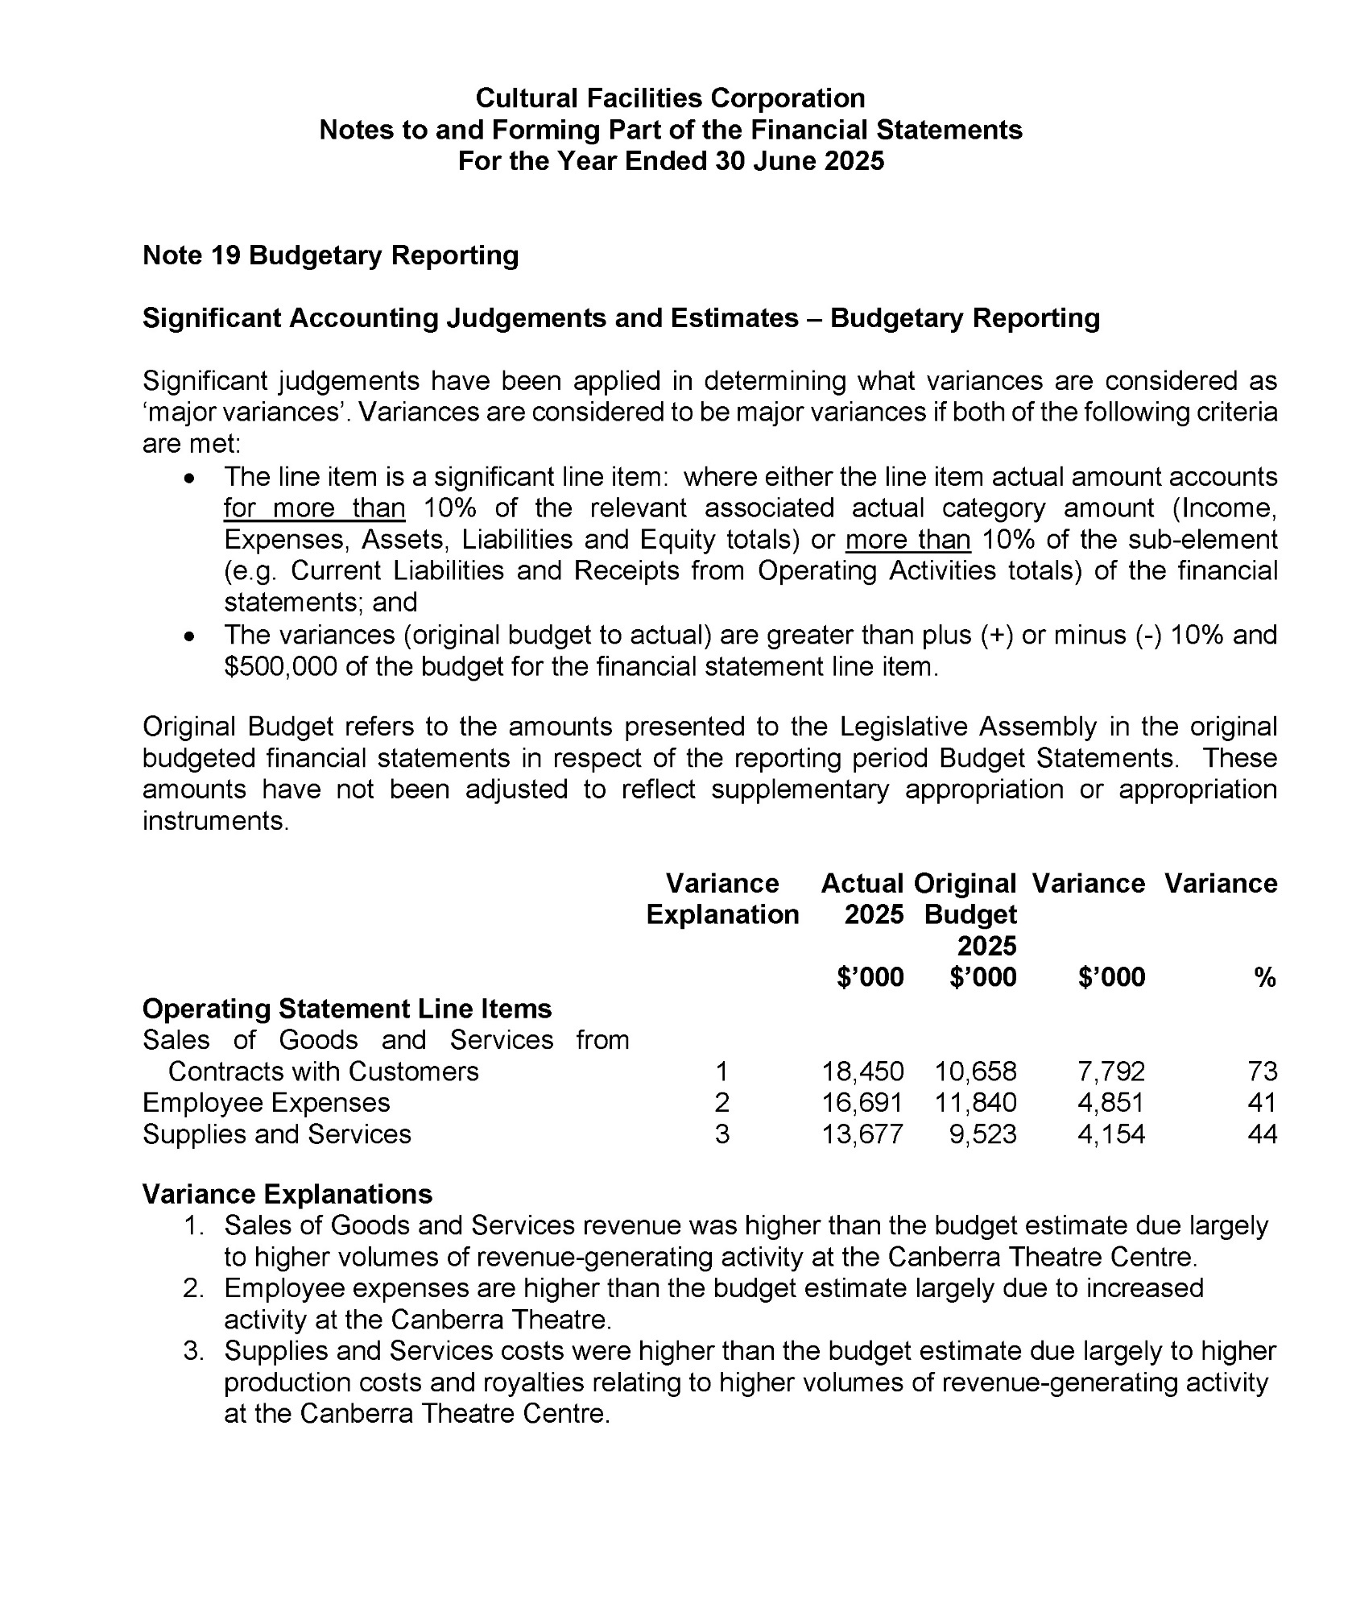
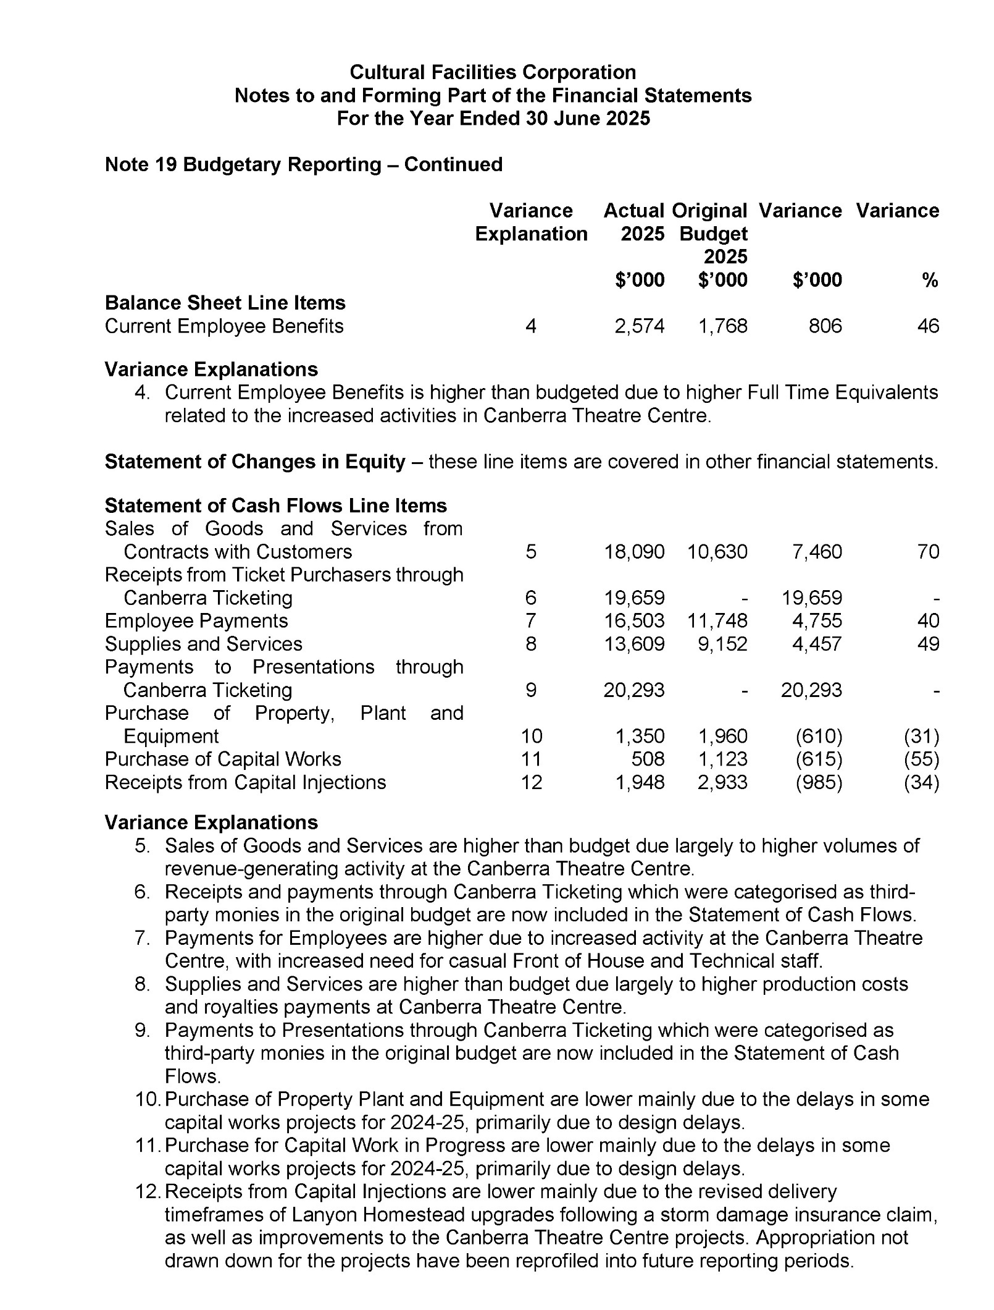

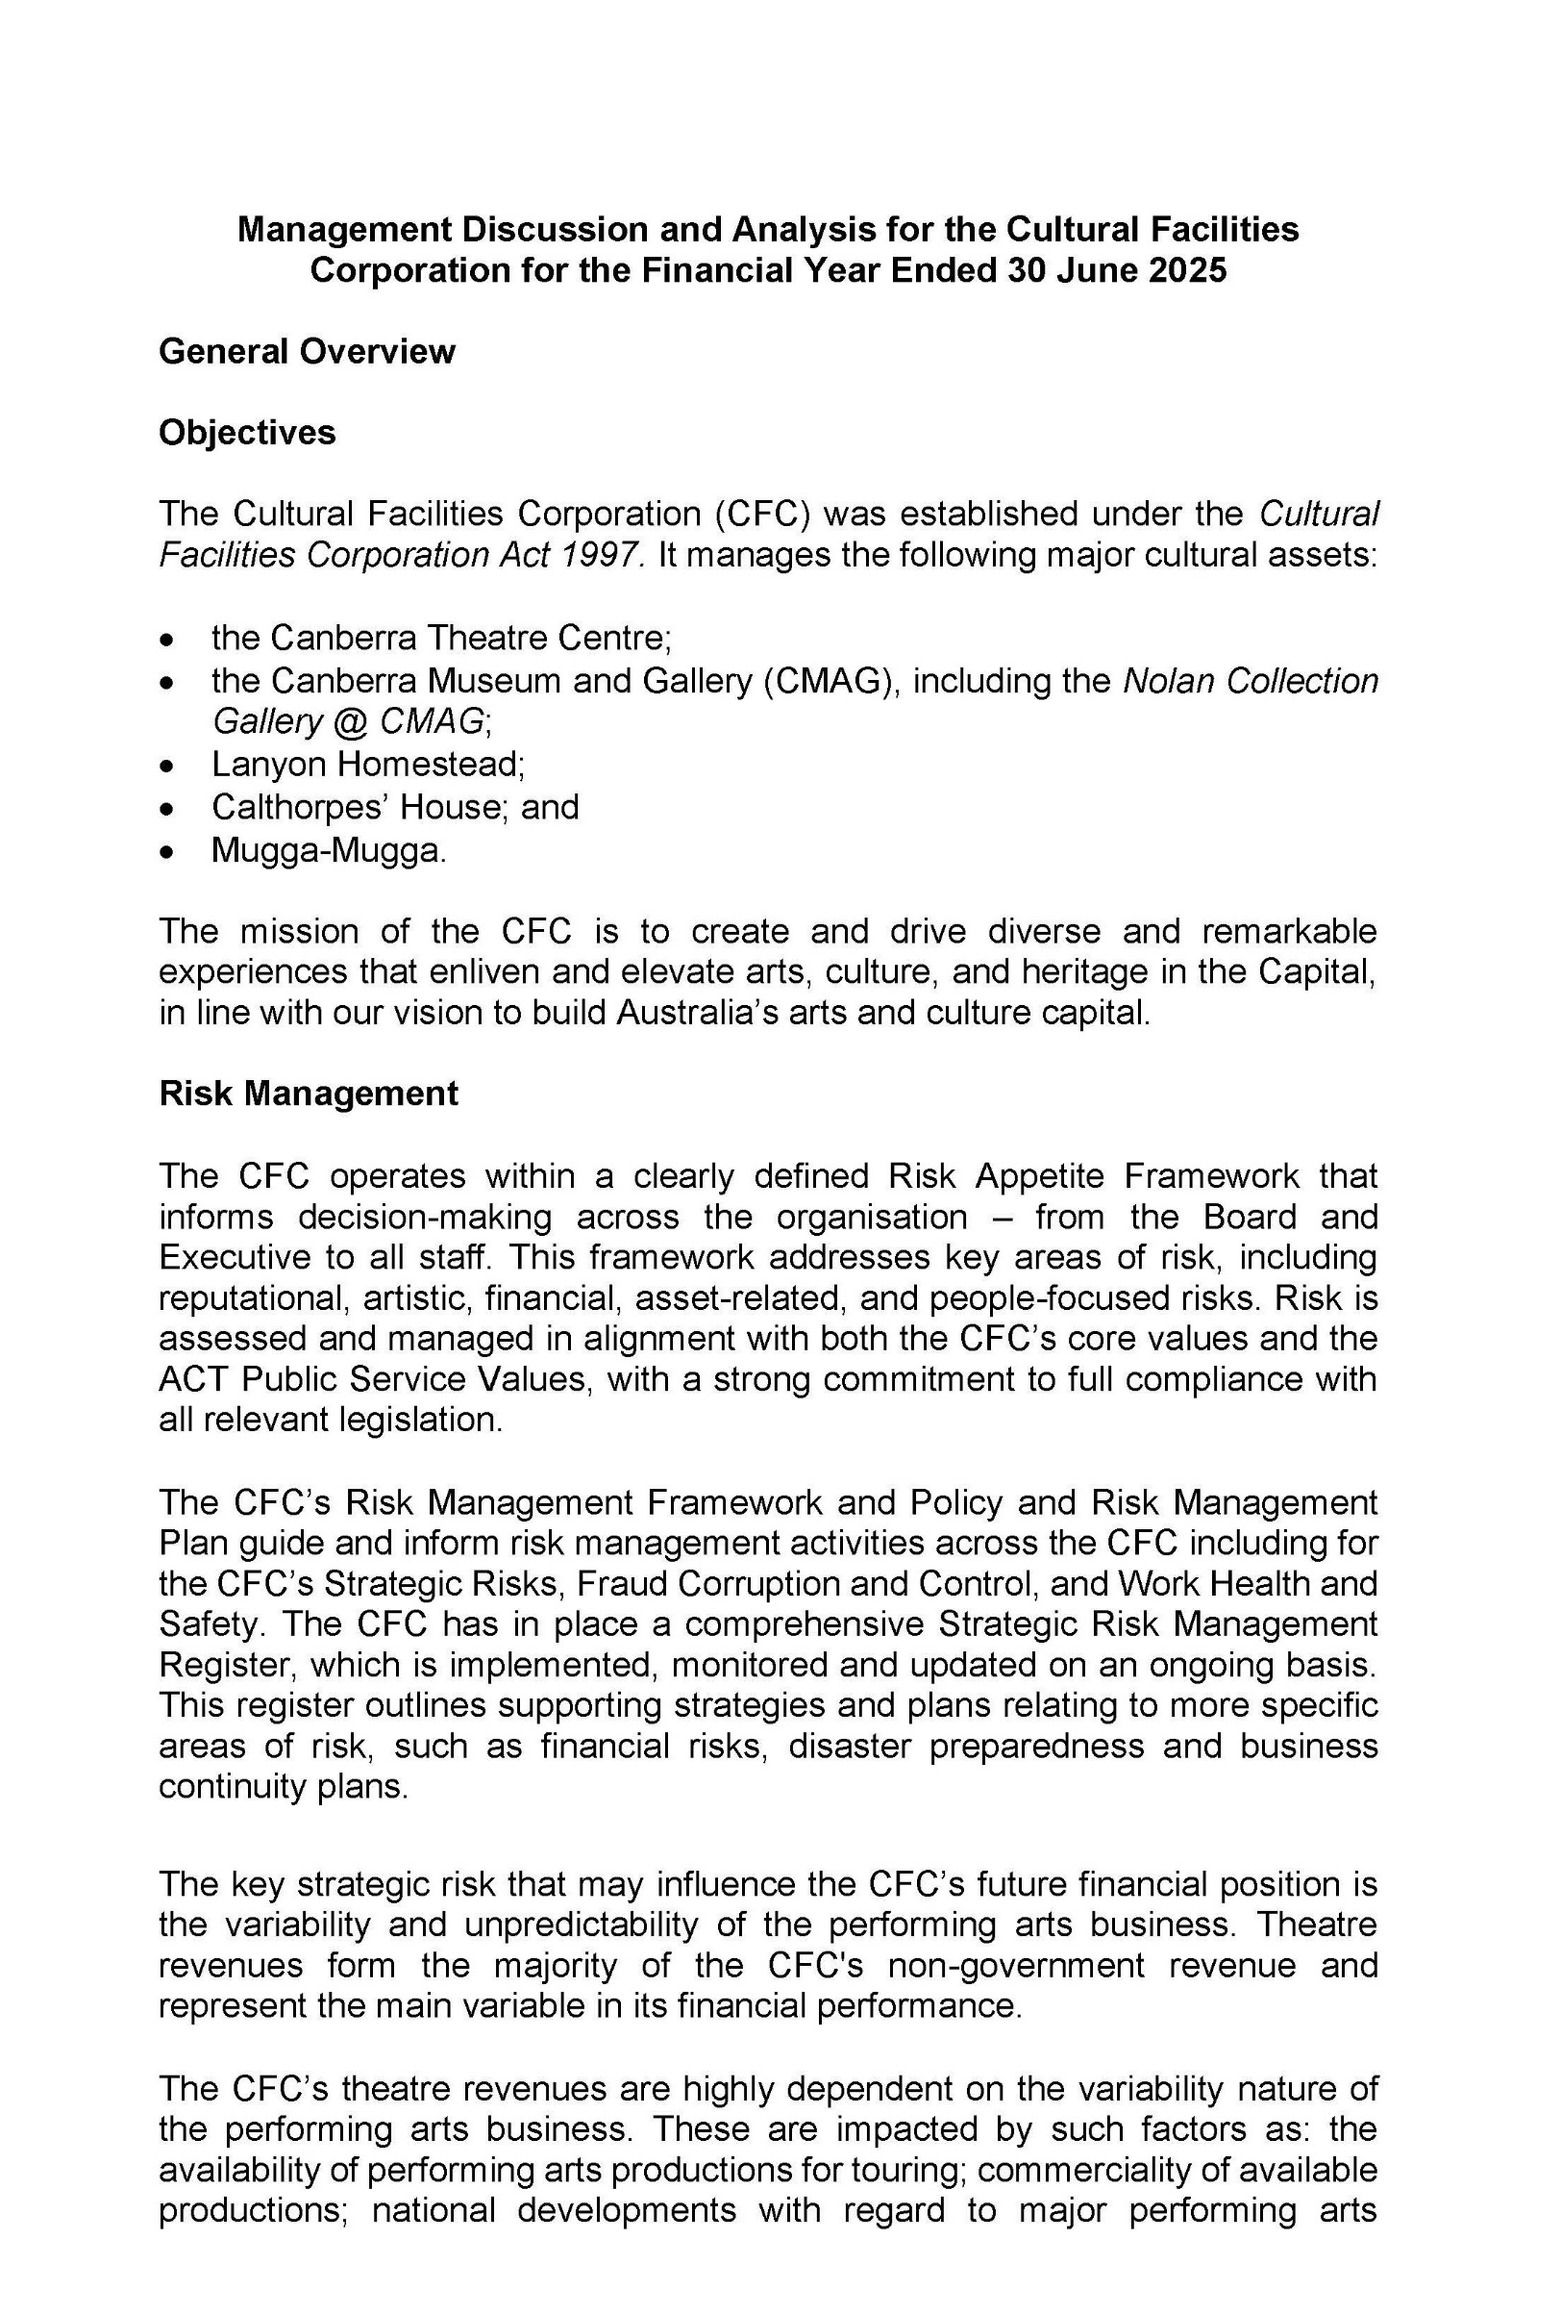
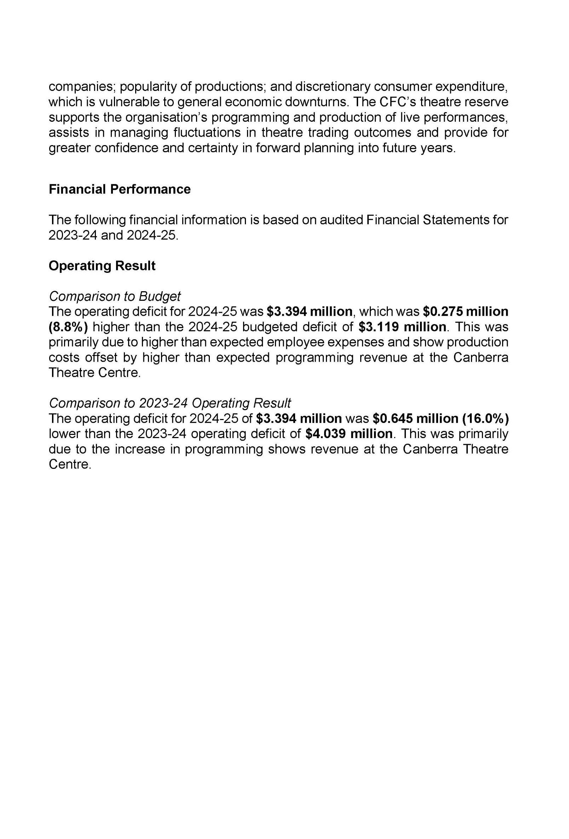
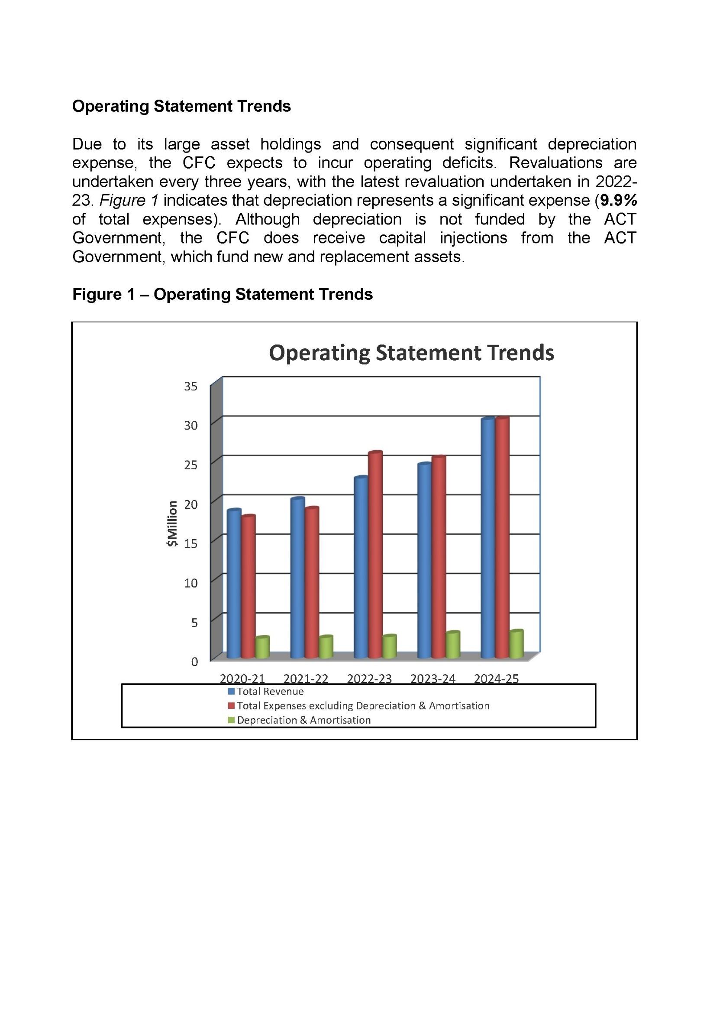
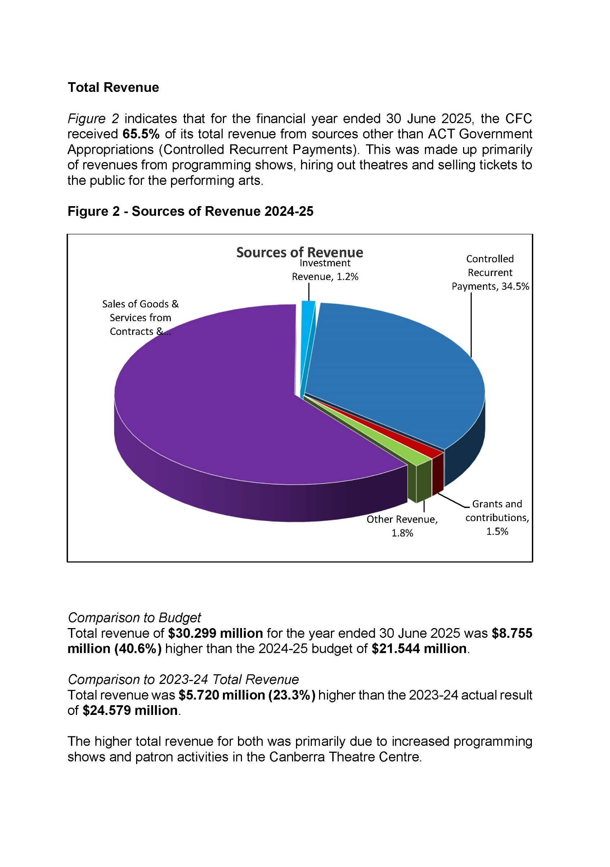
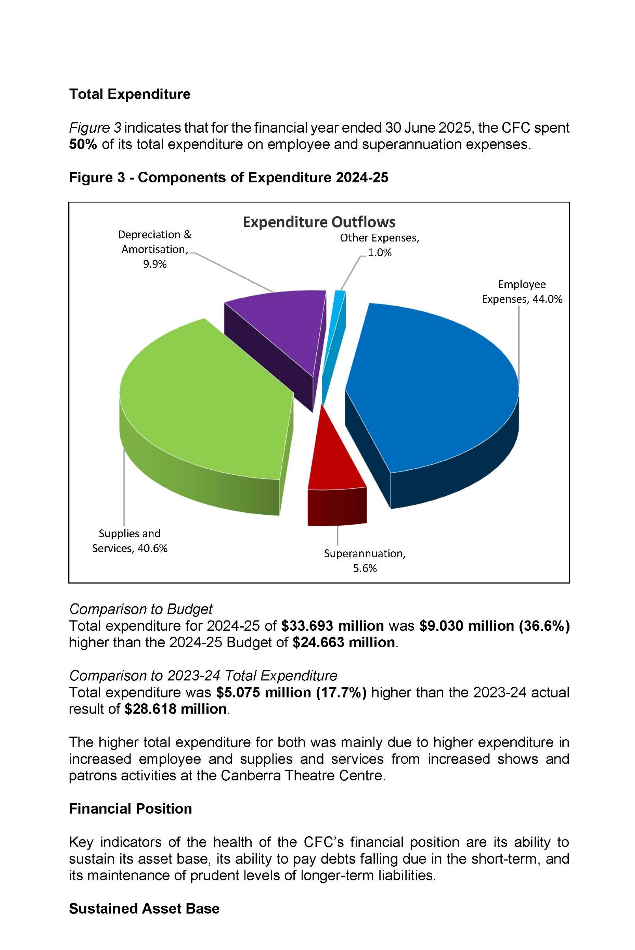
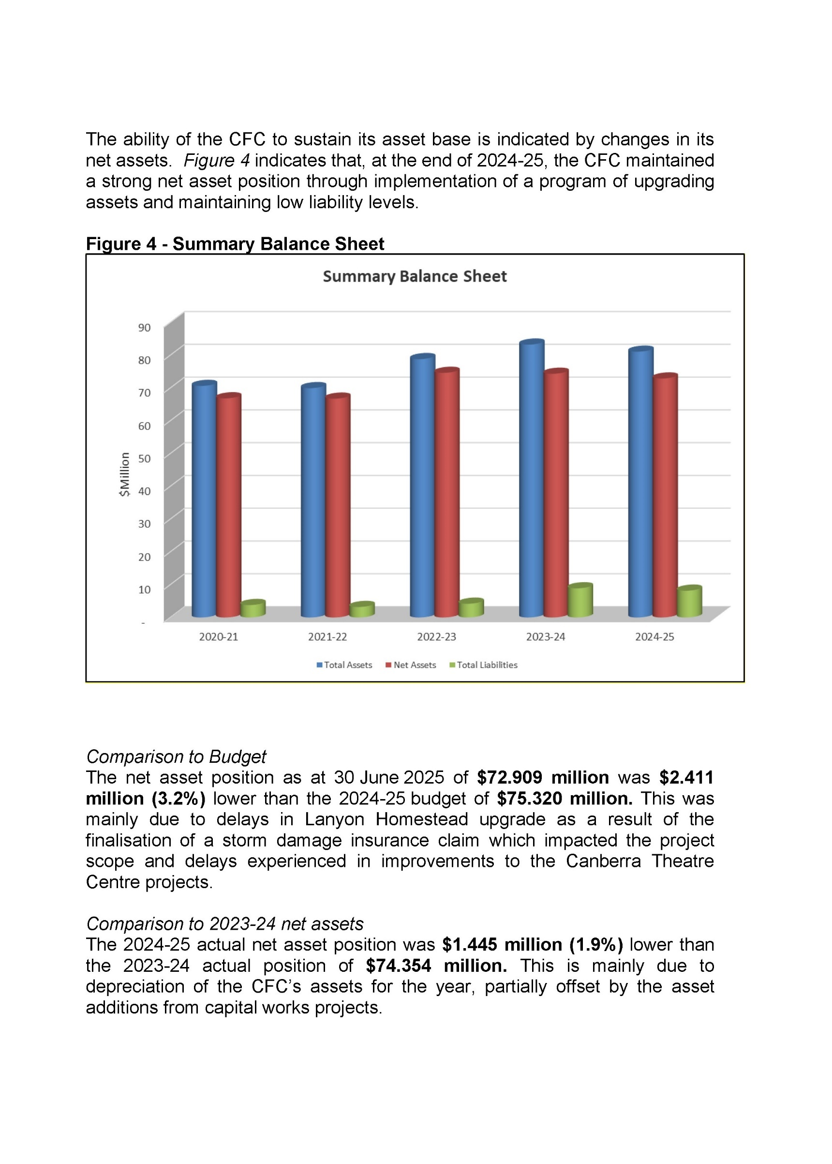
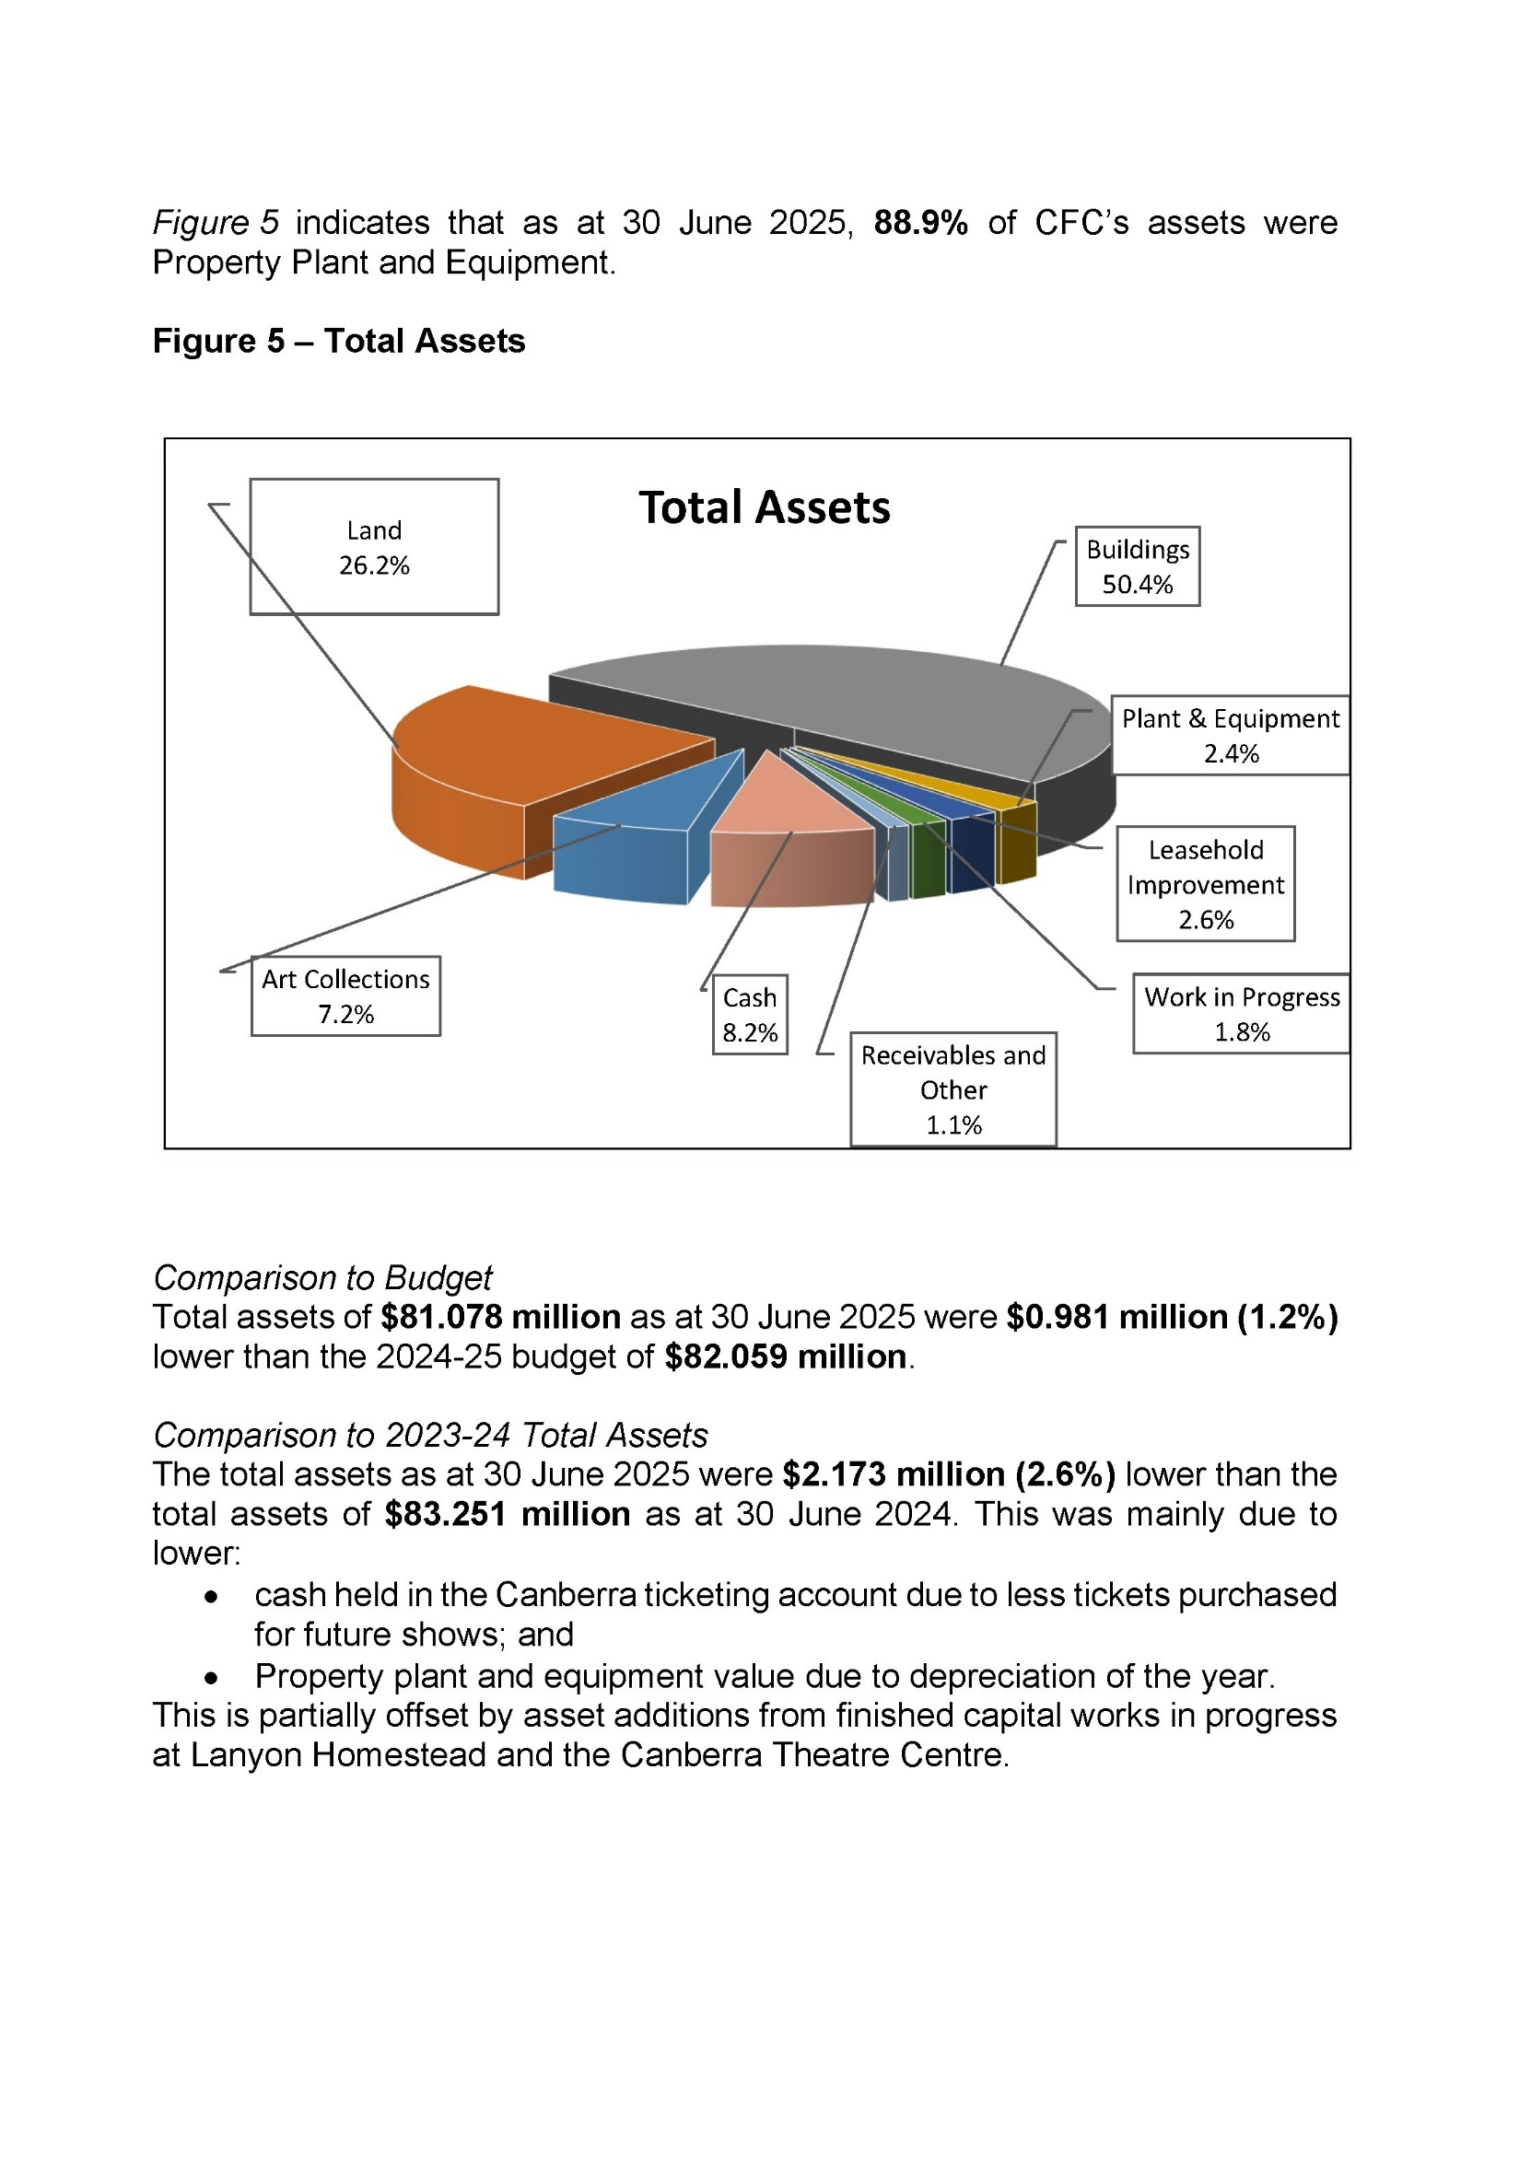
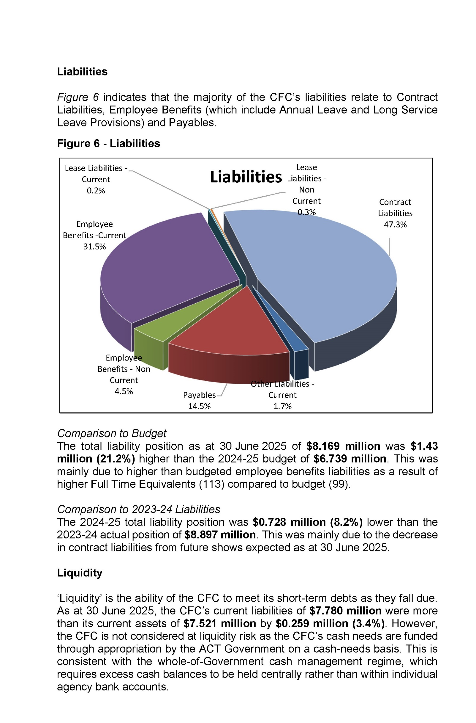

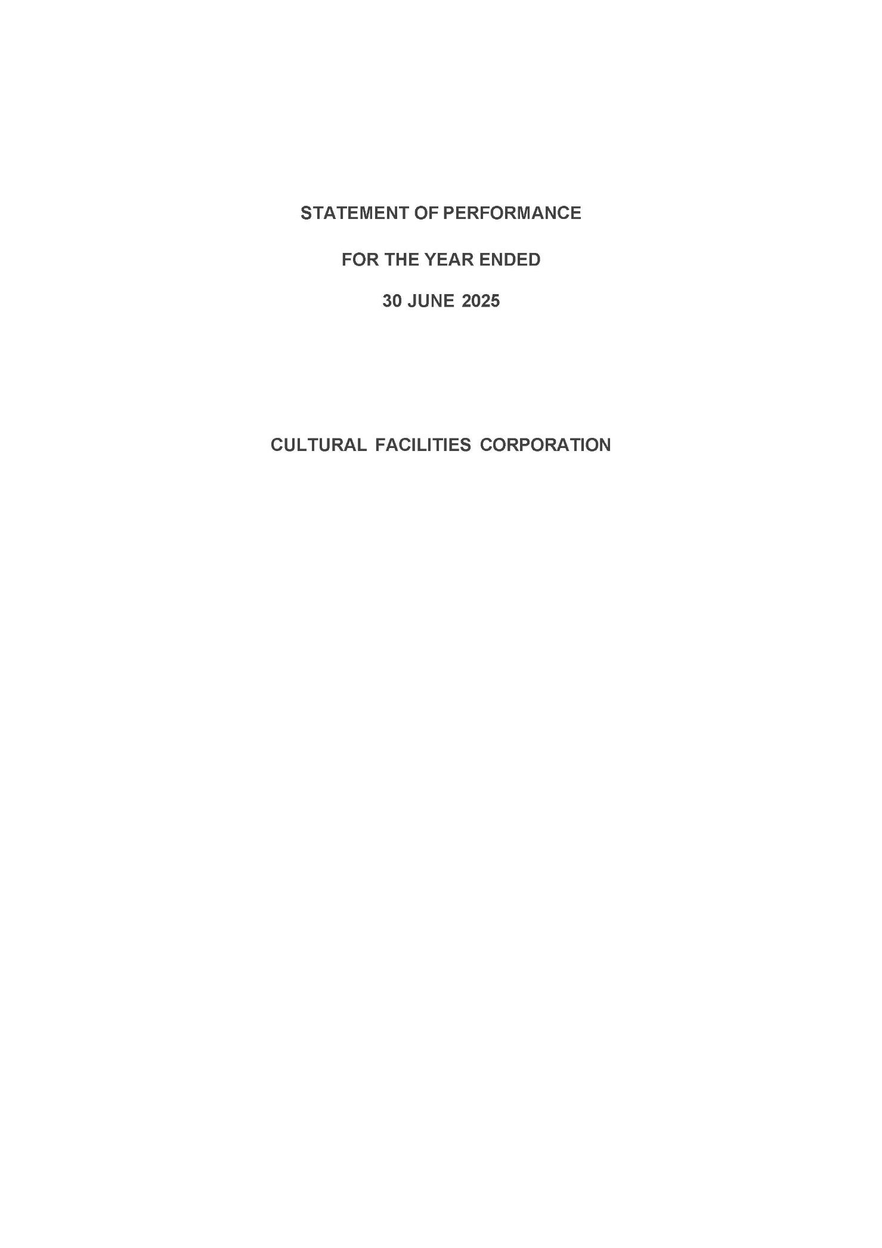
Statement of Performance
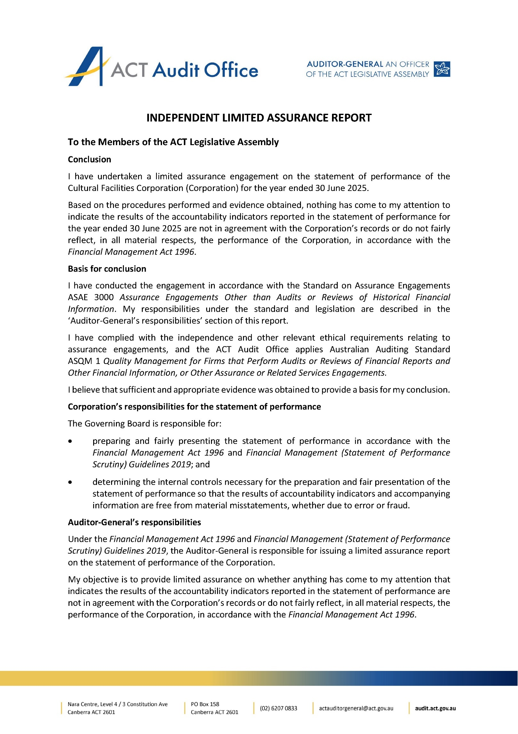
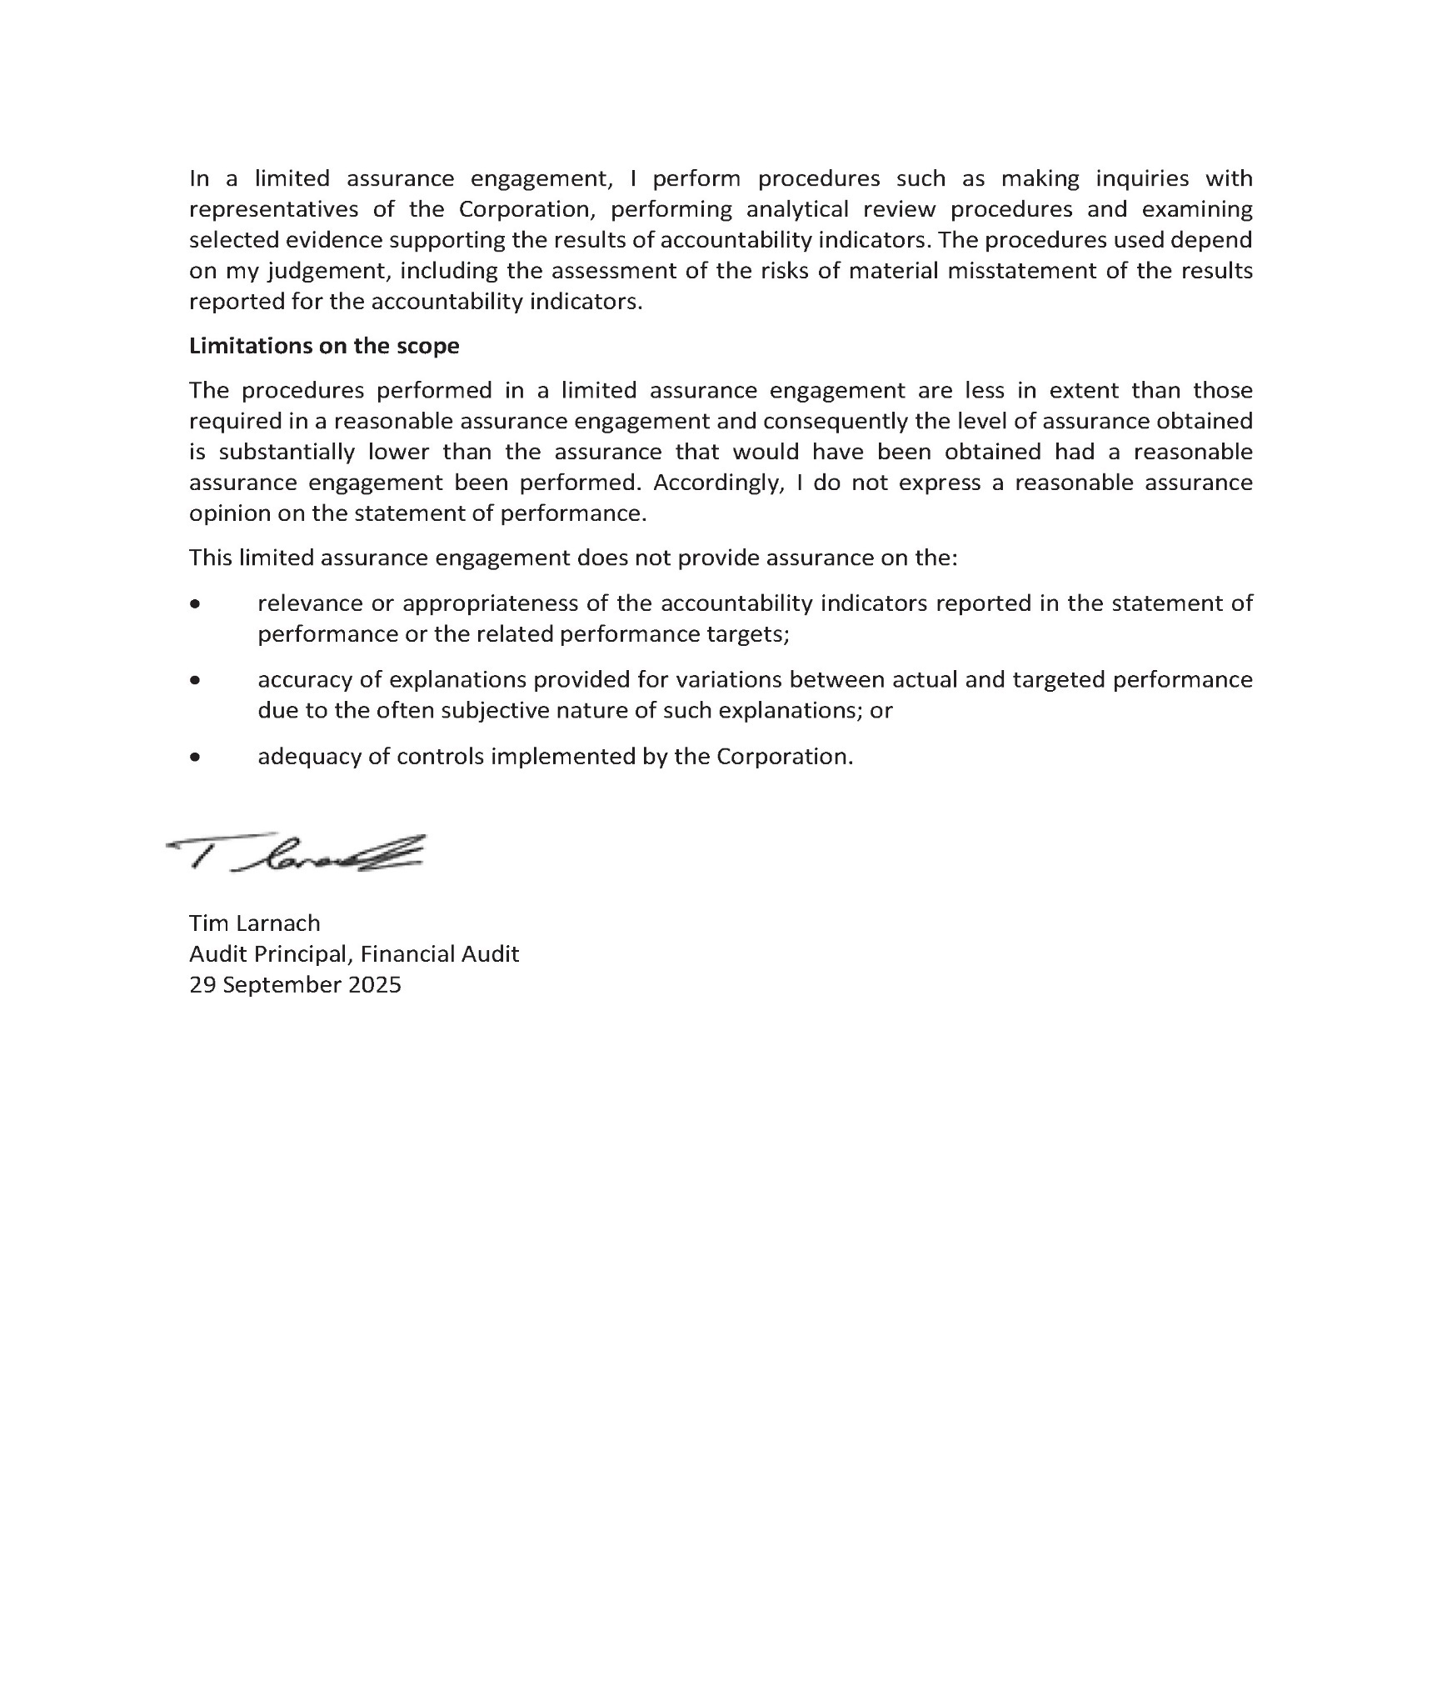
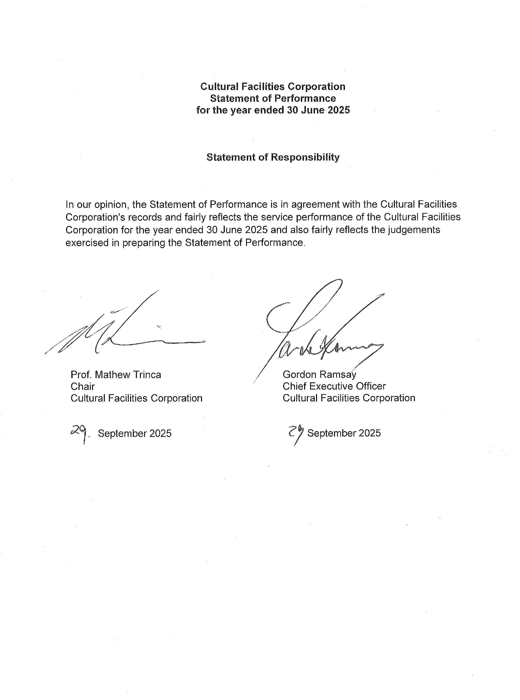
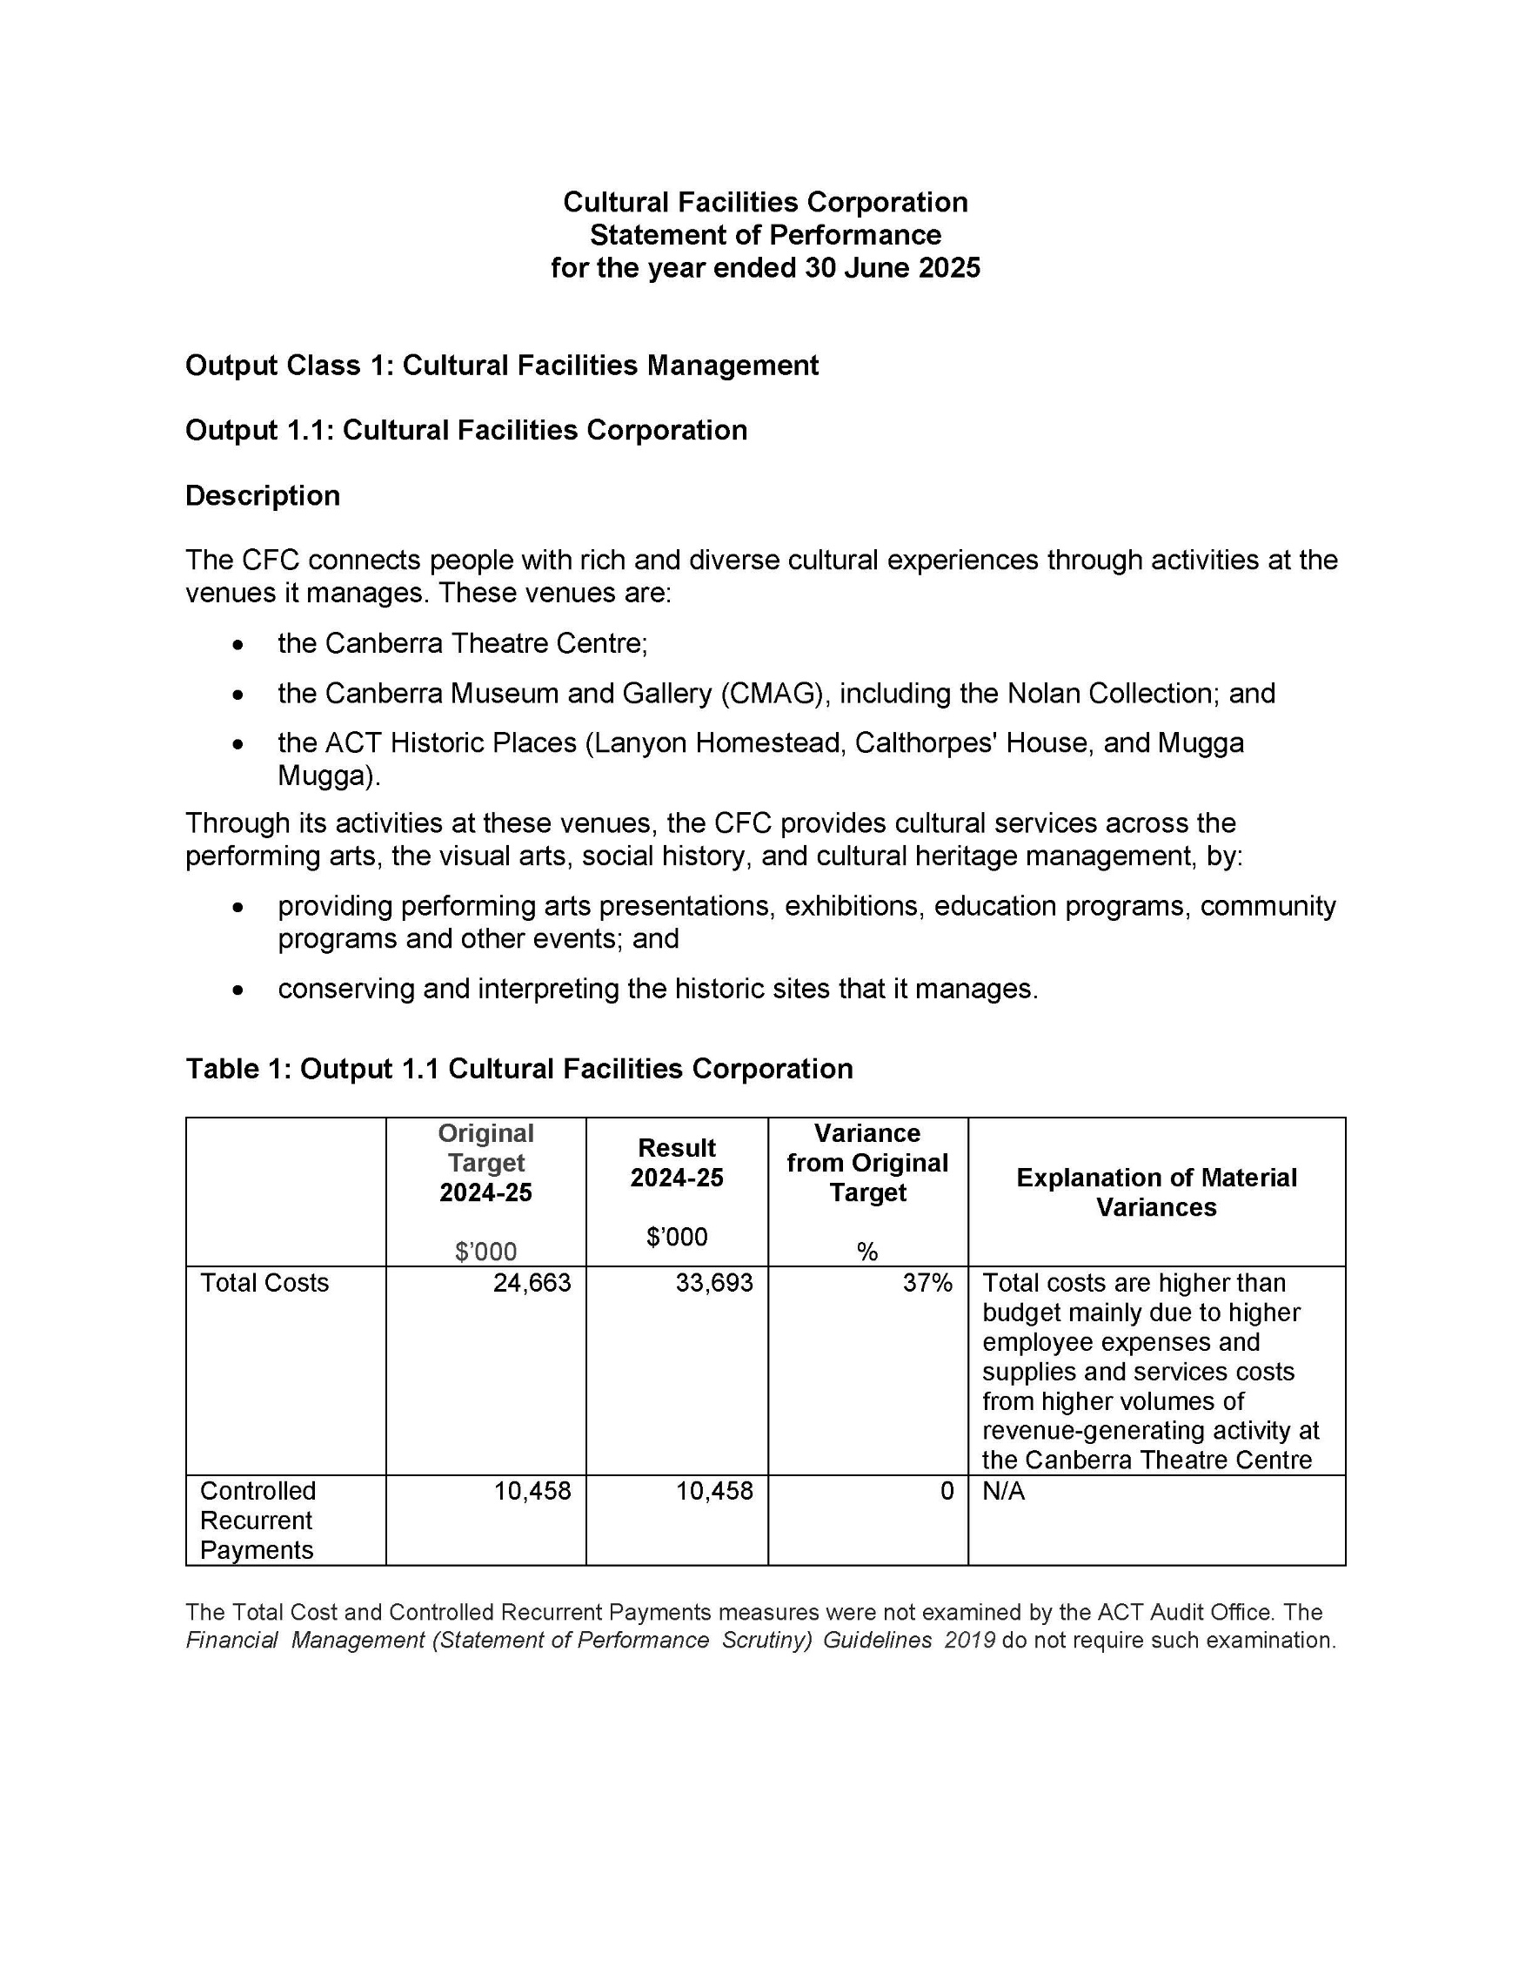
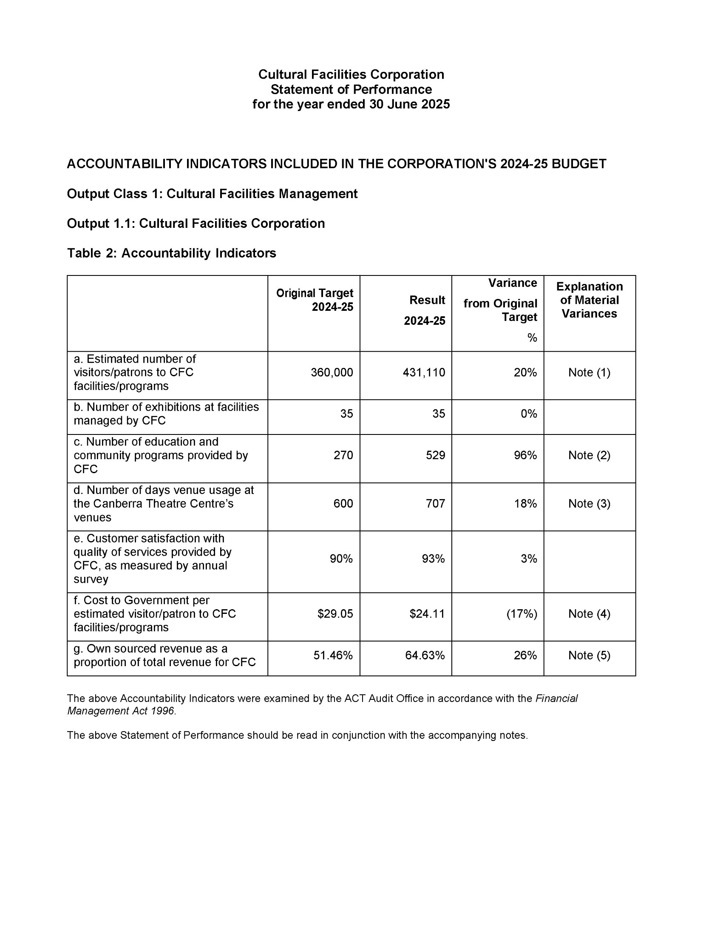
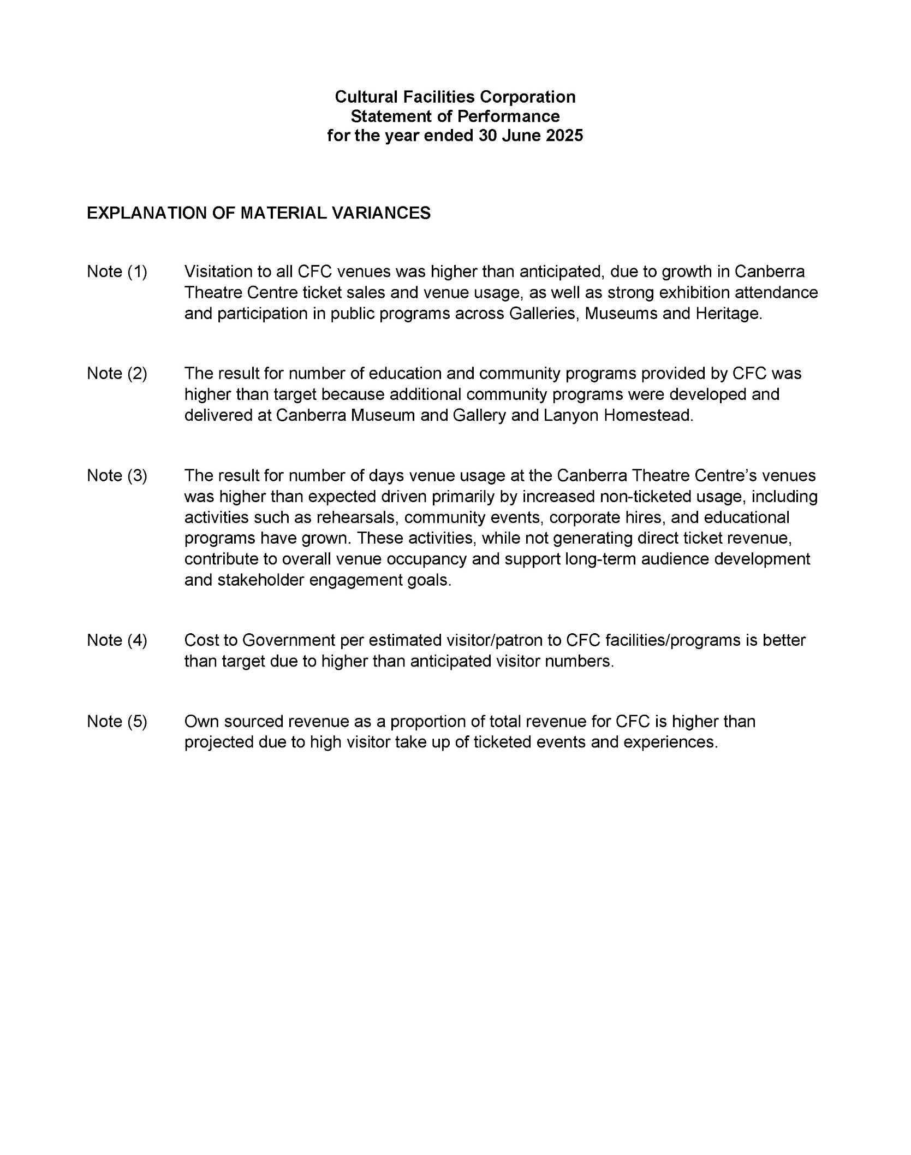
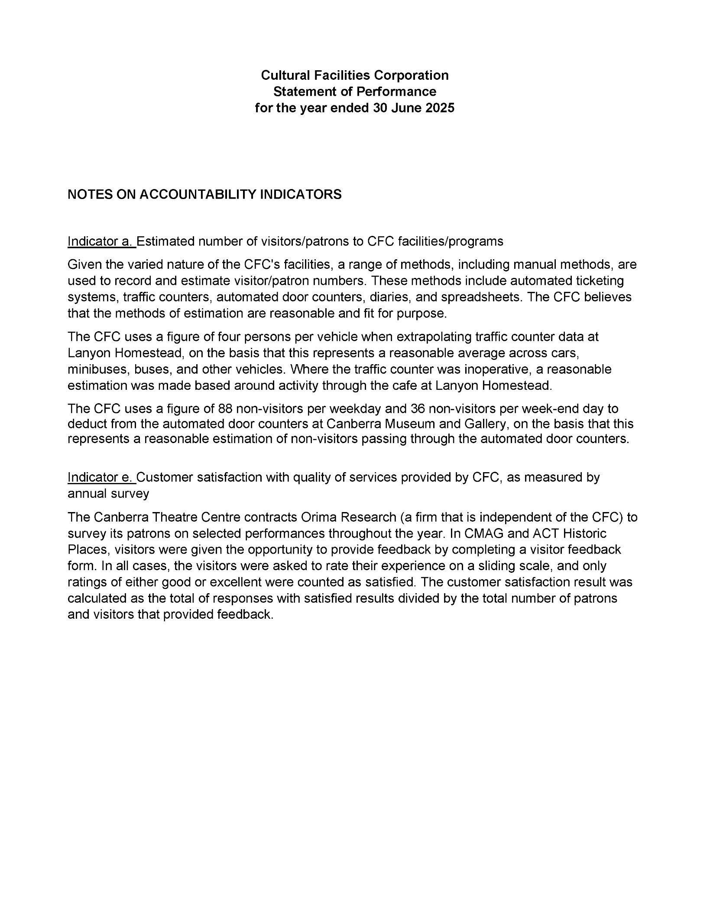

Glossary of Abbreviations and Acronyms

ABC | Australian Broadcasting Corporation
ACC | Agency Consultative Committee
ACT | Australian Capital Territory
ACTHP | ACT Historic Places
ActewAGL | ACT Electricity and Gas
ACTPS | ACT Public Service
AM | Member of the Order of Australia
AMaGA | Australian Museums and Galleries Association
ANU | Australian National University
AO | Officer of the Order of Australia
ASO | Administrative Services Officer
ASOC | Artist Society of Canberra
ATSIPP | Aboriginal and Torres Strait Islander Procurement Policy
BA | Bachelor of Arts
BCP | Business Continuity Plan
BSc | Bachelor of Science
C&E  CEO | Collaboration and Engagement  Chief Executive Officer
CFC | Cultural Facilities Corporation
CFO | Chief Financial Officer
CIO | Chief Information Officer
CMAG | Canberra Museum & Gallery
CMTEDD | Chief Minister, Treasury and Economic Development Directorate
CNG | Compressed Natural Gas
CMP | Conservation Management Plan
COVID-19 | Coronavirus disease 2019
CPI | Consumer Price Index
CRA | City Renewal Authority
CRM | Client Relationship Management
CTC  CTR | Canberra Theatre Centre  Canberra Theatre Redevelopment
CYT  DA | Canberra Youth Theatre  Development Application
ESA | Emergency Services Agency
EPSDD | Environment, Planning and Sustainable Development Directorate
ESD | Ecologically Sustainable Development
ESP | Enterprise Sustainability Platform
FBT | Fringe Benefits Tax
FCP | Fraud Control Plan
FM | Financial Management
FM Act | Financial Management Act 1996
FM | Frequency Modulation
FOI  FTE | Freedom of Information  Full Time Equivalent
GHG | Green House Gas
GMH  GSO | Galleries, Museums & Heritage  General Services Officer
GST | Goods and Services Tax
HR | Human Resources
ICOMOS | International Council on Monuments and Sites
iCBR | Infrastructure Canberra (formerly MPC - Major Projects Canberra)
IT | Information Technology
FOCW  Kg | Facility Operations and Capital Works  Kilogram
kWh | kilowatt hour
LED | Light-emitting diode
LPA | Live Performance Australia
LPG | Liquid Petroleum Gas
MBA | Master of Business Administration
MCC | Minister’s Creative Council
MD&A | Management Discussion and Analysis
MEAA | Media Entertainment and Arts Alliance
MLA | Member of the Legislative Assembly
MWh | megawatt hour
NAIDOC | National Aboriginal and Torres Strait Islander Peoples Day Observance Committee
NGA  NSW | National Gallery of Australia  New South Wales
OIRWS | Office of Industrial Relations and Workforce Strategy
PD | Professional Development
PhD | Doctor of Philosophy
PHEV | Plug-in Hybrid Electric Vehicle
PO | Professional Officer
RED | Respect, Equity and Diversity
S | Section
SES | Senior Executive Service
SLT  SOG | Senior Leadership Team  Senior Officer Grade
SPO | Senior Professional Officer
SRMP | Strategic Risk Management Plan
t | Tonne
TRO | Territory Records Office
VET | Vocational Education and Training
WEX | Work Experience
WHS | Work Health and Safety
ZEVs | Zero Emissions Vehicles



