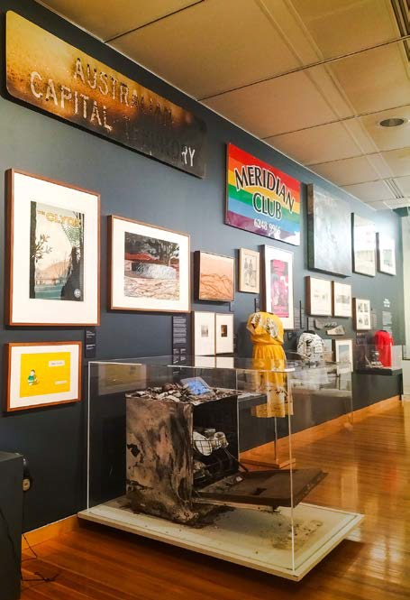



Annual Report 2022–23
Cultural Facilities Corporation

The Cultural Facilities Corporation acknowledges the Ngunnawal people as traditional custodians of the ACT and recognise any other people or families with connection to the lands of the ACT and region.

We respect the Aboriginal and Torres Strait Islander people, particularly our Aboriginal staff, and their continuing culture and contribution they make to the Canberra region and the life of our city.

Contact for this report

General enquiries about this report should be directed to:
Telephone: (02) 6207 3962
Email: cfccorporatefinance@act.gov.au

Accessibility

The ACT Government is committed to making its information, services, events and venues accessible to as many people as possible.

If you are deaf, or have a hearing or speech impairment, and need the telephone typewriter (TTY) service, please phone 13 36 77 and ask for 13 34 27. For speak and listen
users, please phone 1300 555 727 and ask for
13 34 27. For more information on these services, contact us through the National Relay Service: www.relayservice.gov.au.

If English is not your first language and you require a translating and interpreting service, please telephone Access Canberra on
13 22 81.

CULTURAL FACILITIES CORPORATION GPO Box 782
Canberra City ACT 2601 ABN: 88187240846
Published by the Cultural Facilities Corporation, Canberra.

For more information on the activities of the Cultural Facilities Corporation please visit the following websites: www.culturalfacilities.act.gov.au; www.canberratheatrecentre.com.au; www.cmag.com.au; and www.historicplaces.com.au.

Freedom of Information

Freedom of information requests can be made by emailing: cfccorporatefinance@act.gov.au.

ISBN: 978-0-642-60767-6

© Australian Capital Territory, Canberra 2023. This work is subject to copyright. Apart from any use permitted under the Copyright Act 1968, no part may be reproduced by any process without written permission from the Territory Records Office, GPO Box 158 Canberra ACT 2601.

Information about the directorate and an electronic version of this annual report can be found on the website: www.culturalfacilities.act.gov.au.

Front cover CMAG Canberra/Kamberri: Place & People. Image: CFC

Contents
PART A Transmittal Certificate 6
CFC Organisation Chart 7
PART B Organisational Overview and Performance 12
  - Organisational Overview 12
  - Performance Analysis 34
  - Scrutiny 81
  - Risk Management 81
  - Internal Audit 81
  - Fraud Prevention 82
  - Freedom Of Information 82
  - Community Engagement and Support 84
  - Aboriginal and Torres Strait Islander Reporting 85
  - Work Health and Safety 87
  - Human Resource Management 89
  - Ecologically Sustainable Reporting 94
PART C Financial Management Reporting 97
  - Financial Management Analysis 97
  - Financial Statements 97
  - Capital Works 98
  - Asset Management 100
  - Government Contracting 102
  - Statement of Performance 104
APPENDICES
Appendix 1: Members of the CFC Board during 2022-23 106
Appendix 2: Senior Managers of the CFC 109
Appendix 3: Advisory Committees 112
Appendix 4: Facilities and Business/Activities under Management 118
Appendix 5: Canberra Museum and Gallery and ACT Historic Places Venues –
Schedule of Exhibitions, Programs and Events 120
Appendix 6: Canberra Museum and Gallery ……………………………………………………………………………………. 123
Appendix 7: Major Funding, Sponsorship and Support 125
ATTACHMENTS
Attachment 1: Financial and Performance Statements and Management Discussion Analysis 126
Abbreviations and Acronyms 190
Compliance Statement 191

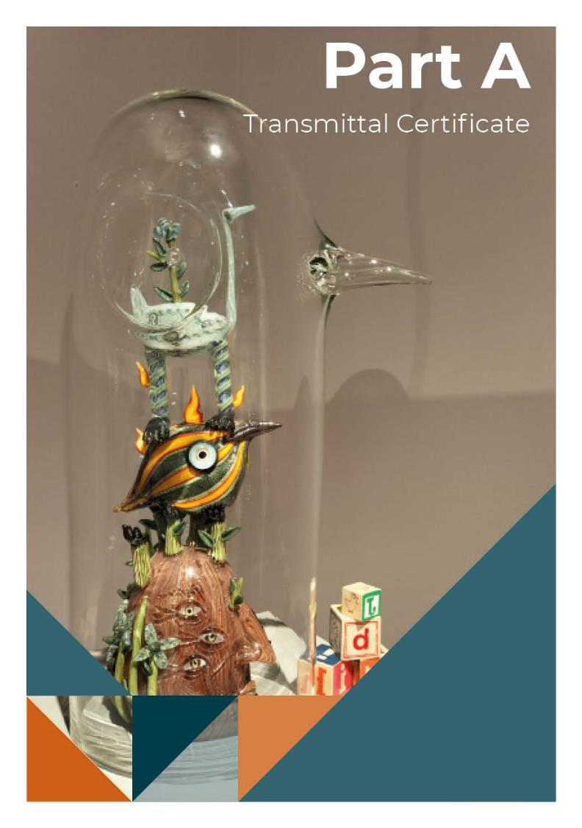
Tom Moore: Abundant Wonder. Image: CFC
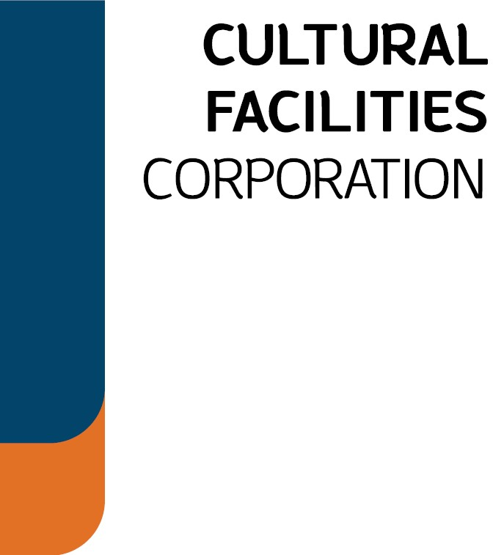
Ms Tara Cheyne MLA Minister for the Arts
ACT Legislative Assembly CANBERRA ACT 2601

Dear Minister

This report has been prepared in accordance with Section 7(2) of the Annual Reports (Government Agencies) Act 2004 and in accordance with the requirements of the Annual Report Directions.

It has been prepared in conformity with other legislation applicable to the preparation of the Annual Report by the Cultural Facilities Corporation (CFC).

We certify that information in the attached annual report, and information for whole of government reporting, is an honest and accurate account and that all material information on the operations of the CFC has been included for the period 1 July 2022 to 30 June 2023.

We hereby certify that fraud prevention has been managed in accordance with the Public Sector Management Standards 2006 (repealed), Part 2.3 (see section 113, Public Sector Management Standards 2016).

Section 13 of the Annual Reports (Government Agencies) Act 2004 requires that you present the Report to the ACT Legislative Assembly within 15 weeks after the end of the reporting year.

We commend this Annual Report to you and look forward to working with you in the year ahead.

Yours sincerely
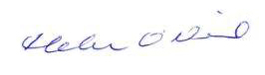

Helen O’Neil Gordon Ramsay
Chair Chief Executive Officer
Cultural Facilities Corporation Cultural Facilities Corporation
28 September 2023 28 September 2023

CFC Organisation Chart

The 2022-23 CFC organisation chart reflects the CFC’s high-level structure for the majority the year, noting that some organisational realignment began around May 2023.

Technical Director James Tighe

Head of Marketing Jennifer Morris
A/g Assistant Director Access & Learning Kay Whitney

Head of Programming Daniel Clarke

Assistant Director Heritage & Collections Amy Jarvis
A/g Assistant Director Access & Learning, Front of House Michael Bailey

Technical Project Director Jeremy Christian
Assistant Director Business Systems Capability Stephen Carter
Assistant Director Human Resources & Industrial Relations Zainab Malik
Assistant Director Visitor Engagement & Interpretation
Anne Brake

General Manager Alexandria Tibbetts

Assistant Director Exhibitions & Collections Rebecca Richards

Financial Controller Jennifer Kilgariff
Director Facility Operations &
Capital Works Ken Gibson
Director, Collaboration & Engagement
Dr Brooke Thomas
A/g Director ACT Historic Places
Amy Jarvis
Director Canberra Theatre Centre
Alex Budd
A/g Director Canberra Museum & Gallery
Dr Anna Wong

Chief Financial Officer Ian Tidy

Chief Executive Officer Gordon Ramsay

Year at a Glance

 | 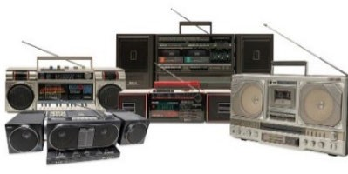  July 2022  Kinloch Kilby's boombox collection, image: courtesy of collector  August 2022    Eirborne, image: courtesy of production | - Back to the Boombox CMAG exhibition showcased the private collection of Kinloch Kilby – an avid collector and music appreciator (picture opposite).  - CMAG hosted Sidney Nolan: Search for Paradise from the Heide Museum of Modern Art, highlighting Nolan’s deepest impulses and his journey of self-discovery.  - The Young Nolan Project continued this year at CMAG, with hundreds of Canberra school students and teachers exploring the work of Sidney Nolan.  - Bangara Dance Company performed Terrain at the Canberra Theatre.  - Ben Kopilow held a Landscape and Nature Photography workshop in the beautiful wintry surrounds of Lanyon.  - CMAG showcased Continuous Culture - works by Dr Danie Mellor, Jennifer Kemarre Martiniello OAM, and Paul House - established Indigenous Australian artists working in the Canberra region.  - The Live rock show Eirborne, a celebration of Irish dance toured at the Canberra Theatre (picture opposite).
 | September 2022  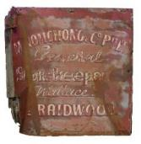  From Guangzhou to Braidwood, image: CMAG | - ACTHP held several events for the Bloom Festival, as part of the Floriade Community Program.  - Tim the Yowie Man presented Stories at Sunset recounting tales of Lanyon’s early families and workers of the historic cemetery, then under the cloak of darkness provides a behind-the-scenes tour of Lanyon and surrounds.  - CMAG presented From Guangzhou to Braidwood: Nomchong family history display bringing together objects and images from CMAG as well as those held by the Braidwood and District Historical Society. The display reflects the Chinese heritage of the region (picture opposite).  - Initial activation of the former Elections ACT office began under the City Renewal Authority’s Second Space pilot.
 | October 2022  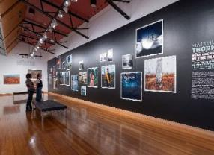  Matthew Thorne: Jingo was born in the slum, image: CMAG | - Direct from its sell-out tour in the US, the ice-skating spectacular  Fairytales on Ice opened at the Canberra Theatre.  - Calthorpes’ House featured Dawn Waterhouse’s royal souvenir collection, with a focus on Queen Elizabeth II.  - CMAG opened the exhibition Matthew Thorne: Jingo was born in the Slum featuring photographs and costumes from Justin Kurzel’s film, True History of the Kelly Gang, alongside Sidney Nolan’s Ned Kelly paintings that influenced the film (picture opposite).  - Nick Cave and Warren Ellis performed their Australian Carnage tour at the Canberra Theatre.

 | November 2022  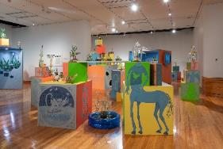  Abundant Wonder, image: CMAG | - In partnership with the DESIGN Canberra Festival and celebrating 50 years of Craft ACT: Craft + Design Centre makers, showcased a curated selection of work from five decades of creative practice in Canberra.  - The CFC hosted the DESIGN Canberra Festival hub and pop-up shop in the Second Space.  - Robin Davison from Rebus Theatre chatted with staff about the connection between the performing arts, inclusion, and wellbeing as part of CFC’s National Mental Health Month morning tea.  - CMAG hosted the touring exhibitions Tom Moore: Abundant Wonder Jam Factory Icon (picture opposite).
 | December 2022  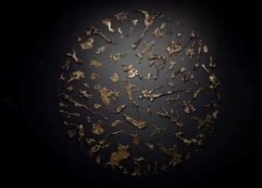  Moon in a Dew Drop, image: Anna  Kučera | - CMAG exhibition by artist Lindy Lee, Lindy Lee: Moon in a Dew Drop ran from September to December (picture opposite).  - Human Nature performed A Christmas Celebration at the Canberra Theatre.  - The Canberra Theatre presented nine performances of the beloved Charles Dickens’ A Christmas Carol.  - Christmas music with CSO Brass Ensemble and choir Andante Andante at various venues.

January 2023  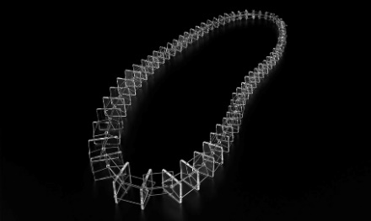  Ripple Effect, image: Grant Hancock | - Storytime Ballet: The Sleeping Beauty created a magical experience at The Playhouse performed by the Australian Ballet.  - CMAG showcased the work of Blanche Tilden: a ripple effect - a 25 year survey from November to February to celebrate the 2022 International Year of Glass (picture opposite).  - Karen Collins collection has been her passion for nearly 20 years and her collection Platypus: A Curious Creature featured at CMAG from January to June 2023.
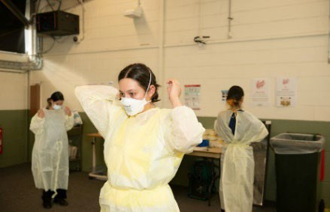  February 2023  Stronger Together, image: Marzena Wasikowska | - CMAG presented Stronger Together: Artists’ perspectives with the ACT COVID-19 frontline health response (picture opposite).  - The 2022 Don Aitkin Awards recognised three staff members for their contribution and achievements: Amy Jarvis (ACTHP staff member); Gillian Schwab (CTC staff member); and Michael Bailey (CMAG staff member).  - Leading participants through a mindful exercise, Fran Romano (local ceramicist) held Wellbeing Workshops: Clay Thought Vessels at Lanyon and CMAG’s Second Space.  - Anh Do brought The Happiest Refugee Live! show to the Canberra Theatre.  - CMAG worked with the National Multicultural Festival, providing sanctuary spaces and family activities.

 | March 2023  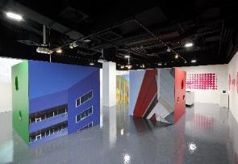  Light, Colour, Humanity, image: CMAG | - Chief Minister Andrew Barr opened the new permanent exhibition Canberra/Kamberri: Place & People on Canberra Day.  - CMAG Curators presented a CURATOR’S TALK: Women of Canberra to celebrate International Women’s Day.  - Light Colour Humanity – the Legacy of Alastair Swayn, opened by ACT Arts Minister Tara Cheyne, featured as the inaugural exhibition in CMAG’s new immersive gallery ‘CMAG on Circuit’ (picture opposite).  - The CFC partnered with the City Renewal Authority for Enlighten in the City, bringing huge dinosaur puppets to Civic Square, and a jungle themed bar to the theatre Terrace.  - Lanyon held its annual Harvest Day Out with record attendance.  - Major conservation works commenced to Lanyon, including roof replacement and fabric conservation.
 | April 2023  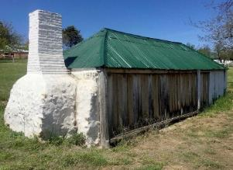  Lanyon Homestead, Image: ACTHP | - CTC co-produced with Sydney Theatre Company a sell-out season of the world premiere of Julia starring Justine Clarke as Julia Gillard.  - Presented to coincide with Refugee Week, CMAG hosted Settled/Unsettled which uses the universal language of visual art to address personal and profound issues faced by Australia’s asylum seekers, refugees and migrants.  - Showcasing the rich landscape that sustained Aboriginal culture and supported European settlement the ACT Heritage Festival, Stories Beyond the Farm Gate tour explores places that are not usually seen by the public at Lanyon (picture opposite).  - Bell Shakespeare performed Macbeth in The Playhouse.
 | May 2023  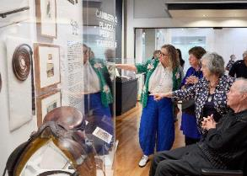  Canberra/Kamberri: Place & People, image: CMAG | - CMAG won a prestigious National Australian and Museum Galleries Award for the new permanent exhibition, Canberra/Kamberri: Place & People (picture opposite).  - As part of this year’s Reconciliation Concert Canberra Theatre presented legendary band Yothu Yindi.  - Lanyon hosted Creative Photography + Story Telling - exploring the lives of the First Nations people through to early colonists and convicts and the pastoralists of the 20th century.  - The record-breaking murder mystery Agatha Christie’s The  Mousetrap toured to The Canberra Theatre.
 | June 2023    Settled/Unsettled, image: courtesy the artist | - Junkyard Dog presented the worldwide smash hit, Tony and Olivier award-winning musical Come From Away at the Canberra Theatre.  - Canberra Youth Theatre presented the world premiere of The  Initiation by Cathy Petocz in the Courtyard Studio.  - Calthorpes’ House held numerous education programs of Dawn’s Surprise.  - Three extraordinary women shared their stories during Refugee Week 2023 sharing the development of Kathrin Longhurst’s series of portrait paintings in the CMAG exhibition Settled/ Unsettled (picture opposite).  - How Cities Work, the touring children’s exhibition from The Museum of History NSW, opened in CMAG.

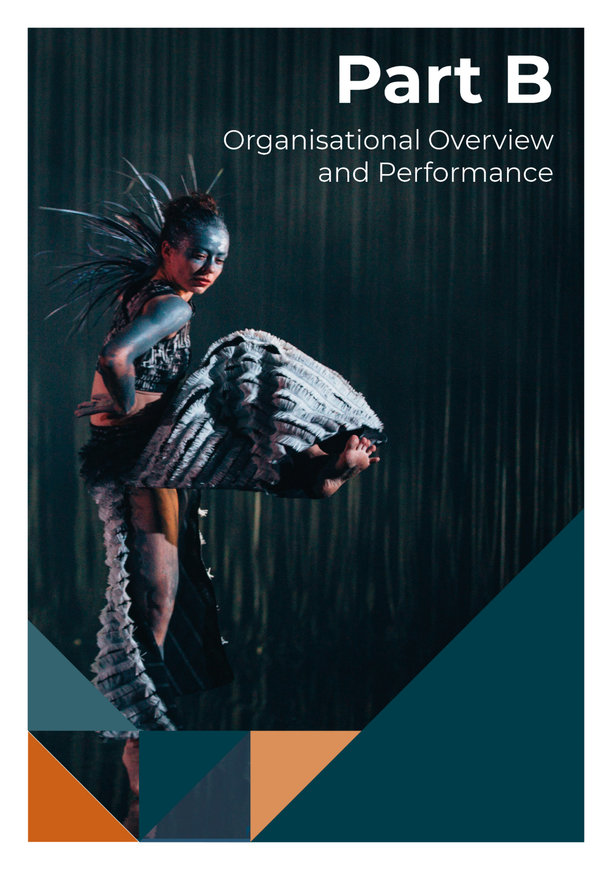
Bangarra Dance Theatre ‘Yuldea’. Image: Kate Longley

Organisational Overview

Vision, mission and values

Strategic Plan 2021-24

During 2022-23, the CFC began shifting to a new Strategic Plan for the period 2023-27, replacing the existing 2021-24 Strategic Plan earlier than anticipated to drive the organisation’s growth in accordance with the government’s Statement of Ambition for the Arts, moving away from a focus on COVID-19

important role in the economy of the ACT and region.

We see the CFC as a leader in this creative city, providing high quality cultural experiences based on the arts and heritage resources that we hold in trust for the people of Canberra, and playing a significant role in the region’s cultural and economic life.

recovery and towards a more ambitious future
that includes the major project to redevelop

Canberra Theatre Centre.

As the 2021-24 Plan was in operation for the majority of 2022-23, reporting presented here is in accordance with that framework.
The 2021-24 Strategic Plan identifies the CFC’s role, vision, key values and principles, and key priorities. It also identifies the mission,

MISSION

Mission/purpose statements are identified in the CFC Strategic Plan 2021-24 as a whole and for each business arm. These are supported by vision statements for each area and statements as to what the CFC is seeking to achieve (from page 38).

purpose, vision and key strategies both for the
organisation as a whole and for its three

business arms:
- the Canberra Theatre Centre (CTC)
- the Canberra Museum and Gallery (CMAG - including The Nolan Collection)
- ACT Historic Places - Lanyon, Calthorpes’ House and Mugga-Mugga.

VISION

Our vision under the Strategic Plan 2021-24 is for Canberra to be a creative capital that values the arts for their intrinsic qualities, their contribution to building a more inclusive and resilient society, their support for making the city an exciting place to live and an attractive destination for business and tourism, and their

VALUES
(under the Strategic Plan 2021-24)

Leadership
- We are committed to providing cultural leadership, excellence, and innovation, including leadership in using digital applications to enhance our systems and programs.

Engagement
- We actively seek to engage our communities in a greater understanding of the value of the arts, and of our cultural heritage, through our programs and activities, placing customer service as our

primary goal and recognising the diverse needs and expectations of our customers.

Collaboration
  - We value cooperative and strategic partnerships across all areas of our activities.

Professionalism
  - We place major importance on maintaining professional standards in the management of our facilities and in the design and delivery of our programs.

In observing these values, we are committed to implementing the ACT Government Service Values: respect, integrity, collaboration, and innovation. The CFC is committed to its role in fulfilling Canberra’s Statement of Ambition for the Arts 2021-26 - to be recognised as Australia’s arts capital, engaging the following strategies:
  - Create amazing art and culture;
  - Develop arts, cultural and creative industry, practice and facilities; and
  - Promote our arts and culture.

New Strategic Plan 2023-27

In April 2023, the CFC Board endorsed the new Strategic Plan which has been developed consultatively with staff, the Board, and key stakeholders, and defines a new vision and mission for the CFC as well as more dynamic values and ambitious goals. The new plan will underpin all CFC activity, planning and reporting from 2023-24, having begun operational phase-in from May 2023.

Mission 2023-27
- We create and drive diverse and remarkable experiences that enliven and elevate arts, culture, and heritage in the Capital.

Vision 2023-27
- Building Australia’s arts and culture capital.

Values 2023-27
- Daring – We are not afraid to experiment.
We challenge our audiences, our collaborators, and ourselves.
- Responsibility – We respect the places, spaces, and collections we manage and develop, and the landscapes in which we work; we value our staff and their wellbeing and safety; we honour First Nations people and their cultures and heritage; and we celebrate our diverse communities.
- Excellence – We strive for best practice in everything we do – including creativity, inclusion, accessibility, integrity, customer experience, and professionalism.
- Agility – We are flexible, embrace new opportunities, and respond collaboratively.
- Magnetic – Great employees, audiences, artists, and partners will be drawn to us.

Strategic Goals 2023-27
- Custodianship, Creativity, and Storytelling – We will deliver creative excellence and custodianship for the CFC’s activities, deepen our contribution to the ACT’s arts, culture and heritage ecology, and grow our national role.
- Growth and Sustainability – We will position the CFC for the future by expanding its income streams and relevance to the arts, culture, and heritage sectors, audiences, and economy.
- Redevelopment of the Canberra Theatre Centre and Canberra Civic and Culture District – We will provide a vision and key leadership for the redevelopment of the CTC and CCCD, developing our

organisation to leverage the opportunities these present.
- Sector Leadership and Development – We will lead our sector in the ACT, growing
audiences, engaging artists, and developing people.
- Best Practice Governance, Organisational Capacity, and Culture – Our operational model will be best practice.

Role, functions and services

The CFC was established under the Cultural Facilities Corporation Act 1997 (the CFC Act), which came into operation as from
1 November 1997. The functions of the CFC, as set out in the CFC Act (Section 6) are:
      - to manage, develop, present, coordinate and promote cultural activities at designated locations and other places in the ACT;
      - to establish and research collections;
      - to conserve and exhibit collections in the possession or under the control of the CFC;
      - to undertake activities, in cooperation with other people if appropriate, to exercise its other functions; and
      - to exercise other functions given to the CFC under this Act or another Territory Law.
The CFC Act (Section 7) requires that the CFC, in exercising its functions, must consider:
- any cultural policies or priorities of the Executive known to the CFC; and
- other cultural activities in the ACT.

With responsibility for the CTC, CMAG and ACTHP, the CFC’s functions include the performing arts, the visual arts, social history and cultural heritage management. The organisation delivers a range of cultural services to the community providing theatre presentations, exhibitions, education and community programs, and conservation and presenting significant aspects of the ACT’s cultural heritage.

We value cooperative and strategic partnerships across all
areas of our activities.

Key clients and stakeholders

During 2022-23, the CFC reported to the Minister for the Arts. The Chief Minister, Treasury and Economic Development Directorate (CMTEDD) is the “parent” directorate for the CFC. The CFC’s other clients and stakeholders include:

  - Ngunnawal and other First Nations peoples;
  - Artists, arts workers, and other arts, culture and heritage organisations;
  - the community of the ACT and region;
  - visitors to the ACT;
  - the arts, cultural, heritage, education, business, night time economy, and tourism sectors;
  - national producers of the performing arts, including commercial and funded companies;
- the City Renewal Authority, the National Capital Authority, and Major Projects Canberra;
- ArtsACT and the Office for the Arts;
- the diplomatic community and the Office of the International Engagement Commissioner;
- Events ACT, Visit Canberra, Canberra and Region Tourism Leaders Forum, and the National Capital Attractions Association; and
- hirers of CFC venues.

Organisational structure, environment and planning framework

Organisational structure

The top-level organisational chart of the CFC as at 30 June 2023 is provided on page 7.

In order to deliver on the updated vision, mission and goals of the CFC under the new 2023-27 Strategic Plan, the CFC began restructuring in May 2023 into three main “creative expressions”, being Galleries, Museums and Heritage, Canberra Theatre Centre, and District and Events, supported by centralised Finance, Corporate, and Facility Operations and Capital Works teams.

Organisational environment

During 2022-23, the CFC had close working relationships with a number of ACT Government agencies and entities including CMTEDD, City Renewal Authority, ArtsACT,
Minister’s Creative Council, Major Projects Canberra, Events ACT, Visit Canberra, ACT Health, Environment, Planning and Sustainable Development Directorate, ACT Government Solicitor, ACT Heritage, Access Canberra, ACT Property Group, Territory Records Office, Public Sector Workforce Health, Safety and Wellbeing, Transport Canberra and City Services, ACT Treasury and ACT Audit Office.

Strategic Framework

As noted in Section B.1.1, page 12, during 2022-23, the CFC operated in accordance with the Strategic Plan 2021-24 which has now been replaced by a new plan for 2023-27. These plans provide the overarching framework for the organisation’s activities, including for the development of its annual business plans.

Due to development of the new Strategic Plan during 2022-23, the CFC did not update its Business Plan but operated according to the 2021-22 Business Plan, based on its 2021-24 Strategic Plan. Results relating to these actions are reported in summary in this section and in detail in Section B.2, page 34.

The CFC’s accountability indicators and targets for 2022-23 were identified in the CFC’s 2022- 23 Statement of Intent, which was included in the 2022-23 ACT Budget statements. The Statement of Intent also identified the CFC’s strategic objectives and indicators. Results
relating to the CFC’s accountability and strategic indicators are reported in summary in this section.

Further details about the CFC’s accountability indicators are provided in the 2022-23 Statement of Performance at Attachment 1, page 182 to this report.

Further details about the CFC’s strategic indicators are provided in Section B.2, page 34.

Summary of performance in achieving objectives and target
Performance outcomes for the CFC in 2022-23 were higher than the previous year as the result of increased activity in all of CFC’s venues, after emerging from the 2021 lockdowns and the wider effects of COVID-19 on the cultural and tourism sectors.

This resulted in the CFC meeting or exceeding the majority of its accountability indicator targets for 2022-23. For example, during 2022-23 the CFC:
      - welcomed over 383,000 visitors and patrons to its facilities and programs, 46% above target
      - recorded 702 days total venue usage at the Canberra Theatre Centre locations, 48% above target.

Detailed performance results and variance explanations are included in the 2022-23 Statement of Performance at Attachment 1, page 183 to this report.

The CFC averaged 31,918 visitors per month and achieved an own-sourced revenue figure of 55.4% against a target of 49.8% and
a cost to government per patron/visitor of $26.64 against a target of $39.02

Summary of performance outcomes
The CFC’s overall financial result for 2022-23 saw an increase in all aspects of the CTC revenue. This reflects an increase in venue hire and patron activity during the financial year. It should be noted that, due to its large asset holdings and consequent significant depreciation expenses, the CFC always expects to have an operating deficit as it is not funded for depreciation but receives capital injections through the capital works program. The higher than estimated deficit was primarily due to additional accrued employee expenses for expected increases from the enterprise bargaining agreement.
The CFC commenced the majority of its 2021-22 capital works and capital upgrade projects by year-end, although certain expenditure on, and funding for, capital projects for ACT Historic Places, CMAG and
CTC, was deferred from 2022-23 into 2023-24. This was due to revised project schedules; delays in obtaining necessary approvals; and COVID-19 related restrictions on interstate contractors and supplies. The CFC will complete the identified capital works program through the 2023-24 financial year under a new, centralised Facility Operations and Capital Works unit.

A full analysis of the CFC’s financial results and financial position is set out in the Management Discussion and Analysis at Attachment 1, page 182 to this report.

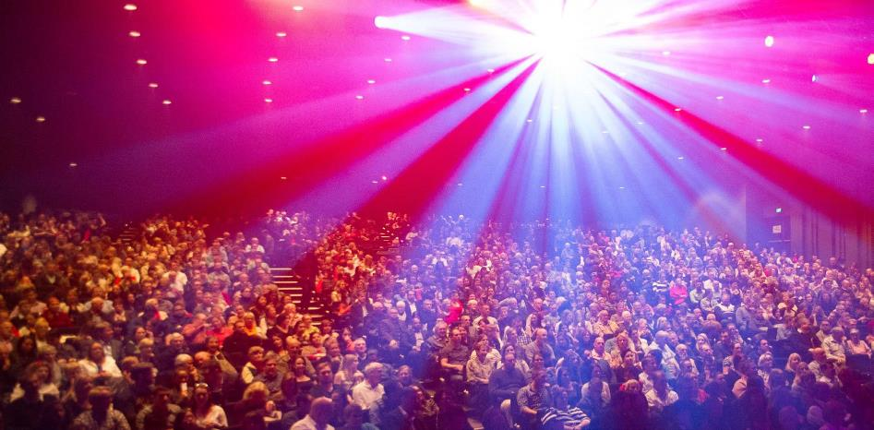
Le Noir Act I. Image: Mark Turner

Performance outcomes–Strategic Objectives/Indicators

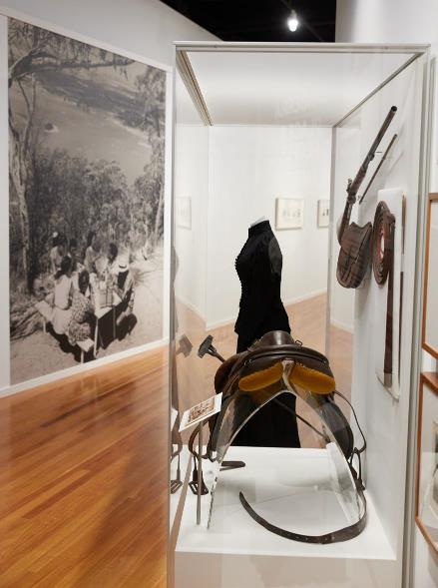
Strategic Objective 1: The CFC provides cultural leadership in the Canberra region
and beyond

Strategic Indicator 1: The extent to which the CFC connects people with rich and
diverse cultural experiences through activities at its venues, in the following areas.

Canberra/Kamberri: Place & People. Image: Paul Webb

Recovery from COVID-19
      - During 2022-23, the CFC accelerated its recovery from the effects of COVID-19 on the cultural and tourism sectors with engaging creative programming pushing audience and visitor numbers back toward pre-pandemic levels.

Leadership: A cultural leader in the ACT region and beyond
      - Throughout the year, as noted in further detail below, the CFC pursued its goal of providing leadership in cultural planning, administration, and management.
  - A key area of leadership was in participating on the selection of the Lead Design Partner for the Canberra Theatre Redevelopment Project (CTRP). This procurement concluded in May 2023 with a consortium of architects Henning Larson, Architectus, and engineering firm ARUP winning the bid.
  - Across each of its creative arms, the CFC has focused resources into fostering the creativity of local arts practitioners and organisations. In particular, the CTC supports local young and emerging artists though its New Works program.
  - The CFC also plays a leadership role in early consideration of the future of Civic Square and surrounds through the CEO’s chairing of the Canberra Civic and Culture District Coordination Group.
  - The CFC continues to coordinate regular meetings of the National Cultural Institutions to foster a more collaborative future approach to marketing, programming, and tourism product development.
  - The CEO is also on the Board of the Canberra and Region Tourism Leaders Forum.
  - In 2022-23 the CFC has had a strong focus on contributing to memorable visitor experiences in Civic Square in partnership with other organisations and agencies. These included:
    - Winter in the City;
    - the CRA’s Second Space initiative;

    - the DESIGN Canberra Festival;
    - the Canberra Art Biennial (Contour 556);
    - Christmas in the City;
    - the National Multicultural Festival;
    - Enlighten in the City;
    - the World Cup Soccer screening;
    - the Heritage Festival; and
    - a dance flash mob in honour of Tina Turner.

Strategy: A clear direction for the future
      - During 2022-23, the CFC commenced work on a new Strategic Plan to better reflect the growing role of the CFC in the Canberra’s cultural life and visitor economy, and to bring focus to the redevelopment of CTC. While this consultative work was occurring, the CFC operated under the 2021-22 Business Plan as an interim plan, under the guidance of the Board.
      - The new Strategic Plan 2023-27 was endorsed by the Board in April 2023 and will underpin all reporting from 2023-34.
      - The new Plan supports the ACT Government’s Statement of Ambition for the Arts, and is a major contributor to creating, developing, and promoting arts, culture, creativity, and heritage under Canberra’s Arts, Culture and Creative Policy 2022-26.
      - The newly defined mission of the CFC is to create and drive diverse and remarkable experiences that enliven and elevate arts, culture, and heritage in the Capital, and our vision is to build Australia’s arts and culture capital. This is lived out in our five strategic goals:
- Custodianship, Creativity, and Storytelling – We will deliver creative excellence and custodianship for the CFC’s activities, deepen our contribution to the ACT’s arts, culture
and heritage ecology, and grow our national role.
- Growth and Sustainability – We will position the CFC for the future by expanding its income streams and relevance to the arts, culture, and heritage sectors, audiences, and economy.
- Redevelopment of the Canberra Theatre Centre and Canberra Civic and Culture District – We will provide a vision and key leadership for the redevelopment of the CTC and CCCD, developing our organisation to leverage the opportunities these present.
- Sector Leadership and Development – We will lead our sector in the ACT, growing audiences, engaging artists, and developing people.
- Best Practice Governance, Organisational Capacity, and Culture – Our operational model will be best practice.

Governance: An accountable and dynamic organisation
- The CFC maintained robust governance systems to provide a high standard of accountability throughout the year.
- Board member current terms:
- Chair, Helen O’Neil
(2 July 2022 - 31 December 2024)
- Deputy Chair, Dr Rachael Coghlan (2 July 2022 - 30 June 2024)
- Genevieve Jacobs
(2 July 2022 - 31 December 2024)
- Michael Sollis
(2 July 2022 - 30 June 2025)
- Tim Lo Surdo
(1 January 2023 - 31 December 2025)
- Christine Shannon
(14 April 2023 - 31 December 2025)

  - Julian Widdup completed his term during the reporting year (1 February 2020 - 31 December 2022)
  - Shad Sears resigned during the reporting year (2 July 2022 -
accessible Core Learning Framework to support foundational APS skills while also ensuring proactive regulatory compliance around a range of WHS-related training areas.

8 December 2022).

People: An employer of choice
  - The CFC focused on attracting, developing and retaining highly skilled staff and volunteers, and on ensuring its sites are safe and rewarding places to work.
  - COVIDSafe plans continued to be observed in line with Government requirements, transitioning to recommended COVID Smart Behaviours from the lifting of public health restrictions in March 2023.
  - A number of improvements were made to support robust, timely recruitment processes and an increasing number of tools, form and policies were moved to the CFC intranet to empower and equip staff.
  - The CFC participated in all four whole-of- government Secure Work Conversion rounds, resulting in three casual or non- ongoing staff taking up an offer of permanent employment.
  - A number of staff wellbeing activities were offered including mindfulness workshops, a
Finances: Long-term financial sustainability
- In 2022-23 the CFC maintained high standards of financial management and reporting.
- The audit of the CFC’s 2022-23 Financial Statements by the ACT Auditor-General resulted in an unmodified audit.
- The CFC developed two bids which were funded in the 2023-24 ACT Budget, leading to further funding for the jointly delivered CTC-CIT Certificate III in Live Production and Technical Services for the training of backstage theatre professionals, and funding to support the ongoing expansion of CMAG into vacant ground floor spaces in the North Building and to contribute to the activation of Civic Square. These are the Circuit Gallery (formerly the Mr Wei restaurant) and the Civic Square Hub (formerly the Elections ACT office). The new areas in turn support future financial sustainability through the income generation opportunities they present.

morning tea with Robin Davidson from Rebus Theatre for Mental Health month,

and free weekly yoga sessions in the galleries. Three staff also received Mental Health First Aid accreditation.
  - Enterprise bargaining continued through 2022-23, with agency-specific consultative sessions with staff held alongside whole-of- government broader bargaining. The draft agreement at the time of this report represents a significant modernisation of the EA that will substantially benefit staff while also improving operations.
  - The CFC continued to develop consultatively with staff a consistent,
Assets: Support for delivering high quality
cultural experiences
- High quality asset management continued to be a key priority for the CFC during 2022- 23, in view of its responsibility for major cultural sites.
- The CFC’s Resource Management Plan continued to provide the framework for the CFC’s sustainability and energy efficiency practices.
Further details regarding outcomes against Strategic Objective 1 and Strategic Indicator 1 are provided under Section B.2, page 34.

Strategic Objective 2: The Canberra Theatre Centre is a leading theatre centre in
Australasia and Asia.

Strategic Indicator 2: The extent to which the CFC connects people with rich and
diverse cultural experiences through activities at its venues, in the following areas.


tenderer QTIX was selected in the first part of 2023-2024.

Beanies. Image: Grant Leslie

A smooth recovery from the COVID-19 pandemic
  - COVIDSafe plans continued to be observed in line with Government requirements, transitioning to recommended COVID Smart Behaviours from the lifting of public health restrictions in March 2023.
  - The CTC launched new marketing branding on the theme “Immerse Yourself” which, combined with broader multi-channel, data-informed marketing, has seen ticket sales begin to recover to pre-pandemic levels.

Customers: Audiences that are growing, diverse, engaged and entertained
  - The CTC continued to act in accordance with ACT Health Guidelines and utilised a range of communicate methods for this. The CTC sends all patrons attending the Theatre an email ahead of their visit that outlines COVID-19 safety, and local traffic and construction information.
  - The CTC continued work on the procurement tender process of a ticketing management system. The successful
Programming: A diverse, high quality, entertaining and distinctive program
- The CTC supported a variety of artists, companies and producers to access its venues through subsidies and sponsorships including Canberra Youth Theatre, Heart Strings Theatre Company, Cahoots Lab - You Are Here, QL2, and Ausdance ACT.
- Major touring productions at the CTC included:
- Bangarra Dance Theatre’s Terrain;
- Girl From the North Country;
- Agatha Christie’s The Mousetrap;
- Come From Away; and
- Charles Dickens’ A Christmas Carol.
- The CTC partnered with Sydney Theatre Company to co-produce the sell-out world- premiere season of Joanna Murray-Smith's Julia.
- The CTC continued its commitment to First Nation’s programming with presentations including Bangarra Dance Theatre’s Terrain, Australian Dance Theatre’s SAVAGE, and a Reconciliation Day Eve Concert headlined by Yothu Yindi.
- CTC also continued its New Works program including a New Idea’s lab and incubator program, 3 paid week-long creative developments of Jake Silvestro’s Alienation, Mark Salvestro’s The Queen’s City of the South, and Christopher Samuel Carroll’s Commitment to the Cause, and the

presentation of the premier season of Batchelor + Lea: A Dance Week Double Bill. New Works also supported further project development for choreographer Melanie Lane’s Mountain and Little Dove Theatre Art’s Francesca Giselle.

Business: Venues, systems and people that support high quality live performances
  - The CTC undertook the second year of a three-year program of upgrades to enhance accessibility and safety for patrons, ensure a high level of Work Health and Safety standards for staff, enhance security infrastructure, and implement other essential works.
Leadership: An integral part of the cultural life of the Canberra region and beyond
- CFC played a vital role in progress on the Canberra Theatre Redevelopment Project, contributing to evaluating the responses from the three shortlisted consortiums, leading to the appointment in May 2023 of the Lead Design Partner, led by Architects Henning Larson, Architectus and engineering firm ARUP.
- Since the appointment of the lead design team in May 2023 the CFC has worked closely in the design and business case process with Major Projects Canberra.

Further details regarding outcomes against Strategic Objective 2 and Strategic Indicator 2 are provided under Section B.2, page 34.

Reconciliation Day. Image: Courtesy of Artists and CTC
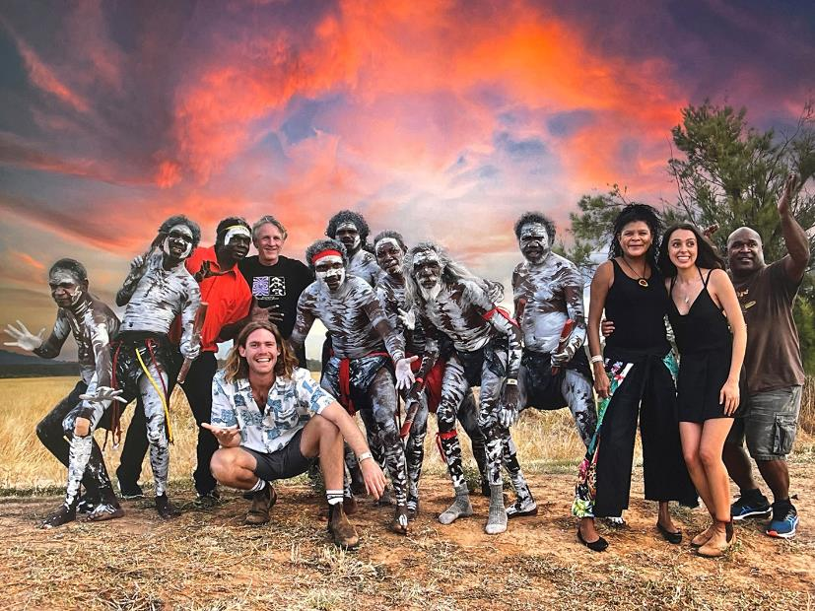

A smooth recovery from the COVID-19 pandemic
  - CMAG continued to provide management and recovery measures relating to COVID-
19. Although there were no COVID-19 restrictions relating to CMAG’s venues and operations, the COVID-19 recovery was ongoing throughout the year.

Customers: Audiences that are growing, diverse and engaged
  - CMAG continually seeks to improve customer satisfaction with their visit to, and experience of, CMAG, with surveys available to complete online and onsite. Surveys are sent via scheduled email to invite feedback from participants after an event.
  - Accessibility upgrades were made to gallery doors and ramps to improve the experience at CMAG for people living with disabilities.
  - CMAG presented exhibitions for a range of audiences including for families, notably How Cities Work, a travelling show from Museums of History NSW. Surveys showed
- CMAG opened a new exhibition space, the Circuit Gallery, with inaugural exhibition, Light, Colour, Humanity: The Legacy of Alistair Swayn.
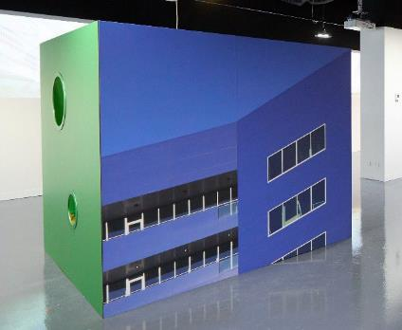
- A new permanent exhibition, Canberra/ Kamberri: Place & People, was opened on Canberra Day by Chief Minister Andrew Barr, and won the AMaGA National Award in the Permanent Exhibition category.
Strategic Objective 3: CMAG is a leading regional cultural venue in Australia and
beyond.

Strategic Indicator 3: The extent to which CMAG connects people with the Canberra region’s rich and diverse stories, sense of place, and contemporary identity, in the following areas.
that 63% of attendees at the exhibition
were new visitors to CMAG.
Programming: Exhibitions and programs that
reflect Canberra’s unique identity
- CMAG presented a high-quality exhibition
program in 2022-23 that reflected the diverse interests of the Canberra
Light, Colour, Humanity. Image: CMAG
community.
- Other key exhibitions in 2022-23 included:
- Sidney Nolan: Search for Paradise presented by the Heide Museum of Modern Art and CMAG - our largest ever display of the work of Sidney Nolan;
- Coinciding with Design Canberra 2022 and the International Year of Glass, touring shows, Jam Factory Icon Tom Moore: Abundant Wonder and Geelong Gallery’s Blanche Tilden: Ripple Effect were installed; and
- Settled/Unsettled part touring show and part CMAG curated Canberra- based visual artists addressing migrant and refugee experiences.
- In addition to artist and curator talks about exhibitions, other significant programming included supporting the DESIGN Canberra

2022 Festival on Canberra Design Symposium in collaboration with Craft ACT and the Australian National University; a forum related to Settled/ Unsettled with the Canberra Refugee Action Campaign; a Canberra Symphony Orchestra Quartet concert as part of the Search for Paradise Sidney Nolan exhibition; an 'in conversation’ event for Platypus: a curious creature with Waterwatch ACT; CMAG After Dark @ Enlighten Festival - Light, Colour, COCKTAILS with the Martini Whisperer.

Stewardship: Venues and collections that allow us to tell the many stories of Canberra
  - A range of best practice policies and procedures were developed and updated to ensure adherence to international museum standards.
  - CMAG continued to conserve, research, interpret and manage the Nolan Collection under the Nolan Management Agreement with the Commonwealth. Two new Nolan exhibitions were held - Matthew Thorne: Jingo was born in the slum and Fly Fly! Sidney Nolan’s Birds, in addition to hosting
Sidney Nolan, Search for Paradise in partnership with the Heide Museum of Modern Art.

Leadership: An integral part of the cultural life of the Canberra region and beyond
- The former Mr Wei restaurant was transformed into a new gallery space with windows fronting London Circuit and Civic Square and opened in March 2023.
- The former Elections ACT office facing Civic Square was converted into a collaborative arts space, branded as the Civic Square Hub after an initial period of activity under the City Renewal Authority’s Second Space pilot program. The space hosted a range of activities with Craft ACT, the ANU, and a number of other activators and events.
- CMAG partnered with the CRA to enhance family programming for Enlighten in the City through a range of events, activities, and activations.

Further details regarding outcomes against Strategic Objective 3 and Strategic Indicator 3 are provided under Section B.2, page 34.

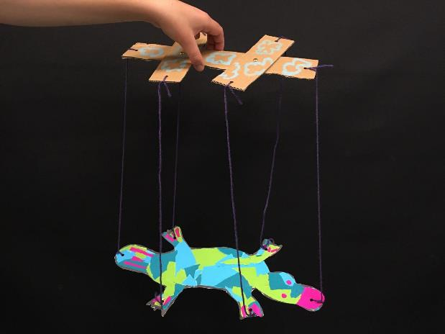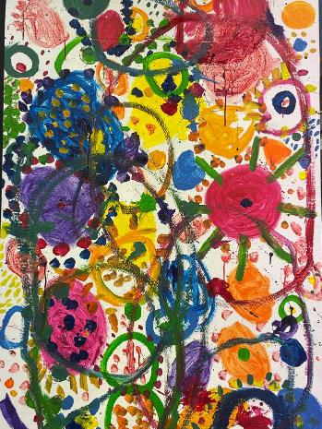
CMAG on Saturdays – Workshops. Images: CMAG

Strategic Objective 4: The ACT Historic Places are leading historic places in
Australia and beyond.

Strategic Indicator 4: The extent to which ACT Historic Places connects people with Canberra’s rich and diverse stories and heritage, the in the following areas.

A smooth recovery from the COVID-19 pandemic
  - ACTHP continued to provide management and recovery measures relating to COVID-19.
Telling, Cultural Weaving, and Floriade- related art classes and tours. Lanyon also hosted Harvest Day Out in March which saw nearly 2,000 people attend in a single day.

Although there were no COVID-19
restrictions relating to ACTHP’s venues and

operations, the COVID-19 recovery was ongoing throughout the year.

Customers: Audiences that are growing, diverse and engaged
  - ACTHP had a strong focus both on retaining existing audiences through the disruption of conservation works at Lanyon as well as building new audiences. Measures included precinct, garden, and landscape tours, and the introduction of the ACTHP Art Prize which encourages new ways of engaging with the heritage values of Lanyon.
Stewardship: Buildings, grounds and collections
that are conserved and researched
- A range of activities was undertaken throughout the year to conserve, research and interpret the Historic Places.
- Extensive conservation works were undertaken at Lanyon including replacement of the roof sheeting and plumbing, restoring water damaged ceilings,

Programming: Programs that explore Canberra’s history by interpreting each place

In 2022-23,
ACTHP
welcomed over 55,000 visitors across Lanyon, Calthorpes’ House and Mugga-Mugga
  - ACTHP provided a broad range of activities that increased people’s understanding and enjoyment of Lanyon,
Calthorpes’ House and Mugga-Mugga, their collections, and landscape settings.
  - A diverse range of activities continue to be offered at ACTHP sites – Lanyon, Calthorpes’ House and Mugga-Mugga – with the aim of extending and diversifying our audiences and broadening engagement with the heritage values of each venue. Notable offerings included Wellness and Sustainability art workshops, Aboriginal Story

and repairing timber, masonry, concrete and tiles.
  - Review and concept development began for the adaptive reuse of the Lanyon Shearer’s Precinct for an arts precinct, and for the conversion of the Lanyon Heritage Centre to staff office accommodation.
  - Acquisition of Dawn Waterhouse’s personal collection of Calthorpes’ House items including objects that were not originally purchased by the government and kept by Dawn and her family due to a deep family connection.
  - A range of works were undertaken at Lanyon regarding a permanent water source, tree management, and erosion control. There was also conservation and repair work at Mugga- Mugga and Calthorpes’ House, and digitising, accessioning, and cataloguing of a significant volume of collection items.
- Launch of three new online exhibitions to increase access and interpretation of ACTHP collections and site histories including:
- Preserving the Past;
- An Exciting New World (Calthorpes’ House); and
- Christmas for the Cunninghams.

Leadership: An integral part of the cultural life of the Canberra region and beyond
- ACTHP has been developing and strengthening relationships with a variety of industry partners in the museum, arts and heritage sectors as well as in with local education and environmental areas of ACT government.
- Professional development, collaboration, and networking opportunities have been strengthened.

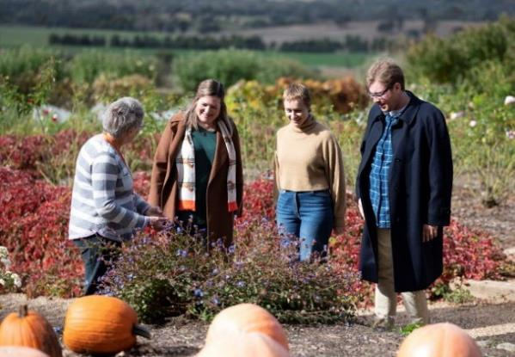
ACT Historic Places Tour. Image ACTHP

Outlook

Current and future priorities
During 2022-23, the CFC’s 2021-24 Strategic Plan guided the work of the Board, advisory committees, staff and volunteers in line with the following six key priorities.
- Progress the development of a major new theatre for the nation’s capital
  - Work with other agencies to refine planning for a fit-for-purpose, audience- focused venue.
  - Build towards this new venue through programming large scale productions and through creative partnerships at local, regional, national and international levels.

- Expand and enhance CMAG
  - Extend CMAG’s facilities and programs within North Building.
  - Enhance CMAG’s presence and profile on Civic Square and London Circuit.

- Position the Canberra Civic and Culture District as a premier cultural location
  - Grow the District as the vibrant creative heart of Canberra.
  - Place the new theatre as its centrepiece and an enhanced CMAG as a key aspect.

- Celebrate the multi-layered heritage values and cultural relevance of ACTHP
  - Highlight their contemporary relevance and their role in enhancing community wellbeing.
  - Develop innovative programming and increased business and tourism opportunities.

- Promote Indigenous engagement and reconciliation
  - Create partnerships with First Nations peoples.
  - Reflect the CFC’s commitment to Indigenous engagement and reconciliation through Reconciliation Action Planning.
- Deliver cultural leadership for the ACT region, including in COVID-19 recovery
  - Position the CFC as a leader in the region’s creative recovery from COVID-19.
  - Advocate for the value of arts and heritage to community wellbeing and the economy.

Looking ahead to 2023-24, the priorities for the CFC are those expressed in the new Strategic Plan 2023-27. These are as follows:

GOAL 1
Custodianship, Creativity, and Storytelling:
- Reinforcing the CFC’s role to preserve, keep, and present the collections and
understanding of the ACT’S arts, culture, and heritage in the visitor economy.
d. Creating new and increased reserves for future acquisitions and innovative and adaptive re-use investments.

assets under our management including
sharing the stories of this place.

- Enhancing our programming strategy, events, and productions to contribute to the ACT calendar of events, linked to the ACT’s tourism strategy, and including expansion into festivals, to help build new markets and attract visitors.
- Fostering participation in the arts and heritage – including through virtual access – for everyone – audiences, students, artists, our community, and other organisations.
- Supporting artists in the creation of new works, development, education, and residencies.
- Commissioning or producing new Australian works and capturing the voices of the nation.
- Establishing priority company relationships with the CTC and enticing world class artists to Canberra.

GOAL 2
Growth and Financial Sustainability:
GOAL 3
Redevelopment of the Canberra Theatre Centre and Canberra Civic and Culture District:
- Ensuring the development and management of the project around design, disruption, construction, and operating model; with design to include safety, public approval and engagement, and excellence.
- Supporting the processes for procurement, design, and construction of world class plans, and funding to develop the new Theatre and CCCD.
- To strengthen CFC’s capacity to provide governance, oversight, and management for CCCD and CTC.
- Rethinking the position of CMAG in the CCCD to lift CMAG’s visibility, profile, and audiences.
- Developing the capabilities to oversee, operate, and activate in the new venue and district and in so doing create a national hub of creative excellence.

  - Expanding and diversifying revenue streams
to support the vision of the CFC, including

building philanthropic engagement and funding partnerships; commercial activation of sites; and expanding our ticketing, retail, food and beverage offering.
  - Ensuring relevance for our existing audiences and building new audiences by making programming decisions focused on the patron experience, informed by data.
  - Contributing to growing the ACT visitor economy and advocating to a greater
GOAL 4
Sector Leadership and Development:
- Being a leader in the ACT cultural sector to promote Canberra as a creative capital; coordinating programming and collaborations within the sector; and promoting professional development opportunities.
- Being committed to providing a means of respectful connection to First Nations arts,

cultures, and history, and to do so with authentic engagement.
- Continuing to grow our role in research.
- Celebrating and elevating Canberra through our collections, interpretation, and programs through the growth of collecting, curatorial, exhibiting, conservation, and education expertise.
- Growing unique, diverse, and high-quality products and experiences, including specific links to education, children and youth.
- Collaborating within the CFC and across the arts, events and festival sector to develop programming and audience experiences that are aligned with and contribute to Canberra’s signature events.

GOAL 5
Best Practice Governance, Organisational Capacity and Culture:
- Ensuring the CFC governance is rigorous and transparent.
- Reviewing the identity, brand, and naming of the CFC and of sub-entities of the CFC.
- Continue reviewing the CFC’s organisational structure to ensure resources can be deployed most effectively for the CFC to achieve its goals. As such, aligning the growth of the CFC with the capacity and volume of its resources, existing and new.
- Building a secure and resilient workforce, offering development and other opportunities for our staff so we are an employer of choice and a training ground for people seeking careers with us and the sector.
- Demonstrating a workplace culture that lives the values of CFC and the ACT Public Service.
- Ensuring best practice management and development of our assets and collections.
- Increasing productivity through continuous upgrading of systems, frameworks, and practices.

We are committed to providing cultural leadership, excellence, and innovation.

Future directions
The decision of the CFC Board and Senior Leadership in late 2022 to refresh the Strategic Plan has bene driven by a need to move beyond the focus of the past three years of navigating and recovering from COVID-19, and toward an ambitious future of growth and sector leadership.

The new Strategic Plan is strongly aligned to the ACT Government's Statement of Ambition for the Arts, the Arts, Culture and Creativity Policy, and the CFC’s deliverables under the Policy's Action Plan.

New Theatre Project and Civic Square
The CFC is excited to be embarking on the next, significant stage of the redevelopment of the CTC. Alongside ensuring the design is world-class, we are working on business cases both for construction and for the future operating model and advocating to position the renewed CTC as a performing arts

centre of national significance. We are also focused on ensuring we keep our audiences engaged throughout the various stages of the redevelopment.

Our ambition is to realise Canberra Theatre Centre’s potential on the world’s stage, creating a destination that attracts artists and audiences from across the city, region, nation and globe.
Our vision is for a new 2,000 seat world class theatre, a transformed flexible Canberra Theatre, a refreshed Playhouse and a new Studio theatre – more than doubling the current Centre’s capacity and cementing its place as a leader in the nation’s cultural conversation.

The redevelopment will offer expanded opportunities for many performance genres including musical theatre, contemporary music, ballet, opera, classical music, circus and immersive performances. We are focused on an expansion of First Nations works and on growing diversity and youth engagement in the arts. We are excited for the creative learning and community engagement and outreach potential.

Through this major project, we are committed to:
- supporting artistic creativity and development of local, national, and global works
- enhancing community access to arts and cultural experiences for all generations and cultures
- increasing visitation, growing the economy, creating jobs, and developing arts and culture-related training programs
- driving growth in the city’s economy through expanded programming and food and beverage offerings.

We are also looking ahead to the future of Civic Square and its potential as the heart of Canberra’s Civic and Cultural District. We will continue to contribute and to grow our involvement in enlivening the Square through use of our outward-facing premises – CMAG’s Circuit Gallery and Hub, and the CTC’s terrace and laneways – and by supporting and creating events and activations in the Square.
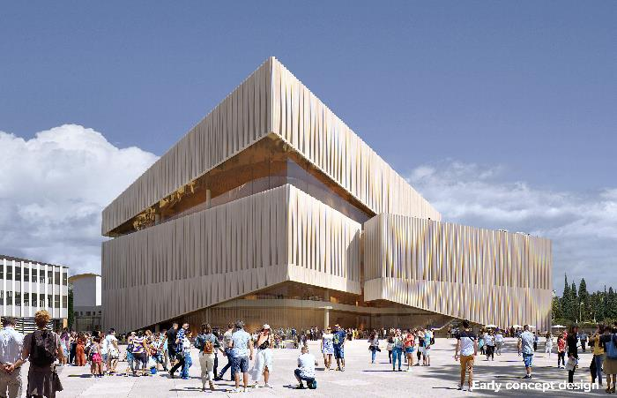

Render of the façade of the new theatre redevelopment. Image: Architectus, Danish Architects Henning Larsen, international theatre designers Arup and a First Nations consultancy team (Yerrabingin)

Internal Accountability
The Leadership team of the CFC comprised the following positions:

 | CFC Leadership Team
Chief Executive Officer | Chief Financial Officer | Chief of Staff
Gordon Ramsay | Ian Tidy | Dr Brooke Thomas
Director, CTC | A/g Director, ACTHP | A/g Director, CMAG
Alex Budd | Amy Jarvis | Dr Anna Wong
Director, Facility Operations and Capital Works
 | Ken Gibson

Information about the Leadership Team is provided at Appendix 1, page 106 (for the Chief Executive Officer, as a CFC Board member) and Appendix 2, page 109 (for the other six leadership team positions).

The responsibilities of each leadership team position are reflected in the organisational chart at page
7. Further information relating to the structure of the organisation is provided at Section B.1.3, page 15.

The team members meet as a Senior Leadership Team every fortnight to discuss strategic, operational, financial and collaboration matters. Other significant committees of the CFC include the WHS Committee, the Agency Consultative Committee, and Audit and Risk Management (refer to Section B.10, page 87)

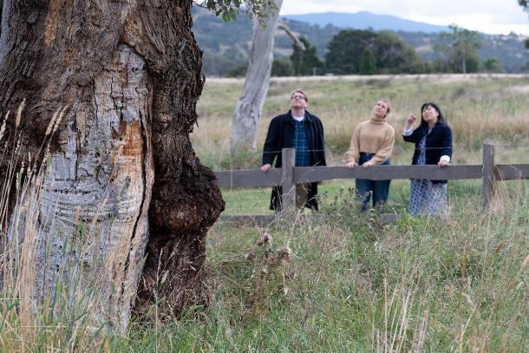
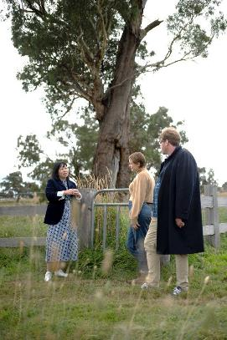
Lanyon. Images: Tourism Australia

Board of the CFC

Composition
Section 10 of the CFC Act provides for the CFC Board to have seven members. The Chair, Deputy Chair, and four Members of the CFC Board are appointed by the Minister in accordance with the provisions of the Financial Management Act 1996 (the FM Act), Sections 78–79. The CFC’s Chief Executive Officer is also a Member of the CFC Board in accordance with Section 80 of the FM Act. remuneration during 2022.

CFC Board Members
Chair | Deputy Chair
Helen O’Neil | Dr Rachael Coghlan
(Ex officio as CEO)
Gordon Ramsay
Members
Genevieve Jacobs AM
Shad Sears
Julian Widdup
Christine Shannon
Tim Lo Surdo
Michael Sollis

The functions of the Chair, Deputy Chair, Chief Executive Officer, and associated provisions relating to Board Members, are set out in the FM Act (Division 9.3).

Further information about the 2022-23 Board members is provided at Appendix 1, page 106.

Remuneration
The FM Act (Division 9.2, Clause 78 (6)) provides that the remuneration of the CFC’s Chair, Deputy Chair, and appointed Members shall be determined by the ACT Remuneration Tribunal.
The current annual remuneration rates, set by the Tribunal’s Determination No. 13 of 2022 are:

Remuneration Rates
Chair | Deputy Chair
$ 29,550 | $ 14,790
Members
$ 10,365

The Chief Executive Officer’s remuneration is determined by the ACT Remuneration Tribunal under normal senior executive remuneration arrangements.

Meetings
The CFC’s Board meetings are convened and conducted in accordance with the provisions of the FM Act (Division 9.4). Information about attendances at these meetings, is at Appendix 1, page 106.

2022-23 Board Meetings
2022 | 2023
18 August | 23 February
20 October | 27 April
7 December | 15 June

The convening of these meetings, and their procedures, complied with the requirements of Division 9.4 of the FM Act.

A quorum was achieved at all meetings (refer to Division 9.4, Section 95 of the FM Act).

Board Charter
The Board has adopted a Board Charter to guide its operations and performance. This is available at http://www.culturalfacilities.act.gov.au.

Audit Arrangements

The CFC has established the Audit Committee as a sub-committee of the Board, with a formal charter setting out its role and functions in relation to oversight of financial, audit, and compliance matters, including risk management and internal controls.

The Audit Committee Charter is provided as Part G of the CFC Board Charter, available at: http://www.culturalfacilities.act.gov.au.

Advisory Committees

The CFC has established three Advisory Committees, in accordance with Section 8 (i)(a) of the CFC Act, to provide expert strategic advice in relation to their respective specialist areas. The committees are the CMAG, ACTHP, and CTC Advisory Committee.

The current advisory committee members’ terms are from 1 January 2022 to 31 December 2024 and in 2022-23, members of the three advisory committees attended meetings for approximately 12 hours of time in total. During 2022-23 the CMAG and CTC advisory committee met three times, and the ACTHP committee met four times.

The operation of the advisory committees is governed by an Advisory Committees Charter, which is available at http://www.culturalfacilities.act.gov.au. Details about Advisory Committee members are provided at Appendix 3, page 112.

2022-23 CFC Advisory Committee Membership
CMAG Advisory Committee | CTC Advisory Committee | ACTHP Advisory Committee
Prof Nicholas Brown (Convenor) | Meg Williams (Convenor) | Barbara Reeve, FIIC, M. ICOMOS (Convenor)
Prof Denise Ferris | Claudia Santangelo (Deputy Convenor) | Dr Dianne Firth OAM (Deputy Convenor)
Squadron Leader Gary Oakley OAM | Soelily Consen-Lynch | Alistair Grinbergs
Dr Charlotte Craw | Fredeliza Campos | Joanne Lisinski
Sara Kelly | David Hobbes | Shannyn Palmer
Amelia Zaraftis | Kels Bagust
 | Shannyn Palmer

Performance Analysis

The CFC’s 2022-23 Statement of Intent was prepared in accordance with Section 61 of the Financial Management ACT 1996 and published in the 2022-23 ACT Budget statements. The Statement of Intent identified the CFC’s strategic objectives and indicators. Performance against these is summarised under Section B.1.4, page 16.

The 2022-23 Statement of Intent also identified targets for the CFC’s accountability indicators, which represent the CFC’s key performance indicators. A detailed analysis of outcomes against these targets is presented in the CFC’s 2022-23 Statement of Performance at Attachment 1, page 183, with a summary provided under Section B.1.4, page 16.

To allow an understanding of trends relating to these key performance indicators, charts are presented below of results for the indicators from 2019-20 to 2022-23.

Figure B.2a: Estimated number of visitors/patrons to CFC facilities/programs

500,000
400,000
300,000
200,000
100,000
0

2019-20 2020-21 2021-22 2022-23

Visitor numbers for 2022-23 were 383,026, 46% above target and have grown post COVID-19, exceeding numbers for the previous two financial years.

Target Actual

Figure B.2b: Number of exhibitions at facilities managed by the CFC
30

20

10

0
2019-20 2020-21 2021-22 2022-23

CFC-managed exhibitions have seen growth post COVID-19 with an increase in 2022-23 from the previous four financial years. It is anticipated that growth will continue into 2023-24 and beyond.

Target Actual

Figure B.2c: Numbers of education and community programs provided by the CFC
500

400

300

200

100
Demand for education and community programs remained strong reaching 382, 86% above CFC’s target for 2022-23.

0
2019-20 2020-21 2021-22 2022-23

Target Actual

800
700
600
500
400
300
200
100
0
Figure B.2d: Number of days venue usage at the Canberra Theatre Centre’s venues

2019-20 2020-21 2021-22 2022-23

Above target usage rates were achieved for the venues of the Canberra Theatre Centre in 2022-23. There were 702 days of venue usage, 48% above target for the financial year.

Target Actual

100

95

90
Figure B.2e: Customer satisfaction with quality of services provided by the CFC, as measured by annual survey

Customer satisfaction levels over the past four years have been above target, reflecting attempts by each venue to achieve as high a standard as possible. The level for 2022-23 was 93%, 3% above target.

85
2019-20 2020-21 2021-22 2022-23

Target Actual

Figure B.2f: Cost to government per estimated visitor/patron to CFC facilities/programs
80
70
60
50
40
30
20
10
0
2019-20 2020-21 2021-22 2022-23

With a target cost to government of $39.02 CFC achieved an actual cost of
$26.64 for 2022-23, resulting in (32%) reduction for the financial year.

Target Actual

Figure B.2g: Own Sourced Revenue as a Proportion of Total Revenue for the Corporation
60
50
40
30
20
10
0
2019-20 2020-21 2021-22 2022-23

CFC’s own sourced revenue increased significantly during 2022-23 reaching 55.4%, 11% above the target of 49.8%.

Target Actual

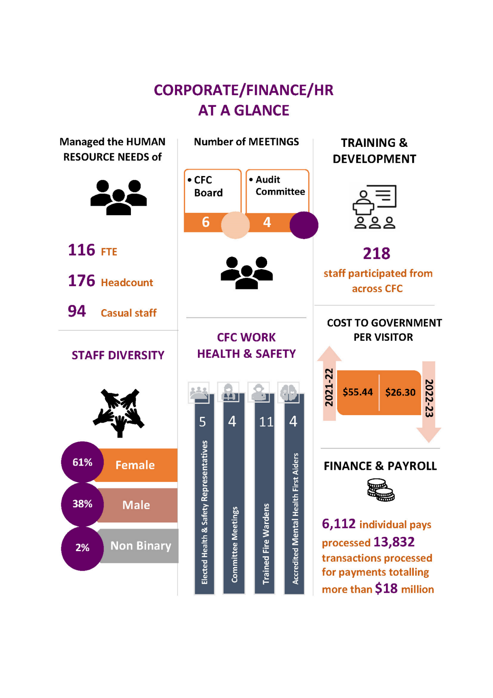
The following section provides a analyses of the organisation’s performance against the mission/purpose statements for the CFC, CTC, CMAG and ACTHP as set out in the CFC’s 2021-22 Business Plan, based on the CFC’s 2021-24 Strategic Plan.

The section provides a medium to long term view of the performance of each of CFC’s business arms. Each section incorporates strategic objectives and outcomes, as identified in the CFC’s 2021- 24 Strategic Plan, and includes strategies and key outcomes in line with the CFC Statement of Performance under the Financial Management Act.

Cultural Facilities Corporation (CFC)

What we are An enterprise of the ACT Government that manages a number of Canberra’s major cultural facilities

What we do We connect people with rich and diverse cultural experiences through activities at our venues

Our vision To provide cultural leadership in the Canberra region and beyond

What we want Leadership: a cultural leader in the ACT region and beyond
to achieve Strategy: a clear direction for our future Governance: an accountable and dynamic organisation People: an employer of choice
Finances: long-term financial sustainability
Assets: support for delivering high quality cultural experiences
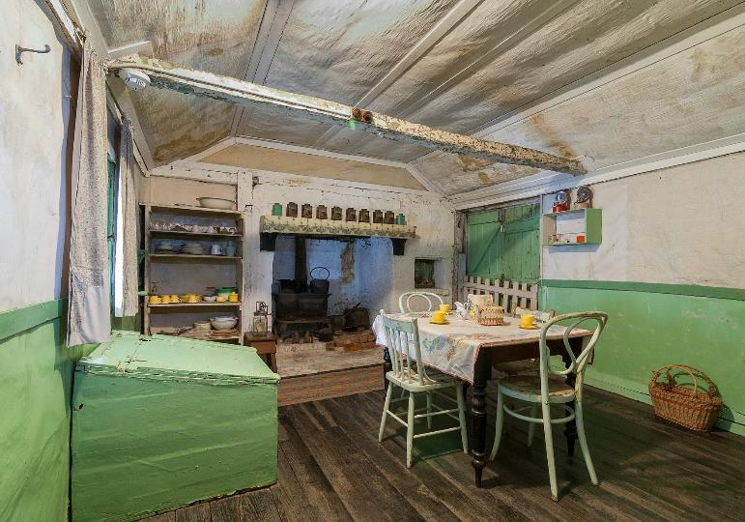
Mugga-Mugga Cottage. Image: Tourism Australia

A smooth recovery from the COVID-19 pandemic
Strategies to achieve this:

Manage through, and recover from, the COVID-19 pandemic, ensuring that, to the extent possible:
- negative impacts of COVID-19 on the CFC’s venues and operations are minimised;
- positive impacts are retained and built upon;
- the CFC’s financial sustainability is maintained; and
- the CFC provides cultural leadership in the recovery from COVID-19.

Key outcomes in 2022-23 against the above strategies
      - After a strong focus on navigating COVID- 19 and its significant impact on the Arts,
the CFC performed strongly in 2022-23 with audiences returning and broadly reaching pre-pandemic levels by the end of the year.

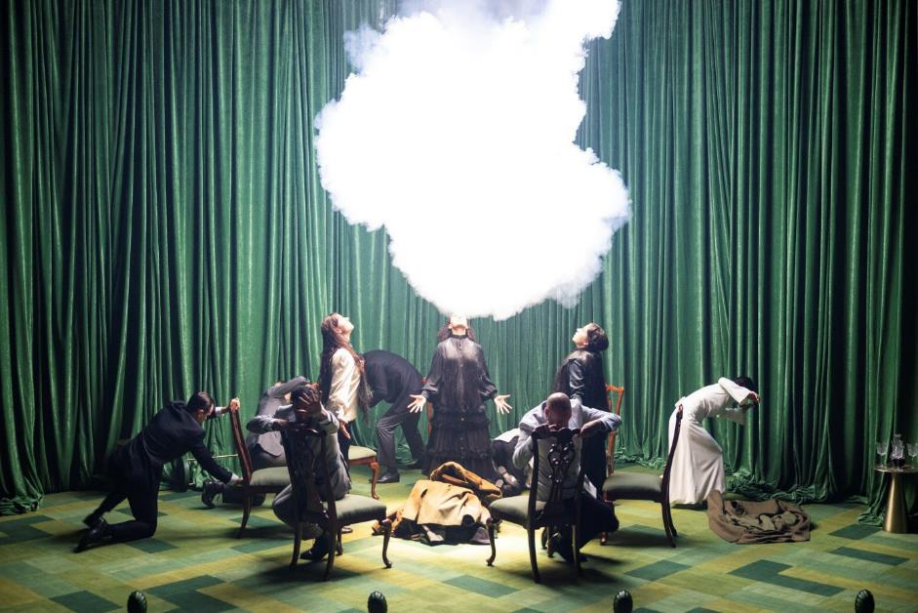
Bell Shakespeare’s Macbeth. Image: Brett Boardman

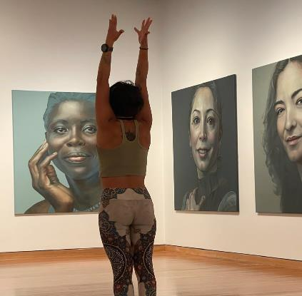
Leadership - A cultural leader in the ACT region and beyond

Strategies to achieve this:

Provide cultural leadership in the ACT region’s creative recovery from COVID-19.

Play a leading role in developing the Canberra Civic and Culture District, in partnership with the City Renewal Authority (CRA) and other agencies.

Work with Major Projects Canberra (MPC) to reduce negative impacts, and promote positive outcomes, for the CFC’s city-based operations from Light Rail Stage 2.

Provide leadership in cultural planning and management, including through creative partnerships; through a commitment to Indigenous engagement and reconciliation; and by demonstrating the importance of arts and heritage to individual and community wellbeing.

Yoga in the Gallery. Image: CMAG

Key outcomes in 2022-23 against the above strategies
      - As above, in 2022-23, the CFC was able to shift focus from COVID-19 recovery and into areas of future growth and leadership.
      - With the launching of the government’s Arts, Culture and Creative Policy 2022-26, the CFC is contributing strongly to the Policy’s Action Plan, with direct responsibility for 26 of the 82 actions under
the Arts policy and a significant role in a further 9 areas.
- Other key areas of leadership in 2022-23 included the CEO chairing the District Coordination group leading government consideration of the future of the Canberra Civic and Culture District; the CEO sitting on the Board of the Canberra and Region Tourism Leaders Forum; and the CEO hosting regular meetings of all the head of the National Cultural Institutions together.
- Relationships were maintained with the Minister’s Creative Council and the Childers Group through periodic briefings with the CFC Board. The Board is also regularly briefed by the CRA and MPC.
- Advocacy has been maintained regarding minimisation of the impact of Stage 2 Light Rail on CTC and CMAG with minimal concerns emerging now that those works are well underway. Future advocacy in this area is more likely to focus on pedestrian connectivity from light rail stops to the theatre.

  - Throughout the year, CFC staff participated in a range of activities with peak cultural and tourism bodies, including conferences and meetings of the Canberra Region Tourism Advisory Forum, Visit Canberra, the National Capital Attractions Association, the Australian Museums and Galleries Association, and the Art Association of Australia and New Zealand.
- For details regarding initiatives to support the inclusion of Aboriginal and Torres Strait Islander people in CFC governance and staffing, please refer to B.9 Aboriginal and Torres Strait Islander reporting, page 85.

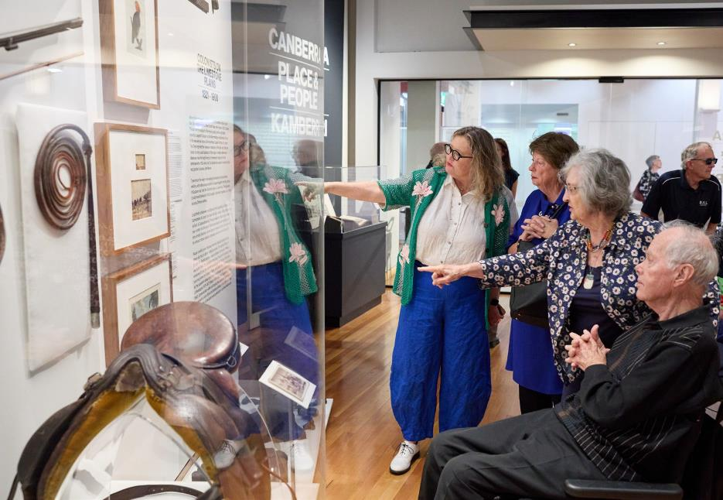
Curator Talk - Canberra/Kamberri: Place & People. Image: CMAG

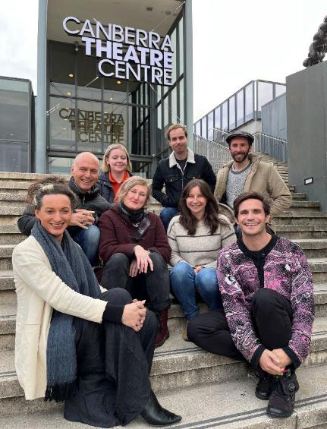
Strategy – A clear direction for our future

Strategies to achieve this:

Ensure our governance systems provide a high standard of accountability.

Maintain our Board at full strength, with members who are highly skilled, diverse, and committed to continuous improvement.

Maintain our three advisory committees as important sources of advice to the organisation, and of engagement with the communities we serve.

New Ideas Lab. Image CTC

Key outcomes in 2022-23 against the above strategies
  - As outlined earlier, a new Strategic Plan 2023-27 has been developed and reflects CFC’s involvement in implementation of the ACT Government’s Statement of Ambition for the Arts, Canberra: Australia’s Arts Capital.
  - Following the updating of the CFC’s Strategic Plan, a new Business Plan will be approved in 2023-24.
- For the majority of 2022-23 while the new Strategic Plan was being developed, the CFC operated according to the CFC’s 2021–22 Business Plan, with the work of the Board, advisory committees, staff and volunteers guided by the CFC 2021–24 Strategic Plan.
- The Board remained at full strength with one resignation and one recruitment and met a total of 6 times.
- The advisory committees were also at full strength and met a total of 10 times.
- The 2021-22 Business Plan incorporated priorities to guide the CFC operations, with a particular focus on managing the impact of the continuing COVID-19 pandemic.
- The CFC’s web portal was updated, in response to Freedom of Information requests, the CFC’s online disclosure log includes access applications, decision notices and released documents.

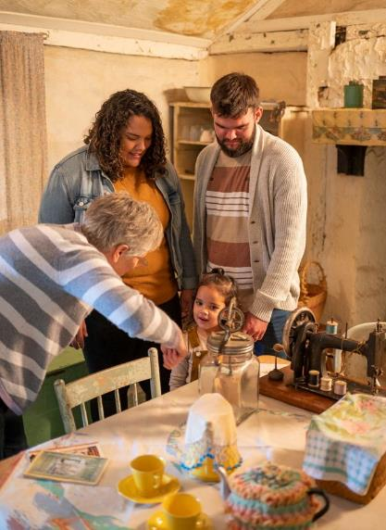
Governance – An accountable and dynamic organisation

Strategies to achieve this:

Ensure our governance systems provide a high standard of accountability.

Maintain our Board at full strength, with members who are highly skilled, diverse, and committed to continuous improvement.

Maintain our three advisory committees as important sources of advice to the organisation, and of engagement with the communities we serve.

Activities at Mugga-Mugga. Image: Tourism Australia

Key outcomes in 2022-23 against the above strategies
  - The CFC maintained robust governance systems to provide a high standard of accountability throughout the year.
On 2 July 2022 Deputy Chair, Helen O’Neil was appointed as Chair, Dr Rachael Coghlan was appointed as Deputy Chair, Michael Sollis commenced a term with the Board, and Genevieve Jacobs was reappointed to the Board until 31 December 2024. Two new Board members were welcomed – Tim
Lo Surdo (appointed from 1 January 2023) and Christine Shannon (appointed 14 April 2023).
- The renewal process for membership of CFC’s three advisory committees was completed in 2021 in accordance with the procedures set out in the CFC’s Advisory Committees Charter, for the period
1 January 2022 to 31 December 2024. New members were inducted and an annual work program for each committee was developed.
- Representatives of the ACT Audit Office were invited to all meetings of the CFC’s Audit Committee during 2022-23. An ACT Audit Office representative provided a briefing to the October 2022 Board meeting on the audit of the CFC’s 2021-22 Financial Statements and 2021-22 Statement of Performance.
- The CFC’s quality assurance program for the year focused calculation on long service leave balances, petty cash, password changes for the finance system, and Accounts Payable vendor verification.
- The CFC Fraud Risk Register was approved by the Board at its December 2022 meeting.
- The CFC’s Security Executive Group met throughout the year to discuss security matters.

  - The Senior Leadership Team meet fortnightly, consisting of the CEO, CFO, and Directors of CTC, CMAG, ACTHP, Collaboration & Engagement, and Facility Operation & Capital Works.
  - The key documents register (KDR) continued to be used by the CFC during the year, in order to centralise policies, develop consistent formatting, ensure alignment to the Strategic Plan and identify timeframes for review, updating and approval.
- An audit of the KDR was completed resulting in an increasing shift toward consistency with and utilisation of whole- of-government documents and a more streamlined approach in the processing and approval of CFC documents, including notably in the areas of recruitment and human resources.
- Key policies, plans, and strategies received Board approval throughout the year.

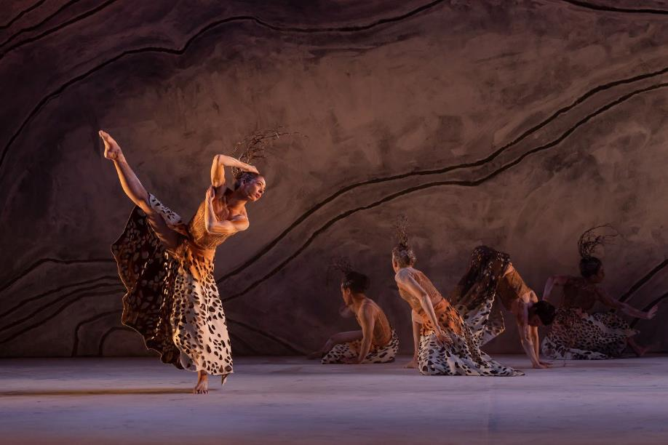
Bangarra Dance Theatre Terrain. Image: Daniel Boud

People – An employer of choice

Strategies to achieve this:

Attract, develop and retain staff and volunteers who are highly skilled, diverse and passionate about their work.

Ensure our workplace is safe, respectful and rewarding for staff and volunteers.
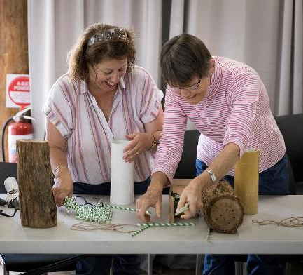

Bee Hotel Workshop Mugga-Mugga. Image: ACTHP

Key outcomes in 2022–23 against the above strategies
  - After the successful introduction of working-from-home provisions for many roles at the CFC as a result of COVID-19 restrictions, hybrid working arrangements continued to be available staff throughout 2022-23.
  - The CFC is focused on attracting, developing, and retaining highly skilled staff and volunteers, and on ensuring its sites are safe and rewarding places to work.
  - CFC Induction sessions are aimed at supporting and settling new employees within the CFC with a focus on providing relevant information to new staff regarding the business of the organisation, including the Enterprise Agreement, staff entitlements, Employee Assistance Program, Work Health and Safety/RiskMan,
performance management and First Aid. Employees are provided with an Induction Pack which includes all supporting documents relating to the session.
- The interim CFC Enterprise Agreement 2021–22 continued to be in operation throughout 2022-23 while whole-of- government enterprise bargaining continued. Agency-specific negotiations were carried out across the different pools of staff and are continuing into 2023-24 with ballot likely to occur in late 2023.
- The CFC participated in whole-of- government Secure Work Conversions with the result of one temporary and two casual staff members being found eligible for conversion to permanent roles.
- The CFC continued to implement the Respect, Equity and Diversity (RED) Framework. RED training occurring in July 2022.
- The CFC uses a range of tools to keep staff informed and connected including a CFC intranet site, a collaborative approach to meetings, holding all-staff townhall meetings, and regular all staff emails.
- The CFC Work Health and Safety (WHS) Committee met quarterly in February, May, August and November to discuss WHS issues across the organisation. Representatives from the Community and Public Sector Union and Media, Entertainment and Arts Alliance (both

unions with coverage in the CFC) were invited to attend and CFC business unit Health and Safety meetings were held throughout the year for CMAG and ACTHP.
  - WHS and injury management improvement strategies continued to be implemented throughout the year, and a report on workplace safety was provided to all Board meetings. In addition to these regular reports, a further report was provided to the Board every six months on key safety risks identified for CFC workplaces, and how these risks were being managed.
  - The CFC’s three advisory committees operated throughout 2022-23. All committee members provide their time on a voluntary basis. Individual committee meetings were held in 2022-23.
During National Volunteer Week in May 2023, ACTHP held a thank you morning tea for volunteers to recognise and celebrate their contributions.
- A flu vaccination program was available to all CFC staff in April 2023.
- The 2022 Don Aitkin Awards were held on 1 February 2023 and recognised three staff members for their contribution and achievements: Amy Jarvis (ACTHP staff member); Gillian Schwab (CTC staff member); and Michael Bailey (CMAG staff member).

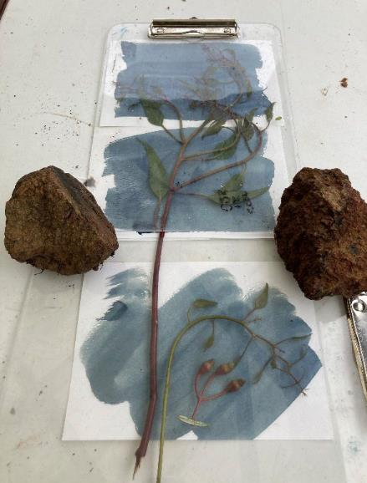
Cyanotype Workshop ACTHP. Image ACTHP

Finances – Long-term financial sustainability

Strategies to achieve this:

Maintain high standards of financial management and reporting.

Maximise both government and own-sourced income, to ensure financial sustainability and support future growth.
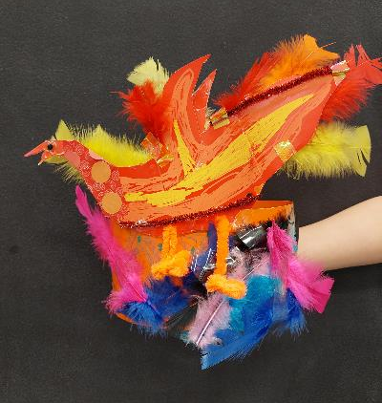

Fantastic Creatures Workshop, CMAG on Saturday. Image: CMAG

Key outcomes in 2022-23 against the above strategies
  - In 2022-23 the CFC maintained high standards of financial management and reporting.
  - The audit of the CFC’s 2022-23 Financial Statements by the ACT Auditor-General resulted in an unmodified audit.
  - For 2022-23, the CFC achieved own-sourced revenue of 55.4% comparable with a target of 49.8%.
  - The CFC achieved a cost to government per visitor outcome of $26.64 compared with a target of $39.02. The better than target figure relates primarily to higher than expected visitors/patrons in the second half of the year and ceasing of COVID-19 related restrictions.

- The CFC’s 2022-23 internal budget included strategies to address COVID-19 and long- term financial sustainability.
- The Government provided additional COVID-19 Response funding of $2.517 million to the CFC in 2021-22 to enable it to continue its operations and to keep employing its staff during the COVID-19 pandemic. Additionally, $438,000 COVID-19 economic support initiative funding was reprofiled from the previous year to continue support in responding to the loss of revenue from the COVID-19 pandemic.
- The Corporate Finance area continued to meet deadlines for payroll, theatre show acquittals, accounts payments and the collection of receivables.
- The CFC developed two bids which were funded in the 2023–24 ACT Budget, leading to further funding for the jointly delivered CTC-CIT Certificate III in Live Production and Technical Services for the training of backstage theatre professionals, and funding to support the ongoing expansion of CMAG into vacant ground floor spaces in the North Building and to contribute to the activation of Civic Square. These are the Circuit Gallery (formerly the Mr Wei restaurant) and the Civic Square Hub (formerly the Elections ACT office). The new areas in turn support future financial sustainability through the income generation opportunities they present.

Assets - Support for delivering high quality cultural experiences

Strategies to achieve this:

Maintain high standards of asset management. Achieve high standards of disability access.
Ensure ICT resources, business systems and records support our work and deliver high quality outcomes.
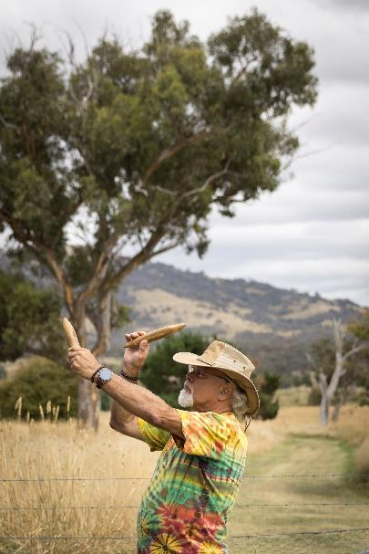

Wally Bell Harvest Day Out. Image: Jane Duong

Key outcomes in 2022-23 against the above strategies
  - High quality asset management continued to be a key priority for the CFC during 2022- 23, in view of its responsibility for major cultural sites.
  - Work continued on introducing a consistent learning and development framework for all staff.
  - The CFC’s Intranet continued to ensure staff key information is shared and located in a
central location, enabling greater communication and collaboration across the CFC.
- In May 2023 CFC tested its preparedness in the event of a disruption, and high-level response and recovery capabilities in relation to major crises including bushfires, smoke haze and COVID-19. The CFC contracted RiskLogic to finalise a new Business Continuity Plan in 2021-22 and levels of readiness were tested through a desktop crisis management exercise in April 2023.
- The CFC continues to use the Whole of Government Electronic Document Records Management System (EDRMS) HPE Content Manager/TRIM (with WIRE interface) for its record management.
- Digitisation of records continued across the CFC and the CFC is presented at Records and Information Management Community of Practice meetings facilitated by Territory Records Services.
- The CFC’s Resource Management Plan continued to provide the framework for the CFC’s sustainability and energy efficiency practices.

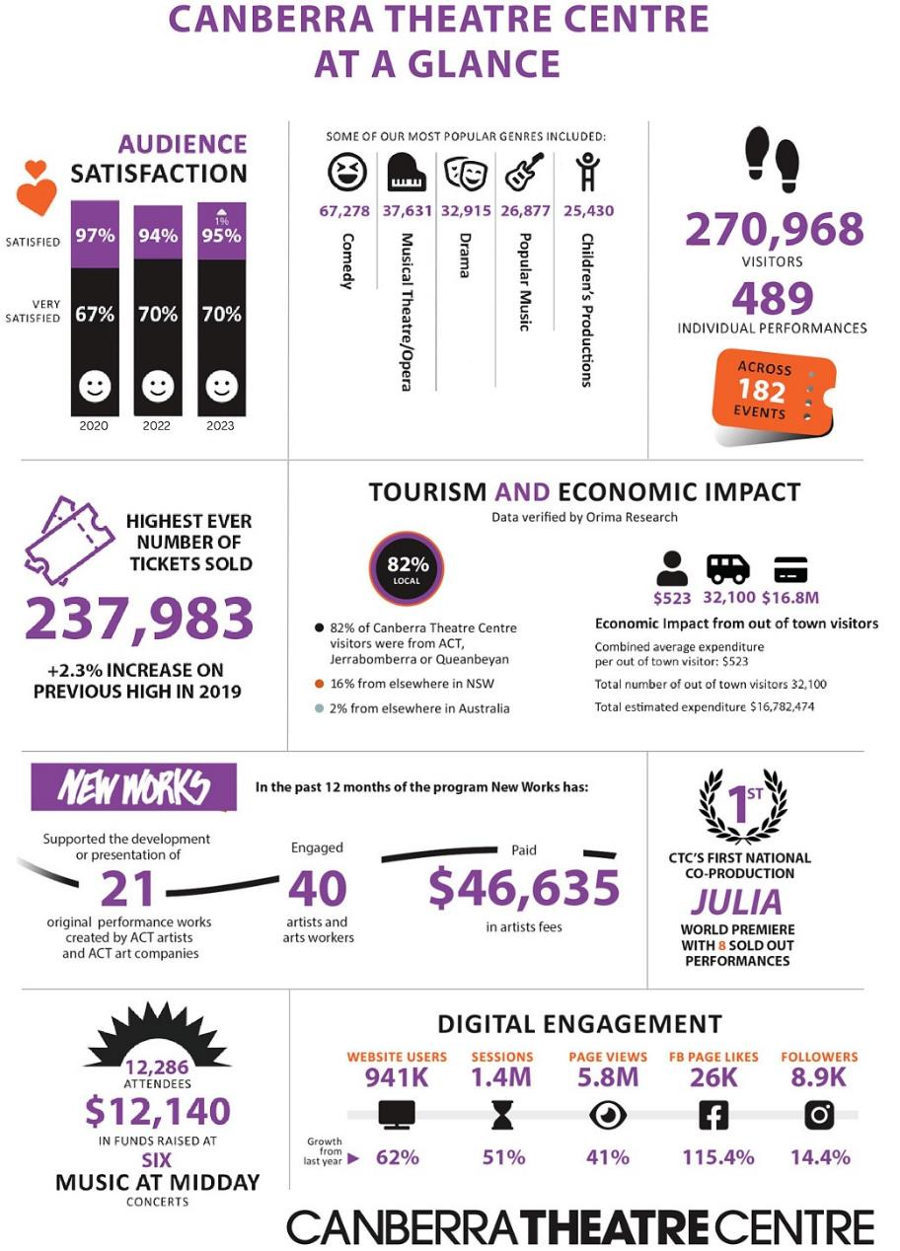

Canberra Theatre Centre

What we are The Canberra region’s main theatre centre, incorporating the Canberra Theatre, The Playhouse and the Courtyard Studio

What we do We connect people with theatre experiences of national and international quality

Our vision To be the leading theatre centre in Australia and Asia

What we want Customers: Audiences that are growing, diverse, engaged and entertained Programming: A diverse, high quality, entertaining and distinctive program Business: Venues, systems and people that support high quality live
performances
Leadership: An integral part of the cultural life of the Canberra region and beyond

A smooth recovery from the COVID-19 pandemic

Strategies to achieve this:
Manage through, and recover from, the COVID-19 pandemic, ensuring that, to the extent possible:
- negative impacts of COVID-19 on the CTC’s venues and operations are minimised;
- positive impacts are retained and built upon.
- the CTC’s financial sustainability is maintained; and
- the CTC provides cultural leadership in the recovery from COVID-19.

Key outcomes in 2022-23 against the above strategies
      - The Canberra Theatre Centre (CTC) recorded a strong recovery from the COVID-19 pandemic within the 2022-23 financial year; recording its highest number of tickets sold (+2.3% increase from the previous high in 2018-2019), nights usage (1.3% increase on 2017-2018) and venue
hire (24.4% increase on 2018-2019 actuals) in recent history.
      - The CTC continued its commitment to extensive marketing support to presenters from outside of the region. This helped to achieve ticket sale objectives, utilising its

large database and engaged social media following.
- CTC continued its commitment to developing greater capacity and visibility for the ACT region’s performing arts sector and creating meaningful opportunities for local artists through its New Works program.
- The 2022/23 New Works program included a professionally mentored New Ideas Lab, two week-long funded developments, and two sponsored two- week developments for local artists.

Customers – Audiences that are growing, diverse, engaged and entertained

Strategies to achieve this:

Ensure that customers remain at the centre of all that we do.

Increase our audience and diversify it in terms of age, geography, and cultural background.

Develop a suite of marketing and ticketing technology that enhances the customer experience and builds the CTC brand.
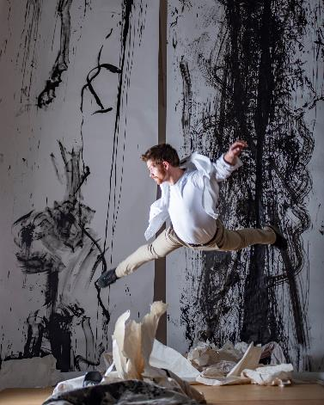

Jake Silvestro Acrobatics ALC. Image Martin Ollman

Key outcomes in 2022-23 against the above strategies
  - The CTC continued work on the procurement tender process of a ticketing management system. The successful tenderer is expected to be confirmed in the first part of 2023-24.
  - The CTC continued to successfully employ a range of communication methods including “info emails” and text messages to inform patrons of ACT Health’s safety guidelines, traffic and construction information, access information, show warnings and show time/venue update information.
  - The CTC continued to promote opportunities for customers to engage in
dialogue with and provide feedback to the CTC through its patron survey, social media community engagement, direct phone calls to Box Office, and in person with Box Office and FOH staff.
- The CTC programmed a range of associated programming and activations providing a wholistic experience for customers. These included special Q&A events for Girl from the North Country, Sydney Dance Company, and Julia; a community choir night for Choir Boy; two Babes in Arms performances for Pony; and custom cocktails, DJ and facepainting event for Briefs Dirty Laundry.
- The CTC held an end of year celebration event for previous subscribers, launching the CTC brand campaign and announcing 7 new productions, including two world premieres.
- The CTC reviewed its options for audience engagement and value adding, continuing analysis as a foundation for a membership program.
- The CTC collaborated with a wide range of national and local institutions and festivals including the National Portrait Gallery, National Museum of Australia, Museum of Australia Democracy, Questacon, Canberra Museum and Gallery, National Dinosaur Museum, Floriade, increasing its reach to new audiences.

  - The CTC's brand campaign was launched with a range of assets in venue and used across digital channels, providing a framework to continue to build the CTC brand.
  - Works presented at CTC included artists of diverse backgrounds and lived experiences across its stages including works by LGBTIQA+ artists, First Nations artists,
Culturally and Linguistically Diverse artists and young artists Including Essential Theatre’s Emilia, Griffin Theatre Company’s Whitefella Yella Tree, National Theatre of Parramatta’s Choir Boy, and Briefs Factory International’s Briefs- Dirty Laundry, Kae Tempest, and Canberra Youth Theatre’s How to Vote.

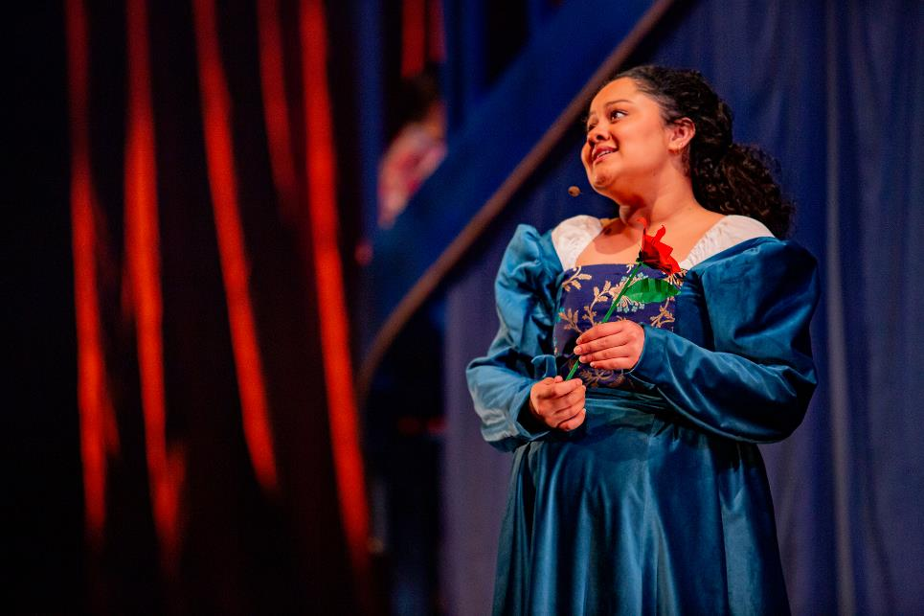

Emilia. Image: Arts Centre Melbourne

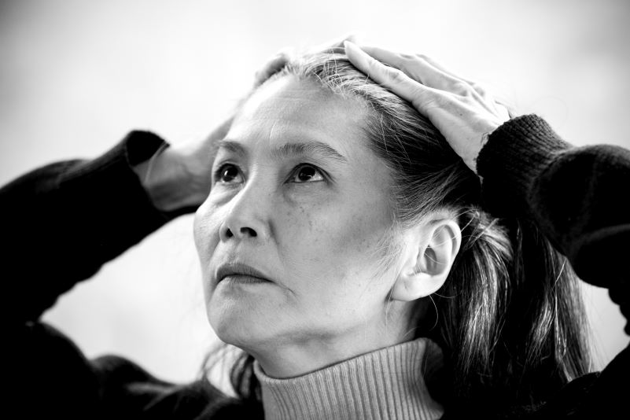
•
Programming – A diverse, high quality, entertaining and distinctive program

Strategies to achieve this:
Deliver a program of performances of the highest quality possible. Develop strategic partnerships with producers and presenters.
Contribute to, and nurture, the deepening of creativity in the ACT. Increase the number of Indigenous performances presented by the CTC.

Miss Peony. Image: Brett Boardman

Key outcomes in 2022-23 against the above strategies
  - Comedy remains incredibly and growingly popular with our audience, with over 65,000 ticket sales (a 32% increase from 21- 22). Total GBO for Comedy in 22-23 amounted to $4.7M - 26% increase from previous high in 18-19. CTC attracted the presentation of many high-quality comedians, including:
    - Jimmy Carr
    - Jimmy Rees
    - Kitty Flanagan
    - Sarah Millican
    - Dylan Moran
    - RuPaul’s Drag Race Down Under
    - Over 30 artists across 34 events of the Canberra Comedy Festival 2023, amounting to over 8,000 ticket sales.
  - The CTC continues to attract high quality contemporary music events throughout the year, yielding more than 25,000 tickets sold, with performers including:

- Amy Shark
- Vika & Linda Bull
- The Whitlams
- Guy Sebastian
- Nick Cave & Warren Ellis
- Kae Tempest
- Human Nature.
- CTC partnered with Sydney Theatre Company to co-produce the world-premiere season of Joanna Murray-Smith's Julia which played to sold out houses in both Canberra and Sydney.
- CTC supported a variety of local artists, companies and producers to access its venues through subsidies and sponsorships including Canberra Youth Theatre, Heart Strings Theatre Company, Cahoots Lab – You Are Here, QL2, and Ausdance ACT.
- Shake & Stir’s Charles Dickens’ A Christmas Carol, a holiday favourite from Brisbane.
- The New Works program continued with information sessions, a New Idea’s lab and incubator program, 3 paid week-long creative developments of Jake Silvestro’s Alienation, Mark Salvestro’s The Queen’s City of the South, and Christopher Samuel Carroll’s Commitment to the Cause, and the presentation of the premier season of Batchelor + Lea: A Dance Week Double Bill. New Works also supported further project development for choreographer Melanie Lane’s Mountain and Little Dove Theatre

Art’s Francesca Giselle.
  - CTC continued to work closely with commercial presenters, attracting several national touring works of significant scale to the Centre including:
    - Girl From the North Country
    - Agatha Christie’s The Mousetrap
    - Come From Away.
  - Family programming included:
    - Brisbane favourite Shake & Stir Theatre Co’s The Twits
    - Canberra connected children’s musicians The Beanies’ Egg- straordinary Day
    - International acclaimed circus duo
Acrobuffo’s’ Air Play
    - Australian urban circus 360 ALLSTARS
    - Perth based puppetry company The Last Great Hunt presented a double bill for Enlighten called The Adventures of Alvin Sputnik: Deep Sea Explorer & New Owner.
  - CTC's ACT UP! Student fringe program continued into its 9th year, with regenerated audiences and student participation from across ACT and regional NSW. 2023 saw participation from 17
schools, 35 teachers, 290 students and 6 local professional artists. Audience attendance was improved and hopes to continue this trend for the 10th anniversary of ACT UP in 2024.
- The CTC continued its commitment to First Nation’s programming with presentations including Bangarra Dance Theatre’s Terrain, and Australian Dance Theatre’s SAVAGE, a work about identity and colonialism choreographed by Canberra connected Wiradjuri man Daniel Riley in his first work with ADT as Artistic Director. 2023 also saw the return of the highly celebrated Reconciliation Day Eve Concert headlined by Yothu Yindi, and supported by local First Nations Artists Alinta Barlow and Stewart Barton, and hosted by Tahalianna.
- CTC has committed to an Emerging First Nations program through to the end of the 23-24 Financial year, aimed at increasing opportunities for Emerging First Nations music performers, local and national, at the Theatre. The first event was held in APR 2023, featuring Pirritu, a proud Wangaaypuwan mayi of the Ngiyampaa.



Roald Dahl - The Twits. Image: David Fell

Contracts by Genre
20%
18%
16%
14%
12%
10%
8%
6%
4%
2%
0%

Children's Production Classical Music
Comedy - Standup Comedy - Acts
Dance - Ballet Dance - Dance Social/Dance Sport
Dance - Contemporary Dance - Dance School
Dance - Cultural MultiArts
Musical Theatre/ Musical Opera Popular Music - Pop, Rock, Tribute, Jazz Presentation Theatre - Drama
Theatre Plays Circus/Physical Theatre

70%

Contracts by Locality

60%

50%

40%

30%

20%

10%

0%

International Local National

Nights Usage by Genre

18%
16%
14%
12%
10%
8%
6%
4%
2%
0%

Children's Production Classical Music
Comedy - Standup Comedy - Acts
Dance - Ballet Dance - Social Dance/Dance Sport
Dance - Contemporary Dance - Dance School
Dance - Cultural MultiArts
Musical Theatre Popular Music - Pop, Rock, Tribute, Jazz
Presentation Theatre - Drama
Theatre Plays Circus/Physical Theatre

Nights Usage by Locality

60%

50%

40%

30%

20%

10%

0%

International Local National

Business – Venues, systems and people that support high quality live
performances

Strategies to achieve this:

Grow the CTC business as it transitions to a 5,000 seat facility. Develop Canberra Ticketing into the ACT’s leading ticketing agency.
Build strength and resilience in the CTC’s budget, to ensure high quality
delivery and maintenance of facilities.
ACT’s leading ticketing agency after the
implementation of the new ticketing management system.
- The marketing of Canberra Ticketing will be
further expanded following the outcome of

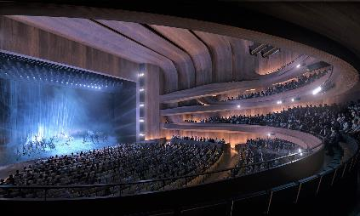

Render of the 2,000-seat theatre. Image: Architectus, Danish Architects Henning Larsen, international theatre designers Arup and a First Nations consultancy team (Yerrabingin)

Key outcomes in 2022-23 against the above strategies
- The CTC conducted work on the procurement tender process of a ticketing management system. The successful tenderer is expected to be confirmed in the first part of 2023-24.
- In Q4 of 2022-23, CTC commenced a brand refresh for Canberra Ticketing in order develop Canberra Ticketing into the

White Pearl. Image: Phil Erbacher
the ticketing system procurement.
- A review of food and beverage options to enhance the customer experience and generate increased revenues has been re- cast as a potential collaborative project across the CFC which will continue throughout the 2023-24 financial year.

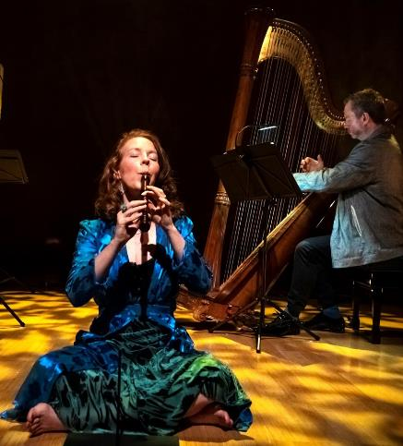
Bower. Image: Gregory Lorenzutti

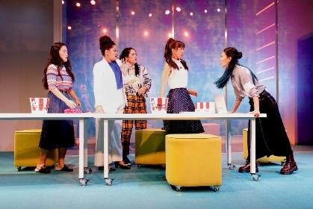

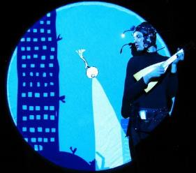
Leadership – An integral part of the cultural life of the Canberra region and beyond

Strategies to achieve this:

Plan for the transformation of the CTC into a leading Australian performing arts centre, through the major new theatre project.

Provide leadership in theatre education from primary through to tertiary and vocational education.

Grow the CTC’s contribution to the creative sector and economy of the Territory.

Alvin Sputnik Down and Down. Image: Michelle Robin Anderson

Key outcomes in 2022-23 against the above strategies
  - The Canberra Theatre Redevelopment Project reached a project milestone with the procurement of the Lead Design Partner in May 2023. The winning design team lead by Architects Henning Larson, Architectus and engineering firm ARUP were successful in the Government procurement process. CTC played a vital role in evaluating the responses from the three shortlisted consortiums and advocating on behalf of the future users of the new theatres.
  - Since the appointment of the lead design team in May 2023 the CTC worked closely
in the design and business case process with Major Projects Canberra.
- During 2023, CTC renewed its partnership with CIT as a facilitator of the Cert III in Live Production. The focus of the course for the next two years of this partnership will be career pathways into the ACT sector, and particularly in supporting CTC’s programming with additional training and support to local theatre technicians. Each year the course supports 10 – 15 students to complete the qualification and gain experience in Lighting, Sound and AV operation as well as bump in and bump out processes and career management in the live production industries.
- The CTC connected with local artists, teachers, students and undergraduates through training in design and stagecraft planning. The CTC’s highly regarded Work Experience program was conducted twice during the year. Each program ran for five days, and hosts up to ten Year 9-12 students, and provides a creative immersion program including guest speakers, creative projects, viewing a performance and several technical drills/exercises.
- The CTC created a suite of New Works videos, promoting the New Works

programs, and the creative developments of two artists. Artists were able to use these assets as proof of concept for the continuation of the development of their works, including for grant applications.
  - The CTC developed a marketing trailer and suite of promotional photos for the co- production Julia, which were used in campaigns in both the Canberra and Sydney markets.
• The CTC’s creation of marketing and publicity materials across 2022-2023 was The CTC’s creation of marketing and publicity materials across 2022-2023 was supported by over 20 freelancers and small
businesses within the ACT, including
  - The CTC’s creation of marketing and publicity materials across 2022-2023 was supported by over 20 freelancers and small businesses within the ACT, including designers, photographers, videographers, and printers.

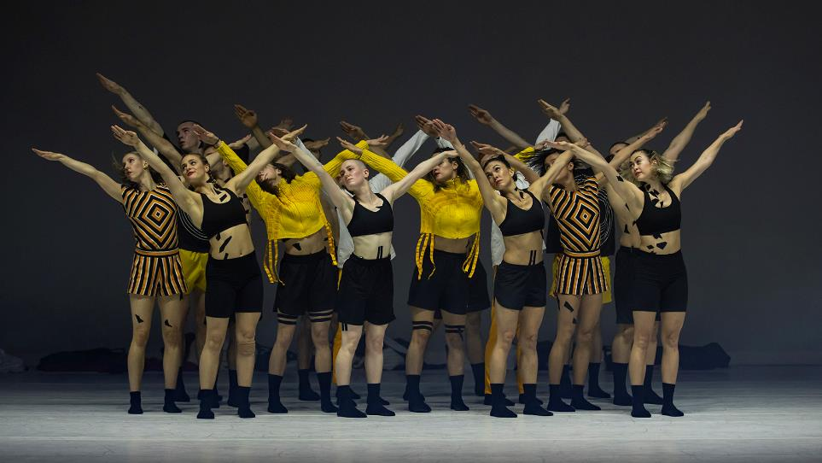
Ascent - Sydney Dance Company, Forever and Ever. Image: Pedro Greig

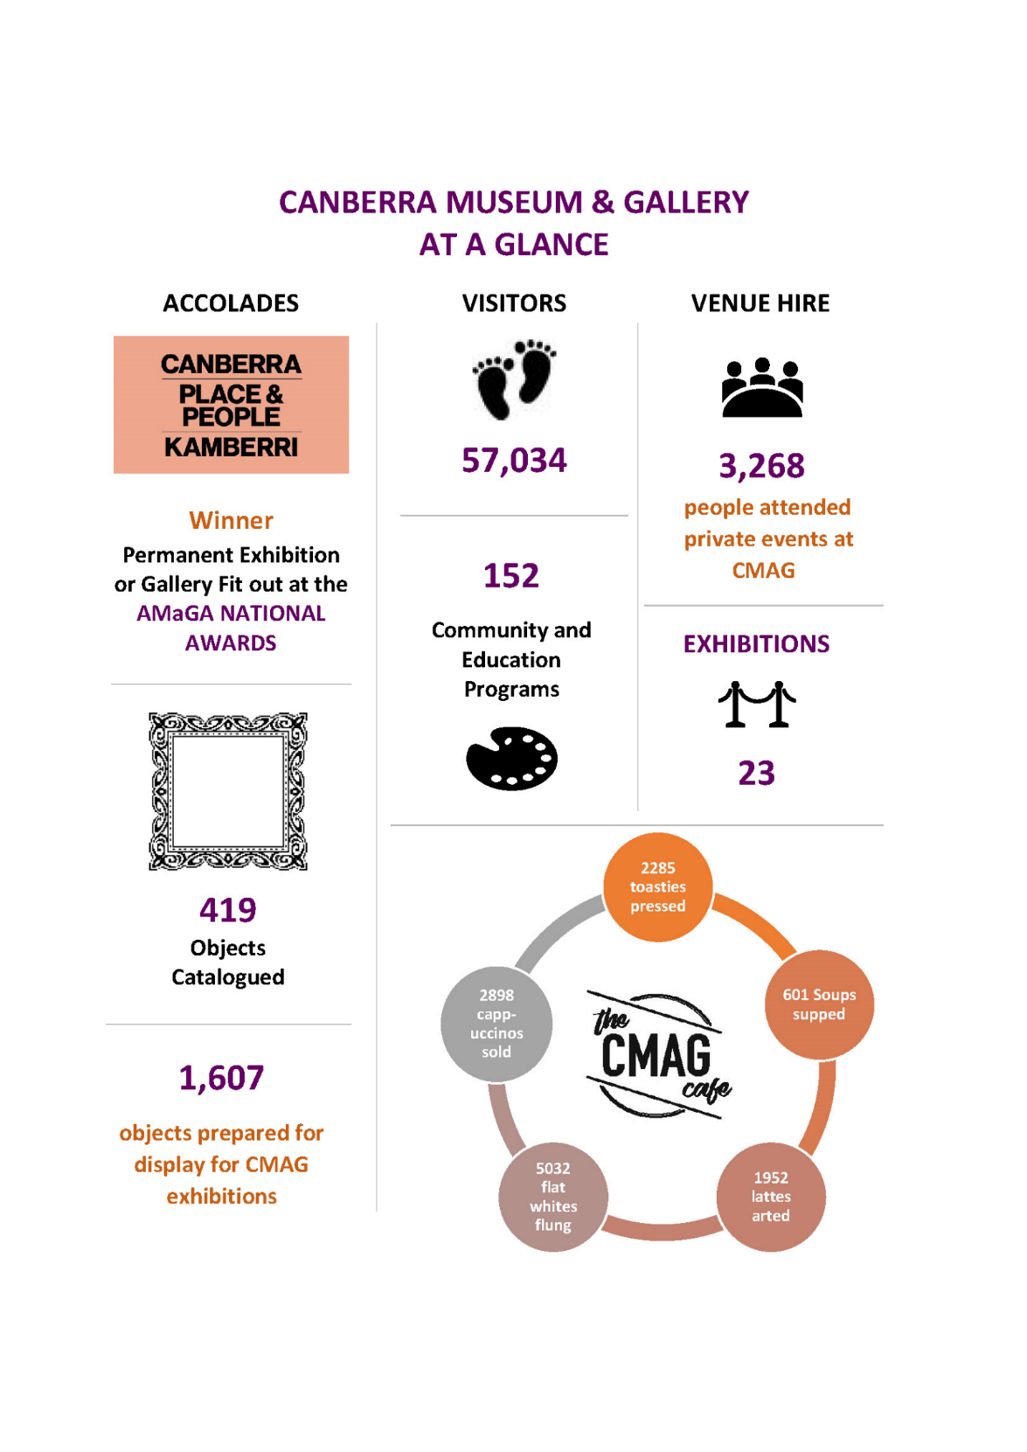

Canberra Museum and Gallery

What we are A museum and gallery dedicated to the visual arts and social history of the Canberra region

What we do We connect people with the Canberra region’s rich and diverse stories, sense of place, and contemporary identity

Our vision To be the leading regional cultural venue in Australia and beyond

What we want Customers: Audiences that are growing, diverse and engaged
to achieve Programming: Exhibitions and programs that reflect Canberra’s unique
identity
Stewardship: Venues and collections that allow us to tell the many stories of Canberra
Leadership: An integral part of the cultural life of the Canberra region and beyond

A smooth recovery from the COVID-19 pandemic

Strategies to achieve this:
Manage through, and recover from, the COVID-19 pandemic, ensuring that:
- negative impacts of COVID-19 on the CMAG’s venues and operations are minimised;
- positive impacts are retained and built upon;
- CMAG’s financial sustainability is maintained; and
- CMAG provides cultural leadership in the recovery from COVID-19.

Key outcomes in 2022-23 against the above strategies
      - CMAG continued to provide management and recovery measures relating to
COVID-19. Although there were no COVID- 19 restrictions relating to CMAG’s venues

and operations, the COVID-19 recovery was ongoing throughout the year.
  - Relevant infection control measures from COVIDSafe plan have been adopted into business-as-usual risk controls.

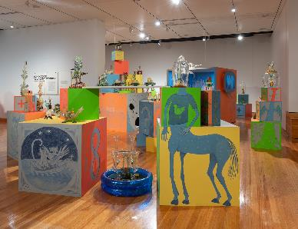
Customers – Audiences that are growing, diverse, engaged and entertained
Strategies to achieve this:

Ensure that customers remain at the centre of all that we do.

Design programs and marketing to reach those audiences that do not currently access our services.

Conduct market research to enable greater focus on target audiences in services and programming.
- Funding was secured in the 2021-22 Budget to enhance CMAG’s accessibility for people living with disabilities and to undertake a range of physical improvements such as the Gallery 1 and Circuit Gallery auto door upgrade works completed in January 2023. Further funding
was secured for additional upgrades in
Tom Moore Abundant Wonder. Image: CMAG

Key outcomes in 2022-23 against the above strategies
    - CMAG continually seeks to improve customer satisfaction with their visit to, and experience of, CMAG, with surveys available to complete online and onsite. Surveys were sent via scheduled email to invite feedback from participants after an event.
    - CMAG presented exhibitions specifically for a family audience including How Cities Work, a travelling show from Museums of History, NSW and Fly Fly! Sidney Nolan’s Birds.
    - A specific exhibition survey was included in the exhibition How Cities Work exhibition to assess the impact of the exhibition with new visitors to CMAG. 63% of the visitors were first time visitors to CMAG to end of June 2023.
2023-24.
- With a more intentional focus on building CMAG’s online activity and social media presence, the following was achieved:
- CMAG website attracted 30.53% more visitors than in 2021-22;
- Instagram profile visits were up 35.8% from 2021-22; and
- The CMAG Facebook reach increased by 191.8% from 2021-22.
- The total value of donations to the CMAG Collection was around $115,000.
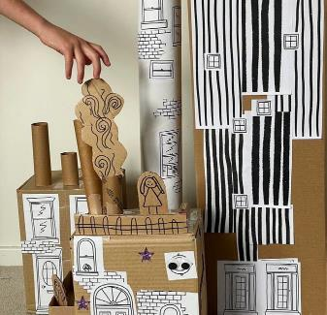
How Cities Work. Image: CMAG

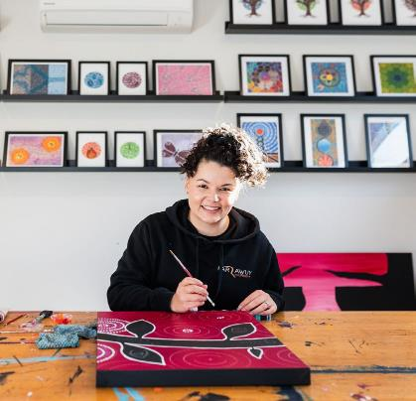
Programming – Exhibitions and programs that reflect Canberra’s unique identity

Strategies to achieve this:
Program excellent, innovative exhibitions, with a well-balanced mix of exhibitions that respond to a breadth of themes and societal issues.
Develop a range of community and learning programs and events that complement the exhibition program and contribute to activation of the precinct.
Ensure exhibitions feature cultural and gender diversity and Indigenous content, with a commitment to exhibitions of Indigenous content being Indigenous led, such as through Indigenous guest curators.

Reconciliation Week workshop. Image CMAG: Sarah Richards

Key outcomes in 2022-23 against the above strategies
  - CMAG presented a high-quality exhibition program in 2022-23 that reflected the diverse interests of the Canberra community.
  - The Canberra/Kamberri: Place & People exhibition was opened on Canberra Day by Chief Minister Andrew Barr. The exhibition also won the AMaGA National Award in the Permanent Exhibition category. The permanent exhibition includes art and objects from the CMAG Collection with a moving image component curated by Shane Breynard and supported by the National Film and Sound Archive.
- CMAG opened a gallery CMAG on the Circuit that included a complete refit of the former restaurant space. Light, Colour, Humanity: The Legacy of Alistair Swayn was the inaugural exhibition.
- Sidney Nolan: Search for Paradise Presented by the Heide Museum of Modern Art and Canberra Museum and Gallery is CMAG’s largest display of the work of Sidney Nolan.
- Dean Cross: Sometimes I Miss the Applause, a First Nations contemporary response to Nolan.
- Coinciding with Design Canberra 2022 and the International Year of Glass, touring shows, Jam Factory Icon Tom Moore: Abundant Wonder and Geelong Gallery’s Blanche Tilden: Ripple Effect were exhibited.
- Settled/Unsettled part touring show and part CMAG curated Canberra-based visual artists addressing migrant and refugee experiences.
- How Cities Work, a travelling show from Museums of History NSW, based on the book of the same name by Lonely Planet Kids, provided an interactive,

immersive exhibition for children and families. This exhibition was a ticketed exhibition and recovered costs.
  - The CMAG Foyer and entrance was activated with costumes from the film The True History of the Kelly Gang; a Diprotodon display for Enlighten 2023, Jan Brown’s: A life with Art, The Nom Chong Family, and Colours of Canberra.
  - The Open Collections Gallery included Life is Art: Works by John Nixon, and Platypus: a curious creature.
  - CMAG on the Square included exhibitions by Canberra practitioners Tony Clarke and Karena Keys.
  - The Nolan Foundation Collection in the Nolan Gallery was complemented by the rotating exhibitions Sidney Nolan’s Inferno; Matthew Thorne: Jingo was born in the Sun and Fly Fly! Sidney Nolan’s Birds.
  - A full list of CMAG exhibitions presented in 2022-23 is provided in Appendix 5, page 120.
  - During the year, CMAG presented a comprehensive range of community and learning programs and other activities, often in association with specific exhibitions or special events:
- Lindy Lee: Moon in a Dewdrop included an Artist Talk, lecture and guided Zen Meditation, and a MakerSpace activity Lantern inspired by Lindy Lee’s sculptures
- Sidney Nolan: Search for Paradise included a highlights tour with Senior Curator, a tour with Lesley Harding, a lecture with Artistic Director HEIDE MoMA, Head Curator Kendrah Morgan lecture with Nolan collector and author Andrew Turley, and a ticketed sell-out performance with the Canberra Symphony Orchestra Ensemble with a program inspired by themes of the exhibition. A
MakerSpace activity for children was developed to enable them to make their own NedHead
- CMAG's Design Canberra 2022 offering included a Canberra Design Symposium in collaboration with Craft ACT DESIGN Canberra Festival and The Australian National University; The presentation of the exhibitions Tom Moore: Abundant Wonder and Blanche Tilden: Ripple Effect; CraftACT’s installation of a temporary exhibition in the CMAG on the Square Gallery; Australian National University-based artist’s residency in CMAG’s Second Space
- CMAG partnered with the National Film and Sound Archive to present a screening of True History of the Kelly Gang and a Q+A; and In conversation: An armour of lace and silk – costuming the Kelly Gang with NFSA Assistant Curator Jenny Gall in the Nolan Gallery.
- CMAG began the program development of a lower and upper Primary Education Resource for Canberra/Kamberri: Place & People exhibition
- Settled/ Unsettled included a forum with the Canberra Refugee Action Campaign, artist Kathrin Longhurst and refugee Nazanin Bagheri
- Platypus: a curious creature included an 'in conversation’ event with Senior Curator Dr Hannah Paddon, collector Karen Collins and Jed Pearson from Waterwatch ACT.
- A Wellness Event: Yoga in the Gallery was initiated as part of the Multicultural Festival.
- Reel McCoy film group continued their bi- weekly film screenings at CMAG, showcasing 20 classic films during 2022-23.
- 388 students participated in the onsite Nolan focused learning program, Every Picture Tells a Story.

  - 21 Nolan Access and Learning programs were delivered (onsite and via outreach).
  - Several programs were delivered to coincide with the Enlighten Canberra festival including:
- CMAG After Dark @ Enlighten Festival
- Light, Colour, COCKTAILS with the Martini Whisperer
- CMAG on Saturday: Dino Days
- The Great Dino Escape - Earth roving Dinosaur Puppets.
Programs were delivered to coincide with the
Heritage Festival including:
- Precinct Tour: Canberra’s Mid Century Modern Heart
- Creative Workshop (all ages): Drawing in the Gallery
- Creative Workshop (teens and adults):
Watercolour with Waratah Lahy.
- For a list of Australian First Nations exhibitions and programming see B.8 Community Engagement and support.

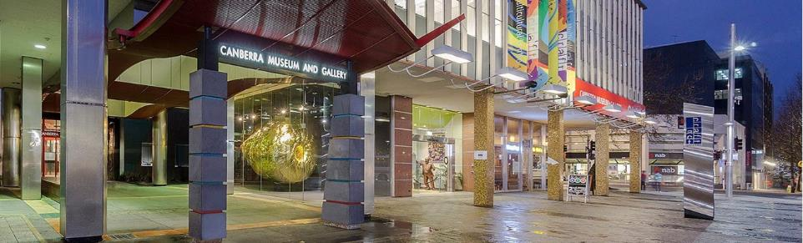
CMAG. Image CFC

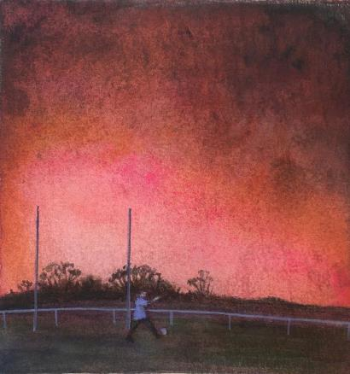
Stewardship – Venues and collections that give us a distinct place in Canberra’s cultural landscape

Strategies to achieve this:
Maintain CMAG’s venues and facilities to accepted international museum standards.
Develop, conserve, research and interpret CMAG’s visual arts and social history collection, and the Commonwealth-owned Nolan Collection.
Market the collections, so that these important resources are leveraged to the benefit of CFC, the ACT Government, and the community.

40th Heritage Festival April 23 - LAHY Waratah, Playing in the apocalypse 2020 - Watercolour workshops

Key outcomes in 2022-23 against the above strategies
  - A CMAG Collection Manager was appointed.
  - Best practice policies and procedures have been developed and are in development including:
    - Collections Disaster Plan
    - Deaccessioning Policy
    - Temporary Accession Numbers
    - Acquisition Proposals KPIs
    - In-house Vernon training for staff
    - Object handling training for staff.
  - A Cultural Gift was submitted to the Australian government for the acquisition of a major work by Imants Tillers.
  - CMAG continued to conserve, research, interpret and manage the Nolan Collection
under the Nolan Management Agreement with the Commonwealth:
- A collection management and conservation assessment of the Nolan Collection has been completed. A scoping of proposed work is underway, and the Commonwealth will be contacted with a status report and proposed actions for essential conservation works in line with CMAG’s obligations under the Collection Management Agreement with the Commonwealth.
- New exhibitions held within the Nolan Gallery included:
  - Sidney Nolan, Search for Paradise,
9 July-22 October 2022. The exhibition, curated by Kendrah Morgan and Dr Nancy Underhill, presented 40 years of Nolan’s career with works from the Heide collection, the Nolan Collection and CMAG’s collection with additional works on loan from major institutions and private lenders
  - Matthew Thorne: Jingo was born in the slum, 1 October-16 April 2023 in partnership with the National Film and Sound Archive. The exhibition featured 20 photographic prints by Matthew Thorne, with Alice Babidge’s costumes from the film on loan from the National Film and Sound Archive as

well as all 24 paintings from the Nolan Collection
- Fly Fly! Sidney Nolan’s Birds, 29 April- 17 September 2023. An exhibition for children and families focusing on the birds in Sidney Nolan’s works. This display also featured materials from Nolan’s set and costume design for the Australian Ballet production of The Display, 1964. The interpretative text was aimed at a younger audience and contained prompts for activities for children to complete at home.
- CMAG collaborated with relevant individuals and agencies to bring works from the Nolan Collection to a wider audience as follows:
  - Heide Museum of Modern Art
  - National Film and Sound Archive
  - Justin Kurzel, Director of True History of the Kelly Gang
  - Costume designer, Alice Babbidge
  - Artist, Matthew Thorne
  - Musician Nick Cave was given a private tour of the exhibition
  - Arts Melbourne
  - ACT Heritage Library
  - The Sidney Nolan Trust, United Kingdom
  - The Canberra Symphony Orchestra.
- Four works on paper by Sidney Nolan were purchased for the CMAG collection to support new exhibitions in the Nolan gallery.
- To acknowledge and celebrate the 50th Anniversary of Nolan’s gift to the people of Australia in 2025, CMAG is planning a suite of exhibitions, public and education programs, collection management and conservation projects.

Kamberra/Canberra: Place & People Opening. Images: Paul Webb

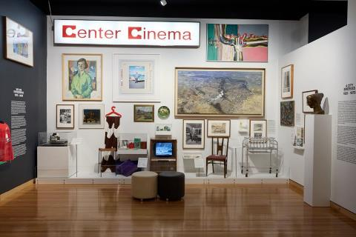
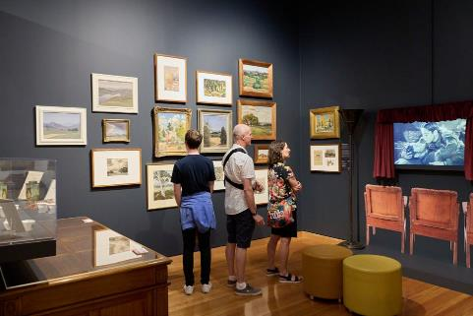

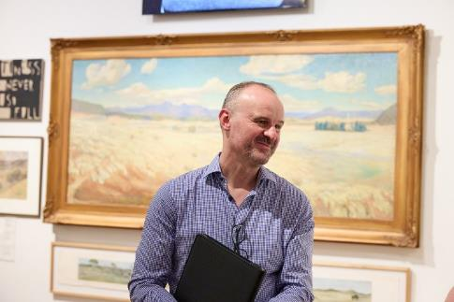

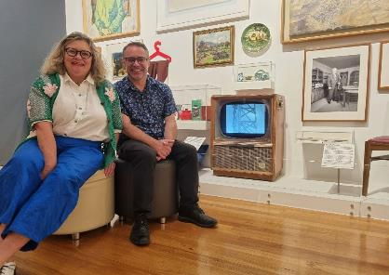
Leadership – An integral part of the cultural •life of the Canberra region and beyond

Strategies to achieve this:
Enhance CMAG’s role as a state/territory level museum, especially by developing a greater footprint in the North Building and enhancing CMAG’s visibility on London Circuit and Civic Square, in order to support activation of the Canberra Civic and Culture District and promotion of CMAG as a major visitor attraction in the city centre of Canberra.
Identify and implement opportunities that demonstrate CMAG’s initiative and entrepreneurship and create a mix of income streams.
Ensure that CMAG’s cultural leadership, and people management and leadership are core to its values and work priorities.

Kamberra/Canberra: Place & People Opening. Images: Paul Webb

Key outcomes in 2022-23 against the above strategies
  - The former Mr Wei restaurant was transformed into a new gallery space with windows fronting London Circuit and Civic Square and opened in March 2023. Exhibition-specific signage was installed on the exterior of the new gallery.
  - CMAG adjusted its opening hours to open seven days a week in 2023 allowing improved access to tourists and visitors to Canberra.
  - The former Elections ACT office facing Civic Square was converted into a collaborative arts space, branded as the Civic Square Hub after an initial period of activity under the

City Renewal Authority’s Second Space pilot program. It hosted a variety of activities including serving as the hub for the DESIGN Canberra Festival in November 2022 and hosting artists from ANU to develop sculptural works. There was also pop-up retail, school holiday activities, and a range of arts and crafts workshops.
- CMAG partnered with City Renewal Authority to present The Great Dino Escape: Roving Performance as part of the CRA’s City Illuminations in conjunction with the Enlighten Festival.
- CMAG supported the Festival of Everyday Art 20 May-13 July by hosting workshops in the CMAG theatrette and presenting an exhibition of photographs in the Civic Square Hub.
- A permanent Cafe Manager was recruited for the CMAG Cafe leading to increased revenue and a greater profile amongst patrons and workers in the City Hill area.
- CMAG Cafe revenue was up 28% compared to 2021-2022.
- CMAG Venue Hire attracted 244% more visitors than in 2021-2022, reflective of recovery from COVID-19.

  - CMAG hosted a ticketed exhibition with
How Cities Work.
  - Several CMAG staff participated in conferences and museum sector initiatives as follows:
    - ANU: Brenda L. Croft and Aidan Hartshorn in conversation—Murrudha: Sovereign walks, tracking cultural actions through art, country, language and music
    - Roger Benjamin Roundhouse tour
    - Australian Museums and Galleries Association (AMaGA) 2023 Conference by the Acting Director
    - Museum of Australian Policing stakeholder consultations, including a presentation about the role of the arts and heritage and community well-being
    - Ngunnawal Language workshop.
  - CMAG’s Senior Curator was opening speaker for a Mandy Martin Exhibition opening at Belconnen Arts Centre, the Naomi Zower Exhibition Megalo Print Studio, Hannah Gason, Canberra Glassworks exhibition, the Sammy Hawker Exhibition Thor’s Hammer, and Photography is Dead Long live Photography at Photo Access.
  - The Senior Curator also participated in the following panels: ANU Sustainable Careers Forum What’s a Creative producer; Design Canberra Panel Speaker Transforming Spaces in Canberra Kambri ANU; and Design Canberra Panel Speaker Respondent to Elizabeth Farrelly.
  - CMAG continued to develop new partnerships with other relevant
organisations, institutions and agencies as follows:
- Lindy Lee: Moon in a Dewdrop, a touring exhibition from the Museum of Contemporary Art
- National Film & Sound Archive partnerships for Canberra/ Kamberri: Place & People and Matthew Thorne: Jingo was Born in the slum
- Stronger Together: A collaborative exhibition with ACT Health
- Blanche Tilden: Ripple Effect, a Geelong Gallery touring show
- Tom Moore: Abundant Wonder, a Jam Factory touring show
- Light, Colour and Humanity: The Legacy of Alistair Swayne, a Monash University and Swayne Foundation exhibition
- How Cities Work, a Museums and History of NSW touring exhibition.
- Stronger Together: A collaborative exhibition with ACT Health
- Blanche Tilden: Ripple Effect, a Geelong Gallery touring show.
- Tom Moore: Abundant Wonder, a Jam Factory touring show
- Light, Colour and Humanity: The Legacy of Alistair Swayne, a Monash University and Swayne Foundation exhibition
- How Cities Work, a Museums and History of NSW touring exhibition.
- Canberra’s Biggest Nutbush Dance held in Civic Square in memory of the late and great Tina Turner, was a fun and free event organised by CMAG, attended by around 300 people.

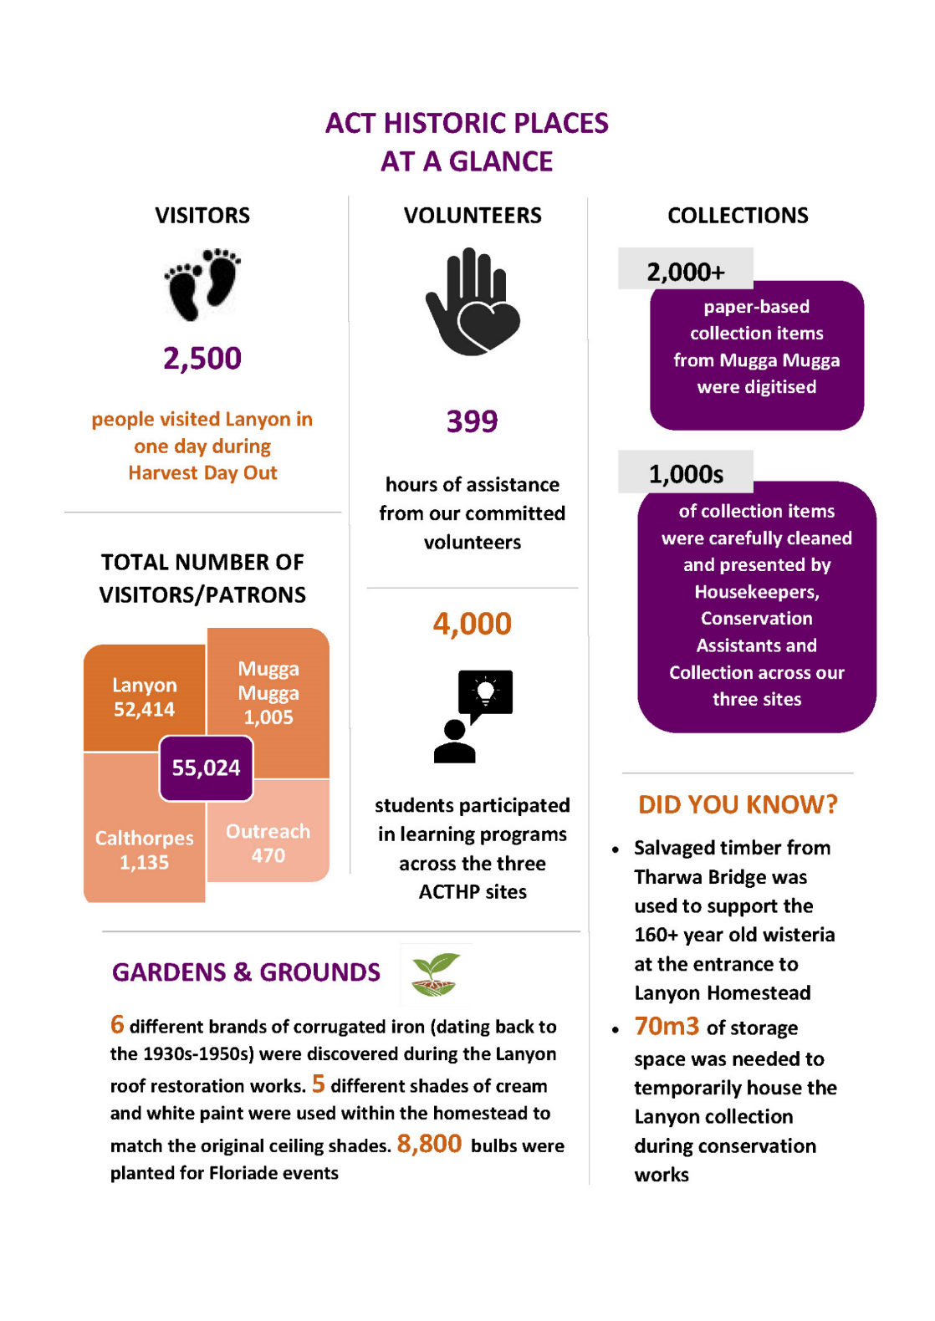

B.2.4 ACT Historic Places

What we are Three historic places that reflect different aspects of Canberra’s history: Lanyon, Calthorpes’ House and Mugga-Mugga

What we do We connect people with Canberra’s rich and diverse stories and heritage

Our vision To be the leading historic places in Australia and beyond

What we want Customers: Audiences that are growing, diverse and engaged
to achieve Programming: Programs that explore Canberra’s history by interpreting
each place
Stewardship: Buildings, grounds and collections that are conserved and researched
Leadership: An integral part of the cultural life of the Canberra region and beyond

A smooth recovery from the COVID-19 pandemic
Strategies to achieve this:
Manage through, and recover from, the COVID-19 pandemic, ensuring that:
- negative impacts of COVID-19 on the CMAG’s venues and operations are minimised;
- positive impacts are retained and built upon;
- CMAG’s financial sustainability is maintained; and
- CMAG provides cultural leadership in the recovery from COVID-19.

Key outcomes in 2022–23 against the above strategies
      - ACTHP continued to provide management and recovery measures relating to COVID-
19. Although there were no COVID-19
restrictions relating to ACTHP’s venues and operations, the COVID-19 recovery was ongoing throughout the year.
  - Relevant infection control measures from COVIDSafe plan have been adopted into business-as-usual risk controls.

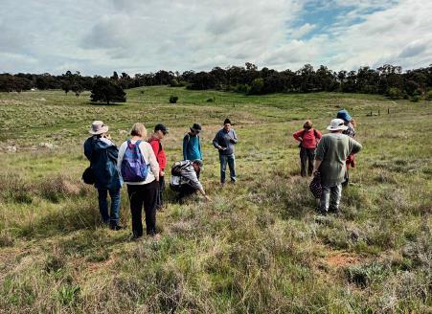
Customers – Audiences that are growing, diverse and engaged
Strategies to achieve this:
Ensure that customers remain at the centre of all that we do.
Develop initiatives to foster special interests and experiences, and increased opportunities for visitor engagement.
Improve public recognition of ACTHP’s brand and profile.
casual visitors, tour participants, venue
hire, education and community programs, or those engaging with us through our outreach programs. 52,024 people visited Lanyon including approximately 5,050 for education and community programs. 1,005 visited Mugga-Mugga including over 660 for education and community programs, and 1,135 visited Calthorpes’ House

Grasslands tour with Geoff Robertson. Image: ACTHP

Key outcomes in 2022-23 against the above strategies
    - Developed a tour of the heritage precinct including outbuildings, to engage visitors while the homestead at Lanyon was closed for conservation works.
    - Encouraged new audiences and supporting artistic opportunities and ways of viewing the heritage values of Lanyon through the inaugural ACT Historic Places
Art Prize. The prize was launched in November 2022 by Minister for the Arts, Tara Cheyne and submissions closed in May 2023. Over 90 works were submitted, with twenty-eight finalists chosen for display in an exhibition in the homestead.
    - Special interest tours, particularly relating to the gardens and landscapes at Lanyon, including the Beyond the Farm Gate tour, were developed and delivered.
    - In 2022-23, ACTHP welcomed just over 55,000 visitors to the three sites including
including some 730 for education and community programs.
- Three on-line exhibitions were developed, including Christmas for the Cunninghams, An exciting new world, and Preserving the past collections and stories connected to our three heritage sites, extending our engagement with geographically and demographically challenged audiences.
- With greater attention to building ACTHP’s online activity and social media presence the following statistics were achieved:
  - the HP website attracted 34% more visits than in 2021-22
  - Instagram profile visits were up 127% from 2021-22
  - Facebook page visits increased by 19% from 2021-22
  - feedback showed most visitors were satisfied or very satisfied with their visit to HP sites.
- Word of mouth remains the main way people hear about ACTHP sites.

- Visitors indicated the main reasons for coming to ACTHP sites was their interest in history and heritage and to spend time with friends and family.
- Most of our visitors come from the ACT with NSW close behind.
- Harvest Day Out, an event that promotes sustainable practices, attracted bumper crowds with around 2,500 people enjoying the beautiful grounds, participating in the various programs, demonstrations, talks and a bite to eat at the market stalls.
- Engagement with First Nation’s people continues to be an important goal for Historic Places. As well as a number of programs led by First Nation’s people.
- Consultation in relation to interpretation and learning programs was pursued and investigations into the development of appropriate protocols around oral history programs were undertaken.
- 2022-23 has seen an increase in the delivery of school holiday programs.
Historic Places volunteers contributed over 400 hours to support visitors.

ACTHP Jazz Picnic. Image: ACTHP
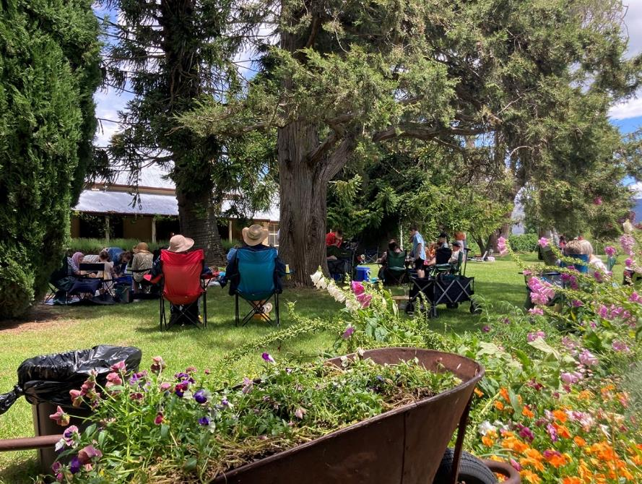
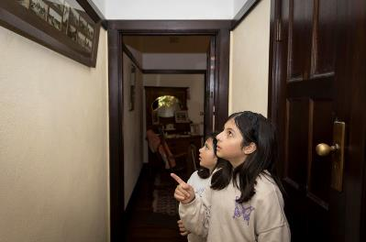
Programming – Programs that explore Canberra’s history by interpreting each place

Strategies to achieve this:
Deliver a diverse and contemporary program of exhibitions and of community, learning and on-line programs, which enhances an understanding of each site’s history, natural and cultural values and contemporary relevance.
Develop and deliver programs based on the principles of lifelong and immersive learning to reach broader audience groups.
Develop programs that support Indigenous reconciliation, cultural values and storytelling.

Learning about Calthorpes’ House. Image Jane Duong

Key outcomes in 2022-23 against the above strategies
  - A diverse range of activities continue to be offered at ACTHP sites – Lanyon, Calthorpes’ House and Mugga-Mugga – with the aim of extending and diversifying our audiences and broadening engagement with the heritage values of each venue.
  - Wellness and Sustainability art workshops included:
    - Rounding the Narrative with artist Mariana del Castillo (Mugga-Mugga)
    - Basketry with grasses with Lisa Stevenson (Mugga-Mugga)
    - Nature printing with Peter McLean. (Mugga-Mugga)
    - Stitching the Landscape with Sharon Peoples (Mugga-Mugga).
  - Three new online exhibitions were launched to increase access and
interpretation of ACTHP collections and site histories including:
- Preserving the Past
- An Exciting New World
- Christmas for the Cunninghams.
- First Nations programs included:
- Aboriginal Story Telling for children with Larry Brandy using artefacts and animal masks (Lanyon)
- Cultural Weaving workshop with Jessika Spender (HDO) (Lanyon)
- An Indigenous plant use talk with Aaron Chatfield (HDO) (Lanyon)
- Maring Ngala Walk - cultural walk to an onsite scar tree with Wally Bell (HDO) (Lanyon)
- Reconciliation Week was celebrated with a Dreamtime Connections workshop on plant use with Aaron Chatfield. (Mugga- Mugga).
- A focus on children’s activities included an increase in our school holiday program offerings as well as at special events like Harvest Day Out and Floriade.
- School holiday activities included Grass Sculptures (Mugga-Mugga) and Funky Felt Flower making (Lanyon).
- ACTHP was part of the Floriade community hosting several events including:

Botanical Illustrations workshop with Halina Steele (Lanyon)
- Grassland tours at Mugga-Mugga Cottage with Geoff Robertson from Friends of Grasslands
- A Family Jazz Picnic (which was postponed until after Floriade due to the weather)
- Making a Bee Hotel with Tracey Bool (Mugga-Mugga).
  - Harvest Day Out – a celebration of all things Autumn in the significant Lanyon landscape. A range of workshops, tours and demonstrations and sustainable practices were held as well as accommodating around 20 market stalls and food vans including:
    - Workshops - Kids Workshop and Garden trail – drawing and badge making, Build a Bee Hotel, Cultural Weaving, Breaking New Ground, Beginners guide to seed saving, Love
Lettuce, and a demonstration –
Making Mrs Calthorpes’ Marmalade
- Talks - Growing and caring for Dahlias, Mrs B Thrifty Preserving History, and Indigenous plant use
- Tours - Garden tour with Head Gardener and the Maring Ngala Walk
- Music in the Homestead with Grace Chan and local band, The Fuellers.
- Stories Beyond the Farm Gate as part of the ACT Heritage Festival.
- Over 70 Collection items were included in small exhibits at Calthorpes’ House (Growing up with Princess Elizabeth) and Lanyon on Harvest Day (Preserving and Conserving)
- Dawn Waterhouse was interviewed at Calthorpes’ House to capture more than seven hours of footage and audio for future use including a series of audio stories planned for Calthorpes’ House.

Neil's garden tour. Image: Jane Duong
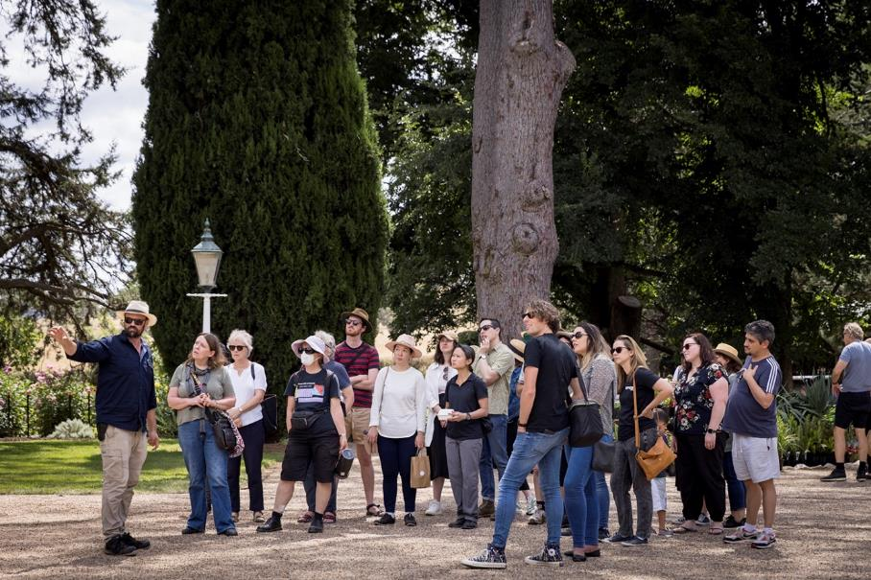

Stewardship – Buildings, grounds and collections that are conserved and
researched

Strategies to achieve this:

Provide leadership in cultural heritage management, including in documentation, research, conservation, interpretation and visitor engagement.
Recognise, conserve and promote the multi-layered heritage values and cultural relevance of each ACTHP site, in the areas of ecological heritage, Indigenous heritage and stories, Canberra’s convict and colonial history, and Canberra’s social history as the Federal Capital.

Realise the potential of each site collection to provide further access and understanding for on-line visitors.
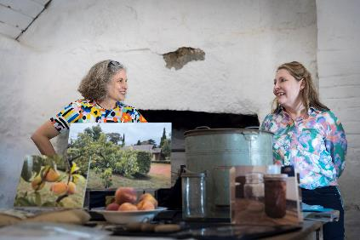

ACTHP Harvest Day Out. Image: Jane Duong

Key outcomes in 2022-23 against the above strategies
  - Extensive conservation works at Lanyon meant that the homestead building was closed for 4 months. The most significant aspect of the works was the replacement of the roof sheeting and roof plumbing both dating from the 1890s onwards. The original shingles remain under the roof sheets. Other works included restoring water damaged ceilings, repairs to timber, masonry, concrete and tiles.
  - Over 1,000 items and their parts from the Lanyon collection were dismantled, packed, relocated and then returned to Lanyon to support the building conservation works.
  - Over 105 square metres of flooring - in addition to the skirting, architraves, trims and ledges - required four layers of
protective material (soft flocking, ply board cut and fitted to size, construction plastic and ram board) to protect the original heritage features throughout the robust plaster repair work and painting program.
- Consultation and design development commenced for the conversion of the former Nolan Gallery, now the Lanyon Heritage Centre, for staff accommodation.
- Review and concept development for the adaptive reuse of the Shearer’s Precinct for an arts precinct at Lanyon.
- Monitoring and minimising further damage while planning remediation works for significant bank erosion of the Murrumbidgee River at Lanyon.
- Tests to establish a bore to secure permanent water on site at Lanyon have been unsuccessful. Other options are now being considered.
- Tree and arboreal management around Lanyon have included the completion of tree assessment with works to mitigate dangerous tree issues under way.
- Grasslands management as per the 2019 Grassland Management Plan continues at Mugga-Mugga.

  - Building conservation and repair work at Mugga-Mugga Cottage and the Mugga- Mugga Education Centre continue.
  - Upgrade works to Cottage 6 at Lanyon allowed for its leasing from December 2022.
  - Security upgrades at Mugga-Mugga and Calthorpes’ House including external cameras and duress alarms.
  - NBN delivered to Mugga-Mugga and Calthorpes’ House – awaiting final connection.
  - 12 framed works and papered and painted surfaces on timber collection items and internal wall fabric received specialist conservation consolidation treatment at Mugga-Mugga Cottage.
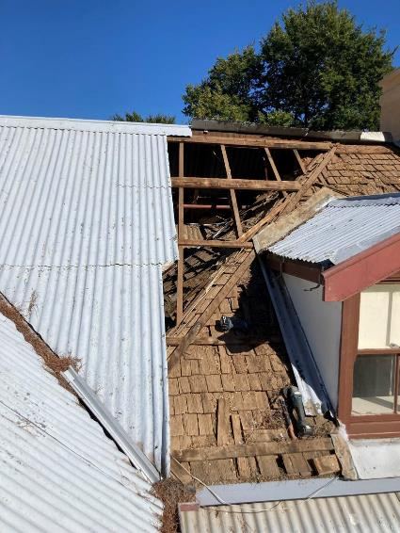
  - The original 1927 tiled surface surrounding the kitchen stove at Calthorpes’ House was consolidated by a specialist conservator.
  - The original linoleum floor surfaces throughout Calthorpes’ House received a condition/comparison assessment by a
specialist conservator to assist in maintaining these original features.
- 45 audio tapes containing Lanyon In Living Memory oral histories were digitised for future research projects and exhibitions at Lanyon.
- Over 115 items from the Calthorpes’ House collection were accessioned/added to the database.
- Over 400 items have been catalogued into the Dawn Waterhouse Research and Exhibition collection (Calthorpes’ House).

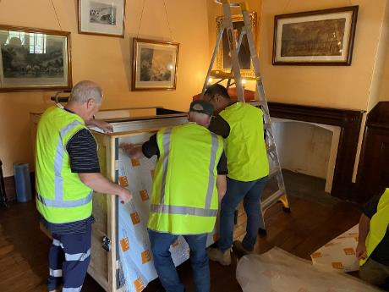
Packing in preparation for conservation works. Image: ACTHP Original roofing at Lanyon. Image: ACTHP

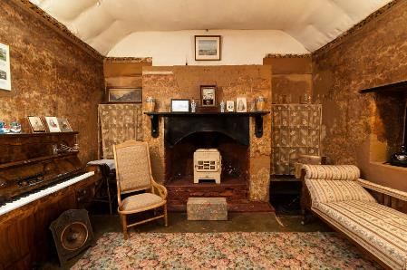
Leadership – An integral part of the cultural life of the Canberra region and beyond

Strategies to achieve this:
Position ACTHP and its sites as cultural places that grow the education and tourism sector in Canberra.
Provide leadership in heritage place activation in order to showcase the cultural, social, education and economic benefits of engaging with cultural heritage.
Provide leadership in cultural planning and management, including through creative partnerships and by demonstrating the importance of arts and heritage to individual and community wellbeing.

Mugga-Mugga Cottage. Image: Tourism Australia

Key outcomes in 2022-23 against the above strategies
  - ACTHP has developed and strengthened relationships with a variety of industry partners including the National Trust of Australia ACT, Australia ICOMOS, Museums of Australian Democracy staff, ACT Heritage and Australian Museums and Galleries.
  - ACTHP Director spoke at the National Australian Museum and Gallery Conference, and the ACT Region Heritage Conference about the role of the arts and heritage in supporting community well-being.
  - ACTHP Acting Director was the guest speaker for the opening of the 2023 Heritage Festival.
  - ACTHP participated in the 2022 Floriade program with our Bloom Festival under the
community events program. This included macro photography, watercolor landscape painting, felt flower badge making, botanical illustrations and build a bee hotel workshops as well as garden tours, an Indigenous plants talk and a family jazz picnic across the month of Floriade.
- Participation in the Design Canberra Festival with a talk and tour of Calthorpes’ House.
- Professional development opportunities were strengthened with the implementation of regular training sessions for Front of House staff including heritage management basics, customer service, bush fire training and visitor engagement.
- Other professional development opportunities have included:
  - First Aid
  - Respect Equity and Diversity
  - Behavioral de-escalation
  - Cultural learning.
- ACTHP developed and strengthened partnerships with relevant education, government and non-government organisations and institutions. These included:

  - Wombat mange treatment and survey at Lanyon with ACT Wildlife
  - Erosion management with ACT Parks and Conservation in the river corridor
  - Participation in ACT Heritage’s Canberra and Region Heritage Festival
  - The provision of learning opportunities for University of Canberra Bachelor of Arts (Heritage Tourism) and Graduate Certificate in Heritage Materials Conservation and ANU Centre for Heritage and Museum Studies students.
- ACTHP recruited a curator to undertake research and interpretation development in relation to the heritage values and stories associated with ACTHP properties.
- The ACT Historic Places Advisory Committee met 4 times. The Advisory Committee includes expertise in heritage management, community consultation and engagement, conservation, archaeology and education and provides ongoing support and advice.
- A partnership program was established with CraftACT (now Craft + Design Canberra) and the Tuggeranong Arts Centre for the inaugural ACT Historic Places Art Prize. Both organisations provided expertise and significant prizes in the support and encouragement of ACT artists and in the development of new ways of presenting and representing ACT heritage and history.
- Staff participated in the ArtsACT + Canberra Innovation Network Collaboration Lab.
- A baby was born at Mugga-Mugga Cottage for the first time in over 130 years.

Collection Recipe Talks. Image ACTHP
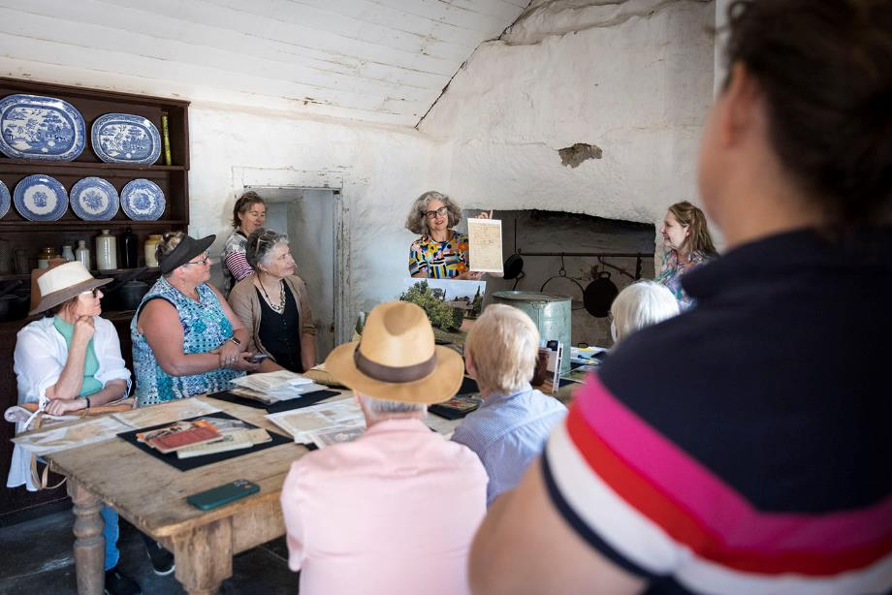

Scrutiny

There were no Auditor-General, ACT Ombudsman or Legislative Assembly Committee reports that related specifically to the CFC in 2022-23.

For further information contact: CFO, CFC Corporation Finance (02) 6205 2195

Risk Management

The CFC’s Risk Management Framework and Policy and Risk Management Plan guide and inform risk management activities across the CFC including for the CFC’s Strategic Risks, Fraud Corruption and Control, and Work Health and Safety. The CFC has in place a comprehensive Strategic Risk Management Register, which is implemented, monitored and updated on an ongoing basis. This register provides the framework for supporting strategies and plans relating to more specific areas of risk, such as disaster preparedness and business continuity plans.

A revised Strategic Risk Management Register was approved by the Board in December 2022.

Internal Audit

The CFC Audit Committee, a subcommittee of the CFC Board, met on six occasions during 2022-23. Meetings were held on 13 July 2022, 28 September 2022, 24 November 2022, 19 January 2023,
24 March 2023 and 25 May 2023.

Name of Member | Position | Meetings attended
Shad Sears | Chair | Three
Christine Shannon | Chair | One
Dr Rachael Coghlan | Acting Chair | Two
Gordon Ramsay | Member | Six
Tim Lo Surdo | Member | One
Helen O’Neil | Member | One

The CFO and Financial Controller are invited to each meeting as observers, and an open invitation is extended to the ACT Audit Office to send an observer to each meeting.

The Part G of the CFC Board Charter sets out the operations for the Audit Committee and incorporates specific roles for risk management and audit matters. It is available at http://www.culturalfacilities.act.gov.au.

Internal Audit
The Audit Committee reviews and approves an internal audit/quality assurance plan for each financial year. A Chief Executive Financial Instruction has been issued dealing with audit committee and internal audit matters.
This financial year the CFC commenced two taxation compliance audits, one on FBT and one on GST. These audits are still ongoing with no final reports being issued as yet.

Fraud Prevention

The CFC has a comprehensive Fraud and Corruption Prevention Plan and Policy (FCPPP) which is implemented and monitored on an ongoing basis. Oversight of this plan is undertaken by the Audit Committee, as one of the roles under its Charter – refer to http://www.culturalfacilities.act.gov.au.
CFC has no reports or allegations of fraud or corruption throughout 2022-23. Fraud awareness training was last conducted in March 2023.
Details of risk assessments conducted: 0 Fraud awareness training: 13
No. of reports or allegations of fraud or corruption received and investigated (and any action taken): 0

Freedom Of Information

Open Access Information - Section 96 (3) (a) (i), (ii) and (iii)

Number of decisions to publish Open Access information. 3 Number of decisions not to publish Open Access information. 0
Number of decisions not to publish a description of Open Access information withheld. 0

FOI Applications received and decision type - Section 96 (3) (a) (iv), (vii), (viii) and (ix)

Number of access applications received. 6
Number of applications where access to all information requested was given. 0
Number of applications where access to only some of the information requested was given (partial release). 5

Number of applications where access to the information was refused. 1

FOI processing timeframe - Section 96 (3) (v) and (vi); Section 96 (3) (d)

Total applications decided within the time to decide under section 40. 4 Applications not decided within the time to decide under section 40. 2
Number of days taken to decide over the time to decide in section 40 for each application. 18 This was with the approval of the respondent under section 41 within 20 working days of the application. 0

Amendment to personal information - Section 96 (a) (x) and Section 96 (3) (e)

Number of requests made to amend personal information, and the decisions made (e.g. amended, refused, notation added to record, other). 0

Reviews – Section 96 (3) (b); Section 96 (3) (c)

Number of applications made to Ombudsman under section 74 and the results of the application (e.g. affirmed, varied, set aside and substituted, withdrawn, other). 1

Number of applications made to ACT Civic and Administrative Tribunal under section 84 and the results of the application (e.g. affirmed, varied, set aside and substituted, withdrawn, other). 0

Fees - Section 96 (3) (f)

Total charges and application fees collected from access applications. 0
FOI requests can be made by contacting the Cultural Facilities Corporation FOI Information Officer, GPO Box 782 Canberra City ACT 2601 or emailing CFCcorporatefinance@act.gov.au.

Further information can be found at http://www.culturalfacilities.act.gov.au.

Community Engagement and Support

The CFC actively seeks to engage its communities in a greater understanding of the value of the arts, and of cultural heritage, through its programs and activities, placing customer service as its primary goal and recognising the diverse needs and expectations of customers. A summary of actions taken by the CFC during 2022-23 in terms of community engagement and support is provided below, with detailed information presented about each of these actions under Section B.2.

Community Engagement Activities

During the year, CMAG and ACT Historic Places (ACTHP) presented a diverse range of high-quality exhibitions, learning and community programs and other activities, including on site, off site (through outreach programs) and online. Productive partnerships were developed with other cultural organisations, the tourism sector and the wider community in developing and delivering programs and events. The Canberra Theatre Centre (CTC) connected the community with the performing arts, including through initiatives that addressed special needs in the community. The CTC provided a wide range of activities for the education system and wider community.

The CFC’s digital strategies continued to provide new community engagement opportunities through the use of social media and digital programming. CFC appointed a Publicity and Content Officer, increasing the relevance and frequency of social media. Museum online learning programs and online catalogues continued to extend the access to exhibitions, collections and programs. ACTHP developed two on-line only exhibitions Preserving the past: recipes from Calthorpes’ House and Mugga-Mugga Cottage and Calthorpes, House: an exciting new world.

The CFC continually seeks to improve customers’ satisfaction with their visit to, and experience of its venues. Customer satisfaction surveys were conducted throughout the year and reported as part of the CFC’s 2022-23 Statement of Performance. Information gained from the surveys was used in future planning to improve facilities and services.

A major community engagement activity for the CFC is the operation of its three CFC advisory committees. In 2022-23, the CFC’s advisory committees provided advice on a range of specialised matters relating to the operation of the CFC’s three program areas: CMAG; ACTHP; and the CTC.

Engagement tools included individual sessions of each committee with approximately 17 advisory committee members participating, providing expert strategic advice on a voluntary basis, and providing important links between the CFC and the wider community.

Aboriginal and Torres Strait Islander Reporting

The CFC ensures cultural diversity is an essential feature of its regular programming, including exhibitions, theatre presentations and programs featuring Australian First Nations cultures. Examples of activities in each area of the CFC in 2022-23 are provided below.

Canberra Theatre Centre

Canberra Theatre Centre (CTC) continued its commitment to showcasing and promoting the work of First Nations artists and strengthening the diversity and cultural connection of its program through the presentation of the following events:
- Bangarra Dance Theatre’s Terrain – a breathtaking exploration of Australia’s largest salt lake. The nine-part performance evokes the power of body and land converging to bring spirit to place.
- CTC presented Australian Dance Theatre’s SAVAGE under the artistic direction of Wiradjuri man, Daniel Riley. This work was an exploration of the ‘violence of forgetting’ and was designed by Dean Cross, an artist of Worimi descent, born and raised on Ngunnawal/Ngambri Country.
- Ngiyampaa man and First Nations singer-songwriter and storyteller Pirritu (Brett Lee) presented classic folk storytelling performance with elements connecting the song man’s personal journey of self-discovery to country and culture.
- In the Courtyard Studio SEARMS Community Housing Aboriginal Corporation and Sista 2 Sista presented a forum on family violence; Sista 2 Sista: Hear Our Voices Yarn Up
- In March in the Canberra Theatre, Senator David Pocock, Referendum Council Co-Chair Aunty Pat Anderson AO, and constitutional lawyer and UN Human Rights Council member, Professor Megan Davis held an In Conversation event; Referendum and Voice to Parliament Information Night, facilitated by Virginia Haussegger AM.
- Griffin Theatre Company’s Whitefella Yella Tree, a queer love story told on the brink of colonial invasion. Whitefella Yella Tree was produced by a majority First Nations creative team and written by Canberra based award-winning playwright and Palawa man Dylan Van Den Berg.
- The CTC’s annual Reconciliation Day Eve Concert featuring performances from the legendary indigenous band Yothu Yindi, and showcased Canberra based First Nations artists Alinta Barlow, Stewart Barton. The event was opened and MC’d by Canberra local and Wiradjuri teen Tahalianna Soward-Mahanga from The Voice (TV Program).

Canberra Museum and Gallery

CMAG’s Aboriginal and Torres Strait Islander engagement during the year included the following:
- CMAG presented a moving image installation by Worimi man, Dean Cross commissioned by Heide Museum of Modern Art.
- CMAG presented a new exhibition Canberra/Kamberri: Place & People. This permanent exhibition features a dedicated First Nations display, Always Was, Always Will be - The

Everywhen that includes objects and artworks made by Ngunnawal and Ngambri People and other Aboriginal people living, working and creating in the region. Beyond the display, acknowledgement of First Nations connections to place and community runs throughout the exhibition. Local First Nations community members, Dr Aunty Matilda House, Professor Brenda
L. Croft, Paul House and Tyrone Bell have visited the exhibition.
- CMAG presented the display Continuous Cultures in the Ramp Showcase, highlighting First Nations makers from the region with works that re-imagine ‘traditional’ making practices and objects.
- CMAG hosted a CareerTrackers intern in Exhibitions and Collections, Access and Learning and Front of House. This program supports Aboriginal and Torres Strait Islander students.
- CMAG was approached by ArtsACT First Nations Engagement Unit requesting safe storage for objects developed during a community consultation arts project. CMAG stored the works for six months in the Collections store.

The following learning programs were delivered at CMAG in 2022-23, each featuring Indigenous content in response to the key cross curriculum priority of Aboriginal and Torres Strait Islander Histories and Cultures in the Australian Curriculum:
- What Do Artists Make – onsite learning program for Preschool to Year 2 students. During this program students engage with works by Aboriginal artists Paul House and Tom Rowney.
- Old Macdonald’s Farm – Outreach resource for Preschool to Year 2 students. This program features the work by Matilda House, Possum Skin Cloak, 2010.
- Blue Suitcase – Outreach resource for Preschool to Year 8 students. This program features the work of Wiradjuri and Ngunnawal artist Lorraine Webb.

The following community programs were delivered at CMAG in 2022-23, featuring Aboriginal and Torres Strait Islander artists:
- Worimi artist Dean Cross and Wiradjuri dancer and artistic director, Daniel Riley held an in- conversation event, reflecting on their long friendship and successful careers in the arts.
- To celebrate NAIDOC Week and Reconciliation Week, CMAG invited teenagers to learn from contemporary Aboriginal artist Sarah Richards in studio workshops.

ACT Historic Places

In 2022-23, ACT Historic Places engaged with Aboriginal and Torres Strait Islander communities to strengthen and improve its approach to interpretation and management of First Nations stories and values through specific activities, including the following:
- With the appointment of a new Researcher and Curator, ACT Historic Places has undertaken extensive research on Calthorpe’s House and Lanyon. These properties, based on Ngunnawal and Ngambri land have long connections to First Nations People and as part of this research ACTHP has made connections with several First Nations community members. It is our aim that First Nations stories will be front and centre in the future interpretation of these places.

The following community programs were delivered at ACTHP in 2022-23, featuring First Nations People:

- Larry Brandy Aboriginal Story Telling program for young children using artefacts and animal masks held at Lanyon.
- Harvest Day Out, a festival in celebration of autumn, included several activities including
  - a cultural weaving workshop with Jessika Spender
  - an Indigenous plant use talk with Aaron Chatfield
  - Maring Ngala Walk (cultural walk to an onsite scar tree) with Wally Bell
- Reconciliation Week was celebrated with a Dreamtime Connections workshop on plant use with Aaron Chatfield
- NAIDOC Week was celebrated with two Ngunnawal language workshops – one for the general public and one for CMAG and ACTHP staff.
- Consultation with Ngunnawal Traditional Owners with regards the inclusion of Frist Nation’s stories, themes and voices in interpretation and learning programs.
- Consultation and engagement with First Nation’s people regarding the interpretation of pre and post the development of Canberra at Calthorpes’ House including the establishment of an Aboriginal Embassy in the house next door. Research on Aboriginal connections through institutions such as AIATSIS.
- Consultation in relation to the timing and appropriateness of cultural burns at our sites.
- Research on the development of culturally appropriate protocols associated with the recording, storage, access and use of Aboriginal oral histories.

Work Health and Safety

The CFC is committed to maintaining the health, safety and welfare of its employees. Workplace Health and Safety (WHS) is managed in accordance with the statutory provisions of the Work Health and Safety Act 2011.

The CFC is committed to prioritising the health and safety of its employees, volunteers and visitors/patrons. The CFC has:
- a CFC WHS Policy Statement, which has been advised to all staff;
- created a WHS section on its new intranet site;
- created four Work Groups;
- nominated five Health and Safety Officers;
- commenced monthly HSR meetings;
- continued with the CFC WHS Committee (WHSC) and Work Unit Health and Safety Committees (WUHSC); and
- ensured that WHS issues are discussed regularly at fortnightly meetings of the CFC Senior Leadership Team – refer to B.1.6.

The CFC is served by two WUHSC, reporting to CFC WHSC. During 2022-23, 22 staff participated in these Committees. The WUHSC conducted a number of site inspections where risks are reviewed and improvements recommended as appropriate.

The highest rated risks for CFC include:
- Electrocution;
- Fire Emergency Management; and
- Working at heights.

The CFC is treating these risks by a number of measures, including ensuring regular test and tag of electrical equipment, Fire Warden training, testing of emergency systems, evacuation practice and ongoing training for working at heights and manual handling.

The CFC’s WHS arrangements operate as part of the ACT WHS and Injury Management Improvement Strategy, which commits ACT Government employers and employees to high standards of workplace health and safety. The CFC’s WHS arrangements also acknowledge the targets set by the ACT Government for improving WHS performance, injury management and prevention.

The CFC Board receives a WHS report at each meeting. These reports include information about accidents or incidents, outcomes and corrective action from previous accidents or incidents, risk assessments undertaken, meetings of the WHSC and WUHSCs, together with key issues discussed at these meetings, training provided on WHS, progress on development of the Safety Management System, and other WHS matters, such as security management.

In addition, every six months, a further report is provided to the Board on key WHS risks in the CFC, together with risk controls and risk treatment strategies.

Work Health and Safety Act 2011
In 2022-23, the CFC received Improvement notices:
- N-0000004464, 4465, 4466, and 4467 under Part 10 of the Work Health and Safety Act 2011. The notices were issued on 20 June 2022, and received on 24 June 2022. The notices related to improvements required of the Canberra Theatre Centre (CTC) in relation to EWIS,
Emergency, First Aid & Fire Panel training. The CTC fully complied with all Improvement Notices, and all notices were confirmed by WorkSafe as closed on 7 July.
- N-0000005921 under Part 10 of the Work Health and Safety Act 2011. This notice was issued on 18 October 2022, and received on 18 October 2023. The notice related to improvements required of the Canberra Theatre Centre (CTC) in relation to section 19 of Work Health and Safety Act 2011 - Primary duty of care and clause 150 of Work Health and Safety Regulation 2011 - Inspection and testing of electrical equipment. The CTC fully complied with all Improvement Notices, and all notices were confirmed by WorkSafe as closed on 9 January 2023.

In 2022-23, the CFC did not receive notices of enforceable undertakings under Part 11 of the Work Health and Safety Act 2011.

In 2022-23, the CFC did not receive notices of failure to comply with a safety duty under Part 2, Division 2.2, 2.3 or 2.4 of the Work Health and Safety Act 2011.

In 2022-23, CFC staff members were trained in WHS through participation in a number of courses, including the following training:

- First Aid/Refresher;
- Mental Health First Aid;
- Fire Warden;
- Authorised Persons
- Behavioural De-Escalation;
- RED Training
- Health and Safety Rep
- Negotiation
- Bushfire Training
- Emergency Control Organisation training and video training;
- QPR training (Question, Persuade, Refer) Suicide prevention training;
- In-House COVID-19 Safe training;
- Manual Handling; and
- CTC Tech rigging training.

There were three serious injury, illness or dangerous incidents reported to WorkSafe ACT in accordance with Part 3 Section 38 of the Work Health and Safety Act 2011 in 2022-23.

Human Resources Management

Human Resources Management
During 2022-23, the CFC’s approach to Human Resources (HR) management and workforce planning as in accordance with its interim HR Plan, aligned to the 2021-26 CFC Strategic Plan with the twin high-level priorities of achieving a highly skilled and capable workforce, and providing a health work- life balance. Further information about HR management is provided in Section B.2.1.

The CFC convenes meetings of its Agency Consultative Committee (ACC) consisting of staff, management and union representatives to provide ongoing feedback on industrial relations matters. The ACC met on 26 July, 16 August, 20 September and 29 November 2022. In 2023, the purpose of these meetings shifted to consideration of ideas for the new CFC Enterprise Agreement 2023-26 (still under negotiation at the time of this report).

Learning and Development
The CFC places high importance on staff training and development. During 2022-23, the CFC established a dedicated position for leading on learning and development which has resulted in the creation of a Core Learning Framework, which provides consistency for staff induction and the development of essential ACT Public Service knowledge and skills. Large numbers of staff have participated in training that focusses on safe and healthy work, including the use of Authorised Persons powers, Behavioural De-escalation, First Aid training, and Mental Health First Aid.

Staff also attended a range of conferences and seminars, and other professional development opportunities. This included attendance at meetings and conferences for the arts and museum sector, such as the annual national conference of the Australian Museums and Galleries Association where CMAG won a MAGNA award.

Other examples of professional development opportunities attended by staff in 2022-23 included the Dementia Forum run by Dementia Australia; Canberra Region Tourism Advisory Forum; BIGSOUND 22 music conference, Brisbane; Everyday Heritage Festival workshops; Visitor Engagement Training; ATO Open Forum Webinar; Health and Safety Representative Training; artACT + Canberra Innovation Network Collab Lab; Still in my mind: Gurindji location, experience and visuality symposium; and the Vernon Systems Collection Management Webinar.

Expenditure on staff training and professional development during 2022-23 amounted to
$49,625. This includes membership fees for professional development programs, staff training and conference fees. Associated travel and accommodation costs are not included in this amount. During the year, over 100 staff members participated in courses provided by ACTPS Training Calendar at a total cost of $22,913.

Staffing Profile
The CFC’s Staffing Profile as at 22 June 2023 (the last pay date for the 2022-23 financial year) was as follows:

FTE and headcount by division/branch

Division/branch | FTE | Headcount
Cultural Facilities Corporation | 116 | 176

FTE and headcount by gender

 | Female | Male | Non-Binary | Total
Full Time Equivalent | 47.6 | 65.72 | 2.68 | 116
Headcount | 107 | 66 | 3 | 176
Percentage of  Workforce | 61% | 37.3% | 1.7% | 100%

Headcount by classification and gender

Classification groups | Female | Male | Non-Binary | Total
Administrative  Services Officers | 45 | 15 | 1 | 61
General Services Officers including  apprentices | 2 | 5 | 2 | 9
Professional Officers | 9 |  |  | 11
Senior Officers | 8 | 5 |  | 13
Senior Professional  Officers | 1 |  |  | 1
Executive Contract |  | 2 |  | 2
Theatre Box Office  Staff | 9 | 5 |  | 14
Theatre Patron  Services Staff | 26 | 16 |  | 42
Theatre Technical  Services Staff | 7 | 18 |  | 25
Total | 107 | 66 | 3 | 176

Headcount by employment category and gender

 | Female | Male | Non-Binary | Total
Casual | 57 | 36 | 1 | 94
Permanent Full-  time | 33 | 21 | 1 | 55
Permanent Part-  time | 13 | 3 |  | 16
Temporary Full-  time | 1 | 5 | 1 | 7
Temporary Part-  time | 3 | 1 |  | 4
Total | 107 | 66 | 3 | 176

Headcount by diversity group

Division/branch | Headcount | Percentage of agency  workforce
Aboriginal and Torres Strait  Islander Peoples | 0 | 0%
Culturally and Linguistically  diverse | 19 | 10%
People with Disability | 2 | 1%

Prospective employees of the CFC are asked to identify their ethnicity or disability. However, declaring this information is not mandatory.

Headcount by age group, gender and average length of service

Age Group | Female | Average length of service | Male | Average length of service | Non-Binary | Average length  of  service
Under 25 | 18 | 1 | 16 | 1 | 1 | 0
25-34 | 25 | 2 | 14 | 2 | 2 | 0
35-44 | 17 | 5 | 14 | 6
45-54 | 22 | 3 | 11 | 8
55 and over | 25 | 8 | 11 | 8

Recruitment and separation rates for the agency

 | Recruitment rate | Separation rate
CFC | 16% | 21%

Attraction and Retention Initiatives (ARins)

 | Total
Number of ARINS as at 30 June 2023 | 3

The statistics exclude Board members and people on leave without pay.

Ecologically Sustainable Reporting

Climate Change and Greenhouse Gas Reduction policies and programs

The Water Supply Infrastructure Upgrade project for Lanyon did not locate a viable source of bore water. After three exploratory test bores were drilled across 2021-22 and 2022-23, no suitable water source was located. Other options are now being explored.

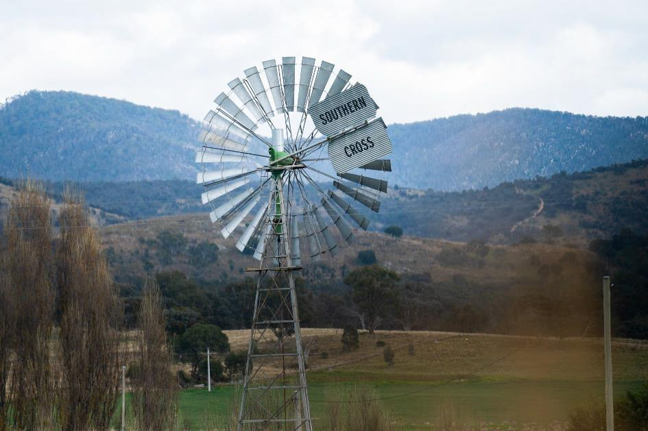
Lanyon Windmill. Image: Tourism Australia

Sustainable Development Performance: 2022-23 & 2021-22

Indicator as at 30 June | Unit | Current  FY | Previous  FY | Percentage  Change
Stationary energy usage
Electricity use | Kilowatt hours | 1,788,726¹ | 1,608,187 | 11%
Natural gas use (non-transport) | Megajoules | 6,345,736 | 5,806,970 | 9%
Diesel use (non-transport) | Kilolitres | - | - | -
Transport fuel usage
Battery Electric Vehicles (BEV) | Number | - | - | -
Hydrogen Fuel Cell Electric Vehicles  (FCEV) | Number | - | - | -
Plug-in Hybrid Electric Vehicles (PHEV) | Number | - | - | -
Hybrid Electric Vehicles (HEV) | Number | 1 | 1 | -
Internal Combustion Engine (ICE)  vehicles | Number | - | - | -
Total number of vehicles | Number | 4 | 5 | (20%)
Fuel use – Petrol | Kilolitres | .5 | .5 | -
Fuel use – Diesel | Kilolitres | .3 | 1.5 | (80%)
Fuel use – Liquid Petroleum Gas (LPG) | Kilolitres | - | - | -
Fuel use – Compressed Natural Gas  (CNG) | Gigajoules | - | - | -
Water usage
Water use | Kilolitres | 5,621 | 5,554 | (1%)
Resource efficiency and waste
Reams of paper purchased | Reams | 261² | 199 | 31%
Recycled content of paper purchased | Percentage | 30%³ | 79% | (62%)
Waste to landfill | Litres | 38,955⁴ | 45,760 | (15%)
Co-mingled material recycled | Litres | 51,123⁵ | 22,880 | 123%
Paper & Cardboard recycled (incl.  secure paper) | Litres | 54,951⁶ | 22,880 | 140%
Organic material recycled | Litres | Note⁷ | Note | -
Greenhouse gas emissions
Emissions from natural gas use (non-  transport) | Tonnes CO2-e | 327 | 299⁸ | 9%
Emissions diesel use (non-transport) | Tonnes CO2-e | - | - | -
Emissions from transport fuel use | Tonnes CO2-e | 2 | 5 | (62%)
Emissions from refrigerants | Tonnes CO2-e | .1 | .1
Total emissions | Tonnes CO2-e | 327 | 304 | 7%

The information used for calculations in the above table was provided by ActewAGL, Weston Energy, ICON Water, ACT Property Group, WINC, Veolia, Iron Mountain, Cleanaway, Elgas, AAAWater and SG Fleet Australia Pty Ltd., with assistance from: the Environment, Planning and Sustainable

Development Directorate (EPSDD); Climate Change and Energy—Zero Emissions Government, Schools and Community; and the Enterprise Sustainability Platform.

- The increase in natural gas and electricity use is due to differing patterns of operations as CFC emerges from the COVID-19 pandemic. For example, usage in 2017-18 was comparable.
- The increase in reams of paper purchased is due to the CFC’s transition from COVID-19 lockdown. We anticipate the paper usage will remain stable due to the increase in electronic record management.
- The decrease in the purchase of recycled content of paper corresponds to an overall reduction in paper use.
- The decrease in waste to landfill is due to CFC’s commitment to recycle and reduce.
- The increase in co-mingled recycling is due to point 4.
- The increase in recycled Paper & Cardboard (incl. secure paper) is due to point 4.
- Large amounts of garden waste are collected, composted and re-used to replenish the gardens at the ACT Historic Places. However, it is not possible to quantify the amount of organic material recycled.

Footnotes for 2022-23 Emissions/Utility Reporting
- Please note that actual electricity consumption may vary from that shown above/below. Data integrity issues at the time of data extraction from the Enterprise Sustainability Platform (ESP) has resulted in some small market sites erroneously reporting higher electricity consumption. This discrepancy is likely to be marginal in the context of annual consumption figures.
- Note that the figures above may include accrued data. Where actual data is not available, the ESP provides estimates using an accrual function. Accruals are calculated from the average annual daily consumption of the most current 12-month period applied for the number of days of missing data.
- Some utility data may be incomplete at the time of data extraction. Where appropriate, accrued data is used to address any gaps. There may be some residual data gaps that will be addressed retrospectively in next year’s reporting period.
- Note that some data reported for 2022-23 in the table above/below may differ slightly from figures reported in the 2022-23 annual report. These are due to retrospective updates to agency occupancy and historical consumption data.
- The ACT Government reports zero greenhouse gas emissions from electricity use as a result of the ACT’s 100% renewable electricity supply.
- Emissions reported for stationary energy and transport fuels include Scope 1 and Scope 2 emissions only. Scope 1 are direct emissions from sources owned and operated by the government, including emissions from transport fuel and natural gas use. Scope 2 are indirect emissions from mains electricity which is considered zero in the ACT.
- Emission factors used to calculate natural gas and fleet fuel are based on the latest National Greenhouse Accounts factors.

Treatment of plug-in hybrids

A plug-in hybrid electric vehicle (also known as a range-extended vehicle) is fueled by electricity as well as having either a petrol or diesel tank to extend the range of the vehicle for long trips.
PHEVs are considered zero emissions vehicles (ZEVs) under the ACT Government Fleet Procurement and Management Policy and are counted as ZEVs in reporting.

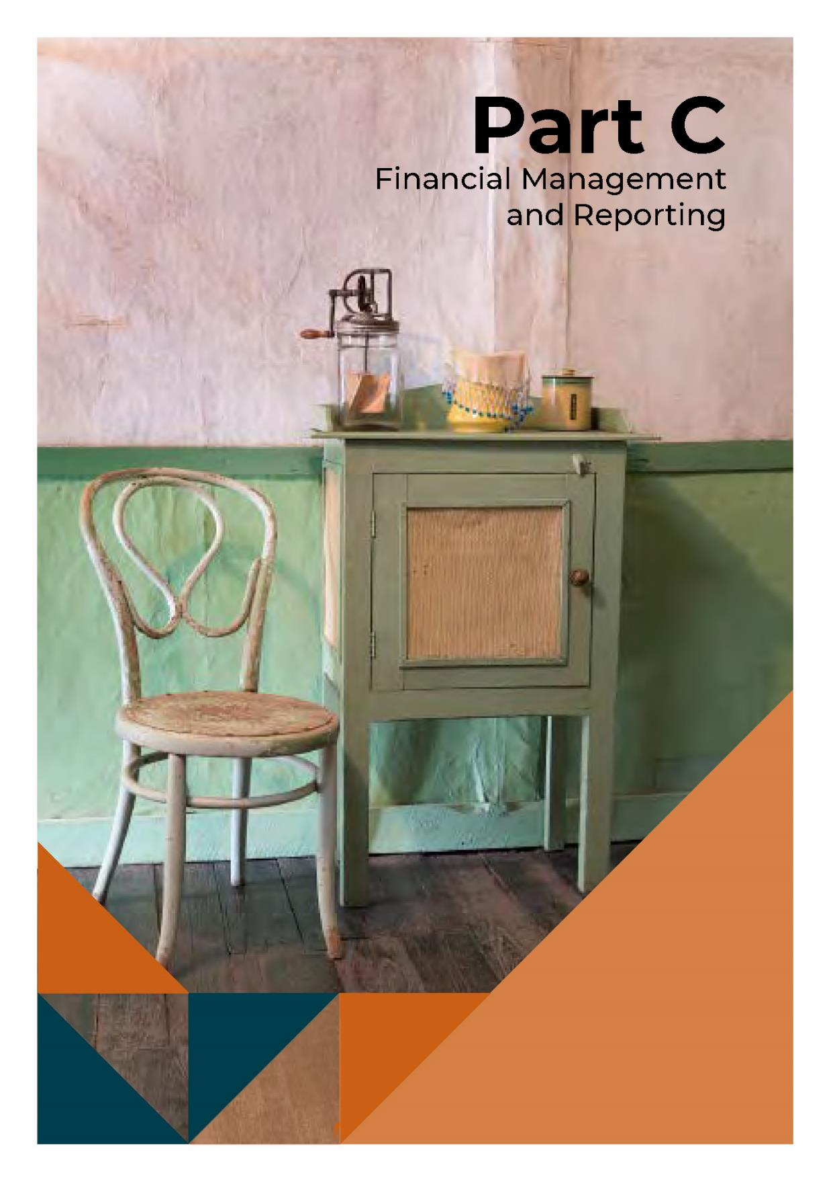

Financial Management Analysis

A full analysis of the CFC’s 2022-23 financial results and financial position is set out in the Management Discussion and Analysis at Attachment 1, page 126 to this report.

Financial Statements

The CFC’s 2022-23 Financial Statements are set out at Attachment 1, page 126 to this report.

Picture Opposite - Mugga-Mugga. Image: Tourism Australia

Cultural Facilities Corporation 97 Annual Report 2022-23

Capital Works

2022-23 CAPITAL WORKS TABLE

Project | Estimated completion  date | Actual completion  date | Original project value  $0,000 | Revised project value  $0,000 | Prior year expenditure  $0,000 | Current year expenditure  $0,000 | Total expenditure to  date  $0,000
New Capital Works
Arts and culture - Canberra Theatre Centre expansion and  redevelopment | June 25 | - | 2,393 | 2,393 | - | 268 | 268
Arts and culture - Lanyon Homestead Upgrades | June 26 | - | 915 | 915 | - | 27 | 27
Lanyon Urgent Driveway Upgrades and Stabilisation of the  Shearers’ Precinct | June 25 | - | 3,903 | 3,903 | - | 7 | 7
Works in Progress
Improvements to the Canberra Museum and Gallery and the  North Building | June 24 | - | 600 | 600 | 106 | 270 | 376
Improvements to the Canberra Theatre Centre | June 25 |  | 1,442 | 1,442 | 460 | 197 | 657
Upgrading Lanyon Homestead | June 25 | - | 3,097 | 3,097 | 811 | 793 | 1,604
Better Infrastructure Fund
Cultural Facilities Corporation | June 23 | June 23 | 450 | 450 | - | 450 | 450
Total Capital Works  Program |  |  | 12,800 | 12,800 | 1,377 | 2,012 | 3,389

2022-23 CAPITAL WORKS RECONCILIATION

2022-23 Approved  Financing  $0,000 |  | 2022-23 Drawdown  Amount  $0,000 | 2022-23 Actual Expenditure  $0,000
New Capital Works
Arts and culture -Canberra Theatre Centre expansion and redevelopment | 1,688 | 268 | 268
Arts and culture - Lanyon Homestead Upgrades | 375 | 27 | 27
Lanyon Urgent Driveway Upgrades and Stabilisation of the Shearers’ Precinct | 927 | 7 | 7
Works in Progress
Improvements to the Canberra Museum and Gallery and the North Building | 520 | 270 | 270
Improvements to the Canberra Theatre Centre | 737 | 197 | 197
Upgrading Lanyon Homestead | 943 | 793 | 793
Better Infrastructure Fund
Cultural Facilities Corporation | 450 | 450 | 450
Total Capital Works Program | 5,640 | 2,012 | 2,012
Works Funded from Other Sources
Adjusted for Capital funded through Own Sourced Revenue | - | - | 408
Adjusted for funding received in 2nd Appropriation | (927) | - | -
Balances per Capital Works Management | 4,713 | 2,012 | 2,420
Balances per cash flow statements | 4,713 | 2,012 | 2,420
For further information contact: CFO, CFC Corporate Finance (02) 6205 2195

Asset Management

Assets Managed

The CFC managed assets with a total value of $75,287,000 as at 30 June 2023. The CFC’s major assets and approximate values are:

Description | $0,000
Canberra Theatre Centre at fair value | 34,719
Land at fair value | 21,203
Historic Places buildings at fair value | 6,740
Plant and equipment at fair value | 4,746
Art and Social History Collection | 5,686
Capital Works in Progress | 2,193
Intangible Assets | 1

During 2022-23 the following major assets were added to the CFC’s asset register:

Description | $0,000
Property, plant and acquisitions | 939
Building upgrades | 1,426
Art and Social History Objects (including donated art) | 150

There were no significant assets removed from the CFC’s asset register during 2022-23.

Assets Maintenance and Upgrade

The CFC maintains its assets in accordance with the CFC’s Strategic Asset Management Plan.

Major asset upgrades (including works funded and reported through the capital works program) completed during 2022-23 were:

Description | $0,000
Works in Progress improving facilities at the Canberra Theatre Centre | 275
Upgrading Lanyon Homestead | 1,918
CMAG Expansion and Activation | 270

For building assets, the expenditure on repairs and maintenance was $386,000, which represented 0.9% of the assets written down value. For Plant and Equipment assets, the expenditure on repairs and maintenance was $87,000, which represented 1.8% of the assets written down value.

A three-year rolling independent valuation of the CFC’s assets has been implemented to ensure all items are reflected at fair value in the CFC’s asset register and any impairment is identified.

Office Accommodation

CFC staff members occupy or use premises at the Canberra Theatre Centre, CMAG, Lanyon, Calthorpes’ House, Mugga-Mugga and North Building administration area locations.

In view of the wide range of workplaces in which CFC staff work (including historic places, theatre and gallery environments, where areas used by staff as offices may be combined with other uses such as ticketing, patron servicing etc.), it is difficult to provide a precise figure of the average area occupied by each employee. An estimate of the total office area occupied as at 30 June 2023 is 1,147 square metres and an estimate of the average area occupied by each (FTE) employee as at 30 June 2023 is 10 square metres.

Government Contracting

Procurement Principles and Processes

The CFC engaged external sources of goods, services and works during 2022-23 and these goods, services and works were procured with the support and assistance of Procurement ACT as required. The CFC believes that its procurement selection and management processes comply with the Government Procurement Act 2001 and Government Procurement Regulation 2007. It liaises regularly with Procurement ACT on procurement matters including through the involvement of officers of Procurement ACT in the more complex or higher value procurement processes.

External Sources of Goods, Services and Works
The online ACT Government Contracts Register records contracts with suppliers of goods, services and works, with a value of $25,000 or more.

A full search of Cultural Facilities Corporation contracts notified with an execution date from 1 July 2022 to 30 June 2023 can be made at https://www.tenders.act.gov.au/contract/search.

Secure Local Jobs Code

Pursuant to section 22H (3) of the Government Procurement Act 2001, I exempt the Cultural Facilities Corporation from the requirements set out in sections 22G (1), (2) and (3) of the Government Procurement Act 2001 in respect of the procurements as advised to me by the Cultural Facilities Corporation for the proposed heritage conservation works related to Lanyon and Mugga-Mugga Cottage (Procurements).

This exemption is granted solely for the Procurements.

The works proposed are specialised heritage and conservation works to ACT Historic Places and as such I consider there are no suitable entities available at reasonable cost to tender or contract for the respective Procurements that would enable the requirements in section 22G (1), (2) and (3) of the Government Procurement Act 2001 to be met.

This exemption is for specialist heritage trade contractors and does not extend to general trades engaged as 3rd party subcontractors to complete associated works captured by the Code requirements.

Cultural Facilities Corporation 102 Annual Report 2022-23

Aboriginal and Torres Strait Islander Procurement Policy (ATSIPP) Performance Measures

No. | ATSIPP Performance Measure | Result
1. | The number of unique Aboriginal and Torres Strait Islander Enterprises that respond to the reporting entity’s tender and quotation opportunities. | Nil
2. | The number of unique Aboriginal and Torres Strait Islander Enterprises attributed a value of addressable spend in the financial year. | Nil
3. | Percentage of the financial year’s addressable spend which is spent with Aboriginal and Torres Strait Islander Enterprises. | Less than 1%

Statement of Performance

The CFC’s 2022-23 Statement of Performance is set out in at Attachment 1, page 183 to this report.

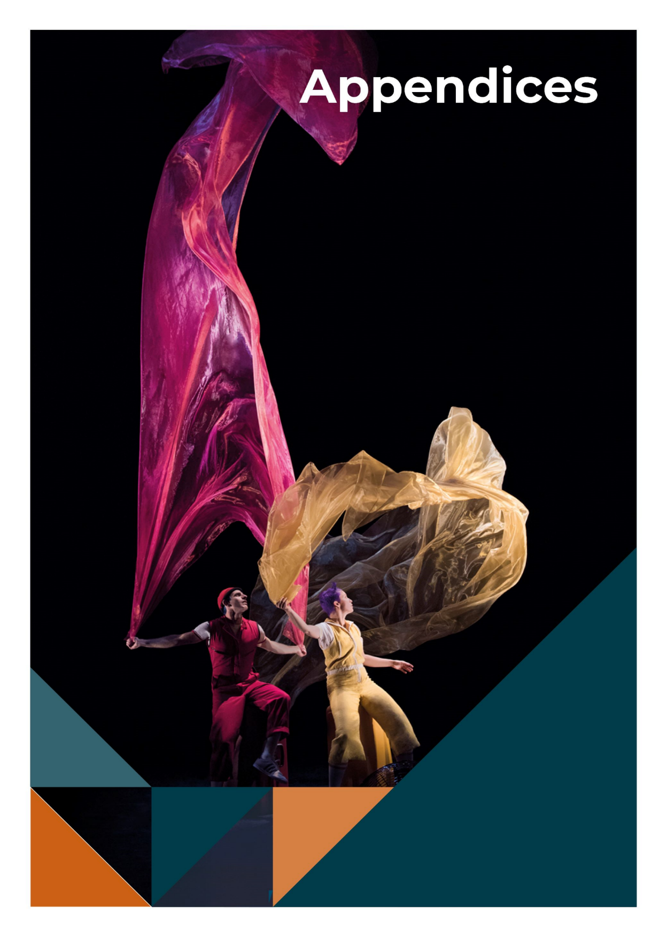
AirPlay, Acrobuffos Pas-De-Deux. Image: Florence Montmare

Appendix 1

Members of the CFC Board During 2022-23

HELEN O’NEIL
(Chair)
Helen is an experienced non-executive director and leader in the arts and creative industries. She was Chair of Performing Arts Connections, representing arts centres, touring companies and service organisations in Australian live performance, and is a board member of South East Arts. She was a Board member of Craft ACT, Currency House Inc, and the Australian Film Finance Corporation. Her executive experience includes roles as Country Director of the British Council in Australia leading cultural relations in the arts, science and higher education; Executive Director of the Australian Major Performing Arts Group and the Council for the Humanities, Arts and Social Sciences; and with Opera Australia.
In public policy she was Senior Adviser to the Minister for the Arts, The Hon Simon Crean, and also worked with the Minister for Communications, The Hon Kim Beazley. Helen has worked in screen and digital areas with News Ltd, and as a journalist with the ABC and The Age. Helen has degrees from the University of Melbourne (BA) and from Harvard University's Kennedy School
(MPA). She is also a Councillor in the Bega Valley Shire.

DR RACHAEL COGHLAN
(Deputy Chair)
Rachael Coghlan is an experienced CEO, cultural strategist and design curator with 20 years’ experience leading transformation projects in Canberra’s creative organisations and national institutions. She is currently establishing a cultural strategy program at Parliament House and is the public art curator
for the Canberra Light Rail. As CEO/artistic director of Craft ACT and the DESIGN Canberra festival, Rachael forged international partnerships to build visibility and income for local artists, and her commitment to interdisciplinary collaboration was acknowledged by the Australian Institute of Architects (ACT) Clem Cummings Medal.
Rachael was awarded a PhD from the ANU and a BA (first class honours) from University of Canberra. Her research bridges practice and research, specifically how museums can become relevant, multi-vocal platforms for the wider social good. She is a board member of the Canberra Region Tourism Leaders Forum and was an ex officio member of the Craft ACT board.

GORDON RAMSAY
(Ex officio as Chief Executive Officer) Gordon is a former member of the ACT Executive (2016–2020) during which he held 6 portfolios, including Attorney-General and Minister for the Arts and was a member of various national ministerial councils. He has a Bachelor of Arts and a Bachelor of Law (Hons) from Sydney University and a Bachelor of Theology from the Sydney College of Divinity. After working as a lawyer in commercial and intellectual property at Freehill Hollingdale and Page he and his family moved to Canberra where he led Kippax Uniting Church and UnitingCare Kippax for 19 years working in areas of service, social equality, inclusion and poverty. He led governance and organisational restructure 2 with UnitingCare NSW.ACT (and then Uniting) from 2011-2016. He led the ACT Targeted Assistance Strategy and was a member of the ACT Community Inclusion

Board between 2006–2008. He has provided consultancy support on policy and organisational governance, strategy and structure locally and nationally for much of the past two decades. He has been an ACT Community Inclusion Advocate, member of the ACT Better Services Taskforce, Community Champion for the “Time to talk: Canberra 2030” and led ACT Anti-Poverty work. He is currently a member of the Board of The Neighbourhood Canberra and the Uniting Church National Assembly Taskforce to develop an apology to the LGBTIQ+ community. He was recognised in the Australian of the Year awards as an ACT Local Hero finalist in 2015.

GENEVIEVE JACOBS AM
Genevieve Jacobs has been a journalist for 30 years, working in print and radio. She was a long time ABC Canberra presenter and is now the Group Editor for Region Media and a graduate of the Australian Institute of Company Directors. Genevieve is a director of the Cultural Facilities Corporation, the Conflict Resolution Service and the Australian Centre for Christianity and Culture. She chaired the ACT Arts Minister's advisory council and Canberra International Music Festival and has an enduring interest in building and strengthening community engagement.

MICHAEL SOLLIS
Michael Sollis is an interdisciplinary artist who promotes how the arts can nurture creative mindsets which generate new ideas. This has included work as founder, composer, and director of the Griffyn Ensemble, and the very first Artistic Director, Education for Musica Viva Australia. As a teaching artist Michael has facilitated projects in places such as Scottish prisons, Egyptian schools, work in urban, rural and remote schools across Australia, and lecturing composition at the Australian National University. His work on sung stories
in the Papua New Guinea highlands is published by ANU E-Press and the Australian Journal of Linguistics. Michael was one of several artists who brought together the ACT Creative community to form the Canberra Artists Action Group and was the founding chair of the International Music Council ‘s Youth Board. Michael was born and raised on Ngunnawal country, following the footsteps of custodians who have listened to this land for centuries.

TIM LO SURDO
Tim is the Founder of Democracy in Colour - Australia's first racial and economic justice organisation led by people of colour. Before starting Democracy in Colour, he worked with low-paid workers to set up Hospo Voice - a new union in hospitality. Previously, Tim was the Head of Campaigns at Oaktree (largest youth-focused international development organisation with over 200,000 members), a senior adviser to two Senators, the Campaigns Director at Jhatkaa (a movement of 1.9 million people taking action for a fairer India), the National Communications Director at UN Youth Australia, and co-founded Open Sky (one of India’s most well-known performance art communities). Tim has served as a Non- Executive Director on 15 Boards and is currently a Director of Plan International, No to Violence, the Australian Marine Conservation Society, Environment Victoria, the Alliance for Gambling Reform, Inner Melbourne Community Legal, the Consumer Policy Research Centre, and the Victorian Government's Sustainability Fund. For his work, Tim was appointed in 2020 as one of 17 UN Young Leaders for the Sustainable Development Goals.

CHRISTINE SHANNON
Christine Shannon has been appointed as a member of the Board and as well as Chair of the CFC’s Audit and Risk Committee. Christine

brings over 25 years of experience in delivering risk and financial management expertise and strategy, as well as governance operations leadership, to the CFC. Her career highlights include delivering the first whole-of- Defence governance and accountability framework and enterprise risk management framework for the then Defence Materiel Organisation's $6 billion capital investment program. With her extensive global and local cultural networks, Christine is well-positioned to support the CFC's growth strategy, including the redevelopment of the Canberra Theatre Centre and the expansion of the
Canberra Museum and Gallery. Her astute business acumen in anticipating and managing political and corporate risks, and in building stakeholder support, will be invaluable to the CFC in achieving its objectives. Christine is a governance expert and legal professional who has advised corporations on marketing and growth strategies, legal risk, enterprise-level risk, and optimal corporate structures with experience in leading workforce change, cyber security, and asset management. She is a fellow of the Australian Institute of Company Directors, and holds a Master of Laws, MBA, Bachelor of Commerce/Laws degrees and AMusA.

Appendix 2

Senior Managers of the CFC

ALEX BUDD – DIRECTOR, CANBERRA THEATRE CENTRE
Alex Budd commenced his arts career in the lighting department at the Canberra
Theatre Centre. He was a founding member of the Canberra based Chamber Opera Company, Stopera. He later worked as Head Electrician and Touring Lighting Designer for Sydney Dance Company, realising lighting designs for Graeme Murphy's ballets across Australia, Europe and the Americas. Alex joined Opera Australia as Tour Manager, Oz Opera in 2000, and has held several roles in Oz Opera and the wider company. After a year at Royal Opera House Covent Garden project managing the Paul Hamlyn Performances, Alex returned to Opera Australia as Manager, Oz Opera, before setting up the Company's Enterprises division. In 2004 Alex was appointed to the Federal Government's Playing Australia Committee, and sat on the Committee for seven years. In 2008 he became General Manager, Melbourne and Enterprises, and in 2016 Executive Producer, Touring and Commercial, the Melbourne-based member of the Company's Executive, with oversight of the music theatre, regional and schools touring and commercial projects of the Opera Australia business. Alex produced 16 New Year's Eve Galas at the Sydney Opera House, as well as the musical tours of South Pacific, The King & I, Anything Goes, My Fair Lady, Evita, and West Side Story. Alex was appointed Director, Canberra Theatre Centre in late 2019, and returned to Canberra to lead the organisation where his career began. Alex has served on the Executive Council for Live Performance Australia and is a currently an
Executive Council Member of the Association of Asia Pacific Performing Arts Centres.

DR ANNA WONG - ACTING DIRECTOR, CANBERRA MUSEUM AND GALLERY
Anna has worked in the museum and cultural heritage management sectors across a broad range of historic, cultural, and natural places and museums in Australia, including precinct- based activation of cultural sites. She previously held archaeology, cultural heritage, planning and museum-related positions with the NSW Government Architect’s Office (NSW Department of Public Works), NSW National Trust, NSW National Parks and Wildlife Service and the National Capital Authority. She was previously a Lecturer in Heritage Studies at the University of Sydney. Her doctoral research examined the Australian heritage conservation movement through the house museum genre and how this shaped our national identity and cultural representation of Australia’s past and present through collections, conservation, exhibitions, public programs, and community engagement. In 2005, Anna was awarded research fellowships at the International Centre for Jefferson Studies at Monticello and the Winterthur Museum in the USA.
Anna has a deep interest in cultural history and the integration of contemporary programs, stories, and site activation to ensure that collections, museums, and our cultural environment continue to be relevant to current communities and audiences.

AMY JARVIS - ACTING DIRECTOR, ACT HISTORIC PLACES
Amy is a heritage conservation and engagement expert with more than 15 years of research and project management experience. Having held key public and private sector leadership and advisory roles, she specialises in built heritage assessment, integrated management planning, community consultation and in the activation and adaptive reuse of heritage places. As an experienced speaker, tour guide and lecturer, Amy has presented in public forums, at conferences, on expert panels and in the media. Her research and practice have focussed on physical building conservation, social history, domestic heritage and communication through education, visitor engagement and interpretation. In her former role as University Heritage Advisor at the Australian National University, she led award- winning projects including the restoration and activation of the Mt Stromlo Director’s Residence and in partnership with local First Nations community members, developed the ANU Aboriginal and Torres Strait Islander Heritage Trail. Amy is also a Churchill Fellow, and Co-Founder and Creative Director of Canberra Modern, an event-based advocacy platform which celebrates the mid-century modern places and spaces of Canberra and has won multiple industry awards. Since 2021, both in her role as Assistant Director, Heritage and Collections, and as Acting Director, Amy has overseen the strategic direction of ACT Historic Places in line with the Cultural Facilities Corporation’s Strategic Plan, relevant legislation and heritage best practice, as well as the recovery of the sites’ following COVID- 19 disruptions. She has delivered major conservation and infrastructure projects including the large-scale restoration of Lanyon, as well as overseeing the development of signature events including
Harvest Day Out (which saw over 2,500 visitors to Lanyon).

DR BROOKE THOMAS – DIRECTOR, COLLABORATION AND ENGAGEMENT
Brooke has 20 years’ experience in a range of public service, tertiary sector, community arts, and political advisory roles including at both the Territory and Federal levels in portfolios including Arts and Attorney-General. She has expertise in social policy development and implementation, complex program management, stakeholder engagement, organisational change, and international relations. In a previous role at Austrade she worked in the area of visitor economy recovery, leading extensive nation-wide consultations for, and delivery of, THRIVE 2030, the national ten-year strategy for visitor economy recovery. She has a PhD in Literature with several publications, and a considerable contribution in ACT community arts sector leadership including as a former Chair of Canberra Dance Theatre and of The
Stellar Dance Company, and as a dance teacher, performer, volunteer, and fundraiser. Her role includes leading on human resources management and a range of corporate governance areas, ministerial and parliamentary matters, strategic coordination of communications and stakeholder engagement, driving organisational capacity building through a range of projects, and leading on collaboration, business development and audience diversification with the goal of boosting the CFC’s contribution to the ACT visitor economy.

IAN TIDY – CHIEF FINANCIAL OFFICER
Ian is a member of Chartered Accountants Australia and New Zealand and has held previous financial roles in retail with Discount Variety Group and in the audit team at BDO Kendalls in Brisbane. He has been employed with the CFC since December 2005, most

recently as the Financial Controller before taking up this position in 2010. He has an undergraduate degree in Business with QUT and has experience in the not-for-profit sector, previously serving on the Board of ArtSound FM.

KEN GIBSON – DIRECTOR, FACILITY OPERATIONS & CAPITAL WORKS
Ken is a client-focussed, experienced senior Government executive with proven record of improving business systems and delivery of transformation Programs within complex environments. Ken is adept at bridging the people, process and technology principles
required for optimising operational and strategic processes and workflows. He is a qualified and experienced Program Director with over 20 years’ experience in engineering drafting, ICT program management, project management, procurement, construction, land management, asset management, contract administration within Australian private sector, Commonwealth and State government sectors. Ken is currently delivering the realignment of a centralised Cultural Facilities Corporation (CFC) integrated facility operations and capital works operating model (towards 30 June 2023).

Appendix 3

Advisory Committees

The CFC has established three Advisory Committees, in accordance with Section 8 (i)(a) of the CFC Act, to provide expert strategic advice in relation to their respective specialist areas. The committees include the Canberra Museum and Gallery Advisory Committee; Historic Places Advisory Committee; and Canberra Theatre Centre Advisory Committee.

Canberra Museum and Gallery Advisory Committee Membership during 2022-23

PROFESSOR NICHOLAS BROWN (CONVENOR)
Nicholas Brown is a professor in the School of History, College of Arts and Social Sciences, Australian National University. He has recently served as the Visiting Cabinet Historian with the National Archives of Australia as a member of the ACT Heritage Council and continues as a member of the Commonwealth and ACT Working Party of the Australian Dictionary of Biography. He is the author and co-author of a number of books, edited collections, and journal articles, most recently A History of Canberra (2016) with Cambridge University Press.

PROFESSOR DENISE FERRIS
Denise Ferris is an Emeritus Professor at the Australian National University, in the School of Art & Design where she was previously Head of School. She is a co-opted board member of the Deans and Directors of Creative Arts (DDCA), a peak body for the tertiary art and design sector, and a board member of South East Arts (SEA). Denise holds degrees from Sydney University and University of Technology Sydney. An art practitioner, Ferris’ photographs are held in Australian public collections, including the National Gallery, National Library, Australian War Memorial, ACT Legislative Assembly Art Collection and Canberra Museum and Gallery as well as international collections
including the District Six Museum, Cape Town and Nara City, Japan.

SQUADRON LEADER GARY OAKLEY OAM
Currently serving in the Royal Australian Air Force in the History and Heritage section as the Indigenous Historian/Curator. He also holds the position of National President of the Aboriginal and Torres Strait Islander Veterans and Services Association. Gary Started his career as a 15-year-old Junior Recruit in the Royal Australian Navy (RAN) and served for 22 years mostly in submarines. As a Vietnam War veteran for service in HMAS Sydney, he left the RAN to take up a position as an Assistant Curator in the Military and Heraldry Section of the Australian War Memorial and after several years moved to the then Gallery Development later Exhibitions section as the Exhibitions Curator in which time he curated most of the galleries currently in the Memorial. Gary also spent time researching, and as a curator at the Bavarian Army Museum in Ingolstadt Germany. He was the first Indigenous Liaison Officer appointed by the Memorial. Whilst a curator at the Memorial he stayed in the RAN Reserve doing programs with the Navy History Section and Australian Defence Force Indigenous Affairs. Gary was offered a position in Air Force in their newly set up Equity and Diversity branch and retired from the Public Service to take up a commission in the Air Force.

DR CHARLOTTE CRAW
Charlotte Craw is an arts, culture and heritage professional with experience working in cultural institutions, public policy, community arts and tertiary education in Australia, Cambodia and New Zealand. She holds a PhD in Australian Indigenous Studies, and her most recent roles have focused on Aboriginal and Torres Strait Islander cultures and heritage. She is a co-author of the Ningaloo
Coast and Sambor Prei Kuk World Heritage nominations, and her other publications include academic articles, art criticism, poetry and short fiction.

SARA KELLY
Sara Kelly has been a museum consultant for the last four and a half years, also undertaking research for cultural institutions on a voluntary basis. Since early 1982 she has worked in art galleries and museums at a National, State, University and Local level, as a Director, Curator, and a Loans and Collections Manager. In addition to a Fine Art degree from the ANU, Sara has a Diploma in Law and Collection Management, which facilitated extensive work on state and international transport logistics, compliance across a number of areas including Indemnity and Sanctions, and their reporting for the movement of cultural material.

AMELIA ZARAFTIS
Amelia Zaraftis is an executive leader, fundraiser, educator, artist, and reconciliation advocate, living on Ngunnawal Ngambri Country. As the Director of Advancement at Burgmann College, a not-for-profit residential college on the ANU campus, Amelia leads the College’s alumni relations, communications, and fundraising program, and champions the College’s Reconciliation program. At the ANU School of Art & Design, Amelia also co-leads the ArtsACT-funded Sharing Stories Arts Exchange project which facilitates artists’ engagement with First Nations communities in Canberra and surrounds. Early her career, Amelia was the Education and Community
Programs Officer at CMAG. In 2018, Amelia was a co-recipient of the ANU Vice Chancellor’s Award for Reconciliation. Amelia holds a Bachelor of Visual Arts (First Class Honours) from the ANU and a Bachelor of Education from the University of Canberra.

The CMAG Advisory Committee last met on 5 May 2023.

ACT Historic Places Advisory Committee Membership during 2022-23

BARBARA REEVE, FIIC, M. ICOMOS (CONVENOR)
Barbara served as the Australian War Memorial's Head of Collection Services in 1998 – 2014 and was responsible for the Conservation, Registration, and Collection Management System teams. She then stepped into the role of Manager, Heritage Preservation Projects, until her retirement in 2017. Prior to moving to Canberra, she was the inaugural Head of Conservation, Australian National Maritime Museum during 1993-98. Her professional training includes: BA (Archaeology) Bryn Mawr College; BSc (Conservation) University of London; Museum Leadership Program, 2001, 2003, 2005; Visiting Scholar, Wolfson College, Cambridge, 2010; Advance Professional Development course, Best Practice in Managing Heritage Places, ANU, 2014; Certified Passivhaus Designer/Consultant, Passivhaus Institut, 2020. A Fellow and Ordinary Member of Council for the International Institute for Conservation, and former Director, AusHeritage, her international experience includes establishing conservation training at Hong Kong University, and work for museums, collectors, and archaeological excavations in Europe, the Asia- Pacific, and the Middle East. Barbara’s professional interests and publications include conservation education and practice, bushfire

recovery, and sustainability/eco-effectiveness in the building and heritage sectors.

DR DIANNE FIRTH OAM (DEPUTY CONVENOR)
Dr Dianne Firth is Adjunct Associate Professor in the Faculty of Arts and Design at the University of Canberra and is a registered landscape architect and Fellow of the Australian Institute of Landscape Architects. She holds a PhD, B Land Arch, BSc, and Dip Ed. She was Head of the Landscape Architecture program at the University of Canberra until 2012 and was Deputy Chair of the ACT Heritage Council until March 2018. In 2017 Dianne was awarded an OAM for her service to landscape architecture and education. Her PhD, Behind the Landscape of Lake Burley Griffin: landscape, water, politics, and the National Capital 1899-1964, was completed in 2000.
The current focus of her research, publication and lecturing is Canberra’s landscape: its design, legacy, and heritage. She has served as chair for the review of the National Capital Open Space System for the National Capital Authority, as a member of the Design Review Panel for the ACT Government, and as a landscape expert on the ACT Government's Tree Renewal Strategic Plan. Firth is also an acknowledged textile artist with works in public collections in Australia and overseas.
Since 2018 she has been president of Ozquilt Network Inc, an organization which promotes art quilters across Australasia.

ALISTAIR GRINBERGS
Alistair is a research scholar with the Centre for Creative and Cultural Research at the University of Canberra. His research focusses on the potential benefits of centering First Nations culture, experience and values in heritage management practice and seeking to understand how that might determine what forms of engagement and investigation are required and what questions about the past then become relevant. From 1993 to 1997:
NSW National Parks & Wildlife Service – responsible for advice on First Nations and historic heritage places and values in the context of environmental impact assessment and negotiation with NSW and Commonwealth Government agencies on the management of legacy Snowy Mountains Scheme assets within Kosciuszko National Park. From 1997 to 1999: Australian Heritage Commission - responsibility for coordinating complex advice to the Government on National Estate listed places and related policy matters including amendments to the Environment Protection and Biodiversity Conservation Act. In 2000: Australian National Antarctic Research Expedition to Heard & McDonald Islands - led a heritage assessment of the former Australian base at Atlas Cove. During 2001 to 2003: Environment Australia - managing a review of the Ozone Protection Act and associated amendments to the legislation to include synthetic greenhouse gasses used as alternatives to ozone depleting substances.
From 2003 to 2008: Independent consulting practice - completed a range of projects including organisational restructures of Booderee and Kakadu National Parks, a national review of heritage tourism in protected areas and the assessment of National Heritage List values of the Australian Alps National Parks. From 2008 to 2016: Ironbark Heritage & Environment – Director of a consulting practice that focused on First Nations heritage assessments in the rapidly expanding WA iron ore mining sector. During 2017 to 2020: EcoLogical Australia and later Lantern Heritage.

JOANNE LISINSKI
Joanne is a Conservator and specialises in modern materials and materials analysis. She has experience in archaeological and built heritage preservation and management and is currently a Senior Conservator at the Australian War Memorial. Prior to this, Joanne

worked in the Middle East for 15 years in Conservation and Technical Art History. She
The ACTHP Advisory Committee last met on 27 April 2023.

completed Master’s degrees in Conservation Science (University College London), Middle

Eastern and Central Asian Studies (Australian National University), and Undergraduate studies in Fine Arts (RMIT). She has particular interest in experimental and contemporary art practice. Joanne is a Board Member at You Are Here (YAH) and Secretary of the Australian Museums and Galleries Association Art, Craft and Design National Network (AMaGA ACD NN). In 2020, Joanne was selected to attend the Audrey Fagan Board Traineeship Program and completed a one-year mentorship program with CFC’s then CEO. Her professional interests and publications include conservation science, collection hazard and risk management, and workplace health and safety.

DR SHANNYN PALMER
Shannyn is a community-engaged practitioner, researcher and writer. She currently works as a consultant, helping organisations and institutions to achieve best practice in community engagement and create meaningful collaborations. She has over a decade of experience working in community engagement, facilitation and research with First Nations and Culturally and Linguistically Diverse peoples and communities and government and non-government organisations in the arts, cultural and cultural heritage sectors. She has a PhD in History from the Australian National University and recently published her first book with Melbourne University Press, Unmaking Angas Downs: Myth and History on a Central Australian Pastoral Station, which traces a history of colonisation in Central Australia from the perspective of Anangu who lived there. She is committed to the development of community- engaged practice and meaningful intercultural conversations and collaborations.
Canberra Theatre Centre Advisory Committee Membership during 2022-23

CLAUDIA SANTANGELO (CONVENOR)
Claudia works at the National Centre for Aboriginal and Torres Strait Islander Wellbeing Research at the Australian National University (ANU). She supports this Indigenous majority, led, and governed team with funding partnerships and project delivery. Prior to joining the Centre in May 2023, she worked for almost 8 years as a major gift fundraiser at ANU driving philanthropic growth in support of Aboriginal and Torres Strait Islander-led projects, and environment and public health initiatives.

Claudia has a strong background in the arts industry. She has produced her own shows for Sydney Fringe, Co-Directed a multi-day arts and music festival, and spent three years as Manager of Sydney Film Festival’s Travelling Film Festival, among other production and events management gigs. Prior to this she managed the IBM Cape York Program, working with Indigenous Enterprise Partnerships to coordinate staff secondments supporting community driven projects. Through 2013- 2015 Claudia worked in Timor-Leste, first as an Australian Youth Ambassador with the Association of Community Radio, supporting this local collective to build their profile, funding and reach. She then worked with the Timor-Leste’s President’s office, successfully establishing a national nutrition awards program.

Claudia also has the privilege of being recently appointed to the Board of Arts Capital Limited.

KELS BAGUST
Kels is a passionate and established arts producer, festival manager, curator of events and general manager. Kels is currently employed at the City of Sydney as the Night Time Economy Project Manager, and is responsible for managing and designing programs to improve vibrancy, diversity and safety at night. Kels has previously worked as Contemporary Music Producer for Sydney Opera House and as Live Music Manager for the University of Canberra’s live music arm, UC Live. Kels is a member of MusicACT, and has worked in event management, operations, and curatorial roles for a number of Canberra based arts organisations, including Ainslie and Gorman Arts Centres and Dionysus.

SOËLILY CONSEN-LYNCH
Soëlily Consen-Lynch is a Dutch trained legal professional in employment law and industrial relations, working as Assistant Director Industrial Relations in ACT Government. Prior to moving to Canberra with her family in 2013, she worked in corporate law and legal aid in the Netherlands. Advocacy has been her passion from early on and as she felt a void "helping people" in Australia, she commenced volunteering in various community organisations as she always tries to look for ways to support and empower people and improve people's quality of life where possible. In 2019 she joined the Multicultural advisory council of the ACT Minister of Multicultural Affairs, a position she recently vacated in April 2022, to give other community members a chance to join the council. In 2021, she was the chair of the ACT chapter of the Mental Health Foundation Australia Multicultural Ambassadors, and she was also a Volunteer Coordinator for UN Women IWD Committee Canberra. Besides work on various committees and panels, Soëlily is also a regular volunteer for ACT Government as MC for citizenship
ceremonies, National Multicultural Festival, Enlighten and Floriade.
- Current- Canberra Theatre Centre Advisory Committee
- 2022 - Celebrate Gungahlin Festival Reference Group
- 2022 - Sexual Health and Family Planning ACT, Member of the Youth Advisory Group
- November 2021- March 2022, UN Women Australia/ IWD ACT Chapter – Volunteer Coordinator
- October 2019 - April 2022, Member ACT Multicultural Advisory Council to the Minister of Multicultural Affairs
- 2019, ACT Government JACS Appeal Panel – Employee Representative
- March 2021 - November 2021, Chair ACT Chapter Multicultural Ambassadors- Mental Health Foundation Australia
- 2021, Co-organiser Think Tank – Youth Growth, Empowerment and Mentoring Group.

FREDELIZA CAMPOS
Fredeliza Campos is an archaeologist and an ethnomusicologist. In the Philippines, she has held various music related positions, such as A&R for BMG Records, Music Specialist for the National Philharmonic Orchestra and as an Archivist for the music instrument collection of the University of the Philippines, Center for Ethnomusicology. She completed her postgraduate studies at the University of the Philippines (Master of Science in Archaeology) and the University of Hong Kong (Master of Philosophy in Ethnomusicology). As an academic, Fredeliza has received fellowships to conduct in-depth analyses of zoological specimens and musical instruments from institutional collections, such as the Field Museum of Natural History in Chicago, Naturalis Biodiversity Center in Leiden, and museums in the Philippines. She is currently affiliated with the Australian National University as part of the secretariat for the

Indo-Pacific Prehistory Association, a large organization of archaeologists, anthropologists and other specialists in similar fields working in the Indo-Pacific region. She has ongoing research on cultural and religious festivals, specifically looking at the performance of traditional musical instruments and their early forms. Fredeliza is also a member of Rondanihan, a rondalla musical group based in Canberra, and plays an active role in various cultural activities as part of the Philippine- Australian diaspora.

DAVID HOBBES
David was a practising architect in Sydney and Canberra for over 30 years and also a heritage consultant during the last 20 years he has lived in Canberra. Having retired from architectural practice he continues on a variety of heritage projects in Canberra and the surrounding region, is Heritage Advisor to Goulburn Mulwaree Council and was recently appointed to the ACT Heritage Council. He has worked on many significant Canberra buildings including the Canberra Theatre having co-authored the Conservation Management Plan for Civic Square. He is a keen supporter of Canberra’s public life, culture and institutions. With the time he has left he is renovating an 1895 workers cottage in the Snowy Mountains.

DR SHANNYN PALMER
Shannyn is a community-engaged practitioner, researcher and writer. She currently works as a consultant, helping organisations and institutions to achieve best practice in community engagement and create meaningful
collaborations. She has over a decade of experience working in community engagement, facilitation and research with First Nations and Culturally and Linguistically Diverse peoples and communities and government and non-government organisations in the arts, cultural and cultural heritage sectors. She has a PhD in History from the Australian National University and recently published her first book with Melbourne University Press, Unmaking Angas Downs: Myth and History on a Central Australian Pastoral Station, which traces a history of colonisation in Central Australia from the perspective of Anangu who lived there. She is committed to the development of community- engaged practice and meaningful intercultural conversations and collaborations.

The CTC Advisory Committee last met on 22 June 2023.

Appendix 4

Facilities and Business/Activities under Management

The Canberra Theatre
Asset | Business Activity | General Description of Business Activity
- Canberra Theatre (1,239 seats)  - The Playhouse Theatre (614 seats)  - The Courtyard Studio (90 seats)  - Other venues and spaces including - Link/Foyer; Technical Workshop; and the CTC Forecourt | - Presentation of live performances  - Technical services support to presenters  - Marketing/sales support to presenters  - Front of house support to presenters  - Front of house services to patrons  - Box Office services  - Building maintenance services, asset management etc  - Discovery and Learning | - Presentation of live performances  - Providing excellent patron experiences  - Foster performing arts skills through creative learning and vocational education and training

Canberra Museum and Gallery

Asset Business Activity
General Description of
Business Activity

  - Canberra Museum and
Gallery (including the Nolan Collection)
  - Gallery spaces
  - Art studio
  - Theatrette
  - Meeting rooms
  - Foyer
  - Civic Square Hub
  - Collection storage area
  - Visual arts/social history
programs (exhibitions, museological activities, etc) curated by the facility or in partnership with community groups, private organisations or other institutions
  - Front of house services to visitors
  - Technical services support for exhibition installation
  - Research, learning and community programs.
  - Venue Hires/usage by commercial/community users
  - CMAG Café
- Development and
presentation of visual arts and social history programs
- Development, conservation and research of an integrated social history visual arts collection

ACT Historic Places
Asset | Business Activity | General Description of Business Activity
- Lanyon Homestead  /Historical Precinct | - House museum and grounds, with associated tours, activities etc  - Conservation management  - Commercial/community venue hire (weddings etc)  - Research, learning and community programs  - Technical/caretaking/ gardening services  - Catering/concessions | - Conservation, interpretation and presentation of cultural heritage resource with associated supporting services and facilities  - Presentation of exhibitions and outdoor performances and events especially in association with festivals

- Calthorpes’ House Red Hill | - House museum and gardens with associated tours, activities etc  - Conservation management  - Research, learning and community programs  - Technical/gardening/security support services | - Conservation, interpretation and presentation of cultural heritage resource associated with support services
- Mugga-Mugga, Symonston | - House museum and grounds with associated tours, activities etc  - Conservation and management  - Education Centre and associated programs  - Commercial/community hires/usages  - Technical/gardening/ security support services | - Conservation, interpretation and presentation of cultural heritage resource associated with support services  - Presentation of events especially in association with festivals  - Environmental education activities

Appendix 5

Canberra Museum and Gallery and ACT Historic Places Venues – Schedule of Exhibitions, Programs and Events
The following is a list of exhibitions, community and education programs and events at CMAG and the ACT Historic Place venues in 2022-23.

Canberra Museum and Gallery – Exhibitions | Date/s
The Nolan Collection | Permanent Exhibition
Brian Corr: Timeshel | Permanent Exhibition
Canberra/Kamberri: Place & People | Permanent Exhibition
*Canberra Raiders: 40 Years in the Limelight | 26 February 2022 – 27 August 2022
*Delene White: Flower Power | 4 December 2021 – 3 September 2022
*Sidney Nolan: Inferno | 9 April 2022 – 17 September 2022
*Glass Alphabet | 7 May 2022 – 1 August 2022
*Jan Brown: A life with Art | 17 June 2022 – 30 March 2023
Sidney Nolan: Search for Paradise | 9 July 2022 – 22 October 2022
Dean Cross: Sometimes I Miss the Applause | 9 July 2022 – 22 October 2022
Life is Art: Works by John Nixon from the collection of Susan Taylor and Peter Jones | 30 July 2022 – 30 November 2022
Lindy Lee: Moon in a Dew Drop | 17 September 2022 - 3 December 2022
Tony Clark: Buehnenbild | 30 November 2022
Matthew Thorne: Jingo was Born in a Slum | 1 October 2022 – 16 April 2023
JamFactory ICON Tom Moore: Abundant Wonder | 5 November 2022 – 12 February 2023
Blanche Tilden: ripple effect – a 25 year survey | 5 November 2022 – 12 February 2023
Platypus: A Curious Creature | 16 January 2023 – 18 June 2023
Stronger Together – Artists’ perspectives on the ACT COVID-19 frontline health response | 4 February 2023 – 30 July 2023
Karena Keys: Wanna Sip | 11 February 2023 – 6 August 2023
Light, Colour, Humanity: the Legacy of Alastair Swayn | 11 March 2023 – 28 May 2023
Settled/Unsettled | 4 March 2023 – 24 June 2023
Fly Fly! - Sidney Nolan's Birds | 29 April 2023 – 17 September 2023
Exhibitions *Exhibitions recorded in 2021-22 Annual Report.

Activities in the Gallery conducted by artists, panels, CMAG staff and other experts in the field for the following exhibitions:

Canberra Museum and Gallery – The Nolan Collection
Sidney Nolan: Search for Paradise – Artist Talks, Exhibition Tours, Highlights Tours
Andrew Turley - Nolan's Africa: The Paradise Paradox
Kendrah Morgan on Nolan's Search for Paradise
Sidney Nolan: Search for Paradise - MakerSpace NedHead

Canberra Museum and Gallery – Outreach Programs
Blue Suitcase – Torrens Preschool
Old MacDonalds Farm - Wanniassa Primary School
Canberra Museum and Gallery – Venue Hire
Venues within CMAG were hired by 39 different organisations during 2022-23, with a number of these organisations hiring venues on multiple occasions. Organisations ranged from Federal and ACT agencies to not-for-profit organisations, community groups, and private sector organisations.

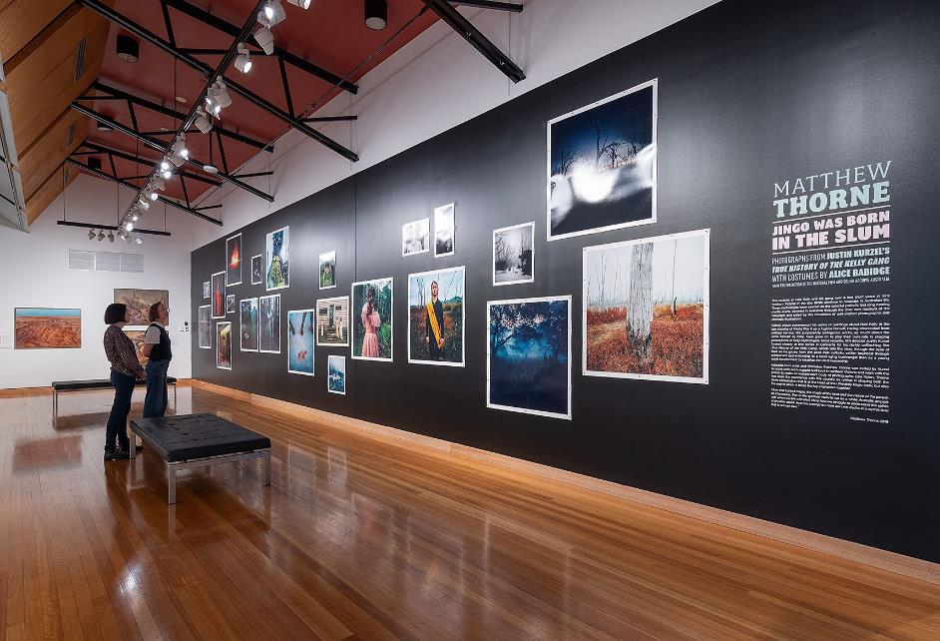
CMAG Nolan Gallery Matthew Thorne Jingo was born in the slum. Image: CMAG

ACT Historic Places - Exhibitions
Lanyon
Within Living Memory | Permanent Exhibition
The Cunningham Family Album | Permanent Exhibition
The Convict Years | Permanent Exhibition
Calthorpes’ House
Calthorpes’ House Orientation Exhibition | Permanent Exhibition
Preserving the Past | Online Exhibition
An Exciting New World at Calthorpes’ | Online Exhibition
Christmas for the Cunninghams Lanyon | Online Exhibition
Mugga-Mugga
Getting it Together | Permanent Exhibition
ACT Historic Places – Learning and Community Programs
Lanyon
Convicts and Who were the Convicts? | Learning programs discussing the profiles of convicts  assigned to Lanyon, attended by various schools.
James’ Diary | Learning programs providing a tour of the homestead in the footsteps of James Cunningham, attended by various  schools
Child’s Play | Learning programs exploring the world of old-fashioned games and Victorian paper dolls, attended by various  schools.
Calthorpes’ House
Dawn’s Surprise | Program taking children on a journey around the house,  attended by various primary schools.
Mugga-Mugga
At the Garden Gate | Program that focuses on the landscape and environment of Mugga-Mugga, attended by various primary schools  and early learning centres.

Other Programs Included: Christmas exhibitions, Winter Landscapes at Lanyon Photography Workshop; Princess Elizabeth and I exhibition; Aboriginal Storytelling with Larry Brandy; ‘Stories at Sunset’ with Tim the Yowie Man; Spring Flower Macro Photography; Making Funky Felt Flower Badges; Free Tours of Lanyon Gardens; Watercolour Landscape Painting in Lanyon Gardens; Mugga- Mugga Cottage Grasslands; Botanical Illustrations with Halina Steele; Floral Art Demonstration with Lou Lou Moxom of Moxom and Whitney; Build a Bee Hotel with Tracey Bool; Family Picnic and Jazz; Make your Own Victorian Christmas Decorations; Legends of Lanyon with Tim the Yowie Man; and Find, Make, Renew - Sustainable Art Workshops.

Venue Hire/Function Usage: Spaces within Lanyon and Mugga-Mugga were used by 16 different organisations and groups during 2022-23.

Appendix 6

Canberra Museum and Gallery – Acquisitions (Purchases and Donations)

PURCHASES
Social History
- Album page with two albumen photographs of Duntroon House, 1873
- Dawn Waterhouse Collection of Canberra- related objects
- Riverslake, book
- Motorists' Map of the South Coast

Visual Arts
- Carl Plate, Study for Pine Forest Mt Stromlo,
1945, mixed media on paper
- Carl Plate, Pine Forest Mt Stromlo, 1945,
- John Hopkins, Capital Hill, 1974, acrylic on canvas
- Blanche Tilden, Epicormic Growth - Black Saturday, 2009, glass and silver neckpiece
- Tom Moore, Pickled Power Beacon, 2014, hot joined blown and solid glass, epoxy and metal with a wooden base
- Frank Hinder, Self, etching and aquatint on paper
- Peter Alwast, In the City, 2022 oil on linen
- Genesis Owusu, Smiling With No Teeth, 2022 vinyl LP special edition
- Mandy Martin, Drawing for Red Break, 1984, mixed media on paper

mixed media on paper
  - Carl Plate, Untitled (Mt Stromlo landscape),

1947, mixed media on paper
  - Carl Plate, Untitled (Mt Stromlo landscape),
1947, mixed media on paper
  - Carl Plate, Untitled (Mt Stromlo landscape),
1947, mixed media on paper
  - Graeme Inson, Big Rock, Delegate Station, oil on board
  - Sidney Nolan, Weeping face, c. 1940, mixed media on paper
  - Sidney Nolan, Flowers on the mantelpiece at Heide, c. 1946, mixed media on paper
  - Sidney Nolan, Woman, c.1946 mixed media on paper
  - Sidney Nolan, Leda and the Swan, c.1960, mixed media on paper
  - Dionisia Salas, Untitled, 2023, mixed media on paper
  - Chelsea Lemon, Callam Offices Tray, 2023,
dyed veneer and walnut
  - James Tylor, CIPX Aidan Hartshorn (Walgalu people of the Ngurmal Nation), 2022, digitally printed daguerreotype photograph

DONATIONS
Social History
- Zoe Rose, Ken Behrens t-shirt
- Collection of 19th Century lace and lace garments and 19th century letter book of Edward K. Crace, Gungahlin
- Canberra Festival Posters
- Craig Colins, Motorised electric bicycle
- Canberra: General Notes for the Information of Public Servants, April 1926
- Collection of 1963 Canberra Jubilee stamps
- The Canberra Dairy Society Limited, Milk Recipes booklet
- Namadgi High School hoodie and Namadgi High School polo t-shirt
- Collection of ‘Canberra 100’ ephemera
- Collection of garments by Christopher Palmer

Visual Arts
  - Imants Tillers, Ocean Surface I and Ocean Surface II, mixed media on boards
  - Faye Skyring, Coat, textile
  - Doug Alexander, dinner set, ceramic Collection of ceramics and glass by Janet De boos, Ian Jones, Patsy Hely and Sarah Rice, Alan Astin, Hiroe Swen, Henri Le Grand and Richard Whiteley, Sarit Cohen Derek
Wrigley, Marquette Jan Brown collection of illustrated Christmas cards
- Carl Plate, Untitled (Mt Stromlo landscape),
1947, mixed media on paper

Note: in some cases the acquisition process was being finalised as at 30 June 2023.

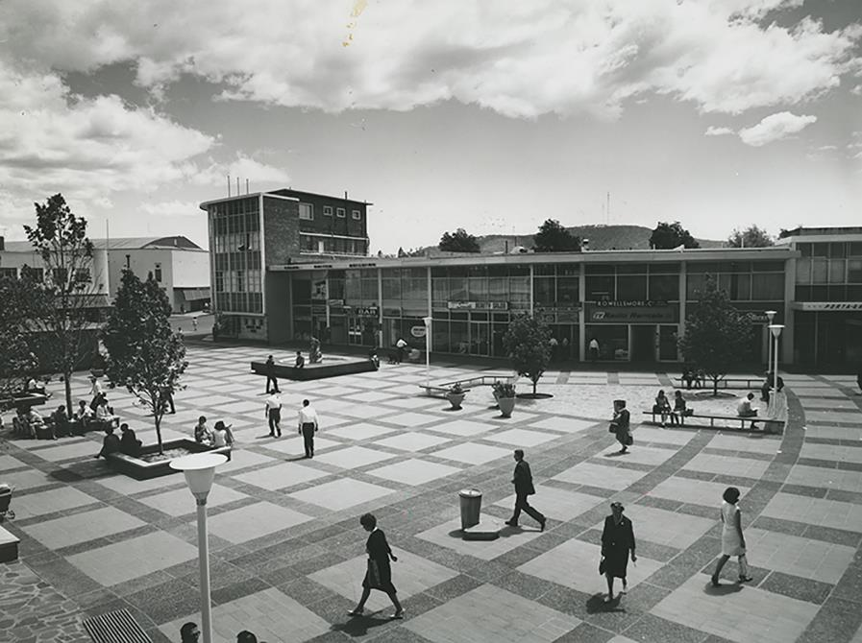
40th Heritage Festival - Precinct Tour – Garema Place 1954. Image: Fairfax Archive Photographs

Appendix 7

Major Funding, Sponsorship and Support
The CFC enjoyed the continuing support of Government agencies and of several major sponsors, as well as the assistance of many donors and supporters during 2022-23. Without their generous support many of the CFC’s performances, exhibitions, programs and events would not be possible.

CFC Government Funding
ACT Government

CANBERRA MUSEUM AND GALLERY
Government Funding
Commonwealth Department of Infrastructure, Transport, Regional Development, Communications and the Arts

Major Non-Government Support (over
$10,000)
Meredith Hinchliffe

Supporters (up to the value of $10,000 and major in-kind support)
Ms Joan Adler
Estate of The Late Mandy Martin

Contributions to the Canberra Region Treasures Fund 2014–2023
John Hindmarsh AM (former CFC Chair) Louise Douglas (former CFC Chair)
Virginia Haussegger AM (former CFC Board Member)
Harriet Elvin (former CEO) Dawn Waterhouse
Laura Cree Maureen Fisher John Mulvaney AO Kerry-Anne Cousins Koula Notaras
John Olsen OBE AO Jody Turner
Frank Bergersen
John and Dianne Firth Dr Howard Galloway Dr Charlotte Galloway Rosanna Burston Phoebe Bischoff OAM Robyn A Duncan
Lady L D Yeend Jacqueline Pinkava Estelle Barnes
Bill and Beverley Wood Dorothy Cameron Marian Hill
Judith Bibo Gabrielle Watt
Karina Harris and Neil Hobbs Dr Roslyn V Russell
Kristine Reithmiller Joan Adler
Paul G White PSM Dr Mark Lax Lynette Henderson Ms Marian Hill Richard Rolfe

ACT HISTORIC PLACES
ACT Government Funding Environment, Planning and Sustainable Development Directorate

CANBERRA THEATRE CENTRE
Supporters (up to the value of $10,000 and major in-kind support)
Ms Helen O’Neil Mr Gordon Ramsay

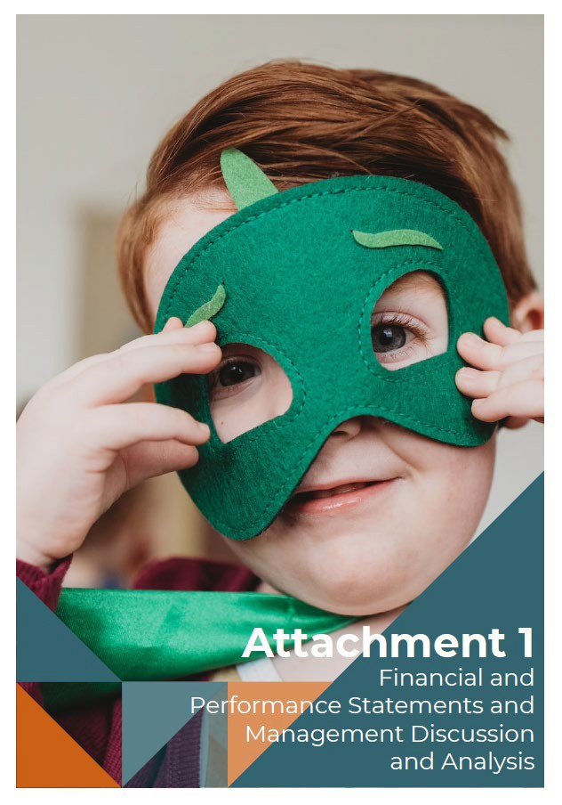

CMAG on Saturdays. Image: Jessica Rockowitz
Cultural Facilities Corporation 126 Annual Report 2022-23

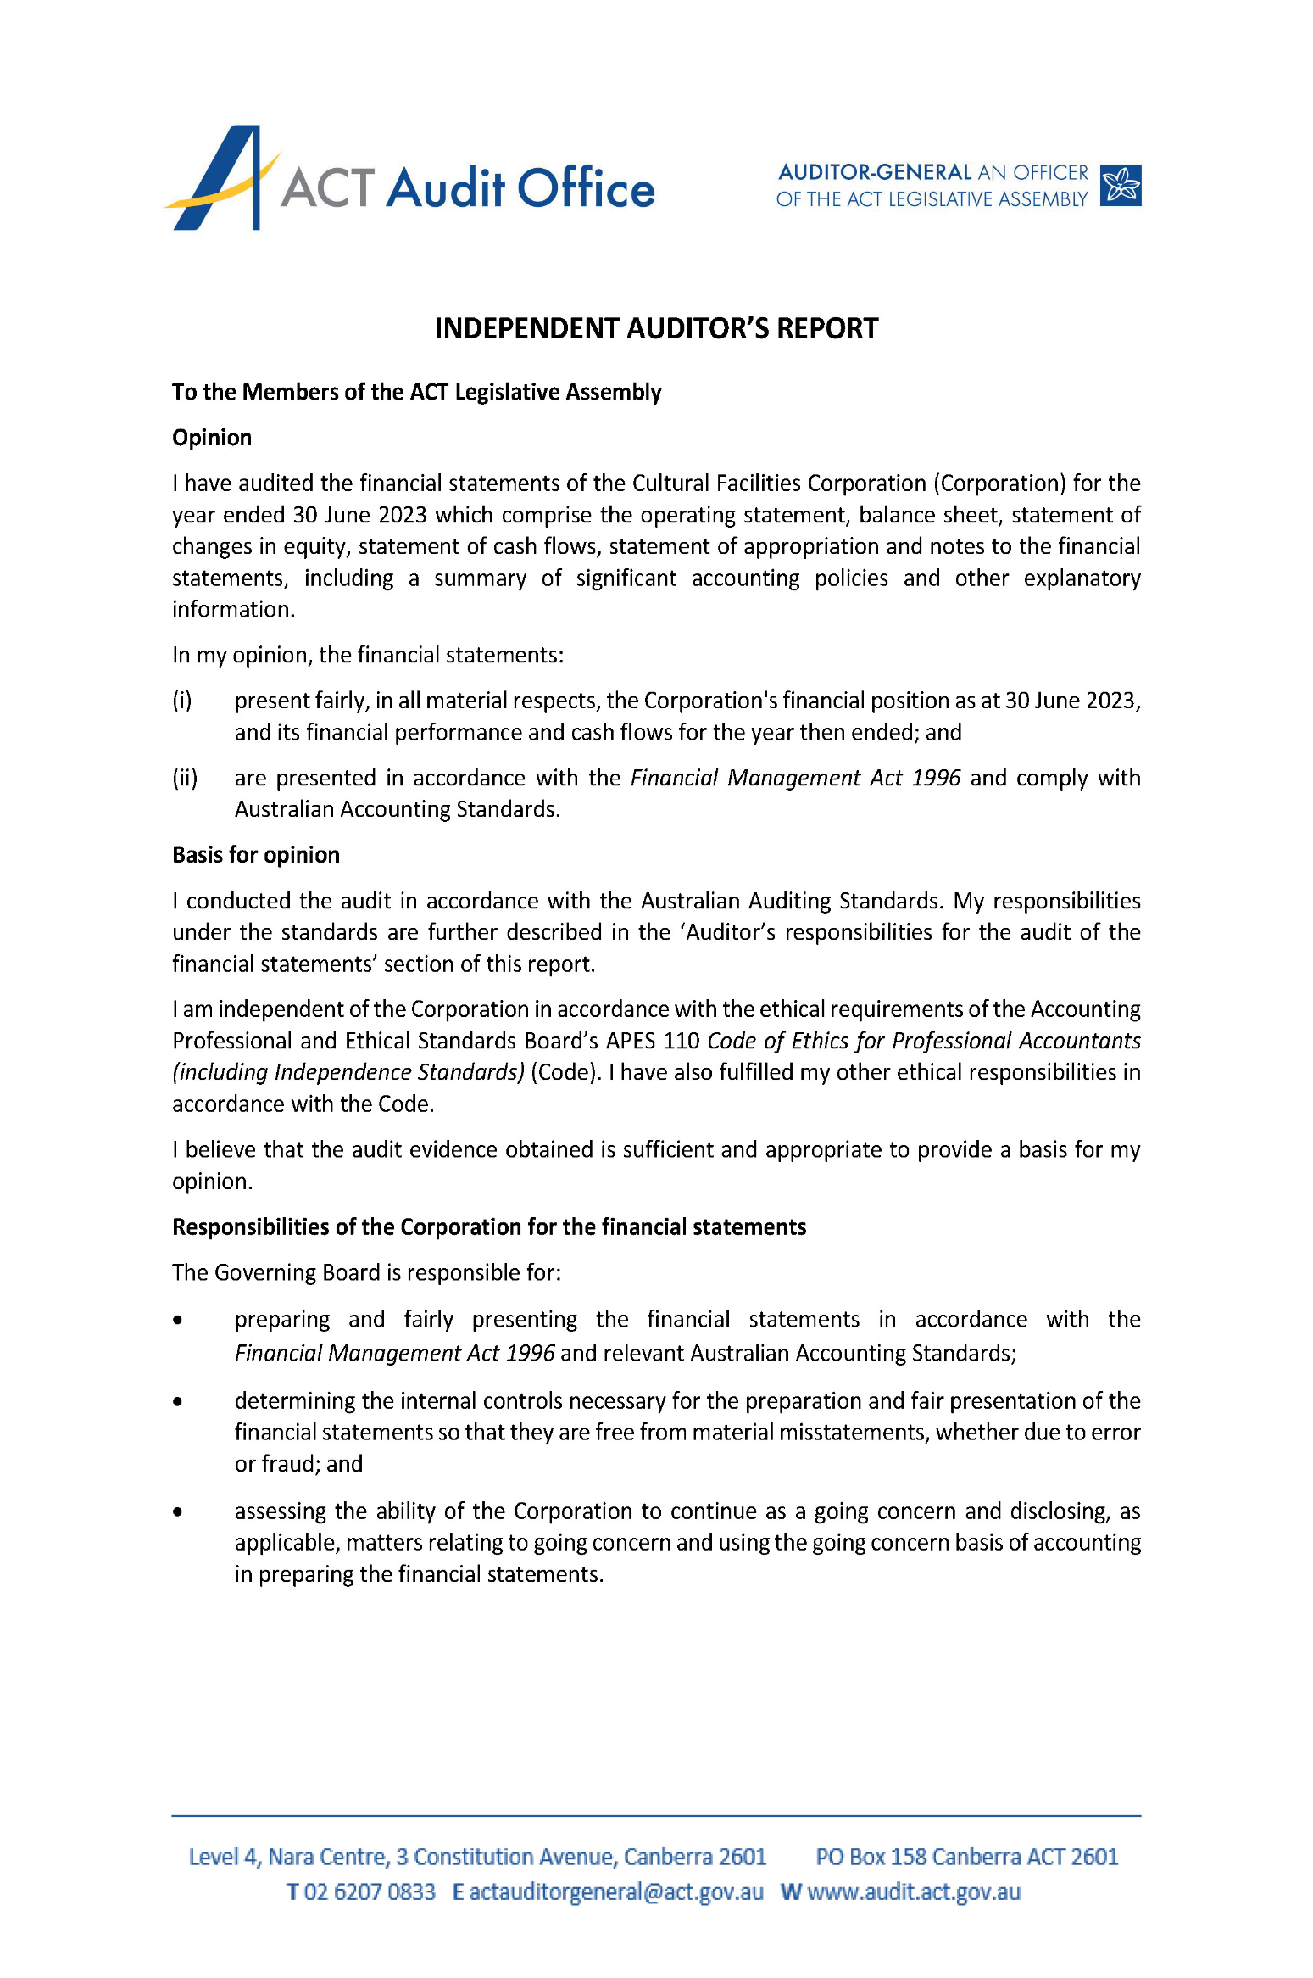
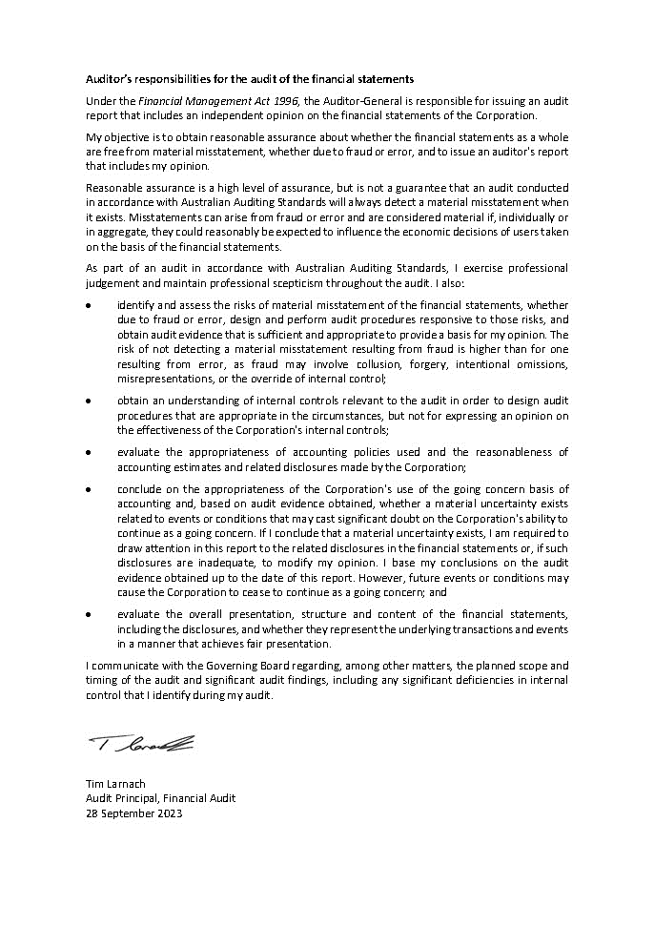
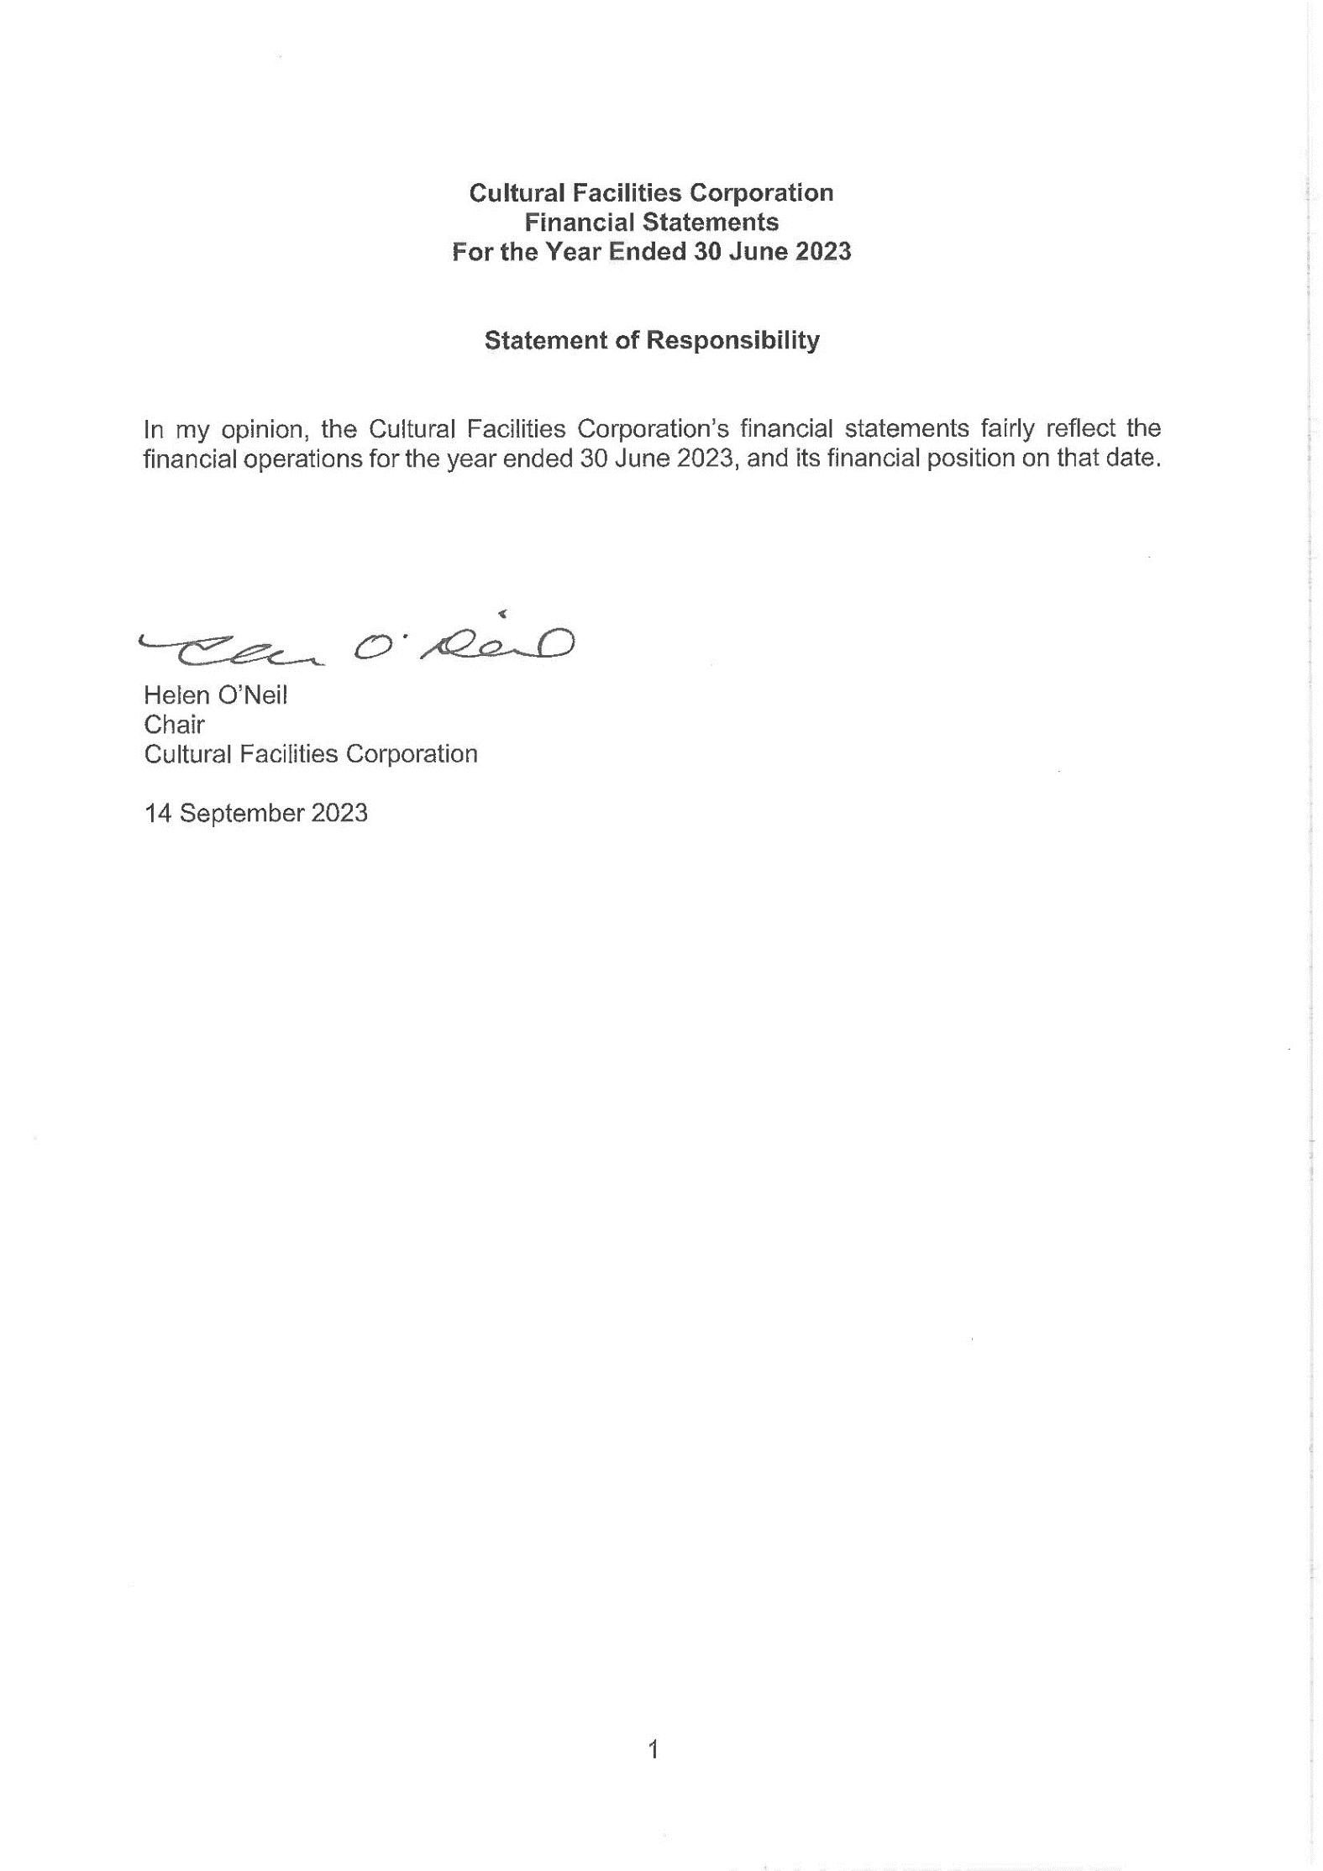
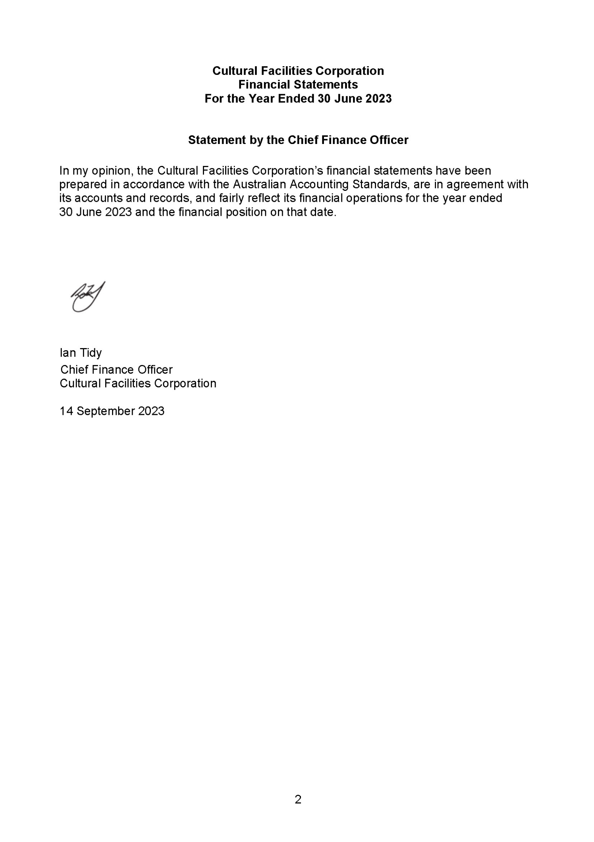
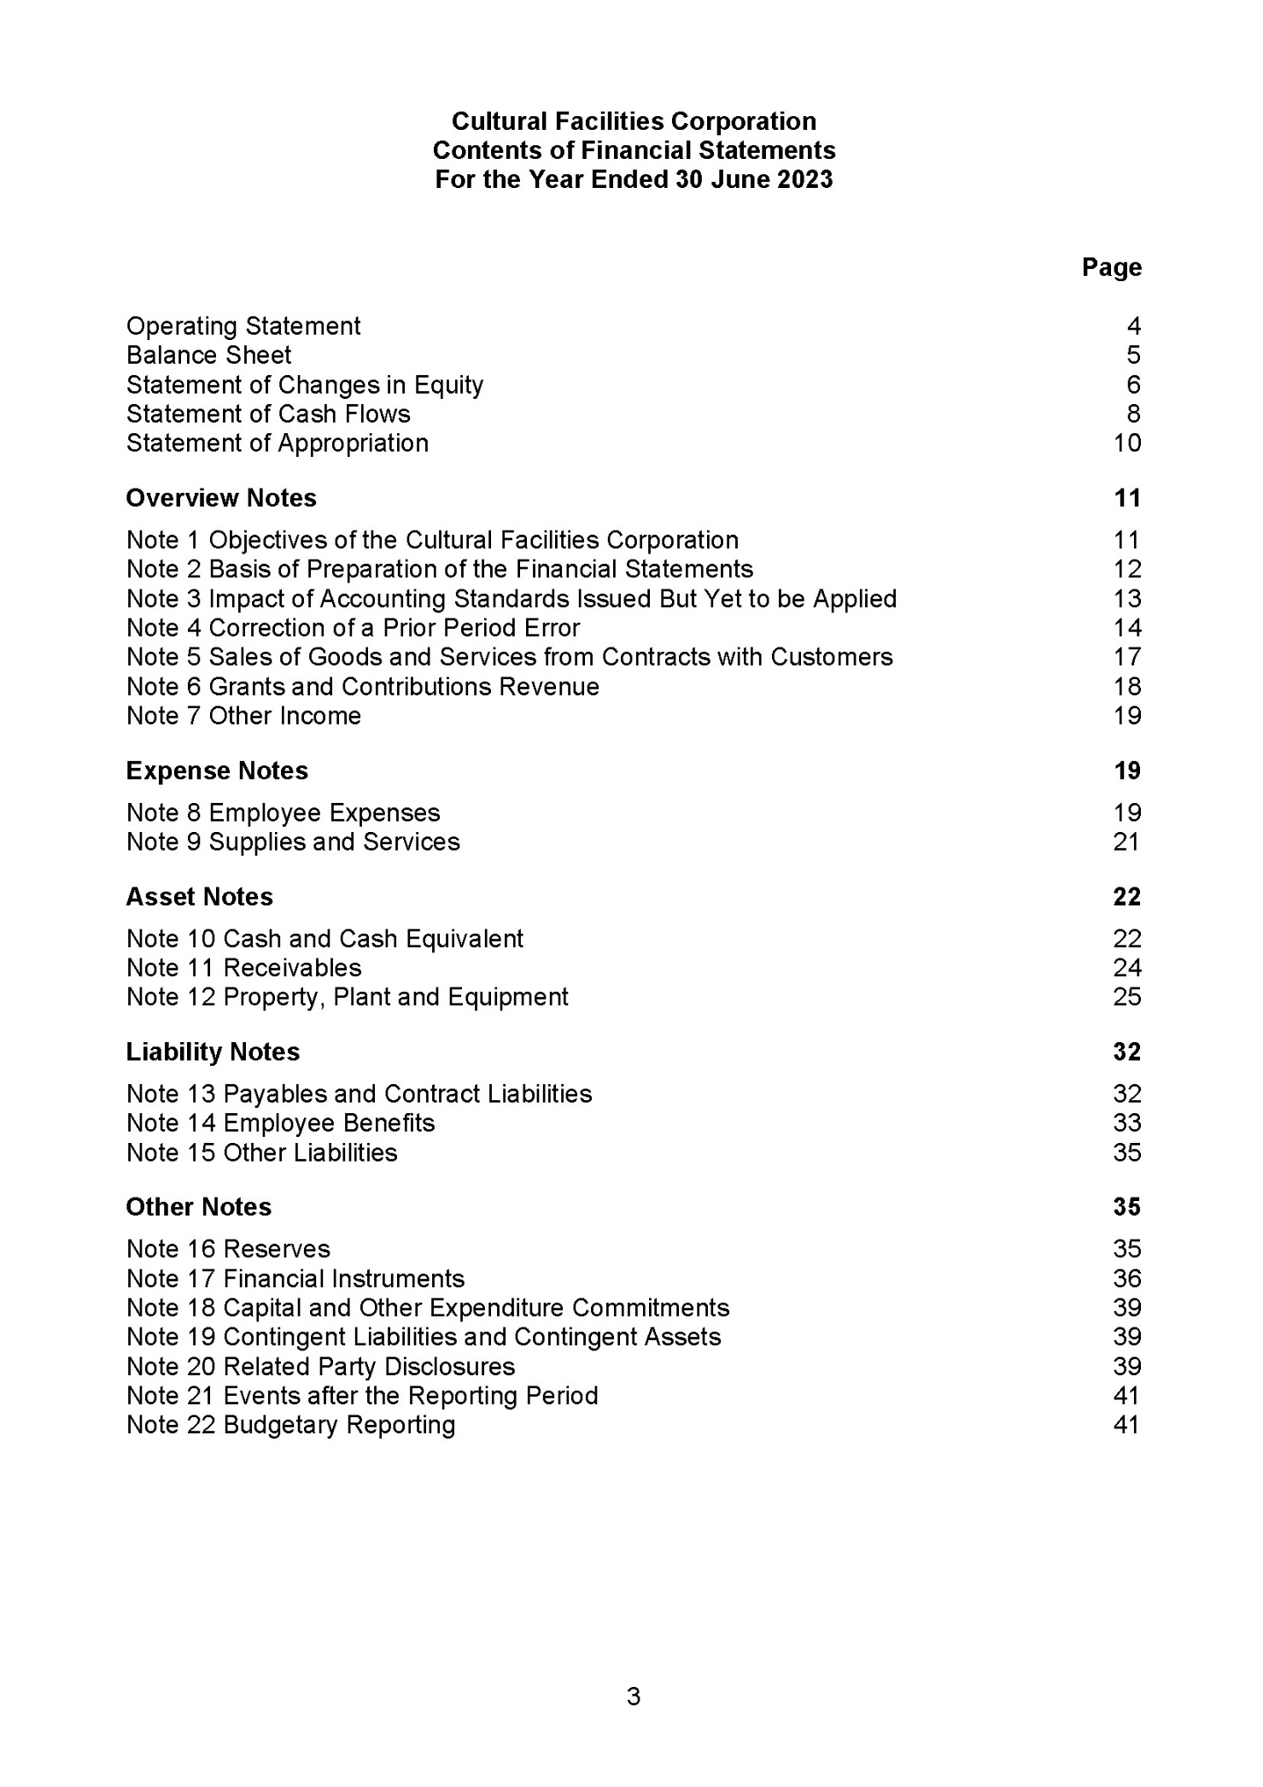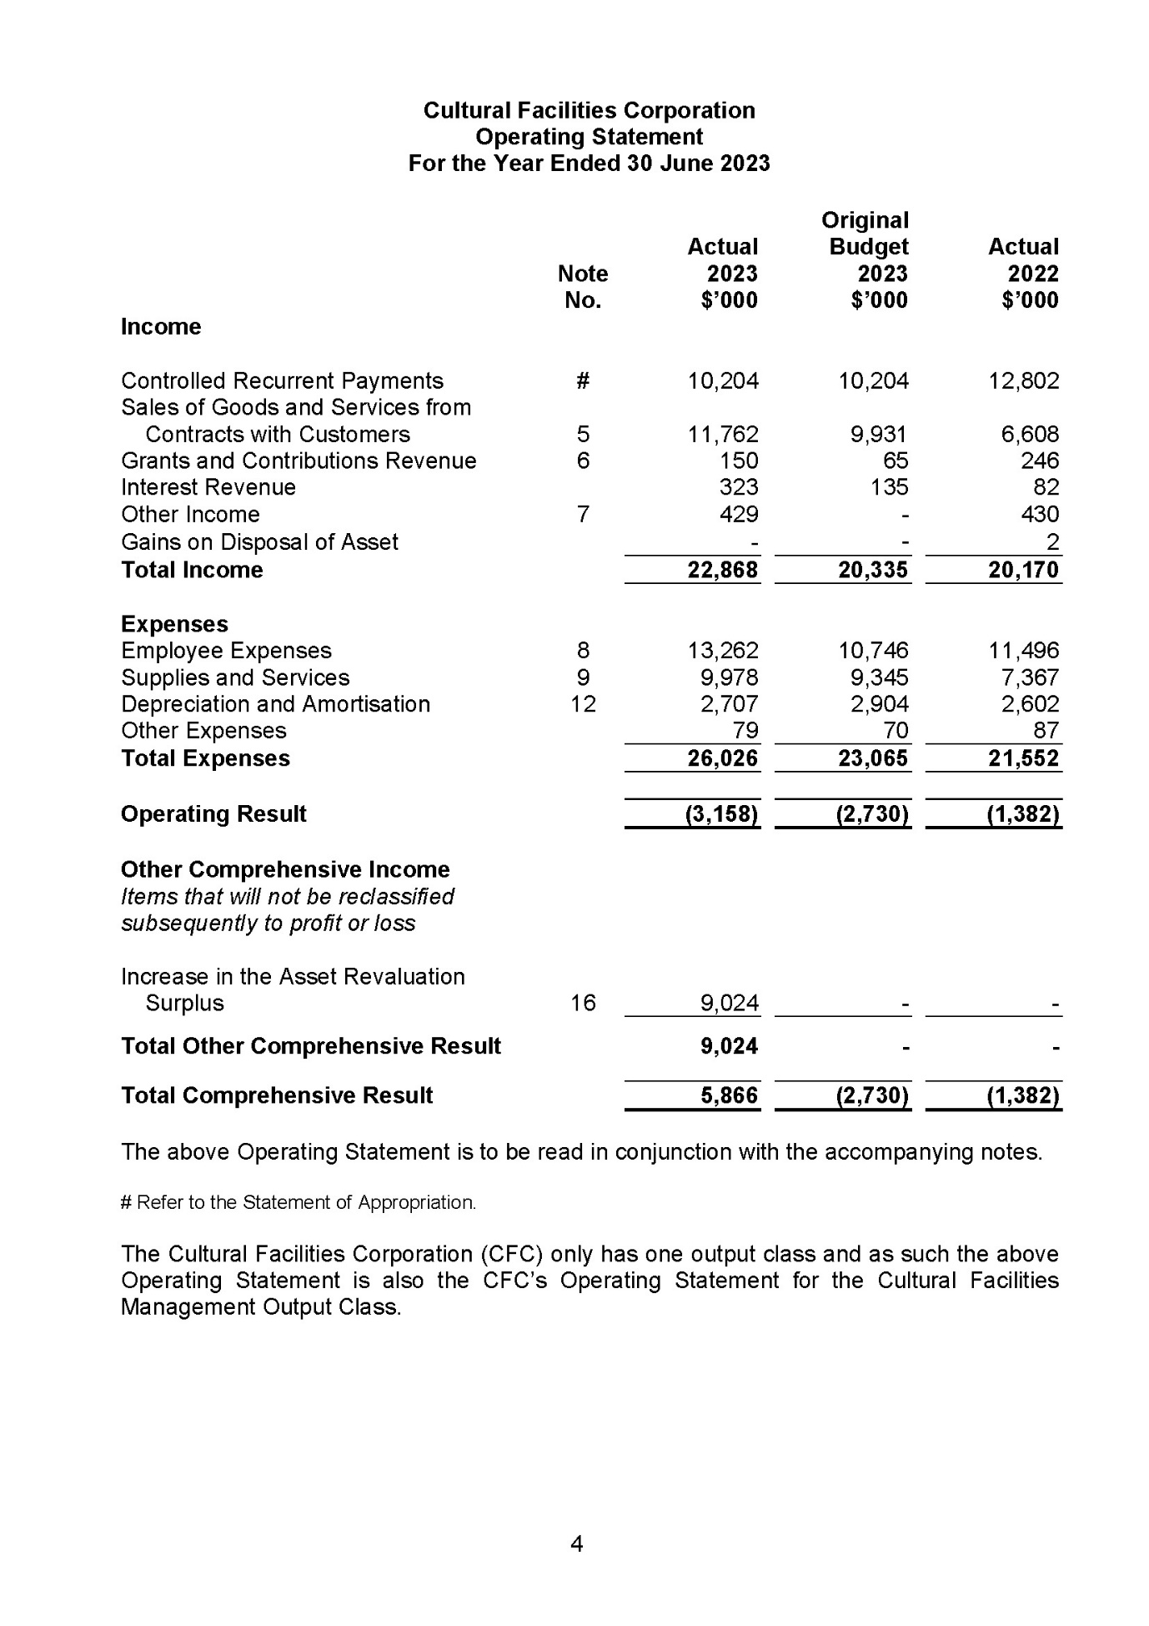
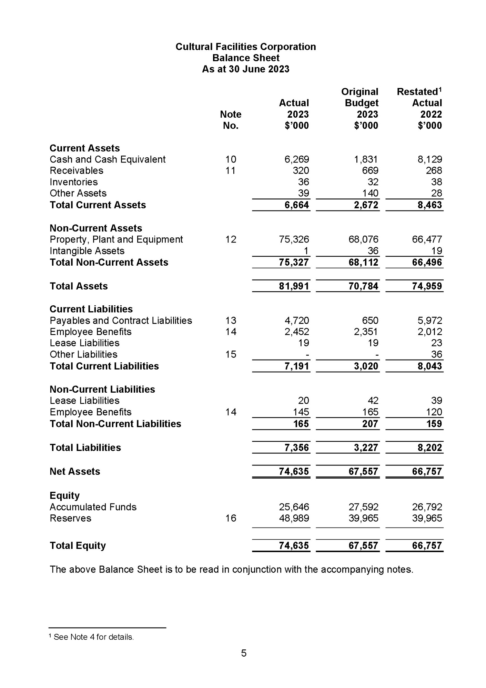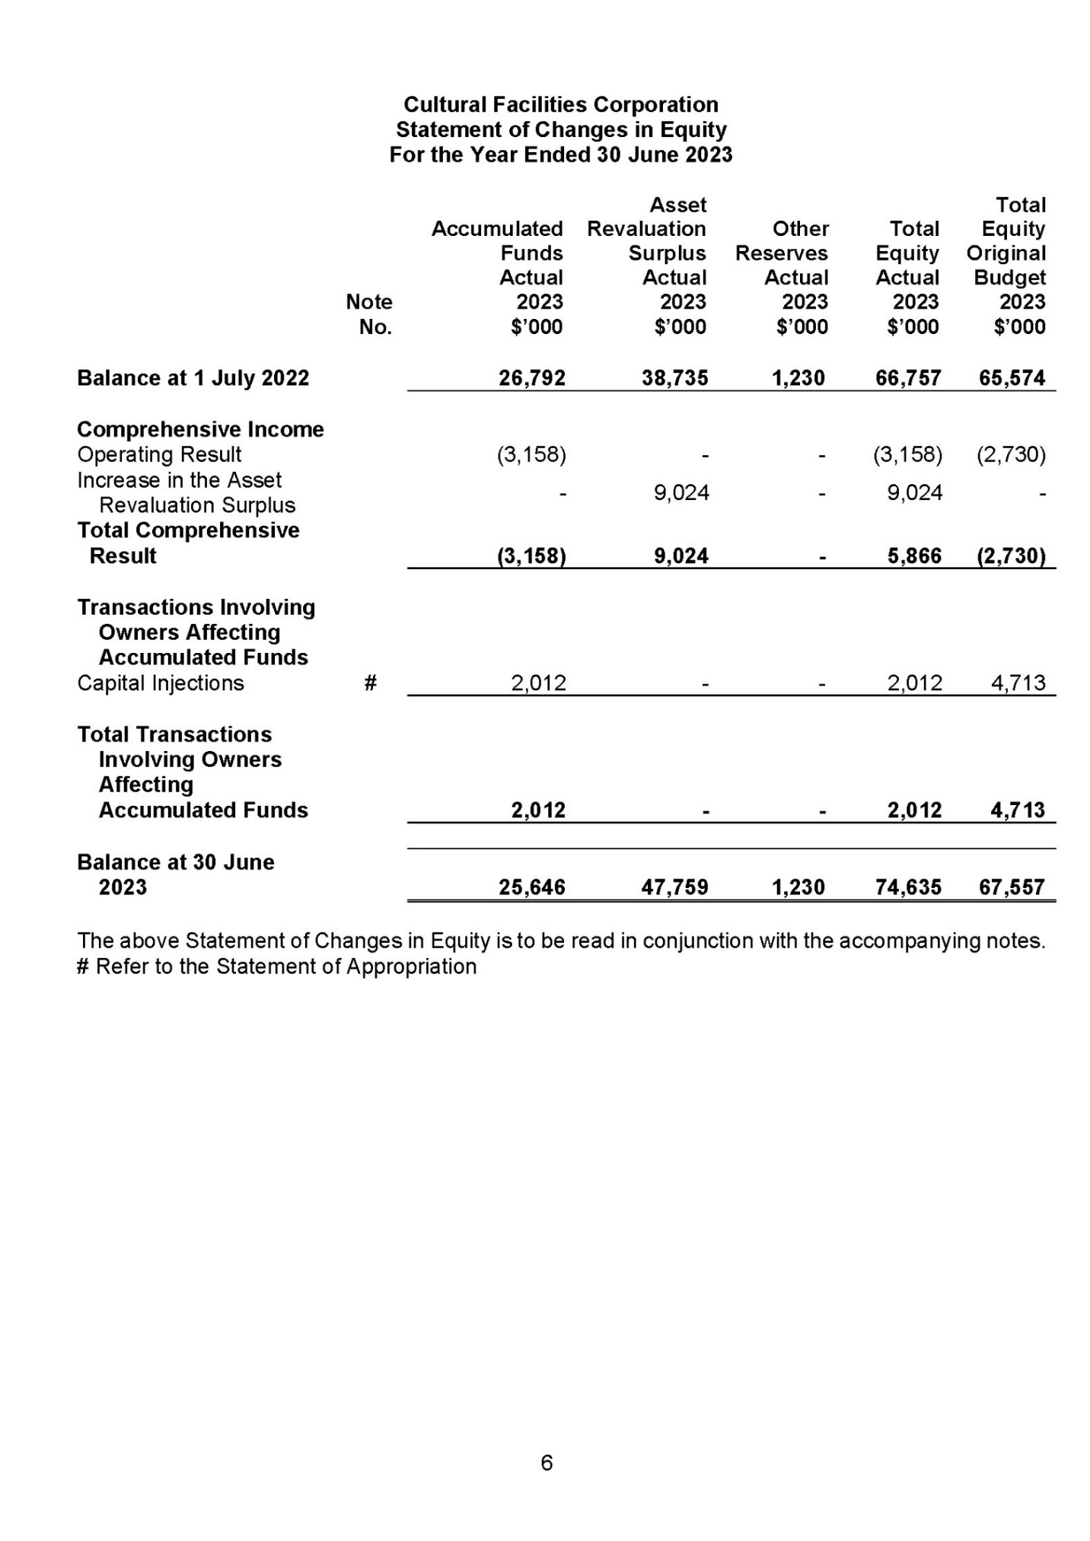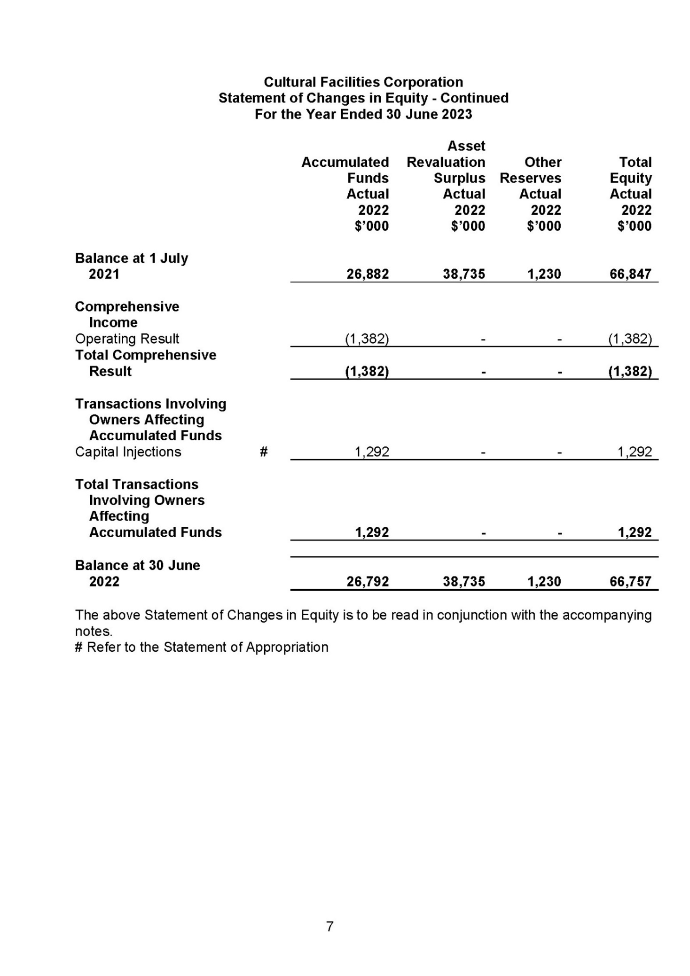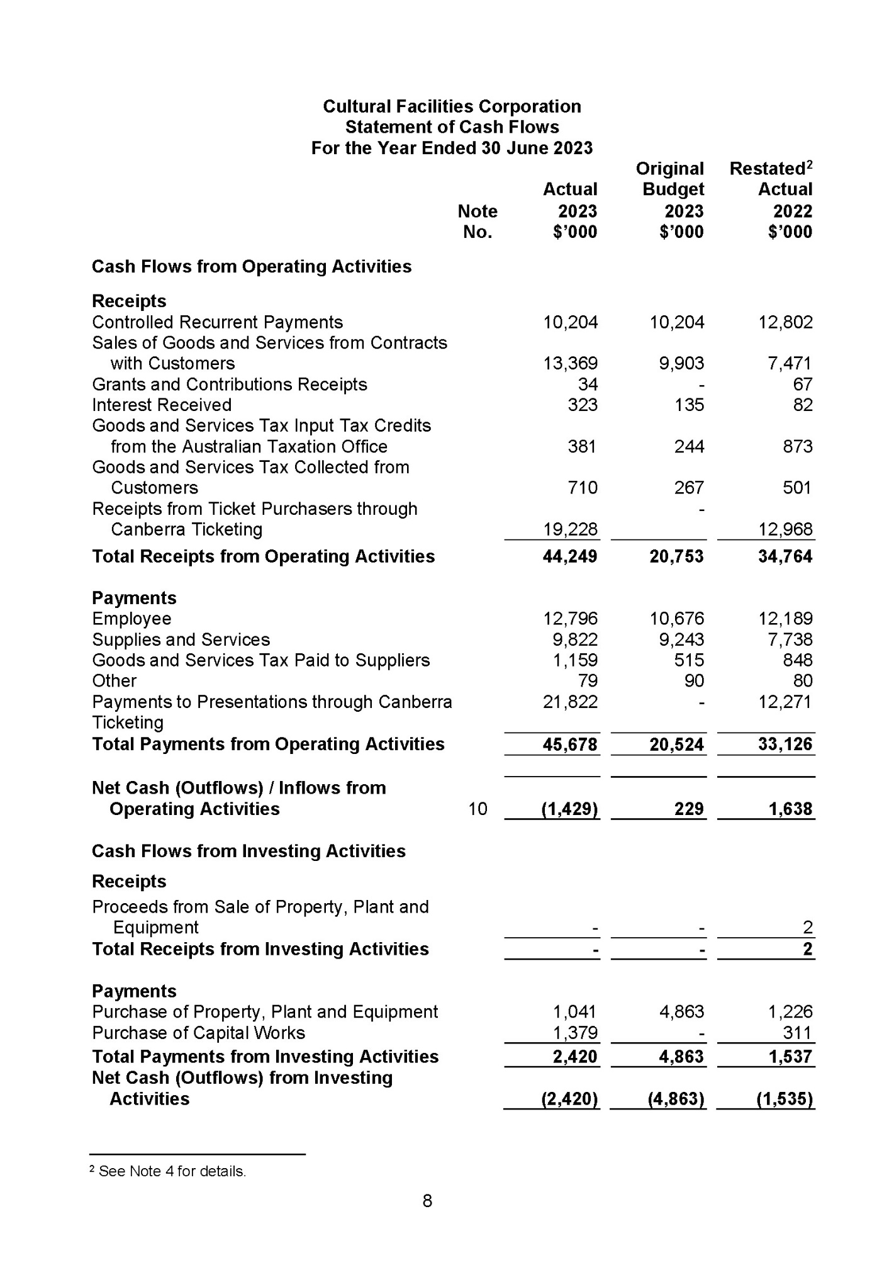
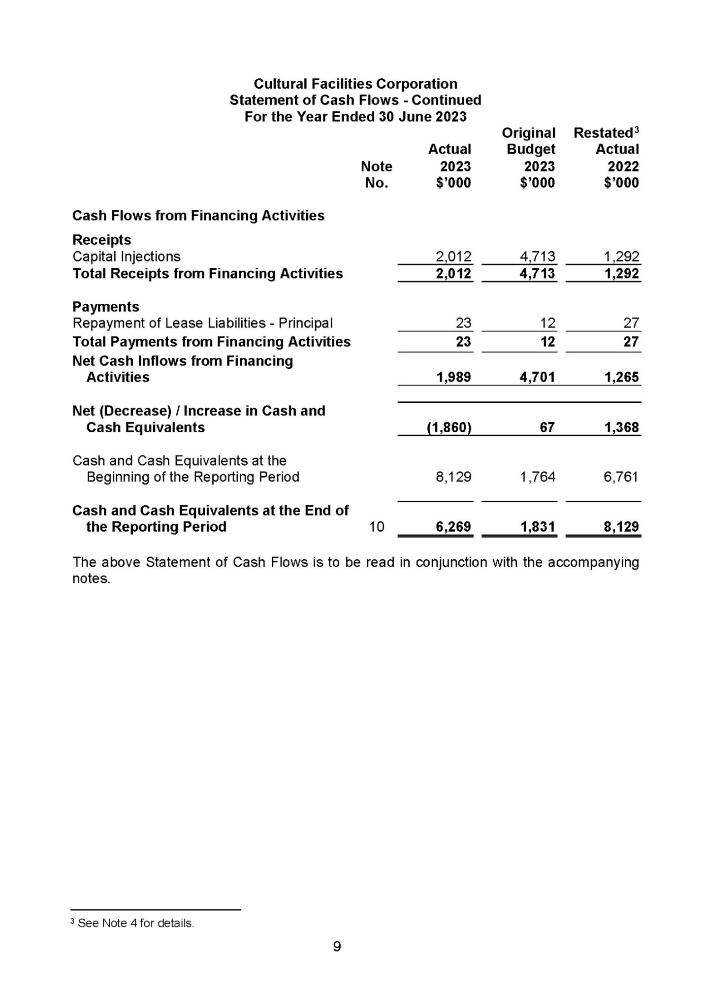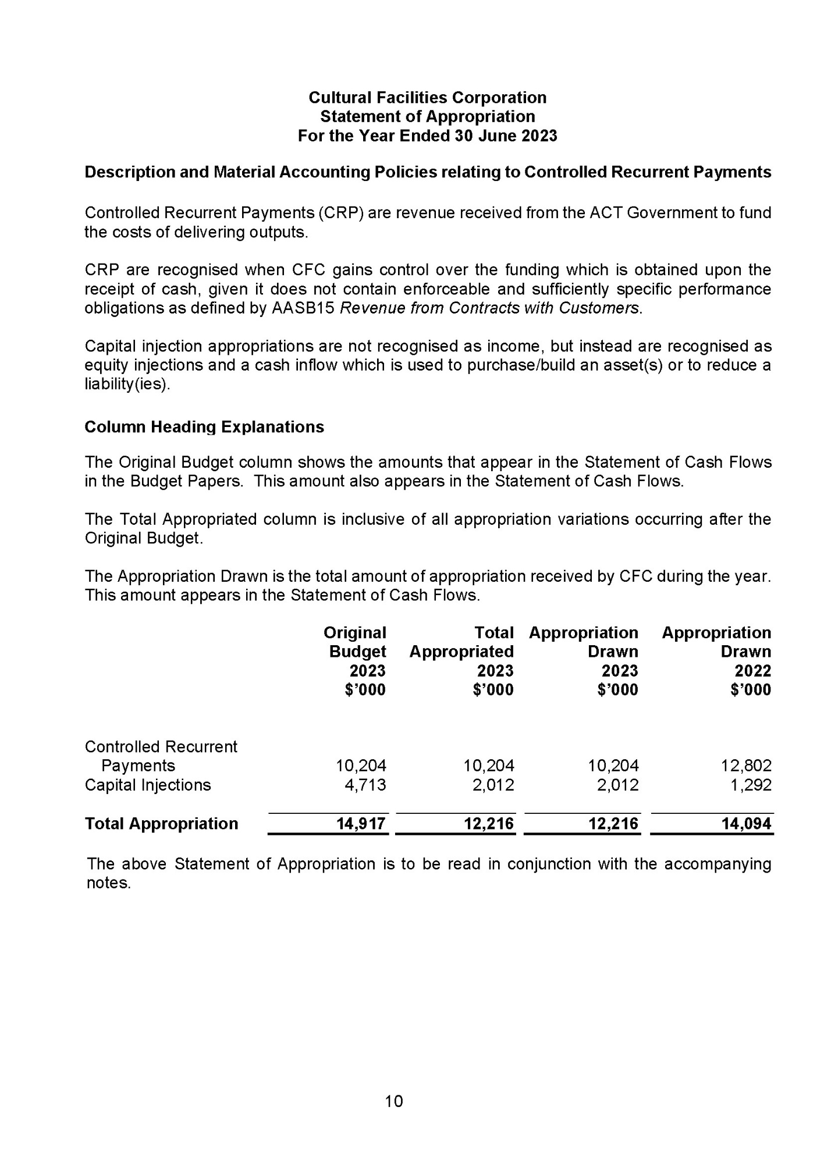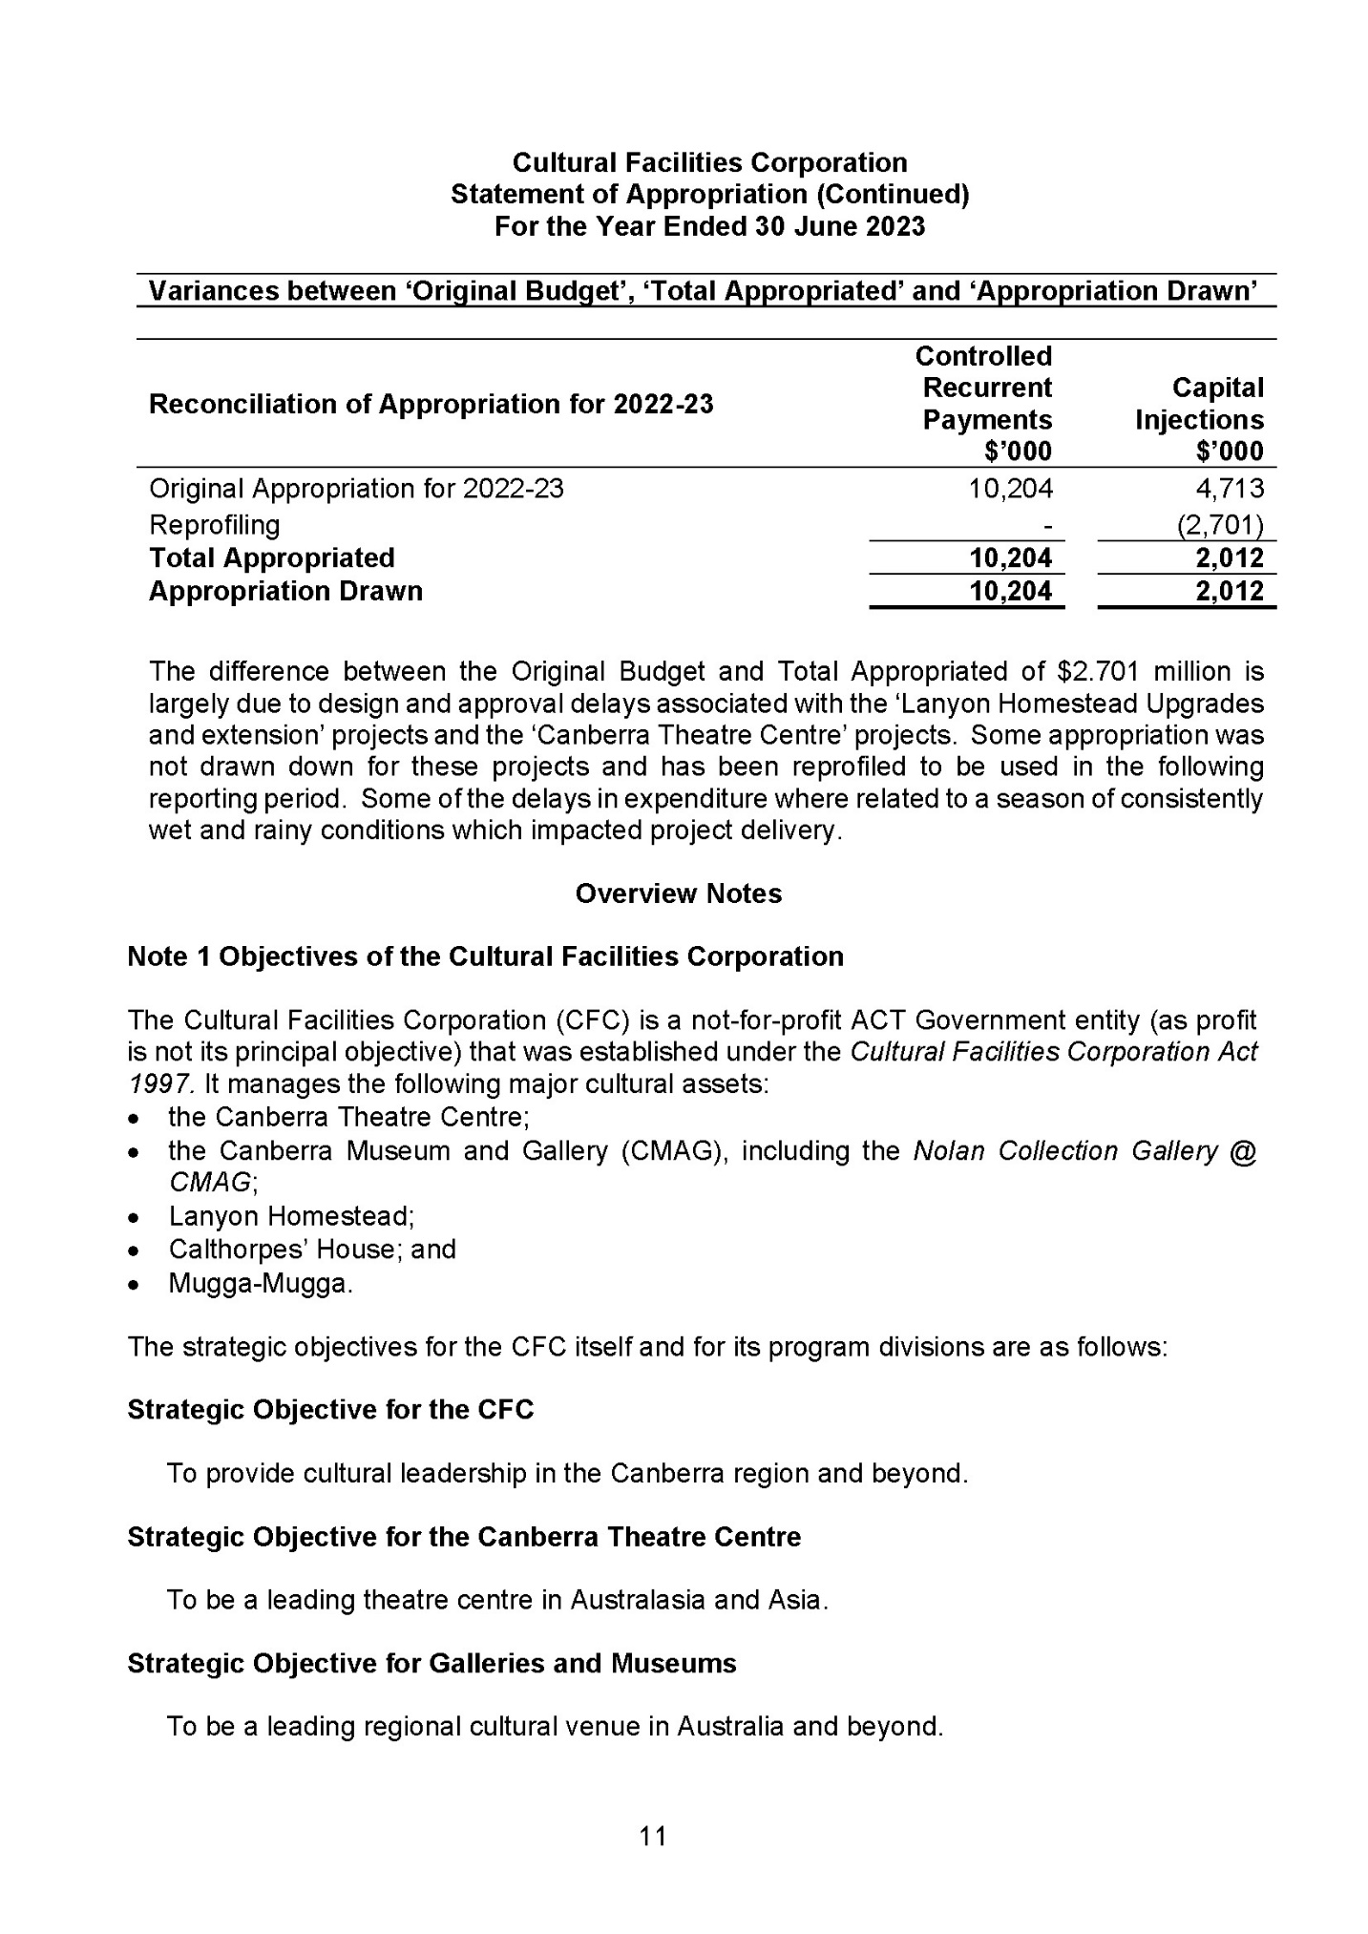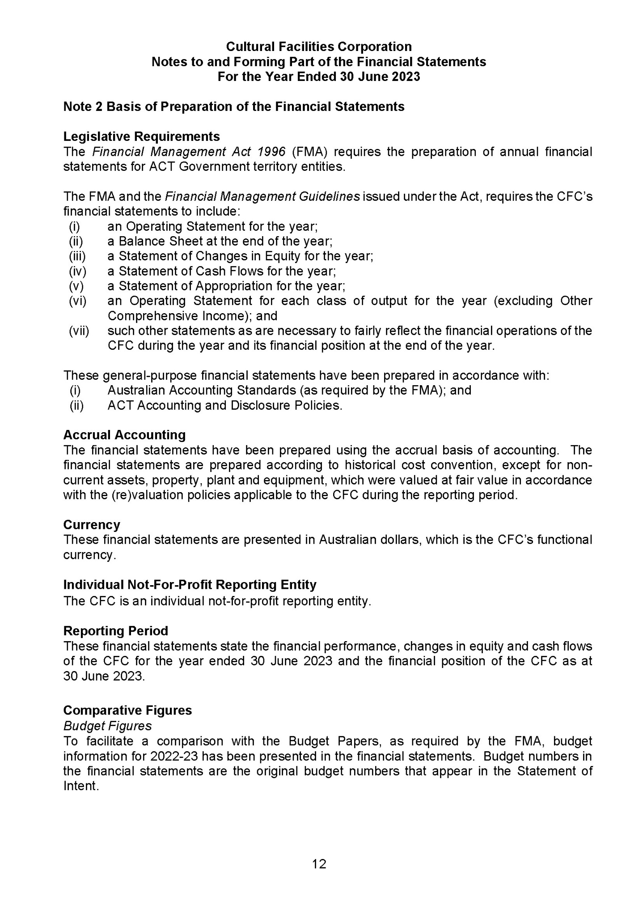
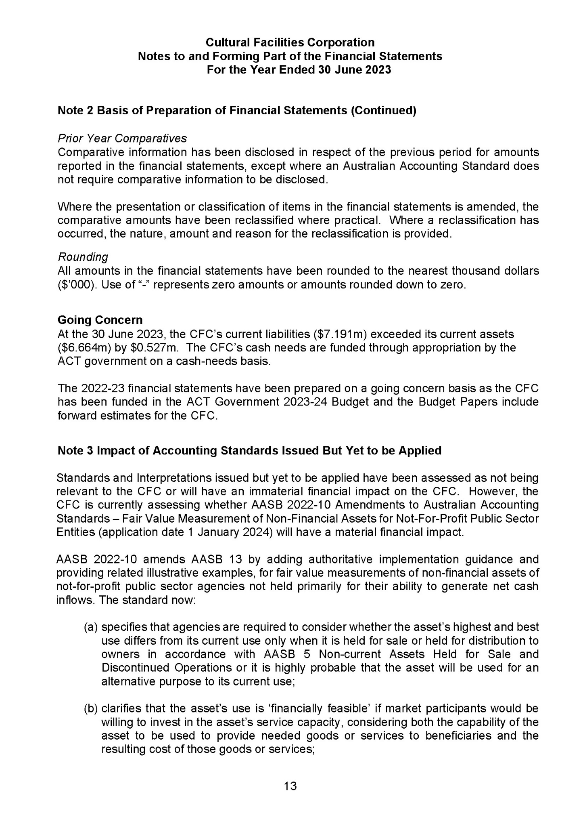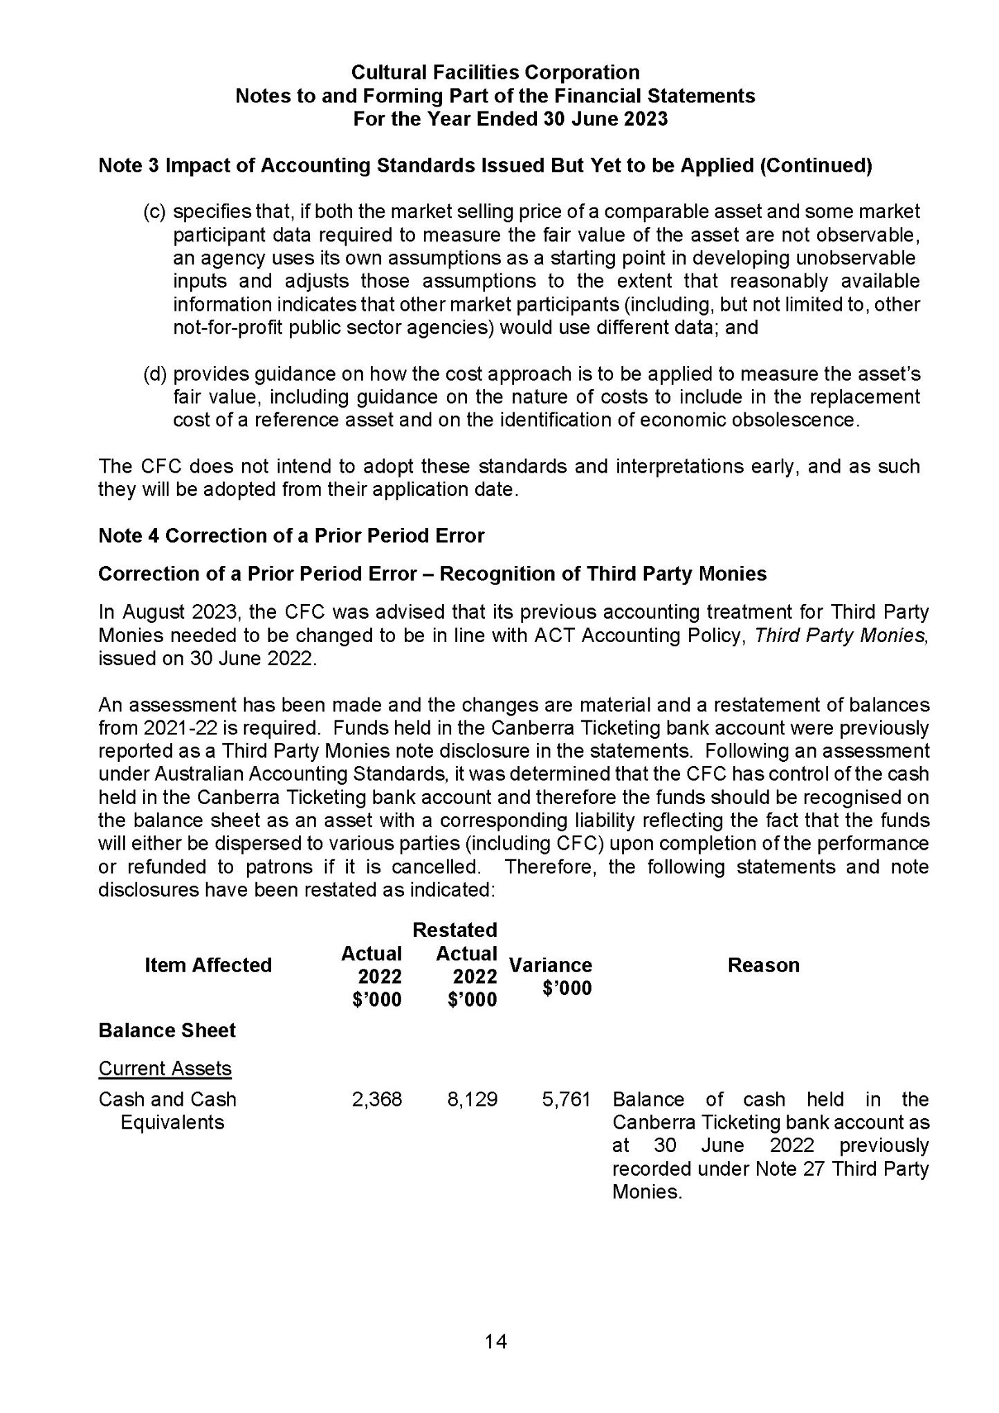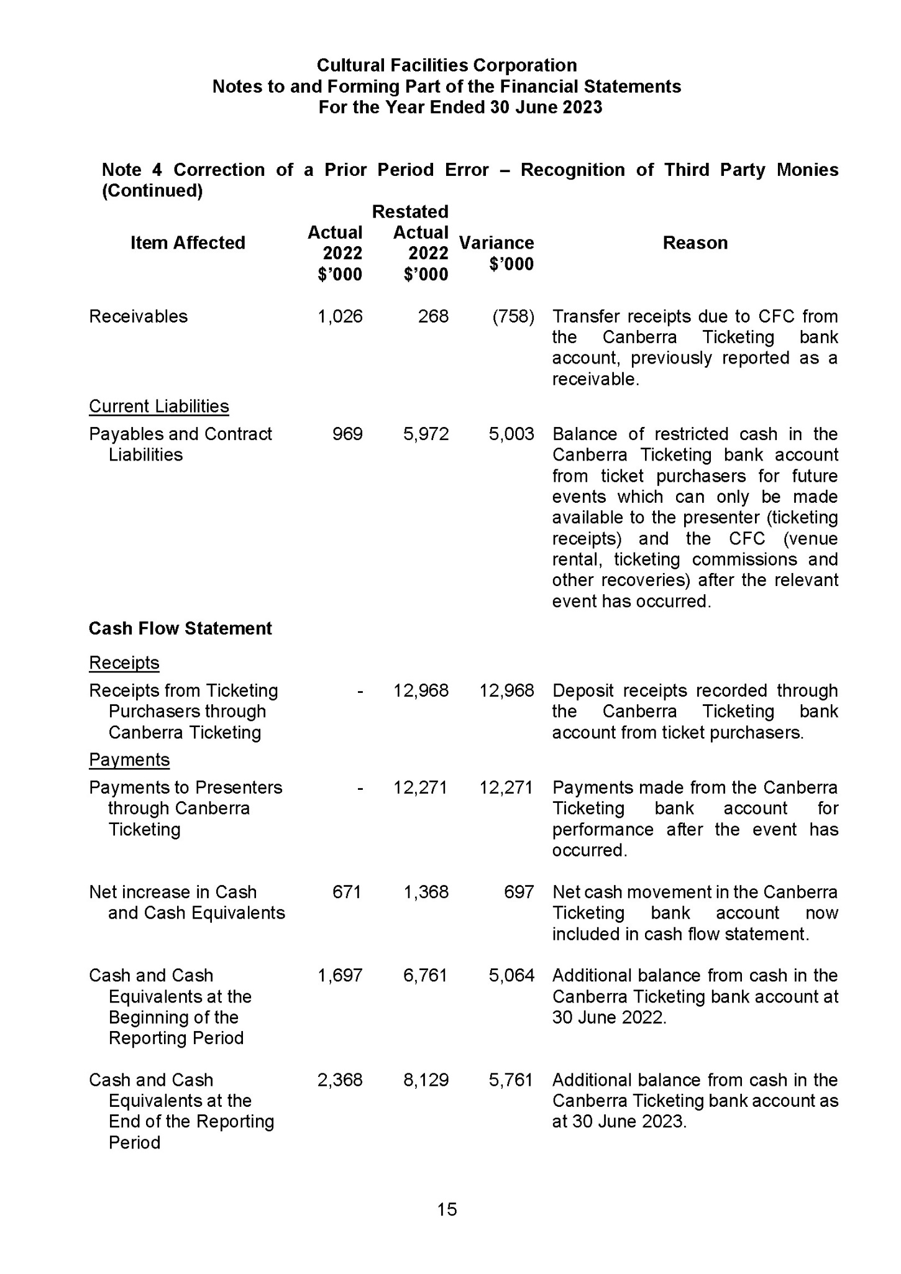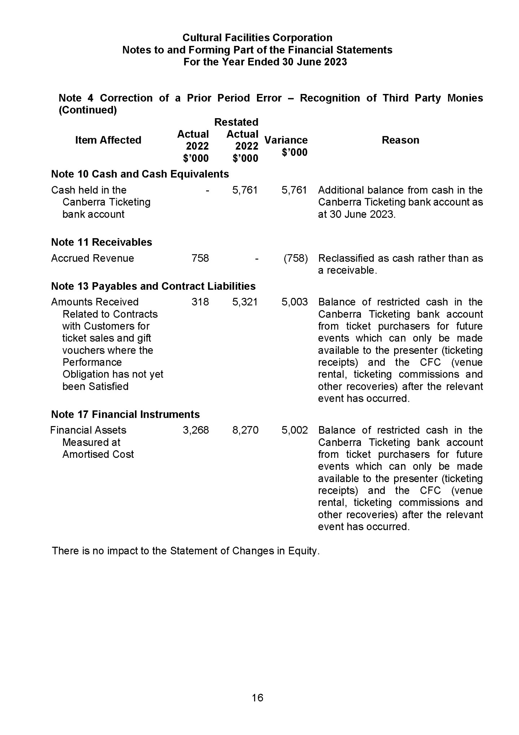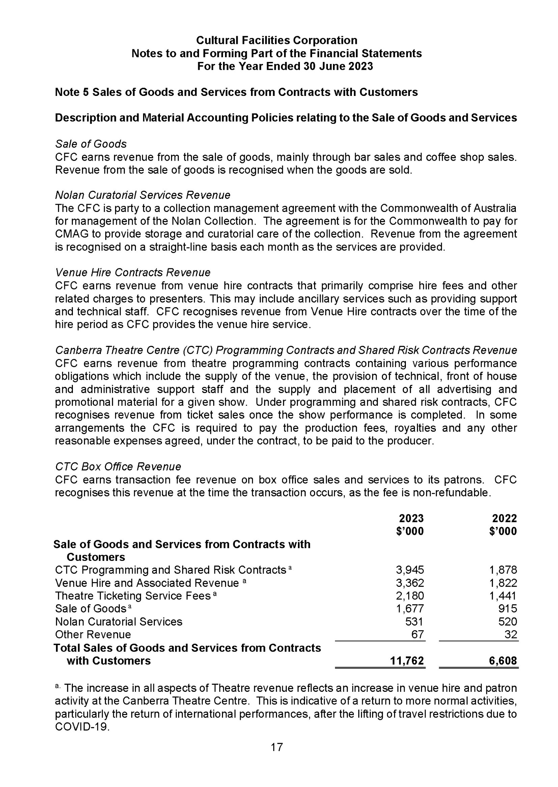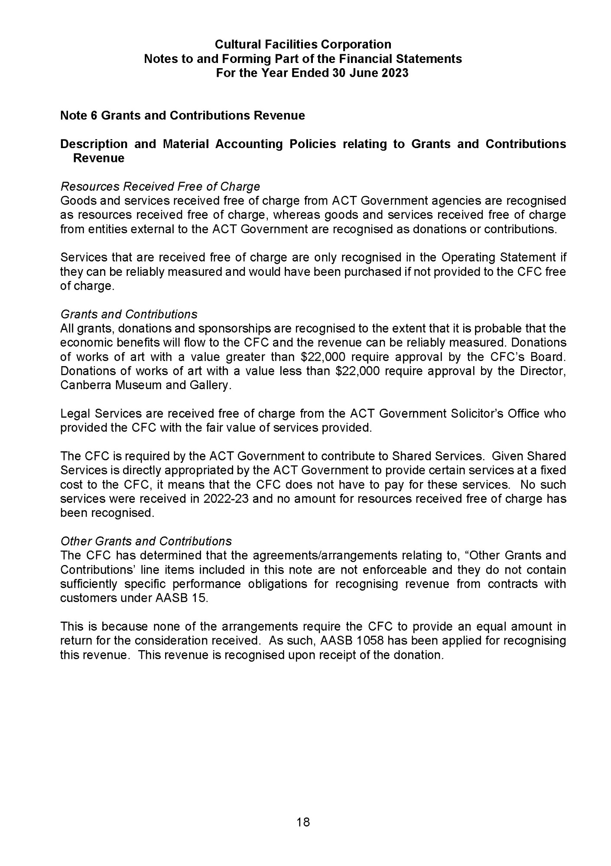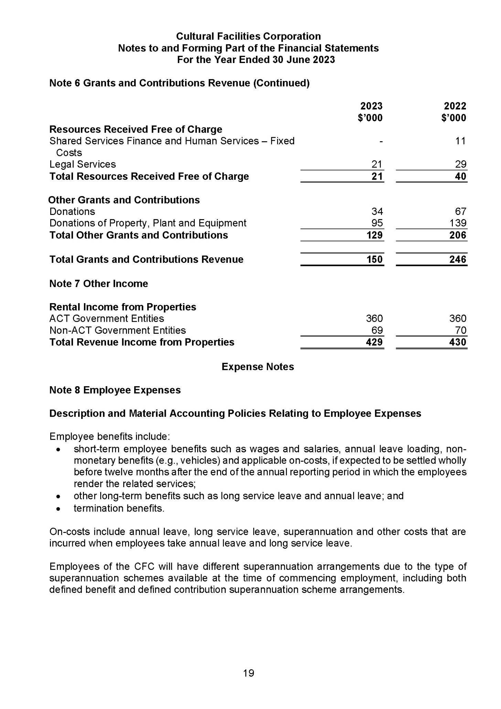
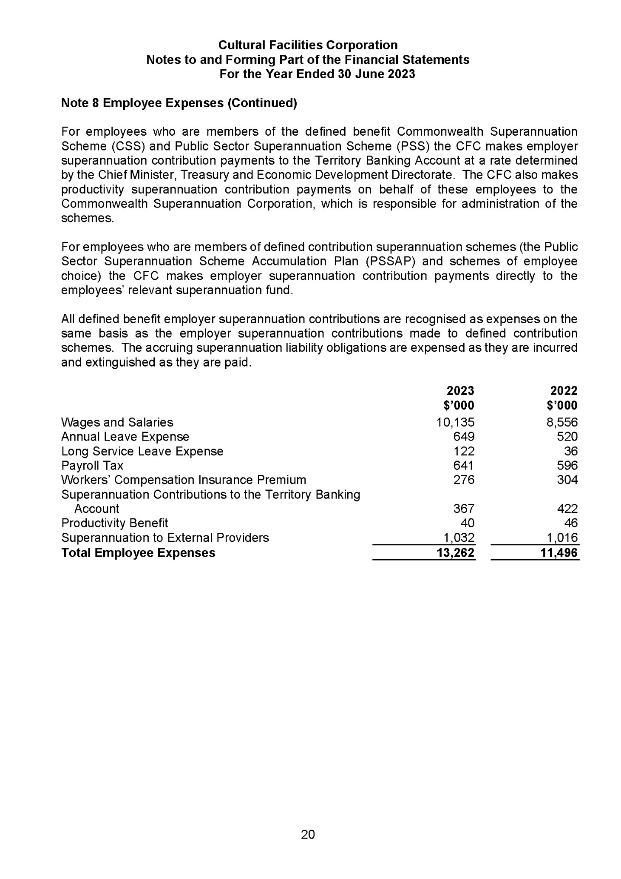
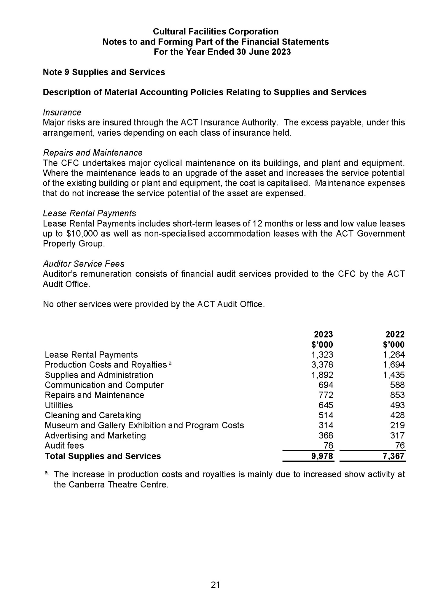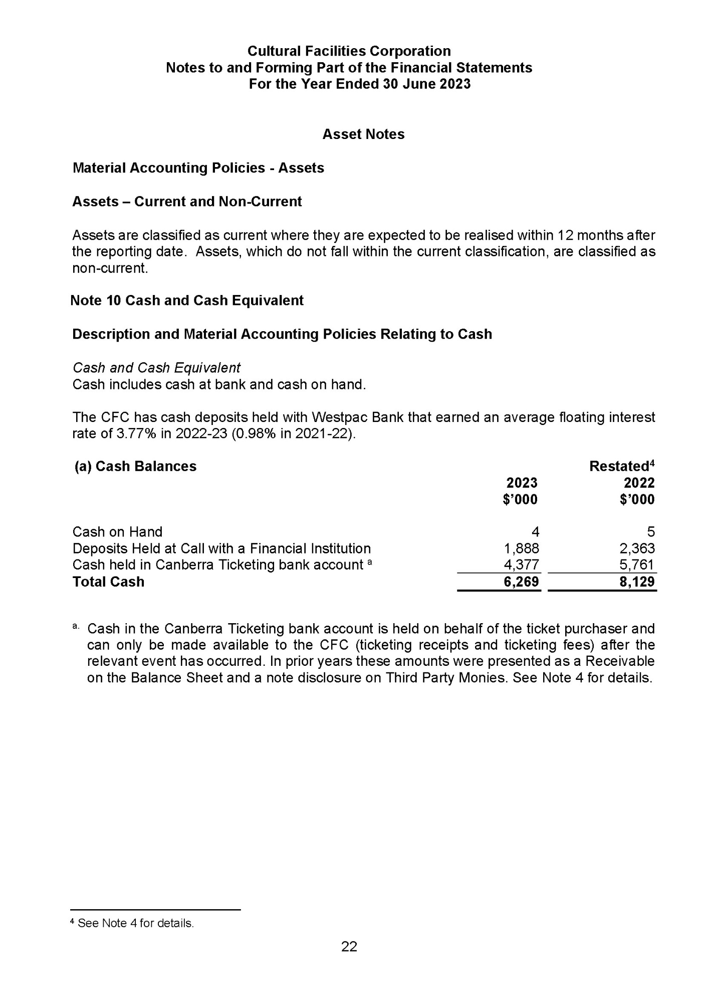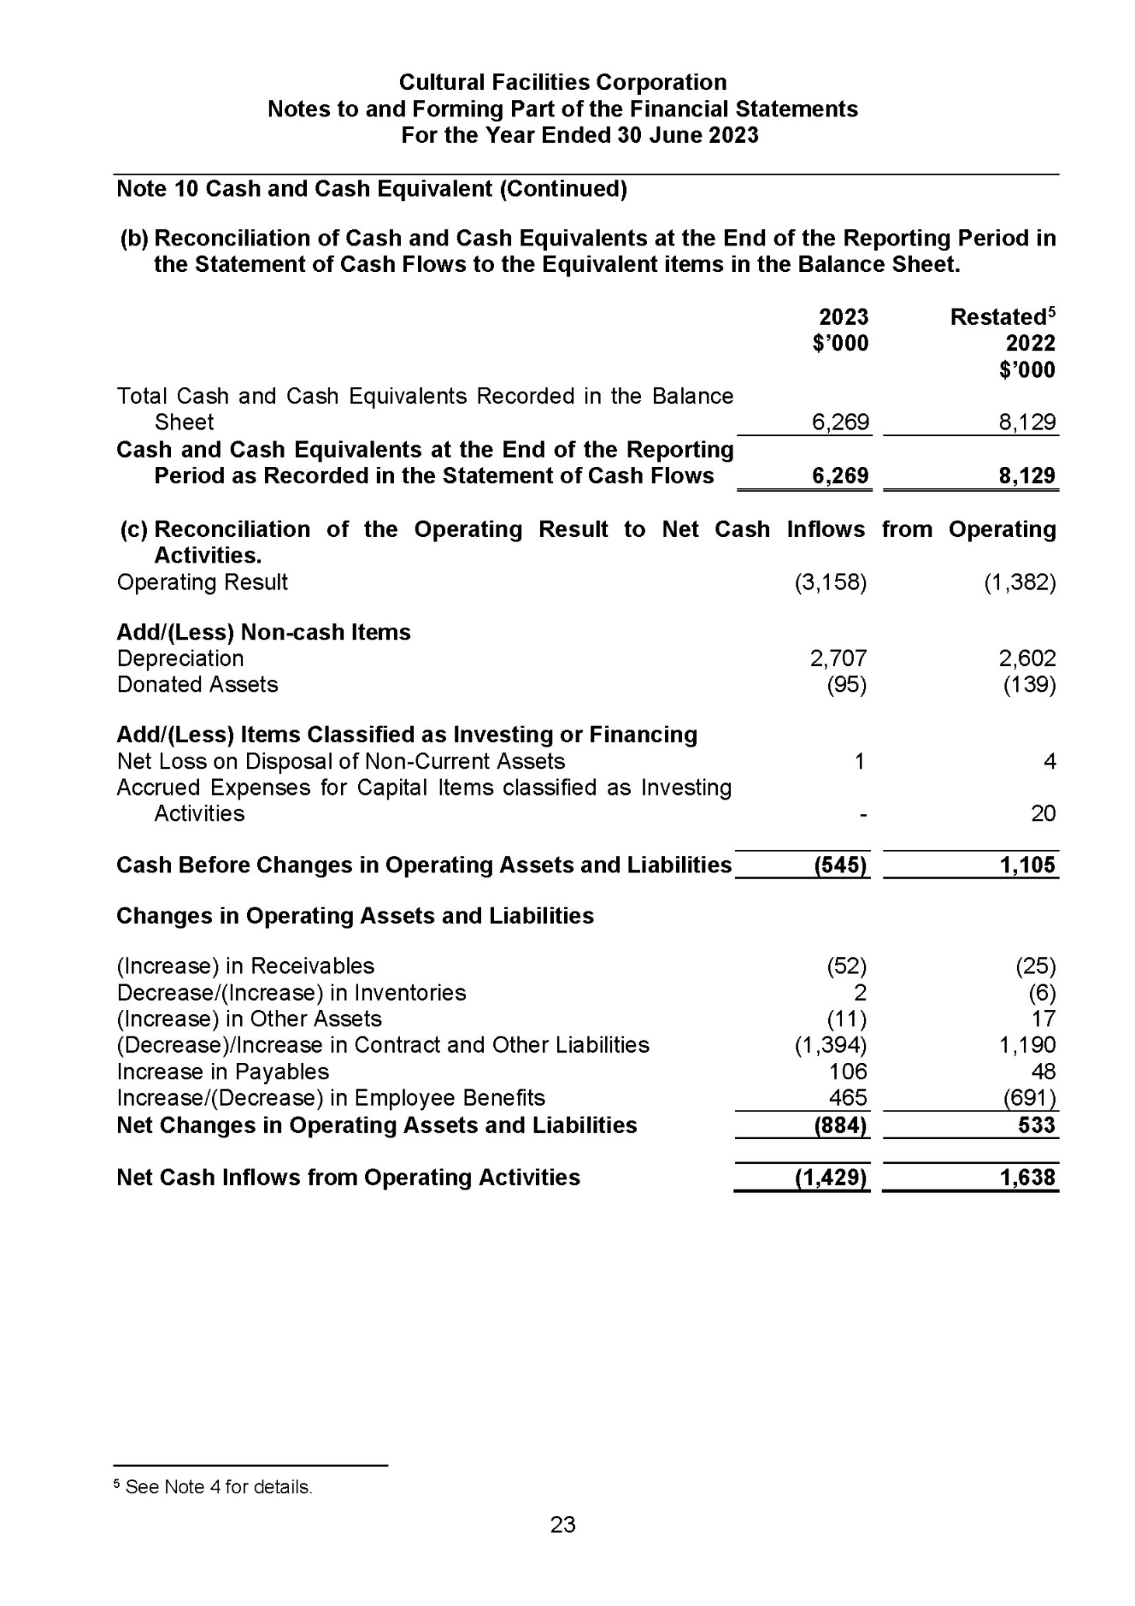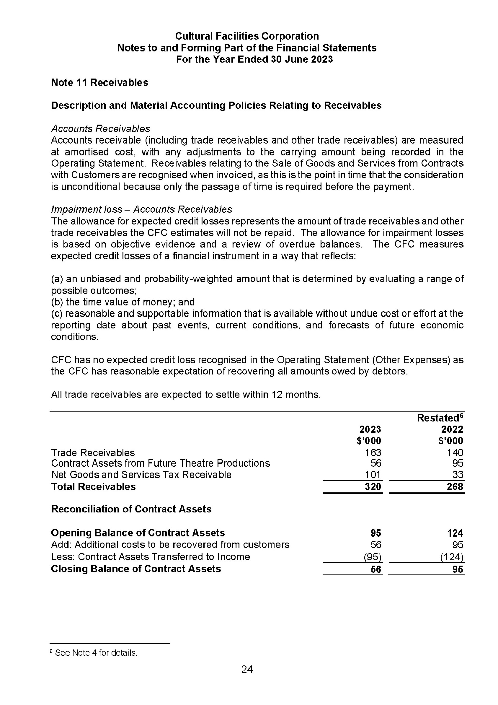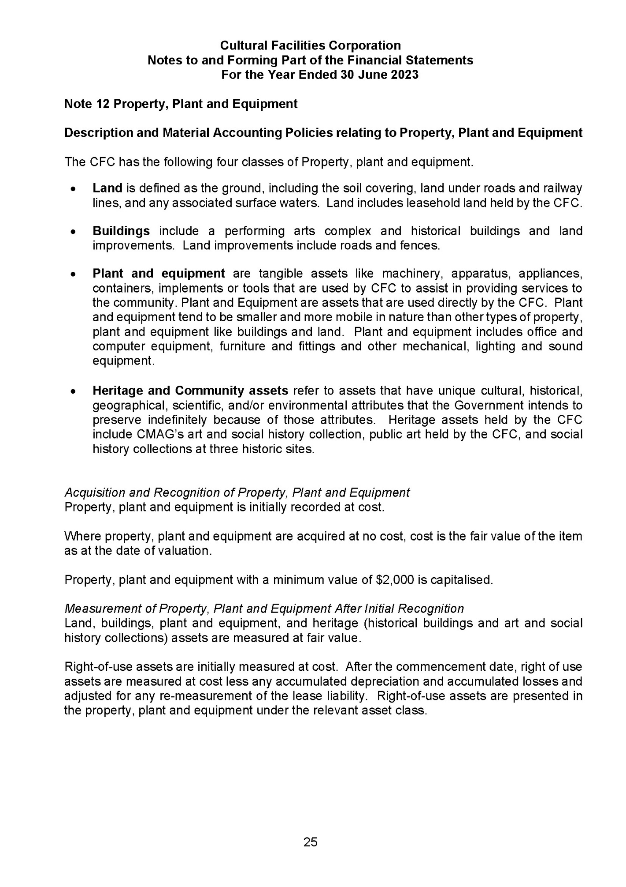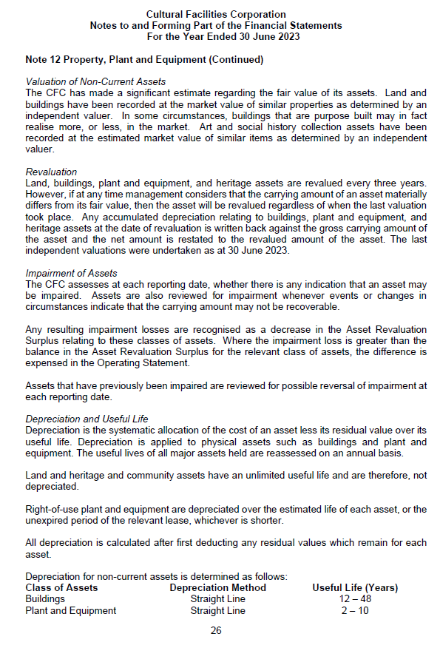
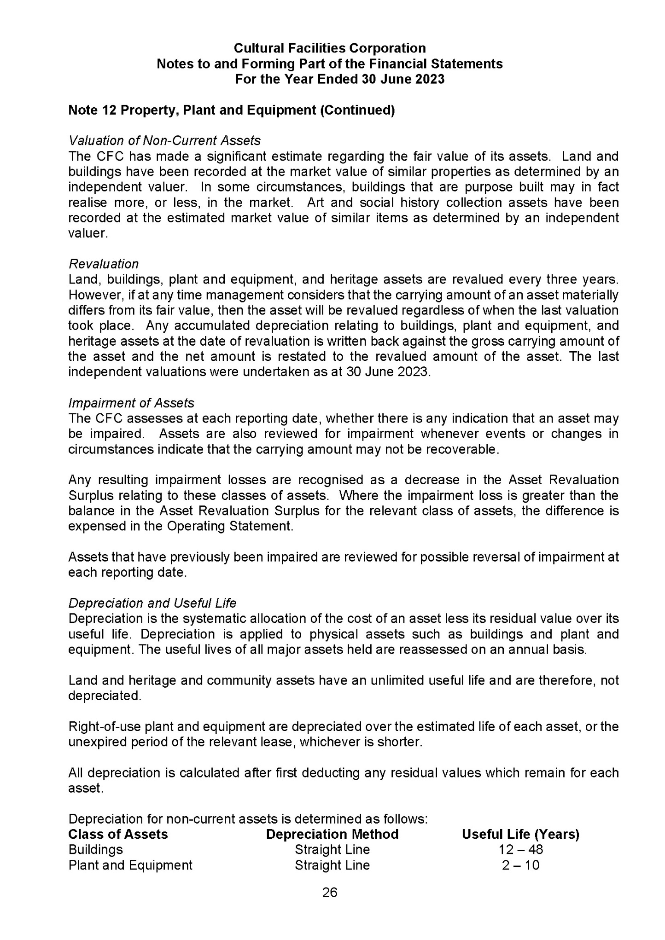
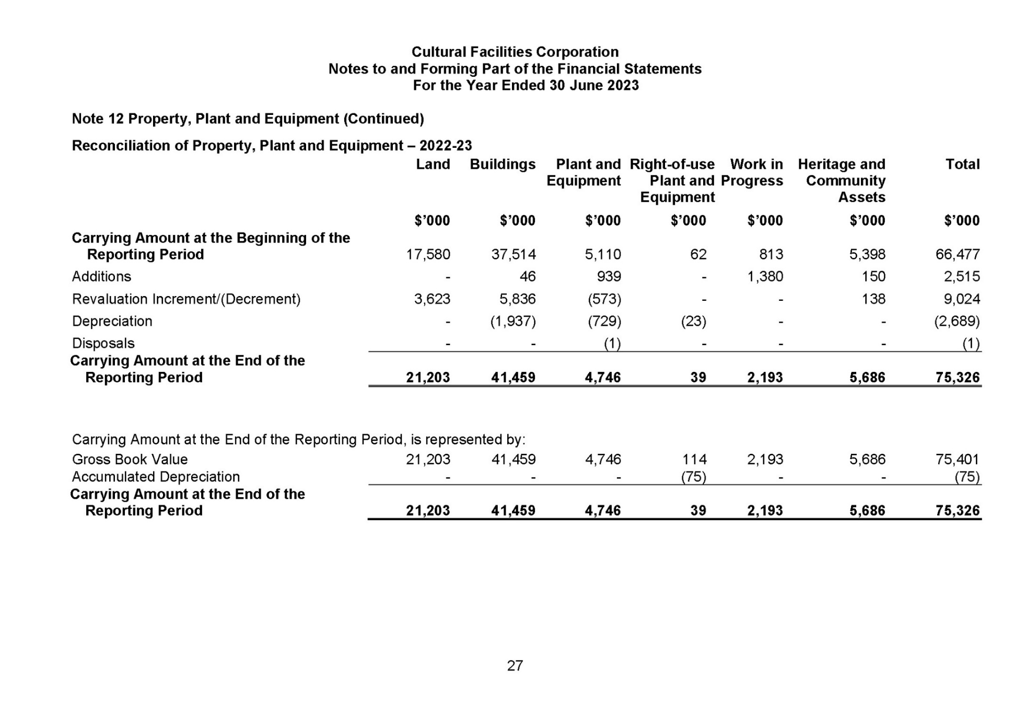
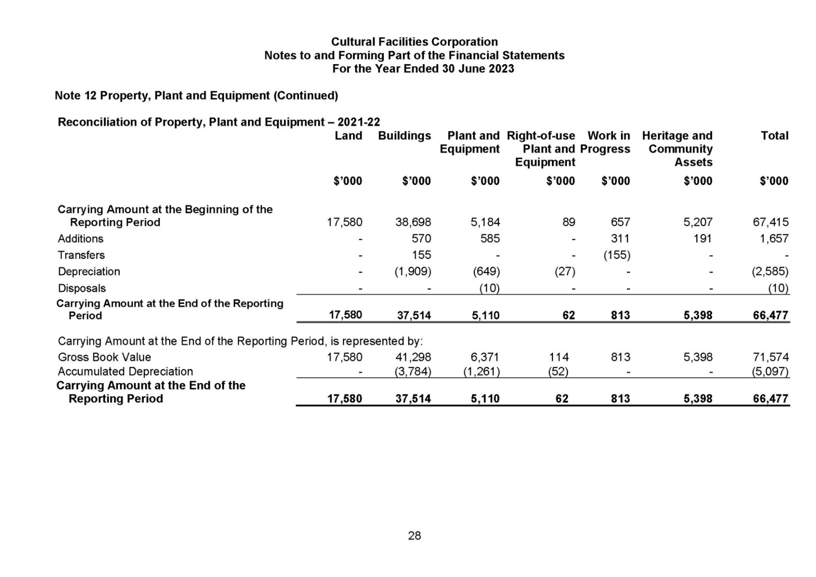

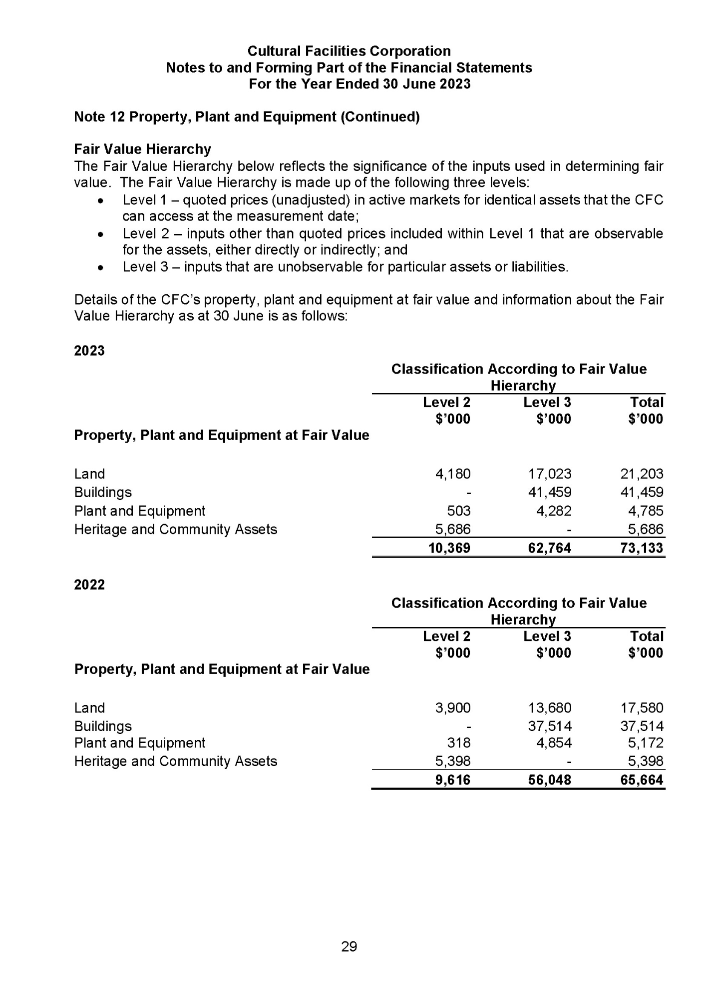
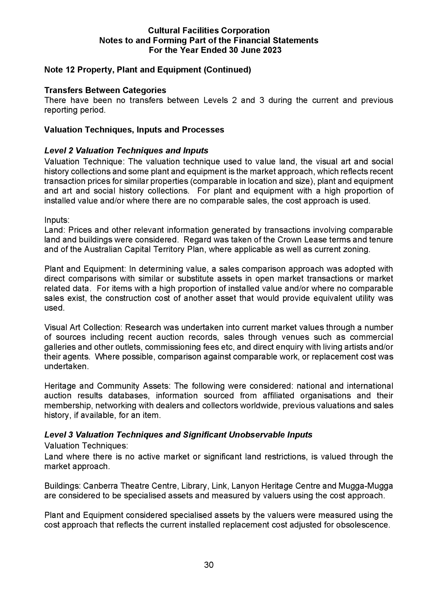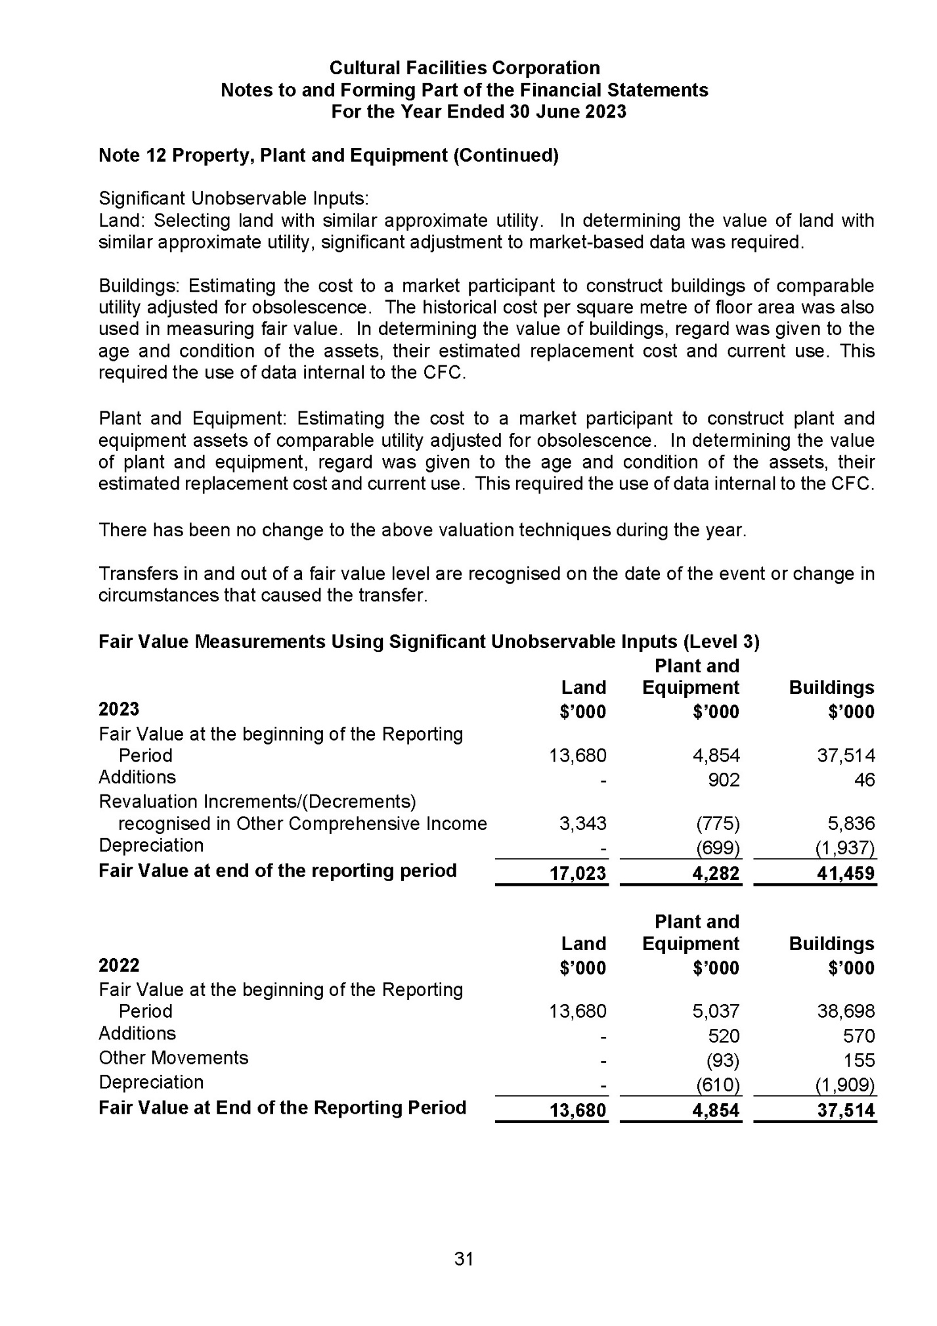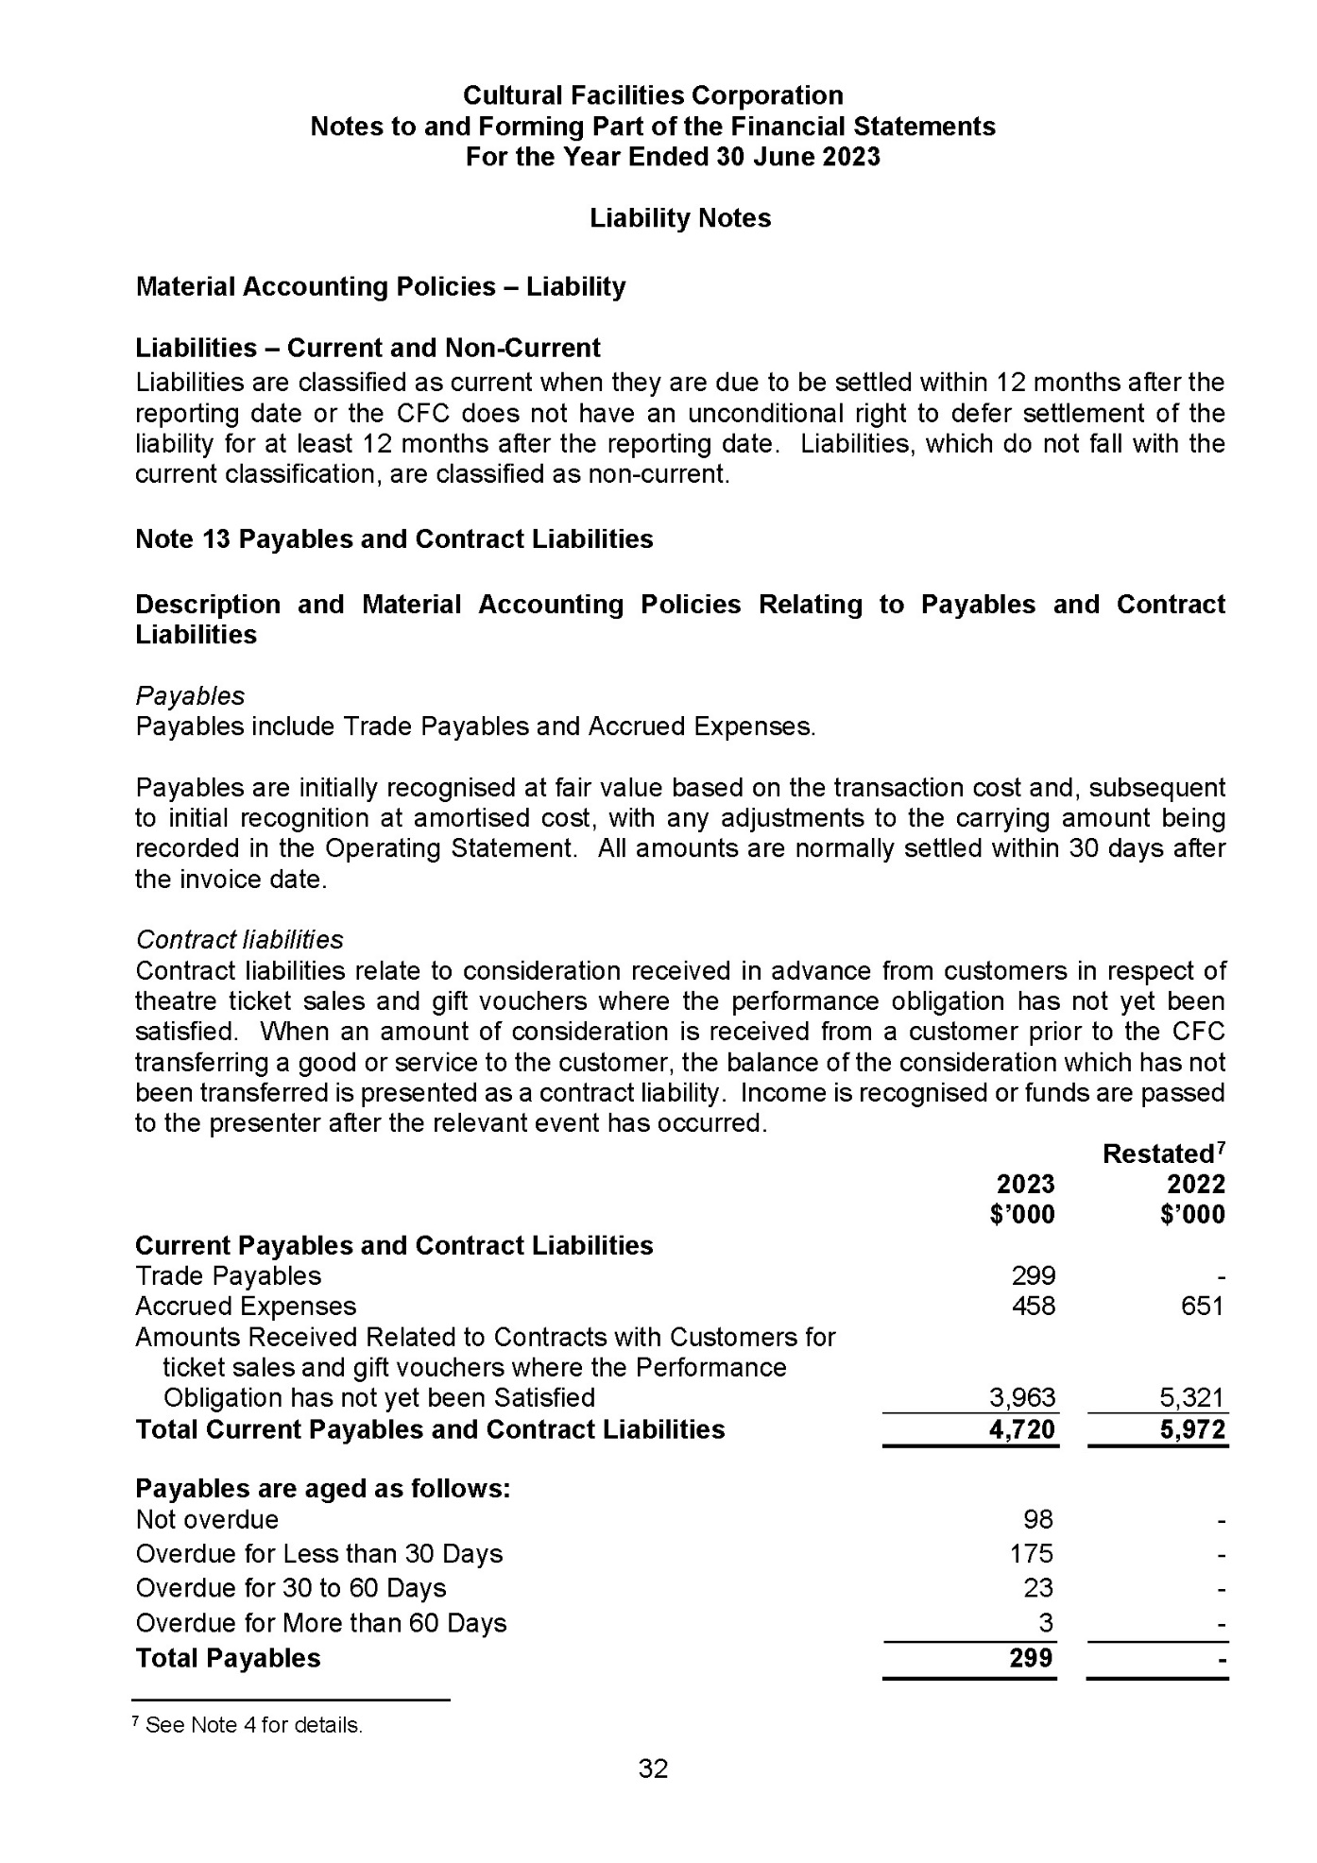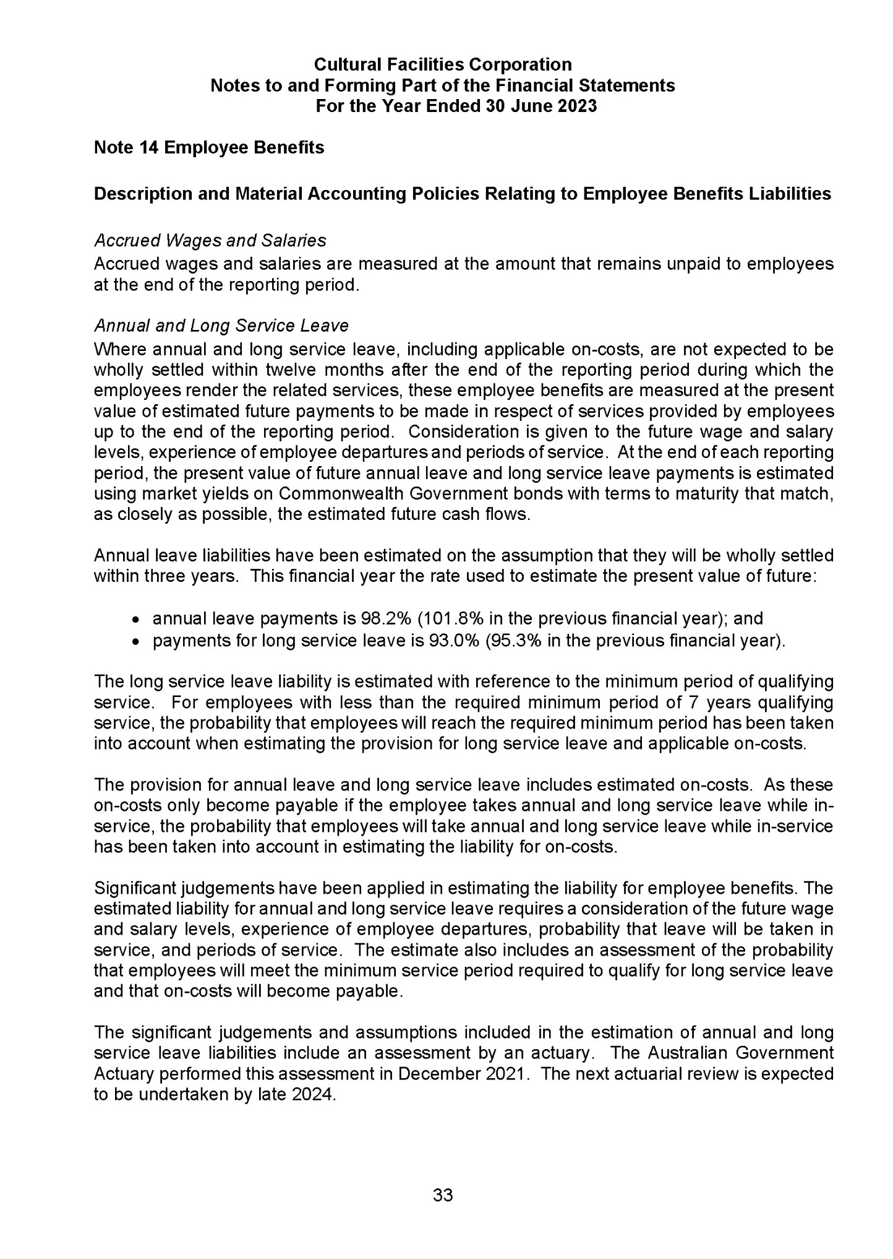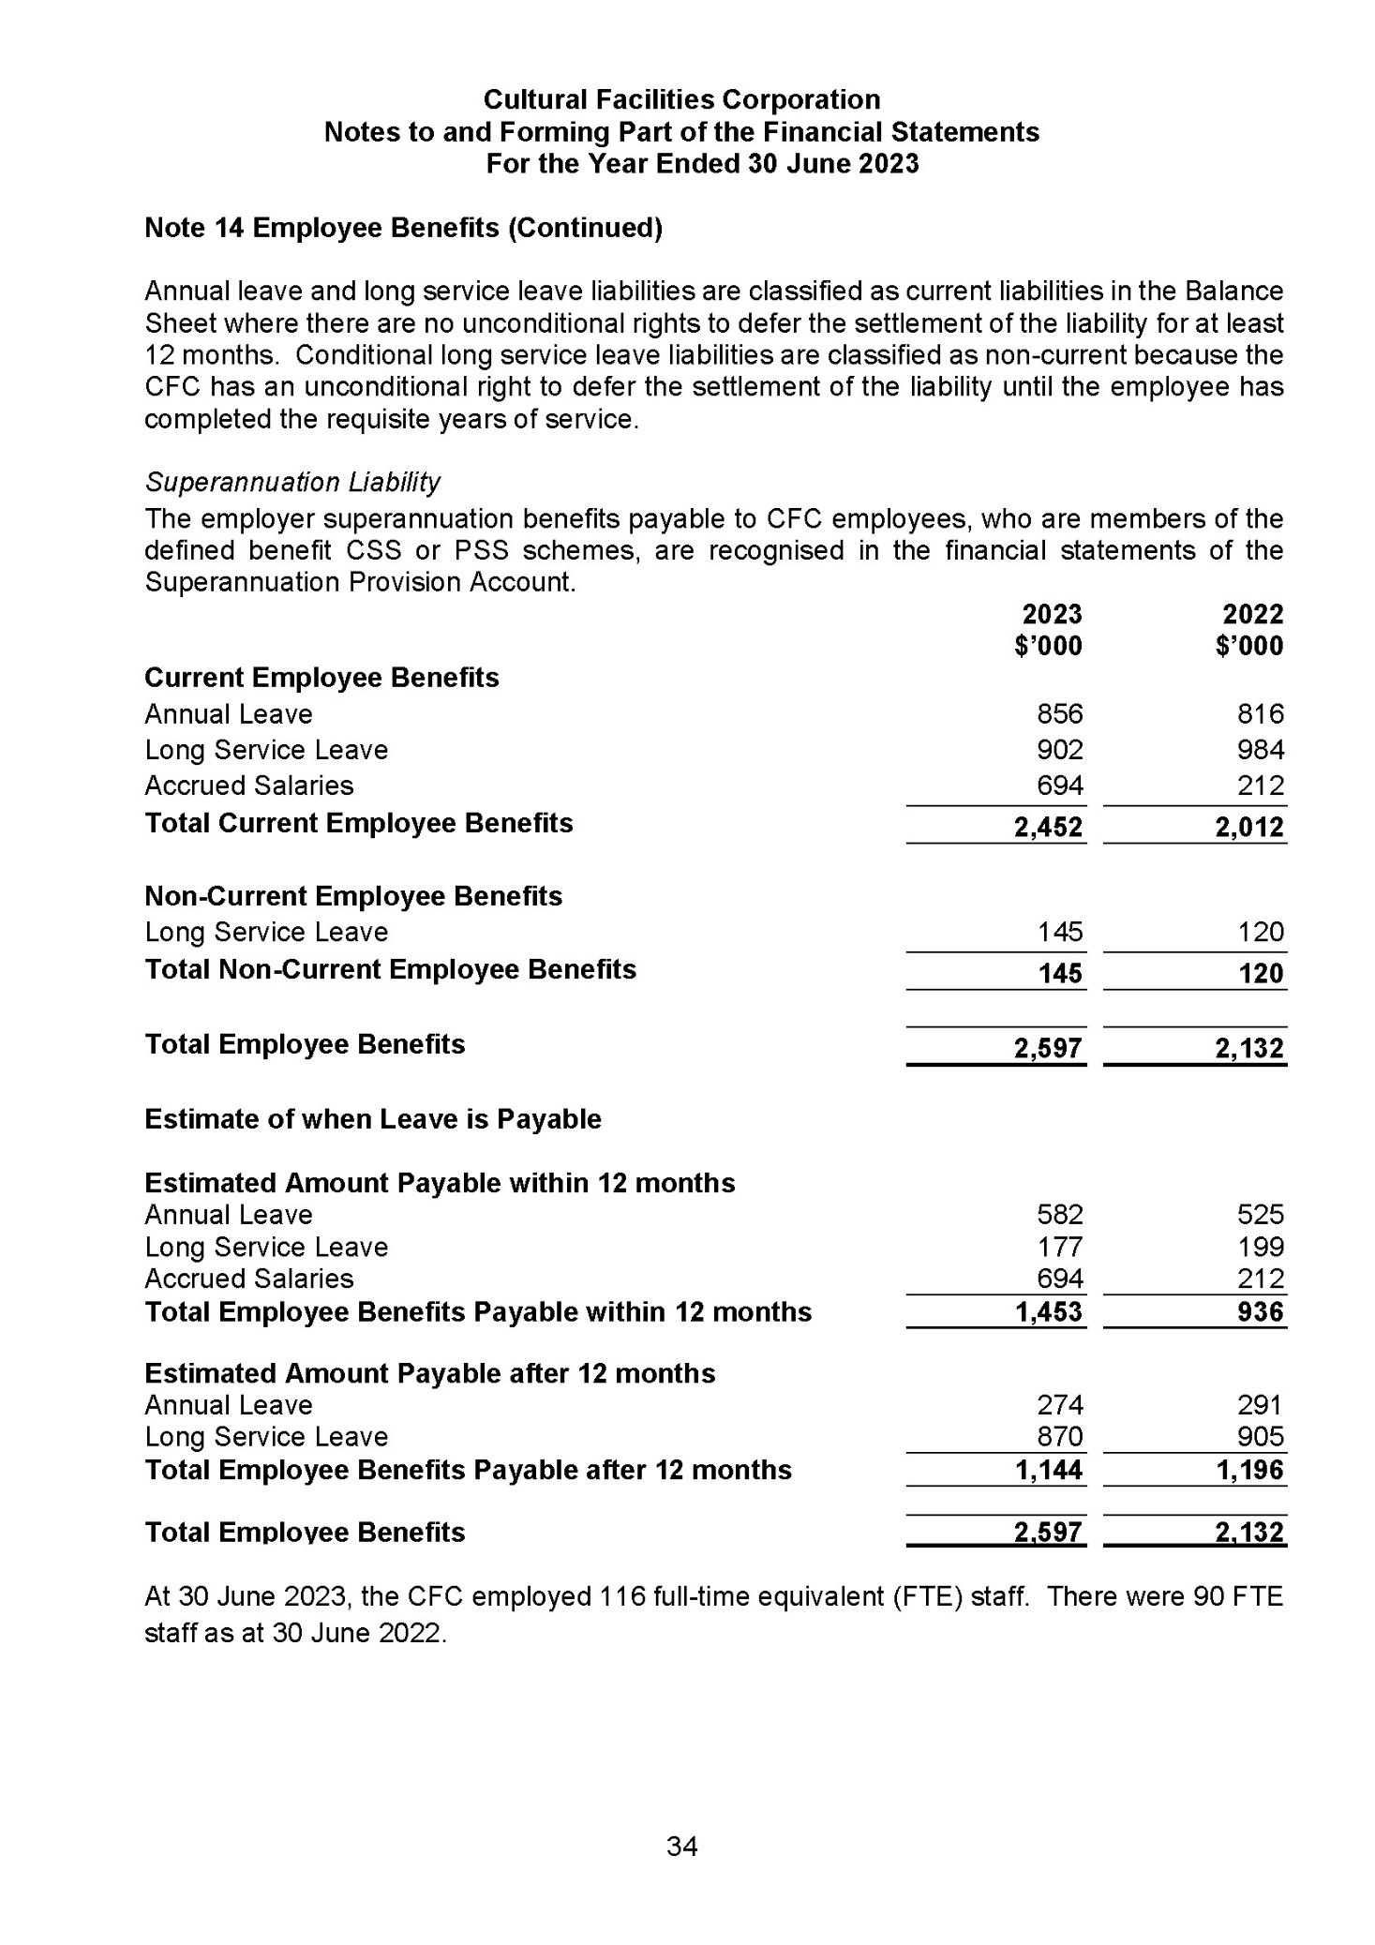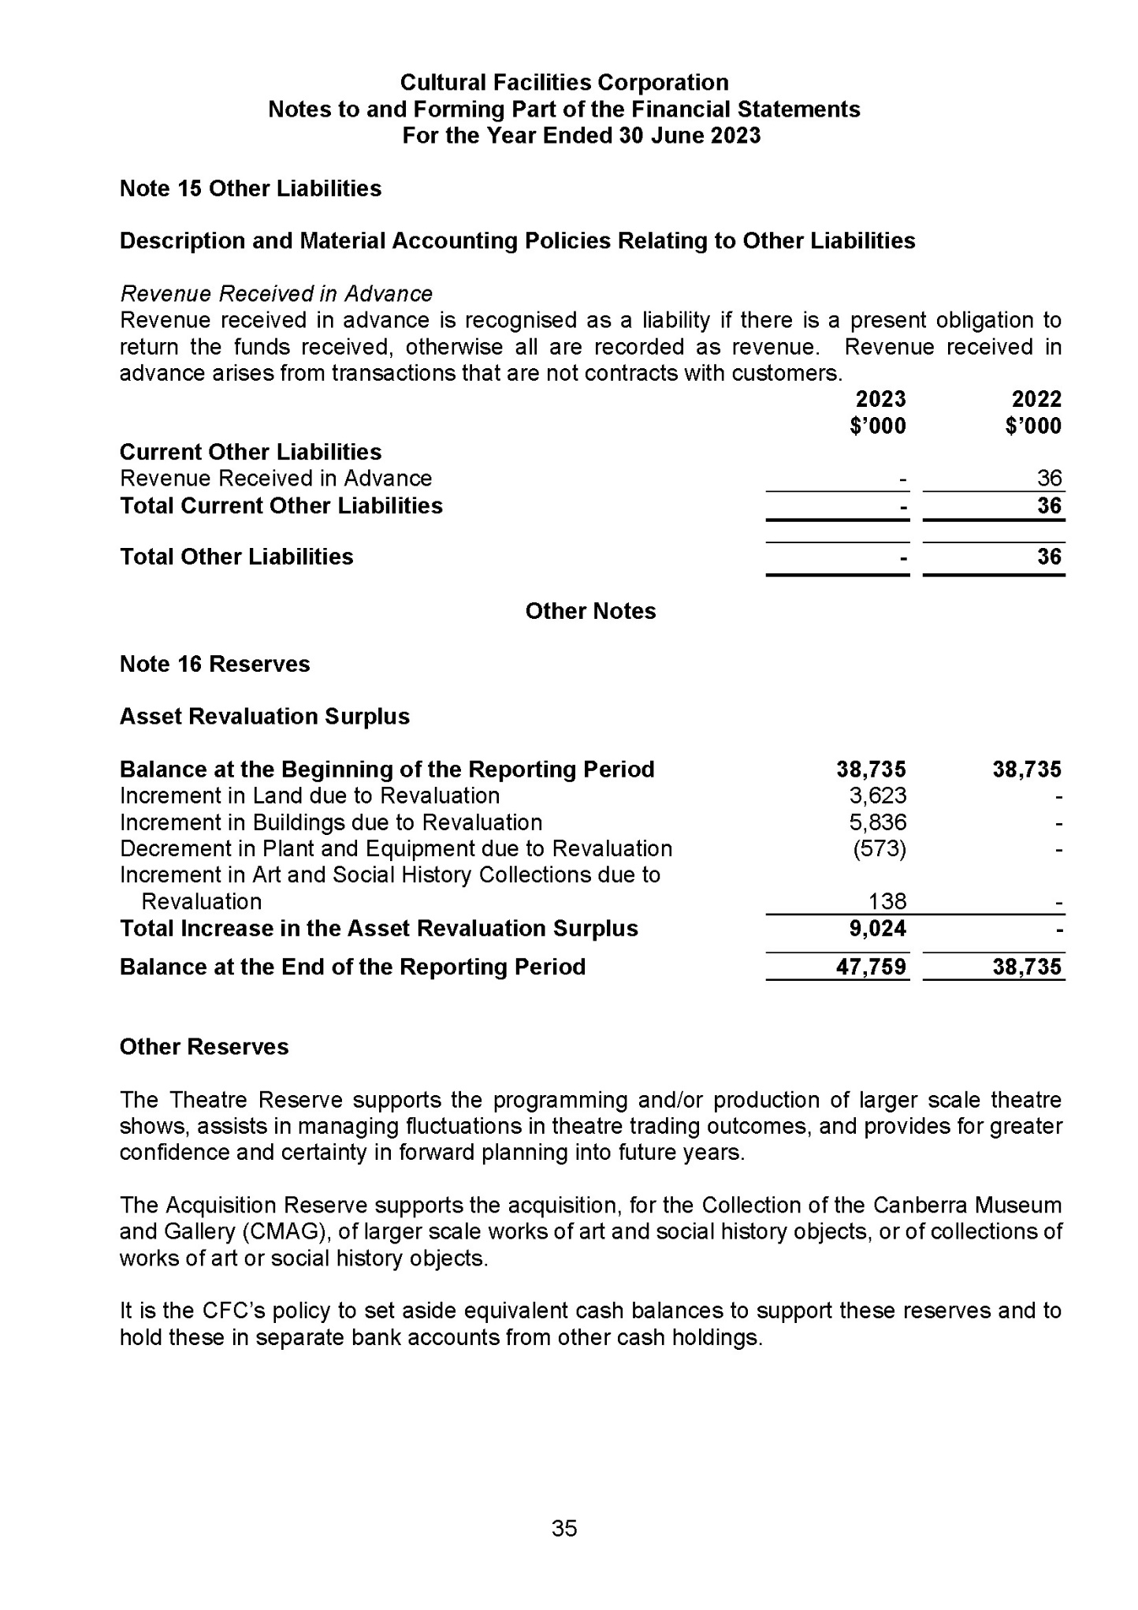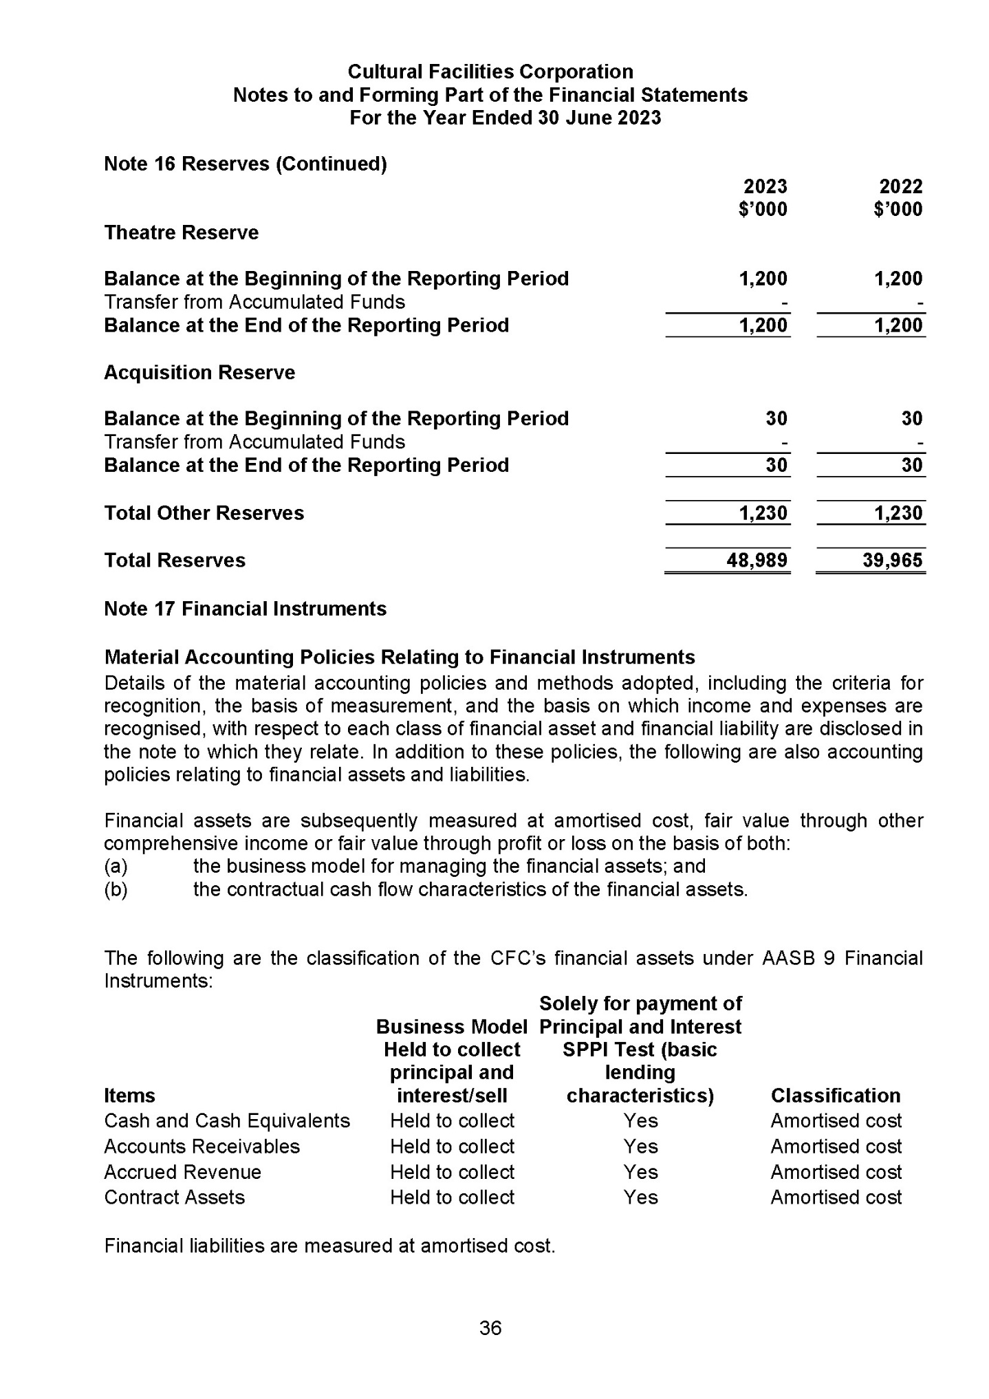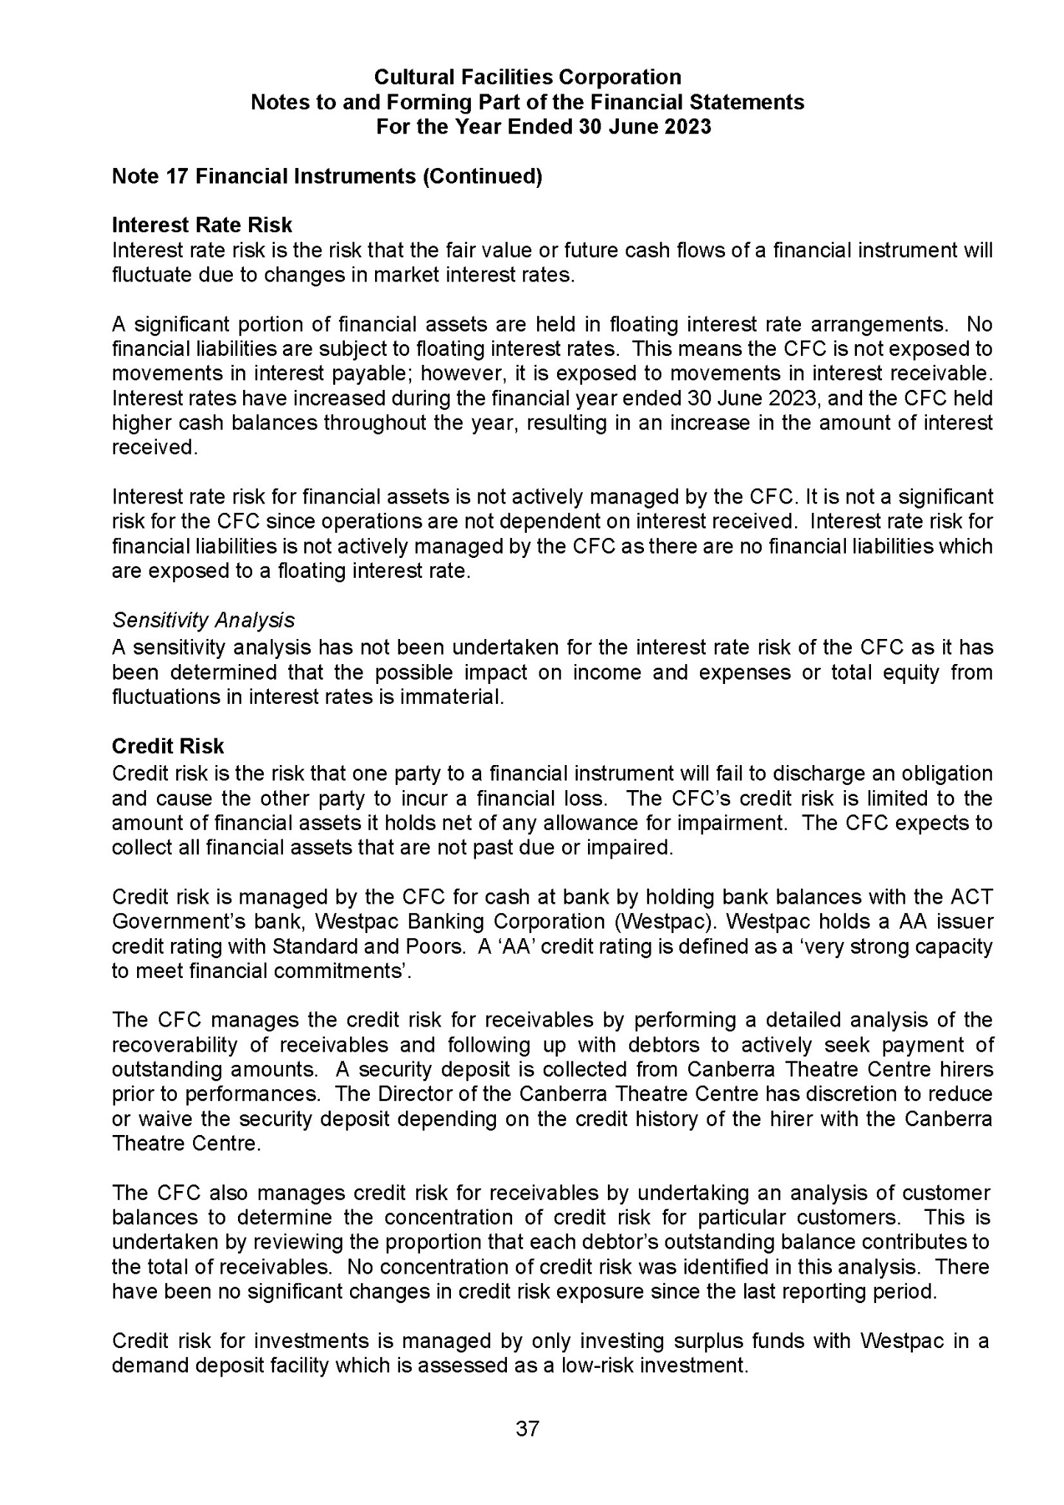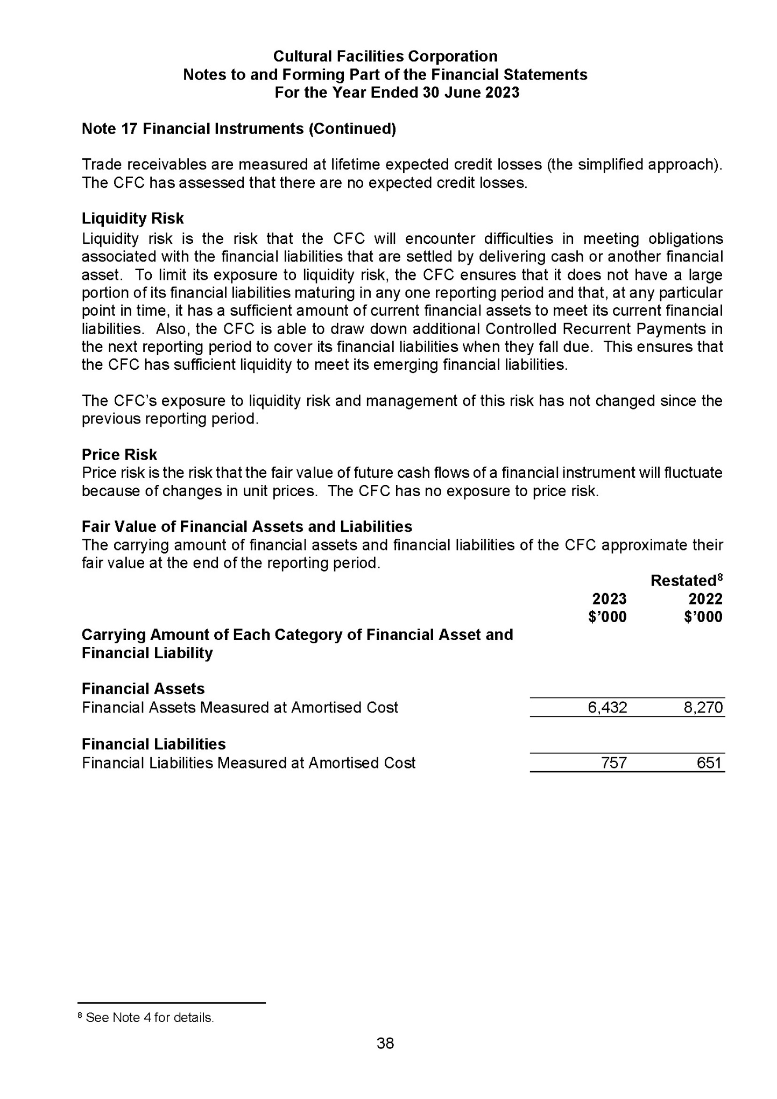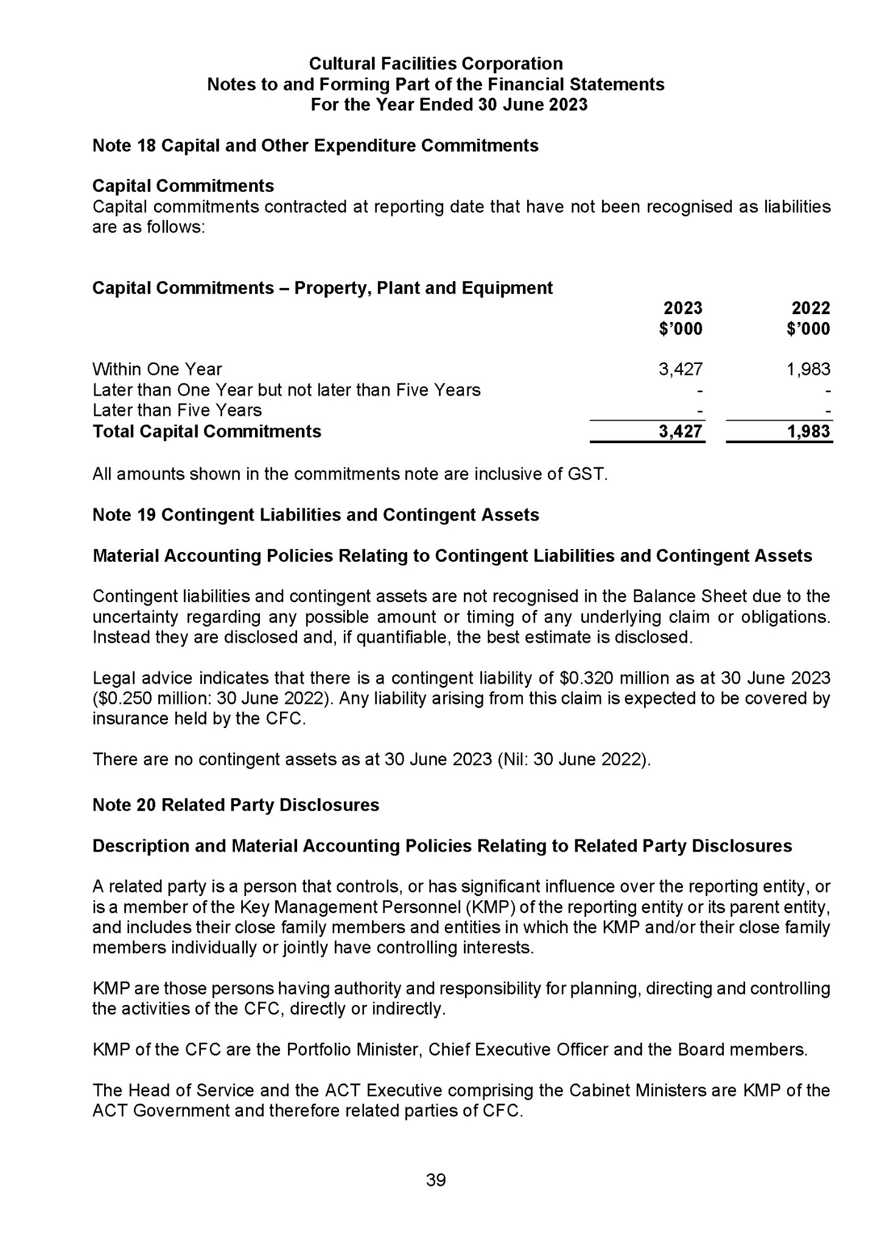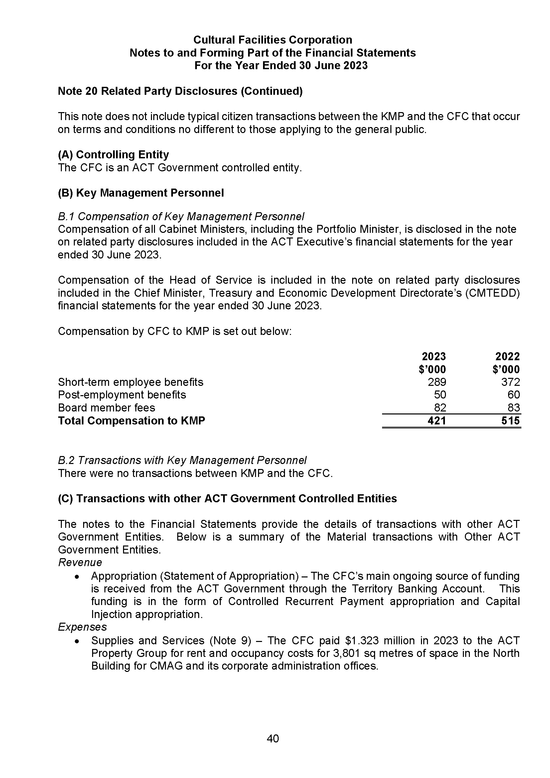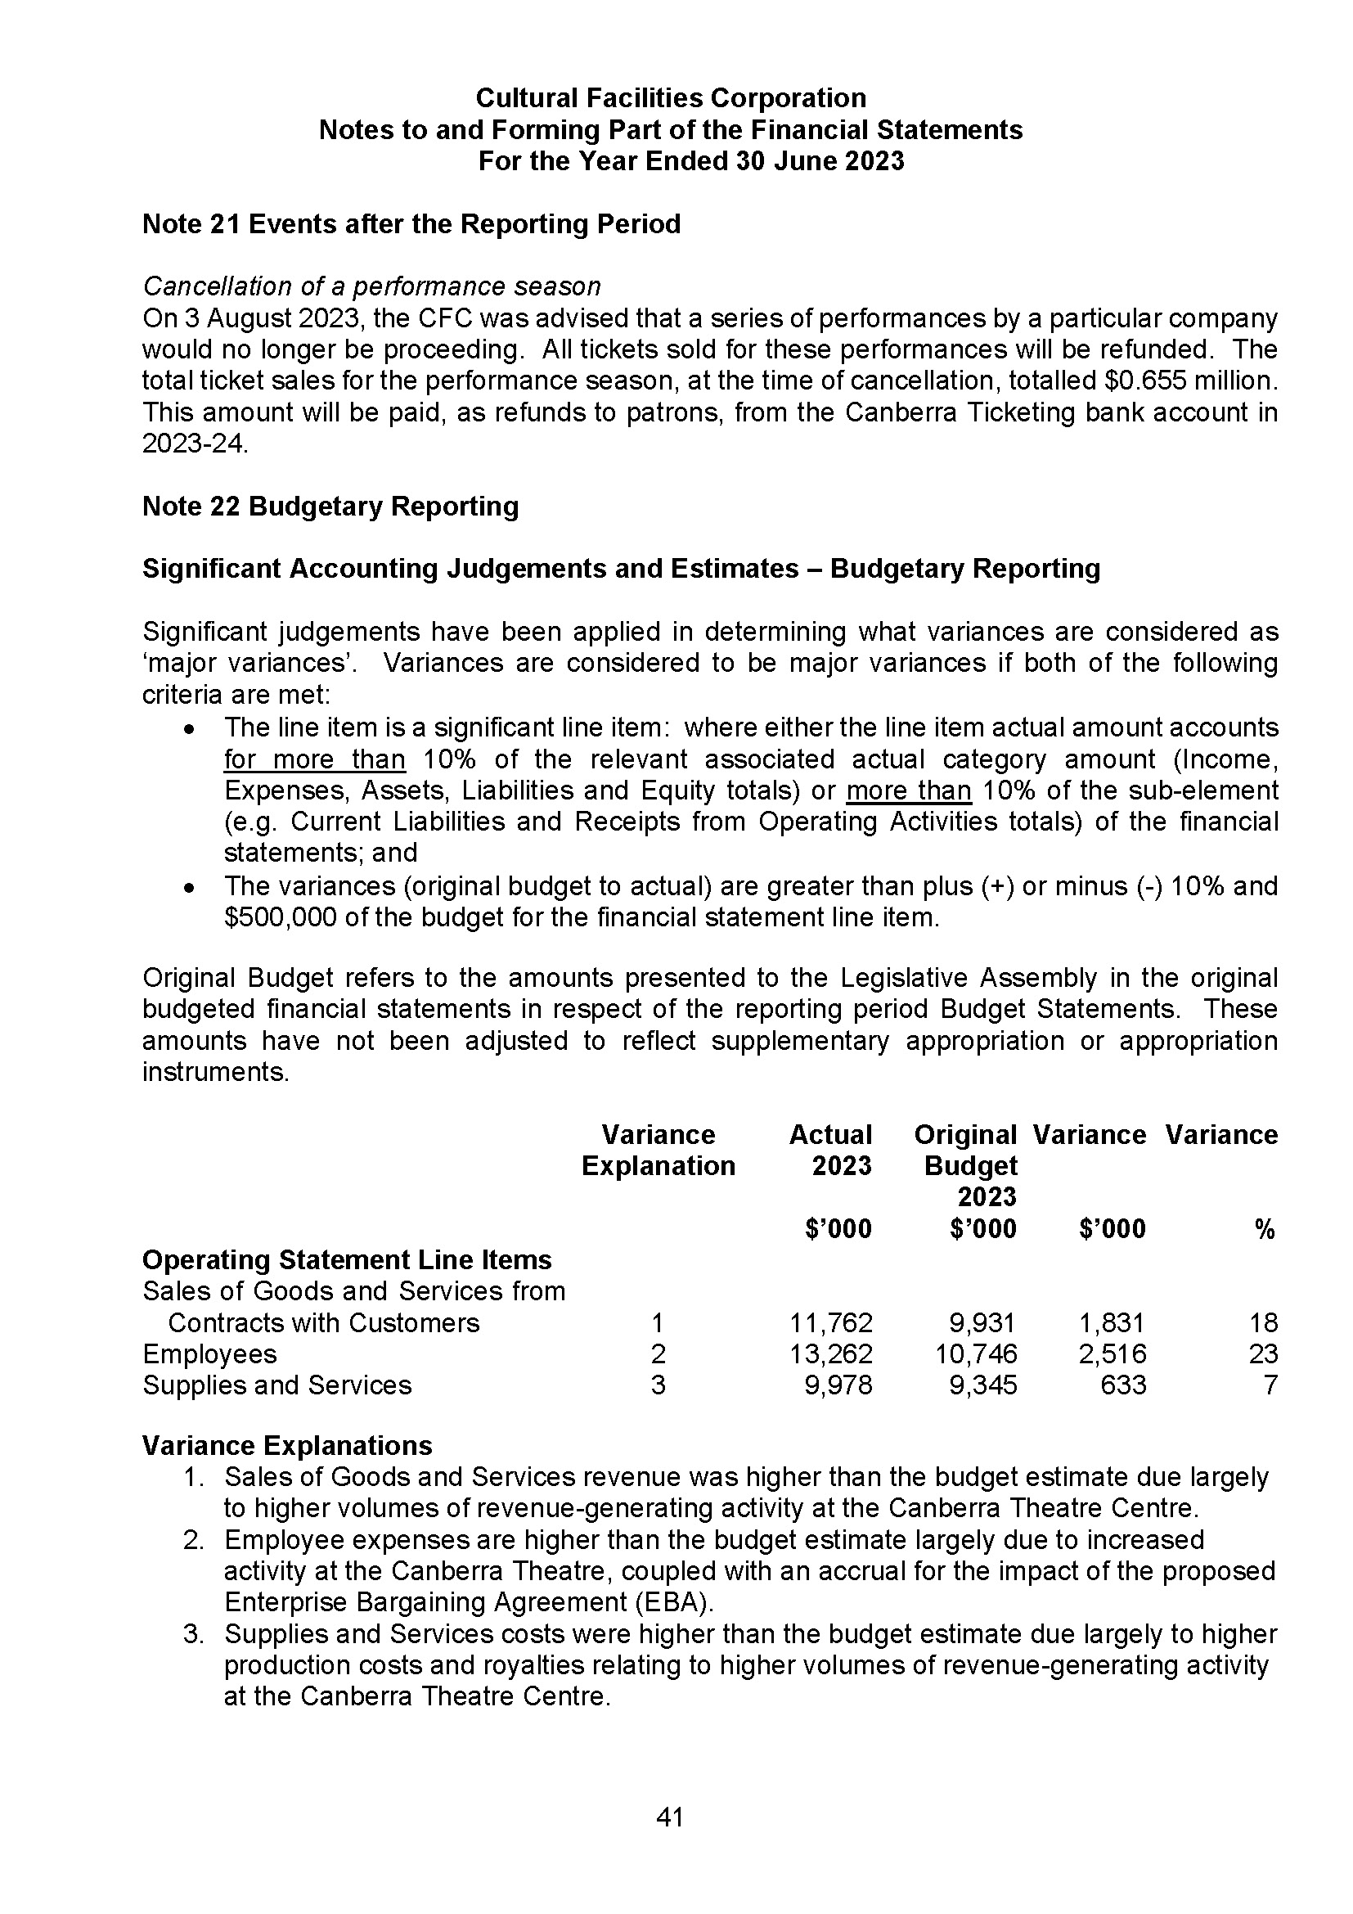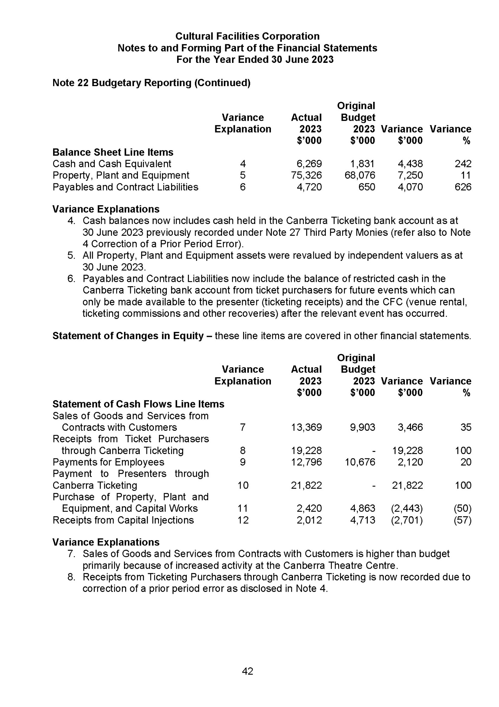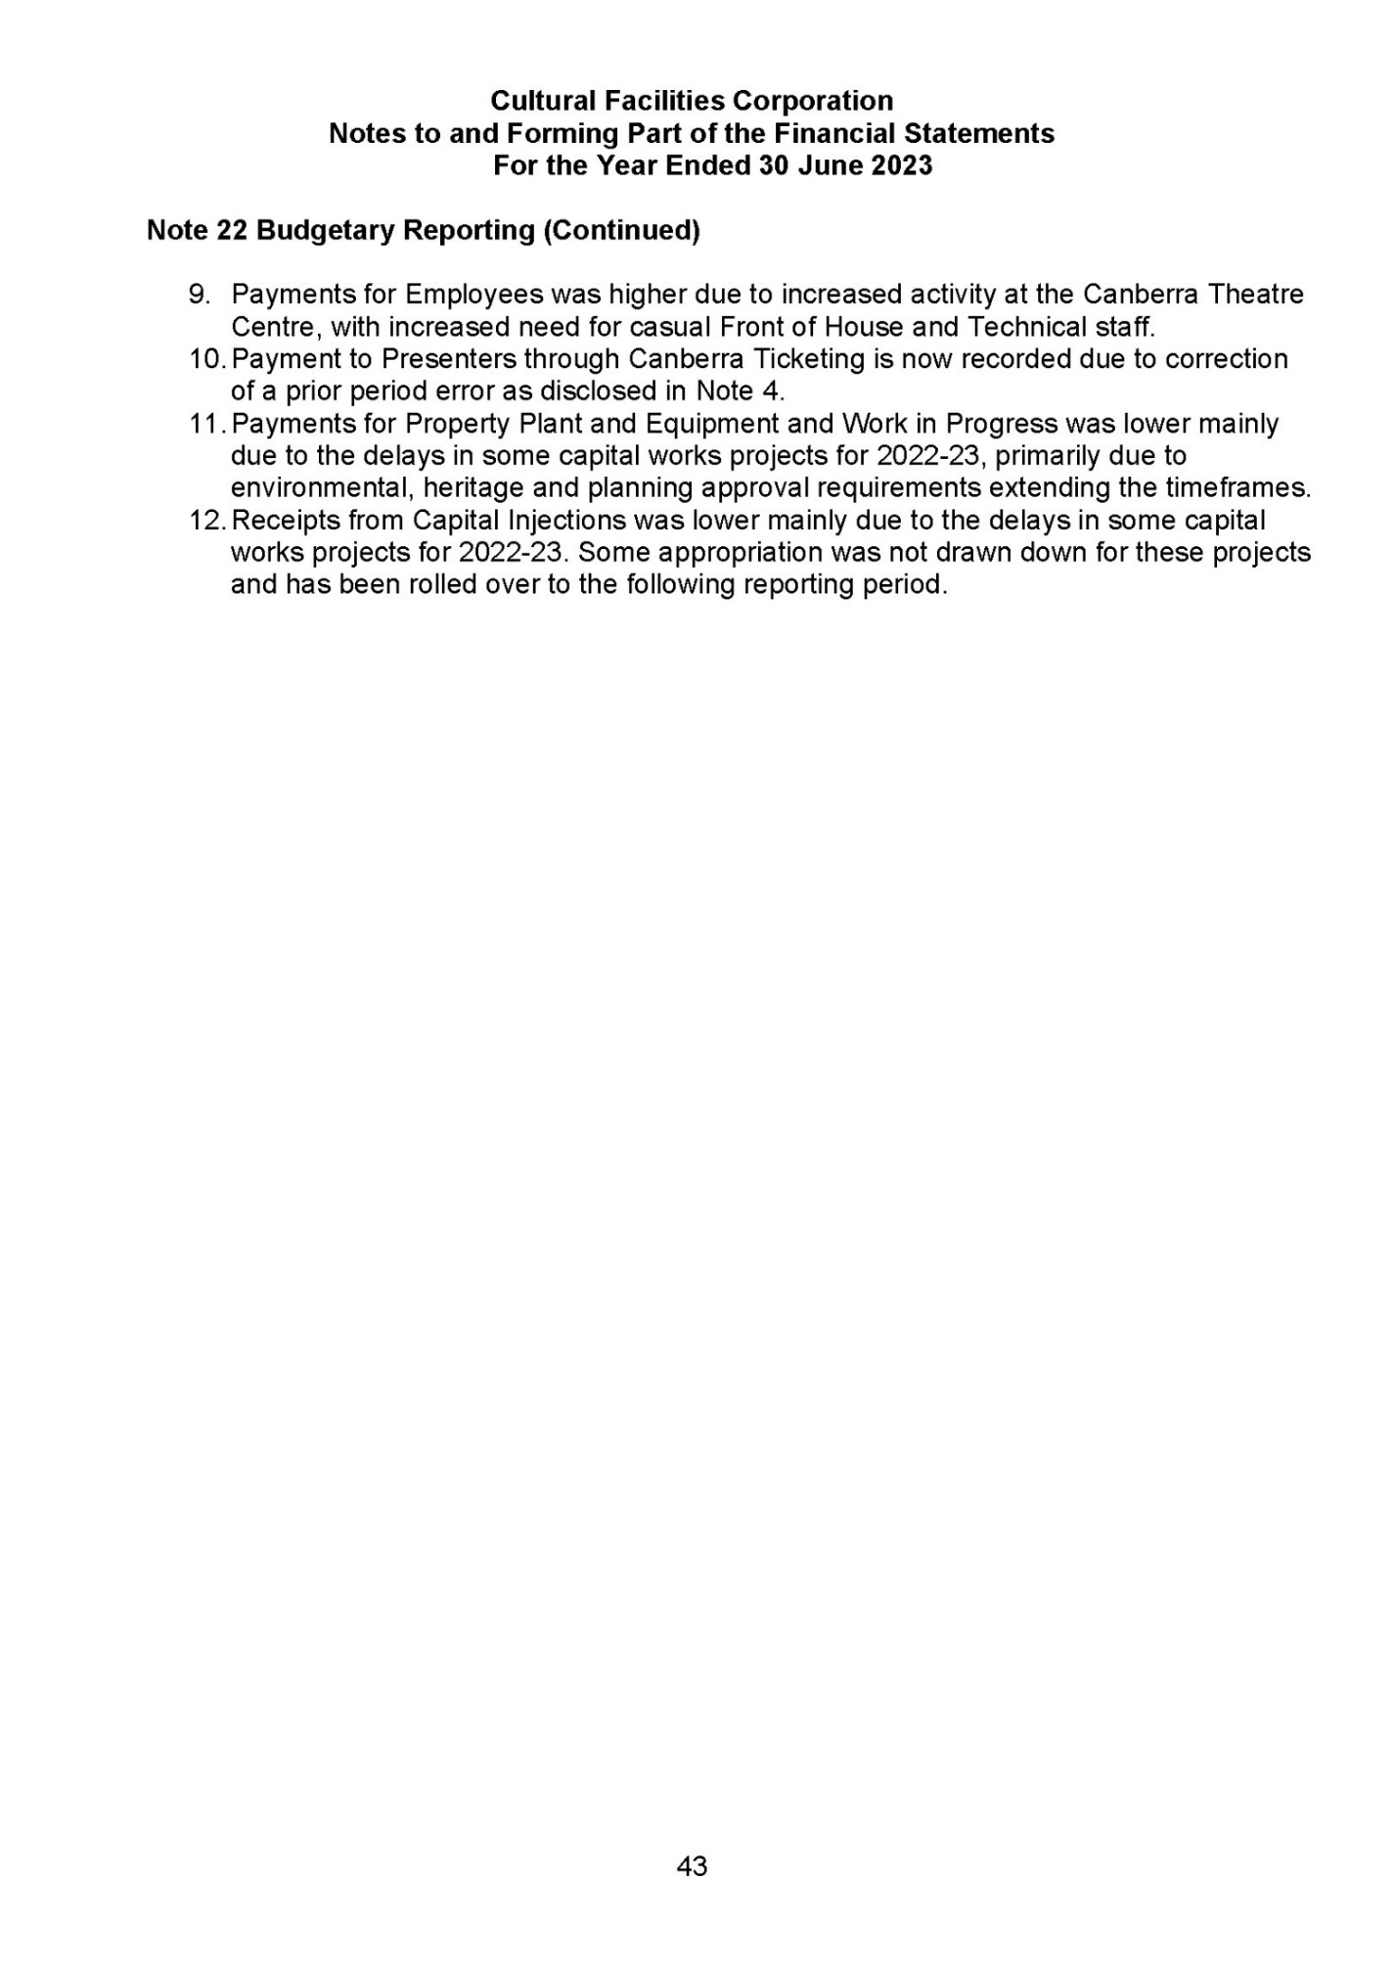

Management Discussion and Analysis for the Cultural Facilities Corporation for the Financial Year Ended 30 June 2023

General Overview

Objectives

The Cultural Facilities Corporation (CFC) was established under the Cultural Facilities Corporation Act 1997. It manages the following major cultural assets:

- the Canberra Theatre Centre;
- the Canberra Museum and Gallery (CMAG), including the Nolan Collection Gallery @ CMAG;
- Lanyon Homestead;
- Calthorpes’ House; and
- Mugga-Mugga.

The strategic objectives for the CFC and for its program divisions are as follows.

Strategic Objective for the CFC

To provide cultural leadership in the Canberra region and beyond.

Strategic Objective for the Canberra Theatre Centre

To be a leading theatre centre in Australasia and Asia.

Strategic Objective for Galleries and Museums

To be a leading regional cultural venue in Australia and beyond.

Risk Management

The key strategic risk that may influence the CFC’s future financial position is the variability and unpredictability of the performing arts business. Theatre revenues form the majority of the CFC's non-government revenue and represent the main variable in its financial performance.

The CFC’s theatre revenues are highly dependent on the variability and unpredictability of the performing arts business. These are impacted by such factors as: the availability of performing arts productions for touring; commerciality of available productions; national developments with regard to major performing arts companies; popularity of productions; and discretionary consumer expenditure, which is vulnerable to general economic downturns.

The CFC’s Theatre Reserve supports the organisation’s efforts to build theatre business. This fund has been developed from the proceeds of previous theatre commercial activity, and now stands at $1.2 million.
The Reserve supports efforts to program larger-scale shows and assists in managing the risks inherent in theatre programming. This is particularly important as the CFC seeks to contribute to national efforts to support performing arts touring, and to bring major shows to Canberra.

The CFC will address the major risk discussed above, and other risks, to the best of its ability, including through its Strategic Risk Management Plan. This Plan informs the prioritisation of projects for internal audit programs and is supported by other plans, such as those covering Fraud Control, Business Continuity, Disaster Preparedness and Security.

The Plan was revised and updated during 2022–23 to reflect recent experiences and will be further updated in 2023-24.

Financial Performance

The following financial information is based on audited Financial Statements for 2021-22 and 2022-23.

Operating Result

Comparison to Budget
The operating deficit for 2022-23 was $3.158m, which was $0.428m (15.7%) higher than the 2022-23 budgeted deficit of $2.730m. The higher than estimated deficit was primarily due to additional accrued employee expenses for expected increases from the enterprise bargaining agreement.

Comparison to 2021-22 Operating Result
The operating deficit for 2022-23 was $1.776m (128.5%) higher than the 2021-22 operating deficit. The higher operating deficit was primarily due to the additional COVID-19 funding from Government received in 2021-22.

Operating Statement Trends

Due to its large asset holdings and consequent significant depreciation expense, the CFC expects to incur operating deficits. Revaluations are undertaken every three years, with 2022-23 being a revaluation year. Figure 1 indicates that depreciation represents a significant expense (10.4% of total expenses). Although depreciation is not funded by the ACT Government, the CFC does receive capital injections from the ACT Government, which fund new and replacement assets.

Figure 1 – Operating Statement Trends

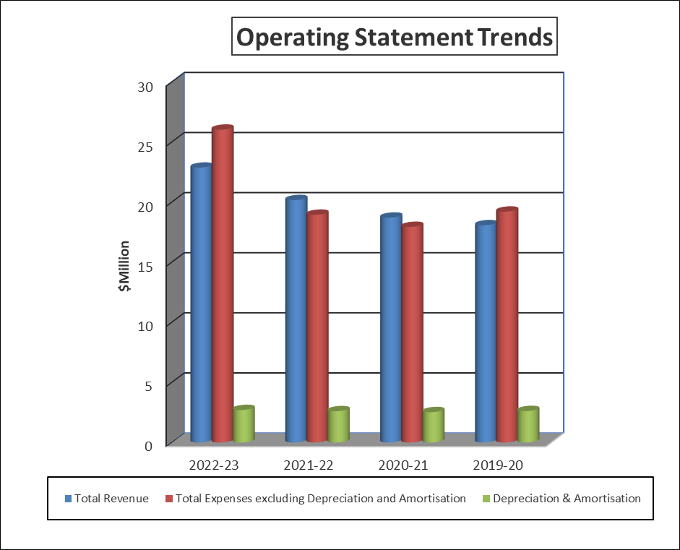

Total Revenue

Figure 2 indicates that for the financial year ended 30 June 2023, the CFC received 55% of its total revenue from sources other than ACT Government Appropriations (Controlled Recurrent Payments). This was made up primarily of revenues from hiring out theatres and selling tickets to the public for the performing arts.

Figure 2 - Sources of Revenue 2022-23

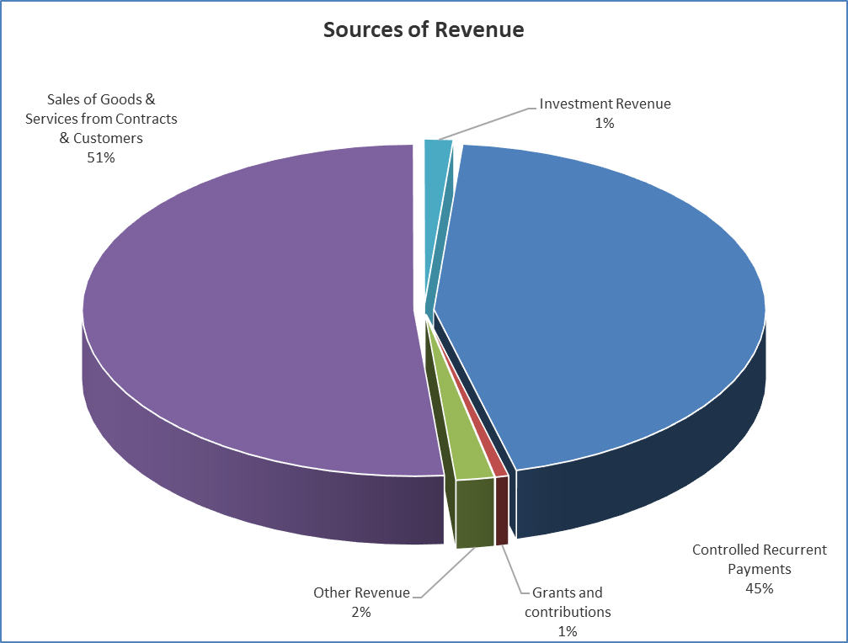

Comparison to Budget
Total revenue of $22.868m for the year ending 30 June 2023 was $2.533m (12.5%) higher than the 2022-23 budget of $20.335m.

Comparison to 2021-22 Total Revenue
Total revenue was $2.698m (13.4%) higher than the 2021-22 actual result.

The higher total revenue for both was primarily due to increased theatre revenues from an increase in the number of nights venue hire at the Canberra Theatre Centre.

Total Expenditure

Figure 3 indicates that for the financial year ended 30 June 2023, the CFC spent 51% of its total expenditure on employee and superannuation expenses.

Figure 3 - Components of Expenditure 2022-23

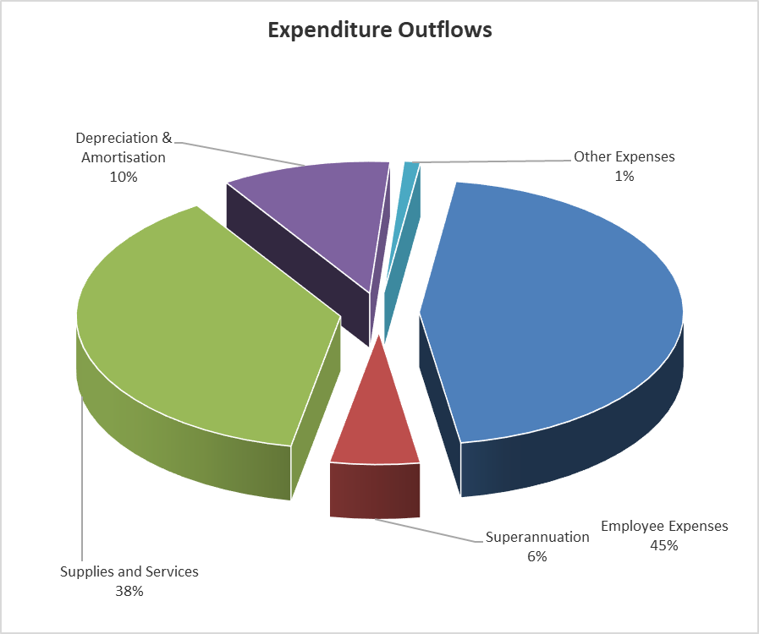

Comparison to Budget
Total expenditure for 2022-23 of $26.026m was $2.961m (12.8%) higher than the 2022-23 Budget of $23.065m. The higher than expected expenditure was mainly due to increased employee expenses due to increased theatre activities at the Canberra Theatre Centre.

Comparison to 2021-22 Total Expenditure
Total expenditure was $4.474m (20.8%) higher than the 2021-22 actual result. The higher total expenditure was primarily due to higher supplies and services expenses from increased theatre activities at the Canberra Theatre Centre.

Financial Position

Key indicators of the health of the CFC’s financial position are its ability to sustain its asset base, its ability to pay debts falling due in the short-term, and its maintenance of prudent levels of longer-term liabilities.

Sustained Asset Base

The ability of the CFC to sustain its asset base is indicated by changes in its net assets. Figure 4 indicates that, at the end of 2022-23, the CFC maintained a strong net asset position through implementation of a program of upgrading assets and maintaining low liability levels.

Figure 4 - Summary Balance Sheet

Comparison to Budget
The net asset position as at 30 June 2023 of $74.635m was $7.078m (10.5%) higher than the 2022-21 budget of $67.557m.

Comparison to 2021-22 net assets
The 2022-23 actual net asset position was $7.878m (11.8%) higher than the 2021-22 actual position.

The higher net asset position for both was as a result of asset revaluations as at 30 June 2023. These revaluations increased the asset totals by $9.024m.

Figure 5 indicates that as at 30 June 2023, 92% of CFC’s assets were Property Plant and Equipment.

Figure 5 – Total Assets

Comparison to Budget
Total assets of $81.991m as at 30 June 2023 were $11.207m (15.8%) higher than the 2022-23 budget of $70.784m.

Comparison to 2021-22 Total Assets
The total assets as at 30 June 2023 were $7.032m (9.4%) higher than the total assets as at 30 June 2022.

The higher Total Assets for both was as a result of asset revaluations as at 30 June 2023. These revaluations increased the asset totals by $9.024m.

Liabilities

Figure 6 indicates that the majority of the CFC’s liabilities relate to Employee Benefits (which include Annual Leave and Long Service Leave Provisions) and Payables.

Figure 6 – Liabilities

Comparison to Budget
The current liability position as at 30 June 2023 of $7.191m was $4.1714m (138.1%) higher than the 2022-23 budget of $3.020m.

Comparison to 2021-22 Liabilities
The 2022-23 current liability position was $0.852m (10.6%) lower than the 2021-22 actual position.

The variance for both is mainly due to movements at reporting dates in Contract Liabilities for amounts received related to contracts with customers for ticket sales where the performance obligation has not yet been satisfied.

Liquidity

‘Liquidity’ is the ability of the CFC to meet its short-term debts as they fall due. As at 30 June 2023, the CFC’s current liabilities ($7.191m) were more than its current assets ($6.664m) by $0.527m (7.9%).

Comparison to 2021-22 Liquidity
As at 30 June 2022, the CFC’s current assets ($8.463m) were more than its current liabilities ($8.043m) by $0.420m (5.2%).

CFC is not considered a liquidity risk as the CFC’s cash needs are funded through appropriation by the ACT Government on a cash-needs basis. This is consistent with the whole-of-Government cash management regime, which requires excess cash balances to be held centrally rather than within individual agency bank accounts.

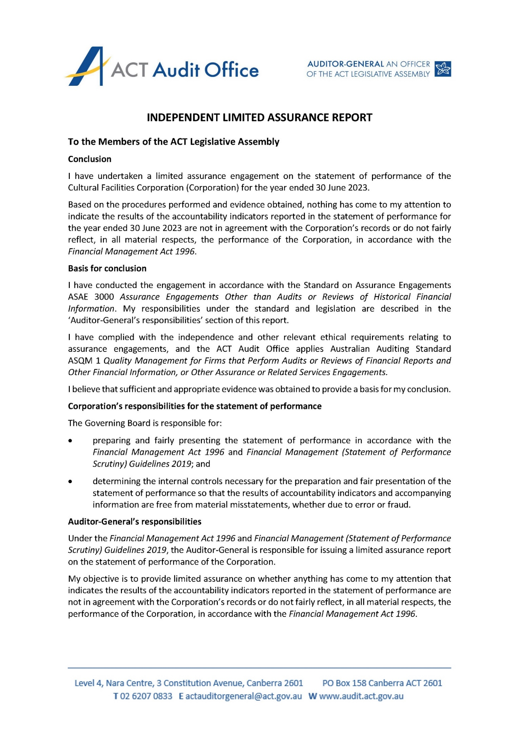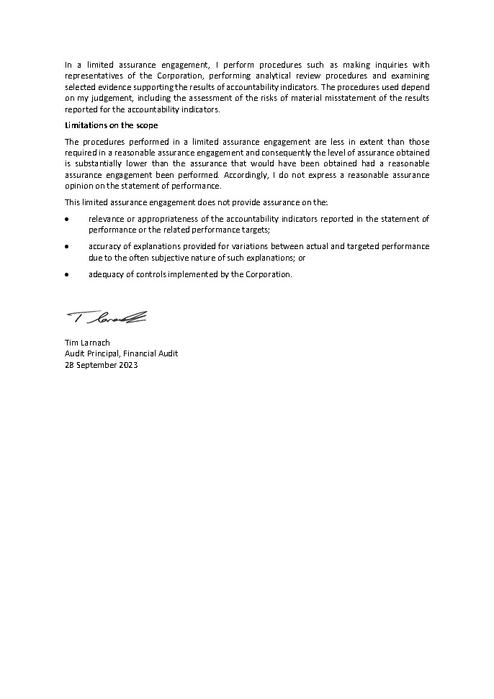
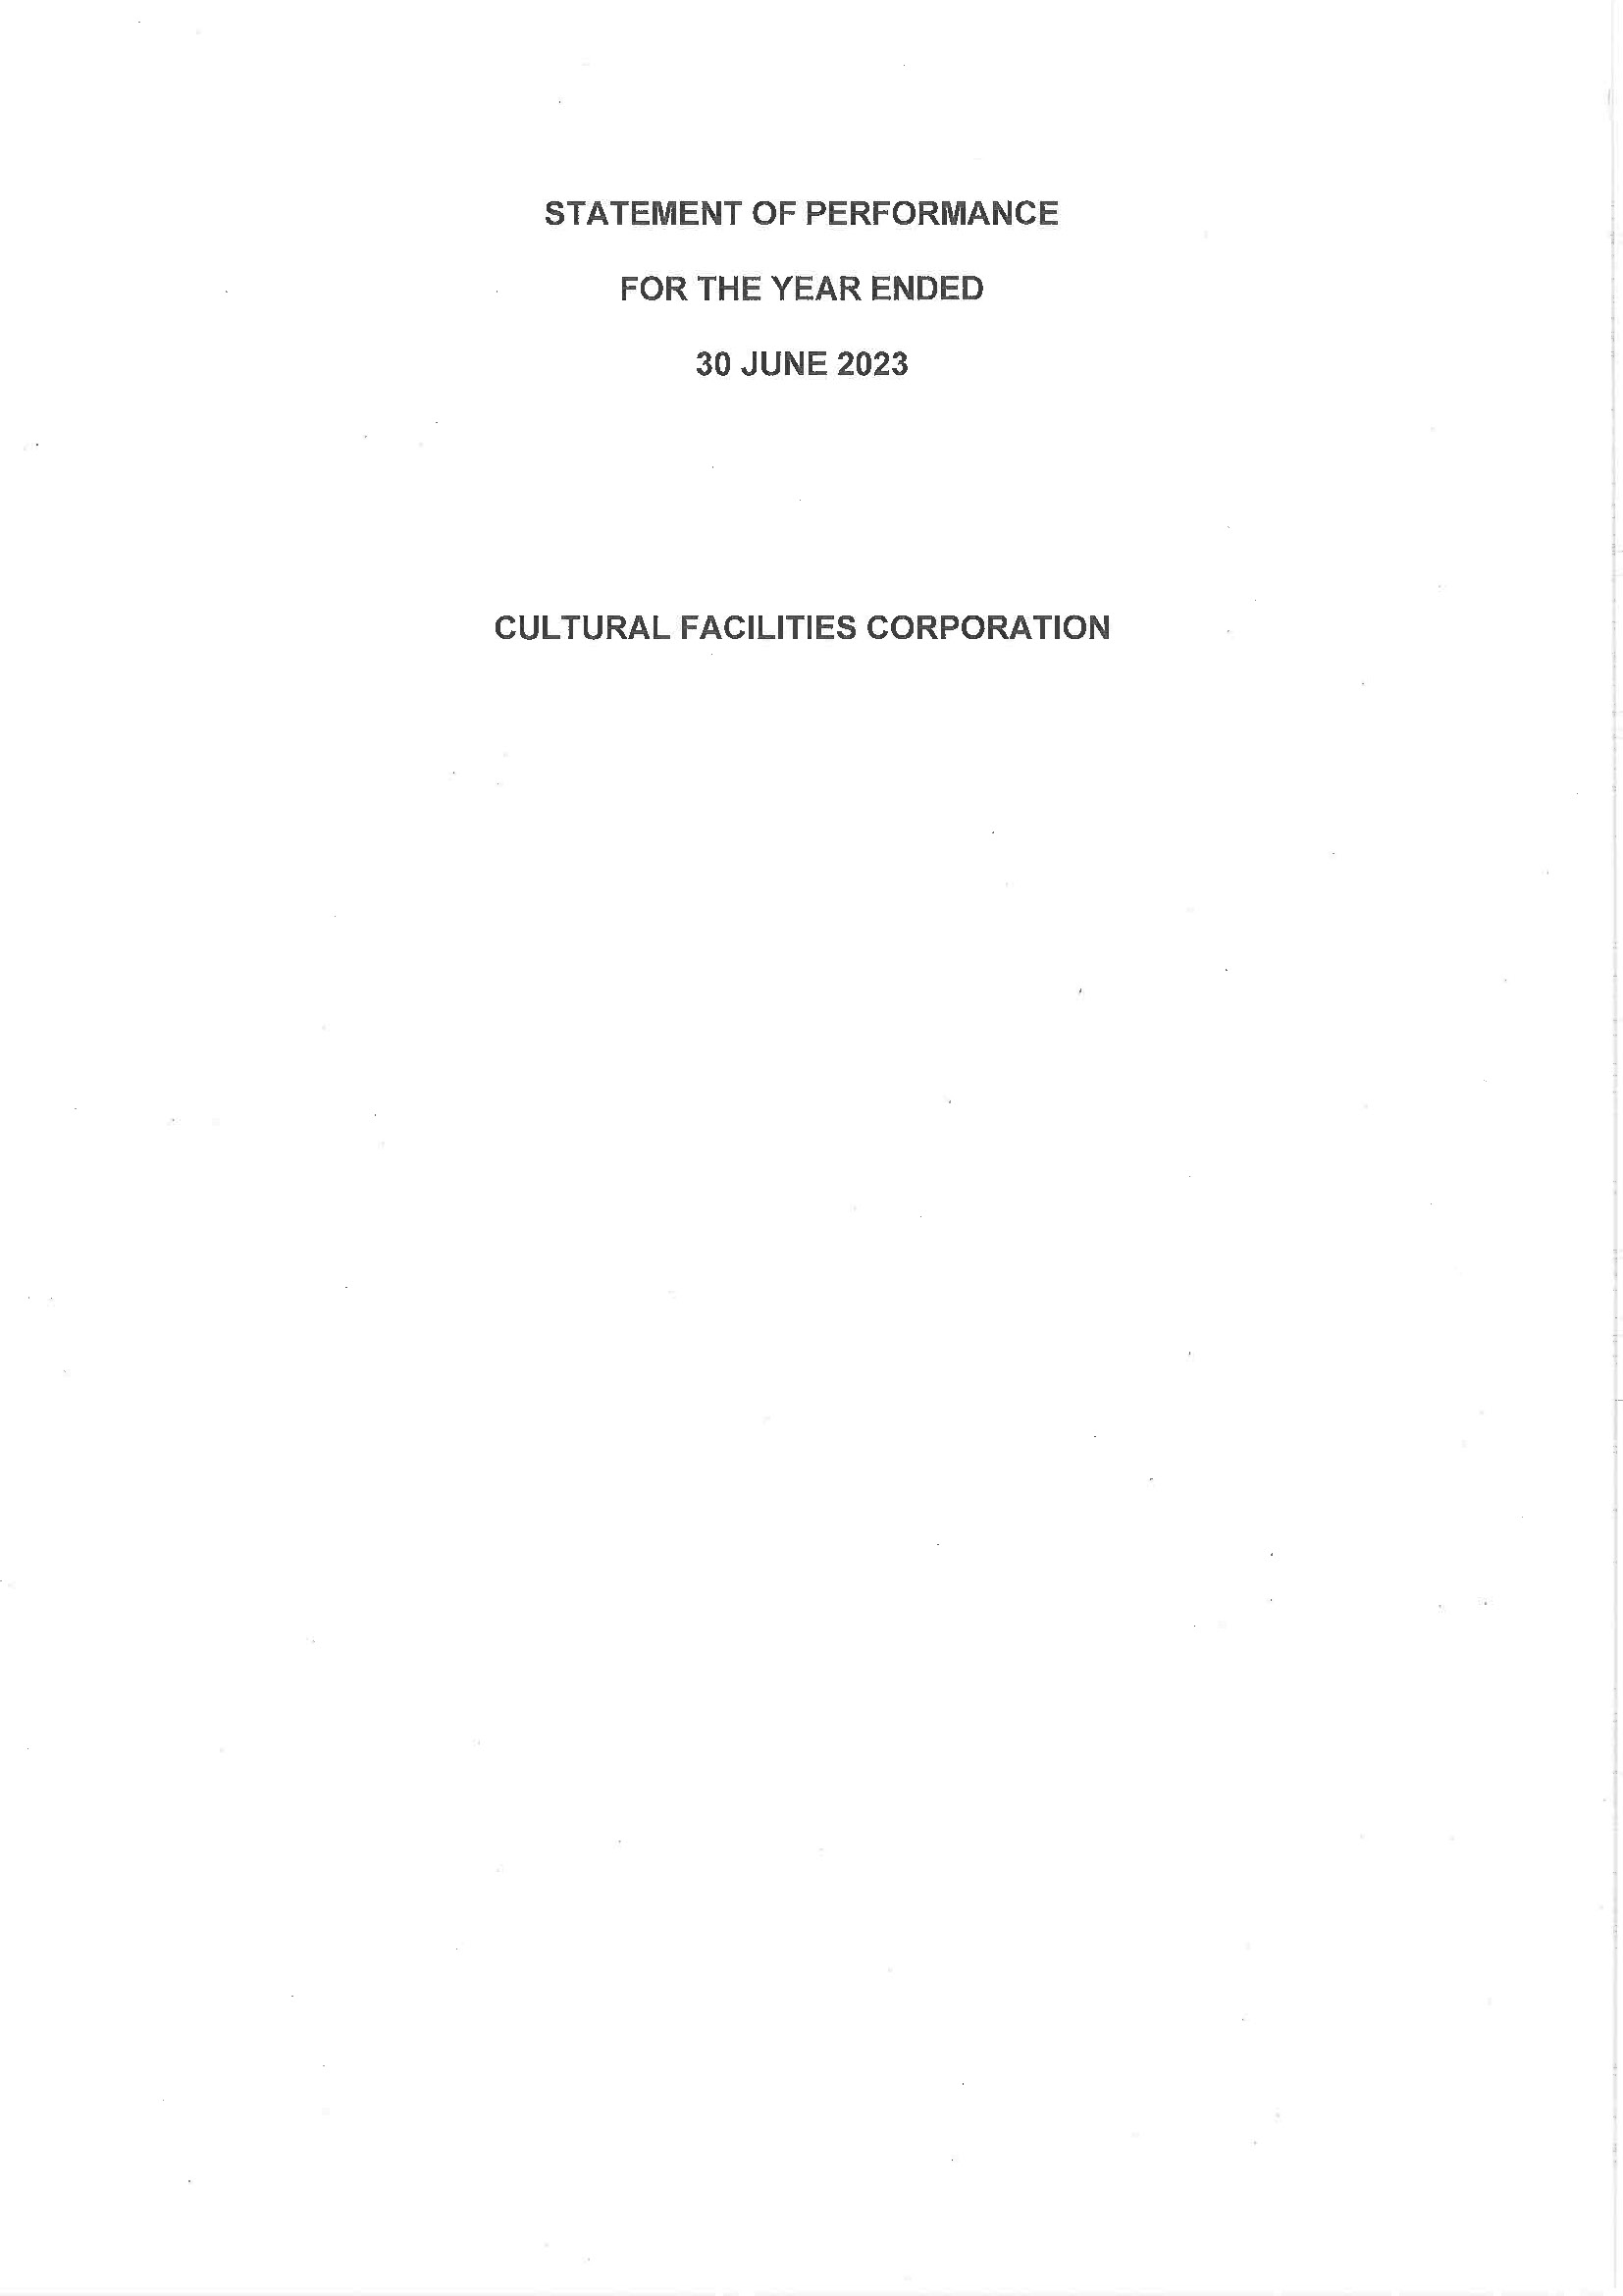
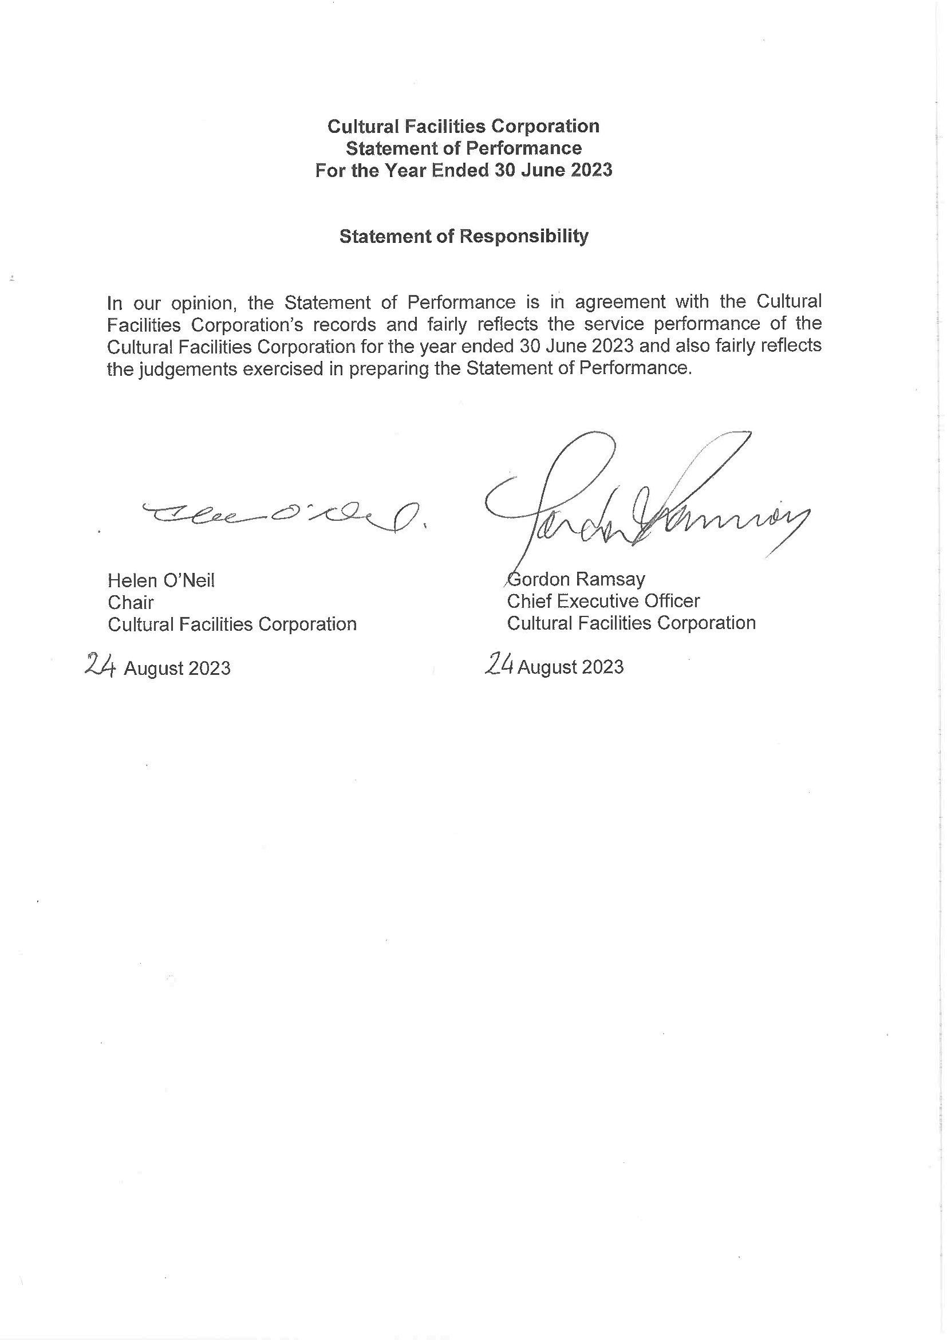
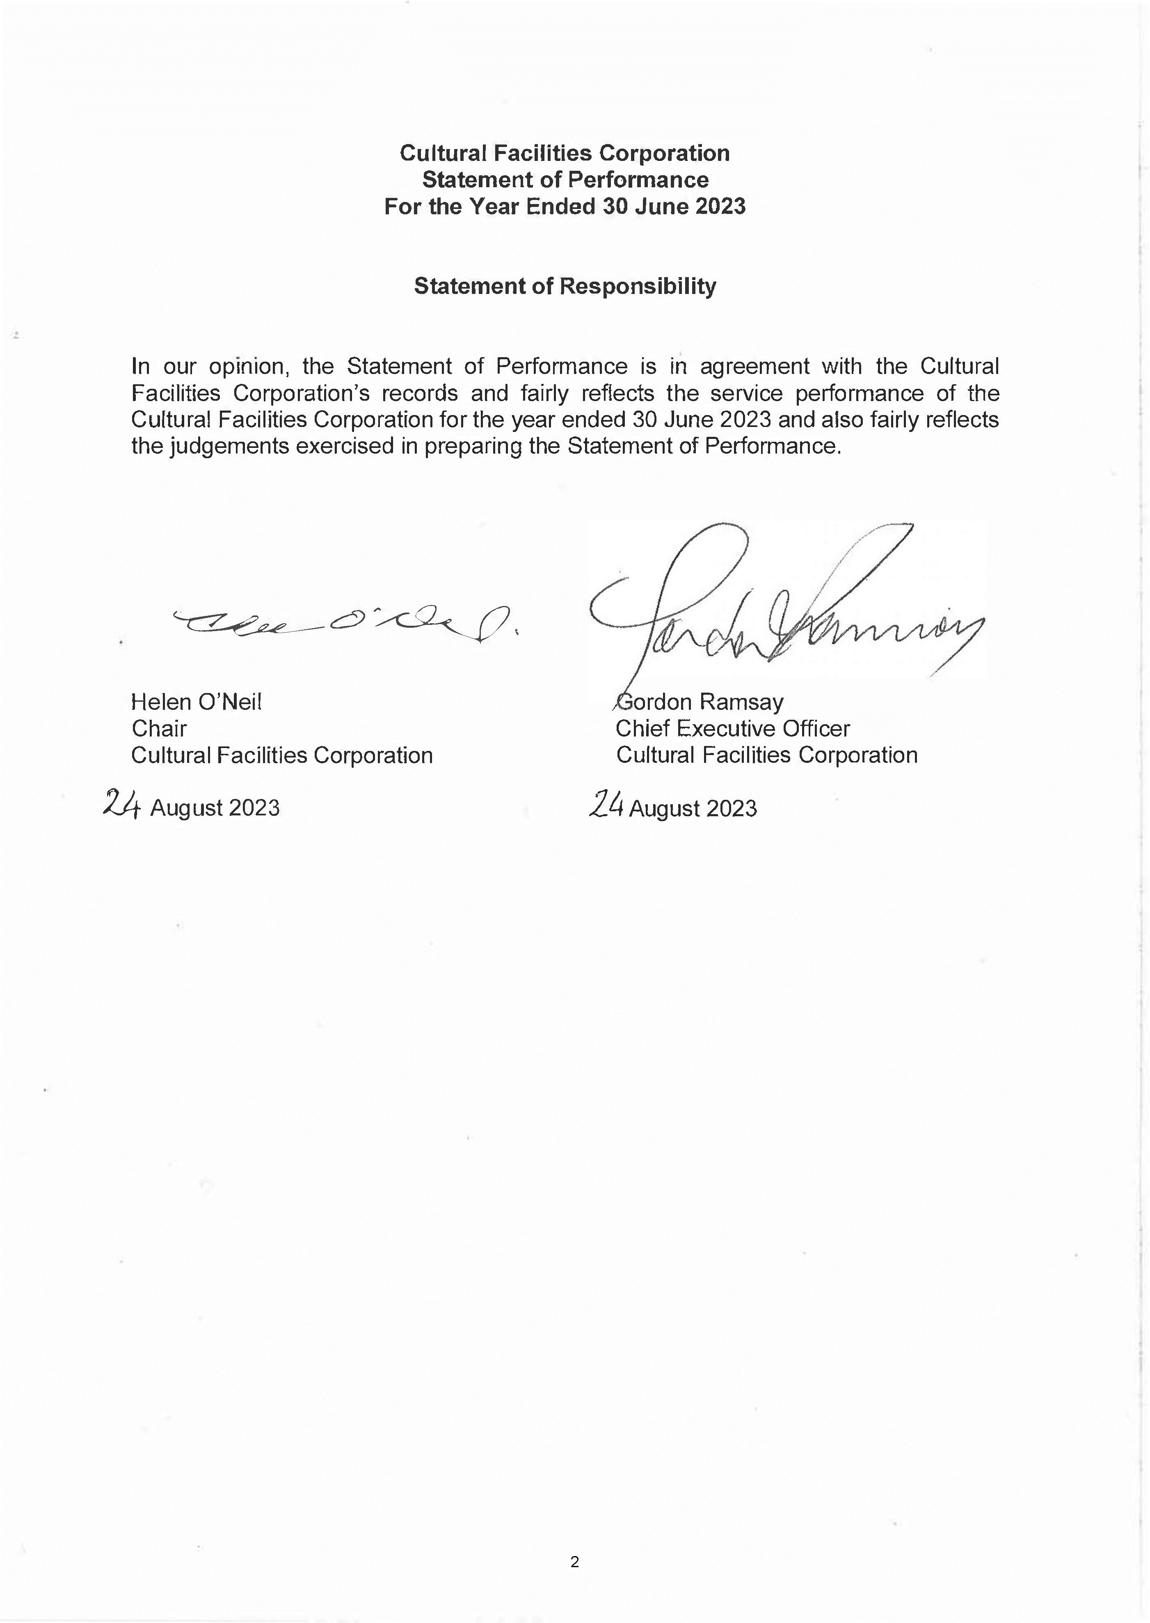
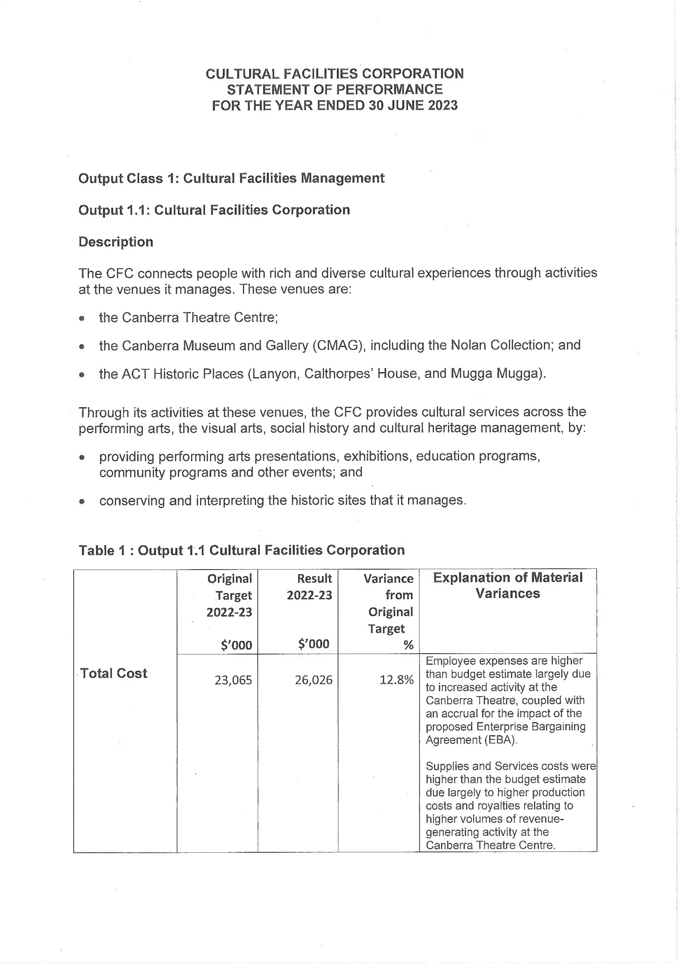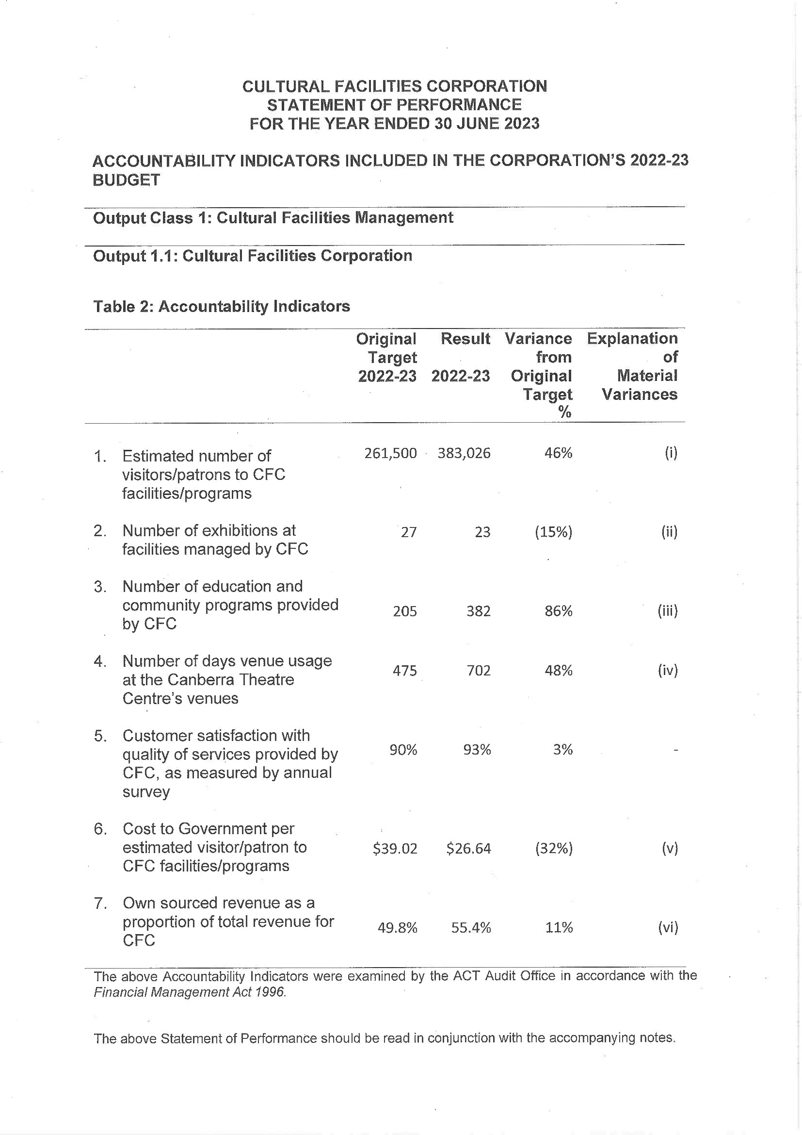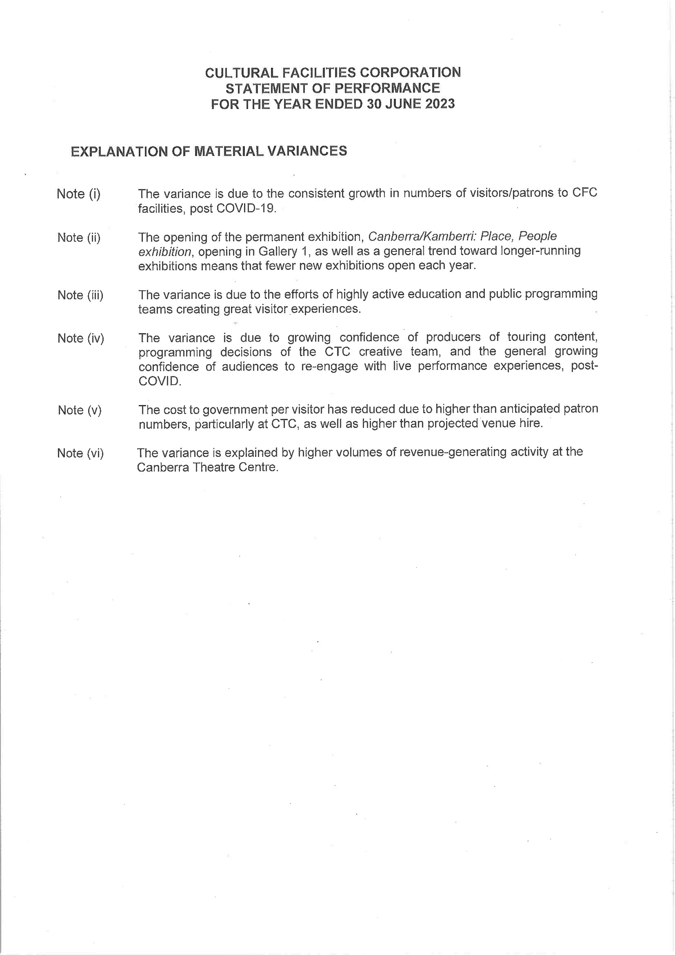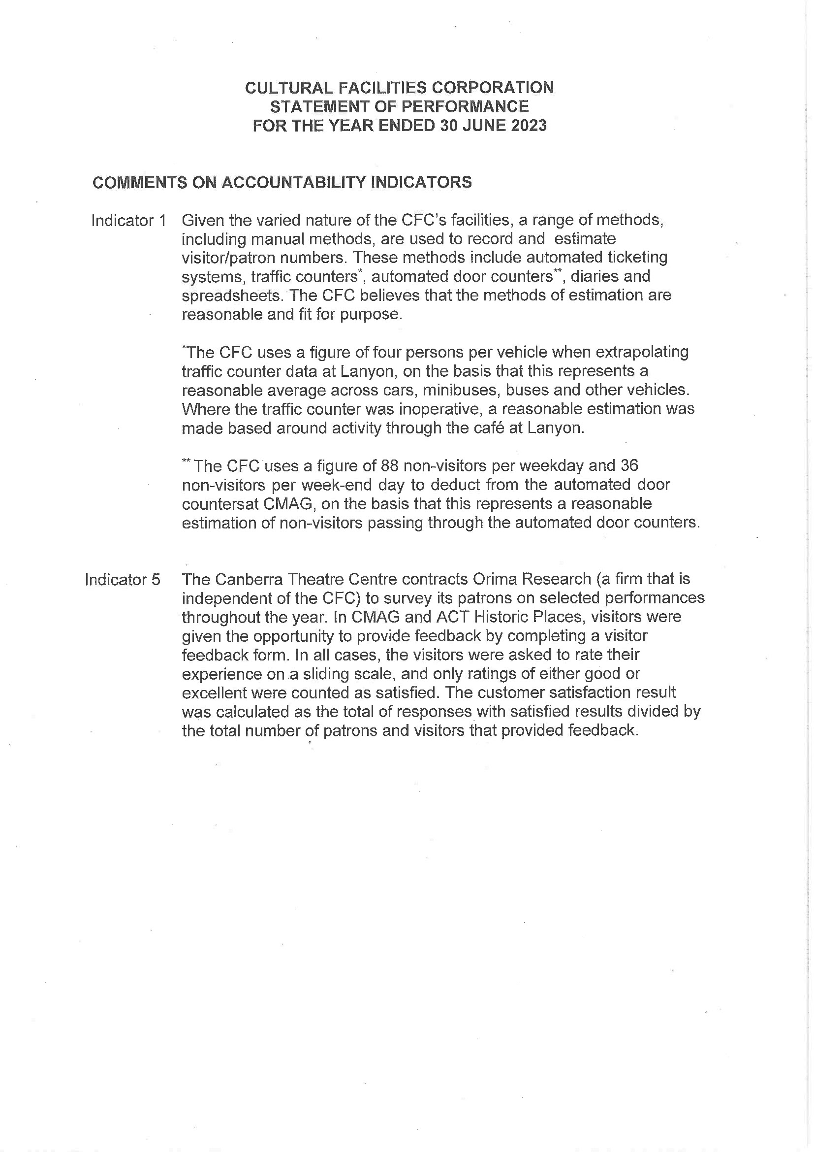

Abbreviations and Acronyms

ABC | Australian Broadcasting  Corporation
ACC | Agency Consultative Committee
ACT  ACTHP | Australian Capital Territory  ACT Historic Places
ActewAGL | ACT Electricity and Gas
ACTPS | ACT Public Service
AM  AMaGA | Member of the Order of Australia  Australian Museums and Galleries Association
ANU | Australian National University
AO  ASO | Officer of the Order of Australia  Administrative Services Officer
ASOC  ATSIPP | Artist Society of Canberra  Aboriginal and Torres Strait Islander Procurement Policy
BA  BCP | Bachelor of Arts  Business Continuity Plan
BSc  CTC | Bachelor of Science  Canberra Theatre Centre
CEO | Chief Executive Officer
CFC | Cultural Facilities Corporation
CFO | Chief Financial Officer
CMAG | Canberra Museum and Gallery
CMTEDD | Chief Minister, Treasury and  Economic Development Directorate
CNG  CMP COVID-19 | Compressed Natural Gas  Conservation Management Plan Coronavirus disease 2019
CPI | Consumer Price Index
CRA  CRM DA ESA | City Renewal Authority  Client Relationship Management Development Application Emergency Services Agency
EPSDD | Environment, Planning and  Sustainable Development Directorate
ESD | Ecologically Sustainable  Development
ESP | Enterprise Sustainability Platform
FBT | Fringe Benefits Tax
FCP | Fraud Control Plan
FM | Financial Management

FM Act | Financial Management Act 1996
FM | Frequency Modulation
FTE | Full Time Equivalent
GHG | Green House Gas
GSO | General Services Officer
GST | Goods and Services Tax
HR | Human Resources
ICOMOS | International Council on  Monuments and Sites
IT | Information Technology
Kg | Kilogram
kWh | kilowatt hour
LED | Light-emitting diode
LPA | Live Performance Australia
LPG | Liquid Petroleum Gas
MBA | Master of Business  Administration
MD&A | Management Discussion and  Analysis
MEAA | Media Entertainment and Arts  Alliance
MLA  MWh | Member of the Legislative  Assembly megawatt hour
NAIDOC | National Aboriginal and Torres  Strait Islander Peoples Day Observance Committee
NSW | New South Wales
PD | Professional Development
PhD  PHEV | Doctor of Philosophy  Plug-in Hybrid Electric Vehicle
PO | Professional Officer
RED | Respect, Equity and Diversity
S | Section
SES | Senior Executive Service
SOG | Senior Officer Grade
SPO  SRMP | Senior Professional Officer  Strategic Risk Management Plan
t | Tonne
VET | Vocational Education and  Training
WHS  ZEVs | Work Health and Safety  Zero Emissions Vehicles

Compliance Statement

The Cultural Facilities Corporation’s (CFC) Annual Report must comply with the Annual Report Directions (the Directions) made under section 8 of the Annual Reports (Government Agencies) Act 2004. The Directions are found at the ACT Legislation Register: http://www.legislation.act.gov.au. The Compliance Statement indicates the subsections, under Parts 1 to 5 of the Directions, that are applicable to the CFC and the location of information that satisfies these requirements.

Part 1 - Directions Overview

The requirements under Part 1 of the Directions relate to the purpose, timing and distribution, and records keeping of annual reports. The CFC’s Annual Report complies with all subsections of Part 1 under the Directions.

In compliance with section 15 Feedback, Part 1 of the Directions, contact details for the CFC are provided within the CFC’s Annual Report to provide readers with the opportunity to provide feedback.

Part 2 - Reporting entity Annual Report Requirements

The requirements within Part 2 of the Directions are mandatory for all reporting entities and the CFC complies with all subsections. The information that satisfies the requirements of Part 2 is found in the CFC’s Annual Report as follows:
- Part A. Transmittal Certificate, see page 6;
- Part B. Organisational Overview and Performance, inclusive of all subsections, see page 12; and
- Part C. Financial Management Reporting, inclusive of all subsections, see pages 97.

Part 3 - Reporting by Exception

The CFC has nil information to report by exception under Part 3 of the Directions for the 2022-23 reporting year.

Part 4 - Reporting entity Specific Annual Report Requirements
The following subsection of Part 4 of the 2022 Directions is applicable to the CFC.
- Ministerial and Director-General Directions - The CFC has nil information to report for the 2022-23 reporting period.

Part 5 - Whole of Government Annual Reporting

All subsections of Part 5 of the Directions apply to the CFC. Consistent with the Directions, the information satisfying these requirements is reported in the one place for all ACT Public Service directorates, as follows:
- Bushfire Risk Management, see the annual report of the Justice and Community Safety Directorate;
- Human Rights, see the annual report of the Justice and Community Safety Directorate;
- Legal Services Directions, see the annual report of the Justice and Community Safety Directorate; and
- Territory Records, see the annual report of Chief Minister, Treasury and Economic, Development Directorate.

Part 6 - State of the Service report

- Public Sector Standards and Workforce Profile, see the annual State of the Service Report.
- ACT Public Service Directorate annual reports are found at the following web address: http://www.cmd.act.gov.au/open_government/report/annual_reports

Cultural Facilities Corporation 192 Annual Report 2022-23



